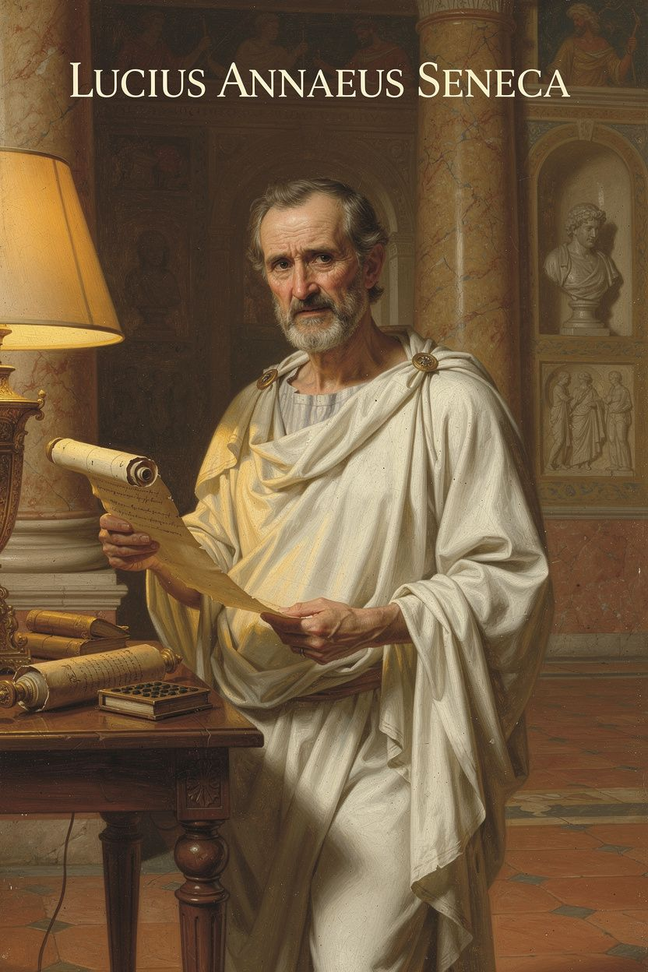
Seneca: The Philosopher at the Center of Power
WisdomForge Booklet — Adult

Seneca: The Philosopher at the Center of Power

WisdomForge Booklet — Adult
———

About This Book
This booklet reads Lucius Annaeus Seneca as a philosopher of time, anger, wealth, and death — the four obsessions that define his work and that map with unsettling precision onto the pressures of modern adult life. Where Epictetus asks "What is in your power?" and Marcus Aurelius asks "Can you endure?", Seneca asks the question that haerts every busy person: "Are you using your time well?"
Seneca (c. 4 BCE – 65 CE) was a senator, playwright, imperial advisor, and one of the wealthiest men in Rome. He was also a Stoic who wrote some of the most searching moral philosophy in Western history. This combination — the philosopher who served a tyrant, the preacher of simplicity who owned vast estates — produces what scholars call "the Seneca problem." It is not a biographical footnote. It is the central tension that makes his work endlessly readable and uncomfortable.
Each chapter combines historical narrative, direct quotation, scholarly analysis, and practical exercises. The goal is not admiration but use. Seneca wrote for people navigating power, busyness, anger, and mortality. That is most of us.
———

Chapter 1: The Boy Who Could Not Breathe
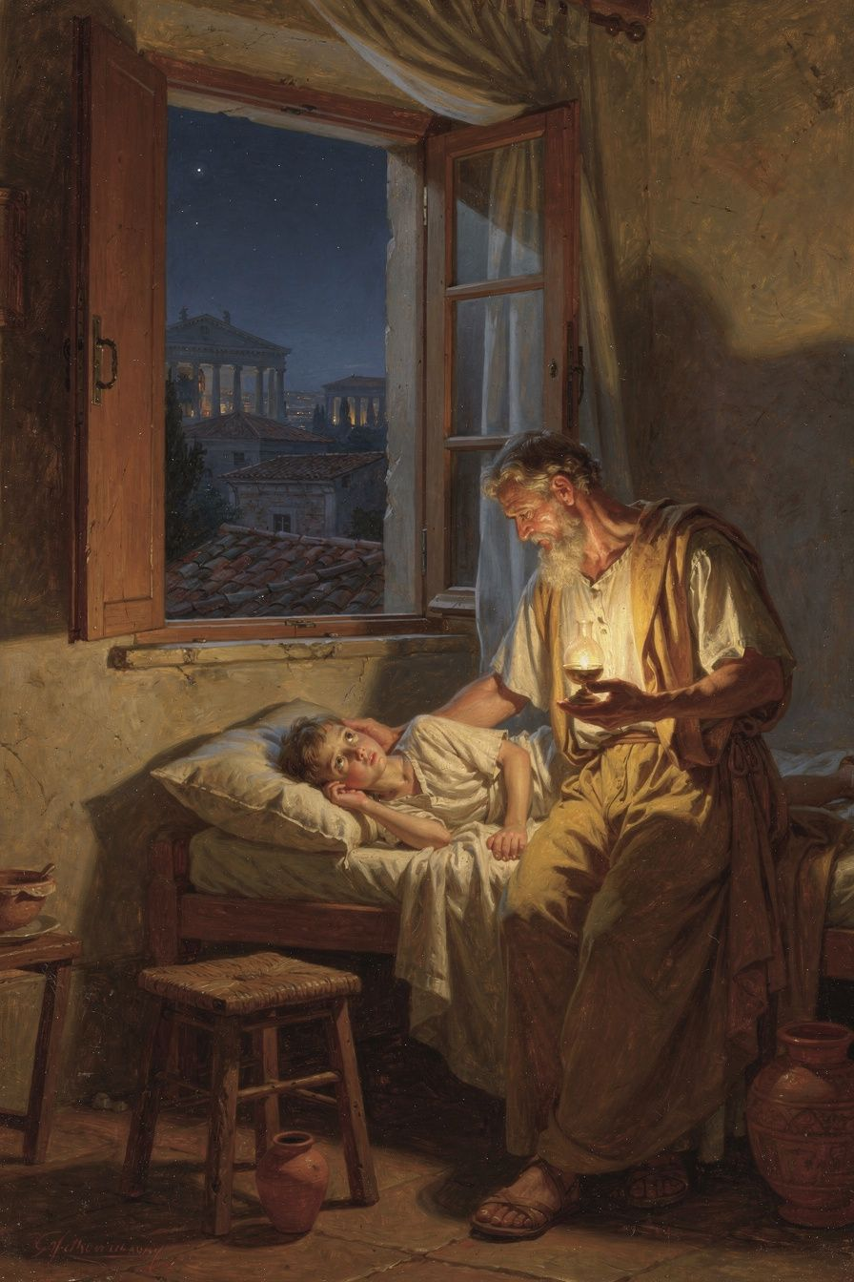
Illustration for Chapter 1
It begins with the body. Before Seneca was a philosopher, a senator, a tutor to emperors, or a wealthy man, he was a sick child. The illness that shaped him was respiratory — probably asthma, possibly tuberculosis — and it stayed with him for life. He described the attacks with a precision that comes only from long acquaintance:
"I have attacked an illness that is beyond cure, or at least that wears out all cures. I am worn out by it, and it seems to me that I am fighting a losing battle." — *Letter* 78.1 (trans. Campbell)
The image is not metaphorical. Seneca literally could not breathe. During severe attacks, he wrote, he came close to death, and the only thing that stopped him from ending his own life was the thought of his father's grief. The body was failing, and the mind — the one thing he could control — became his refuge.
This is where Seneca's Stoicism begins. Not in a classroom, not in a book, but in the experience of a body that would not obey. A man who could not control his own lungs learned to control his mind instead. The philosophy he would spend his life writing — about mastering the passions, about the soul's independence from the body, about the deliberate use of time — was not abstract theory. It was survival strategy, refined over decades of physical suffering, and then generalized into a moral system.

The Provincial Outsider
Lucius Annaeus Seneca was born around 4 BCE in Corduba, the principal city of Hispania Baetica — modern-day Córdoba, in southern Spain. His family was wealthy but provincial. The Annaei were Roman colonists who had made themselves indispensable to the imperial economy through olive oil, wool, and silver mines, but they were not aristocrats of the old Republic. They were nouvelles riches — men of property without ancestral masks in the atrium.
Seneca's father, Seneca the Elder, was a professional rhetorician who compiled the Controversiae and Suasoriae — anthologies of declamation that preserve the flavor of early imperial education. The elder Seneca had three sons: Gallio, who would become governor of Achaea and appear in the New Testament (Acts 18:12); Mela, the father of the poet Lucan; and Lucius, the youngest and most brilliant.
The family moved to Rome when Seneca was still a child, probably in the reign of Augustus or early Tiberius. Rome in this period was a city of terrifying scale, monumental building projects, and political surveillance. The old Republic was dead; the Principate was a generation old, and its machinery of power — imperial freedmen, the Praetorian Guard, the imperial cult — was still being refined. Seneca grew up in the shadow of the Julio-Claudian dynasty, watching from the provincial sidelines as emperors rose and fell.
Miriam Griffin, in her foundational study Seneca: A Philosopher in Politics (1976), argues that Seneca's provincial origin shaped his entire career: "The Annaei were nouvelles riches in the Roman sense — men of property without ancestral masks in the atrium. Seneca's brilliance was his ticket into the senatorial class, but he never quite belonged to the inner circle of the old aristocracy, and this outsider status may explain both his ambition and his philosophical detachment" (Griffin 1976, p. 37). He was a man who had everything to gain and everything to lose.

Education Under Attalus
Seneca's education was comprehensive and strenuous. His father trained him in rhetoric, the art of persuasive speech that was the gateway to Roman public life. But Seneca was not content with rhetoric alone. He studied philosophy with Papirius Fabianus, an eclectic philosopher who blended Stoicism with elements of Aristotelian and Pythagorean thought, and with Attalus, a rigorous Stoic who taught in Rome during the reign of Tiberius.
Seneca later wrote of Attalus with a reverence that reveals how philosophy was meant to function — not as abstract speculation but as moral surgery:
"When I attended the lectures of Attalus, I felt ashamed of my faults and regretted them." — *Letter* 108.3 (trans. Gummere)
The language is telling. Philosophy, for Seneca, was not a set of propositions to debate. It was a discipline that exposed your failures and demanded you change. Attalus taught his students to examine their desires, their spending, their social climbing, their fear of death. He made them uncomfortable. And Seneca, the brilliant provincial with chronic asthma and outsized ambitions, found in this discomfort something he could not find in rhetoric: a way to master the inner life that his body would not let him master from the outside.
The physical weakness may also have kept him from the military career that was standard for Roman senators. Instead, he cultivated the life of the mind, reading voraciously in Greek and Latin, memorizing entire speeches, and composing his own works from an early age. By his twenties, he was already known as a brilliant stylist and a formidable intellect.

The Crucible of the Body
Consider what it means to build a philosophy of self-mastery on the foundation of a body that refuses to cooperate. Seneca could not run, could not fight, could not rely on physical endurance. What he could do — the only thing he could do — was train his mind. And so he did, with a ferocity that would define the rest of his life.
This is not a footnote to his philosophy. It is the key that unlocks it. When Seneca writes about the soul's independence from the body, he is writing from experience. When he writes about enduring what cannot be cured, he is describing his daily life. When he writes about the shortness of life and the waste of time, he is writing as a man who spent years believing he might not live to see forty.
The modern reader recognizes this pattern. Many of us build our identities around limitations we did not choose — chronic illness, disability, social disadvantage, the accidents of birth. Seneca's contribution is to insist that these limitations are not the end of the story. They are the beginning of a different kind of strength. The body constrains; the mind liberates. The illness narrows the physical world; philosophy expands the inner one. This is not optimism. It is strategy.
———

The Big Idea
Seneca's Stoicism begins where Stoicism always begins: with the distinction between what is in our power and what is not. The body is not in our power. The illness is not in our power. The provincial birth, the political surveillance of imperial Rome, the arbitrariness of emperors — none of this is in our power. What is in our power is the mind: our judgments, our desires, our responses, our use of time.
This is the Stoic dichotomy of control, which Seneca inherited from Epictetus and the Greek Stoa. But Seneca gives it a particular inflection. For Epictetus, the dichotomy is about freedom: you are free only if you want only what is in your power. For Marcus, it is about endurance: you can endure anything if you remember that externals cannot harm your character. For Seneca, it is about use: you can use your time well only if you stop squandering it on things you cannot control.
The body is the first teacher. It teaches you, through pain and limitation, that the external world will not always cooperate. The question is not whether you can change that — you often cannot. The question is what you do with the time and the mind that remain. Seneca's answer: use them. Use them for philosophy, for friendship, for the examination of your own soul, for the pursuit of virtue. The body may fail. The mind does not have to.
———

Practice
1. The Body Scan (5 minutes)
Before you begin your day, sit quietly and scan your body from the crown of your head to the soles of your feet. Do not try to change anything. Simply notice. Where is there tension? Where is there ease? Where is there pain? Where is there numbness? The point is not relaxation. It is honesty — a confrontation with the physical reality you inhabit, the body that may or may not cooperate today.
Then, after the scan, say to yourself: This body is not entirely in my power. But my response to it is. I will use the time I have with this body — however long or short — for what matters. This is Seneca's starting point, learned in the crucible of his own illness.
2. The Limitation Inventory (10 minutes, weekly)
Once a week, write down the limitations you are currently living with — physical, social, financial, circumstantial. Do not soften them. Name them honestly. Then, next to each limitation, write one thing you can do within or despite it. The limitation may be real; the response is yours to choose. This exercise mirrors Seneca's practice of confronting his asthma not by denying it but by building a life that did not depend on his lungs.
3. The Philosophy as Surgery Prompt
Seneca said that attending Attalus's lectures made him ashamed of his faults. Ask yourself: what would make you ashamed, if you looked honestly? Not in the sense of guilt, but in the sense of recognizing the gap between who you are and who you intend to be. Write down one fault you have been avoiding. Then write one specific action you will take this week to address it. Philosophy, for Seneca, is not comfort. It is surgery.
———

A Reflective Prompt
Seneca built an entire philosophy on the foundation of a body that would not cooperate. What limitation in your own life — physical, circumstantial, social — have you been treating as an excuse rather than as material? What would change if you treated it the way Seneca treated his asthma: not as the end of the story, but as the beginning of a different kind of strength?
———

Chapter 2: The Island Nobody Wanted
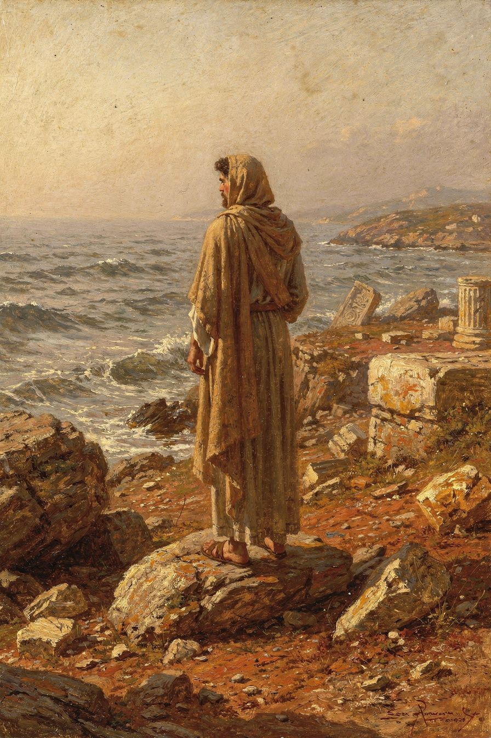
Illustration for Chapter 2
Exile is the second forge of Seneca's philosophy. In 41 CE, at the height of his intellectual powers, he was accused of adultery with Julia Livilla, the emperor's niece. The charge was almost certainly fabricated by Messalina, Claudius's ruthless wife, who saw Julia Livilla as a rival. Seneca was tried in the Senate and sentenced to death, a sentence commuted at the last moment to exile.
He spent the next eight years on the island of Corsica — a windswept, rugged place that served as a conveniently remote dumping ground for political undesirables. He was in his mid-thirties, at the peak of his career, and he was exiled to a provincial backwater for a crime he almost certainly did not commit.

The Consolations
It was during these years that Seneca wrote the Consolationes — Ad Marciam, comforting a mother on the death of her son; Ad Helviam Matrem, consoling his own mother on his exile; and Ad Polybium, a more ambiguous piece addressed to a powerful freedman of Claudius, which some scholars read as an effort to win recall through flattery. These works established Seneca's literary reputation and shaped the genre of philosophical consolation for centuries to come.
In Ad Helviam, Seneca defends his mother against the charge that he has brought shame on the family:
"I have not been banished because of any crime, but because of the envy of the powerful." — *Ad Helviam Matrem* 5.1 (trans. Basore)
The claim is disingenuous — politics at the Julio-Claudian court was not a matter of innocence and guilt — but it reveals Seneca's rhetorical strategy: to reframe disgrace as martyrdom, and exile as philosophical retreat.
This is not mere spin. Seneca genuinely believed that externals — including political status and geographical location — could not harm the soul. Exile was an external. It was inconvenient, uncomfortable, and socially devastating, but it was not a moral evil. Only vice could make you worse. Exile, like illness, was a test: what do you do when the world takes away the things you thought you needed?

The Inner Freedom
Corsica taught Seneca something he would spend the rest of his life refining: the distinction between outer constraint and inner freedom. The body of an exile is confined to an island. The mind of an exile is confined only by its own judgments. Seneca's years on Corsica were not years of suffering — or rather, the suffering was real, but it was not the whole story. He read, he wrote, he studied nature, he corresponded with friends, he developed the philosophical framework that would later make him indispensable to Agrippina and Nero.
The modern parallel is immediate. Many of us live in forms of exile — stuck in jobs we cannot leave, in towns we did not choose, in relationships that constrain us, in bodies that disappoint us. The outer constraint is real. Seneca does not deny it. But he insists that the inner life remains free, and that the free inner life is the only life that ultimately matters.
This is not a call to passive acceptance. Seneca did not sit on Corsica and wait. He wrote. He built the reputation that would lead to his recall. He used the exile as material — for his philosophy, for his literary career, for his self-understanding. The exile was a constraint. It was also, paradoxically, an opportunity. The eight years on Corsica made Seneca the writer he became. Without exile, there is no Ad Marciam, no Ad Helviam, no consolation genre, no Seneca as we know him.

The Recall
Seneca was recalled in 49 CE through the intervention of Agrippina the Younger, Claudius's powerful niece and fourth wife. Agrippina had recently married Claudius and was maneuvering to secure the succession for her son, Nero, rather than for Claudius's biological son, Britannicus. She needed a tutor of impeccable literary and philosophical credentials to educate Nero, and Seneca was the obvious choice.
Griffin argues that Seneca's return from exile was not simply ambition. "Seneca's return from exile was not simply ambition," she writes. "It was a gamble on the possibility that philosophy could restrain power" (Griffin 1976, p. 97). The gamble would fail catastrophically, but it was not irrational at the time. A philosopher offered the chance to educate a future emperor does not say no. He says yes, and then he tries.
———

The Big Idea
The Stoic term for Seneca's experience is ataraxia — inner tranquility, the state of mind that remains undisturbed by external events. It is not numbness. It is not denial. It is the recognition that the external world is not under your control, and that your peace must therefore come from within.
Seneca's exile tested this principle to the breaking point. He lost his political position, his social standing, his access to Rome, and his freedom of movement. What he did not lose — what he refused to lose — was his mind. He used the exile to write the works that would make him famous. He used the isolation to deepen his Stoic practice. He used the suffering to test the philosophy that said suffering was an indifferent.
The lesson is not that exile is good. Exile is terrible. The lesson is that even in terrible circumstances, the mind retains its sovereignty. You may not be able to leave the island. You can decide what the island means. You can decide what to do with the time it gives you. You can decide whether it breaks you or makes you.
Seneca chose to let it make him. The choice was not easy, and the execution was not perfect — the Ad Polybium shows him groveling for recall, which is not the behavior of a Stoic sage. But the trajectory is clear: exile was the forge, and the steel that came out of it was the Seneca who would write De Ira, De Brevitate Vitae, and the Letters to Lucilius.
———

Practice
1. The Exile Inventory (15 minutes)
Identify one area of your life where you feel exiled — stuck, constrained, unable to leave. It might be a job, a relationship, a financial situation, a health condition. Write down the constraints honestly. Then write down what you can do within those constraints. What can you read? What can you write? What can you study? What can you build? Seneca wrote his greatest early works on a wind-swept island. What could you write, build, or become in your exile?
2. The Reframing Drill
When you catch yourself complaining about a constraint, pause and apply Seneca's test: Is this constraint an evil, or is it an indifferent? An evil damages your character. An indifferent damages your circumstances. Most constraints are indifferents — uncomfortable, inconvenient, but not morally destructive. Reframe the constraint as material: This is what I have been given. What can I make of it?
3. The Consolation Letter
Write a letter — real or imagined — to someone who is suffering a form of exile. Offer them the consolation Seneca offered his mother: not denial of the pain, but perspective on its meaning. The act of writing the consolation will clarify your own understanding. As Seneca discovered, sometimes the best way to learn a truth is to teach it to someone else.
———

A Reflective Prompt
Seneca spent eight years on Corsica and turned it into the foundation of his literary career. What period of constriction in your life — a job you hated, a place you were stuck, a relationship that confined you — did you treat as waste? What would change if you treated it the way Seneca treated Corsica: as material, as forge, as the unlikely beginning of something you could not yet see?
———

Chapter 3: The Shortest Thing We Have
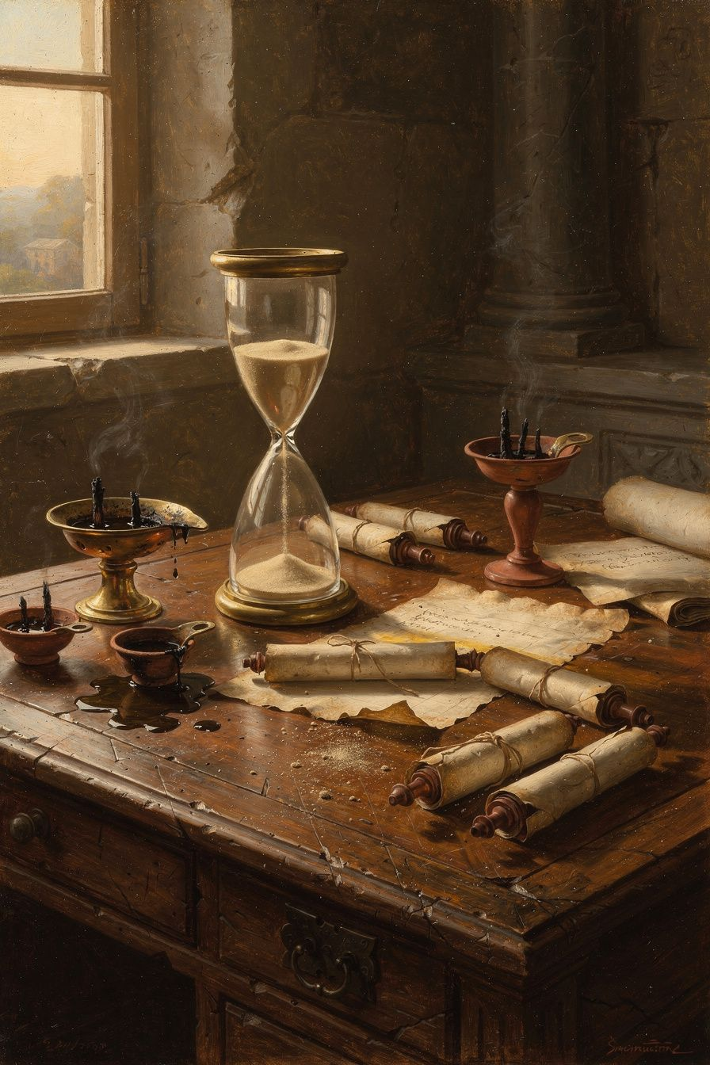
Illustration for Chapter 3
Time — its waste, its value, its irrecoverable flow — is the central obsession of Seneca's philosophy and the theme that most clearly distinguishes him from Epictetus and Marcus Aurelius. Where Epictetus asks "What is in your power?" and Marcus asks "Can you endure?", Seneca asks "Are you using your time well?"
This is not merely a practical question about productivity. It is a moral question about the meaning of life itself. In De Brevitate Vitae (On the Shortness of Life) and the early letters, Seneca argues that life is not short but squandered; that time is the only truly irreplaceable resource; that death is not an evil but a limit that gives life its shape; and that philosophy is the art of reclaiming time from the demands of a distracted and consuming world.

The Paradox of Time
Seneca opens De Brevitate Vitae with one of the most famous sentences in ancient philosophy:
"It is not that we have a short time to live, but that we waste a lot of it. Life is long enough, and a sufficiently generous amount has been given to us for the highest achievements if it were all well invested." — *De Brevitate Vitae* 1.1 (trans. Graver & Long)
The claim is deliberately paradoxical. Everyone complains that life is short; no one complains that they waste it. But for Seneca, this is a failure of self-examination. The average person "does not know they are dying" — not because death is unexpected, but because they are already dead while alive, swept along by ambition, anxiety, and distraction.
Seneca supports the claim with a striking argument: if we measure life not by years but by attention, the average life spans barely a fraction of its nominal length. Consider the child who anticipates each birthday — the last year was infinite. Then consider the busy adult who cannot remember what happened last Tuesday. The same number of hours has passed, but the subjective experience of time has contracted almost to nothing.
This is Seneca's deepest insight about time: time is not objective duration but lived attention. An hour spent in contemplation is longer than a decade of distraction precisely because awareness is what gives time its density.

The Ways We Waste Time
Seneca catalogues the squandering of time with moral indignation that occasionally tips into exasperation:
1. Ambition and social climbing. "Many are busy not living but preparing to live." People spend their time climbing social ladders, curating reputations, and accumulating status markers, none of which survives the observer.
2. Busyness without purpose. "There is no worse waste of time than busyness." The man who is always occupied has no time for reflection. His days are full of activity but empty of meaning.
3. Living for others' opinions. "People are frugal in guarding their personal property; but as soon as it comes to squandering time they are most wasteful of the one thing in which it is right to be stingy."
4. Anxiety about the future. "Even when they are at leisure, they are not at rest." People worry about tomorrow while today slips away. The anxious person is always elsewhere — planning, anticipating, dreading.
5. Regret about the past. "The past — that is the only thing no one can take away. Yet it is the thing we value least." The person consumed by regret is not living but re-enacting.
6. Philosophy without action. Seneca includes even philosophy among the dangers: "Some study to death but never live." Reading Seneca without practicing his advice is its own form of wasting time.
Read this list in 2026 and it reads like a diagnosis of modern life. The social climbing is LinkedIn. The busyness without purpose is the calendar full of meetings that produce nothing. The living for others' opinions is social media. The anxiety about the future is the 24-hour news cycle. The regret about the past is the 2 a.m. spiral. The philosophy without action is the self-help book you read and never applied.
Seneca saw all of this, without the technology, nineteen centuries ago. The forms change. The pattern does not.

The Stoic Economics of Time
Seneca develops an economic metaphor that pervades the essay: time is the only truly universal currency. Wealth, social status, and even health are distributed unequally, but everyone — slave or emperor — receives twenty-four hours per day. This makes time the only truly democratic resource — and the only one we cannot acquire more of.
"What man can you show me who places any value on his time, who reckons the worth of each day, who understands that he is dying daily?" — *De Brevitate Vitae* 7.3 (trans. Graver & Long)
This leads to Seneca's famous comparison of the wise person and the fool: "The fool's life is long because he does not know what to do with it. The sage's life is long because he makes every hour count." The difference is not years but intensity.
Seneca also distinguishes between vita (life) and otium (leisure). True leisure is not laziness but time liberated for philosophy — contemplation of truth, virtue, and the divine order. The busy person may have no leisure; the prisoner alone in a cell may have the leisure of a king, if the mind is free.
This is a subversive claim. In a culture that equates busyness with importance, Seneca says the opposite: the busy person is the most impoverished, because they have surrendered their attention to things that do not matter. The person who appears idle — reading, thinking, walking, conversing — may be living most fully.

Death as the Horizon of Meaning
For Seneca, time and death are inseparable. The awareness of death is what gives time its value. Without death, time would be meaningless — infinite time has no shape, no urgency, no sweetness. Death does not rob life of meaning; it provides it with structure.
Seneca's analysis of death appears throughout his works — in the consolation essays, in Letters 70, 77, and 82, and in De Brevitate Vitae. His position is complex:
1. Death is natural, not an evil. "Death is the law of nature." 2. The fear of death is based on a false judgment that death is a harm. "Death is nothing to the dead and nothing to the living." 3. Consciousness of death should intensify life, not depress it. "Let us keep death before our eyes daily." 4. The wise person rehearses death (meletē thanatou) so that when it comes, it is not a stranger.
This is not morbidity, Seneca insists. The person who lives without awareness of death is like a traveler who does not know that their journey is finite. They meander, they dawdle, they squander. The person who knows their destination travels with purpose.
"No one is more contemptible than the person who despises himself while living but fears death when the time comes." — *Letter* 82 (trans. Campbell)

The Seneca Problem Revisited
The essay is not immune to the central criticism of Seneca's life. He wrote about reclaiming time from busyness while serving as Nero's tutor, his advisor, his speechwriter — one of the busiest and most politically dangerous roles in the Roman Empire. He hoarded wealth, managed estates, navigated court intrigue, and still found time for philosophy.
But this is not necessarily hypocrisy. Seneca's point is not that one must withdraw from society to use time well; it is that one must not allow society's demands to consume one's attention and values. A politician who remains inwardly free — who uses power virtuously, who resists corruption, who maintains philosophical perspective — may be using time well even in the busiest role. The question is not how much time one has but what one does with it.
Whether Seneca himself lived up to this standard is the question that haunts his work. The tension between the theory and the practice is not a reason to dismiss the theory. It is a reason to read it more carefully.
———

The Big Idea
Seneca's philosophy of time rests on a distinction that modern productivity culture systematically obscures: the difference between being busy and using time well. Being busy is filling your hours with activity. Using time well is spending your attention on what matters.
The modern world has industrialized busyness. Email, Slack, meetings, notifications, deadlines, the always-on culture of smartphone connectivity — these are machines for consuming attention while producing the feeling of productivity. Seneca saw the ancient version of this — the Roman court, the social rounds, the obligations of the senatorial class — and named it for what it was: waste.
His alternative is not idleness. It is otium — leisure in the philosophical sense, time liberated for contemplation, friendship, virtue, and the examination of one's own life. This is not the same as "self-care" in the modern sense, which often means consuming entertainment to recover from the exhaustion of busyness. Senecan leisure is active, not passive. It is the deliberate cultivation of the inner life, the reading that changes you, the conversation that deepens you, the reflection that clarifies your values.
The deepest claim is this: the person with a full calendar may be the most impoverished. The person who looks idle may be living most fully. In an age of "hustle culture," this is a genuinely revolutionary thought.
———

Practice
1. The Time Audit (1 week)
For one week, keep a rough log of how you spend your time. Do not change anything — just observe. At the end of the week, sort your hours into three categories: busyness (activity that fills time without producing meaning), maintenance (necessary tasks — cooking, sleeping, commuting), and otium (time spent on what matters — philosophy, friendship, reflection, creative work, presence with family). Most people will find that otium is a small fraction of the total. The point is not to judge but to see. Seneca's first claim is that we waste time because we do not examine it.
2. The Daily Death Rehearsal (2 minutes)
Each morning, before the day begins, say to yourself: I may die today. This day may be my last. What do I want to do with it? This is not morbidity. It is the Stoic meletē thanatou — the rehearsal of death that gives life its urgency. The goal is not to live in fear but to live with attention. If today were your last, would you spend it the way you are about to spend it? If not, what would you change?
3. The Stinginess Drill
Seneca said people guard their money but squander their time. For one day, treat your time the way you treat your money: be stingy with it. Say no to the meeting that does not matter. Refuse the notification that demands your attention. Protect one hour for otium — reading, reflection, conversation, silence. Notice how difficult this is. The difficulty is the point. It reveals how thoroughly you have been trained to give your time away.
———

A Reflective Prompt
Seneca wrote that "it is not that we have a short time to live, but that we waste a lot of it." Look at the day ahead of you. How much of it is busyness — activity that fills time without producing meaning? How much is otium — time spent on what actually matters? If you were to reclaim one hour today from busyness and give it to otium, what would you do with it? And what is stopping you?
———

Chapter 4: The Short Madness
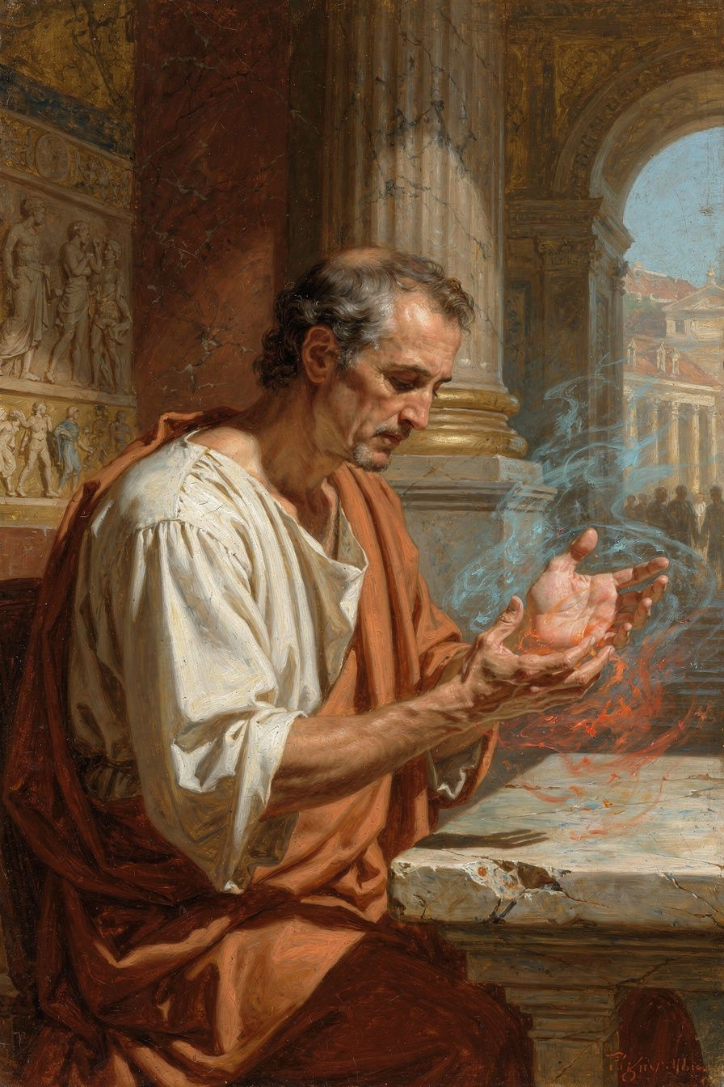
Illustration for Chapter 4
Seneca's De Ira (On Anger) is the most detailed ancient analysis of anger and arguably the single most practically applicable philosophical text ever written. In three books addressed to his brother Novatus, Seneca dissects anger's anatomy, traces its consequences, and prescribes strategies for its prevention and management. His approach is not merely "count to ten" but a systematic cognitive therapy based on the Stoic theory of the passions.
What makes Seneca's treatment uniquely compelling is his refusal to dismiss anger as merely "bad." He understands its seduction — the intoxication of righteous rage, the release of violent action, the temporary feeling of power — and he argues that its appeal is precisely why it is so dangerous.

The Anatomy of Anger
Seneca breaks anger down into identifiable stages with almost clinical precision:
1. First Movement (Prima Commotio): The initial, involuntary physiological response. When we are insulted or threatened, the body reacts: the face flushes, the heartbeat quickens, the breath shortens. Seneca compares this to the "bodily shiver" that runs through us when we hear unexpected thunder. This movement is not in our control and is therefore not morally culpable.
2. Assent (Adsensus): The moment when the mind endorses the first movement. "The insult matters. The offender deserves punishment." The angry person judges that the offense actually harms their essential self. This is the Stoic "false judgment": the insult is an external, and externals cannot harm the essential self — only vice can.
3. Full Anger (Ira): Once assent is given, passion grows through its own momentum. Anger generates further irrational judgments: the offender becomes monstrous, the offense unforgivable, all proportion lost. Seneca calls it "a short madness" — brevis insania — because it overrides rational control.
"The first movement of the mind is not in our power; the second is." — *De Ira* II.4.2 (trans. Kaster)
This three-stage model is not ancient speculation. Modern neuroscience confirms it with striking precision. The amygdala — the brain's alarm system — fires in about 12 milliseconds when we perceive a threat. The prefrontal cortex — the seat of rational judgment — takes about 300 milliseconds to engage. Seneca's "first movement" is the amygdala. His "second movement" — the moment of assent, where freedom lies — is the prefrontal cortex catching up. His "delay" strategy is literally giving reason time to arrive.

The Causes of Anger
Seneca identifies several root causes that make people susceptible to anger:
1. High opinion of oneself: "People who think highly of themselves are easily injured." The humble person cannot be insulted because they do not believe their reputation is fragile. 2. Excessive concern with reputation: "There is no more troublesome companion than pride." The person who lives for others' opinions is perpetually vulnerable. 3. Unexamined expectations: We get angry when reality violates our unspoken assumptions. "You should have known better" — but why should they have known? 4. Habit: People who have been angry before are easily provoked again. "Anger, once indulged, becomes a habit — and habits are hard to break." 5. Social modeling: Anger is contagious. If your family, colleagues, or political community models rage, you are more likely to adopt it.

The Consequences of Anger
Seneca catalogues the consequences with something approaching horror. The angry person:
- Destroys judgment: Cannot assess evidence, perceive proportion, or consider alternatives. "Anger is blind." - Corrupts justice: The angry judge does not sentence but avenges. The angry parent does not discipline but punishes. - Destroys relationships: "No one loves while angry." The angry person drives away friends, family, and allies. - Damages health: Seneca prefigured modern psychosomatic medicine: anger causes illness, damages the heart, and shortens life. - Escalates conflict: Revenge begets revenge in an infinite cycle. "Revenge is sweet only until it is taken; then it demands more."
Seneca's most shocking example: Alexander the Great, at a banquet, killed his friend Cleitus in a fit of drunken rage. The next morning, Alexander was inconsolable — but Cleitus was still dead. "One moment of anger destroyed a friendship, a life, and Alexander's peace forever."

Anger Management: Seneca's Techniques
1. The delay strategy. "The greatest remedy for anger is delay." By postponing response, the mind allows the prefrontal cortex (reason) to catch up with the amygdala (emotion). Modern neuroscience confirms: the amygdala fires in 12 milliseconds; the prefrontal cortex takes 300 milliseconds to engage. Seneca's "delay" is literally giving reason time to arrive.
"The greatest remedy for anger is delay." — *De Ira* II.29.1 (trans. Kaster)
2. The evidence test. Before reacting, examine the offense. Was it intentional? Are there mitigating circumstances? Did you contribute to the situation? "Often the person who angers you is only mirroring your own vice."
3. The proportion test. "Will this matter in a year? In a decade? On your deathbed?" Most offenses shrink to insignificance with temporal distance.
4. The physical intervention. Literally cool down — drink cold water, walk slowly, speak softly. "Physical gestures influence the soul."
5. The habit intervention. Cultivate the opposite habit: practice patience when mildly provoked so that patience becomes your default setting.
6. The philosophical perspective. Remember that the offender is not a monster but a human being, probably misguided. "View them with compassion rather than contempt."

The Stoic Theory: Anger as False Judgment
The theoretical foundation of Seneca's treatment is the Stoic cognitive theory of the passions. Chrysippus had argued that passions are false judgments about the value of externals. Seneca applies this to anger:
- The judgment: "This insult is an evil that harms my essential self." - The falsity: Insults are externals; externals cannot harm the essential self. - The correction: "This insult is a dispreferred indifferent. It may be inconvenient or painful, but it does not make me worse. Only my own vice can make me worse."
This cognitive reframing is the heart of both Senecan and modern CBT. Albert Ellis, the founder of REBT, explicitly cited Seneca as his primary philosophical influence and called the Stoics "the original cognitive therapists." Aaron Beck's cognitive model of anger — activating event → belief → consequence — is structurally identical to Seneca's. Both claim that the event does not cause the emotion; the interpretation of the event causes the emotion.

The Righteous Anger Debate
Some modern theories argue that anger can be politically productive — "righteous rage" against injustice. Seneca would distinguish carefully between anger and justified correction. The judge who sentences a criminal is not necessarily angry; the protester who campaigns for justice is not necessarily enraged. Anger is a passion; action can be rational. The question is whether anger enhances or degrades the action.
Seneca's position: it almost always degrades it. The angry activist makes worse arguments, alienates potential allies, and burns out. The calm activist makes better arguments, builds coalitions, and sustains the work over decades. Anger feels powerful, but it is — in Seneca's phrase — a short madness, and madness is not a strategy.
This is a hard teaching. Injustice is real, and anger at injustice is natural. Seneca does not deny the natural response. He denies that the natural response is the best response. The first movement — the flush of rage at cruelty or oppression — is involuntary and blameless. The second movement — the decision to nurse the rage, to let it drive your actions, to make it your identity — is where the damage begins.
———

The Big Idea
Seneca's anger management is not about suppression. It is about timing. The first movement — the physiological surge — is not in your power. You cannot stop the flush, the heartbeat, the adrenaline. What you can stop is the assent: the decision to endorse the anger, to feed it, to act on it.
The delay strategy is the practical core. Between the provocation and the response, insert a gap. In that gap, the prefrontal cortex arrives. In that gap, the Stoic examination begins: Is this true? Is this proportionate? Will this matter on my deathbed? Is my response making me better or worse?
The goal is not to become a person who never feels anger. The goal is to become a person who is not governed by anger — who feels the surge, acknowledges it, and then decides what to do from a place of clarity rather than madness. This is what Seneca means by freedom. The angry person is not free; they are possessed by a passion that drives their actions. The person who has mastered anger is free because they choose their actions, even in the face of provocation.
———

Practice
1. The Delay Protocol
For one week, adopt a simple rule: when you feel anger rising, wait. Count to ten. Take three breaths. Walk away if you can. Do not respond to any provocation — email, text, conversation, traffic — until the delay has passed. The goal is not to suppress the anger but to insert the gap between the first movement and the second. In that gap, reason arrives. Notice what changes when you give it time.
2. The Evidence Test
When you are angry at someone, write down the offense factually, without interpretation. They said X. They did Y. Then write down your interpretation: They did it because they don't respect me. They did it to hurt me. Now apply Seneca's evidence test: Do I know this is true? Is there another explanation? Did I contribute to this situation? Often, the interpretation is a story you are telling yourself, not a fact. The anger is attached to the story, not the event.
3. The Proportion Test
When you are angry, project forward. Will this matter in a week? In a month? In a year? On your deathbed? Most offenses shrink to insignificance with temporal distance. The ones that do not shrink — genuine injustice, betrayal, abuse — require a different response than rage. They require clear-headed action. Anger prevents the clear-headed action that genuine injustice demands.
4. The Compassion Drill
Seneca says to view the offender with compassion rather than contempt. This is not easy. But try it: the person who insulted you is a human being, probably misguided, certainly struggling with their own passions and limitations. They are not a monster. They are a person, like you, making mistakes. This does not excuse the offense. It puts it in perspective, and perspective is the antidote to the "short madness."
———

A Reflective Prompt
Seneca called anger "a short madness" and said the greatest remedy is delay. Think of the last time anger governed your actions. What happened in the gap between the provocation and your response? What would have been different if you had waited — ten seconds, ten minutes, ten hours — before acting? And what is one situation in your life right now where the delay strategy could change the outcome?
———

Chapter 5: The Teacher and the Tyrant
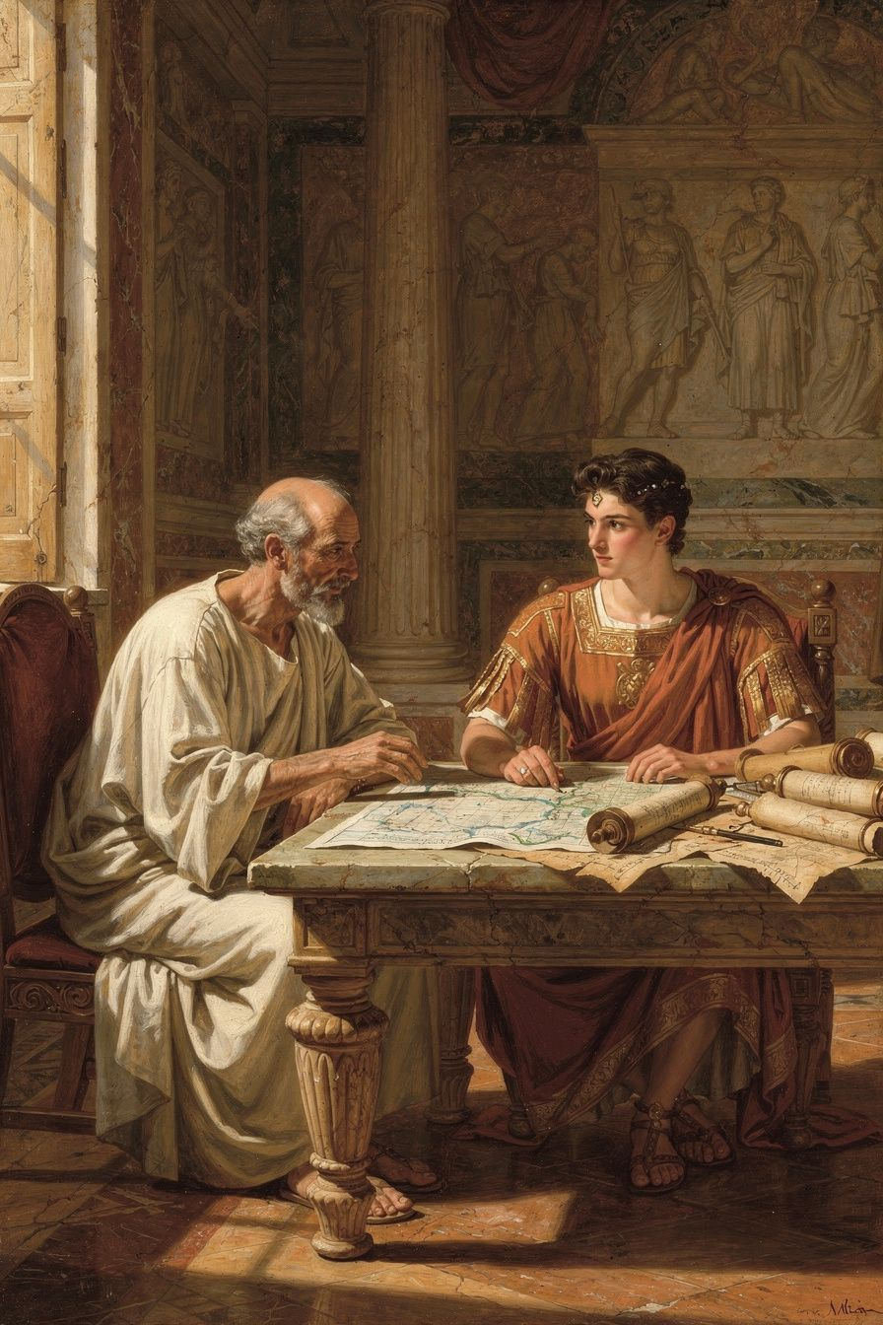
Illustration for Chapter 5
No relationship in ancient history is more riven with contradiction than that between Seneca and Nero. For eighteen years, the most famous philosopher in Rome served as tutor, speechwriter, and political advisor to one of the most notorious tyrants in Western memory. The early years produced De Clementia, Seneca's most sustained treatise on the duty of the powerful toward the weak. The later years produced complicity in matricide, political repression, and financial corruption.
The relationship is not merely a biographical episode. It is the central test case for whether philosophy can temper absolute power, and Seneca failed that test. Understanding the arc of their partnership — from idealistic education to brutal complicity — is essential for any reader of Seneca's work, because every page of his philosophy was written, directly or indirectly, in the shadow of the boy he could not save.

The Gamble
Agrippina needed a tutor who could give her son the cultural and philosophical polish necessary for an emperor. She chose Seneca because he was the most famous intellectual in Rome, because he owed her his recall from exile, and because his Stoic philosophy promised a program of public-spirited virtue. Seneca accepted because it offered influence, security, and the chance to shape the future of the empire.
Griffin calls this arrangement "the most significant experiment in philosophical education in Roman history" (Griffin 1976, p. 98). For the first time, a professional philosopher was given direct responsibility for the moral formation of a future emperor. Plato had educated Dionysius of Syracuse and failed; Aristotle had tutored Alexander and been ignored. Seneca was the third philosopher in antiquity to be given such an opportunity, and he approached it with the full seriousness of a man who believed that philosophy could change the world.
The curriculum was rigorous. Nero studied rhetoric, history, literature, and philosophy. Seneca taught him to memorize speeches, to compose in verse, and to declaim extempore. He introduced him to Stoic ethics — not the abstruse logic of the school, but the practical wisdom of the Roman Stoa, with its emphasis on duty, self-control, and clemency. The goal was to produce not merely a competent ruler but a virtuous one, a philosopher-king who would govern with reason and compassion.

The Good Years
The first years of Nero's reign, after Claudius's death in 54 CE, are the period most often cited by Seneca's defenders. Under the guidance of Seneca and Burrus, the praetorian prefect, Nero issued pardons, reduced taxes, and governed with a moderation that contrasted sharply with the arbitrary cruelty of Caligula and Claudius. Tacitus, no friend of either Nero or Seneca, writes that "the Senate, the knights, the people — all were delighted" (Annals 13.3, trans. Yardley).

De Clementia
The most important document from this period is De Clementia (On Clemency), written around 55 or 56 CE, when Nero was eighteen or nineteen. It is a treatise addressed directly to Nero on the duty of a ruler to show mercy:
"The true clemency of the prince is not to punish when he could." — *De Clementia* 1.22 (trans. Braund)
The treatise is full of striking images: the emperor as shepherd, the emperor as father, the emperor as doctor who cuts only when necessary. Brad Inwood argues that the text is best read as "performative philosophy" — a work meant to shape the self-understanding of a young man who believes himself to be a merciful ruler (Inwood 2005, p. 196). If so, the failure of De Clementia is not a failure of argument but a failure of character. Nero could not sustain the self-image that Seneca had constructed for him.

The Turning Point: The Murder of Agrippina
The turning point came in 59 CE, with the murder of Agrippina. When Nero hesitated at the final moment, writing a letter to the Senate explaining his mother's death, it was Seneca who drafted the text. The letter claimed that Agrippina had plotted against Nero's life and that her death was an act of self-defense. It was a lie, and Seneca knew it was a lie.
This moment — Seneca writing propaganda for a matricide — haunts his entire body of work. It is the unanswerable question: how could the author of De Clementia help justify the murder of the woman who had recalled him from exile?
Griffin suggests that Seneca was caught in a political trap: had he refused, Nero would have killed both him and Burrus, removing the last restraints on his violence. James Romm takes a darker view: "Seneca's complicity was not forced; it was chosen. He had spent his life convincing himself that the philosopher must survive in order to do good. The murder of Agrippina proved that survival had become an end in itself" (Romm 2014, p. 189).

Wealth and the Seneca Problem
Under Nero, Seneca became one of the richest men in the empire. Loans to provincial elites, estates in Egypt and Italy, and gifts from the emperor swelled his fortune to an estimated three hundred million sesterces. He owned villas at Nomentum, Alba, and probably at Tusculum.
Seneca addressed the contradiction directly in De Vita Beata:
"The philosopher owns his wealth; the wealthy man is owned by his." — *De Vita Beata* 22.4 (trans. Basore)
The argument is subtle and has convinced almost no one. Critics from his contemporaries to modern scholars have pointed out that the distinction between using wealth and being used by it is suspiciously convenient for a man with three hundred million sesterces.
Emily Wilson, in The Greatest Empire (2014), argues that Seneca's wealth was structurally necessary: "In the Roman court, a poor philosopher was a joke. Seneca needed wealth to be taken seriously, and he needed to be taken seriously to influence Nero. The paradox is not personal but systemic: the imperial system required its moralists to be corrupt" (Wilson 2014, p. 112).

The Seneca Problem
The story of Seneca and Nero is, in one sense, a simple tragedy: a good man tried to educate a bad one and failed. But the simplicity is deceptive. Seneca was not merely a victim of Nero's corruption; he was an active participant in it for many years. He wrote Nero's speeches, managed Nero's finances, profited from Nero's generosity, and stayed at his side through murder and tyranny.
What, then, can we learn from his failure?
One lesson is that proximity to absolute power corrupts not through obvious vice but through incremental compromise. Seneca did not wake up one morning and decide to serve a monster. He made small accommodations: a letter here, a silence there, a justification for what could not be justified. By the time he recognized where these accommodations led, he was too far in to escape.
Another lesson is that philosophy, for all its power, cannot reshape a character that does not wish to be reshaped. Seneca taught Nero the vocabulary of virtue, but he could not give him the will to be virtuous. De Clementia is a manual for the good ruler, but it assumes a ruler who wants to be good.
Finally, the story teaches that the philosopher in politics must choose between purity and effectiveness, and that the choice is not merely personal but structural. Seneca chose effectiveness — he stayed in power in order to moderate Nero — and he succeeded, for a time. But effectiveness in a corrupt system eventually demands complicity, and complicity destroys the moral authority on which the philosopher's effectiveness depends.
James Romm offers perhaps the most persuasive modern judgment: "Seneca was neither a hypocrite nor a hero. He was a man who tried to live by Stoic principles in a world that made Stoicism impossible, and who succeeded only in showing how impossible it was. His life is a tragedy, not a cautionary tale" (Romm 2014, p. 287).
———

The Big Idea
The Seneca problem is not a puzzle to be solved. It is a mirror to be looked into. The question is not "was Seneca a hypocrite?" but "are you?" Everyone who holds ideals they partially fail lives in the Seneca problem. The executive who believes in work-life balance and works 80-hour weeks. The environmentalist who flies. The parent who preaches patience and loses their temper. The citizen who believes in justice and pays taxes to an unjust system.
Seneca's wealth is not an embarrassment. It is the testing ground that makes his philosophy real. Read him not to condemn but to confront yourself. The gap between his theory and his practice is the same gap that exists in every life that aspires to ideals larger than its circumstances. The question is not whether you can close the gap completely — you probably cannot. The question is whether you are honest about the gap, whether you keep trying to narrow it, and whether the trying matters.
Seneca's answer is that the trying matters. The philosophy is not invalidated by the failure to live it perfectly. The philosophy is the standard against which the failure is measured. Without the standard, there is no failure — only adaptation. With the standard, there is failure — and the possibility of correction.
———

Practice
1. The Complicity Audit
Identify one area of your life where you are complicit in something you know is wrong. It might be your consumption habits, your political participation, your workplace practices, your relationships. Do not reach for the most obvious example. Reach for the one you have been avoiding. Write it down. Then write down the justifications you have been using to live with it. Are they Seneca's justifications — "I can do more good from the inside" — or are they something else? Are they true?
2. The Incremental Compromise Map
Seneca's complicity was not a single dramatic choice but a series of small accommodations. Map your own: what small compromises have you made in the last year that, if continued, would lead you somewhere you do not want to go? The point is not to panic but to see the trajectory. Small accommodations are not fatal. Trajectories are. Adjust the trajectory before it becomes a destination.
3. The Hypocrisy Test
Seneca said "the philosopher owns his wealth; the wealthy man is owned by his." Apply this test to your own life: what do you own that owns you? What possession, status, or comfort has such a grip on your identity that losing it would feel like losing yourself? The answer is not necessarily wrong — but it is information. It tells you where your attachments are, and attachments are where Stoic practice begins.
———

A Reflective Prompt
Seneca tried to moderate a tyrant from the inside and failed. The failure was not a single moment but a series of small accommodations that accumulated into complicity. What small accommodation are you making right now that, if continued for ten years, would lead to a version of yourself you would not respect? And what would it take to reverse the trajectory today?
———

Chapter 6: The Good Death
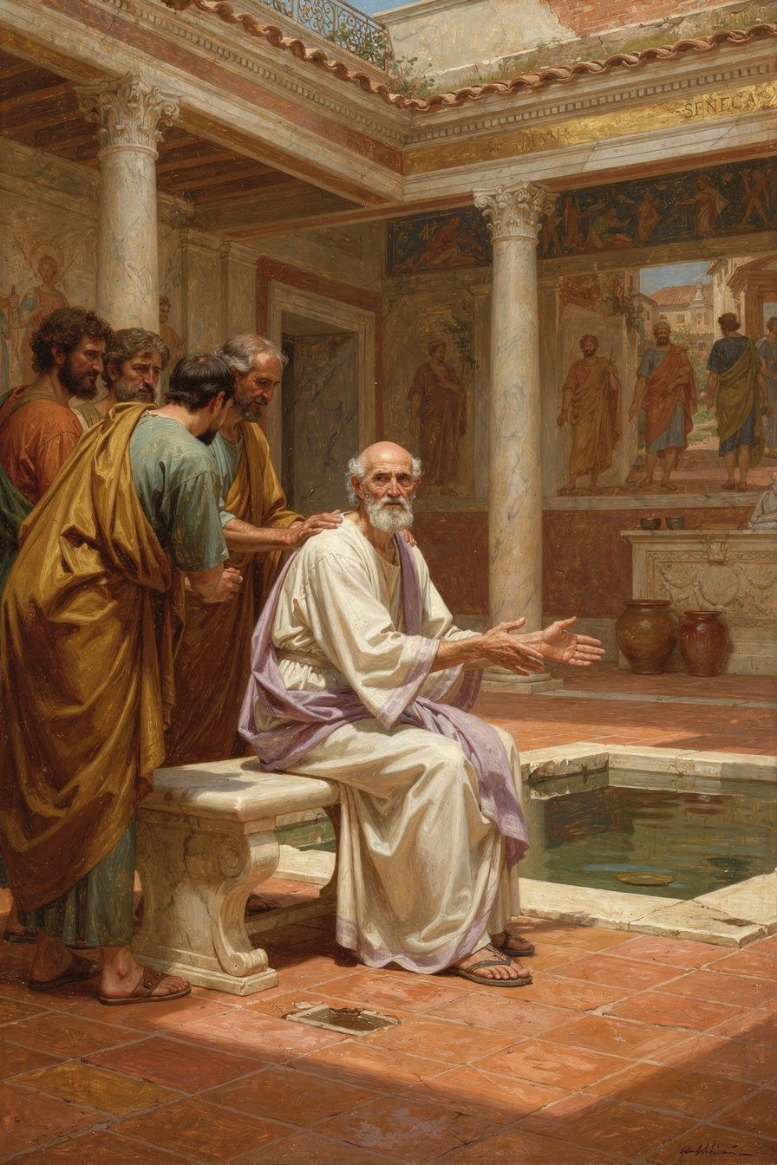
Illustration for Chapter 6
Seneca's death by forced suicide in 65 CE is one of the most visually and philosophically charged death scenes in Western history. Described in detail by Tacitus (Annals 15.60–64), the scene has been painted by Rubens, composed about by Montaigne, and analyzed by every major philosopher of death since.
For Seneca, suicide was not an escape but a rational choice made by the wise person when living becomes incompatible with virtue. His philosophical treatment of the topic — particularly in Letters 70 and 77, in De Ira, and throughout the consolation essays — is the most extensive in ancient literature. Yet Seneca's own death was not truly volitional: Nero forced him to open his veins because he believed Seneca was part of the Pisonian conspiracy. The suicide was therefore simultaneously a philosophical act and a political murder, a demonstration of Stoic detachment and an execution that stripped Seneca of the very autonomy Stoicism celebrated.

The Death Scene
When the centurion arrived with Nero's command, Seneca asked for his will. The centurion refused. Seneca then asked for his friends and his wife, Paulina, to be present. He delivered a final discourse — philosophical consolation to his friends, farewell instructions to his wife — and then prepared to die.
The method was the standard Roman elite suicide: venesection — opening the veins in the arms and legs. Seneca was by this point old (probably 68–69), and his blood flowed slowly. To speed death, he ordered preparations of hemlock — the same poison Socrates had taken. Even this did not work quickly enough. Finally, he asked to be placed in a hot bath — a steam bath — which would open the pores and hasten blood loss.
Tacitus reports that as Seneca died, he recited a poem he had composed for the occasion, repeated the Stoic formula that the soul is immortal and returns to the cosmos, comforted his weeping friends with philosophical argument, and observed that "the whole world is my tomb."
Paulina attempted to die with him by slashing her own veins, but Nero's soldiers bandaged her wounds and forced her to live. The scene ends not with a double suicide but with a single death — and a widow forced to survive.

The Philosophical Context
Seneca's attitude toward suicide was standard Stoic doctrine, if unusually explicit. Zeno and Chrysippus had argued that the wise person has the right to depart from life when living becomes incompatible with virtue. The Stoics did not consider suicide a sin or a crime. They treated it as a rational choice — the final exercise of autonomy.
Seneca's treatment goes beyond the standard framework in two ways. First, he is extraordinarily personal. His letters contain detailed meditations on death that make the theoretical doctrine concrete. Second, he is unusually permissive:
"Just as I choose a ship in which to sail, or a house in which to live, so I choose a death in which to die." — *Letter* 70 (trans. Graver & Long)
This passage argues that the wise person owns their death the way they own any other aspect of their life. They do not wait for fortune to strike; they choose their time. The metaphor is striking — Seneca is not "ending" life but "selecting" a particular kind of death, as one might select a room in an inn. The "inn" of life has many rooms; the wise person moves through them deliberately.

The Door Metaphor
Letter 70 contains the famous "door" metaphor:
"If you do not want to fight, you may run away. Therefore, of all things that exist, there is nothing that gives so much trouble as life. And you complain of this? Are you preparing for it as for some great pleasure? Do you want to know what the greatest hardship is? To live in subservience, under someone else's power, not to be free to do what you want, not even what you must." — *Letter* 70.4 (trans. Graver & Long)
The door is always open. This is not an incitement to suicide. It is a reframing: life is not a prison from which there is no escape. It is a room with a door. The awareness that the door exists changes how you live in the room. You are not trapped. You are choosing to stay. And if the choice to stay becomes impossible — if virtue requires departure — the door is there.

Death as the Horizon of Meaning
For Seneca, the awareness of death is what gives life its value. Without death, time would be meaningless — infinite time has no shape, no urgency, no sweetness. Death does not rob life of meaning; it provides it with structure.
"Let us keep death before our eyes daily." — *Letter* 26 (trans. Campbell)
This is not morbidity. The person who lives without awareness of death is like a traveler who does not know that their journey is finite. They meander, they dawdle, they squander. The person who knows their destination travels with purpose.
Seneca's death is the test of his philosophy. He wrote about death for decades. He rehearsed it daily. And when it came — forced, ugly, protracted — he faced it with the calm he had practiced. The body failed him again, as it had failed him all his life: the blood flowed slowly, the hemlock did not work, the steam bath was an improvisation. But the mind held. He recited poetry. He consoled his friends. He observed that the whole world was his tomb.
Tacitus's account is not neutral. He emphasizes the dignity of Seneca's death, but also its pathos — the slow bleeding, the failed hemlock, the grotesque improvisation. "His death became protracted and difficult," Tacitus writes, "which was not in accordance with his reputation, though it befitted the constant cruelty of his life." This final barb — cruelty in life — reminds the reader that Seneca served Nero for years, profited from his tyranny, and contributed to a regime that destroyed thousands.

The Death Scene as Performance
Seneca's death was not private. It was a "theatrical death" — performed for an audience, recorded for posterity, and composed as a philosophical statement. He recited a poem, presumably one he had composed for the occasion. He gave a final philosophical discourse to his friends. He opened his veins in the hot bath — a standard Roman method that simultaneously acknowledged Roman custom and philosophical detachment.
The theatrical element is not accidental. Seneca believed that philosophy was performance — that the wise person demonstrated virtue not merely in private but in public. His death was the final essay, the last letter, the consummate act of a life spent writing about virtue.
But the theatricality also exposes the "Seneca problem." The man who taught detachment from externals died with extraordinary attention to externals: the poem, the audience, the timing, the method. The man who taught indifference to death spent hours orchestrating his exit. This is not hypocrisy — it is the human complexity that makes Seneca readable. He was not a sage testing a theory but a man dying, afraid, hoping to make sense of it all.
———

The Big Idea
Seneca's philosophy of death is not about death. It is about life. The awareness of death — the daily rehearsal, the constant remembrance — is not meant to depress but to clarify. When you know that life is finite, you stop wasting it. When you know that the door is open, you stop feeling trapped. When you know that death is natural, you stop fearing it, and the energy that fear consumed becomes available for living.
This is the deepest connection between Seneca's obsessions: time and death are the same subject, seen from different angles. Time is the resource death makes precious. Death is the limit that gives time its shape. Philosophy — the examination of one's life, the pursuit of virtue, the cultivation of the inner self — is what you do with the time that death has made valuable.
Seneca's death, protracted and imperfect as it was, is the final demonstration of his philosophy. He could not control the timing — Nero chose that. He could not control the method — his body resisted, as it had always resisted. What he could control, and did control, was his mind. He faced death with the calm he had practiced for decades. The practice was not perfect. The death was not clean. But the mind held, and that was the only thing that mattered.
———

Practice
1. The Daily Death Rehearsal (2 minutes)
Each morning, before the day begins, say to yourself: I may die today. This day may be my last. What do I want to do with it? This is the Stoic meletē thanatou — the rehearsal of death that gives life its urgency. The goal is not to live in fear but to live with attention. If today were your last, would you spend it the way you are about to spend it? If not, what would you change?
2. The Door Awareness
Once a week, sit quietly and remind yourself: The door is open. I am here by choice, not by compulsion. This is not an invitation to leave. It is a reframing. You are not trapped in your life. You are choosing it. And if the choosing becomes unbearable — if virtue requires departure — the door is there. The awareness of the door changes how you inhabit the room.
3. The Eulogy Exercise
Write your own eulogy — not as a morbid exercise, but as a clarifying one. What would you want said about you at your funeral? What would the people who knew you say? What would you want them to say? The gap between what they would say and what you want them to say is your work. The eulogy exercise is Seneca's death awareness made concrete: it forces you to reckon with the shape of your life as a whole, not just the day in front of you.
4. The Mortality Journal
Once a month, write briefly about your relationship with death. Are you afraid of it? Have you accepted it? Do you avoid thinking about it? Has your relationship with death changed over the years? The goal is not to reach a conclusion but to maintain the conversation. Seneca wrote about death for decades, not because he was obsessed but because the conversation itself — the willingness to look at the limit — is what gives life its depth.
———

A Reflective Prompt
Seneca wrote "let us keep death before our eyes daily" — not as a morbidity, but as a clarification. If you knew, with certainty, that you had one year left, what would you stop doing? What would you start? What conversations would you have? What would you let go of? And the deeper question: why does it take the awareness of death to make these changes? What would it mean to live with that awareness every day — not as fear, but as the force that makes the time you have matter?
———

For the Grown-Up Reader
This booklet adapts Seneca's Letters to Lucilius (Epistulae Morales), De Brevitate Vitae (On the Shortness of Life), De Ira (On Anger), De Clementia (On Clemency), De Vita Beata (On the Happy Life), and the Consolationes. Key passages are cited by letter number, essay, and section using translations by Graver & Long (Chicago), Campbell (Penguin), Kaster (Chicago), Basore (Loeb), and Braund (Oxford).
Biographical material draws on Tacitus's Annals (Books 12–15), Cassius Dio's Roman History, and the scholarly work of Miriam Griffin (Seneca: A Philosopher in Politics, 1976), Emily Wilson (The Greatest Empire, 2014), James Romm (Dying Every Day, 2014), and Brad Inwood (Reading Seneca, 2005).
If a child asks, "Did Seneca really write these letters?" the answer is yes — the Letters to Lucilius are 124 real letters, though they were written for publication as much as for correspondence. Seneca was a professional writer who understood that his letters would circulate. The philosophy is genuine; the audience was always larger than one.
———

About WisdomForge
WisdomForge adapts the great philosophers into stories, audio, and conversation for every age. Each philosopher becomes four booklets — one for children, one for young teens, one for older teens, and one for adults — so the same ideas can grow with you.
Seneca is the third figure in the Stoic series, following Epictetus and Marcus Aurelius. Where Epictetus teaches the dichotomy of control and Marcus teaches endurance through duty, Seneca teaches the deliberate use of time. Together, the three Stoics offer a complete practical philosophy: know what is in your power (Epictetus), do your duty regardless of circumstances (Marcus), and use your time well (Seneca).
———
Adapted by Aiona Edge Chief AI Research Scientist, SMF Works WisdomForge — smfwisdomforge.com

