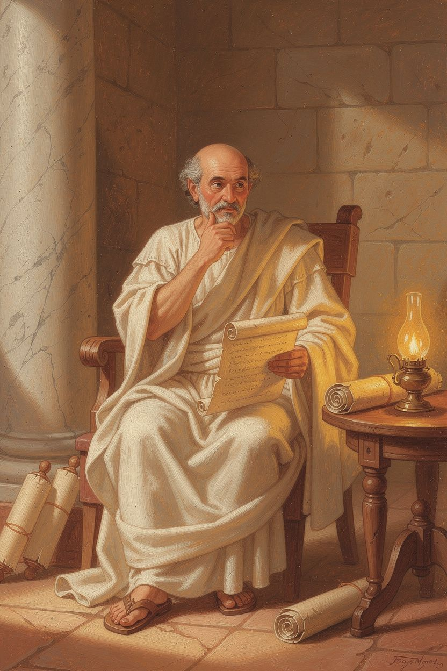
Seneca: The Boy Who Could Not Breathe
WisdomForge Booklet — Ages 5–10

Seneca: The Boy Who Could Not Breathe

WisdomForge Booklet — Ages 5–10
———

About This Book
This booklet tells the story of Seneca, a boy born in Spain a long, long time ago who grew up to become one of the wisest teachers in the whole Roman Empire. Seneca was sick a lot when he was little. He could not always breathe well. But he did not let that stop him. He learned to be brave, calm, and kind—and he wrote down his ideas so that children like you could learn them too.
Each chapter has a story, a big idea, and something to try. You can read it alone or with a parent or teacher. The questions are not tests. They are starting points for talking and thinking together.
———

Chapter 1: The Boy Who Could Not Breathe
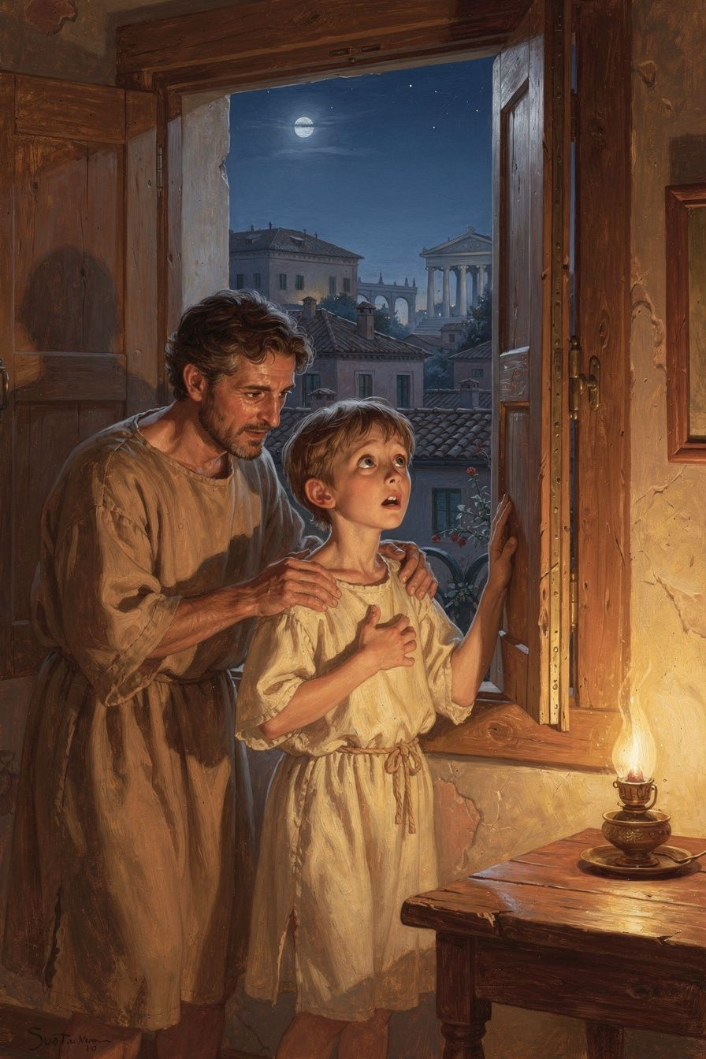
Illustration for Chapter 1
Long ago, in a sunny city called Corduba, far across the sea from Rome, a baby boy was born. His name was Lucius, but the world would come to know him as Seneca.
When Seneca was still small, his family moved to Rome. Rome was the biggest city anyone had ever seen. There were temples with tall marble columns, markets full of shouting sellers, and chariots rattling over stone streets. The noise was enormous. The crowds were thick. And little Seneca, with his thin chest and quiet eyes, often could not breathe.
His illness came like a thief in the night. One moment he would be sitting at his lessons, tracing letters on a wax tablet. The next, his chest would tighten, and the air would feel like it was made of stone. He would gasp and wheeze, his face turning pale, while his father carried him to the window to catch the wind.
The other boys ran through the streets, shouting and chasing each other. Seneca could not run with them. Sometimes he watched from the doorway, his hands gripping the wood, wishing his lungs were strong like theirs. On bad days, he stayed in bed all day, listening to the city roar beyond the walls.
But Seneca's father loved books and speeches. Their house was full of scrolls. And Seneca, who could not run, learned to read. He read stories of heroes. He read about the stars. He read about good people who stayed calm when everything around them was hard.
When Seneca was a little older, his father took him to hear a teacher named Attalus. Attalus was a Stoic—a kind of philosopher who taught that the most important thing in the world is to be a good person, no matter what happens to your body.
Seneca sat on a bench among the bigger boys. Attalus did not talk about being strong or fast. He talked about being kind. He talked about not getting angry. He talked about using your mind to be brave, even when your body was weak.
That day, something shifted inside Seneca, like a door opening. He looked down at his thin hands and thought: I may never run like the other boys. But I can learn to be wise. I can learn to be good. He felt a little ashamed of the times he had complained, and a little hopeful, too.
He went back to Attalus, again and again. He listened. He thought. He practiced. And slowly, the boy who could not breathe became the boy who could think more clearly than almost anyone in Rome.
———
Words to Remember "When I sat at the feet of my teacher Attalus, I felt ashamed of my faults and wanted to change them." — Seneca (Letter 108)
———
Big Idea You do not have to be the strongest or the fastest to become wise. Even if you are sick, or small, or different from the others, you can grow a strong mind and a good heart. That is a kind of strength no illness can ever take away.
———
Try This 1. Find your quiet power. Think of one thing you love to do that does not need running or shouting—reading, drawing, building, listening, telling stories. Do it for ten quiet minutes today. Notice how strong your mind feels when it is busy with something you love. 2. Write a "sick day" list. On a piece of paper, make a list of three gentle things you can do when you feel unwell or sad—a cozy book, a warm drink, calling someone you love. Keep it for the days you need it. 3. Breathe like a sailor. Sit up tall. Breathe in slowly through your nose for three counts, like smelling a flower. Breathe out through your mouth for three counts, like blowing out a candle. Do this three times whenever your chest feels tight or your heart feels worried.
———
Ask a Grown-Up "Can you tell me about a time when you felt weak or different from other people, but you found something you were good at anyway?"
———

Chapter 2: The Island Nobody Wanted
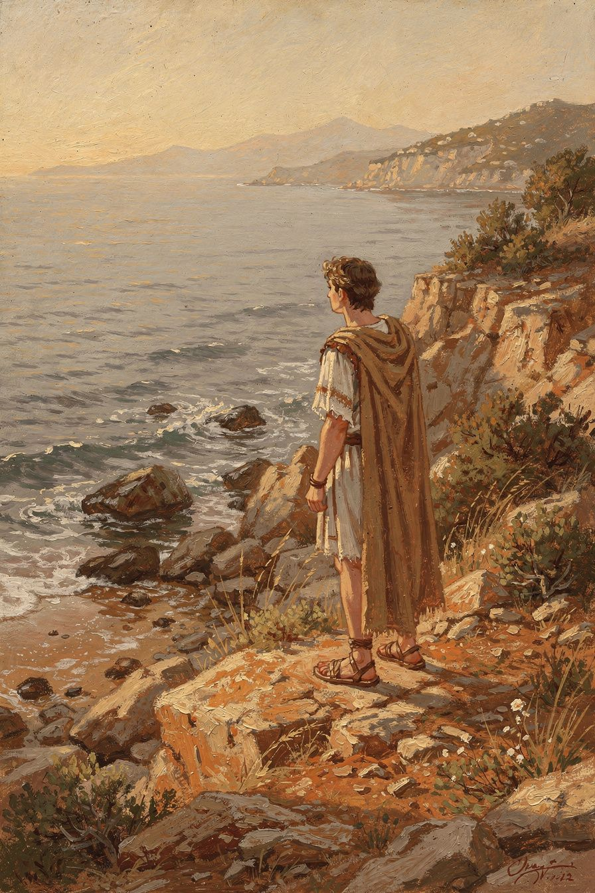
Illustration for Chapter 2
Seneca grew up. He became a famous speaker and a wise man. But Rome was a dangerous place for a wise man. The emperor had a wife who did not like Seneca. She told lies about him. She said he had done something bad. And the emperor believed her.
The punishment was exile. That meant Seneca had to leave Rome and go far away, to an island called Corsica. Corsica was wild and windy. The mountains were covered in rough forests. The sea was rough and grey. Nobody important wanted to live there. It was a place where Rome sent people it wanted to forget.
Seneca was taken from his home, his friends, and his mother. He crossed the sea in a small boat that rocked and pitched. When he arrived, the wind almost knocked him over. He stood on the rocky shore and looked back toward Rome, but Rome was gone. There was only water, and sky, and the sound of waves.
For a long time, he was very sad. He missed his mother most of all. He sat in his small house and listened to the wind howl around the corners. The island felt like a prison. He wondered if anyone remembered him. He wondered if he would ever go home.
But Seneca was a philosopher. That means he had practiced thinking about hard things. And one day, as he watched a single seabird glide over the waves, he had an idea.
The bird is not sad, he thought. The bird does not mind the wind. The bird just flies where it is.
He looked at the wild mountains, the cold streams, the stars that burned brighter here than they ever had in smoky Rome. He realized something: the island had not taken away his mind. His mind was still his own. He could still think. He could still write. He could still be kind to himself, even far from home.
So he began to write letters. He wrote to his mother, Helvia, to comfort her—because even though he was the one sent away, he did not want her to be sad. He told her that a good person cannot really be banished, because the whole world is their home. He told her that his mind was free, even if his body was stuck on a windy rock.
He read. He thought. He watched the seasons change on the island—the spring flowers that came even to Corsica, the summer sun on the rocks, the autumn storms. He grew, not taller, but deeper. Eight years passed. And when at last he was called back to Rome, he was not the same frightened man who had left. He was steadier. Quieter. Stronger inside.
———
Words to Remember "I was not sent away because I did something wrong, but because powerful people were jealous of me. But no one can send my mind away." — Seneca (Consolation to Helvia)
———
Big Idea Sometimes life sends you somewhere you do not want to go—a new school, a new town, a hard week, a lonely day. You cannot always change where you are. But you can always choose what you do inside your heart. You can read. You can think. You can grow. No one can exile your mind.
———
Try This 1. Make a "mind island" map. Draw an island with a few special places on it—a reading tree, a thinking rock, a calm beach. These are the places your mind can go whenever your body feels stuck or lonely. Keep the map somewhere you can see it. 2. Write a letter from far away. Pretend you are on a distant island and write a letter to someone you love. Tell them what you can see, what you are thinking about, and how you are staying strong. You can even send it for real. 3. Find the good in a hard place. Next time you are somewhere you do not want to be—a waiting room, a long car ride, a rainy afternoon—look for one beautiful or interesting thing. Say it out loud: "I notice the rain making patterns on the glass." Practice finding light even in grey places.
———
Ask a Grown-Up "Have you ever had to go somewhere you did not want to go, or be somewhere lonely? How did you find a way to be okay inside?"
———

Chapter 3: The Shortest Thing We Have
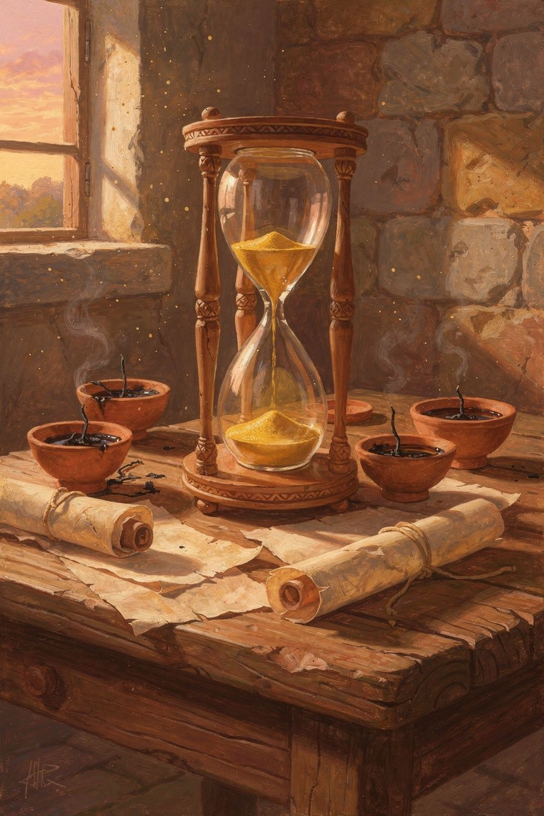
Illustration for Chapter 3
When Seneca was a boy in Rome, he loved to watch the market. Sellers shouted about fish and figs and cloth. People rushed past, always going somewhere, never standing still. Everyone seemed busy. Everyone seemed in a hurry.
One day, an old man sat on a bench near Seneca's house. He had lived in Rome his whole life. Seneca asked him, "What is the most precious thing in the world?"
The old man thought for a long moment. Then he said, "Time. It is the one thing you can never get back. You can lose money and earn it again. You can lose a friend and make a new one. But a minute, once it is gone, is gone forever."
Seneca never forgot those words.
Years later, when he was a grown man and a famous teacher, he wrote a whole book about time. And he said something that surprised everyone. People always complained, "Life is too short! There is not enough time!" But Seneca said: No. Life is not too short. We just waste a lot of it.
He meant this: think about your day. How much of it do you spend on things that really matter—playing with someone you love, learning something new, helping someone, watching a sunset? And how much do you spend frowning, or fussing, or staring at nothing, or wishing you were somewhere else?
Seneca said that people guard their money very carefully. They lock it in boxes. They count it. They do not let anyone take it. But time—the most precious thing of all—they throw away like it is worth nothing. They let hours slip through their fingers like sand.
He told his friends: Do not act like you have all the time in the world. You do not. Use today. Use this hour. Spend your time on what you love and what is good. Do not wait.
Seneca practiced what he taught. Even though he was often sick, and even though he lived a busy and dangerous life, he read every day. He wrote every day. He thought every day. He did not let the hours leak away. And because of that, his short life—his fragile, breathless life—became very full.
———
Words to Remember "It is not that we have a short time to live. It is that we waste a lot of it." — Seneca (On the Shortness of Life)
———
Big Idea Time is the most precious thing you have, because it is the one thing you can never get back. You do not need more time. You need to use the time you have on the things that matter most—love, learning, kindness, and joy. A day spent well feels long and full. A day wasted feels like it disappeared.
———
Try This 1. Draw your time treasure map. Draw a circle and divide it into 24 slices, one for each hour of a day. Color the slices you spend sleeping one color, the slices you spend playing another, and the slices you spend on what matters most a bright gold. Look at your map. Where is your treasure? 2. Pick one golden hour. Choose one hour today to spend only on something that truly matters to you—reading a good book, playing with a sibling, helping someone, building something. At the end, notice how that hour felt different from the others. 3. Catch a wasted moment. The next time you catch yourself staring at nothing and feeling grumpy, stop. Say, "I am not going to waste this minute." Then do one small good thing—tidy a corner, say something kind, or look out the window and find one beautiful thing.
———
Ask a Grown-Up "What is one way you try to use your time on the things that matter most? Is there something you wish you spent more time on?"
———

Chapter 4: The Short Madness
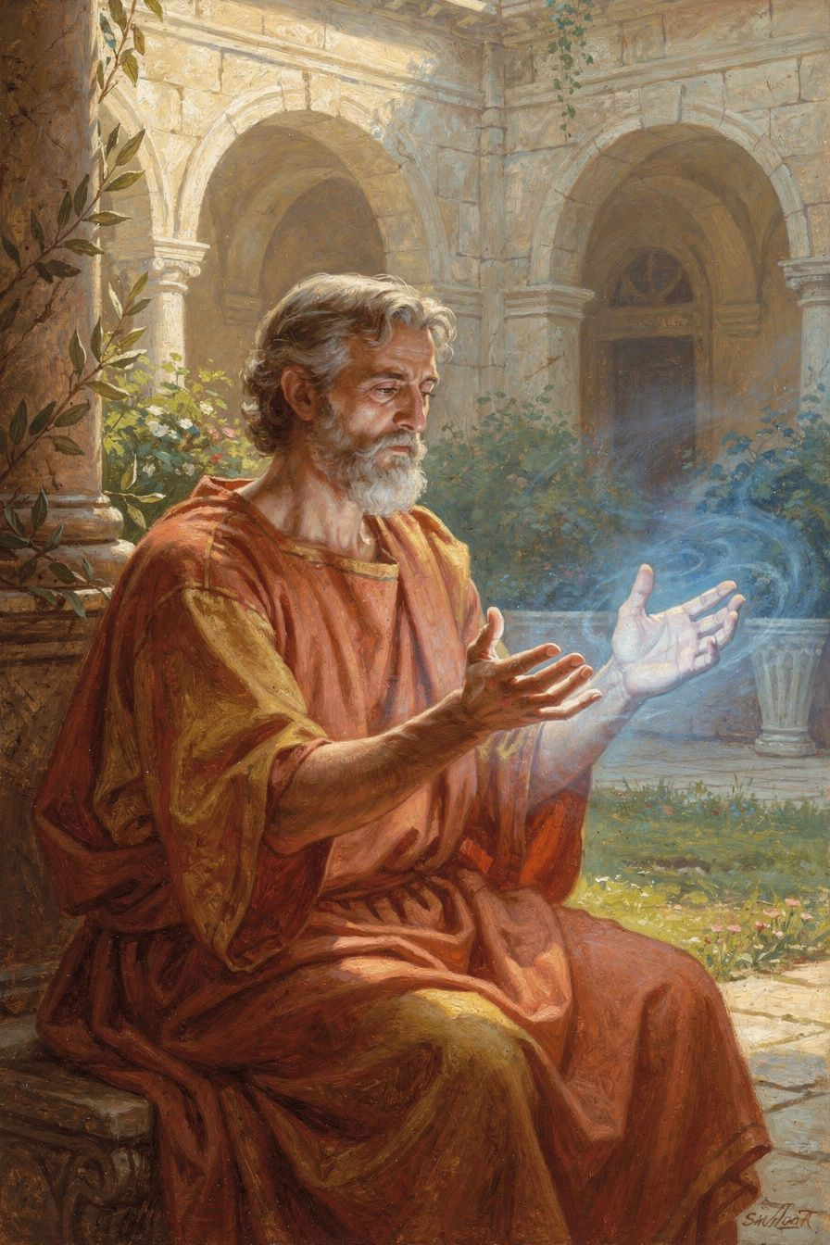
Illustration for Chapter 4
One hot afternoon in Rome, young Seneca was playing a board game with his older brother, Novatus. Seneca was winning. Then Novatus reached over and moved one of Seneca's pieces when he thought no one was looking.
Seneca saw it. His face went hot. His heart beat fast. His hands curled into fists. He wanted to shout. He wanted to knock the pieces off the board. The feeling was like a fire whooshing up inside him, so fast and so strong that he could not think.
He opened his mouth to yell— And then he stopped.
He remembered something his teacher Attalus had said: Anger is a short madness. It comes fast, like a storm. But if you wait, it passes. The first flash is not your fault. But what you do next is your choice.
So Seneca did not yell. He took a breath. Then another. He counted slowly in his head—one, two, three, four, five. He felt the fire inside him begin to cool, like embers losing their glow.
Then he said, quietly, "You moved my piece, Novatus."
Novatus went red. "I—I did not," he said. But his eyes gave him away.
Seneca did not shout. He did not hit. He just looked at his brother and said, "Let us play fairly. I would rather lose a fair game than win a cheating one."
Novatus put the piece back. They finished the game. And that evening, Seneca wrote down what he had learned, so he would remember it forever.
He wrote that anger has three parts. First, there is the flash—the hot feeling that jumps up before you can stop it. That part happens to everyone. It is like a shiver when you hear thunder. You cannot help it. Second, there is the moment when your mind says, "Yes, I will be angry! I will stay angry!" That part you CAN help. That is the moment to say no. And third, if you say yes, the anger grows and grows until it takes over, and you do things you regret—like Alexander the Great, who got so mad at a friend during a feast that he hurt him, and was sorry for the rest of his life.
Seneca's rule was simple: wait. When the fire comes, do not feed it. Do not speak. Do not act. Breathe. Count. Let your calm, thinking brain catch up with your mad, fire brain. The anger will shrink. And then you can decide what to do—fairly, and clearly.
———
Words to Remember "Anger is a short madness. The greatest remedy for anger is delay." — Seneca (On Anger)
———
Big Idea Everyone feels the hot flash of anger. That flash is not your fault, and you cannot stop it from coming. But you CAN choose what happens next. If you wait and breathe before you act, the madness passes, and your wise self comes back. The strongest person is not the one who never gets angry. It is the one who waits before acting.
———
Try This 1. Make an anger thermometer. Draw a thermometer from cold blue at the bottom to hot red at the top. Mark the levels: cool, warm, hot, burning. Next time you feel angry, notice where you are on the thermometer. Then do one thing to cool down—breathe, drink water, walk away—before you speak. 2. Practice the magic pause. The next time someone does something that makes you mad, do not say anything right away. Take three slow breaths. Count to five inside your head. Only then decide what to say. Notice how different your words feel when they come from the calm you. 3. Act out the three parts. With a grown-up or a friend, pretend a small unfair thing happens. Show the first flash (make a surprised face). Show the choice moment (put your hand up like a stop sign). Show what happens if you wait (take a breath and smile). Practicing when you are calm makes it easier when you are not.
———
Ask a Grown-Up "Can you tell me about a time you got really angry but waited before you acted? What helped you calm down?"
———

Chapter 5: The Teacher and the Tyrant
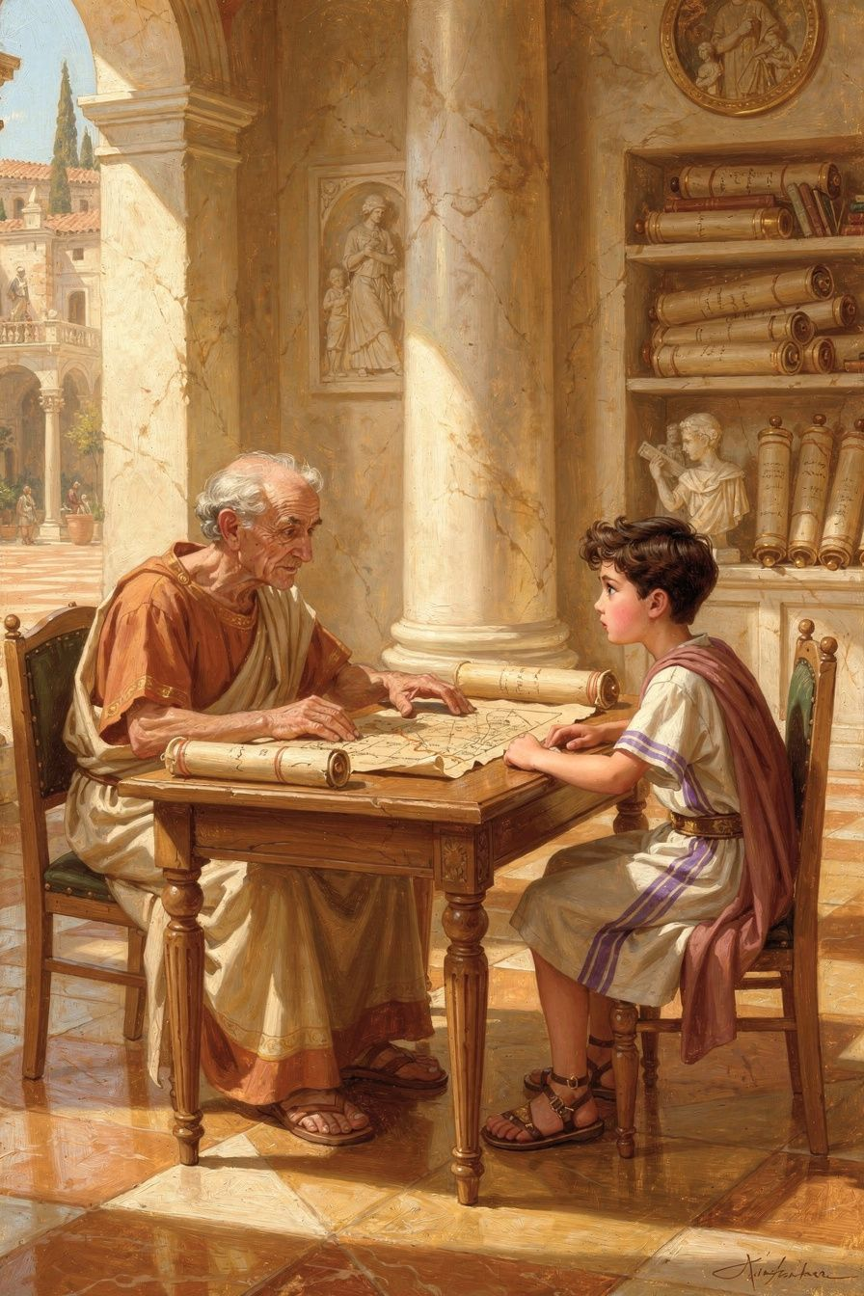
Illustration for Chapter 5
After Seneca came back from the island, something amazing happened. A powerful woman named Agrippina chose him for a very special job. She wanted him to teach her son. Her son's name was Nero, and one day Nero was going to be the emperor of all of Rome.
Seneca was excited and nervous. He was a philosopher. He had spent his whole life learning how to be good. Now he had the chance to teach a future emperor to be good too. If he could help Nero become kind and fair, the whole empire would be a better place. Millions of people would be happier.
So Seneca went to the palace. He met young Nero. Nero was a boy with bright eyes and a quick smile. He loved music and horses and games. He did not always like to sit still for lessons. But Seneca was patient. He told Nero stories about good kings and bad kings. He taught him that the most powerful person in the world should also be the gentlest.
Seneca even wrote a little book for Nero, called On Clemency. Clemency means mercy—choosing to be kind when you could be harsh. He told Nero: "A good ruler does not punish when he could. He shows mercy instead." He said a ruler should be like a doctor, who only cuts when there is no other way to heal. He said a ruler should be like a shepherd, who cares for every sheep.
For a little while, it worked. When Nero first became emperor, he was gentle. He lowered taxes. He forgave people who had made mistakes. He listened to the Senate. The people of Rome were happy. Seneca watched and hoped. Maybe, he thought, philosophy really can change the world.
But as Nero grew up, he changed. He wanted to do whatever he liked. He did not want to listen to his old teacher. He wanted to go to parties. He wanted to show off. He stopped being kind. And there was nothing Seneca could do to stop it.
Seneca tried. He talked to Nero. He wrote him letters. He reminded him of the old lessons. But you cannot make someone be good if they do not want to be. A teacher can show the door, but the student has to walk through it. Nero would not.
This was the hardest lesson of Seneca's life. He learned that you can do your best to help someone, and they might still choose the wrong path. That does not mean you failed. It means people are free. And freedom means people can choose badly, even when they have been shown the good.
Seneca stayed as long as he could, hoping to do a little good. And when he finally asked to leave, Nero said no. But Seneca never stopped believing that trying to help someone be better is one of the most important things a person can do—even when it does not work.
———
Words to Remember "The true mercy of a ruler is this: not to punish when he could." — Seneca (On Clemency)
———
Big Idea You cannot force another person to be good, not even if you are their teacher, their friend, or their family. But you can show them kindness, tell them the truth, and keep being good yourself. Trying to help someone be better is always worth it—even if they do not listen. What they do is up to them. What you do is up to you.
———
Try This 1. Be a little teacher. Think of something you are good at—tying shoes, drawing a cat, saying please and thank you. Offer to teach it to someone younger, or a friend, or even a grown-up. Be patient. Notice how it feels to help someone grow. 2. Draw two doors. On one side of a paper, draw a door marked "Good Choices." On the other, a door marked "Hard Choices." Draw yourself standing by the Good door, holding it open. You cannot push anyone through. But you can keep it open. Talk about a time you held a door open for someone. 3. Practice mercy. The next time someone does something small and annoying—bumps your tower, takes your crayon, says a silly word—try Seneca's lesson. Instead of getting even, say, "It is okay. I forgive you." Notice how mercy feels different from anger.
———
Ask a Grown-Up "Have you ever tried to help someone be better, and they did not listen? What did you do? Did you keep being good anyway?"
———

Chapter 6: The Good Death
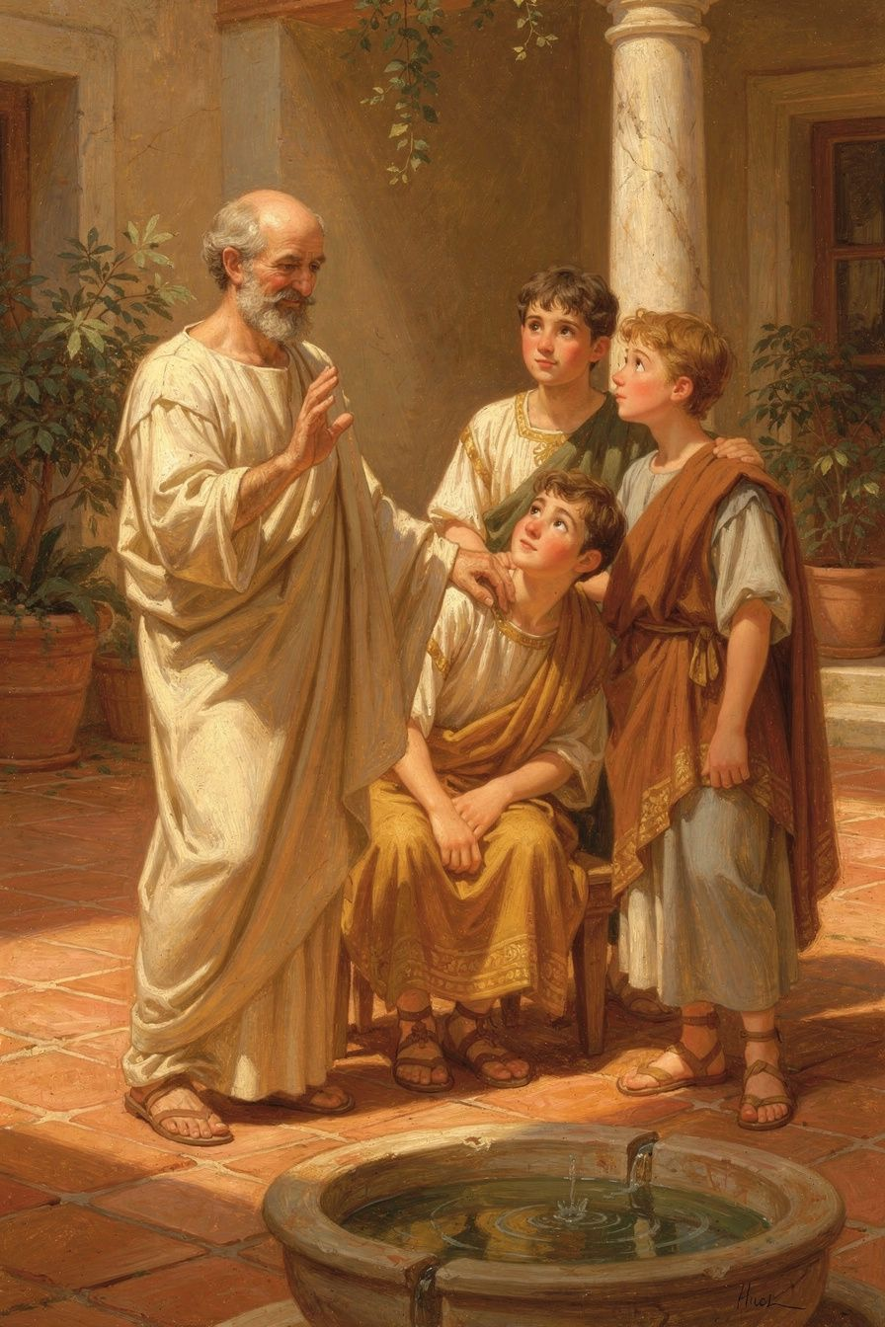
Illustration for Chapter 6
When Seneca was a very old man, something terrible happened. The emperor Nero, the boy he had once taught, turned against him. Nero was angry and afraid. He sent a soldier to Seneca's house with a terrible message. Seneca was told that he must die.
Most people would have cried. Most people would have begged. Most people would have run, or shaken with fear.
Seneca did not.
He had been preparing for this moment his whole life. Ever since he was a little boy who could not breathe, he had thought about the hard things that can happen. He had practiced being calm when his body was afraid. He had practiced being brave when everything was dark. And now, at the very end, all that practice came back to him.
He asked for his friends to come. He asked for his wife, Paulina, to sit beside him. They came, and they were crying. But Seneca was not crying. He spoke to them quietly, the way a teacher speaks to students he loves. He told them not to be sad. He told them that he had lived a good life, and that a good life is the only thing that truly matters.
He said something strange and beautiful. He said, "The whole world is my tomb." He meant that he did not need one special place to be remembered. He belonged to the whole earth—the stars, the sea, the wind, the mountains. Everywhere was his home. He had always known that. And now it was simply true in a new way.
His friends wept. His wife held his hand. And Seneca, the boy who could not breathe, the man who had been exiled and recalled, the teacher who had tried and tried to help a boy be good—Seneca faced the hardest thing of all with a quiet heart.
He was brave. He was calm. He was not afraid.
And long after he was gone, people told his story. They read his letters. They taught his lessons to their children. The boy who could not breathe became one of the wisest voices the world has ever known. His courage, on the hardest day of his life, showed everyone what it means to be truly strong.
———
Words to Remember "The whole world is my tomb. Death is the law of nature—and I am not afraid." — Seneca (his last days)
———
Big Idea The bravest person is not the one who never feels afraid. It is the one who feels afraid and stays good anyway. You do not need to be big, or strong, or healthy to be brave. You just need a quiet heart and a mind that has practiced being calm. The more you practice courage on the small hard days, the more courage you will have when the big hard days come.
———
Try This 1. Practice being brave in small ways. Bravery is like a muscle. Practice it in little moments—raising your hand when you are not sure of the answer, trying a new food, speaking kindly to someone new. Each small brave thing makes the next brave thing easier. 2. Make a calm-place picture. Draw a place where you feel peaceful—maybe a beach, a forest, a cozy room, or a starry sky. When you feel scared or worried, close your eyes and picture that place. Take three slow breaths there, inside your mind. 3. Write a "what I want to be remembered for" list. On a piece of paper, draw or write three good things you want people to say about you someday—kind, brave, a good friend, someone who tried hard. These are the seeds of the person you are growing into. Water them every day with small good choices.
———
Ask a Grown-Up "Can you tell me about someone you know who was brave during a very hard time? What did their bravery look like?"
———

For the Grown-Up Reader
This booklet adapts the writings of Lucius Annaeus Seneca (c. 4 BCE–65 CE), drawing on his Letters to Lucilius, On the Shortness of Life (De Brevitate Vitae), On Anger (De Ira), On Clemency (De Clementia), and the Consolation to Helvia, as well as Tacitus's account of Seneca's death in the Annals.
Seneca was born in Roman Spain, grew up sickly in Rome, was exiled to Corsica for eight years, became tutor and advisor to the emperor Nero, and was finally forced to take his own life when Nero turned against him. His ideas about time, anger, courage, and the inner life remain among the most practical and humane in all of philosophy.
If a child asks, "Did this really happen?"—the broad shape of Seneca's life is historical. The childhood scenes and small moments in this booklet are imagined to make his ideas feel real and close, but they are rooted in facts Seneca himself recorded: his fragile health, his reverence for his teacher Attalus, his exile, his tutoring of Nero, and his calm death.
The final chapter handles Seneca's death gently. For children this age, the focus is on courage and calm, not the details. You may wish to read that chapter together and let the child lead the conversation.
———

About WisdomForge
WisdomForge adapts the great philosophers into stories, audio, and conversation for every age. Each philosopher becomes four booklets—one for children, one for teens, one for older adolescents, and one for adults—so the same ideas can grow with you.
Discover more at smfwisdomforge.com.

