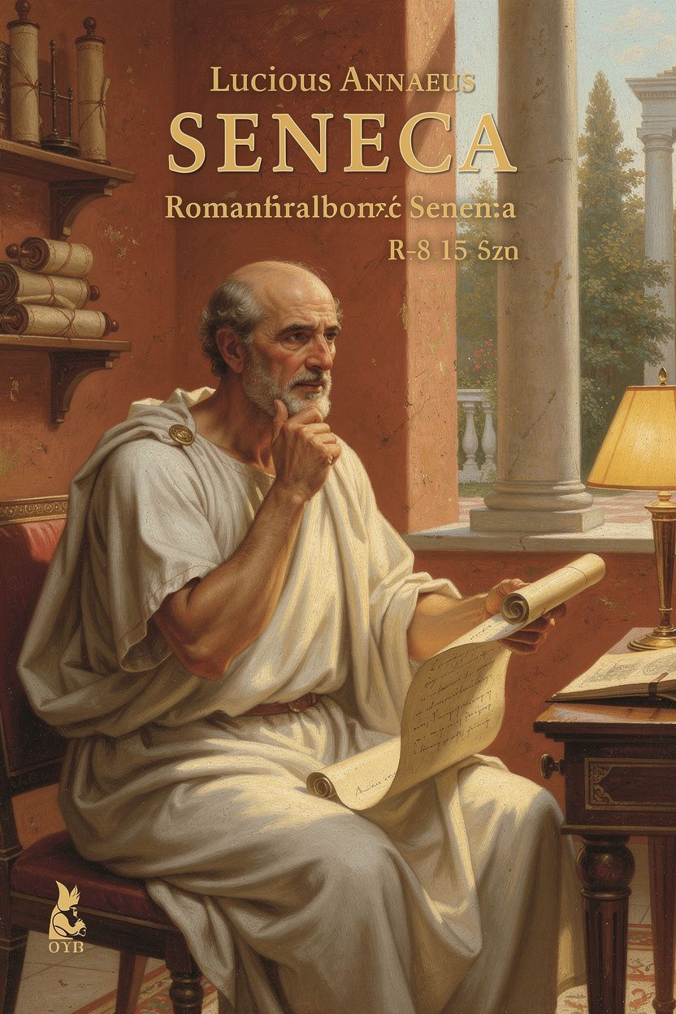
Seneca: The Philosopher Who Could Not Breathe
WisdomForge Booklet — Ages 15–18

Seneca: The Philosopher Who Could Not Breathe

WisdomForge Booklet — Ages 15–18
———

About This Book
Seneca wrote about anger, time, death, wealth, and power while serving as the tutor and advisor to Nero — one of history's worst tyrants. He was chronically ill, exiled for a crime he didn't commit, one of the richest men in the Roman Empire, and forced to kill himself by the emperor he had served. His philosophy is not the work of a man sitting safely in a library. It is the work of a man trying to stay human inside a machine designed to destroy humanity.
This booklet reads Seneca as a philosopher of the body, the mind under pressure, and the impossible moral choices of adult life. Each chapter takes one theme — illness and transformation, exile, time, anger, power, and death — and develops it through historical narrative, direct quotation, and practical exercises. Seneca's contradictions are not hidden. They are the point.
———

Chapter 1: The Boy Who Could Not Breathe
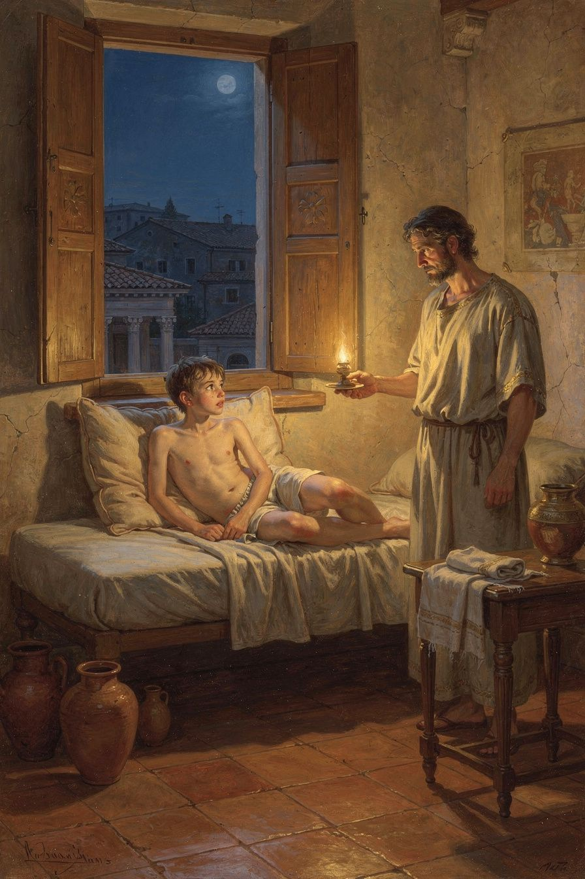
Illustration for Chapter 1
Imagine being fifteen and waking up unable to breathe. Your lungs have locked. Your chest is a cage with the door welded shut. You sit up, gasping, hands clawing at the air, certain you are going to die. Then the spasm breaks. Air rushes back. You are shaking, soaked in sweat, and the room is dark and quiet as if nothing happened. But something did happen. You met the edge of your own body, and your body lost.
That experience — repeated, unpredictable, terrifying — was the defining condition of Seneca's life. He suffered from chronic asthma, or possibly tuberculosis, from his youth onward. He described the attacks with a precision that comes only from living inside them: "I have attacked an illness that is beyond cure, or at least that wears out all cures. I am worn out by it, and it seems to me that I am fighting a losing battle" (Letter 78.1, trans. Campbell). The verb is attacked — not "suffered from" or "endured." Seneca frames his own body as an enemy combatant, and himself as a soldier who knows the war is unwinnable but keeps fighting anyway. This is not self-pity. It is the rhetoric of a man who has decided that the way you describe your suffering changes what the suffering does to you.
Seneca was born around 4 BCE in Corduba, the principal city of Hispania Baetica — Roman Spain, a province famous for its olive oil, wool, and silver mines. His family, the Annaei, were wealthy colonists but not aristocrats of the old Republic. Miriam Griffin, in her foundational study Seneca: A Philosopher in Politics, argues that this provincial origin shaped Seneca's entire career: "The Annaei were nouvelles riches in the Roman sense — men of property without ancestral masks in the atrium. Seneca's brilliance was his ticket into the senatorial class, but he never quite belonged to the inner circle of the old aristocracy" (Griffin 1976, p. 37). He was a man who had everything to gain and everything to lose — an outsider who fought his way into the center of the most powerful empire on earth through sheer intellectual force.
His father, Seneca the Elder, was a professional rhetorician who compiled anthologies of declamation — the staged, competitive speeches that were the backbone of Roman education. The elder Seneca had three sons: Gallio, who became governor of Achaea and appears in the New Testament (Acts 18:12); Mela, whose son was the poet Lucan; and Lucius, the youngest and most brilliant. The family moved to Rome when Seneca was still a child, and the boy grew up in the shadow of the Julio-Claudian emperors — watching from the provincial sidelines as Augustus's successors rose, decayed, and fell.
His education was comprehensive and brutal. His father trained him in rhetoric, the art of persuasive speech that was the gateway to Roman political life. But Seneca was drawn deeper. He gravitated toward philosophy — and specifically toward the Stoics, who taught that virtue is the only true good, that external circumstances cannot touch the soul, and that philosophy is not abstract theory but daily practice of self-transformation.
The teacher who changed his life was Attalus, a rigorous Stoic who lectured in Rome during the reign of Tiberius. Seneca later wrote of him with the reverence of a man describing a religious conversion: "When I attended the lectures of Attalus, I felt ashamed of my faults and regretted them" (Letter 108.3, trans. Gummere). Not "I learned interesting arguments." Not "I was intellectually stimulated." Seneca felt ashamed. Philosophy, as Attalus taught it, was moral surgery — an operation performed on the self, with the self as both patient and surgeon. The goal was not to win debates but to become a different person.
Seneca also studied with Papirius Fabianus, an eclectic philosopher who blended Stoicism with elements of Aristotelian and Pythagorean thought. From these teachers, Seneca absorbed a conviction that would define everything he wrote: philosophy is useless if it stays in the lecture hall. It must enter the bloodstream. It must change how you eat, how you sleep, how you greet a stranger, how you face your own death.
His chronic illness made this conviction existential. A man who could not control his own lungs learned to control his mind instead. During the worst attacks, he came close to choosing suicide — not out of despair, but out of a rational calculation that the suffering was not worth enduring. He pulled back because the illness itself taught him something: the body is a crucible, and the soul that survives the crucible is stronger than the fire. His physical weakness may also have kept him from the military career standard for Roman senators. Instead, he cultivated the life of the mind — reading voraciously in Greek and Latin, memorizing entire speeches, composing his own works from an early age.
This is where Seneca's story becomes directly relevant to yours. You may not have asthma. But you have a body, and your body has limits. Maybe it's a chronic illness. Maybe it's anxiety that hits your chest like a panic attack. Maybe it's the exhaustion of being a teenager in a world that never stops demanding. Seneca's insight is that the body is not something you transcend — it's something you work with. The limits are real. The breathing will stop sometimes. The question is not whether you can eliminate the limits but whether you can build a mind that remains steady when the body fails. That is what philosophy meant to Seneca: not an escape from the body, but a way to live inside it without being destroyed by it.
———

The Big Idea: Philosophy as Self-Transformation
The Stoics had a word for what Seneca was doing: askēsis — spiritual exercise, daily training of the soul. The word gives us "asceticism," but the Stoic version is not about self-denial for its own sake. It is about building the inner capacity to meet any situation without being broken by it. Seneca's teacher Attalus, Seneca later recalled, taught him to examine his own faults with such honesty that he felt ashamed — and that shame was the beginning of transformation. Philosophy was not information to memorize. It was a practice that changed who you were.
The French philosopher Pierre Hadot, who spent his career studying ancient philosophy as a way of life, argued that the Stoics understood something modern education has largely forgotten: knowledge without transformation is empty. You can read every book on resilience and still fall apart when the first real crisis hits. You can ace a psychology exam on anxiety management and still have a panic attack before the test. The Stoics knew this. Their philosophy was built around exercises — morning meditations, evening reviews, visualization of worst-case scenarios, rehearsal of insults — designed to build the mind the way an athlete builds muscle. Repetition, not revelation, is what changes a person.
Seneca's illness gave him an advantage that healthy philosophers lacked: he could not pretend the body was irrelevant. The Stoic theory says externals — including health — are "indifferent" to your moral character. But Seneca knew viscerally that illness is not indifferent to your experience. It hurts. It limits. It terrifies. His philosophy is not the clean theory of a healthy man. It is the desperate, rigorous, sometimes contradictory practice of a man whose body was a daily battlefield. When he writes about controlling the mind, he is writing from inside the war.
This matters for you because you are already doing askēsis, whether you know it or not. Every time you force yourself to study when you'd rather scroll, hold your tongue when someone provokes you, get back up after a failure instead of collapsing — you are training your soul. The question is not whether you are practicing. The question is whether you are practicing deliberately, or being shaped randomly by whatever pressure happens to hit you. Seneca's life suggests that conscious practice — choosing your exercises, naming your weaknesses, tracking your progress — is the difference between becoming the person you want to be and becoming whatever the world makes of you.
———

Try This
1. The Attalus Audit Seneca said Attalus's lectures made him ashamed of his faults. That shame was not punishment — it was awareness, the first step of change. For one week, end each day by writing down one moment where your behavior fell short of your own standards. Not someone else's — yours. Maybe you snapped at a sibling. Maybe you procrastinated on something that mattered. Write the moment down without justification. Just name it. At the end of the week, read your list. What patterns do you see?
2. The Body as Crucible Journal Seneca's philosophy was forged in his body. Yours is too. For three days, keep a log of one moment when your body set a limit — too tired to focus, too anxious to speak, too hungry to think clearly. Write what happened, how you responded, and what you wished you had done. Then ask: Could a practice of the mind have changed your response, even if it couldn't change the body's limit?
3. Translation Comparison: The Shame Passage Compare two renderings of Letter 108.3. Gummere: "When I attended the lectures of Attalus, I felt ashamed of my faults and regretted them." A more literal rendering: "I was ashamed of my failings and repented them." How does "repented" change the tone? Does it sound more religious, more serious, more final than "regretted"? Write a short paragraph on which translation captures what you think philosophy should feel like.
4. Debate Prompt: Can Philosophy Change Who You Are? Seneca believed philosophy could transform a person. Modern neuroscience agrees the brain is plastic. But some philosophers argue character is largely fixed by early adulthood. Argue both sides. For "yes," argue that conscious practice can reshape habits, emotional responses, and values. For "no," argue that temperament is largely innate and philosophy merely helps you manage who you already are. Then reflect: have you ever changed a trait you didn't like? How?
5. The Illness Thought Experiment Imagine you developed a chronic condition tomorrow — painful, incurable, unpredictable. How would it change your priorities? Your friendships? Your sense of what matters? Write a page as if from one year into that life. Do not romanticize it. Be honest about the fear, the anger, the loss. Then write one sentence about what you would want your mind to be like inside that body. That sentence is your philosophical starting point.
———
A Question to Carry With You
Seneca's illness was not a metaphor. It was a daily reality that shaped everything he wrote. If philosophy is supposed to help you live well, what does it owe to the body? Can a philosophy that calls health "indifferent" be honest about what it feels like to suffocate? Where is the line between transcending your body and denying it?
———

Chapter 2: The Island Nobody Wanted
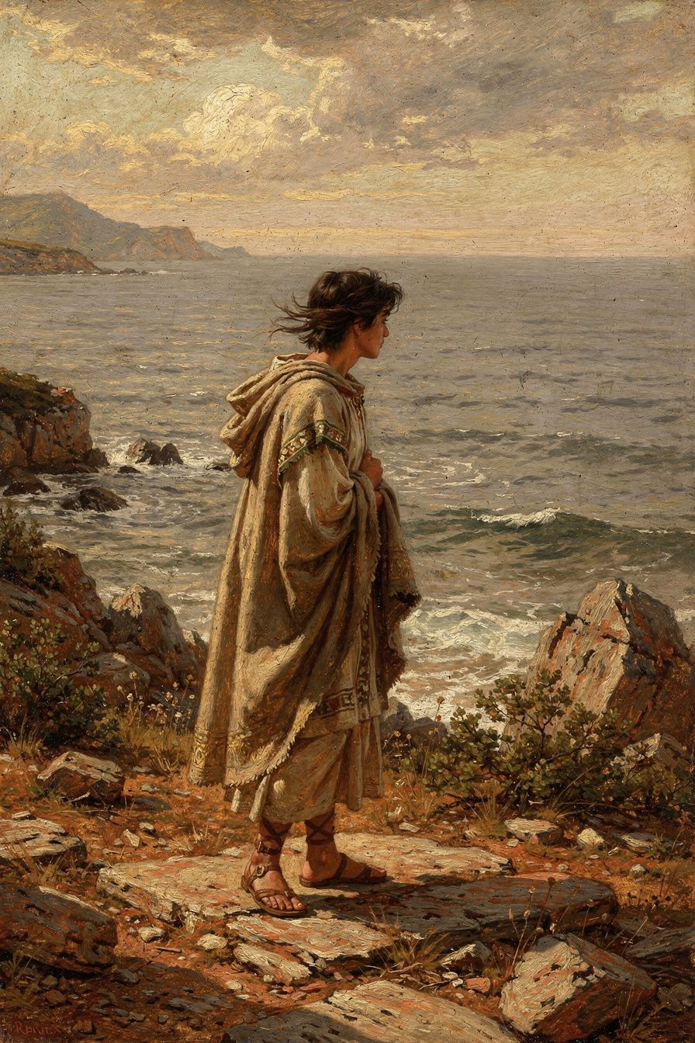
Illustration for Chapter 2
You know what it feels like to be excluded. Maybe it was a party you weren't invited to. Maybe it was a group chat that went quiet when you entered it. Maybe it was a friend who drifted away without explanation, and you spent weeks replaying conversations, searching for the moment you became disposable. The circumstances change, but the sensation is the same: you have been removed from a world that continues without you, and the removal feels like a verdict on your worth.
Now scale that feeling. You are not excluded from a party. You are excluded from your city, your career, your family, your entire life. The most powerful man in the world has signed a paper, and you are gone. Put on a boat. Shipped to an island in the Mediterranean — windswept, rugged, barely populated — and told you will stay there indefinitely. You have committed no crime. The charge is fabricated. The trial is a formality. The sentence is removal, and removal is permanent.
This is what happened to Seneca in 41 CE. He was in his mid-thirties, at the height of his intellectual powers, a rising senator with a reputation as one of the finest writers in Rome. The emperor Claudius had recently taken power, and Claudius's wife, Messalina — a woman of ferocious political ambition and ruthless instinct — accused Seneca of adultery with Julia Livilla, the emperor's niece and sister of the dead emperor Caligula. The charge was almost certainly fabricated. Messalina saw Julia Livilla as a rival and Seneca as a convenient target. Seneca was tried in the Senate and sentenced to death. At the last moment, the sentence was commuted to exile. He was sent to Corsica.
Corsica, in the first century, was not the vacation destination it is today. It was a windswept, mountainous island that Rome used as a dumping ground for political undesirables. Seneca was not imprisoned — he was removed from Rome and forbidden to return. He could move around the island. He could write. He could receive visitors, though few came. But he was cut off from everything that had defined his life: the Senate, the courts, the literary circles, the intellectual ferment of the capital. He was thirty-five, and he had been erased.
He spent eight years on that island. Eight years. Think about what eight years means at your age. It is more than half your life. It is the distance between childhood and adulthood. For Seneca, it was the prime of his career, spent staring at the sea and writing letters to a mother who could not visit him.
The first thing he wrote in exile was a consolation addressed to his mother, Helvia — Ad Helviam Matrem. His mother was grieving not her son's death but his disgrace, which in Roman society was almost worse. Seneca's rhetorical strategy was to reframe the entire experience. He did not deny that exile was painful. He did not pretend Corsica was a philosophical retreat. Instead, he argued that the things exile had taken from him were never truly his: "I have not been banished because of any crime, but because of the envy of the powerful" (Ad Helviam 5.1, trans. Basore). The claim is partly disingenuous — politics at the Julio-Claudian court was never a simple matter of innocence and guilt — but it reveals Seneca's core move: to reframe disgrace as martyrdom, and exile as philosophical opportunity.
During the Corsican years, Seneca also wrote Ad Marciam, a consolation to a woman grieving the death of her son. The work is remarkable for its psychological acuity. Seneca acknowledges the reality of loss — "Your son is gone; this is a genuine deprivation" — and then gradually redirects her toward a Stoic reframing: death is natural, grief is understandable but should not become permanent. He also wrote Ad Polybium, a consolation to a powerful freedman of Claudius. This one is more ambiguous — some scholars read it as sincere, others as an attempt to win recall through flattery. The tension between sincerity and strategy is a recurring feature of Seneca's writing, and of his life.
The exile lasted from 41 to 49 CE. Eight years of an island nobody wanted, writing consolations for other people's suffering while sitting inside his own. Then, in 49 CE, he was recalled — not because his innocence was recognized, but because a new political player needed him. Agrippina the Younger, Claudius's powerful niece and fourth wife, was maneuvering to secure the succession for her son Nero. She needed a tutor of impeccable literary and philosophical credentials, and Seneca was the obvious choice. He was recalled, restored to the Senate, and appointed praetor. Within months, he was at the center of the imperial household.
Griffin argues that Seneca's return was not simple ambition: "Seneca's return from exile was not simply ambition. It was a gamble on the possibility that philosophy could restrain power" (Griffin 1976, p. 97). The gamble would fail catastrophically. But the eight years on Corsica had given Seneca something that success never could: a lived understanding of what it means to lose everything and survive. His philosophy of adversity was not written in a comfortable study. It was written on an island that the Roman Empire used as a trash can for inconvenient people.
———

The Big Idea: Adversity as Training
The Stoics had a radical theory about misfortune: the premeditatio malorum — premeditation of evils. The practice involves imagining the worst before it happens: exile, poverty, illness, the loss of everyone you love. Not to depress yourself, but to accomplish two things. First, to reduce the shock when bad things actually occur — you have already lived this in imagination, so the reality is less paralyzing. Second, to clarify what you actually value. When you imagine losing everything, you discover what you cannot lose without losing yourself. That discovery, the Stoics believed, is the beginning of wisdom.
Seneca's exile was not a premeditation. It was the real thing. And what it taught him was the Stoic principle in its sharpest form: external circumstances — wealth, status, location, even freedom of movement — are indifferent. Not because they don't matter. They matter enormously to your comfort, your career, your social life. But they do not touch your character. They cannot make you better or worse. Only your own choices can. Exile took away Seneca's city, his Senate seat, his political influence. It could not take away his mind, his ability to write, his capacity to think clearly. That capacity, the Stoics argued, is the only thing truly yours. Everything else is on loan from fortune.
This is not a comforting philosophy. It does not say everything happens for a reason. It does not promise the exile will end, the pain will be redeemed, the universe is just. It says something harder: you cannot control what the world does to you, but you can control what you do with it. The world can put you on an island. It cannot make you despair. The world can take your reputation. It cannot take your integrity. The inner freedom that external circumstances cannot touch is the only freedom worth having — and the only freedom that requires constant practice.
For a teenager, this is both abstract and urgent. You may not face exile. But you face its equivalents: the social exile of being left out, the academic exile of failing a class, the familial exile of a parents' divorce that uproots your life. Seneca's claim is that these losses are real but not final. They are circumstances, not verdicts. The question is not whether you can prevent them — you often cannot — but whether you can meet them with a mind trained to remain steady. That training is what exile gave Seneca. It is what every loss can give you, if you let it.
———

Try This
1. The Premeditation Exercise The Stoics practiced premeditatio malorum — imagining the worst before it happens. Try this. Pick one fear: failing an important exam, losing a close friendship, not getting into the college you want. Write a detailed account of that fear coming true. What happens the day after? The week after? Be specific. How do you feel? What do you do? Then write how you would recover. What would you do next? What would still be true about you? The goal is not to make yourself anxious. It is to discover that the worst case, while painful, is survivable.
2. The "What Is Truly Mine" Inventory Seneca argued that externals are not truly yours — they are on loan from fortune. List everything you consider "yours": your phone, friends, grades, reputation, plans for the future. Imagine each being taken away, one at a time. After each removal, ask: What is left? Who am I without this? The things that remain after every external is stripped away — your capacity to think, to choose, to care, to be honest — are what the Stoics called truly yours. Write a paragraph about what the exercise revealed.
3. Translation Lab: The Exile Defense Read Seneca's defense in Ad Helviam 5.1: "I have not been banished because of any crime, but because of the envy of the powerful." Then find another passage where Seneca discusses exile and fortune — Letter 82 or Letter 104. Compare his tone. In the consolation, he is defiant: I was wronged. In the later letters, he is more philosophical: fortune is fickle. Which tone do you find more useful when suffering? Is defiance a form of resilience, or does it keep you trapped in anger? Is acceptance wisdom, or does it let the wrongdoer off the hook?
4. The Reframing Challenge Seneca reframed exile as philosophical retreat. He did not deny the pain; he reinterpreted its meaning. Try this with a current difficulty. Write three sentences describing the situation as a disaster. Then three sentences describing the same situation as an opportunity for growth. Then three sentences describing it as simply neutral — a fact you must now navigate. Which framing feels most honest? Which feels most useful? Can a framing be honest and useful at the same time?
5. Debate Prompt: Is Inner Freedom Enough? Seneca claimed external circumstances cannot touch the soul. Critics argue this is a luxury of the privileged. A person in exile with food and shelter is not the same as a person in a prison cell or refugee camp. Is Seneca's inner freedom real, or an illusion that only works when your body is basically safe? Argue both sides. For "yes," cite Victor Frankl in Auschwitz, Nelson Mandela on Robben Island. For "no," argue that Stoicism underestimates the damage physical deprivation and trauma do to the mind. Where do you land?
———
A Question to Carry With You
Seneca was exiled for a crime he didn't commit and spent eight years on an island that was used as a prison. He responded by writing consolations — for his mother, for a grieving woman, for a powerful man who might help him return. Was he practicing philosophy, or performing it? Can you tell the difference when you are the one suffering? And if you can't, does the difference matter?
———

Chapter 3: The Shortest Thing We Have

Illustration for Chapter 3
It is 11:47 PM. You have been studying for three hours, or you have been scrolling for three hours, or — more likely — you have been doing both in a confused alternation that leaves you feeling like you accomplished neither. The screen glows. Your eyes burn. You are aware, in a vague and uncomfortable way, that you have wasted the evening, and you are also aware that tomorrow you will probably do the same thing. The thought produces a small wave of self-loathing, which you suppress by opening another app. The cycle continues. The night deepens. The time is gone, and you cannot say where it went.
Seneca would have recognized this pattern immediately. He opens his essay De Brevitate Vitae — On the Shortness of Life — with one of the most famous sentences in ancient philosophy:
*"It is not that we have a short time to live, but that we waste a lot of it. Life is long enough, and a sufficiently generous amount has been given to us for the highest achievements if it were all well invested."* — *De Brevitate Vitae* 1.1 (trans. Graver & Long)
Read that sentence again. The claim is deliberately paradoxical. Everyone complains that life is short. No one complains that they waste it. But for Seneca, the second observation is the one that matters. Life is not short. Time is not the problem. The problem is that we squander the time we have on things that do not deserve it, and then complain that we didn't have enough. It is like spending your entire paycheck on things you don't want and then blaming your salary for being too small. The salary was fine. The spending was the problem.
Seneca supports this claim with an argument that feels ripped from modern psychology. If we measure life not by years but by attention — by the hours we actually remember, actually lived, actually were present for — then the average life spans barely a fraction of its nominal length. Consider the child who anticipates each birthday: the last year felt infinite because every moment was vivid. Then consider the busy adult who cannot remember what happened last Tuesday. The same number of hours has passed, but the subjective experience of time has contracted almost to nothing. A year of distracted busyness passes faster than a month of engaged presence. This is Seneca's deepest insight about time: time is not objective duration but lived attention. An hour spent in contemplation is longer than a decade of distraction, precisely because awareness is what gives time its density.
He catalogs the ways we waste time with an exasperation that transcends two thousand years:
Ambition and social climbing. "Many are busy not living but preparing to live." People climb ladders and arrive at the top having never lived — always getting ready, always one achievement away from the life they meant to have.
Busyness without purpose. "There is no worse waste of time than busyness." The always-occupied person has no time for reflection. Their days are full of activity but empty of meaning.
Living for others' opinions. "People are frugal in guarding their personal property; but as soon as it comes to squandering time they are most wasteful of the one thing in which it is right to be stingy" (De Brevitate Vitae 2.5). We lock our money in vaults and throw our hours out the window.
Anxiety about the future. "Even when they are at leisure, they are not at rest." The anxious person is always elsewhere — planning, anticipating, dreading. Today slips away while they live in tomorrow.
Regret about the past. "The past — that is the only thing no one can take away. Yet it is the thing we value least." The person consumed by regret is not living but re-enacting.
This catalog should make you uncomfortable. It is uncomfortably accurate about the way most of us actually live. We are busy. We are anxious. We are either regretting or anticipating, rarely present. We scroll through other people's lives while our own passes unattended. Seneca's diagnosis is that the problem is not the length of life but the quality of our attention to it.
He also develops an economic metaphor that pervades the essay: time is the only truly universal currency. Wealth, social status, and even health are distributed unequally, but everyone — slave or emperor, student or teacher — receives twenty-four hours per day. This makes time the only truly democratic resource, and the only one we cannot acquire more of. "What man can you show me who places any value on his time, who reckons the worth of each day, who understands that he is dying daily?" (De Brevitate Vitae 7.3, trans. Graver & Long). The question is rhetorical. Seneca is asking: do you value your time? Do you understand that each day is a finite withdrawal from an account you cannot refill?
The modern parallels are startling. Stephen Covey's "put first things first" and "begin with the end in mind" are directly Senecan. Tim Ferriss's The 4-Hour Workweek is a hyper-modern version of Senecan otium (leisure liberated for philosophy). The mindfulness movement's emphasis on present-moment awareness is a secularized version of Senecan contemplation. But Seneca is not a productivity guru. He does not want you to get more done. He wants you to do what matters. "Using time well" does not mean answering more emails or climbing higher. It means spending your hours on virtue, friendship, truth, and philosophy — which may mean more time in conversation, in nature, in silence. Seneca's most subversive claim is that the person with a full calendar may be the most impoverished. The person who looks idle may be living most fully.
The essay is not immune to the central criticism of Seneca's life. He wrote about reclaiming time from busyness while serving as Nero's tutor, advisor, and speechwriter — one of the busiest and most politically dangerous roles in the Roman Empire. But this is not necessarily hypocrisy. Seneca's point is not that one must withdraw from society to use time well. It is that one must not allow society's demands to consume one's attention and values. A politician who remains inwardly free — who uses power virtuously, who maintains philosophical perspective — may be using time well even in the busiest role.
———

The Big Idea: Time as Lived Attention
The German philosopher Martin Heidegger coined Sein-zum-Tode — "being-toward-death" — arguing that authentic existence requires confronting mortality, because only the awareness that your time is finite gives choices urgency and meaning. A life lived as if infinite is a life of procrastination and drift. A life lived with the horizon of death always visible is a life of purpose.
Seneca made essentially the same argument nineteen centuries earlier. The awareness of death is what gives time its value. Without death, time would be meaningless — infinite time has no shape, no urgency, no sweetness. Death does not rob life of meaning. It provides the structure that makes meaning possible. "Let us keep death before our eyes daily" (Letter 26, trans. Campbell) is not morbid. It is practical. The person who knows their journey is finite travels with purpose. The person who thinks the journey endless dawdles.
This is why Seneca's time philosophy and his mortality philosophy are inseparable. Time is short not because we die early but because we forget that we are dying. The person who remembers death — not obsessively, but as a quiet background awareness — uses time differently. They are less likely to spend three hours scrolling, less likely to hold a grudge, less likely to postpone the conversation that matters. The deadline of death is the only deadline that cannot be negotiated, and it is the one we most consistently pretend doesn't exist.
This connects directly to what modern psychologists call "mortality salience." Research by Greenberg, Pyszczynski, and Solomon — known as Terror Management Theory — shows that awareness of death can produce very different outcomes depending on how it is integrated. When death awareness is suppressed or denied, it increases anxiety, defensiveness, and conformity. When it is consciously integrated into a meaningful framework, it increases purpose, kindness, and presence. Seneca's meletē thanatou — meditation on death — is essentially a structured integration technique. The goal is not to make yourself afraid but to make yourself awake.
The implication for your life is direct. You are in a phase where time feels both abundant and scarce — abundant because you are young, scarce because every adult tells you these years determine everything. Seneca's reframing cuts through both. Time is not abundant: you cannot get any of it back. Time is not scarce: you have enough for what matters if you stop wasting it on what doesn't. The question is not how many hours you have but how many of those hours you actually inhabit. An hour of genuine attention — reading a book you love, having a conversation that matters, thinking clearly — is worth more than a week of distracted motion. The shortest thing we have is not time. It is attention.
———

Try This
1. The Attention Audit For one day, every hour, write down what you were actually doing for the past sixty minutes — not what you planned, but what you did. Be honest. If you spent forty minutes on your phone, write that. At day's end, review your log. How many hours were spent on things you genuinely value? How many on things you don't remember? Now calculate: if you lived eighty years at this ratio, how many years would be "lived" versus "wasted"? The number may be sobering. Seneca's point is not guilt but awareness — because awareness is the only thing that can change the ratio.
2. The Death Morning Practice For one week, each morning before checking your phone, spend thirty seconds silently acknowledging you might not live to see the evening. Do not dramatize it. Just hold the thought: This day is not guaranteed. Then ask: Given that this day might be my last, what is worth doing? Write down one thing. At week's end, review your list. Did the practice change anything? Seneca's claim is that death awareness should intensify life, not depress it. Did it?
3. Translation Comparison: The Opening Line Read the opening of De Brevitate Vitae in two translations. Graver & Long: "It is not that we have a short time to live, but that we waste a lot of it." An older rendering: "It is not that we have a short time to live, but that we make it short." How does "waste" differ from "make short"? Does "waste" imply moral failure while "make short" implies mechanical inefficiency? Which word gives you more agency? Write a short reflection on how a single word changes your relationship to the idea.
4. The Hustle Culture Debate Seneca wrote: "There is no worse waste of time than busyness." Modern hustle culture says the opposite: busyness is a badge of honor. Debate both sides. For Seneca, argue that busyness without reflection is motion without direction. For hustle culture, argue that intense effort is necessary for achievement, and "reflection" is often procrastination in disguise. Then synthesize: is there a way to be intensely engaged without being busy in Seneca's sense? What would Seneca say to someone preparing for college applications?
5. The Time Economics Exercise Track your time for three days, then break it into categories: sleep, school, homework, social media, friends, family, alone time, exercise, worry. Now imagine you are paid for your time at minimum wage. How much "money" did you spend on each category? Which would you invest more in if managing your time like a financial portfolio? Which would you cut? The exercise is not about optimizing every minute — Seneca would hate that. It is about making the invisible economy of your time visible.
———
A Question to Carry With You
Seneca said that life is not short but squandered. But what counts as squandering? Is time spent resting wasted? Is time spent with friends wasted? Is time spent doing nothing — genuinely nothing, not scrolling, just being — wasted? Who decides what counts as "well invested"? And is it possible that Seneca, who spent his life in frantic political activity, was projecting his own guilt onto the rest of us?
———

Chapter 4: The Short Madness
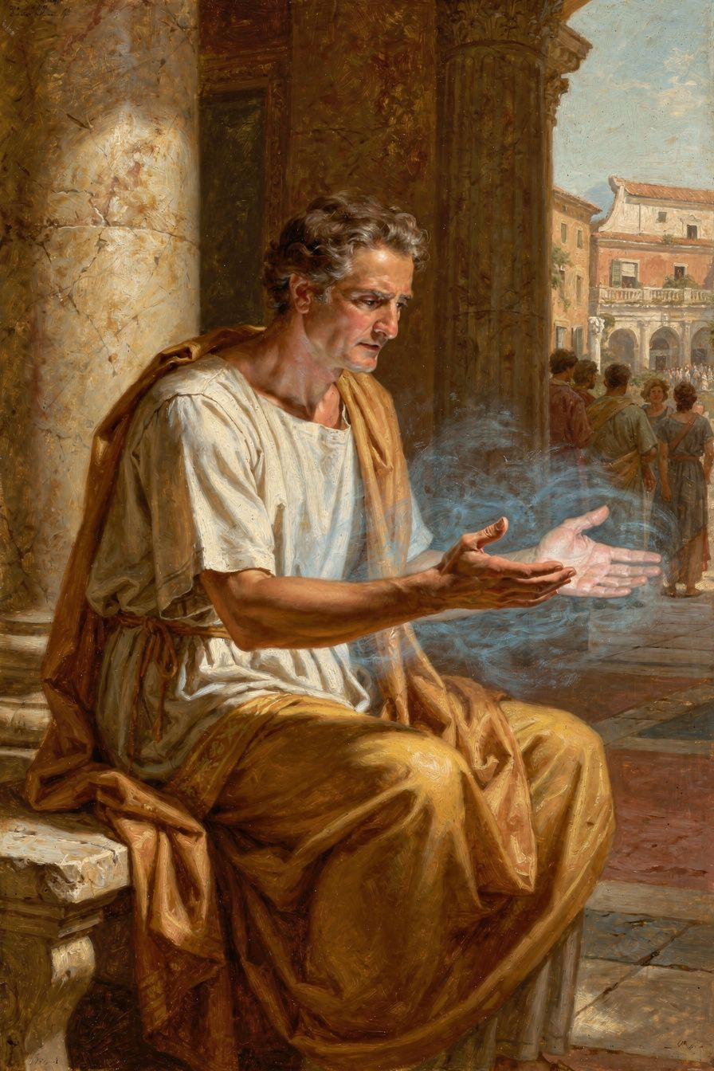
Illustration for Chapter 4
Your phone buzzes. You pick it up. There is a screenshot in the group chat — a conversation you had in private, shared without your permission, with commentary attached. The comments are mocking. Some are from people you thought were your friends. Your face goes hot. Your hands shake. Your vision narrows until the only thing in the world is that screen and the burning need to respond — to defend yourself, to attack back, to make someone feel what you are feeling right now. You start typing. The words come fast and sharp and wrong. Your thumb hovers over send.
In that moment — the heat, the tunnel vision, the compulsion to strike — you are experiencing what Seneca called brevis insania: a short madness. "Anger is a short madness" (De Ira I.1.3, trans. Kaster), he wrote, and he meant it literally. Anger is not an emotion like sadness or fear, which come and go like weather. Anger is a temporary takeover of the rational mind by something that behaves exactly like insanity: it distorts perception, destroys judgment, overrides self-control, and leaves wreckage behind. The person who is angry is not thinking badly. They are not thinking at all. They are being driven.
Seneca's De Ira — On Anger — is the most detailed ancient analysis of anger ever written. In three books addressed to his brother Novatus, Seneca dissects anger's anatomy, traces its consequences, and prescribes strategies for its management. His approach is not "count to ten." It is a systematic cognitive therapy based on the Stoic theory of the passions. And it anticipates modern cognitive-behavioral therapy by nearly two thousand years.
The key is the distinction between three movements — three stages through which an insult becomes full-blown rage:
The First Movement (*prima commotio*): The initial, involuntary physiological response. Your face flushes. Your heartbeat quickens. Your breath shortens. Seneca compares this to the shiver that runs through you when you hear unexpected thunder. This movement is not in your control and is not morally culpable. Even the Stoic sage would flinch at a sudden insult.
The Second Movement (*adsensus*): The critical moment. The mind receives the first movement and decides whether to endorse it. "The insult matters. The offender deserves punishment." This is the Stoic "false judgment": the belief that the external insult can harm your essential self. The Stoics argued that insults are externals, and externals cannot touch your character. This movement is in your control. This is where anger is born or starved.
The Third Movement (*ira*): Once assent is given, the passion grows through its own momentum. The offender becomes monstrous. The offense unforgivable. All proportion lost. Seneca calls this brevis insania — short madness — because it overrides rational control entirely.
*"The first movement of the mind is not in our power; the second is."* — *De Ira* II.4.2 (trans. Kaster)
That single sentence is the foundation of Seneca's anger management and of modern cognitive-behavioral therapy. You cannot control the flush of heat when insulted. You can control whether you endorse the thought that the insult matters. The space between the first movement and the second is the only freedom you have — and it is enough.
Seneca identifies the root causes that make people susceptible to anger:
High opinion of yourself. "People who think highly of themselves are easily injured." The person who believes they are important cannot tolerate being treated as if they are not.
Excessive concern with reputation. "There is no more troublesome companion than pride." The person who lives for others' opinions is perpetually vulnerable.
Unexamined expectations. We get angry when reality violates our unspoken assumptions. "You should have known better" — but why should they have known?
Habit. People who have been angry before are easily provoked again. Anger, once indulged, becomes a default response.
The consequences Seneca catalogs are devastating. The angry person destroys judgment, corrupts justice, ruins relationships, damages health, and escalates conflict. His most shocking example: Alexander the Great, at a banquet, killed his friend Cleitus in a fit of drunken rage. The next morning, Alexander was inconsolable — but Cleitus was still dead. One moment of anger destroyed a friendship, a life, and Alexander's peace forever. The madness passes. The wreckage remains.
Seneca's remedy is deceptively simple: "The greatest remedy for anger is delay" (De Ira II.29.1, trans. Kaster). By postponing response, you give reason time to catch up with emotion. Modern neuroscience confirms this: the amygdala fires in about 12 milliseconds. The prefrontal cortex — the rational, deliberative part — takes about 300 milliseconds to engage. Seneca's "delay" is literally giving your prefrontal cortex time to arrive.
He prescribes other techniques that read like a modern therapy manual: examine the evidence before reacting; apply the proportion test (will this matter in a year?); physically cool down (drink cold water, walk slowly, speak softly); cultivate the opposite habit (practice patience when mildly provoked); and remember the offender is not a monster but a human being, probably misguided — "View them with compassion rather than contempt."
The theoretical foundation is the Stoic cognitive theory of the passions: anger is a false judgment about the value of an insult. The judgment: "This insult is an evil that harms my essential self." The falsity: insults are externals, and externals cannot harm your essential self. The correction: "This insult is a dispreferred indifferent. It may be painful, but it does not make me worse. Only my own vice can make me worse." This cognitive reframing is the heart of both Senecan philosophy and modern CBT. Albert Ellis, the founder of Rational Emotive Behavior Therapy, explicitly cited Seneca as his primary philosophical influence and called the Stoics "the original cognitive therapists."
But there is a deeper question Seneca's analysis raises and does not fully resolve: is there such a thing as righteous anger? Audre Lorde, in "The Uses of Anger," argues that anger at oppression is politically necessary. Seneca would distinguish between anger and justified correction. The judge who sentences a criminal is not necessarily angry. The protester who campaigns for justice is not necessarily enraged. Anger is a passion — a loss of rational control. Action can be rational. The question is whether anger enhances the action or degrades it. Seneca's position: it almost always degrades it. The person who fights injustice with a cool head is more effective than the one who fights it with a hot one. The heat feels like power, but it is actually a loss of power — you have handed control of your mind to the person who provoked you.
———

The Big Idea: Anger as Cognitive Error
The Stoic theory of the passions, which Seneca applies to anger with surgical precision, makes a claim that feels counterintuitive but is supported by modern neuroscience: emotions are not things that happen to you. They are things your mind constructs through judgment. The event — the insult, the betrayal, the screenshot — does not cause the anger. The anger is caused by the interpretation: "This is an intolerable harm, and the person who did it deserves punishment." Change the interpretation, and you change — or eliminate — the emotion.
This is the foundation of cognitive-behavioral therapy, developed by Aaron Beck in the 1960s. Beck's model — activating event → belief → consequence — is structurally identical to Seneca's: impression → assent → passion. Both claim the event does not cause the emotion. Both use Socratic questioning to challenge irrational beliefs. Both insist the space between stimulus and response is where freedom lives. The difference is that Seneca adds a moral dimension modern therapy often lacks: anger is not just a cognitive error but a moral failure — a moment in which you allow another person to determine your internal state. The angry person is not only unhappy. They are unfree. Seneca's goal is not to make you "manage" your anger but to liberate you from the tyranny of being provoked.
This is harder than it sounds, and Seneca knows it. The first movement — the physiological flush — is not in your control. You will feel the heat. You will feel the compulsion. The Stoics never claimed you could eliminate the body's automatic responses. What they claimed is that you can refuse to endorse them. The second movement — the judgment that the insult matters — is where your freedom begins. And here is the crucial insight: that judgment is a habit. Something you have practiced thousands of times without realizing it. Every time you assented to "this is an outrage," you strengthened the neural pathway that makes the next outrage feel automatic. But habits can be broken. The practice of delay — pausing between the first movement and the second, refusing to assent immediately — is the practice of building a new habit. Over time, the pause gets longer. The pause becomes a gap. The gap becomes a space large enough to hold your entire self.
For a teenager, this is not abstract. You are living in a world designed to provoke you: social media that rewards outrage, politics that runs on anger, peer dynamics that manufacture grievance. The skill of not assenting — of holding the first movement without endorsing it — may be the most practical philosophical skill you can develop. It will not make you passive. It will make you effective. The person who can feel the heat without being consumed by it is the person who can act clearly in a crisis, argue persuasively in a debate, and stand up to injustice without becoming a mirror of the injustice they oppose.
———

Try This
1. The Delay Experiment Seneca's core technique is delay. For one week, every time you feel the first flush of anger, impose a mandatory sixty-second delay before acting. During those sixty seconds, do nothing. Do not type. Do not speak. Just breathe and let the first movement pass. After sixty seconds, ask: Do I still want to respond the way I did a minute ago? Track your results. How often did the delay change your response?
2. The Evidence Test Before reacting to an offense, Seneca recommends examining the evidence. Next time you feel angry, write down: Was the offense intentional, or could it have been careless? Are there circumstances I don't know about? Did I contribute to the situation? Is the person who angered me possibly mirroring a fault I myself have? Seneca wrote: "Often the person who angers you is only mirroring your own vice." This is uncomfortable but often true. Note any patterns.
3. The Proportion Test When anger hits, ask: Will this matter in a year? In five years? On my deathbed? Try this with three recent moments of anger. Rate each on two scales: how intense was the anger in the moment (1–10), and how much will it matter in five years (1–10). Notice the gap. The gap between intensity and significance is where reason can enter.
4. The CBT Comparison Research CBT's ABC model: Activating event, Belief, Consequence. Map Seneca's three movements onto it. First movement = activating event. Second movement = belief. Third movement = consequence. Write a short essay comparing the two frameworks. Where do they agree? Where do they differ? Seneca adds a moral dimension — anger is a vice, not just a cognitive error. Is this helpful, or does moralizing anger make it worse by adding guilt?
5. Debate Prompt: Righteous Anger Seneca argues anger always degrades action. Audre Lorde argues anger at oppression is politically necessary. Debate both sides. For Seneca, argue that anger makes you less effective, less strategic, more easily manipulated. For Lorde, argue that anger is a legitimate response to injustice and that demanding calm from the oppressed is itself a form of oppression. Then synthesize: is there a difference between feeling anger and being controlled by anger? Can you harness anger's energy without giving it the steering wheel?
———
A Question to Carry With You
If anger is a "short madness" — a temporary insanity that destroys judgment — then is the person who provokes you responsible for your anger, or are you? Seneca's answer is uncompromising: you are. The insult is external. The assent is yours. But does this let the provocateur off the hook? Does it place an impossible burden on the person who is wronged? Where is the line between taking responsibility for your own mind and excusing the cruelty of others?
———

Chapter 5: The Teacher and the Tyrant
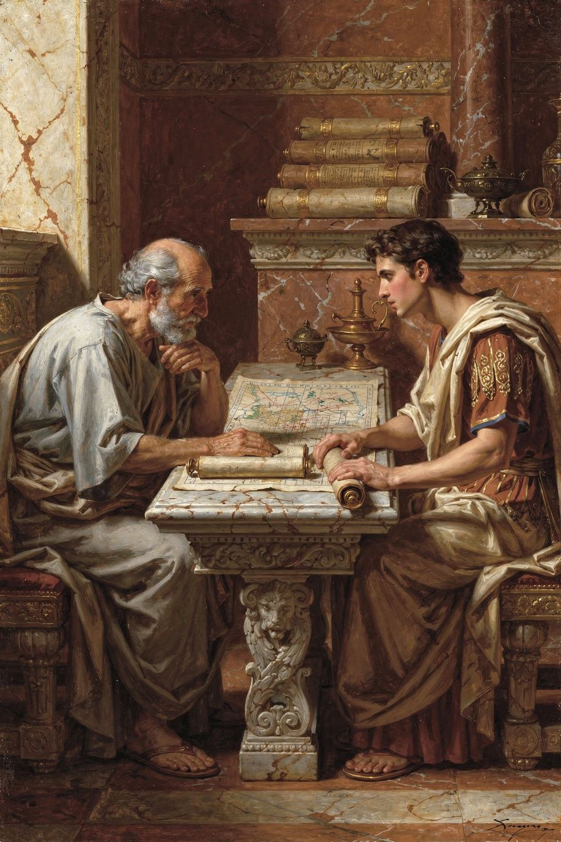
Illustration for Chapter 5
Imagine that you have been offered a job. The job is this: teach a sixteen-year-old boy to be good. The boy is about to become the most powerful person in the world. He is not obviously evil — he is charming, talented, capable of kindness. But he has a mother who murders her enemies, a court that rewards cruelty, and an empire that has never been governed by anyone under twenty. If you succeed, you will have shaped the future of civilization. If you fail, millions may suffer. And if you refuse, you will return to the island where you spent eight years in exile, and someone less qualified will take the job instead.
This was Seneca's position in 49 CE, when Agrippina the Younger recalled him from Corsica to tutor her son Nero. He was the most famous intellectual in Rome. He owed Agrippina his freedom. He believed — or wanted to believe — that philosophy could restrain power. Miriam Griffin calls this arrangement "the most significant experiment in philosophical education in Roman history" (Griffin 1976, p. 98). Plato had educated Dionysius of Syracuse and failed. Aristotle had tutored Alexander and been ignored. Seneca was the third philosopher in antiquity given direct responsibility for the moral formation of a future emperor, and he approached it with the full seriousness of a man who believed that philosophy could change the world.
The curriculum was rigorous. Nero studied rhetoric, history, literature, and philosophy in both Greek and Latin. Seneca taught him to memorize speeches, compose in verse, and declaim extempore. He introduced him to Stoic ethics — not the abstruse logic of the school, but the practical wisdom of the Roman Stoa, with its emphasis on duty, self-control, and clemency. The goal was to produce not merely a competent ruler but a virtuous one — a philosopher-king who would govern with reason and compassion.
The first few years, it seemed to work. When Claudius died in 54 CE — poisoned, according to tradition, by Agrippina — Nero became emperor at sixteen. Seneca and Burrus, the praetorian prefect, formed a kind of regency. They managed the administration, restrained Nero's impulses, and presided over a period that Tacitus called, with perhaps only slight irony, remarkable good government: "The Senate, the knights, the people — all were delighted" (Annals 13.3, trans. Yardley). The young emperor issued pardons, reduced taxes, and governed with moderation that contrasted sharply with his predecessors' cruelty.
The most important document from this period is De Clementia — On Clemency — written around 55 or 56 CE, when Nero was eighteen or nineteen. It is a treatise addressed directly to Nero on the duty of a ruler to show mercy. Seneca praises Nero for his natural clemency, then argues that mercy is not merely a personal virtue but a political necessity. A ruler who is merciful earns loyalty; a ruler who is cruel inspires fear, and fear breeds conspiracy. "The true clemency of the prince is not to punish when he could" (De Clementia 1.22, trans. Braund). The phrase echoes through the history of political thought, influencing everyone from Machiavelli — who inverted it — to Montesquieu.
Brad Inwood argues that De Clementia is best read as "performative philosophy" — a work meant to do something, not merely say something. "It was written not for the philosophical school but for the court. Its arguments are not meant to convince an academic opponent; they are meant to shape the self-understanding of a young man who believes himself to be, or wants to believe himself to be, a merciful ruler" (Inwood 2005, p. 196). If so, the failure of De Clementia is not a failure of argument but a failure of character. Nero could not sustain the self-image Seneca had constructed for him.
The turning point came in 59 CE, with the murder of Agrippina. Nero planned the assassination — staging a shipwreck that failed, then sending soldiers. Seneca's role is documented by Tacitus with precision that is almost sadistic. When Nero hesitated at the final moment, needing a letter to the Senate explaining his mother's death, it was Seneca who drafted the text. The letter claimed Agrippina had plotted against Nero's life and that her death was self-defense (Annals 14.11). It was a lie, and Seneca knew it. He composed it anyway.
This moment — Seneca writing propaganda for a matricide — haunts his entire body of work. How could the author of De Clementia help justify the murder of the woman who recalled him from exile? Griffin suggests Seneca was caught in a political trap: had he refused, Nero would have killed both him and Burrus. Romm takes a darker view: "Seneca's complicity was not forced; it was chosen. He had spent his life convincing himself that the philosopher must survive in order to do good. The murder of Agrippina proved that survival had become an end in itself" (Romm 2014, p. 189).
After Agrippina's death, Seneca's position deteriorated steadily. Nero turned to new favorites. Burrus died in 62 CE, possibly poisoned. Seneca offered to retire, to surrender his wealth and withdraw. Nero refused — perhaps because he still needed Seneca's reputation, perhaps because he enjoyed the philosopher's humiliation. The Great Fire of Rome in 64 CE destroyed much of the city, and Nero blamed the Christians, subjecting them to grotesque public executions. Seneca does not mention Christianity anywhere in his extant works. The silence is itself significant. A philosopher who wrote about universal humanity had nothing to say about the persecution of a religious minority under his own emperor.
Then, in 65 CE, the Pisonian Conspiracy — a plot to assassinate Nero — was uncovered. Seneca was not among the original conspirators, but his name was on the list of those to be killed. The accusation was thin, and Nero knew it. He ordered Seneca's death not because he thought Seneca had plotted against him but because the conspiracy gave him the pretext he had long sought to remove the philosopher from his court.
This is the arc of Seneca and Nero: from idealistic education to brutal complicity, from the promise of a philosopher-king to the reality of a monster. It is the central test case for whether philosophy can temper absolute power, and Seneca failed that test. But the failure is not simple. It is the predictable outcome of a system that made a Stoic philosopher the tutor of a Julio-Claudian emperor — a system in which proximity to power corrupts not through obvious vice but through incremental compromise. Seneca did not wake up one morning and decide to serve a monster. He made small accommodations: a letter here, a silence there, a justification for what could not be justified. By the time he recognized where these accommodations led, he was too far in to escape.
And there is the wealth. Under Nero, Seneca became one of the richest men in the empire — an estimated three hundred million sesterces, with estates in Italy and Egypt, loans in Britain. He addressed the contradiction in De Vita Beata: "The philosopher owns his wealth; the wealthy man is owned by his" (De Vita Beata 22.4, trans. Basore). The argument is subtle — wealth is a tool, not a good — and it has convinced almost no one. Emily Wilson argues in The Greatest Empire that the wealth was structurally necessary: "In the Roman court, a poor philosopher was a joke. The paradox is not personal but systemic: the imperial system required its moralists to be corrupt" (Wilson 2014, p. 112).
———

The Big Idea: The Seneca Problem
The story of Seneca and Nero raises the question that scholars call "the Seneca problem": the apparent contradiction between the austere philosopher who demanded self-denial and the wealthy politician who served a tyrant. Was Seneca a hypocrite who used philosophy to rationalize his own comfort? Or was he a pragmatist who did what he could to moderate an irredeemable regime? Was he a coward who failed to resist Nero, or a realist who understood that resistance meant death without result?
The scholarly landscape is divided between three positions. Griffin's defense: Seneca was consistent with Stoic orthodoxy. Stoicism permits wealth and power so long as one is not attached to them. Seneca genuinely attempted to moderate Nero, protect victims, and promote clemency. The gap between ideal and practice is not hypocrisy but the condition of moral life. Paul Veyne's skepticism: Seneca's philosophy was a sophisticated form of self-justification. He genuinely wanted both wealth and simplicity, both power and withdrawal. Philosophy was the arena where these contradictory impulses negotiated — not the bridge between them but the battlefield. He believed his own performance, but that does not make the performance honest. Brad Inwood's productive tension: Seneca's contradictions are not flaws but the engine of his philosophical creativity. The essays are not settled dogma but dialectical exercises — attempts to think through problems from multiple angles.
James Romm's Dying Every Day offers the most accusatory reading: Seneca was more than a passive courtier; he actively enabled Nero's regime — writing speeches, shaping policy, legitimizing tyranny. The claim that he "moderated" Nero is a self-serving story. When the Pisonian conspiracy erupted, Seneca's refusal to join it was not virtue but calculation — and when he was killed anyway, his death was not philosophical martyrdom but the execution of a man who had played politics badly.
The honest conclusion is that Seneca was contradictory in ways that are neither resolved by defense nor captured by accusation. He genuinely believed in philosophy and genuinely failed at it. He genuinely tried to moderate Nero and genuinely profited from his service. He genuinely loved simplicity and genuinely loved luxury. He was not a cynic who preached virtue while practicing vice. He was a person whose ideals exceeded his conduct and whose conduct exceeded his ideals in different domains. The Seneca problem is not a problem about Seneca. It is a problem about the human condition: every person who holds ideals fails to achieve them. The question is not whether there is a gap but how you respond to it. Seneca's response — writing about the gap, analyzing it, attempting to narrow it — is itself a form of integrity that a merely hypocritical person could never achieve.
This matters for you because you will face your own versions of the Seneca problem. You will hold values you cannot fully live. You will make compromises your ideals condemn. You will participate in systems you know are unjust because withdrawing entirely feels both impossible and ineffective. The question is not whether you will compromise. You will. The question is whether you will do it consciously, naming the compromise and its cost, or let it happen in the dark, where it will corrode you without your knowledge. Seneca's example suggests consciousness is not a solution but a starting point. The philosopher who knows they are compromising is already different from the courtier who doesn't notice.
———

Try This
1. The Compromise Audit Seneca's failure was not a single betrayal but a series of small accommodations. Examine your own life. Where are you currently making small compromises with something you know is wrong? It could be participation in a social dynamic that excludes people, silence about a friend's behavior, acceptance of a system you find unjust. Write down three specific compromises. For each, ask: What would it cost to stop? What does continuing cost? Which cost is actually higher? The goal is not to judge yourself but to make invisible compromises visible.
2. The Three Scholars Exercise Read the three scholarly positions on Seneca: Griffin (defense), Veyne (performance), Romm (complicity). Write one paragraph summarizing each. Then apply all three to a modern case: a tech CEO who preaches sustainability while running a carbon-intensive company. Which framework best fits? Which framework best fits you, when you examine your own compromises? Is there a fact of the matter, or does interpretation depend on your priors?
3. Debate Prompt: Can You Serve Power and Remain Good? This is the central question of Seneca's life. For "yes," argue that the philosopher inside the court can moderate power, protect victims, and achieve more good than the philosopher outside. Use Seneca's early years as evidence. For "no," argue that proximity to power inevitably corrupts — the compromises required destroy the moral authority that made the philosopher valuable. Use Seneca's later years as evidence. Then synthesize: under what specific conditions might serving power be morally defensible?
4. The Wealth and Virtue Test Seneca wrote: "It is not the man who has too little, but the man who craves more, who is poor" (Letter 2). And: "Riches are a good thing if they are in the hands of a good man" (De Vita Beata 23.2). The Stoic argument is that wealth is not evil in itself — the question is whether you possess it or it possesses you. List the material things you consider essential to your happiness. Imagine each being taken away. Which losses would diminish your character? Which would only diminish your comfort?
5. The Silence Question Seneca said nothing about the persecution of the Christians. His silence is one of the most damning facts in his biography. Examine your own silences. Where are you currently silent about something you know is wrong? Write down one silence you are maintaining. Then ask: Why am I silent? What would it cost to speak? What does my silence cost others? Is my silence strategic, or is it cowardice dressed up as strategy? You do not have to break the silence today. But you should know — honestly — why you are keeping it.
———
A Question to Carry With You
Seneca believed he could shape Nero into a good ruler. He failed. But was the failure his — a failure of teaching, of courage, of philosophy — or was it the failure of a system that gives one person absolute power and then asks another person to make them good? Is the Seneca problem a problem about one man's weakness, or a problem about the impossibility of the task he accepted? And if the task was impossible, was accepting it a mistake, or was refusing to try even worse?
———

Chapter 6: The Good Death
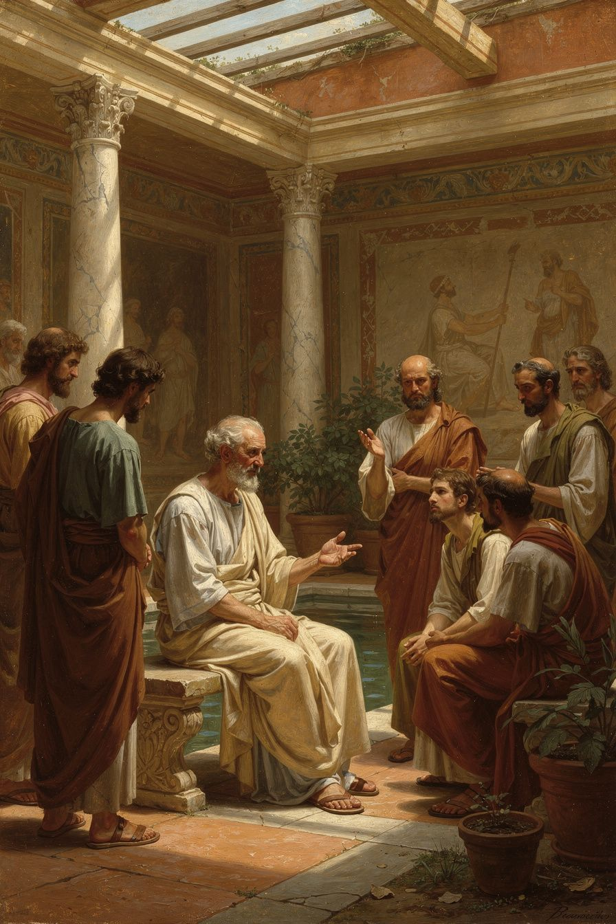
Illustration for Chapter 6
It is April of 65 CE. Seneca is at his suburban villa outside Rome — a wealthy man in his late sixties, retired from politics but unable to escape its reach. A centurion arrives with Nero's command: he must die. The order is not a judgment. It is a killing dressed in the language of law. Seneca is implicated in the Pisonian Conspiracy, though the evidence is thin and Nero knows it. The conspiracy is a pretext. Nero has wanted Seneca dead for years. Now he has the excuse.
Seneca asks for his will. The centurion refuses. He asks for his friends and his wife, Pompeia Paulina, to be present. This is allowed. They gather. Seneca delivers a final discourse — philosophical consolation to his friends, farewell instructions to his wife — and prepares to die.
The method is the standard Roman elite suicide: venesection, the opening of the veins. Seneca is old, his body emaciated by years of chronic illness. His blood flows slowly. To speed death, he orders preparations of hemlock — the same poison Socrates had taken, a deliberate echo everyone in the room would recognize. Even the hemlock does not work quickly enough. Finally, he asks to be placed in a hot bath — a steam bath that would open the pores and hasten blood loss. He dies over hours, not minutes, surrounded by weeping friends and the soldiers who have come to ensure he does not survive.
Tacitus, our only surviving source, records the scene with cinematic precision and a characteristic barb: "His death became protracted and difficult, which was not in accordance with his reputation, though it befitted the constant cruelty of his life" (Annals 15.64, trans. Grant, adapted). The barb is Tacitus's — the philosopher who wrote about the easy death died a hard one, and the man who served Nero for years is not innocent just because Nero killed him.
Paulina attempted to die with him, slashing her own veins in solidarity. Nero's soldiers bandaged her wounds and forced her to live. The scene ends not with a double philosophical death but with a single death and a widow forced to survive — a final cruelty Tacitus reports without comment, letting the reader feel the horror.
Before the centurion arrived, Seneca had spent his entire philosophical life writing about death. In Letter 70, the most important ancient text on Stoic suicide, he wrote:
*"Just as I choose a ship in which to sail, or a house in which to live, so I choose a death in which to die."* — *Letter* 70 (trans. Graver & Long)
The metaphor is striking. Seneca is not "ending" life but "selecting" a particular kind of death, as one might select a room in an inn. The inn of life has many rooms; the wise person moves through them deliberately. The argument is that the wise person owns their death the way they own any other aspect of their life. They do not wait for fortune to strike. They choose their time. In Letter 82, he wrote: "No one is more contemptible than the person who despises himself while living but fears death when the time comes" (trans. Campbell). And throughout his letters and essays, he returned to the same instruction: "Let us keep death before our eyes daily" (Letter 26, trans. Campbell) — not as morbidity but as a tool for living well.
The Stoic position on death was standard doctrine, if unusually explicit in Seneca's hands. Zeno and Chrysippus argued that the wise person has the right to depart from life when living becomes incompatible with virtue. Suicide is not a sin or a crime. It is a rational choice — the final exercise of autonomy. Seneca was more permissive than most: he treated death as something the wise person should rehearse constantly, so that when it comes, it is not a stranger.
But here is the complication: his death was not truly volitional. Nero ordered it. Seneca complied. This was not Cato's defiant suicide at Utica — a free man choosing death over submission to Caesar. It was an execution performed by the victim on himself. The Stoics defined suicide as voluntary. Seneca's death was, at best, semi-voluntary. The question is whether compliance can preserve the autonomy of choice. Seneca's slow, deliberate death — his selection of method, his philosophical consolation to his friends, his refusal to beg or rage — suggests he was performing autonomy even under compulsion. The tyrant can command the body. He cannot command the soul. "The wise person who is forced to die by a tyrant is not conquered," Seneca had written in De Ira III.15 (trans. Kaster, modified). "The tyrant can take the body, but not the soul."
Whether this is true or beautiful rhetoric is a question Seneca took to his grave. The death scene is simultaneously philosophy and humiliation, autonomy and compulsion, dignity and squalor. It is not a Stoic success story or a Stoic failure. It is a human being dying — afraid, in pain, trying to make meaning from an experience that resists meaning. The philosophical consolation he gave his friends may have been for them. It may have been for himself. Whether it helped is a question no one can answer.
———

The Big Idea: Death as the Horizon of Meaning
Seneca's philosophy of death is not about eliminating fear. It is about transmuting fear into what he called virtus — courage, dignity, rational acceptance. The practice of meletē thanatou — meditation on death, the daily rehearsal of mortality — transforms death from a source of terror into an instrument of life-enhancement. By contemplating death regularly, the practitioner gains perspective, urgency, and clarity: the deadline that makes procrastination impossible, the limit that makes choices meaningful.
This is not morbidity. Seneca's argument is that the person who lives without awareness of death is like a traveler who does not know their journey is finite. They meander. They dawdle. They squander. The person who knows their destination travels with purpose. Death is not the enemy of a good life. It is the frame that makes a good life possible. Without the horizon of death, time would be infinite, and infinite time has no urgency. Every decision could be postponed. Every conversation deferred. Every risk avoided because there would always be tomorrow. Death removes the luxury of procrastination. It is the deadline that makes life matter.
Modern psychology confirms this intuition. Terror Management Theory — the research program of Greenberg, Pyszczynski, and Solomon — shows that awareness of death produces very different outcomes depending on how it is integrated. When death awareness is suppressed, it increases anxiety, defensiveness, and conformity. When it is consciously integrated into a meaningful framework, it increases purpose, kindness, and presence. Seneca's meletē thanatou is essentially a structured integration technique. The goal is not to make yourself afraid but to make yourself awake. The person who remembers death uses time differently. They are less likely to hold grudges, less likely to waste hours on things that don't matter, more likely to say the things they need to say and do the things they need to do.
Seneca also argued, against the Epicureans, that we should not simply dismiss death as "nothing to us." The Epicurean argument — death is nothing to the dead and nothing to the living, because when we exist death is not, and when death is we are not — is logically clean but emotionally inadequate. Seneca insisted we should rehearse death, not reason it away. The rehearsal is exposure therapy: confronting the feared stimulus until it habituates. The person who has imagined their own death a hundred times is less paralyzed when it approaches. Not fearless — Seneca never claimed that — but familiar. Fear of the unknown is terror. Fear of the known is merely caution. Seneca wanted us to know death like we know a neighbor: not as a friend, but as a familiar presence.
This is where Seneca's philosophy meets your life most directly. You are at an age where death feels both distant and terrifyingly close. A grandparent dies. A classmate is in an accident. The news is full of deaths that feel arbitrary and unfair. The instinct is to look away — push death back to the margins, get on with living. Seneca's argument is that looking away is the worst strategy. The person who refuses to think about death does not live more fully. They live more frantically — filling every moment with distraction because the emptiness of an unexamined life is too close to the emptiness of death itself. The person who looks at death directly — acknowledges it, rehearses it, integrates it — lives more deliberately. They do not live as if death is near. They live as if life matters, because they know it is finite.
The philosopher Martha Nussbaum has criticized Stoic grief management as emotionally impoverished — a noble lie that denies the genuine value of attachment. If death is "nothing to us," then why do we grieve? If externals are indifferent, then why does losing someone we love feel like the end of the world? Seneca's answer, in the consolation essays, is more nuanced than his critics sometimes acknowledge. He does not deny grief. He does not tell Marcia, who has lost her son, that her tears are inappropriate. He acknowledges the reality of loss: "Your son is gone; this is a genuine deprivation." What he resists is grief that becomes permanent — grief that hardens into despair and makes life impossible. The sage cries but does not wail. Grieves but does not collapse. The distinction is subtle but real. Seneca does not ask you to feel nothing. He asks you to feel without being destroyed.
———

Try This
1. The Morning Death Awareness Practice For one week, each morning before checking your phone, spend one minute silently acknowledging that you will die. Not today, probably. But someday. Hold the thought without dramatizing it. Then ask: If this day were one of my last, what would I do differently? Write down one thing. At week's end, review your list. Did the practice change how you spent your time? The goal is not fear but clarity. If the practice produces only anxiety, stop. If it produces clarity, continue.
2. The Legacy Review Imagine you died yesterday. Write the eulogy your closest friend would give — honest, not flattering. What would they say about how you treated people? About what you cared about? About what you spent your time on? Now write the eulogy you wish they would give. Compare the two. The gap is your philosophical to-do list. What would you need to change to close it?
3. The Nussbaum Critique Martha Nussbaum argues that Stoic detachment devalues genuine attachment — by calling externals "indifferent," Stoicism makes love, friendship, and grief less meaningful. Read Seneca's Ad Marciam and evaluate: does he genuinely honor Marcia's grief, or does he override it too quickly with philosophy? Argue both sides. For Seneca, argue that he acknowledges grief while redirecting it toward virtue — modulation is not suppression. For Nussbaum, argue that "redirecting" grief implies it is a problem to be solved rather than an experience to be inhabited. Where do you stand?
4. The Death Rehearsal vs. YOLO Debate Seneca's meletē thanatou and the modern "YOLO" movement both start from the same premise: life is finite. But they draw opposite conclusions. Seneca says death awareness should make you more deliberate, more virtuous, more present. YOLO says it should make you more impulsive, more adventurous. Debate both. For Seneca, argue that awareness of death should produce focus. For YOLO, argue that it should produce boldness. Then synthesize: are these actually opposites? Can you be both deliberate and bold?
5. The Question of Seneca's Own Death Seneca's death was messy: veins opened slowly, hemlock failed, steam bath was improvised. He died over hours, in pain, in front of an audience. Was his death a vindication of his philosophy — he remained calm and philosophical until the end — or a refutation — no amount of rehearsal can prepare you for a slow, painful death? Write a short analysis. Consider: his theory was inadequate to the reality. But it also worked — he did not rage, despair, or plead. Is the gap between theory and practice a failure, or is it the human condition?
———
A Question to Carry With You
Seneca wrote that the wise person chooses their death the way they choose a house to live in. But his own death was not chosen — it was commanded. He spent his life rehearsing a death that, when it came, was messy, painful, and not fully his own. Does this make his philosophy a failure? Or does it reveal something deeper: that philosophy is not about controlling the end but about being present for it, whatever form it takes? Seneca's last act was not to choose his death but to remain himself inside a death he did not choose. Is that enough?
———

For the Grown-Up Reader
This booklet adapts Seneca's Epistulae Morales (Moral Letters), De Brevitate Vitae (On the Shortness of Life), De Ira (On Anger), De Clementia (On Clemency), De Vita Beata (On the Happy Life), and the Consolationes (Ad Marciam, Ad Helviam Matrem), alongside the scholarly commentary of Miriam Griffin (Seneca: A Philosopher in Politics), Paul Veyne (Seneca: The Life of a Stoic), James Romm (Dying Every Day), Emily Wilson (The Greatest Empire), and Brad Inwood (Reading Seneca). Key passages are cited by letter number or essay and section, using translations by Graver & Long, Campbell, Kaster, Basore, and Braund. The death scene follows Tacitus, Annals 15.60–64.
If a teenager asks, "Did Seneca really live what he preached?" the honest answer is: no, and he knew it. His philosophy and his life existed in permanent tension. That tension is not a reason to dismiss him. It is the reason to read him. The Seneca problem — the gap between his ideals and his conduct — is the problem of every person who holds values they cannot fully embody. His writing is valuable not because he was a sage but because he was a struggling, contradictory, painfully self-aware human being who kept reaching for wisdom even as his hands were dirty.
———

About WisdomForge
WisdomForge adapts the great philosophers into stories, audio, and conversation for every age. Each philosopher becomes four booklets — one for children, one for teens, one for older adolescents, and one for adults — so the same ideas can grow with you.

