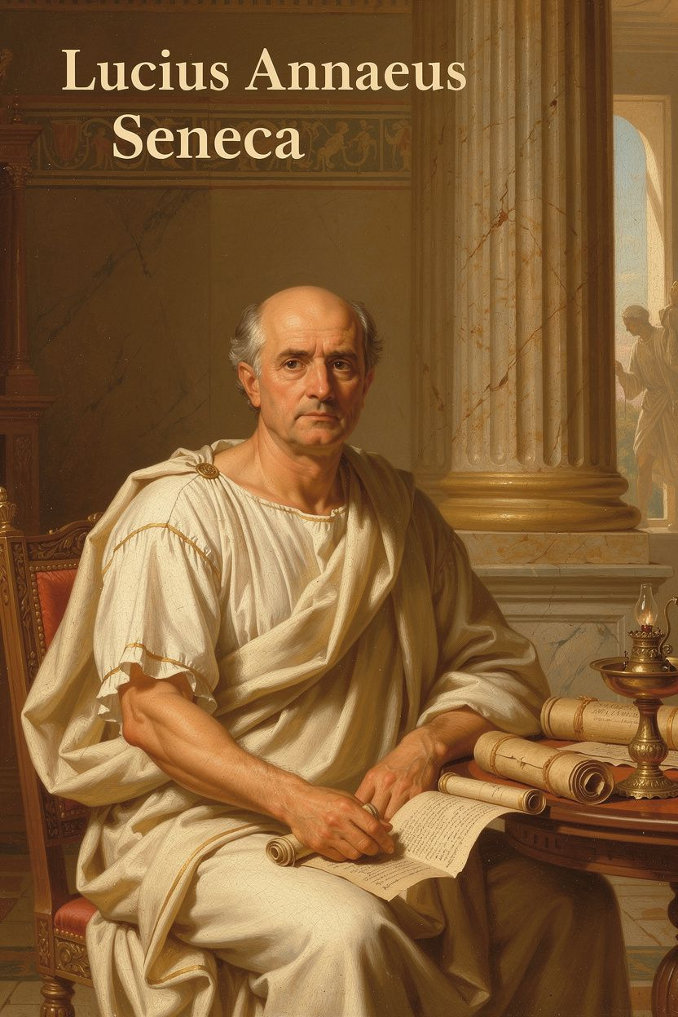
Seneca: The Philosopher Who Couldn't Breathe
WisdomForge Booklet — Ages 11–14

Seneca: The Philosopher Who Couldn't Breathe

WisdomForge Booklet — Ages 11–14
———

About This Book
Seneca was a Roman philosopher who lived two thousand years ago, but his life was surprisingly modern. He was a sick kid who couldn't catch his breath. He got exiled to an island nobody wanted—not for misbehaving, but because powerful people lied about him. He spent eight years stranded there. Then he came back and became the tutor to a teenage emperor who turned out to be one of the worst rulers in history.
Along the way, Seneca wrote about anger, time, fear, friendship, and what it means to be good when the world around you is not good. He didn't always get it right. He was rich while telling people money didn't matter. He served a monster while writing about mercy. But that's exactly why his story is worth reading: he was a real person struggling with real contradictions, not a perfect sage on a mountaintop.
This booklet follows Seneca's life and ideas into situations you might recognize—school pressure, friendships that fall apart, the anger that flares before you can stop it, and the big scary questions about time and death that everyone thinks about but nobody talks about. Each chapter has a story, a big idea, and things to try.
———

Chapter 1: The Boy Who Could Not Breathe
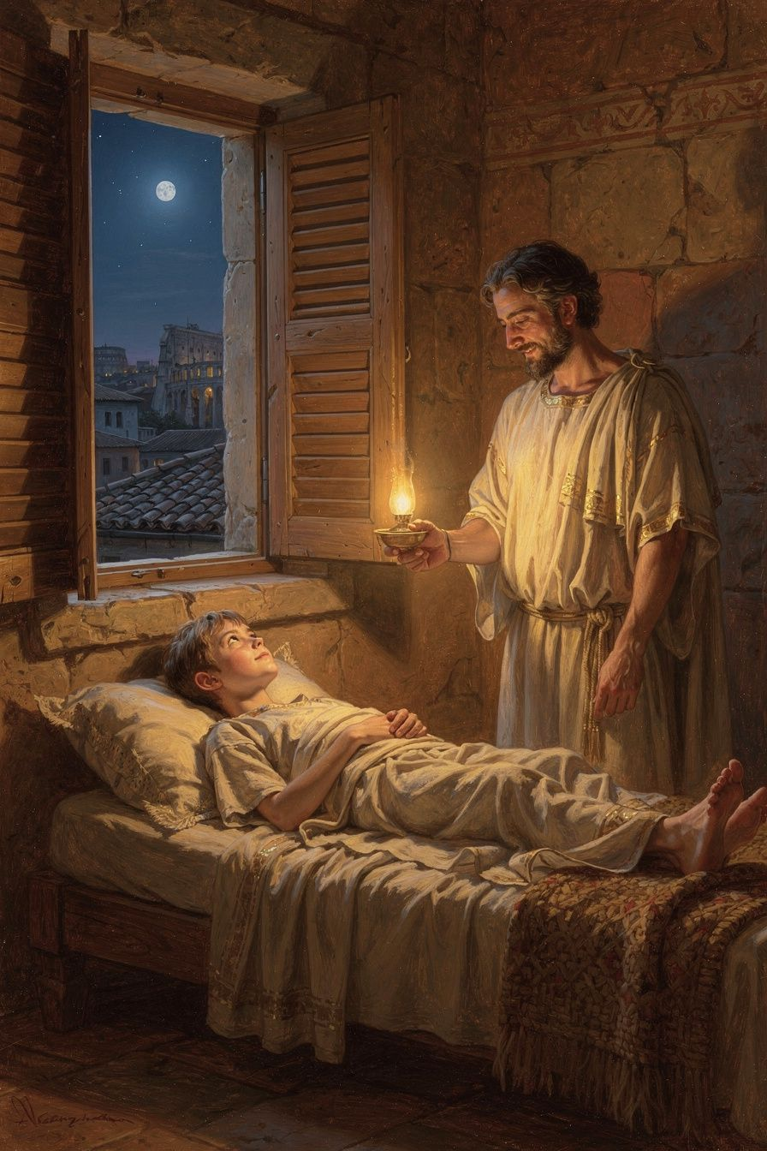
Illustration for Chapter 1
Mateo was twelve, and his lungs were betraying him. Again.
It happened during the mile run in PE. He'd made it maybe four hundred meters before his chest tightened like someone had wrapped a rubber band around his ribs. His breath came out in thin, whistling gasps. The other kids passed him while he bent double on the grass, hands on his knees, face burning. The teacher jogged over. "Sit down, Mateo. Take your inhaler."
He did. The medicine opened his airways a little, but the shame stayed closed up tight. I'm the kid who can't run. I'm the kid who always has to stop. At lunch, his friend Jada tried to help. "My cousin has asthma and she does swimming." Mateo nodded, but he wasn't really listening. He was replaying the moment—everyone looking, nobody saying anything, the awkward silence worse than teasing.
That night, his abuela found him on the back porch, staring at his phone without actually looking at it. She sat down without asking permission. That was her way. "You look like someone stole your favorite thing," she said.
"I can't even run a mile," Mateo muttered.
His abuela was quiet for a moment. "Did I ever tell you about the Roman philosopher who couldn't breathe?"
Mateo looked up. "A philosopher with asthma?"
"Something like it. His name was Seneca. He lived two thousand years ago, and his lungs were worse than yours. But he did something with that weakness that nobody expected."
———
Seneca was born around 4 BCE in Corduba—now Córdoba, in Spain. Back then, Spain was part of the Roman Empire, the biggest empire the world had ever seen. Seneca's family, the Annaei, were what the Romans called nouvelles riches—new money. People who had worked their way up.
Seneca's father—also named Seneca, which gets confusing—was a teacher of rhetoric, the art of persuasive speaking. In ancient Rome, it was the most important skill a young man could learn. The family moved to Rome when Seneca was still a boy. Rome was a monster of a city, the largest the world had ever known—a million people crammed into its walls. Temples, arenas, markets, tenements stacked five stories high. Emperors who could kill you with a word.
And Seneca was not a healthy boy. He suffered from chronic asthma—or possibly tuberculosis; the ancient sources aren't perfectly clear. Either way, his lungs failed him regularly. He described the attacks with terrifying honesty years later: "I have attacked an illness that is beyond cure, or at least that wears out all cures. I am worn out by it, and it seems to me that I am fighting a losing battle" (Letter 78.1). Imagine being a kid in ancient Rome—the dust, the smoke, the pollution from a million people—and not being able to draw a full breath.
Here's the thing that could have broken him but didn't: his body was weak, so he made his mind strong. Because he couldn't do what other Roman boys did—train for the army, compete in athletics—he turned to the life of the mind. He read everything. He memorized speeches. He wrote constantly. His father trained him in rhetoric, but Seneca wanted something deeper: wisdom.
He found it in a Stoic philosopher named Attalus, who taught in Rome during the reign of the emperor Tiberius. Attalus was not a soft teacher. He was rigorous, demanding, and unafraid to tell his students the truth about themselves. Seneca later wrote: "When I attended the lectures of Attalus, I felt ashamed of my faults and regretted them" (Letter 108.3). Notice that word—ashamed. Attalus didn't just feed Seneca information. He held up a mirror. That's what good teachers do. They don't let you hide from yourself.
From Attalus, Seneca learned the lesson that became the foundation of everything he wrote: your limitations don't define you—your response to them does. A boy who couldn't breathe became one of the most powerful minds in Rome. He couldn't control his lungs, so he controlled what he could: his thoughts, his words, his choices. That trade—exchanging the things you can't control for mastery of the things you can—became the root of Stoic philosophy.
His abuela's voice came back to Mateo on the porch. "Seneca couldn't run either. But he became the most famous writer in Rome. He became the teacher of an emperor. He did it because he stopped trying to be the kid with the strong body and started being the kid with the strong mind."
Mateo looked at his inhaler. "So I'm not supposed to want to run?"
"No," his abuela said. "You're supposed to stop letting running be the only thing that matters. Seneca didn't stop being sick. He stopped being defined by being sick."
———
The Big Idea
Think of a tree growing in a courtyard. A wall blocks its light. A bigger tree steals the shade. The tree can't move or argue. But it can send its roots deep, twist toward whatever light reaches it, and grow in the direction that's available. A tree that grows crooked because it reached for the light is still a tree—and those twisted trees are often the strongest. They survived conditions that broke the straight, easy ones.
Seneca was that tree. The wall was his asthma. He couldn't knock it down. But he could send his roots somewhere else—into books, into philosophy, into the training of his mind—and grow so well in that direction that the wall stopped mattering.
Here's the harder truth: having a limitation is not the same as having an excuse. Giving up says, "I can't do this, so I'll do nothing." Finding a different path says, "I can't do this, so what can I do, and how well can I do it?" The question isn't "How do you knock down the wall?" but "In which direction can you still grow?"
———
Try This
1. The Roots Audit Make two lists. On the left, the things you can't control—a limitation, a class that's too hard, a broken friendship. On the right, the things you can still grow toward—subjects you enjoy, skills you could build, people who support you. Look at the right column. That's your sunlight.
2. The Attalus Mirror Seneca said his teacher made him feel ashamed of his faults—not to punish him, but to help him see himself honestly. Find someone who tells you the truth. Ask: "What's one thing I could work on?" Don't argue with the answer. Sit with it. You can't grow in a direction you can't see.
3. The Weakness Re-frame Pick one limitation that frustrates you. Write: "Because of this, I can't do ____. But because of this, I can do ____." Seneca couldn't be a soldier, but he could be a writer. What's your version? The re-frame doesn't make the limitation disappear. It reminds you the wall is not the whole courtyard.
———
Here's a question to carry with you this week: What if the thing you think is holding you back is actually pointing you in a direction you wouldn't have found otherwise?
———

Chapter 2: The Island Nobody Wanted
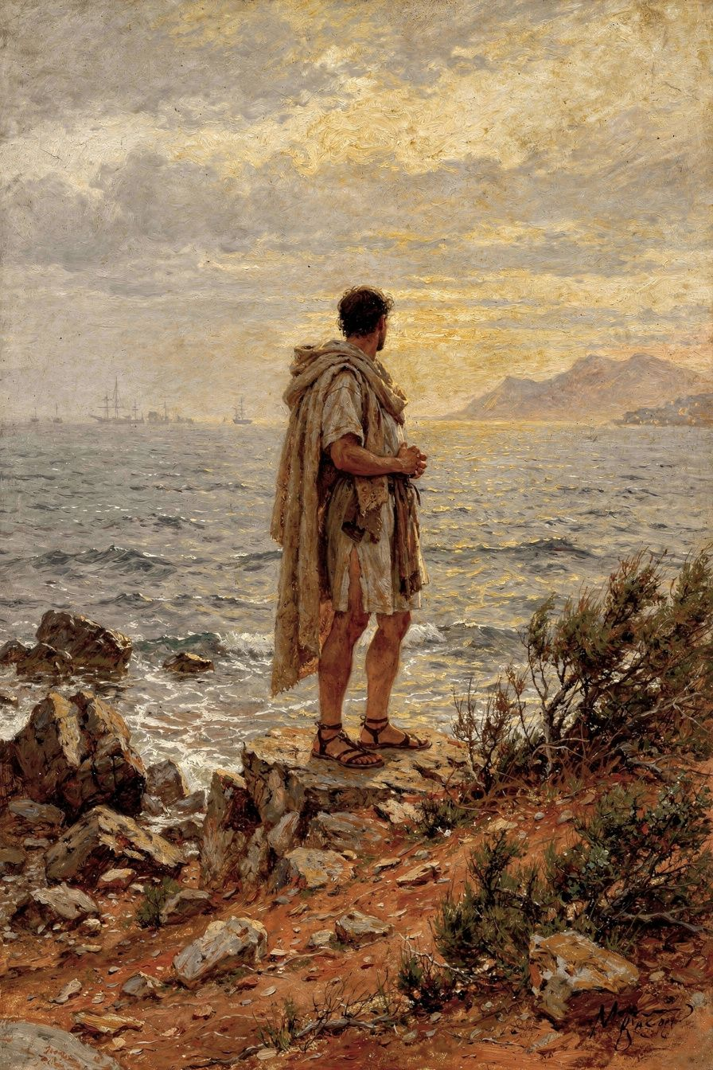
Illustration for Chapter 2
The message arrived on a Tuesday, and it ruined Priya's entire year.
It was from her best friend, Naya—or the person who used to be her best friend. The text was short: "I don't think we should hang out anymore. You're too much." That was it. No explanation. No conversation. Just a digital door slamming shut. Priya stared at her phone in the middle of the cafeteria, surrounded by noise and people, and felt more alone than she had ever felt.
The next weeks were a slow-motion disaster. Naya had been her person—lunch partner, lab partner, the one who saved her a seat on the bus. Without Naya, Priya drifted. She sat at the edge of other groups, never quite fitting. She replayed every interaction she'd ever had with Naya, searching for the moment she'd gone wrong. What did I do? What's wrong with me?
Her older brother, Dev, found her in her room one evening, wrapped in a blanket, scrolling through old photos. He didn't say "it'll get better." Instead, he sat on the floor and said, "Let me tell you about a guy who got sent to an island for eight years for something he didn't do."
Priya pulled the blanket down. "Eight years?"
"Eight years. On an island so remote that the Romans used it as a punishment. And he didn't just survive it. He wrote things there that people are still reading two thousand years later."
———
Seneca was about thirty-five when everything fell apart. The year was 41 CE. A new emperor, Claudius, had taken power, and his wife, Messalina, accused Seneca of adultery with the emperor's niece. The charge was fabricated. In the Roman court, innocence had very little to do with the outcome.
Seneca was sentenced to death, commuted at the last moment to exile. That was Roman mercy: instead of killing you, they erased you. He was sent to Corsica.
In the first century, Corsica was rugged, windswept, and wild—the Romans used it as a dumping ground for political undesirables. Seneca was simply removed from Rome and forbidden to return. He could walk around. He could write. He just couldn't go home.
He was in his mid-thirties, a brilliant man with a growing reputation, a wife, a career, a network of powerful friends. All of it stripped away in a single political decision. He was, in every way that mattered, erased.
And he stayed there for eight years.
If you're twelve right now, eight years is more than half your life. Seneca spent that entire span on a rock in the Mediterranean, knowing the people who sent him there were climbing the ladder he'd been pulled off of.
Here's the question that matters: what did he do with it?
He could have spent eight years in bitterness. Instead, he wrote. During those years, he produced the Consolations. He wrote Ad Marciam, comforting a mother who had lost her son. He wrote Ad Helviam Matrem, consoling his own mother for his exile—a remarkable reversal. He told her he had not been banished because of any crime but "because of the envy of the powerful" (Ad Helviam 5.1).
That sentence is doing something important. Seneca reframed the entire situation. Being exiled by the envy of the powerful was not a disgrace; it was, in a strange way, a compliment. You only get exiled if you matter enough to be a threat. He took the worst thing that had happened to him and found a way to make it mean something different.
He refused to let exile define him the way his enemies wanted. They wanted him erased. He made himself louder.
Exile is being cut off from the world you know. That's exactly what Priya was going through. Naya had exiled her, and Priya was stranded on her own emotional Corsica.
But here's what Seneca discovered: exile doesn't have to be empty time. When the world removes you from one place, it doesn't remove your ability to think, to write, to grow. Seneca became a writer on Corsica. The exile gave him something comfort never would have: the time and silence to find his real voice.
Dev put it this way: "Seneca didn't get off the island by being angry about being there. He got off by becoming someone worth bringing back. And eight years later, someone did bring him back."
He was right. In 49 CE, Agrippina recalled Seneca because she needed a tutor for her son—a boy named Nero who would one day be emperor. Seneca's recall didn't come from protesting his innocence. It came from becoming indispensable during the years when nobody wanted him.
———
The Big Idea
Imagine you're a seed dropped on rocky soil. Every other seed landed in the soft dirt by the river. Unfair? Absolutely. But the seeds that grow on rocky soil develop roots that are incredibly strong. The ones in the soft dirt grow fast, but their roots are shallow, and the first flood washes them away.
Seneca was a seed on rocky soil. Instead of dying on it, he grew roots so deep that when he was transplanted back to Roman politics, nothing could blow him over.
This is the heart of resilience, and it's different from what most people think. Resilience is not "bouncing back" to who you were before. It's becoming someone stronger because of what happened. The person Seneca became on Corsica was more powerful than the politician he'd been before.
The hard part: resilience doesn't mean the unfair thing was okay. Seneca was clear about the injustice. But he understood: being right about the unfairness doesn't help you survive it. What helps is deciding what to do with the time the unfairness has handed you. You can be completely innocent and completely stuck at the same time. The question is not "was it fair?" but "now that this has happened, what do I build?"
———
Try This
1. The Corsica Journal When something unfair happens, write for ten minutes. First, the facts: what happened, without the story you're telling yourself. Then the injustice: why it wasn't fair. Get it out. Then write: "Given that this happened, what can I do with this time?" Not "how do I undo it?"—you probably can't. But "what can I build while I'm here?" That's the question Seneca asked on Corsica for eight years.
2. The Re-frame Game Seneca reframed his exile as proof he mattered enough to be a threat. Practice reframing. Take a situation where you feel rejected and write three interpretations—not to lie to yourself, but to see your first interpretation isn't the only one. "Naya doesn't want to hang out." 1: "I'm too much." 2: "Naya is going through something I don't know about." 3: "This frees me to find people who want to be around me." Which is true? Maybe all of them. But the one that blames you isn't automatically right just because it's the loudest.
3. The Eight-Year Question Pick something you're going through that feels like exile. Ask: "If this lasted a long time, who could I become because of it?" Seneca became a writer. What could you become? More independent? More compassionate toward others who get left out? Better at being alone? The exile might end tomorrow or last years. Either way, you decide what it builds.
———
Here's a question to carry with you this week: When life is unfair—and it will be—do you spend your energy proving it was unfair, or becoming someone the unfairness couldn't break?
———

Chapter 3: The Shortest Thing We Have

Illustration for Chapter 3
"I have no time."
That was what Lila said to her mom every day. No time to practice piano. No time to read the book for English. No time to call her grandmother. No time to do anything except homework, soccer, and scroll through her phone until her eyes burned. She was thirteen, and she was already exhausted.
One Saturday, instead of arguing, her mom handed her a piece of paper. "Write down everything you did yesterday. Estimate the time for each thing."
Lila rolled her eyes but did it, because arguing took more energy than obeying. She wrote: woke up at 7, got ready (45 min), school (7 hours), soccer (2 hours), dinner (30 min), homework (2 hours), phone (??). The last one stumped her. She knew she'd been on her phone, but she couldn't remember for how long. It felt like ten minutes.
Her mom looked at the list. "You wrote 'phone' with a question mark."
"Because I don't know. I wasn't doing anything important. I was just... on it."
Her mom handed Lila her phone and pointed to the screen-time report. Lila opened it, scrolled to yesterday, and felt her stomach drop. Four hours and twelve minutes. Four hours she couldn't account for. Four hours that had simply vanished, like water poured into sand.
Her mom sat down. "There was a Roman philosopher who said everyone complains life is short, but the real problem is that we throw it away. He said people guard their money like dragons but squander their time like it's worthless. His name was Seneca. And two thousand years before screen-time reports, he figured out what you just figured out."
———
Seneca wrote a short, powerful essay called De Brevitate Vitae—On the Shortness of Life. It opens with a sentence quoted ever since: "It is not that we have a short time to live, but that we waste a lot of it. Life is long enough, and a sufficiently generous amount has been given to us for the highest achievements if it were all well invested" (De Brevitate Vitae 1.1).
Read that again. Seneca is not saying "life is long, so don't worry." He's saying something more disturbing: life is long enough to do important things, but most of us don't do them because we fritter the time away.
Here's how he put the contradiction: "People are frugal in guarding their personal property; but as soon as it comes to squandering time they are most wasteful of the one thing in which it is right to be stingy" (De Brevitate Vitae 2.5). If someone stole five dollars from your wallet, you'd be furious. But if you spend four hours scrolling through posts you won't remember tomorrow, you don't feel robbed. The four hours are worth far more than the five dollars. You can earn back five dollars. You cannot earn back four hours.
Seneca was writing about Roman society, but he could have been writing about your phone. The medium changes; the problem doesn't. The question is: are you spending your time on what matters, or letting it leak away?
Here's where it gets complicated. Seneca didn't think the answer was to fill every minute with productive work. He criticized people who were "busy" without purpose: "There is no worse waste of time than busyness"—the person always occupied but never doing the thing that matters.
So what does "using time well" mean? For Seneca, it meant spending your hours on the things that make you wiser, kinder, more honest, more free. Not more productive. More good. Reading a book that changes how you think is using time well. Staring at a screen that makes you feel worse is not.
He also said time isn't just about how much you have—it's about how much you notice. An hour spent fully present feels longer and matters more than a whole day spent half-aware, drifting. "What man can you show me who places any value on his time, who reckons the worth of each day?" Seneca asked (De Brevitate Vitae 7.3). He knew the answer: almost nobody.
And then there's the part that sounds dark until you sit with it. Seneca thought about death—a lot. Not because he was depressed, but because remembering you're going to die is the best way to stop wasting time. "Let us keep death before our eyes daily" (Letter 26). That sounds terrifying if you're twelve. But Seneca's point isn't to scare you. It's to wake you up.
Imagine you're on a road trip with limited gas. If you don't know how far the gas has to last, you wander down side roads and run out. But if you know exactly how much gas you have, you plan your route. You go where it matters. Death, for Seneca, is the fuel gauge. It doesn't ruin the trip. It makes the trip mean something.
Lila's mom didn't tell her to throw away her phone. She said: "You don't have to do more. You have to notice more. You have four hours back every day. What do you want them for?"
———
The Big Idea
Think of time as the only currency you can't earn more of and can't get a refund for. Every person—Roman emperor or middle-schooler—gets twenty-four hours every morning. Every night, whatever you didn't spend is gone. No savings account. No rollover. It just vanishes.
Most of us live like we have an infinite supply. We spend time the way a kid with an allowance spends quarters—on whatever's in front of us, because there always seem to be more. But there aren't always more. And unlike money, you can't check your statement at the end of the month. It just... goes.
Here's the deeper layer: time isn't just about quantity; it's about attention. An hour where you're fully present—really reading, really listening, really creating—is worth more than ten hours where your body is in one place and your mind is in another. The feeling of "not having enough time" is often really the feeling of not being present for the time you have. You can have a perfectly free Saturday and still feel like you have no time if you spend it in a fog of scrolling.
And the death part? Once in a while, asking "if this were my last week, would I spend it this way?" is a clarifying question. Not because it will be your last week. Because it cuts through the fog and reminds you what matters. Seneca didn't want you to live in fear of death. He wanted you to live so fully that death, whenever it comes, doesn't find you unfinished.
———
Try This
1. The Seneca Time Audit For one day, keep a rough log of how you spend your time. Find the chunk you can't account for. Then ask: was that time well invested? Not "was it productive?"—was it invested in something that made you better, happier, or more connected? You can't fix a leak you can't see.
2. The One-Thing Day Pick one day this week and decide on one thing that matters—a book, a conversation, a skill. Protect time for it the way you'd protect five dollars in your wallet. When something tries to steal that time, say: this is the thing Seneca said to be stingy with. Do the one thing. Notice how it feels to spend time on something that matters.
3. The Fuel Gauge Question When you're doing something that feels pointless—scrolling, replaying an argument, staring at a screen you're not enjoying—pause. Ask: "If I knew I had a limited amount of time left—and I do—would I spend this hour this way?" You don't have to answer perfectly. But asking the question will change something. Seneca called it keeping death before your eyes. You can call it the fuel gauge. Same idea: it wakes you up.
———
Here's a question to carry with you this week: If you had to account for every hour of today the way you account for every dollar in your wallet, would you feel rich or robbed?
———

Chapter 4: The Short Madness
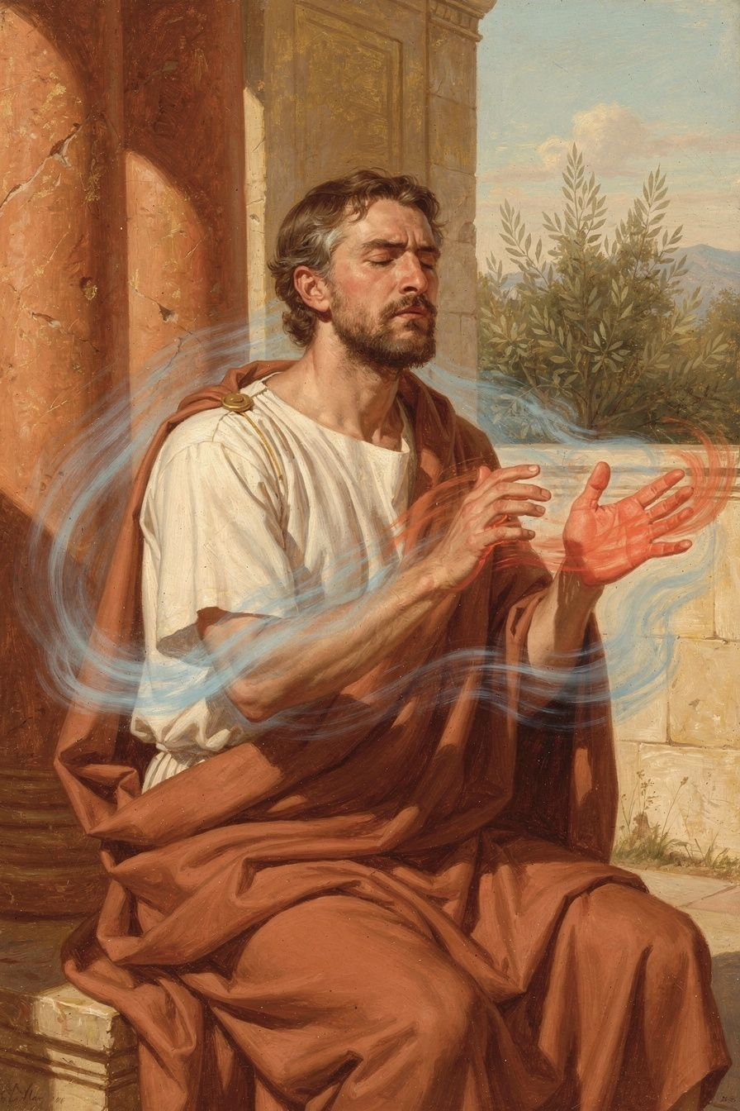
Illustration for Chapter 4
The phone hit the wall before Marcus even knew he'd thrown it.
One second he was reading the group chat, the next he was standing in his bedroom with his hand still outstretched and his phone face-down on the floor, a new crack across the screen. His heart was hammering. And the message that had set him off was still glowing through the broken glass: a screenshot from his classmate Ryan, forwarded to the whole group, of a private text Marcus had sent about another kid. It was meant for one person. Now everyone had it.
Something rose in him bigger than anger—a hot, red wave that wanted to break things. He wanted to text Ryan forty exclamation points. He wanted to make Ryan feel exactly this burning.
His mom appeared in the doorway. She'd heard the phone hit the wall. She looked at the crack, looked at Marcus, and said, "Sit down. You're in the short madness right now."
Marcus blinked. "What?"
"Sit down. There was a Roman philosopher who wrote an entire book about what you're feeling. He called it 'a short madness.' And he said the most dangerous thing about it is that it feels justified."
———
Seneca wrote De Ira—On Anger—addressed to his brother Novatus. It's basically the world's oldest anger management manual. He took anger apart like a mechanic taking apart an engine, figured out how it worked, and told you how to stop it from wrecking your life.
The first thing he did was break anger into stages. Anger isn't one feeling; it's a process.
Stage one: the first movement. Something happens. Your body reacts before your mind can think. Face flushes. Heart pounds. Breath gets shallow. Seneca compared this to the shiver you feel when you hear a sudden loud noise. It's involuntary. "The first movement of the mind is not in our power" (De Ira II.4.2).
Stage two: assent. After the first jolt, your mind makes a decision—usually without realizing it. It says: "That was an insult. I've been wronged. They deserve to be punished." This is where anger goes from a physical reaction to a full-blown emotion. And this is the moment you can control. The first movement is not in our power; the second is. You don't choose the flush, the pounding heart. But you do choose whether to endorse it—whether to say "yes, I should be furious" or "wait, let me think."
Stage three: full anger. Once you give assent, anger takes over. It builds its own momentum. All proportion vanishes. Seneca called this "a short madness" (De Ira I.1.3)—brevis insania in Latin—because that's what it is: a temporary insanity that overrides your ability to think.
The phone hitting the wall? Stage three. Marcus's body did stage one automatically. Then his mind did stage two in a flash: "Ryan betrayed me. Someone has to pay." Then stage three took over, and the phone was in the air before he knew he'd thrown it.
Here's Seneca's remedy: "The greatest remedy for anger is delay" (De Ira II.29.1). Not forever. Just delay. When the first movement hits—the hot wave, the clenched fists—don't act. Don't speak. Don't text. Don't post. Wait. Give your thinking brain time to catch up with your feeling brain. Modern research confirms: the emotional part of your brain fires almost instantly, but the rational part takes longer to engage. Delay is literally giving reason time to arrive. You're not suppressing the anger. You're waiting for the part of your brain that can think to join the conversation.
Seneca had other techniques. Examine the evidence: was it intentional? Test the proportion: will this matter in a year? Most things that make us furious shrink to nothing on a longer timeline. Physically cool down—drink water, walk slowly, speak softly.
But here's the question that matters most: is anger ever justified?
Seneca's answer was mostly no. Even when you've been genuinely wronged, anger corrupts your judgment. The angry person doesn't seek justice; they seek revenge. Revenge says "I want them to suffer." Justice says "I want this to be made right." Anger can't tell the difference.
But Seneca did allow something: you can be angry about injustice without being angry in your response. A person who stands up to a bully doesn't have to be furious to be firm. You can act strongly without being in the short madness. The calm person who confronts a bully is more effective than the furious person who lashes out—because the calm person is still thinking.
Marcus sat with his mom for fifteen minutes. The shaking stopped. He picked up his cracked phone and looked at the group chat. Ryan had still done what he'd done. But Marcus could think now. He could see that Ryan had forwarded the text to look funny, not to destroy Marcus—careless, not calculated. That didn't make it okay. But it changed what Marcus wanted to do. Instead of forty exclamation points, he sent a single calm message: "That wasn't cool. We need to talk."
The phone was still cracked. The situation was still bad. But Marcus hadn't made it worse. And in Seneca's world, that's not a small thing. That's everything.
———
The Big Idea
Picture your mind as a car with two drivers: Emotion and Reason. Emotion is fast—really fast. It sees a threat and slams the gas before you know what's happening. Reason is slower. It takes a moment to assess, check the mirrors, figure out the best route. When anger hits, Emotion is already driving and Reason is still fumbling for the keys.
Seneca's "delay" is not about kicking Emotion out of the car. Emotion is the alarm system that tells you something matters. The delay is giving Reason time to get into the passenger seat and say, "I see why you're upset. But here's what's actually going on." The car still moves. You still respond. But you respond with both drivers, not just one.
Here's the deeper point: anger feels like power, but it's actually the loss of power. When you're in the short madness, anger is driving your car. The person who made you angry pressed the button, and you reacted exactly the way they wanted. The angry person is not free. The person who pauses, thinks, and chooses their response—that person is free.
And the justified anger question? There's a difference between feeling something is wrong—which is healthy—and letting that feeling hijack your brain. You should feel angry when someone is bullied. But the moment anger takes over your judgment, you become less able to fix the thing you're angry about. The activist who campaigns calmly for years accomplishes more than the person who yells once and burns out. Firmness without fury. That's the Seneca ideal.
———
Try This
1. The Five-Minute Rule The next time you feel the hot wave—the first movement—don't respond. Don't text, don't speak, don't post. Set a mental timer for five minutes. Seneca said delay is the greatest remedy. You're not pretending you're not angry. You're waiting for your thinking brain to arrive. After five minutes, ask: "Do I still want to say what I was about to say?" Often, the answer is different. Sometimes it's the same—but calmer and less likely to make things worse.
2. The Proportion Test When you're angry, stretch it on a timeline. Will this matter tomorrow? Next week? Next year? On your deathbed? Most middle-school angers—group chat drama, the insult in the hallway—shrink dramatically when you stretch them out. This doesn't mean they don't matter now. It means they don't matter as much as the short madness is telling you. The proportion test gives you perspective, and perspective is the antidote to the short madness.
3. The Evidence Exam Before you respond, examine the evidence. Was it intentional? Do I know the full story? Is there something going on with the other person I don't know about? Am I contributing to this in a way I'm not seeing? Seneca said something sharp: "Often the person who angers you is only mirroring your own vice." That stings, but it's worth sitting with. Sometimes the thing that makes us most furious is the thing we recognize in ourselves.
———
Here's a question to carry with you this week: The next time anger gives you a choice between reacting and responding, which one will you choose—and who will be driving the car?
———

Chapter 5: The Teacher and the Tyrant
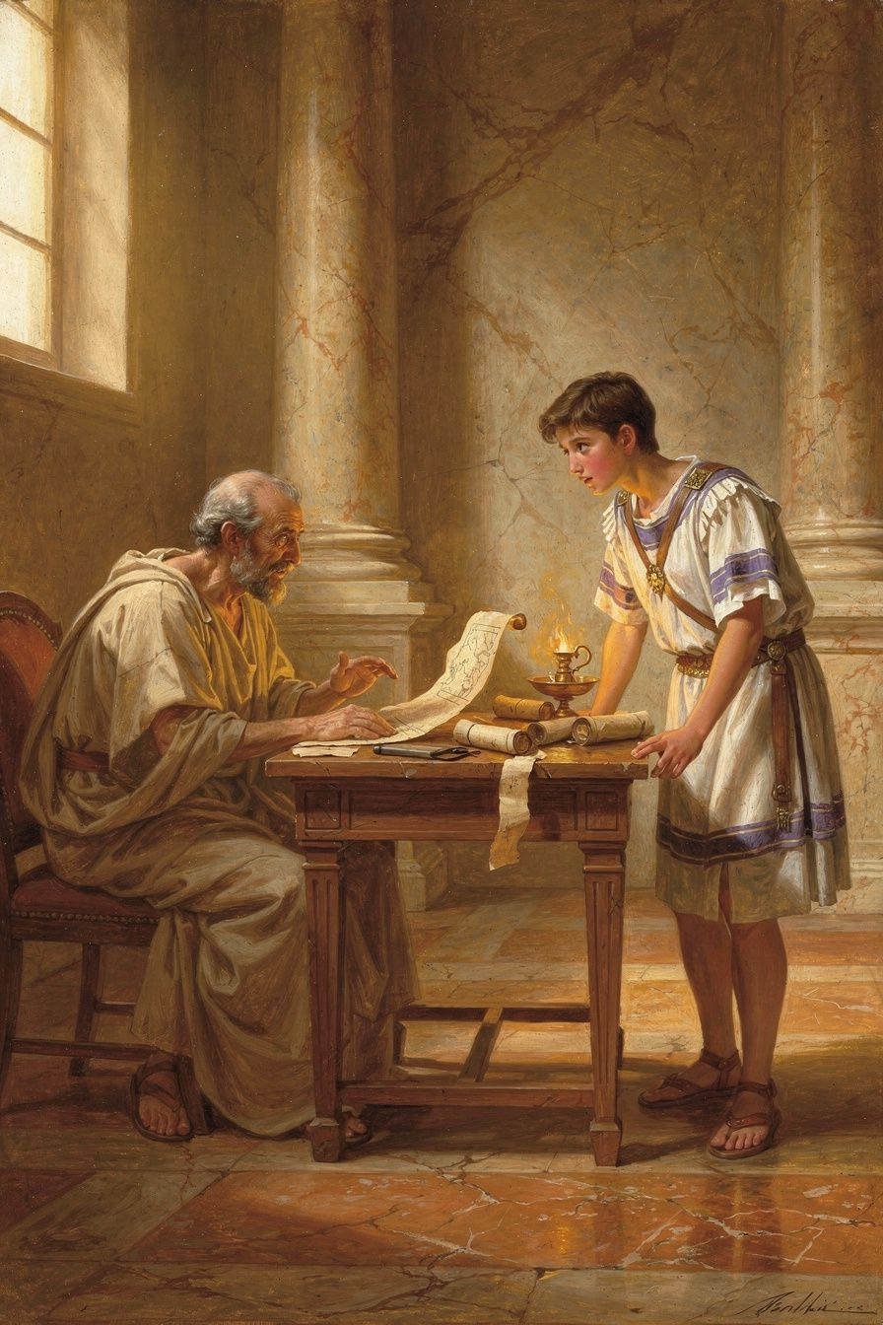
Illustration for Chapter 5
Imagine this: you're a teacher. You've been given one student. He's a teenager—sixteen, seventeen years old. He can be charming. He can be kind. He's popular. But he's also the most powerful person in the world. Whatever he says, goes. And if you cross him, he can have you killed.
That was Seneca's job.
In 49 CE, after eight years of exile on Corsica, Seneca was recalled to Rome by Agrippina, the new wife of the emperor Claudius. She needed a tutor for her son, Nero—a boy who would, within five years, become emperor. Seneca was restored to the Senate, made a praetor, and given a teenager to educate.
At first, it seemed to work. When Nero became emperor in 54 CE at sixteen, Seneca and a man named Burrus (head of the emperor's bodyguard) essentially ran the government. The early years were surprisingly good. The historian Tacitus, who was not easy to impress, wrote that "the Senate, the knights, the people—all were delighted" (Annals 13.3). Nero issued pardons. He reduced taxes. He seemed, for a moment, like exactly what Seneca had hoped for: a ruler guided by philosophy.
Seneca even wrote a book for Nero called De Clementia—On Clemency—about the duty of a powerful person to show mercy. He told the teenage emperor: "The true clemency of the prince is not to punish when he could" (De Clementia 1.22). He compared the emperor to a shepherd, a father, a doctor—someone whose power exists to protect, not destroy.
But then things changed.
Nero grew up. In 59 CE, he murdered his own mother, Agrippina—the woman who had recalled Seneca from exile. He staged a fake shipwreck. When she survived, he sent soldiers to finish the job.
And here's where Seneca's story gets really uncomfortable. When Nero killed his mother, he needed someone to write the letter to the Senate explaining why it was "necessary." He asked Seneca. And Seneca wrote it. The letter claimed Agrippina had plotted against Nero's life and her death was self-defense. It was a lie. Seneca knew it was a lie. He composed it anyway.
Think about that. The man who wrote On Clemency—the book about mercy—wrote the cover-up for a matricide. Why? Because to refuse would have been to die. And because he may still have believed he could do more good inside the system than outside it.
But here's the question that haunts Seneca's entire life: was he right?
Some scholars, like Miriam Griffin, argue Seneca was caught in an impossible trap. If he refused, Nero would have killed both him and Burrus, removing the last people who might restrain the emperor. He chose effectiveness over purity.
Other scholars, like James Romm, take a darker view. They argue Seneca's complicity wasn't forced—it was chosen. He didn't jump into corruption; he slid into it, one letter, one silence, one justification at a time.
And then there's the money. While serving Nero, Seneca became one of the richest men in the Roman Empire—estates in Egypt and Italy, a fortune estimated at three hundred million sesterces. And while accumulating this wealth, he wrote about how money doesn't matter. "It is not the man who has too little, but the man who craves more, who is poor" (Letter 2). "The philosopher owns his wealth; the wealthy man is owned by his" (De Vita Beata 22.4). His critics have asked: how can you write about the emptiness of wealth while swimming in it?
Seneca tried to answer. He said wealth is a tool. The wise person can own wealth without being owned by it. "He who is not content with what he has would not be content with what he would like to have" (Letter 16).
Here's the honest truth: Seneca was not a hypocrite in the simple sense, and he was not a saint. He was a person trying to do good in a bad situation and making compromises that slowly eroded his ability to do good at all. The philosopher Brad Inwood put it well: Seneca's essays are exercises in moral reasoning—attempting to think through problems in real time. He was struggling, out loud, on paper, with the gap between what he believed and how he lived.
That gap is the Seneca problem, and here's why it matters for you: you will face versions of it. Not with a murderous emperor, but with a friend group that does something cruel. With a team that cheats. With a situation where speaking up costs you something and staying silent keeps you safe. The question Seneca's life forces you to ask: how far do you go to stay close to power before you become part of the problem?
Seneca tried to withdraw. In 62 or 63 CE, he offered to give back his wealth and retire. Nero refused. Seneca was trapped by his own success.
———
The Big Idea
Think of integrity like a wall, built brick by brick—each honest choice, each time you speak up when it's easier to stay quiet. The wall is strong. But Seneca's story shows: the wall doesn't usually collapse from a single blow. It gets taken down one brick at a time. One small compromise. One little silence. One "I'll just do this one thing and then I'll get back to being good." Each seems small in the moment. But bricks don't go back. Once you've removed one, the wall is weaker, and the next is easier.
Seneca didn't wake up and decide to serve a monster. He made small accommodations. A letter here. A silence there. By the time he recognized where they led, the wall was gone.
Here's what makes this more than a Roman story: the Seneca problem is the human problem. Everyone who holds ideals fails to fully live up to them. The question isn't whether there's a gap between your beliefs and your behavior—there always is. The question is what you do about it. Do you ignore it? Or do you, like Seneca, write about it, examine it, and try to narrow it?
Seneca's value is not that he was perfect. His value is that he was honest about his imperfection. He didn't hide his wealth and pretend to be poor. He wrote about the tension. His candor about his own contradictions is, paradoxically, a form of integrity. The person who hides the gap is dishonest. The person who writes about the gap with Seneca's honesty is doing something valuable, even if the gap remains.
Can you believe in something you don't fully achieve? A doctor who smokes can still tell patients not to smoke—and the advice is still good. The question is whether the doctor is honest about their own struggle. Seneca was honest. That doesn't erase the contradiction. But it makes it human instead of fraudulent.
———
Try This
1. The Brick Audit Think about a situation where you've been making small compromises—a friend group that gossips, a habit you know isn't good for you. Write down each compromise. Don't judge—just list. Now ask: "Are these bricks coming out of my wall? Is there one brick I could put back today?" You don't have to fix everything. But you should know which bricks are missing.
2. The Seneca Question When you're next in a situation where going along with the group would be easier than speaking up, ask: "Can I stay good while staying close to this?" If yes, stay and be a good influence. If no—or if you realize the group is changing you more than you're changing it—consider stepping back. Seneca couldn't leave Nero. You probably can leave a friend group. That's a freedom he didn't have.
3. The Hypocrisy Test Think of something you believe in strongly—kindness, honesty, fairness. Ask: "Where is the biggest gap between what I believe and how I actually live?" Write it down honestly. Seneca's gap was wealth. Yours might be something else. The point isn't to feel guilty. It's to see the gap clearly, because you can't narrow a gap you won't look at.
———
Here's a question to carry with you this week: If you realized you were slowly becoming part of something you didn't believe in, would you be brave enough to see it—and honest enough to say so out loud?
———

Chapter 6: The Good Death
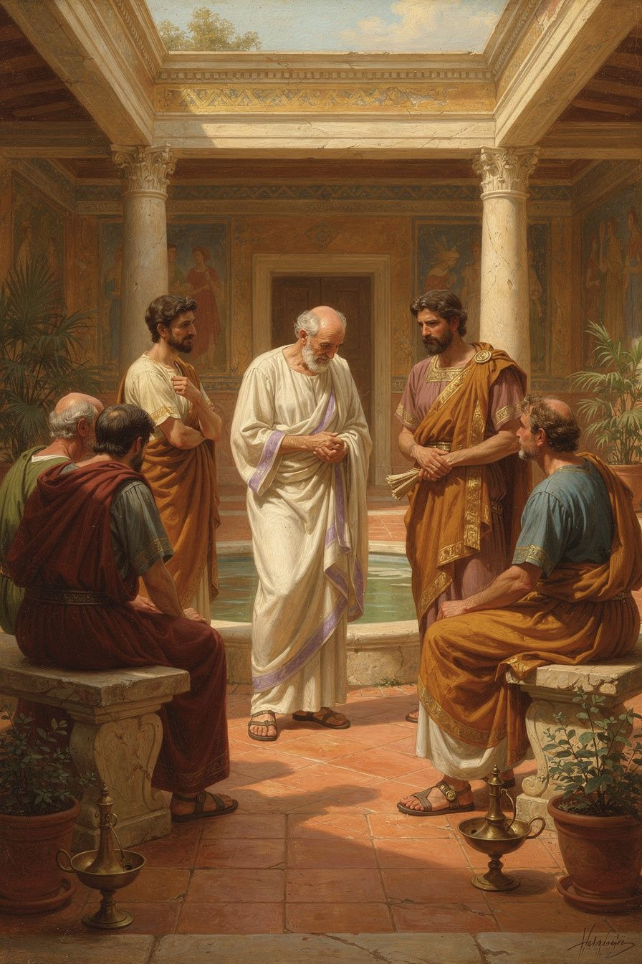
Illustration for Chapter 6
The news came on a Friday.
Mateo's abuela had been sick for a while—the kind of sick where everyone knows what's coming but nobody says it out loud. The cancer had spread. The doctors said weeks, maybe less. Mateo sat in the hospital room with his mom and his uncle, staring at his abuela's face on the pillow. She was thinner than he remembered. But her eyes, when they opened, were the same sharp eyes that had sat next to him on the porch the night he couldn't run the mile.
"You're all crying," she said, her voice thin but clear. "I can hear you crying even with your eyes closed."
"We're not crying," his mom lied, wiping her face.
"You're terrible liars," his abuela said. "Mateo, come here."
He moved closer. She took his hand. "Do you remember the Roman philosopher? The one who couldn't breathe?"
"Seneca," Mateo said.
"Seneca. He died too. Not from asthma—from an emperor who ordered him to kill himself. And the way he died is the reason people still talk about him two thousand years later. Not because he was brave in battle. Because he was brave in a bath."
———
In 65 CE, when Seneca was about sixty-eight, the end came. A conspiracy against Nero—the Pisonian conspiracy—had been discovered. Seneca was not among the plotters. The evidence linking him was thin, possibly fabricated. But Nero didn't need evidence. He had wanted Seneca gone for years—the philosopher was a reminder of everything Nero had failed to be. The conspiracy gave him the excuse.
A centurion arrived with Nero's command: he must die. In ancient Rome, when the emperor ordered you to die, you got a choice about how. The standard method was to open your veins—a "noble" death, a way to maintain some dignity when the emperor had taken everything else.
But here's what Seneca believed: death is not the worst thing. Living without virtue is the worst thing. "Death is the law of nature," he wrote (Letter 82). He had spent his entire life preparing for this moment. He had rehearsed death in his mind the way an actor rehearses a role, so that when the real performance came, he wouldn't freeze.
When the centurion delivered the order, Seneca didn't panic. He asked for his friends and his wife, Pompeia Paulina, to be present. And then, according to the historian Tacitus, Seneca did something extraordinary: he comforted them. He told his friends the only thanks he owed Nero was for giving him the chance to show how courageously a philosopher could die.
He opened his veins. But Seneca was old and sick—his body had never been strong. The blood came slowly. He asked for hemlock—the same poison Socrates had drunk five hundred years earlier. Even that didn't work quickly enough. Finally, he was placed in a hot bath to hasten the end. As he died, Tacitus reports, he continued to speak, offering philosophical consolation to his weeping friends.
His wife, Paulina, tried to die with him. She opened her own veins in solidarity. But Nero's soldiers bandaged her wounds and forced her to live. The scene ends with a single death and a widow forced to survive.
Seneca is reported to have said, as he died: "The whole world is my tomb."
Here's where it gets complicated. His death was not purely voluntary. Nero ordered it. It was an execution dressed up as a suicide. But within that compulsion, Seneca made choices. He chose to face it calmly. He chose to comfort his friends. He couldn't control the fact of his death. He could control the manner of it. And that distinction—between what happens to you and how you respond—is the whole of Stoicism in a single breath.
Seneca had written about this years earlier: "Just as I choose a ship in which to sail, or a house in which to live, so I choose a death in which to die" (Letter 70). A beautiful sentence, capturing the Stoic idea that even in death, there is a kind of freedom. But it sits uncomfortably next to the reality: Seneca didn't choose his death. Nero chose it.
So what do we make of this? Is Seneca's death a triumph of philosophy or a tragedy that philosophy couldn't prevent? The honest answer is: it's both.
For Seneca, dying well meant not letting death make him less than he was. He had spent his life writing about courage, about the unconquered soul. Death was the final test of whether he meant any of it. And the evidence suggests that, in those last hours, he meant it. He wasn't perfect. He had failed at many things. But in his death, he did the one thing he had spent his life preparing to do: he faced the end without letting it break him.
Here's what Mateo's abuela wanted him to understand: Seneca's death wasn't good because he died. It was good because of how he lived in the moment of dying. He was present. He was brave. He was thinking about others. He didn't pretend it wasn't terrible. He just refused to let the terribleness turn him into someone he didn't want to be.
A few days later, Mateo's abuela died. She was in a hospital bed with her family around her. But she did something Seneca would have recognized. She didn't pretend it wasn't happening. She held Mateo's hand. She told his mom to stop lying about not crying. She made a joke about the hospital food. And then she was gone.
It wasn't a Roman death. It was a human one. And it was good—not because it was easy, but because she faced it the way she had faced everything: with her eyes open and her hand in someone else's.
———
The Big Idea
Think of death not as a wall at the end of a long hallway, but as the walls of the hallway itself—the boundaries that give the hallway its shape. Without walls, a hallway is just an empty field. You'd wander forever, with no direction, no urgency. The walls are what make the path real. It's the limits—the fact that time runs out, that bodies fail—that give life its urgency, its beauty, its meaning.
This is what Seneca meant when he said to keep death before your eyes. Not to be morbid. But to remember the hallway has walls.
Here's the harder part: a good death is not about dying. It's about living in a way that makes dying less terrifying. Seneca didn't face his death calmly because he was brave in that final moment. He faced it calmly because he had been practicing for forty years. Every time he asked "am I living in a way I won't regret?"—he was rehearsing. The final performance was the last scene of a play he'd been performing his whole life.
This doesn't mean you should think about death all the time. But Seneca's insight is that thinking about death occasionally makes you live better now. When you remember time is limited, you waste less of it. When you remember people don't last forever, you treat them better.
And the question of what a "good death" means? For most people, it's quieter than Seneca's: being present, being honest, being with people you love, and facing what's happening instead of hiding from it. The core of it—courage, honesty, care for others—is available to everyone. You don't need a hot bath and a philosophical discourse. You just need to face the hard thing without letting it make you less than you are.
———
Try This
1. The Rehearsal This isn't about death—it's about the principle behind it. Seneca rehearsed the hard things so they wouldn't surprise him. Pick one thing you're dreading—a hard conversation, a test, a moment you wish you could avoid. Mentally rehearse it. Imagine walking into it calm. Imagine handling it the way you'd want to. Seneca called this meletē thanatou—rehearsal for death. You can call it rehearsal for Tuesday. Same principle: the thing you've prepared for is less terrifying than the thing that takes you by surprise.
2. The "What Would I Regret?" Check Once this week, ask: "If I couldn't do this anymore—if this were the last time—what would I regret not saying or doing?" This is Seneca's "keep death before your eyes" in a form that doesn't require thinking about actual death. It's a way of noticing what matters. Maybe you'd regret not telling your friend you appreciate them. Maybe you'd regret not finishing the thing you started. Whatever it is, the question wakes you up. And then—do the thing.
3. The Good Moment Practice A good death, for Seneca, was really just a good moment scaled up—being present, being honest, caring for others. Practice that in small moments. The next time something hard happens, try to face it the way Seneca faced the biggest thing. Be present. Don't pretend it's not happening. Think about the people around you. Don't let the hard thing turn you into someone you don't want to be. If you can do that in small moments, you're building the muscle Seneca used in the final one.
———
Here's a question to carry with you—not just this week, but for a long time: When the hardest moment of your life comes—and it will come—what kind of person do you want to be in that moment? And what can you do today to start becoming that person?
———

For the Grown-Up Reader
This booklet adapts Seneca's De Brevitate Vitae, De Ira, De Clementia, De Vita Beata, the Epistulae Morales (especially Letters 2, 16, 26, 70, 78, 82, 108), the Consolationes (Ad Helviam Matrem, Ad Marciam), and the biographical accounts in Tacitus's Annals (Books 13–15) and Cassius Dio's Roman History. Translations referenced include Campbell, Gummere, Graver & Long, Kaster, Basore, Edwards, and Braund.
The biographical facts—birth in Corduba around 4 BCE, education under Attalus, chronic illness, eight years of exile on Corsica (41–49 CE), recall by Agrippina, tutelage of Nero, the early good government with Burrus, the murder of Agrippina in 59 CE, Seneca's composition of the Senate letter justifying it, his enormous wealth (estimated at three hundred million sesterces), his attempted retirement in 62–63 CE, and his forced suicide in 65 CE following the Pisonian conspiracy—are drawn from Tacitus, Dio Cassius, and the modern scholarship of Miriam Griffin, Emily Wilson, James Romm, and Brad Inwood.
If a child asks, "Did Seneca really write those things?" the answer is yes—the letters and essays are his own words. If a child asks, "Was he really that rich?" the answer is also yes, and the tension between his wealth and his philosophy is not a mistake in the story—it is the story. The "Seneca problem" is presented honestly, at an age-appropriate level, because it is more valuable to encounter a flawed philosopher who struggled with contradictions than a perfect sage who never did.
A note on the death scene: Seneca's forced suicide is historically accurate and philosophically central to his story, but the framing emphasizes courage, honesty, and care for others rather than the method. The goal is not to romanticize suicide but to show what Seneca meant by facing the worst with dignity.
———

About WisdomForge
WisdomForge adapts the great philosophers into stories, audio, and conversation for every age. Each philosopher becomes four booklets—one for children, one for teens, one for older adolescents, and one for adults—so the same ideas can grow with you.

