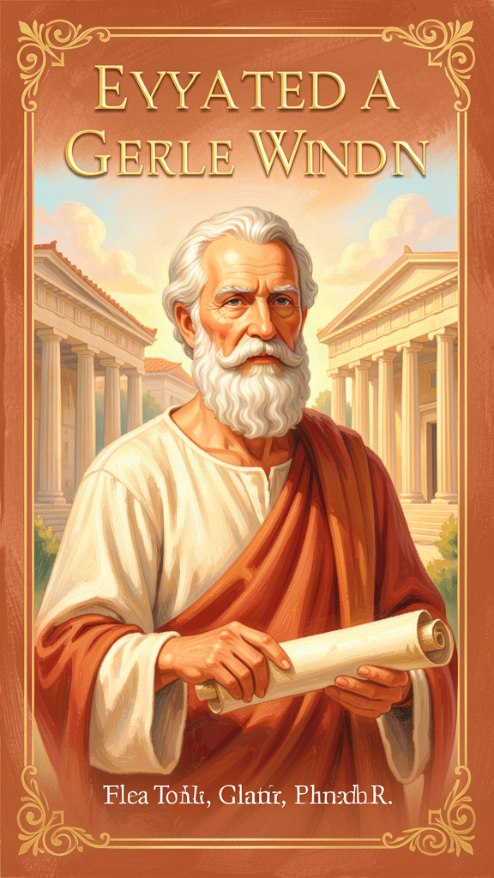
Aristotle: The Man Who Wanted to Understand Everything
WisdomForge Booklet — Ages 5–10

Aristotle: The Man Who Wanted to Understand Everything

WisdomForge Booklet — Ages 5–10
———

About This Book
This booklet tells the story of Aristotle, a thinker who lived in ancient Greece about 2,400 years ago. He was a student of the famous philosopher Plato, and he became the tutor of Alexander the Great, one of the most powerful kings in history. But Aristotle's biggest adventure was not on a battlefield or in a palace. It was in his mind.
Aristotle wanted to understand everything. He studied animals and plants, the stars and the seasons, how people think and how they argue, what makes a good life and what makes a good government. He founded a school called the Lyceum, where he walked with his students through gardens and groves, asking questions about the world.
Each chapter in this book tells a story about one of Aristotle's big ideas. There is a story, a real quote from his writing, a big idea to think about, something to try, and a question to ask a grown-up. You don't have to understand everything right away. The ideas are like seeds. They grow over time.
———

Chapter 1: The Good Life — What Is Everything For?
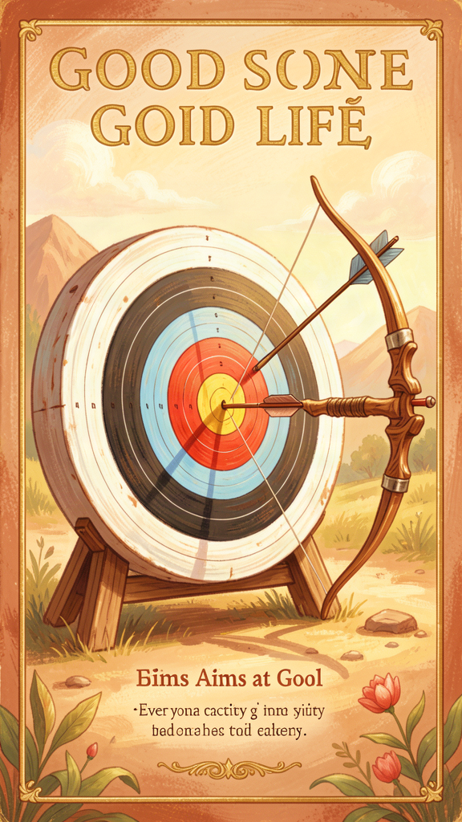
Illustration for Chapter 1
Long ago, in the city of Athens, there was a man named Aristotle who loved to walk and think. Every morning, he and his students walked together along the paths of the Lyceum, a beautiful grove of trees where they talked about everything in the world.
One morning, Aristotle stopped beside a fig tree and asked his students a question. "Tell me," he said. "When a doctor practices medicine, what is she trying to do?"
"To make people healthy," said a student named Theophrastus.
"And when a shipbuilder builds a ship, what is he trying to do?"
"To make a boat that sails well," said another student.
"And when a general makes a plan for battle, what is he trying to do?"
"To win," said the students.
Aristotle smiled. "You see? Every activity aims at something. The doctor aims at health. The shipbuilder aims at a good ship. The general aims at victory. Every single thing people do is trying to reach a goal."
He held up a hand. "But here is the big question. If every activity aims at something, is there one goal that all the others are trying to reach? Is there a top of the ladder?"
The students thought about this. One said, "Maybe the top goal is being happy."
"Maybe," said Aristotle. "But happiness is not just a feeling. It is a whole life lived well. The Greek word for it is eudaimonia — flourishing. Think of a plant that has everything it needs: sun, water, good soil. It grows strong and tall and beautiful. That is flourishing. A human being flourishes by living well — by being brave, kind, fair, and wise."
"So the good life," said Theophrastus, "is not just one thing. It is everything together."
"Exactly," said Aristotle. "Every activity aims at some good. The highest good is a life where you become the best version of yourself."
He looked at the fig tree. "Even this tree is trying to do something. It is trying to make figs. And when it makes good figs, it has done what a fig tree is supposed to do."
"What is a person supposed to do?" a young student asked.
Aristotle laughed. "That is the best question I have heard all morning. Come. Let us walk and think about it together."
Words to Remember Every art and every inquiry, and likewise every action and choice, seems to aim at some good; hence the good has been well described as that at which all things aim. — Aristotle, Nicomachean Ethics I.1
Big Idea Aristotle noticed that everything people do has a goal. You practice piano to play well. You study to learn. You help a friend to be kind. All these goals are like steps on a ladder. At the top of the ladder is the highest good — a life lived well, where you become the best person you can be. The Greek word for this is eudaimonia, which means flourishing. A flourishing life is not just feeling happy. It is a whole life where you use your best gifts well — your mind, your heart, and your courage.
Try This - Climb the ladder. Think of three things you do this week — homework, a sport, helping at home. Ask yourself: What is each one trying to reach? What goal is it aiming at? Draw a ladder with three rungs and put each activity on a rung. At the top, write one word for what all your activities are trying to reach. - Watch a plant grow. Find a plant — in a garden, a park, or a pot. Watch it for a week. What is it trying to do? It is trying to grow, make leaves, make flowers, make seeds. Everything in nature aims at something. People do too. - Ask the big question. Tonight, before you go to sleep, ask yourself: What is one thing I did today that helped me become a better person? It could be sharing with a sibling, being kind to a friend, or learning something new. That is one rung on your ladder.
Ask a Grown-Up "What is one thing you do every day that makes your life feel meaningful — that makes you feel like you are living well?"
———

Chapter 2: Finding the Right Amount — The Doctrine of the Mean
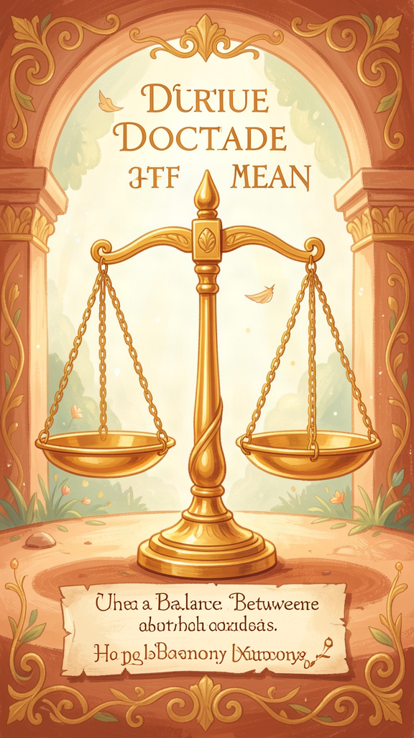
Illustration for Chapter 2
There were two boys in Aristotle's school. One was named Timon, and the other was named Bryson. They were both learning to swim in the river that ran through the hills near Athens.
Timon was afraid. He stood at the edge of the water and shivered. "What if it is too cold? What if I sink? What if there are fish that bite?" He would not put even one toe in the water.
Bryson was the opposite. He ran to the edge and leaped into the deepest part of the river without looking. "Cannonball!" he shouted. He could not swim well, but he jumped anyway. The current was strong, and he came up coughing.
Aristotle watched them both. He called them over.
"You are both making the same mistake," he said, "but in opposite directions."
Timon looked confused. "I am afraid. He is not. How is that the same?"
"Because neither of you is doing the right thing," Aristotle said. "Timon, you have too little courage. You are so afraid that you cannot even try. Bryson, you have too much of what looks like courage but is really recklessness. You jump in without thinking, without knowing whether you can swim."
He picked up a stick and drew a line in the sand. On the left, he wrote "too little." On the right, he wrote "too much." In the middle, he drew a star.
"The right amount is here, in the middle. Not too little courage, and not too much. The right amount is what I call the mean. And the mean is not the same for everyone. A strong swimmer can go into deep water. A beginner should stay in the shallow part. The right amount depends on who you are and what is happening."
He looked at Timon. "Courage does not mean having no fear. It means being afraid but doing the right thing anyway. Start in the shallow water. Put your feet in. When you are ready, go a little deeper."
Then he looked at Bryson. "And courage does not being foolish. Before you jump, check the water. Can you swim here? Is the current too strong? Being brave means being smart about your bravery."
That afternoon, Timon put his feet in the shallow water. Bryson practiced in the part where he could stand. Both boys were doing the right thing — the right amount for each of them.
"This works for everything," Aristotle told them. "Being generous is good. Giving away all your money is too much. Giving nothing is too little. The right amount is in the middle. Being honest is good. Telling everyone every thought you have is too much. Lying is too little. The right amount is in the middle."
He smiled. "You become brave by doing brave things. You become generous by giving. You become honest by telling the truth. Virtue is a habit. The more you practice the right amount, the more it becomes who you are."
Words to Remember Virtue is a state of character concerned with choice, lying in a mean, i.e., the mean relative to us, this being determined by rational principle and by that by which the practically wise person would determine it. — Aristotle, Nicomachean Ethics II.6
Big Idea Aristotle said that being good is not about having too much or too little of something. It is about finding the right amount. Think of a volume knob on a radio. Too low and you cannot hear the music. Too high and it hurts your ears. The right amount depends on the song and the room. Courage is the right amount between being scared of everything and being scared of nothing. Generosity is the right amount between giving nothing and giving everything away. The right amount is different for each person and each situation. You find it by thinking carefully and practicing.
Try This - Find the mean. Think of a time when you were either too scared or too reckless. Maybe you were afraid to try a new food, or maybe you ran too fast down a hill and fell. Write down what happened. Then write what the right amount would have been. What would the middle look like? - Practice the right amount. This week, pick one virtue to practice. Try generosity. Give something — a snack, a turn with a toy, a kind word — but do not give away so much that you feel bad. Find the right amount. Notice how it feels. - Watch others. Notice when people around you have too much or too little of something. Is someone talking too loud? That is too much. Is someone too quiet to be heard? That is too little. The right amount is in between. You are learning to see the mean.
Ask a Grown-Up "Can you tell me about a time when you had to find the right amount of something — not too much and not too little? How did you figure out what was right?"
———

Chapter 3: Three Kinds of Friends — The Ladder of Friendship
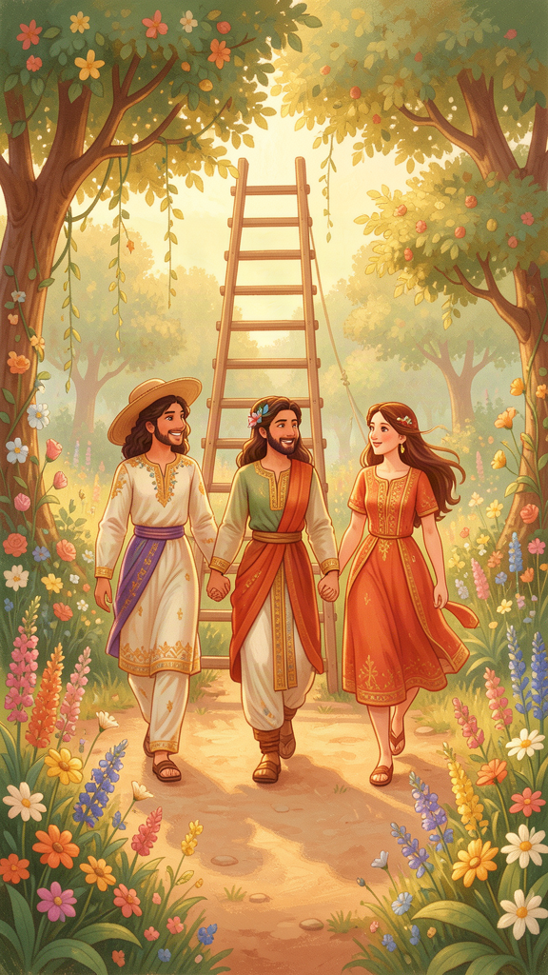
Illustration for Chapter 3
In the Lyceum, there was a girl named Myrrhine who loved to make friends. She had many friends, but Aristotle noticed that her friendships were different from each other.
There was a boy named Cephisus who helped Myrrhine with her math lessons. When she was stuck on a hard problem, Cephisus explained it. Myrrhine liked him because he was useful. When the math test was over, they did not always spend time together. Their friendship was real, but it was about the help they gave each other.
There was another girl named Glycera who was the most fun person Myrrhine knew. Glycera told the best jokes, played the best games, and always made Myrrhine laugh. They had wonderful times together. But when the fun stopped — when one of them was sad or in trouble — they did not always know what to say to each other. Their friendship was real, but it was about the pleasure of being together.
Then there was a boy named Eudemus. Eudemus was not the best at math, and he was not the funniest person in the school. But he was good. He was kind when no one was watching. He was honest even when it was hard. He stood by Myrrhine when she was sad, and he told her the truth even when she did not want to hear it. When Myrrhine was with Eudemus, she tried to be a better person, because he was a good person and she wanted to be good too.
One day, Aristotle asked Myrrhine about her three friends.
"Tell me," he said. "Are Cephisus, Glycera, and Eudemus all your friends?"
"Yes," said Myrrhine.
"Are they all friends in the same way?"
Myrrhine thought. "No," she said. "Cephisus helps me. Glycera makes me happy. Eudemus makes me better."
Aristotle nodded. "You have just described three kinds of friendship. The first is friendship for usefulness — you help each other. The second is friendship for pleasure — you enjoy each other. The third is friendship for goodness — you make each other better."
He held up three fingers. "The first two are not bad. It is good to help each other and good to enjoy each other. But they do not last. When the help is no longer needed, the first friendship fades. When the fun stops, the second friendship fades. Only the third friendship lasts, because it is not about what you get from the other person. It is about who the other person is."
"How do I find the third kind?" Myrrhine asked.
"You cannot find it by looking for it," Aristotle said. "You find it by becoming the kind of person who can be that kind of friend. Be good yourself. Then good friends will find you. The best friend is like a second self — someone who wants good things for you for your own sake."
Myrrhine looked across the garden at Eudemus, who was helping a younger student pick up scattered scrolls. She smiled. She did not need the most useful friend or the most fun friend. She needed the friend who helped her grow.
Words to Remember There are therefore three kinds of friendship, equal in number to the things that are lovable. Now those who love each other for their utility do not love each other for themselves but insofar as some good arises for them from each other. Similarly too with those who love for pleasure; for they do not love witty people for their characters but insofar as they are pleasant to them. The friendship of the good, however, is the friendship of those who are good in themselves. — Aristotle, Nicomachean Ethics VIII.3
Big Idea Aristotle said there are three kinds of friendship. The first kind is useful — friends who help each other, like a classmate who shares notes. The second kind is fun — friends who make you laugh and play games with you. Both of these are real friendships, but they fade when the help or the fun stops. The third kind is the deepest: friends who are good people and make you want to be good too. This friendship lasts because it is not about what you get. It is about who the other person is. The best friend is like a second self.
Try This - Make a friendship map. Draw three circles. In the first, write the names of friends who help you with things. In the second, write the names of friends who are fun to be with. In the third, write the names of friends who make you want to be a better person. Some names may be in more than one circle. That is good. Notice which circle has the fewest names. That is the rarest kind of friendship. - Be the third kind of friend. This week, pick one person and try to be their third-kind friend. Help them not because you need something back, but because they are good and you want them to do well. Tell them the truth. Stand by them when something is hard. - Watch a friendship grow. Think about one friendship that has lasted a long time. Why does it last? Is it useful, fun, or good? The friendships that last the longest are usually the third kind. See if you can tell why.
Ask a Grown-Up "Who is a friend who has been in your life for a long time? What makes them a friend who stays — not just someone useful or fun, but someone who makes you better?"
———

Chapter 4: Looking at the Stars — Contemplation as the Highest Happiness

Illustration for Chapter 4
Every evening, when the lessons were done and the Lyceum was quiet, Aristotle and his students walked to a hill outside Athens where they could see the sky. They lay on their backs in the grass and watched the stars appear, one by one, like tiny lamps being lit across the dark.
One night, a student named Cleobulus asked, "Teacher, you say the good life is a life of action — being brave, being generous, being a good friend. But tonight, we are not doing anything. We are just lying here, looking at the stars. Is this part of the good life too?"
Aristotle was quiet for a moment. A shooting star crossed the sky.
"Tell me," he said. "When you look at the stars, what are you doing?"
"Thinking," said Cleobulus.
"Thinking about what?"
"About how far away they are. About whether they move. About what they are made of. About why the sky is so beautiful."
Aristotle propped himself up on one elbow. "You are doing something very special right now. You are not making anything. You are not fixing anything. You are not helping anyone or fighting anyone. You are simply thinking about something true and beautiful. That is what I call contemplation."
"Is contemplation better than action?" Cleobulus asked.
"In one way, yes," Aristotle said. "When you are brave, you need something to be brave about. When you are generous, you need something to give. But when you contemplate, you need nothing but your mind. The mind can think about anything — stars, numbers, goodness, the nature of things — without needing anything outside itself. That makes contemplation the most self-sufficient activity."
He pointed at the sky. "Think about the stars. They move in perfect circles, night after night, year after year. They do not get tired. They do not change. Whatever moves them moves them forever. The thing that moves them does not get tired either, because it is not moved by anything else. It is pure activity — always thinking, always alive, never stopping."
"Is that God?" a student whispered.
"Perhaps," Aristotle said. "It is the highest thing I can imagine — a mind that thinks perfectly, forever, without needing anything. And when we think — when we look at the stars and wonder — we are doing, for a little while, what that mind does always. We are touching something divine."
The students were quiet. The stars turned slowly overhead.
"You do not need to understand all of this now," Aristotle said gently. "But remember this: the highest happiness is not just action. It is also wonder. When you look at the stars and your heart feels full of questions — that is not a small thing. That is the best part of you waking up."
Cleobulus lay back down. He watched a bright star climb above the hills. He did not understand everything Aristotle had said. But he felt something he could not name — a mixture of wonder and peace and the feeling that the world was bigger and more beautiful than he had known.
That feeling, Aristotle would have said, was contemplation. And it was the closest a human being could come to the happiness of the stars.
Words to Remember If happiness is activity in accordance with virtue, it is reasonable that it should be in accordance with the highest virtue; and this will be the virtue of the best part of us. Whether this be reason or something else that is thought to be naturally our ruler and guide and to be concerned with what is noble and divine... this activity would be the complete happiness of man. — Aristotle, Nicomachean Ethics X.7
Big Idea Aristotle said that the highest happiness is not just doing good things. It is thinking deeply about what is true and beautiful. He called this contemplation. When you look at the stars and wonder, when you think hard about a question that has no easy answer, you are doing something special. You are not making anything or fixing anything. You are just using the best part of yourself — your mind. Aristotle believed that thinking about big, beautiful, true things is the closest we come to the happiness of the divine. Wonder is not a small thing. It is the best part of you waking up.
Try This - Go outside and wonder. On a clear night, go outside and look at the stars. Do not try to name them or learn about them. Just look. Let yourself feel wonder. Ask one big question in your mind: What are those lights? How far away are they? Why are they there? You are doing contemplation. - Think about one thing deeply. Pick something you are curious about — a bug, a cloud, a number, a word. Spend ten minutes thinking about it. What is it? What is it made of? What does it do? Why is it the way it is? You are practicing what Aristotle called the highest activity. - Keep a wonder journal. Every night for a week, write down one thing that made you wonder. It could be a question, a feeling, something you saw. You do not need to answer the questions. Just collect them. Wonder is the beginning of contemplation.
Ask a Grown-Up "What is something you wonder about — something you do not have an answer for but like to think about anyway?"
———

Chapter 5: Four Questions About Everything — The Four Causes
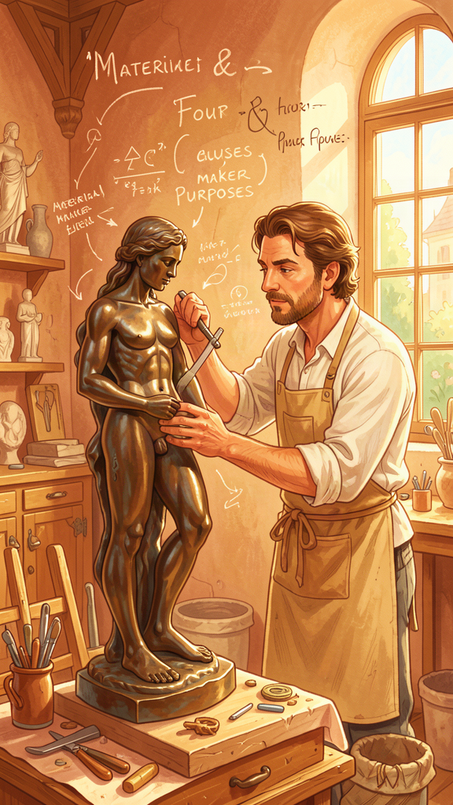
Illustration for Chapter 5
One morning, Aristotle brought his students to the workshop of a sculptor named Cephisodotus. The sculptor was making a statue of the god Apollo. A block of bronze sat on the floor. Nearby, a half-finished figure was taking shape — the young god, holding a bow, his face calm and strong.
Aristotle gathered his students around the statue.
"Today," he said, "we will learn to ask four questions about anything in the world. These four questions will help you understand why things are the way they are."
He pointed at the bronze. "Question one: What is it made of? This statue is made of bronze. The bronze is its material cause. Everything has a material cause. A table is made of wood. A bird is made of flesh and bone. A river is made of water."
He pointed at the shape the sculptor was carving. "Question two: What kind of thing is it? This is a statue of Apollo. The shape — the form of a young god holding a bow — is its formal cause. The form is what makes the thing what it is. Without the form, it is just a lump of bronze. With the form, it is a statue."
He pointed at the sculptor. "Question three: What made it? Cephisodotus made this statue. He is the efficient cause. Everything that comes to be has a maker. A bird is made by its parents. A table is made by a carpenter. A story is made by a storyteller."
He paused and looked at his students. "Question four: What is it for? Why does this statue exist? It exists to honor the god Apollo in the temple. That purpose — the reason for making it — is its final cause. Everything has a purpose. A heart exists to pump blood. A wing exists to fly. A pen exists to write."
Theophrastus raised his hand. "Can you ask these four questions about anything?"
"Anything," said Aristotle. "Try. Pick something."
"A tree," said Theophrastus.
"What is it made of? Wood, bark, leaves, roots, sap. That is the material cause. What kind of thing is it? An oak tree — its form is the shape and nature of an oak. That is the formal cause. What made it? An acorn, planted in the ground, grew by the power of nature. That is the efficient cause. What is it for? To grow, to make shade, to produce more acorns, to be a home for birds. That is the final cause."
A young student named Strato spoke up. "What about a person?"
Aristotle looked at him. "What are you made of? Flesh, bone, blood. What kind of thing are you? A human being — a living thing that thinks and chooses and loves. What made you? Your parents, and your own growth. What are you for? That is the biggest question of all. You are for living well — for using your mind and your heart and your courage to become the best version of yourself."
He smiled. "The four questions work on everything. The more you practice asking them, the more you understand the world. And understanding the world is the beginning of wisdom."
Words to Remember That for the sake of which something comes to be, and the good for the sake of which it comes to be — this is a cause. — Aristotle, Physics II.3
Big Idea Aristotle said that to understand anything, you need to ask four questions. What is it made of? (material cause). What kind of thing is it? (formal cause). What made it? (efficient cause). What is it for? (final cause). These four questions work on everything — a statue, a tree, a bird, a person. When you ask all four, you understand not just what something is but why it is the way it is. The most important question is the last one: What is it for? Everything has a purpose, and understanding the purpose is the key to understanding the thing.
Try This - Four questions for an object. Pick any object in your room — a book, a pencil, a shoe. Ask the four questions: What is it made of? What kind of thing is it? What made it? What is it for? Write the answers down. You are doing what Aristotle did. - Four questions for a living thing. Go outside and find a plant or an animal — a flower, a bug, a bird. Ask the four questions. What is it made of? What kind of thing is it? What made it? What is it for? The last question is the hardest and the most interesting. - Four questions for yourself. Ask the four questions about yourself. What are you made of? What kind of person are you? What made you who you are? What are you for? The last question is the one Aristotle spent his whole life thinking about. You do not need to answer it today. Just start asking.
Ask a Grown-Up "If you had to answer the four questions about your own life — what you are made of, what kind of person you are, what made you, and what you are for — which question is the easiest and which is the hardest?"
———

Chapter 6: The Dancer and the Music — The Unmoved Mover

Illustration for Chapter 6
One evening, Aristotle and his students sat by the river that ran below the Lyceum. The water moved over the stones, and the wind moved the leaves, and the sun moved down the sky toward the hills.
"Everything moves," said Aristotle. "The water moves. The wind moves. The sun moves. Animals move. People move. But have you ever wondered: What makes everything move?"
A student named Phania spoke. "The wind moves because the air is pushed by something. The water moves because the hill is sloped. The sun moves because... " He paused. "I do not know what moves the sun."
"Good," said Aristotle. "You are thinking. Everything that moves is moved by something else. The wind moves the leaves. The hill moves the water. Your muscles move your body. But if everything that moves is moved by something else, we have a problem."
"What problem?" asked Phania.
"Think of a long line of dominoes," said Aristotle. "The first domino falls because the second one pushed it. The second fell because the third pushed it. The third fell because the fourth pushed it. But what pushed the very first domino? If every domino is pushed by another domino, something must have started the whole chain — something that pushes but is not pushed itself."
The students were quiet.
"Or think of a dancer," Aristotle continued. He pointed to a girl across the river who was dancing to the sound of a flute. "She moves because she hears the music. The music does not push her. It draws her. She wants to dance because the music is beautiful. The music moves her without being moved itself."
He looked at his students. "The whole universe is like that dancer. Everything moves — the stars, the seasons, the living things. And at the beginning of all motion, there must be something that moves without being moved. Not because it pushes, but because it draws. It is the most beautiful and the most good thing there is, and everything else is drawn toward it, the way the dancer is drawn by the music."
"Is it God?" a student asked.
"I call it the Unmoved Mover," Aristotle said. "It is eternal. It never began and it will never end. It is pure activity — always thinking, always alive. It does not need anything. Everything else needs it."
He looked at the sky, where the first stars were appearing. "You do not need to understand all of this now. But carry the image with you: the dancer and the music. Everything in the world is in motion. Something at the center of it all is not moving but is moving everything else, the way beautiful music moves a dancer to dance. That something is the reason there is motion rather than rest. It is the reason the world exists at all."
The students watched the dancer across the river. She spun and leaped, her arms wide, her face full of joy. The music rose and fell. The stars turned slowly above. And for a moment, they could feel it — the sense that everything was connected, everything was moving, and at the heart of it all was something that did not move but made all the motion possible.
Words to Remember There is, then, something which is always moved with an unceasing motion, which is motion in a circle... and therefore there must be something which moves it. And since that which is moved and moves is intermediate, there must be something which moves without being moved. — Aristotle, Physics VIII.6
Big Idea Aristotle noticed that everything in the world moves. The stars move, the seasons change, animals walk, rivers flow. Everything that moves is moved by something else. But if every moving thing is moved by another moving thing, there must be something at the very beginning that moves without being moved. Aristotle called this the Unmoved Mover. It does not push things. It draws them, the way beautiful music draws a dancer to dance. The Unmoved Mover is eternal, perfect, and the reason there is any motion at all. Everything in the universe is moving because something at the center of it all is beautiful enough to draw everything toward it.
Try This - Watch the dominoes. Line up a row of dominoes or blocks. Knock over the first one and watch the chain reaction. Ask yourself: What started it? Your finger. Your finger is the unmoved mover of the dominoes. It moved without being moved by a domino. Now think bigger: What moved your finger? What moved that? Where does the chain stop? - Watch the dancer. The next time you hear music that makes you want to move, notice what happens. The music does not push you. It draws you. You move because the music is beautiful. That is how Aristotle imagined the Unmoved Mover. It does not push the universe. The universe is drawn to it because it is beautiful and good. - Think the biggest thought. Tonight, before you sleep, try to think the biggest thought you can: Everything is moving. The earth, the stars, your heart, your breath. And at the beginning of all that motion, something started it — something that does not move but makes all motion possible. You do not need to know what it is. Just wonder about it. Wonder is the beginning of understanding.
Ask a Grown-Up "Do you think there is something at the beginning of everything — something that started it all but was not started by anything else? What do you think that something is?"
———

For the Grown-Up Reader
This booklet adapts Aristotle's surviving works — primarily the Nicomachean Ethics, Physics, Metaphysics, On the Soul, Politics, and Poetics — into stories for young children. The historical details (Aristotle's life from 384 to 322 BCE, his twenty years in Plato's Academy, his founding of the Lyceum in 335 BCE, his observation of animals and the natural world) are drawn from the ancient biographer Diogenes Laërtius and the scholarly tradition summarized in Jonathan Barnes's edition of the complete works.
If a child asks, "Did Aristotle really say that?" the answer is yes for the quotations. Each Words to Remember passage is drawn from the surviving texts, cited by work and book number. The stories themselves are imaginative reconstructions in the spirit of his teachings, designed to make the ideas vivid and memorable for young minds. The characters — Theophrastus, Eudemus, Myrrhine, Cleobulus — are named after real members of Aristotle's school, but the stories are invented.
The six chapters map to the core of Aristotle's philosophy: the teleological structure of action and the good life (Chapter 1), the doctrine of the mean as virtue (Chapter 2), the three kinds of friendship (Chapter 3), contemplation as the highest happiness (Chapter 4), the four causes as a framework for understanding (Chapter 5), and the Unmoved Mover as first cause (Chapter 6). Together, they carry Aristotle's central conviction: that the world is intelligible, that human beings can understand it, and that understanding it is the highest activity we are capable of.
———

About WisdomForge
WisdomForge adapts the great philosophers into stories, audio, and conversation for every age. Each philosopher becomes four booklets — one for children, one for teens, one for older adolescents, and one for adults — so the same ideas can grow with you.

