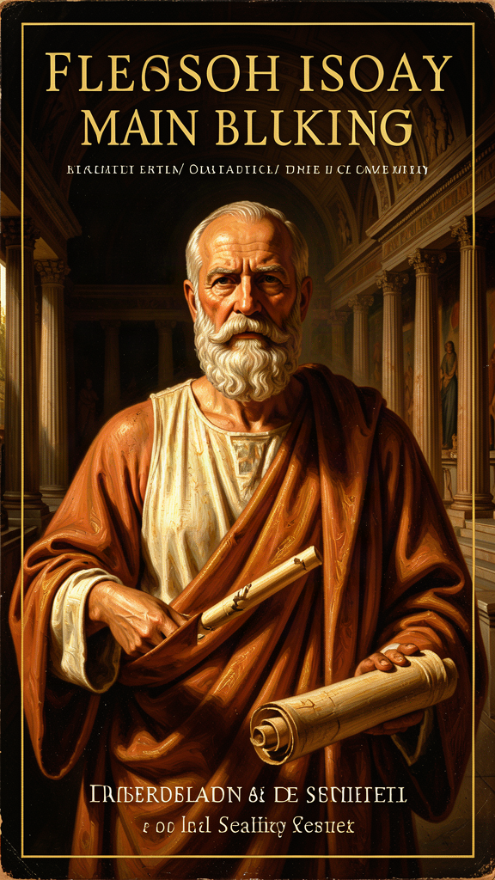
Aristotle: The Philosopher Who Taught the West How to Think
WisdomForge Booklet — Ages 15–18

Aristotle: The Philosopher Who Taught the West How to Think

WisdomForge Booklet — Ages 15–18
———

About This Book
Aristotle did not write for the general reader. He wrote for students, colleagues, and serious inquirers. The works we have read like compressed lecture notes — dense, systematic, technical — the working drafts of a mind that was building a comprehensive account of everything: logic, physics, biology, psychology, ethics, politics, rhetoric, and poetry. He was Plato's student for twenty years, Alexander the Great's tutor for several more, and the founder of the Lyceum, a research institution in Athens that collected data on animals, constitutions, and the natural world on a scale nobody had attempted before.
This booklet reads Aristotle as a philosopher of the good life, of character, of friendship, of the mind, and of the structure of reality. Six chapters trace six threads through his work: the good life as the aim of all activity, the doctrine of the mean as the structure of virtue, the three kinds of friendship, contemplation as the highest happiness, the four causes as a framework for understanding, and the Unmoved Mover as the first cause of all motion.
Each chapter combines a philosophical idea with historical context and a practical exercise. The goal is not to make you an Aristotelian. It is to give you tools: for examining your own choices, for understanding your relationships, for asking better questions about the world, and for thinking about what it means to live well. Aristotle's answers are not always ours. We do not share his views on slavery, women, or the structure of the cosmos. But his method — careful observation, clear definition, balanced judgment — is still a model for how to think. Read this booklet as an apprenticeship to a habit of mind, not as a doctrine to memorize.
———

Chapter 1: The Good Life — Every Activity Aims at the Good
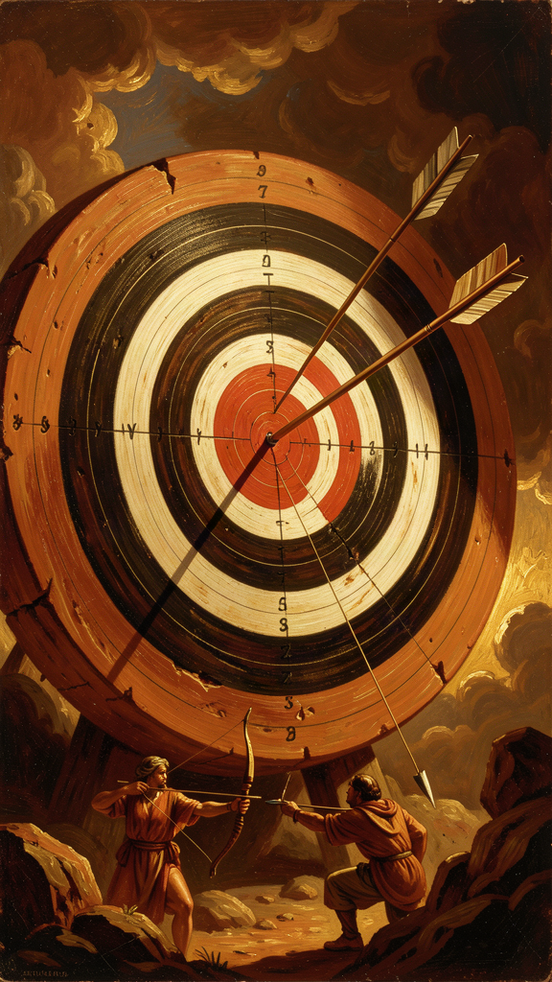
Illustration for Chapter 1
It is 335 BCE, and a man in his late forties is walking through a grove of trees near the temple of Apollo Lyceus, on the eastern edge of Athens. His name is Aristotle. He has been away from Athens for twelve years — first in Assos, then in Macedon, tutoring a teenage prince named Alexander who will, within a decade, conquer the known world. Now he is back, and he has founded a school. They call it the Lyceum, after the grove where it meets.
The Lyceum is not like Plato's Academy, where Aristotle spent twenty years as a student. The Academy focused on mathematics and dialectic. The Lyceum focuses on observation and classification. Aristotle and his students are collecting data — on the constitutions of 158 Greek cities, on the parts and behaviors of animals, on the history of philosophy, on the weather, on the Olympic victors. The treatises Aristotle writes — the Nicomachean Ethics, the Politics, the Metaphysics, the Physics, On the Soul, the Poetics — are the theoretical residue of this empirical program. They read like lecture notes because they are.
The Nicomachean Ethics is the most widely read of these works. It asks the most practical question in philosophy: How should a human being live? Aristotle opens with an observation that is more radical than it first appears:
Every art and every inquiry, and likewise every action and choice, seems to aim at some good; hence the good has been well described as that at which all things aim. (*Nicomachean Ethics* I.1, 1094a1–3)
Notice the modesty. Aristotle says "seems" and "has been well described." He is not proving the existence of a highest good on the first page. He is setting up a question. Every craft, investigation, action, and decision has a goal. Medicine aims at health. Shipbuilding aims at a vessel. Strategy aims at victory. If there is a single end that we want for its own sake — not for the sake of anything else — that end would be the highest good. The rest of the Ethics is the attempt to answer: What is that good?
Aristotle identifies it as eudaimonia. The word is often translated as "happiness," but that is misleading. Happiness suggests a feeling — something that comes and goes with circumstances. Eudaimonia is not a feeling. It is a whole life lived well. Aristotle defines it as activity of the soul in accordance with virtue, sustained over a complete lifetime, with enough external goods to make virtue possible. A flourishing life, not a happy mood.
To arrive at this definition, Aristotle uses what scholars call the function argument. Every thing has a function, and the good of that thing is performing its function well. A good knife cuts well. A good eye sees well. A good flute player exercises the function of flute playing well. What is the function of a human being? Not merely living (plants do that) or sensing (animals do that). The distinctively human function is the activity of the soul in accordance with reason. A good human being is one who exercises that function well.
The good for man is an activity of the soul in accordance with virtue, and if there are several virtues, in accordance with the best and most complete. (*Nicomachean Ethics* I.7, 1098a16–18)
The function argument is one of the most discussed passages in ancient ethics, and it raises immediate questions. Does it commit a naturalistic fallacy — deriving an "ought" from an "is"? Does saying that reason is our distinctive function already imply that we should cultivate it? And what about people whose reason is impaired — are they excluded from the good life?
Aristotle's defenders argue that the function argument is not deriving a moral ought from a biological is. It is making a teleological claim: things have natures, and the good of a thing is the actualization of its nature. A knife that does not cut is a bad knife. A human being who does not think, choose, and act well is not flourishing. The "ought" is not imposed from outside. It follows from what the thing is.
This has a practical consequence that shapes the entire Ethics: the good life is not something that happens to you. It is something you do. You become a good person by acting well — repeatedly, habitually, over time. We become brave by doing brave things, just by doing just things, temperate by practicing temperance. Excellence is not an act, but a habit. The Greek word for virtue — arete — means excellence, not moral purity. It is the excellence of a thing functioning well.
This is both encouraging and demanding. It means anyone can become virtuous — you do not need a special nature or a divine gift. You need practice. But it also means you cannot fake it. You cannot declare yourself virtuous. You have to do the work, in real situations, with real consequences, over time. And Aristotle is clear that external goods matter: you need enough resources, enough health, enough freedom to make virtue possible. A person crushed by poverty or tyranny may not be able to live well, no matter how virtuous their intentions. Eudaimonia is not just an internal state. It is a life, and lives require conditions.
Three scholarly debates are worth knowing, because they shape how the function argument is read.
The naturalistic fallacy objection. Does the function argument illegitimately derive an "ought" from an "is"? G. E. Moore, in Principia Ethica (1903), accused Aristotle of defining "good" in terms of a natural property — rational activity — which would make the claim "rational activity is good" a tautology. Aristotle's defenders respond that the argument is not defining "good." It is making a teleological claim: things have natures, and the good of a thing is the actualization of its nature. A knife that does not cut is a bad knife, not because someone decided cutting is good, but because cutting is what a knife is for. The "ought" follows from what the thing is.
The inclusivism debate. Is eudaimonia a single activity (contemplation, as Book X argues) or an inclusive whole that includes multiple goods (moral virtue, friendship, pleasure, external goods)? The inclusivist reading holds that eudaimonia is the whole of a good life, not a single activity within it. The dominant reading holds that contemplation is the single highest good and other goods are subordinate. The debate shapes how the entire Ethics is read. If inclusivism is right, the Ethics is a harmonious account of the good life. If the dominant reading is right, the Ethics ends by subordinating most of what it argued for to contemplation.
The external goods problem. Aristotle insists that eudaimonia requires "enough external goods." This creates a tension. If the good life depends on external goods, then it is not entirely under the agent's control. Martha Nussbaum, in The Fragility of Goodness (1986), develops this point: Aristotle's ethics acknowledges the role of luck in human life, and this makes it more honest but also more fragile than a system that locates the good entirely in the agent's will (as the Stoics would). The question of whether virtue is sufficient for happiness — or whether happiness also requires goods beyond the agent's control — is one of the deepest tensions in ancient ethics.
The Big Idea: The Teleological Structure of the Good Life
Aristotle's ethics is teleological: it is structured by ends, not by rules. Every activity aims at some good. The highest good is eudaimonia — flourishing, the full actualization of human potential, defined as activity of the soul in accordance with virtue over a complete life. The function argument grounds this: the good of a thing is performing its function well, and the function of a human being is rational activity. Therefore the good life is rational activity in accordance with virtue.
This changes the question you ask yourself. Instead of "Am I happy?" (a question about feelings) or "Am I following the rules?" (a question about compliance), you ask "Am I flourishing?" (a question about the whole shape of your life). Am I exercising my distinctive capacities well? Am I becoming the kind of person who is capable of flourishing? Am I building the habits — brave, generous, honest, temperate — that constitute a good character? The good life is not a destination. It is an activity, sustained over time, built one choice at a time.
Practice
1. The Aim Map. List five things you are pursuing right now — a grade, a sport, a relationship, a skill, a goal. For each, ask: What is this for? Keep asking until you reach something you want for its own sake. That thing is your candidate for the highest good. Is it worthy? Can it carry the weight of your whole life? If your answer is "getting into a good college" or "being popular," ask what that is for. Aristotle's bet is that if you keep asking, you will eventually arrive at something like eudaimonia — a whole life lived well. If you arrive somewhere else, notice what that says about your hierarchy of goods.
2. The Function Test. Aristotle says the function of a human being is rational activity. Test it. What are the capacities that make you distinctively human — not the ones you share with other animals, but the uniquely human ones? Thinking, choosing, deliberating, creating, loving, building. Which of these are you exercising well? Which are you neglecting? If the good life is the actualization of your distinctive capacities, then the question is not "What do I enjoy?" but "What am I built for, and am I using it?"
3. The Habit Audit. Aristotle says excellence is a habit, not an act. Audit your habits. Pick one virtue — honesty, courage, generosity, justice — and track your choices around it for one week. Each time you make a choice related to that virtue, write down what you did. At the end of the week, look at the pattern. Are your choices building the virtue or undermining it? Are you honest by habit, or honest only when it is easy? The audit is not about guilt. It is about data. Aristotle says character is built through repeated action. The audit shows you what you are building.
4. The External Goods Check. Aristotle says eudaimonia requires "enough external goods." What are yours? Do you have enough resources, health, freedom, and friendship to make virtue possible? If not, what would it take to get there? If yes, are you using your external goods well, or are you wasting the conditions that make a good life possible? This exercise counters the temptation to think that the good life is purely internal. Aristotle says it is not. Lives require conditions.
Reflect
Aristotle says the good life is activity in accordance with virtue over a complete lifetime. This means the good life cannot be assessed at any single moment. You cannot know whether you are flourishing by looking at one day, one year, or one success. You can only know whether you are flourishing by looking at the whole shape of a life — and even then, Aristotle says, you should "call no man happy until he is dead," because a single catastrophe can undo a life's flourishing. Is this too demanding? Does it make the good life unreachable? Or does it simply take seriously the fact that a life is a whole, not a series of moments? What would it mean to live as if your flourishing could only be assessed from the perspective of your complete life?
———

Chapter 2: The Doctrine of the Mean — Virtue Is a Habit of Choice

Illustration for Chapter 2
The doctrine of the mean is the most famous — and the most misunderstood — idea in Aristotle's ethics. It is not a call for moderation in all things. It is not a recommendation to split the difference. It is a theory of what virtue is and how it is built.
Aristotle's argument, in Nicomachean Ethics Book II, goes like this. Moral virtue is a settled state of character — not a feeling, not a capacity, but a hexis, a dispositional state that determines how you choose. Each virtue lies between two vices: one of excess, one of deficiency. Courage is between cowardice (deficiency of fear) and rashness (excess of fearlessness). Generosity is between stinginess (deficiency of giving) and prodigality (excess of giving). Truthfulness is between self-deprecation (deficiency) and boastfulness (excess). The virtue is the mean — the right amount, in the right way, at the right time, toward the right person, for the right reason.
Virtue is a state of character concerned with choice, lying in a mean, i.e., the mean relative to us, this being determined by rational principle and by that by which the practically wise person would determine it. (*Nicomachean Ethics* II.6, 1106b36–1107a2)
The key phrase is "the mean relative to us." The mean is not a mathematical midpoint. It is the right response for this particular person, in this particular situation, with these particular facts. The mean for a trained soldier facing danger is different from the mean for an untrained civilian. The mean for giving to a friend in genuine need is different from the mean for giving to a manipulative stranger. The mean is determined by phronesis — practical wisdom, the intellectual virtue that allows you to discern what morality requires when rules run out.
This is why the doctrine of the mean is not moderation. Sometimes the right response is intense. Sometimes it is restrained. A person who is being attacked may need to respond with maximum force — and that may be the mean, not excess. A person who is grieving may need to feel deep sorrow — and that may be the mean, not deficiency. The point is not to be in the middle. The point is to respond appropriately — to the right person, at the right time, for the right reason, in the right amount.
Aristotle makes a crucial qualification. Some actions are wrong in themselves, not because of excess or deficiency. Murder, theft, betrayal, adultery — these are not on a spectrum. There is no "right amount" of murder. You cannot be "moderately" treacherous. These actions are wrong by their nature, regardless of the circumstances. The doctrine of the mean applies to virtues that involve feelings and actions that can be done well or badly. It does not apply to actions that are always wrong.
The second part of the doctrine is about how virtue is built. Aristotle is emphatic: virtue is not innate. You are not born brave or generous or honest. You become these things through practice.
We become just by doing just things, temperate by doing temperate things, brave by doing brave things. (*Nicomachean Ethics* II.1, paraphrased)
This is the habit argument. You learn virtue the way you learn a craft. A builder learns to build by building. A harpist learns to play by playing. A person learns to be brave by acting bravely — first in small situations, then in larger ones — until brave action becomes a settled disposition. The more you practice the mean, the more natural it becomes. Eventually, the practically wise person does not need to calculate the mean consciously. They have internalized it. Their character is the mean. They feel the right things, at the right time, in the right amount, because years of practice have made that their default.
This has a paradoxical implication. Aristotle says that to become virtuous, you must act as the virtuous person would act — but you cannot do this well until you are already virtuous. It is like learning to play the piano: you must play to learn, but you cannot play well until you have learned. The solution is that you start badly. You practice the mean imperfectly, in small situations, and you get better over time. The beginning is awkward and uncertain. The end is a character so settled that doing the right thing feels natural.
Practical wisdom (phronesis) is what makes this possible. It is the intellectual virtue that allows you to perceive the mean in particular situations. Rules cannot do this. "Be brave" does not tell you how brave to be in this situation, with this danger, given your capabilities. "Be generous" does not tell you how much to give to this person, in these circumstances. Practical wisdom is the capacity to read the situation and discern what virtue requires. It is learned through experience, not through books. And it is what Aristotle calls "the eye of the soul" — the faculty that sees what is good in particular cases.
Two scholarly debates are worth knowing.
The unity of the virtues. Aristotle appears to argue that the moral virtues are unified — that you cannot have one without the others, because all of them require practical wisdom, and practical wisdom requires all of them. This is the "unity of virtue" thesis. If it is right, then you cannot be brave without also being just, generous, and temperate. If it is wrong, then virtues can come separately — a person can be brave but unjust, generous but intemperate. The debate matters because it determines whether virtue is a whole or a collection. Aristotle's text is ambiguous. Some passages suggest unity (practical wisdom is the same regardless of which virtue it serves). Others suggest separability (he discusses people who have one virtue but lack another). The issue remains open.
The problem of *akrasia* (weakness of will). Aristotle devotes Nicomachean Ethics Book VII to akrasia — knowing what is good but failing to do it. The akratic person has the right belief about what to do, but their reason is temporarily overcome by appetite or emotion. They know what is good, but they do not do it, because at the moment of action, their knowledge is "asleep" or displaced by desire. This is not the same as ignorance (you do not know what is good) or vice (you do not care what is good). It is a third condition: you know, you care, and you still fail. Aristotle's account of akrasia shaped the Western philosophical understanding of weakness of will from antiquity through Donald Davidson's 1969 essay "How Is Weakness of the Will Possible?" and into contemporary action theory. The problem is still live: if you know what is right and you want to do it, why do you sometimes not do it? Aristotle's answer — that reason can be temporarily displaced by desire — is not the only one, but it remains one of the most influential.
The Big Idea: Virtue as Responsive Excellence
The doctrine of the mean says that virtue is a settled state of character that disposes you to choose the mean — the right response, in the right amount, at the right time, toward the right person, for the right reason. The mean is not a midpoint. It is the response a practically wise person would make. Virtue is built through practice: you become brave by acting bravely, generous by giving, honest by telling the truth — repeatedly, until the behavior becomes a settled disposition.
The crucial concept is phronesis — practical wisdom. Rules cannot tell you what the mean is in a particular situation. Only practical wisdom can. And practical wisdom is learned through experience, not through instruction. This means Aristotle's ethics is not a rule-based system. It is a virtue-based system. The question is not "What is the rule?" but "What would a person of practical wisdom do here?" — and the answer requires judgment, perception, and experience.
Practice
1. The Mean Map. Pick a virtue you want to develop — courage, honesty, generosity, patience, justice. Identify the two vices on either side: one of excess, one of deficiency. Now track yourself for one week. Each time you make a choice related to that virtue, write down: What did you do? Was it the mean, or did you fall to excess or deficiency? What would the mean have looked like? At the end of the week, look for patterns. Do you consistently fall to one side? What situations push you there? The map shows you where your character is and where it needs to go.
2. The Anger Audit. Aristotle says there is a virtue concerned with anger — the right amount, at the right person, for the right reason, for the right duration. Track your anger for one week. Each time you feel angry, write down: At whom? Why? How intense? How long did it last? Was the anger proportionate? At the end of the week, assess: Are you angry at the right things, or at the wrong things? Is your anger proportionate, or is it excessive or deficient? The mean is not "don't get angry." It is "get angry at the right things, to the right degree, for the right duration."
3. The Habit Experiment. Pick one virtue and practice it deliberately for two weeks. Not in general — in specific actions. If honesty: tell the truth in five situations where you would normally hedge, soften, or avoid. If generosity: give five things — time, attention, a possession, a turn, a kind word — that you would normally keep. If courage: do five things that scare you (within reason). At the end of two weeks, ask: Has the practice made the virtue easier? Does it feel more natural? Aristotle says virtue is built through repetition. Test the claim.
4. The Practical Wisdom Exercise. Aristotle says practical wisdom is the ability to perceive what virtue requires in particular situations — and that it cannot be reduced to rules. Test this. Take a moral question from your own life (Should I tell my friend a truth that will hurt them? Should I report a classmate who cheated? Should I spend time with a struggling friend when I have my own work to do?). Try to answer it with a rule. Then try to answer it by asking: What would a person of practical wisdom do in this exact situation? Notice the difference. The rule gives you an answer. Practical wisdom gives you a better answer — one that accounts for the particulars the rule cannot reach.
Reflect
Aristotle says virtue is a habit built through repeated choices, and that practical wisdom — the ability to discern the mean in particular situations — is learned through experience, not through books. This means you cannot become virtuous by reading about virtue. You can only become virtuous by practicing it, in real situations, with real consequences, over time. Is this encouraging or discouraging? It means anyone can become virtuous — but it also means there are no shortcuts. What would it look like to treat your moral development the way you treat your development in a sport or a craft — as something that requires daily practice, honest feedback, and years of work?
———

Chapter 3: The Ladder of Friendship — Three Kinds of Friendship
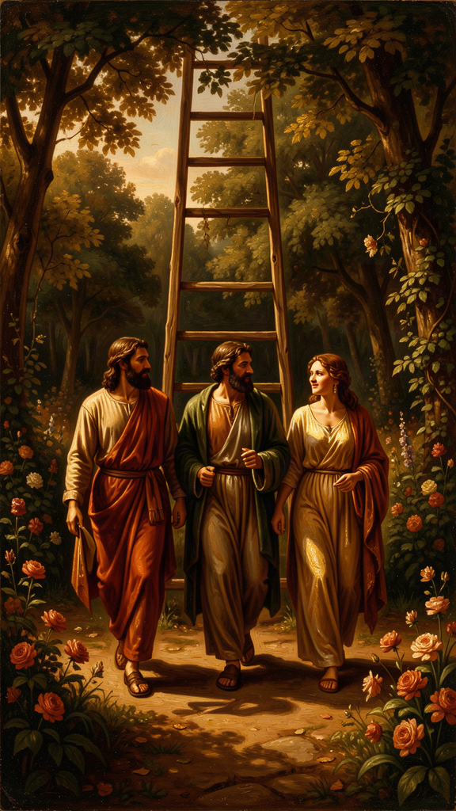
Illustration for Chapter 3
Aristotle dedicated two full books of the Nicomachean Ethics — Books Eight and Nine — to friendship. More space than he gives to any other topic. This is not accidental. For Aristotle, friendship is not a pleasant addition to a good life. It is necessary for a good life. You cannot flourish alone.
Without friends no one would choose to live, though he had all other goods. (*Nicomachean Ethics* VIII.1, 1155a5)
The argument is teleological. Human beings are political animals — we are made to live in communities. But the polis is not enough. The city provides the framework for a good life — laws, institutions, education — but it does not provide the intimate bonds that make life worth living. Those bonds are friendships. Without them, even the best city is a structure without a soul.
Aristotle distinguishes three kinds of friendship, based on what the friends love in each other:
There are therefore three kinds of friendship, equal in number to the things that are lovable. Now those who love each other for their utility do not love each other for themselves but insofar as some good arises for them from each other. Similarly too with those who love for pleasure; for they do not love witty people for their characters but insofar as they are pleasant to them. The friendship of the good, however, is the friendship of those who are good in themselves. (*Nicomachean Ethics* VIII.3, 1156a10–16)
Friendship for utility. You are friends because you are useful to each other. Study partners, business contacts, professional connections, neighbors who help each other out. This is a real friendship — it involves goodwill and mutual benefit. But it is incomplete. When the usefulness ends — when the class is over, the project is done, the neighbor moves — the friendship fades. It was never about the person. It was about the benefit.
Friendship for pleasure. You are friends because you enjoy each other. Teammates, party friends, people who share an interest, a sense of humor, a taste in music. This too is real friendship. But it is also incomplete. When the pleasure ends — when the team dissolves, the interests diverge, the jokes stop landing — the friendship fades. It was about the enjoyment, not the person.
Friendship for virtue. You are friends because you are both good people, and you love each other for who you are. This friendship is the fullest form. It is durable, because it does not depend on circumstances. It is mutual, because good people wish each other good for their own sake. And it is morally formative, because good friends make each other better. Aristotle says the best friend is "a second self" — someone whose good you wish as you wish your own, someone whose presence makes you a better version of yourself.
The first two are not bad. Aristotle is explicit about this. It is good to be useful to each other. It is good to enjoy each other. Most friendships involve some mix of all three. But only the third is friendship in the fullest sense, because only the third loves the other person for who they are, not for what they provide.
The third kind is rare, and Aristotle explains why. It requires time and shared life — trust is built through tested reliability, not through declarations. It requires moral similarity — you cannot be virtue friends with someone whose values you fundamentally do not share, because the friendship is built on mutual recognition of each other's goodness. It requires goodwill that is not transactional — you wish the other person well for their own sake, not because their wellbeing benefits you. And it requires scarcity — you can only have a few friendships of this depth, because each one demands sustained attention and care.
Aristotle also considers whether self-love is possible. Can you be a friend to yourself? His answer is yes — but only if you are a good person. A vicious person is at war with themselves, because their desires conflict with their reason. A good person is friends with themselves, because their desires and their reason are in harmony. The friendship of virtue is, in a sense, an extension of the right kind of self-love: you love your friend the way you love your own best self, wishing them good for their own sake.
This analysis has a sharp edge for modern life. Social media tends to produce utility- and pleasure-based friendships — connections built on shared interests, mutual benefit, or the pleasure of interaction, but not on deep mutual knowledge and moral commitment. These are not bad. But they are not the third kind. And if you treat them as if they were — if you expect a social media friend to carry the weight that only a virtue friend can carry — you will be disappointed. The disappointment is not the friend's fault. It is a category error. You asked a first- or second-kind friendship to do third-kind work.
A scholarly debate worth knowing: Aristotle's threefold classification has been challenged as incomplete. Some modern philosophers argue that it misses important forms of friendship — collegial friendship (built on shared professional commitment), civic friendship (built on shared citizenship), and what some call "friendship of association" (built on proximity and routine, like neighbors or coworkers). These are not reducible to utility, pleasure, or virtue. They have their own dynamics. Aristotle's classification may be a starting point, not a complete taxonomy. The question of whether his three kinds exhaust the field — or whether there are forms of friendship he did not see — remains open.
The Big Idea: Friendship as Moral Formation
Aristotle's three kinds of friendship are not a ranking from bad to good. They are an analysis of what friendships are built on, and therefore of what they can carry. Utility friendships are built on mutual benefit. Pleasure friendships are built on shared enjoyment. Virtue friendships are built on mutual recognition of each other's goodness. All three are real. But only the third is durable under pressure, because only the third does not depend on circumstances.
The third kind is also morally formative. Good friends make each other better. They hold each other accountable, model virtue for each other, and create a shared life in which goodness is practiced and reinforced. Aristotle says the best friend is "a second self" — and this means that friendship is not just a relationship. It is a mirror. You become like the people you spend your life with. Choose your friends carefully, because they are choosing who you become.
Practice
1. The Friendship Map. Make three columns: Utility, Pleasure, Virtue. List your friendships under the column that best describes what each is built on. Be honest. Some friendships are a mix — note that. The goal is not to rank your friends from best to worst. It is to see clearly what each friendship is built on, so you know what it can carry and what it cannot. A utility friend is great for homework help. Do not ask them to carry your deepest fears. A pleasure friend is great for fun. Do not expect them to be there in crisis. A virtue friend can carry weight. Do not take them for granted.
2. The Test Question. For each friendship, ask: If the usefulness ended, or the pleasure stopped, would this friendship survive? If yes, it may be the third kind. If no, it is the first or second. This is not a judgment. It is a diagnosis. Knowing what a friendship is built on tells you what you can ask of it — and what you owe it. Utility friendships require fairness and reciprocity. Pleasure friendships require enjoyment and presence. Virtue friendships require moral commitment and sustained attention.
3. Invest in the Third Kind. Identify one friendship that is — or could be — the third kind. This month, invest in it. Not with a grand gesture. With real conversations. Tell them something true about your life. Ask them something true about theirs. Be reliable when they need you. Notice when they are struggling. The third kind is not declared. It is built, through shared life, one conversation at a time.
4. The Mirror Exercise. Aristotle says you become like the people you spend your life with. Audit your closest friendships. What qualities do your friends have that you admire? What qualities do they have that you are absorbing — for better or for worse? If you are becoming like them, is that a good thing? The exercise is not about dropping friends. It is about awareness. Your friends are shaping you. Do you want the shape they are making?
Reflect
Aristotle says the third kind of friendship requires moral similarity — you cannot be deep friends with someone whose values you do not share. But he also says friendship is a mirror: you become like your friends. Is this a contradiction? If you can only be friends with people who are already like you, how do you grow? Or is the point that growth happens through the friendship — that being around a good person makes you better, even if you started from a different place? What does this mean for friendships across difference — political, religious, cultural? Can the third kind of friendship cross those lines, or does it require shared moral ground?
———

Chapter 4: Contemplation as the Highest Happiness
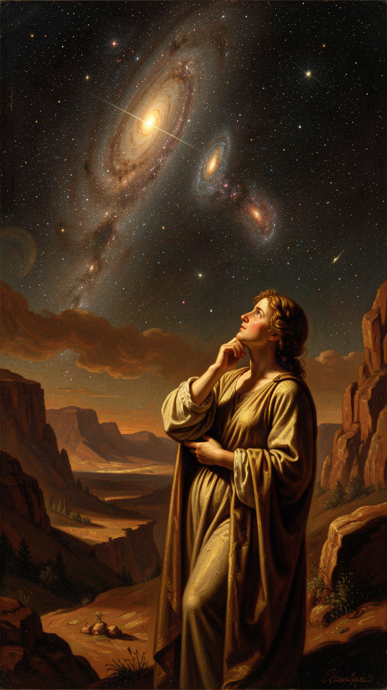
Illustration for Chapter 4
In the final book of the Nicomachean Ethics, Aristotle says something that seems to contradict everything that came before. After nine books arguing that the good life is a life of moral and political action — courage, generosity, friendship, civic engagement — he argues that the highest happiness is contemplation.
If happiness is activity in accordance with virtue, it is reasonable that it should be in accordance with the highest virtue; and this will be the virtue of the best part of us. Whether this be reason or something else that is thought to be naturally our ruler and guide and to be concerned with what is noble and divine... this activity would be the complete happiness of man. (*Nicomachean Ethics* X.7, 1177a12–18)
The argument is that contemplation (theoria) is the highest activity because it is the most continuous (you can think longer than you can do anything else), the most self-sufficient (you need less equipment, fewer external goods), the most pleasant (not fun, but deeply satisfying), loved for its own sake (nobody contemplates to get something else), and the most divine (the gods, if they exist, would think, not manage politics). Contemplation is the activity that most resembles the life of the divine.
This creates what scholars call the inclusivity problem. Is Aristotle saying the best life is only contemplation — withdrawing from the world to think? Or is he saying contemplation is the peak of a complete human life, which also requires moral virtue, friendship, and civic engagement? If the first, then the moral life of the first nine books is demoted. If the second, contemplation completes the moral life but does not replace it.
The majority scholarly reading is the second. Aristotle is not saying: withdraw and think. He is saying: within a complete human life — one that includes action, friendship, and civic engagement — the highest single activity is contemplation. The moral life is necessary. But it is not the summit. The summit is the moment when you stop doing and start understanding — when you think about what is true, what is good, what is beautiful, what the nature of things is.
There is a further argument. Aristotle connects contemplation to the divine. The Unmoved Mover — his name for the ultimate cause of all motion — is pure thought thinking itself (noesis noeseos). It is eternal, immaterial, and its activity is contemplation. When a human being contemplates, they are doing, for a finite time, what the divine does eternally. Contemplation is the point at which human life touches something beyond itself.
This is not a religious claim in the modern sense. Aristotle's Unmoved Mover is not the God of the Bible. It does not create the world, love humanity, or answer prayers. It is a metaphysical principle. But it is also the highest thing Aristotle can imagine — a mind that thinks perfectly, forever, without needing anything. And when we think — when we look at the stars, or work through a hard problem, or grasp something true about the nature of things — we are doing, for a moment, what that mind does always.
The scholarly debate here is called the inclusivity problem. Is Aristotle saying the best life is only contemplation — withdrawing from the world to think? Or is he saying contemplation is the peak of a complete human life, which also requires moral virtue, friendship, and civic engagement? The dominant reading holds that contemplation is the single highest good and other goods are subordinate. The inclusivist reading holds that eudaimonia is an inclusive whole — a life that includes contemplation, moral virtue, friendship, and external goods — and contemplation is the highest element within it, not a replacement for the rest. A third reading, associated with Sarah Broadie, holds that the two are not competitors. The moral life is the necessary condition of eudaimonia. Contemplation is its peak. A good life is moral action with moments of contemplation. The debate is unresolved and shapes how the entire Ethics is read.
The practical question is whether this is elitist. If the highest happiness is contemplation, does that mean most people — who do not have the time, education, or freedom to contemplate — are excluded from the best life? Aristotle's answer is complicated. He thinks contemplation is the highest activity, but he also thinks the moral life — the life of practical wisdom, friendship, and civic engagement — is available to more people and is a genuine form of flourishing. Not the peak, but a real good. A complete human life, for most people, is a moral life with moments of contemplation. For a few — philosophers, scientists, scholars — it may be a life organized around contemplation. Aristotle does not say everyone must be a philosopher. He says contemplation is the highest happiness, and the moral life is the second-best — which is still very good.
This matters for a practical reason. Most people live in a state of perpetual action — doing, producing, performing, optimizing — without ever stopping to ask what any of it is for. Aristotle's point is not that action is bad. It is that action without contemplation is blind. You do things because they are on the list, not because you have thought about whether they are worth doing. You pursue goals because they are expected, not because you have asked whether they are good. Contemplation is the activity that gives action its meaning. It is the moment when you step off the treadmill and ask: What is the good I am aiming at? Am I aiming at it well? What would it mean to live well, not just to do well?
The Big Idea: Contemplation as the Completion of Action
Aristotle's argument for contemplation as the highest happiness creates a tension in the Ethics that scholars have debated for two millennia. The best reading is that contemplation is not a replacement for the moral life but its completion. A good human life requires moral virtue, friendship, and civic engagement. But it also requires moments when you stop doing and start understanding — when you think about what is true, what is good, what is beautiful. Without contemplation, action is blind. Without action, contemplation is empty. The good life is both.
This has a practical implication. If you never stop to think about what your actions are for, you are not living a complete life. You are running on a treadmill. The treadmill may be productive — you may get good grades, win games, build a resume — but it does not ask the question that Aristotle says is the most important: What is the good? What is all this activity for? Contemplation is the activity that asks that question. It is not a luxury. It is the thing that makes the rest of it make sense.
Practice
1. The Daily Contemplation. For one week, spend fifteen minutes every day in pure thought. No phone, no music, no agenda. Sit somewhere quiet. Think about a question that matters to you — not a practical problem to solve, but a question to sit with. What is the good life? What is friendship for? What does it mean to be brave? Do not try to answer the question. Just hold it. Let your mind work on it. Notice what happens to your relationship with your daily activities when you have spent fifteen minutes asking what they are for.
2. The Hard-Book Practice. Find a book — fiction or nonfiction — that is genuinely difficult for you. Not impossible, but hard. Read it slowly, for thirty minutes a day, without checking your phone. When you do not understand something, stay with it. Reread. Think about it. This is contemplation applied to a text. You are not reading for information. You are reading for understanding — the activity Aristotle says is the highest happiness.
3. The Action Audit. List everything you are doing right now — activities, commitments, obligations, pursuits. For each, ask: When was the last time I thought about why I am doing this? If the answer is "never" or "I don't remember," that activity has lost its contemplative grounding. Pick one item and spend fifteen minutes thinking about it. What is it for? What good does it aim at? Is it still worth doing? The audit is not about quitting things. It is about reconnecting action to the thinking that gives it meaning.
4. The Inclusivity Test. Aristotle says contemplation is the highest happiness but the moral life is also good — second-best but still real. Test this against your own life. What would it look like to organize your life around contemplation? What would you have to give up? What would you gain? Now what would it look like to organize your life around moral action — friendship, service, civic engagement — with contemplation as an occasional peak? Which life is available to you? Which do you want? The test is not to choose. It is to see the two options clearly and understand what each requires.
Reflect
Aristotle says contemplation is the most self-sufficient activity — you need less equipment, fewer external goods, to think than to do anything else. But is that true? Contemplation requires free time, education, safety, and a degree of material security. If you are struggling to survive, you may not have the luxury to contemplate. Does this make Aristotle's hierarchy elitist? Or does it simply name a condition that most people can meet at least occasionally — the fifteen minutes before sleep, the walk without earbuds, the Sunday morning with nothing scheduled? What would it take to make contemplation available to more people, not just to those who can afford it?
———

Chapter 5: The Four Causes — Why Things Are the Way They Are
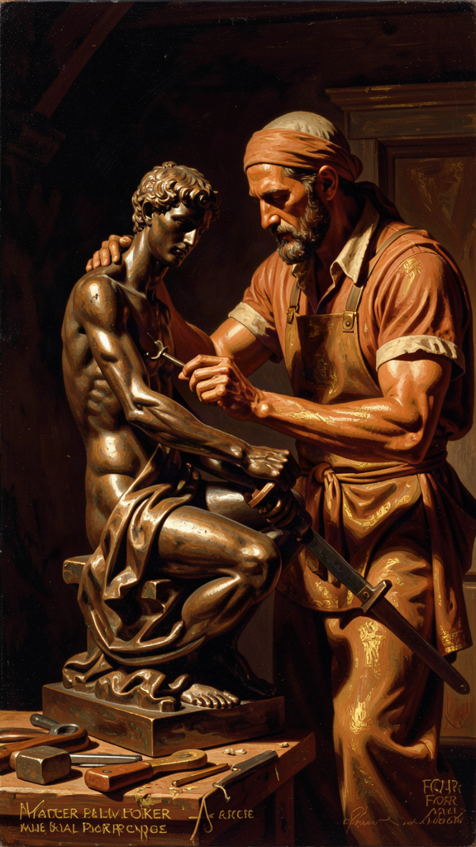
Illustration for Chapter 5
Aristotle's four causes are one of his most influential and most contested ideas. He presents them in the Physics (Book II, Chapter 3) and the Metaphysics (Book V, Chapter 2). The argument is that to explain anything fully, you need four kinds of answer.
Material cause — What is it made of? A statue is made of bronze. A house is made of wood and stone. A human being is made of flesh and bone. The material cause is the stuff out of which a thing is made.
Formal cause — What kind of thing is it? The statue has the shape of a god. The house has the form of a house — a structure with walls, a roof, and rooms. A human being has the form of a human being — a living, rational animal. The formal cause is the pattern, structure, or essence that makes the thing the kind of thing it is.
Efficient cause — What brought it into being? The sculptor made the statue. The carpenter made the house. The parents made the child. The efficient cause is the agent or process that produced the thing.
Final cause — What is it for? The statue exists to honor a god. The house exists to provide shelter. The heart exists to pump blood. The final cause is the purpose, end, or telos for which the thing exists.
That for the sake of which something comes to be, and the good for the sake of which it comes to be — this is a cause. (*Physics* II.3, 195a23–24)
The four causes are a theory of explanation. Aristotle is saying that a complete explanation of anything requires all four. If you know what a thing is made of but not what it is for, you do not really understand it. If you know what brought it about but not what kind of thing it is, you do not really understand it. Full understanding requires material, formal, efficient, and final causes.
The framework is connected to Aristotle's hylomorphism — the doctrine that substances are composed of matter (hyle) and form (morphe). A bronze statue is not just bronze; it is bronze shaped in a certain way. A human being is not just a body; it is a body animated by a soul. The soul is the form of the body — what makes it alive, what makes it the kind of living thing it is. Matter without form is just stuff. Form without matter is an abstraction. Real things are composites of both.
We can dismiss as unnecessary the question whether the soul and the body are one: it is as though we were to ask whether the wax and its shape are one. (*On the Soul* II.1, 412b6–8)
This is Aristotle's answer to both materialism and Platonism. Things are not just stuff (materialism). But form is not a separate thing floating in a realm of its own (Platonism). Form is the principle that makes matter what it is. The soul is not a ghost in a machine. It is what makes the body alive — the way the shape of a statue makes the bronze a statue.
Hylomorphism raises a question that has driven philosophy of mind for two thousand years: the problem of personal identity. If a thing is matter plus form, what persists over time? A statue can lose some bronze and gain new bronze and remain the same statue. A human body replaces most of its cells over a lifetime. Are you the same person because your matter persists (but it doesn't, entirely), or because your form persists (but what is form, if not the pattern of matter)? Aristotle's hylomorphism does not resolve this. It frames it. The debate continues in contemporary philosophy of mind, from neo-Aristotelian accounts of hylomorphic personal identity to opposing views that persons are best understood as psychological continuities rather than hylomorphic composites.
The most controversial of the four causes is the final cause — purpose, telos. Aristotle's natural philosophy is thoroughly teleological: it explains things by their ends. "Nature does nothing in vain," he says repeatedly (On the Soul III.13, 435a18; Politics I.2, 1253a9). The structure of an animal's body, the growth of a plant, the fall of a stone — all can be understood as movements toward a natural end. A bird's wing exists for the sake of flight. A fish's gill exists for the sake of breathing underwater. The eye exists for the sake of seeing.
Modern science largely abandoned final causes in physics. The Scientific Revolution replaced "what is it for?" with "what caused it?" — efficient causes, not final causes. A stone does not fall because it is "trying to reach its natural place." It falls because gravity accelerates it toward the earth's center. The question "what is a stone for?" does not have a scientific answer in physics.
But final causes survived in two places. First, in biology, where functional explanation is still indispensable. Why does the heart have four chambers? To pump blood efficiently through the lungs and body. Why do birds have hollow bones? To reduce weight for flight. These are final-cause explanations, and they are not replaceable by efficient-cause explanations. You can describe the evolutionary mechanism (efficient cause) that produced hollow bones — natural selection favored lighter skeletons in flying animals — but you still need the functional explanation (final cause) to understand why the trait was selected. Biology is still teleological, even if physics is not.
Second, in ordinary reasoning about human action. Why did you build that bookshelf? The material cause is wood and screws. The formal cause is the design. The efficient cause is you, with tools. The final cause is to hold your books. Try explaining the bookshelf without the final cause. You can describe the wood, the shape, and the construction in infinite detail, and you still will not understand why it exists. For that, you need to know what it is for.
The four causes are also a tool for self-understanding. Apply them to your own life. Material cause: what are you made of — physically, temperamentally, socially? Formal cause: what kind of person are you — what is your form, your character, your essence? Efficient cause: what made you who you are — your parents, your education, your experiences, your choices? Final cause: what are you for? This last question is the hardest and the most important. Aristotle's answer is that the final cause of a human being is eudaimonia — flourishing, the full actualization of human potential. But what does that mean, specifically, for you? What are you for?
The Big Idea: Explanation Requires All Four Causes
Aristotle's four causes are a theory of what a complete explanation requires. To understand anything, you need to know: what it is made of (material), what kind of thing it is (formal), what brought it about (efficient), and what it is for (final). The most important and most contested is the final cause — purpose, telos. Modern science abandoned final causes in physics, but they survive in biology (where functional explanation is indispensable) and in ordinary reasoning about human action (where purpose is irreducible). The framework also applies to yourself: what are you made of, what kind of person are you, what made you, and what are you for? The last question is the one Aristotle spent his career thinking about.
Practice
1. Four Causes for an Object. Pick any object near you. Ask the four questions: What is it made of? What kind of thing is it? What made it? What is it for? Write down the answers. Notice which question is easiest and which is hardest. The final cause is almost always the hardest — and the most revealing. If you cannot say what something is for, do you really understand it?
2. Four Causes for a Living Thing. Go outside and find a plant or animal. Apply the four causes. For a living thing, the final cause is usually connected to survival and reproduction — but ask deeper. What is the good of this thing? What does it do well? What is its telos? Aristotle says "nature does nothing in vain." Whether or not you agree, the exercise of asking what a living thing is for changes how you see it. It becomes not just a thing that exists, but a thing with a purpose.
3. Four Causes for a Human Institution. Apply the four causes to something social — a school, a team, a government, a religion. Material: what is it made of (people, buildings, money)? Formal: what kind of institution is it (what is its structure)? Efficient: what created it (history, founders, events)? Final: what is it for? The final cause of an institution is often contested — people disagree about what a school or a government is for. The four-cause analysis makes the disagreement visible. Try it on an institution you care about. What do you think it is for? What do others think? Where do you disagree?
4. Four Causes for Yourself. Apply the four causes to your own life. Material: what are you made of — physically, temperamentally, socially? Formal: what kind of person are you — what is your character, your form? Efficient: what made you who you are — parents, education, experiences, choices? Final: what are you for? This last question is the one Aristotle spent his career thinking about. You do not need a final answer. But you need to be asking. Write a one-page response to all four. The page on the final cause will be the hardest to write — and the most important.
Reflect
Aristotle says "nature does nothing in vain" — every natural feature has a purpose. Modern evolutionary biology explains apparent design without attributing intentions to nature: wings exist because they were selected for, not because nature "wanted" flight. Is Aristotle's teleology simply wrong, superseded by Darwin? Or did he identify a kind of explanation — functional explanation — that evolutionary biology still needs, even if it rejects the metaphysical claim that nature has intentions? If biology still needs final-cause explanations (the heart is for pumping blood), then Aristotle's framework is not obsolete. It is partially right, partially wrong, and the boundary between the two is one of the most interesting questions in philosophy of science. Where do you draw the line?
———

Chapter 6: The Unmoved Mover — The First Cause of All Motion
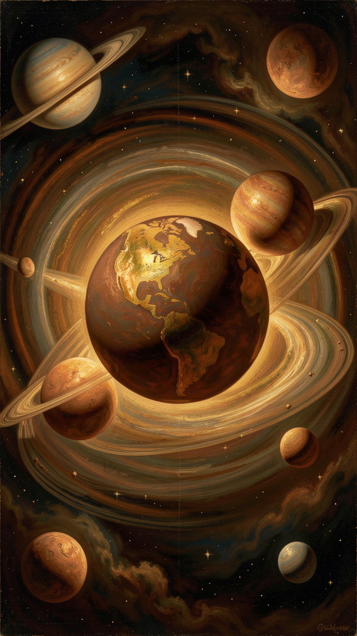
Illustration for Chapter 6
Aristotle's argument for the Unmoved Mover is in Physics Book VIII and Metaphysics Book XII. It is one of the most influential arguments in the history of philosophy, and it addresses one of the oldest and deepest questions: Why is there motion rather than rest?
The argument, stripped to its skeleton:
1. Everything that is in motion is moved by something else. (Aristotle defines motion as the actualization of a potential. Whatever is moving from potential to actual must be moved by something already actual. A cold stone becomes warm because something warm acts on it. A seed becomes a tree because the form of the tree, present in the parent, guides the growth.)
2. The chain of movers cannot go back to infinity. (If every mover is itself moved by another mover, and that by another, ad infinitum, there is no first mover. But an infinite chain of dependent movers explains nothing — the motion is never accounted for. There must be a starting point, a first mover that is not itself moved.)
3. Therefore, there must be a first mover that is itself unmoved. (This is the Unmoved Mover — to kinoun akineton. It causes motion without being moved. It is the beginning of the chain.)
There is, then, something which is always moved with an unceasing motion, which is motion in a circle... and therefore there must be something which moves it. And since that which is moved and moves is intermediate, there must be something which moves without being moved. (*Physics* VIII.6, 258b10–15)
The crucial question is how the Unmoved Mover causes motion. It does not push. It is not a physical force. Aristotle's answer: the Unmoved Mover causes motion as an object of desire and thought. It moves the heavens the way a loved object moves the lover, or the way beautiful music moves a dancer. It does not act on the world. It attracts the world. The cosmos is drawn toward it because it is the most beautiful, the most good, the most perfect thing there is.
The Unmoved Mover is pure actuality — energeia with no dynamis, no potentiality. It cannot change, because change is the actualization of a potential, and it has no potential. It cannot come to be or pass away. It is eternal. It is immaterial. It is divine. Its activity is contemplation — pure thought thinking itself (noesis noeseos). It thinks about itself, because there is nothing better to think about.
It is a life such as the best which we enjoy, and enjoy for but a short time... its life is of such as ours for a short time, but its life is always so. (*Metaphysics* XII.7, 1072b14–16)
This is not the God of the Bible. The Unmoved Mover does not create the world, love humanity, or answer prayers. It is a metaphysical principle — the ultimate explanation for why there is motion rather than rest. But it is also, in a sense, divine. It is eternal, perfect, and the object of the highest activity (contemplation). When a human being contemplates, they are doing, for a finite time, what the Unmoved Mover does eternally.
The argument had an enormous afterlife. In the Middle Ages, Jewish, Islamic, and Christian theologians saw it as a philosophical anticipation of God. Moses Maimonides adapted it in the Guide for the Perplexed. Avicenna and Averroes debated it in the Islamic tradition. Thomas Aquinas adapted it as the First of his Five Ways to prove the existence of God. The argument has also been attacked. David Hume argued that the causal principle does not extend beyond our experience. Immanuel Kant argued that the concept of a necessary being is incoherent. Modern cosmology describes a universe that began with the Big Bang and may not require a first cause in the Aristotelian sense.
But the question does not go away. Even if you accept the Big Bang as the beginning of the physical universe, you can still ask: What caused the Big Bang? And if you say "nothing," you are saying the chain of physical causes stops at something that was not caused by anything physical — which is not so different from what Aristotle said. The argument does not prove the God of any religion. It argues that the chain of motion requires a starting point. What you call that starting point — God, the Big Bang, the Unmoved Mover, the first cause — depends on your metaphysics. The argument tells you there must be a something. It does not tell you what the something is.
The Big Idea: The Question That Does Not Go Away
Aristotle's Unmoved Mover is his answer to: Why is there motion rather than rest? The argument: everything in motion is moved by something else. The chain cannot go back to infinity. Therefore, there must be a first mover that moves without being moved. The Unmoved Mover causes motion not by pushing but by attracting — as an object of desire and thought. It is pure actuality, eternal, immaterial, and divine.
The argument has been adapted by theologians and challenged by philosophers and scientists. But the question it addresses — why is there something rather than nothing? — remains live. Even modern cosmology, which traces the universe back to the Big Bang, does not answer the question of what caused the Big Bang, or why there is a universe at all. Aristotle's argument does not settle the matter. But it identifies the question, and it argues that the question requires an answer. The chain of causes cannot be infinite. There must be a starting point. What that starting point is — that is the question every metaphysics must answer.
Practice
1. Trace the Chain. Pick something that is moving right now — a bird, a car, a cloud, your own hand. Ask: What is moving it? Then ask: What moved that? Keep going. How far can you trace the chain? Where does it stop? This is the exercise Aristotle is running in Physics Book VIII. You probably will not reach the Unmoved Mover. But you will feel the shape of the question. Everything in motion is moved by something else. Where does the chain stop?
2. The Dancer and the Music. The next time you see someone moved by music — dancing, swaying, tapping a foot — ask: What is moving them? The music does not push them. It draws them. They move because the music is beautiful. This is how Aristotle imagines the Unmoved Mover. It does not push the universe. The universe is drawn toward it because it is the most beautiful and most good thing there is. The image is not a proof. But it is a way of understanding what kind of cause the Unmoved Mover is — an attractive cause, not a mechanical one.
3. The Infinite Chain Objection. Aristotle says the chain of movers cannot be infinite. Write the strongest objection you can to this claim. Why might an infinite chain be acceptable? (Hint: some modern philosophers argue that an infinite causal chain is logically possible, even if it is psychologically unsatisfying.) Then write Aristotle's best response. The exercise is not to settle the question. It is to see both sides clearly.
4. The Metaphysics Test. Aristotle's argument concludes that there must be a first cause. What is yours? Write one paragraph: What do you think is at the beginning of the chain of motion — God, the Big Bang, the Unmoved Mover, brute fact, something else? Then write one paragraph on why. The goal is not to prove anything. It is to discover your own metaphysical commitments — the assumptions about reality that you bring to the question before you start arguing.
Reflect
Aristotle's Unmoved Mover is pure thought thinking itself — eternal, immaterial, divine, and completely indifferent to the world it moves. It does not create, love, or care. It attracts. Later theologians, especially Aquinas, saw this as a philosophical road to God. But the gap between Aristotle's Unmoved Mover and the God of the Bible is enormous. Can Aristotle's argument be honestly adapted to prove the God of a religion? Or does it prove, at most, a metaphysical principle — a first cause that may or may not be personal, conscious, or loving? What is at stake in this question, and what does your answer reveal about the relationship between philosophy and theology?
———

For the Grown-Up Reader
This booklet adapts Aristotle's surviving works — primarily the Nicomachean Ethics, Physics, Metaphysics, On the Soul, Politics, and Poetics — into narrative essays for high-school readers. The historical context (Aristotle's life from 384 to 322 BCE, his twenty years in Plato's Academy, his tutoring of Alexander, his founding of the Lyceum around 335 BCE, his empirical method) is drawn from Diogenes Laërtius and the scholarly tradition, as summarized in Jonathan Barnes's edition of the complete works and the secondary literature cited in the research files.
If a teenager asks, "Did Aristotle really say this?" the answer is yes for every quotation. The quotes are drawn from the Revised Oxford Translation and the translations by Terence Irwin (Nicomachean Ethics), Joe Sachs (Metaphysics and Physics), Carnes Lord (Politics), and Daniel Kolak (On the Soul). The philosophical analysis reflects mainstream scholarly interpretation, with attention to the major debates: the inclusivity problem (is the best life contemplative or active?), the naturalistic fallacy objection to the function argument, the status of final causes in modern science, and the relationship between the Unmoved Mover and the God of theism.
A note on Aristotle's difficult passages: the Politics contains defenses of slavery and the subordination of women that modern readers find troubling. These are not incidental. They are part of Aristotle's teleological framework — he believed some people were "natural slaves" and that women were naturally subordinate. These claims are wrong, and they should be confronted directly, not ignored. Aristotle's method — careful observation, clear definition, balanced judgment — is still a model for thinking. But his conclusions are not always ours, and the places where they diverge are instructive.
———

About WisdomForge
WisdomForge adapts the great philosophers into stories, audio, and conversation for every age. Each philosopher becomes four booklets — one for children, one for younger teens, one for older adolescents, and one for adults — so the same ideas can grow with you. The Aristotle series covers the good life and eudaimonia, the doctrine of the mean, the three kinds of friendship, contemplation as the highest happiness, the four causes, and the Unmoved Mover — the same system, told at four levels of depth.

