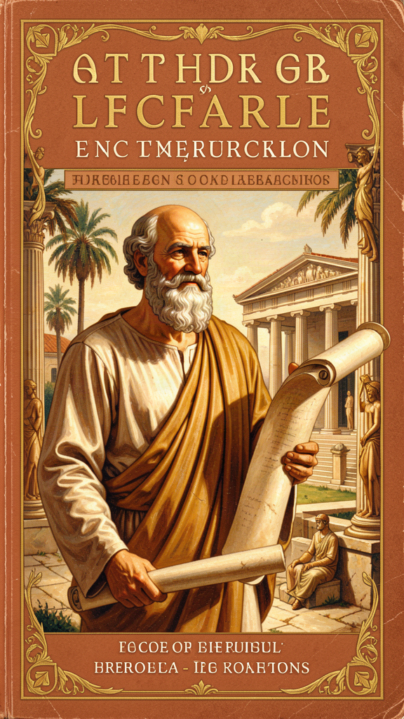
Aristotle: The Man Who Tried to Understand Everything
WisdomForge Booklet — Ages 11–14

Aristotle: The Man Who Tried to Understand Everything

WisdomForge Booklet — Ages 11–14
———

About This Book
Most people who have heard of Aristotle know two things: he was Plato's student, and he was Alexander the Great's tutor. Both are true. But they barely scratch the surface of who this man was and why his ideas still matter.
Aristotle lived from 384 to 322 BCE, in ancient Greece. He was not a king or a soldier. He was a thinker — one of the most wide-ranging thinkers the world has ever produced. He wrote about logic, physics, biology, psychology, ethics, politics, rhetoric, and poetry. He founded a school called the Lyceum, where he and his students collected information about the natural world on a scale nobody had attempted before. They studied the constitutions of 158 Greek cities. They dissected animals. They classified living things. They watched the stars.
What made Aristotle different from his teacher Plato was his method. Plato looked upward — toward eternal Forms, toward a perfect reality behind the visible world. Aristotle looked around him — at animals, at constitutions, at arguments, at emotions. He believed that to understand anything, you had to look at it closely, define your terms carefully, review what others had said, and work through the problem step by step. He did not dazzle. He constructed.
This booklet follows Aristotle through six of his most important ideas: the good life, the doctrine of the mean, friendship, contemplation, the four causes, and the Unmoved Mover. Each chapter combines a story with context, a big idea, something to try, and something to talk about. You don't have to agree with everything Aristotle said. But you might be surprised how much of it still works — not because he got everything right, but because his method of careful, patient, honest thinking is still a model for how to make sense of the world.
———

Chapter 1: The Good Life — Every Activity Aims at the Good
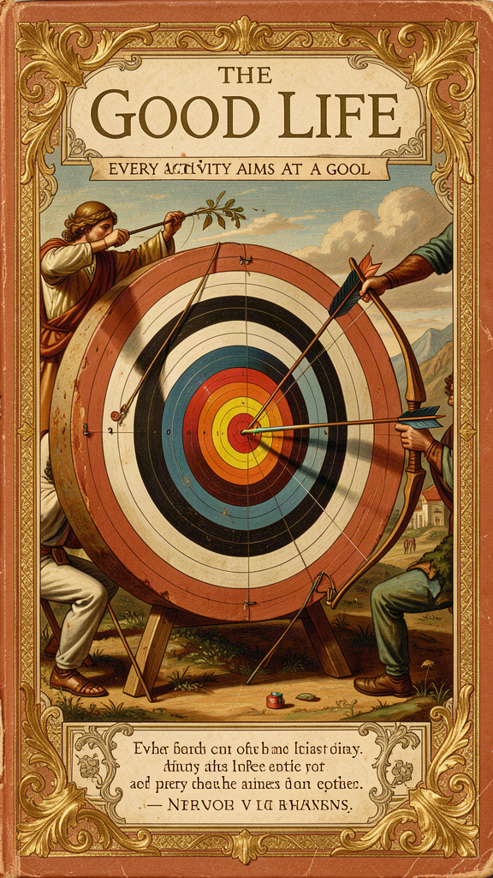
Illustration for Chapter 1
Damaris had a plan for eighth grade, and the plan was already fraying.
The plan was simple: get good grades, make the basketball team, get invited to the right parties, and become the kind of person who seemed to have it together. By November, the grades were okay (two B's she was trying to turn into A's, one C+ she was trying not to think about). Basketball tryouts were in two weeks, and she could feel herself getting nervous every time she picked up a ball. The party invitations had happened — once — and the group that had invited her was already talking about someone else's party that she had not been invited to. And the feeling of having it together was getting further away, not closer.
She was sitting at the kitchen table, staring at a math worksheet, when her grandfather sat down across from her with a book.
"You look like you're trying to solve everything at once," he said.
"I am," said Damaris.
"Can I tell you about a man who thought about exactly this question? Not how to solve everything, but how to figure out what 'everything' is for."
———
The man was Aristotle, and the question he started with was the most basic question in philosophy: What is the good life for a human being?
Aristotle was born in 384 BCE in Stagira, a small town in northern Greece. His father was the personal physician to the king of Macedon, which meant Aristotle grew up around medicine, science, and the observation of living things. He came to Athens at seventeen to study at Plato's Academy, where he stayed for twenty years. Plato was his teacher, and the two men respected each other, but Aristotle was never going to be a Platonist. Where Plato looked for eternal Forms in a realm beyond the senses, Aristotle looked at the world in front of him and asked: What is this thing? What is it made of? What is it for?
After Plato died, Aristotle left Athens, traveled, studied biology, and eventually became the tutor of a young Macedonian prince named Alexander — the boy who would become Alexander the Great. He taught Alexander for several years, and the relationship mattered: Alexander carried Aristotle's influence with him as he conquered the known world, sending specimens and reports back to his old teacher from his campaigns. Aristotle, in turn, used the information.
Around 335 BCE, Aristotle returned to Athens and founded his own school: the Lyceum. It was different from Plato's Academy. Where the Academy focused on mathematics and dialectic, the Lyceum focused on observation and classification. Aristotle and his students collected data — on animals, on constitutions, on the weather, on the history of philosophy. They walked together in a grove near the temple of Apollo Lyceus, discussing what they found. The Lyceum was a research institution, not just a school.
It was here, in the Lyceum, that Aristotle wrote the works that would shape Western thought for over two thousand years. The Nicomachean Ethics — probably named for his son or his father, both called Nicomachus — was his most famous work. It asks the question Damaris was struggling with: What is the good life?
Aristotle opens the Ethics with an observation that seems simple but turns out to be radical:
Every art and every inquiry, and likewise every action and choice, seems to aim at some good; hence the good has been well described as that at which all things aim. (*Nicomachean Ethics* I.1, 1094a1–3)
Read that carefully. Aristotle does not say "the good is what people want." He says every activity aims at something — and that something is a good of some kind. A doctor aims at health. A shipbuilder aims at a ship. A general aims at victory. Every craft, investigation, action, and choice has a goal. The goal is the good of that activity.
But then Aristotle asks the question that makes the whole book necessary: Is there a single, highest good — an end we want for its own sake, not for the sake of anything else? If there is, that would be the good for human beings. The rest of the Ethics is the answer.
Aristotle calls this highest good eudaimonia. The word is often translated as "happiness," but that is misleading. Happiness suggests a feeling — something that comes and goes. Eudaimonia is not a feeling. It is a whole life lived well. Aristotle defines it as activity of the soul in accordance with virtue, sustained over a complete lifetime, with enough external goods to make virtue possible. A flourishing life, not a happy mood.
To figure out what eudaimonia is, Aristotle uses what scholars call the function argument. Every thing has a function, and the good of that thing is performing its function well. A good knife cuts well. A good eye sees well. What is the function of a human being? Aristotle says it is the activity of the soul in accordance with reason. We are the animal that thinks, chooses, and deliberates. A good human being is one who exercises that function well — who thinks clearly, chooses wisely, and acts in accordance with virtue.
The good for man is an activity of the soul in accordance with virtue, and if there are several virtues, in accordance with the best and most complete. (*Nicomachean Ethics* I.7, 1098a16–18)
This is a big claim. It means that the good life is not something that happens to you. It is something you do. You become a good person by acting well — repeatedly, habitually, over time. We become brave by doing brave things, just by doing just things, temperate by practicing temperance. Excellence is not an act but a habit.
———
Damaris read the passage her grandfather had bookmarked. "So Aristotle is saying that my problem is not that I don't have the right grades or the right party invitations. My problem is that I'm aiming at the wrong things?"
"Partly," her grandfather said. "Aristotle is saying that every activity aims at something. Grades aim at learning. Basketball aims at skill and teamwork. Parties aim at belonging. None of those are bad. But if you treat any one of them as the highest good — as the thing you want for its own sake — you will be anxious, because none of them can carry that weight. They're all means, not ends."
"So what is the end?"
"Aristotle says the end is a flourishing life. A life where you use your best capacities — your mind, your judgment, your character — well. Not perfectly. Not without struggle. But well, over time, with people you care about."
Damaris thought about her plan. Every item on it was a means to something else. Good grades were for getting into a good high school. The basketball team was for feeling accomplished. The parties were for feeling like she belonged. None of them were wrong. But none of them were the point. The point was the kind of person she was becoming while she pursued them.
That night, she rewrote her plan. At the top, she wrote one word: flourishing. Below it, she listed the things she actually cared about — learning, friendship, honesty, getting better at things that mattered to her. The grades and the basketball and the parties were still there. But they were in service of something larger, not replacing it.
The Big Idea
Aristotle's opening move in the Nicomachean Ethics is deceptively simple: every activity aims at some good. The doctor aims at health, the builder at a house, the student at knowledge. But if every activity aims at a good, is there a highest good — a single end we want for its own sake, not for the sake of anything else? Aristotle says there is, and he calls it eudaimonia — flourishing, living well, the full actualization of human potential.
The crucial insight is that eudaimonia is not a feeling. It is not happiness in the sense of a good mood. It is a whole life lived in accordance with virtue, sustained over time, with enough external goods to make virtue possible. And it is something you do, not something that happens to you. The good life is active. You build it through repeated choices — brave choices, generous choices, honest choices — that shape your character over time. Excellence is not an act, but a habit.
This changes the question you ask yourself. Instead of "Am I happy?" you ask "Am I becoming the kind of person who is capable of flourishing?" The answer to that question depends less on your circumstances and more on your choices.
Try This
1. Map your aims. Make a list of five things you are pursuing right now — grades, a sport, a friendship, a skill, a goal. For each one, ask: What is this for? What does it aim at? Keep asking until you reach something you want for its own sake. That thing — the one you cannot reduce to anything else — is your candidate for the highest good. Is it worthy of the position? Is it something that can carry the weight of your whole life?
2. The function test. Aristotle says the function of a human being is the activity of the soul in accordance with reason. Test it. What are the capacities that make you distinctively human — not just the capacities you share with other animals, but the ones that are uniquely yours? Thinking, choosing, deliberating, creating, loving. Which of these are you exercising well? Which are you neglecting? The function argument says: the good life is the one that exercises your distinctive capacities well.
3. The habit experiment. Aristotle says we become brave by doing brave things, generous by doing generous things. Pick one virtue and practice it for one week. Not in a dramatic way — in small, deliberate actions. If you choose honesty: tell the truth in five situations where you would normally hedge. If you choose generosity: give something — time, attention, a possession — five times this week. At the end of the week, ask: Did practicing the virtue make it easier? Did it start to feel more natural? That is what Aristotle means by habit.
4. Quote to keep. Write this down and put it somewhere you will see it: "Every art and every inquiry, and likewise every action and choice, seems to aim at some good." When you catch yourself pursuing something frantically, read it and ask: What is this for? What good does it aim at? If you cannot answer, you may be climbing a ladder that does not lean against the right wall.
———
Talk About It
- Aristotle says the good life requires "enough external goods to make virtue possible." What does that mean? Can you live well if you are poor, sick, or alone? Where is the line between what you need and what you want? - The function argument says the good for a human being is activity in accordance with reason. Does that seem right to you? Is reason really our most important capacity, or are there others — empathy, creativity, courage — that matter just as much? - Aristotle says excellence is a habit, not an act. Does that change how you think about your own character? If you are dishonest once, does that make you a dishonest person? If you are brave once, does that make you brave?
———
Here is a question to carry with you this week: If every activity aims at some good, what is your life aiming at right now — and is that target worthy of being the highest good?
———

Chapter 2: The Doctrine of the Mean — Virtue Is a Habit of Choice
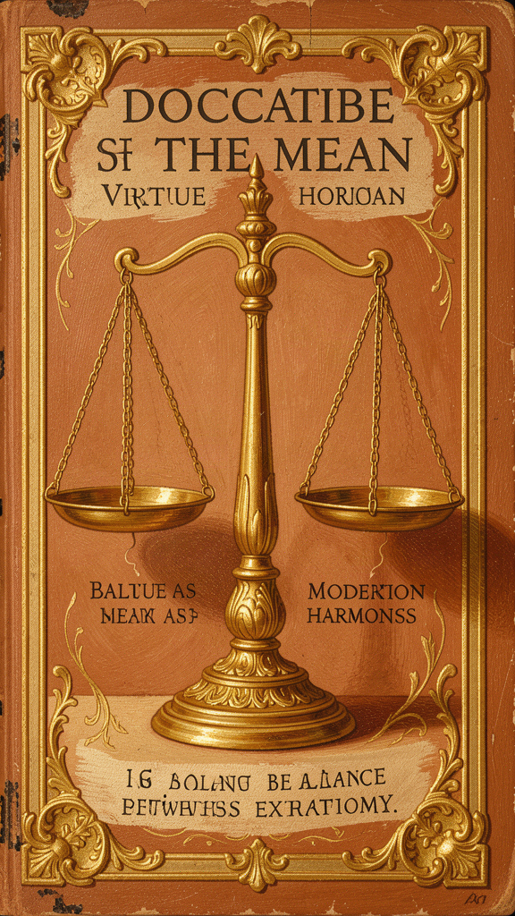
Illustration for Chapter 2
Marcus was angry. He had been angry for three days, and he was not sure whether to be proud of it or ashamed of it.
It started on Monday, when his friend Jaden borrowed his phone to look something up and then, without asking, read a text message that was not meant for him. The message was about Jaden — not bad, but private. Marcus's other friend Lila had written it, and Jaden read it, and then Jaden was upset, and then Lila was upset at Marcus for letting Jaden use his phone, and Marcus was upset at everyone.
On Tuesday, Marcus did not say anything to Jaden. He just stopped talking to him. Jaden asked what was wrong, and Marcus said, "Nothing." On Wednesday, Marcus still said nothing. By Thursday, the silence had become its own kind of weapon, and Marcus could feel it — the cold satisfaction of withholding, mixed with the discomfort of knowing it was not really fair.
He told his mother about it that night, not because he wanted advice but because he could not carry the silence anymore.
His mother listened. Then she said, "You know there's a philosopher who thought about exactly this situation? About having too much anger and too little, and finding the right amount?"
Marcus did not believe her. But he was curious.
———
The philosopher was Aristotle, and the idea is called the doctrine of the mean.
Aristotle's argument, in the Nicomachean Ethics, goes like this. Moral virtue is a settled state of character — not a feeling, not a capacity, but a habit that disposes you to choose well. Each virtue lies between two vices: one of excess and one of deficiency. Courage is between cowardice (deficiency) and rashness (excess). Generosity is between stinginess (deficiency) and wastefulness (excess). Truthfulness is between self-deprecation (deficiency) and boastfulness (excess). The virtue is the mean — the right amount, in the right way, at the right time, toward the right person, for the right reason.
The key thing to understand is that the mean is not a mathematical midpoint. It is not halfway between two extremes on a ruler. Aristotle calls it "the mean relative to us" — the right response for this particular person, in this particular situation, with this particular set of facts. The mean for a trained soldier facing danger is different from the mean for an untrained civilian. The mean for giving to a friend in need is different from the mean for giving to a stranger who is scamming people. The mean is determined by practical wisdom — the ability to discern what virtue requires when no rule can tell you.
Virtue is a state of character concerned with choice, lying in a mean, i.e., the mean relative to us, this being determined by rational principle and by that by which the practically wise person would determine it. (*Nicomachean Ethics* II.6, 1106b36–1107a2)
This definition is dense. Unpack it. Virtue is a state of character — it is who you are, not what you do once. It is concerned with choice — it shows up in what you decide, not just in what you feel. It lies in a mean — the right amount, not too much and not too little. The mean is relative to us — it depends on the person and the situation. And it is determined by rational principle and by what the practically wise person would do — it requires judgment, not just instinct.
The doctrine of the mean is often misunderstood as mediocrity. It is not. Aristotle is not saying "be moderate in everything" or "always split the difference." Sometimes the right response is intense. Sometimes it is restrained. The point is not to be in the middle. The point is to respond appropriately — to feel and act in the way that the situation calls for, neither too much nor too little.
Take Marcus's situation. His anger at Jaden for reading the private message was not wrong. Aristotle does not say you should never be angry. He says there is a virtue concerned with anger — he calls it gentleness, meaning the right amount of anger — and it lies between irascibility (too much anger, too quickly, at the wrong things) and spiritlessness (no anger at all, even when anger is appropriate). The right amount of anger is the anger a practically wise person would feel: at the right person, for the right reason, to the right degree, for the right duration.
Marcus's problem was not that he was angry. His problem was that his anger had moved from the right amount to the wrong amount. Three days of silence was not a just response to reading one private message. It was excess — punishment out of proportion to the offense. And the silence itself was a kind of deficiency, because Marcus was failing to do the thing that the situation required: talk to Jaden, directly, about what happened.
The mean, in Marcus's case, would have been: feel the anger, say what happened, name what was wrong, listen to Jaden's response, and decide what the friendship requires next. Not too much (exploding, retaliating, freezing him out for days), and not too little (pretending it didn't matter, letting it go without being honest). The right amount.
Aristotle has a further point that matters. Virtue is built through practice. You do not become generous by deciding to be generous. You become generous by giving — repeatedly, in concrete situations, until giving well becomes a habit. You do not become brave by resolving to be brave. You become brave by acting bravely — in small situations first, then larger ones — until brave action becomes your default. Character is not given. It is built.
We become just by doing just things, temperate by doing temperate things, brave by doing brave things. (*Nicomachean Ethics* II.1, paraphrased)
This is both encouraging and demanding. It means anyone can become virtuous — you do not need a special nature or a divine gift. You just need to practice. But it also means you cannot fake it. You cannot declare yourself virtuous. You have to do the work, in real situations, with real consequences, over time.
———
Marcus talked to Jaden the next day. It was awkward. He said, "You read a message that wasn't for you. That made me angry, and instead of telling you, I stopped talking to you, which wasn't fair either." Jaden apologized. Marcus apologized for the silence. They did not become perfect friends in that moment. But they did the thing the situation required — not too much, not too little — and the friendship continued.
The Big Idea
The doctrine of the mean is Aristotle's account of what virtue is and how you build it. Virtue is a settled state of character — a habit, not a feeling or a one-time act. Each virtue lies between two vices: one of excess, one of deficiency. Courage is between cowardice and rashness. Generosity is between stinginess and wastefulness. The mean is not a mathematical midpoint. It is the right response for the particular person in the particular situation, determined by practical wisdom.
The doctrine is often misunderstood as "be moderate in everything." It is not that. Sometimes the right response is intense. Sometimes it is restrained. The point is to respond appropriately — to the right person, at the right time, for the right reason, in the right amount. And you build this capacity through practice. You become brave by acting bravely, honest by acting honestly, generous by giving. Character is not given. It is built, one choice at a time.
Try This
1. Find your mean. Think of a virtue you want to develop — courage, honesty, generosity, patience. Now identify the two vices on either side of it. If it's patience: the deficiency is apathy (not caring when you should), the excess is irritability (too much frustration, too fast). The mean is responding with the right amount of concern at the right time. Track yourself for one week. When do you fall to one side or the other? What would the mean look like in that situation?
2. The anger audit. Aristotle says there is a virtue concerned with anger — the right amount, at the right person, for the right reason, for the right duration. Track your anger for one week. Each time you feel angry, write down: Who are you angry at? Why? How intense is it? How long does it last? At the end of the week, look for patterns. Are you angry at the right things, or at the wrong things? Is your anger proportionate, or is it too much or too little? The mean is not "don't get angry." It is "get angry at the right things, to the right degree, for the right duration."
3. The habit experiment. Pick one virtue and practice it deliberately for one week. Do not try to be virtuous in general. Choose specific actions. If honesty: tell the truth in five situations where you would normally soften or avoid it. If generosity: give five things — time, attention, a possession, a turn, a kind word — that you would normally keep to yourself. At the end of the week, ask: Did the practice make the virtue easier? Did it start to feel more natural? Aristotle says virtue is built through repetition. Test it.
4. Quote to keep. Write this down: "We become just by doing just things, temperate by doing temperate things, brave by doing brave things." Read it when you are tempted to think that being a good person is about having the right intentions. Aristotle says it is about doing the right things — repeatedly, until doing them becomes who you are.
———
Talk About It
- The doctrine of the mean says the right action depends on the situation. There is no rule that always works. Does that seem right to you, or does it feel like an excuse for doing whatever you want? How do you know what the mean is if there is no rule to follow? - Aristotle says some actions are always wrong — murder, theft, betrayal. These cannot be placed on a spectrum between deficiency and excess. There is no "right amount" of murder. Does this change how you think about the doctrine of the mean? - If virtue is a habit built through practice, what does that mean for people who have not had the chance to practice? Can someone who grows up in a dishonest environment become an honest person? How?
———
Here is a question to carry with you this week: If virtue is a habit built through repeated choices, what is one virtue you are practicing right now — and what is one virtue you are failing to practice?
———

Chapter 3: The Ladder of Friendship — Three Kinds of Friendship
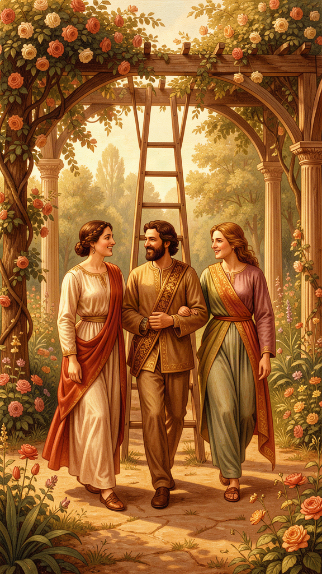
Illustration for Chapter 3
Sofia had a lot of friends. She was not sure, anymore, which ones counted.
There was her oldest friend, Priya, who she had known since second grade. They had gone through everything together — the year Sofia's parents split up, the year Priya broke her arm, the slow, complicated process of growing up. They did not talk every day anymore. Sometimes weeks went by. But when they did talk, it was the same. Priya knew who Sofia was, and Sofia knew who Priya was, and neither of them had to perform.
There was her basketball friend, Jordan. They had been on the same team for two years. They had a great time at practice and after games. They talked about basketball, about school, about who was dating whom. But when Sofia tried to talk to Jordan about something real — the fight with her mom, the panic about high school — Jordan changed the subject. Not meanly. Just awkwardly, like someone who did not know what to do with that kind of conversation.
There was her study friend, Wei. They helped each other with homework. They were useful to each other. When the homework was done, there was not much else to talk about.
And there were the friends she had made on social media — people she followed, people who followed her, people she chatted with about shared interests. She had never met most of them. She liked them. She was not sure they would recognize her on the street.
Sofia was telling her older cousin, who was home from college, about this tangle of relationships. Her cousin said, "You know Aristotle wrote about exactly this? Three kinds of friendship. It's in the Nicomachean Ethics, Book Eight."
Sofia was surprised. "Aristotle wrote about friendship?"
"He wrote one of the best things anyone has ever written about it."
———
Aristotle dedicated two full books of the Nicomachean Ethics — Books Eight and Nine — to friendship. More space than he gives to any other topic. This is not accidental. For Aristotle, friendship is not a pleasant addition to a good life. It is necessary for a good life. You cannot flourish alone.
Without friends no one would choose to live, though he had all other goods. (*Nicomachean Ethics* VIII.1, 1155a5)
Aristotle distinguishes three kinds of friendship, based on what the friends love in each other:
There are therefore three kinds of friendship, equal in number to the things that are lovable. Now those who love each other for their utility do not love each other for themselves but insofar as some good arises for them from each other. Similarly too with those who love for pleasure; for they do not love witty people for their characters but insofar as they are pleasant to them. The friendship of the good, however, is the friendship of those who are good in themselves. (*Nicomachean Ethics* VIII.3, 1156a10–16)
The first kind is friendship for utility. You are friends because you are useful to each other. Study partners, business contacts, neighbors who help each other out. This is a real friendship — it involves goodwill, mutual benefit, and some degree of care. But it is incomplete. When the usefulness ends — when the class is over, the project is done, the neighbor moves — the friendship fades. It was never about the person. It was about the benefit.
The second kind is friendship for pleasure. You are friends because you enjoy each other. Teammates, party friends, people who share an interest or a sense of humor. This too is real friendship. But it is also incomplete. When the pleasure ends — when the team dissolves, the interests diverge, the jokes stop landing — the friendship fades. It was about the enjoyment, not the person.
The third kind is friendship for virtue (or friendship of the good). You are friends because you are both good people, and you love each other for who you are, not for what you get. This friendship is the fullest form. It is durable, because it does not depend on circumstances. It is mutual, because good people wish each other good for their own sake. And it is morally formative, because good friends make each other better. Aristotle says the best friend is "a second self" — someone whose good you wish as you wish your own.
The first two kinds of friendship are not bad. Aristotle is clear about that. It is good to be useful to each other. It is good to enjoy each other. Most friendships are a mix of all three. But only the third kind is friendship in the fullest sense, because only the third kind loves the other person for who they are, not for what they provide.
The practical question is: which of your friendships are which? And more importantly: what conditions support the third kind?
Aristotle has a hard answer. The third kind of friendship requires time and shared life. It requires trust, which is built through tested reliability. It requires moral similarity — you cannot be virtue friends with someone whose values you do not share, because the friendship is built on mutual recognition of each other's goodness. And it requires goodwill that is not transactional — you wish the other person well for their own sake, not because their wellbeing benefits you.
This is why the third kind is rare. Most friendships do not survive the conditions that would test them. Most friendships are utility or pleasure friendships that have not yet been tested. The test comes when the usefulness ends, or the pleasure stops, or one friend needs something that the other cannot easily give. The third kind survives the test. The first two do not.
———
Sofia thought about her four friendships. Priya was the third kind. They had been through hard things together, and the friendship was not about usefulness or pleasure. It was about knowing each other and wanting each other to be well. Jordan was the second kind — fun, enjoyable, but not built to carry real weight. Wei was the first kind — useful, mutually beneficial, but not much more. The social media friends were a mix of utility and pleasure, leaning toward the shallow end of both.
This did not mean Jordan and Wei were bad friends. Aristotle did not say that. He said they were incomplete. The question was not "should I drop them?" The question was "which friendships am I investing in as if they were the third kind, when they are actually the first or second — and am I neglecting a third-kind friendship because I am distracted by first- and second-kind ones?"
Sofia texted Priya that night. Not about anything in particular. Just: "Hey. I was thinking about you. Want to hang out this weekend?"
Priya texted back in thirty seconds: "Yes. I've been wanting to talk to you about something."
The Big Idea
Aristotle identifies three kinds of friendship, based on what the friends love in each other. Friendship for utility: you are useful to each other. Friendship for pleasure: you enjoy each other. Friendship for virtue: you love each other for who you are, and you make each other better. The first two are real but incomplete. They fade when the usefulness or the pleasure ends. The third is durable because it does not depend on circumstances. It requires time, trust, moral similarity, and goodwill that is not transactional. It is rare, because most friendships do not survive the conditions that would test them.
The practical question is not "which friends should I drop?" It is "which friendships am I treating as if they were the deepest kind, when they are actually the shallower kind — and am I neglecting a deep friendship because I am distracted by shallow ones?" The third kind is not the only kind worth having. But it is the kind worth protecting.
Try This
1. Map your friendships. Make three columns: Utility, Pleasure, Virtue. List your friendships under the column that best describes each one. Be honest. Some friendships are a mix — note that. The goal is not to rank your friends from best to worst. It is to see clearly what each friendship is built on, so you know what it can carry and what it cannot.
2. The test question. For each friendship, ask: If the usefulness ended, or the pleasure stopped, would this friendship survive? If yes, it may be the third kind. If no, it is the first or second. This is not a judgment. It is a diagnosis. Knowing what a friendship is built on tells you what you can ask of it. A utility friend is great for homework help. Do not ask them to carry your deepest fears.
3. Invest in the third kind. Identify one friendship that is — or could be — the third kind. This week, invest in it. Not with a grand gesture. With a real conversation. Tell them something true about your life. Ask them something true about theirs. The third kind is built through shared life, and shared life is built through real conversations, one at a time.
4. Quote to keep. Write this down: "Without friends no one would choose to live, though he had all other goods." Read it when you are tempted to think you do not need anyone. Aristotle says you do. Not for usefulness. Not for pleasure. For the kind of friendship that makes you a better person.
———
Talk About It
- Aristotle says the third kind of friendship requires moral similarity — you cannot be virtue friends with someone whose values you do not share. Is that true? Can you be deep friends with someone who believes things you think are wrong? - Social media tends to produce utility- and pleasure-based friendships. What conditions would support virtue friendships online? Is it possible, or does the third kind require physical presence? - Aristotle says the best friend is "a second self." What does that mean? Have you ever had a friend who felt like a second self? What made that friendship different from your others?
———
Here is a question to carry with you this week: Which of your friendships would survive the loss of usefulness and pleasure — and what would it take to build one more that could?
———

Chapter 4: Contemplation as the Highest Happiness
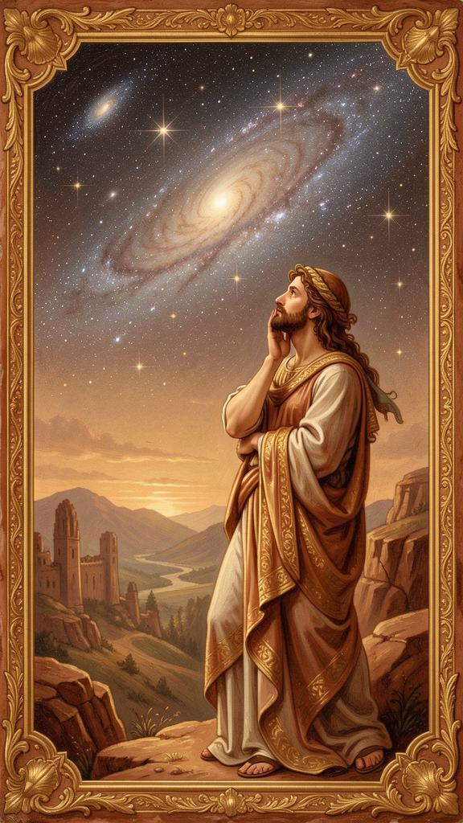
Illustration for Chapter 4
Tomás was exhausted. He had been exhausted for months, in a way that had nothing to do with not getting enough sleep.
He was a junior. He was taking three AP classes, playing varsity soccer, volunteering at a food bank on Saturdays, and trying to be a good friend, a good son, and a good boyfriend. He was doing all the right things. He was also starting to dread mornings, because mornings meant the list, and the list never got shorter.
His AP History teacher, Mr. Reyes, noticed. After class one day, he asked Tomás to stay for a minute.
"You look like you're running on empty," Mr. Reyes said.
"I'm fine," Tomás said automatically.
"You're not fine. You're doing everything and enjoying none of it. Can I tell you about a philosopher who thought about exactly this? He wrote a whole book about what the good life is, and at the end of it, he said something that most people find surprising."
Tomás sat down. "What did he say?"
"He said the highest happiness is not action. It's contemplation."
———
The philosopher was Aristotle, and the passage is one of the most debated in the Nicomachean Ethics. In Book X, chapters 7 and 8, after nine books arguing that the good life is a life of moral and political action — courage, generosity, friendship, civic engagement — Aristotle says something that seems to contradict everything that came before:
If happiness is activity in accordance with virtue, it is reasonable that it should be in accordance with the highest virtue; and this will be the virtue of the best part of us. Whether this be reason or something else that is thought to be naturally our ruler and guide and to be concerned with what is noble and divine... this activity would be the complete happiness of man. (*Nicomachean Ethics* X.7, 1177a12–18)
Read that carefully. Aristotle is saying that the highest happiness — the fullest form of eudaimonia — is not the moral life, not the political life, not the life of action. It is the life of contemplation: theoria, the activity of the highest part of the soul, reason, thinking about what is true, eternal, and divine.
Why? Aristotle gives several reasons. Contemplation is the most continuous activity — you can think for longer than you can do anything else. It is the most self-sufficient — you do not need equipment, or money, or other people to think (though friends help). It is the most pleasant — not in the sense of fun, but in the sense of deep satisfaction. It is loved for its own sake — nobody contemplates in order to get something else out of it. And it is the most divine — because the gods, if they exist, would not be managing politics or fighting wars. They would be thinking. Contemplation is the activity that most resembles the life of the divine.
This creates a tension in Aristotle's ethics that scholars have argued about for two thousand years. Is the best life contemplative or active? Is Aristotle saying that the moral life — the life of courage, generosity, friendship, and justice — is second-best? Or is he saying that contemplation is the peak of a complete human life, which also requires moral virtue and friendship?
Most scholars read it the second way. Aristotle is not saying: withdraw from the world and think. He is saying: within a complete human life — one that includes action, friendship, and civic engagement — the highest activity is contemplation. The moral life is necessary. But it is not the summit. The summit is the moment when you stop doing and start understanding — when you look at the stars, or think through a difficult problem, or grasp something true about the nature of things, and you feel the deep satisfaction that comes from exercising the best part of yourself.
This matters for Tomás because Tomás is doing everything and contemplating nothing. He is acting — morally, politically, socially — but he has no time to think about what any of it means. He is running on the treadmill of action without ever stepping off to ask: What is this for? What am I becoming? Is the list getting shorter, or am I just getting faster?
Aristotle's point is not that Tomás should quit his activities. It is that the activities, by themselves, are not enough. They need contemplation to complete them. Without reflection, action becomes blind — you do things because they are on the list, not because you have thought about whether they are worth doing. Without contemplation, the moral life becomes a performance — you are courageous because the situation demands it, generous because the occasion calls for it, but you never ask what the whole thing is for.
Contemplation is the activity that gives action its meaning. It is the moment when you stop and think: What is the good I am aiming at? Am I aiming at it well? What would it mean to live well, not just to do well?
———
Tomás sat with that for a minute. "So Aristotle is saying I should stop doing everything and just think?"
"No," Mr. Reyes said. "He's saying your doing needs thinking to be complete. Right now, you're doing without thinking. You're running a race without knowing where the finish line is. Contemplation is how you find the finish line. It's not a luxury. It's the thing that makes the rest of it make sense."
"What does contemplation actually look like?"
"It looks like what we're doing right now," Mr. Reyes said. "Sitting still. Asking a real question. Not trying to solve it immediately, but actually thinking about it. It looks like reading a book that's too hard for you and staying with it until it opens up. It looks like walking alone and letting your mind go somewhere it doesn't usually go. It looks like looking at the night sky and wondering."
Tomás tried it that night. He turned off his phone, sat on the back porch, and looked at the sky for fifteen minutes. He did not solve anything. He did not have an epiphany. But he noticed something: the hum of anxiety that had been with him for months got a little quieter. Not gone. Just quieter. The doing was still waiting for him in the morning. But for fifteen minutes, he was not doing. He was being. And the being felt like relief.
The Big Idea
In the final book of the Nicomachean Ethics, Aristotle argues that the highest happiness is contemplation — theoria, the activity of reason thinking about what is true, eternal, and divine. This is surprising, because the first nine books argue that the good life is a life of moral and political action. The tension is real, and scholars have debated it for centuries.
The best reading is that contemplation is not a replacement for action. It is the completion of action. A good human life requires moral virtue, friendship, and civic engagement. But it also requires moments when you stop doing and start understanding — when you think about what is true, what is good, what is beautiful, what it all means. Without contemplation, action becomes blind. You do things because they are on the list, not because you have thought about whether they are worth doing. Contemplation is the activity that gives action its meaning.
This is not an argument for withdrawing from the world. It is an argument for making space within the world for the activity that makes the rest of it make sense.
Try This
1. The fifteen-minute experiment. Turn off your phone. Sit somewhere quiet — outside if possible. For fifteen minutes, do not do anything. Do not plan, do not list, do not solve. Just think. About whatever comes. If your mind wanders to the list, notice it and bring it back. The goal is not to have a revelation. The goal is to practice the activity Aristotle says is the highest happiness. Do this every day for one week. Notice what changes.
2. The hard-book practice. Find a book — fiction or nonfiction — that is genuinely difficult for you. Not impossible, but hard. Read it slowly, for thirty minutes, without checking your phone. When you do not understand something, stay with it. Reread. Think about it. This is contemplation applied to a text. You are not reading for information. You are reading for understanding.
3. The action audit. Make a list of everything you are doing right now — activities, commitments, obligations. For each one, ask: When was the last time I thought about why I am doing this? If the answer is "never" or "I don't remember," that is a sign the action has lost its contemplative grounding. Pick one item and spend fifteen minutes thinking about it. What is it for? What good does it aim at? Is it still worth doing?
4. Quote to keep. Write this down: "This activity would be the complete happiness of man." Read it when you are tempted to think that doing more is always the answer. Aristotle says the highest activity is not doing. It is understanding.
———
Talk About It
- Aristotle says contemplation is the most self-sufficient activity — you do not need equipment or other people to think. Is that true? Or is contemplation actually dependent on a lot of conditions (free time, education, safety) that most people do not have? - If contemplation is the highest happiness, does that make the moral life second-best? Is Aristotle saying that being a good person is less important than thinking deep thoughts? - Tomás is exhausted because he is doing too much. Aristotle says contemplation completes action. But what if the problem is not lack of contemplation but lack of rest? Is contemplation a luxury that only people who are not struggling to survive can afford?
———
Here is a question to carry with you this week: If the highest happiness is contemplation, when was the last time you stopped doing and started thinking — and what would it take to do it again?
———

Chapter 5: The Four Causes — Why Things Are the Way They Are
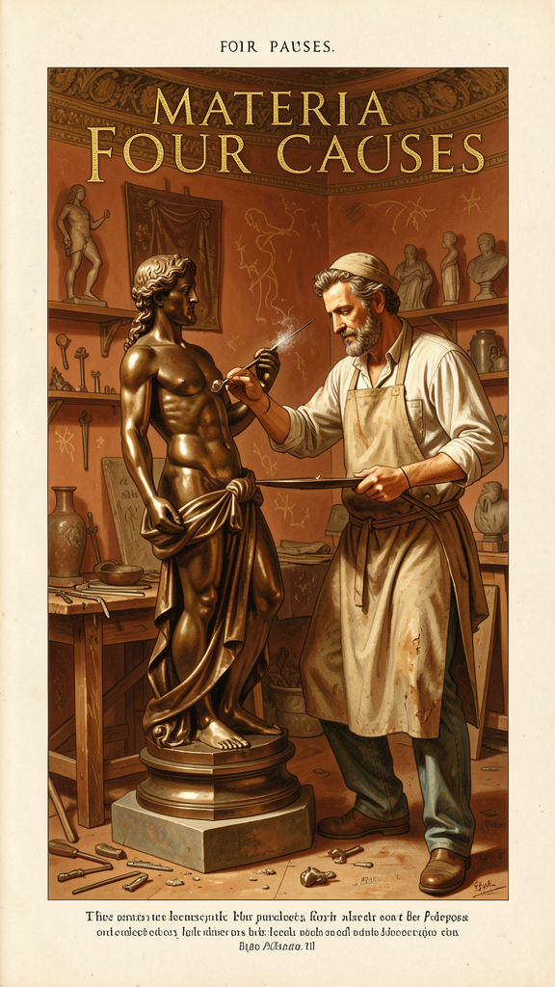
Illustration for Chapter 5
Nadia's science teacher, Dr. Okafor, brought a bird's nest to class one Monday. It was a small, intricate structure — twigs woven together, lined with soft grass and what looked like bits of string and plastic.
"Where did this come from?" Dr. Okafor asked.
"A bird made it," someone said.
"Yes. But what kind of answer is that? It tells me that a bird was involved. It does not tell me why this nest exists, why it is shaped this way, what it is made of, or what it is for. A philosopher named Aristotle, about 2,400 years ago, said that to understand anything fully, you need four kinds of answer. He called them the four causes."
———
Aristotle's four causes are one of his most influential ideas. He presents them in the Physics (Book II, Chapter 3) and the Metaphysics (Book V, Chapter 2). The argument is simple: to explain something fully, you need to answer four questions.
The material cause — What is it made of? A statue is made of bronze. A nest is made of twigs and grass. A human being is made of flesh and bone. The material cause is the stuff out of which a thing is made.
The formal cause — What kind of thing is it? The statue has the shape of a god. The nest has the form of a bird's nest — a particular structure, woven in a particular way. A human being has the form of a human being — a living, rational animal. The formal cause is the pattern, structure, or essence that makes the thing the kind of thing it is.
The efficient cause — What brought it into being? The sculptor made the statue. The bird made the nest. The parents made the child. The efficient cause is the agent or process that produced the thing.
The final cause — What is it for? The statue exists to honor a god. The nest exists to hold eggs and raise young. The heart exists to pump blood. The final cause is the purpose, end, or telos for which the thing exists.
That for the sake of which something comes to be, and the good for the sake of which it comes to be — this is a cause. (*Physics* II.3, 195a23–24)
The four causes are not just a classification scheme. They are a theory of explanation. Aristotle is saying that a complete explanation of anything requires all four. If you know what a thing is made of but not what it is for, you do not really understand it. If you know what made it but not what kind of thing it is, you do not really understand it. Full understanding requires material, formal, efficient, and final causes.
The most controversial of the four is the final cause — purpose, telos. Aristotle's natural philosophy is teleological: it explains things by their ends. "Nature does nothing in vain," he says repeatedly (On the Soul III.13, Politics I.2). The structure of an animal's body, the growth of a plant, the fall of a stone — all can be understood as movements toward a natural end. A bird's wing exists for the sake of flight. A fish's gill exists for the sake of breathing underwater. The eye exists for the sake of seeing.
Modern science largely abandoned final causes in physics. The Scientific Revolution replaced "what is it for?" with "what caused it?" — efficient causes, not final causes. A stone does not fall because it is "trying to reach its natural place." It falls because gravity accelerates it toward the earth's center. The question "what is a stone for?" does not have a scientific answer.
But final causes did not disappear. They survived in biology, where functional explanation is still indispensable. Why does the heart have four chambers? To pump blood efficiently through the lungs and body. Why do birds have hollow bones? To reduce weight for flight. These are final-cause explanations, and they are not replaceable by efficient-cause explanations. You can describe the evolutionary mechanism (efficient cause) that produced hollow bones, but you still need the functional explanation (final cause) to understand why the trait was selected. Biology is still teleological, even if physics is not.
The four causes also survive in ordinary reasoning about human action. Why did you build that bookshelf? The material cause is wood and screws. The formal cause is the design of a bookshelf. The efficient cause is you, with tools. The final cause is to hold your books. Try explaining the bookshelf without the final cause. You can describe the wood, the shape, and the construction in infinite detail, and you still will not understand why it exists. For that, you need to know what it is for.
———
Nadia's class applied the four causes to the bird's nest.
Material cause: twigs, grass, string, plastic bits, mud. Formal cause: the structure of a cup-shaped nest, woven and lined. Efficient cause: the bird (probably a sparrow) that built it. Final cause: to hold eggs, protect chicks, and raise young.
Then Dr. Okafor asked: "Can you apply the four causes to something that is not physical? An argument, for instance. What are the four causes of a good argument?"
The class worked through it. Material cause: words, premises, evidence. Formal cause: the logical structure — syllogism, deduction, induction. Efficient cause: the person making the argument. Final cause: to persuade, to discover truth, to justify a belief.
"Can you apply them to yourself?" Dr. Okafor asked.
Nadia thought. Material cause: flesh, bone, blood, cells — the stuff she was made of. Formal cause: a human being — a living, rational animal, with a particular personality and set of capacities. Efficient cause: her parents, her upbringing, her education, her experiences. Final cause: that was the hardest one. What was she for? Aristotle's answer would be: to live well, to exercise her distinctive capacities, to flourish. But what did that mean, specifically, for her? She did not have an answer yet. But the question was the right one. Aristotle said the final cause is the most important. The purpose is the key to understanding the thing.
The Big Idea
Aristotle's four causes are a theory of explanation. To understand anything fully, you need four answers: What is it made of? (material cause). What kind of thing is it? (formal cause). What made it? (efficient cause). What is it for? (final cause). The four causes work on everything — a statue, a bird's nest, an argument, a human being. The most important and the most controversial is the final cause: purpose, telos. Modern science abandoned final causes in physics, but they survive in biology (why does the heart have four chambers? to pump blood efficiently) and in ordinary reasoning about human action (why did you build that bookshelf? to hold books). Full understanding requires all four. If you know what a thing is made of but not what it is for, you do not really understand it.
Try This
1. Four causes for an object. Pick any object near you right now. Ask the four questions: What is it made of? What kind of thing is it? What made it? What is it for? Write down the answers. Notice which question is easiest and which is hardest. The final cause is almost always the hardest — and the most revealing.
2. Four causes for a living thing. Go outside and find a plant or animal. Apply the four causes. The material cause is the stuff it is made of. The formal cause is the kind of living thing it is. The efficient cause is the process that produced it (parents, growth, evolution). The final cause is its purpose — what it does, what it is for. For a living thing, the final cause is usually connected to survival and reproduction. But ask deeper: what is the good of this thing? What does it do well?
3. Four causes for yourself. Apply the four causes to your own life. What are you made of? What kind of person are you? What made you who you are? What are you for? The last question is the one Aristotle spent his whole career thinking about. You do not need to have a final answer. But you need to be asking.
4. Quote to keep. Write this down: "That for the sake of which something comes to be, and the good for the sake of which it comes to be — this is a cause." Read it when you are tempted to think that understanding is just about how things work. Aristotle says it is also about what things are for. The "why" matters as much as the "how."
———
Talk About It
- Modern science mostly uses efficient causes, not final causes. A stone falls because of gravity, not because it is "trying to reach its natural place." Is Aristotle wrong about physics? Or did he identify a kind of explanation that still matters, even if it does not apply to everything? - Biology still uses final-cause explanations: the heart exists to pump blood, wings exist for flight. Is that real teleology, or is it just a shorthand for evolutionary adaptation? What is the difference? - If you apply the four causes to your own life, which cause is hardest to answer? For most people, it is the final cause: What am I for? Why is that question so hard — and so important?
———
Here is a question to carry with you this week: If understanding anything requires knowing what it is for, what are you for — and how would your life change if you took that question seriously?
———

Chapter 6: The Unmoved Mover — The First Cause of All Motion
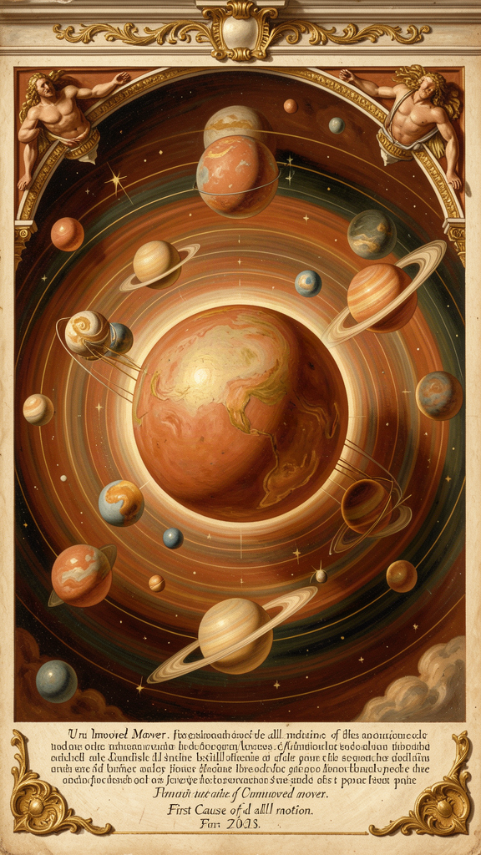
Illustration for Chapter 6
Theo was lying on his back in the grass, staring at the night sky, when the question hit him. It came from nowhere and everywhere.
Everything is moving. The stars are moving. The earth is spinning. The wind is blowing. His heart is beating. His blood is flowing. Every atom in his body is in motion. And if everything that moves is moved by something else, what started it all? What moves without being moved?
He did not have an answer. But he could not stop thinking about it.
———
This is the question Aristotle asks in Book VIII of the Physics and Book XII of the Metaphysics. It is one of the oldest and deepest questions in philosophy: Why is there motion rather than rest? And if everything in motion is moved by something else, what is at the beginning of the chain?
Aristotle's argument, stripped to its skeleton, goes like this:
1. Everything that is in motion is moved by something else. (This is a principle, not an observation. Aristotle defines motion as the actualization of a potential. Whatever is moving from potential to actual must be moved by something already actual.)
2. The chain of movers cannot go back to infinity. (If every mover is itself moved by another mover, and that mover by another, and so on forever, there is no first mover. But an infinite chain of dependent movers explains nothing. The motion is never accounted for. There must be a starting point.)
3. Therefore, there must be a first mover that is itself unmoved. (This is the Unmoved Mover — to kinoun akineton. It causes motion without being moved. It is the beginning of the chain.)
There is, then, something which is always moved with an unceasing motion, which is motion in a circle... and therefore there must be something which moves it. And since that which is moved and moves is intermediate, there must be something which moves without being moved. (*Physics* VIII.6, 258b10–15)
The crucial question is: How does the Unmoved Mover cause motion? It does not push. It is not a physical force. Aristotle's answer is surprising: the Unmoved Mover causes motion as an object of desire and thought. It moves the heavens the way a beautiful song moves a dancer, or the way a loved object moves the lover. It does not act on the world. It attracts the world. The cosmos is drawn toward it because it is the most beautiful, the most good, the most perfect thing there is.
The Unmoved Mover is pure actuality — energeia with no dynamis, no potentiality. It cannot change, because change is the actualization of a potential, and it has no potential. It cannot come to be or pass away, because it is already fully actual. It is eternal. It is immaterial. It is divine.
It is a life such as the best which we enjoy, and enjoy for but a short time... its life is of such as ours for a short time, but its life is always so. (*Metaphysics* XII.7, 1072b14–16)
Aristotle's Unmoved Mover is not the God of the Bible. It does not create the world. It does not love humanity. It does not answer prayers or issue commandments. It is a metaphysical principle — the ultimate explanation for why there is motion rather than rest. But it is also, in a sense, a kind of god. It is eternal, divine, and the object of the highest activity (contemplation). It thinks — and what it thinks about is itself, because there is nothing better to think about. It is pure thought thinking itself (noesis noeseos).
This argument had an enormous afterlife. In the Middle Ages, Jewish, Islamic, and Christian theologians saw the Unmoved Mover as a philosophical anticipation of God. Thomas Aquinas adapted it as the First of his Five Ways to prove the existence of God. The argument has been criticized — David Hume and Immanuel Kant both attacked the assumption that the chain of causes cannot be infinite, and modern cosmology describes a universe that may not need a first cause in the Aristotelian sense. But the argument remains influential, and the question it addresses is still live: Why is there something rather than nothing? Why is there motion rather than rest?
———
Theo told his older sister, who was studying philosophy in college, about the question that had been bothering him.
"That's the Unmoved Mover argument," she said. "Aristotle, Physics Book Eight. The question is: if everything in motion is moved by something else, what moves without being moved? Aristotle says there has to be something at the beginning of the chain — something that moves everything else without being moved itself."
"Does he think it's God?"
"Not exactly. It's not the God of any religion. It's a metaphysical principle — the ultimate cause of all motion. But later theologians, especially Thomas Aquinas, thought it pointed toward God. They saw it as a philosophical version of the argument from design."
"Do you think it works?"
His sister was quiet for a moment. "I think the question is real. Everything is moving. Everything is caused. The chain of causes either goes back forever or it stops somewhere. Aristotle says it stops. Modern physics says maybe it doesn't — maybe the chain goes back to the Big Bang, and before that, we don't know. But the question doesn't go away. Even if you say the Big Bang started everything, you can still ask: What caused the Big Bang? And if you say nothing, you're saying the chain stops at something that was not caused by anything. That's not so different from what Aristotle said."
"So it's not a proof of God."
"It's a proof that there has to be something at the beginning of the chain of motion. What you call that something — God, the Big Bang, the Unmoved Mover, the first cause — depends on your metaphysics. The argument doesn't tell you what the something is. It tells you that there has to be a something."
Theo looked at the stars again. The question was still there. Everything was moving. Something had started it. He did not know what. But he felt, for the first time, that the question was not just abstract. It was personal. He was moving. His life was moving. And the question of what moved everything — including him — was the biggest question there was.
The Big Idea
Aristotle's Unmoved Mover is his answer to the question: Why is there motion rather than rest? The argument: everything in motion is moved by something else. The chain of movers cannot go back to infinity (an infinite chain of dependent movers explains nothing). Therefore, there must be a first mover that moves without being moved — the Unmoved Mover. It causes motion not by pushing but by attracting, the way a beautiful object draws a lover. It is pure actuality, eternal, immaterial, and divine.
The argument had an enormous afterlife. Jewish, Islamic, and Christian theologians saw it as a philosophical anticipation of God. Thomas Aquinas adapted it as the First of his Five Ways. Modern physics challenges the assumption that the chain cannot be infinite, but the question remains live: Why is there something rather than nothing? The argument does not prove the God of any religion. It argues that there must be something at the beginning of the chain of motion. What you call that something depends on your metaphysics.
Try This
1. Trace the chain. Pick something that is moving right now — a bird, a car, a cloud, your own hand. Ask: What is moving it? Then ask: What moved that? Keep going. How far back can you trace the chain? Where does it stop? This is the exercise Aristotle is running in Physics Book VIII. You probably will not reach the Unmoved Mover. But you will feel the shape of the question.
2. The dancer and the music. The next time you see someone moved by music — dancing, swaying, tapping a foot — ask: What is moving them? The music does not push them. It draws them. They move because the music is beautiful. This is how Aristotle imagines the Unmoved Mover. It does not push the universe. The universe is drawn toward it because it is the most beautiful and most good thing there is. The image is not a proof. But it is a way of understanding what kind of cause the Unmoved Mover is.
3. The modern test. Aristotle says the chain of movers cannot be infinite. Modern cosmology says the chain of physical causes goes back to the Big Bang, about 13.8 billion years ago. What caused the Big Bang? Some physicists say the question is meaningless (there was no "before"). Others say the chain continues into a multiverse or a cyclical universe. Write one paragraph: Does the Big Bang support or challenge Aristotle's argument? Does it answer the question, or just push it back one more step?
4. Quote to keep. Write this down: "There must be something which moves without being moved." Read it when you are tempted to think that everything just happens, with no explanation. Aristotle says there has to be a starting point. You may disagree with his answer. But the question — what started it all? — is one of the oldest and deepest questions humans have asked.
———
Talk About It
- Aristotle says the chain of movers cannot be infinite. Is that true? Why can't it be infinite? What is wrong with an infinite chain of causes? - The Unmoved Mover causes motion by being an object of desire, not by pushing. Is that satisfying? Or is it just a way of avoiding the question of how something can cause motion without itself being in motion? - Does the Unmoved Mover argument prove the existence of God? Why or why not? What would it prove, and what would it leave unproven?
———
Here is a question to carry with you this week: If everything in motion is moved by something else, and the chain cannot go back forever — what is at the beginning? And does knowing there is a beginning change how you think about your own motion, your own life?
———

For the Grown-Up Reader
This booklet adapts Aristotle's surviving works — primarily the Nicomachean Ethics, Physics, Metaphysics, On the Soul, Politics, and Poetics — into narrative form for middle-school readers. The historical details (Aristotle's life from 384 to 322 BCE, his twenty years in Plato's Academy, his tutoring of Alexander, his founding of the Lyceum around 335 BCE, his empirical method of observation and classification) are drawn from the ancient biographer Diogenes Laërtius and the scholarly tradition, as summarized in Jonathan Barnes's edition of the complete works and the secondary literature cited in the research files.
If a young person asks, "Did Aristotle really say this?" the answer is yes for every quotation in this booklet. The quotes are drawn from the Revised Oxford Translation and the translations by Terence Irwin (Nicomachean Ethics), Joe Sachs (Metaphysics and Physics), and Carnes Lord (Politics). The stories (Damaris, Marcus, Sofia, Tomás, Nadia, Theo) are invented scenarios designed to make the ideas concrete for middle-school readers; the philosophy is not invented.
A note on the four causes and the Unmoved Mover: Aristotle's teleological framework has been challenged by modern science. The four causes remain useful as a thinking tool, but the final cause (purpose, telos) does not have the same status in modern physics that it had for Aristotle. The Unmoved Mover argument has been adapted by theologians (especially Aquinas) and challenged by philosophers (Hume, Kant) and scientists (modern cosmology). The arguments are presented fairly, with their strengths and weaknesses. The goal is not to convince but to equip young readers to think about the questions Aristotle raised — questions that are still live.
———

About WisdomForge
WisdomForge adapts the great philosophers into stories, audio, and conversation for every age. Each philosopher becomes four booklets — one for children, one for younger teens, one for older adolescents, and one for adults — so the same ideas can grow with you. The Aristotle series covers the good life and eudaimonia, the doctrine of the mean, the three kinds of friendship, contemplation as the highest happiness, the four causes, and the Unmoved Mover — the same system, told at four levels of depth.

