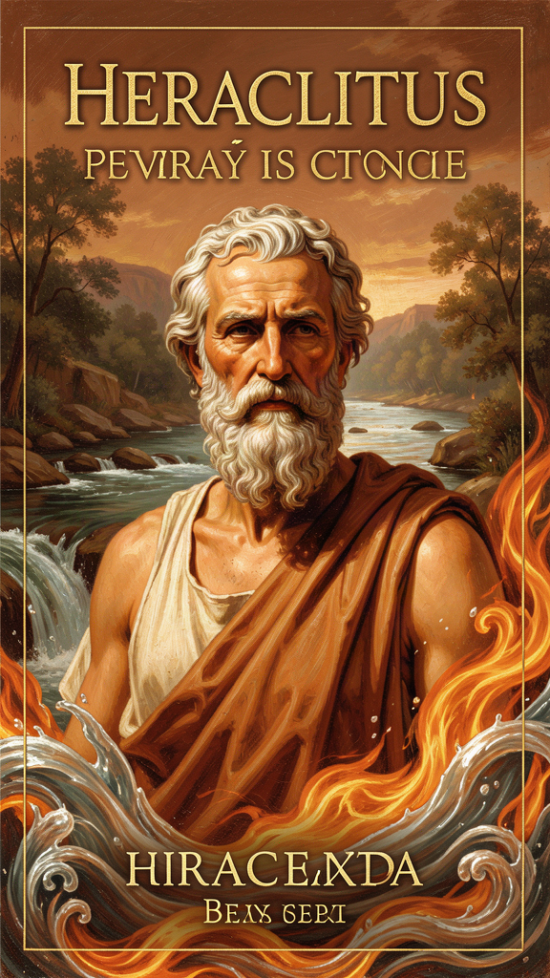
Heraclitus: The Cosmos as Process
WisdomForge Booklet — Adult

Heraclitus: The Cosmos as Process

WisdomForge Booklet — Adult
———

About This Book
Heraclitus of Ephesus (c. 535–475 BCE) is the philosopher who said the world is not a thing but a process. He wrote one book, filled with compressed, paradoxical sayings, and deposited it in the Temple of Artemis — one of the Seven Wonders of the Ancient World. The book is lost. What survives are roughly 126 fragments, short quotations preserved by later authors from Plato to Hippolytus.
Those fragments are some of the most explosive sentences in the history of thought. "You cannot step into the same river twice." "The way up and the way down are one and the same." "War is the father of all and king of all." "The hidden harmony is better than the visible." These are not aphorisms. They are arguments, compressed to their minimum form. Each one is a philosophical grenade that detonates on reflection.
This booklet is not a biography. It is not a history lesson. It is a practical exploration of what the Heraclitean tradition has to offer a thoughtful adult: a way of seeing the world as process rather than substance, a practice of attending to the hidden pattern beneath the noise, a framework for living with tension rather than trying to eliminate it, and a reframing of loss as transformation. No self-help padding. No shortcuts. Just the ideas, the evidence, and the questions they raise for how you live.
Heraclitus matters because he is the first Western philosopher to put process at the center of reality. Before him, thinkers asked what the world is made of. Heraclitus asked how it keeps going. The answer is flux — but flux with a pattern. Change is not chaos. It follows a logos, a rational order that makes the world intelligible even as it never stands still. This claim, made 2,500 years ago by a man who wrote in riddles, became the foundation of Plato's philosophy (as the antagonist he had to refute), the Stoic worldview (which adopted his logos and fire), Hegel's dialectic (which adopted his unity of opposites), and the modern scientific conviction that the universe is a processual, mathematically intelligible system.
———

Chapter 1: The River — Everything Flows
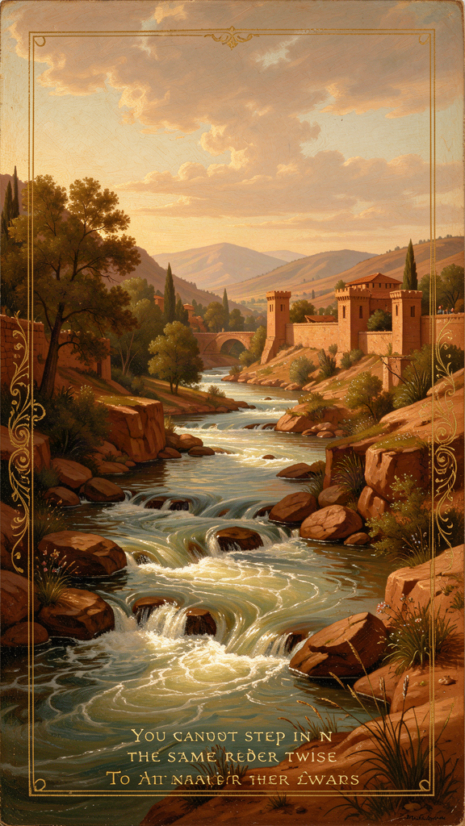
Illustration for Chapter 1
You step into a river. The water splashes around your ankles. You step out, walk away, and come back the next day. You step in again. But the water that touched your feet yesterday is already gone — flowing toward the sea. New water has come from upstream. Is it the same river?
Heraclitus said no. And yes. "Into the same river you could not step twice, for other and still other waters are flowing" (DK B41). The river looks the same. The banks stay. The name stays. But every drop of water inside it is different from yesterday. How can something be the same river if the water is always new?
This is the most quoted line in Western philosophy, and it is almost always misread. People treat it as a claim about impermanence: everything changes, so nothing lasts, so nothing matters. That is the opposite of what Heraclitus meant. The river is not gone. The river is still there. The puzzle is how something can be both the same and different at once. That question is the heart of his philosophy.

The Ionian Inheritance
Heraclitus inherited a question from the earlier Ionian thinkers. Thales had said the world is made of water. Anaximander had said it comes from the boundless (apeiron). Anaximenes had said it is air, modified by rarefaction and condensation. Each tried to explain diversity and change by reducing them to a single underlying substance governed by natural law rather than divine caprice. Heraclitus accepted the Ionian premise — the cosmos is intelligible without recourse to myth — but he rejected the solution. The fundamental reality is not a stable substance. It is process.
The river is his answer and his provocation. A river is not the water inside it. A river is the flowing. The water comes and goes, but the flowing continues. The identity of the river is in the pattern, not in the stuff. The river stays a river by never staying the same.
This is a remarkably modern claim. Consider the Ship of Theseus. If you replace every plank of a ship over time, is it still the same ship? Heraclitus would say yes and no. The ship is the same pattern — its form, its function, its name. But the matter is entirely different. Identity, for Heraclitus, is not a property of an unchanging substrate. It is a property of a pattern that endures through change.

The Radical Version
The radical version comes in DK B49a: "We step and do not step into the same rivers; we are and are not." This applies the river insight inward. The person who steps into the river is also a river. Your body replaces its cells constantly. The atoms that make up your body now are not the atoms that made it up seven years ago. Your mind shifts from moment to moment. You are not the same organism you were seven years ago. You are not the same self you were yesterday. Heraclitus uses paradox to make us notice that ordinary language divides what reality joins. We are both stable and changing, both present and passing.
Heraclitus' most extreme follower, Cratylus, pushed flux so far that he reportedly stopped speaking. If everything is always different, any word names something that is already gone. Why talk? Heraclitus himself did not go this far. His view is more balanced. The river is both the same and different. The "and" is the whole lesson. Flux without logos would be chaos. Logos without flux would be a frozen cosmos. Heraclitus wants both: enough change to be alive, enough measure to be intelligible.

The Cosmic Dimension
The sun confirms the pattern. "The sun is new every day" (DK B6). The sun is not a permanent object doing the same thing forever. It is a daily renewal of fire. Yet the renewal is so regular that we plan our lives around it. The sun rises and sets on a schedule. Flux and order are not enemies here. They are the same fact seen from two angles.
"Time is a child playing at draughts, a child's kingdom" (DK B79). This is one of Heraclitus' most striking images. A child at play makes arbitrary-looking moves from the perspective of the pieces, yet the game itself has a hidden order. Time does not rule like a serious adult. It plays. It moves pieces around the board. Kingship belongs to a child. The image is not whimsical — it is precise. Time is creative, unpredictable on the surface, and still governed by the rules of the game. The logos is the rules. The child is time. The board is the cosmos.
"All things move, and nothing remains still" (DK B83). This is the most general statement of the flux doctrine. Plotinus reports it in the form "all things move," which is the nearest ancient equivalent to the famous "everything flows" (panta rhei) attributed to Heraclitus by later authors. The point is not chaos. Rest is found not by stopping change but by understanding it. The only constancy is the fact of motion itself.

The Big Idea
Heraclitus' river fragment is not a lament about impermanence. It is a claim about how identity works in a world of process. The real is not what never changes. The real is what maintains itself through change. A healthy body is not one that never changes. It is one that changes in a balanced way. A healthy city is not one that never reforms. It is one that reforms while preserving its law. A healthy marriage is not two static people preserving an unchanged bond. It is two changing people continuously renewing their bond. A career is not a fixed occupation. It is a trajectory through changing roles, skills, and industries.
This is the first Western philosophy of process. The world is not a collection of static things that occasionally move. It is a pattern of movement that occasionally looks like a thing. The flame keeps its shape while every particle of it is replaced. The river keeps its name while every drop of water flows away. Identity is dynamic, not static. It is the shape of a flame, not a lump of wax.
The modern parallel is exact. In physics, the particles that make up a solid object are in constant motion. In biology, organisms are open systems — they maintain themselves by exchanging matter and energy with their environment. A whirlpool is a stable form sustained by moving water. A flame is a stable form sustained by chemical reaction. In psychology, the self is revised through memory, experience, and reflection. Flux is not ancient speculation. It is a workable model of how stable things actually work.
Heraclitus' insight also poses a challenge to Plato. Plato argued that if everything flows, knowledge is impossible — you cannot know what is always changing. His solution was the Theory of Forms: true knowledge is of the unchanging intelligible world, not the flowing sensible one. But Heraclitus' point is subtler than Plato admits. The river is not unknowable. It is knowable precisely because its flow has a pattern. You can model a river, predict its behavior, navigate it. Knowledge of change is still knowledge. Modern science confirms this: we study rivers, climates, organisms, and economies not by freezing them but by modeling their dynamics. The logos makes flux intelligible. That is Heraclitus' answer to Plato, even if he never made it explicitly.

Practical Application
The practical question is not how to stop change but how to steer within it. Most people spend enormous energy trying to make life stand still: keep the same job, the same identity, the same relationships, the same routines. Heraclitus says this effort is partly futile. The world will not stand still. The more you demand permanence, the more you suffer when it slips away.
This does not mean commitment is worthless. It means commitment must be made inside a flowing world. A marriage is not two static people preserving an unchanged bond. It is two changing people continuously renewing their bond. A career is not a fixed occupation. It is a trajectory through changing roles, skills, and industries. A commitment that knows it is made in flux is more alert, more resilient, and more honest than one that pretends the ground will never move.
Three strategies for living in flux:
Build rhythm, not rigidity. Rigidity breaks when conditions change. Rhythm adapts. A daily practice — exercise, reading, reflection, creative work — is a pattern that can survive changes in time, place, and circumstance. Heraclitus' cosmic measures suggest that order is not absence of motion but measured motion. Your life can be the same.
Hold identity lightly. Identity is often treated as a possession: "I am this kind of person." Heraclitus invites you to treat identity as a process. You are not a finished object. You are a pattern of choices, habits, and relationships that maintains itself through change. When circumstances change, the question is not "Who am I really?" but "Who am I becoming, and is the direction good?"
Update your maps. A plan is a map drawn for yesterday's terrain. Heraclitus would say the wise person revises the map continuously. This is the practical side of listening to the logos: pay attention to the actual patterns around you rather than clinging to an outdated picture.

Practice
1. The Identity Audit. Pick something you consider "the same" over time — yourself, your marriage, your career, your organization. List five ways it has changed in the last year. List three ways it has stayed the same. Ask: is the "same" a fixed object or a maintained pattern? Write one paragraph: what would it mean to treat this thing as a process rather than a thing? 2. The Dynamic Equilibrium Test. A bicycle stays upright only by moving. A person stays healthy only by continuously replacing cells. A relationship stays alive only by continuously being renewed. An organization stays relevant only by continuously adapting. Find one example in your own life where stability requires ongoing change. Describe what would happen if the change stopped. Would the thing remain, or would it collapse? 3. The Map Update. Pick one plan or assumption you are carrying — about your career, your family, your finances, your health. Ask: when was this map drawn? Is the terrain still the same? What has changed that the map does not reflect? Write down one revision. Heraclitus would say the wise person revises the map continuously.

Reflect
If identity is a pattern maintained through change, not a fixed substance, what does that mean for how you think about yourself? Are you the same person you were ten years ago? What has changed? What has stayed the same? Is the "you" that stays the same a thing, or a pattern? And if it is a pattern, what would it mean to steer the pattern rather than cling to the thing?
———

Chapter 2: The Logos — The Hidden Pattern
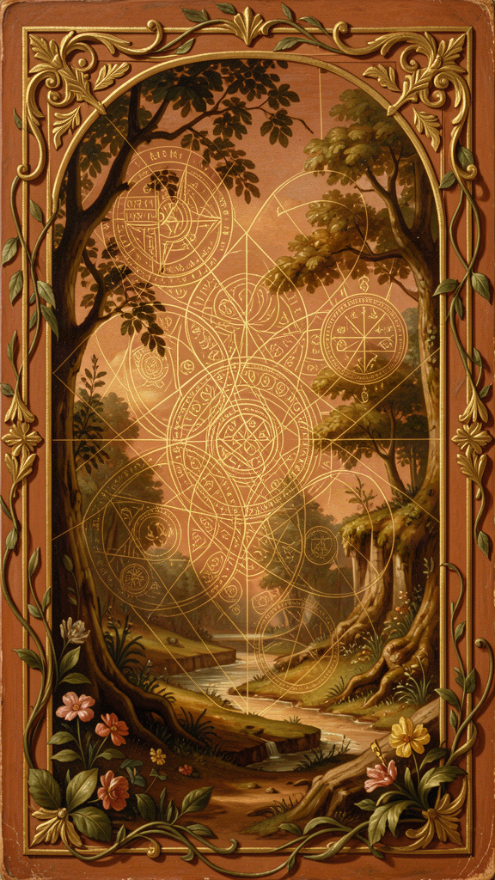
Illustration for Chapter 2
If everything flows, how does the world hold together? Why does the sun keep coming up? Why do the seasons keep turning? Why does the river keep flowing between its banks instead of sloshing everywhere? Heraclitus' answer is one word: logos.
Logos is the hardest word in Heraclitus, and it may be the most important word in all of ancient philosophy. It does not translate neatly into English. In fifth-century Greek, logos had a wide semantic field: speech, word, account, explanation, ratio, proportion, reason, principle, law, and gathering. Heraclitus almost certainly means all of these at once.

The Meanings of Logos
The Greek word logos carries at least three senses in Heraclitus. First, speech or statement — the words Heraclitus is speaking. Second, ratio or measure — the proportion that governs change. Third, reason or principle — the intelligence that steers the cosmos. The brilliance of the word is that these senses are not separate. Heraclitus' speech describes the cosmic ratio because the cosmic ratio is itself rational. The same word names the account, the structure, and the intelligence.
The opening fragment of Heraclitus' book announces both the truth and the difficulty: "It is wise for those who hear, not me, but the universal Reason, to confess that all things are one" (DK B1). He is not asking you to trust him as a person. He is asking you to listen to the pattern that runs through everything. That pattern is the logos. And the logos says: all things are one. The apparent multiplicity of the world conceals a deeper unity.
Then comes the sting: most people will not understand. "To this universal Reason which I unfold, although it always exists, men make themselves insensible, both before they have heard it and when they have heard it for the first time" (DK B2). The logos is not hidden because it is far away or too small to see. It is hidden because it is everywhere. People walk past it every day. They hear the words, but they do not understand. "Those who hear and do not understand are like the deaf. Of them the proverb says: 'Present, they are absent'" (DK B3).

The Logos Is Common
The logos is xunos — common, shared, public. It is not owned by any tribe, city, or individual. "Although the Law of Reason is common, the majority of people live as though they had an understanding of their own" (DK B2). Most people ignore the common pattern and live by private opinion. They treat their own guess as if it were the truth. This gives Heraclitus' philosophy a political and ethical dimension: to understand the logos is to leave the private self behind and enter the common world.

The Logos Is Hidden
"Nature loves to conceal herself" (DK B123). The logos does not jump out and announce itself. It has to be searched for. You infer the law from the way things behave, the way you infer gravity from watching objects fall. The logos is like a mathematical law hidden inside a falling stone. You do not see the law directly. You see its effects, and you work backward to the structure.
The Delphic oracle gives Heraclitus a model for his own style. "The lord whose oracle is at Delphi neither speaks plainly nor conceals, but gives a sign" (DK B93). The oracle does not hand you answers. It gives signs. You have to think. Heraclitus' fragments do the same. They are not lectures. They are signs — compressed, paradoxical, demanding. The difficulty is not a flaw. It is the pedagogy. If wisdom were obvious, it would not be wisdom.

The Logos Is Measure
"This world ... always was, and is, and shall be, an ever-living fire, kindled in due measure, and in due measure extinguished" (DK B30). The logos is the measure that keeps fire from consuming everything or going out entirely. It is the law of exchange between elements. It is the cosmic scale that says how much sea becomes earth, how much earth becomes fire, and when. Even change is lawful.

The Logos Is the Unity of Opposites
"They do not understand: how that which separates unites with itself. It is a harmony of oppositions, as in the case of the bow and of the lyre" (DK B45). The bowstring is pulled in opposite directions. The lyre string is stretched between opposite points. The harmony comes from the ratio of tension. The logos is that ratio. It explains why difference does not tear the world apart.

The Logos and the Soul
Heraclitus also says the soul has its own logos. "The soul has a self-increasing logos" (DK B115). This is obscure but important. It suggests that human beings do not simply receive the cosmic logos from outside. They also cultivate a logos within their own souls. The more you attend to the common pattern, the larger your inner logos becomes. Understanding is not passive reception. It is active cultivation.

The Logos and the Divine
"There is only one supreme Wisdom. It wills and wills not to be called by the name of Zeus" (DK B32). The ruling intelligence of the cosmos is one. Calling it "Zeus" is partly right and partly wrong. The divine order exceeds its names. Heraclitus keeps religious language but reinterprets it philosophically. The logos is not an anthropomorphic god on Olympus. It is the rational structure of reality itself — closer to what a scientist means by "the laws of nature" than to what a poet means by "the will of the gods."

Scholarly Debate: What Does Logos Mean?
Scholars disagree about which sense of logos is primary. The Stoic and later Platonic reading treats logos as cosmic reason — the rational principle that governs the universe, divine, common, and accessible to human reason. This interpretation connects Heraclitus to the later tradition that most directly influenced Western thought, but it may read Stoic meanings back into a thinker who did not yet have those theological frameworks.
Others argue that the primary meaning is "account" or "message." Heraclitus is saying, "Listen not to me but to my account." The logos is the teaching contained in the book. This reading respects the opening words of B1, where Heraclitus distinguishes himself from his logos, but it may reduce the cosmic scope of the doctrine.
Still others emphasize the mathematical sense. The logos is the measure or ratio that governs transformations. This fits the fire fragments and the regular measures of cosmic change, but it may understate the rational and linguistic dimensions.
Martin Heidegger and some contemporary scholars stress the etymological connection to legein as "gathering." The logos is what gathers opposites into unity. This reading emphasizes the unity of opposites and the way logos holds together what appears scattered, but it risks becoming too speculative or anachronistic.
The best current view is that Heraclitus uses logos polysemously. The word means all of these things at once: the rational structure of the cosmos, the account that articulates it, the proportion that measures it, and the gathering that unifies it. His philosophy gains force precisely because one Greek word can carry so many senses. The debate is unresolvable because the fragments are too short and too allusive to settle the question. Rather than choosing one meaning, readers should hold the cluster together.

The Big Idea
The logos is the rational structure that makes the world intelligible. It is common (it belongs to everyone), hidden (you have to look for it), and practical (finding it means paying attention to the real pattern instead of your private opinion). The logos is what makes flux bearable. Without it, change would be chaos. With it, change is a cosmos — an ordered, intelligible, beautiful process.
The modern parallel is the laws of nature. Gravity, evolution, thermodynamics — these are modern names for the logos. They are common (they apply to everyone), hidden (you have to discover them), measurable (they follow patterns), and they connect what looks separate. When a physicist writes an equation that predicts the motion of planets, she is listening to the logos. When a biologist traces the pattern of natural selection, she is reading the common order. Heraclitus did not have equations. But he had the insight: the world is mathematically, rationally, structurally intelligible. The logos is the reason that works.
The problem is not that the logos is absent. The problem is that people become deaf to it. They live by private opinion and habit. They see what they expect to see. They hear what they want to hear. "Eyes and ears are bad witnesses to men having rude souls" (DK B4). Perception is only as good as the soul that interprets it. A "barbarian soul" is like a foreigner who hears Greek words without grasping their meaning. The logos is speaking. Most people are not really listening.
Heraclitus distinguishes learning from wisdom. "Much learning does not teach one to have understanding, else it would have taught Hesiod and Pythagoras, and again Xenophanes and Hecataeus" (DK B16). Collecting facts is not the same as grasping the pattern. You can read a hundred books and still miss the logos, if you treat the information as a private possession rather than a window onto the common order. Wisdom is not the accumulation of data. It is the recognition of the structure that makes the data make sense.

Practical Application
In everyday terms, the logos is the truth of the situation before you add your preferences, fears, and habits. It is the evidence, the pattern, the actual structure of what is happening. Finding the logos is the opposite of sleepwalking.
Examples: In an argument, the logos is what both sides are actually saying, stripped of tone and defensiveness. In a market, the logos is the real supply, demand, and value, not the hype. In your own body, the logos is the actual signal of fatigue or energy, not the story you tell yourself about it. In a project, the logos is the real progress and risk, not the optimistic report or the anxious rumor.
Heraclitus names several reasons people miss the logos: habit (we see what we expect to see), private opinion (we prefer our own interpretation to the shared evidence), sleep (we go through life distracted, reactive, and automatic), and pride (we think we already understand). Each obstacle has a corresponding practice.

Practice
1. The Common Test. Before accepting your own interpretation of any event, ask: "What would someone who disagreed with me see here?" The logos is common. If your view cannot be shared or defended in public terms, it may be private fantasy. Do this for one week. Write down one instance where the common test changed your view. 2. The Pattern Journal. Each day, write down one event that seemed chaotic and one regularity you noticed inside it. A stressful project has a rhythm. A difficult relationship has a structure. A volatile market has a pattern. Over time, this trains the eye to find measure inside change — which is what finding the logos means. 3. The Pause. Heraclitus contrasts the sleeping and the waking. A simple waking practice is the deliberate pause before reacting. In the gap between stimulus and response, the logos becomes audible. Pick one situation where you usually react automatically — an argument with a partner, a stressful email, a financial decision. For one week, pause three seconds before responding. Notice what changes. 4. Speak As If Awake. Heraclitus says "we ought not to act and speak as though we were asleep" (DK B94). For one day, say only what you actually believe and can defend. Do not repeat what you heard someone else say. Do not fill silence with noise. Notice how much of your daily speech is automatic rather than intentional.

Reflect
What private opinion are you currently treating as truth? Where in your life are you ignoring the common evidence because it is inconvenient? A grudge, a political assumption, a professional article of faith, a self-image? Heraclitus says the logos is common. Healing begins when we move from private interpretation to shared reality. What would it cost to let the private view go — and what would you gain?
———

Chapter 3: The Unity of Opposites — The Way Up and the Way Down
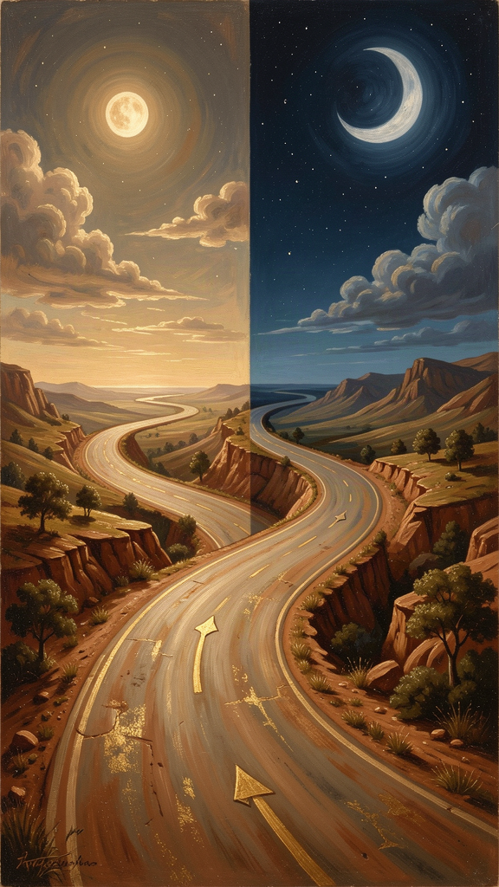
Illustration for Chapter 3
Heraclitus was walking on a road that went up a hill. He climbed to the top, turned around, and walked back down. He looked at the road and said: "The way upward and downward are one and the same" (DK B69).
This sounds like a riddle, but the meaning is right there. The road did not change. It is one road. From the bottom, it goes up. From the top, it goes down. Up and down are not two roads. They are two directions on the same path. The opposite directions belong to one structure.
This is the core of Heraclitus' doctrine of the unity of opposites, and it is one of the most original ideas in early Greek thought. He does not mean opposites are identical — day is not night, hot is not cold, life is not death. He means they are partners in a single process. Each defines the other. Each turns into the other. Each needs the other to exist.

Three Layers of Unity
There are three layers to this claim. First, opposites are mutually dependent. You cannot have day without night, because day is what comes after night and before night again. You only know something is hot because you have felt cold. The concept "up" requires the concept "down." Each opposite defines the other.
Second, opposites continuously transform into each other. "Cold becomes warm, and warm, cold; wet becomes dry, and dry, wet" (DK B39). Heat chills. Dampness dries out. Dryness drinks up moisture. Each quality is a station on a road that leads back to its opposite. The elements are phases of a single exchange, not permanent substances.
Third, opposites are held in a single order. The logos joins them. The road is one; the directions are two. The scale is one; the endpoints are many. Temperature is one scale; hot and cold are positions on it. The unity is not static. It is the unity of a scale, not the unity of a lump.

The Sea: Pure and Foul
The clearest example is the sea. "Sea water is very pure and very foul, for, while to fishes it is drinkable and healthful, to men it is hurtful and unfit to drink" (DK B52). The sea does not have an intrinsic value of "pure" or "foul." Its value depends on the creature encountering it. The same water is life for a fish and death for a person. The opposites come from the relationship, not from the water itself. This is perspectival unity: the opposition appears when we look locally. The unity appears when we look widely.

Good and Evil
Heraclitus pushes this to its most challenging point: "Good and evil are the same" (DK B57). He does not mean cruelty is good. He means that the concepts "good" and "evil" are mutually defined and sometimes transform into each other. A medicine that heals one person can poison another. A drought that ruins crops may restore a forest over decades. A war that destroys one civilization may reshape another. The point is not to abolish judgment. It is to enlarge the frame in which we judge. From a local human perspective, war looks evil. From the perspective of the whole, it may be part of a larger order. "To God all things are beautiful and good and right, though men suppose that some are right and others wrong" (DK B61).
This is not moral relativism. Heraclitus is not saying that all judgments are equally valid. He is saying that our judgments are partial — they depend on where we stand. The sea is not "really" pure or "really" foul. It is both, depending on the relationship. The question is not "which judgment is correct?" but "from what scale is this judgment being made, and what would the same situation look like from a larger scale?" This is a standing invitation to enlarge the frame. The person who only sees the local view lives in a private world. The person who can hold multiple perspectives at once participates in the common one.

The Bow and the Lyre
The central image is the bow and the lyre (DK B45). A bowstring is pulled in two directions at once — the wood bends one way, the string pulls the other. That tension is what lets the bow shoot. A lyre string is stretched between two points. That tension is what lets the lyre sing. Remove the tension, and the bow is just a stick. Remove the tension, and the lyre is just a frame with loose strings. The word Heraclitus uses is palintropos — "back-turning." The opposites curve back into each other. They do not cancel out. They hold together, and the holding is what makes the power.
"From differences results the most beautiful harmony" (DK B46). A painting needs light and shadow. A story needs conflict. A song needs high notes and low notes. Sameness is dull and powerless. Difference, held in tension, is beautiful. This is not just an aesthetic preference. It is a structural claim. If hot and cold were unconnected, there would be no warming or cooling. If life and death were separate realms, there would be no generation. Opposites are not endpoints. They are turning points. Each opposite contains the seed of the other. The opposition is the engine of change.
"The hidden harmony is better than the visible" (DK B47). When you look at the bow, you see wood and string. You do not see the force that makes it shoot. When you look at the lyre, you see the frame and the strings. You do not see the music until someone plays. The real power — the harmony — is invisible. It is the tension itself. The logos is the hidden harmony that holds the opposites together. We see conflict on the surface. The logos sees order at the depth.

The Big Idea
The unity of opposites is not a claim that "everything is its opposite." That would be nonsense. Heraclitus says opposites belong to a single process. Day is not night, but day passes into night and night into day. The distinction is real. The separation is false. The unity is dynamic, not static — it is the unity of a scale, a cycle, a road.
This has a direct practical consequence. Most of us treat oppositions as problems to solve. We try to eliminate the tension between work and rest, independence and commitment, honesty and tact, planning and improvisation. Heraclitus says the tension is not the problem. The tension is the structure. The bow needs pulling. The lyre needs stretching. The goal is not to abolish the opposition but to find its measure — the point where both sides are honored and the tension produces something neither could produce alone.
The modern parallel is dialectical thinking. Hegel said "there is no proposition of Heraclitus which I have not adopted in my Logic." His dialectic — thesis, antithesis, synthesis — is a systematized version of the unity of opposites. An idea generates its internal contradiction. The contradiction produces a higher unity that preserves and transcends both moments. Heraclitus did not use this vocabulary, but he saw the structure first: opposites held in tension generate something larger than either side alone.
The same structure appears in Darwin's natural selection. The "struggle for existence" is a sorting mechanism that produces adaptation and order. Conflict, governed by the constraints of the environment, generates the diversity and fitness of living things. Heraclitus' polemos and Darwin's selection share a deep structure: opposition, held in a system, produces order. The difference is that Heraclitus sees the sorting as cosmic and lawful, while Darwin sees it as biological and mechanistic. But both reject the idea that order comes from the absence of conflict. Order comes from conflict that is structured.

Practical Application
The practical application is direct and adult. Close relationships always contain tension: independence versus togetherness, honesty versus kindness, stability versus adventure. Many people treat these tensions as signs that the relationship is broken. Heraclitus would say they are signs that the relationship is alive. The question is whether the tension is productive (it clarifies differences and strengthens the bond) or destructive (it aims at victory and weakens trust). The goal is not to end the tension. The goal is to keep it in the zone of the bow: taut enough to function, not so tight that it breaks.
The same principle applies to creative work. Great work often emerges from the clash of constraints. A composer balances melody and dissonance. A writer balances clarity and depth. A designer balances function and beauty. The constraints pull against each other. The result is better than either side alone could produce. Heraclitus' image of the lyre applies directly: the strings are under tension, and the music comes from that tension. No tension, no music. The creative person does not remove the constraints. She tunes them.
The same principle applies to organizations. A company needs both stability and innovation. Too much stability, and it becomes rigid and irrelevant. Too much innovation, and it becomes chaotic and unsustainable. The healthy organization holds both in tension — stable enough to execute, innovative enough to adapt. The tension is not a problem to solve. It is the engine of the company's life.

Practice
1. The Opposite Journal. At the end of each day for one week, write down one pair of opposites that appeared in your experience. Work and rest. Independence and commitment. Honesty and tact. Planning and improvisation. For each pair, ask three questions: What would happen if I removed one side entirely? What would happen if one side dominated? What is the healthy tension between them — the measure where both are honored? 2. The Tension Map. Identify one opposition in your life right now that you are trying to resolve permanently — maybe independence versus commitment, ambition versus contentment, security versus growth. Do not try to resolve it. Instead, map the tension. Where is it too tight (one side dominating)? Where is it too loose (one side neglected)? What would the "measure" look like — the point where both sides are honored? 3. The Reframe. Pick a "negative" emotion you experienced this week — grief, anger, fear, boredom. Heraclitus says many emotions we label "bad" are the other side of desirable states. Grief is the other side of love. Fear is the other side of care. Anger is the other side of boundary. Boredom is the other side of possibility. Write one paragraph reframing the emotion as the necessary counterpart of something you value. What would be lost if the negative half disappeared? 4. Analyze a Paradox. Take one Heraclitean paradox — "the way up and the way down are one" (DK B69), or "we are and are not" (DK B49a). Do not treat it as a contradiction. Treat it as a compressed argument. What premise does it challenge? What conclusion does it point toward? Write one paragraph unpacking the logic.

Reflect
Where in your life are you treating an opposition as a problem to be eliminated rather than a tension to be managed? What would happen if you stopped trying to end the tension and started looking for its measure — the point where the bow is taut enough to shoot but not so tight that it breaks?
———

Chapter 4: Fire as Arche — The Ever-Living Fire
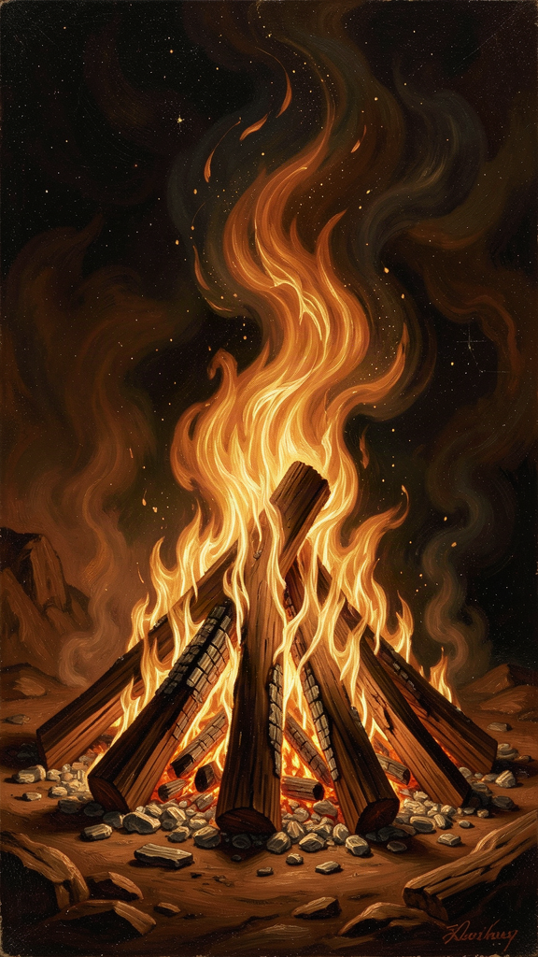
Illustration for Chapter 4
Every Greek philosopher before Heraclitus asked the same question: what is the world made of? Thales said water. Anaximenes said air. Anaximander said the boundless. Heraclitus said fire. But fire is not just another material candidate. It is the element that most clearly displays change while maintaining identity. A flame is always becoming new fuel, new heat, new light — yet we still call it "the fire." It is the perfect image for a cosmos that is both flux and order.

The Cosmic Fire
The key fragment is DK B30: "This world, the same for all, neither any of the gods nor any man has made, but it always was, and is, and shall be, an ever-living fire, kindled in due measure, and in due measure extinguished." Three things to notice. First, the cosmos is eternal — it was not created, and it will not end. Second, the cosmos is fire — not water, not air, but fire. Third, the fire is measured — it kindles and goes out in proportion. Even change is lawful.

Why Fire?
Consider the alternatives. Water is fluid and life-giving, but it is too passive — it preserves rather than transforms. Air is ubiquitous and animating, but it is invisible and lacks the visible drama of change. The boundless is neutral and unlimited, but it is too abstract — it offers no specific image of process. Fire is unique. It is always changing, yet it is always fire. It consumes, transforms, illuminates, and gives off other substances. It is the clearest example of a reality that is pure process. Heraclitus chose the element that most clearly shows what the cosmos is: not a stable substance, but a stable process.

The Cosmic Exchange
Heraclitus describes a cycle of elemental transformation. "The transmutations of fire are, first, the sea; and of the sea, half is earth, and half the lightning flash" (DK B31). Fire becomes sea. The sea divides — half becomes earth, half becomes lightning (which is fire returning). The earth returns to sea. The sea returns to fire. Nothing is lost. Everything changes form. This is a process model of physics. The elements are not permanent substances. They are phases of a single exchange.
"All things are exchanged for fire and fire for all things, just as wares for gold and gold for wares" (DK B22). The simile is economic. In a marketplace, goods are exchanged for gold and gold for goods. In the cosmos, all things are exchanged for fire and fire for all things. Fire is the universal medium of transformation — the cosmic currency. Heraclitus does not say fire is the only real thing and everything else is an illusion. He says fire is the medium through which all things are related.
"Fire lives in the death of earth, air in the death of fire, water in the death of air, and earth in the death of water" (DK B25). Each element is born from the "death" of the one before it. Death here means transformation, not annihilation. The old form goes; the process continues. This is the elemental version of the mortality cycle. Life passes into death; death passes into life. The boundary is real but porous.
"Immortals are mortal, mortals immortal, living in their death and dying in their life" (DK B67). This is one of the most mystical-sounding fragments, but its logic is the same as the rest. The living die into the next form; the dead give rise to new life. Mortality and immortality are not two separate realms. They are phases of one cycle. The boundary between them is a turning point, not a wall.

Fire and Justice
The fire is not wild. It is measured. "The sun will not overstep his bounds, for if he does, the Erinyes, helpers of justice, will find him out" (DK B29). Even the sun — the greatest fire in human experience — moves within limits. The Erinyes are the personified enforcers of cosmic law. The cosmos is not tyrannical fire. It is lawful fire. The measures are what make the fire a cosmos rather than a conflagration.
This is Heraclitus' answer to the fear that a world of fire would be a world of destruction. Fire is dangerous when unchecked. But the cosmic fire is ordered by justice (dikē). Change is real, but it follows a law. The sun is new every day — but it always comes back. The seasons turn — but they always return. The fire burns in measures, not in chaos.

Scholarly Debate: Is Fire Literal or Symbolic?
Scholars debate this. The literal reading says fire really is the primary stuff; other elements are transformations of it. The metaphorical reading says fire is an image for the principle of transformation itself — the real arche is becoming, not any particular element. The middle reading — probably the best — says fire is both a physical reality and the most fitting image of a world that is always changing yet always ordered. Heraclitus is not doing modern chemistry. He is asking: what is the most adequate symbol for a world that is always in process? Fire wins.
The Stoics later developed Heraclitus' fire into a doctrine called ekpyrōsis — the periodic conflagration in which the whole cosmos is consumed by fire and then reborn. Some readers import this Stoic idea back into Heraclitus. But Heraclitus' own fragments describe an ongoing, measured exchange, not a final apocalyptic burning. The fire does not end the world. It is the way the world keeps going.

Fire and the Soul
Heraclitus sometimes uses fire-language for the soul. "For souls it is death to become water" (DK B36). This is moral psychology, not physics. The fiery soul is active, awake, and intelligent. The watery soul is dull, passive, and forgetful. The dry soul is closest to fire and therefore closest to wisdom. The soul that becomes like water — heavy, sinking, drowning in appetite — has lost its fire. The soul that stays dry — sharp, awake, responsive — keeps its logos.

The Big Idea
Fire is the arche because fire is the clearest image of what the cosmos is: not a stable substance but a stable process. The fire is always changing — new fuel, new heat, new light — yet it is always fire. It consumes and creates at the same time. What looks like destruction is transformation. The form is lost; the energy continues.
This is not a claim that destruction is painless. Fire burns. Transformation hurts. But the meaning of the fire is not "everything ends." It is "everything becomes." The old form goes; the process continues. The matter and energy reorganize. The cosmos does not run down — it renews itself, kindling and going out in measures, forever.
The modern parallel is thermodynamics and the concept of dissipative structures. Ilya Prigogine showed that order can emerge from non-equilibrium processes. A whirlpool is a stable form sustained by moving water. A flame is a stable form sustained by chemical reaction. A living organism is a stable form sustained by the continuous flow of matter and energy. The cosmos, on this view, is not a clock winding down. It is a flame — a process that maintains its form through constant transformation. Heraclitus did not have the physics. He had the metaphor. And the metaphor turns out to be surprisingly accurate.

Practical Application: Loss as Transformation
The fire doctrine offers a framework for thinking about loss that is neither sentimental nor cold. When someone dies, a relationship ends, a project fails, or an identity dissolves, it feels like something has been taken out of the world. Heraclitus would not dismiss that feeling. The lost form is real, and the grief is appropriate. But he would also say the process continues. The person, the role, the hope is gone in one form. What remains — memories, effects, love, lessons — enters a new phase. Loss is not the end of the story. It is a turning in the story.
This is not a reason to rush through grief. It is a frame for understanding grief. The form is lost; the process continues. Healing does not mean forgetting. It means allowing the loss to transform. The memory remains, but its place in your life changes. The love remains, but it takes a new shape. The fire does not destroy what it consumes. It turns it into something else.
The key question after a loss or a failure is not "Why did this happen?" but "What is this becoming?" That question shifts attention from the lost form to the emerging one. Fire does not just destroy. It turns what it consumes into heat, light, ash, and new fuel. The form is lost; the energy continues. Failure can be understood as a kind of fire — it burns away the plan you had and releases energy for the next attempt. Many successful people describe their failures as necessary transformations rather than final defeats. Heraclitus gives that experience a philosophical structure.

Practice
1. Watch a Fire. Light a candle or find a campfire. Watch for fifteen minutes. The flame keeps its shape while every particle of it is replaced. The wax changes, the air changes, the heat changes — but the flame persists. Write down what you notice about the relationship between form and process. What does it mean that the flame is "the same" from moment to moment while being entirely different? 2. The Transformation Map. Pick a loss or ending in your life — a death, a divorce, a career change, a friendship that ended, a project that failed. Heraclitus says the form is lost but the process continues. Map the transformation: what was the "old form"? What remains — memories, effects, lessons, love? What is the emerging form? Write one paragraph on what this loss is becoming, not just what it was. 3. The Measure Audit. Heraclitus says the cosmic fire burns "in due measure." Where in your life is the fire too wild — burning everything up, consuming without renewing? This could be workaholism, a consuming passion, an addiction, a conflict that has escalated past productivity. Where is it too weak — barely lit, about to go out? This could be a stagnant relationship, a dead career, a creative practice you have abandoned. Pick one area and describe what the "measure" would look like: enough fire to transform, not so much that it destroys. 4. The Elemental Cycle. Draw Heraclitus' cycle: fire → sea → earth + lightning → sea → fire. Trace the arrows. Each arrow is both a death and a birth. Now apply it to something in your life: what "dies" into what? What is "born" from what? The cycle is not abstract. It is a way of seeing how your life renews itself through exchange.

Reflect
Heraclitus says fire is the arche because fire is always changing yet always fire. What is the "fire" in your life right now — the process that consumes the old and generates the new? Is it measured (lawful, balanced) or wild (burning everything up)? What would it mean to bring it into measure — enough fire to transform, not so much that it destroys?
———

Chapter 5: The Common and the Private — Waking and Sleeping
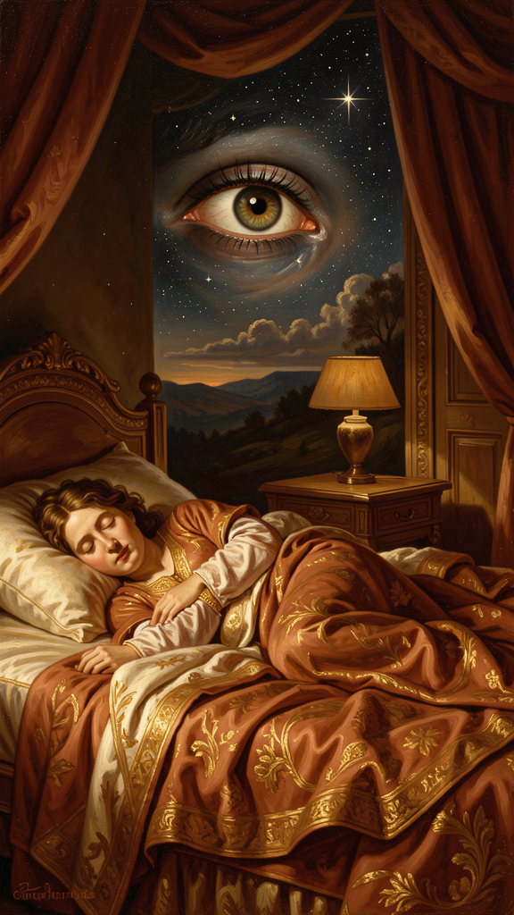
Illustration for Chapter 5
Heraclitus had a disturbing idea about people. He said most of us are asleep, even when our eyes are open. He did not mean we are literally dreaming. He meant we go through life without really seeing. We walk the same route without noticing it. We hold opinions we have never examined. We react before we understand. We hear, but we do not comprehend.
"Those who hear and do not understand are like the deaf. Of them the proverb says: 'Present, they are absent'" (DK B3). Hearing is not enough. The logos demands active comprehension. The person who listens but does not understand is compared to someone deaf at a concert: the sound is there, but the music is not received.

The Common and the Private
Heraclitus draws a sharp line between two ways of living: the common and the private. The common world is the world governed by the logos — the shared, measurable, rational structure of reality. The private world is the world of individual opinion, personal habit, and partial perspective. Most people, Heraclitus thought, live in private worlds even while surrounded by the common one.
The key fragment is DK B95: "To those who are awake, there is one world in common, but of those who are asleep, each is withdrawn to a private world of his own." The common world belongs to the awake. Private dreams belong to the asleep. The transition from private to common is not just an intellectual shift. It is a moral and spiritual awakening. When you wake up, you do not leave the world. You finally enter it.

The Masses and the Few
Heraclitus is unsparing about mass opinion. "What intelligence or understanding have they? They follow the crowd and take the masses for a teacher" (DK B104, paraphrased). Popularity is not a sign of truth. The crowd lives in private worlds that overlap by accident, not by understanding. Wisdom requires stepping away from the multitude — not to become a loner, but to find the common pattern the crowd has missed. "Dogs bark at what they do not know" (DK B97). People attack what they do not understand, because it threatens their private worldview. The common thinker is calm because she is anchored in something larger than opinion.

The City and the Law
Heraclitus gives this a political dimension. "The people must fight for the law as for the city wall" (DK B44). A city survives by common agreement on its rules. The law (nomos) is the human expression of the logos within a community. A city without law collapses into private interests, just as a soul without logos collapses into private opinions. "All human laws are dependent upon one divine Law, for this rules as far as it wills, and suffices for all, and overabounds" (DK B91). Human law is grounded in cosmic law. The rules that hold a city together reflect the deeper order that holds the cosmos together.
This is not conformity. Conformity is just many private minds agreeing by accident. Common thinking is agreement with the logos, which may put you at odds with the crowd. The person who understands the common pattern may be the one person in the room who disagrees with everyone else — because she is listening to the evidence, not to the group.

Learning vs. Wisdom
Heraclitus distinguishes learning from wisdom. "Much learning does not teach one to have understanding, else it would have taught Hesiod and Pythagoras, and again Xenophanes and Hecataeus" (DK B16). Collecting facts is not the same as grasping the pattern. You can read a hundred books and still miss the logos, if you treat the information as a private possession rather than a window onto the common order. Wisdom is not the accumulation of data. It is the recognition of the structure that makes the data make sense.
He also attacked Pythagoras directly: "Pythagoras, son of Mnesarchus, practiced investigation most of all men, and having chosen out these treatises, he made a wisdom of his own — much learning and bad art" (DK B129). Pythagoras studied widely but ended up with a private system. The charge is a warning against confusing erudition with insight. Real wisdom is not assembled from other people's ideas. It is the recognition of the common logos that makes all ideas intelligible.

The Big Idea
There are two ways to live: awake (in the common world, governed by the logos) or asleep (in a private world, governed by personal opinion). Most people are asleep. They mistake their private view for the truth. They follow the crowd. They bark at what they do not understand. Waking up means paying attention, checking your opinions against reality, and joining the shared world. It is uncomfortable — private worlds protect our self-image, our grudges, and our laziness. But it is the only way to see clearly.
Heraclitus links waking to ethics. "Self-control is the highest virtue, and wisdom is to speak the truth and consciously to act according to nature" (DK B107). Waking is not optional for the good life. It is the condition of the good life. You cannot act well if you do not see clearly. You cannot speak truth if you are mumbling in a private dream. The person who understands the logos will speak truly and act according to nature. Knowledge without discipline is incomplete.

Practical Application
The modern parallel is the critique of filter bubbles and confirmation bias. Each person on social media lives in a feed tailored to private preference. The algorithm shows you what you already believe. You never encounter the common world — only a private world that looks like one. Heraclitus' insight is 2,500 years ahead of this problem. The logos is common. The feed is private. The task is to break out of the feed and find the pattern that belongs to everyone.
This also connects to the problem of expertise. In any field, people mistake credentials, reputation, or data accumulation for understanding. "Much learning does not teach understanding" (DK B16). The expert who has read everything but missed the pattern is still asleep. The person who has read little but grasped the logos is awake. Heraclitus would warn that none of these — credentials, reputation, information — guarantee understanding. Wisdom is the recognition of the common order, not the size of your private library.
The ethical inversion is striking. In ordinary life, we prize what is "mine": my opinion, my tribe, my pleasure, my expertise. Heraclitus says the valuable thing is what is not mine — the common logos. The soul becomes healthier as it becomes less private and more common. This is not the same as conformity. Conformity is just many private minds agreeing by accident. Common thinking is agreement with the logos, which may put you at odds with the crowd. The task is to move from "what do I think?" to "what does the evidence actually show?"

Practice
1. The Morning Question. Before the day begins, ask: "What am I not seeing?" This puts you in the posture of searching for the logos rather than assuming you already have it. Do it for one week. Write down one thing each day that you had been missing. 2. The Conversational Check. In your next three conversations, ask yourself: "Am I actually listening, or am I waiting for my turn to speak?" Most social sleep takes this form. Real listening is waking. Notice how often you are planning your response instead of hearing the other person. 3. The Evidence Review. When you are about to make a significant decision — career, financial, relational — list the evidence that does not fit your preferred outcome. This is the common test in action. We naturally weight evidence that confirms what we already believe. The logos demands that we weight the evidence that challenges us. Write down one decision where the evidence review changed your mind. 4. The Evening Recollection. At the end of the day, recall one moment when you were truly awake — paying attention, responsive, present — and one when you were asleep — reactive, automatic, checked out. The practice builds self-knowledge and gradually shifts the balance. Do it for one week and notice the pattern.

Reflect
Heraclitus said most people "live as though they had an understanding of their own" (DK B2). What private opinion are you treating as truth right now? Where in your life are you defending a private worldview against the common evidence? A feud, a political identity, a professional assumption, a self-image? What would it cost to let it go — and what would you gain?
———

Chapter 6: Strife and Harmony — The Bow and the Lyre
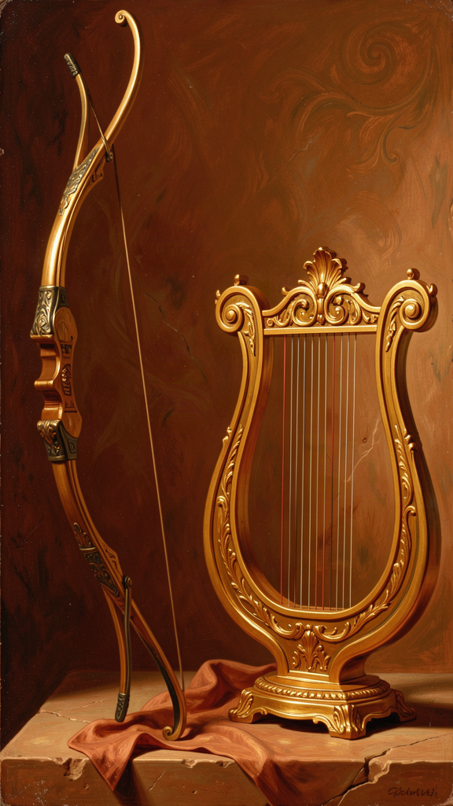
Illustration for Chapter 6
Heraclitus shocks his readers. He says war is the father of all things. He says strife is justice. He says the most beautiful harmony comes from tensions that pull in opposite directions. This is not a celebration of violence. It is a metaphysical claim: the cosmos is ordered by opposing forces that are balanced, not by forces that have been eliminated.

Polemos: War as Father
"War is the father of all and king of all, and some he shows as gods, others as men; some he makes slaves, others free" (DK B53). The Greek word is polemos — war, battle, contest, struggle. Heraclitus uses it metaphysically. Polemos is the force that sorts things into their roles. Without conflict, there would be no distinction, no structure, no hierarchy. The differences that make the world the world come from tension.

Strife Is Justice
"It is necessary to know that war is common and strife is justice, and that all things happen in accordance with strife and necessity" (DK B80). This is one of the most difficult fragments. How can conflict be fair? Heraclitus' answer is that the cosmos sorts itself through balanced opposition. What looks like unfair battle from a local view is, from the cosmic view, the process by which everything finds its measure. Strife is not an exception to justice. It is the mechanism of justice.
Think about how this works in systems you know. Democracy depends on structured disagreement — voters choose between different visions. Science depends on testing theories against rivals. Markets set prices through the tug of supply and demand. Legal systems resolve disputes through adversarial proceedings. These systems work not despite conflict but because of it, when the conflict is governed by fair rules. Justice often emerges from the contest of competing claims, not from the elimination of difference.

From Differences, Beautiful Harmony
"From differences results the most beautiful harmony" (DK B46). A painting needs light and shadow. A story needs conflict. A song needs tension and release. A cosmos needs opposing forces. Sameness is dull and powerless. Difference, held in tension, is beautiful. This connects strife to aesthetics. A uniform gray field is not beautiful. The beauty of the world depends on the oppositions that structure it.

The Bow and the Lyre
The bow and the lyre are Heraclitus' central images (DK B45). The bow is an instrument of war. The lyre is an instrument of music. Both depend on balanced tension. The bowstring is pulled in two directions; the lyre string is stretched between two points. Remove the tension, and neither works. War and beauty come from the same structural principle: productive tension.
The word Heraclitus uses is palintropos — "back-turning." The opposites curve back into each other. They do not cancel out. They hold together, and the holding is the harmony. "The hidden harmony is better than the visible" (DK B47). The visible harmony of the lyre string is only the surface. The real harmony is the invisible law of tension, proportion, and vibration. The same is true of the cosmos. We see conflict on the surface. The logos sees order at the depth. Strife on the surface may be harmony at the core.

The Cosmic Cycle of Craving and Satiety
Heraclitus names the forces that drive the cosmic cycle: "Craving and Satiety" (DK B24). Fire needs fuel (craving) and consumes fuel (satiety). The cosmos is driven by opposed impulses. Wanting and having. Hunger and fullness. The cycle of desire and satisfaction mirrors the cycle of elemental transformation. Strife is not only external war. It is also the internal tension of wanting and having, lacking and fulfilling, that keeps the fire alive.

Why This Is Not a Celebration of Violence
It is crucial not to misread Heraclitus as a militarist. He is not saying "go start wars." He is saying opposition is a structural feature of reality. War is one image of that opposition. The same principle appears in music (tension and release), medicine (fever and recovery), politics (debate and vote), and elemental transformation (fire and water). When conflict is balanced, it is harmony. When it is unbalanced, it is destruction. Heraclitus' ideal is not endless battle. It is measured strife — tension that creates, not tension that destroys.
The practical question is not "how do I eliminate conflict?" but "how do I keep the tension in the zone where it produces value?" A bow at rest is not a bow in use. A bow with a snapped string is useless. The working bow is taut — but not too taut. The same goes for a team, a marriage, a creative project, a company, or a democracy. The tension is the engine. The skill is finding the measure.

The Big Idea
The world is held together by tension, not by the absence of tension. The bow works because it is pulled two ways. The lyre sings because it is stretched between two points. Strife is the father of order because order is balanced opposition, not blank peace. The goal is not to eliminate conflict but to find its measure — the point where the tension is productive, where both sides are honored, where the bow is taut enough to shoot but not so tight that it breaks.
Heraclitus' insight anticipates later ideas in surprising ways. Darwin's natural selection is a sorting mechanism that produces order through conflict — the struggle for survival generates adaptation. Hegel's dialectic sees history advancing through the clash of thesis and antithesis. Nietzsche praised Heraclitus for understanding that struggle is the source of all value. In each case, the structure is the same: opposition, held in a system, generates something neither side could produce alone.
The Stoics were the most systematic heirs of this idea. They adopted Heraclitus' polemos and turned it into a providential ordering principle. Where Heraclitus says "war is the father of all," the Stoics say conflict is the mechanism by which divine reason sorts the cosmos. They tamed the wild paradox into a rational, morally ordered system. The gain was clarity and practical ethics. The loss was the poetic density and metaphysical daring of the original. Heraclitus is raw; Stoicism is cooked. Both can nourish — but they taste different.

Practical Application
The practical application is direct and adult. Close relationships always contain tension: independence versus togetherness, honesty versus kindness, stability versus adventure, giving versus receiving. Many people treat these tensions as signs that the relationship is broken. Heraclitus would say they are signs that the relationship is alive. The question is whether the tension is productive (it clarifies differences and strengthens the bond) or destructive (it aims at victory and weakens trust). The goal is not to end the tension. The goal is to keep it in the zone of the bow: taut enough to function, not so tight that it breaks.
The same principle applies to creative work. Great work often emerges from the clash of constraints. A composer balances melody and dissonance. A writer balances clarity and depth. A designer balances function and beauty. The constraints pull against each other. The result is better than either side alone could produce. Heraclitus' image of the lyre applies directly: the strings are under tension, and the music comes from that tension. No tension, no music. The creative person does not remove the constraints. She tunes them.
The same principle applies to organizations. A company needs both stability and innovation. Too much stability, and it becomes rigid and irrelevant. Too much innovation, and it becomes chaotic and unsustainable. The healthy organization holds both in tension — stable enough to execute, innovative enough to adapt. The tension is not a problem to solve. It is the engine of the company's life.
The same principle applies to democracy. A healthy democracy depends on structured disagreement. Voters choose between different visions. Parties compete. The press challenges power. The courts check the legislature. These tensions are not signs that the system is broken. They are the mechanism by which the system works — when the conflict is governed by fair rules. Remove the tension, and you get either tyranny or apathy. The goal is not consensus. It is productive contest.

Practice
1. Name the Tension. Pick one conflict in your life right now — with a partner, a colleague, a family member, a team. Name the opposing values. Is it honesty versus kindness? Independence versus belonging? Ambition versus contentment? Security versus growth? Write them down. Do not try to resolve the conflict. Instead, ask: what is the measure where both values are honored? 2. Resist Premature Resolution. Sometimes the right answer is to keep the tension alive. For one week, when you feel pressure to "just decide" in a difficult situation, pause. Ask: is this a tension that should be resolved, or a tension that should be managed? Write down one case where keeping the tension alive produced a better outcome than rushing to resolve it. 3. Watch for Breakage. Heraclitus says the bow must be taut but not too taut. For one week, monitor one tension in your life. When does it feel productive — generating energy, clarity, or growth? When does it feel destructive — becoming personal, hostile, or exhausting? Write down the threshold where the tension crossed from creative to damaging. The skill is knowing where the line is. 4. The Creative Constraint. Pick a creative project — an essay, a presentation, a design, a business problem. Identify two constraints that pull against each other (clarity versus depth, function versus beauty, speed versus quality, risk versus safety). Do not remove either constraint. Work within both. Write one paragraph on how the tension between them improved the result.

Research Prompt
Heraclitus said "war is the father of all" (DK B53). Hegel said "there is no proposition of Heraclitus which I have not adopted in my Logic." Darwin described natural selection as a struggle for survival that produces adaptation. The Stoics turned polemos into a providential ordering principle. Compare these four thinkers. What do they share? Where do they diverge? Is conflict the engine of order in all four systems, or does the meaning of "conflict" change from one to the next? Read Charles Kahn's The Art and Thought of Heraclitus (1979), pp. 199–210; Hegel's Lectures on the History of Philosophy, vol. 1, on Heraclitus; and a selection from Darwin's On the Origin of Species (1859) on the struggle for existence. Write a short essay (800–1,200 words) comparing the role of strife in Heraclitus, Hegel, Darwin, and the Stoics. Where does the Heraclitean insight survive, and where does it transform into something different?
———

For the Grown-Up Reader
Heraclitus of Ephesus (c. 535–475 BCE) is one of the most important and most misunderstood thinkers in the Western tradition. He wrote a single book, deposited in the Temple of Artemis at Ephesus, that survives only in fragments — roughly 126 short quotations preserved by later authors (Plato, Aristotle, Plutarch, Hippolytus, Clement of Alexandria, Sextus Empiricus, Diogenes Laërtius, and others). The standard scholarly reference is the Diels-Kranz numbering system (DK B1–B126).
What is real and what is legend? We know with reasonable confidence that Heraclitus was an aristocrat from Ephesus, active around 500 BCE, who wrote in a deliberately obscure, oracular style. He may have held a hereditary priesthood connected to the Temple of Artemis. Ancient sources say he surrendered a ceremonial title of "king" to his brother because he preferred philosophy to politics. Almost everything else — his withdrawal from public life, his "weeping" temperament, his death from dropsy (edema), the story that he covered himself in cow dung to cure himself — comes from late and unreliable biographers, especially Diogenes Laërtius, who wrote about 700 years later. The "Weeping Philosopher" label is a Roman-era caricature, paired with Democritus as the "Laughing Philosopher." The fragments themselves are severe, ironic, and often luminous — not despairing. The cow-dung death is almost certainly a hostile fiction.
Are the quotes real? Every quote in this booklet is a genuine fragment, cited by DK number. The translations are adapted for adult readers but remain faithful to the meaning. No quote has been invented or paraphrased into untruth. The fragments are drawn from the research compendium at `/home/mikesai1/Documents/WisdomForge/wisdomforge/content/heraclitus/`, which grounds each fragment in its ancient source and scholarly commentary. The primary sources are the ancient authors who preserved the quotations: Plutarch, Hippolytus, Clement of Alexandria, Sextus Empiricus, Diogenes Laërtius, Plotinus, Origen, and others.
Scholarship used: Charles Kahn's The Art and Thought of Heraclitus (1979) is the best English edition with commentary and the primary source for fragment interpretation. Daniel Graham's "Heraclitus: Flux, Order, and Knowledge" in the Oxford Handbook of Presocratic Philosophy (2008) provides the modern scholarly framework. G.S. Kirk's Heraclitus: The Cosmic Fragments (1954) remains essential for the cosmological fragments. Edward Hussey's The Presocratics (1972) and his "Epistemology and Meaning in Heraclitus" (Language and Logos, 1982) inform the epistemological sections. M.M. Mackenzie's "Heraclitus and the Art of Paradox" (Oxford Studies in Ancient Philosophy 6, 1988) informs the treatment of the riddling style. A.A. Long's "Heraclitus on Measure and the Explicit Emergence of Rationality" (Doctrine and Doxography, 2013) informs the logos discussion. Nehamas's "Parmenidean Being/Heraclitean Fire" in Virtues of Authenticity (1999) informs the Parmenides comparison. Robin Waterfield's The First Philosophers (Oxford, 2000) provides accessible translations. Brooks Haxton's Fragments (2001) is a poetic translation.
Scholarly debates engaged: (1) Did Heraclitus write one structured book or a collection of independent aphorisms? Most scholars accept one book but doubt we can reconstruct its order. (2) Is flux absolute or cosmic — does everything change, or does change follow the logos? (3) What does logos mean — word, reason, proportion, gathering, or all at once? (4) Is fire literal or metaphorical? (5) The authenticity of the fragments — how much can we know from secondhand quotations? (6) The parallel with Eastern thought — is the resemblance to Daoism and Buddhism genuine insight or projection? This booklet engages these debates where they illuminate the text, without pretending they are settled.
Common misconceptions addressed: (1) Heraclitus is not a pessimist — the "Weeping Philosopher" is a late caricature. His fragments are luminous, not despairing. (2) "Everything flows" does not mean nothing matters — the logos gives change a pattern, which makes commitment and knowledge possible. (3) Fire is not destruction — it is transformation. (4) The riddling style is not irrationality — it is a deliberate method that forces the reader to think. (5) Heraclitus is not "just Zen" — he is rooted in Greek rationalism and Ionian natural philosophy. (6) "Panta rhei" is attributed to Heraclitus by Plato but does not appear as a direct quotation in the fragments. (7) "The only constant is change" is a modern saying, not a Heraclitus fragment.
A note on the quotes: Heraclitus is the philosopher most often recruited to say things he did not say. Every quotation in this booklet is grounded in the actual textual record, with DK numbering and ancient source attribution. The translations are simplified for readability but remain faithful to the scholarly consensus on meaning.
Further Reading: - Kahn, Charles H. The Art and Thought of Heraclitus (1979) — the best English edition with commentary. - Graham, Daniel W. Explaining the Cosmos (2006) — on the Ionian tradition. - Kirk, G.S. Heraclitus: The Cosmic Fragments (1954) — essential for the cosmological fragments. - Barnes, Jonathan. The Presocratic Philosophers (1982) — skeptical and rigorous. - Waterfield, Robin. The First Philosophers (Oxford, 2000) — accessible translations with context. - Haxton, Brooks. Fragments (2001) — a poetic translation. - Hadot, Pierre. The Veil of Isis (2006) — on Heraclitus and the hiddenness of nature.
———

About WisdomForge
WisdomForge creates age-adapted booklets that bring the great thinkers of philosophy and theology to readers at every stage of life. Each figure gets four booklets: one for ages 5–10, one for 11–14, one for 15–18, and one for adults. The same ideas, shaped for how you think right now.
We believe the deepest ideas belong to everyone — not just scholars. A child can wonder about a river. A teenager can wrestle with opposites. An adult can find the logos in a career or a family. The questions are old. The conversation is always new.
Read it. Question it. Discuss it. The thinkers in these pages have been alive for thousands of years. They are waiting for you to join the conversation.
Adapted by Aiona Edge for WisdomForge Content based on the Heraclitus Compendium by Harry © SMF Works — Free to download, read, and share

