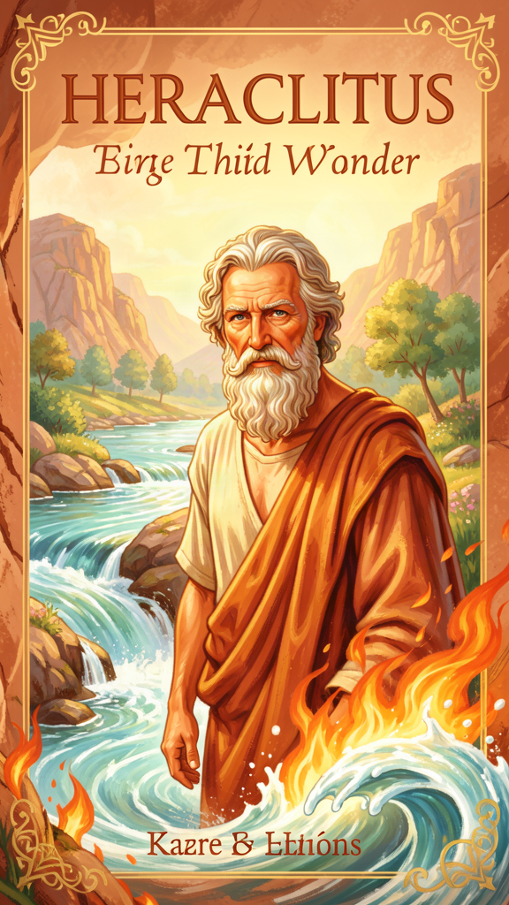
Heraclitus: The Man Who Saw the River Dancing
WisdomForge Booklet — Ages 5–10

Heraclitus: The Man Who Saw the River Dancing

WisdomForge Booklet — Ages 5–10
———

About This Book
A long time ago, in a city near the sea, there lived a man named Heraclitus. He loved to watch rivers. He loved to watch fire. He loved to think about how the world keeps changing — and how it keeps being the same.
Heraclitus wrote short, tricky sayings called fragments. They sound like riddles. "You cannot step into the same river twice." "The way up and the way down are one and the same." He wrote this way on purpose. He wanted you to stop and think.
This booklet tells his story in six chapters. Each chapter has a story, words to remember, a big idea, and something to try. Read it alone or with a grown-up. The questions aren't tests — they're starting points for wondering together.
———

Chapter 1: The River That Never Stops Moving
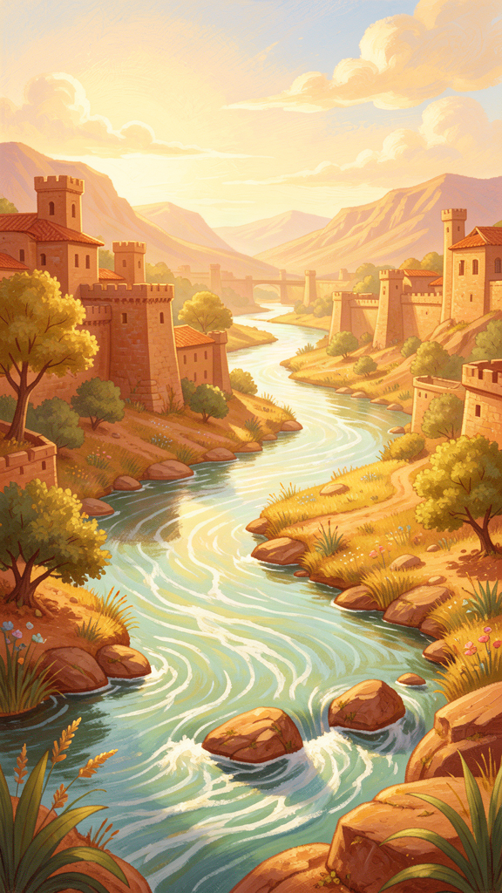
Illustration for Chapter 1
There once was a boy named Heraclitus who lived in a city called Ephesus. Ephesus sat near the sea, and a river ran through it. Every day, Heraclitus walked to the river and watched the water flow.
One morning, he stepped into the river. The water splashed around his feet. He stepped out, walked away, and came back the next day. He stepped in again. But something had changed. The water that touched his feet yesterday was already gone — flowing toward the sea. New water had come from upstream. Was it the same river?
Heraclitus thought about this for a long time. The river looked the same. The banks were the same. The name was the same: "the river." But every drop of water inside it was different from yesterday. How could something be the same river if the water was always new?
He told his friends what he had noticed. "Into the same river you could not step twice, for other and still other waters are flowing." That became one of the most famous things anyone ever said about the world.
Heraclitus saw that the river is not the water. The river is the moving. The water comes and goes, but the flowing stays. The river is a pattern, not a thing. It keeps being a river by never staying the same.
This was a big idea. Most people thought the world was made of things that stayed put — rocks, trees, houses. Heraclitus said the world is more like a river. Everything moves. Everything changes. But the changing has a shape, like the shape of a river's flow. The world stays the world by changing, not by standing still.
Words to Remember
"Into the same river you could not step twice, for other and still other waters are flowing." — Heraclitus, DK B41
This means: the river looks the same, but the water is always new. The name stays; the stuff moves.
Big Idea
The world is like a river. It keeps changing, but it keeps being the world. You cannot hold the water, but the river still flows. Changing and staying the same are not opposites — they are partners.
Try This
- Visit a river, a fountain, or a tap. Watch the water move. Ask: "Is this the same water I saw a minute ago? Is it still the same river?" Let yourself feel the puzzle Heraclitus felt. - Watch a candle burn. The flame keeps its shape, but the wax keeps disappearing. Is the flame the same from moment to moment? Heraclitus would say yes and no — and that is the whole lesson. - Draw a river. Draw the water with arrows showing which way it moves. Now draw the banks that stay still. You have just drawn Heraclitus' big idea: movement inside, shape outside.
Ask a Grown-Up
"When you were my age, were you the same person you are now? What has changed about you? What has stayed the same?"
———

Chapter 2: The Hidden Pattern
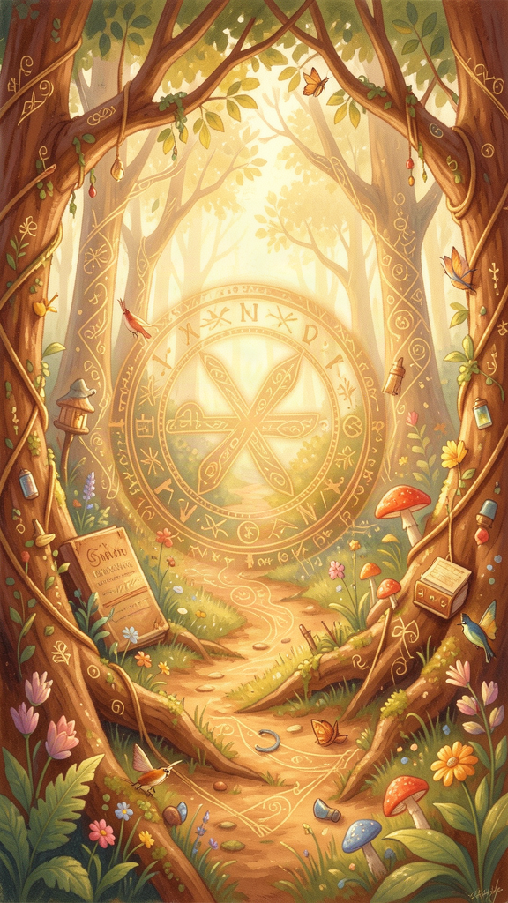
Illustration for Chapter 2
Heraclitus did not think the world was a jumble. The river moves, but it moves in a pattern. The fire burns, but it burns in measures. There is a hidden order inside the changing. Heraclitus called this order the logos.
Logos is a hard word to translate. It can mean "word," "reason," "measure," or "the way things fit together." Heraclitus used it for all of these at once. The logos is the pattern that makes the world make sense. It is the rule behind the river, the law behind the fire, the reason the sun comes up every morning.
Heraclitus said something surprising about the logos: most people miss it. The logos is not hidden because it is far away. It is hidden because it is everywhere. People walk past it every day, but they do not see it. They hear the words, but they do not understand.
He compared people who miss the logos to someone deaf at a concert. The music is playing. The sound is there. But the deaf person does not hear it. "Those who hear and do not understand are like the deaf," he said. "Present, they are absent."
How do you find the logos? You slow down. You pay attention. You look for the rule inside the changing. When you watch a river, the logos is the pattern of the flow. When you listen to music, the logos is the beat that holds the notes together. When you watch the seasons turn, the logos is the rhythm that brings summer, then winter, then summer again.
Heraclitus said the logos is common. That means it belongs to everyone. It is not a secret only Heraclitus knows. It is the shared pattern of the whole world. But you have to wake up to see it. You have to stop sleepwalking.
Words to Remember
"To those who are awake, there is one world in common, but of those who are asleep, each is withdrawn to a private world of his own." — Heraclitus, DK B95
This means: when you pay attention, you share the real world with everyone. When you do not pay attention, you live inside your own dream.
Big Idea
The world has a hidden pattern called the logos. It is everywhere, but most people miss it because they are not paying attention. Finding the logos means waking up — looking for the rule inside the changing, the order inside the noise.
Try This
- Play "find the rule." Make a pattern with blocks, beads, or coins — red, blue, red, blue. Ask someone to guess the rule. The logos is the rule that makes the pattern work. - Listen for the beat. Put on your favorite song. Find the beat. The notes change, but the beat holds them together. The beat is like the logos — the pattern inside the sound. - Watch the sky for a week. Draw the moon every night. Does it change? Is there a pattern? Heraclitus watched the sun and the moon. The sun is new every day, he said — but it always comes back.
Ask a Grown-Up
"Can you think of a pattern in the world that is always there but easy to miss? Like the way the seasons turn, or the way your heart keeps beating?"
———

Chapter 3: The Way Up and the Way Down
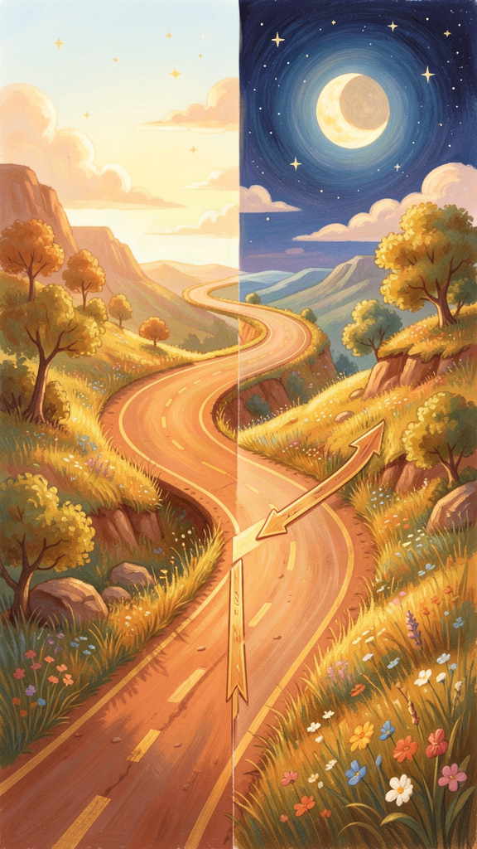
Illustration for Chapter 3
One day Heraclitus was walking on a road that went up a hill. He walked up to the top. Then he turned around and walked back down.
He looked at the road and laughed. "The way up and the way down are one and the same," he said.
What did he mean? The road did not change. It was one road. But from the bottom, it went up. From the top, it went down. The same road held both directions. Up and down were not two roads. They were two ways of walking the same path.
This was one of Heraclitus' favorite ideas: opposites are not enemies. They are partners. Day needs night. You cannot have day without night, because day is what comes after night and before night again. Hot needs cold. You only know something is hot because you have felt cold. Life needs death. Living things die, and from what dies, new things grow.
Heraclitus saw opposites everywhere, and he saw that they belonged together. The bow needs two opposite pulls to shoot an arrow. The lyre needs two opposite stretches to make music. Without the pulling, the bow is just a stick. Without the stretching, the lyre is just a frame with loose strings.
He said something that sounds strange: "Good and evil are the same." He did not mean that being cruel is good. He meant that good and evil are tied together like day and night. A medicine that heals one person can poison another. A drought that hurts the crops may help the forest in the long run. The same thing can be good from one angle and bad from another. The difference depends on where you stand.
The road is one. The directions are two. Both are real. That is Heraclitus' secret: opposites are not a problem to solve. They are the way the world works.
Words to Remember
"The way upward and downward are one and the same." — Heraclitus, DK B69
This means: the same road goes both up and down. What changes is which way you are walking, not the road itself.
Big Idea
Opposites are not enemies. They are partners. Day needs night. Hot needs cold. Up needs down. The world is made of pairs that pull against each other — and that pulling is what makes everything work.
Try This
- Walk up and down a hill. Notice that it is the same road. From the bottom it is "up." From the top it is "down." The road does not change. You do. - Stretch a rubber band. Pull it from both ends. It only works because two sides pull against each other. Let go of one side, and it snaps. That is Heraclitus' bow — the power is in the pulling. - Play one note on an instrument, then play a chord. One note is plain. A chord has different notes together. The difference is what makes it interesting. Heraclitus said beauty comes from differences held together.
Ask a Grown-Up
"Can you think of two things that seem opposite but actually need each other? Like work and rest, or talking and listening?"
———

Chapter 4: The Ever-Living Fire
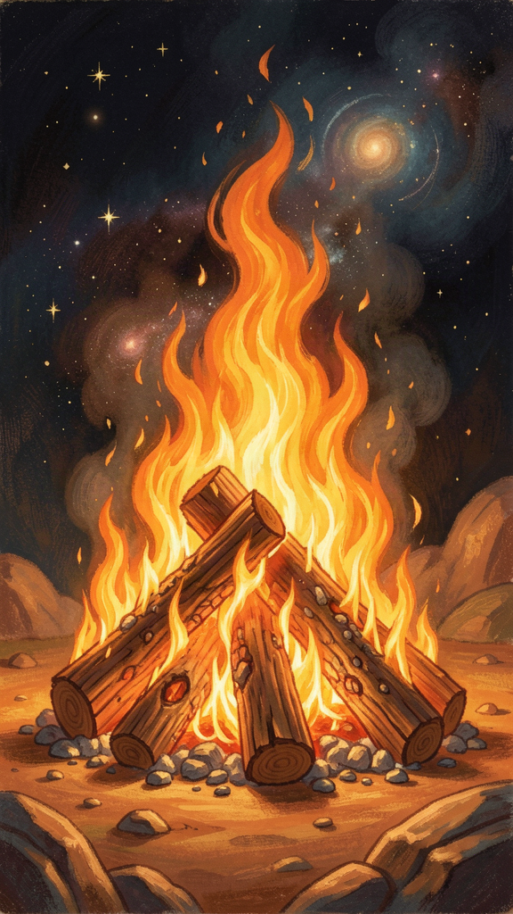
Illustration for Chapter 4
Heraclitus loved to watch fire. A campfire, a candle, a bonfire — he watched them all. And he noticed something no one else had seen.
Fire is never the same. The flame dances. It eats the wood. It makes heat and light. It changes everything it touches. But while it burns, we still call it "the fire." The flame keeps its shape while every part of it is changing.
Heraclitus said the whole world is like a fire. The universe is not a thing someone built. It is a living flame that always burns, always changes, always stays. "This world, the same for all, neither any of the gods nor any man has made, but it always was, and is, and shall be, an ever-living fire, kindled in due measure, and in due measure extinguished."
That last part matters: "in due measure." The fire does not burn everything up. It does not go out. It burns in measures — the right amount, at the right time. The sun comes up every morning and goes down every evening. That is fire in measure. The seasons turn. That is fire in measure.
Heraclitus said fire turns into other things. Fire becomes sea. The sea becomes earth and lightning. The earth turns back to sea, and the sea turns back to fire. Everything is exchanged for fire, like trading goods for gold and gold for goods. Fire is the money of the cosmos. Everything can be changed into it, and it can be changed into everything else.
When something burns, it is not gone. It has changed form. The wood becomes ash, smoke, heat, and light. Nothing is lost. Everything becomes something else. Heraclitus said even death is not an ending. It is a transformation. The old form goes; the process continues.
He warned that fire is not just destruction. Fire is the way the world renews itself. What looks like ending is beginning in disguise. The sun is new every day — not because the old sun died, but because fire keeps relighting itself.
Words to Remember
"This world ... always was, and is, and shall be, an ever-living fire, kindled in due measure, and in due measure extinguished." — Heraclitus, DK B20
This means: the universe is a living flame. It does not stop. It burns in the right amounts, at the right times. It changes everything and destroys nothing.
Big Idea
The world is like fire. It always changes, but it always keeps going. Fire does not destroy — it transforms. What looks like ending is the start of something new. The fire burns in measures, not in chaos.
Try This
- Light a candle and watch it. Is the flame the same shape from second to second? The wax changes, the air changes, but the flame keeps its shape. That is Heraclitus' fire — always new, always fire. - Cook something with a grown-up. The fire turns raw food into a meal. The food is "destroyed" as raw food and "created" as cooked food. Was that only destruction, or was it also making? - Draw the fire cycle. Fire becomes sea. Sea becomes earth and lightning. Earth becomes sea. Sea becomes fire. Draw arrows in a circle. You have drawn Heraclitus' picture of how the world keeps itself alive.
Ask a Grown-Up
"When something in your life ended — a job, a friendship, a phase — did something new begin? Was the ending also a beginning?"
———

Chapter 5: Waking Up
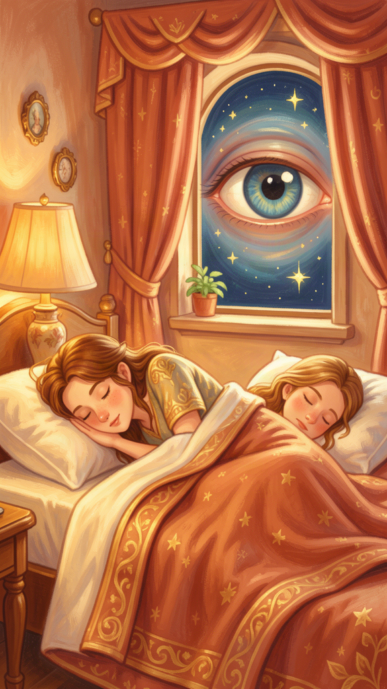
Illustration for Chapter 5
Heraclitus had a strange idea about people. He said most of us are asleep — even when our eyes are open.
He did not mean we are literally dreaming. He meant we go through life without really seeing. We walk the same route without noticing it. We say the same words without thinking about them. We hold opinions we have never checked. We hear, but we do not understand. "Those who hear and do not understand are like the deaf," he said. "Present, they are absent."
Heraclitus split the world into two groups: the sleeping and the waking. The sleepers live in private worlds. They think their own opinion is the truth. They do not check whether what they believe matches the world. They walk through the day like someone walking in a dream — moving, but not noticing.
The waking are different. They pay attention. They look for the logos — the shared pattern of reality. They check their opinions against the world. They share one world with everyone else who is awake. The sleepers each live in their own bubble.
The hard part is that sleep feels normal. You do not know you are asleep until you wake up. Heraclitus said most people will not understand him, because waking up is uncomfortable. It means admitting you were wrong. It means giving up your private dream for the shared world.
But waking up is also joyful. When you stop sleepwalking, the world becomes vivid. You notice the river. You hear the music. You see the pattern. The same world that was grey and automatic becomes bright and alive.
Heraclitus gave a rule for waking: do not speak and act as if asleep. Say only what you really believe and can defend. Pay attention to what is in front of you. Stop reacting on autopilot. The morning you decide to notice the world is the morning you start to wake up.
He also said the eyes and ears can fool you. "Eyes and ears are bad witnesses for those who have barbarian souls." He did not mean your eyes are useless. He meant that seeing is not enough. You have to understand what you see. A camera takes a picture, but it does not know what the picture means. You have to bring understanding to your seeing.
Words to Remember
"We ought not to act and speak as though we were asleep." — Heraclitus, DK B94
This means: wake up. Pay attention. Say what you mean. Notice the world instead of sleepwalking through it.
Big Idea
Most people are asleep — not literally, but in how they live. They go through the day without noticing. Waking up means paying attention, checking your opinions, and joining the shared world. It is hard, but it makes everything brighter.
Try This
- Play "freeze and notice." Walk around your room. When someone says "freeze," stop and name three things you can see, two things you can hear, and one thing you can feel. That is waking up, Heraclitus-style. - Ask one real question a day. Pick something you usually ignore — a shadow, a sound, the way water runs. Ask: "Why does that happen?" Wondering is the beginning of waking up. - Check an opinion. Think of something you believe. Now ask: "How do I know this is true?" If you cannot answer, you might be sleepwalking. That is okay — noticing is the first step to waking.
Ask a Grown-Up
"What is something you used to believe without checking, that you later found out was wrong? How did it feel to wake up to the truth?"
———

Chapter 6: The Bow and the Lyre
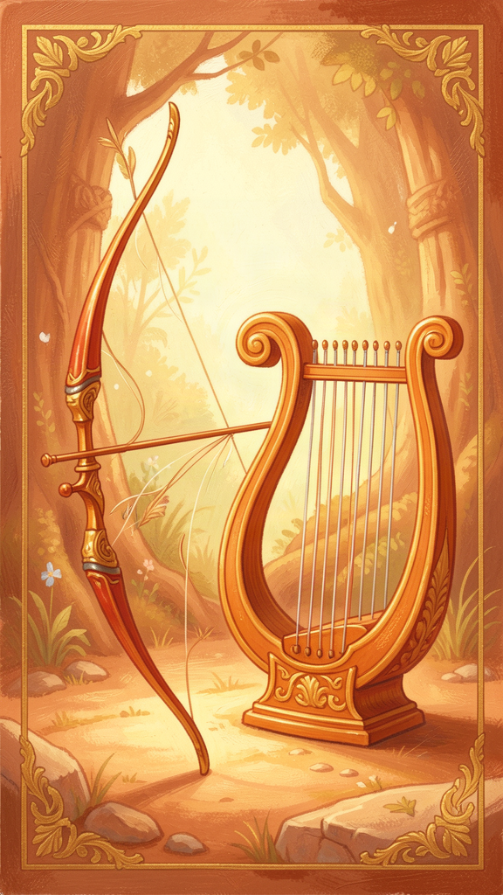
Illustration for Chapter 6
Heraclitus had one more big idea, and it brings everything together. He said the world is held together by tension.
Think about a bow. A bow is a stick with a string. To shoot an arrow, you pull the string back. The string pulls one way; the wood bends the other way. The bow works because two forces pull against each other. If you take away the tension, the bow is just a stick. It cannot do anything.
Now think about a lyre — a kind of small harp. The strings are stretched tight between two points. When you pluck a string, it vibrates and makes music. But if the string is loose, there is no sound. The music comes from the tension.
Heraclitus said the whole world is like a bow and a lyre. "It is a harmony of oppositions, as in the case of the bow and of the lyre." The world works because opposite forces pull against each other. Day pulls against night. Heat pulls against cold. Life pulls against death. The tension is not a flaw. The tension is what makes the world work.
He even said something that sounds scary: "War is the father of all and king of all." He did not mean war is good. He meant that struggle, contest, and opposition are what sort things out. Without conflict, there would be no winners and losers, no gods and humans, no free people and slaves. The differences that make the world the world come from tension.
Heraclitus said the best harmony is the kind you cannot see. "The hidden harmony is better than the visible." When you look at the bow, you see a stick and a string. You do not see the force that makes it shoot. When you look at the lyre, you see wood and strings. You do not see the music until someone plays it. The real power is invisible. It is the tension itself.
He said beauty comes from difference. A painting needs light and shadow. A story needs a problem. A song needs high notes and low notes. If everything were the same, nothing would be interesting. The world is beautiful because it is full of opposites held together.
This is Heraclitus' final lesson: do not try to get rid of the tension. Do not wish for a world with no problems. A bow with no tension cannot shoot. A lyre with no tension cannot sing. A life with no tension cannot grow. The goal is not to end the pulling. The goal is to find the right measure — tight enough to work, loose enough not to break.
Words to Remember
"They do not understand: how that which separates unites with itself. It is a harmony of oppositions, as in the case of the bow and of the lyre." — Heraclitus, DK B45
This means: the bow and the lyre work because they are pulled in two directions at once. The tension is the harmony. Without it, there is no power and no music.
"The hidden harmony is better than the visible." — Heraclitus, DK B47
This means: the deepest order is the one you cannot see. The surface shows you a stick and a string. The truth shows you the force that makes them work.
Big Idea
The world is held together by tension, like a bow and a lyre. Opposites pull against each other, and that pulling is what makes everything work. Do not wish the tension away. Find the right measure instead.
Try This
- Play tug-of-war. Both sides pull. If one side lets go, the game collapses. The game works because of the pulling. That is Heraclitus' bow. - Pluck a rubber band. Stretch it between your fingers and pluck it. It makes a sound. Now hold it loose and pluck it. No sound. The tension makes the music. - Tell a story with no problem. Try to tell a story where nothing goes wrong, nobody disagrees, and everything is fine. Is it interesting? Heraclitus said a world with no tension would be like that — boring and powerless.
Ask a Grown-Up
"Is there a tension in your life — like work and rest, or being alone and being with people — that actually helps you? What would happen if that tension went away completely?"
———

For the Grown-Up Reader
Heraclitus of Ephesus (c. 535–475 BCE) is one of the most important and most misunderstood thinkers in the Western tradition. He wrote a single book, deposited in the Temple of Artemis, that survives only in fragments — short, paradoxical sayings quoted by later authors. The standard scholarly reference is the Diels-Kranz numbering system (DK B1–B126).
What is real and what is legend? We know he was an aristocrat from Ephesus, active around 500 BCE. We know he wrote in a deliberately obscure, oracular style. Almost everything else — his withdrawal from politics, his "weeping" temperament, his death from dropsy — comes from late and unreliable biographers, especially Diogenes Laërtius, who wrote 700 years later. The "Weeping Philosopher" label is a Roman-era caricature, not a reading of the fragments.
Are the quotes real? Every quote in this booklet is a genuine fragment, cited by DK number. The translations are simplified for young readers but faithful to the meaning. The sources are the ancient authors who preserved the quotations: Plutarch, Hippolytus, Clement of Alexandria, Sextus Empiricus, and others. No quote has been invented or paraphrased into untruth.
Scholarship used: Charles Kahn's The Art and Thought of Heraclitus (1979) is the best English edition with commentary. Daniel Graham's work on Heraclitus in the Oxford Handbook of Presocratic Philosophy (2008) provides the modern scholarly framework. Robin Waterfield's The First Philosophers (Oxford, 2000) offers accessible translations. Brooks Haxton's Fragments (2001) is a poetic translation suitable for younger readers.
One caution: Heraclitus is the philosopher most often recruited to say things he did not say. "The only constant is change" is a modern saying, not a Heraclitus fragment. "Panta rhei" ("everything flows") is attributed to him by Plato but does not appear as a direct quotation in the fragments. Every quote in this booklet is grounded in the actual textual record.
———

About WisdomForge
WisdomForge creates age-adapted booklets that bring the great thinkers of philosophy and theology to readers at every stage of life. Each figure gets four booklets: one for ages 5–10, one for 11–14, one for 15–18, and one for adults. The same ideas, shaped for how you think right now.
We believe the deepest ideas belong to everyone — not just scholars. A child can wonder about a river. A teenager can wrestle with opposites. An adult can find the logos in a career or a family. The questions are old. The conversation is always new.
Read it. Question it. Discuss it. The thinkers in these pages have been alive for thousands of years. They are waiting for you to join the conversation.
Adapted by Aiona Edge for WisdomForge Content based on the Heraclitus Compendium by Harry © SMF Works — Free to download, read, and share

