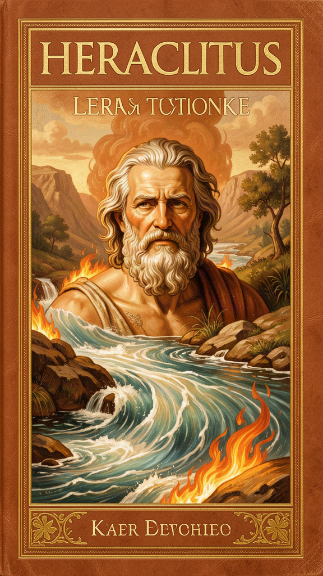
Heraclitus: The Philosopher of Fire and Flow
WisdomForge Booklet — Ages 11–14

Heraclitus: The Philosopher of Fire and Flow

WisdomForge Booklet — Ages 11–14
———

About This Book
Heraclitus lived nearly 2,500 years ago in a Greek city called Ephesus, on the coast of what is now Turkey. He wrote one book, filled with short, difficult sayings, and left it in the Temple of Artemis — one of the Seven Wonders of the Ancient World. The book is lost. What survives are fragments: about 126 short quotations preserved by later authors.
Those fragments are some of the most powerful sentences ever written. "You cannot step into the same river twice." "The way up and the way down are one and the same." "War is the father of all and king of all." These are not just clever sayings. They are compressed arguments. Heraclitus wrote in riddles because he thought the world itself is like a riddle — it hides its pattern, and you have to work to see it.
This booklet explores his six big ideas: the river (everything flows), the logos (the hidden pattern), the unity of opposites (the way up and the way down), fire as the first principle, the common and the private (waking and sleeping), and strife and harmony (the bow and the lyre). Each chapter has a story, context from history, a big idea, and something to try. The questions are not tests — they are starting points for thinking for yourself.
———

Chapter 1: The River — Everything Flows
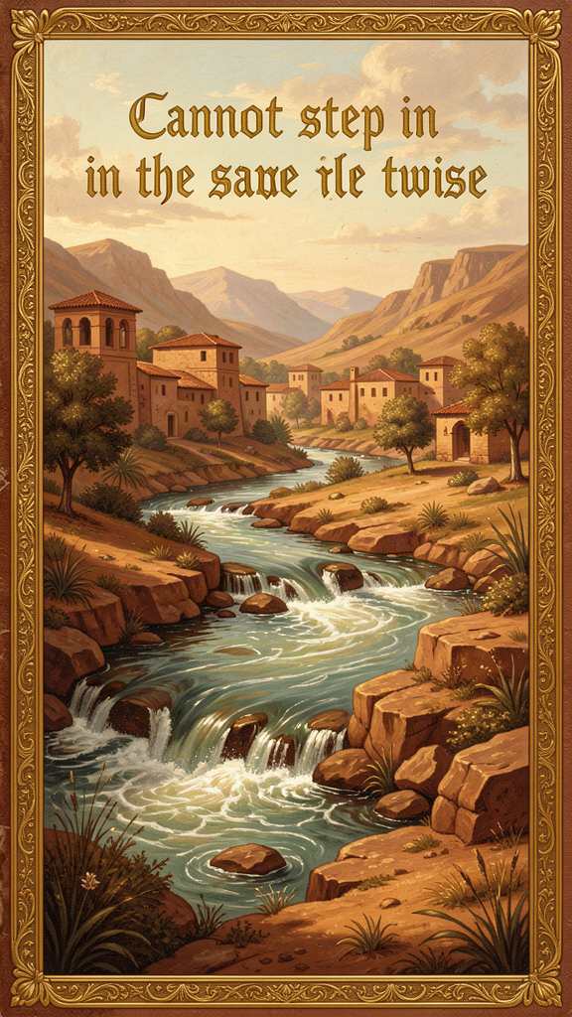
Illustration for Chapter 1
Heraclitus was born around 535 BCE in Ephesus, a wealthy trading city on the coast of Asia Minor. Ephesus had a great harbor, a famous temple, and a river — the Cayster — that wound through the countryside and emptied into the sea. Heraclitus grew up watching that river.
One day he made an observation that would echo through 2,500 years of philosophy. He said: "Into the same river you could not step twice, for other and still other waters are flowing." The river looks the same. The banks stay. The name stays. But the water is always new. By the time you step in again, yesterday's water is already on its way to the sea.
This is the most quoted line in Western philosophy, and it is often misunderstood. People think Heraclitus is saying that nothing is stable, so nothing matters. That is the opposite of what he meant.
Heraclitus inherited a question from the earlier Ionian thinkers. Thales had asked what the world is made of (water). Anaximander had asked where it comes from (the boundless). Anaximenes had asked how it changes (rarefaction and condensation of air). Heraclitus asked a deeper question: how does anything stay the same while changing? The river is his answer — and his puzzle.
Here is the puzzle. The river is both the same and different. It is the same river — you can point to it, name it, walk along it. But it is not the same water. How can something be the same and different at once? That question is the heart of Heraclitus' philosophy.
He is not saying the river is an illusion. He is saying the river is a process, not a thing. A river is not the water inside it. A river is the flowing. The water comes and goes, but the flowing continues. The identity of the river is in the pattern, not in the stuff.
This applies to you, too. Almost every cell in your body is replaced over time. The atoms that make up your body now are not the atoms that made it up seven years ago. Yet you are still you. Your memories shift. Your opinions change. Your body grows and ages. Heraclitus would say: you are the same person and a different person at once. Your identity is a pattern that maintains itself through change, like the shape of a flame.
Key Facts: The River Fragments
| Fragment | Source | What It Says | |---------|--------|--------------| | DK B12 | Arius Didymus | "Upon those who step into the same rivers, different and again different waters flow." | | DK B41 | Plutarch | "Into the same river you could not step twice, for other and still other waters are flowing." | | DK B49a | Heraclitus the Allegorist | "We step and do not step into the same rivers; we are and are not." | | DK B83 | Plotinus | "All things move, and nothing remains still." |
Scholars debate whether B12 and B41 are two versions of one saying or two separate fragments. Either way, the point is the same: the river keeps its identity by changing, not by standing still.
Notice that B49a goes further than B41. It says "we are and are not." This applies the river insight to the self. The person who steps into the river is also a river — body, mind, and soul are constantly exchanging matter and experience. You are not the same organism you were seven years ago. You are not the same mind you were yesterday. Heraclitus uses paradox to make us notice that ordinary language divides what reality joins. We are both stable and changing, both present and passing.
The later philosopher Cratylus, who followed Heraclitus, pushed this further. He said you cannot step into the same river even once — by the time your foot touches the water, it has already changed. Cratylus took flux so seriously that he reportedly stopped speaking entirely, since any word would name something that was already different. Heraclitus himself did not go this far. His view is more balanced. The river is both the same and different. The "and" is the whole lesson.
Heraclitus applied this to the sun, too. "The sun is new every day" (DK B6). The sun is not a permanent object doing the same thing forever. It is a daily renewal of fire. Yet the renewal is so regular that we plan our lives around it. Change and order are not enemies. They are the same fact seen from two angles.
Key Quote
"Into the same river you could not step twice, for other and still other waters are flowing." — Heraclitus, DK B41 (Plutarch)
Big Idea
The world is not a collection of fixed things. It is a pattern of movement. The river stays a river by flowing, not by standing still. Identity is dynamic, not static. You are the same person you were yesterday — but the cells in your body, the thoughts in your mind, and the experiences you have had are all different. The pattern continues; the stuff changes.
Try This
- The Ship of Theseus. Imagine a famous ship. Over the years, every plank is replaced, one by one. After all the planks are replaced, is it still the same ship? Heraclitus would say yes and no. That "and" is the whole lesson. Write down your answer and explain why. - Watch a fountain or a stream for five minutes. Try to "catch" the water. You can hold it for a second, but it flows away. Now look at the fountain as a whole. The shape stays; the water moves. That is Heraclitus' river. - Track one change in yourself. Pick something — your height, your favorite book, your best friend. How has it changed in the last year? How has it stayed the same? Heraclitus would say both are true at once.
Talk About It
1. If every cell in your body is replaced over time, are you still "you"? What makes you the same person you were when you were five years old? 2. Heraclitus said "we are and are not" (DK B49a). Is this a contradiction, or is it a precise description of how identity works in a changing world? 3. If the river changes but keeps its pattern, what is the difference between a thing and a process? Is a flame a thing or a process?
———
Can you step into the same river twice — or is the question itself the answer?
———

Chapter 2: The Logos — The Hidden Pattern
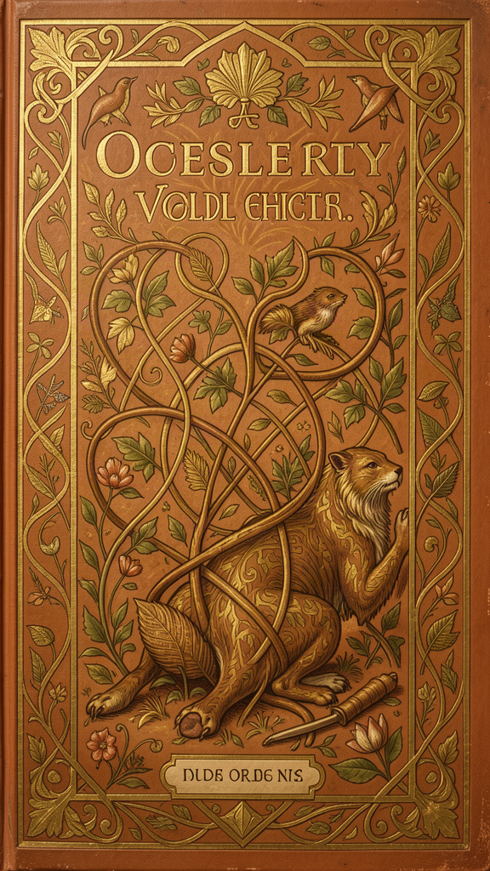
Illustration for Chapter 2
If everything flows, how does the world hold together? Why does the sun keep coming up? Why do the seasons keep turning? Why does the river keep flowing instead of just sloshing everywhere?
Heraclitus' answer is one word: logos.
Logos is the hardest word in Heraclitus, and it may be the most important word in all of ancient philosophy. It does not translate neatly into English. In Greek, it can mean "word," "speech," "reason," "account," "ratio," "proportion," "law," and "gathering." Heraclitus probably means all of these at once.
Here is what the logos does: it is the pattern that makes the world make sense. The river flows, but it flows in a pattern — between its banks, downhill, toward the sea. The fire burns, but it burns in measures — kindled in due proportion, extinguished in due proportion. The sun rises, but it rises on a schedule. Behind all the change is an order. That order is the logos.
Heraclitus said something startling about the logos: most people miss it. The logos is not hidden because it is far away or too small to see. It is hidden because it is everywhere. People walk past it every day. They hear the words, but they do not understand. "Those who hear and do not understand are like the deaf," he said. "Present, they are absent" (DK B3).
Key Facts: What Logos Means
| Sense | Example | How It Shows Up | |-------|---------|-----------------| | Word/Speech | "Listen not to me, but to the logos" (DK B1) | Heraclitus is speaking, but the pattern he describes is bigger than his words | | Reason/Rationality | "The Law of Reason is common" (DK B2) | The world is intelligible — it can be understood | | Ratio/Proportion | "Kindled in due measure, extinguished in due measure" (DK B30) | Change follows measure, not chaos | | Law/Principle | "All human laws are dependent upon one divine Law" (DK B91) | Human rules are grounded in cosmic order | | Gathering | The unity of opposites (DK B45) | The logos gathers what looks scattered into one whole |
The logos is common — it belongs to everyone, not just to Heraclitus. It is not a secret he invented. It is the shared structure of reality. "Although the Law of Reason is common, the majority of people live as though they had an understanding of their own" (DK B2). Most people, Heraclitus thought, ignore the common pattern and live by private opinion. They treat their own guess as if it were the truth.
The logos is also hidden. "Nature loves to conceal herself" (DK B123). The pattern is real, but it does not announce itself. You have to look for it. You have to infer the law from the way things behave, the way you infer gravity from watching objects fall.
Here is the practical question: how do you find the logos? Heraclitus' answer is attention. The logos is not a mystical vision. It is the disciplined reading of evidence. In an argument, the logos is what both sides are actually saying, stripped of defensiveness. In a market, the logos is the real supply and demand, not the hype. In your own body, the logos is the actual signal of fatigue or energy, not the story you tell yourself about it.
Heraclitus honored the senses — "whatever concerns seeing, hearing, and learning, I particularly honor" (DK B13) — but he warned that perception alone is not enough. "Eyes and ears are bad witnesses to men having rude souls" (DK B4). A camera takes a picture, but it does not know what the picture means. You have to bring understanding to your seeing.
He also distinguished learning from wisdom. "Much learning does not teach one to have understanding, else it would have taught Hesiod and Pythagoras" (DK B16). Collecting facts is not the same as grasping the pattern. You can read a hundred books and still miss the logos, if you treat the information as a private possession rather than a window onto the common order. Wisdom is not the accumulation of data. It is the recognition of the structure that makes the data make sense.
Key Quote
"It is wise for those who hear, not me, but the universal Reason, to confess that all things are one." — Heraclitus, DK B1 (Hippolytus)
Big Idea
The world is not random. It has a hidden pattern — the logos — that makes it intelligible. The logos is common (it belongs to everyone), hidden (you have to look for it), and practical (finding it means paying attention to the real pattern instead of your private opinion). Most people miss it because they are not paying attention.
Try This
- The Pattern Journal. For one week, each day write down one event that seemed chaotic and one regularity you noticed inside it. A rainy day has a rhythm. A busy hallway has traffic patterns. The logos is the regularity inside the change. Over time, this trains your eye to find measure inside noise. - The Common Test. Before you accept your own interpretation of something, ask: "What would someone who disagreed with me see here?" If your view cannot be shared or defended in public terms, it might be private fantasy, not the logos. - Translate the logos. Pick three things in your life — a sport, a friendship, a school subject. What is the "logos" (the underlying rule or pattern) that makes each one work? Write it down. The logos of basketball is spacing and movement. The logos of friendship is reciprocity. What else?
Talk About It
1. Heraclitus said most people live as though they had a "private understanding" (DK B2). Can you think of a time when you treated your own opinion as the truth without checking it? What happened? 2. The logos is "common" — it belongs to everyone. How is this different from "popular"? Can something be common (true for everyone) but not popular (not believed by most people)? 3. "Nature loves to hide" (DK B123). Can you think of a pattern in nature or in your life that is real but hard to see? What makes it hard to see?
———
If the pattern is everywhere, why do most people miss it — and what would it take to see it?
———

Chapter 3: The Unity of Opposites — The Way Up and the Way Down

Illustration for Chapter 3
Heraclitus was walking on a road that went up a hill. He climbed to the top, turned around, and walked back down. Then he looked at the road and said: "The way upward and downward are one and the same" (DK B69).
This sounds like a riddle, but the meaning is right there. The road did not change. It is one road. From the bottom, it goes up. From the top, it goes down. Up and down are not two roads. They are two directions on the same path. The opposite directions belong to one structure.
This is Heraclitus' doctrine of the unity of opposites, and it is one of the most original ideas in early Greek thought. He does not mean opposites are identical — day is not night, hot is not cold. He means they are partners in a single process. Each one defines the other. Each one turns into the other. Each one needs the other to exist.
Key Facts: How Opposites Unite
| Fragment | Opposite Pair | How They Are One | |---------|---------------|------------------| | DK B69 | Up / Down | One road, two directions | | DK B57 | Good / Evil | Bound in a single process; value depends on perspective | | DK B67 | Mortal / Immortal | Phases of one cycle; life passes into death, death into life | | DK B52 | Pure / Foul | The same water saves fish and kills humans; value is relational | | DK B78 | Living / Dead, Awake / Asleep, Young / Old | Transmutations of each other |
The clearest example is the sea. "Sea water is very pure and very foul, for, while to fishes it is drinkable and healthful, to men it is hurtful and unfit to drink" (DK B52). The sea does not have an intrinsic value of "pure" or "foul." Its value depends on the creature encountering it. The same water is life for a fish and death for a person. The opposites come from the relationship, not from the water itself.
Heraclitus pushes this further with one of his most challenging fragments: "Good and evil are the same" (DK B57). He does not mean cruelty is secretly good. He means that the concepts "good" and "evil" are bound together. A medicine that heals can poison. A hardship that breaks one person strengthens another. A drought that kills crops may restore a forest over decades. The point is not to abolish judgment. The point is to enlarge the frame in which you judge.
The Bow and the Lyre
Heraclitus' central image for the unity of opposites is the bow and the lyre (DK B45). A bowstring is pulled in two directions at once — the wood bends one way, the string pulls the other. That tension is what lets the bow shoot. A lyre string is stretched between two points. That tension is what lets the lyre sing. Remove the tension, and the bow is just a stick. Remove the tension, and the lyre is just a frame with loose strings.
The word Heraclitus uses for this is palintropos — "back-turning." The opposites curve back into each other. They do not cancel out. They hold together, and the holding is what makes the power.
"From differences results the most beautiful harmony" (DK B46). A painting needs light and shadow. A story needs conflict. A song needs high notes and low notes. Sameness is dull and powerless. Difference, held in tension, is beautiful.
This is not just an aesthetic preference. It is a structural claim about how the world works. If hot and cold were completely unconnected, there would be no warming or cooling. If life and death were separate realms with no passage between them, there would be no generation. Opposites are not endpoints. They are turning points. Each opposite contains the seed of the other. Hot cools. Cold warms. Living things die. Dead things feed new life. The opposition is the engine of change.
The Hidden Harmony
"The hidden harmony is better than the visible" (DK B47). When you look at a bow, you see wood and string. You do not see the force that makes it shoot. When you look at a lyre, you see the frame and the strings. You do not see the music until someone plays. The real power — the harmony — is invisible. It is the tension itself. The logos is the hidden harmony that holds the opposites together.
Key Quote
"They do not understand: how that which separates unites with itself. It is a harmony of oppositions, as in the case of the bow and of the lyre." — Heraclitus, DK B45 (Hippolytus)
Big Idea
Opposites are not enemies. They are partners in a single process. Day needs night, hot needs cold, life needs death. The world is held together by tension, not by the absence of tension. The bow works because it is pulled two ways. The lyre sings because it is stretched between two points. Beauty comes from difference held in measure.
Try This
- The Opposite Journal. At the end of each day for a week, write down one pair of opposites that appeared in your experience. Work and rest. Talking and listening. Alone and together. Then ask: What would happen if I removed one side entirely? What would happen if one side took over? What is the healthy tension between them? - Play a chord on an instrument. If you can, play a single note, then a chord (two or more notes at once). Ask: Are the notes one or many? The answer is both. They are different notes, but they are one chord. Heraclitus wants you to hear both at once. - Find the hidden harmony. Think of a tension in your life right now — maybe independence versus belonging, or honesty versus kindness. Do not try to resolve it. Instead, ask: What is the "music" this tension produces? What would be lost if the tension disappeared?
Talk About It
1. Heraclitus said "good and evil are the same" (DK B57). Is he right that value depends on perspective? Can you think of something that is good from one angle and bad from another? Where do you draw the line? 2. The bow needs tension to work. Can you think of a tension in your life — like the pull between freedom and responsibility — that actually gives you energy? What would happen if that tension vanished? 3. "The hidden harmony is better than the visible" (DK B47). What does this mean? Can you think of a situation where the surface looked like conflict but the deeper pattern was order?
———
If up and down are one road, what changes when you change direction — the road, or you?
———

Chapter 4: Fire as Arche — The Ever-Living Fire
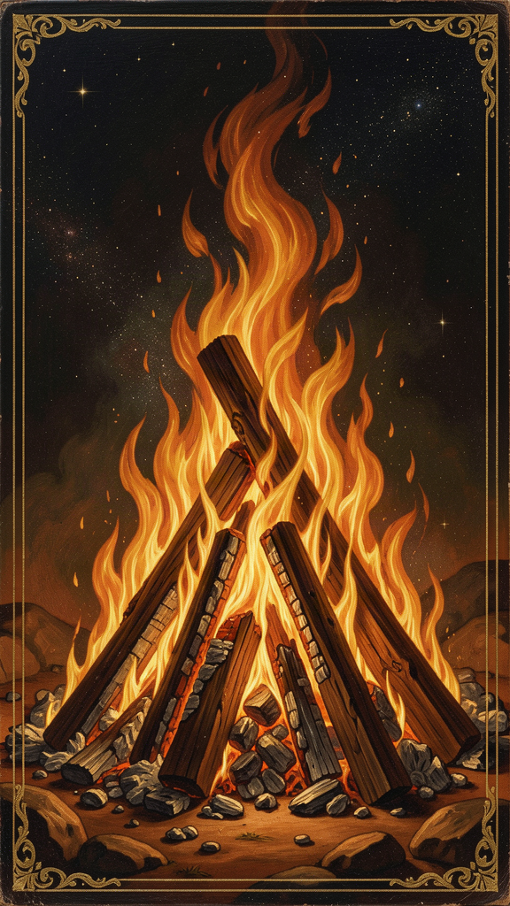
Illustration for Chapter 4
Every Greek philosopher before Heraclitus asked the same question: what is the world made of? Thales said water. Anaximenes said air. Anaximander said the boundless. Heraclitus said fire.
But fire is not just another material. Fire is the element that most clearly shows change while keeping its identity. A flame is always becoming new fuel, new heat, new light — yet we still call it "the fire." It is the perfect image for a cosmos that is both flux and order.
Key Facts: The Fire Fragments
| Fragment | Source | What It Says | |---------|--------|--------------| | DK B20 | Clement of Alexandria | The cosmos is "an ever-living fire, kindled in due measure, and in due measure extinguished." | | DK B21 | Clement of Alexandria | Fire becomes sea; sea becomes earth and lightning. | | DK B22 | Plutarch | "All things are exchanged for fire and fire for all things, just as wares for gold and gold for wares." | | DK B25 | Maximus of Tyre | "Fire lives in the death of earth, air in the death of fire, water in the death of air, and earth in the death of water." | | DK B29 | Plutarch | "The sun will not overstep his bounds." |
The key fragment is DK B20: "This world, the same for all, neither any of the gods nor any man has made, but it always was, and is, and shall be, an ever-living fire, kindled in due measure, and in due measure extinguished." Three things to notice. First, the cosmos is eternal — it was not created, and it will not end. Second, the cosmos is fire — not water, not air, but fire. Third, the fire is measured — it kindles and goes out in proportion. Even change is lawful.
Why Fire?
| Element | Philosopher | Why It Fails as Arche | |---------|-------------|----------------------| | Water | Thales | Too passive; preserves rather than transforms | | Air | Anaximenes | Invisible; lacks the visible drama of change | | The Boundless | Anaximander | Too abstract; no specific image of process | | Fire | Heraclitus | Always changing yet always fire; the clearest image of process |
Fire is the element that most resembles a living process. It eats fuel. It grows. It moves. It dies if you cut it off. It transforms everything it touches. Heraclitus chose the element that most clearly shows what the cosmos is: not a thing, but a process.
The Cosmic Exchange
Heraclitus describes a cycle of transformation. Fire becomes sea. The sea divides — half becomes earth, half becomes lightning (which is fire returning). The earth returns to sea. The sea returns to fire. Nothing is lost. Everything changes form. "All things are exchanged for fire and fire for all things, just as wares for gold and gold for wares" (DK B22). Fire is the universal currency. Everything can be converted into it, and it into everything else.
This means destruction is never final. "Fire lives in the death of earth, air in the death of fire, water in the death of air, and earth in the death of water" (DK B25). Each element is born from the "death" of the one before it. Death here means transformation, not annihilation. The old form goes; the process continues.
Think about what this means for personal loss. When someone dies, a relationship ends, a project fails, or an identity dissolves, it feels like something has been taken out of the world. Heraclitus would not dismiss that feeling. The lost form is real, and the grief is appropriate. But he would also say the process continues. The person, the role, the hope is gone in one form. What remains — memories, effects, love, lessons — enters a new phase. Loss is not the end of the story. It is a turning in the story.
The key question after a loss or a failure is not "Why did this happen?" but "What is this becoming?" That question shifts attention from the lost form to the emerging one. Fire does not just destroy. It turns what it consumes into heat, light, ash, and new fuel. The form is lost; the energy continues.
Fire and Justice
The fire is not wild. It is measured. "The sun will not overstep his bounds, for if he does, the Erinyes, helpers of justice, will find him out" (DK B29). Even the sun — the greatest fire in human experience — moves within limits. The cosmos is not chaotic fire. It is lawful fire. The measures are what make the fire a cosmos rather than a conflagration.
This is Heraclitus' answer to the fear that a world of fire would be a world of destruction. Fire is dangerous when unchecked. But the cosmic fire is ordered by justice (dikē). Change is real, but it follows a law.
Is Fire Literal or Symbolic?
Scholars debate this. Some think Heraclitus means physical fire is the primary stuff. Others think fire is a symbol for transformation itself — the real arche is becoming, not any particular element. The best reading is probably the middle one: fire is both a physical reality and the most fitting image of a world that is always changing yet always ordered.
The Stoics, who came centuries later, took Heraclitus' fire and developed it into a doctrine called ekpyrōsis — the idea that the whole cosmos is periodically consumed by fire and then reborn. Some readers import this Stoic idea back into Heraclitus. But Heraclitus' own fragments do not describe a final burning of the world. They describe an ongoing, measured exchange. The fire does not end the world. It is the way the world keeps going.
Key Quote
"This world ... always was, and is, and shall be, an ever-living fire, kindled in due measure, and in due measure extinguished." — Heraclitus, DK B20 (Clement of Alexandria)
Big Idea
The cosmos is not a machine someone built. It is a living fire that always burns, always changes, always stays. Fire is the perfect image for a world that is both flux and order: always becoming new, yet always fire. What looks like destruction is transformation. The fire burns in measures — it is lawful, not chaotic.
Try This
- Watch a campfire or a candle. The fire turns wood into ash, heat, light, and smoke. Nothing disappears; it changes form. The fire needs fuel (craving) and consumes fuel (satiety). Try to name each transformation you see. - The elemental cycle. Draw Heraclitus' cycle: fire → sea → earth + lightning → sea → fire. Draw arrows in a circle. Each arrow is both a death and a birth. You have drawn his picture of how the world keeps itself alive. - Find the "fire" in your life. What process consumes the old and generates the new? Learning? Grief? Creativity? A hard transition? Heraclitus would ask: is your fire measured (lawful, balanced) or wild (burning everything up)?
Talk About It
1. Heraclitus chose fire because it is always changing yet always fire. If you had to choose one element to represent how the world works, which would you pick and why? 2. "Fire lives in the death of earth" (DK B25). What does it mean that death is transformation, not annihilation? Does this change how you think about endings? 3. The sun "will not overstep his bounds" (DK B29). What does it mean that even fire has limits? Can you think of a situation where too much change (too much fire) would be destructive rather than creative?
———
If the world is a fire that never goes out and never burns everything, what keeps it in measure?
———

Chapter 5: The Common and the Private — Waking and Sleeping
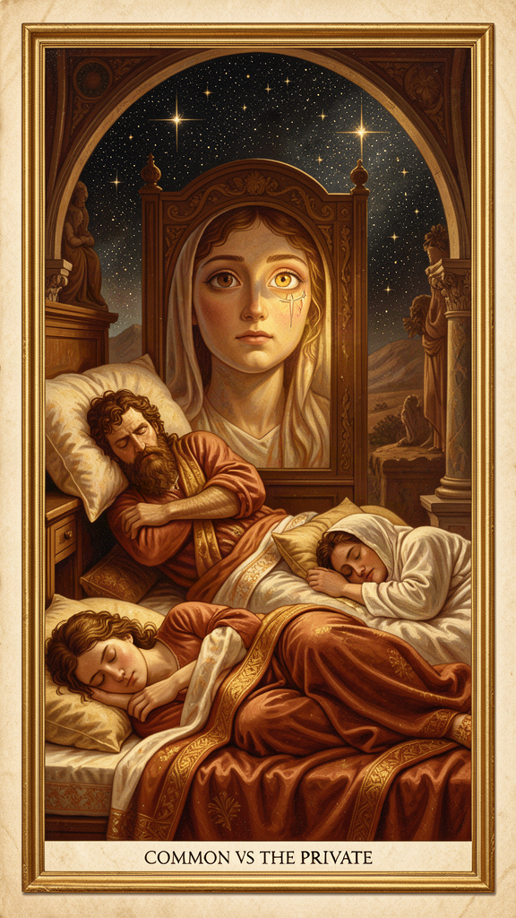
Illustration for Chapter 5
Heraclitus had a disturbing idea about people. He said most of us are asleep, even when our eyes are open.
He did not mean we are literally dreaming. He meant we go through life without really seeing. We walk the same route without noticing it. We hold opinions we have never examined. We hear, but we do not understand. "Those who hear and do not understand are like the deaf. Present, they are absent" (DK B3).
Heraclitus draws a sharp line between two ways of living: the common and the private. The common world is the world governed by the logos — the shared, measurable, rational structure of reality. The private world is the world of individual opinion, personal habit, and partial perspective. Most people, Heraclitus thought, live in private worlds even while surrounded by the common one.
Key Facts: Common vs. Private
| Concept | Greek | Meaning | |---------|-------|---------| | Common | xunos | Shared, public, governed by the logos — the real world | | Private | idios | One's own, personal opinion — a private dream | | Awake | egrēgoros | Participating in the common world | | Asleep | koimōmenos | Withdrawn into a private world |
The key fragment is DK B95: "To those who are awake, there is one world in common, but of those who are asleep, each is withdrawn to a private world of his own." The common world belongs to the awake. Private dreams belong to the asleep. The transition from private to common is not just an intellectual shift — it is a moral and spiritual awakening.
The metaphor of sleep is one of Heraclitus' most powerful images. To be asleep is to be lost in your own subjective world. To be awake is to participate in the shared world. The transition is not mystical escape. It is participation in shared understanding. When you wake up, you do not leave the world — you finally enter it.
Heraclitus is unsparing about mass opinion. "What intelligence or understanding have they? They follow the crowd and take the masses for a teacher" (DK B104, paraphrased). Popularity is not a sign of truth. The crowd lives in private worlds that overlap by accident, not by understanding. Wisdom requires stepping away from the multitude — not to be a loner, but to find the common pattern the crowd has missed.
The City and the Law
Heraclitus gives this a political dimension. "The people must fight for the law as for the city wall" (DK B44). A city survives by common agreement on its rules. The law (nomos) is the human expression of the logos within a community. A city without law collapses into private interests, just as a soul without logos collapses into private opinions.
The deeper point: "All human laws are dependent upon one divine Law, for this rules as far as it wills, and suffices for all, and overabounds" (DK B91). Human law is grounded in cosmic law. The rules that hold a city together are not arbitrary inventions. They reflect the deeper order that holds the cosmos together.
What Waking Means
Waking, for Heraclitus, is not just being alert. It is participating in the common world. The wakeful share one world; the sleeping each withdraw into a private one. Waking is relational — it means aligning your perception with the shared logos.
This is close to what modern psychology calls mindfulness, but it is more than personal calm. It is a moral and intellectual orientation. To be awake is to be honest, attentive, and responsive to reality. "We ought not to act and speak as though we were asleep" (DK B94).
Heraclitus also links waking to ethics. "Self-control is the highest virtue, and wisdom is to speak the truth and consciously to act according to nature" (DK B107). Waking is not optional for the good life. It is the condition of the good life. You cannot act well if you do not see clearly. You cannot speak truth if you are mumbling in a private dream.
The Difficulty
Waking is hard because sleep is comfortable. Private worlds protect our self-image, our grudges, and our laziness. The logos asks us to leave that comfort. That is why Heraclitus says most people will not understand. The person who sleeps does not know they are asleep until they wake up. "Dogs bark at what they do not know" (DK B97) — people attack what they do not understand, because it threatens their private worldview.
Key Quote
"To those who are awake, there is one world in common, but of those who are asleep, each is withdrawn to a private world of his own." — Heraclitus, DK B95 (Plutarch)
Big Idea
There are two ways to live: awake (in the common world, governed by the logos) or asleep (in a private world, governed by personal opinion). Most people are asleep. They mistake their private view for the truth. Waking up means paying attention, checking your opinions against reality, and joining the shared world. It is uncomfortable — but it is the only way to see clearly.
Try This
- The Morning Question. Before the day begins, ask: "What am I not seeing?" This puts you in the posture of searching for the logos rather than assuming you already have it. Try it for a week. - The Conversational Check. In your next conversation, ask yourself: "Am I actually listening, or am I waiting for my turn to speak?" Most social sleep takes this form. Real listening is waking. - The Evidence Review. When you are about to make a decision — even a small one — list one piece of evidence that does not fit your preferred outcome. This is the common test in action. It fights the private worldview.
Talk About It
1. Heraclitus said most people "live as though they had an understanding of their own" (DK B2). Can you think of a time when you treated your own opinion as the truth? What would it look like to check it against the "common" evidence? 2. "Dogs bark at what they do not know" (DK B97). Have you ever seen someone attack an idea they did not understand? Have you ever done it yourself? What makes people defensive about their private worldview? 3. The common world is "one world in common" (DK B95). How is this different from conformity? Can you share the common world and still disagree with the crowd?
———
If you are asleep, how would you know — and what would it take to wake up?
———

Chapter 6: Strife and Harmony — The Bow and the Lyre
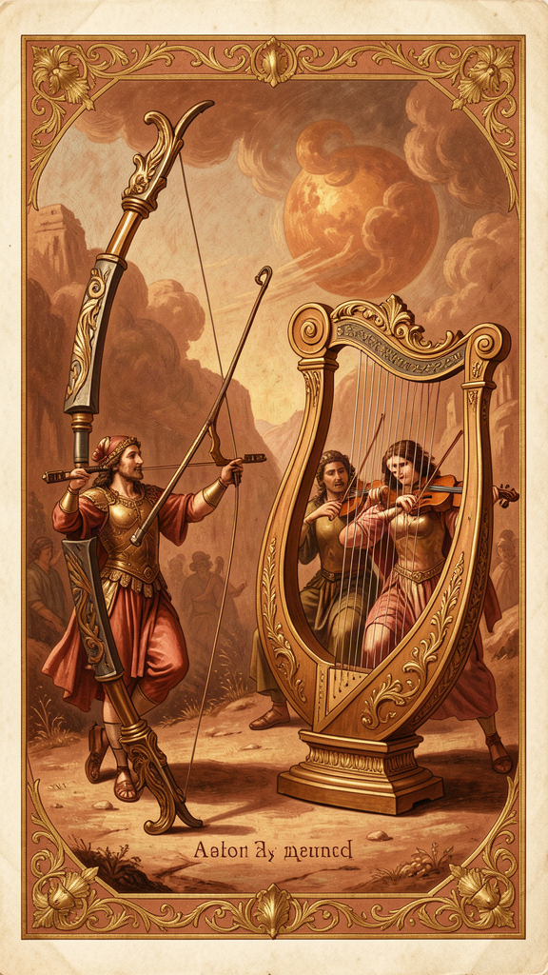
Illustration for Chapter 6
Heraclitus shocks his readers. He says war is the father of all things. He says strife is justice. He says the most beautiful harmony comes from tensions that pull in opposite directions.
This is not a celebration of violence. It is a metaphysical claim: the cosmos is ordered by opposing forces that are balanced, not by forces that have been eliminated. Strife is the father of order because order is tension, not the absence of tension.
Heraclitus' predecessors had already sensed this. Anaximander had said that things pay each other "penalty and reparation according to the ordinance of time." The seasons take turns. Day and night alternate. One thing rises by pushing another down, and then the pattern reverses. Heraclitus generalizes this insight: the whole cosmos works by structured opposition.
Key Facts: Strife and Harmony
| Fragment | Source | What It Says | |---------|--------|--------------| | DK B53 | Hippolytus | "War is the father of all and king of all, and some he shows as gods, others as men; some he makes slaves, others free." | | DK B80 | Origen | "It is necessary to know that war is common and strife is justice, and that all things happen in accordance with strife and necessity." | | DK B46 | Aristotle | "The unlike is joined together, and from differences results the most beautiful harmony." | | DK B45 | Hippolytus | "It is a harmony of oppositions, as in the case of the bow and of the lyre." | | DK B47 | Hippolytus | "The hidden harmony is better than the visible." |
Polemos: War as Father
The Greek word is polemos — war, battle, contest, struggle. Heraclitus uses it metaphysically. Polemos is the force that sorts things into their roles. Without conflict, there would be no distinction, no structure, no hierarchy. "War is the father of all and king of all" (DK B53). Conflict is what makes the difference between strong and weak, god and human, free and slave.
Strife Is Justice
"It is necessary to know that war is common and strife is justice" (DK B80). This is one of the most difficult fragments. How can conflict be fair? Heraclitus' answer is that the cosmos sorts itself through balanced opposition. What looks like unfair battle from a local view is, from the cosmic view, the process by which everything finds its measure.
Think about how this works in systems you know. Democracy depends on structured disagreement — voters choose between different visions. Science depends on testing theories against rivals. Markets set prices through the tug of supply and demand. These systems work not despite conflict but because of it, when the conflict is governed by fair rules.
The same principle appears in relationships. Close relationships always contain tension: independence versus togetherness, honesty versus kindness, stability versus adventure. Many people treat these tensions as signs that the relationship is broken. Heraclitus would say they are signs that the relationship is alive. The question is whether the tension is productive (it clarifies differences and strengthens the bond) or destructive (it aims at victory and weakens trust).
From Differences, Beautiful Harmony
"From differences results the most beautiful harmony" (DK B46). A uniform gray field is not beautiful. A painting needs light and shadow. A story needs a problem. A song needs tension and release. A cosmos needs opposing forces. Sameness is dull and powerless. Difference, held in tension, is beautiful.
The Bow and the Lyre
The bow and the lyre are Heraclitus' central images (DK B45). The bow is an instrument of war. The lyre is an instrument of music. Both depend on balanced tension. The bowstring is pulled in two directions; the lyre string is stretched between two points. Remove the tension, and neither works. War and beauty come from the same structural principle: productive tension.
The word Heraclitus uses is palintropos — "back-turning." The opposites curve back into each other. They do not cancel out. They hold together, and the holding is the harmony.
The Hidden Harmony
"The hidden harmony is better than the visible" (DK B47). The visible harmony of the lyre string is only the surface. The real harmony is the invisible law of tension, proportion, and vibration. The same is true of the cosmos. We see conflict on the surface. The logos sees order at the depth. Strife on the surface may be harmony at the core.
Why This Is Not a Celebration of Violence
It is crucial not to misread Heraclitus as a militarist. He is not saying "go start wars." He is saying opposition is a structural feature of reality. War is one image of that opposition. The same principle appears in music (tension and release), medicine (fever and recovery), politics (debate and vote), and elemental transformation (fire and water). When conflict is balanced, it is harmony. When it is unbalanced, it is destruction. Heraclitus' ideal is not endless battle. It is measured strife — tension that creates, not tension that destroys.
The practical question is not "how do I eliminate conflict?" but "how do I keep the tension in the zone where it produces value?" A bow at rest is not a bow in use. A bow with a snapped string is useless. The working bow is taut — but not too taut. The same goes for a team, a friendship, a creative project, or a democracy. The tension is the engine. The skill is finding the measure.
Key Quote
"War is the father of all and king of all, and some he shows as gods, others as men; some he makes slaves, others free." — Heraclitus, DK B53 (Hippolytus)
Big Idea
The world is ordered by opposing forces in balance, not by forces that have been eliminated. Strife is the father of order because order is tension. The bow works because it is pulled two ways. The lyre sings because it is stretched between two points. The goal is not to end conflict but to find its measure — tight enough to work, loose enough not to break.
Try This
- Tug-of-war. If both teams pull equally, the rope stays in the middle and the game works. If one team lets go, the game collapses. Strife is what makes the game possible. Try it and notice what happens when the balance shifts. - The Story Test. Try to tell a story with no problem, no conflict, no disagreement. Is it interesting? Heraclitus thought the whole world is like a good story — it needs tension to have shape. - Find the productive tension. Pick one opposition in your life right now — maybe independence versus belonging, or honesty versus kindness. Do not try to eliminate it. Ask: What is the "music" this tension produces? What would be lost if it vanished? What is the right measure — tight enough to work, loose enough not to break?
Talk About It
1. Heraclitus said "war is the father of all" (DK B53). He did not mean literal war. What did he mean? Can you think of a system — a sport, a school, a government — that works because of structured disagreement? 2. "The hidden harmony is better than the visible" (DK B47). What does this mean? Can you think of a situation where the surface looked like conflict but the deeper pattern was order? 3. "From differences results the most beautiful harmony" (DK B46). Do you agree that beauty needs difference? What would a world without opposition look like — and would it be worth living in?
———
If the bow needs tension to shoot and the lyre needs tension to sing, what tension in your life is actually making you stronger?
———

For the Grown-Up Reader
Heraclitus of Ephesus (c. 535–475 BCE) is one of the most important and most misunderstood thinkers in the Western tradition. He wrote a single book, deposited in the Temple of Artemis at Ephesus, that survives only in fragments — roughly 126 short quotations preserved by later authors (Plato, Aristotle, Plutarch, Hippolytus, Clement of Alexandria, Sextus Empiricus, and others). The standard scholarly reference is the Diels-Kranz numbering system (DK B1–B126).
What is real and what is legend? We know with reasonable confidence that Heraclitus was an aristocrat from Ephesus, active around 500 BCE, who wrote in a deliberately obscure, oracular style. Almost everything else — his withdrawal from politics, his "weeping" temperament, his death from dropsy — comes from late and unreliable biographers, especially Diogenes Laërtius, who wrote about 700 years later. The "Weeping Philosopher" label is a Roman-era caricature, paired with Democritus as the "Laughing Philosopher." It does not reflect the tone of the fragments, which are severe, ironic, and often luminous.
Are the quotes real? Every quote in this booklet is a genuine fragment, cited by DK number. The translations are adapted for young readers but remain faithful to the meaning. No quote has been invented or paraphrased into untruth. The fragments are drawn from the research compendium at `/home/mikesai1/Documents/WisdomForge/wisdomforge/content/heraclitus/`, which grounds each fragment in its ancient source and scholarly commentary.
Scholarship used: Charles Kahn's The Art and Thought of Heraclitus (1979) is the best English edition with commentary. Daniel Graham's "Heraclitus: Flux, Order, and Knowledge" in the Oxford Handbook of Presocratic Philosophy (2008) provides the modern framework. G.S. Kirk's Heraclitus: The Cosmic Fragments (1954) remains essential. Robin Waterfield's The First Philosophers (Oxford, 2000) offers accessible translations. Brooks Haxton's Fragments (2001) is a poetic translation suitable for younger readers.
Common misconceptions addressed in this booklet: (1) Heraclitus is not a pessimist — the "Weeping Philosopher" is a late caricature. (2) "Everything flows" does not mean nothing matters — the logos gives change a pattern, which makes commitment and knowledge possible. (3) Fire is not destruction — it is transformation. (4) The riddling style is not irrationality — it is a deliberate method that forces the reader to think. (5) Heraclitus is not "just Zen" — he is rooted in Greek rationalism and Ionian natural philosophy.
———

About WisdomForge
WisdomForge creates age-adapted booklets that bring the great thinkers of philosophy and theology to readers at every stage of life. Each figure gets four booklets: one for ages 5–10, one for 11–14, one for 15–18, and one for adults. The same ideas, shaped for how you think right now.
We believe the deepest ideas belong to everyone — not just scholars. A child can wonder about a river. A teenager can wrestle with opposites. An adult can find the logos in a career or a family. The questions are old. The conversation is always new.
Read it. Question it. Discuss it. The thinkers in these pages have been alive for thousands of years. They are waiting for you to join the conversation.
Adapted by Aiona Edge for WisdomForge Content based on the Heraclitus Compendium by Harry © SMF Works — Free to download, read, and share

