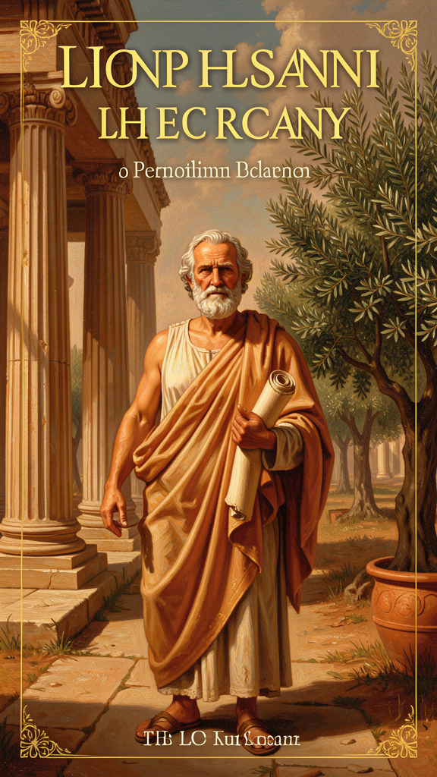
Plato: The Architecture of Reality
WisdomForge Booklet — Adult

Plato: The Architecture of Reality

WisdomForge Booklet — Adult
———

About This Book
Plato is the philosopher you think you know and probably do not.
The name is a brand. "Platonic love" means something chaste. "Platonic ideal" means something perfect but unreachable. "Platonic form" means an abstract pattern. None of these uses captures the philosopher. Plato (c. 428–348 BCE) wrote dramatic conversations about a man named Socrates who asked questions until the people answering them realized they did not know what they were talking about. From those conversations, Plato built a metaphysics, an ethics, a political theory, a psychology, and an epistemology that have shaped Western thought for 2,400 years. He also wrote myths — the Cave, the charioteer, the Myth of Er — that are still doing philosophical work today, not as doctrine but as images that make you see what argument alone cannot say.
This booklet is for adults who want to engage with Plato seriously — not as a survey course, but as a conversation with a mind that was more honest about the limits of its own ideas than most of its critics have been. Each chapter is a philosophical essay grounded in a specific text, engaging with the scholarly debates, the reception history, and the questions that Plato's arguments raise for an adult life: career, family, mortality, power, the formation of character, and the possibility that the world you see is not the world that is.
———

Chapter 1: The Allegory of the Cave
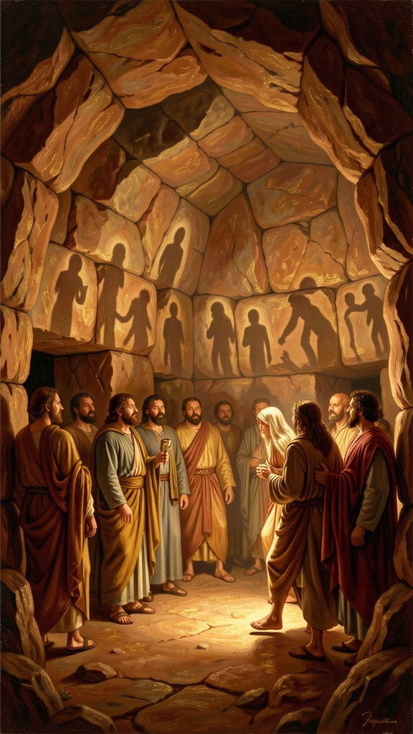
Illustration for Chapter 1
The Cave is the most overused image in philosophy. Everyone knows it, or thinks they do. Prisoners in a cave, shadows on a wall, one escapes, sees the sun, comes back, no one believes him. The image has been used to justify everything from political revolution to the claim that we live in a computer simulation. Most of these uses reduce it to a slogan: "wake up, sheeple." That is not what Plato wrote.
———
The allegory appears in Book VII of the Republic, after hundreds of pages of argument. It is not a standalone parable. It sits inside a specific philosophical context: Socrates has just described the Divided Line (four levels of cognition — imagination, belief, mathematical reasoning, dialectical knowledge), the Form of the Good (the highest object of knowledge), and the education of the guardians (decades of training from childhood through age fifty). The Cave dramatizes the same ascent as a story. It shows what the Divided Line describes. It makes the abstract progression visible — and, crucially, it makes it painful.
The prisoners are chained since childhood, facing a wall. Behind them, a fire. Between fire and prisoners, people carry objects. The fire casts shadows. The prisoners name the shadows, hold contests to predict them, give awards. The shadows are their world.
One prisoner is freed and dragged up a rough, steep path into the sunlight. The light hurts. He cannot see. He wants to go back. His eyes adjust — shadows, then reflections, then the stars, then the sun. He understands. He pities the prisoners. He goes back. They mock him. If someone tried to free them, they would kill him.
———
What makes this more than a parable about ignorance is Plato's claim about the structure of false knowledge. The prisoners are not stupid. They are not uninformed. They have a system. They have expertise — the ability to predict shadows. They have status — the awards for correct predictions. They have a culture. The entire culture is oriented toward shadows. Their expertise is real, but it is expertise about the wrong thing. Their status is real, but it is status in a system that does not correspond to reality.
This is the claim that should trouble you. Plato is not describing cavemen. He is describing any community whose status system is built around representations rather than truth. The allegory applies to any institution where the metric has replaced the thing the metric was supposed to measure. Academic culture: citation counts as shadows, rankings as shadow-prediction awards. Corporate culture: quarterly earnings as shadows, stock price as the award. Political culture: polling as shadows, election victories as the award. Social media: engagement metrics as shadows, follower counts as the award. In each case, the system is internally coherent. The experts are genuinely good at predicting the shadows. The problem is not that the system does not work. The problem is that the system works perfectly — at the wrong thing.
Plato's deepest point is that you cannot detect the cave from inside it. The prisoners' thinking is self-consistent. It passes every internal test. The only way to discover you are in a cave is to be dragged out — which is painful, disorienting, and resisted. The allegory is not about ignorance. It is about the invisibility of systematic error to the people inside the system.
———
The ascent maps onto the Divided Line: imagination (shadows), belief (physical objects), mathematical reasoning (hypotheses), dialectical knowledge (the Forms). The Cave and the Line are the same progression in different forms. The Cave is a narrative. The Line is a diagram. Both say that not all cognition is equal, and that the highest — dialectic — reaches behind appearances to the Forms, the eternal patterns that the visible world imitates.
The ascent is not intellectual tourism. It is a reorientation of the entire soul, and Plato is explicit that it hurts. The freed prisoner is dragged up the path. He does not go willingly. The light causes pain. He wants to return to the dark, where he is competent and comfortable. This is Plato's theory of education: learning is not the pleasant accumulation of facts. It is the painful turning of the soul from one orientation to another. The prisoner does not lack information. He has too much of it — all about shadows. What he lacks is the right direction. Education does not fill an empty head. It turns a head that is facing the wrong way.
———
The return to the cave is the philosophical heart of the allegory, and it is the part most interpretations skip.
The freed prisoner goes back. His eyes, adjusted to the light, stumble in the dark. He cannot name the shadows as well as before. The prisoners mock him. If someone tried to free them, they would kill him.
Plato was talking about Socrates, who was actually killed. Plato was about twenty-eight when Socrates died. He was present, or near enough to know the details. The Apology records the trial. The Crito records the refusal to escape. The Phaedo records the death. The Republic asks the question the death forced: what kind of city does this, and what kind of soul can survive living in it?
The return raises the question of obligation. The freed prisoner was not self-freed. He was dragged up by someone. Having received the truth, he owes the truth to others. The philosopher who refuses to return is committing an injustice — hoarding a cure. The Good, by its nature, must be shared. A value that is not communicated is incomplete. This is Plato's answer to the question of why a philosopher should engage with politics at all: the philosopher would rather contemplate, but the city needs the philosopher, and the philosopher owes the city. The philosopher-king is the freed prisoner who goes back.
———
The reception history of the Cave is itself a study in how images escape their authors. The allegory has been read as: a defense of philosophical elitism (only the few can ascend), a model of political liberation (the prisoners must be freed), a theory of education (learning as reorientation), an argument for religious transcendence (the sun as God), a critique of media (shadows as representations), and a precursor to the simulation hypothesis (the cave as a virtual world). Each reading captures something. None captures everything.
The existentialist reading — that the Cave describes the human condition — is the most common and the most reductive. The Cave is not a general metaphor for "waking up." It is a specific claim about the structure of knowledge: that most of what passes for knowledge is opinion, that opinion is systematic, that the system resists correction, and that the correction requires a painful reorientation that the system will punish. The allegory is not about individual enlightenment. It is about the sociology of error and the cost of truth.
The Big Idea: The Structure of False Knowledge
The Cave's deepest claim is that false knowledge is not random. It is structural. Communities build status systems around representations, and those systems become self-sustaining. The prisoners are not failing to think. They are thinking successfully within a system that does not correspond to reality. The allegory asks you to consider that your most confident beliefs might be shadows — not your obviously wrong beliefs, but the ones that give you status, that seem too obvious to question, that would cost you something to abandon. The only way to find out is to be dragged up — which means accepting the pain of reorientation and the likelihood that the community you return to will not thank you.
Practice
1. The Shadow Audit. List five beliefs or metrics that give you professional or social status — things that make you look competent, moral, or successful to your community. For each, ask: "Is this measuring what it claims to measure, or is it measuring a shadow?" If the answer is "a shadow," what would the real thing be? What would it cost you to stop optimizing for the shadow and start optimizing for the real thing? Write one paragraph per belief.
2. The Drag-Up Exercise. Identify one framework you rely on — a professional methodology, a political ideology, a personal philosophy — and spend one hour reading the strongest critique of it from the most credible opponent you can find. Write a fair summary of the critique that a defender of the framework would accept as accurate. Then ask: does the critique hold? What changes if it does? This is the ascent. Notice the resistance — the desire to go back to the wall where you are comfortable.
3. The Return Audit. Think of one truth you know that your professional or social community does not want to hear. What would it cost to say it? What is the cost of not saying it? Plato says the philosopher must return to the cave. What would returning look like in your life — a conversation, a memo, a career risk? Write one page on the cost of return and the cost of silence.
Reflect
Plato says the prisoners would kill the person who tried to free them. Socrates was killed. Is there a truth you have been punished for telling? What did the punishment teach you — about the truth, about the community, and about yourself? Would you tell it again?
———

Chapter 2: The Form of the Good
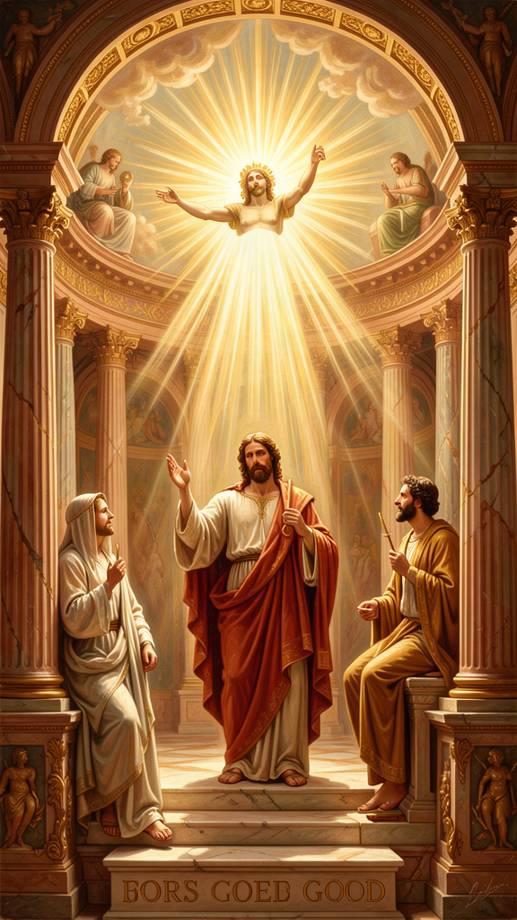
Illustration for Chapter 2
The Form of the Good is the summit of Plato's metaphysics and the most contested concept in his philosophy. It is the foundation of everything — ethics, politics, epistemology — and it is the thing he refuses to define. In the Republic, Socrates says he cannot say what the Good is. He can only say what it is like. The analogy is the sun.
———
Just as the sun makes sight possible — illuminating objects and giving the eye the power to see — the Good makes knowledge possible. It illuminates the Forms and gives the mind the power to understand. Just as the sun nourishes visible things and helps them grow, the Good sustains the intelligible world and gives being to the Forms. Without the Good, you could have facts but not understanding. You could know that something is true without knowing why it matters.
"The Good may be said to be not only the object of knowledge but also the thing that gives truth to the things known, and to the one who knows them, the power to know." — Plato, *Republic* 508e
This analogy sits inside the Theory of Forms. Plato held that behind the visible world of changing, imperfect things lies a world of eternal, perfect patterns. A beautiful painting participates in the Form of Beauty. A just law participates in the Form of Justice. Every quality we recognize in the sensible world is a copy. The Form is the original. The Forms are not mental concepts or subjective preferences. They are real — more real, Plato says, than physical objects, because they do not change, decay, or pass away.
At the top of this hierarchy is the Good. Beauty, Justice, Truth, Equality — all the other Forms derive their intelligibility from the Good. The Good is to the Forms what the sun is to visible things: the condition that makes them knowable. Without the Good, the other Forms would be real but invisible — like stars without a sun. With the Good, the whole intelligible world is lit up.
This is Plato's answer to the question every ethical theory must answer: what makes good things good? Is justice good because we prefer it, or because it participates in something good in itself? Plato's answer is the latter. Justice is good because it participates in the Form of Justice, which is intelligible because of the Good. The Good is not good for anything. It is good in itself. Everything else is good insofar as it participates in it.
———
The concept is philosophically contentious in ways that matter.
The Third Man Argument. Aristotle, Plato's own student, raised the most famous objection. If a beautiful thing is beautiful because it participates in the Form of Beauty, and if the Form of Beauty is itself beautiful (which Plato says it is), then there must be a higher Form — one that accounts for the beauty of both the thing and the Form. But then you need a further Form, and so on, infinitely. This regress threatens the entire Theory of Forms. If the Forms need Forms above them, the system never grounds itself. Aristotle thought this was fatal. The argument has been debated for 2,400 years. Some scholars think Plato has a response (the Form of Beauty is not beautiful in the same way the particular is — it is beauty, not something that has beauty). Others think the regress is real and the Theory of Forms cannot survive it.
The problem of participation. How does a particular "participate" in a Form? Is the Form in the thing? Is the thing a copy of the Form? Is the relationship one of resemblance, instantiation, or something else? Plato never gave a clear answer. In the Parmenides, Plato himself stages a devastating critique of his own theory. The older Parmenides interrogates the young Socrates and exposes a series of problems: if the Forms are indivisible, how can they be present in many things at once? If there are Forms for everything, are there Forms for mud, hair, and dirt? If the Forms are in a separate realm, how can we know them? The dialogue ends in aporia — no resolution. Some scholars read the Parmenides as Plato's confession of doubt. Others read it as a training exercise in dialectical method. The text does not tell you which. That is part of its power.
The problem of access. If the Good is the condition of all knowledge, how do we know it? Plato says through dialectic — a long ascent from hypotheses to first principles. But if the Good is what makes knowledge possible, you need some knowledge to begin the ascent. The apparent circularity is addressed by the theory of recollection (from the Meno): the soul knew the Forms before birth and "recollects" them through inquiry. But this presupposes immortality, which is itself unproven. The architecture is grand but the foundations are uncertain. Plato may have known this. The Seventh Letter (if genuine) says the highest knowledge "cannot be put into words" but arises only from "long companionship in a common life devoted to the subject" — a statement that suggests the Good is known through practice, not through argument. This is either deep wisdom or an admission that the theory cannot be defended.
———
The Good raises the question of authoritarianism with particular force. If there is a single, objective Good that only philosophers can know, and if knowledge of the Good justifies political rule, the theory creates a hierarchy where one group claims access to truth that others cannot verify. Karl Popper made this argument in The Open Society and Its Enemies (1945). Popper read the Republic as a blueprint for totalitarianism: a ruling class that claims knowledge of an objective Good, uses that claim to justify absolute power, and dismisses the citizens' judgment as ignorance. Popper's critique shaped twentieth-century political philosophy and remains influential.
The critique is contested. Ronald Levinson (In Defense of Plato, 1953) argued that Popper caricatured Plato, ignored the dialogue form, and projected twentieth-century totalitarianism onto a fourth-century text. C. D. C. Reeve and others have argued that the Republic is a thought experiment, not a political program. The ideal city is a standard, not a constitution. But the concern persists regardless of whether Popper got Plato right. A theory that grounds political authority in knowledge that only a few can access can be used to justify the few's rule, whether or not Plato intended it. The question is not what Plato meant but what the text does — and the text has been used to justify both philosophical idealism and political authoritarianism. That ambiguity is part of the Republic's power and its danger.
The deeper question — one that survives even if the Theory of Forms falls — is whether value is objective. Is "good" a fact about the world, or a projection of preference? If it is a fact, who can know it, and how? If it is a projection, what happens to ethics when the projectors disagree? Plato's answer — that the Good is real, objective, and accessible through disciplined inquiry — is the most ambitious answer in the history of philosophy. It may also be wrong. But the question it answers does not go away.
The Big Idea: The Foundation of Value
The Form of the Good is Plato's claim that there is an objective source of value — real, eternal, and accessible through philosophical inquiry. It grounds all other Forms and makes knowledge possible. The theory faces serious objections: the Third Man regress, the problem of participation, the problem of access, and the political danger of grounding authority in knowledge most people cannot verify. But the underlying question — is value objective or constructed? — has not been answered by 2,400 years of philosophy. Plato's answer is the strongest version of objectivism. Every subsequent moral theory — Kantian, utilitarian, existentialist, constructivist — is, at some level, a response to it.
Practice
1. The "Why Does It Matter?" Chain. Take something you believe is genuinely good — not merely pleasant, but good. Ask why it is good. Get an answer. Ask again. Continue until you hit something you cannot explain but are certain of. That stopping point is your version of the Good. Now ask: is it objective (true whether anyone recognizes it) or subjective (true because you prefer it)? Write a one-page defense of your answer. If you say "objective," how do you know? If you say "subjective," what happens when someone else's subjective good conflicts with yours?
2. The Third Man Stress Test. Write out the argument: "Beautiful things are beautiful because they participate in the Form of Beauty, which is itself beautiful." Now write the regress objection. Try to stop the regress on Plato's behalf — can you distinguish the way the Form is beautiful from the way the particular is? If you can, is the distinction coherent? If you cannot, does the Theory of Forms survive? Write two paragraphs — one defending, one attacking.
3. The Authoritarian Test. Write the strongest case for Plato's claim that rulers should know the Good: what would a society look like if leaders were required to study ethics for decades before holding power? Then write the strongest case against: what happens when a small group claims exclusive access to truth? Can you construct a version of Plato's insight — that power requires knowledge of value — that avoids the authoritarian danger? This is not an academic exercise. Every political system faces the question: who should lead, and what should they know?
Reflect
If there is an objective Good that most people cannot see, how would you distinguish a philosopher who has seen it from a charlatan who claims to have seen it? What test would you trust? And if you cannot devise a test, what does that say about the idea?
———

Chapter 3: The Philosopher-King
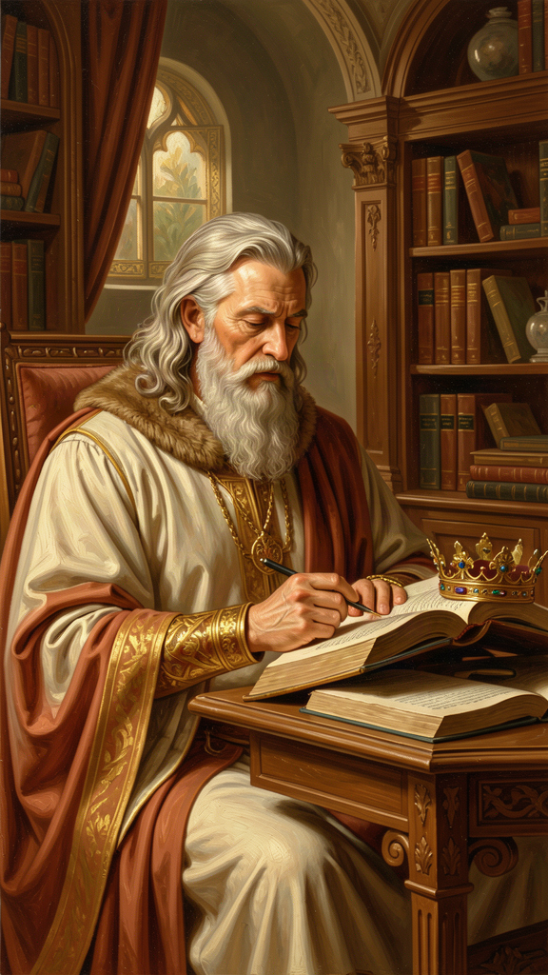
Illustration for Chapter 3
"Until philosophers rule as kings or those who are now called kings and leading men genuinely and adequately philosophize, cities will have no rest from evils." — Plato, Republic 473c-d
This sentence has been called the foundation of political philosophy and the blueprint for totalitarianism. It deserves a careful reading, because the common summary — "Plato wanted philosophers to be kings" — misses the argument.
———
The Republic opens with a question: what is justice? Socrates refutes three definitions — justice as paying debts (Cephalus), as helping friends and harming enemies (Polemarchus), and as the advantage of the stronger (Thrasymachus). Having demolished the alternatives, Socrates builds his own account by constructing a city in speech — an ideal polis — and arguing that justice in the city and justice in the soul share the same structure.
The city has three classes: producers (farmers, craftsmen, merchants, governed by appetite), auxiliaries (soldiers, governed by spirit), and rulers (philosopher-kings, governed by reason and knowledge of the Good). Each class does what it is fitted for. The result is not democracy. It is a hierarchy ordered by knowledge.
The rulers are selected through decades of education: gymnastics and music in childhood, mathematics in adolescence, dialectic in young adulthood, fifteen years of practical political service, and only then — around age fifty — ready to rule. They own no private property. They have no families. Their material needs are met by the community, but they cannot accumulate wealth. Their children are raised in common so that no family loyalty competes with loyalty to the city. Plato calls this arrangement the Kallipolis, the Beautiful City.
This is a radical vision. Plato admits it is probably impossible. The Republic is not a constitution for a real city. It is an ideal — a thought experiment that reveals what justice would look like if fully realized. Its purpose is not implementation but orientation. A ship that does not know its destination will never arrive. The ideal city tells the city where justice lies, so real cities can measure how far they fall short.
———
The argument for the philosopher-king rests on a claim about the nature of ruling: it is a craft that requires knowledge, and the knowledge it requires is knowledge of the Good.
Plato develops this through the ship of state analogy. A shipowner is stronger than everyone on the ship but nearsighted and not a navigator. The sailors quarrel over who should steer, though none has studied navigation. They do not understand that navigation requires knowledge of the stars, winds, and seasons. They think it cannot be taught. They crowd around the shipowner, begging to steer, and kill anyone who says they need to study first. Meanwhile, the true navigator — the one who understands the craft — is called a "stargazer" and ignored.
The analogy maps onto politics. The democratic electorate is the shipowner: powerful but ignorant. The politicians are the sailors: fighting for control without knowing how to steer. The philosopher is the navigator: ignored, mocked, called useless. The analogy is a direct attack on democracy, and Plato's personal experience gave it force. He watched the Athenian democracy execute Socrates. He watched the assembly make catastrophic military decisions — the Sicilian expedition that destroyed the Athenian empire. He did not trust crowds to make wise choices, because crowds are swayed by emotion, rhetoric, and self-interest, not by knowledge.
———
The philosopher-king has been read in two radically different ways, and the text supports both.
The idealist reading. Plato describes the conditions under which a city would be well-governed: rulers who know the Good, who cannot be bribed because they own nothing, who cannot be corrupted by family ambition because they have no families, who rule from knowledge rather than appetite. No actual regime matches this. The ideal reveals what every regime lacks. It is a standard, not a program. On this reading, the Republic is a critique of all existing politics, not a manual for dictatorship. Julia Annas (An Introduction to Plato's Republic, 1981) reads the ideal city as a thought experiment whose purpose is to illuminate the structure of the soul, not to provide a political blueprint.
The authoritarian reading. Plato describes a system where one class holds all power, claims exclusive access to truth, censors art, abolishes the family for the ruling class, and prohibits citizens from questioning the rulers. On this reading, the Republic is the first blueprint for totalitarianism. Karl Popper (The Open Society and Its Enemies, 1945) argued this forcefully. Plato's philosopher-king is a dictator who justifies power by claiming knowledge the citizens cannot verify. The censorship of poetry, the abolition of the family, the class rigidity — these are not incidental. They are the mechanisms of control.
Both readings have textual support. The city censors poetry, bans certain types of music, abolishes the family for guardians, and requires citizens to accept their class without complaint. These are authoritarian features. But the text also requires rulers to own nothing, to serve the city rather than themselves, and to rule only after decades of education. The philosopher-king is not a strongman. The philosopher-king is a person who has been stripped of every personal ambition except the desire for truth.
———
Plato's own political experience is relevant. He tried to implement his ideas, and they failed.
In his sixties, Plato made three trips to Syracuse, in Sicily, at the invitation of his friend Dion. The goal was to educate Dionysius II, the young ruler of Syracuse, into a philosopher-king. The experiment was a disaster. Dionysius was more interested in power than philosophy. The court was full of intrigue. Dion was exiled. Plato was nearly killed. The Seventh Letter (if genuine) records Plato's reflections on the failure: he went to Syracuse because he believed philosophy and power should be united, and he left convinced that the attempt to educate a tyrant was worse than futile — it was dangerous.
The Syracuse failure is not just a biographical anecdote. It is evidence against the philosopher-king ideal. The theory assumes that education in philosophy reliably produces virtue. Syracuse shows it does not. Dionysius studied with Plato and remained a tyrant. The Academy produced good philosophers and bad politicians. The question Plato's experience forces is whether anyone can be trusted with unchecked power, even a philosopher — or whether the problem is not who rules but the uncheckability of rule itself.
———
The deeper question is whether the philosopher-king ideal has any value if it is impossible. Plato says the Kallipolis will never exist. The ideal serves as a standard, not a program. But standards can be dangerous. An impossible ideal can be used to justify real violence in the name of an unattainable goal. The history of political idealism — from Plato through Rousseau to Marxism — is a history of ideals that produced mountains of corpses when people tried to implement them. The question is whether an impossible ideal illuminates or intoxicates. Plato would say it illuminates: it shows you what justice looks like, so you can measure how far you fall short. Popper would say it intoxicates: it tells you that perfection is possible, so any imperfection can be blamed on the people who are not perfect enough, and the solution is always more control.
The reception history bears both readings. The philosopher-king influenced Cicero's ideal of the statesman-philosopher, the Renaissance mirror-for-princes literature, the Enlightenment idea of the enlightened despot, and the modern technocratic ideal of rule by experts. Each of these has produced both good and bad outcomes. The question is whether the ideal itself is the problem, or whether the problem is the human tendency to confuse the ideal with a program.
The Big Idea: The Knowledge Requirement
Plato's argument is that political power without knowledge of the Good is dangerous, and knowledge of the Good without political power is wasted. The philosopher-king unites the two. The argument's strength is its insistence that ruling is a craft requiring expertise, not a popularity contest. Its weakness is its assumption that philosophical education reliably produces virtue — that knowing the Good makes you good. Syracuse shows it does not. The deeper problem is uncheckability: if only philosophers can know the Good, no one can check the philosopher-king's claim to know it. The ideal works only if the philosopher is genuinely virtuous, and the theory provides no mechanism for ensuring that. The question is not whether philosophers should rule. It is whether anyone should rule without accountability.
Practice
1. The Ship of State. Map Plato's analogy onto an institution you know — your workplace, your government, a professional association. Who is the shipowner (powerful but ignorant)? Who are the sailors (fighting for control without expertise)? Who is the navigator (ignored expert)? Does the navigator exist? Are they heard? Write one page on what would have to change for the navigator to be in charge, and what prevents it.
2. The Syracuse Analysis. Research the Syracuse episode — Plato's three trips, his relationship with Dion, the failure with Dionysius II. Write a two-page analysis: why did it fail? Was the idea wrong, or the execution? What does the failure reveal about the limits of the philosopher-king ideal? Is there a version of the ideal that could work, or does Syracuse refute the concept?
3. The Popper Debate. Read or research Popper's critique in The Open Society and Its Enemies. Write the strongest version of Popper's argument. Then write the strongest response — from Annas, Levinson, or your own reasoning. Which is more convincing? Can you construct a version of Plato's insight — that power requires knowledge of the good — that survives Popper's objection? Write one page.
4. The Accountability Problem. Plato's philosopher-king cannot be checked because only philosophers can judge philosophers. Design a modern institution that embodies Plato's principle — that leaders need knowledge of the good — with a mechanism for accountability. How would you ensure that the "philosophers" do not become a self-serving elite? What checks would you build? Write a one-page proposal. The goal is to extract what is living in Plato's idea and discard what is dangerous.
Reflect
Plato says the philosopher does not want power and must be compelled. If someone actively wants political power, Plato would say that is evidence they should not have it. Do you agree? In your experience, are the people who seek leadership the people who should have it? What would a system look like that preferred leaders who did not want to lead?
———

Chapter 4: Justice as Harmony of the Soul
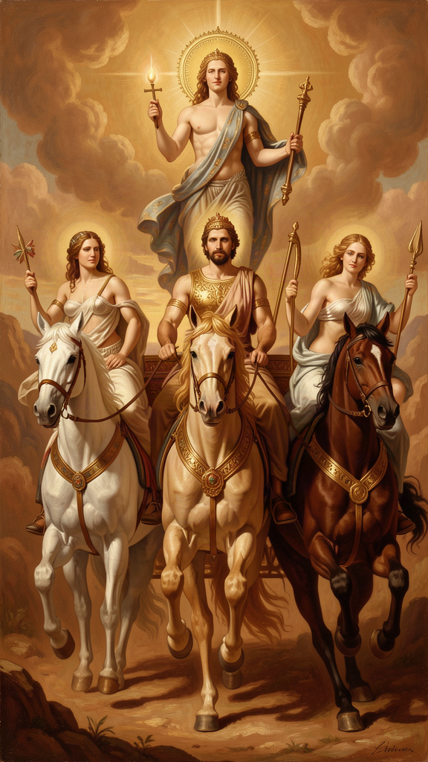
Illustration for Chapter 4
The Republic is about justice. It takes 350 pages to reach the definition, and the definition is not what you expect.
Plato does not define justice as fairness, law-abidingness, or desert. He defines it as a condition of the soul: reason rules, spirit supports reason, appetite obeys. Justice is inner harmony. Injustice is civil war in the soul.
———
The argument begins with the soul's three parts, argued for empirically in Book IV through psychological conflict. When you are thirsty but restrain yourself, something is thirsty (appetite) and something is restraining (reason). When you are angry at yourself for wanting something, something is wanting (appetite) and something is angry at the wanting (spirit). The soul is not unitary. It is a composite of forces that can cooperate or conflict.
- Reason (logistikon): seeks truth, understands the Forms, plans, governs. - Spirit (thumoeides): seeks honor, gets angry at injustice, defends what is right. - Appetite (epithumetikon): seeks pleasure, food, comfort, money, status.
Justice is when the three are in the right relation: reason rules, spirit is reason's ally, appetite is governed. The soul is orderly, calm, and effective. Injustice is when the parts are in the wrong relation: appetite rules, spirit rebels, reason is enslaved. The person is torn apart — wanting and hating the wanting, doing and being ashamed of the doing. The tyrant is the extreme case: appetite has total control, and the soul is the most disordered it can be. Plato calls the tyrant the most miserable person, not despite having everything but because of it.
———
Plato extends this to the city. A just city has the same three parts: rulers (reason), auxiliaries (spirit), producers (appetite). When each does its own work and does not seize another's, the city is just. The city-soul analogy is structural, not literal. The same pattern of justice — each part doing its own work under the right leadership — holds at both levels. The city is the soul written large.
This extension is where the model becomes politically dangerous. If justice in the city requires that producers (the majority) obey and never rule, the model justifies a rigid class system. Plato's producers are not slaves, but they are excluded from governance. The model has been used to justify hierarchy, caste, and the exclusion of the majority from political participation. The question is whether the tripartite city is a metaphor for the tripartite soul — in which case it is psychological, not political — or a political prescription — in which case it is authoritarian.
———
The most provocative claim is that justice is its own reward. The just person is always happier than the unjust person, regardless of circumstances.
Plato makes this argument against Thrasymachus, who claims that justice is "the advantage of the stronger": the rules the powerful make to serve themselves. Socrates shifts the frame from external justice (the rules societies enforce) to internal justice (the condition of the soul). He argues that a person whose appetite rules — whose soul is at war — is miserable regardless of wealth, power, or pleasure. The external successes cannot fix the internal disorder. Conversely, the just person — whose soul is in harmony — is at peace regardless of poverty, persecution, or death (Socrates was all three). The harmony of the soul is the only lasting happiness, because it is the soul's own condition, not something the world gives and can take away.
This is a strong claim. Is it true that the just person is always happier? What about a just person who is tortured? What about an unjust person who lives in luxury? Plato's answer is that external circumstances do not change the internal condition. But this raises a question that has been debated since the Republic was written: is a "healthy soul" sufficient for happiness under conditions of extreme suffering?
The Stoics took Plato's argument further, claiming that external circumstances are entirely irrelevant to happiness — only the inner condition matters. Most people find this counterintuitive, and most modern moral philosophers reject it. The question is whether Plato has conflated two things: the health of the soul (which may be independent of external circumstances) and happiness (which may not). If happiness requires both inner order and a minimum of external goods — food, safety, freedom, relationships — then Plato's claim is too strong. If happiness is identical to the soul's condition, regardless of external goods, then Plato is right but his definition of happiness is so narrow it has lost touch with what most people mean by the word.
Martha Nussbaum (The Fragility of Goodness, 1986) argues that Plato's move here is part of a larger pattern: the attempt to make the good life invulnerable to fortune. The tripartite soul, the Form of the Good, the philosopher-king — all are strategies for making value independent of the unstable, changing world. Nussbaum thinks this is a mistake. She argues that the value of human life is bound up with its fragility — with the risk that comes from loving particular people, living in particular places, and depending on things that can be lost. A life that has eliminated risk has eliminated something essential. The question is whether Plato's justice is a form of flourishing or a form of self-protective withdrawal from the world's risk.
———
The modern relevance is substantial. Plato's tripartite soul is the ancestor of every subsequent model of the divided self. Freud's id, ego, superego is a secularized version: the id is appetite, the superego is spirit (internalized rules and social honor), the ego is reason, mediating. Cognitive behavioral therapy works on a similar principle: that psychological suffering comes from internal conflict — irrational beliefs fighting rational ones — and that healing comes from bringing the parts into alignment. Jonathan Haidt's metaphor of the rider and the elephant (reason as a small rider on a large emotional elephant) is a modern version of the charioteer: reason is not the strongest part, but it can, with training, guide the stronger parts.
The language changes. The structure persists. The insight that the self is not unitary — that it is a composite of forces that can be in harmony or conflict — has survived 2,400 years because it matches experience. You know what it is like to be torn. You know that the part of you that wants is not always the part of you that decides. Plato's model gives that experience a name and a structure, and his ethics says: the work of life is bringing the parts into the right relation. Not eliminating any part — you need all three — but ordering them so that the right one leads.
The Big Idea: Justice as Psychological Health
Plato's definition of justice as inner harmony is a revolution that is still reverberating. It says that justice is not a set of rules you follow but a condition you inhabit. The just person is not the one who obeys the law but the one whose soul is in order. This means justice is primarily internal, and external justice (fair laws, equal treatment) is a symptom of internal justice, not its source. The city is just because the citizens are just. The citizens are just because their souls are in order. And the soul is in order because reason rules. This inverts the modern assumption that justice is a social arrangement that produces individual behavior. For Plato, it is the reverse: justice is a psychological condition that produces a social arrangement. The question this raises — and has raised for 2,400 years — is whether this is true, or whether just institutions can produce just souls even when the souls start out disordered.
Practice
1. The Soul Audit. For one week, keep a journal of internal conflicts. Each time you feel torn — wanting something you think you should not, or feeling angry about something you think you should not — write down what each part of the soul is saying. Label them: Reason, Spirit, Appetite. At the end of the week, review: which part is winning? Is your soul just or unjust? Write a one-page diagnosis using Plato's model and a one-page plan for shifting the balance.
2. The Thrasymachus Debate. Write a dialogue between yourself and Thrasymachus. He says: "Justice is the advantage of the stronger. The strong make the rules to serve themselves. You obey because you are weak." Write your response, then his counter, for three exchanges. Does Socrates' argument — that injustice damages the soul — answer Thrasymachus, or does Thrasymachus describe a reality that Socrates evades? Where do you stand?
3. The Nussbaum Question. Research Nussbaum's argument that Plato's ethics is a strategy for invulnerability. Write her argument in one paragraph, then Plato's best response in another. The question: is the value of a good life bound up with its fragility? Can you love particular people, live in particular places, and depend on things that can be lost, without making your happiness hostage to fortune? Or does the attempt to make happiness invulnerable remove something essential?
4. The Career Application. Apply Plato's model to your professional life. When you make career decisions, which part of the soul is driving — reason (what is truly good), spirit (what looks good to others), or appetite (what pays the most)? Review your last three major career decisions. Were they just (reason leading) or unjust? What would a reason-led career look like for you, and what would it cost?
Reflect
Plato says the just person is always happier than the unjust person, even under torture. Do you believe this? Is there a circumstance under which you think Plato is wrong — where external suffering overwhelms the health of the soul? If so, what does that tell you about the limits of the model? And if Plato is right, what does that say about what happiness actually is?
———

Chapter 5: The Myth of Er
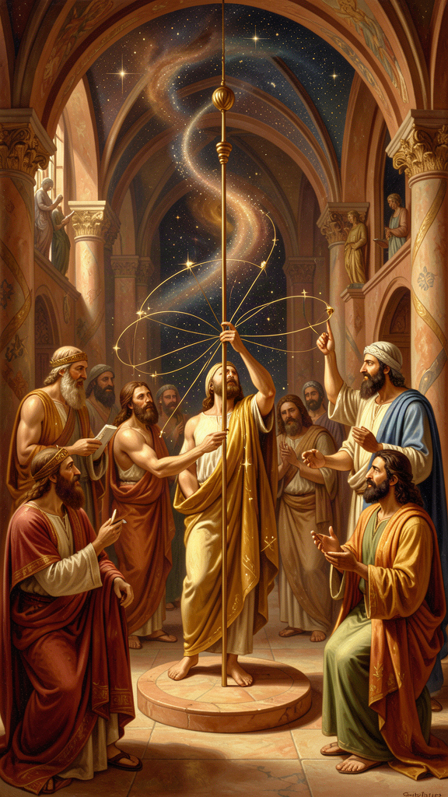
Illustration for Chapter 5
The Republic is 350 pages of argument. It ends with a story.
A soldier named Er dies in battle. On the twelfth day, as his body is about to be burned, he comes back to life and tells what he saw.
———
Er's soul traveled to a place between worlds. He saw two openings in the earth and two in the sky. Souls emerged — some from below, dusty and worn from punishment; some from above, radiant from reward. They gathered in a meadow and told each other their stories.
The souls from below had been punished ten times the measure of each wrong they had done. Some had spent a thousand years underground. The souls from above had been rewarded for good lives. But even they had to return. No soul stayed forever.
After judgment, the souls gathered in a meadow. A pillar of light stretched from earth to heaven. The spindle of Necessity turned it. The three Fates — Clotho, Lachesis, Atropos — sat on thrones. A herald announced: "The souls will now choose their next lives."
The lives were spread out — more than anyone could count. Kings and beggars, animals and humans, the brave and the cowardly. Each soul had to choose. The order was drawn by lot, but the choice was free.
A soul that had been a great hero drew an early lot. He saw the life of a swan — eating without working — and chose it, not understanding that he was choosing laziness. Another soul chose the life of a tyrant, not seeing the suffering that comes with power without wisdom. He wept when he realized his mistake, but it was too late.
The philosopher chose well. He had spent his life learning to love the Good, and when the lives were spread before him, he recognized the best one and chose it.
The herald warned: "Virtue has no master. Each of you will have more or less of it, depending on whether you honor or dishonor it. Responsibility lies with the one who chooses. God is not responsible."
After choosing, each soul drank from the River of Forgetfulness and forgot everything. They were born into the lives they had chosen. Er was sent back — without drinking — to tell the story.
———
The Myth of Er is not a doctrine. Plato never says it is literally true. Socrates calls it a muthos and offers it as something worth believing, not as something proven. The question is: what work is the myth doing that the arguments could not do?
The myth does three things.
First, it dramatizes moral responsibility. The souls choose their lives. No one is assigned. The choice is free, but it is made from the character the soul has developed. The hero chooses the swan because his character is lazy. The tyrant-chooser chooses tyranny because his character is greedy. The philosopher chooses well because his character is wise. The myth says: you are building the self that will choose your future. Every choice is an act of self-formation.
Second, it extends the frame beyond this life. The arguments of the Republic show that justice is its own reward. But those arguments are internal to a single life. The myth extends the frame: the soul's condition carries forward. The character you build now determines the choices you will make in the future, in this life and beyond. This does not prove that justice pays. It makes the stakes feel real.
Third, it provides a motivation that argument alone cannot. Plato knew that human beings are not purely rational. We are moved by stories, images, and narratives. The Republic is an argument for the rational soul. The Myth of Er is a story for the whole soul — including the parts that do not respond to logic. The myth makes you ask: if this were true, would I live differently? If the answer is yes, the myth has done its work, whether or not it is literally true.
———
The myth sits at the junction of philosophy and literature, and it raises a question that Plato's entire corpus engages: what can myth do that argument cannot?
Plato is famous for criticizing poetry. In the Republic, he banishes the poets from the ideal city because imitation corrupts the soul and poets do not know what they imitate. Yet Plato uses myth throughout his dialogues. The Cave is a myth. The charioteer is a myth. The Myth of Er is a myth. The Timaeus cosmology is a "likely story." Plato criticizes other people's myths while deploying his own.
This is not hypocrisy. It is a theory of myth. Plato distinguishes between myths that corrupt — myths that present false images as truth, that flatter the soul's lowest parts, that teach people to value appearances — and myths that elevate — myths that point the soul toward truth, that make the good attractive, that dramatize the stakes of moral choice. The poets Homer and Hesiod told stories of gods who lied, cheated, and raped. Those myths corrupt because they make vice look divine. Plato's myths tell stories of souls that choose, judge, and ascend. Those myths elevate because they make virtue look real.
The deeper question is whether myth can be philosophy. Plato's answer is: yes, when the myth is governed by philosophical understanding. A philosopher who knows the Good can craft a myth that points toward it. The myth is not a substitute for argument. It is a complement — an instrument for the parts of the soul that argument cannot reach. The Republic argues for justice. The Myth of Er makes you feel why justice matters. Both are necessary. Argument without myth is inert for most people. Myth without argument is dangerous — it becomes the poets' corrupting stories. Philosophy needs both.
———
The philosophical content of the myth is the claim that character is destiny. The choices you make now — to be brave or cowardly, honest or deceitful, kind or cruel — are not isolated actions. They are acts of self-formation. Each choice makes you slightly more the kind of person who makes that kind of choice. Over time, the pattern hardens into character, and character determines what you will choose when the stakes are highest.
This claim does not require the cosmology. It is a claim about moral psychology: you are always becoming someone, and the someone you are becoming will determine the choices available to you. The person who has spent years training their soul to love the Good will see the good life and choose it. The person who has spent years feeding appetite will see the easy life and choose it, not understanding that easy is not good. The choice is free, but the capacity to choose well is not free — it is the product of a lifetime of formation.
This raises the problem of moral luck, which Bernard Williams would articulate 2,400 years later. If your capacity to choose well is shaped by forces outside your control — your upbringing, your culture, your biology, your circumstances — how responsible are you for who you become? The herald says, "Responsibility lies with the one who chooses. God is not responsible." But what if the chooser was formed by forces that are not the chooser's doing? Plato's myth assumes a degree of agency that may not exist. The philosopher who chooses well did so because he was trained to love the Good — but who trained him? And who trained the trainer? The regress of responsibility is a problem the myth does not solve. It dramatizes the stakes but leaves the deepest question open.
The Big Idea: Character as Destiny
The Myth of Er says the soul's condition determines its choices. The souls choose freely, but they choose from who they are. The hero chooses the swan because he is lazy. The tyrant-chooser chooses tyranny because he is greedy. The philosopher chooses well because he is wise. The myth dramatizes a claim that does not require the cosmology: you are always building the self that will choose your future. Every choice is a formation, not just an action. The question is not "what will I choose?" but "who am I becoming, and will that person choose well?" The myth also raises a question it cannot answer: if the self that chooses is shaped by forces outside the self's control, how responsible is the self for its choices? Plato's myth assumes agency. Modern moral psychology questions that assumption. The tension is live.
Practice
1. The Life Choice. Imagine you are in the meadow. The lives are spread before you. Write down three lives you would seriously consider choosing — not fantasy lives, but lives you might actually be capable of living. For each, ask: why would I choose this? What does the choice reveal about who I am now? What would I need to change about myself to choose better? The answer to the last question is your philosophical agenda.
2. The Character Ledger. For one week, track every significant choice you make. For each, ask: "Is this choice training my soul toward the Good, or feeding my appetite?" Keep a running tally. At the end of the week, review the ratio. What does it tell you about who you are becoming? Write a one-page self-assessment using the tripartite soul model: which part is dominant, and what would it take to shift the balance?
3. The Moral Luck Problem. Research Bernard Williams's concept of moral luck. Write the problem in one paragraph: how can you be responsible for who you are if who you are is shaped by forces outside your control? Then write Plato's best response. Does the Myth of Er survive the problem of moral luck, or does it assume an agency that does not exist? If it does not survive, what is left of the myth's claim? Write one page.
4. The Myth Critique. The Myth of Er assumes the soul survives death and carries its character forward. Write the strongest argument against this assumption — from materialism, neuroscience, or the problem of other minds. Then write Plato's best response. Does the myth need to be literally true to do its work? If not, what does it need to be? If the cosmology is false, is the moral claim false too, or does it stand on its own?
Reflect
The herald says, "Responsibility lies with the one who chooses. God is not responsible." But what if your capacity to choose well was shaped by forces you did not control — your parents, your culture, your genes, your luck? How much of your character is your own doing? How much is fate? And if you cannot answer that question, what does it mean to take responsibility for who you are becoming?
———

Chapter 6: The Charioteer of the Soul
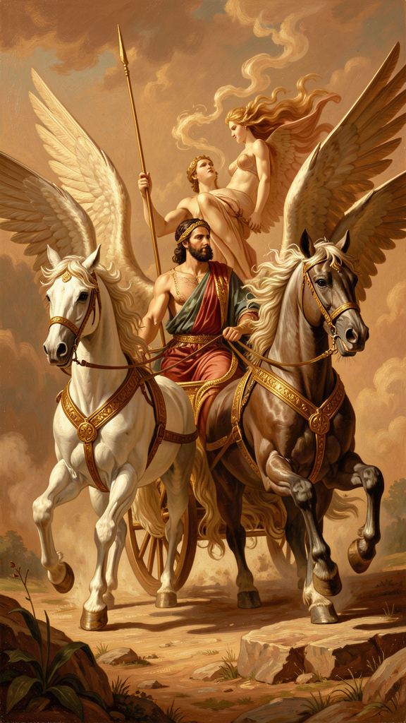
Illustration for Chapter 6
The Phaedrus is a dialogue about love, rhetoric, and the soul. It contains Plato's most vivid image of the self: the charioteer.
The soul is a chariot. The charioteer is reason. Two horses pull the chariot. One is noble — proud, obedient, drawn toward truth and beauty. The other is wild — crooked, disobedient, drawn toward bodily pleasure. The charioteer must guide both. He cannot cut the wild horse loose. He needs both to move. But he must hold the reins.
———
Plato sets this in a cosmic drama. The gods ride their chariots through the heavens, their horses perfectly matched, soaring to the edge of the sky where they feast on the Forms. The sight of the Forms is the greatest experience a soul can have. It is what the soul was made for.
Mortal souls struggle. The wild horse drags them down. Most rise partway, catch a glimpse of the Forms, and fall back. The wild horse is stronger than the noble horse, and reason — the charioteer — is not the strongest part of the soul. Reason wins only through discipline, the support of the noble horse, and the long process of training.
The key scene: the charioteer sees a beautiful person. The sight reminds him of Beauty itself — the Form of Beauty he glimpsed in the heavens. The noble horse rises, wanting to honor and love the beauty rightly. The wild horse lunges, wanting to seize and possess it. The charioteer must hold on. If the wild horse wins, the soul falls into lust and domination. If the charioteer controls the wild horse and lets the noble horse lead, the soul rises toward true love — love that sees beauty not just in one body but in all beautiful things, and finally in Beauty itself.
———
This is the same ascent described in the Symposium by Diotima, the priestess who teaches Socrates about love. Diotima describes a ladder: love begins with one beautiful body, then all beautiful bodies, then beautiful souls, then beautiful laws and institutions, then beautiful knowledge, and finally Beauty itself — eternal, unchanging, not in any particular thing. The charioteer and the ladder are two images of the same ascent. The chariot shows the struggle. The ladder shows the progression. Together they give a complete picture: love is not a feeling. It is a discipline. It begins with desire for a particular beautiful thing and, if guided rightly, rises to desire for Beauty itself.
———
The charioteer adds something the Republic's tripartite soul does not: the experience of moral conflict. The Republic describes the three parts analytically. The charioteer dramatizes them. You can understand the tripartite soul as a diagram. You feel the charioteer. You know the noble horse — the part that wants to do right, that feels proud when you do, that gets angry at injustice. You know the wild horse — the part that wants what you should not have, that does not think, that only wants. And you know the charioteer — the part that sees both, knows which should win, and struggles to hold the reins.
This is Plato's insight about moral psychology: the self is not unified. It is a battlefield. The outcome is not determined by strength — the wild horse is stronger — but by discipline and training. The noble horse can be strengthened. The wild horse can be somewhat tamed. But neither is eliminated. The struggle is permanent. The question is not whether you will fight but whether you will win more often than you lose.
———
The charioteer makes a claim about love that has been debated for 2,400 years. Plato's model of love is ascent: love begins with the body and rises to the Form. The particular beloved is a starting point, not a destination. The goal is to move beyond the particular to the universal.
This has been controversial. Aristotle, in the Nicomachean Ethics, argued that the highest friendship is between two particular people who wish each other well for their own sakes — not as rungs on a ladder to Beauty, but as ends in themselves. The particularity of the beloved is not a limitation to be transcended but a value to be honored.
Martha Nussbaum (The Fragility of Goodness, 1986) develops this critique. She argues that Plato's ascent model is a flight from the vulnerability of loving particular people. The ladder lets you love Beauty without risking the loss that comes when the particular beautiful thing changes, ages, or dies. The ascent is a strategy for invulnerability. Nussbaum thinks this is a mistake — the value of love is bound up with its risk, and a love that has eliminated risk has eliminated love. To love Beauty without loving the particular is to love an abstraction, and abstractions do not die, but they also do not hold your hand.
The counter-argument is that Plato does not say stop loving the particular. He says continue loving it, but understand it as a participation in Beauty. The lover who has climbed the ladder does not stop seeing beauty in the beloved. He sees it more clearly, because he understands what beauty is. The ascent does not devalue the particular. It grounds it. The risk remains. The vulnerability remains. But the loss of one beautiful thing is bearable because Beauty itself does not die.
The text is ambiguous. In Diotima's speech, the particular beloved drops out of the account once the ascent begins. The ladder moves away from the individual. In the charioteer, the beautiful person is the occasion for the ascent but not its destination. Plato's imagery consistently moves from the particular to the universal. The question is whether this movement is a deepening or an abandonment. Plato would say deepening. Nussbaum would say abandonment. The debate is real, and it applies to every love you will ever have: is the person you love an end in themselves, or a window onto something larger? Can they be both? And if you say both, does one role eventually dominate?
———
The reception history of the charioteer is vast. Freud's structural model (id, ego, superego) is a secularized version: the wild horse is the id, the noble horse is the superego, the charioteer is the ego. Freud's innovation was to make the charioteer weak — the ego is "not master in its own house," as Freud put it, because the unconscious forces (the horses) are stronger. Plato's charioteer is also not the strongest, but Plato thinks training can shift the balance. Freud is more pessimistic: the wild horse (the id) is not tamed but managed, and even the management is never complete.
Daniel Kahneman's Thinking, Fast and Slow (2011) maps onto the same structure: System 1 (fast, intuitive, emotional) is the wild horse. System 2 (slow, deliberate, rational) is the charioteer. Kahneman's finding — that System 1 is the default and System 2 is effortful and easily depleted — is a modern version of Plato's claim that the wild horse is stronger and reason wins only through discipline. The language has changed. The structure has not. 2,400 years after Plato described a charioteer struggling to control two horses, cognitive science is confirming that the rational part of the mind is not the strongest and that the struggle is permanent.
This convergence does not prove Plato was right. It proves the structure he identified is real — that the self is divided, that the divisions are unequal in strength, and that the work of a life is training the weaker part (reason) to guide the stronger parts. Whether you call it reason-spirit-appetite, ego-superego-id, or System 2-System 1, the architecture is the same. The charioteer endures because it is not just an image. It is a map of the human condition.
The Big Idea: The Divided Self in Permanent Struggle
The charioteer is Plato's most honest image of what it is like to be a person. You are not one thing. You are a battlefield. The noble horse pulls toward truth, honor, and beauty. The wild horse pulls toward pleasure, possession, and comfort. The charioteer — reason — is supposed to be in charge but is not the strongest. The outcome is determined not by which side is stronger but by which side is trained. The noble horse can be strengthened. The wild horse can be disciplined. But the war is permanent. The best you can do is win more battles than you lose, and the way you do that is through the daily practice of choosing truth over comfort, honor over appetite, and the Good over the easy. This is not a recipe for perfection. It is a description of the only honest way to live: knowing you will lose sometimes, and choosing to fight anyway.
Practice
1. The Chariot Journal. For one week, at the end of each day, identify one moment when the noble horse was pulling and one when the wild horse was pulling. For each, write: what did each horse want? Which won? What was the outcome? At the end of the week, review: is your chariot rising or falling? What is the pattern? Write a one-page diagnosis and a one-page plan for the next week.
2. The Ladder of Love. Think of someone or something you love. Follow Diotima's ladder: what do you love about it? Is it just this particular thing, or is there a quality it shares with other things? Keep climbing: what is the quality of? Can you reach a point where you are loving something that is not located in any single object? Write your experience of the climb. Where did you stop? Why? Did the climb deepen your love for the particular, or does the particular feel diminished by the ascent? This is the question Nussbaum raises. Your answer is your own.
3. The Nussbaum Debate. Research Nussbaum's argument in The Fragility of Goodness. Write her critique of Plato's ascent model in one page: is the ladder a strategy for invulnerability? Does it devalue the particular? Then write Plato's best response in another page. Which is more convincing? Is the ladder a deepening of love or an escape from it? Where do you stand, and why?
4. The Training Plan. The noble horse gets stronger every time you choose truth over comfort. Design a one-month training program: one specific daily choice that strengthens the noble horse (a hard truth, a difficult conversation, an act of integrity that costs something). At the end of the month, assess: did the noble horse feel stronger? Did the wild horse get quieter? Write one page on what you learned about the training of a soul — and about the permanent nature of the struggle.
Reflect
Plato says the wild horse can never be eliminated, only controlled. The struggle is permanent. Is this a hopeful claim or a tragic one? If the best you can do is win more battles than you lose, is that enough for a good life? Or does Plato's model condemn you to a fight you can never fully win — and if so, is that the most honest thing a philosopher has ever said about what it means to be human?
———

For the Grown-Up Reader
This booklet engages with Plato's philosophy at a level appropriate for adult readers with or without prior philosophical training. It draws on six dialogues and one letter: Republic (the Cave VII, the Form of the Good VI, the philosopher-king V, the tripartite soul IV, the Myth of Er X, the Divided Line VI), Phaedrus (the charioteer 246a–256e), Apology (38a), Meno (81c-d), Crito (54b), Symposium (Diotima's ladder 210a–212a), Parmenides (the Third Man Argument and self-critique), and the Seventh Letter (341c-d, 344b-c). Translations used: C. D. C. Reeve, Republic (Hackett, 2004); Nehamas and Woodruff, Symposium and Phaedrus (Hackett); Hackett Complete Works edited by John M. Cooper (1997).
The quotes are real and cited by dialogue and Stephanus page. Plato wrote dramatic conversations, not treatises. The Socrates of the dialogues is a character; the degree to which he represents the historical Socrates is a live scholarly question (the "Socratic problem"). The images in this booklet — the Cave, the Good as sun, the philosopher-king, the tripartite soul, the Myth of Er, the charioteer — are myths and analogies, not literal claims. Plato was explicit about this. He distinguished between myths that corrupt (Homer's stories of corrupt gods) and myths that elevate (his own, which point the soul toward truth).
Scholarly debates referenced in depth: the Third Man Argument (Aristotle, Metaphysics; Vlastos, Platonic Studies; reviewed in the Cambridge Companion to Plato); the Parmenides as self-critique (read as confession of doubt by some, as dialectical training by others); Karl Popper's critique of Plato as totalitarian (The Open Society and Its Enemies, 1945; contested by Levinson, Annas, and others); Martha Nussbaum's critique of the ascent model as flight from vulnerability (The Fragility of Goodness, Cambridge 1986); the Socratic problem (Vlastos, Socrates: Ironist and Moral Philosopher; Kahn, Plato and the Socratic Dialogue); the authenticity of the Seventh Letter (debated; see Kahn and the Cooper edition introduction); the Syracuse episode (attested in the Seventh Letter and Plutarch's Life of Dion); the connection to modern psychology (Freud's id/ego/superego; Kahneman's System 1/System 2; CBT's model of internal conflict). The moral luck problem (Bernard Williams, Moral Luck, 1981) is raised against the Myth of Er's assumption of agency.
This booklet does not claim that Plato is right. It claims that the questions he asked are still live, that the arguments he made are still worth engaging, and that the images he created still illuminate the structure of human experience. Whether the Form of the Good exists, whether the philosopher-king is idealism or authoritarianism, whether justice is psychological health, whether the ascent of love deepens or abandons the particular — these are questions that 2,400 years have not settled. Plato would have it no other way. He did not write treatises. He wrote conversations. The conversation is not finished. You are part of it.
———

About WisdomForge
WisdomForge adapts the great philosophers into stories, audio, and conversation for every age. Each philosopher becomes four booklets — one for children, one for young teens, one for older teens, and one for adults — so the same ideas can grow with you. The questions are older than civilization. The answers are yours to find.

