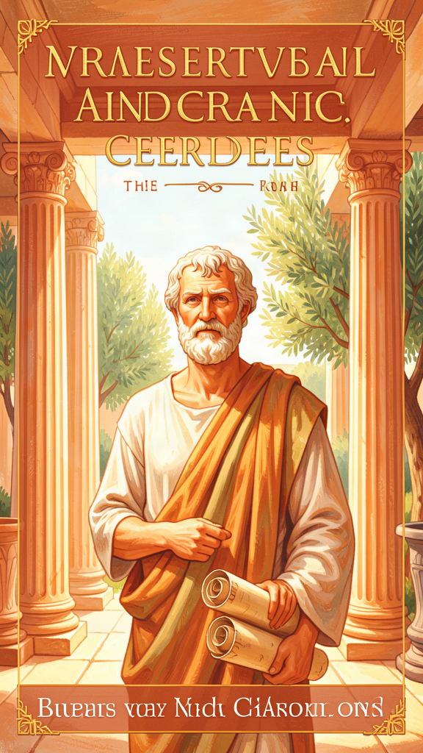
Plato: The Man Who Saw the Sun
WisdomForge Booklet — Ages 5–10

Plato: The Man Who Saw the Sun

WisdomForge Booklet — Ages 5–10
———

About This Book
This booklet tells the story of Plato, a philosopher who lived in ancient Greece about 2,400 years ago. Plato loved asking questions. He believed that the world we see is like a shadow of something bigger and more real — and he wanted to help people see it.
Plato wrote his ideas as conversations. He created a wise character named Socrates, based on his real teacher, who asked questions that made people think. This booklet follows Socrates through six big ideas: a cave full of shadows, a sun that lights up the mind, a wise ruler, a soul that needs harmony, a story about what happens after we die, and a chariot pulled by two horses.
Each chapter has a story, words to remember, a big idea, something to try, and a question for a grown-up. Read it alone or with someone you love. The questions aren't tests. They're doorways.
———

Chapter 1: The Cave of Shadows
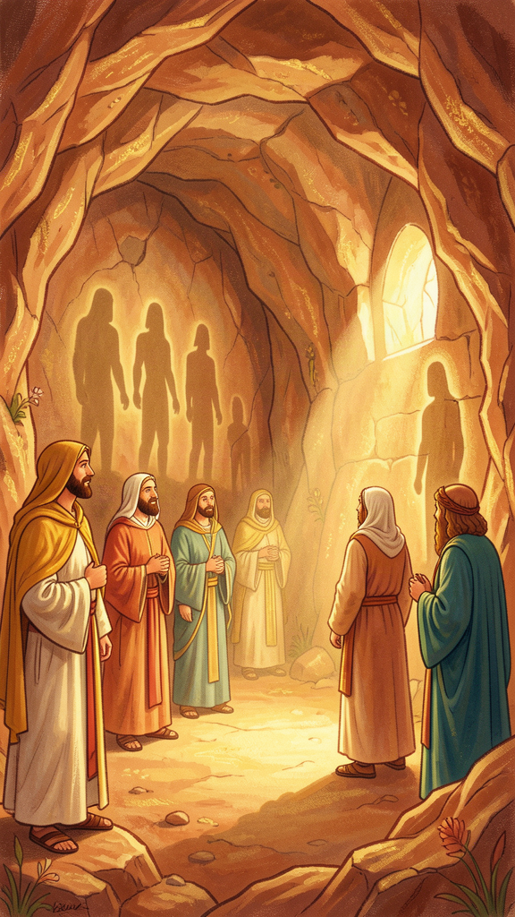
Illustration for Chapter 1
Imagine a dark cave. Deep underground, a group of people sit in a row, chained so they can only look at one wall. They have been there since they were born. They have never turned around. They have never seen the sky.
Behind them, a fire burns. Between the fire and the prisoners, a low wall stands, and behind that wall, other people walk, carrying things — statues of animals, models of trees, shapes of all kinds. The fire casts shadows of those objects onto the wall the prisoners face.
The prisoners watch the shadows. They name them. They argue about which shadow is bigger, which is faster, which is most beautiful. They give prizes to whoever is best at guessing which shadow will come next. To the prisoners, the shadows are the whole world. They have never seen anything else.
One day, a prisoner is freed. The chains come off. Someone turns him around.
The fire is behind him. It hurts his eyes. It is so bright after a lifetime of darkness that he wants to turn back to the wall. The shadows are familiar. The fire is painful.
But he is dragged up a rough, steep path, out of the cave, into the open air.
At first he can see nothing. The sunlight is blinding. He closes his eyes. Slowly, slowly, his eyes adjust. He sees shadows first — real shadows, cast by real things. Then he sees reflections in water. Then, in the evening, he can look at the stars and the moon. And finally, at noon, he can look at the sun.
He understands. The sun is the source of everything — the light, the warmth, the growth of plants, the seeing of eyes. The cave was just shadows. This is real.
He thinks of his friends, still chained below, watching shadows and giving prizes. He pities them. He goes back down.
When he returns to the cave, his eyes are used to the light. He stumbles in the dark. He cannot name the shadows as well as he used to. The other prisoners laugh at him. They say the journey ruined his eyes. They say he has come back stupid.
Plato said: if someone tried to free them and turn them toward the light, they would kill him.
He was talking about Socrates. Socrates asked questions that turned people toward the truth, and the people of Athens put him to death for it.
Words to Remember The unexamined life is not worth living for a human being. — Socrates in Plato, Apology
Big Idea Most people spend their whole lives looking at shadows — opinions, rumors, appearances — and thinking those are real. The philosopher is the one who turns around, sees the fire, climbs out, and discovers the sun. But the hardest part is not getting out. It is going back down to help the others, even when they laugh at you.
Try This - The Shadow Theater. Turn off the lights in a room. Shine a flashlight on a wall. Hold up your hands and make shadow puppets — a rabbit, a bird, a dog. Now think: the shadow puppet is not the animal. It is just a shape made by light and dark. Plato said the whole world we see is like that — a shadow of something more real. What do you think the "more real" thing is? - The Turn-Around. Think of something you used to believe was true, but then you learned it wasn't. Maybe you thought the stars were tiny, or that the earth was flat. Draw what you believed before (the shadow) and what you learned (the sun). That moment of turning around — that is what Plato's cave is about. - The Going-Back Test. Imagine you discovered something amazing — a secret, a beautiful place, a truth nobody else knew. Would you go back and tell people, even if they laughed at you? Draw yourself climbing back down into the cave, carrying the sun.
Ask a Grown-Up "Have you ever changed your mind about something big — and had people tell you you were wrong? What did you do?"
———

Chapter 2: The Sun That Lights the Mind
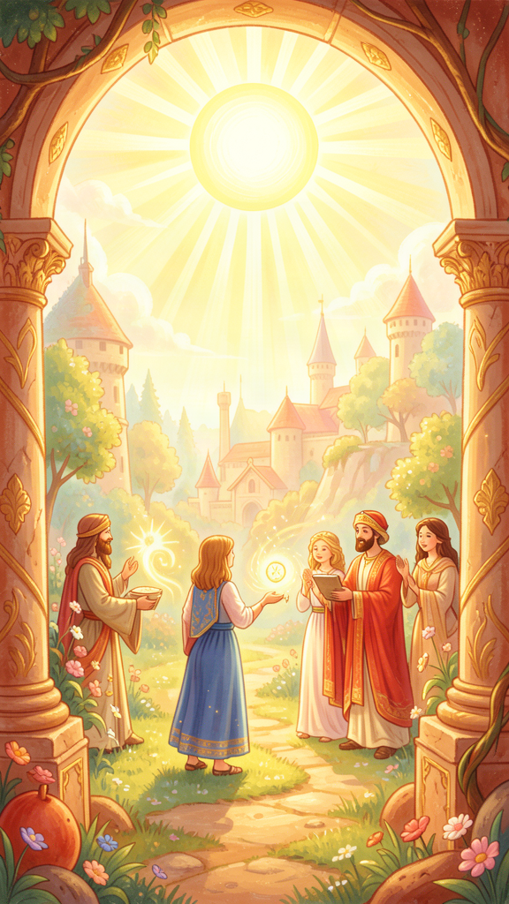
Illustration for Chapter 2
The freed prisoner stood on the hillside and looked at the sun. He had spent his life in the cave watching shadows. Now he saw the thing that made the shadows possible.
Plato said: just as the sun lights up the world so your eyes can see, there is something called the Good that lights up the mind so your thoughts can understand.
Think about it this way. Without the sun, you cannot see. The most beautiful painting, the most colorful garden, the most interesting book — all of them are invisible in the dark. Your eyes are fine. The objects are there. But without light, seeing does not happen.
The sun does two things. It makes objects visible, and it makes your eyes able to see them. The sun also helps things grow. Plants reach toward it. The whole world is alive because of the sun.
Plato said the Good is like that, but for the mind. The Good is not a thing you can touch. It is not a stone or a tree or a person. It is more like a light that makes everything else make sense. When you understand why something is good — why kindness is better than cruelty, why truth is better than lies, why justice is better than cheating — you are seeing by the light of the Good.
Without the Good, your mind stumbles in the dark. You might be clever. You might know lots of facts. But you would not understand why any of it matters. The facts would be like objects in a dark room — there, but invisible.
Socrates told his friends that the Good is the most important thing to learn. Not because it will make you rich. Not because it will make you famous. But because once you see it, everything else falls into place, the way colors appear when the sun comes up.
A child asked Socrates, "What does the Good look like?" Socrates smiled and said it does not look like anything. You cannot draw it. You cannot take a picture of it. You can only see it with the mind, not with the eyes.
This is hard. It is the hardest thing in philosophy. But Plato said it is also the most important. The person who knows the Good will rule wisely, love truly, and live well. The person who does not know the Good will stumble through life, mistaking shadows for sunlight.
Words to Remember The Good may be said to be not only the object of knowledge but also the thing that gives truth to the things known, and to the one who knows them, the power to know. — Socrates in Plato, Republic
Big Idea The Good is like the sun for your mind. Just as the sun makes seeing possible, the Good makes understanding possible. Without it, you might know facts but not understand why they matter. With it, everything becomes clear — what is just, what is beautiful, what is true, and how to live.
Try This - The Dark Room Test. Go into a room and turn off all the lights. Try to read a book. Try to find a toy. Try to see the color of the wall. You cannot. Now turn on one light. Everything appears. That is what the Good does for the mind. Without it, the facts are there but you cannot understand them. With it, they become clear. - The "Why Does It Matter?" Game. Pick something you know is true — the sky is blue, two plus two is four, fire is hot. Now ask: "Why does that matter?" Keep asking "why" until you reach something you cannot explain but you know is important. That hard-to-name important thing — that is what Plato called the Good. - The Sun Drawing. Draw the sun in the middle of a page. Around it, draw things the sun makes possible: a growing flower, a person seeing, a warm house, a bright day. Now imagine a sun that does the same thing for your thoughts. What would you draw around it? Understanding, kindness, truth, fairness — the things the Good makes grow.
Ask a Grown-Up "When you know something is the right thing to do, how do you know? Where does that feeling come from?"
———

Chapter 3: The Wise Ruler
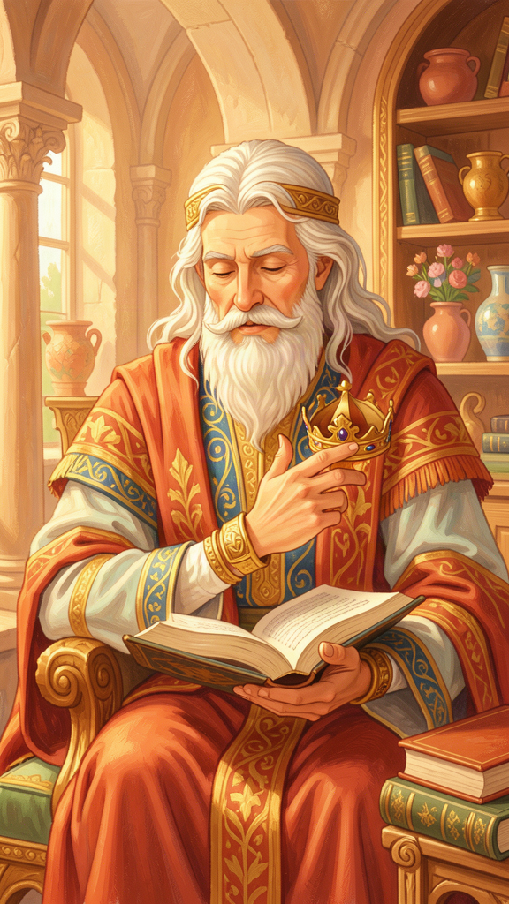
Illustration for Chapter 3
Plato told a story about a perfect city. He called it Kallipolis, the Beautiful City. In this city, the wisest people were in charge.
In most cities, Plato said, the people who rule are the ones with the most money, or the biggest armies, or the loudest voices. But Plato thought that was backwards. Would you want a captain who had never sailed to steer your ship? Would you want a doctor who had never studied medicine to treat your sickness? Of course not. You would want the person who knew the most about sailing, or the person who knew the most about healing.
Plato said a city should work the same way. The person who knows the most about what is good and just should be the one to lead. He called this person the philosopher-king.
But here is the surprising part. Plato said the philosopher-king would not want the job.
Imagine you had climbed out of the cave and seen the sun. You had found truth, beauty, and peace. Would you want to go back down into the dark, noisy cave to argue with people who think shadows are real? Of course not. You would want to stay in the sunlight.
Plato said the philosopher feels the same way about ruling. The philosopher has seen the Good and wants to spend all day thinking about truth. Being a ruler means dealing with arguments, lies, greed, and complaints. It is exhausting. The philosopher would rather study.
But Plato said the philosopher must rule anyway. Why? Because if the people who love truth refuse to lead, then the people who love power will lead instead. And people who love power, not truth, will make the city a worse place for everyone.
So Plato's city has a rule: the philosophers must take turns being rulers. They do not rule for money (they own nothing). They do not rule for fame (no one knows their names). They do not rule for power (they share it). They rule because it is the right thing to do. And when their turn is over, they go back to studying, grateful to be done.
Plato said this would never actually happen, not perfectly. Most people do not want wise leaders. They want leaders who tell them what they want to hear. But he told the story anyway, because a city should know what it is aiming for, even if it falls short. A ship that does not know where it is going will never get there, even on a calm sea.
Socrates, Plato's teacher, was the closest thing to a philosopher-king Plato had ever met. He was wise, brave, and honest. He asked hard questions that made powerful people uncomfortable. And the city of Athens killed him for it. Plato never forgot that lesson: the city that needs wisdom most is often the city that hates it most.
Words to Remember Until philosophers rule as kings or those who are now called kings and leading men genuinely and adequately philosophize, cities will have no rest from evils. — Socrates in Plato, Republic
Big Idea Plato said the best ruler is the one who knows the most about what is good and just — the philosopher. The philosopher does not want power. The philosopher wants truth. But Plato said the philosopher must lead anyway, because if wise people refuse to lead, greedy people will. A city is only as good as the people who guide it.
Try This - The Captain Game. Imagine you are choosing a captain for a ship. You have three choices: someone who is very rich, someone who is very strong, or someone who has studied sailing for years. Who do you pick? Why? Now imagine choosing a leader for a city. What should matter most — money, strength, or wisdom? - The "Who Would Want That?" Puzzle. Plato said the best ruler is the one who does not want to rule. Think about that. Why might a wise person not want to be in charge? What might they rather do instead? Draw two pictures: the wise person studying in peace, and the wise person trying to lead a noisy, arguing crowd. - The Leader You Know. Think of a leader you know — a teacher, a coach, a parent, a principal. Do they lead because they love power, or because they want to help? How can you tell the difference? What would Plato say makes a good leader?
Ask a Grown-Up "Do you think the smartest person would make the best leader? Or are there things besides being smart that matter? What are they?"
———

Chapter 4: The Soul That Sings in Harmony
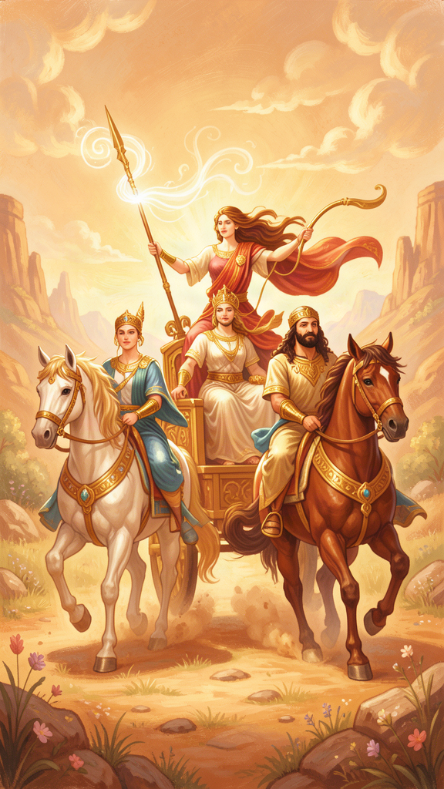
Illustration for Chapter 4
Plato said every person has a soul, and the soul has three parts. He compared them to three different voices inside you.
The first voice is Reason. It is the part that thinks, asks questions, plans ahead, and tries to figure out what is true. When you stop and think, "Should I really do that?" — that is Reason speaking.
The second voice is Spirit. It is the part that gets angry when something is unfair, that feels proud when you do something well, and that wants to defend what is right. When you say, "That's not fair!" or "I won't let them treat me like that!" — that is Spirit speaking.
The third voice is Appetite. It is the part that wants things — food, fun, toys, attention, treats. When you say, "I want it! I want it now!" — that is Appetite speaking.
All three voices are part of you. None of them is bad by itself. Appetite keeps you alive — you need to eat. Spirit keeps you brave — you need to stand up for yourself. Reason keeps you wise — you need to think.
But the three voices do not always agree. Sometimes Appetite shouts, "Eat all the cookies!" and Reason says, "You will feel sick." Sometimes Spirit says, "Hit him back!" and Reason says, "That will make it worse." The fight inside you — that is what Plato called injustice.
Justice, Plato said, is when the three voices work together in harmony. Reason is the leader. Spirit is the helper. Appetite is the follower. When Reason is in charge, Spirit supports it, and Appetite does what it is told, the soul is at peace. You feel calm. You feel whole. You feel like a song that is in tune.
Plato compared the just soul to a well-tuned instrument. Each string has its own note. None of them tries to be the loudest. Together they make music. When one string is too tight or too loose, the music sounds wrong. When all are tuned right, the music is beautiful.
He compared the unjust soul to a civil war. Appetite has seized control. Spirit is rebelling. Reason has been locked in a room. The person feels torn apart — wanting something, hating themselves for wanting it, ashamed of what they did, doing it anyway. That is the opposite of harmony.
Plato said this is true not just inside one person but inside a whole city. A city has the same three parts: the people who think (leaders), the people who fight (soldiers), and the people who make things (workers). When each group does its own job well, and no group tries to take over, the city is just. When the soldiers try to rule, or the workers grab power they cannot use wisely, the city falls apart — just like a soul in civil war.
Socrates told his friends that being just is not about following rules other people make. It is about being healthy inside. A just person is happy, even if bad things happen to them, because their soul is in order. An unjust person is miserable, even if they get everything they want, because their soul is at war with itself.
Words to Remember It is the most important thing to become as virtuous as possible and to live as nobly as possible. — Socrates in Plato, Crito
Big Idea Your soul has three parts: Reason, Spirit, and Appetite. Justice is when Reason leads, Spirit helps, and Appetite follows. That harmony is the source of real happiness — not getting everything you want, but having the parts of yourself work together like a well-tuned song.
Try This - The Three Voices. Think of a time you felt torn about something. Maybe you wanted to eat a treat but knew you should save it. Maybe you wanted to yell at someone but knew it would make things worse. Draw three faces: Reason, Spirit, and Appetite. What is each one saying? Which one won? Which one should have won? - The Song of Your Soul. Imagine your soul is a band. Reason is the conductor. Spirit is the drummer — strong and loud. Appetite is the singer — wants all the attention. Draw your band. Are they playing together, or is everyone trying to be the loudest? What would it take to make them play in harmony? - The Tuning Test. Plato said a just soul is like a tuned instrument. Close your eyes and ask yourself: "Is my soul in tune right now?" Is Reason in charge, or is Appetite running the show? Is Spirit helping or making trouble? There is no wrong answer. Just notice. Then take three breaths and imagine the strings tightening into tune.
Ask a Grown-Up "Have you ever wanted something really badly but knew you shouldn't do it? How did you decide? Which part of you won?"
———

Chapter 5: The Soldier Who Came Back
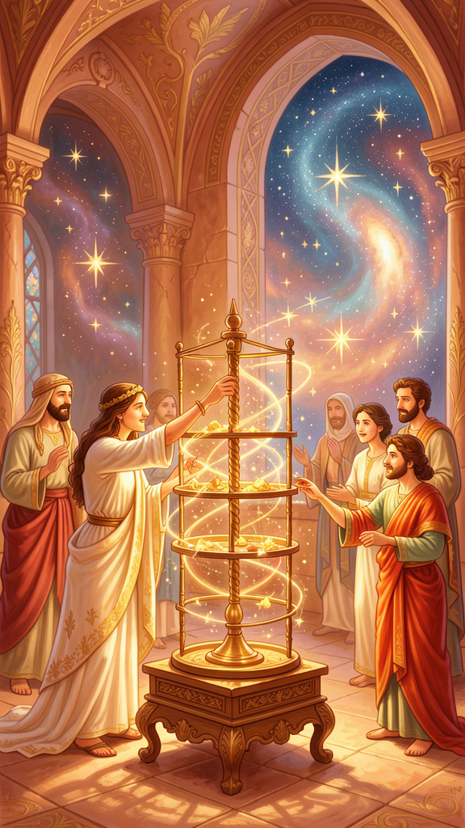
Illustration for Chapter 5
At the end of his big book, Plato told a strange and wonderful story. It is called the Myth of Er.
A soldier named Er was killed in battle. His body was placed on a funeral pyre, ready to be burned. But on the twelfth day, just as the fire was about to be lit, Er came back to life.
He sat up and told the people what he had seen.
When he died, Er said, his soul left his body and traveled to a mysterious place. He saw two openings in the earth and two openings in the sky. Souls came up from the earth, dusty and worn, and souls came down from the sky, clean and shining. They gathered in a meadow and told each other their stories.
The ones who had come up from the earth had been punished for the wrong things they did in life. For every person they hurt, for every lie they told, for every injustice they committed, they had paid. Some had been there for a thousand years. The punishment was ten times the crime. It was not quick. It was not easy.
The ones who had come down from the sky had lived good lives. They had been rewarded with peace and beauty. But even they had to return, eventually, to live again.
After the souls were judged and purified, they gathered in a great meadow. In the center stood a pillar of light, stretching from the earth to the heavens. The spindle of Necessity turned it, and the Sirens sang the notes of the cosmic scale. The three daughters of Necessity — Clotho, Lachesis, and Atropos — sat on thrones, controlling the threads of fate.
A herald stepped forward and made an announcement. "The souls will now choose their next lives." He spread out the lives before them, more than any soul could count. There were lives of animals and lives of humans. There were lives of kings and lives of beggars. There were lives of the brave and lives of the cowardly. Every kind of life was there.
And here is the most important part: each soul had to choose. No one was assigned a life. They picked.
But they chose in a way that revealed who they really were. The herald warned them: "Choose wisely. Let the one who draws the first lot choose wisely. Virtue has no master. Each of you will have more or less of it, depending on whether you honor or dishonor it."
One soul, who had been a great hero in a previous life, saw the life of a swan and chose it. He did not see that the swan eats without working. He wanted an easy life. He did not understand that ease is not the same as goodness.
Another soul, who had suffered greatly, chose the life of a tyrant. He did not see that the tyrant's life includes the worst suffering of all — the misery of power without wisdom. He chose with his Appetite, not his Reason. He wept when he realized what he had done, but it was too late. The choice was made.
The philosopher, Plato said, would choose well. The philosopher has spent life learning to love the Good. So when the philosopher sees the lives spread out, he does not choose the easy one or the powerful one. He chooses the one that will help him grow wiser and better. The choice reveals the character. The character was shaped by the life.
After the choosing, each soul drank from the River of Forgetfulness and forgot everything. Then they were born into the lives they had chosen.
Er was not allowed to drink. He was sent back to tell the story.
Plato said the myth teaches one thing above all: character is destiny. The choices you make now — to be brave or cowardly, kind or cruel, truthful or deceitful — are shaping who you are. And who you are determines what you will choose when the moment comes. So the work of becoming good is not just for this life. It is for all the lives to come.
Words to Remember The soul is immortal, has been born often, and has seen all things here and in the underworld. There is nothing it has not learned. — Socrates in Plato, Meno
Big Idea Plato's story says that after we die, our souls are judged and then we choose our next lives. But we choose based on the kind of person we have become. If you spend your life learning to love what is good, you will choose well. If you spend your life chasing easy pleasures, you will choose badly. Who you are now shapes who you will be — forever.
Try This - The Life Menu. Imagine you are standing in the meadow, and the lives are spread before you. You could choose to be a king, an artist, a farmer, a doctor, a traveler, a musician, a teacher, an animal. Write down or draw three lives you would choose. Now ask: why those three? What does your choice say about who you are? - The Character Check. Plato said your choices reveal your character. Think about a choice you made this week — something small, like what to do with your free time, or something big, like how to treat a friend. Did the choice show Reason in charge, or Appetite? Did it show Spirit helping or Spirit fighting? Draw your choice and label which part of your soul was driving. - The "Who Would I Be?" Story. Imagine you lived a whole life as a different person — maybe a person in a different country, a different time, a different family. Who would you be? Would you still be kind? Would you still be curious? Plato said the most important thing about you is not your body or your name. It is the kind of soul you have. Draw the soul you would want to have, no matter what life you were born into.
Ask a Grown-Up "Do you think the kind of person you are now is shaped more by the choices you make or by what happens to you? Can you change who you are by choosing differently?"
———

Chapter 6: The Chariot and the Two Horses
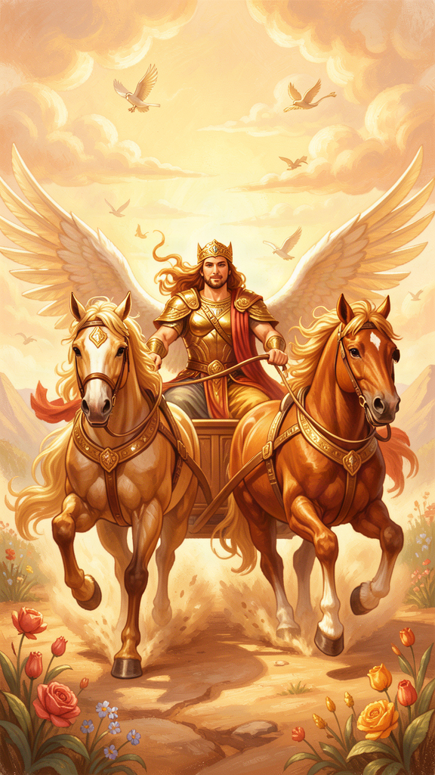
Illustration for Chapter 6
Plato told one more story about the soul. This one is about a chariot.
Imagine a charioteer standing in a chariot, holding the reins. The chariot is pulled by two horses. One horse is noble and good. The other is wild and dangerous.
The noble horse is proud and strong. It stands tall. Its coat is clean. It listens to the charioteer. When the charioteer pulls the reins, this horse obeys. It wants to go where reason leads. It is drawn toward truth and beauty and goodness.
The wild horse is big and noisy. It is covered in sweat. It fights the reins. It wants to go wherever its body pulls it — toward food, toward fun, toward whatever feels good right now. It does not think about what is good. It only thinks about what it wants.
The charioteer is Reason. The two horses are the two other parts of the soul: the noble horse is Spirit, the part that loves honor and goodness. The wild horse is Appetite, the part that craves pleasure and comfort.
The charioteer's job is to guide both horses. He cannot cut the wild horse loose. He needs both horses to pull the chariot forward. But he must keep control. If the wild horse takes over, the chariot veers off the road, crashes, and the soul falls.
Plato said the soul's journey is like a great procession through the heavens. The gods ride their chariots easily, their horses perfectly matched, soaring up to the edge of the sky, where they can see the Forms — Truth, Beauty, Justice, the Good itself. It is the most beautiful sight there is.
But mortal souls struggle. The wild horse pulls down. The noble horse struggles up. The charioteer fights to hold the reins. Most souls cannot rise all the way. They catch a glimpse of the Forms and then fall back, pulled down by the wild horse's weight.
Here is the moment that matters most. The charioteer sees a beautiful face — a person walking on the earth. And the sight reminds him of Beauty itself, the Form of Beauty he glimpsed in the heavens. The noble horse rises toward the beauty, wanting to honor it and love it rightly. The wild horse lunges toward it, wanting to grab it and possess it.
The charioteer must hold on. If he lets the wild horse have its way, the soul falls into lust and selfishness. If he controls the wild horse and lets the noble horse lead, the soul rises toward true love — love that sees beauty not just in one body but in all beautiful things, and finally in Beauty itself.
Plato said this is the struggle of every life. You are the charioteer. Every day, the noble horse whispers, "Do what is right. Seek what is true. Honor what is beautiful." And the wild horse shouts, "Take it. Eat it. Grab it now." The charioteer must listen to both but obey neither completely. He must guide.
The good news is that the noble horse can be trained. Every time you choose truth over comfort, the noble horse gets stronger. Every time you choose kindness over selfishness, the wild horse gets a little quieter. The chariot rises a little higher. You see a little more of the sky.
And every time the wild horse wins, it gets louder, and the chariot sinks. The struggle never ends in this life. But the direction matters. Are you rising or falling? That is the question the charioteer must ask, every single day.
Words to Remember He will see beauty with the part of the soul by which it is visible. — Plato, Symposium
Big Idea Your soul is a chariot pulled by two horses. The noble horse pulls you toward what is good and true. The wild horse pulls you toward what feels good right now. You are the charioteer — Reason — and your job is to hold the reins. You cannot get rid of either horse. But you can train the noble horse to be stronger and the wild horse to be quieter, one choice at a time.
Try This - The Chariot Drawing. Draw your chariot. The charioteer at the front is Reason. The noble horse is on one side — label it "Spirit" and draw it standing tall. The wild horse is on the other side — label it "Appetite" and draw it pulling away. Where is your chariot headed? Is it rising toward the sky or crashing toward the ground? - The Two-Horse Check. Think of a choice you faced today. What did the noble horse want? (Honor, truth, kindness.) What did the wild horse want? (Fun, comfort, "I want it now.") Which one won? Draw the two horses and put a checkmark on the one that was stronger today. - The Training Plan. Plato said the noble horse gets stronger every time you choose it. Pick one thing you will do tomorrow that the noble horse would want — tell the truth when it's hard, share something you want to keep, be kind when you feel grumpy. Draw the noble horse getting a little bigger after you do it. That is how you train a soul.
Ask a Grown-Up "Have you ever felt two parts of yourself pulling in different directions — one wanting to do the right thing and one wanting to do the easy thing? How do you decide which one to follow?"
———

For the Grown-Up Reader
This booklet adapts the philosophy of Plato (c. 428–348 BCE), drawing on the dialogues Republic (the Cave, the Form of the Good, the philosopher-king, the tripartite soul, the Myth of Er), Phaedrus (the charioteer), Apology (the unexamined life), Meno (the soul's immortality), and Crito (the life of virtue). Translations cited are from Plato, Complete Works, edited by John M. Cooper (Hackett, 1997), with C. D. C. Reeve's Republic translation (Hackett, 2004) and the Nehamas-Woodruff Symposium (Hackett, 1989).
Plato wrote no treatises. He wrote dramatic conversations, almost always featuring Socrates as the main speaker. Children should understand that Socrates was a real person — Plato's teacher, executed by Athens in 399 BCE — and that Plato used him as a character to explore ideas. The stories in this booklet — the Cave, the Good as sun, the philosopher-king, the tripartite soul, the Myth of Er, the charioteer — are myths and images, not literal claims. Plato said as much. He believed images could move the soul toward truth in ways that direct argument could not, especially for the young.
The quotes are real, drawn from the dialogues named in the text. They have been simplified for children in their framing, not altered in content. If a child asks, "Did Socrates really say that?" — the answer is yes, in the dialogue cited, though Plato put the words in Socrates' mouth.
———

About WisdomForge
WisdomForge adapts the great philosophers into stories, audio, and conversation for every age. Each philosopher becomes four booklets — one for children, one for young teens, one for older teens, and one for adults — so the same ideas can grow with you. The questions are older than civilization. The answers are yours to find.

