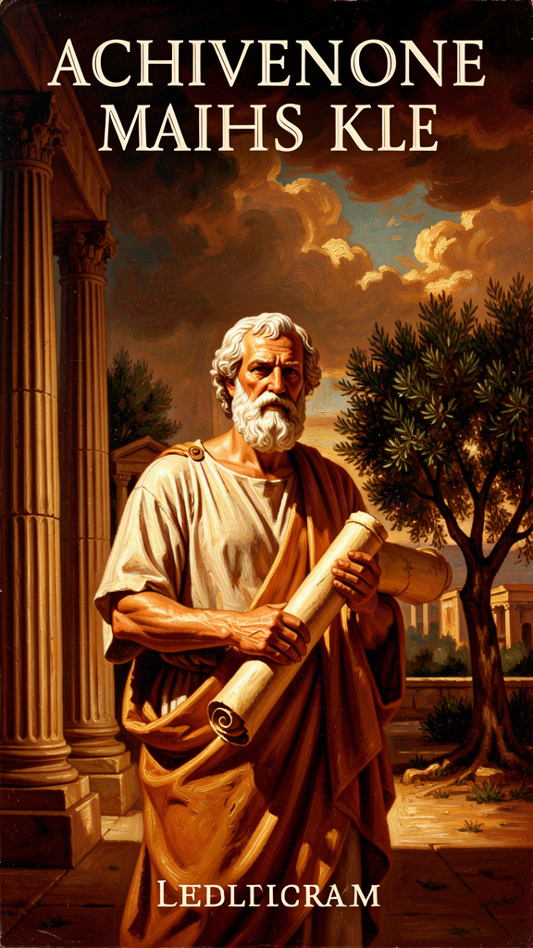
Plato: The Philosopher Who Invented Philosophy
WisdomForge Booklet — Ages 15–18

Plato: The Philosopher Who Invented Philosophy

WisdomForge Booklet — Ages 15–18
———

About This Book
Plato did not just write philosophy. He invented the way we do it.
Before Plato, philosophers were either natural scientists asking what the world is made of, or sophists teaching people how to win arguments. Plato changed the game. He wrote philosophy as dramatic conversations — dialogues — in which a character named Socrates asks questions, tests answers, and refuses to accept comfortable lies. He did not write treatises. He wrote plays about thinking. And through those plays, he created the method that philosophy has used ever since: take a claim everyone assumes is true, ask what it actually means, follow the argument wherever it goes, and do not stop until you have reached something solid or discovered that you know less than you thought.
Plato lived from about 428 to 348 BCE in Athens. He was a young man when the city executed his teacher Socrates in 399 BCE. That event shaped everything he wrote. The Republic, the Symposium, the Phaedo, the Phaedrus — all of them are, at some level, about the question Socrates' death forced: what kind of city kills the person who tells the truth, and what kind of soul can survive living in it?
This booklet takes you through six of Plato's most powerful images and arguments. Each chapter is an essay, not a summary. It engages with real arguments and real objections. It names the scholarly debates and lets you decide. The goal is not to make you a Platonist. It is to give you the tools Plato gave the West: the habit of questioning appearances, the discipline of following arguments, and the courage to live with what you find.
———

Chapter 1: The Allegory of the Cave
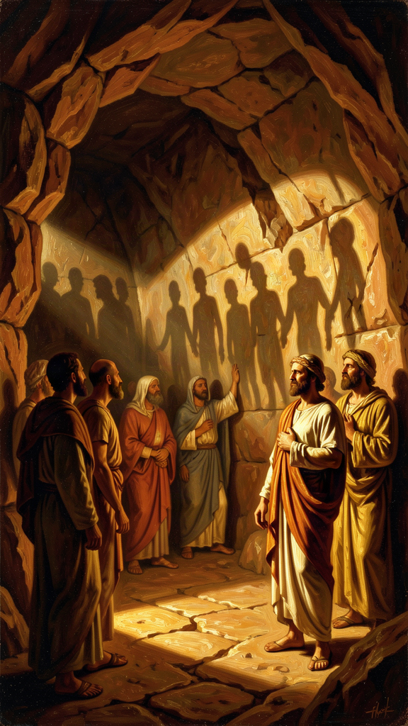
Illustration for Chapter 1
You are in a cave. You have always been in the cave. Everyone you know is in the cave. The cave is all there is.
This is not a horror story. It is the opening of the most famous passage in Western philosophy, and its point is that the horror is invisible to the people inside it. They do not know they are prisoners. They think they are experts.
Plato's allegory, from Book VII of the Republic, asks you to imagine prisoners chained underground since childhood, facing a wall. Behind them burns a fire. Between the fire and the prisoners, people carry objects whose shadows fall on the wall. The prisoners watch the shadows. They name them. They hold contests to predict which shadow will appear next. They give awards. The shadows are their world.
One prisoner is freed and dragged up into the sunlight. The light blinds him. He is in pain. He wants to go back. But his eyes adjust. He sees real shadows, then reflections, then the stars, then the sun. He understands: the sun is the source of everything. The cave was a puppet show. He goes back down to tell the others, and they mock him. If someone tried to free them, Plato says, they would kill him.
———
The allegory is about knowledge, but it is also about power. The prisoners are not stupid. They are sophisticated. They have a system. They have expertise — the ability to predict shadows. They have status — the awards for correct predictions. They have a culture. The problem is that the entire culture is oriented toward shadows. Their expertise is real, but it is expertise about the wrong thing. Their status is real, but it is status in a system that does not correspond to reality. The allegory is not about ignorant people. It is about knowledgeable people whose knowledge is pointed in the wrong direction.
This is the part that should make you uncomfortable. Plato is not describing cavemen. He is describing you. The cave is any system where people mistake representations for reality and build their lives around the mistake. Social media is a cave: the curated feed is a shadow, the like count is a shadow prediction award, and the "expertise" of going viral is expertise about the wrong thing. Political discourse is a cave: the slogan is a shadow, the poll is a shadow prediction, and the "expertise" of spin is expertise about the wrong thing. Academic culture can be a cave: the citation count is a shadow, the ranking is a shadow prediction, and the "expertise" of gaming metrics is expertise about the wrong thing.
Plato's point is that the cave is not a specific place. It is a structure. Any time a community builds its status system around appearances rather than truth, it is a cave. And the people inside it will resist the person who tells them, because the truth threatens the system that gives them their identity.
———
The freed prisoner's journey is an ascent through levels of reality. Plato maps this onto what he calls the Divided Line — four levels of cognition:
1. Imagination (eikasia): shadows, reflections, images. The prisoners are here. 2. Belief (pistis): physical objects, the things that cast the shadows. The freed prisoner sees these when he exits the cave. 3. Mathematical reasoning (dianoia): abstract reasoning from hypotheses. The freed prisoner reasons about the structure of what he sees. 4. Dialectical knowledge (noesis): direct intellection of the Forms, ending in the Good. The freed prisoner sees the sun.
The Cave and the Divided Line are the same ascent in different forms. The Cave is a story. The Line is a diagram. Both say that not all thinking is equal. Most thinking is about appearances. The highest thinking — dialectic — reaches behind appearances to the Forms, the eternal patterns that the visible world imitates. And above all the Forms stands the Good, the source of all intelligibility, which we will examine in Chapter 2.
The crucial claim is that the ascent is painful. The freed prisoner is dragged up the path. He does not go willingly. The light hurts. He wants to return to the dark, where things are familiar and he is good at predicting shadows. This is Plato's theory of education: learning is not the pleasant acquisition of facts. It is the painful reorientation of the entire soul from one direction to another. The prisoner does not lack information. He has too much of it — all about shadows. What he lacks is orientation. Education does not fill an empty head. It turns a head that is facing the wrong way.
———
The return to the cave is the part most people skip. It is also the most important.
The freed prisoner goes back. His eyes, adjusted to the light, stumble in the dark. He cannot name the shadows as well as before. The prisoners mock him. They say the journey ruined his eyes. If someone tried to free them, they would kill him.
Plato was talking about Socrates. Socrates spent his life turning people toward the truth by asking questions. Athens killed him. The allegory is not hypothetical. It is a description of what actually happened, written by a man who loved the person the city killed. Plato was about twenty-eight when Socrates died. He was present, or near enough to hear the details. The trial, the vote, the hemlock — these were not abstractions. They were the murder of his teacher by the democracy he lived in. Every dialogue Plato wrote is, at some level, a response to that event. The Apology records the trial. The Crito records the refusal to escape. The Phaedo records the death. And the Republic asks the question the death forced: what kind of city does this, and what kind of soul can survive living in it?
But the return raises a harder question: why go back? The freed prisoner has seen the sun. He knows the cave is a puppet show. Why descend into the dark to argue with people who will mock him?
Plato's answer is an obligation. The freed prisoner did not free himself. He was freed — dragged up by someone. Having received the truth, he owes the truth to others. The philosopher who refuses to return is like a doctor who has found the cure and refuses to share it. The knowledge is not private property. It creates a duty. The person who has seen the Good cannot hoard it. The Good, by its nature, is something that must be shared, because the Good is the source of all value, and a value that is not communicated is incomplete.
This is Plato's answer to the question of why a philosopher should engage with politics at all. The philosopher would rather contemplate the Forms. But the city needs the philosopher, and the philosopher owes the city. The philosopher-king, which we will examine in Chapter 3, is the freed prisoner who goes back. The obligation is not optional. Plato is saying that the educated person who retreats into private contemplation and refuses to serve the community is committing a kind of injustice. You were dragged out of the cave. You did not free yourself. The least you can do is go back for someone else.
The Big Idea: The Structure of False Knowledge
The Cave's deepest claim is not that most people are wrong. It is that most people are systematically wrong in a way that feels like being right. The prisoners have a coherent world. They have expertise. They have status. They have a community. Everything works — except that it is all pointed at shadows. The error is not in the parts. It is in the orientation.
This is why the allegory is dangerous. It says that you cannot tell whether you are in the cave by examining your own thinking from inside it. The prisoners' thinking is self-consistent. It passes every internal test. The only way to discover you are in a cave is to be dragged out — which is painful, disorienting, and resisted. And the only way to confirm you were in a cave is to look back from outside and see the shadows for what they were.
Plato is asking you to consider that your most confident beliefs might be shadows. Not your obviously wrong beliefs — those are easy to question. Your most confident ones. The ones that seem too obvious to examine. The ones that give you status. The ones that would cost you something to abandon. Those are the shadows, because those are the beliefs you have built your identity on, and identity is the thing the cave protects.
Practice
1. The Shadow Audit. List five beliefs you hold that give you social status — beliefs that make you look smart, moral, or sophisticated to the people around you. For each, ask: "If this belief were false, would I want to know?" If the answer is no, that belief is a candidate for a shadow. The resistance to questioning it is the resistance of the prisoner who does not want to turn around. Write down which of the five you would least want to lose, and why. The "why" is the chain anchoring you to the wall.
2. The Drag-Up Exercise. Pick one belief from your Shadow Audit. Spend twenty minutes researching the strongest case against it. Not the weak version — the strongest version, from the most credible source you can find. Write a one-paragraph summary of the opposing case that a believer would agree is fair. This is the moment your eyes start adjusting to the light. It will be uncomfortable. Notice the discomfort and keep going.
3. The Return Test. Think of a conversation you avoid — a topic you steer away from because you know your views will not be welcome. Write down what you would say if you said what you actually think. Then ask: what is the cost of saying it? What is the cost of not saying it? Plato says the philosopher must return to the cave. What would it mean for you to go back into one of your caves — a classroom, a family dinner, a friend group — and speak honestly?
Reflect
Plato says the prisoners would kill the person who tried to free them. Socrates was actually killed. Is there a belief you hold that you would defend so fiercely you would punish the person who challenged it? What does that tell you about the belief — and about yourself?
———

Chapter 2: The Form of the Good
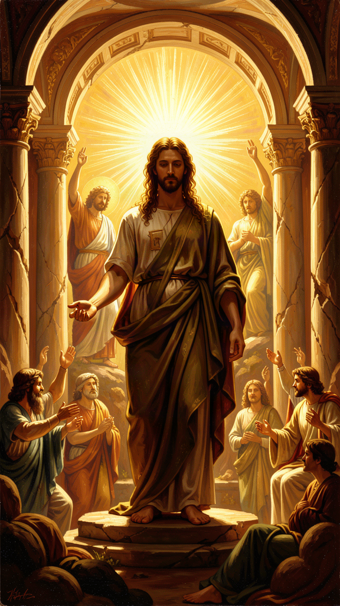
Illustration for Chapter 2
The Form of the Good is the most important and the most frustrating concept in Plato. It is the summit of his metaphysics, the foundation of his ethics, and the basis of his political theory. It is also the thing he refuses to state directly. In the Republic, Socrates says he cannot say what the Good is — only what it is like. He offers an analogy: the sun.
Just as the sun makes sight possible — it illuminates objects and gives the eye the power to see — the Good makes knowledge possible. It illuminates the Forms and gives the mind the power to understand. Just as the sun nourishes visible things and helps them grow, the Good sustains the intelligible world and gives being to the Forms. Without the Good, you could have facts but not understanding. You could know that something is true without knowing why it matters.
"The Good may be said to be not only the object of knowledge but also the thing that gives truth to the things known, and to the one who knows them, the power to know." — Plato, *Republic* 508e
———
This analogy sits inside a larger framework: the Theory of Forms. Plato held that behind the visible world of changing, imperfect things lies a world of eternal, perfect patterns — the Forms. A beautiful painting is beautiful because it participates in the Form of Beauty. A just action is just because it participates in the Form of Justice. Every quality we recognize in the sensible world is a copy. The Form is the original.
The Forms are not mental concepts. They are not subjective preferences. They are real — more real, Plato says, than physical objects, because they do not change, decay, or pass away. Beauty itself does not fade. Justice itself does not shift with fashion. The Good itself does not depend on what anyone thinks of it. The Forms are the stable reality behind the unstable appearances.
At the top of this hierarchy is the Good. Beauty, Justice, Truth, Equality — all the other Forms — derive their intelligibility from the Good. The Good is to the Forms what the sun is to visible things: the condition that makes them knowable. Without the Good, the other Forms would be real but invisible — like stars without a sun. With the Good, the whole intelligible world is lit up.
This is Plato's answer to a question that every ethical theory must answer: what makes good things good? Is justice good because we prefer it, or because it participates in something that is good in itself? Plato's answer is the latter. Justice is good because it participates in the Form of Justice, which is intelligible because of the Good. The Good is the source of all value. It is not good for anything. It is good in itself. Everything else is good insofar as it participates in it.
———
Here is where the concept becomes philosophically contentious, and where you should start arguing.
The Third Man Argument. Aristotle, Plato's own student, raised a devastating objection. If a beautiful thing is beautiful because it participates in the Form of Beauty, and if the Form of Beauty is itself beautiful (which Plato says it is), then there must be a higher Form — Beauty itself plus the beautiful thing and the Form of Beauty — that accounts for the beauty of both. But then you need a further Form to account for that, and so on, infinitely. This is the Third Man Argument, and it threatens the entire Theory of Forms with a regress. If the Forms need Forms above them to explain their own qualities, the system collapses.
The problem of participation. How does a beautiful thing "participate" in the Form of Beauty? Is the Form in the thing? Is the thing a copy of the Form? What does "participation" even mean? Plato never gave a clear answer. In the Parmenides, a late dialogue, Plato himself raises these objections through the character of the older philosopher Parmenides, who demolishes the young Socrates' version of the Theory of Forms. The dialogue ends in aporia — no resolution. Some scholars read this as Plato's own confession of doubt. Others read it as Plato stress-testing his theory to make it stronger. The debate is open.
The problem of access. If the Good is the highest Form and the condition of all knowledge, how do we know it? Plato says through dialectic — a long, difficult process of reasoning that ascends from hypotheses to first principles. But if the Good is what makes knowledge possible, you need some knowledge to begin the ascent. Is this circular? Plato's answer is that the soul already knows the Forms from before birth (the theory of recollection, from the Meno). But this presupposes immortality, which is itself unproven. The architecture is grand but the foundations are uncertain.
———
Plato was aware of these problems. The Parmenides is not a refutation of his own theory by a careless reader. It is Plato's own most rigorous critique. He put the strongest objections into the mouth of a respected philosopher and let them stand without easy answers. This is one of the things that makes Plato a great philosopher rather than a dogmatist: he did not hide from the weaknesses of his own system. In the first part of the Parmenides, the young Socrates presents the Theory of Forms and is demolished. In the second part, Parmenides leads Socrates through a bewildering series of deductions about the One and the many — eight hypotheses, each generating paradoxes, none resolving them. The dialogue ends in aporia. Some scholars read this as Plato's own confession that the Theory of Forms is in trouble. Others read it as a training exercise: Parmenides is teaching Socrates how to do philosophy by showing him how to stress-test his own ideas. The dialogue itself does not tell you which reading is right. That is part of its philosophical power. It forces you to decide.
The Good also raises the question of whether Plato's metaphysics is a form of authoritarianism. If there is a single, objective Good that only philosophers can know, and if knowledge of the Good justifies political rule (the philosopher-king), then the theory can be used to justify a hierarchy where one group claims access to truth that others cannot verify. Karl Popper made this argument in The Open Society and Its Enemies (1945), calling Plato the enemy of the open society. Popper argued that Plato's Theory of Forms, combined with the philosopher-king, creates a template for totalitarianism: a ruling class that claims knowledge of an objective truth that the masses cannot check, and that uses this claim to justify absolute power. Popper's critique is itself contested — many scholars, including Ronald Levinson (In Defense of Plato, 1953) and C. D. C. Reeve, argue that Popper caricatured Plato and ignored the dialogue form. But the concern is real, regardless of whether Popper got Plato right. A theory that grounds knowledge in something most people cannot access can be used to dismiss most people's judgment.
You do not have to resolve these debates. You have to know they exist, take a position, and be able to defend it. The Form of the Good is not a comfortable idea. It is a claim that there is an objective source of value, that most people do not see it, and that seeing it requires years of training. That claim is either the most important truth in philosophy or the most dangerous illusion. Plato would say the only way to find out is to do the work.
The Big Idea: The Foundation of Value
The Form of the Good is Plato's answer to the question: what makes good things good? His answer is that there is an objective, eternal source of value — the Good — that stands behind all other Forms and makes them intelligible. Without it, facts are just facts; with it, they have meaning. The theory is contested: the Third Man Argument threatens it with regress, the problem of participation is unsolved, and the claim that only philosophers can access the Good can justify authoritarian politics. But the underlying question — is there an objective basis for value, or is "good" just what we happen to prefer? — has not gone away. Every ethical system, secular or religious, must answer it. Plato's answer is the most ambitious. It may also be the most vulnerable.
Practice
1. The "Why Does It Matter?" Chain. Take something you believe is genuinely good — not just pleasant, but good. Ask: "Why is that good?" Get an answer. Ask again. Keep going until you hit something you cannot explain but are certain of. That stopping point is your version of the Good. Write it down. Now ask: is it objective (true whether anyone recognizes it) or subjective (true because you prefer it)? Defend your answer in a paragraph. Plato would say it is objective. Can you argue against him?
2. The Third Man Stress Test. Write down Plato's argument: "Beautiful things are beautiful because they participate in the Form of Beauty." Now write Aristotle's objection: if the Form of Beauty is itself beautiful, what makes it beautiful? Try to answer on Plato's behalf. If you cannot, you have felt the force of the strongest objection to the Theory of Forms. Write one paragraph defending Plato and one attacking him. Which is stronger?
3. The Authoritarian Test. Plato says only philosophers can know the Good, and those who know the Good should rule. Write the strongest case for this claim: what would a society look like if its leaders were required to study ethics for decades before taking power? Then write the strongest case against it: what happens when a small group claims exclusive access to truth? Can you find a version of Plato's idea that avoids the authoritarian danger?
Reflect
If there is an objective Good that most people cannot see, how would you tell the difference between a philosopher who has seen it and a charlatan who claims to have seen it? What test would you trust?
———

Chapter 3: The Philosopher-King
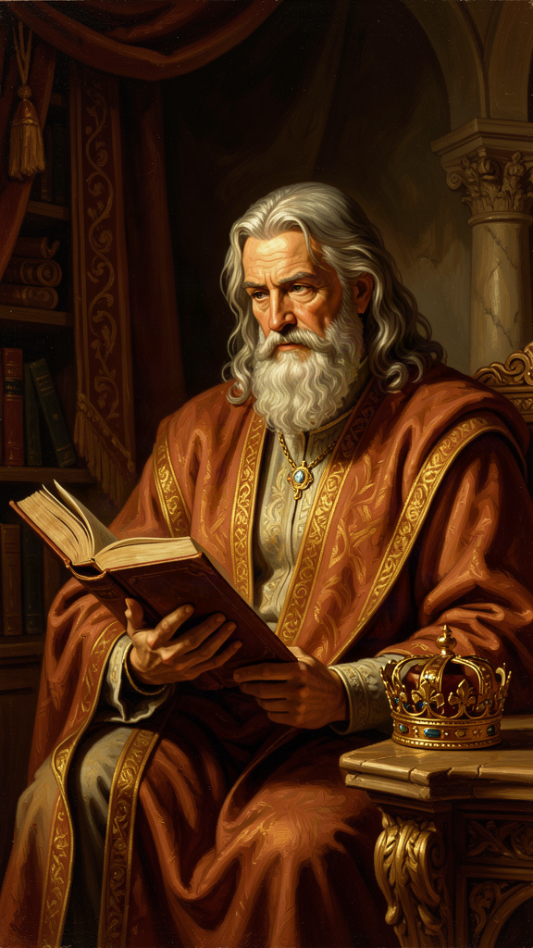
Illustration for Chapter 3
"Until philosophers rule as kings or those who are now called kings and leading men genuinely and adequately philosophize, cities will have no rest from evils." — Plato, Republic 473c-d
This is the most controversial sentence Plato ever wrote. It has been called the foundation of political philosophy and the blueprint for totalitarianism. It has been praised by thinkers who wanted wise leaders and cited by dictators who wanted to call themselves wise. It deserves a careful reading.
———
Plato's argument has a specific context. The Republic opens with a question: what is justice? Socrates refutes three definitions — justice as paying debts (Cephalus), as helping friends and harming enemies (Polemarchus), and as the advantage of the stronger (Thrasymachus). Having demolished the alternatives, Socrates must build his own account. He does this by constructing a city in speech — an ideal polis — and arguing that justice in the city and justice in the soul have the same structure.
The city has three classes:
- Producers — farmers, craftsmen, merchants — governed by appetite. - Auxiliaries — soldiers and guardians — governed by spirit. - Rulers — philosopher-kings — governed by reason and knowledge of the Good.
Each class does what it is fitted for. The result is not democracy. It is a hierarchy ordered by knowledge, not by wealth, birth, or popularity. The rulers are selected through decades of education: gymnastics and music in childhood, mathematics in adolescence, dialectic in young adulthood, and fifteen years of practical political service before they are ready to rule. They own no private property. They have no families. Their material needs are met by the community, but they cannot accumulate wealth, and their children are raised in common so that no family loyalty competes with loyalty to the city.
This is a radical vision. It is also, Plato admits, probably impossible. The Republic is not a constitution for a real city. It is an ideal — a thought experiment that reveals what justice would look like if it were fully realized. The purpose of the ideal is not to be implemented literally but to serve as a standard. A ship that does not know its destination will never arrive. The ideal city tells the city where justice lies, so that real cities can measure how far they fall short.
———
The argument for the philosopher-king rests on a specific claim: ruling is a craft that requires knowledge, and the knowledge it requires is knowledge of the Good.
Plato develops this through the analogy of the ship of state. A shipowner is stronger than everyone on the ship but nearsighted and not a navigator. The sailors quarrel over who should steer, though none of them has studied navigation. They do not understand that navigation requires knowledge of the stars, winds, and seasons. They think it cannot be taught. They crowd around the shipowner, begging to be allowed to steer, and kill anyone who says they need to study first. Meanwhile, the one person who does understand navigation — the true pilot — is called a "stargazer" and ignored.
The analogy maps directly onto politics. The democratic electorate is the shipowner: powerful but ignorant. The politicians are the sailors: fighting for control without knowing how to steer. The philosopher is the navigator: ignored, mocked, called useless. The analogy is a direct attack on democracy. Plato watched Athens, a democracy, execute Socrates. He watched the Athenian assembly make catastrophic decisions during the Peloponnesian War. He did not trust the crowd.
This is where the argument gets dangerous. Plato's critique of democracy is not wrong. Democracies do make terrible decisions. The Athenian assembly voted to execute Socrates, to launch the Sicilian expedition that destroyed their empire, and to massacre the people of Melos. Modern democracies have made equally catastrophic choices. The question is whether the alternative Plato proposes is better.
———
The philosopher-king has been read in two radically different ways:
The idealist reading. Plato is describing the conditions under which a city would be well-governed: rulers who know the Good, who cannot be bribed because they own nothing, who cannot be corrupted by family ambition because they have no families, who rule from knowledge rather than appetite. No actual regime matches this. But the ideal reveals what every actual regime lacks. It is a standard, not a program. On this reading, the Republic is a critique of all existing politics, not a manual for dictatorship.
The authoritarian reading. Plato is describing a system where one class holds all power, claims exclusive access to truth, censors art, abolishes the family for the ruling class, and prohibits citizens from questioning the rulers. On this reading, the Republic is the first blueprint for totalitarianism. Karl Popper argued this in The Open Society and Its Enemies. The philosopher-king is a dictator who justifies power by claiming knowledge the citizens cannot verify.
Both readings have merit. The text supports both. Plato's city censors poetry, bans certain types of music, abolishes the family for guardians, and requires citizens to accept their class without complaint. These are authoritarian features. But the text also requires rulers to own nothing, to serve the city rather than themselves, and to rule only after decades of education in philosophy. These are anti-tyrannical features. The philosopher-king is not a strongman. The philosopher-king is a person who has been broken of every personal ambition except the desire for truth.
The deepest question is: can anyone be trusted with unchecked power, even a philosopher? Plato says yes, because the philosopher has nothing to gain from power. The philosopher owns nothing, wants nothing, and would rather study. But this assumes that education in philosophy reliably produces people who are immune to corruption. Plato's own experience contradicts this: he tried to educate Dionysius II of Syracuse into a philosopher-king and failed completely. Dionysius was more interested in power than wisdom. The experiment nearly cost Plato his life.
The Big Idea: The Knowledge Requirement
Plato's argument is that political power without knowledge of the Good is dangerous, and knowledge of the Good without political power is wasted. The philosopher-king is the union of the two. The argument's strength is its insistence that ruling is a craft requiring expertise, not a popularity contest. Its weakness is its assumption that expertise in philosophy reliably produces virtue — that knowing the Good makes you good. Plato's own life suggests it does not. The Syracuse experiment failed. The Academy produced good philosophers and bad politicians. The question Plato leaves us with is not whether philosophers should rule, but whether anyone can be trusted to.
Practice
1. The Ship of State. Write Plato's ship analogy in your own words, then map it onto a modern institution: your school, your government, a corporation. Who is the shipowner (powerful but ignorant)? Who are the sailors (fighting for control without expertise)? Who is the navigator (ignored expert)? Does the navigator exist in your institution? Are they listened to? Write one paragraph on what would have to change for the navigator to be heard.
2. The Syracuse Test. Plato tried to turn a tyrant into a philosopher and failed. Research the Syracuse episode briefly — Plato's three trips, his relationship with Dion, the failure with Dionysius II. Write a one-page analysis: why did it fail? Was the idea wrong, or was the execution wrong? What does the failure tell you about the limits of the philosopher-king ideal? Would it work with a different ruler, or is the concept itself flawed?
3. The Popper Counter-Argument. Read or research Karl Popper's critique of Plato in The Open Society and Its Enemies. Write the strongest version of Popper's argument in one paragraph, then write Plato's best defense in another. Which is more convincing to you? Can you construct a version of Plato's idea — that rulers need knowledge of the good — that avoids Popper's objection?
4. The Modern Philosopher-King. Design a modern institution that embodies Plato's principle — that leaders should be trained in ethics before holding power — without the authoritarian features. What would the training look like? What safeguards would prevent the "philosophers" from becoming a self-serving elite? Write a one-page proposal. The goal is to extract what is living from Plato's idea and discard what is dangerous.
Reflect
Plato says the philosopher does not want to rule and must be compelled. If someone actively wants political power, Plato would say that is evidence they should not have it. Do you agree? Is the desire for power always a sign of corruption, or can it be a sign of public spirit? Where do you draw the line?
———

Chapter 4: Justice as Harmony of the Soul
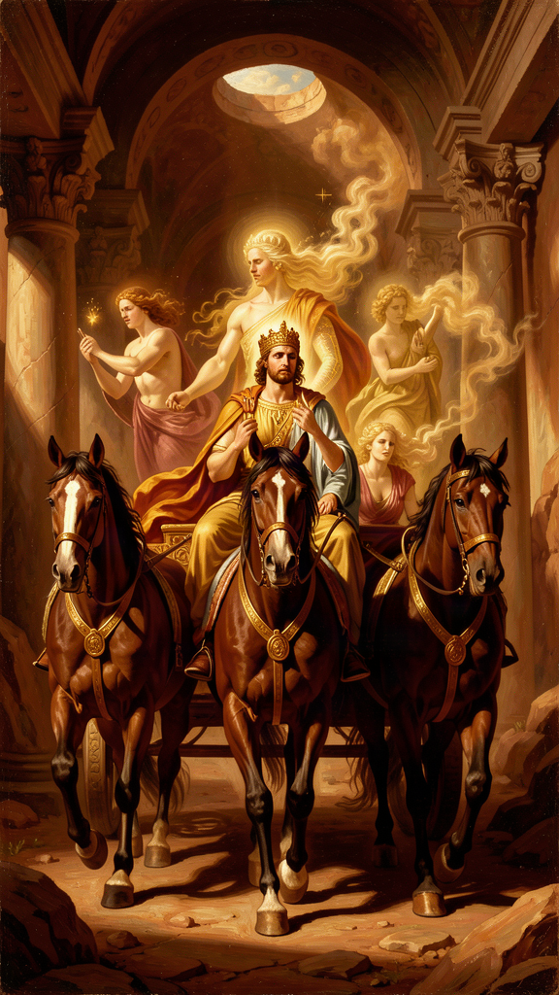
Illustration for Chapter 4
The Republic is a book about justice. It takes 350 pages to get to the definition, and the definition is not what you expect.
Plato does not define justice as fairness, or as following the law, or as giving people what they deserve. He defines it as a condition of the soul: reason rules, spirit supports reason, and appetite obeys. Justice is inner harmony. Injustice is civil war in the soul.
———
The argument begins with the soul's three parts:
- Reason (logistikon): seeks truth, understands the Forms, plans, governs. - Spirit (thumoeides): seeks honor, gets angry at injustice, defends what is right. - Appetite (epithumetikon): seeks pleasure, food, comfort, money, status.
These are not metaphors. Plato argues for them empirically in Book IV of the Republic through the phenomenon of psychological conflict. When you are thirsty but restrain yourself, something is thirsty (appetite) and something is restraining (reason). When you are angry at yourself for wanting something, something is wanting (appetite) and something is angry at the wanting (spirit). The soul is not unitary. It is a composite of forces that can cooperate or conflict.
Justice is when the three parts are in the right relation: reason rules, spirit is reason's ally, appetite is governed. This produces a soul that is orderly, calm, and effective — like a well-tuned instrument. Each part does its own work. None tries to do another's work. The result is not just behavior but a state of being: the soul is healthy.
Injustice is when the parts are in the wrong relation. If appetite rules, the person is consumed by desire — for food, money, pleasure, status — and reason is enslaved. If spirit rules, the person is driven by honor and anger, pursuing victory at any cost. If the parts war with each other, the person is torn apart, wanting something and hating themselves for wanting it, doing something and being ashamed of having done it. The tyrant is the extreme case: appetite has seized total control, and the soul is the most disordered it can be. Plato calls the tyrant the most miserable person — not despite having everything, but because of it.
———
Plato extends this model to the city. A just city has the same three parts:
- Rulers — governed by reason, knowledge of the Good. - Auxiliaries — governed by spirit, honor, courage. - Producers — governed by appetite, desire for wealth.
When each class does its own work and does not try to take over, the city is just. When the soldiers try to rule, or the producers seize power, the city is unjust — exactly as the soul is unjust when appetite or spirit overthrows reason.
The city-soul analogy is powerful but imperfect. Cities are made of people; souls are parts of one person. Plato is aware of this. He uses the analogy not as an identity but as a structural comparison: the same pattern of justice — each part doing its own work under the right leadership — holds at both levels. The city is the soul written large.
———
The most provocative claim is that justice is its own reward — that the just person is always happier than the unjust person, regardless of circumstances.
Plato makes this argument against the sophist Thrasymachus, who claims that justice is "the advantage of the stronger": the rules the powerful make to serve themselves. On this view, justice is for suckers. The strong take what they want and call it justice. The weak obey because they have no choice. Thrasymachus is not making a moral argument. He is describing what he sees as a fact about power.
Socrates' response is to shift the frame. Thrasymachus is talking about external justice — the rules societies enforce. Socrates asks about internal justice — the condition of the soul. He argues that a person who is unjust on the inside — whose appetite rules, whose reason is enslaved, whose soul is at war — is miserable regardless of their external circumstances. They may have money, power, and pleasure, but they are not at peace. They cannot be. Their soul is sick.
Conversely, the just person — whose reason rules, whose soul is in harmony — is at peace regardless of their external circumstances. They may be poor, persecuted, or condemned to death (Socrates was all three). But their soul is healthy. And a healthy soul, Plato says, is the only lasting happiness. Everything else — wealth, status, pleasure — can be taken away. The harmony of the soul cannot, because it is the soul's own condition, not something the world gives.
This is a strong claim and you should test it. Is it true that the just person is always happier? What about a just person who is tortured? What about an unjust person who lives in luxury and dies peacefully? Plato's answer is that the tortured just person still has a healthy soul, while the luxuriating unjust person has a sick one. The external circumstances do not change the internal condition. But this raises a question: is a "healthy soul" enough to make someone happy in a concentration camp? Plato's account seems to undervalue external suffering. The Stoics, who will push this further, argue that external circumstances are truly irrelevant — only the inner condition matters. Most people, then and now, find this counterintuitive. The question is whether Plato has confused two things: the health of the soul (which may indeed be independent of external circumstances) and happiness (which may not). If happiness requires both inner order and a minimum of external goods — food, safety, freedom — then Plato's claim that justice alone is sufficient for happiness is too strong. If happiness is identical to the soul's condition, regardless of external goods, then Plato is right but his definition of happiness is so narrow that it has lost touch with what most people mean by the word.
———
The modern relevance of Plato's model is substantial. Cognitive behavioral therapy (CBT) works on a similar principle: that psychological suffering comes from internal conflict — irrational beliefs fighting rational ones — and that healing comes from bringing the parts into harmony. Freud's tripartite model of the psyche (id, ego, superego) is a secularized version of Plato's model: the id is appetite, the superego is spirit (internalized rules and honor), the ego is reason, mediating between them. The language has changed. The structure has not.
Plato's insight is that moral psychology is not separate from moral philosophy. You cannot ask "what should I do?" without first asking "what kind of soul am I?" because the answer to the first question depends on the answer to the second. A soul ruled by appetite will give one answer. A soul ruled by reason will give another. Ethics is not just about choosing the right action. It is about forming the right self.
The Big Idea: Justice as Psychological Health
Plato's definition of justice as inner harmony is a revolution. It says that justice is not a set of rules you follow but a condition you inhabit. The just person is not the one who obeys the law but the one whose soul is in order. This means justice is primarily internal, not external — and that external justice (fair laws, equal treatment) is a symptom of internal justice, not its source. The city is just because the citizens are just. The citizens are just because their souls are in order. And the soul is in order because reason rules. This inverts the modern assumption that justice is a social arrangement. For Plato, justice is a psychological condition that produces a social arrangement.
Practice
1. The Soul Audit. For three days, keep a journal of internal conflicts. Each time you feel torn — wanting something you think you shouldn't, or feeling angry about something you think you shouldn't — write down what each part of the soul is saying. Label them: Reason, Spirit, Appetite. At the end of three days, review: which part is winning most often? Is your soul just (reason leading) or unjust (appetite or spirit running the show)? Write a one-paragraph diagnosis.
2. The Thrasymachus Debate. Write a dialogue between yourself and Thrasymachus. Thrasymachus says: "Justice is the advantage of the stronger. The strong make the rules to serve themselves. You obey because you are weak. If you were strong, you would do the same." Write your response. Then write Thrasymachus's counter-response. Keep going for three exchanges. Does Socrates' argument — that injustice damages the soul — hold up against Thrasymachus's cynicism?
3. The Tyrant Test. Plato says the tyrant is the most miserable person because their soul is the most disordered. Find a real example — a historical tyrant, a corrupt CEO, a celebrity who "had everything" and self-destructed. Research their life. Is there evidence that their soul was at war — addiction, paranoia, isolation, paranoia? Write a one-page analysis applying Plato's model: which part of the soul was in charge? What was the cost?
4. The CBT Connection. Research cognitive behavioral therapy's model of psychological suffering: that it comes from internal conflict between irrational and rational beliefs. Write a one-page comparison: how is this similar to Plato's tripartite soul? How is it different? Does CBT validate Plato's insight that justice is psychological health, or does it secularize it in a way that changes its meaning?
Reflect
Plato says the just person is always happier than the unjust person, even if the just person is tortured and the unjust person lives in luxury. Do you believe this? Is there a circumstance under which you think Plato is wrong? If so, what does that tell you about the limits of his model?
———

Chapter 5: The Myth of Er
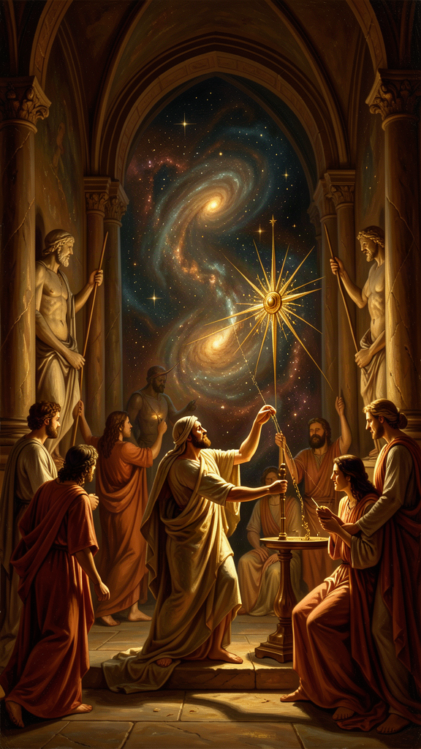
Illustration for Chapter 5
The Republic is 350 pages of argument. It ends with a story.
A soldier named Er dies in battle. On the twelfth day, as his body is about to be burned, he comes back to life. He tells what he saw.
———
Er's soul traveled to a place between worlds. He saw two openings in the earth and two in the sky. Souls emerged — some from below, dusty and worn from punishment; some from above, radiant from reward. They gathered in a meadow and told each other their stories.
The souls from below had been punished ten times the measure of each wrong they had done. Some had spent a thousand years underground. The souls from above had lived good lives and been rewarded. But even they had to return. No soul stayed forever.
After judgment, the souls gathered in a meadow. A pillar of light stretched from earth to heaven. The spindle of Necessity turned it. The three Fates sat on thrones. A herald announced: "The souls will now choose their next lives."
The lives were spread out — more than anyone could count. Kings and beggars, animals and humans, the brave and the cowardly. Each soul had to choose. The order was drawn by lot, but the choice was free.
The crucial moment: a soul that had been a great hero drew an early lot. He saw the life of a swan — eating without working — and chose it, not understanding that he was choosing laziness. Another soul chose the life of a tyrant, not seeing the suffering that comes with power without wisdom. He wept when he realized his mistake, but it was too late.
The philosopher chose well. He had spent his life learning to love the Good, and when the lives were spread before him, he recognized the best one and chose it.
The herald warned: "Virtue has no master. Each of you will have more or less of it, depending on whether you honor or dishonor it. Responsibility lies with the one who chooses. God is not responsible."
After choosing, each soul drank from the River of Forgetfulness and forgot everything. They were born into the lives they had chosen. Er was sent back — without drinking — to tell the story.
———
The Myth of Er is not a doctrine. Plato never says "this is literally true." The Socrates of the dialogue says the story is a muthos — a myth — and offers it as something worth believing, not as something proven. The question is: what work is the myth doing?
The myth does three things that the arguments of the Republic cannot do on their own.
First, it dramatizes moral responsibility. The souls choose their lives. No one is assigned. The choice is free, but it is made from the character the soul has developed. The hero who chooses the swan's life does so because his character is lazy. The soul who chooses tyranny does so because his character is greedy. The philosopher chooses well because his character is wise. The myth says: you are building the self that will choose your future. Every choice you make is not just an action but a formation of the chooser.
Second, it connects this life to a larger frame. The arguments of the Republic show that justice is its own reward — the just soul is healthier than the unjust soul. But the arguments are internal to this life. The myth extends the frame: the soul's condition carries forward. The character you build now determines the choices you will make in the future — in this life and beyond. This does not prove that justice pays. It makes the stakes feel real in a way that abstract argument cannot.
Third, it provides a motivation that argument alone cannot. Plato knew that human beings are not purely rational. We are moved by stories, images, and narratives. The Republic is an argument for the rational soul. The Myth of Er is a story for the whole soul — including the parts that do not respond to logic. The myth makes you ask: if this were true, would I live differently? If the answer is yes, the myth has done its work, whether or not it is literally true.
———
The philosophical content of the myth is the claim that character is destiny. The choices you make now — to be brave or cowardly, honest or deceitful, kind or cruel — are not isolated actions. They are acts of self-formation. Each choice makes you slightly more the kind of person who makes that kind of choice. The brave person becomes braver. The cowardly person becomes more cowardly. Over time, the pattern hardens into character, and character determines what you will choose when the stakes are highest.
The Myth of Er dramatizes this process as a cosmic judgment scene. But the underlying claim does not require the cosmology. It is a claim about moral psychology: you are always becoming someone, and the someone you are becoming will determine the choices available to you. The person who has spent years training their soul to love the Good will see the good life and choose it. The person who has spent years feeding appetite will see the easy life and choose it, not understanding that easy is not good. The choice is free, but the capacity to choose well is not free — it is the product of a lifetime of formation.
This is the ultimate payoff of the Republic. Every argument — the Cave, the Good, the philosopher-king, the tripartite soul — leads here: to the claim that philosophy is the training that makes you capable of choosing well. The unexamined life is not worth living not because it is unpleasant but because it produces an unexamined character, and an unexamined character, when the moment of choice comes, will choose badly and not know it.
It is worth noting that the Myth of Er occupies a specific rhetorical position in the Republic. The dialogue begins with a question about justice and proceeds through hundreds of pages of argument — definitions refuted, analogies built, the city constructed in speech, the soul analyzed, the Forms described. Then, at the very end, Plato switches modes. He stops arguing and starts telling a story. This is not a surrender of philosophy to myth. It is a recognition that argument has limits. The arguments have shown that justice is its own reward. The myth makes you feel why that matters. The arguments address the rational part of the soul. The myth addresses the whole soul — including the parts that respond to narrative, image, and dread. Plato was a philosopher, but he was also a literary artist. He knew that the most rigorous argument may fail to move the person who needs moving. The myth is the instrument for the part of the soul that dialectic cannot reach.
The Big Idea: Character as Destiny
The Myth of Er says that the soul's condition determines its choices. The souls in the meadow choose freely, but they choose from who they are. The hero chooses the swan because he is lazy. The tyrant-chooser chooses tyranny because he is greedy. The philosopher chooses well because he is wise. The myth dramatizes a claim that does not require the cosmology to be true: you are always building the self that will choose your future. Every choice is not just an action but a formation. The question is not "what will I choose?" but "who am I becoming, and will that person choose well?"
Practice
1. The Life Choice. Imagine you are in the meadow. The lives are spread before you. Write down three lives you would seriously consider choosing — not fantasy lives, but lives you might actually be capable of living. For each, write: why would I choose this? What does my choice reveal about who I am now? Now ask: what would I need to change about myself to choose better? The answer to that question is your philosophical agenda.
2. The Character Ledger. For one week, track every significant choice you make. For each, ask: "Is this choice training my soul toward the Good, or feeding my appetite?" Keep a running tally. At the end of the week, review the ratio. What does it tell you about the person you are becoming? Write a one-paragraph self-assessment using Plato's three-part soul model: which part is dominant?
3. The Myth Critique. The Myth of Er assumes the soul survives death and carries its character forward. Write the strongest argument against this assumption — from materialism, from neuroscience, from the problem of other minds. Then write Plato's best response. Does the myth need to be literally true to do its work? If not, what does it need to be? Write your answer in one paragraph.
4. The Responsibility Claim. The herald says, "Responsibility lies with the one who chooses. God is not responsible." Write a one-page essay on this claim. What does it mean for moral responsibility if your character — which determines your choices — is itself the product of choices you may not have controlled (your upbringing, your genes, your circumstances)? Is Plato's claim coherent? Can you defend it, or does it collapse under the weight of determinism?
Reflect
The Myth of Er says you will become the kind of person who chooses well or badly, and the choice of who to become is yours. But what if your capacity to choose well has already been shaped by forces outside your control — your family, your culture, your biology? How much of your character is your own doing? How much is fate? And if you cannot answer that question, what does it mean to take responsibility?
———

Chapter 6: The Charioteer of the Soul
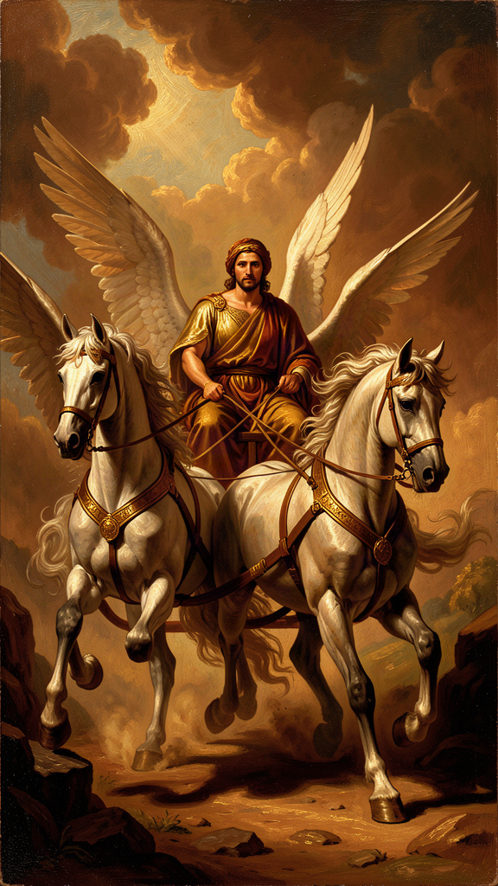
Illustration for Chapter 6
The Phaedrus is a dialogue about love, rhetoric, and the soul. It contains Plato's most vivid image of the self: the charioteer.
The soul is a chariot. The charioteer is reason. Two horses pull the chariot. One is noble — proud, obedient, drawn toward truth and beauty. The other is wild — crooked, disobedient, drawn toward bodily pleasure and whatever feels good. The charioteer must guide both. He cannot cut the wild horse loose. He needs both to move. But he must hold the reins.
———
Plato sets this in a cosmic drama. The gods ride their chariots through the heavens, their horses perfectly matched, soaring to the edge of the sky where they feast on the Forms — Truth, Beauty, Justice, the Good. The sight of the Forms is the greatest experience a soul can have. It is what the soul was made for.
Mortal souls struggle. The wild horse drags them down. Most rise partway, catch a glimpse of the Forms, and fall back. Some barely get off the ground. The wild horse is stronger than the noble horse, and the charioteer — reason — is not the strongest part of the soul. Reason wins only through discipline, the support of the noble horse, and the long process of training.
Then comes the key scene. The charioteer sees a beautiful person on the earth below. The sight reminds him of Beauty itself — the Form of Beauty he glimpsed in the heavens. The noble horse rises, wanting to honor and love the beauty rightly. The wild horse lunges, wanting to seize and possess it. The charioteer must hold on. If the wild horse wins, the soul falls into lust and domination. If the charioteer controls the wild horse and lets the noble horse lead, the soul rises toward true love — love that sees beauty not just in one body but in all beautiful things, and finally in Beauty itself.
———
This is the same ascent described in the Symposium by Diotima, the priestess who teaches Socrates about love. Diotima describes a ladder:
1. Love begins with one beautiful body. 2. The lover recognizes that beauty in all bodies. 3. The lover values beauty of soul more than beauty of body. 4. The lover sees beauty in laws, institutions, and knowledge. 5. The lover beholds Beauty itself — eternal, unchanging, not in any particular thing.
The charioteer and the ladder are two images of the same ascent. The chariot shows the struggle — the fight between the noble and wild horses. The ladder shows the progression — the steps from one body to Beauty itself. Together they give a complete picture: love is not a feeling. It is a discipline. It begins with desire for a particular beautiful thing and, if guided rightly, rises to desire for Beauty itself.
———
The charioteer image adds something the Republic's tripartite soul does not: the experience of moral conflict. The Republic describes the three parts analytically — reason, spirit, appetite — as a structural model. The charioteer dramatizes them. You can understand the tripartite soul as a diagram. You feel the charioteer. You know what it is like to be pulled in two directions at once. You know the noble horse — the part of you that wants to do the right thing, that feels proud when you do, that gets angry at injustice. You know the wild horse — the part of you that wants the thing you should not have, that does not think, that only wants. And you know the charioteer — the part that sees both, knows which one should win, and struggles to hold the reins.
This is Plato's insight about moral psychology: the self is not unified. It is a battlefield. And the outcome of the battle is not determined by strength — the wild horse is stronger — but by discipline and training. The noble horse can be strengthened. The wild horse can be somewhat tamed. But neither is eliminated. The struggle is permanent. The question is not whether you will fight but whether you will win more often than you lose.
———
The charioteer also makes a claim about love that is worth arguing with. Plato's model of love is ascent: love begins with the body and rises to the Form. The particular beloved is a starting point, not a destination. The goal is to move beyond the particular to the universal.
This has been controversial. Critics from Aristotle to the present have argued that Plato's model devalues the particular. If the beloved is just a rung on a ladder, what happens to the beloved when the lover has climbed past? Is Diotima's ladder a recipe for transcending love or for abandoning the person who occasioned it? Plato would say the ladder does not abandon the beloved — it deepens the love by placing it in a larger frame. But the text is ambiguous. The boy who is the object of the charioteer's vision is not mentioned after the ascent begins. He drops out. The Forms do not.
Martha Nussbaum, in The Fragility of Goodness (1986), argues that Plato's ascent model is a flight from the vulnerability of loving particular people. The ladder lets you love Beauty without risking the loss that comes when the particular beautiful thing changes, ages, or dies. The ascent is a strategy for invulnerability. Nussbaum thinks this is a mistake — that the value of love is bound up with its risk, and that a love that has eliminated risk has eliminated love. This is a serious objection. It asks whether Plato's philosophy, in its drive for the eternal and unchanging, misses what is most valuable about the temporal and fragile.
The counter-argument is that Plato does not say stop loving the particular. He says continue loving it, but understand it as a participation in Beauty. The lover who has climbed the ladder does not stop seeing beauty in the beloved. He sees it more clearly, because he understands what beauty is. The ascent does not devalue the particular. It grounds it. The risk remains. The vulnerability remains. But the loss of one beautiful thing is bearable because Beauty itself does not die.
You will have to decide which side you find more convincing. Plato gives you the image. The argument is yours.
The Big Idea: The Divided Self in Moral Conflict
The charioteer is Plato's most honest image of what it is like to be a person. You are not one thing. You are a battlefield. The noble horse pulls toward truth, honor, and beauty. The wild horse pulls toward pleasure, possession, and comfort. The charioteer — reason — is supposed to be in charge but is not the strongest. The outcome of the battle is determined not by which side is stronger but by which side is trained. The noble horse can be strengthened. The wild horse can be disciplined. But the war is permanent. The best you can do is win more battles than you lose, and the way you do that is through the daily practice of choosing truth over comfort, honor over appetite, and the Good over the easy.
Practice
1. The Chariot Journal. For one week, at the end of each day, identify one moment when the noble horse was pulling and one when the wild horse was pulling. For each, write: what did each horse want? Which won? What was the outcome? At the end of the week, review: is your chariot rising or falling? What is the pattern? Write a one-paragraph diagnosis and a one-paragraph plan for the next week.
2. The Ladder of Love. Think of something or someone you love. Follow Diotima's ladder: what do you love about it? Is it just this particular thing, or is there a quality it shares with other things? Keep climbing: what is the quality of? Can you reach a point where you are loving something that is not located in any single object? Write your experience of the climb in one page. Where did you stop? Why?
3. The Nussbaum Objection. Research Martha Nussbaum's argument in The Fragility of Goodness that Plato's ascent model is a flight from vulnerability. Write her argument in one paragraph. Then write Plato's best response in another. Which is more convincing? Is the ladder a strategy for invulnerability, or does it deepen love without removing risk? Where do you stand?
4. The Training Plan. The noble horse gets stronger every time you choose truth over comfort. Design a one-week training program: one specific choice per day that strengthens the noble horse (telling a hard truth, choosing study over distraction, defending someone who cannot defend themselves). At the end of the week, assess: did the noble horse feel stronger? Did the wild horse get quieter? Write one paragraph on what you learned about the training of a soul.
Reflect
Plato says the wild horse can never be eliminated, only controlled. The struggle is permanent. Is this a hopeful claim or a tragic one? If the best you can do is win more battles than you lose, is that enough for a good life? Or does Plato's model condemn you to a fight you can never fully win?
———

For the Grown-Up Reader
This booklet adapts the philosophy of Plato (c. 428–348 BCE), drawing on six dialogues and one letter: Republic (the Cave VII, the Form of the Good VI, the philosopher-king V, the tripartite soul IV, the Myth of Er X, the Divided Line VI), Phaedrus (the charioteer 246a–256e), Apology (38a), Meno (81c-d), Crito (54b), Symposium (Diotima's ladder 210a–212a), Parmenides (the Third Man Argument), and the Seventh Letter (341c-d). Translations: C. D. C. Reeve, Republic (Hackett, 2004); Nehamas and Woodruff, Symposium and Phaedrus (Hackett); Hackett Complete Works edited by John M. Cooper (1997) for remaining dialogues.
The quotes are real and cited by dialogue and Stephanus page. Plato wrote dramatic conversations, not treatises. The Socrates of the dialogues is a character; the degree to which he represents the historical Socrates is a live scholarly question (the "Socratic problem"). The images in this booklet — the Cave, the Good as sun, the philosopher-king, the tripartite soul, the Myth of Er, the charioteer — are myths and analogies, not literal claims. Plato was explicit that myths are images for the soul, not scientific accounts.
Scholarly debates referenced: the Third Man Argument (Aristotle, Metaphysics; reviewed in Vlastos, Platonic Studies); the authenticity of the Seventh Letter (debated; see Kahn, Plato and the Socratic Dialogue, Cambridge 1996); Karl Popper's critique of Plato as totalitarian (The Open Society and Its Enemies, 1945; contested by many scholars); Martha Nussbaum's critique of the ascent model as flight from vulnerability (The Fragility of Goodness, Cambridge 1986); the Socratic problem (Vlastos, Socrates: Ironist and Moral Philosopher; Kahn). The Parmenides as self-critique is debated — some read it as Plato's own confession of doubt about the Forms, others as a stress test. The Syracuse episode is attested in the Seventh Letter and Plutarch's Life of Dion.
———

About WisdomForge
WisdomForge adapts the great philosophers into stories, audio, and conversation for every age. Each philosopher becomes four booklets — one for children, one for young teens, one for older teens, and one for adults — so the same ideas can grow with you. The questions are older than civilization. The answers are yours to find.

