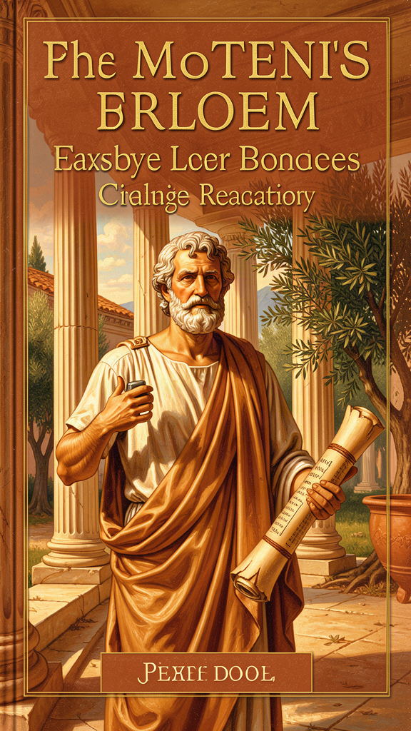
Plato: The Thinker Who Turned the World Inside Out
WisdomForge Booklet — Ages 11–14

Plato: The Thinker Who Turned the World Inside Out

WisdomForge Booklet — Ages 11–14
———

About This Book
You've heard of Plato. Maybe you've heard the name "Platonic" — as in a relationship that's deep but not physical, or an ideal that's perfect but unreachable. You may have heard of Socrates, the man who was sentenced to die for asking too many questions. What you may not know is that Plato was Socrates' student, and almost everything we know about Socrates comes from Plato's writing.
Plato lived in Athens from about 428 to 348 BCE. He wrote philosophy as conversations — dialogues — not as lectures. His main character is Socrates, who asks questions, tests answers, and refuses to let people get away with comfortable lies. Plato's big idea is that the world we see is not the real world. The real world is behind the appearances, and you can only reach it by thinking hard, asking honestly, and being willing to have your mind changed.
This booklet takes you through six of Plato's most powerful images: the Cave, the Form of the Good, the philosopher-king, justice as harmony of the soul, the Myth of Er, and the charioteer. Each chapter has a story, a big idea, things to try, questions to talk about, and one question to carry with you. You don't have to agree with Plato. He would have hated that. He wanted you to think — which means questioning him too.
———

Chapter 1: The Allegory of the Cave
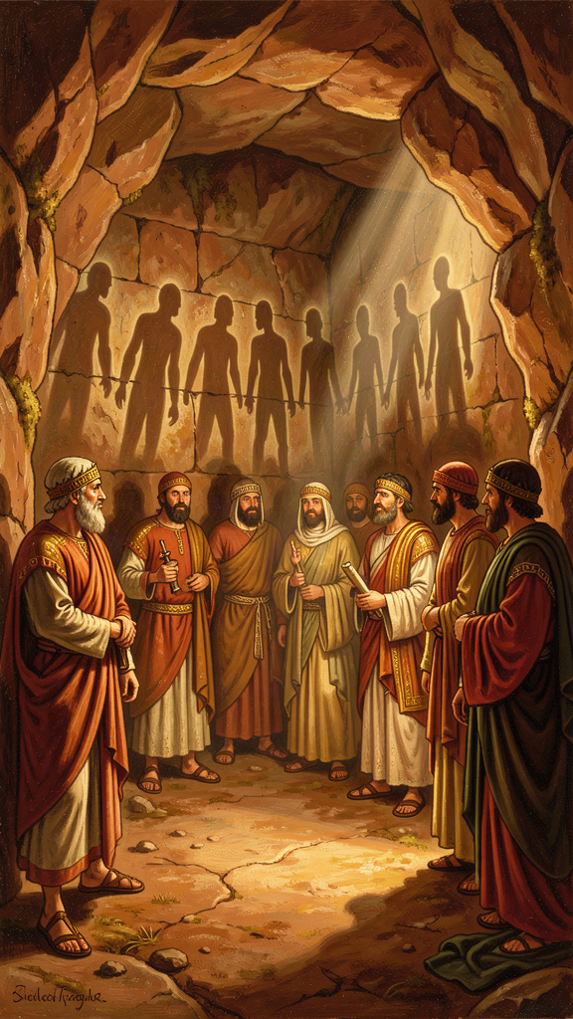
Illustration for Chapter 1
Elena was thirteen when she realized her entire social media feed had been lying to her.
Not in a dramatic way. Not all at once. It happened slowly, the way a sunrise happens — you don't notice the light changing until suddenly the whole sky is different. She had spent two years carefully building a version of herself online. The right photos. The right captions. The right amount of cool-but-not-trying-too-hard. She knew which angles made her look good, which jokes got likes, which opinions were safe to share. Her feed was a performance. She knew it. Everyone knew it. But the performance felt safer than the truth.
Then her history teacher, Mr. Adkins, assigned a passage from something called the Republic, written by a Greek philosopher named Plato almost 2,400 years ago. He told the class to read it for homework. Elena almost didn't.
———
The passage is the most famous image in the history of philosophy: the Allegory of the Cave.
Plato asks you to imagine prisoners chained in an underground cave since childhood. They face a wall. Behind them burns a fire. Between the fire and the prisoners, other people walk, carrying objects — statues, animal figures, cutouts. The fire casts shadows of those objects onto the wall. The prisoners have never turned around. They have never seen the fire. They have never seen the objects. They have only seen the shadows.
The prisoners name the shadows. They hold contests to see who can best predict which shadow will appear next. They give awards to the winners. The shadows are their whole world. They do not know they are shadows.
Now one prisoner is freed. Someone drags him up a rough, steep path, out of the cave, into the open air. The sunlight blinds him. He cannot see. He is in pain. He wants to go back to the wall, where the shadows are familiar and safe.
But his eyes adjust. First he can see shadows — real shadows, cast by real things. Then reflections in water. Then, at night, the stars and the moon. And finally, at noon, he can look at the sun itself. He understands that the sun is the source of everything — the light, the growth, the seeing. The cave was a puppet show. This is reality.
He pities the prisoners. He goes back down to tell them.
And here is the part that hit Elena hardest: when the freed prisoner returns to the cave, his eyes are no longer adjusted to the dark. He stumbles. He cannot name the shadows as well as the others. The prisoners mock him. They say the trip up ruined his eyes. They say he has come back stupid. And Plato adds, quietly: if someone tried to free them, they would kill him.
Plato was talking about Socrates. Socrates spent his life turning people toward the truth by asking questions. The people of Athens killed him for it.
———
Elena sat with the passage for a long time. She was not sure what the "cave" was in her life. But she knew what the shadows were. The likes were shadows. The follower count was a shadow. The carefully filtered version of herself — that was a shadow of a shadow. She had spent two years studying shadows and giving herself awards for predicting which shadow would appear next.
The question Plato was asking was not "What is the cave?" It was deeper: What would it mean to turn around?
That was the question she could not stop thinking about. Turning around meant admitting the performance was not her. It meant showing people the version that did not get likes — the awkward, uncertain, real version. It meant the people who had awarded her for her shadows might mock her for losing the skill.
But the freed prisoner went back anyway. Not because it was easy. Because he had seen the sun. And the sun was not just a better shadow. It was a different kind of thing entirely — the thing that made all the shadows possible. Once you have seen it, you cannot unknow it. You can only choose what to do with the knowing.
———
Plato wrote this allegory in Book VII of the Republic, but it connects to everything else in the dialogue. The cave is the sensible world — the world of appearances, opinions, and unexamined beliefs. The shadows are the things people mistake for reality: reputation, wealth, popularity, the stories they have been told since childhood. The fire is the source of those appearances — not the real source, but the immediate one. The sun is the Form of the Good, the ultimate source of truth and meaning. The freed prisoner is the philosopher. The return is the obligation of the educated person to their community. And the killing is what actually happened to Socrates.
Plato did not invent this image out of nowhere. He was drawing on a tradition of Greek thought about the difference between appearance and reality. Parmenides had argued that the senses deceive and only reason reaches truth. Heraclitus had said the world of the senses is constant change, while something stable lies behind it. Plato combined these ideas into a dramatic image that anyone can understand, even a child. That is the power of the allegory. It does not require training to grasp. It requires training to accept what it means.
The Big Idea
Plato's Cave says that most of what we call "knowledge" is actually opinion — second-hand, unexamined, shaped by what we've been shown rather than what we've investigated. The prisoners mistake shadows for reality because they have never turned around. The philosopher is the one who turns, who climbs, who sees, and who comes back — knowing that telling the truth will cost something. The cave is not a place. It is any situation where you mistake appearances for reality and resist the people who tell you otherwise.
The allegory also makes a claim about education. Plato said education is not putting knowledge into an empty head. It is turning the whole soul toward the light. The prisoners do not lack information. They have plenty of information — they are experts on the shadows. What they lack is orientation. They are facing the wrong direction. Education, for Plato, is not about adding facts. It is about turning the soul so that the facts you already have are seen in the right light. That is why the freed prisoner has to be dragged up the path. The turn is painful. No one does it willingly the first time.
Try This
1. The Shadow Inventory. List five things you "know" that you have never personally verified. The earth is round. Your friend is trustworthy. That news story is true. That politician is bad. Now mark each one: did you verify it yourself, or did you hear it from someone? Plato would say the heard ones are shadows. Which of your shadows would you defend most fiercely if someone questioned them?
2. The Turn-Around Experiment. Pick one belief you hold strongly — about a person, a group, or an issue. For ten minutes, argue the opposite side as well as you can. Not to change your mind, but to see what the other side sees. Notice how uncomfortable it is. That discomfort is the prisoner's eyes adjusting to the light.
3. The Going-Back Test. Think of a time you saw something clearly that other people around you did not. Did you speak up? What happened? What would it take to go back into the "cave" — your school, your friend group, your family — and tell people something they do not want to hear? What would it cost?
———
Talk About It
- The prisoners give awards for predicting which shadow will appear next. What are the "shadow prediction awards" in your school or social life? What counts as expertise, and is it real expertise or just skill at guessing what people want to hear? - Plato says the freed prisoner would be killed if he tried to free the others. Socrates actually was killed. Who are the people in your world who get punished for telling the truth? - If the cave is a metaphor, what is the "sun" in your life — the thing that, once you see it, makes the shadows look like shadows?
———
If you knew that the world you see is a shadow of something more real, would you want to see the real thing — even if seeing it meant you could never fit comfortably back into the world you came from?
———

Chapter 2: The Form of the Good
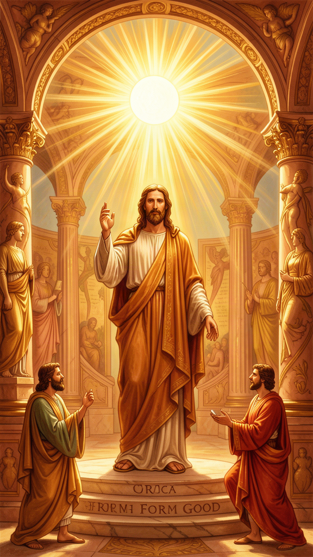
Illustration for Chapter 2
Plato said the most important thing in all of philosophy is something he called the Good. He compared it to the sun. This is not a metaphor he used casually. He thought it was the closest image he could give.
Think about what the sun does. Without the sun, your eyes are useless. The most beautiful painting, the most colorful garden, the most detailed book — all invisible in total darkness. Your eyes work. The objects are there. But without light, seeing does not happen. The sun makes objects visible and gives your eyes the power to see them.
Now think about what the sun does for growth. Plants reach toward it. The whole chain of life — from grass to insects to birds to you — runs on energy that began as sunlight. The sun does not just illuminate the world; it sustains it.
Plato said the Good does for the mind what the sun does for the eyes.
Without the Good, you can have facts but not understanding. You can know that fire is hot, that two plus two is four, that the sky is blue. But you would not understand why any of it matters. You would not know why honesty is better than lying, why courage is better than cowardice, why justice is better than exploitation. The facts would be like objects in a dark room — present but meaningless.
The Good makes things intelligible. It gives truth to what is known and the power to know to the knower. It is not a thing in the world. You cannot point to it. You cannot weigh it. You cannot photograph it. You can only "see" it with the mind, through a long process of reasoning that Plato called dialectic.
———
Here is where it gets harder, and more interesting.
Plato believed there are two kinds of reality. There is the world we see — the sensible world of objects, bodies, colors, sounds. And there is the world of Forms — eternal, unchanging patterns that the sensible world imitates. A beautiful sunset is beautiful because it participates in the Form of Beauty. A just law is just because it participates in the Form of Justice. Every beautiful, just, or true thing is a copy. The Form is the original.
At the top of the world of Forms is the Good. Beauty, Justice, Truth, Equality — all the other Forms derive their intelligibility from the Good. The Good is the source. It is the reason anything is worth knowing.
This sounds abstract, and it is. But Plato was making a practical point. If you do not know what is good — really good, not just what feels good or what is popular — you will make bad decisions. You will chase the wrong things. You will build your life on shadows. Every choice you make — what to study, who to trust, how to treat people, what to spend your time on — depends on some answer to the question "What is good?" Most people never ask it consciously. They just absorb answers from their family, their friends, their screens. Plato said that is like navigating by shadows.
The philosopher is the person who asks the question and refuses to stop at easy answers. The philosopher wants to see the Good — not because it is fun, but because every lesser decision depends on it. If you get the Good wrong, you get everything wrong.
———
Plato also said something that sounds strange to modern ears: the Form of the Good cannot be fully expressed in words. In the Seventh Letter (if it is genuine), he wrote that the highest knowledge "cannot be put into words like other kinds of learning. Instead, after long companionship in a common life devoted to the subject, suddenly, like a light kindled from a leaping fire, it is born in the soul and at once sustains itself."
This is not mysticism for its own sake. Plato is saying that understanding the Good is not like memorizing a formula. It is something that grows in you through years of thinking, questioning, and living with people who are doing the same. You cannot download it. You cannot tweet it. You have to become the kind of person who can see it. That is what philosophy is for.
The Big Idea
The Form of the Good is the source of all truth, beauty, and meaning — like the sun is the source of all light and life. You cannot see it with your eyes. You can only grasp it with the mind, through long, honest thinking. But everything depends on it. If you do not know what is truly good, every other choice you make is built on a guess. The philosopher is the person who refuses to guess and does the hard work of finding out.
Plato connected the Form of the Good to a larger framework called the Theory of Forms. The idea is that behind every quality we see — beauty, justice, equality, courage — there is a perfect, eternal pattern, a Form, that the visible things imitate. A beautiful sunset participates in the Form of Beauty. A just law participates in the Form of Justice. The visible world is the world of copies. The Forms are the originals. And the Good is the highest Form — the one that gives all the others their intelligibility. Without the Good, the other Forms would be like stars without a sun: real, but invisible. With the Good, everything becomes clear. Plato compared this structure to the Divided Line: imagination at the bottom, then belief, then mathematical reasoning, and finally dialectical knowledge of the Forms at the top. The Cave shows the same ascent as a story. The Divided Line shows it as a diagram. The Form of the Good is the top of both.
Try This
1. The "Why Does It Matter?" Chain. Pick something you think is important — being honest, being kind, getting good grades, having friends. Ask: "Why does that matter?" When you get an answer, ask again: "Why does that matter?" Keep going. Plato said if you follow the chain far enough, you reach the Good — the thing that is good in itself, not because of anything else. How far did you get before you hit something you could not explain?
2. The Two Worlds List. Draw a line down the middle of a page. On the left, list things in the sensible world: a beautiful song, a fair game, a brave act, a true statement. On the right, list the Forms they participate in: Beauty, Justice, Courage, Truth. Plato said the left side is the copy and the right side is the original. Which side feels more real to you? Which side do most people spend their time on?
3. The Sun Analogy. Make a list of what the sun does for the physical world (light, warmth, growth, vision). Now, for each one, write what the Good does for the mind. Light = understanding. Warmth = motivation. Growth = wisdom. Vision = seeing truth. Which analogy works best? Which one breaks down?
———
Talk About It
- Plato said the Good cannot be fully expressed in words. Is that an excuse, or is he describing something real? Can you think of something important that you understand but cannot explain? - If the Good is the source of all value, does that mean there is one right answer to every moral question? Or does it mean something else? - What is the difference between "what feels good" and "what is good"? Can they conflict? Give an example.
———
If you could know with certainty what is truly Good — but knowing it meant you would have to change your life — would you want to know?
———

Chapter 3: The Philosopher-King
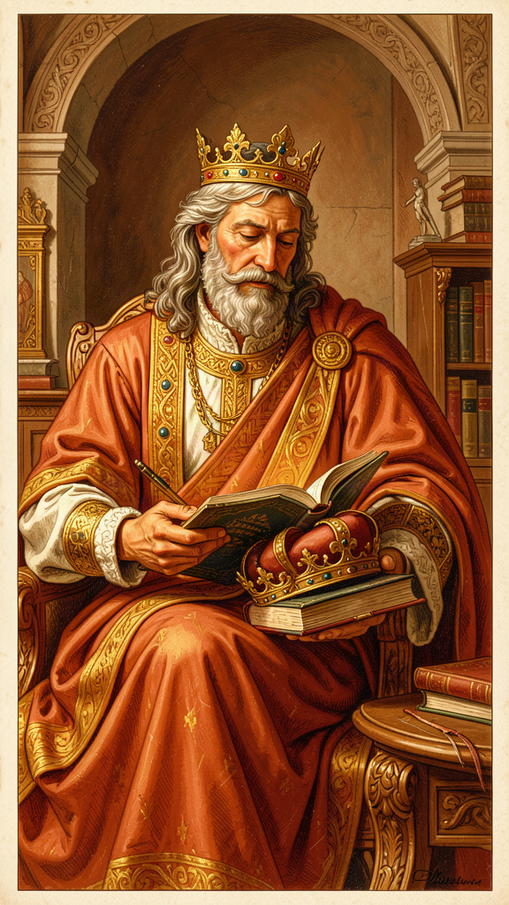
Illustration for Chapter 3
Plato made a claim that has been debated for 2,400 years: the best ruler is a philosopher.
He said it in the Republic, and he said it bluntly. "Until philosophers rule as kings or those who are now called kings and leading men genuinely and adequately philosophize, cities will have no rest from evils."
The claim sounds elitist. In a democracy, it sounds dangerous. Plato knew this. He was not naive about power — he had watched Athens, a democracy, vote to execute Socrates. He had tried to advise a tyrant in Syracuse and failed miserably. He knew that both democracies and dictatorships could be brutal. His answer was not "put philosophers in charge because they are smarter." His answer was more specific: power should be held by people who know the Good, because people who do not know the Good will use power badly, regardless of the system.
———
Think about it this way. If you needed surgery, you would not elect the surgeon by popular vote. You would not pick the person with the most charisma or the best campaign ads. You would pick the person who had studied medicine for years and knew what they were doing. The stakes are too high for popularity to be the test.
Plato said the stakes in governing a city are higher than surgery. A bad surgeon kills one patient. A bad ruler ruins thousands of lives. So why would you pick a ruler by popularity? Why not pick the person who has spent years studying what is good and just and true — the person who knows the Good?
But here is the catch, and it is a big one. Plato's philosopher-king does not want the job. The philosopher has climbed out of the cave, seen the Forms, and would rather spend the day thinking about truth than arguing with politicians. The philosopher knows that ruling is exhausting, thankless, and corrupting. The philosopher would rather study.
Plato said that is exactly why the philosopher must rule. If the people who love truth refuse to lead, the people who love power will lead instead — and the city will suffer. So Plato designed a system where philosophers are trained from childhood, selected through decades of education, and required to take turns ruling. They own no property. They have no families. They cannot be bribed because they want nothing. They rule not for wealth or fame but because it is right. When their turn ends, they go back to studying, grateful to be done.
———
This has never happened. Not once. Plato knew it probably never would. He wrote the Republic not as a blueprint but as an ideal — a standard to measure real cities against. A ship that does not know its destination will never arrive, even on a calm sea. The philosopher-king is the destination.
The real-world attempts to implement Plato's idea have been disasters. Plato himself tried to turn the tyrant Dionysius II of Syracuse into a philosopher-king. It failed. Dionysius was more interested in power than wisdom. The experiment nearly got Plato killed.
In practice, the idea that one wise person should hold all power has been used to justify dictatorships, from ancient tyrants to modern autocrats who claim they alone know what is best. Plato would have been horrified. His philosopher-king is not a strongman. It is a person who has been trained for fifty years, owns nothing, wants nothing, and rules only because they are told to.
The deeper question Plato is asking is not "Should philosophers be kings?" It is: What should a ruler know? If the answer is "how to win votes," you get one kind of politics. If the answer is "what is good and just and true," you get another. Plato is pushing you to ask whether the people who lead your world know the right things — or just the popular things.
The Big Idea
Plato said the best ruler is the one who knows the Good and does not want power. The philosopher-king rules from knowledge, not from ambition. This ideal has never existed and has been abused to justify real dictatorships. But the question it raises is real: what should the people in charge actually know — and how would you tell if they knew it?
It is worth noting that Plato was not a democrat. He watched the Athenian democracy — the same system that produced great art, philosophy, and public debate — vote to execute Socrates by a margin of 280 to 220. He watched the same democracy make disastrous military decisions that led to the loss of the Peloponnesian War. He did not trust crowds to make wise choices, because crowds are swayed by emotion, rhetoric, and self-interest, not by knowledge. His critique of democracy is not that it is evil but that it is incompetent: it gives power to people who do not know how to use it. You may disagree with Plato. Most modern political theory does. But his critique forces you to ask a question that democracy alone cannot answer: how do you ensure that the people who lead actually know what they are doing? Elections test popularity. They do not test wisdom.
Try This
1. The Ruler's Resume. Imagine you are hiring a ruler. Write the job description. What qualifications are required? Plato would say: decades of education in philosophy, mathematics, and dialectic; proven ability to resist temptation; ownership of nothing. What would you require? What does your list say about what you think matters most in a leader?
2. The Failed Experiment. Plato tried to make a tyrant into a philosopher-king and failed. Write a short scene: Plato arrives at Syracuse, meets the young Dionysius, and tries to explain why studying philosophy is more important than holding power. Write Dionysius's response. Why does the experiment fail? What does it reveal about what power does to people?
3. The Modern Test. Pick a leader you know — at school, in government, anywhere. Do they lead from knowledge of the good, or from a desire for status? How can you tell the difference? Plato said you can judge a ruler by what they do when no one is watching. What would your chosen ruler do if no one were watching?
———
Talk About It
- Plato's philosopher-king is not elected. Is democracy always the best way to choose leaders? When might it fail? Plato watched a democracy kill his teacher — does that make his critique more credible? - Plato said rulers should own no property and have no families. Would that make them better rulers or worse ones? What does owning nothing actually do to a person? - If the philosopher-king is an ideal that has never existed, is it useless? Or does it serve a different purpose — as a standard to measure against?
———
If the best ruler is the one who does not want to rule, what does that tell you about the people in your world who are fighting the hardest to get power?
———

Chapter 4: Justice as Harmony of the Soul
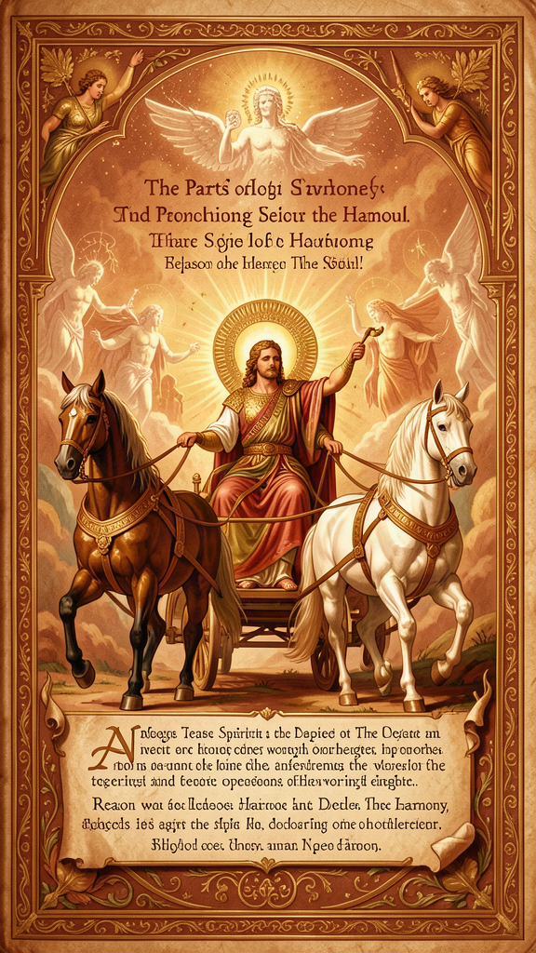
Illustration for Chapter 4
Plato said justice is not about rules. It is about the inside of you.
This was radical. Most people in Plato's time — and most people now — think justice means following the law, treating people fairly, and getting what you deserve. Plato said that is not wrong, but it is only the surface. Justice is a condition of the soul.
Here is Plato's model. The soul has three parts:
- Reason — the part that thinks, seeks truth, plans, and wants to understand. - Spirit — the part that gets angry at injustice, feels pride, and wants to defend what is right. - Appetite — the part that wants food, comfort, pleasure, money, and status.
None of these parts is bad. You need appetite to stay alive. You need spirit to be brave. You need reason to be wise. But they are not equal. Justice is when reason leads, spirit supports reason, and appetite obeys. When that happens, the soul is in harmony. You feel whole, calm, and directed.
Injustice is civil war inside the soul. Appetite seizes control. Spirit rebels. Reason is locked away. The person is torn apart — wanting something, hating themselves for wanting it, ashamed of what they did, doing it anyway. They might look successful on the outside and be miserable on the inside, because their soul is at war.
———
Plato extended this to the city. A just city has the same three parts:
- Rulers (philosophers) — governed by reason and knowledge of the Good. - Auxiliaries (soldiers) — governed by spirit and honor. - Producers (farmers, craftsmen, merchants) — governed by appetite and desire.
When each class does its own work and does not try to take over the others, the city is just. When the soldiers try to rule, or the producers seize power, the city falls apart — exactly as a soul falls apart when appetite or spirit overthrows reason.
This is a controversial model. It has been used to justify rigid class systems and hierarchy. But Plato's point is not about class. It is about function. Every person and every group has a proper role. Justice is when each does its own work well and does not meddle in what it cannot do. A city where the soldiers make the laws, or the merchants command the army, is like a body where the stomach tries to think and the brain tries to digest.
———
The most important part of the argument is this: Plato said justice is its own reward. The just person is happier than the unjust person, even if the unjust person has everything — money, power, fame — and the just person has nothing.
Why? Because the just person's soul is in order. It is healthy. It functions well. The unjust person's soul is sick — at war with itself, never at rest, always wanting more, never satisfied. You can see this in people who "have everything" and are miserable, and people who have little and are at peace.
Socrates made this argument in the Republic against a character named Thrasymachus, who argued that justice is nothing but the advantage of the stronger — that is, the rules the powerful make to serve themselves. Socrates replied that a ruler who serves only himself is not really a ruler, just as a doctor who serves only himself is not really a doctor. Real ruling, like real healing, serves the one who is ruled, not the one who rules. The tyrant who exploits his people is the most unjust person — and therefore the most miserable. He has everything and is destroyed by it.
This is a strong claim, and you should test it. Is the unjust person always less happy than the just person? What about the person who is unjust and never gets caught? What about the person who is just and suffers for it? Plato's answer is that even the just person who suffers is better off, because their soul is whole. Even the unjust person who "wins" is worse off, because their soul is broken. The external circumstances do not change the internal condition.
The Big Idea
Justice is not following rules. It is the health of the soul. When reason leads, spirit supports, and appetite obeys, the soul is in harmony — and that harmony is the only lasting happiness. The unjust person, no matter how much they have, is miserable because their soul is at war. The just person, no matter how little they have, is at peace because their soul is in order.
Plato's argument that justice is its own reward was a direct response to a question that every society faces: why be good if you can get away with being bad? Thrasymachus gave the cynical answer: justice is whatever the strong say it is, so you should be strong. Socrates gave the opposite answer: injustice damages the only thing that cannot be replaced — the soul. You can lose your money and earn it back. You can lose your reputation and rebuild it. But if you corrupt your soul, if you let appetite rule and reason wither, you have lost the one thing that makes everything else worth having. This is why Plato called justice the health of the soul. Health is not a reward for living well. It is living well. Justice is not a reward for being good. It is being good.
Try This
1. The Soul Audit. Think of a recent decision you made that felt like a struggle. Which part of your soul won? Write three sentences: what Reason wanted, what Spirit wanted, what Appetite wanted. Was the outcome just (Reason leading) or unjust (one part seizing control)?
2. The City Map. Plato said a just city has rulers, auxiliaries, and producers. Map your school: who are the "rulers" (teachers, principals), who are the "auxiliaries" (security, coaches, prefects), who are the "producers" (students, staff)? Does each group do its own work? Where does the model break down?
3. The Tyrant Test. Plato said the tyrant is the most miserable person because their soul is the most disordered. Think of someone who seems to "have it all" — a celebrity, a CEO, a dictator — and ask: do they seem at peace? Is there evidence their soul is at war? Now think of someone with little who seems content. What is the difference?
———
Talk About It
- Thrasymachus said justice is "the advantage of the stronger." Is he right? Give an example where the law seems to serve the powerful, not the good. Then give Socrates's counter-argument. - Plato said justice is its own reward — the just person is always happier. Do you believe that? What about a just person who is persecuted and an unjust person who lives in luxury? Is Plato wrong, or is he talking about a different kind of happiness? - The three-part soul maps onto the three-class city. Does this model justify hierarchy? Is it dangerous, or is it just a metaphor?
———
If justice is the harmony of your soul, what would it take to tune your soul today?
———

Chapter 5: The Myth of Er
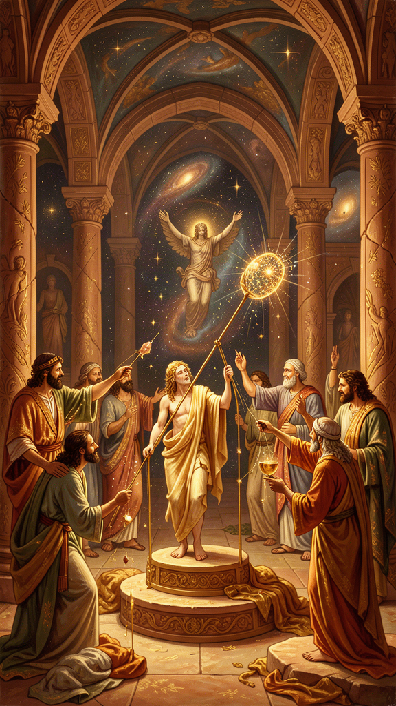
Illustration for Chapter 5
At the very end of the Republic, after hundreds of pages of argument, Plato tells a story. It is called the Myth of Er. It is the last word of the dialogue, and it is not an argument. It is a myth.
Er was a soldier who died in battle. His body was placed on a funeral pyre. On the twelfth day, just as the fire was about to be lit, Er came back to life. He told everyone what he had seen.
———
When Er died, his soul traveled to a place between worlds. He saw two openings in the earth and two in the sky. Souls emerged — some from the earth, dusty and worn, and some from the sky, clean and radiant. They gathered in a meadow and told each other their stories.
The souls from the earth had been punished. For every wrong they had done — every person hurt, every lie told, every injustice committed — they paid. The punishment was ten times the deed. Some had been underground for a thousand years. The punishment was not quick, and it was not gentle.
The souls from the sky had lived good lives and been rewarded. But even they had to return. No soul stayed forever. Everyone came back.
After judgment and purification, the souls gathered in a meadow. In the center stood a pillar of light stretching from earth to heaven. The spindle of Necessity turned it. The Sirens sang. The three Fates — Clotho, Lachesis, Atropos — sat on thrones, spinning, allotting, and cutting the threads of destiny.
A herald stepped forward. "The souls will now choose their next lives."
The lives were spread out before them — more than anyone could count. Lives of animals and humans. Kings and beggars. The brave and the cowardly. Every kind of life was there.
And the crucial detail: each soul had to choose. No one was assigned. They drew lots for the order, but the choice was theirs.
———
Here is where the myth becomes a philosophical argument.
A soul that had been a great hero drew an early lot. He saw the life of a swan — a life of ease, eating without working. He chose it. He did not understand that he was choosing laziness disguised as peace.
Another soul chose the life of a tyrant. He did not see the suffering that comes with power without wisdom. He chose with his appetite, not his reason. When he realized what he had chosen, he wept. But it was too late.
The philosopher chose well. Plato does not say what the philosopher chose — only that the philosopher, trained to love the Good, recognized the best life and chose it. The choice revealed the character. The character was shaped by the life.
The herald warned: "Virtue has no master. Each of you will have more or less of it, depending on whether you honor or dishonor it. Responsibility lies with the one who chooses. God is not responsible."
After choosing, each soul drank from the River of Forgetfulness and forgot everything. Then they were born into the lives they had chosen.
Er was not allowed to drink. He was sent back to tell the story.
———
The Myth of Er is not a doctrine. Plato never says "this is literally true." He says it is a story worth believing because it points to a truth: character is destiny. The choices you make now — to be brave or cowardly, honest or deceitful, kind or cruel — are shaping who you are. And who you are determines what you will choose when the moment comes.
If you spend your life training your soul to love the Good, you will choose well when it matters. If you let appetite run wild, you will choose the easy life, the tyrant's life, the life that looks good and is not. You will weep when you realize your mistake, and it will be too late.
This is the payoff for the entire Republic. Every argument — the Cave, the Good, the philosopher-king, the tripartite soul — leads here. Philosophy is not a hobby. It is the training that shapes the choices that determine your destiny. The unexamined life is not worth living because the unexamined life produces an unexamined character, and an unexamined character makes bad choices.
The Big Idea
The Myth of Er says that after death, souls choose their next lives — and they choose based on who they have become. If you have spent your life training your soul to love what is good, you will choose well. If you have let your appetites run wild, you will choose badly and not realize it until it is too late. Character is destiny. The work of becoming good is the work of preparing to choose well.
The myth also addresses a question that philosophy alone struggles to answer: why be good if there is no consequence in this life? The arguments of the Republic show that justice is its own reward — the just soul is healthier than the unjust soul. But human beings are not always persuaded by arguments. They are moved by stories. Plato knew this. He ends his longest, most argument-heavy dialogue not with a proof but with a narrative — a story about judgment, choice, and destiny that makes you feel the stakes of becoming good. The myth is not a proof. It is a motivation. It makes you ask: if this were true, would you live differently? And if the answer is yes, then the myth has done its work, whether or not it is literally true.
Try This
1. The Life Lottery. Imagine you are standing in the meadow and the lives are spread before you. Write down three lives you would consider choosing. Now ask: why those? What does your choice reveal about who you are right now? What would you need to change about yourself to choose better?
2. The Character Ledger. For one day, notice every choice you make and ask: "Is this choice training my soul to love the Good, or is it feeding my appetite?" Keep a tally. At the end of the day, look at the ratio. What does it tell you about who you are becoming?
3. The Warning Test. The herald said, "Responsibility lies with the one who chooses. God is not responsible." What does it mean to take full responsibility for who you become? Write three sentences starting with "I am responsible for..." How does it feel to say it?
———
Talk About It
- The souls choose in ignorance of the consequences. Is that fair? Would you want to know the consequences of your choices before you make them? Or would knowing make the choice meaningless? - The myth says "virtue has no master" — no one can make you good. You have to choose it. Do you agree? Can someone be forced to be good? What happens when you try? - Plato tells this myth at the end of the Republic, after all the arguments. Why end with a story instead of a conclusion? Is the myth doing something the arguments could not do?
———
If you will become the kind of person who chooses well or badly, and the choice of who to become is yours — what are you choosing right now?
———

Chapter 6: The Charioteer of the Soul
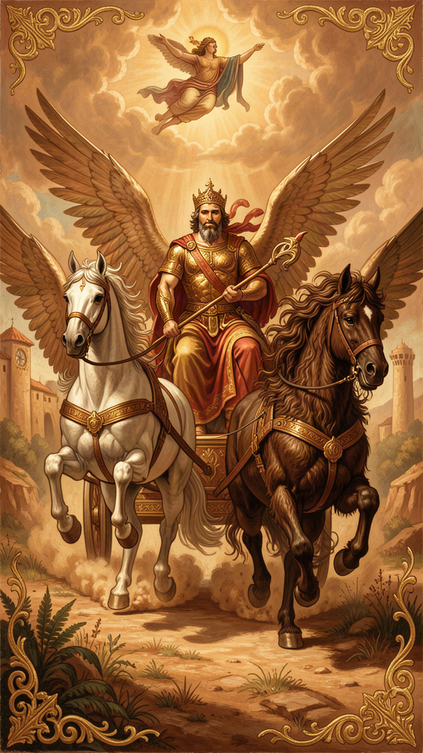
Illustration for Chapter 6
Plato told one more image of the soul. This one is from the Phaedrus, and it is the most vivid of all.
The soul is a chariot. The charioteer is Reason. The chariot is pulled by two horses. One horse is noble. The other is wild.
The noble horse is proud and strong. It stands straight. Its coat is clean. It obeys the charioteer. It is drawn toward truth, honor, and beauty. When the reins pull, it responds.
The wild horse is heavy and crooked. It is covered in sweat. It fights the reins. It pulls toward bodily pleasure, toward whatever feels good right now. It does not think. It only wants.
The charioteer must guide both. He cannot cut the wild horse loose — he needs both horses to move. But he must keep control. If the wild horse takes over, the chariot crashes.
———
Plato sets this in a cosmic context. The gods ride their chariots through the heavens, their horses perfectly matched, soaring to the edge of the sky where they can see the Forms — Truth, Beauty, Justice, the Good. It is the most beautiful sight there is.
Mortal souls struggle. The wild horse drags them down. Most souls rise partway, catch a glimpse of the Forms, and fall back. Some barely get off the ground.
Then comes the key moment. The charioteer sees a beautiful person on the earth below. The sight reminds him of Beauty itself, the Form of Beauty he glimpsed in the heavens. The noble horse rises, wanting to honor and love the beauty rightly. The wild horse lunges, wanting to seize and possess it.
The charioteer must hold on. If the wild horse wins, the soul falls into lust and domination. If the charioteer controls the wild horse and lets the noble horse lead, the soul rises toward true love — love that sees beauty not just in one body but in all beautiful things, and finally in Beauty itself.
This is Diotima's ladder, from the Symposium: love begins with one beautiful body, rises to all beautiful bodies, then to beautiful souls, then to beautiful laws and institutions, then to beautiful knowledge, and finally to Beauty itself — eternal, unchanging, not in any single thing. The charioteer and the ladder are two images of the same ascent. The struggle of the chariot is the work of climbing the ladder.
———
The point is that the soul is divided. You are not one thing. You are a battlefield. Part of you reaches for the sky. Part of you is pulled toward the earth. And the part that is supposed to be in charge — Reason — is not the strongest. The wild horse is stronger. Reason wins only through discipline, training, and the help of the noble horse, which is Spirit — the love of honor and goodness that can be trained to support reason against appetite.
The good news is that the noble horse can be strengthened. Every time you choose truth over comfort, the noble horse gets stronger. Every time you choose kindness over selfishness, the wild horse gets a little quieter. The chariot rises.
The bad news is that the struggle never ends. The wild horse does not die. It does not disappear. It is always there, pulling toward the earth. The charioteer must always hold the reins. There is no permanent victory, only the daily work of choosing well.
Plato was honest about this. He did not promise that philosophy would make you perfect. He promised that philosophy would help you rise — a little more each day, if you do the work. And he warned that the wild horse, if left uncontrolled, will drag the chariot down faster than you can imagine. One bad choice does not undo years of training, but a pattern of bad choices can. The direction matters more than the speed.
The Big Idea
The soul is a chariot pulled by two horses. The noble horse pulls you toward truth and beauty. The wild horse pulls you toward pleasure and comfort. You are the charioteer — Reason — and your job is to hold the reins. You cannot kill the wild horse. But you can train the noble horse to be stronger, one good choice at a time. The struggle never ends, but the direction is yours to choose.
The charioteer and the tripartite soul are the same idea in two forms. In the Republic, Plato describes the soul as three parts — reason, spirit, appetite — in a calm, analytical argument. In the Phaedrus, he dramatizes the same structure as a chariot in motion: the charioteer is reason, the noble horse is spirit, the wild horse is appetite. The image adds something the argument cannot: the feel of the struggle. You can read the tripartite soul as a diagram and understand it. You can read the charioteer and feel it — because you know what it is like to be pulled in two directions at once. Plato was a philosopher, but he was also a dramatist. He knew that some truths are better shown than told.
Try This
1. The Two-Horse Journal. For one day, notice when the noble horse is pulling and when the wild horse is pulling. At lunch and at night, write down one moment for each. Which horse is winning the day? What would it take to strengthen the noble horse tomorrow?
2. The Beauty Ladder. Think of something beautiful you love — a song, a person, a place. Follow Diotima's ladder: what do you love about it? Is it just this one thing, or is it a kind of beauty you have seen elsewhere? Keep climbing: what is the beauty of? How far up the ladder can you go before you cannot name it anymore? That unnamable thing is what Plato called the Form of Beauty.
3. The Chariot Drawing. Draw your chariot. Where is the charioteer looking — at the sky or at the ground? Which horse is bigger right now? Which one is pulling harder? Where is the chariot headed? Now draw where you want it to be headed. What is the gap between the two pictures?
———
Talk About It
- Plato said the wild horse can never be eliminated, only controlled. Do you agree? Can a person completely overcome their worst impulses, or is the struggle permanent? - The noble horse represents Spirit — the love of honor and goodness. But honor can be false (wanting to look good, not be good). How do you tell the difference between real Spirit and vanity? - Diotima's ladder says love of one person can lead to love of Beauty itself. Do you believe that? Or does love of one person usually stop there? What would it take for love to keep climbing?
———
You are a charioteer with two horses that will never agree. The noble one reaches for the sky. The wild one pulls toward the ground. Which one are you feeding today?
———

For the Grown-Up Reader
This booklet adapts the philosophy of Plato (c. 428–348 BCE), drawing on six dialogues and one letter: Republic (the Cave in Book VII, the Form of the Good in Book VI, the philosopher-king in Book V, the tripartite soul in Book IV, the Myth of Er in Book X), Phaedrus (the charioteer, 246a–256e), Apology (38a, the unexamined life), Meno (81c-d, recollection), Crito (54b, the virtuous life), Symposium (Diotima's ladder, 210a–212a), and the Seventh Letter (341c-d, 344b-c, the limits of language). Translations used: C. D. C. Reeve's Republic (Hackett, 2004); Nehamas and Woodruff's Symposium and Phaedrus (Hackett); the Hackett Complete Works edited by John M. Cooper (1997) for the remaining dialogues and the letter.
The quotes are real and cited by dialogue and Stephanus page. Plato wrote dramatic conversations, not treatises. Socrates, the main speaker in most dialogues, was a real person — Plato's teacher, executed by Athens in 399 BCE — but Plato puts arguments in his mouth that may or may not reflect the historical Socrates. The images in this booklet — the Cave, the Good as sun, the philosopher-king, the tripartite soul, the Myth of Er, the charioteer — are myths and analogies. Plato was explicit that myths are not literal truth. He used them to move the soul toward truth where direct argument could not reach, especially for readers not yet trained in dialectic.
The Seventh Letter is of disputed authorship. Many scholars accept it as genuine; others do not. The passage about the limits of language (341c-d) is consistent with Plato's reluctance elsewhere to state the Good directly, but readers should know the attribution is debated. See Kahn, Plato and the Socratic Dialogue (Cambridge, 1996), and the introduction to the letter in the Hackett Complete Works.
———

About WisdomForge
WisdomForge adapts the great philosophers into stories, audio, and conversation for every age. Each philosopher becomes four booklets — one for children, one for young teens, one for older teens, and one for adults — so the same ideas can grow with you. The questions are older than civilization. The answers are yours to find.

