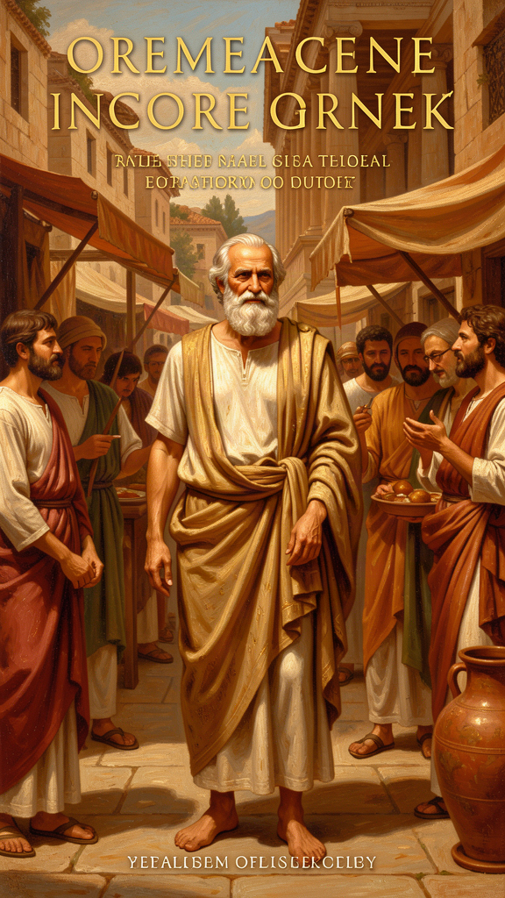
Socrates: The Examined Life and Its Costs
WisdomForge Booklet — Adult Readers

Socrates: The Examined Life and Its Costs

WisdomForge Booklet — Adult Readers
———

About This Book
Socrates never wrote a word. He left no books, no essays, no letters, no lecture notes. He founded no school, held no office, and charged no fees. He walked the streets of Athens barefoot, wore a single cloak in all weather, and spent his days in conversation with anyone who would talk — demanding that they explain what they meant by justice, by courage, by piety, by the good. And yet, twenty-four centuries after a jury of his fellow citizens sentenced him to drink hemlock, he remains one of the founding figures of Western philosophy. The word "philosophy" itself — love of wisdom — was shaped by what he did and how he died.
How does a man who wrote nothing become one of the most influential thinkers in history? The answer is twofold. First, Socrates understood something that most people, including most educated people, do not: the greatest obstacle to knowledge is not ignorance but the illusion of knowledge. We think we know what justice is, what piety is, what a good life is — until someone asks us to explain. Then the knowing evaporates, and we discover that what we called knowledge was habit, convention, or borrowed opinion. Socrates made this discovery visible and made it the starting point of philosophy.
Second, Socrates had a student who could write. Plato, born into an aristocratic Athenian family around 428 BCE, became a follower of Socrates as a young man. He was present, or nearly present, at Socrates' trial and death. Afterward he founded the Academy in Athens and spent roughly fifty years writing dialogues — dramatic conversations in which Socrates is usually the main speaker. These dialogues are not transcripts. They are literary reconstructions, and their reliability as historical sources varies. Scholars divide them into three periods: the early dialogues (c. 399–380 BCE), which are brief, ethically focused, and often end in puzzlement (aporia), are generally taken to be the closest window onto the historical Socrates. The middle dialogues (c. 380–360 BCE) — the Republic, the Symposium, the Phaedrus — introduce the Theory of Forms, the tripartite soul, and the ideal city, and use Socrates increasingly as a mouthpiece for Plato's own philosophy. The late dialogues (c. 360–347 BCE) are more critical and self-questioning, and Socrates sometimes recedes into the background.
This booklet draws from the early dialogues: Apology, Crito, Phaedo, and Euthyphro. These are the works scholars consider most reliable as sources for the historical Socrates' methods and concerns. They are also the works where Socrates is at his most characteristic: questioning, ironic, unwilling to settle, and — in the end — willing to die rather than abandon the examined life.
But there is a complication that this booklet takes seriously throughout: the Socratic Problem. Because Socrates wrote nothing, we know him only through others. Plato is the primary source, but he is not the only one. Xenophon, the Athenian soldier and historian, wrote a Socrates who is more practical, conventional, and pious than Plato's — a moral teacher who gives advice on household management and self-discipline rather than a philosopher who exposes contradictions. Aristophanes, the comic playwright, mocked Socrates in Clouds (423 BCE) as a dangerous fraud who taught young men to argue dishonestly and deny the gods. Aristotle, born fifteen years after Socrates' death, mentions him as an ethical thinker who sought universal definitions — and explicitly rejects the Socratic claim that virtue is knowledge. None of these sources is unbiased. Together they form a prism rather than a photograph.
The six chapters that follow trace the arc of Socrates' most important ideas and most dramatic moments, engaging with the scholarly debates that surround each. We begin with the oracle at Delphi and Socrates' discovery that his wisdom consists in knowing what he does not know. We move through his declaration that the unexamined life is not worth living, his argument that the soul must take priority over wealth and reputation, his refusal to escape prison because doing so would violate his principles, the mysterious final words he spoke as he died, and the dilemma he posed about the relationship between goodness and divine authority.
Each chapter is a narrative essay. The quotes are real, drawn directly from the cited Plato dialogues. The scholarly debates are real, drawn from the secondary literature. The questions at the end are for you.
———

Chapter 1: The Oracle at Delphi — No One Is Wiser
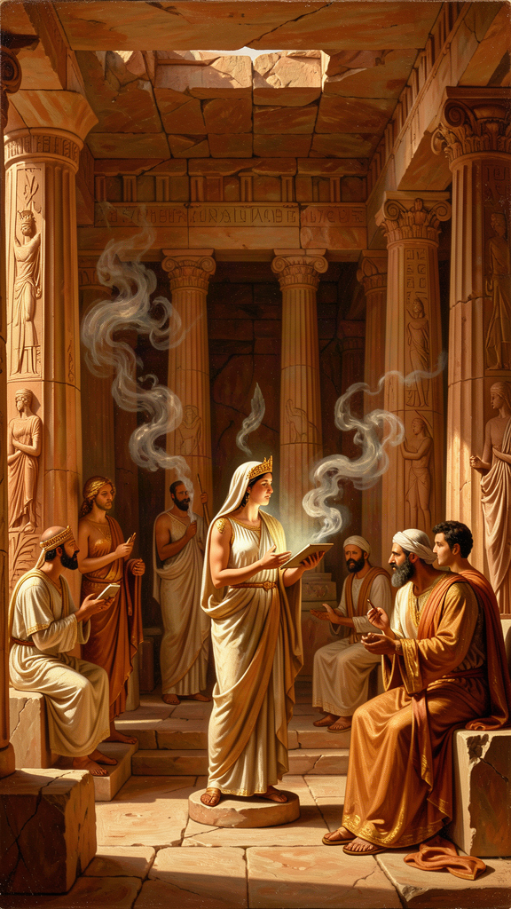
Illustration for Chapter 1
![Chapter 1](/images/booklets/socrates-adult-ch01.png)

The Historical Setting
Fifth-century Athens was a city built on speech. Its democracy — the word is Greek — depended on the ability of citizens to persuade one another in the assembly and the law courts. There were no professional lawyers; citizens represented themselves. There were no career politicians in the modern sense; leadership depended on the capacity to speak well and persuade. Rhetoric was power, and the Sophists — itinerant teachers who charged fees to instruct young men in the art of persuasion — flourished. Protagoras, Gorgias, Hippias, and Prodicus traveled the Greek world offering instruction in argument, and they found eager customers among the sons of the Athenian elite.
Into this culture of paid instruction and competitive speech walked a man who did not fit. Socrates, born around 470 BCE, was the son of a sculptor (Sophroniscus) and a midwife (Phaenarete). He served as a hoplite in three military campaigns — at Potidaea, Delium, and Amphipolis — and was noted for his physical endurance, his courage, and his habit of standing still in deep thought for hours on end. He lived simply, charged no fees, and spent his days in conversation. His appearance was against him: he was short, stout, snub-nosed, and bulging-eyed. Ancient sources, including Diogenes Laertius, describe him as ugly. He was not the kind of man who impressed at first sight. But his mind was relentless, and his method — though he would have disclaimed the word "method" — was devastating: he asked questions, pursued definitions, and exposed the gap between what people claimed to know and what they could defend.

The Oracle
The story that defines Socrates' philosophical mission comes from the Apology, his defense speech at the 399 BCE trial. He tells the jury about his friend Chaerephon, a bold and impulsive democrat who had fought to restore Athenian democracy after the oligarchic coup of 404 BCE. Chaerephon traveled to Delphi, the sacred site where the oracle — a priestess called the Pythia, believed to channel the god Apollo — answered questions from visitors. Chaerephon asked whether anyone was wiser than Socrates.
The oracle answered: no one.
The historicity of this episode is disputed. Some scholars think Plato invented or embellished it to give Socrates' mission a divine sanction. Others note that Chaerephon was a real, historically attested figure and that the story would have been checkable by the jury — many of whom would have known Chaerephon personally. The question of whether the oracle actually spoke these words matters less than what Socrates did with them. He treated the oracle not as a compliment but as a riddle.
When Chaerephon reported the oracle's answer, Socrates was genuinely bewildered. He knew he had no special knowledge. He could not explain the movements of the stars, the nature of the earth, or the principles of politics. If the oracle said he was the wisest, either the oracle was wrong or Socrates was misunderstanding what wisdom meant. He chose the latter hypothesis and decided to test it. If he could find someone who genuinely possessed wisdom — not just a reputation for it — the oracle would be refuted. So he went looking.

The Investigation
Socrates' investigation took him through three classes of people who claimed wisdom.
The politicians. He approached public figures who governed the city, made its laws, and commanded its forces. He found them confident, articulate, and convinced of their own understanding. But when he asked them to define the concepts they invoked — justice, the good, the best way to live — their answers collapsed. They relied on convention, habit, and the authority of their position. They could not give an account (logos) of their own claims. Socrates concluded that they thought they knew what they did not know.
The poets. Socrates turned to the poets, whose works moved audiences to grief and wonder. He asked them to explain what their poems meant. Most could not. They composed by instinct, inspiration, and inherited technique — not by knowledge. Socrates concluded that poetic power is a gift, not a form of wisdom. The poet is like a prophet who speaks truth without understanding it. (This is one of the more controversial passages in the Apology; some scholars think Socrates is being deliberately provocative, since the poets were among the most revered figures in Greek culture.)
The craftsmen. Finally, Socrates questioned the artisans — builders, metalworkers, shoemakers. These people did possess real knowledge (episteme). A skilled craftsman understands his trade and can explain it. But the craftsmen made the same error as the others, in a more subtle form: because they knew their craft, they assumed they also understood ethics, politics, and the good life. Their expertise in one domain bred a false confidence that colonized every other domain. They were knowledgeable about something, and that made them think they were knowledgeable about everything.

The Discovery
After this long investigation, Socrates understood what the oracle meant:
"I am wiser than this man: neither of us knows anything, but he thinks he knows something, while I know nothing. Yet I appear to be wiser in just this one respect: if I do not know something, I do not think that I do." — Plato, *Apology* 21d
This passage is the foundation of what scholars call "Socratic ignorance" — not a claim to know nothing, but a disciplined awareness of the boundary between genuine knowledge and mere opinion (doxa). It is not false modesty. It is a philosophical method. The recognition of ignorance is not the conclusion of inquiry but its precondition. You cannot learn what you think you already know. The people most dangerous to themselves and to others — in politics, in education, in every sphere of life — are those who are most certain they already understand.

The Social Cost
There is a dimension to this story that is easy to miss if we focus only on the epistemology. Socrates did not reach his conclusion by solitary meditation. He reached it by going out and testing it against real people, in public, often with young men watching and listening. Socratic ignorance is not passive or private. It is active, social, and confrontational. The examination of the politicians was not a private interview. It was a public event, performed in front of an audience that included the sons of the Athenian elite — young men who would go on to imitate Socrates' questioning style, to the fury of their elders.
This is why the oracle story is not just about epistemology but about the social cost of intellectual honesty. No one enjoys having their ignorance exposed, and the exposure was performed in the most public setting Athens had to offer. The politicians Socrates questioned were public figures with reputations to protect. The poets were cultural authorities. The craftsmen were respected experts. Having their confidence dismantled in front of an audience of young men — some of whom would go on to question their own fathers and teachers the same way — was humiliating. Socrates' willingness to pay this social cost is what set his life on the path that led to a death sentence. The oracle did not just tell him he was wise. It gave him a mission whose price was his life.

The Socratic Problem: Who Is Speaking?
Before we move on, we must confront the complication that hangs over everything. The Socrates who tells this story is a character in a dialogue written by Plato. How much of this speech is Socrates' own, and how much is Plato putting words in his mouth?
Most scholars agree that the Apology is among the most historically reliable of Plato's dialogues. The speech has a forensic quality — it reads like a legal defense, not a philosophical treatise — and its style is less literary than the middle dialogues. Gregory Vlastos, in Socrates: Ironist and Moral Philosopher (1991), argued that the early dialogues, including the Apology, preserve a Socrates who is distinguishable from the Socrates of the middle period. The early Socrates disclaims knowledge, pursues definitions, and ends in aporia. The middle Socrates expounds positive doctrines — the Theory of Forms, the immortality of the soul, the ideal city — that the early Socrates never mentions. This "two Socrateses" model, while not universally accepted, remains the dominant framework for distinguishing the historical Socrates from Plato's literary creation.
Charles Kahn, in Plato and the Socratic Dialogue (1996), pushed back against the sharp division, arguing that even the early dialogues are carefully constructed literary works and that the historical Socrates is unrecoverable. The debate is ongoing. What we can say with reasonable confidence is this: the Apology presents a Socrates whose philosophical method — testing claims through questioning, exposing the gap between knowledge and opinion, and recognizing his own ignorance — is consistent across the early dialogues and is likely close to the historical person's actual approach. The specific wording of the speech is Plato's. The method and the stance are probably Socrates'.

Big Idea
Socratic ignorance is the disciplined awareness of the boundary between knowledge and opinion. It is not a passive acknowledgment of limitation but an active, social method: you test your ignorance against real people, in real conversations, and you treat the recognition of not-knowing as the beginning of inquiry, not the end of it. The social cost of this honesty is real — exposing other people's false confidence makes enemies. Socrates paid that cost with his life.

Practice
1. Identify your false confidence. Make a list of five things you "know" about politics, morality, or society. For each, trace the source: where did this belief come from? A parent? A teacher? A book? A news source? A social media post? Now ask: could you defend this claim against a rigorous questioner? If not, what you have is opinion, not knowledge. The point is not to discard the opinion — it may be right — but to be honest about its epistemic status. This is harder than it sounds. Most of what we call knowledge is inherited opinion that has never been tested.
2. Run a Socratic investigation. Pick a concept you use confidently — "justice," "freedom," "fairness," "success." Write down a one-sentence definition. Now have a friend or colleague ask you questions about it for ten minutes: "But what about X? Doesn't that contradict your definition? What do you mean by Y? Can you give an example where your definition works — and one where it fails?" See how long your definition survives. Most definitions collapse within five minutes. That collapse is the Socratic experience. The goal is not a perfect definition but the discovery that your confidence outran your understanding.
3. Observe the craftsman's error in yourself. Think of an area where you have genuine expertise — your profession, a skill, a body of knowledge you have mastered. Now ask: do you also opine confidently about subjects outside your expertise? Do you hold strong views on economics, politics, medicine, or education that you could not defend at the level you can defend your professional knowledge? The craftsman's error — expertise in one domain breeding false confidence in all others — is the most common form of the illusion of knowledge. Noticing it in yourself is the first Socratic exercise.

Reflect
Socrates believed that recognizing your own ignorance is wisdom. But is there a danger in taking this too far? If you doubt everything you think you know, can you ever make a decision, take a stand, or commit to anything? The Stoics, who claimed Socrates as an ancestor, worried about this and argued that some forms of knowledge — particularly moral knowledge — are sufficient for action. Where is the line between healthy Socratic skepticism and epistemological paralysis? Is there a point where you must stop questioning and act — and if so, how do you know when you have reached it?
———

Chapter 2: The Unexamined Life Is Not Worth Living
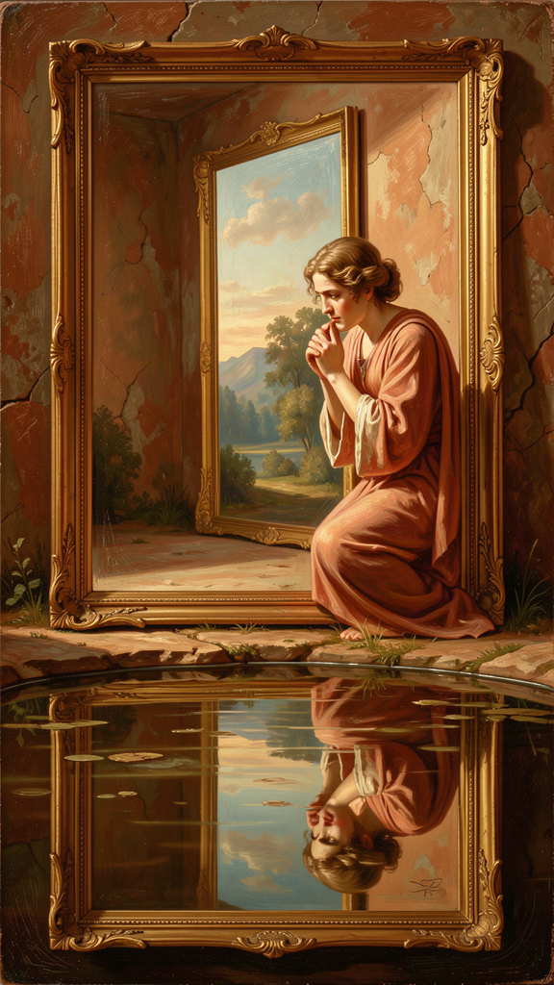
Illustration for Chapter 2
![Chapter 2](/images/booklets/socrates-adult-ch02.png)

The Trial
In 399 BCE, three men — Anytus, a democratic politician whose son Socrates had befriended; Meletus, a young poet; and Lycon, an obscure orator — brought formal charges against Socrates. The indictment, as reported in Diogenes Laertius, read: "Socrates is guilty of corrupting the young and of not believing in the gods in whom the city believes, but in other new spiritual things." The case went to a jury of hundreds of Athenian citizens, chosen by lot, in a system with no judge, no lawyers, no rules of evidence, and no professional legal expertise. The defendant spoke for himself.
Plato recorded the speech as the Apology. It is the most direct statement of Socrates' philosophical mission that survives, and it is also, in its own strange way, a provocation. Socrates did not grovel or flatter. He did not bring his family to the courtroom to win sympathy, as defendants commonly did. He did not promise to change his ways. He explained why he had spent his life asking questions and why he would not stop.

The Gadfly
Socrates told the jury the story of the oracle at Delphi. He explained how he had spent years testing the oracle's claim by questioning politicians, poets, and craftsmen. He said that his questioning was not a hobby or a nuisance but a divine mission — a task assigned to him by the god through the oracle. And he used an image that has become permanent in Western thought: the gadfly.
He compared Athens to a large, noble horse — great and capable, but in danger of growing sluggish. He compared himself to a fly that stings the horse into alertness. His questions were the sting. The city, he said, needed waking up. It had grown comfortable in its assumptions about justice, piety, and the good life. Socrates' questions were an attempt to disrupt that comfort — not to destroy the city but to keep it from drifting into unexamined decay.
This is a remarkable claim. Socrates is telling the jury that his annoying, disruptive, socially costly behavior is a public service. He is not the enemy of Athens. He is its physician. The medicine tastes bad. That does not mean it is not working. The image also contains a warning: a horse that kills the gadfly does not solve its problem. It simply goes back to sleep, and the sleep is dangerous. Socrates is implicitly telling the jury that executing him will not make their problems go away. It will just remove the one person who was trying to wake them up.

The Refusal
Then Socrates said something that sealed his fate. He told the jury that if they offered to let him go free on one condition — that he stop philosophizing, stop questioning, stop examining himself and others — he would refuse. He said he would keep doing what he had always done for as long as he lived. He said it was better to obey the god's command than to save his own life.
This is not a negotiating position. It is a declaration of identity. Socrates is telling the jury that they cannot buy him off. The thing they want him to stop doing — questioning, examining, exposing false confidence — is the thing that gives his life meaning. If he stops, he is no longer Socrates. If he stops, his life is not worth living:
"The unexamined life is not worth living for a human being." — Plato, *Apology* 38a

What It Means
This line is quoted constantly, often as a slogan. But its meaning is more specific than its fame suggests. Socrates is not saying that every moment must be spent in philosophical reflection. He is not against joy, friendship, athletics, or pleasure. He is saying something structural: a life in which you never stop to ask "Is this the right way to live? Am I being a good person? Do my values hold up under examination?" is a life that has surrendered the distinctive capacity that makes it human.
An animal lives by instinct. A human being can live by instinct too — and many do. But a human being also has the capacity to step back from instinct and ask: why am I doing this? Is it worth doing? Is there a better way? That capacity for self-examination is what separates a human life from a merely biological one. A life that never uses it has given up the thing that makes it human. It is sleepwalking.
The line also contains a threat and a promise. The threat is that unexamined opinions harden into prejudices. If you never question your assumptions — about other people, about what is fair, about what success means, about what your culture takes for granted — those assumptions become rigid. You cannot defend them, but you cannot let them go. They govern your behavior without your consent. The promise is that examination — even when it leaves you confused, even when it does not produce a clean answer — is the beginning of genuine understanding. The confusion is not failure. It is the door opening.

The Political Dimension
There is also a political dimension that the slogan form of the quotation obscures. Socrates is not just talking about individual self-help. He is saying that a city that never examines itself is asleep. Athens assumed its democracy was just, its empire was legitimate, its traditions were wise, its gods were satisfied. Socrates questioned all of it. The unexamined life applies to societies as well as to persons. A nation that never asks whether its laws are fair, its wars are justified, its economic system is humane, its priorities are sound, is a nation that is sleepwalking. Socrates' claim is that the gadfly — the person who asks the uncomfortable question — is not the enemy of the community but its necessity. Without the gadfly, the horse dozes. And a dozing horse can stumble into a ditch.
This has implications that reach beyond ancient Athens. Every society has its gadflies: journalists, whistleblowers, dissidents, satirists, philosophers, artists — people whose function is to question what everyone else takes for granted. They are rarely popular. They are often prosecuted, silenced, or killed. Socrates' argument is that the cost of silencing them is not just injustice to the individual but a danger to the community. A city that kills its gadflies does not achieve peace. It achieves sleep. And sleep, in political life, is the prelude to disaster.

The Verdict and Its Aftermath
The jury voted. A narrow majority — perhaps 281 to 220, though the exact numbers are disputed — found Socrates guilty. The penalty was death by hemlock.
Socrates had a chance to propose an alternative penalty. He offered, characteristically, not exile or a fine but free meals at public expense — the honor given to Olympic victors and other benefactors of the city. The jury found this impudent. The vote for the death penalty was larger than the vote for guilt, which means some jurors who had voted to acquit voted to execute, perhaps offended by Socrates' refusal to perform the conventional gestures of contrition. He was sent to prison to await execution.
The trial has been debated for 2,400 years. Was it a political trial disguised as a religious one? Socrates had been associated with Critias, the leader of the oligarchic coup of 404 BCE, and with Alcibiades, the charismatic general who defected to Sparta. Anytus, one of the accusers, was a leader of the restored democracy. The charges of "corrupting the young" may have been code for Socrates' association with men who had betrayed the democracy. I. F. Stone, in The Trial of Socrates (1988), argued that the democracy had legitimate grievances. The truth is probably a mixture: political resentment provided the motivation, philosophical activity provided the pretext, and the legal charges provided the mechanism.

Big Idea
The unexamined life is not worth living because self-examination is the capacity that makes human life distinctively human. A life that never questions its own assumptions has surrendered the thing that separates it from instinct. The claim applies to societies as well as individuals: a city that kills its gadflies does not achieve peace but sleep, and sleep is the prelude to disaster. Socrates chose death over the abandonment of examination, making the point not as an argument but as a life — and demonstrating that the examined life is not a comfortable intellectual exercise but a stance that may cost everything.

Practice
1. Map your unexamined assumptions. Spend thirty minutes writing down beliefs you hold but have never seriously questioned. Include beliefs about morality, politics, identity, and success. For each, ask: Where did this belief come from? Have I ever seriously considered the alternative? Could I defend it to a rigorous questioner? The goal is not to abandon your beliefs but to discover which ones are examined and which are inherited. You may be surprised by how many of your deepest convictions have never been tested.
2. Examine a social assumption. Pick one assumption your society treats as obvious — that economic growth is good, that education should be compulsory, that voting is a civic duty, that social media connects people, that privacy matters. Write a one-page essay arguing the opposite. You do not have to agree with the counter-argument. The exercise is to discover whether you can even formulate it. If you cannot, you may not understand the original assumption as well as you think. The inability to argue the other side is itself a sign of unexamined belief.
3. Audit your daily life. For one week, keep a log of how you spend your time — work, family, screens, conversation, solitude, service. At the end of the week, examine the log. Ask: Does the way I spend my time reflect what I say I value? If someone saw only this log, what would they conclude my values are? The gap between your stated values and your lived values is where the unexamined life operates. Most people, when they do this exercise, discover that their time goes to things they do not consciously choose and would not defend as their highest priorities. That discovery is the beginning of examination.

Reflect
Socrates chose death over silence. Is that admirable, fanatical, or something else? Is there anything you believe strongly enough that you would choose to die rather than abandon it? If the answer is no, does that mean you lack conviction — or does it mean your beliefs are not the kind of thing that martyrdom serves? The Stoic Epictetus, who was himself a former slave, wrote: "Others may kill me, but they cannot harm me." Is this Socratic calm in the face of death a form of wisdom, or is it a form of detachment from the very life it claims to value? When does the examined life become the unlived life?
———

Chapter 3: The Priority of the Soul
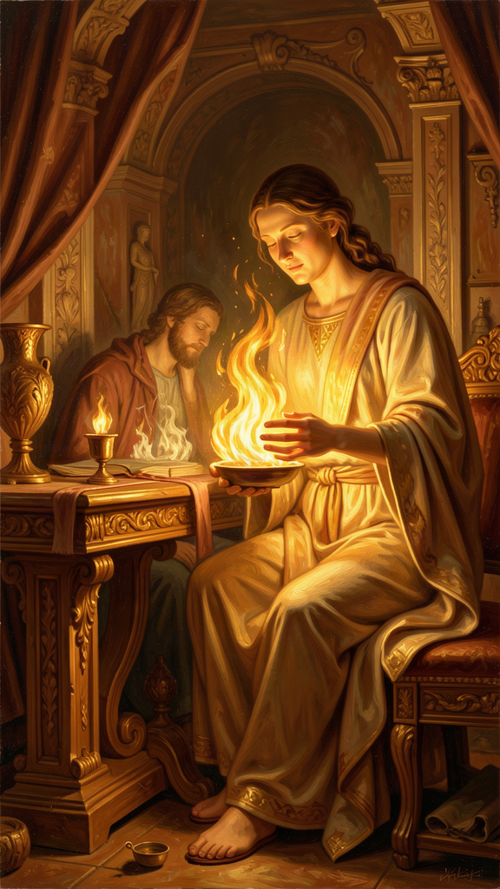
Illustration for Chapter 3
![Chapter 3](/images/booklets/socrates-adult-ch03.png)

The Accusation Turned Inward
During his defense speech, Socrates turned the logic of a trial inside out. Instead of simply defending himself — arguing that he was innocent, that he posed no danger, that the jury should acquit — he accused the jury. He told them that they were the ones in trouble. Not because of anything he had done, but because of what they cared about.
"Are you not ashamed of your eagerness to possess as much wealth, reputation, and honors as possible, while you do not care for nor give thought to wisdom or truth, or the best possible state of your soul?" — Plato, *Apology* 29e
The Athenians, Socrates said, were anxious about the wrong things. They spent their energy pursuing wealth, reputation, and honors. They worried about their bodies, their social standing, their political power. And they gave no thought to the one thing that determines whether a life is good or bad: the condition of their souls.

What the Soul Means
The word "soul" — in Greek, psyche — does not mean for Socrates what it often means in later religious traditions. It is not a ghost that floats free of the body at death, destined for heaven or hell. It means the whole moral and intellectual self: your character, your judgment, your capacity for truth and justice. It is the part of you that decides to be honest or dishonest, brave or cowardly, kind or cruel. You cannot weigh it or photograph it. But it is more truly you than your face, your body, or your possessions.
The translation matters. The Grube/Reeve translation uses "soul." Other translations use "self" or "the best possible state of yourself." The choice affects how we read the passage. "Soul" carries religious baggage that Socrates may not have intended. "Self" is more neutral but loses the sense that what is at stake is the core of moral agency. The Greek psyche is broader than either English word. It is the animating principle of a person — the thing that thinks, chooses, and acts. Whatever translation we use, the point is the same: the condition of your moral and intellectual self is more important than any external good.

The Socratic Scale of Values
The Socratic scale of values places the soul at the top. Below it are the external goods: wealth, reputation, power, physical health, beauty. These are not evil. Socrates does not preach asceticism for its own sake. But they are secondary. Their value depends on the soul to use them well. A wealthy person with a corrupt soul is worse off than a poor person with a just one, because the wealth only gives the corrupt person more power to do harm. A famous person without wisdom has no idea what to do with the attention. A powerful person without justice uses power to oppress.
The argument has a structure: external goods are conditional goods. They are good if the soul is in good condition, and bad if the soul is not. Money is good if you are wise enough to use it well; it is destructive if you are not. Fame is good if you have the judgment to handle it; it is corrosive if you do not. Power is good if you are just; it is tyrannical if you are not. The soul, by contrast, is an unconditional good. A good soul is good in itself, regardless of circumstances. It does not need anything external to complete its value.
This is why the soul comes first. Everything else depends on it. You can lose your money and still be a good person. You can lose your reputation and still be just. You can lose your health and still be wise. But if you lose your soul — if your character is corrupt, your judgment is warped, your honesty is gone — no amount of money, fame, or power can compensate. The soul is the only thing that is truly yours, in the sense that it is the only thing no one can take from you and the only thing whose condition is entirely in your own hands.

The Connection to the Gorgias
The priority of the soul is not an isolated claim in the Apology. It connects to a broader Socratic ethical framework that appears most fully in the Gorgias, one of the longest and most aggressive early dialogues. There, Socrates confronts three speakers — Gorgias, Polus, and Callicles — who represent different degrees of attachment to rhetoric and power. Socrates argues that rhetoric without knowledge is not a genuine art (techne) but a form of flattery — a way of pleasing the audience without improving it. The true art of politics, like medicine, aims at the good of the soul; rhetoric as commonly practiced aims only at persuasion.
The climax of the Gorgias is a debate with Callicles, who argues that the strong have a natural right to dominate the weak and that conventional morality is a trick invented by the weak to restrain the strong. Socrates responds by arguing that the person who does injustice without paying for it is worse off than the person who is wronged, because injustice damages the soul — the most important part of the self:
"It is better to suffer wrong than to do wrong." — Plato, *Gorgias* 469b
This claim connects the Gorgias directly to the Crito. Socrates is willing to die in Athens rather than do wrong by escaping, because harming the soul is worse than harming the body. The Gorgias also prepares the way for Plato's later political theory in the Republic: if politics is not guided by knowledge of the good, it becomes mere manipulation. The priority of the soul is the ethical foundation on which Socrates' political philosophy rests.

The Intellectualist Ethics
The priority of the soul is connected to one of the most debated claims in Socratic philosophy: the thesis that virtue is knowledge. In several dialogues — especially the Protagoras — Socrates argues that if someone truly knows what is good, they will do it. Bad actions come from ignorance, not from a separate desire for evil:
"No one errs willingly." — Plato, *Protagoras* 345d
This is the intellectualist view of virtue. It seems to deny akrasia — weakness of will, the phenomenon of acting against one's better judgment. We all know people who smoke, procrastinate, or say cruel things while knowing better. Socrates would reply that in such cases the person does not really know what is best. Their knowledge is not deep enough to govern their action. It is overwhelmed by pleasure, fear, or habit.
Aristotle explicitly rejected this view. In the Nicomachean Ethics (1145b22–27), he argued that akrasia is real: people can know the good and still fail to do it. The debate between Socratic intellectualism and Aristotelian acknowledgment of weakness of will is one of the oldest in philosophy, and it is not resolved. But the Socratic claim is not naive. It is a challenge: if you keep doing something harmful, perhaps you have not fully understood its harm. Perhaps what you call "knowing better" is really just acknowledging a rule you have memorized, not a truth you have internalized. The priority of the soul is not just about valuing the right things. It is about knowing them deeply enough that the knowledge actually shapes your behavior.

The Challenge to Our Priorities
This argument is as radical today as it was in 399 BCE. We live in a culture that measures success by external marks: salary, title, followers, net worth, awards, the size of a house, the brand of a car. Socrates asks us to flip the scale. What good is any of that if the person inside is dishonest, unkind, or unexamined? What good is a corner office if the person in it has never asked what a good life is? What good is a high net worth if the person who has it has no idea what is worth wanting?
There is a practical test. Ask yourself: who are the people you most admire? Are they the ones with the most money, the most followers, the most impressive résumés? Or are they the ones whose character you respect — the ones who are honest when honesty costs them, brave when courage is hard, kind when kindness is inconvenient, thoughtful when thoughtfulness is unfashionable? If you admire character more than achievement, you already agree with Socrates more than the culture around you. Your own judgment tells you to value the soul. The culture tells you to value the résumé. Socrates' argument is that your judgment is right and the culture is confused.
The difficulty is that the soul is invisible. You cannot put it on a résumé. You cannot list it on a performance review. You cannot photograph it or post about it. The culture measures what it can see, and the soul cannot be seen. This is why the Socratic priority of the soul is not just a philosophical claim but a practical rebellion against the metrics of success that govern most of our lives. It demands that we measure ourselves by a standard the world does not recognize and cannot verify.

Big Idea
The Socratic scale of values places the soul — your moral and intellectual character — above all external goods. Wealth, reputation, and power are conditional goods whose value depends on the soul to use them well. The soul is an unconditional good, the only thing that is truly yours and whose condition is entirely in your hands. The claim connects to Socrates' intellectualist ethics (virtue is knowledge; no one errs willingly) and to his argument in the Gorgias that it is better to suffer wrong than to do wrong. The priority of the soul is not just a philosophical thesis but a practical rebellion against external metrics of success.

Practice
1. Audit your values. Make two lists. On the left, list five things you are actively pursuing or proud of — achievements, possessions, recognition. On the right, list five qualities of character you aspire to. Now rank each list in order of how much time and energy you actually devote to it. Compare the rankings. Where does your time go? Does it match your stated priorities? The gap between what you value and what you pursue is the space where the unexamined life operates. Most people discover that their time goes to the left list and their aspirations go to the right. That gap is the measure of the work to be done.
2. Test the unconditional good. Write a two-page essay defending this claim: "A just person with nothing is better off than an unjust person with everything." First, argue for it as strongly as you can, drawing on Socrates' arguments in the Apology and the Gorgias. Then argue against it as strongly as you can, drawing on Aristotle's critique or your own experience of akrasia. Which argument did you find more convincing? Why? If you found the defense harder than the attack, ask yourself what that reveals about the assumptions of your culture.
3. Examine the craftsman's error in your profession. You have expertise in something. Do you also opine confidently about subjects outside your expertise? Do you hold strong views on economics, politics, medicine, education, or climate that you could not defend at the level you can defend your professional knowledge? Write down three such opinions. For each, ask: if someone challenged me to defend this with the rigor I expect of myself in my own field, could I? If not, what I have is the craftsman's error — expertise in one domain breeding false confidence in all others. Noticing this in yourself is harder and more important than noticing it in others.

Reflect
Socrates' argument assumes that the soul — moral and intellectual character — is more important than external goods. But is that always true? What about someone living in poverty, facing oppression, or struggling to survive? Is the priority of the soul a luxury that only the comfortable can afford? Martha Nussbaum and Amartya Sen have argued that external goods — nutrition, health, education, political freedom — are preconditions for the development of capabilities, including the capability for philosophical self-examination. On this view, the soul cannot be prioritized until the body is secure. Does this undermine Socrates' argument, or does it simply add a prerequisite? Can both be true: that the soul is the highest good, and that certain external goods are necessary for the soul to function?
———

Chapter 4: Crito and the Laws of Athens
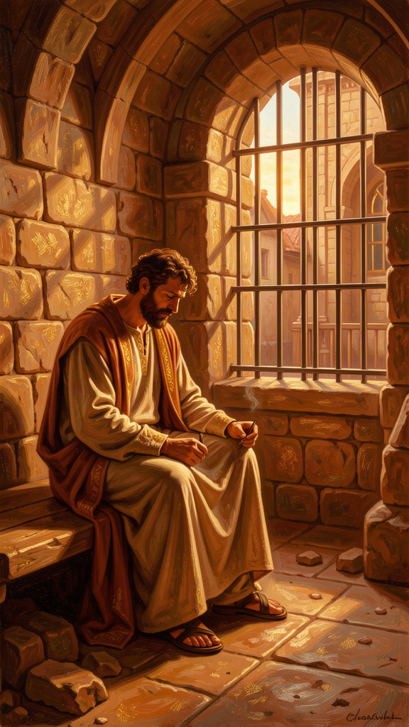
Illustration for Chapter 4
![Chapter 4](/images/booklets/socrates-adult-ch04.png)

The Prison
Socrates was found guilty and sentenced to death. But the execution was delayed. A sacred ship had been sent from Athens to the island of Delos on a religious mission commemorating Theseus's voyage to Crete, and an ancient custom forbade the city from carrying out executions until the ship returned. Socrates waited in prison for about a month.
His friends used that time to plan. His old friend Crito, a wealthy man who cared deeply about Socrates, arranged everything: money to bribe the guards, helpers to smuggle Socrates out, contacts in Thessaly and other cities where he could live in safety. All Socrates had to do was agree to leave.
Early one morning, before dawn, Crito came to the cell. He found Socrates sleeping peacefully. Crito was astonished — how could anyone sleep the night before a possible escape? He woke Socrates and laid out the plan. The ship would return any day. Time was running out.

Crito's Arguments
Crito made several arguments, each designed to appeal to a different moral instinct:
Reputation. If Socrates died, people would think his friends did not care enough to save him — that they were cheap, cowardly, or both. His death would shame the people who loved him.
Family. Socrates was abandoning his children. A father has a duty to raise his sons. How could he choose death when his children needed him?
Justice. The trial was unjust. The charges were false, the jury was prejudiced, the verdict was wrong. Escaping would not be breaking the law — it would be correcting an injustice. Socrates owed it to himself and to truth to resist a wrongful conviction.
Each argument is strong. Each appeals to a recognizable moral intuition: loyalty to friends, duty to family, resistance to injustice. Crito is not a villain. He is a friend who loves Socrates and cannot understand why Socrates will not save himself.

Socrates' Response
Socrates listened to every argument. Then he responded, calmly and systematically, in the conversation Plato recorded as the Crito. His answer rests on a single principle: it is never right to do wrong, even in return for wrong. This principle, stated early in the dialogue (49a–c), is the axiomatic foundation of the entire argument that follows.
Socrates agrees that the trial may have been unjust. But he argues that responding to injustice with more injustice does not make things right. Running away — breaking the laws of his own city, abandoning his agreements, damaging the community — would be doing wrong, regardless of whether the trial was fair. The soul is harmed by doing injustice, and harming the soul is worse than any harm to the body. Two wrongs do not make a right.
Then Socrates does something striking. He imagines the Laws of Athens speaking to him directly, as if they were standing in the cell. This is not a legal argument in the modern sense. It is a dramatic device — a personification — that lets Socrates stage a debate between himself and the system he is considering violating. The device is characteristic of Plato's method: instead of presenting a treatise on political obligation, he dramatizes the argument, giving the Laws a voice and letting the reader judge.

The Case of the Laws
The Laws make their case in several steps:
They raised him. The Laws provided the marriage customs that brought Socrates' parents together. They established the education system that trained him. They created the political order that gave him freedom and security. Socrates did not spring into existence independently. He was made by the city, through its laws.
He accepted the arrangement. Socrates lived in Athens his entire life — seventy years. He never chose to leave. He never emigrated. He traveled abroad only on military campaigns and always returned. By staying, he demonstrated consent to the city's arrangements. Athens was not a prison he was locked in. It was a home he chose.
The agreement is binding. If a citizen disagrees with a particular verdict, does that give him the right to ignore the whole system? If everyone who lost a case simply refused to accept the outcome, the laws would mean nothing. The city would collapse. By living under the laws and enjoying their benefits, Socrates entered into a kind of contract. He cannot enjoy the benefits for decades and then tear up the contract the moment it goes against him.
"Then consider, Socrates, whether we are right in saying that by attempting to escape you are attempting an injustice against us in a certain way." — Plato, *Crito* 50c
The argument is a form of social contract theory — arguably the earliest in Western philosophy. The Laws claim that the citizen's obligation is not merely to obey particular laws but to uphold the system that makes law possible. Escaping does not just break one rule. It attacks the authority of law itself. This is a strong claim, and it has been debated ever since.

The Harder Claim
Behind the personification lies a deeper philosophical claim. Socrates is not simply saying that obedience is convenient or that disobedience is risky. He is saying that doing injustice damages the soul — the most important part of the self — and that this damage is worse than any physical harm the city can inflict. The person who is wronged suffers in body or reputation. The person who does wrong suffers in character. Since the soul is more important than the body (the argument of Chapter 3), it is better to suffer injustice than to commit it. Escaping would save Socrates' body but ruin his soul. He chose his soul.
This is the same principle that appears in the Gorgias: it is better to suffer wrong than to do wrong (469b). The Crito and the Gorgias together present a consistent Socratic ethics: the soul is the highest good, injustice damages the soul, and therefore no benefit to the body — not even survival — is worth the cost of doing wrong. The argument is not that the laws are always right. It is that the cost of breaking them — to your own character — is higher than the cost of obeying them, even when they are wrong.

The Objection and the Modern Debate
The argument has provoked disagreement for 2,400 years, and the strongest objection goes to its core assumption. Socrates assumes that the Laws deserve respect because they benefited him. But what if the Laws are systematically unjust — not just mistaken in this one case, but structured to oppress? Does a citizen owe respect to a legal system that is fundamentally corrupt? Socrates' argument seems to assume that the social contract is basically fair. If it is not, the obligation to obey may not hold.
Later thinkers took this objection in a direction Socrates did not. Henry David Thoreau, in "Civil Disobedience" (1849), argued that when a law is unjust, the citizen has a duty to break it — peacefully, openly, and accepting the consequences. He refused to pay a poll tax that funded slavery and the Mexican-American War, and he spent a night in jail. Mahatma Gandhi expanded this into satyagraha — truth-force — a philosophy of nonviolent resistance that broke unjust laws openly and accepted the punishment, using the breaking of the law as a means to expose its injustice and force reform. Martin Luther King Jr., writing from a Birmingham jail in 1963, made the most influential statement of this position: "One has not only a legal but a moral responsibility to obey just laws. Conversely, one has a moral responsibility to disobey unjust laws." King argued that breaking an unjust law openly, with willingness to accept the penalty, is the highest respect for law — because it exposes the injustice and forces the community to confront it.
Socrates' position is more conservative. He accepts the punishment but refuses to break the law. King breaks the law and accepts the punishment. Both accept consequences. The difference is in the act itself: Socrates will not break the law even to save his life; King will break the law to expose injustice. The disagreement is not about whether consequences matter — both agree they do. It is about whether breaking an unjust law can itself be a form of respect for the moral order. Socrates says no: breaking the law damages the soul. King says yes: breaking an unjust law openly is the deepest form of respect for law, because it appeals to a higher law that the unjust law violates.
This debate is live and unresolved. It matters every time citizens face laws they believe are unjust — immigration laws, drug laws, surveillance laws, laws that discriminate. The question is not simply whether to obey or disobey. It is what obedience and disobedience mean, what they cost the soul, and what they owe the community.

Big Idea
Socrates argues that it is better to suffer injustice than to commit it, because injustice damages the soul — the highest good. A citizen who has benefited from a community's laws owes those laws respect, and breaking the law — even to escape an unjust verdict — is itself a wrong. The argument is an early form of social contract theory: by living under the laws and enjoying their benefits, the citizen consents to their authority. The disagreement with later thinkers who argue for principled lawbreaking (Thoreau, Gandhi, King) is not about whether consequences matter but about whether breaking an unjust law can itself be a form of respect for the moral order — or whether it is always a damage to the soul.

Practice
1. Stage the debate. Write a dialogue between Socrates and Martin Luther King Jr. on the question: "Is it ever right to break an unjust law?" Give each a substantial paragraph to make his case. Socrates argues that breaking the law damages the soul, even if the law is unjust. King argues that breaking an unjust law openly and accepting the consequences is the highest respect for law, because it exposes injustice and forces reform. Who makes the stronger case? Write a third paragraph stating your own position and your reasoning. Be honest about where your argument is weakest.
2. Test the contract. Socrates argues that by living under a community's laws and enjoying their benefits, you enter into an agreement to obey them. Does this hold? Consider: you did not choose to be born in your country. You did not choose its laws. You may not have had a realistic option to leave. Is living in a place the same as consenting to its laws? What would genuine consent look like? Is there a difference between implicit consent (staying) and explicit consent (a citizenship oath)? Write a two-page essay on what it means to owe a community obedience — and where the limits of that obligation lie.
3. Apply the principle. Think of a situation in your own life where you were treated unfairly — by an employer, an institution, a government agency, a relationship. Now ask: did you respond by doing something wrong in return (lying, cheating, retaliating, sabotaging)? Or did you accept the injustice without committing injustice yourself? Which choice left you feeling better — not in the short term, but over months and years? Does your experience support or challenge Socrates' claim that it is better to suffer injustice than to commit it? The answer may be more complicated than either Socrates or his critics allow.

Reflect
Socrates chose to die rather than break his word to his city. He called this integrity — wholeness, the condition of acting in accordance with your deepest principles even when it costs everything. But is there a point where integrity becomes rigidity? Is refusing to break a law you believe is unjust a sign of moral strength, or a failure to resist evil? Socrates and King both accepted death for their principles. Both were willing to pay the ultimate price. The difference is that King broke the law and Socrates did not. Which path is more just? Which is more effective? Can both be right — and if so, how do we know which to follow in a given situation?
———

Chapter 5: Socrates' Final Words
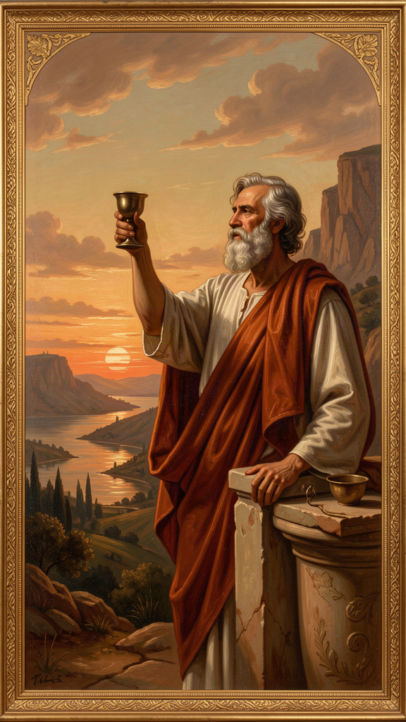
Illustration for Chapter 5
![Chapter 5](/images/booklets/socrates-adult-ch05.png)

The Last Day
The sacred ship returned. The delay was over. Socrates' friends came to the prison for the last time. The conversation that day, recorded by Plato in the Phaedo, is one of the most extraordinary scenes in Western literature.
The Phaedo is a complex dialogue. Its primary philosophical content is a series of arguments for the immortality of the soul — the cyclical argument, the theory of recollection, the affinity argument, and the final argument from the Theory of Forms. These arguments are more Platonic than Socratic. Most scholars believe the Theory of Forms, the arguments for immortality, and the metaphysical framework of the Phaedo belong to Plato, not to the historical Socrates. The early dialogues, which are our closest window onto Socrates, show no interest in metaphysics. They are concerned with ethics, definitions, and the examined life. The Phaedo represents Plato's own philosophical development, projected onto the figure of his teacher at the moment of death.
But the dramatic frame — a man about to die, calmly reasoning with his friends, refusing to weep or beg — is something else. Whether or not the arguments are Socratic, the scene itself is one of the most powerful in Western literature, and its power does not depend on the validity of the immortality proofs.

The Argument About Death
Socrates tells his friends not to fear death. Death, he says, is one of two things. Either it is a deep, dreamless sleep — and who would not prefer a peaceful sleep to a restless life? — or it is a journey of the soul to another place, where one could meet and converse with the great figures who had died before: Homer, Hesiod, the heroes of the Trojan War. If death is sleep, it is rest. If death is a journey, it is the greatest conversation imaginable. Either way, there is nothing to fear.
This is not bravado. Socrates is not pretending. He has spent his life arguing that the soul matters more than the body, that the examined life is worth more than unexamined survival, that doing right is more important than avoiding suffering. Now he is about to die, and he is calm. The calm is the argument. It demonstrates, in action, that a life lived in accordance with these principles leaves nothing to fear. The death is the proof that the philosophy was not just words.

The Poison
A servant entered carrying a cup of hemlock. The friends broke down. Socrates told them to be quiet. He did not want to die amid noise and weeping. He wanted composure.
He took the cup. He drank it, every drop, without hesitation. He walked around the cell as instructed, until his legs grew heavy. Then he lay down. The poison moved upward, numbing his body from the feet. A friend covered his face. Socrates pulled the covering away and spoke his last words:
"Crito, we owe a cock to Asclepius. Will you offer it?" — Plato, *Phaedo* 118

The Mystery
Asclepius was the god of healing. In Greek religious practice, people offered a rooster to Asclepius when they recovered from an illness — a thanksgiving for a cure. Why would a man about to die ask for a healing offering?
Scholars have debated this for centuries. Three main interpretations have emerged, and each changes how we read the entire scene.
The first reading: death as cure. On this interpretation, Socrates means that life in the body was a kind of disease, and death is the healing — the moment when the soul is freed from the body's corruptions. The offering to Asclepius is Socrates' way of saying that death has cured him. This reading fits the Phaedo's broader argument that the body is a prison of the soul and that philosophy is a preparation for death (melete thanatou). It makes Socrates' final act a statement that he has been liberated. The body was the ailment. Death is the remedy.
The second reading: ordinary piety. Socrates was a religious man. He spoke throughout his life of a divine inner voice — a daimonion — that warned him away from certain actions. He participated in the city's religious practices. His last words may simply be a final act of devotion: even at the moment of death, he remembers his religious obligations and ensures the offering is not forgotten. On this reading, the final words show not metaphysical triumph but humble piety — the philosopher who questioned everything still performs the small rites. This reading complicates the picture of Socrates as a rationalist who undermined traditional religion. He may have been both: the questioner and the pious man.
The third reading: final irony. Socrates spent his life leaving people with puzzles. His method was to ask a question that opened a problem, not to deliver a settled answer. His last words may be one more puzzle — a gift to his friends, something to think about and argue over for as long as they live. On this reading, Socrates is being himself to the very end: the man who leaves a question rather than an answer. The irony is that even his death becomes a teaching moment — not by resolving anything, but by provoking more thought. The last words are not a statement. They are a Socratic question in the form of a request.
We do not know which reading is correct. Perhaps Socrates meant all three. Perhaps he meant none. The mystery is part of the scene's power. The words are deliberately ambiguous, and the ambiguity has kept scholars arguing for 2,400 years — which may be exactly what Socrates intended.

Why the Death Endures
People die every day. Executions have happened in every century. What makes this death different?
The answer is that this death is a demonstration. Socrates spent his life making claims: the soul is more important than the body, the examined life is worth more than survival, doing right is more important than avoiding suffering, one should never do injustice even in return for injustice. At the end, he lived every one of those claims. He did not just preach them. He died for them. The death is the proof that the philosophy was not a set of abstract propositions but a way of being — and that Socrates was willing to die rather than abandon it.
This is why the scene has been remembered for 2,400 years. It is not the death of a philosopher. It is the life of a philosophy, made visible in its final moment. The composure, the argument, the refusal to weep or beg, the mysterious last words — all of it is Socrates being Socrates, one last time. The death does not validate the arguments. It shows what it looks like when someone actually believes them — and the spectacle of that belief is more persuasive than any argument could be.

The Socratic Problem and the Phaedo
A note on the Socratic Problem as it applies to this chapter. The Phaedo is where the distinction between the historical Socrates and Plato's literary creation becomes most visible. The arguments for immortality are almost certainly Plato's. The historical Socrates, as he appears in the early dialogues, shows no interest in metaphysics, does not argue for the immortality of the soul, and does not invoke the Theory of Forms. The Phaedo is Plato's eulogy as much as it is Plato's record.
This does not make the Phaedo unreliable as a source for the death itself. The basic facts are corroborated by Xenophon. What is Platonic is the metaphysical framework. What is likely Socratic is the composure, the refusal to fear death, and the mysterious final request. The death scene is probably close to what happened. The immortality arguments are probably what Plato wished Socrates had said.

Big Idea
Socrates' death is the enactment of his philosophy. His calm in the face of execution demonstrates — does not merely argue — that a life spent caring for the soul leaves nothing to fear. His final words, offered to the god of healing, are deliberately ambiguous: a cure, an act of piety, or a final puzzle. The mystery is itself a teaching: Socrates leaves his friends with a question, as he always did. The death endures because it shows what it means to live according to your principles, all the way to the end. The Phaedo's immortality arguments are Plato's; the death scene itself is probably close to historical.

Practice
1. Interpret the final words. Choose one of the three scholarly readings — death as cure, ordinary piety, or final irony — and write a three-page essay defending it. Use evidence from the Phaedo and from what you know of Socrates' character from the other early dialogues. Then write a second essay arguing against your own interpretation. Which reading did you find harder to defend, and why? Does the ambiguity itself tell us something about Socrates' philosophical method? Is the unresolvability of the final words a feature or a bug?
2. Examine your relationship to death. Socrates said death is either dreamless sleep or a journey of the soul. Neither frightened him. What frightens you about death? Is it the loss of consciousness, the loss of relationships, the loss of the future, the unknown, the process of dying, the injustice of it, or something else? Write honestly — not what sounds philosophical, but what is true. Then ask: does Socrates' argument address your fear, or does it miss what actually scares you? Epicurus later argued that "death is nothing to us, since when we are, death is not, and when death is, we are not." Does this help, or is it a rationalization that misses the emotional core of the fear?
3. Identify your demonstration. Socrates' death was the demonstration of his life's philosophy. What would the "demonstration" of your principles look like? If you had to show, not just say, what you believe — if you had to live it in a way that was visible, costly, and undeniable — what would that look like? Write a page describing the moment where your principles would be tested and how you hope you would respond. This is not a fantasy. It is an audit of what you actually believe, measured by what you would be willing to do. If you cannot identify such a moment, ask yourself whether your principles are real or merely stated.

Reflect
Socrates met death with calm because he believed the soul mattered more than the body. But what if he was wrong? What if death is simply the end — no journey, no conversation, no soul continuing? Does that make his calm less admirable, or more? Is courage in the face of death more impressive if there is something on the other side, or if there is nothing? Camus argued that the recognition of absurdity — life without ultimate meaning, death without afterlife — is the starting point for authentic rebellion and freedom. Is Socrates' calm a form of what Camus described, or is it dependent on a metaphysics that may not hold?
———

Chapter 6: Euthyphro's Dilemma
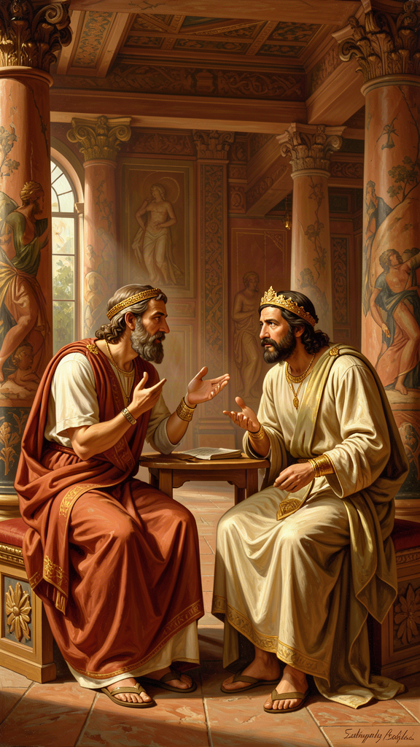
Illustration for Chapter 6
![Chapter 6](/images/booklets/socrates-adult-ch06.png)

The Meeting
The Euthyphro takes place outside a courthouse in Athens. Socrates is there to answer preliminary charges — the same charges that will eventually lead to his trial. He meets a man named Euthyphro, who is also at the courthouse, but for very different business.
Euthyphro is prosecuting his own father for murder. A servant on the family estate had killed a man. Euthyphro's father bound the servant and left him in a ditch while he sent for a religious authority to decide what to do. The servant died in the ditch. Euthyphro believes that piety demands he prosecute his own father, regardless of family loyalty.
Most Athenians found this shocking. Turning against your own father violated deep conventions about filial duty. But Euthyphro is not troubled. He is supremely confident. He is certain that he knows what piety is — what is holy, what is right, what the gods require.
When Euthyphro hears that Socrates has been charged with impiety, he is mildly interested. Socrates, with his usual instinct, sees an opportunity. He says: you are so confident about what piety is that you are prosecuting your own father. You must know a great deal. Will you teach me?

The Definitions
Euthyphro offers several definitions. Socrates tests each one.
First definition: piety is prosecuting wrongdoers. Socrates points out that this is an example, not a definition. He wants the essential characteristic (eidos) that makes something pious — the form — not one instance of it. Euthyphro's prosecution of his father might be pious, but it does not tell us what piety is.
Second definition: piety is what is pleasing to the gods. But the Greek gods famously disagree. They quarrel, fight, and take sides in human conflicts. If the gods disagree, then the same action could be pious (loved by some gods) and impious (hated by others) simultaneously. The definition makes piety incoherent. This objection reflects the polytheistic context of Greek religion; in a monotheistic framework, the objection would need to be reformulated.
Third definition: piety is what *all* the gods love. Euthyphro revises: the pious is what all the gods love, and the impious is what all the gods hate. This seems to solve the disagreement problem. If we stipulate that the gods agree, then piety is whatever enjoys universal divine approval.
"The pious is what all the gods love, and the opposite, what all the gods hate, is the impious." — Plato, *Euthyphro* 9e

The Question
Socrates then asks the question that has never stopped being asked:
"Is the pious loved by the gods because it is pious, or is it pious because it is loved by the gods?" — Plato, *Euthyphro* 10a
This is the Euthyphro dilemma. It looks like a grammatical puzzle, a question about word order. It is one of the most important questions in the history of ethics.
Option A: Something is pious because the gods love it. On this view, the gods' love creates the piety. The piety did not exist before the gods loved it. If the gods changed their minds and loved cruelty, cruelty would become pious. If they hated kindness, kindness would become impious. Goodness is whatever the gods happen to prefer. Morality is a matter of divine taste. This makes morality arbitrary: there is no reason the gods love what they love, and if they loved something different, morality would be different. There is no standard of goodness independent of divine preference. We cannot ask "but is it really good?" because "really good" just means "loved by the gods."
Option B: The gods love something because it is pious. On this view, the piety exists independently of the gods. The gods recognize it and love it, but they did not create it. Something is pious because it is genuinely good, and the gods, being wise, love what is good. But this means there is a standard of goodness that is bigger than the gods — a standard they did not invent and cannot change. The gods are not the source of goodness. They are its most perceptive observers. They love the good because it is good, not the other way around.
Both options lead somewhere uncomfortable. If goodness is just whatever the gods say (Option A), then morality is arbitrary and there is no deeper reason to call anything good or bad. "Good" means nothing more than "commanded." If goodness exists independently of the gods (Option B), then the gods are not ultimate. There is something above them — a moral reality they must conform to. This challenges divine omnipotence, because even God cannot change what is genuinely good. And it raises the question of where this independent standard comes from. If goodness is not created by the gods, what is it? Is it a Platonic Form? A feature of reality? A human construction that even the gods are subject to?

Beyond the Gods: The General Form
The dilemma does not apply only to Greek gods. It applies to any authority that claims to define morality. Replace "the gods" with "the government," "the church," "your parents," "your culture," "the Constitution," "the scientific consensus," or "the market." The same question arises: is something good because the authority says so, or does the authority say so because it is already good?
This is not a word game. It has concrete implications. Consider a government that passes a law. Is the law just because the government enacted it — because the government has the authority to define justice? Or is the law just because it conforms to a standard of justice that exists independently, a standard the government is supposed to follow? If you believe the first, then any law a government passes is automatically just, and injustice becomes impossible by definition. If you believe the second, then a government can pass unjust laws, and the fact that it enacted them does not make them right. Most people, when pressed, believe the second. But the second means that justice is not created by authority. It is recognized by authority. And that raises the hardest question: where does the standard come from, and how do we know it?

The Dilemma's Descendants
The Euthyphro dilemma reappears in multiple philosophical traditions, in forms that map directly onto Socrates' original question.
Divine command theory. In medieval and modern theology, the dilemma becomes: does God command something because it is good, or is it good because God commands it? William of Ockham defended the second option: morality is whatever God commands, and God could have commanded the opposite. This preserves divine omnipotence but makes morality arbitrary. Thomas Aquinas defended the first option: God commands what is good because it is good, and the good is grounded in God's own nature. This preserves the objectivity of morality but means God cannot change it. The debate is a direct descendant of the Euthyphro.
Legal positivism versus natural law. In jurisprudence, the dilemma becomes: is law whatever the sovereign enacts (positivism), or must law conform to a moral standard to be valid (natural law)? H. L. A. Hart defended versions of positivism: a law is a law regardless of its moral content. Lon Fuller and John Finnis defended versions of natural law: a legal system that grossly violates justice is not a legal system at all. The debate maps exactly onto Socrates' question: is the law just because the authority enacted it, or did the authority enact it because it conforms to an independent standard?
Moral realism versus moral constructivism. In meta-ethics, the dilemma becomes: are moral truths discovered (realism) or invented (constructivism)? If moral truths exist independently — as features of reality, as Platonic Forms, as grounded in human nature — then authorities recognize them but do not create them. If moral truths are constructed — by cultures, by evolution, by agreements — then they are whatever the constructing authority makes them. The debate is the modern form of the Euthyphro dilemma.
The dilemma's persistence across theology, law, and meta-ethics is evidence of its depth. Socrates identified a structural problem in the relationship between authority and value that reappears wherever someone claims that an authority defines morality. The problem does not go away by changing the authority. It goes away only if one of the two options can be defended — and neither has been decisively defended in 2,400 years.

The Aporia and the Method
Socrates does not resolve the dilemma. He does not offer his own theory of what makes something pious. He leaves it as a problem. Euthyphro, unable to answer, tries to change the subject, grows frustrated, and finally claims he is in a hurry. He rushes away. Socrates calls after him, but Euthyphro is gone. The dialogue ends in aporia — that productive standstill where confidence gives out and genuine thinking can begin.
This is characteristic. Socrates' goal was not to win arguments. It was to expose the gap between confidence and understanding. Euthyphro thought he knew what piety was — he was so sure he was willing to prosecute his own father. After a few questions, he discovered he could not defend his own definition. That discovery — not the resolution of the dilemma, but the recognition that it exists — is where philosophy begins.
The Euthyphro is also a portrait of a method. Notice how Socrates operates. He does not attack Euthyphro directly. He does not say "you are wrong." He asks questions. He lets Euthyphro's own answers defeat themselves. He uses the interlocutor's own premises to generate contradictions. This is the Socratic method (elenchus) at its purest: not lecturing, not refuting from outside, but drawing out the internal inconsistency in the other person's position and letting them see it for themselves. The method is not aggressive. It is diagnostic. Socrates is not trying to defeat Euthyphro. He is trying to show Euthyphro that Euthyphro does not know what he thinks he knows. The frustration and the flight are Euthyphro's response to that diagnosis, not to Socrates' hostility.

Big Idea
The Euthyphro dilemma asks whether morality is created by authority or recognized by it. If goodness is whatever authority commands, morality is arbitrary. If authority recognizes a goodness that exists independently, then authority is not the source of value. The dilemma applies to every authority — gods, governments, parents, cultures, markets — and it has no easy resolution. Its descendants include divine command theory, the debate between legal positivism and natural law, and the dispute between moral realism and constructivism. Socrates does not solve the dilemma. He makes it visible, and in doing so, he opens the space for genuine philosophical inquiry. The method matters as much as the content: Socrates does not tell Euthyphro he is wrong. He asks questions that let Euthyphro discover it for himself.

Practice
1. Apply the dilemma. Choose an authority in your life — a government, a religious tradition, a legal system, a cultural norm, an employer. Identify a rule that authority sets. Now write both sides of the dilemma: (A) This rule is good because the authority says so. What follows? If the authority changed the rule, would the new rule be equally good? (B) The authority says the rule is good because it is already good. What follows? Is there a standard above the authority? How would we know it? Which side do you find more convincing, and what are the consequences of your choice for the authority's legitimacy?
2. Trace a descendant. Research one of the dilemma's modern descendants in depth: divine command theory (Aquinas vs. Ockham, or the modern debate between Robert Adams and Philip Quinn), legal positivism versus natural law (Hart vs. Fuller, or Austin vs. Finnis), or moral realism versus constructivism (Railton vs. Korsgaard, or Mackie vs. Parfit). Write a three-page summary of how the debate maps onto Socrates' original question and where the modern arguments have taken it. Has the dilemma been resolved, reformulated, or merely restated?
3. Practice the *elenchus*. Find someone who holds a confident moral view. Without being hostile or combative, ask them to define their terms. If they say "X is wrong," ask "What do you mean by wrong?" If they give a definition, ask a follow-up that tests it: "But what about this case? Does your definition cover it? What if someone disagreed — where would they be right?" See how many questions it takes before their confidence wavers. The goal is not to win or to embarrass. It is to discover, as Socrates did, where confidence outruns understanding — in others and in yourself. Then turn the method on yourself: pick one of your own confident moral views and subject it to the same questioning.

Reflect
The Euthyphro ends without an answer. Socrates leaves Euthyphro confused and walks away. Is this satisfying? Is a question that produces only more questions valuable, or is it just frustrating? Socrates seems to believe that honest confusion is better than false confidence — that the recognition of not-knowing is the beginning of wisdom. But is there a point where this becomes counterproductive? Can a society function if no one is willing to commit to an answer? Aristotle, who wrote after Socrates and Plato, believed that philosophy must eventually move from aporia to positive doctrine — that questioning, however valuable, must eventually yield to constructive argument. Is Aristotle right? Is there a tension between the Socratic love of questioning and the practical need to act, decide, and build? Where do you draw the line between healthy questioning and destructive skepticism — and who draws it?
———

For the Grown-Up Reader
This booklet is the adult-level entry in the WisdomForge Socrates series. It presents Socrates through six chapters drawn from Plato's early dialogues, engaging with the philosophical content at a level appropriate for adult readers and incorporating scholarly debates from the secondary literature.
All quotations are genuine, drawn from the cited Plato dialogues. The translations follow the Grube/Reeve versions in Plato: Complete Works (Hackett, 1997), the standard scholarly reference in English. The secondary sources referenced include Gregory Vlastos (Socrates: Ironist and Moral Philosopher, 1991), Charles Kahn (Plato and the Socratic Dialogue, 1996), I. F. Stone (The Trial of Socrates, 1988), and the Stanford Encyclopedia of Philosophy entry on Socrates.
A few notes on the scholarly choices:
- The oracle story (Apology 21a–23b) is presented with attention to both its epistemological content (Socratic ignorance) and its social cost. The chapter addresses the Socratic Problem directly, using Vlastos's "two Socrateses" framework and Kahn's counter-argument. The historicity of the oracle episode is noted as disputed but treated as philosophically significant regardless of its factual status. - The unexamined life (Apology 38a) is presented in its trial context and extended from individuals to societies. The chapter engages with I. F. Stone's argument that the trial had political dimensions — Socrates' association with Critias and Alcibiades — and treats the trial as a mixture of political resentment and philosophical pretext. - The priority of the soul (Apology 29e) is connected to the broader Socratic ethical framework in the Gorgias (469b: "it is better to suffer wrong than to do wrong") and to the intellectualist thesis that virtue is knowledge (Protagoras 345d: "no one errs willingly"). The chapter engages with Aristotle's rejection of this thesis (Nicomachean Ethics 1145b22–27) and with modern capability theory (Nussbaum, Sen) as a potential challenge to the priority of the soul under conditions of deprivation. - The *Crito (50a–54e) is presented as an early form of social contract theory and is compared with later thinkers (Thoreau, Gandhi, King) who argue for principled lawbreaking. The chapter takes seriously the strongest objection — that the argument assumes a basically fair contract — and leaves the debate unresolved, as it is in the scholarly literature. - The Phaedo* chapter explicitly distinguishes the dramatic frame (probably close to historical) from the immortality arguments (almost certainly Platonic). The three readings of the final words are presented without resolution. The chapter engages with the question of whether Socrates' calm depends on metaphysical commitments that may not hold, drawing on Camus as a counterpoint. - The Euthyphro (9e–10a) is presented in full and extended beyond theology to political, legal, and meta-ethical authority. The chapter traces the dilemma's descendants: divine command theory (Aquinas vs. Ockham, Adams vs. Quinn), legal positivism vs. natural law (Hart vs. Fuller, Austin vs. Finnis), and moral realism vs. constructivism (Railton vs. Korsgaard, Mackie vs. Parfit). The aporia ending is treated as philosophically productive, and the chapter engages with Aristotle's view that philosophy must eventually move from aporia* to positive doctrine.
On the Socratic Problem: Socrates wrote nothing. Everything comes through Plato (primary), Xenophon (alternative), and Aristophanes (comic caricature). The early dialogues are the closest to the historical Socrates. The Phaedo's metaphysical arguments are Plato's own. Xenophon's Socrates is more conventional. Aristophanes' is a caricature that may have shaped public opinion. This booklet acknowledges these complications throughout and treats the Socrates of the early dialogues as a philosophical reconstruction — which is, paradoxically, what makes him philosophically alive. A figure we could recover with certainty would be a person. A figure we can only reconstruct through competing testimonies is a philosophical problem. And Socrates, who spent his life insisting that the recognition of uncertainty is the beginning of wisdom, would have approved.
———

About WisdomForge
WisdomForge creates age-adapted booklets that bring the great thinkers of human history to readers of every age. Each booklet takes a single figure — a philosopher, theologian, scientist, or sage — and presents their most important ideas in a form suited to the reader's stage of life.
Every WisdomForge figure gets four booklets: one for elementary ages (5–10), one for middle school (11–14), one for high school (15–18), and one for adult readers. The same core ideas appear in all four, but the depth, vocabulary, and style change. A child meets Socrates as a story character. A teenager meets him as a thinker with arguments to wrestle with. An adult meets him as a figure whose questions still shape philosophy, law, theology, and ethics today — and as a figure whose historical reality is itself a philosophical problem.
WisdomForge uses only real quotes, cited by source. We do not invent words and put them in a thinker's mouth. When Socrates speaks, the words come from Plato's dialogues, and the dialogue is named. When scholarly debates are referenced, the sources are named. The secondary literature is drawn from the standard scholarly works in the field.
Our booklets are written in the spirit of the thinkers themselves: clear, honest, and unwilling to settle for easy answers. We believe that the best ideas do not decay. They wait, like seeds, for the right reader to pick them up.

