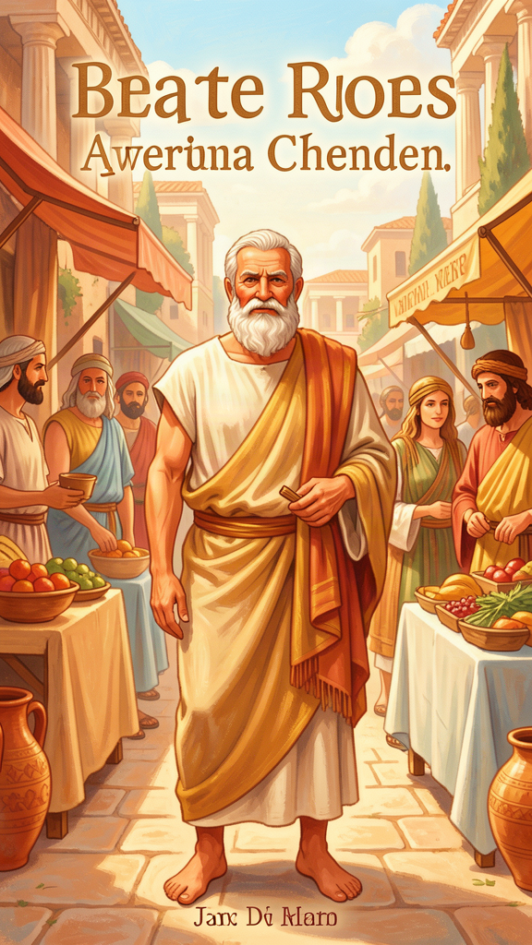
The Man Who Asked Questions
WisdomForge Booklet — Ages 5–10

The Man Who Asked Questions

WisdomForge Booklet — Ages 5–10
———

About This Book
A long time ago, about 2,400 years ago, there lived a man in a city called Athens. His name was Socrates (say it like SOCK-ruh-teez). He did not build castles. He did not command armies. He did not own a treasure chest. He did something that made him famous forever: he asked questions.
Socrates walked the streets of Athens and talked to people. He asked them what it meant to be a good person. He asked them what it meant to be brave, or fair, or wise. He asked them if they really knew what they thought they knew.
Socrates never wrote any books. Not one. He believed that the best way to learn was to talk with people, face to face, and to ask questions that made them think. Because he wrote nothing himself, we know him through the stories his student Plato wrote down. Plato wrote little plays called dialogues — conversations between Socrates and the people he met.
In this book, you will read six stories about Socrates. Each one teaches a big idea about thinking, living well, and caring about the things that matter most. You will meet the oracle who said Socrates was the wisest man alive. You will hear why he thought asking questions was the most important thing a person could do. You will follow him into prison, where he chose to stay even when friends offered to help him escape. And you will hear the very last words he spoke.
Socrates asked questions because he believed that a person who never stops to think about how they are living is like someone who is asleep. His questions were a way of waking up. This book is an invitation to wake up too — to ask, to wonder, and to think for yourself.
———

Chapter 1: The Oracle at Delphi — No One Is Wiser
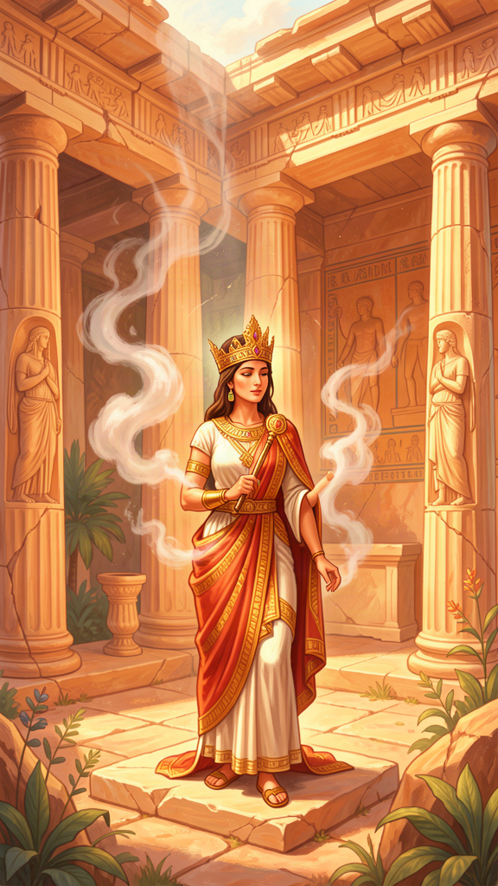
Illustration for Chapter 1
![Chapter 1](/images/booklets/socrates-elementary-ch01.png)
The city of Athens sat on a rocky hill above the sea. It was busy and loud. Merchants sold olives and pottery in the marketplace. Children ran between the stalls. Soldiers drilled in the open squares. In the middle of all this noise walked a man who did not look like much. He was short, a bit round in the middle, with a snub nose and big eyes. He wore an old cloak and often went barefoot. His name was Socrates.
Socrates was not rich. He did not hold an important job. He spent his days doing one thing: talking. He talked to people everywhere — in the market, in the workshops, by the gymnasium where athletes trained. He asked them questions. What is courage? What is justice? What makes a person good? Most people he asked thought they already knew. But after talking with Socrates for a while, they were not so sure.
One day, a friend of Socrates named Chaerephon traveled to a place called Delphi. Delphi was famous for its oracle — a priestess who sat in a temple and was said to speak for the gods. People came from all over Greece to ask the oracle important questions.
Chaerephon loved his friend Socrates. He wanted to know if Socrates was the wisest person in the world. So he asked the oracle a bold question: "Is anyone wiser than Socrates?"
The oracle answered: "No one is wiser."
When Chaerephon came home and told Socrates what the oracle had said, Socrates was confused. He did not feel wise at all. He knew that he did not have any special knowledge. He could not build a ship or command an army. He could not predict the weather or explain how the stars moved. How could the oracle say he was the wisest?
Socrates decided to test the oracle. He would go to people who were famous for being wise — politicians, poets, craftsmen — and ask them questions. He would see if they really knew more than he did.
He went to a politician who everyone said was wise. Socrates asked him questions about justice and the good life. The politician gave confident answers. But as Socrates kept asking — "But what do you mean by that?" and "If that is true, then how about this?" — the politician's answers began to wobble. It turned out that the politician only seemed wise. He did not really understand what he was talking about.
Socrates went to the poets next. The poets wrote beautiful words that moved people. But when Socrates asked them what their poems meant, many of them could not explain. They wrote by feeling and habit, not by knowledge. They were like people who could sing a song but not say what it was about.
Finally, Socrates went to the craftsmen — the people who made shoes, built wheels, and shaped metal. These people did know their trades. A shoemaker knows how to make a good shoe. But the shoemaker, proud of his skill, also thought he understood politics and the meaning of life. He did not. Because he was good at one thing, he thought he was good at everything.
After talking to all these people, Socrates understood what the oracle meant. The oracle was not saying that Socrates knew everything. The oracle was saying something more surprising: Socrates was wiser than the others because he knew that he did not know. The politicians, poets, and craftsmen all thought they knew things they did not know. Socrates, at least, was honest about what he did not know.
This was a strange kind of wisdom. It was not the kind of wisdom where you have all the answers. It was the kind of wisdom where you understand the limits of what you know — and you keep asking questions to learn more.

Words to Remember
"I am wiser than this man: neither of us knows anything, but he thinks he knows something, while I know nothing. Yet I appear to be wiser in just this one respect: if I do not know something, I do not think that I do." — Plato, *Apology* 21d

Big Idea
The wisest people are not the ones who have all the answers. They are the ones who know what they do not know — and are not afraid to ask questions to find out more.

Try This
Think of something you feel very sure about — something you think you know well. Now ask yourself: "How do I know this is true? Could I be wrong?" Ask a grown-up to help you find one thing you only thought you knew. Notice how it feels to discover you did not know as much as you thought.

Ask a Grown-Up
Ask a grown-up: "What is something you used to think you knew, but later found out you were wrong about?" Listen to their story. Then ask: "How did it feel to find out you were wrong?"
———

Chapter 2: The Unexamined Life Is Not Worth Living
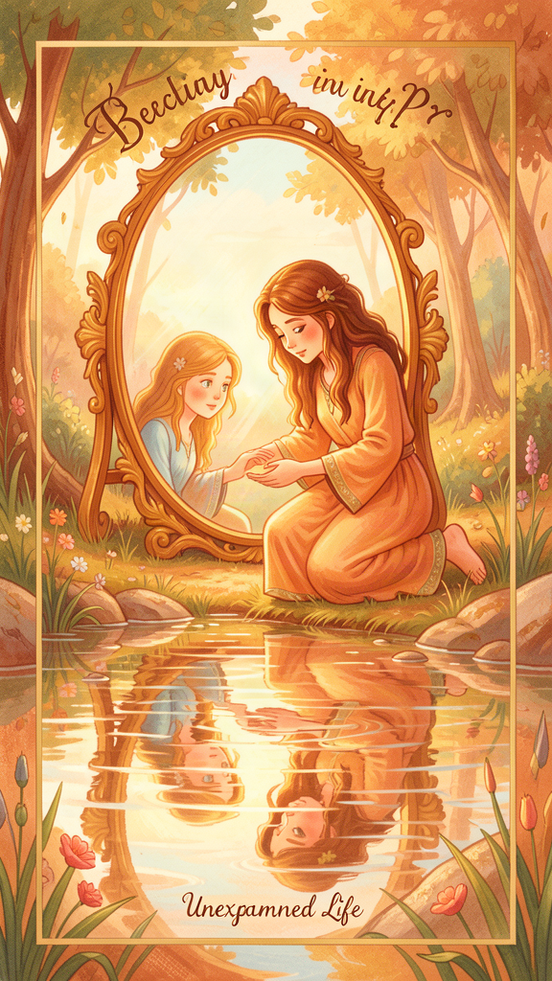
Illustration for Chapter 2
![Chapter 2](/images/booklets/socrates-elementary-ch02.png)
Socrates kept asking questions, day after day, year after year. He believed that questioning was not just a fun hobby. He believed it was the most important thing a person could do.
Some people in Athens loved talking with him. They liked the way his questions made them think in new ways. But other people grew tired of him. He made them uncomfortable. He showed them that they did not know as much as they thought. That felt embarrassing. Some powerful people decided they wanted to get rid of him.
They brought Socrates to trial. They accused him of two things: not believing in the gods the city believed in, and corrupting the young — teaching them to question everything, even their parents and teachers.
Socrates stood before a large jury of Athenian citizens — hundreds of them — and gave a speech defending himself. We know this speech because Plato wrote it down. It is called the Apology, which means "defense." In it, Socrates explained why he had spent his whole life asking questions.
He told the jury the story of the oracle. He explained how he had tested the oracle by talking to politicians, poets, and craftsmen. He said that his questioning was a kind of mission — something he was supposed to do. He believed the god had put him in Athens to be a "gadfly," like a fly that stings a big, lazy horse and wakes it up. The city of Athens, he said, was like a big horse that had gotten lazy and needed to be woken up by questions.
Then Socrates said something brave. He said that even if the jury offered to let him go free on one condition — that he stop asking questions and mind his own business — he would not agree. He said he would keep questioning people for as long as he lived. He said it was better to obey the god than to save his own life.
And then he said the most famous words he ever spoke:
"The unexamined life is not worth living for a human being." — Plato, *Apology* 38a
What does this mean? It means that a life where you never stop to think — never ask "Am I doing the right thing?" or "Is this the best way to live?" — is not really a full life. It is like sleepwalking. You go through the motions, but you never truly wake up to understand what you are doing and why.
Imagine eating the same meal every day without ever tasting it. Imagine walking the same path every day without ever looking around to see where you are. That is what an unexamined life is like. You are alive, but you are not paying attention.
Socrates was not saying you should think hard every single minute. You should play and laugh and rest. But he was saying that if you never ask yourself "Am I being a good person?" or "What matters most?" then your life is missing something important. The questions are what make us human.
The jury listened. Many of them were angry. They voted to find Socrates guilty. The punishment was death.

Words to Remember
"The unexamined life is not worth living for a human being." — Plato, *Apology* 38a

Big Idea
Thinking about how we live — asking "Am I being good? Am I doing the right thing?" — is not extra. It is what makes life worth living. A life without questions is like sleepwalking.

Try This
Tonight, before you go to sleep, ask yourself one question: "What did I do today that I feel good about?" Then ask: "Is there anything I wish I had done differently?" You do not have to answer out loud. Just thinking about it is enough. That small moment of thinking is what Socrates meant by examining your life.

Ask a Grown-Up
Ask a grown-up: "What is one question you wish you had asked earlier in your life?" Listen to what they say. Then ask: "Why was that question important?"
———

Chapter 3: The Priority of the Soul

Illustration for Chapter 3
![Chapter 3](/images/booklets/socrates-elementary-ch03.png)
At his trial, Socrates said something that surprised the jury. He told them they were worrying about the wrong things.
The people of Athens cared a lot about money, reputation, and looking good to others. They wanted to be rich, famous, and admired. Socrates said that those things were not bad, but they were not the most important things. He said the most important thing was something he called the "soul."
The soul, for Socrates, does not just mean a ghost inside your body. It means the whole of who you are inside — your thoughts, your choices, your character. It is the part of you that decides to be brave or cowardly, kind or cruel, honest or dishonest. You cannot see it or touch it, but it is more truly you than your face or your clothes or your toys.
Here is what Socrates told the jury:
"Are you not ashamed of your eagerness to possess as much wealth, reputation, and honors as possible, while you do not care for nor give thought to wisdom or truth, or the best possible state of your soul?" — Plato, *Apology* 29e
Socrates was not saying that money and nice things are evil. He was saying they are not the main thing. Think of it like this: if you have a beautiful bicycle but never learn to ride it well, what good is the bicycle? If you have a great house but never take care of the people inside it, what good is the house? In the same way, if you have money and fame but your soul — your character — is in bad shape, those things cannot make you truly happy.
The soul is like a garden. If you tend it — by thinking about what is right, by practicing honesty and kindness, by asking good questions — it grows into something beautiful. If you ignore it, weeds grow. And no amount of money can pull the weeds out for you. Only you can take care of your own soul, by paying attention to the kind of person you are becoming.
Socrates believed that a person with a good soul is better off than a rich person with a bad one. A just person with little money is richer in what matters than an unjust person with piles of gold. The care of the soul comes first. Everything else — wealth, success, praise — comes after.
This is a hard idea, even for grown-ups. We all want to have nice things and be liked by others. But Socrates reminds us that the most important question is not "What do I have?" but "What kind of person am I?"

Words to Remember
"Are you not ashamed of your eagerness to possess as much wealth, reputation, and honors as possible, while you do not care for nor give thought to wisdom or truth, or the best possible state of your soul?" — Plato, *Apology* 29e

Big Idea
The most important thing about you is not what you own or how famous you are. It is what kind of person you are inside — your soul, your character. That is what you should care about most.

Try This
Draw a picture with two halves. On one half, draw things you have — your home, your toys, your clothes, your food. On the other half, draw things you are — kind, curious, brave, honest, a good friend. Now look at both halves. Which one matters more to the kind of person you are becoming? Talk about your picture with a grown-up.

Ask a Grown-Up
Ask a grown-up: "What do you think it means to take care of your soul?" Listen to their answer. Then ask: "How do you try to do that in your own life?"
———

Chapter 4: Crito and the Laws of Athens
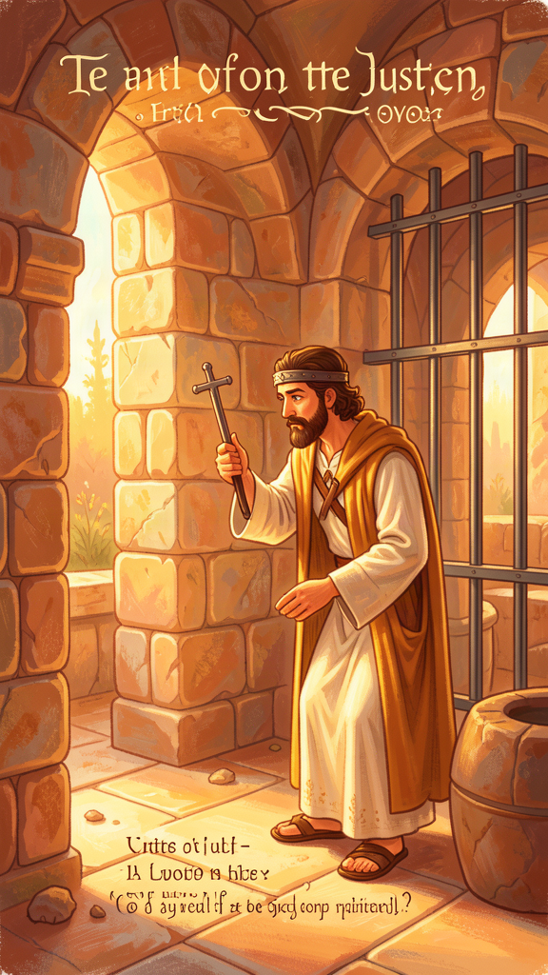
Illustration for Chapter 4
![Chapter 4](/images/booklets/socrates-elementary-ch04.png)
The jury found Socrates guilty. The punishment was death by a poison called hemlock. But there was a delay. A sacred ship had been sent on a mission to a nearby island, and by an old custom, no one could be executed in Athens until the ship returned. So Socrates was locked in a prison cell, waiting.
His friends were terrified. They did not want Socrates to die. One of his oldest friends, a man named Crito, came to the prison before dawn one morning. Crito had a plan. He had arranged for money and helpers. He wanted to smuggle Socrates out of Athens and take him somewhere safe.
Crito expected Socrates to be relieved. Instead, Socrates was calm. He had no interest in escaping.
Crito tried to persuade him. He said that if Socrates died, his friends would look bad — people would think they did not care enough to save him. He said that Socrates would be leaving his children behind. He said the trial was unfair, so escaping was the right thing to do.
Socrates listened patiently. Then he explained why he would not go. He said that doing a wrong thing is never the right answer, even when someone else has done a wrong thing to you first. The trial may have been unfair. But running away — breaking the laws of his own city — would still be doing something wrong. Two wrongs do not make a right.
Then Socrates did something interesting. He imagined the Laws of Athens speaking to him, as if they were people standing in the cell. The Laws said:
"Think, Socrates. We raised you. We educated you. We gave your father citizenship. We protected your family. You were born here, grew up here, and lived your whole life here. You never chose to leave. By staying in Athens and enjoying what the city gave you, you agreed to follow its rules. If those rules sometimes go against you, is it right to run away?"
Socrates imagined the Laws saying that if he escaped, he would be showing contempt for the whole idea of law. Other people might copy him. The city would suffer. And he would be breaking his word — the unspoken promise he made by living in Athens his whole life.
"Then consider, Socrates, whether we are right in saying that by attempting to escape you are attempting an injustice against us in a certain way." — Plato, *Crito* 50c
This was Socrates' answer to Crito. It is better to suffer injustice than to commit injustice. Harming your own soul by doing wrong is worse than having something bad done to you. The soul matters more than the body. And so Socrates chose to stay in prison.
Crito could not persuade him. He left, knowing that his friend would die.
This is a hard story. Even grown-ups argue about whether Socrates was right. Some people say that if a law is unfair, you have a duty to break it. Others say that rules keep a community together, and breaking them damages everyone. Socrates chose to obey the law and accept his punishment. He believed that keeping his promise to his city mattered more than saving his own life.

Words to Remember
"Then consider, Socrates, whether we are right in saying that by attempting to escape you are attempting an injustice against us in a certain way." — Plato, *Crito* 50c

Big Idea
Doing something wrong is never the right answer, even when someone has done something wrong to you first. Keeping your promises and following the rules of your community matters — even when it is hard.

Try This
Think of a rule in your home or school that you think is unfair. Now think about what would happen if everyone broke that rule whenever they wanted to. What would your home or school be like? Talk with a grown-up about why rules exist and what happens when people ignore them.

Ask a Grown-Up
Ask a grown-up: "Have you ever had to follow a rule you did not agree with? What did you do?" Listen to their story. Then ask: "Do you think there is ever a time when breaking a rule is the right thing to do?"
———

Chapter 5: Socrates' Final Words
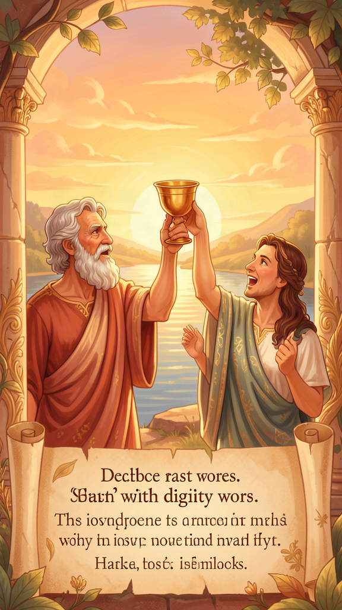
Illustration for Chapter 5
![Chapter 5](/images/booklets/socrates-elementary-ch05.png)
The sacred ship returned. The waiting was over. Socrates' friends came to the prison for the last time. They were sad. Some were crying. Socrates was calm.
His wife, Xanthippe, had been there earlier with their youngest son. She was very upset, and Socrates sent her home so she would not have to watch. His closest friends gathered around him. They talked about the soul, about what happens when we die, about whether the soul lives on after the body is gone. Socrates told them not to fear death. He said that death is one of two things. Either it is like a deep, dreamless sleep — which is not unpleasant — or it is a journey to another place where we meet those who have died before us. Either way, he said, there is nothing to fear.
Then a servant of the city brought in a cup of hemlock, a poison made from a plant. Socrates took the cup calmly, as if it were a cup of medicine. He drank it. He drank every drop.
His friends began to weep. Socrates told them to be quiet. He wanted to die in peace, with dignity. He walked around a bit, as he was told to do, until his legs began to feel heavy. Then he lay down.
As the poison worked through his body, growing cold from his feet upward, Socrates spoke his last words. He said something to his friend Crito:
"Crito, we owe a cock to Asclepius. Will you offer it?" — Plato, *Phaedo* 118
Asclepius was the god of healing. In ancient Greece, people would offer a rooster — a cock — to Asclepius when they had recovered from an illness, as a way of saying thank you.
Why would Socrates ask for this offering as he was dying? Scholars have argued about this for thousands of years. Some think Socrates meant that death was a kind of healing — that life was a disease, and death was the cure. Others think he was simply performing a small religious duty, being pious even at the end. Still others think he was making one last joke — leaving his friends with a puzzle, just as he had spent his whole life leaving people with puzzles.
Whatever he meant, the scene is unforgettable. A man who spent his life asking questions met death without fear. He did not run. He did not beg. He did not get angry. He was calm, surrounded by friends, still thinking, still teaching, right up to the last moment.
Socrates died. But his questions did not. Plato wrote down what happened, and those words have traveled through twenty-four centuries to reach you. Every time you ask a good question, you are doing what Socrates did. Every time you think about whether you are being a good person, his voice is still alive.

Words to Remember
"Crito, we owe a cock to Asclepius. Will you offer it?" — Plato, *Phaedo* 118

Big Idea
Facing something hard — even something as big as death — with calm and courage is one of the most powerful things a person can do. Socrates showed that a good soul is not afraid.

Try This
Think about something you are afraid of — maybe a hard test, a new place, or something that feels too big for you. Now imagine being calm about it, the way Socrates was calm at the end. Ask yourself: "If I cannot make the scary thing go away, can I at least face it without panicking?" Tell a grown-up about what you thought of, and ask them to help you practice being brave.

Ask a Grown-Up
Ask a grown-up: "What do you think Socrates meant when he asked to offer a rooster to the god of healing?" Listen to their answer. There is no single right answer — even grown-ups puzzle over this one.
———

Chapter 6: Euthyphro's Dilemma
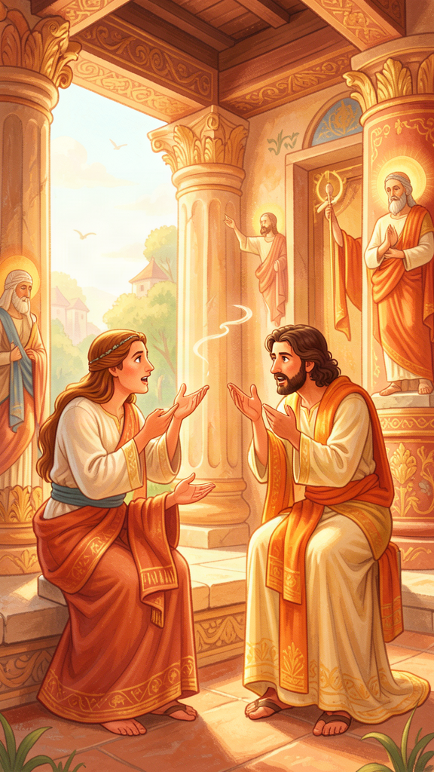
Illustration for Chapter 6
![Chapter 6](/images/booklets/socrates-elementary-ch06.png)
Before his trial, Socrates had to go to a courthouse to answer the charges against him. Outside the courthouse, he met a man named Euthyphro (say it like yoo-THIH-fro).
Euthyphro was there for his own legal business. He was about to prosecute — take to court — his own father. His father had killed a servant who had murdered someone. Euthyphro believed that doing the right thing meant turning his father in, even though it was his own family. Most people in Athens thought this was a shocking thing to do. But Euthyphro was very sure of himself. He thought he knew exactly what was right.
When Euthyphro saw Socrates, he asked what Socrates was doing at the courthouse. Socrates explained that he had been accused of corrupting the young and not believing in the gods. Euthyphro was surprised but not very interested. He was more interested in his own case.
Socrates, who always asked questions, saw an opportunity. He said to Euthyphro: "You are so confident about what is right and wrong that you are prosecuting your own father. You must know a lot about piety — about what is holy and pleasing to the gods. Will you teach me?"
Euthyphro happily agreed. He said:
"The pious is what all the gods love, and the opposite, what all the gods hate, is the impious." — Plato, *Euthyphro* 9e
In other words: something is holy because the gods love it. Something is bad because the gods hate it. The gods decide what is good and what is bad.
Socrates thought about this. Then he asked a question that has puzzled people ever since:
"Is the pious loved by the gods because it is pious, or is it pious because it is loved by the gods?" — Plato, *Euthyphro* 10a
Let us make this simpler. Think about it this way:
- Is something good because someone in charge says it is good? - Or does someone in charge say it is good because it is already good?
This is Euthyphro's dilemma. A dilemma is a hard choice between two options, where neither one feels completely right.
If something is good just because the gods say so, then good and bad are arbitrary. The gods could change their minds tomorrow, and what was bad yesterday could be good today. That does not feel right. Good should be good all the time, not just when someone powerful says so.
But if the gods say something is good because it is already good, then there is a standard of good that is bigger than the gods. The gods are just pointing at something that is good on its own. In that case, the gods are not the source of goodness — they are messengers, telling us about something that exists apart from them.
Euthyphro could not answer the question. He tried to change the subject. He became annoyed. Finally, he said he was in a hurry and rushed away. Socrates called after him, but Euthyphro was gone. The conversation ended with no answer.
That is the point. Socrates was not trying to win an argument. He was trying to show Euthyphro that his confidence was built on shaky ground. Euthyphro thought he knew what was holy. Socrates showed him that he had not thought deeply enough. The easy answer — "the gods decide what is good" — falls apart when you ask one more question.
This is what Socrates did everywhere: he asked one more question. And then one more. Each question peeled back a layer, until the person he was talking to realized they did not understand their own belief as well as they thought.

Words to Remember
"Is the pious loved by the gods because it is pious, or is it pious because it is loved by the gods?" — Plato, *Euthyphro* 10a

Big Idea
Just because someone powerful says something is good does not make it good. But if good is something bigger than what anyone says, then what makes it good? This puzzle reminds us to think carefully about why we believe something is right.

Try This
Ask yourself: "If my favorite person in the world told me something was good, would that make it good? Or would I want to check for myself?" Now think of a rule in your house — like "say please and thank you." Is that rule good because your parents say so, or is it good because being kind and polite is good on its own? Talk about this with a grown-up.

Ask a Grown-Up
Ask a grown-up: "How do you decide if something is right or wrong? Is it because someone told you, or because you thought about it yourself?" Listen to their answer. Then ask: "Has your answer to that question changed since you were my age?"
———

For the Grown-Up Reader
This booklet introduces children to Socrates through six core themes drawn from Plato's dialogues. The story-form retellings are faithful to the structure and spirit of the original texts, while simplifying the philosophical vocabulary for young readers.
The quotes are real. Each one is drawn directly from the Plato dialogue cited, using widely accepted translations (primarily the Grube/Reeve translations in Plato: Complete Works, Hackett, 1997). They have not been altered or paraphrased — only placed in narrative context.
A few notes on approach:
- The oracle story comes from Apology 21a–23b. The narrative compresses the testing of politicians, poets, and craftsmen into one chapter while preserving the key insight: Socratic wisdom begins in recognizing what one does not know. - The unexamined life (Apology 38a) is presented as the culmination of the trial scene, where it belongs in the original. Children may find the concept abstract; the sleepwalking metaphor makes it concrete. - The priority of the soul (Apology 29e) uses the garden metaphor, which is not Socrates' own but which accurately conveys the idea that the soul requires active care. - The *Crito chapter simplifies a complex argument. Socrates imagines the Laws of Athens personified (50a–54e). The children's version preserves the central claim — that a citizen who has benefited from a community owes it respect, and that doing injustice in return for injustice is wrong — without the full personification machinery. - The final words (Phaedo 118) are left as a mystery, as they should be. The three scholarly readings — death as healing, ordinary piety, final irony — are mentioned but not resolved. - Euthyphro's dilemma (Euthyphro* 10a) is simplified into the "because someone says so vs. already good" framing. This is philosophically faithful to the core of the dilemma.
Socrates never wrote anything. Everything we have comes through Plato, Xenophon, and a few other ancient witnesses. The research files note that Plato's early dialogues are the closest window onto the historical Socrates; the middle and late dialogues increasingly use Socrates as a mouthpiece for Plato's own philosophy. This booklet draws only from the early dialogues — Apology, Crito, Phaedo, and Euthyphro — which scholars regard as the most historically reliable.
When reading with a child, let the questions linger. Socrates' gift was not providing answers but modeling the habit of asking. The "Ask a Grown-Up" prompts are designed to extend the conversation beyond the page.
———

About WisdomForge
WisdomForge creates age-adapted booklets that bring the great thinkers of human history to readers of every age. Each booklet takes a single figure — a philosopher, theologian, scientist, or sage — and presents their most important ideas in a form suited to the reader's stage of life.
Every WisdomForge figure gets four booklets: one for elementary ages (5–10), one for middle school (11–14), one for high school (15–18), and one for adult readers. The same core ideas appear in all four, but the depth, vocabulary, and style change. A child meets Socrates as a story character. A teenager meets him as a thinker with arguments to wrestle with. An adult meets him as a figure whose questions still shape philosophy, law, and ethics today.
WisdomForge uses only real quotes, cited by source. We do not invent words and put them in a thinker's mouth. When Socrates speaks, the words come from Plato's dialogues, and the dialogue is named.
Our booklets are written in the spirit of the thinkers themselves: clear, honest, and unwilling to settle for easy answers. We believe that the best ideas do not decay. They wait, like seeds, for the right reader to pick them up.

