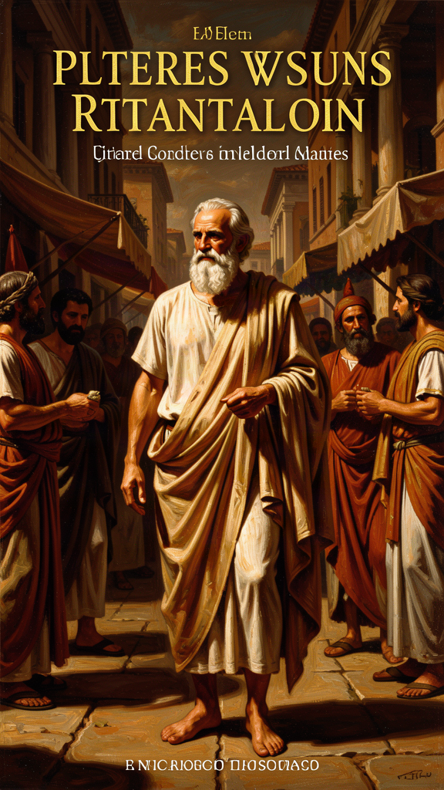
The Gadfly of Athens
WisdomForge Booklet — Ages 15–18

The Gadfly of Athens

WisdomForge Booklet — Ages 15–18
———

About This Book
Socrates never wrote a word. He founded no school, commanded no army, held no office, and left no writings. He walked the streets of Athens barefoot, wore a single shabby cloak in all weather, and spent his days asking people questions — questions that made the confident look foolish and the complacent uncomfortable. And yet, twenty-four centuries after his death, he remains one of the most influential figures in Western intellectual history. How?
The answer lies in the peculiar power of the question. Socrates understood something that most people, including most people who think of themselves as educated, do not: that the greatest obstacle to knowledge is not ignorance but the illusion of knowledge. We think we know what justice is, what courage is, what piety is, what a good life is — until someone asks us to explain. Then the knowing evaporates, and we discover that what we called knowledge was habit, convention, or borrowed opinion.
Socrates did not solve this problem. He made it visible. He made it the starting point of philosophy. And he did it not by writing treatises but by talking — by cornering people in the marketplace, the gymnasium, and the workshop, and refusing to let them retreat into unexamined certainty. Plato, his most devoted student, turned these conversations into written dialogues: dramatic works in which Socrates is usually the main speaker, testing definitions, exposing contradictions, and leaving interlocutors in a state the Greeks called aporia — a productive standstill where confidence gives out and genuine thinking can begin.
But there is a catch, and it matters. Socrates wrote nothing. Everything we have comes through other people, above all through Plato. And Plato, who spent fifty years writing dialogues after Socrates' death, increasingly used the figure of Socrates as a mouthpiece for his own evolving philosophy. The early dialogues — brief, ethically focused, often ending in puzzlement — are generally taken to be the closest we can get to the historical Socrates. The middle and late dialogues — the Republic, the Symposium, the Phaedrus — present a Socrates who expounds Plato's Theory of Forms, his tripartite psychology, his ideal city. That Socrates is less a historical person than a literary character speaking Plato's doctrines.
This booklet draws from the early dialogues: Apology, Crito, Phaedo, and Euthyphro. These are the works scholars consider most reliable as windows onto the historical Socrates. They are also the works where Socrates is at his most characteristic: questioning, ironic, unwilling to settle for easy answers, and — in the end — willing to die rather than abandon the examined life.
The six chapters that follow trace the arc of Socrates' most important ideas and most dramatic moments. We begin with the oracle at Delphi and Socrates' discovery that his wisdom consists in knowing what he does not know. We move through his declaration that the unexamined life is not worth living, his argument that the soul must take priority over wealth and reputation, his refusal to escape prison because doing so would violate his principles, the mysterious final words he spoke as he died, and the dilemma he posed about the relationship between goodness and divine authority.
Each chapter is a narrative essay. The quotes are real, drawn directly from the cited Plato dialogues. The arguments are Socrates' own, reconstructed faithfully from the texts. The questions at the end are for you.
———

Chapter 1: The Oracle at Delphi — No One Is Wiser
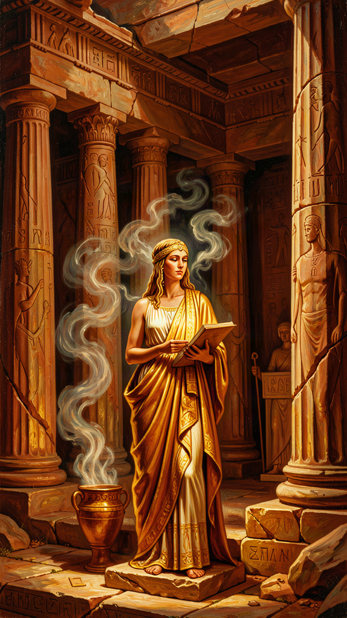
Illustration for Chapter 1
![Chapter 1](/images/booklets/socrates-high-ch01.png)

The Setting
Fifth-century Athens was a city built on speech. Its democracy — the word is Greek, meaning "rule by the people" — depended on the ability of citizens to persuade one another in the assembly and the law courts. Rhetoric was power. The Sophists, itinerant teachers who charged fees to instruct young men in the art of persuasion, flourished. In a city where speech was power, the man who asked the sharpest questions was either the most useful citizen or the most dangerous one.
Socrates was both. He was born around 470 BCE, the son of a sculptor and a midwife. He served with distinction as a hoplite in three military campaigns. He lived simply, charged no fees, and spent his time in conversation with anyone willing to talk. His appearance was against him: he was short, stout, snub-nosed, and bulging-eyed — the opposite of the Greek ideal of physical beauty. But his mind was relentless. He had a method, though he would have disclaimed the word: he asked questions. He pursued definitions. He exposed the gap between what people claimed to know and what they could actually defend.

The Oracle
The story that defines Socrates' philosophical mission begins with his friend Chaerephon, a bold and impulsive democrat who had fought to restore Athenian democracy after the oligarchic coup of 404 BCE. Chaerephon traveled to Delphi, the sacred site where the oracle — a priestess called the Pythia, believed to channel the god Apollo — answered questions from visitors. Chaerephon asked whether anyone was wiser than Socrates.
The oracle answered: no one.
When Chaerephon reported this, Socrates was genuinely bewildered. He knew he had no special knowledge. He could not explain the movements of the stars, the nature of the earth, or the principles of politics. He was not a Sophist with a stock of teachable techniques. If the oracle said he was the wisest, either the oracle was wrong or Socrates was misunderstanding what wisdom meant.
He chose the latter hypothesis and decided to test it. If he could find someone who genuinely possessed wisdom — not just a reputation for it — the oracle would be refuted. So he went looking.

The Investigation
Socrates' investigation took him through three classes of people who claimed wisdom.
The politicians. He approached public figures who governed the city, made its laws, and commanded its forces. He found them confident, articulate, and convinced of their own understanding. But when he asked them to define the concepts they invoked — justice, the good, the best way to live — their answers collapsed. They relied on convention, habit, and the authority of their position. They could not give an account of their own claims. They thought they knew what they did not know.
The poets. Socrates turned to the poets, whose works moved audiences to grief and wonder. He asked them to explain what their poems meant. Most could not. They composed by instinct, inspiration, and inherited technique — not by knowledge. They could produce beautiful language but could not articulate the meaning behind it. Socrates concluded that poetic power is a gift, not a form of wisdom. The poet is like a prophet who speaks truth without understanding it.
The craftsmen. Finally, Socrates questioned the artisans — builders, metalworkers, shoemakers. These people did possess real knowledge. A skilled craftsman understands his trade and can explain it. But the craftsmen made the same error as the others, in a more subtle form. Because they knew their craft, they assumed they also understood ethics, politics, and the good life. Their expertise in one domain bred a false confidence that colonized every other domain. They were knowledgeable about something, and that made them think they were knowledgeable about everything.

The Discovery
After this long investigation, Socrates understood what the oracle meant. The oracle was not saying that Socrates possessed superior knowledge. It was saying something far more unsettling: his only advantage over the politicians, poets, and craftsmen was that he did not claim to know what he did not know. They did. That was the whole difference.
"I am wiser than this man: neither of us knows anything, but he thinks he knows something, while I know nothing. Yet I appear to be wiser in just this one respect: if I do not know something, I do not think that I do." — Plato, *Apology* 21d
This passage is the foundation of what scholars call "Socratic ignorance" — not a claim to know nothing, but a disciplined awareness of the boundary between genuine knowledge and mere opinion. It is not false modesty. It is a philosophical method. The recognition of ignorance is not the conclusion of inquiry but its precondition. You cannot learn what you think you already know. The people most dangerous to themselves and to others — in politics, in education, in every sphere of life — are those who are most certain they already understand.
There is a further dimension to this discovery that is easy to miss. Socrates did not reach his conclusion by solitary meditation. He reached it by going out and testing it against real people. Socratic ignorance is not passive or private. It is active, social, and confrontational. Socrates treated his ignorance as a reason to investigate, not a reason to retire. And the investigation itself was public: he examined people in front of others, often with young men watching and listening. This is why the oracle story is also the origin story of Socrates' unpopularity. No one enjoys having their ignorance exposed, and the exposure was performed in the most public setting Athens had to offer.
The oracle story, then, is not simply about epistemology. It is about the social cost of intellectual honesty. Socrates' willingness to pay that cost — to keep asking questions even when the questions made him enemies — is what set his life on the path that led to a death sentence. The oracle did not just tell him he was wise. It gave him a mission: to examine, to question, to expose the illusion of knowledge. The mission cost him everything.

Big Idea
Socratic ignorance is the disciplined awareness of the boundary between knowledge and opinion. The wisest people are not those with the most answers but those who know what they do not know — and who treat that recognition as the beginning of inquiry, not the end of it. The social cost of this honesty is real: exposing other people's false confidence makes enemies. Socrates paid that cost willingly.

Practice
1. Identify your false confidence. Make a list of five things you "know" about politics, morality, or society. For each one, write down the source of your knowledge: where did you learn it? A parent? A teacher? A news source? A friend? A book? Now ask: could I defend this claim against a sharp questioner? If not, what you have is opinion, not knowledge. The point is not to discard the opinion — it may be right — but to be honest about its status.
2. Run a Socratic investigation. Pick a concept you use confidently — "fairness," "success," "bravery," "freedom." Write down a one-sentence definition. Now have a friend ask you questions about it for five minutes: "But what about X? Doesn't that contradict your definition? What do you mean by Y?" See how long your definition survives. The goal is not to produce a perfect definition but to experience what Socrates' interlocutors experienced: the discovery that a confident answer does not survive examination.
3. Observe the craftsman's error. Think of someone you know who is expert in one field — a coach, a teacher, a parent, a friend. Does that person also opine confidently about subjects outside their expertise? How do their non-expert opinions compare to their expert knowledge? Is the confidence level the same? Notice the gap between what expertise licenses and what the expert claims.
4. Test the oracle. Ask three people — a classmate, a parent, a teacher — "What is justice?" or "What makes a life good?" Listen to their answers. Do not argue. Just ask follow-up questions: "What do you mean by that? Can you give an example? What if someone disagreed?" Observe how long each answer holds. You are doing what Socrates did.

Reflect
Socrates believed that recognizing your own ignorance is a form of wisdom. But is there a danger in taking this too far? If you doubt everything you think you know, can you ever make a decision, take a stand, or commit to anything? Where is the line between healthy Socratic skepticism and paralysis? Is there a point where you must stop questioning and act — and if so, how do you know when you have reached it?
———

Chapter 2: The Unexamined Life Is Not Worth Living
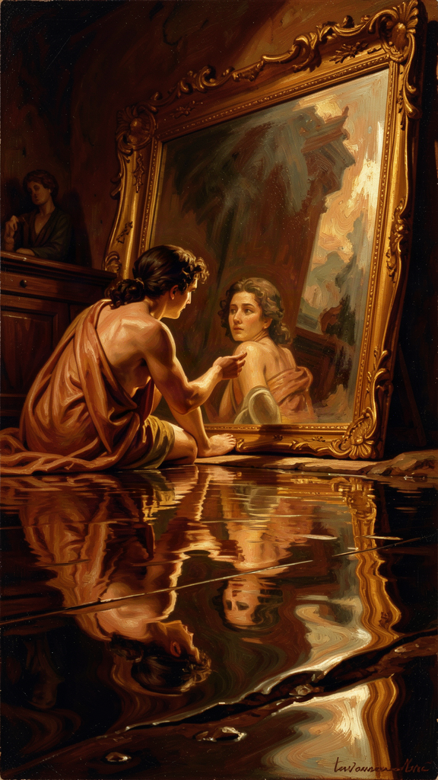
Illustration for Chapter 2
![Chapter 2](/images/booklets/socrates-high-ch02.png)

The Trial
In 399 BCE, when Socrates was seventy, three men — Anytus, Meletus, and Lycon — brought formal charges against him. The indictment was twofold: Socrates did not believe in the gods the city recognized, and he corrupted the young. The case went to a jury of hundreds of Athenian citizens, chosen by lot, in a system that had no judge, no lawyers, and no rules of evidence. The defendant spoke for himself.
Plato recorded the speech as the Apology — the Greek apologia means "defense speech," not an apology in the modern sense. It is the most direct statement of Socrates' philosophical mission that we have. It is also, in its own strange way, a provocation. Socrates did not grovel or flatter. He did not bring his family to the courtroom to win sympathy, as defendants commonly did. He did not promise to change his ways. He explained why he had spent his life asking questions and why he would not stop.

The Gadfly
Socrates told the jury the story of the oracle at Delphi. He explained how he had spent years testing the oracle's claim by questioning politicians, poets, and craftsmen. He said that his questioning was not a hobby or a nuisance but a divine mission. And then he used an image that has become permanent in Western thought: the gadfly.
He compared Athens to a large, noble horse — great and capable, but in danger of growing sluggish. He compared himself to a fly that stings the horse into alertness. His questions were the sting. The city, he said, needed waking up. It had grown comfortable in its assumptions about justice, piety, and the good life. It assumed its democracy was good, its traditions were right, its gods were satisfied. Socrates' questions were an attempt to disrupt that comfort — not to destroy the city but to keep it from drifting into unexamined decay.
This is a remarkable claim. Socrates is telling the jury that his annoying, disruptive, socially costly behavior is actually a service to the city. He is not the enemy of Athens. He is its physician. The medicine tastes bad. That does not mean it is not working.

The Refusal
Then Socrates said something that sealed his fate. He told the jury that if they offered to let him go free on one condition — that he stop philosophizing, stop questioning, stop examining himself and others — he would refuse. He said he would keep doing what he had always done for as long as he lived. He said it was better to obey the god's command than to save his own life.
This is not a negotiating position. It is a declaration of principle. Socrates is telling the jury that they cannot buy him off. The thing they want him to stop doing — questioning, examining, exposing false confidence — is the thing that gives his life meaning. If he stops, he is no longer Socrates. If he stops, his life is not worth living. And then he said the words:
"The unexamined life is not worth living for a human being." — Plato, *Apology* 38a

What It Means
This line is quoted constantly, often as a slogan, sometimes as a bumper sticker. But its meaning is more specific than its fame suggests. Socrates is not saying that every moment must be spent in philosophical reflection. He is not against joy, friendship, athletics, or pleasure. He is saying something structural: a life in which you never stop to ask "Is this the right way to live? Am I being a good person? Do my values hold up under examination?" is a life that has surrendered the distinctive capacity that makes it human.
An animal lives by instinct. It eats when hungry, sleeps when tired, fights when threatened. It does not ask whether its life is meaningful. A human being can live that way too — and many people do. But a human being also has the capacity to step back from instinct and ask: why am I doing this? Is it worth doing? Is there a better way? That capacity for self-examination is what separates a human life from a merely biological one. A life that never uses it has given up the thing that makes it human. It is sleepwalking.
The line also contains a threat and a promise. The threat is that unexamined opinions harden into prejudices. If you never question your assumptions about other people, about what is fair, about what success means, those assumptions become rigid. You cannot defend them, but you cannot let them go. They govern your behavior without your consent. The promise is that examination — even when it leaves you confused, even when it does not produce a clean answer — is the beginning of genuine understanding. The confusion is not failure. It is the door opening.
There is also a political dimension. Socrates is not just talking about individual self-help. He is saying that a city that never examines itself is asleep. Athens assumed its democracy was just, its empire was legitimate, its traditions were wise. Socrates questioned all of it. The unexamined life applies to societies as well as to persons. A nation that never asks whether its laws are fair, its wars are justified, its priorities are sound, is a nation that is sleepwalking. Socrates' claim is that the gadfly — the person who asks the uncomfortable question — is not the enemy of the community but its necessity. Without the gadfly, the horse dozes. And a dozing horse can stumble into a ditch.

The Verdict
The jury voted. A narrow majority — perhaps 281 to 220, though the exact numbers are disputed — found Socrates guilty. The penalty was death by hemlock.
Socrates had a chance to propose an alternative penalty. He offered, characteristically, not exile or a fine but free meals at public expense — the honor given to Olympic victors. The jury found this impudent. The vote for the death penalty was larger than the vote for guilt, which means some jurors who had voted to acquit voted to execute, perhaps offended by Socrates' tone. He was sent to prison to await execution.

Big Idea
The unexamined life is not worth living because self-examination is the capacity that makes human life distinctively human. A life that never questions its own assumptions — whether those of an individual or a society — has surrendered the thing that separates it from instinct. The confusion that examination produces is not failure but the precondition of genuine understanding. Socrates chose death over the abandonment of examination, making the point not as an argument but as a life.

Practice
1. Map your unexamined assumptions. Spend thirty minutes writing down beliefs you hold but have never seriously questioned. Include beliefs about morality ("cheating is always wrong"), politics ("democracy is the best system"), identity ("I am a kind person"), and success ("getting good grades matters"). For each, ask: Where did this belief come from? Have I ever seriously considered the alternative? Could I defend it to a rigorous questioner? The goal is not to abandon your beliefs but to discover which ones are examined and which are inherited.
2. Examine a social assumption. Pick one assumption your society treats as obvious — for example, that economic growth is good, that education should be compulsory, that voting is a civic duty, or that social media connects people. Write a one-page essay arguing the opposite. You do not have to agree with the counter-argument. The exercise is to discover whether you can even formulate it. If you cannot, you may not understand the original assumption as well as you think.
3. Track your daily life. For one week, keep a log of how you spend your time — classes, studying, social media, sleep, conversation, entertainment. At the end of the week, examine the log. Ask: Does the way I spend my time reflect what I say I value? If someone saw only this log, what would they conclude my values are? The gap between your stated values and your lived values is where the unexamined life hides.

Reflect
Socrates chose death over silence. Is that admirable, fanatical, or something else? Is there anything you believe strongly enough that you would choose to die rather than abandon it? If the answer is no, does that mean you lack conviction — or does it mean your beliefs are not the kind of thing that martyrdom serves? Is the willingness to die for a principle always noble, or can it be a form of stubbornness? Where do you draw the line between integrity and rigidity?
———

Chapter 3: The Priority of the Soul
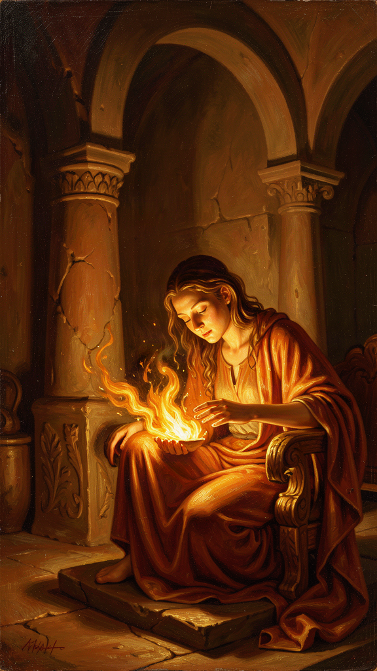
Illustration for Chapter 3
![Chapter 3](/images/booklets/socrates-high-ch03.png)

The Accusation Turned Inward
During his defense speech, Socrates did something that turned the logic of a trial inside out. Instead of simply defending himself — arguing that he was innocent, that he posed no danger, that the jury should acquit — he accused the jury. He told them that they were the ones in trouble. Not because of anything he had done, but because of what they cared about.
The Athenians, Socrates said, were anxious about the wrong things. They spent their energy pursuing wealth, reputation, and honors. They worried about their bodies, their social standing, their political power. And they gave no thought to the one thing that determines whether a life is good or bad: the condition of their souls.
"Are you not ashamed of your eagerness to possess as much wealth, reputation, and honors as possible, while you do not care for nor give thought to wisdom or truth, or the best possible state of your soul?" — Plato, *Apology* 29e

What the Soul Means
The word "soul" — in Greek, psyche — does not mean for Socrates what it often means in later religious traditions. It is not a ghost that floats free of the body at death, destined for heaven or hell. It means the whole moral and intellectual self: your character, your judgment, your capacity for truth and justice. It is the part of you that decides to be honest or dishonest, brave or cowardly, kind or cruel. You cannot weigh it or photograph it. But it is more truly you than your face, your body, or your possessions. It is the seat of everything that makes you a good or bad person.
The Socratic scale of values places the soul at the top. Below it are the external goods: wealth, reputation, power, physical health, beauty. These are not evil. Socrates does not preach asceticism for its own sake. But they are secondary. Their value depends on the soul to use them well. A wealthy person with a corrupt soul is worse off than a poor person with a just one, because the wealth only gives the corrupt person more power to do harm. A famous person without wisdom has no idea what to do with the attention. A powerful person without justice uses power to oppress. The external goods are instruments. The soul is the hand that wields them. A good hand can make a bad tool useful. A bad hand makes even the best tool dangerous.

Why the Soul Comes First
The argument has a structure. External goods are conditional goods. They are good if the soul is in good condition, and bad if the soul is not. Money is good if you are wise enough to use it well; it is destructive if you are not. Fame is good if you have the judgment to handle it; it is corrosive if you do not. Power is good if you are just; it is tyrannical if you are not. The soul, by contrast, is an unconditional good. A good soul is good in itself, regardless of circumstances. It does not need anything external to complete its value.
This is why the soul comes first. Everything else depends on it. You can lose your money and still be a good person. You can lose your reputation and still be just. You can lose your health and still be wise. But if you lose your soul — if your character is corrupt, your judgment is warped, your honesty is gone — no amount of money, fame, or power can compensate. The soul is the only thing that is truly yours, in the sense that it is the only thing no one can take from you and the only thing whose condition is entirely in your own hands.
Socrates lived this argument. He charged no fees. He held no office. He did not pursue wealth or reputation. He wore a shabby cloak and lived simply. None of this was performance. It flowed directly from his conviction that the only thing worth pursuing was the improvement of the soul. His poverty was not a virtue in itself — it was a consequence of his priorities.

The Challenge to Our Priorities
This argument is as radical today as it was in 399 BCE. We live in a culture that measures success by external marks: grades, test scores, college admissions, salary, followers, awards, the size of a house, the brand of a phone. Socrates asks us to flip the scale. What good is any of that if the person inside is dishonest, unkind, or unexamined? What good is admission to a top university if the student who gets in has never asked what kind of person they are becoming? What good is a high salary if the person earning it has no idea what a good life is?
There is a practical test. Ask yourself: who are the people you most admire? Are they the ones with the most money, the most followers, the most impressive résumés? Or are they the ones whose character you respect — the ones who are honest when honesty costs them, brave when courage is hard, kind when kindness is inconvenient, thoughtful when thoughtfulness is unfashionable? If you admire character more than achievement, you already agree with Socrates more than the culture around you. Your own judgment tells you to value the soul. The culture tells you to value the résumé. Socrates' argument is that your judgment is right and the culture is confused.
The difficulty, of course, is that the soul is invisible. You cannot put it on a college application. You cannot list it on a résumé. You cannot photograph it or post about it. The culture measures what it can see, and the soul cannot be seen. This is why the Socratic priority of the soul is not just a philosophical claim but a practical rebellion against the metrics of success that govern most of our lives.

Big Idea
The Socratic scale of values places the soul — your moral and intellectual character — above all external goods. Wealth, reputation, and power are conditional goods whose value depends on the soul to use them well. The soul is an unconditional good, the only thing that is truly yours and whose condition is entirely in your hands. Socrates' challenge is to live as though you believe this, even when every pressure around you measures success by what you have rather than who you are.

Practice
1. Audit your values. Make two lists. On the left, list five things you are actively pursuing or proud of — achievements, possessions, recognition. On the right, list five qualities of character you aspire to — honesty, courage, compassion, integrity, wisdom. Now rank each list in order of how much time and energy you actually devote to it. Compare the rankings. Where does your time go? Does it match your stated priorities? The gap between what you value and what you pursue is the space where the unexamined life operates.
2. Test the unconditional good. Write a one-page essay defending this claim: "A just person with nothing is better off than an unjust person with everything." First, argue for it as strongly as you can. Then argue against it as strongly as you can. Which argument did you find more convincing? Why? If you found the defense harder than the attack, ask yourself what that reveals about your assumptions.
3. Observe the soul in action. For one week, notice moments where someone's character — their honesty, courage, kindness, or integrity — is visible in a small decision. A classmate who admits a mistake. A teacher who changes a grade because it was wrong. A friend who tells you the truth when a lie would be easier. Write these moments down. At the end of the week, compare the number of character moments you noticed to the number of achievement moments. Which kind of moment made a stronger impression on you?
4. Flip the metric. Imagine you are writing your own eulogy — not in a morbid way, but as an exercise in identifying what you want to be remembered for. What would you want people to say about your character? Now compare that to the things you currently spend your time pursuing. How close is the match? What would you need to change to bring your daily life into alignment with the person you want to have been?

Reflect
Socrates' argument assumes that the soul — moral and intellectual character — is more important than external goods. But is that always true? What about someone living in poverty, facing oppression, or struggling to survive? Is the priority of the soul a luxury that only the comfortable can afford? Or is it precisely in hardship that the soul matters most? Discuss with someone: Does the Socratic scale of values hold up when life is genuinely difficult, or does it apply only when basic needs are already met?
———

Chapter 4: Crito and the Laws of Athens
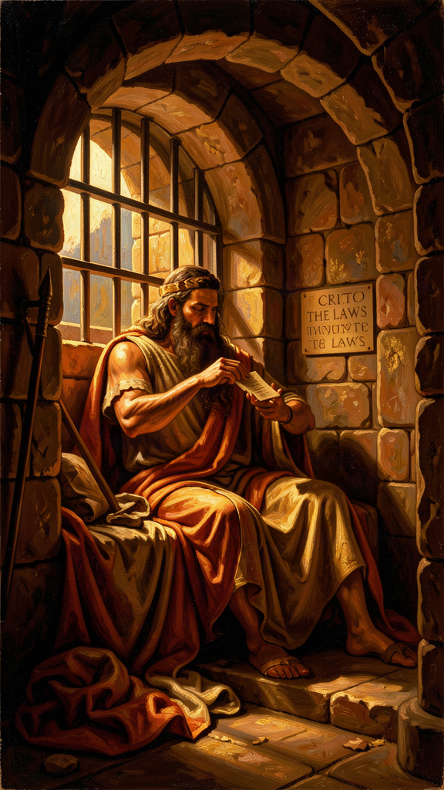
Illustration for Chapter 4
![Chapter 4](/images/booklets/socrates-high-ch04.png)

The Prison
Socrates was found guilty and sentenced to death. But the execution was delayed. A sacred ship had been sent from Athens to the island of Delos on a religious mission, and an ancient custom forbade the city from carrying out executions until the ship returned. Socrates waited in prison for about a month.
His friends used that time to plan. His old friend Crito, a wealthy man, arranged everything: money to bribe the guards, helpers to smuggle Socrates out, contacts in a nearby city where he could live in safety. All Socrates had to do was agree to leave.
Early one morning, before dawn, Crito came to the cell. He found Socrates sleeping peacefully. Crito was astonished — how could anyone sleep the night before a possible escape? He woke Socrates and laid out the plan. The ship would return any day. Time was running out.

Crito's Arguments
Crito made several arguments, each designed to appeal to a different kind of concern:
Reputation. If Socrates died, people would think his friends did not care enough to save him — that they were cheap, cowardly, or both. His death would shame the people who loved him.
Family. Socrates was abandoning his children. A father has a duty to raise his sons. How could he choose death when his children needed him?
Justice. The trial was unjust. The charges were false, the jury was prejudiced, the verdict was wrong. Escaping would not be breaking the law — it would be correcting an injustice. Socrates owed it to himself and to truth to resist a wrongful conviction.
Each argument is strong. Each appeals to a recognizable moral instinct: loyalty to friends, duty to family, resistance to injustice. Crito is not a villain. He is a friend who loves Socrates and cannot understand why Socrates will not save himself.

Socrates' Response
Socrates listened to every argument. Then he responded, calmly and systematically, in the conversation Plato recorded as the Crito. His answer rests on a single principle: it is never right to do wrong, even in return for wrong.
Socrates agrees that the trial may have been unjust. But he argues that responding to injustice with more injustice does not make things right. Running away — breaking the laws of his own city, abandoning his agreements, damaging the community — would be doing wrong, regardless of whether the trial was fair. The soul is harmed by doing injustice, and harming the soul is worse than any harm to the body. Two wrongs do not make a right.
Then Socrates does something striking. He imagines the Laws of Athens speaking to him directly, as if they were standing in the cell. This is not a legal argument in the modern sense. It is a dramatic device — a personification — that lets Socrates stage a debate between himself and the system he is considering violating.

The Case of the Laws
The Laws make their case in several steps:
They raised him. The Laws provided the marriage customs that brought Socrates' parents together. They established the education system that trained him. They created the political order that gave him freedom and security. Socrates did not spring into existence independently. He was made by the city, through its laws.
He accepted the arrangement. Socrates lived in Athens his entire life — seventy years. He never chose to leave. He never emigrated. He traveled abroad only on military campaigns and always returned. By staying, he demonstrated consent to the city's arrangements. Athens was not a prison he was locked in. It was a home he chose.
The agreement is binding. If a citizen disagrees with a particular verdict, does that give him the right to ignore the whole system? If everyone who lost a case simply refused to accept the outcome, the laws would mean nothing. The city would collapse. By living under the laws and enjoying their benefits, Socrates entered into a kind of contract. He cannot enjoy the benefits for decades and then tear up the contract the moment it goes against him.
"Then consider, Socrates, whether we are right in saying that by attempting to escape you are attempting an injustice against us in a certain way." — Plato, *Crito* 50c

The Harder Claim
Behind the personification lies a deeper philosophical claim. Socrates is not simply saying that obedience is convenient or that disobedience is risky. He is saying that doing injustice damages the soul — the most important part of the self — and that this damage is worse than any physical harm the city can inflict. The person who is wronged suffers in body or reputation. The person who does wrong suffers in character. Since the soul is more important than the body, it is better to suffer injustice than to commit it. Escaping would save Socrates' body but ruin his soul. He chose his soul.
This is the same principle that appears in the Gorgias, where Socrates argues that the person who does injustice without paying for it is worse off than the person who is wronged. Injustice is not just a social harm. It is a corruption of the self. The Crito and the Gorgias together present a consistent Socratic ethics: the soul is the highest good, injustice damages the soul, and therefore no benefit to the body — not even survival — is worth the cost of doing wrong.

The Objection
The argument has provoked disagreement for 2,400 years, and the disagreement is worth taking seriously. The strongest objection goes like this: Socrates assumes that the Laws deserve respect because they benefited him. But what if the Laws are systematically unjust — not just mistaken in this one case, but structured to oppress? Does a citizen owe respect to a legal system that is fundamentally corrupt? Socrates' argument seems to assume that the social contract is basically fair. If it is not, the obligation to obey may not hold.
Later thinkers took this objection in a direction Socrates did not. Henry David Thoreau argued that when a law is unjust, the citizen has a duty to break it — peacefully, openly, and accepting the consequences. Mahatma Gandhi expanded this into a philosophy of nonviolent resistance. Martin Luther King Jr., writing from a Birmingham jail, argued that one has a moral responsibility to disobey unjust laws, and that doing so openly, with willingness to accept the penalty, is the highest respect for law — because it exposes the injustice and forces the community to confront it.
Socrates' position is more conservative. He accepts the punishment but refuses to break the law. King breaks the law and accepts the punishment. Both accept consequences. The difference is in the act itself: Socrates will not break the law even to save his life; King will break the law to expose injustice. The disagreement between these two positions is one of the most important conversations in political philosophy, and it has no clean resolution.

Big Idea
Socrates argues that it is better to suffer injustice than to commit it, because injustice damages the soul — the highest good. A citizen who has benefited from a community's laws owes those laws respect, and breaking the law — even to escape an unjust verdict — is itself a wrong. The disagreement with later thinkers who argue for principled lawbreaking (Thoreau, Gandhi, King) is not about whether consequences matter but about whether breaking an unjust law can itself be a form of respect for the moral order.

Practice
1. Stage the debate. Write a dialogue between Socrates and Martin Luther King Jr. on the question: "Is it ever right to break an unjust law?" Give each a paragraph to make his case. Socrates argues that breaking the law damages the soul, even if the law is unjust. King argues that breaking an unjust law openly and accepting the consequences is the highest respect for law, because it exposes injustice and forces reform. Who makes the stronger case? Write a third paragraph stating your own position and your reasoning.
2. Test the contract. Socrates argues that by living under a community's laws and enjoying their benefits, you enter into an agreement to obey them. Does this hold? Consider: you did not choose to be born in your country. You did not choose its laws. You may not have had a realistic option to leave. Is living in a place the same as consenting to its laws? What would genuine consent look like? Write a one-page essay on what it means to owe a community obedience — and where the limits of that obligation might lie.
3. Apply the principle. Think of a situation in your own life where you were treated unfairly — by a teacher, a coach, a parent, an institution. Now ask: did you respond by doing something wrong in return (lying, cheating, retaliating)? Or did you accept the injustice without committing injustice yourself? Which choice left you feeling better — not in the short term, but in the long term? Does your experience support or challenge Socrates' claim that it is better to suffer injustice than to commit it?

Reflect
Socrates chose to die rather than break his word to his city. He called this integrity — wholeness, the condition of acting in accordance with your deepest principles even when it costs everything. But is there a point where integrity becomes rigidity? Is refusing to break a law you believe is unjust a sign of moral strength, or a failure to resist evil? Socrates and King both accepted death for their principles. Both were willing to pay the ultimate price. The difference is that King broke the law and Socrates did not. Which path is more just? Which is more effective? Can both be right?
———

Chapter 5: Socrates' Final Words
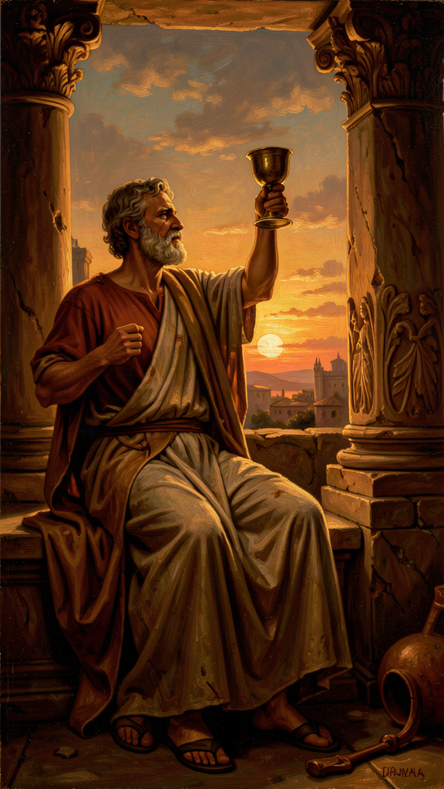
Illustration for Chapter 5
![Chapter 5](/images/booklets/socrates-high-ch05.png)

The Last Day
The sacred ship returned. The delay was over. Socrates' friends came to the prison for the last time. The conversation that day, recorded by Plato in the Phaedo, is one of the most extraordinary scenes in Western literature — not because of what happens (a man drinks poison and dies) but because of how it happens.
Socrates' friends were grief-stricken. Some wept openly. His wife, Xanthippe, had been there earlier with their youngest son, wailing and clutching the child, until Socrates sent her home. The friends who remained tried to hold themselves together. Socrates, characteristically, began to talk. He was not interested in sympathy. He was interested in argument.

The Argument About Death
The Phaedo is primarily a philosophical dialogue about the immortality of the soul. Socrates offers several arguments — some stronger than others — that the soul survives the death of the body. These arguments are more Platonic than Socratic; most scholars believe the theory of Forms and the arguments for immortality belong to Plato, not to the historical Socrates. But the setting and the dramatic frame — a man about to die, calmly reasoning with his friends — are unforgettable regardless of how one assesses the arguments.
Socrates tells his friends not to fear death. Death, he says, is one of two things. Either it is a deep, dreamless sleep — and who would not prefer a peaceful sleep to a restless life? — or it is a journey of the soul to another place, where one could meet and converse with the great figures who had died before. If death is sleep, it is rest. If death is a journey, it is the greatest conversation imaginable. Either way, there is nothing to fear.
This is not bravado. Socrates is not pretending. He has spent his life arguing that the soul matters more than the body, that the examined life is worth more than unexamined survival, that doing right is more important than avoiding suffering. Now he is about to die, and he is calm. The calm is the argument. It demonstrates, in action, that a life lived in accordance with these principles leaves nothing to fear. The death is the proof that the philosophy was not just words.

The Poison
A servant entered carrying a cup of hemlock. The friends broke down. Socrates told them to be quiet. He did not want to die amid noise and weeping. He wanted composure.
He took the cup. He drank it, every drop, without hesitation. He walked around the cell as instructed, until his legs grew heavy. Then he lay down. The poison moved upward, numbing his body from the feet. A friend covered his face with both hands. Socrates pulled the covering away and spoke his last words:
"Crito, we owe a cock to Asclepius. Will you offer it?" — Plato, *Phaedo* 118

The Mystery
Asclepius was the god of healing. In Greek religious practice, people offered a rooster to Asclepius when they recovered from an illness — a thanksgiving for a cure. Why would a man about to die ask for a healing offering?
Scholars have debated this for centuries. Three main interpretations have emerged, and each changes how we read the entire scene.
The first reading: death as cure. On this interpretation, Socrates means that life in the body was a kind of disease, and death is the healing — the moment when the soul is freed from the body's corruptions. The offering to Asclepius is Socrates' way of saying that death has cured him. This reading fits the Phaedo's broader argument that the body is a prison of the soul and that philosophy is a preparation for death. It makes Socrates' final act a statement that he has been liberated.
The second reading: ordinary piety. Socrates was a religious man. He spoke throughout his life of a divine inner voice — a daimonion — that warned him away from certain actions. He participated in the city's religious practices. His last words may simply be a final act of devotion: even at the moment of death, he remembers his religious obligations and ensures the offering is not forgotten. On this reading, the final words show not metaphysical triumph but humble piety — the philosopher who questioned everything still performs the small rites.
The third reading: final irony. Socrates spent his life leaving people with puzzles. His method was to ask a question that opened a problem, not to deliver a settled answer. His last words may be one more puzzle — a gift to his friends, something to think about and argue over for as long as they live. On this reading, Socrates is being himself to the very end: the man who leaves a question rather than an answer. The irony is that even his death becomes a teaching moment — not by resolving anything, but by provoking more thought.
We do not know which reading is correct. Perhaps Socrates meant all three. Perhaps he meant none. The mystery is part of the scene's power. The words are deliberately ambiguous, and the ambiguity has kept scholars arguing for 2,400 years — which may be exactly what Socrates intended.

Why the Death Endures
People die every day. Executions have happened in every century. What makes this death different?
The answer is that this death is a demonstration. Socrates spent his life making claims: the soul is more important than the body, the examined life is worth more than survival, doing right is more important than avoiding suffering, one should never do injustice even in return for injustice. At the end, he lived every one of those claims. He did not just preach them. He died for them. The death is the proof that the philosophy was not a set of abstract propositions but a way of being — and that Socrates was willing to die rather than abandon it.
This is why the scene has been remembered for 2,400 years. It is not the death of a philosopher. It is the life of a philosophy, made visible in its final moment. The composure, the argument, the refusal to weep or beg, the mysterious last words — all of it is Socrates being Socrates, one last time. The death does not validate the arguments. It shows what it looks like when someone actually believes them.

Big Idea
Socrates' death is the enactment of his philosophy. His calm in the face of execution demonstrates — does not merely argue — that a life spent caring for the soul leaves nothing to fear. His final words, offered to the god of healing, are deliberately ambiguous: a cure, an act of piety, or a final puzzle. The mystery is itself a teaching: Socrates leaves his friends with a question, as he always did. The death endures because it shows what it means to live according to your principles, all the way to the end.

Practice
1. Interpret the final words. Choose one of the three scholarly readings — death as cure, ordinary piety, or final irony — and write a two-page essay defending it. Use evidence from the Phaedo and from what you know of Socrates' character. Then write a second essay arguing against your own interpretation. Which reading did you find harder to defend, and why? Does the ambiguity itself tell us something about Socrates?
2. Examine your relationship to death. Socrates said death is either dreamless sleep or a journey of the soul. Neither frightened him. What frightens you about death? Is it the loss of consciousness, the loss of relationships, the loss of the future, the unknown, the process of dying, or something else? Write honestly — not what sounds good, but what is true. Then ask: does Socrates' argument address your fear, or does it miss what actually scares you?
3. Identify your demonstration. Socrates' death was the demonstration of his life's philosophy. What would the "demonstration" of your principles look like? If you had to show, not just say, what you believe — if you had to live it in a way that was visible, costly, and undeniable — what would that look like? Write a paragraph describing the moment where your principles would be tested and how you hope you would respond. This is not a fantasy. It is an audit of what you actually believe, measured by what you would be willing to do.

Reflect
Socrates met death with calm because he believed the soul mattered more than the body. But what if he was wrong? What if death is simply the end — no journey, no conversation, no soul continuing? Does that make his calm less admirable, or more? Is courage in the face of death more impressive if there is something on the other side, or if there is not? Discuss with someone: What would it take for you to face your own death with the composure Socrates showed? Is it a matter of belief, philosophy, character, or something else?
———

Chapter 6: Euthyphro's Dilemma
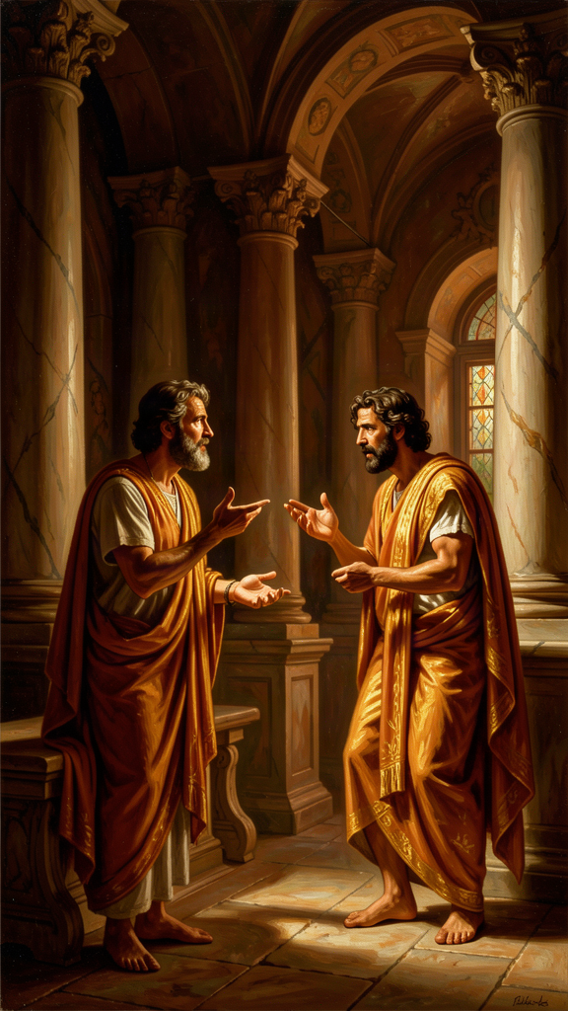
Illustration for Chapter 6
![Chapter 6](/images/booklets/socrates-high-ch06.png)

The Meeting
The Euthyphro takes place outside a courthouse in Athens. Socrates is there to answer preliminary charges — the same charges that will eventually lead to his trial. He meets a man named Euthyphro, who is also at the courthouse, but for very different business.
Euthyphro is prosecuting his own father for murder. A servant on the family estate had killed a man. Euthyphro's father bound the servant and left him in a ditch while he sent for a religious authority to decide what to do. The servant died in the ditch. Euthyphro believes that piety demands he prosecute his own father, regardless of family loyalty.
Most Athenians found this shocking. Turning against your own father violated deep conventions about filial duty. But Euthyphro is not troubled. He is supremely confident. He is certain that he knows what piety is — what is holy, what is right, what the gods require.
When Euthyphro hears that Socrates has been charged with impiety, he is mildly interested. Socrates, with his usual instinct, sees an opportunity. He says: you are so confident about what piety is that you are prosecuting your own father. You must know a great deal. Will you teach me?

The Definitions
Euthyphro offers several definitions. Socrates tests each one.
First definition: piety is prosecuting wrongdoers. Socrates points out that this is an example, not a definition. He wants the essential characteristic that makes something pious — the eidos, the form — not one instance of it. Euthyphro's prosecution of his father might be pious, but it does not tell us what piety is.
Second definition: piety is what is pleasing to the gods. But the Greek gods famously disagree. They quarrel, fight, and take sides in human conflicts. If the gods disagree, then the same action could be pious (loved by some gods) and impious (hated by others) simultaneously. The definition makes piety incoherent.
Third definition: piety is what *all* the gods love. Euthyphro revises: the pious is what all the gods love, and the impious is what all the gods hate. This seems to solve the disagreement problem. If we stipulate that the gods agree, then piety is whatever enjoys universal divine approval.
"The pious is what all the gods love, and the opposite, what all the gods hate, is the impious." — Plato, *Euthyphro* 9e

The Question
Socrates then asks the question that has never stopped being asked:
"Is the pious loved by the gods because it is pious, or is it pious because it is loved by the gods?" — Plato, *Euthyphro* 10a
This is the Euthyphro dilemma. It looks like a grammatical puzzle, a question about word order. It is one of the most important questions in the history of ethics. Let us unpack it carefully.
Option A: Something is pious because the gods love it. On this view, the gods' love creates the piety. The piety did not exist before the gods loved it. If the gods changed their minds and loved cruelty, cruelty would become pious. If they hated kindness, kindness would become impious. Goodness is whatever the gods happen to prefer. Morality is a matter of divine taste. This makes morality arbitrary: there is no reason the gods love what they love, and if they loved something different, morality would be different. There is no standard of goodness independent of the gods' preferences. We cannot ask "but is it really good?" because "really good" just means "loved by the gods."
Option B: The gods love something because it is pious. On this view, the piety exists independently of the gods. The gods recognize it and love it, but they did not create it. Something is pious because it is genuinely good, and the gods, being wise, love what is good. But this means there is a standard of goodness that is bigger than the gods — a standard they did not invent and cannot change. The gods are not the source of goodness. They are its most perceptive observers. They love the good because it is good, not the other way around.
Both options lead somewhere uncomfortable. If goodness is just whatever the gods say (Option A), then morality is arbitrary and there is no deeper reason to call anything good or bad. "Good" means nothing more than "commanded." If goodness exists independently of the gods (Option B), then the gods are not ultimate. There is something above them — a moral reality they must conform to. This challenges the idea of divine omnipotence, because even God cannot change what is genuinely good.

Beyond the Gods
The dilemma does not apply only to Greek gods. It applies to any authority that claims to define morality. Replace "the gods" with "the government," "the church," "your parents," "your culture," "the Constitution," or "the scientific consensus." The same question arises: is something good because the authority says so, or does the authority say so because it is already good?
Consider a concrete example. A government passes a law. Is the law just because the government enacted it — because the government has the authority to define justice? Or is the law just because it conforms to a standard of justice that exists independently, a standard the government is supposed to follow? If you believe the first, then any law a government passes is automatically just, and injustice becomes impossible by definition — whatever the government does is, by definition, just. If you believe the second, then a government can pass unjust laws, and the fact that it enacted them does not make them right. Most people, when pressed, believe the second. But the second means that justice is not created by authority. It is recognized by authority. And that raises the hardest question: where does the standard come from? How do we know it? Who gets to interpret it?
This question is alive in every domain of life. When a parent says "because I said so," the child faces the Euthyphro dilemma: is the rule good because the parent said so, or did the parent say so because the rule is already good? When a church declares a doctrine, when a court issues a ruling, when a culture establishes a tradition — the same question appears. Is the authority the source of the value, or is it the recognizer of a value that exists independently?
The dilemma reappears in theology as the question of divine command theory: does God command something because it is good, or is it good because God commands it? It reappears in legal theory as the debate between legal positivism (the law is whatever the sovereign says) and natural law (the law must conform to a moral standard). It reappears in meta-ethics as the question of moral realism: are moral truths discovered or invented?

The Aporia
Socrates does not resolve the dilemma. He does not offer his own theory of what makes something pious. He leaves it as a problem. Euthyphro, unable to answer, tries to change the subject, grows frustrated, and finally claims he is in a hurry. He rushes away. Socrates calls after him, but Euthyphro is gone. The dialogue ends in aporia — that productive standstill where confidence gives out and genuine thinking can begin.
This is characteristic. Socrates' goal was not to win arguments. It was to expose the gap between confidence and understanding. Euthyphro thought he knew what piety was — he was so sure he was willing to prosecute his own father. After a few questions, he discovered he could not defend his own definition. That discovery — not the resolution of the dilemma, but the recognition that it exists — is where philosophy begins.
The Euthyphro is also a portrait of a method. Notice how Socrates operates. He does not attack Euthyphro directly. He does not say "you are wrong." He asks questions. He lets Euthyphro's own answers defeat themselves. He uses the interlocutor's own premises to generate contradictions. This is the Socratic method at its purest: not lecturing, not refuting from outside, but drawing out the internal inconsistency in the other person's position and letting them see it for themselves.

Big Idea
The Euthyphro dilemma asks whether morality is created by authority or recognized by it. If goodness is whatever authority commands, morality is arbitrary. If authority recognizes a goodness that exists independently, then authority is not the source of value. The dilemma applies to every authority — gods, governments, parents, cultures — and it has no easy resolution. Socrates does not solve it. He makes it visible, and in doing so, he opens the space for genuine philosophical inquiry. The method matters as much as the content: Socrates does not tell Euthyphro he is wrong. He asks questions that let Euthyphro discover it for himself.

Practice
1. Apply the dilemma. Choose an authority in your life — a parent, a teacher, a religious tradition, a legal system, a cultural norm. Identify a rule that authority sets. Now write both sides of the dilemma: (A) This rule is good because the authority says so. What follows from this? If the authority changed the rule, would the new rule be equally good? (B) The authority says the rule is good because it is already good. What follows from this? Is there a standard above the authority? How would we know it? Which side do you find more convincing, and what are the consequences of your choice?
2. Trace the dilemma through history. The Euthyphro dilemma reappears in many forms. Research one of the following: divine command theory in medieval theology (is something good because God commands it, or does God command it because it is good?), legal positivism versus natural law (is law whatever the sovereign enacts, or must law conform to moral standards?), or moral realism versus moral constructivism (are moral truths discovered or invented?). Write a one-page summary of how the debate maps onto Socrates' original question.
3. Practice the method. Find someone who holds a confident moral view — a friend, a classmate, a family member. Without being hostile or combative, ask them to define their terms. If they say "X is wrong," ask "What do you mean by wrong?" If they give a definition, ask a follow-up that tests it: "But what about this case? Does your definition cover it?" See how many questions it takes before their confidence wavers. The goal is not to win or to embarrass. It is to discover, as Socrates did, where confidence outruns understanding — in others and in yourself.

Reflect
The Euthyphro ends without an answer. Socrates leaves Euthyphro confused and walks away. Is this satisfying? Is a question that produces only more questions valuable, or is it just frustrating? Socrates seems to believe that honest confusion is better than false confidence — that the recognition of not-knowing is the beginning of wisdom. But is there a point where this becomes counterproductive? Can a society function if no one is willing to commit to an answer? Is there a tension between the Socratic love of questioning and the practical need to act, decide, and build? Where do you draw the line between healthy questioning and destructive skepticism?
———

For the Grown-Up Reader
This booklet introduces readers aged 15–18 to Socrates through six chapters drawn from Plato's early dialogues. The narrative essays preserve the structure, dramatic setting, and central arguments of the original texts while engaging with the philosophical content at a level appropriate for high school readers.
All quotations are genuine, drawn from the cited Plato dialogues. The translations follow the Grube/Reeve versions in Plato: Complete Works (Hackett, 1997), the standard scholarly reference in English.
A few notes on approach and choices:
- The oracle story (Apology 21a–23b) is presented with the threefold structure Socrates himself gives it — politicians, poets, craftsmen — and with attention to the social cost of Socratic inquiry. The chapter emphasizes that Socratic ignorance is not passive but active: a method, not a conclusion. - The unexamined life (Apology 38a) is presented in its trial context. The chapter extends the argument from individuals to societies, following Socrates' own gadfly metaphor. The claim is not that every moment must be philosophical but that a life (or a city) that never examines itself has surrendered its distinctive human capacity. - The priority of the soul (Apology 29e) introduces the Socratic scale of values and distinguishes conditional goods (external) from unconditional goods (the soul). The chapter does not present the soul in a religious sense but as the whole moral and intellectual self. The connection to the Gorgias — where Socrates argues that the unjust person is worse off than the wronged one — is noted to show the consistency of the argument across dialogues. - The *Crito (50a–54e) presents both Crito's arguments and Socrates' personification of the Laws. The chapter takes seriously the strongest objection — that the argument assumes a basically fair social contract — and connects it to later thinkers (Thoreau, Gandhi, King) who argue for principled lawbreaking. The comparison is not meant to dismiss Socrates but to show that the debate is live and unresolved. - The Phaedo* chapter distinguishes the dramatic frame (historically Socratic) from the immortality arguments (likely Platonic). The three readings of the final words are presented without resolution. The chapter's key move is to argue that the death endures not because Socrates died but because his death was the enactment of his philosophy — a demonstration, not just an argument. - The Euthyphro (9e–10a) presents the dilemma in full and extends it beyond theology to political, parental, and cultural authority. The chapter traces the dilemma's descendants: divine command theory, legal positivism versus natural law, moral realism versus constructivism. The aporia* ending is treated as philosophically productive, not as a failure.
On the Socratic Problem: Socrates wrote nothing. Everything comes through Plato, Xenophon, and Aristophanes. Scholars debate how much of the Socrates in the dialogues is historical and how much is Plato's literary creation. Most scholars agree that the early dialogues — Apology, Crito, Phaedo, Euthyphro — are the closest to the historical Socrates. The Phaedo's immortality arguments are generally considered more Platonic than Socratic, which this booklet acknowledges. Xenophon's Socrates is more practical and conventional; Aristophanes' is a comic caricature. Neither is used here, but both complicate the Platonic portrait in important ways, and the adult booklet engages with them directly.
The "Practice" exercises are designed to be genuinely philosophical — not review questions but invitations to do what Socrates did: examine assumptions, test definitions, and discover where confidence outruns understanding. The "Reflect" prompts raise meta-questions about the limits of Socratic method itself: When does questioning become paralysis? When does integrity become rigidity? Socrates would welcome these questions. The unexamined method is not worth following either.
———

About WisdomForge
WisdomForge creates age-adapted booklets that bring the great thinkers of human history to readers of every age. Each booklet takes a single figure — a philosopher, theologian, scientist, or sage — and presents their most important ideas in a form suited to the reader's stage of life.
Every WisdomForge figure gets four booklets: one for elementary ages (5–10), one for middle school (11–14), one for high school (15–18), and one for adult readers. The same core ideas appear in all four, but the depth, vocabulary, and style change. A child meets Socrates as a story character. A teenager meets him as a thinker with arguments to wrestle with. An adult meets him as a figure whose questions still shape philosophy, law, and ethics today.
WisdomForge uses only real quotes, cited by source. We do not invent words and put them in a thinker's mouth. When Socrates speaks, the words come from Plato's dialogues, and the dialogue is named.
Our booklets are written in the spirit of the thinkers themselves: clear, honest, and unwilling to settle for easy answers. We believe that the best ideas do not decay. They wait, like seeds, for the right reader to pick them up.

