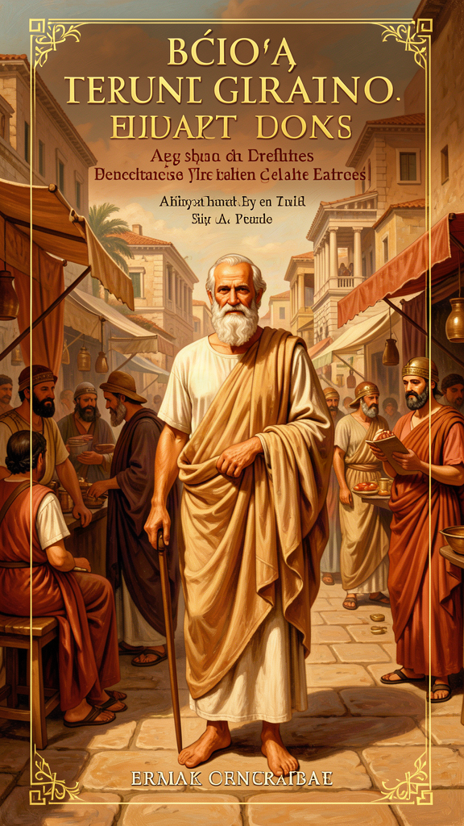
The Examined Life
WisdomForge Booklet — Ages 11–14

The Examined Life

WisdomForge Booklet — Ages 11–14
———

About This Book
Socrates never wrote a single word. He left no books, no essays, no letters. Yet he is one of the most important thinkers in all of human history. How is that possible?
The answer is that Socrates did his thinking out loud. He walked the streets of Athens, a city in ancient Greece, and talked to people. He asked them questions — about justice, about courage, about what makes a life worth living. He did not hand out answers. He handed out questions, and the questions made people think in ways they had never thought before.
We know about Socrates because others wrote about him. His student Plato wrote philosophical dialogues — written conversations in which Socrates is the main speaker. A historian named Xenophon wrote about a more practical, down-to-earth Socrates. A comedian named Aristophanes mocked Socrates on stage as a dangerous fraud. Each source gives us a different portrait. Put them together and you get not a photograph but a prism: the same figure refracted through different lenses.
This booklet tells six stories from Socrates' life and thought. Each one centers on a famous moment from Plato's dialogues. You will read about the oracle that called Socrates the wisest man alive, about his refusal to stop asking questions even when it cost him his life, about his argument that caring for your soul matters more than wealth or fame, about his choice to die in prison rather than break the law, about the mysterious words he spoke as he died, and about a question he asked that still puzzles philosophers today.
These are not just old stories. They are live questions. Socrates believed that the unexamined life is not worth living — that a person who never stops to ask "What kind of life am I living?" is asleep at the wheel. This booklet invites you to wake up and start asking.
———

Chapter 1: The Oracle at Delphi — No One Is Wiser
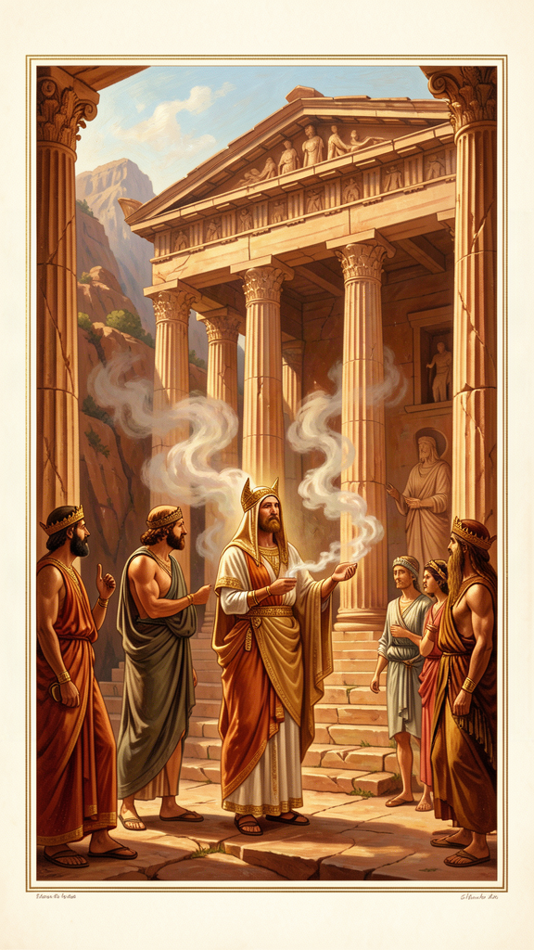
Illustration for Chapter 1
![Chapter 1](/images/booklets/socrates-middle-ch01.png)
Athens in the fifth century BCE was one of the most remarkable cities the world has ever known. It was a democracy — the word itself is Greek, meaning "rule by the people." Athenian citizens voted on laws, served on juries, and debated policy in the assembly. The city produced great tragedies, great architecture, great sculpture, and great arguments. It was a place where speech was power.
Into this loud, competitive city walked a man who did not look the part of a thinker. Socrates was short, stocky, and not handsome. He had a snub nose, bulging eyes, and a thick mouth. He wore an old cloak in all weather and often went barefoot. He did not charge fees for teaching, unlike the traveling lecturers called Sophists who made good money instructing young men in rhetoric and argument. Socrates lived simply and talked to anyone — rich or poor, powerful or unknown.
His method was simple and maddening: he asked questions. He would find someone who claimed to know something — what justice is, what courage is, what piety is — and then he would ask a series of follow-up questions. Each question tested the person's answer. Each answer led to a new question. Sooner or later, the person would discover that what they thought they knew did not hold up. They would reach a state the Greeks called aporia — a standstill, a moment of puzzlement where confidence gives out.
One day, a friend of Socrates named Chaerephon traveled to Delphi, a sacred site in the mountains where an oracle — a priestess believed to speak for the god Apollo — answered questions from visitors. Chaerephon, who admired Socrates enormously, asked the oracle a bold question: "Is anyone wiser than Socrates?"
The oracle replied: "No one is wiser."
When Chaerephon reported this, Socrates was genuinely confused. He did not feel wise. He knew he did not possess special knowledge about the natural world, about politics, or about the gods. The oracle's answer seemed impossible. How could he be the wisest person alive if he knew so little?
Rather than dismiss the oracle, Socrates decided to test it. He would find people with a reputation for wisdom, question them, and see whether they actually knew what they claimed. If they did, the oracle would be proven wrong. If they did not, perhaps the oracle meant something he did not yet understand.
He went first to the politicians. These were the men who ran the city, made the laws, and commanded the armies. Socrates found that the politicians he questioned thought they knew a great deal. They spoke with confidence about justice, the good, and the best way to live. But when Socrates pressed them — "What do you mean by justice?" "If justice is X, then how do you explain Y?" — their answers collapsed. They had been relying on habit, convention, and the authority of their position. They did not understand their own claims.
Next, Socrates turned to the poets. The poets of Athens wrote works that moved audiences to tears. Socrates asked them to explain what their poems meant. Many could not. They composed by instinct and inspiration, not by knowledge. They could make beautiful words but could not account for the meaning behind them. Socrates realized that poetic talent is not the same as wisdom.
Finally, Socrates questioned the craftsmen — the builders, metalworkers, and shoemakers. These people did possess real knowledge. A skilled shoemaker genuinely knows how to make a good shoe. But the craftsmen made the same mistake as the others: because they knew their own craft well, they assumed they also understood politics, ethics, and the good life. Their expertise in one area bred false confidence in every other area.
After this long investigation, Socrates understood what the oracle meant. The oracle was not saying that Socrates knew everything. It was saying something more subtle and more challenging. Socrates was wiser than the politicians, poets, and craftsmen because he knew the limits of his own knowledge. They did not. They thought they knew things they did not know. Socrates, at least, was honest about what he did not know — and that honesty, that awareness of his own ignorance, was a form of wisdom they lacked.
"I am wiser than this man: neither of us knows anything, but he thinks he knows something, while I know nothing. Yet I appear to be wiser in just this one respect: if I do not know something, I do not think that I do." — Plato, *Apology* 21d
This is the seed of what scholars call "Socratic ignorance" — not a claim to know nothing, but a disciplined awareness of the boundary between what you know and what you only think you know. It is not false modesty. It is a working method. The people most dangerous to themselves and to others are often those who are most certain they already understand. Socrates' wisdom began in refusing that certainty.
There is something important to notice about how Socrates reached this conclusion. He did not sit alone in a room and think his way to it. He went out and tested it. He talked to real people. He asked real questions. He treated his ignorance not as a reason to stay quiet but as a reason to investigate. Socratic ignorance is not passive. It is active, social, and relentless. The recognition that you do not know something is not the end of thinking. It is the beginning.
This also explains why Socrates made enemies. No one enjoys being shown that they do not know what they thought they knew. The politicians Socrates questioned were public figures with reputations to protect. Having their confidence dismantled in front of an audience — especially an audience of young men who would go on to imitate Socrates' questioning style — was humiliating. The oracle story is not just about wisdom. It is about the social cost of pursuing it honestly. Socrates' willingness to pay that cost is what set his life on its collision course with the city.

Big Idea
True wisdom is not having all the answers. It is knowing the difference between what you actually know and what you only think you know — and being honest enough to admit the gap. Socratic ignorance is not passivity. It is the active, courageous decision to investigate what you do not understand, even when the investigation costs you.

Try This
Pick something you feel confident about — a school subject, a hobby, a skill. Write down three things you "know" about it. Now, for each one, ask yourself: "How do I know this? Where did I learn it? Could I be wrong?" You may discover that some of what you call knowledge is really assumption. That discovery is the first step toward Socratic wisdom.

Talk About It
Discuss with a friend, classmate, or family member: Why do people who know a lot about one subject often assume they are experts on everything else? Have you ever seen this happen — in a teacher, a coach, a relative, or yourself? What makes it hard to say "I don't know"?
———

Chapter 2: The Unexamined Life Is Not Worth Living
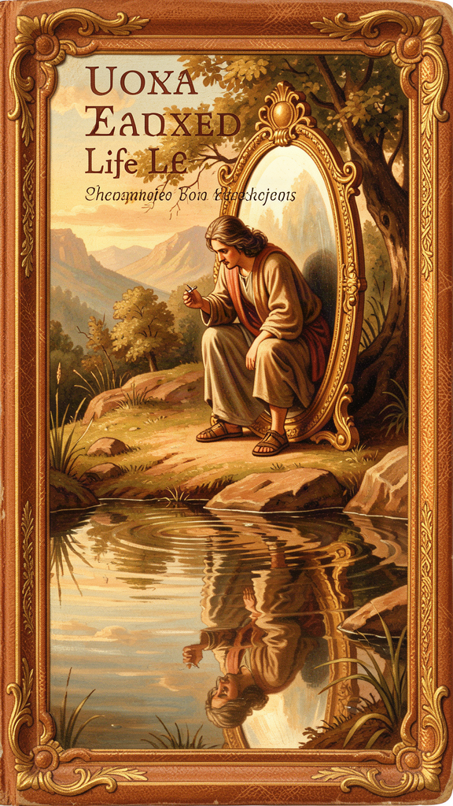
Illustration for Chapter 2
![Chapter 2](/images/booklets/socrates-middle-ch02.png)
Socrates' questioning made him famous, but it also made him enemies. The politicians he examined felt humiliated. The young men who watched Socrates in action began to imitate him, questioning their elders and exposing the same gaps in knowledge. This did not endear Socrates to the people in power.
In 399 BCE, when Socrates was seventy years old, three men brought formal charges against him. The charges were serious: impiety (not believing in the gods the city recognized) and corrupting the youth (teaching young people to question authority and tradition). The case went to a jury of hundreds of Athenian citizens.
Socrates stood before the jury and gave the speech Plato recorded as the Apology — the Greek word apologia means "defense," not an apology in the modern sense. He did not grovel or plead. He did not bring his weeping family to the courtroom to win sympathy, as defendants often did. He made his case directly: he explained why he had spent his life asking questions and why he would not stop.
He told the jury about the oracle at Delphi. He explained how he had spent years testing the oracle's claim by questioning politicians, poets, and craftsmen. He said that his questioning was not a hobby or a nuisance but a divine mission. He compared himself to a "gadfly" — a fly that stings a large, lazy horse to wake it up. Athens, he said, was the horse: great and noble, but in danger of falling asleep. His questions were the sting that kept the city alert to its own assumptions.
Then Socrates said something that sealed his fate. He told the jury that if they offered to let him go free on one condition — that he stop philosophizing, stop questioning, stop examining himself and others — he would refuse. He said he would keep doing what he had always done, questioning anyone he met, for as long as he drew breath. He said it was better to obey the god's command than to save his own life.
And then he said the words that have echoed for 2,400 years:
"The unexamined life is not worth living for a human being." — Plato, *Apology* 38a
What does this mean? Socrates is not saying that you must spend every waking moment in deep reflection. He is not against playing sports, telling jokes, or enjoying a good meal. He is saying something more fundamental: a life in which you never stop to ask "Is this the right way to live? Am I being a good person? Do my values hold up under examination?" is not fully human. It is a life on autopilot.
Think of it this way. An animal lives by instinct. It eats when hungry, sleeps when tired, fights when threatened. It does not ask whether its life is meaningful. A human being can do all those things too — but a human being can also step back and ask "Why am I doing this? Is this worth doing? Is there a better way?" That ability to question is what separates a human life from a merely biological one. A life that never uses that ability has given up the thing that makes it human.
Socrates' claim is not just about individuals. It is about entire societies. A city that never asks whether its laws are just, whether its customs are humane, whether its priorities are sound, is a city that is sleepwalking. Athens was a great city — but it had stopped examining itself. It assumed its democracy was good, its traditions were right, its gods were satisfied. Socrates' questions were an attempt to wake the city up. That is why he called himself a gadfly: not to destroy the city, but to keep it alert. A gadfly does not kill the horse. It keeps the horse from dozing into danger.
The line is also a warning. Unexamined opinions easily become prejudices. If you never question your assumptions about other people, about what is fair, about what success means, those assumptions harden into beliefs you cannot defend but also cannot let go of. Examination — even when it leaves you confused — is the beginning of genuine understanding. The confusion is not a failure. It is the door opening.
The jury was not moved. A narrow majority voted to find Socrates guilty. The penalty was death by hemlock, a poison made from a plant. Socrates had one more chance to speak, and he used it calmly. He told the jury that death was one of two things: either a dreamless sleep, which is not unpleasant, or a journey to another place where one could converse with the great souls who had died before. Either way, he said, there was nothing to fear.
The sentence was carried out several weeks later, after a delay caused by a religious festival. Socrates spent those final weeks in prison, still talking, still questioning, still teaching.

Big Idea
A life without self-examination — without ever asking "Am I living the right way?" — is not fully human. The ability to question our own assumptions is what separates a life from a routine. Examination, even when it leads to confusion, is the beginning of real understanding.

Try This
Take ten minutes this week to sit quietly and write down answers to these three questions: (1) What do I spend most of my time doing? (2) Why do I spend my time that way? (3) If I could change one thing about how I live, what would it be? Do not rush. Do not write what sounds good — write what is true. This is your first examined-life exercise.

Talk About It
Socrates said he would rather die than stop asking questions. Do you think that is brave, stubborn, or something else? Is there anything you care about enough that you would refuse to give it up, even under pressure? Discuss with someone: What makes a principle worth holding onto, even when it costs you something?
———

Chapter 3: The Priority of the Soul
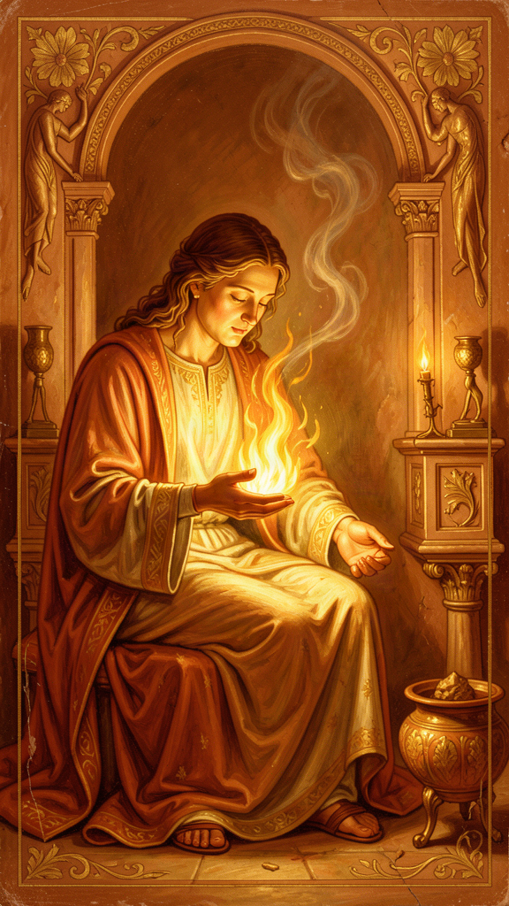
Illustration for Chapter 3
![Chapter 3](/images/booklets/socrates-middle-ch03.png)
During his defense speech, Socrates did something that startled the jury. He turned the tables on his accusers. Instead of defending himself in the usual way — arguing that he was innocent and posing no danger — he told the jury that they were the ones in trouble, not him.
The people of Athens, Socrates said, were anxious about the wrong things. They worried about wealth, reputation, honors, and physical safety. They spent their energy chasing money, admiration, and status. Meanwhile, they gave no thought to the one thing that actually determines whether a person's life is good or bad: the condition of their soul.
The word "soul" — in Greek, psyche — did not mean for Socrates what it sometimes means in religion today. It was not a ghost that floats out of the body after death. It meant the whole moral and intellectual self: your character, your judgment, your capacity for truth and justice. It is the part of you that decides to be honest or dishonest, brave or cowardly, kind or cruel. You cannot weigh it or photograph it, but it is more truly you than anything else about you.
Here is what Socrates said:
"Are you not ashamed of your eagerness to possess as much wealth, reputation, and honors as possible, while you do not care for nor give thought to wisdom or truth, or the best possible state of your soul?" — Plato, *Apology* 29e
Notice the word "ashamed." Socrates is not just making a philosophical point. He is issuing a moral challenge. He is saying that a life spent pursuing external goods — money, fame, status — while ignoring the inner life is a life that should cause its owner embarrassment.
This does not mean Socrates thought wealth and reputation were evil. He did not preach poverty as a virtue in itself. His point was about priority. External goods — money, fame, power, beauty, health — are not bad, but they are secondary. They depend on the soul to be used well. A wealthy person with a corrupt soul is worse off than a poor person with a just one, because the wealth only gives the corrupt person more power to do harm. A famous person without wisdom has no idea what to do with the attention.
Think of it as a scale of values. At the top is the soul — your moral and intellectual character. Below that are the external goods: money, reputation, physical well-being. The external goods have value, but only when the soul is in good condition. Without wisdom, wealth can destroy you. Without justice, power corrupts. Without self-knowledge, fame makes you hollow. The soul comes first because everything else depends on it.
Socrates lived this principle. He did not charge fees. He did not pursue political power. He did not care about his reputation enough to stop asking questions, even when questioning made him enemies. He wore a shabby cloak and lived simply. None of this was for show. It flowed from his conviction that the only thing worth pursuing was the improvement of the soul.
This is a radical idea, and it is still radical today. We live in a world that measures success by external marks: grades, followers, salary, awards, the size of a house, the brand of a car. Socrates asks us to flip the scale. What good is any of that if the person inside is dishonest, unkind, or unexamined? What good is a gold medal if the person wearing it has never asked what kind of person they are becoming?
The soul, for Socrates, is the only thing that is truly yours. Money can be lost. Reputation can be destroyed by a rumor. Beauty fades. Physical strength declines. But your character — the choices you make, the values you hold, the honesty with which you face yourself — is something no one can take from you. It is the one thing you can always work on, no matter your circumstances.
There is a practical test for this idea. Ask yourself: who are the people you most admire? Are they the ones with the most money, the biggest houses, the most awards? Or are they the ones whose character you respect — the ones who are honest when honesty costs them, brave when courage is hard, kind when kindness is inconvenient? If you admire character more than possessions, you already agree with Socrates more than you might have realized. The culture tells you to chase the external goods. Your own judgment tells you to value the soul. Socrates' argument is that your judgment is right and the culture is confused.

Big Idea
Wealth, fame, and physical comfort have value, but they are secondary. The condition of your soul — your character, your judgment, your moral and intellectual self — is what determines whether your life is good or bad. The soul comes first because everything else depends on it.

Try This
Make two lists. On the left, list five things you are proud of having or achieving — a good grade, a skill, a possession, a reputation. On the right, list five qualities of who you are — honest, curious, loyal, brave, generous. Now cover the left list and look only at the right. Ask yourself: "If I lost everything on the left, would the things on the right still make my life meaningful?" Then cover the right and look only at the left. Ask: "If I had everything on the left but none of the qualities on the right, would my life be good?" The difference between your two answers is the Socratic scale of values.

Talk About It
We live in a culture that measures success by external achievements — grades, followers, awards, money. Socrates says those are secondary. Do you agree? Where do you see pressure to value external goods over inner character? Discuss with a friend: Is it possible to care about both, or does one always end up crowding out the other?
———

Chapter 4: Crito and the Laws of Athens
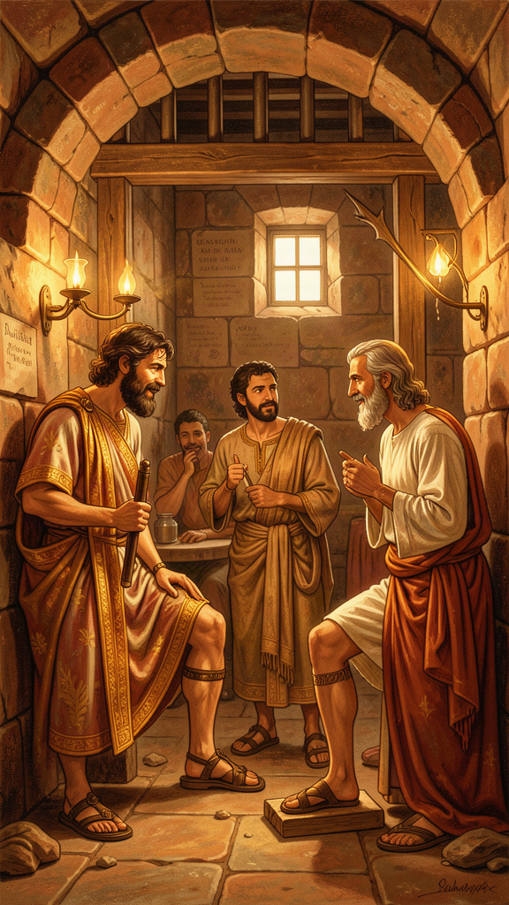
Illustration for Chapter 4
![Chapter 4](/images/booklets/socrates-middle-ch04.png)
Socrates was found guilty and sentenced to death. But the execution was delayed. A sacred ship had been sent from Athens to the island of Delos on a religious mission, and an old custom forbade the city from carrying out any executions until the ship returned. Socrates sat in prison, waiting, for about a month.
His friends used that time to plan. His old friend Crito, a wealthy man who cared deeply about Socrates, arranged everything. He had money to bribe the guards. He had helpers ready to smuggle Socrates out of Athens and to a safe city nearby. All Socrates had to do was agree to leave.
Early one morning, before dawn, Crito came to the prison cell. He found Socrates sleeping peacefully. Crito was astonished — how could anyone sleep the night before a possible escape? He woke Socrates and told him the plan. The ship would return any day now. Time was running out. This might be the last chance.
Crito made several arguments. He said that if Socrates died, people would think his friends did not care enough to save him — that they were cheap or cowardly. He said that Socrates was abandoning his children, who needed their father. He said the trial was unjust, so escaping was simply correcting an injustice, not committing a crime.
Socrates listened to every argument. Then he responded, calmly and methodically, in the conversation Plato recorded as the Crito. His answer comes down to one principle: it is never right to do wrong, even in return for wrong.
Socrates agreed that the trial may have been unjust. But he said that responding to injustice with more injustice does not make things right. Running away — breaking the laws of his own city, abandoning his agreements, damaging the community — would be doing wrong, regardless of whether the trial was fair. Two wrongs do not make a right. The soul is harmed by doing injustice, and harming your soul is worse than any harm to your body.
Then Socrates did something striking. He imagined the Laws of Athens speaking to him directly, as if they were standing in the cell. The Laws made their case:
They said they had raised Socrates. They had provided the marriage laws that brought his parents together. They had given him an education. They had protected his family and allowed him to live in a free and prosperous city. By choosing to live in Athens his whole life — never leaving, never choosing another city — Socrates had entered into an agreement with the Laws. He had accepted their benefits and, by staying, had accepted their authority.
The Laws asked: if a citizen disagrees with a particular verdict, does that give him the right to ignore the whole system? If everyone who lost a case simply refused to accept the outcome, the laws would mean nothing. The city would collapse into chaos. By living under the laws and enjoying what they provide, Socrates owed them a basic respect — even when a particular decision went against him.
"Then consider, Socrates, whether we are right in saying that by attempting to escape you are attempting an injustice against us in a certain way." — Plato, *Crito* 50c
The argument is not that the laws are always right. Socrates does not say the trial was just. He says that a citizen who has benefited from a community owes that community a kind of respect, and that breaking the law is a serious matter even when the law is mistaken. The relationship between citizen and city is like a contract. You cannot enjoy the benefits for decades and then tear up the contract the moment it goes against you.
Socrates concluded that it is better to suffer injustice than to commit injustice. The person who is wronged suffers in body or reputation, but the person who does wrong damages the soul — the thing that matters most. Escaping would save his body but harm his soul. He chose his soul.
Crito could not answer. He left the cell knowing that his friend would die.
This dialogue raises questions that are still alive today. What do you owe your community? If a law is unjust, is breaking it always wrong? Later thinkers — Henry David Thoreau, Mahatma Gandhi, Martin Luther King Jr. — argued that breaking an unjust law can be a moral act, provided the lawbreaker accepts the consequences openly. Socrates' position is more conservative: he accepts the consequences, but he refuses to break the law at all. The disagreement between Socrates and these later thinkers is one of the most important conversations in political philosophy.
There is also a personal dimension to Socrates' choice that is easy to miss. Crito offered him safety, comfort, and more years of life. Socrates refused, not because he wanted to die, but because he could not live with himself if he broke his word. The Crito is, among other things, a portrait of integrity: the condition of being whole, of acting in accordance with your deepest principles even when it would be easier not to. Socrates' integrity was more important to him than his survival. That is a high standard. Whether we can meet it is a question each person must answer for themselves — but the Crito shows us what the standard looks like when someone does.

Big Idea
Doing wrong in response to wrong is still doing wrong. A citizen who benefits from a community's laws owes those laws respect, even when a particular decision is unjust. For Socrates, harming your own soul by acting unjustly is worse than suffering injustice at the hands of others.

Try This
Write a short paragraph answering this question: "If you were falsely accused of something at school and given an unfair punishment, would it be right to sneak out of detention? Why or why not?" Now write a second paragraph from the opposite viewpoint, arguing the other side. Which argument do you find more convincing? Why?

Talk About It
Socrates chose to obey a law he believed was unjustly applied rather than break it. Later thinkers like Martin Luther King Jr. argued that breaking unjust laws can be a moral duty — if you do it openly and accept the punishment. Who do you think is right? Can both be right in different situations? Discuss with someone: What is the difference between Socrates accepting his punishment and King accepting his — and where does the difference matter?
———

Chapter 5: Socrates' Final Words
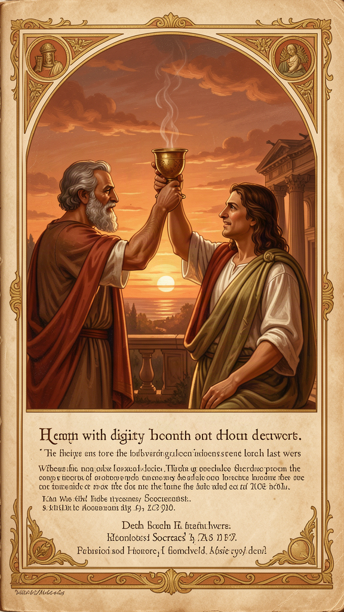
Illustration for Chapter 5
![Chapter 5](/images/booklets/socrates-middle-ch05.png)
The sacred ship returned to Athens. The delay was over. Socrates' friends came to the prison for the last time. The conversation that day, recorded by Plato in the Phaedo, is one of the most powerful scenes in all of literature.
Socrates' friends were grief-stricken. Some were weeping openly. His wife Xanthippe had been there earlier with their youngest child, distraught, and Socrates had sent her home so she would not have to witness the end. The friends gathered around him tried to hold themselves together. Socrates, characteristically, began to talk.
He talked about death. He told his friends not to fear it. Death, he said, is one of two things. Either it is a deep, dreamless sleep — and who would not prefer a peaceful sleep to a restless life? — or it is a journey of the soul to another place, where one could meet and converse with the great figures who had died before. Either way, there was nothing to fear. If death is sleep, it is rest. If death is a journey, it is the greatest conversation of all.
Then a servant of the city entered carrying a cup of hemlock. The friends broke down. Socrates told them to be calm. He did not want to die amid weeping and noise. He wanted to meet death with composure.
He took the cup. He drank it, every drop, without hesitation. He walked around the cell as the poison began to take effect. When his legs grew heavy, he lay down. The poison moved upward, numbing his body from the feet. A friend covered his face. Socrates pulled the cover away and spoke his last words:
"Crito, we owe a cock to Asclepius. Will you offer it?" — Plato, *Phaedo* 118
Asclepius was the god of healing. In Greek religious practice, people offered a rooster — a cock — to Asclepius when they recovered from an illness. It was a thanksgiving for a cure.
Why would a man about to die ask for a healing offering? Scholars have debated this for centuries, and no one knows for certain what Socrates meant. Three main interpretations have emerged.
The first reading: death is a cure. Socrates means that life in the body was a kind of disease, and death is the healing — the moment when the soul is freed from the body's limitations and corruptions. On this view, the offering to Asclepius is Socrates' way of saying that death has cured him of the ailment of living.
The second reading: ordinary piety. Socrates was a religious man. Throughout his life, he spoke of a divine inner voice — a daimonion — that warned him away from certain actions. He participated in the city's religious practices. His last words may simply be a final act of piety: even at the moment of death, he remembers his religious duties and makes sure the offering is not forgotten.
The third reading: final irony. Socrates spent his life leaving people with puzzles. His last words may be one more puzzle — a gift to his friends, something to think about and argue over for as long as they live. On this view, Socrates is being himself to the very end: the man who asks a question rather than giving a settled answer.
We do not know which reading is correct. Perhaps Socrates meant all three. Perhaps he meant none. The mystery is part of the scene's power. A man dies calmly, surrounded by friends, still thinking, still teaching, still leaving questions behind. The composure itself — the refusal to weep or beg or rage — became one of the most powerful images in Western culture. It showed that a person who has examined their life and cared for their soul has nothing to fear from death.
Socrates died. But his questions survived. Plato wrote down what happened, and those words have traveled through nearly two and a half millennia to reach you. Every time someone asks a hard question instead of accepting an easy answer, Socrates' voice is still alive.
The scene raises a question that goes beyond the mystery of the final words. Why has this death been remembered for 2,400 years? People die every day. Executions have happened in every century. What makes this one different?
The answer, perhaps, is that Socrates' death is a demonstration of his philosophy. He spent his life saying that the soul matters more than the body, that examined life is worth more than unexamined survival, that doing right is more important than avoiding suffering. At the end, he lived those claims. He did not just preach the priority of the soul — he died for it. The death is the proof that the philosophy was not words to him. It was a way of being, and he was willing to die rather than abandon it. That is why the scene endures. It is not the death of a philosopher. It is the life of a philosophy, made visible in its final moment.

Big Idea
The way a person faces death reveals what they truly believe. Socrates met death with calm and curiosity, showing that a life spent caring for the soul leaves nothing to fear. His final words — puzzling and mysterious — were one last act of the philosopher who never stopped asking.

Try This
Socrates said death is either a dreamless sleep or a journey to meet those who have gone before. Write a short paragraph about which of those two possibilities you find more comforting — and why. Then write a second paragraph about what you think Socrates' final words meant. There is no wrong answer. The point is to think carefully and give your reasoning.

Talk About It
Socrates faced death without fear. Do you think that takes extraordinary courage, or do you think his philosophy made it easier — if you truly believe the soul matters more than the body, death is less frightening? Discuss with someone: What would it take to face something frightening with that kind of calm? Is it a matter of philosophy, or character, or both?
———

Chapter 6: Euthyphro's Dilemma
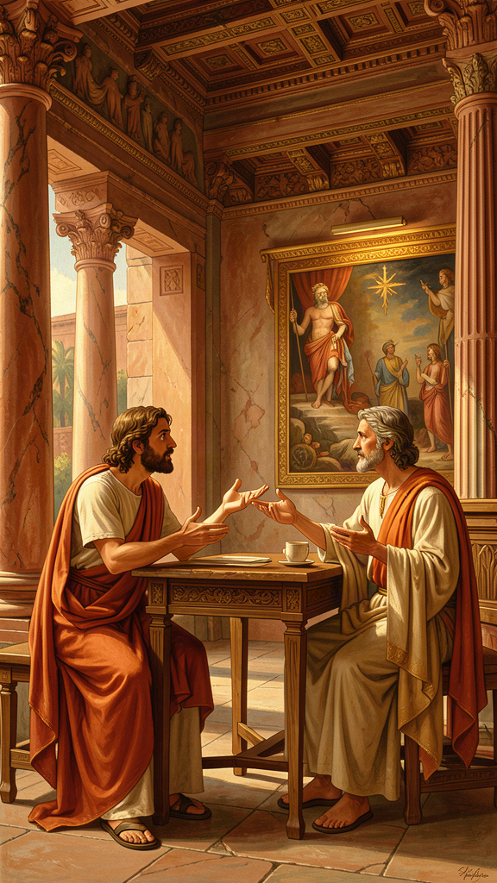
Illustration for Chapter 6
![Chapter 6](/images/booklets/socrates-middle-ch06.png)
The story of the Euthyphro begins outside a courthouse in Athens. Socrates is there to answer the charges that will eventually lead to his trial. He meets a man named Euthyphro, who is also at the courthouse for legal business — but of a very different kind.
Euthyphro is prosecuting his own father for murder. A servant on the family estate had killed a man. Euthyphro's father had bound the servant and thrown him in a ditch while he sent for instructions from a religious authority about what to do. The servant died in the ditch. Euthyphro believes that the right thing to do — the pious thing — is to prosecute his own father for the death, regardless of family loyalty.
Most Athenians found this shocking. Turning against your own father, even for a good reason, violated deep conventions about family duty. But Euthyphro is not troubled. He is supremely confident. He is certain that he knows what piety is — what is holy, what is right, what the gods want.
When Euthyphro hears that Socrates has been charged with impiety, he is interested but not very concerned. Socrates, with his usual instinct, sees an opportunity. He says: "You are so confident about what piety is that you are prosecuting your own father for it. You must know a great deal. Will you teach me what piety is?"
Euthyphro happily accepts. He offers his first definition: piety is prosecuting wrongdoers, regardless of who they are. Socrates points out that this is an example, not a definition. He wants to know what piety is — the essential characteristic that makes something pious, not just one case of it.
Euthyphro tries again. His second answer: piety is what is pleasing to the gods. But Socrates notes that the Greek gods famously disagree with one another — they quarrel, fight, and take sides in human conflicts. If the gods disagree, then the same action could be pious (loved by some gods) and impious (hated by others) at the same time. That makes the definition useless.
Euthyphro revises. His third answer is the one that matters:
"The pious is what all the gods love, and the opposite, what all the gods hate, is the impious." — Plato, *Euthyphro* 9e
This seems better. If we set aside the question of whether the gods always agree, the definition says: something is pious if and only if all the gods love it, and impious if and only if all the gods hate it.
Socrates then asks the question that has never stopped being asked:
"Is the pious loved by the gods because it is pious, or is it pious because it is loved by the gods?" — Plato, *Euthyphro* 10a
This is the Euthyphro dilemma. It looks like a word puzzle, but it is one of the most important questions in the history of ethics. Let us unpack it.
Option A: Something is pious because the gods love it. On this view, the gods' love creates the piety. If the gods decided to love cruelty, cruelty would become pious. If they decided to hate kindness, kindness would become impious. Goodness is whatever the gods happen to prefer. This makes morality arbitrary — a matter of divine taste, not of truth.
Option B: The gods love something because it is pious. On this view, the piety exists independently of the gods. The gods recognize it and love it, but they did not create it. Something is pious because it is genuinely good, and the gods, being wise, love what is good. But this means there is a standard of goodness that is bigger than the gods — a standard they did not invent and cannot change.
Both options lead somewhere uncomfortable. If goodness is just whatever the gods say, then morality is arbitrary and there is no real reason to call anything good or bad. If goodness exists independently of the gods, then the gods are not the source of goodness — they are just knowledgeable observers pointing at something that exists on its own.
The dilemma does not only apply to Greek gods. It applies to any authority that claims to define morality. Replace "the gods" with "the government," "the church," "your parents," "your culture," or "the law." The same question arises: is something good because the authority says so, or does the authority say it is good because it is already good? This question matters every time we ask whether a law is just, whether a tradition is right, or whether a leader's command is moral.
Consider a concrete example. A government passes a law. Is the law just because the government enacted it — because the government has the authority to define justice? Or is the law just because it conforms to a standard of justice that exists independently, a standard the government is supposed to follow? If you believe the first, then any law a government passes is automatically just, and injustice becomes impossible by definition. If you believe the second, then a government can pass unjust laws — and the fact that it enacted them does not make them right. Most people, when pressed, believe the second. But the second option means that justice is not created by authority. It is recognized by authority. And that raises the hardest question of all: where does the standard come from, and how do we know it?
Socrates does not answer that question. He leaves it hanging. That is characteristic of his method: he does not resolve the dilemma. He makes it visible. Before Socrates' questions, Euthyphro was confident. After them, he was confused. Socrates would say the confusion was progress.
Euthyphro could not answer. He tried to deflect, then grew frustrated, then claimed he was in a hurry and rushed away. The dialogue ends in aporia — that standstill of puzzlement that Socrates produced wherever he went. Socrates called after him, but Euthyphro was gone.
The point, as always, was not to win. Socrates was not trying to humiliate Euthyphro. He was trying to show that a confident answer, when examined, reveals a deeper problem. Euthyphro thought he knew what piety was. After a few questions, he discovered he did not. That discovery — that moment of honest confusion — is where philosophy begins.

Big Idea
The Euthyphro dilemma asks whether something is good because an authority says so, or whether the authority says so because it is already good. The question applies to gods, governments, parents, and cultures: is morality invented by authority, or recognized by it? The dilemma has no easy answer, and that is the point — easy answers hide deep problems.

Try This
Replace "the gods" in Euthyphro's dilemma with something from your own life. Pick a rule you follow — at home, at school, or in your community. Now ask: "Is this rule good because [authority] says so, or does [authority] say so because the rule is already good?" Write down your answer and your reasoning. If you are not sure, that is fine — Socrates was not sure either. The thinking matters more than the conclusion.

Talk About It
Here is the closing question for this chapter, and for the whole booklet: Socrates spent his life asking questions and never claimed to have the final answer. He believed that the questioning itself — the willingness to examine your own assumptions and admit what you do not know — is what makes a life worth living. Do you agree? Is a life of asking better than a life of certainty? Or do we sometimes need to stop asking and just decide?
Discuss this with someone you trust. Listen to their answer. Then ask one more question — the way Socrates would.
———

For the Grown-Up Reader
This booklet introduces readers aged 11–14 to Socrates through six chapters drawn from Plato's early dialogues. The narrative retellings preserve the structure, dramatic setting, and central arguments of the original texts while adapting the vocabulary and pacing for middle-school readers.
All quotations are genuine, drawn from the Plato dialogues cited. The translations follow the Grube/Reeve versions in Plato: Complete Works (Hackett, 1997), the standard scholarly reference in English.
A few notes on adaptation choices:
- The oracle story comes from Apology 21a–23b. The testing of politicians, poets, and craftsmen is preserved in full, with the threefold structure that Socrates himself gives it. - The unexamined life (Apology 38a) is presented in the context of the trial, where it belongs. The chapter explains the line's meaning without reducing it to a slogan — emphasizing that Socrates is talking about a life that never questions itself, not a life that lacks constant meditation. - The priority of the soul (Apology 29e) introduces the Socratic scale of values: soul first, external goods second. The chapter explains that Socrates did not condemn wealth but insisted on priority. - The *Crito chapter presents both Crito's arguments for escape and Socrates' personification of the Laws (50a–54e). The comparison with later thinkers (Thoreau, Gandhi, King) is included to connect the ancient argument to modern debates about civil disobedience. - The Phaedo* chapter presents the three main scholarly readings of Socrates' final words without resolving them. The mystery is left intact, as it should be. - The Euthyphro** chapter presents the dilemma in full and extends it beyond theology to political and parental authority. This generalization is faithful to the philosophical structure of the argument.
Socrates never wrote anything. Everything comes through Plato (and, to a lesser extent, Xenophon and Aristophanes). The research files note the "Socratic Problem": scholars debate how much of the Socrates in the dialogues is historical and how much is Plato's literary creation. Most scholars agree that the early dialogues — Apology, Crito, Phaedo, Euthyphro — are the closest to the historical Socrates. This booklet draws only from those early dialogues, deliberately avoiding the middle-period works (Republic, Symposium) where Socrates increasingly becomes Plato's mouthpiece.
A note on the other ancient sources: Xenophon, a historian and soldier who also knew Socrates, wrote a portrait that is more practical and conventional than Plato's. His Socrates gives advice on household management, self-discipline, and civic duty — closer to a moral teacher than a philosophical questioner. Aristophanes, the comic playwright, mocked Socrates in Clouds (423 BCE) as a dangerous sophist who taught young men to argue dishonestly and deny the gods. Both sources complicate Plato's portrait. They remind us that Socrates looked different to different people, and that no single source gives us the whole person. The historical Socrates is a figure reconstructed from competing testimonies, not a man we can know directly.
The "Talk About It" prompts are designed to extend conversation beyond the page. Socrates' gift was not providing answers but modeling the discipline of asking. The best outcome of this booklet is a reader who keeps asking questions after the last page.
———

About WisdomForge
WisdomForge creates age-adapted booklets that bring the great thinkers of human history to readers of every age. Each booklet takes a single figure — a philosopher, theologian, scientist, or sage — and presents their most important ideas in a form suited to the reader's stage of life.
Every WisdomForge figure gets four booklets: one for elementary ages (5–10), one for middle school (11–14), one for high school (15–18), and one for adult readers. The same core ideas appear in all four, but the depth, vocabulary, and style change. A child meets Socrates as a story character. A teenager meets him as a thinker with arguments to wrestle with. An adult meets him as a figure whose questions still shape philosophy, law, and ethics today.
WisdomForge uses only real quotes, cited by source. We do not invent words and put them in a thinker's mouth. When Socrates speaks, the words come from Plato's dialogues, and the dialogue is named.
Our booklets are written in the spirit of the thinkers themselves: clear, honest, and unwilling to settle for easy answers. We believe that the best ideas do not decay. They wait, like seeds, for the right reader to pick them up.

