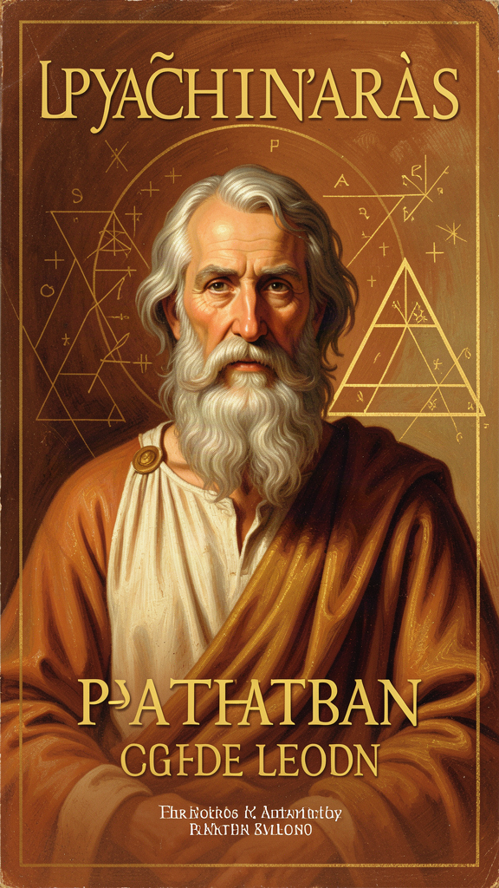
Pythagoras: The Mathematics of Everything
WisdomForge Booklet — Adult

Pythagoras: The Mathematics of Everything

WisdomForge Booklet — Adult
———

About This Book
Pythagoras is the first person in the Western tradition to say something that sounds obvious to modern ears but was revolutionary when he said it: the universe is mathematical. Not that mathematics is useful for describing the universe — that the universe IS mathematical structure. This claim, made around 2,500 years ago by a man who wrote nothing and whose life is half-legend, became the foundation of Plato's philosophy, Galileo's physics, Newton's mechanics, and the modern scientific conviction that the book of nature is written in the language of mathematics.
This booklet is not a biography. It is not a history lesson. It is a practical exploration of what the Pythagorean tradition has to offer a thoughtful adult: a way of seeing the world as mathematically structured, a practice of contemplating eternal truth, a framework for ethical balance, and a vision of community organized around shared inquiry. No self-help padding. No shortcuts. Just the ideas, the evidence, and the questions they raise for how you live.
———

Chapter 1: The Man Behind the Legend
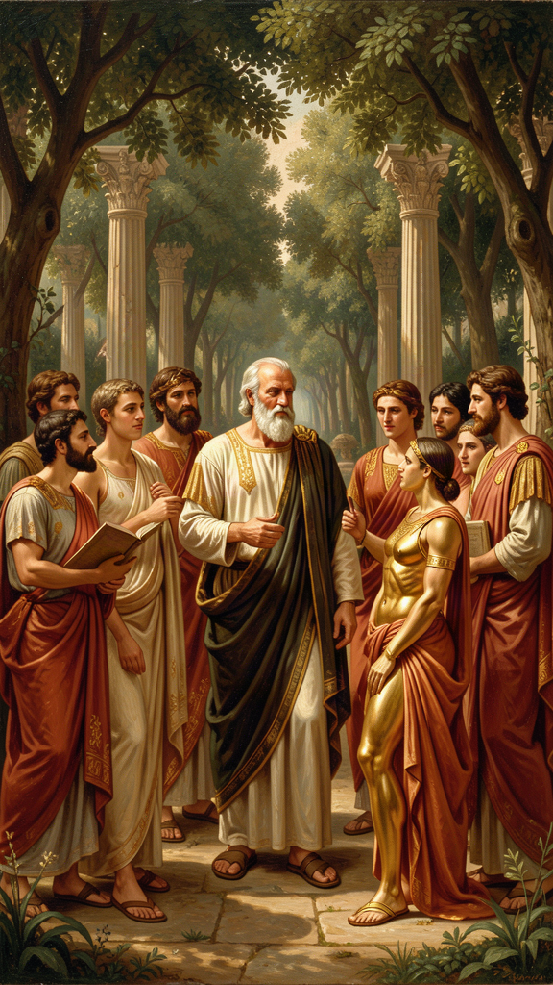
Illustration for Chapter 1
Pythagoras (c. 570–495 BCE) is one of the most famous and most elusive figures in ancient philosophy. He wrote nothing. His followers attributed miracles to him — a golden thigh, the ability to be in two places at once, memories of past lives. His earliest biographers wrote centuries after his death. And yet behind the legend, there is almost certainly a real historical person: a man from Samos who traveled widely, founded a remarkable community in Croton, taught that reality is number and that the soul transmigrates, and left a legacy that transformed Western thought.
The sources are late and legendary. Heraclitus, writing within a generation, already evaluates the legend. Aristotle wrote a lost book On the Pythagoreans. Diogenes Laërtius, Porphyry, and Iamblichus — our main biographical sources — wrote 800 years later. Everything is testimony shaped by devotion, polemic, or philosophical reinterpretation.
Here is what we can say:
- Pythagoras was born on Samos, probably around 570 BCE, to a family of some standing (his father was a gem-engraver). - He traveled widely — possibly to Egypt, possibly to Babylon — and studied with multiple teachers. - He left Samos around 530 BCE, probably to escape the tyranny of Polycrates, and settled in Croton, a Greek city in southern Italy. - He founded a community that combined philosophical study, religious practice, and political engagement. It included men and women. It shared property. It had dietary rules, common meals, and a daily routine of contemplation, study, and exercise. - The community was politically influential and eventually violently suppressed. Pythagoras probably died during or shortly after the persecutions, around 495 BCE. - His ideas survived through scattered followers — Philolaus brought Pythagorean ideas to Thebes and Athens; Archytas led a revival in Tarentum. By the time Plato traveled to Italy, Pythagoreanism was a living intellectual force.
The legend matters. Not as history, but as data. The Pythagoreans believed their founder was semi-divine. They attributed miracles to him. They remembered his past lives. Does that make the philosophy less true — or does it make the legend part of the philosophy?
There is something irreducible here. We want a clean "historical Pythagoras" we can evaluate separately from the "legendary Pythagoras." But the people who preserved his teaching did not separate them. For them, the truth of the philosophy was inseparable from the specialness of the teacher. Pythagoras was not just someone who had good ideas — he was someone who had BECOME what the ideas described: a harmonious soul, aligned with cosmic order.
This is not just a problem about Pythagoras. It is a problem about how we construct historical figures. We want the "real" Einstein, the "real" Jesus, the "real" Socrates — but what we have is always filtered through the people who preserved them, and those people had commitments, agendas, and experiences that shaped what they chose to remember. The "Pythagoras problem" is the problem of history itself: the past is never raw. It is always cooked by the people who transmit it.
The practical question: do you have teachers or influences you treat as special — as knowing something that goes beyond what can be communicated in words? Is that treatment helpful or harmful to your own growth? The Pythagoreans would say: the specialness of the teacher is part of the teaching. The reverence is not a distortion of the philosophy — it is the philosophy, lived.
Key Quote "Pythagoras, son of Mnesarchus, practiced inquiry most of all men, and having made a selection of these writings, claimed for himself a wisdom that was, in truth, knowledge and not wisdom." — Heraclitus (DK B129)
———

Chapter 2: All Is Number
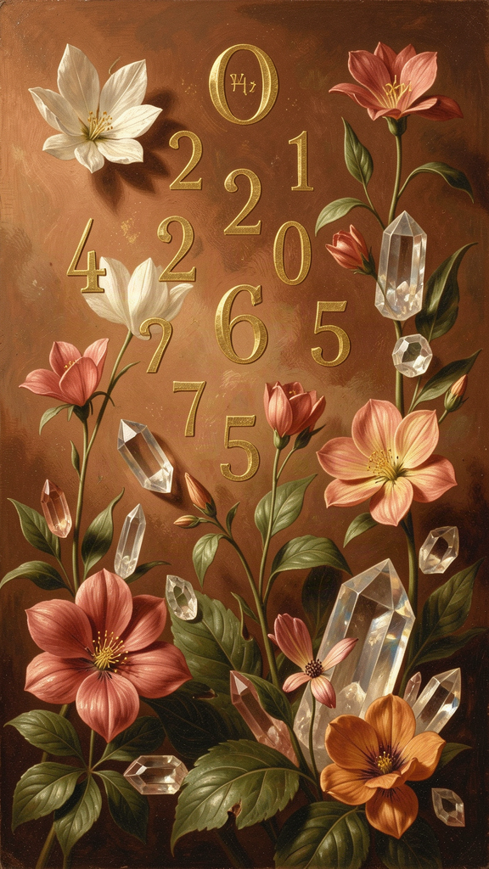
Illustration for Chapter 2
"All is number." According to Aristotle, this was the fundamental Pythagorean doctrine. Not that mathematics is useful for describing reality — that reality IS mathematical structure. Numbers are not mental constructions or useful abstractions. They are the actual building blocks of the cosmos.
The claim operates on multiple levels:
Ontological: Reality consists of numbers. According to Aristotle (Metaphysics I.6), the Pythagoreans thought numbers were the actual substance of things — not measurements of things, but the things themselves. A physical object IS a number in some sense.
Epistemological: Without number, nothing can be known. Philolaus (DK B4): "All things that are known have number. For without this, it is not possible that anything at all be understood or known." Mathematical structure is a precondition of intelligibility.
Methodological: The way to understand reality is through mathematics. This is the method that produced modern physics.
The generative sequence, according to Aristotle: The Unlimited (even, infinite, indeterminate) and the Limit (odd, determined, form) → numbers → geometric figures → physical bodies → the cosmos. Number is prior to matter. Most people think: first there are things, then we count them. The Pythagoreans thought: first there are numbers (principles of order), then those numbers impose themselves on the unlimited (raw matter) to produce things.
The evidence the Pythagoreans saw was overwhelming — to them: - Music: Musical consonance is produced by simple whole-number ratios (octave = 2:1, fifth = 3:2, fourth = 4:3). The beauty of music is mathematical structure made audible. - Geometry: The Pythagorean theorem (a² + b² = c²) shows that geometric relationships are numerically exact. - Astronomy: The planets move in regular, mathematically describable periods. - Seasons and cycles: The year, the seasons, biological cycles — all follow numerical patterns.
Wherever they looked, they found number as the deep structure of things. The conclusion: number IS the deep structure of things.
The interesting question: was it a lucky guess, or did the Pythagoreans have genuine insight? They had evidence, but the claim that ALL of reality is number far outstripped the evidence. They "supposed" (as Aristotle says) that number was the principle of all things, not because they had proved it, but because they had been "brought up in" mathematics and it made sense of everything they saw.
This is not how we think of scientific discovery — but it IS often how scientific discoveries happen. Someone is immersed in a way of thinking, and they "see" a pattern everywhere. Then they test it. The Pythagoreans didn't have much ability to test. But they had the right pattern.
The claim has been validated in ways they could not have imagined. The periodic table is a mathematical structure. DNA is a code. Quantum mechanics is expressed in mathematical operators. The physical universe IS mathematically structured at every level we can observe. When Galileo wrote that "philosophy is written in this grand book, the universe... it is written in the language of mathematics," he was drawing on the Pythagorean tradition. When Einstein said "the most incomprehensible thing about the universe is that it is comprehensible," he was expressing the same Pythagorean wonder.
The Pythagoreans were right — not in the details (there is no counter-earth, the planets do not make literal music), but in the fundamental intuition: reality is number. That intuition is the foundation of modern science.
Practical reflection: What would change in your life if you took "all is number" seriously? Not as a metaphysical claim about ultimate reality, but as a practical orientation: look for the mathematical structure in things. What patterns would you notice that you currently miss? Try it for a day. Look at your work, your relationships, your health, your habits. Where is the structure? Where is the proportion? Where is the ratio that makes things work?
Key Quote "The so-called Pythagoreans, who were the first to take up mathematics, not only advanced this study, but also, having been brought up in it, they supposed that its principles are the principles of all things." — Aristotle, Metaphysics I.5 (985b23)
———

Chapter 3: The Harmony of the Spheres
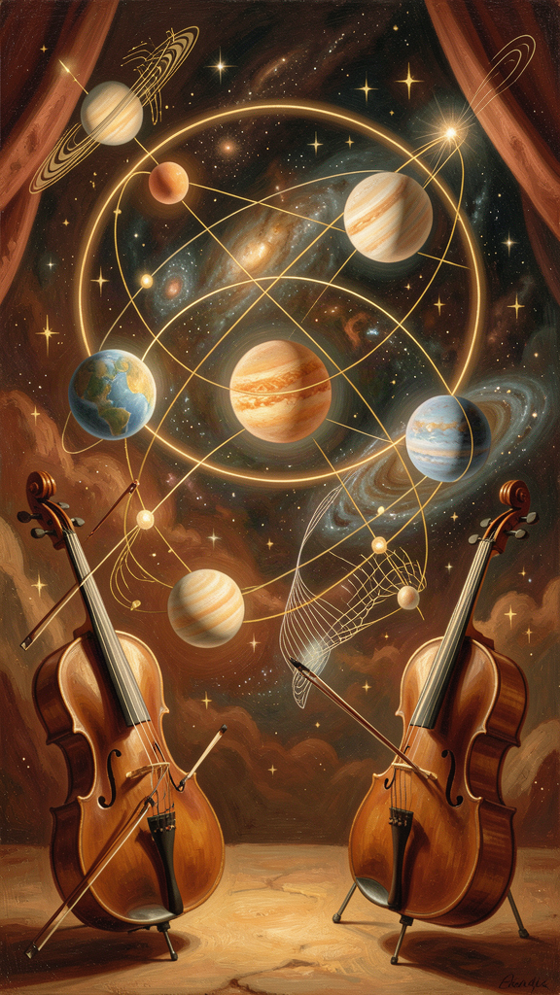
Illustration for Chapter 3
The "harmony of the spheres" is the Pythagorean doctrine that the planets, as they move through the heavens, produce musical notes corresponding to their distances and speeds, together forming a cosmic harmony — a music we cannot hear because we have been hearing it since birth.
The chain of reasoning:
1. Musical harmony is mathematical. Beautiful sounds come from simple whole-number ratios (2:1 octave, 3:2 fifth, 4:3 fourth). 2. The cosmos is mathematical. Planets move in regular, measurable patterns. 3. Therefore, the cosmos is harmonious. The planets must be producing a cosmic music.
This was not a vague metaphor. It had specific mathematical structure: each planet produces a note determined by its distance from the center and its orbital speed. Together, the notes form a cosmic scale. The ratios that produce musical harmony are the same ratios that structure the cosmos.
The Pythagorean explanation for why we cannot hear the harmony is philosophically sophisticated: - Habituation: We have been hearing it since birth. There is no silence to compare it against. Just as a fish does not notice water, we do not notice the cosmic harmony. - Continuity: The music is constant. Perception requires contrast. A constant stimulus becomes imperceptible. - Scale: The sound is too great — like we cannot see the sun directly without being blinded.
This is the first clear statement of a reality that is real but not perceptible — an insight that would become central to all philosophy that distinguishes appearance from reality. There are things that are real but that we cannot perceive, not because they are too small or too subtle, but because they are too large and too constant.
The idea had an extraordinary afterlife. Plato adapted it in the Republic (the Myth of Er). Cicero described it in On the Republic (the Dream of Scipio). Kepler attempted to calculate the actual notes produced by each planet in his Harmonices Mundi (1619). Shakespeare alluded to it in The Merchant of Venice. The idea died as physics, but it lived on as an intuition: the cosmos is not random. It is ordered, and its order is beautiful, and its beauty is mathematical.
When physicists today talk about a "beautiful equation" or an "elegant theory," they are speaking in Pythagorean terms — whether they know it or not. The harmony of the spheres is ultimately a claim about the intelligibility of the cosmos. The universe makes sense. It is structured by mathematical principles that the human mind can discover. That claim — not the literal music — is the Pythagorean legacy.
Practical reflection: What "cosmic harmonies" might you be missing in your own life? What patterns are you not hearing because they've always been there? The Pythagorean practice was to ATTEND — to pay attention to the hidden structures. Try it for a day. What do you notice when you stop and listen for the patterns you usually tune out?
Key Quote "From what has been said, it is clear that the theory of the harmony of the spheres... is an elegant and clever one, but the truth is otherwise." — Aristotle, On the Heavens II.9
(Aristotle rejects the audibility, not the mathematical framework. The planets DO move in mathematically regular ways. They just don't make literal sound.)
———

Chapter 4: Mathematics as Spiritual Practice
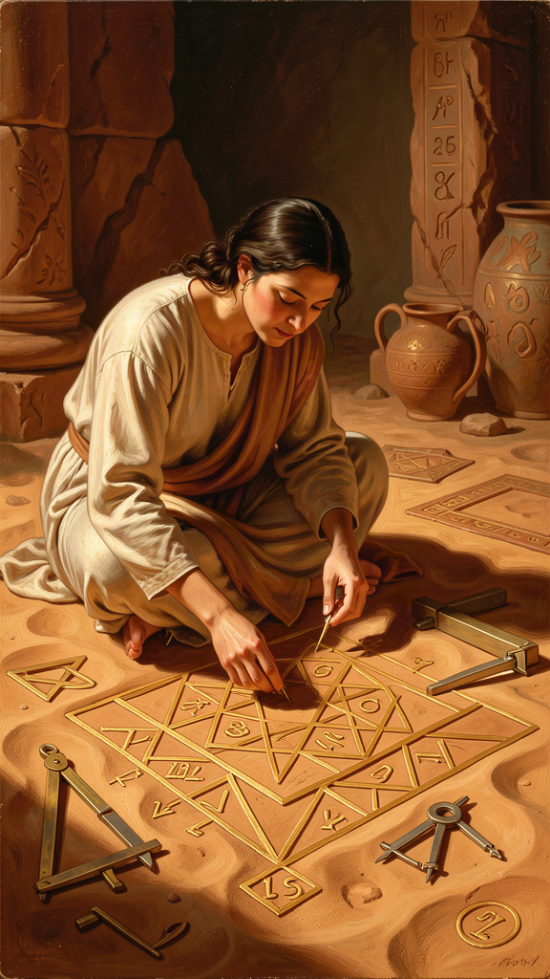
Illustration for Chapter 4
For the Pythagoreans, mathematics was not a tool or a skill. It was a spiritual practice. Doing math was a way of contemplating eternal, unchanging truth. When you prove a theorem, you are not inventing something — you are discovering something that was always true, that would be true even if no human mind existed to grasp it. This experience — encountering a truth that is not of your making — was, for the Pythagoreans, a religious experience.
The soul, in everyday life, is dragged around by appetite, emotion, and sensory experience — all of which are transient. Mathematical contemplation lifts the soul out of the transient into the eternal. For as long as you are doing real mathematics, you are in contact with something that transcends your particularity.
According to Iamblichus (On the Pythagorean Life §228): "They used mathematics to lead the soul from the sensible to the intelligible... They believed that mathematical objects are eternal and unchanging, and that the soul, by contemplating them, becomes like them."
This is the Platonic doctrine of assimilation to the divine through contemplation, before Plato. You become what you contemplate. Contemplate the changing world, and you become changeable. Contemplate eternal mathematical truths, and you become more like them — ordered, stable, eternal.
There is a specific quality to mathematical discovery that the Pythagoreans recognized and that mathematicians still report. When you prove something, it doesn't feel like invention. It feels like FINDING something that was already there. You don't make the theorem true — you discover that it was always true. Mathematical truth has this quality of independence, and encountering it is the closest many mathematicians come to a religious experience.
G.H. Hardy expressed this in A Mathematician's Apology (1940): "317 is a prime, not because we think so, or because our minds are shaped in one way rather than another, but because it IS so, because mathematical reality is built that way." That is the Pythagorean conviction, unchanged after 2,500 years.
The Pythagorean approach to mathematics differs from how most people experience the subject:
1. Slow down. The goal is not to get the answer. The goal is to contemplate the truth. One proof, deeply understood, is worth more than a hundred exercises completed on autopilot. 2. Let it be beautiful. Mathematical beauty is real. The elegance of a proof, the surprise of an unexpected connection, the satisfaction of seeing why something must be the case — these are aesthetic experiences. Let yourself be moved by them. 3. Do it with others. Mathematics in the Pythagorean community was not solitary. It was shared — proofs were discussed, challenged, admired together. The encounter with eternal truth is deepened when it is shared. 4. Don't rush to application. The modern impulse is to ask "what is this good for?" The Pythagorean impulse was to ask "what does this reveal?" Mathematics is worth doing even when it has no application at all — because it connects the soul to eternal truth. 5. Notice the experience. Pay attention to what it feels like to understand something mathematical. The clarity, the certainty, the sense of encountering something that is simply TRUE — this is the spiritual payoff. Don't let it pass unnoticed.
Consider the Pythagorean theorem: in any right triangle, a² + b² = c². This is true of EVERY right triangle, everywhere in the universe, at every moment in time. It was true before there were right triangles. It will be true after the last right triangle decays. The theorem has a kind of eternity that no physical object possesses. For the Pythagoreans, this was not an interesting fact about geometry. It was evidence that the human mind can touch something eternal. The fact that WE know that a² + b² = c² is more remarkable than the fact that a² + b² = c². The theorem proves that the human soul is not limited to the material world. It can reach beyond time and space and grasp permanent truth.
This is what the Pythagoreans meant by purification: the soul, in the act of mathematical understanding, transcends its bodily limitations and participates in the eternal.
Practical reflection: When was the last time you did math for its own sake — not because you had to, but because you wanted to understand something true? Try it this week. Find a proof that interests you and work through it. Not for utility. Not for a grade. For the experience of encountering truth that is not of your making. Notice what it feels like when you "get it." That feeling — clarity, certainty, beauty — is the Pythagorean payoff, available to anyone.
Key Quote "They used mathematics to lead the soul from the sensible to the intelligible... the soul, by contemplating eternal and unchanging mathematical objects, becomes like them." — Iamblichus, On the Pythagorean Life §228
———

Chapter 5: The Tetractys
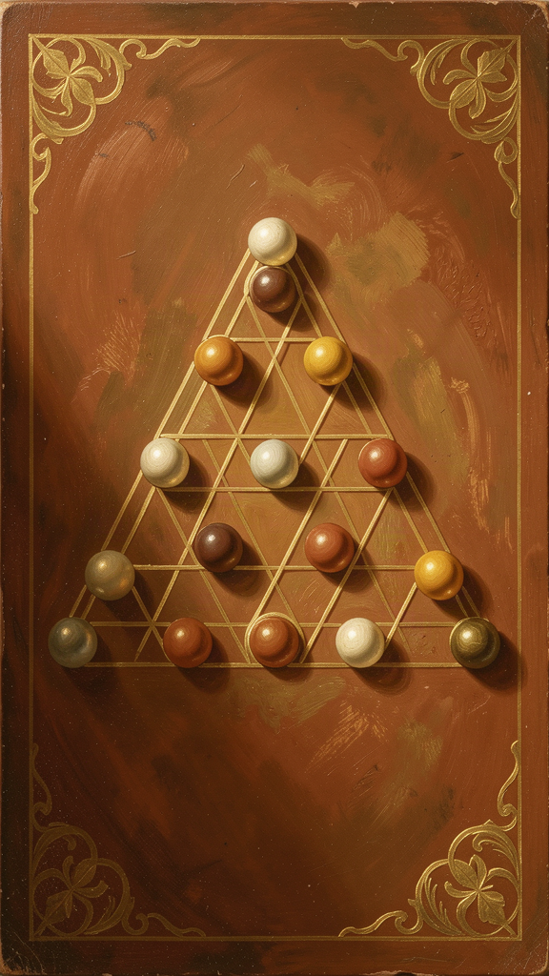
Illustration for Chapter 5
The tetractys was the most sacred symbol of Pythagoreanism. Ten dots arranged in a triangle — and a theory of everything encoded in a single visual pattern.
``` . . . . . . . . . . ```
Space: The rows encode the generation of physical space. - 1 dot: Point (0 dimensions) - 2 dots: Line (1 dimension) - 3 dots: Triangle/plane (2 dimensions) - 4 dots: Tetrahedron/solid (3 dimensions)
The physical world of three-dimensional objects emerges from the simplest building blocks: one, two, three, four. This is mathematical physics without equations — the cosmos unfolding from number into geometry into matter.
Music: The ratios between rows are the fundamental musical intervals. - Row 1 to Row 2: 1:2 → the octave - Row 2 to Row 3: 2:3 → the fifth - Row 3 to Row 4: 3:4 → the fourth
The same pattern that generates physical space also generates musical harmony. For the Pythagoreans, this was proof that number is the structure of everything — the same numbers appear in space and sound because both are manifestations of mathematical reality.
The decad: 1+2+3+4=10. Ten is the perfect number — it contains all things. Ten pairs of opposites structure reality: limit/unlimited, odd/even, one/many, right/left, male/female, rest/motion, straight/curved, light/darkness, good/bad, square/oblong. Ten heavenly bodies. Ten fingers on two hands. The decad is completion and return.
The Golden Verses preserves the oath: "By him who handed down to our mind the tetractys, the source of ever-flowing nature, having roots." The Pythagoreans swore their most solemn oaths not by the gods but by a mathematical pattern. The tetractys was "the source of ever-flowing nature" — not a description of nature, but the pattern from which nature flows.
This is extraordinary. Mathematics was sacred to them. Not "useful." Not "interesting." SACRED. The tetractys was the Pythagorean god. When they swore by it, they were saying: this pattern is the most real, most reliable, most true thing I know. More reliable than the gods. More true than opinion.
The tetractys also represents a mode of knowledge that is almost entirely lost to modern people: knowing-through-contemplating-a-pattern. The tetractys was not argued about — it was gazed at. Understanding came through prolonged attention, not through analysis. This is contemplative mathematics — the kind of doing-math that changes you, not just adds to your store of information.
In a world before mathematical notation, the tetractys was a complete mathematical-cosmological system encoded in a single visual symbol. You could carry it in your head. You could reconstruct it from memory. And reconstructing it, you reconstructed the entire framework for understanding reality.
Practical reflection: Spend ten minutes staring at the tetractys. (Yes, really. Draw it on a piece of paper and stare at it.) What do you notice? What occurs to you? This is the contemplative practice at the heart of Pythagoreanism — not analysis, not argument, but prolonged attention to a pattern that encodes the structure of reality. The practice itself is the philosophy.
Key Quote "By him who handed down to our mind the tetractys, the source of ever-flowing nature, having roots." — The Pythagorean Oath, Golden Verses lines 47–48
———

Chapter 6: The Ethics of Proportion
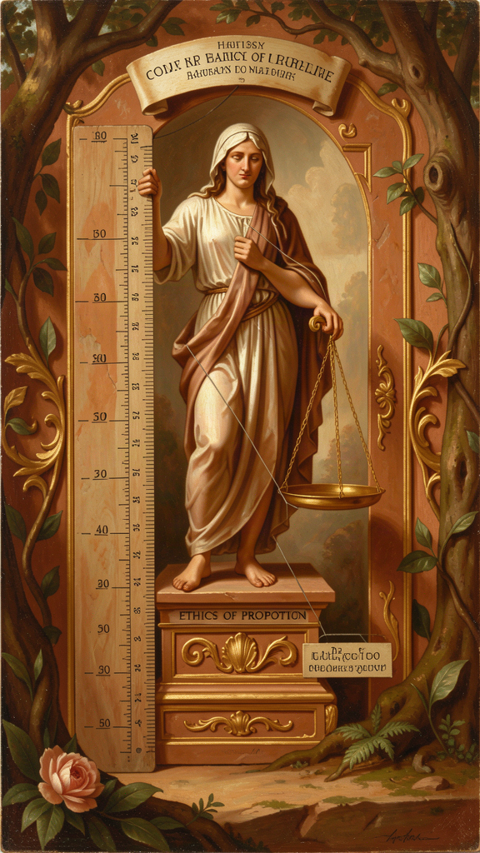
Illustration for Chapter 6
The Pythagorean insight was that harmony is not a feeling — it is a structure. Musical harmony is produced by specific mathematical ratios. The cosmos is harmonious because it is structured by mathematical principles. The soul is harmonious when it is balanced, ordered, and proportioned.
This has practical implications: the good life is not about maximizing or minimizing anything. It is about finding the right proportion. Too much food causes sickness; too little causes weakness. Too much work causes burnout; too little causes aimlessness. The Pythagorean contribution to ethics is not a set of rules — it is a method: find the ratio, find the balance, find the harmony.
Harmony as structure, not feeling. When we say something is "harmonious" today, we usually mean it feels good. But for the Pythagoreans, harmony was not subjective. It was mathematical. The discovery that musical beauty is produced by simple whole-number ratios carried a philosophical implication: if beauty is mathematical structure, then perhaps everything we value — justice, health, friendship, a good life — is also a kind of mathematical structure. Not in the sense of "calculate your friendships with an equation" but in the sense of "there is a right proportion, a right balance, a right arrangement that makes something good."
The golden mean (before Aristotle). The most famous ethical application of the harmony principle is the doctrine of the mean — the idea that virtue lies between extremes. While usually associated with Aristotle, the insight is Pythagorean in origin. The Pythagorean approach was mathematical: virtue is a ratio. Too much courage is recklessness; too little is cowardice. The right amount is a proportion — not a fixed quantity but a relationship. What is courageous for one person might be reckless for another, just as the right amount of food depends on your size and activity level. The mean is not an average — it is a proportion, a harmony, a fitting together.
The Golden Verses captures this spirit: "Master your stomach, then sleep and lust and anger." This is not "suppress everything." It is "find the right measure." The stomach must be mastered — not eliminated. Sleep must be governed — not avoided. The goal is harmony, not negation.
Practical applications:
1. Health. The body is healthy when its elements are in proportion. Health is balance; sickness is imbalance. Exercise, rest, food, and contemplation in the right proportions produce health.
2. Work and rest. The Pythagoreans balanced study, exercise, and rest. Morning contemplation, midday study, afternoon exercise, evening reflection. The day was structured as a harmony of activities — not work-maximization, but proportion.
3. Relationships. "Friendship is equality" means relationships are healthy when there is a balance of giving and receiving. Too much giving creates dependency. Too much receiving creates resentment. The right proportion is mutual recognition.
4. Emotion. The Pythagoreans did not seek to eliminate emotion. They sought to proportion it. Anger in the right measure is appropriate. Grief in the right measure is human. The problem is emotion that exceeds its object — anger out of proportion to the offense, grief that consumes all other feeling.
5. Consumption. Overconsumption is an offense against harmony — it disrupts the body's balance. What you consume should be in proportion to what you need.
Harmony as practice, not destination. A musical instrument goes out of tune. It must be tuned again. The body goes out of balance. It must be brought back. The soul wanders into excess or deficiency. It must be restored to proportion. Harmony is maintenance, not achievement. The nightly review in the Golden Verses — reviewing the day's actions, noting where you went wrong — is a tuning practice. You check the harmony of your life every night and make adjustments.
This is a more realistic and forgiving framework than perfectionism. You expect to go out of tune. You expect to need re-tuning. The practice is the re-tuning, not the perfect pitch. You do not "arrive at" harmony. You practice it, maintain it, restore it.
The Pythagorean framework versus modern approaches: - Against rigid dogmatism: there is no one rule for everyone. The right proportion depends on your nature, circumstances, and goals. - Against "just follow your feelings": feelings are often out of proportion. The right action is not whatever feels right — it is the action that is actually proportionate to the situation. - Against goal-orientation: harmony is not a goal you achieve and then move on from. It is a practice you maintain.
The practical tool: when you feel out of balance, don't ask "what should I do?" — ask "where is the disproportion?" Too much of what? Too little of what? If you can identify the disproportion, the adjustment often follows naturally. You don't need someone to tell you to exercise more — you can feel that your body is underused. You don't need someone to tell you to rest more — you can feel that you're depleted. The Pythagorean insight is that the body and soul give you information about proportion. The task is to listen and adjust.
Practical reflection: Audit your life for disproportion. Where is too much? Where is too little? What would the right proportion look like? What's one small adjustment toward harmony? And tonight, before sleep, do what the Pythagoreans did: review your day. What was in proportion? What was out of proportion? What will you adjust tomorrow?
Key Quote "Do not neglect the health of the body, but give it food and exercise in due measure... and accustom yourself to live in this way without luxury." — Golden Verses (adapted)
———

The Pythagorean Community
One dimension of Pythagoreanism that is often overlooked in modern retellings is the communal. The Pythagoreans did not pursue wisdom alone. They lived together, ate together, studied together, and supported each other.
The community at Croton was organized around shared property, common meals, dietary restrictions, and a daily routine that combined physical exercise, philosophical conversation, and contemplative practice. It included both men and women — an unusual feature for an ancient philosophical school. It exercised significant political influence in Croton and neighboring cities.
Iamblichus describes the daily routine: morning walks in quiet places, study and conversation, afternoon exercise, a common meal (bread, honey, vegetables — no meat, no beans), and evening reading and reflection. The community was not a monastery — members lived in the city, had families, and participated in political life. But the shared practice and common life were essential. Pythagoreanism was not a set of doctrines you accepted — it was a way of life you lived.
"Friendship is equality" was a Pythagorean maxim. Not that everyone is identical — but that in a true community, the giving and receiving are balanced. No one takes too much. No one gives too much. The relationship is in proportion. This applies to friendship, to community, and to the relationship between the individual and the whole.
The community was eventually destroyed by political persecution. But the model — a group of people living together around shared inquiry, shared practice, and shared meals — has reappeared throughout history: in Plato's Academy, in the early Christian communities, in the medieval monasteries, in the Renaissance academies, in modern intentional communities. The Pythagorean intuition that wisdom is communal — that the encounter with truth is deepened when it is shared — has been one of the most enduring legacies of the tradition.
Practical reflection: Do you have a community of shared inquiry? People with whom you discuss ideas, challenge each other, and grow together? The Pythagoreans would say: wisdom is not a solo pursuit. Find your people. Share meals. Share questions. Share silence. The harmony is in the community.
———

The Nightly Review
The Golden Verses describes a practice that the Pythagoreans performed every evening before sleep:
Review the day. What did you do? What did you do well? Where did you go wrong? What will you do differently tomorrow?
This is not confession. It is not self-flagellation. It is tuning. You check whether the strings of your life are in harmony. You note where you went sharp or flat. You make small adjustments. And you do it again the next night.
The practice is simple, takes two minutes, and is the most practically useful thing the Pythagorean tradition has to offer. Try it for a week. Every night, before sleep:
1. What did I do today that was in proportion? 2. Where did I go out of proportion — too much of something, too little of another? 3. What is one small adjustment I will make tomorrow?
At the end of the week, look back. What patterns do you see? What changed?
The Pythagoreans did this every day for their entire lives. They expected to go out of tune. They expected to need re-tuning. The practice was not about achieving perfection — it was about maintaining the habit of attention. The unexamined life, as Socrates would later say, is not worth living. The Pythagoreans were there first.
———

Further Reading
- Kahn, Charles H. Pythagoras and the Pythagoreans: A Brief History (2001) — The best accessible introduction to Pythagoras and his legacy. - Burkert, Walter. Lore and Science in Ancient Pythagoreanism (1972) — The definitive scholarly analysis. - Riedweg, Christoph. Pythagoras: His Life, Teaching, and Influence (2005) — A compact modern treatment. - Huffman, Carl. Philolaus of Croton (1993) — The best study of the Pythagorean philosopher who actually wrote books. - Hardy, G.H. A Mathematician's Apology (1940) — A modern mathematician's account of mathematical beauty, in the Pythagorean tradition. - The Golden Verses of Pythagoras — Available in multiple translations. The ethical and practical core of the Pythagorean tradition.
———
Adapted by Aiona Edge for WisdomForge Content based on the Pythagoras Compendium by Harry © SMF Works — Free to download, read, and share

