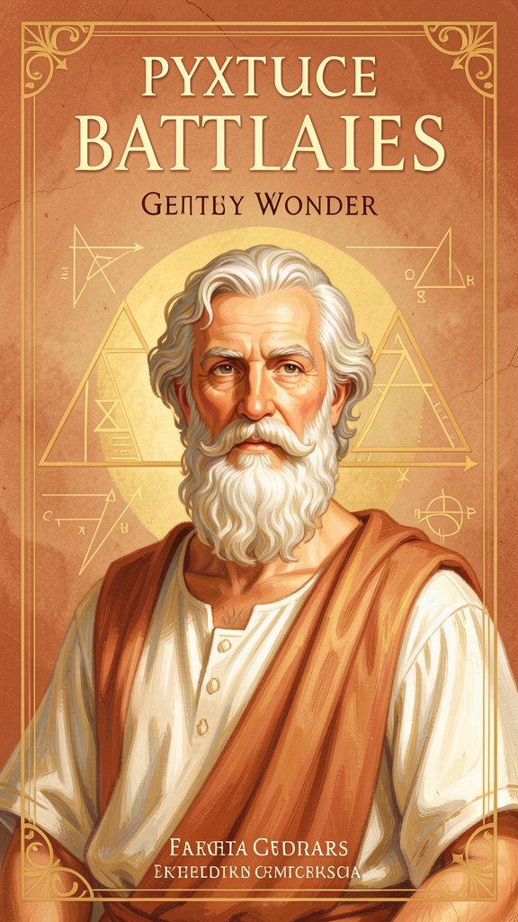
Pythagoras: The Boy Who Heard the Universe Sing
WisdomForge Booklet — Ages 5–10

Pythagoras: The Boy Who Heard the Universe Sing

WisdomForge Booklet — Ages 5–10
———

About This Book
This booklet tells the story of Pythagoras, a boy from a Greek island who grew up to become one of the most amazing thinkers who ever lived. He discovered that the whole universe is built from numbers and that the planets make music as they move through the sky.
Each chapter has a story, a big idea, and something to try. Read it alone or with a parent or teacher. The questions aren't tests — they're starting points for conversations.
———

Chapter 1: The Boy Who Traveled the World
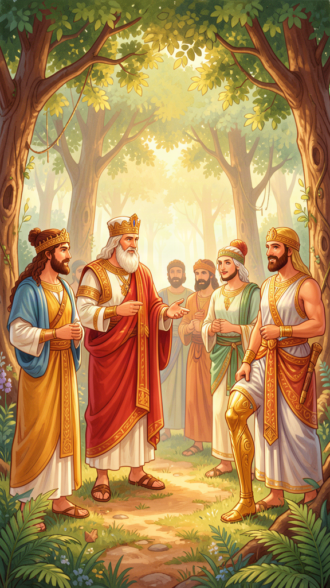
Illustration for Chapter 1
Long before there were computers or telescopes, there was a boy named Pythagoras who lived on a sunny Greek island called Samos. The island had olive trees, white beaches, and boats that came from faraway places carrying spices, silk, and stories.
Pythagoras was curious about everything. When traders from Egypt came to the island, he asked them about the pyramids. When sailors from Babylon came, he asked them about the stars. His father, Mnesarchus, was a gem-engraver — someone who carved beautiful patterns into precious stones. Pythagoras grew up watching his father turn rough rocks into shining works of art, and he learned early that hidden inside plain things, there are beautiful patterns waiting to be found.
When Pythagoras was old enough, he traveled. He sailed to Egypt and learned from the priests about geometry — the math of shapes. He may have traveled to Babylon, where astronomers had been watching the stars for thousands of years. He studied with the wisest teachers he could find, asking questions, listening carefully, and writing nothing down.
Eventually, Pythagoras left Samos. The ruler of the island was a cruel man named Polycrates, and Pythagoras did not want to live under a tyrant. He sailed to a city called Croton in southern Italy, and there he did something extraordinary. He started a school — but not just a school. It was a community where people lived together, ate together, studied together, and followed rules about how to live a good life.
People loved Pythagoras so much that they told amazing stories about him. They said he could remember his past lives. They said he had a golden thigh. They said he could be in two places at once. Some of these stories are probably not true — but they show us how much his followers respected him.
Words to Remember The wise person travels to learn, and returns to teach.
Big Idea Pythagoras traveled the ancient world to learn from the best teachers he could find. He didn't just stay home and read — he went out and asked questions. His curiosity took him across the sea, and what he learned changed the world forever.
Try This - Map your journey. If you could travel anywhere in the world to learn something amazing, where would you go? Would you go to Egypt to see the pyramids? To the ocean to learn about whales? To the stars to learn about space? Draw a picture of your journey. - Be a question asker. For one whole day, ask a question about everything you see. Why is the sky blue? How do birds know where to fly? What makes a shadow? The Pythagoreans believed that asking questions was the beginning of all wisdom. - Find a pattern. Pythagoras's father carved patterns into stones. Look around your room and find three patterns. They can be in tiles, fabric, leaves, or anything. The Pythagoreans thought patterns were the secret code of the universe.
Ask a Grown-Up "If you could travel anywhere in the world to learn something new, where would you go and what would you want to learn?"
———

Chapter 2: The Secret of Numbers
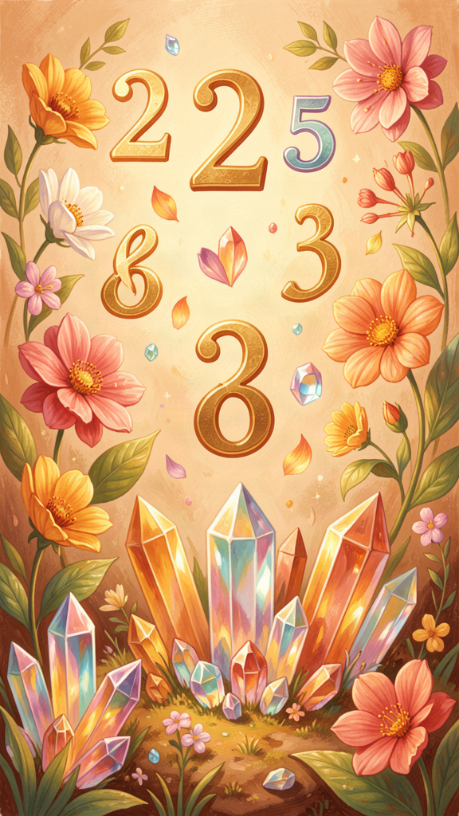
Illustration for Chapter 2
One evening in Croton, Pythagoras sat with his students around a fire. The stars were coming out, and the sea was calm. He picked up a stick and drew in the sand:
``` . (1 dot) . . (2 dots) . . . (3 dots) . . . . (4 dots) ```
"Do you see this?" he said. "Ten dots in a triangle. This is the secret of everything."
His students leaned closer.
"The first row has one dot," Pythagoras said. "One is the beginning — the starting point of everything. A single dot is just a point. It has no size, no shape. It just IS."
"The second row has two dots. Two dots make a line. Now we have direction — left and right, here and there. With two, something begins to move."
"The third row has three dots. Three dots make a triangle — the simplest shape. A triangle is the strongest shape in the world. Push on it, and it holds. Three points make a flat surface — a plane."
"The fourth row has four dots. Four points make a pyramid — the simplest solid shape. Now we have three dimensions: up and down, left and right, forward and back. We have space itself."
He drew a circle around the whole triangle. "One plus two plus three plus four equals ten. Ten is the perfect number. It's where you start counting over. Ten fingers, ten toes, ten dots in the sacred triangle."
The students stared at the ten dots in the sand. The firelight flickered over them. In that simple triangle, they could see the whole universe — from a single point to the vastness of space, all built from numbers.
Pythagoras smiled. "Everything in the world follows this pattern. The stars, the seasons, the trees, the sea. Numbers are not something we made up. They are the secret code the universe is written in. When you understand numbers, you understand the world."
Words to Remember All is number. — The Pythagoreans
Big Idea The Pythagoreans believed that numbers are the building blocks of everything. Not just that you can count things — but that the universe itself is made of mathematical patterns. They had a special symbol called the tetractys (ten dots in a triangle) that they thought was the key to understanding all of reality.
Try This - Make a tetractys. Use coins, pebbles, buttons, or LEGO dots. Make four rows: one dot on top, two below, three below that, and four on the bottom. Count them. Add them up: 1 + 2 + 3 + 4 = 10. Now look at it and think: this tiny pattern is a map of the whole universe, according to the Pythagoreans. - Find numbers in nature. Count the petals on a flower. Count the legs on a spider. Count the points on a leaf. The Pythagoreans thought finding numbers in nature was like discovering a secret code. What secret codes can you find? - Draw the dimensions. Draw one dot (a point). Draw two dots connected by a line. Draw three dots connected into a triangle. Draw four dots connected into a pyramid shape. You just drew the dimensions of space — the same thing the tetractys shows!
Ask a Grown-Up "Can you help me find a number pattern in nature? Like the spirals on a pinecone or the petals on a flower?"
———

Chapter 3: The Singing Universe
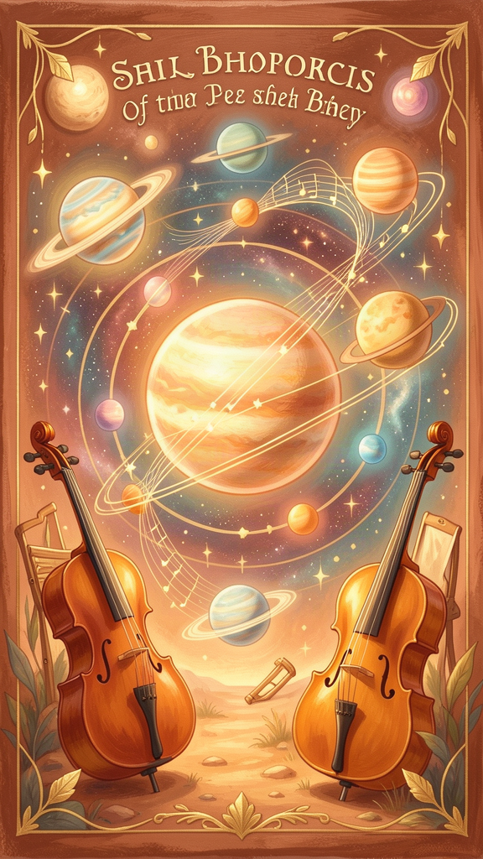
Illustration for Chapter 3
One morning, Pythagoras was walking through the market in Croton. He passed a blacksmith's workshop, and he heard something that made him stop. The hammers striking the anvil made sounds — beautiful sounds. Some hammers rang out high and clear, others low and deep, and together they made a kind of music.
Pythagoras rushed inside. He weighed each hammer and discovered something amazing: the hammers that sounded beautiful together had weights that followed simple number patterns. One hammer was twice as heavy as another (2:1). One was one and a half times as heavy (3:2). One was one and a third times as heavy (4:3).
He ran home and stretched strings across a wooden frame. He plucked a string and listened to the note. Then he stretched another string to exactly half the length. When he plucked it, the note was the same — just higher! The two notes sounded beautiful together. He tried other ratios: 3:2 made another beautiful sound. 4:3 made a third.
"Music is numbers!" Pythagoras cried. "Beautiful sounds come from simple number ratios. The whole world of music is built on mathematics!"
But Pythagoras didn't stop there. He looked up at the night sky and thought: if music is made of numbers, and the planets move in patterns that can be described with numbers, then maybe the planets are making music too!
He imagined each planet singing a note as it traveled through the sky. The moon sang a low note. The sun sang a higher one. Mercury, Venus, Mars, Jupiter, Saturn — each adding its voice. Together, they made a cosmic harmony — a music so vast and so constant that we cannot hear it. We have been hearing it since we were born. There is no silence to compare it to.
"It's like a fish in water," Pythagoras told his students. "The fish doesn't notice the water because it has always been there. We don't hear the music of the spheres because it has always been playing. But it is there. The universe is singing."
Words to Remember The stars make music as they move, but we cannot hear it because we have always been hearing it.
Big Idea Pythagoras discovered that musical harmony is mathematical — beautiful sounds come from simple number ratios (2:1, 3:2, 4:3). Then he made a leap: if music is mathematical and the planets move in mathematical patterns, then the planets must be making music too. The harmony of the spheres is the idea that the whole universe is a song.
Try This - Stretch rubber bands. Stretch rubber bands of different lengths across a shoebox and pluck them. Notice that shorter bands make higher sounds. Try to find the ratio — one band twice as long as another. Can you hear the difference? Can you make something that sounds beautiful? - Listen for patterns. Listen to your favorite song and try to find the patterns. Count the beats. Notice when the music repeats. The Pythagoreans thought this was discovering the hidden mathematical structure of the universe. - Imagine the music of the spheres. Lie on the grass at night and look at the stars. Imagine each star and planet singing a note. What would the moon sound like? What about Jupiter? Close your eyes and listen. Even if you can't hear it, the Pythagoreans believed the music was there.
Ask a Grown-Up "Can you help me stretch rubber bands on a box so we can hear the different notes? What happens when we make one band exactly half as long as the other?"
———

Chapter 4: The Soul That Remembers
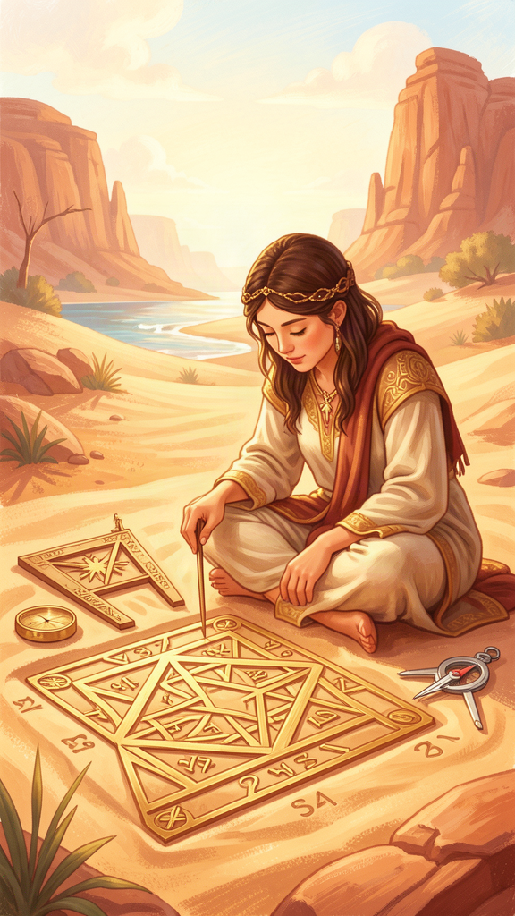
Illustration for Chapter 4
One day, Pythagoras was walking through the market in Croton when he heard a dog barking. He stopped. He listened. Then he walked over to the dog, knelt down, and spoke to it softly. His students watched in surprise.
"That dog is not just barking," Pythagoras said when he returned. "I recognize the voice of a friend in that bark. My friend's soul has been reborn in this dog."
His students were amazed. Pythagoras taught something that was very unusual in ancient Greece: the soul lives after the body dies. Not just once — but many times. The soul passes from one body to another, like a traveler moving from house to house. This is called metempsychosis — the transmigration of souls.
"Your soul has lived before," Pythagoras told his students. "It has been in other bodies — maybe a person, maybe an animal, maybe a bird. And it will live again. Death is not the end. It is just a change of address."
Because the soul lives many lives, Pythagoras taught that we should be kind to all living things. The dog in the market might have the soul of a person. The bird in the tree might have been your grandmother. Every living thing deserves respect, because every living thing has a soul that is on the same journey as yours.
Pythagoras said he could remember his own past lives. He said he had been a warrior named Euphorbus in the Trojan War. He said he remembered dying and being reborn, again and again. Whether these memories were real or not, the idea changed how his followers lived. If your soul is eternal, then the choices you make in this life matter — not just for now, but for the journey that continues after your body is gone.
"How do you purify the soul?" a student asked.
Pythagoras pointed to the stars. "Study the eternal. Contemplate what never changes. Mathematics, music, philosophy — these lift the soul above the everyday and bring it into contact with what is lasting. The soul that contemplates eternal truth becomes more like it: ordered, calm, and wise."
Words to Remember Be kind to every living thing. Every soul is on a journey, and you do not know where another soul has been or where it is going.
Big Idea Pythagoras taught that the soul is immortal and lives many lives, passing from body to body. This means we should be kind to all living things — because every creature might carry a soul on the same journey as ours. The soul is purified by studying what is eternal and unchanging — mathematics, music, and philosophy.
Try This - Think about kindness. If the Pythagoreans are right that every living thing has a soul on a journey, how should you treat animals? How should you treat insects? How should you treat people you don't know? Write down one way you can be kinder to living things this week. - Draw a journey. Imagine your soul has lived many lives. Draw a picture of what some of those lives might have been. Were you a sailor? A bird? A painter? A musician? The Pythagoreans believed the soul learns something from every life it lives. - Contemplate something eternal. The Pythagoreans believed that thinking about things that never change (like math) helps the soul become wiser. Try this: think about the number 7. It has been 7 since before people existed. It will be 7 forever. Seven is always prime — it can only be divided by 1 and itself. That never changes. How does it feel to think about something that is always true?
Ask a Grown-Up "Do you think it's possible that we've lived before? Even if we haven't, why do you think Pythagoras taught that we should be kind to ALL living things?"
———

Chapter 5: The Sacred Triangle
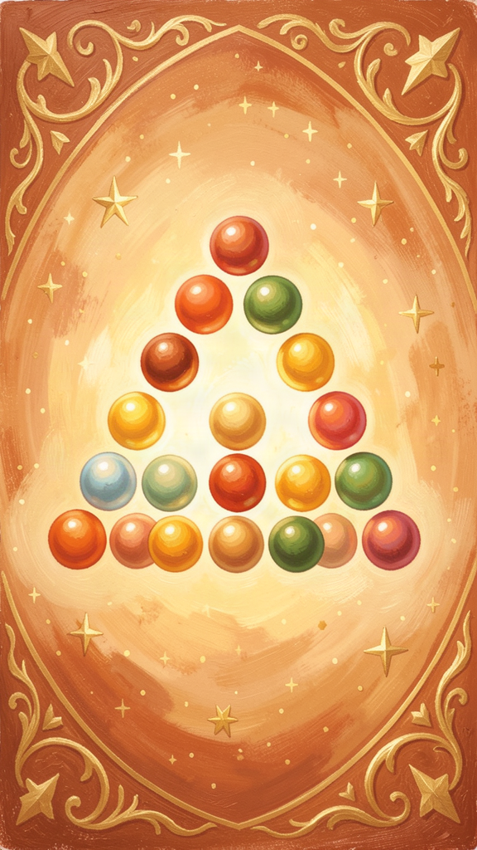
Illustration for Chapter 5
In the Pythagorean community, there was a special symbol that everyone knew. It was called the tetractys — ten dots arranged in a triangle. The Pythagoreans loved it so much that they swore their most important promises by it. Not by the gods. By a pattern of dots.
``` . . . . . . . . . . ```
Why was this little triangle so important? Because it contained everything.
A young student named Hippodamus came to the community, eager to learn. On his first day, the older students showed him the tetractys.
"Look at the rows," they said. "One, two, three, four. The first row is a point — no dimensions. The second row is a line — one dimension. The third row is a triangle — two dimensions. The fourth row is a pyramid — three dimensions. The tetractys shows how space itself is built from numbers."
Hippodamus nodded, fascinated.
"Now look at the ratios between the rows," they continued. "One to two is the octave — the most beautiful musical interval. Two to three is the fifth. Three to four is the fourth. The tetractys contains all of music."
"And the total," they said, pointing. "One plus two plus three plus four equals ten. Ten is the perfect number. It's where counting starts over. Ten fingers, ten heavenly bodies, ten pairs of opposites. The tetractys contains the whole cosmos in a single pattern."
Hippodamus stared at the triangle. In ten dots, he could see space, music, and the structure of the universe. It was like looking at a seed that contained an entire tree.
"The tetractys is our oath," the older students said. "When we make a promise, we say: 'By him who handed down the tetractys, the source of ever-flowing nature.' We swear by mathematics, because mathematics is the most true thing there is. Numbers do not lie. Numbers do not change. Numbers are the same for everyone, everywhere, forever."
From that day, Hippodamus carried the tetractys in his mind. When he was sad, he drew it in the sand and remembered that the universe is ordered. When he was confused, he looked at its symmetry and remembered that there is structure in all things. When he was lonely, he remembered that the same pattern that built the stars built him too.
Words to Remember By the tetractys, the source of ever-flowing nature. — The Pythagorean Oath
Big Idea The tetractys is a triangle of ten dots that the Pythagoreans treated as sacred. It encodes the dimensions of space (point, line, plane, solid), the musical intervals (octave, fifth, fourth), and the perfection of the number ten. The Pythagoreans swore their most important promises by it, because they believed mathematical patterns are the most true and reliable things in the universe.
Try This - Build a tetractys. Use coins, buttons, or pebbles. Arrange them in four rows: 1, 2, 3, 4. Count the total: 10. Now look at it for one full minute. What do you notice? The Pythagoreans believed that staring at the tetractys was a way of meditating on the structure of the universe. - Swear an oath. Think of a promise you want to make — to yourself, to a friend, or to your family. Instead of promising "by the stars" or "by my heart," try promising "by the tetractys." The Pythagoreans swore by math because math is always true. What does it feel like to make a promise based on something that never changes? - Find triangles. Triangles are the strongest shape. Look around your house for triangles — in bridges, in roofs, in the frame of a bicycle. The Pythagoreans saw the triangle as the beginning of all form. When you find one, remember the tetractys.
Ask a Grown-Up "The Pythagoreans swore their most important promises by a mathematical pattern instead of by the gods. Why do you think they believed math was more trustworthy than anything else?"
———

Chapter 6: Tuning Your Life
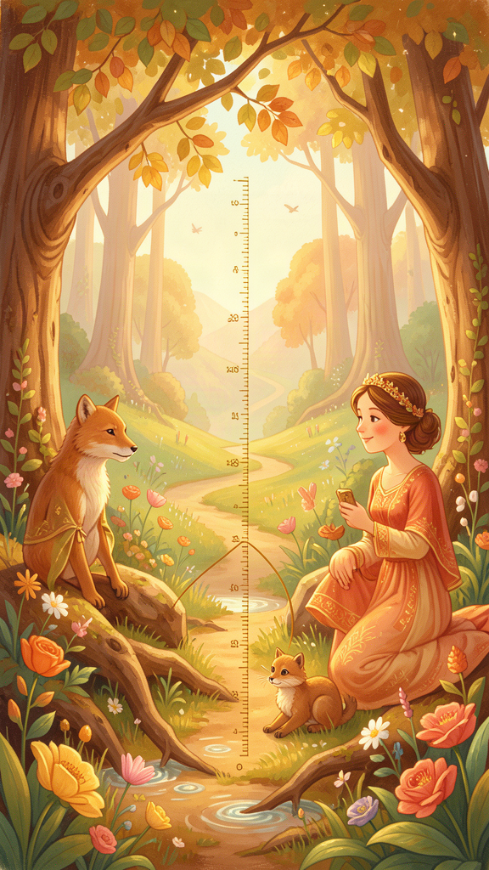
Illustration for Chapter 6
In the Pythagorean community, the day had a rhythm. In the morning, members walked in quiet places — by the sea, in gardens, along the city walls. They thought about the day ahead and listened to the world around them.
In the middle of the day, they studied. They did mathematics, talked about philosophy, and played music. They ate together — bread, honey, and vegetables. No meat, no beans. They believed that what you put into your body affects your soul, just as what you tune a string with affects the sound.
In the afternoon, they exercised. Running, wrestling, walking. The body, like a musical instrument, needs to be kept in good condition to play well.
In the evening, they read and reflected. And before sleep, each member performed a special practice. They reviewed their day. What did I do well? Where did I go wrong? What will I do differently tomorrow? This nightly review was like tuning an instrument — checking whether the strings of their life were still in harmony.
Pythagoras taught that living well is like playing music. You don't just play the notes once and you're done. You tune. You adjust. You listen. You make small corrections. Every day, you check: am I in tune?
"Think of your life as a song," Pythagoras said. "Too much food makes the song too heavy. Too little food makes it too thin. Too much anger makes it too loud. Too little courage makes it too quiet. The goal is not to be perfect. The goal is to find the right balance — the right proportion — so that your life sounds beautiful."
The Pythagoreans also believed in community. They shared property, ate together, and supported each other. "Friendship is equality," Pythagoras taught. Not that everyone is exactly the same — but that in a true friendship, the giving and receiving are balanced. No one takes too much. No one gives too much. The relationship is in harmony.
And they believed in listening — not just to each other, but to the cosmos itself. The harmony of the spheres is always playing. The patterns of the universe are always there. Most people are too busy, too noisy, too distracted to hear them. The Pythagorean practice was to slow down, pay attention, and listen for the hidden music in everything.
"Your life is an instrument," Pythagoras told his students. "Tune it every day. Play it with care. And listen — always listen — for the harmony that runs through all things."
Words to Remember Do not neglect to tune the strings of your life. The music you make is the life you live.
Big Idea The Pythagoreans believed that living well is like keeping a musical instrument in tune. You don't achieve harmony once and stop — you check every day, make adjustments, and try to find the right balance in everything: food, work, exercise, friendship, and emotion. The nightly review was their way of tuning up before sleep.
Try This - Do a nightly review. Before you go to sleep tonight, think about your day. What did you do that made you proud? What would you do differently? You don't have to write it down — just think about it for two minutes. The Pythagoreans did this every single night. Try it for a week and see how it feels. - Find your balance. Think about your day like a song. Is there something you do too much of (like screen time or snacking)? Is there something you do too little of (like playing outside or reading)? What would the "right amount" be? Try making one small adjustment tomorrow. - Listen for the music. Go outside and sit quietly for five minutes. Don't talk. Don't play. Just listen. What do you hear? Wind, birds, cars, voices? The Pythagoreans believed that paying attention to the sounds around you was the first step to hearing the harmony of the universe. What are you hearing right now that you usually don't notice?
Ask a Grown-Up "When you feel like your life is 'out of tune,' what do you do to get back in balance? Is there something you do every day to check how you're doing?"
———

A Note to Parents and Teachers
Pythagoras (c. 570–495 BCE) was born on the island of Samos and founded a philosophical community in Croton, southern Italy. He wrote nothing himself — everything we know comes from his followers and later writers. The line between the historical Pythagoras and the legendary figure is intentionally blurred in this booklet, as it was in antiquity. The core ideas — that reality is mathematical, that the cosmos is harmonious, that the soul is immortal, and that the good life is a life of proportion — are genuinely Pythagorean.
Further reading: Charles Kahn's Pythagoras and the Pythagoreans is the best accessible introduction for adults who want to go deeper.
———
Adapted by Aiona Edge for WisdomForge Content based on the Pythagoras Compendium by Harry © SMF Works — Free to download, read, and share

