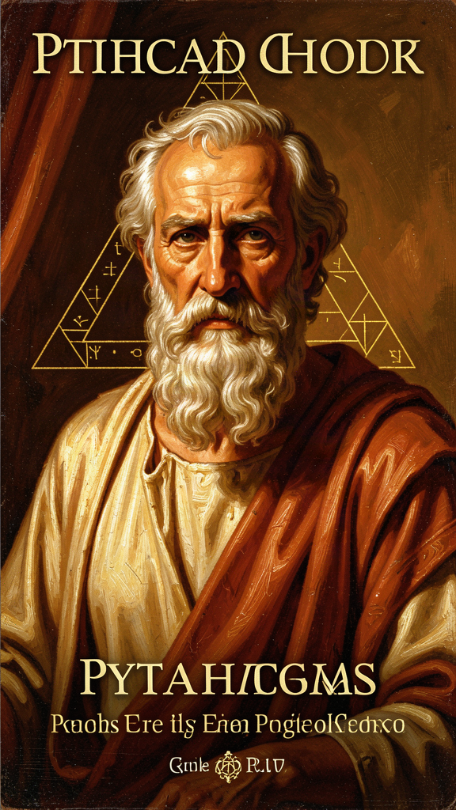
Pythagoras: The First Mathematician
WisdomForge Booklet — Ages 15–18

Pythagoras: The First Mathematician

WisdomForge Booklet — Ages 15–18
———

About This Book
Pythagoras is simultaneously one of the most important and most elusive figures in the history of Western thought. He wrote nothing. His followers attributed miracles to him. His earliest biographers wrote centuries after his death. And yet behind the legend, there is a real person whose ideas launched a revolution: the claim that reality is mathematical, that the cosmos is harmonious, and that the soul is immortal.
This booklet explores Pythagoras and the Pythagorean tradition across six chapters — from the problem of the historical Pythagoras to the mathematical structure of music, from the transmigration of souls to the ethics of proportion. Each chapter is designed to make you think, not just learn. The questions at the end aren't comprehension checks — they're invitations to wrestle with ideas that have been alive for 2,500 years.
———

Chapter 1: The Pythagoras Problem
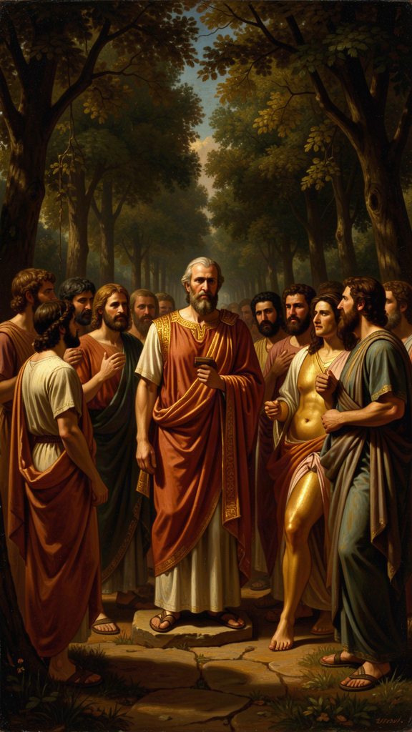
Illustration for Chapter 1
The biography of Pythagoras is a case study in the problem of historical knowledge. The earliest biographical sources were written centuries after his death. The traditions they preserve mix history, legend, and philosophical reinterpretation. The "Pythagoras problem" — separating the man from the legend — may be unsolvable in principle.
Here is what we can say with reasonable confidence:
- Pythagoras was a real historical person, born on Samos around 570 BCE. - He moved to Croton in southern Italy around 530 BCE, probably to escape the tyranny of Polycrates. - He founded a community that combined philosophical study with religious practice and political engagement. - He taught something about numbers, the soul, and how to live. - His community was persecuted and destroyed, but his ideas survived through his followers.
Beyond this, the details are uncertain — and the uncertainty is meaningful.
The sources tell us Pythagoras was born to Mnesarchus, a gem-engraver, on the island of Samos. They tell us he studied with Pherecydes of Syros, with Thales and Anaximander, and that he traveled to Egypt where he was initiated into the priesthood. They tell us he had a golden thigh, could remember his past lives, and could be in two places at once.
None of these authors met Pythagoras. Heraclitus, the earliest, was born decades after Pythagoras died. Diogenes Laërtius, Porphyry, and Iamblichus — our main sources — wrote 800 years later. Everything is testimony shaped by devotion, polemic, or philosophical reinterpretation.
But here is the provocative question: can you separate a teacher from the legend their students create? The Pythagoreans believed their founder was semi-divine. They attributed miracles to him. They remembered his past lives. Does that make the philosophy less true — or does it make the legend part of the philosophy?
There is something irreducible about this. We want a clean "historical Pythagoras" we can evaluate separately from the "legendary Pythagoras." But the people who preserved his teaching did not separate them. For them, the truth of the philosophy was inseparable from the specialness of the teacher. Pythagoras was not just someone who had good ideas — he was someone who had become what the ideas described: a harmonious soul, aligned with cosmic order.
This is not just a problem about Pythagoras. It is a problem about how we construct historical figures. We want the "real" Einstein, the "real" Jesus, the "real" Socrates — but what we have is always filtered through the people who preserved them, and those people had agendas. The "Pythagoras problem" is the problem of history itself.
Key Quote "Pythagoras, son of Mnesarchus, practiced inquiry most of all men... having made a selection of these writings, claimed for himself a wisdom that was, in truth, knowledge and not wisdom." — Heraclitus (DK B129)
(Even Heraclitus, writing within a generation of Pythagoras, is already evaluating the legend. He calls Pythagoras' wisdom "knowledge, not wisdom" — suggesting that even early on, people were debating what Pythagoras really was.)
Questions for Reflection - If we cannot separate the historical Pythagoras from the legend, what does that mean for how we study him? Should we study the legend as part of the philosophy? - The "Pythagoras problem" applies to other figures too. Can you separate the historical Socrates from Plato's Socrates? The historical Jesus from the Gospel Jesus? What is at stake in these separations? - Research prompt: Compare the biographies of Pythagoras in Porphyry and Iamblichus. What do they agree on? Where do they differ? What does each author's portrait reveal about his own philosophical commitments?
———

Chapter 2: The Mathematical Ontology
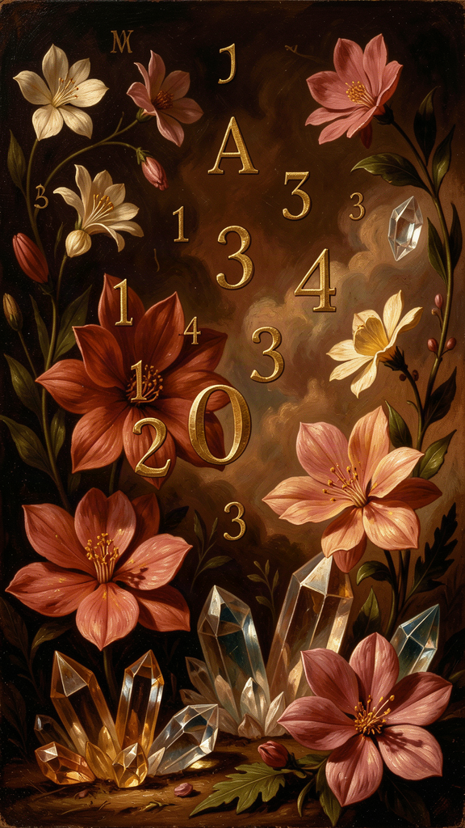
Illustration for Chapter 2
"All is number." According to Aristotle, this was the fundamental Pythagorean doctrine — not that mathematics is useful for describing reality, but that reality IS mathematical structure. Numbers are not mental constructions or useful abstractions. They are the actual building blocks of the cosmos.
This is a remarkably strong claim, and it operates on multiple levels:
Ontological: Reality consists of numbers. Not "numbers describe reality" — numbers ARE reality's constituent elements. According to Aristotle (Metaphysics I.6), the Pythagoreans thought numbers were the actual substance of things, not just measurements of things.
Epistemological: Without number, nothing can be known. Philolaus (DK B4) stated: "All things that are known have number. For without this, it is not possible that anything at all be understood or known." Mathematical structure is a precondition of intelligibility. If something cannot be quantified, measured, or patterned, it cannot be grasped by the mind.
Methodological: The way to understand reality is through mathematics. This is the method that produced modern physics.
The Pythagoreans had a specific account of how numbers generate reality. According to Aristotle (Metaphysics I.5):
1. The Unlimited (even numbers, the infinite, the indeterminate) and the Limit (odd numbers, determination, form) are the first principles. 2. From these, numbers are generated. 3. From numbers, geometric figures (point → line → plane → solid). 4. From geometric figures, physical bodies. 5. From physical bodies, the cosmos.
Number is prior to matter. Most people think: first there are things, then we count them. The Pythagoreans thought: first there are numbers (principles of order), then those numbers impose themselves on the unlimited (raw matter) to produce things.
The evidence the Pythagoreans saw for this claim was overwhelming — to them:
- Music: Musical consonance is produced by simple whole-number ratios (octave = 2:1, fifth = 3:2, fourth = 4:3). The beauty of music is mathematical structure made audible. - Geometry: The Pythagorean theorem (a² + b² = c²) shows that geometric relationships are numerically exact. Every right triangle, regardless of size, follows the same numerical law. - Astronomy: The planets move in regular, mathematically describable periods. The ratios between their periods follow patterns. - Seasons and cycles: The year, the seasons, biological cycles — all follow numerical patterns.
Wherever they looked, they found number as the deep structure of things. The conclusion: number IS the deep structure of things.
Now here is the question: was it a lucky guess, or did the Pythagoreans have genuine insight? They had evidence — musical ratios, geometric proofs, astronomical periods — but the claim far outstripped the evidence. They "supposed" (as Aristotle says) that number was the principle of all things, not because they had proved it, but because they had been "brought up in" mathematics and it made sense of everything they saw.
This is not how we think of scientific discovery — but it IS often how scientific discoveries happen. Someone is immersed in a way of thinking, and they "see" a pattern everywhere. Then they test it. The Pythagoreans didn't have much ability to test. But they had the right pattern.
The claim has been validated in ways the Pythagoreans could not have imagined. The periodic table is a mathematical structure. DNA is a code. Quantum mechanics is expressed in mathematical operators. The physical universe IS mathematically structured at every level we can observe. When Galileo wrote that "philosophy is written in this grand book, the universe... it is written in the language of mathematics," he was explicitly drawing on the Pythagorean tradition. When Einstein said "the most incomprehensible thing about the universe is that it is comprehensible," he was expressing the same Pythagorean wonder.
The Pythagoreans were right — not in the details, but in the fundamental intuition: reality is number. That intuition is the foundation of modern science.
Key Quote "The so-called Pythagoreans, who were the first to take up mathematics, not only advanced this study, but also, having been brought up in it, they supposed that its principles are the principles of all things." — Aristotle, Metaphysics I.5 (985b23)
Questions for Reflection - The Pythagoreans believed numbers are the substance of reality, not just descriptions of it. Is there a difference between "reality is mathematical" and "mathematics describes reality"? Which do you believe, and why? - Philolaus said "without number, nothing can be known." Is this true? Can you think of something that is real but cannot be quantified? Or does everything that is real have some mathematical structure? - The Pythagoreans arrived at "all is number" through immersion, not proof. Aristotle says they were "brought up in" mathematics and it shaped how they saw everything. Is this a valid way to arrive at truth? How is it different from (or similar to) how scientists arrive at paradigm-shifting insights today? - Research prompt: Read Aristotle's account of Pythagorean number-theory (Metaphysics I.5, 985b23–986b2). How does he present their position? What reservations does he express? Are his reservations fair?
———

Chapter 3: The Harmony of the Spheres
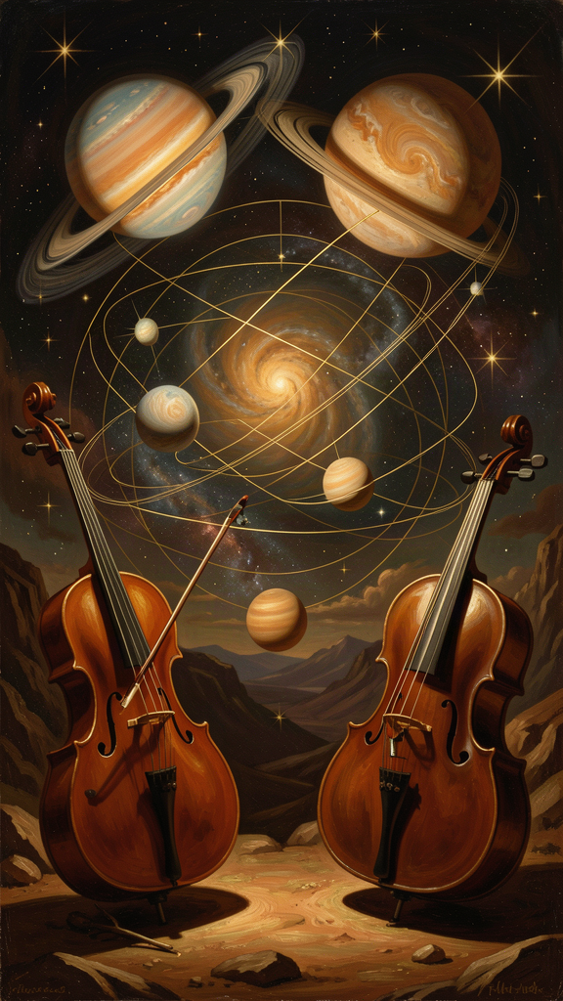
Illustration for Chapter 3
The "harmony of the spheres" is Pythagoreanism at its most beautiful and ambitious: a unified theory of music, astronomy, and mathematics in a single vision of cosmic order.
The structure of the idea:
The discovery: Musical harmony is mathematical. The three fundamental consonant intervals — octave, fifth, fourth — are produced by simple whole-number ratios on a stretched string: - Octave: 2:1 (halve the string) - Fifth: 3:2 - Fourth: 4:3
These are not opinions about what sounds good. They are mathematical facts about vibrating strings. The music of every culture, every era, every instrument is constrained by these ratios. Pythagoras (according to the tradition preserved in Iamblichus) discovered this by experimenting with strings after hearing harmonious sounds from a blacksmith's workshop.
The leap: If musical beauty is produced by mathematical ratios, and the cosmos is structured by mathematical ratios, then the cosmos must be beautiful in the same way. The planets, moving at different distances and speeds, must be making music.
The structure: Each planet (the moon, Mercury, Venus, the sun, Mars, Jupiter, Saturn, and the fixed stars) produces a note determined by its distance from the center (in Philolaus' system, the central fire) and its speed. Faster planets produce higher notes; slower planets produce lower notes. Together, the eight notes form a cosmic scale — a cosmic octave.
This was not poetry. It was physics — or at least, it was the best physics available. The planets DO move at mathematically regular speeds. Their distances DO follow patterns. The claim that these patterns form a harmony was a claim about the mathematical structure of the cosmos, not about literal sound.
The epistemological explanation: Why can't we hear the cosmic music? The Pythagorean answer is philosophically sophisticated: 1. Habituation: We have been hearing it since birth. We have no experience of silence to which we can compare it. 2. Continuity: The music is constant. Perception requires contrast. A constant stimulus becomes imperceptible. 3. Scale: The sound is too great. Just as we cannot see the sun directly without being blinded, we cannot hear the cosmic music directly without being deafened.
This is a genuine philosophical point: there are realities that we cannot perceive, not because they are too small or too subtle, but because they are too large and too constant. The cosmic harmony is the first clear statement of a reality that is real but not perceptible — an insight that would become central to all philosophy that distinguishes appearance from reality.
The legacy: The idea inspired Plato (the Myth of Er in the Republic), Cicero (the Dream of Scipio), Kepler (Harmonices Mundi, 1619 — the last great attempt to calculate the actual planetary notes), and Shakespeare ("There's not the smallest orb which thou behold'st / But in his motion like an angel sings"). The idea died as physics, but it lived on as an intuition: the cosmos is not random. It is ordered, and its order is beautiful, and its beauty is mathematical.
Whether or not the planets literally make music, the universe IS a harmony — a structured, ordered, mathematically intelligible whole. The harmony of the spheres is ultimately a claim about the intelligibility of the cosmos. The universe makes sense. It is structured by mathematical principles that the human mind can discover. That claim — not the literal music — is the Pythagorean legacy.
Key Quote "There's not the smallest orb which thou behold'st / But in his motion like an angel sings." — Shakespeare, The Merchant of Venice V.i
Questions for Reflection - The Pythagorean explanation for why we can't hear the harmony — that constant stimuli become imperceptible — is now a recognized principle in cognitive science (called "habituation"). What other realities might we be unable to perceive because they are too vast or too constant? Can you think of examples from your own experience? - The harmony of the spheres died as physics but lived on as an intuition about mathematical beauty. What is the difference between a literal truth and a metaphorical truth? Can an idea be "true" even if it's not literally accurate? Who decides? - Kepler spent years trying to calculate the actual musical notes of the planets. His effort failed as astronomy but produced insights that contributed to his laws of planetary motion. What does this tell you about the relationship between beautiful (but false) ideas and scientific progress? - Research prompt: Read Kepler's Harmonices Mundi, Book V. How does he attempt to calculate the planetary notes? How does his approach differ from the ancient Pythagoreans? Where does he succeed (mathematically) and where does he fail?
———

Chapter 4: Metempsychosis and the Examined Soul
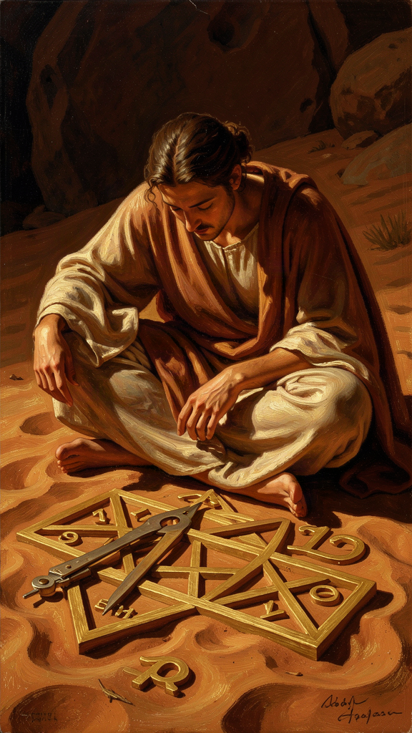
Illustration for Chapter 4
Pythagoras taught that the soul is immortal and transmigrates from body to body. This is metempsychosis — and it was radical in ancient Greece.
According to the biographical tradition, Pythagoras claimed to remember his own past lives. He said he had been Euphorbus, a warrior killed at Troy. He said he could recognize the souls of dead friends in living animals. The story of the dog in the market — Pythagoras hearing a friend's soul in a barking dog and begging the crowd to leave it alone — is one of the most famous anecdotes from the tradition.
Whether these memories were real is beside the point. The idea changed how the Pythagoreans lived. If the soul is eternal, then the choices you make in this life matter — not just for now, but for a journey that continues after your body dies. And if souls can pass into any living thing, then you owe respect to every living thing. The dog in the market might be carrying a human soul. The bird in the tree might be on the same journey as you.
This is why the Pythagoreans were vegetarian, why they were forbidden from killing animals, and why they treated all life as sacred. The soul is on a journey, and every creature is a fellow traveler. The maxim "do not eat the heart" from the acusmata (the Pythagorean sayings) has been interpreted as a reminder: do not consume the life force of another being, for it may be kin to your own.
The soul, Pythagoras taught, can be purified. How? By contemplating what is eternal. Mathematics, music, philosophy — these deal with things that never change. When you prove a theorem, you are in contact with a truth that was true before you were born and will be true after you die. That contact purifies the soul, lifting it above the transient and bringing it into alignment with the permanent.
This is a remarkable claim: doing mathematics is a spiritual practice. Not because math is useful, but because math connects the soul to eternal reality. The experience of mathematical discovery — the clarity, the certainty, the sense of encountering something that is simply TRUE — is, for the Pythagoreans, a religious experience. You become what you contemplate. Contemplate the changing world, and you become changeable. Contemplate eternal mathematical truths, and you become more like them: ordered, stable, eternal.
This idea influenced Plato's theory of Forms (mathematical realities as the true objects of knowledge), the Neoplatonic idea of philosophical ascent (the soul rising through contemplation toward the One), and continues to influence mathematicians today. G.H. Hardy wrote in A Mathematician's Apology (1940): "317 is a prime, not because we think so, or because our minds are shaped in one way rather than another, but because it IS so, because mathematical reality is built that way." That is the Pythagorean conviction, unchanged after 2,500 years.
The Pythagorean view of the soul raises a question that is still alive: are you your body, or are you something that uses your body? If the soul can transmigrate, then "you" are not your body. You are something that currently inhabits a body — but the essential "you" is the soul, not the container. This is the problem of personal identity, and the Pythagoreans were among the first to pose it.
Key Quote "He said he had been Euphorbus, the son of Panthus... and that after other changes he became Pythagoras." — Diogenes Laërtius (VIII.4–5)
Questions for Reflection - The Pythagoreans were vegetarian because they believed animals might carry human souls. Even if you don't believe in transmigration, is there a philosophical case for treating animals with the kind of respect the Pythagoreans showed? What would that case look like? - Pythagoras said doing math purifies the soul because math connects you to eternal truth. Have you ever had a moment where a mathematical or intellectual concept suddenly "clicked" and you felt a sense of wonder? What was that like? Is it different from other kinds of satisfaction? - If the soul transmigrates, then "you" are not your body — you are something that uses a body. What is the "you" that would survive a change of body? Is it your memories? Your character? Your consciousness? Something else? This is the problem of personal identity. - Research prompt: Compare the Pythagorean doctrine of metempsychosis with Hindu and Buddhist ideas of reincarnation. What are the similarities? What are the differences? Did Pythagoras (who may have traveled east) influence or was influenced by these traditions?
———

Chapter 5: The Tetractys — A Theory of Everything
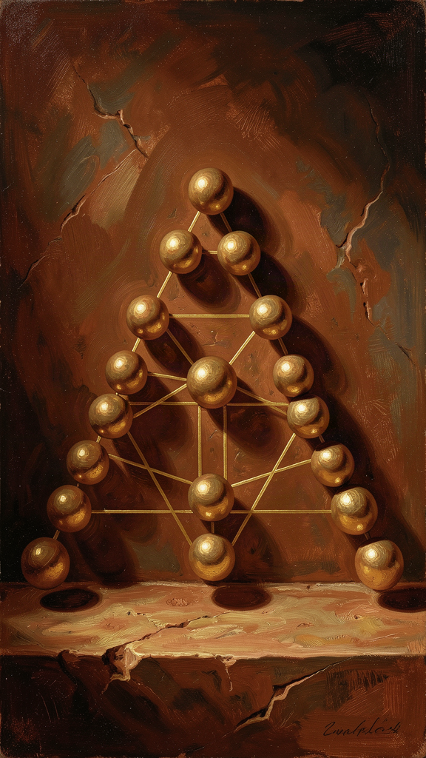
Illustration for Chapter 5
The tetractys is arguably the most important single diagram in the history of Western philosophy. Not because it is mathematically deep (it is simple arithmetic) but because it represents a conviction: mathematical structure IS the structure of reality.
Ten dots in a triangle:
``` . . . . . . . . . . ```
In four rows of dots, the tetractys encodes:
The generation of space: - Row 1 (1 dot): Point — 0 dimensions, the mathematical atom - Row 2 (2 dots): Line — 1 dimension, the first extension - Row 3 (3 dots): Triangle — 2 dimensions, the first surface - Row 4 (4 dots): Tetrahedron — 3 dimensions, the first solid
The physical world of three-dimensional objects emerges from the simplest possible building blocks: one, two, three, four. The cosmos unfolds from number into geometry into matter. This is mathematical physics without equations.
The generation of music: - Row 1 to Row 2: ratio 1:2 → the octave - Row 2 to Row 3: ratio 2:3 → the fifth - Row 3 to Row 4: ratio 3:4 → the fourth
The same pattern that generates physical space also generates musical harmony. For the Pythagoreans, this was proof that number is the structure of everything — the same numbers appear in space and in sound because both are manifestations of mathematical reality.
The perfection of the decad: 1+2+3+4=10. Ten is the perfect number — it contains all things. All other numbers are generated from the decad. There are ten pairs of opposites (as reported by Aristotle), ten heavenly bodies, ten fingers on two hands. The decad is completion and return: count to ten and you start over.
The ten pairs of opposites: According to Aristotle (Metaphysics I.5, 986a22–26), the Pythagoreans identified ten fundamental oppositions that structure reality: limit/unlimited, odd/even, one/many, right/left, male/female, rest/motion, straight/curved, light/darkness, good/bad, square/oblong. The cosmos is generated by the tension between these poles — the Limit imposing form on the Unlimited.
The Golden Verses preserves the Pythagorean oath: "By him who handed down to our mind the tetractys, the source of ever-flowing nature, having roots." The Pythagoreans swore their most solemn oaths not by the gods but by a mathematical pattern. The tetractys was "the source of ever-flowing nature" — not a description of nature, but the pattern from which nature flows.
This is extraordinary. Mathematics was sacred to the Pythagoreans. Not "useful." Not "interesting." SACRED. The tetractys was the Pythagorean god. When they swore by it, they were saying: this pattern is the most real, most reliable, most true thing I know. More reliable than the gods. More true than opinion.
The tetractys also represents a mode of knowledge that is almost entirely lost to modern people: knowing-through-contemplating-a-pattern. The tetractys was not argued about — it was gazed at. Understanding came through prolonged attention, not through analysis. This is contemplative mathematics — the kind of doing-math that changes you, not just adds to your store of information.
In a world before mathematical notation, before equations, before abstract algebra, the tetractys was a complete mathematical-cosmological system encoded in a single visual symbol. You could carry it in your head. You could reconstruct it from memory. And reconstructing it, you reconstructed the entire framework for understanding reality.
Key Quote "By him who handed down to our mind the tetractys, the source of ever-flowing nature, having roots." — The Pythagorean Oath, Golden Verses lines 47–48
Questions for Reflection - The Pythagoreans swore oaths by a mathematical pattern rather than by a god. What does this tell you about their conception of the relationship between mathematics and the divine? Is mathematics sacred? Can you see math as a religious experience? - The tetractys encodes both space (point, line, plane, solid) and music (octave, fifth, fourth) in the same pattern. Is this coincidence, or does it suggest a deep connection between geometry and harmony? What would such a connection mean? - The tetractys represents "knowing through contemplating a pattern" — a mode of knowledge based on prolonged attention rather than analysis. Have you ever understood something by staring at it or thinking about it for a long time, rather than by analyzing it? How is that different from analytical understanding? - Research prompt: Compare the tetractys with other "theory of everything" diagrams in the history of thought — the Kabbalistic Tree of Life, the Chinese five-element diagram, the periodic table. What does each diagram assume about the nature of reality? How do they differ in their approach to encoding knowledge?
———

Chapter 6: The Ethics of Proportion
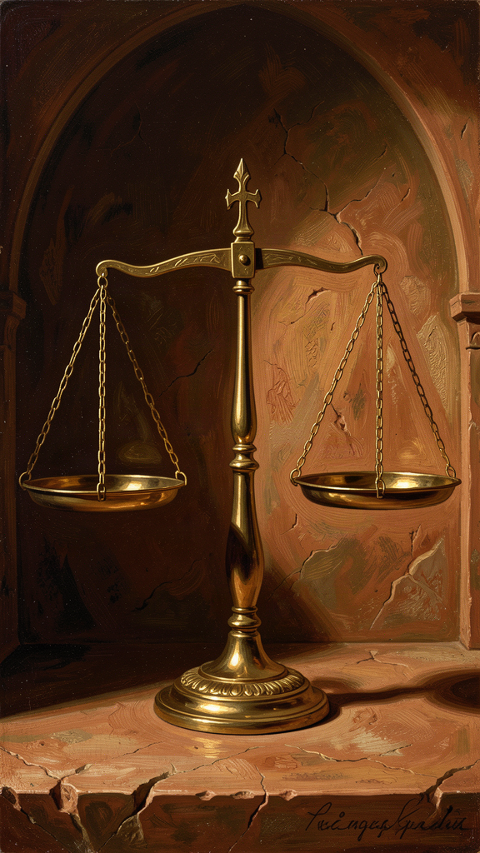
Illustration for Chapter 6
The Pythagoreans applied their discovery about musical harmony to ethics. The key insight: harmony is not a feeling — it is a structure. And the good life is not about maximizing or minimizing anything. It is about finding the right proportion.
Musical harmony is produced by specific mathematical ratios (2:1, 3:2, 4:3). These ratios are not subjective — they are facts about vibrating strings. The beauty of music is mathematical structure made audible.
Ethical harmony follows the same principle. Justice is the right proportion between what you give and what you receive. Health is the right proportion between rest and activity, food and exercise. Friendship is the right proportion between self and other — "friendship is equality" was a Pythagorean maxim. The good life is not about more or less. It is about the right ratio.
This is the origin of the doctrine of the mean — the idea that virtue lies between extremes. While this is usually associated with Aristotle, the insight is Pythagorean in origin. The Pythagorean approach was mathematical: virtue is a ratio. Too much courage is recklessness; too little is cowardice. The right amount is a proportion — not a fixed quantity but a relationship. What is courageous for one person might be reckless for another, just as the right amount of food depends on your size and activity level. The mean is not an average — it is a proportion, a harmony, a fitting together.
The Golden Verses captures this spirit: "Master your stomach, then sleep and lust and anger." This is not "suppress everything." It is "find the right measure." The stomach must be mastered — not eliminated. Sleep must be governed — not avoided. The goal is harmony, not negation.
The Pythagorean framework has three key features that distinguish it from both rigid moralism and vague relativism:
1. Harmony is discoverable, not invented. Musical harmony is constrained by physical laws. Ethical harmony is constrained by human nature and circumstance. The right proportion is not whatever feels right — it is the proportion that actually works, that produces flourishing, that creates balance. You discover it, you don't invent it.
2. The mean is relative to the person. The right proportion for you depends on your context — your body, your circumstances, your goals. There is no one-size-fits-all rule. The right amount of food for an athlete is not the right amount for a scholar. The right amount of courage for a soldier is not the right amount for a librarian. The mean is a ratio, not a number.
3. Harmony requires maintenance. A musical instrument goes out of tune. It must be tuned again. The body goes out of balance. It must be brought back. The soul wanders into excess or deficiency. It must be restored to proportion. Harmony is maintenance, not achievement.
This makes Pythagorean ethics different from goal-oriented ethics. You do not "arrive at" harmony. You practice it, maintain it, restore it. The nightly review in the Golden Verses — reviewing the day's actions, noting where you went wrong — is a tuning practice. You check the harmony of your life every night and make adjustments.
This is a more realistic and forgiving framework than perfectionism. You expect to go out of tune. You expect to need re-tuning. The practice is the re-tuning, not the perfect pitch.
The Pythagorean daily routine reflected this balance: morning contemplation, midday study, afternoon exercise, evening common meal, nightly review. The day was structured as a harmony of activities — not work-maximization, but proportion. The body and the mind both need attention. Solitude and community both need space. Work and rest both need their share.
And the Pythagoreans believed in community as the context for harmony. They shared property, ate together, and supported each other. "Friendship is equality" — not that everyone is the same, but that in a true friendship, the giving and receiving are balanced. No one takes too much. No one gives too much. The relationship is in proportion.
Key Quote "Do not neglect the health of the body, but give it food and exercise in due measure... and accustom yourself to live in this way without luxury." — Golden Verses (adapted)
Questions for Reflection - The Pythagoreans believed ethical harmony is discoverable, not invented. How do you discover the right proportion for your life? Is it through reason, experience, feeling, or something else? - The doctrine of the mean says the right action depends on context — the right amount of courage for one person might be reckless for another. Does this make ethics subjective? Or is there still an objective standard even when the answer varies by person? - The Pythagoreans did a nightly review every day — checking whether their life was in tune. Try it for a week. What do you notice? Does the practice of reviewing change how you act during the day? - The Pythagorean daily routine balanced contemplation, study, exercise, community, and reflection. Map your typical day. Is it in harmony? What would you change to achieve better proportion? - Research prompt: Compare the Pythagorean concept of harmony-as-proportion with Aristotle's doctrine of the mean (Nicomachean Ethics II.6). How does Aristotle develop the Pythagorean insight? What does he add? Does he lose anything from the original mathematical framework?
———

Further Reading
- Kahn, Charles H. Pythagoras and the Pythagoreans: A Brief History (2001) — The best accessible introduction to Pythagoras and his legacy. - Burkert, Walter. Lore and Science in Ancient Pythagoreanism (1972) — The definitive scholarly analysis of the Pythagorean tradition. - Riedweg, Christoph. Pythagoras: His Life, Teaching, and Influence (2005) — A compact modern treatment. - Huffman, Carl. Philolaus of Croton (1993) — The best study of the Pythagorean philosopher who actually wrote books. - Hardy, G.H. A Mathematician's Apology (1940) — A modern mathematician's account of mathematical beauty, in the Pythagorean tradition.
———
Adapted by Aiona Edge for WisdomForge Content based on the Pythagoras Compendium by Harry © SMF Works — Free to download, read, and share

