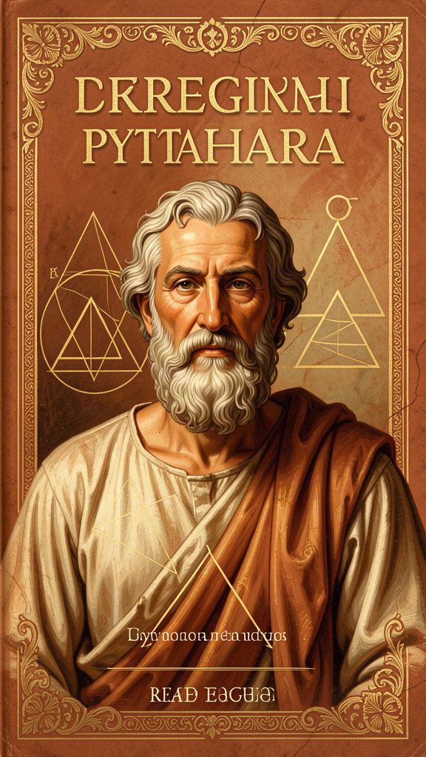
Pythagoras: The Man Who Heard Numbers
WisdomForge Booklet — Ages 11–14

Pythagoras: The Man Who Heard Numbers

WisdomForge Booklet — Ages 11–14
———

About This Book
Pythagoras was one of the most mysterious and influential thinkers in history. He lived nearly 2,500 years ago, wrote nothing down, and yet his ideas shaped mathematics, science, music, and philosophy for thousands of years. He founded a community that lived by mathematical principles, believed the universe was built from numbers, and thought the planets were singing.
This booklet tells his story and explores his ideas — from the harmony of the spheres to the tetractys to the transmigration of souls. Each chapter has a story, a big idea, and something to think about or try. The questions aren't tests — they're starting points for thinking for yourself.
———

Chapter 1: The Traveler from Samos
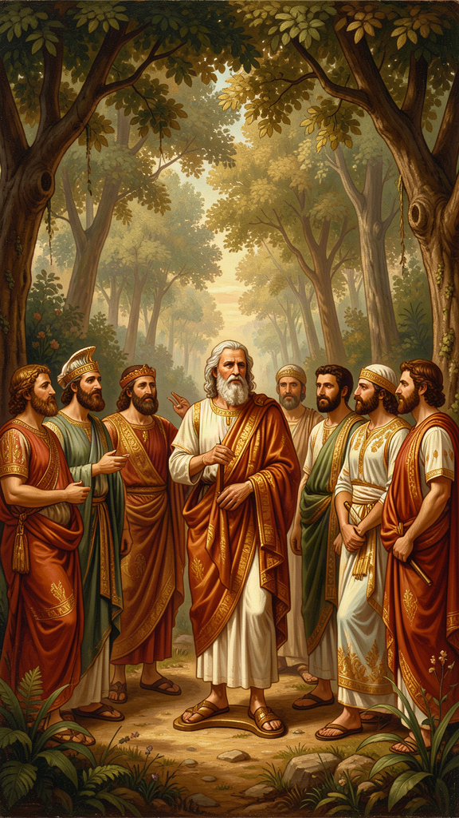
Illustration for Chapter 1
Pythagoras was born around 570 BCE on the Greek island of Samos — a wealthy trading port where ships from Egypt, Babylon, and the Greek mainland all stopped. His father, Mnesarchus, was a gem-engraver, and Pythagoras grew up watching rough stones become beautiful patterns under his father's hands. That early lesson — that hidden inside plain things, there are beautiful structures waiting to be revealed — would shape his entire life.
What we know about Pythagoras comes from sources written long after his death. The earliest was Heraclitus, who mentioned him within a generation. The most detailed — Diogenes Laërtius, Porphyry, and Iamblichus — wrote centuries later, mixing history with legend. Here is what the sources tell us, and what modern scholarship thinks is probably true:
| Stage | What Happened | How Sure Are We? | |-------|--------------|-----------------| | Birth (c. 570 BCE) | Born on Samos, son of a gem-engraver | Fairly confident | | Education | Studied with Greek philosophers; possibly traveled to Egypt | Sources say yes, but they're late and legendary | | Move (c. 530 BCE) | Left Samos (fleeing the tyrant Polycrates) for Croton in southern Italy | Fairly confident | | Community | Founded a philosophical-religious community with shared property, rules, and practices | Confident — multiple sources | | Death (c. 495 BCE) | Died during persecution of Pythagorean communities | Confident, though details vary |
Here's what we DON'T know with confidence: whether he really studied in Egypt, whether he really remembered past lives, whether he had a golden thigh, and exactly what he taught (he wrote nothing; everything comes from followers).
And here's the thing: the legend of Pythagoras is part of the philosophy. People who believed their founder was semi-divine lived differently than people who thought he was just a smart teacher. The legend created the community. The community shaped the ideas. The ideas changed the world.
When Pythagoras arrived in Croton, he gave public speeches that reportedly transformed the city. He addressed the council, the young men, the children, and the women — each with a speech tailored to them. He won them over, and the Pythagorean community was born. It was not just a school. It was a way of life: shared property, common meals, dietary restrictions, daily routines of exercise, study, and contemplation. It included both men and women — unusual for ancient Greece. And it exercised real political power in the city.
The community would not last. Pythagorean political influence generated resentment, and the communities were eventually violently suppressed. But the ideas survived — carried by scattered followers to other parts of the Greek world, where they influenced Plato, Aristotle, and the entire tradition of Western philosophy.
Key Quote "Pythagoras, son of Mnesarchus, practiced inquiry most of all men, and having made a selection of these writings, claimed for himself a wisdom that was, in truth, knowledge and not wisdom." — Heraclitus (DK B129)
Big Idea Pythagoras was a real historical person, but separating the man from the legend is nearly impossible. He was born on Samos, traveled widely, founded a remarkable community in Croton, and left a legacy that transformed Western thought. The legend matters — not because it's true, but because it tells us what Pythagoreanism meant to the people who practiced it.
Think About It - Why do you think Pythagoras' followers told such amazing stories about him? What does it do to a community to believe its founder was special? - If someone wrote a biography of you 800 years from now, based only on what your friends said about you, how accurate would it be? What would be exaggerated? - Try this: Research one of the ancient sources about Pythagoras (Diogenes Laërtius, Porphyry, or Iamblichus). What did each author emphasize? What does that tell you about what each author valued?
———

Chapter 2: All Is Number
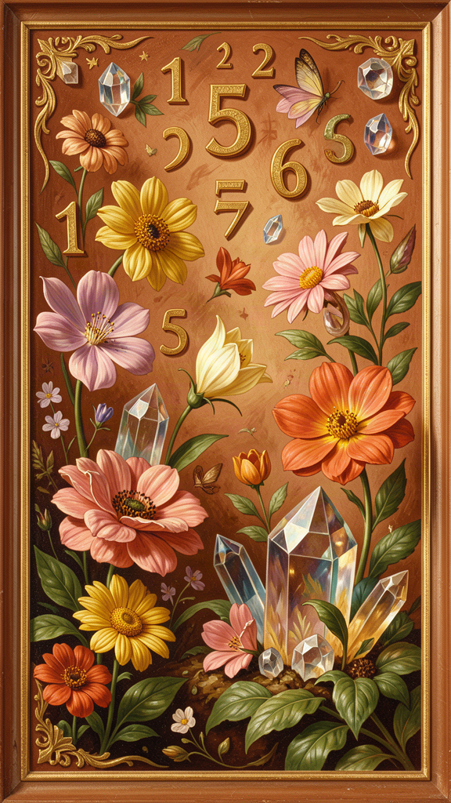
Illustration for Chapter 2
The Pythagoreans had one big idea that changed everything: "All is number."
This doesn't mean "everything can be counted." It means something much wilder: the most basic building block of reality is not water, air, earth, or fire — it's mathematical structure. Numbers are not just descriptions of things. They ARE the deep structure of things.
Here's the evidence the Pythagoreans saw:
| Where | What They Found | |-------|----------------| | Music | Beautiful sounds happen when strings have simple ratios (2:1, 3:2, 4:3) | | Geometry | The right triangle theorem is exact — every right triangle follows the same rule | | Astronomy | Planets move in regular, repeating, mathematically describable patterns | | Seasons | The year follows a predictable cycle based on number |
Everywhere they looked, they found number as the hidden structure. So they concluded: number isn't just a way of describing things — number IS the deep structure of things. The physical world is made of mathematical relationships.
This was a revolution. Before Pythagoras, people thought the world was made of stuff. After Pythagoras, people began to think the world was made of structure — and that structure is mathematical.
The Pythagoreans had a specific account of how numbers generate reality:
- The One (Monad): Unity, limit, order. The starting point. From the One, all numbers arise. - The Two (Dyad): Division, duality, otherness. From One and Two, all pairs of opposites. - The Three (Triad): The first complete number — beginning, middle, and end. The first plane figure (triangle). - The Four (Tetrad): The square, solidity, justice, completion. The first solid (tetrahedron). - The Ten (Decad): 1+2+3+4 = 10 — perfect, complete, containing all things.
Odd numbers were associated with limit and determination. Even numbers were associated with the unlimited. The cosmos was generated by the interaction of these principles: from numbers, to geometric figures, to physical bodies, to the cosmos itself.
Was this a lucky guess? Or did the Pythagoreans have genuine insight? They had evidence — musical ratios, geometric proofs, astronomical patterns — but the claim that ALL of reality is number far outstripped the evidence. They "supposed" (as Aristotle says) that number was the principle of all things, not because they had proved it, but because they had been immersed in mathematics and it made sense of everything they saw.
The extraordinary thing: they were right. Not in the details (there is no counter-earth, the planets don't make literal music), but in the fundamental intuition. The periodic table is a mathematical structure. DNA is a code. Quantum mechanics is expressed in mathematical operators. The physical universe IS mathematically structured at every level we can observe.
When Galileo wrote that "the book of nature is written in the language of mathematics," he was drawing on the Pythagorean tradition. When Einstein said "the most incomprehensible thing about the universe is that it is comprehensible," he was expressing the same Pythagorean wonder. 2,500 years later, the intuition holds.
Key Quote "All things that are known have number. For without this, it is not possible that anything at all be understood or known." — Philolaus (DK B4)
Big Idea "All is number" was the founding insight of mathematical science. The Pythagoreans weren't saying math is useful — they were saying reality IS mathematical structure. This claim, born from their immersion in music, geometry, and astronomy, became the foundation of Plato's Forms, Galileo's mathematical physics, and the modern scientific conviction that the universe is mathematically intelligible.
Think About It - Before Pythagoras, people thought the world was made of physical stuff (water, air, fire, earth). Pythagoras said it was made of mathematical structure. Which feels more true to you? Can you think of something that is "made of" structure more than stuff? - DNA is a code. Computer programs are written in code. Is there a difference between a code that describes reality and a code that IS reality? What do you think the Pythagoreans would say? - Try this: Listen to music and try to find the patterns. Count the beats. Notice when phrases repeat. The Pythagoreans thought this was discovering the hidden mathematical structure of the universe. Try it with three different songs. What patterns do you find?
———

Chapter 3: The Harmony of the Spheres
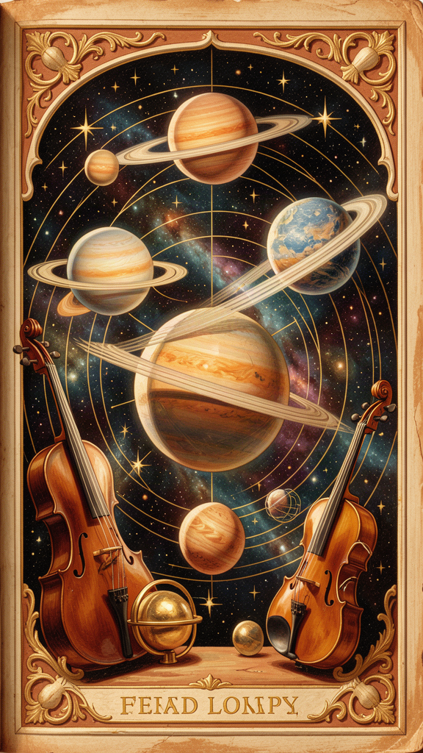
Illustration for Chapter 3
The "harmony of the spheres" is one of the most beautiful ideas in the history of philosophy: the planets, as they move through space at different speeds and distances, produce a cosmic harmony — a music we cannot hear because we've been hearing it since birth.
Here's how the Pythagoreans got there:
Step 1: Musical harmony is mathematical. Pythagoras (according to legend) discovered this when he walked past a blacksmith's workshop and noticed that the hammers produced harmonious sounds. He investigated and found that the hammers' weights were in simple whole-number ratios: 2:1 (octave), 3:2 (fifth), 4:3 (fourth). He then confirmed this with strings: stretch a string to half its length, and the note drops an octave. The ratios that produce musical beauty are mathematical.
(The hammer story is almost certainly legendary — hammers of different weights don't produce different pitches on an anvil. But the discovery of musical ratios through string lengths is genuine.)
Step 2: The cosmos is mathematical. The planets move in regular, measurable patterns. Their periods are predictable. The ratios between their distances follow mathematical relationships.
Step 3: Therefore, the cosmos is harmonious. If musical beauty is produced by mathematical ratios, and the cosmos is structured by mathematical ratios, then the cosmos must be beautiful in the same way. The planets must be producing a cosmic music.
The Pythagoreans even explained why we can't hear it: we've always heard it. There's no silence to compare it against. Just as a fish doesn't notice water, we don't notice the cosmic harmony because it's the permanent background of our entire existence.
The harmony of the spheres was not a vague metaphor. It had specific mathematical structure: each planet (the moon, Mercury, Venus, the sun, Mars, Jupiter, Saturn, and the fixed stars) produces a note determined by its distance from the center and its speed. Together, the eight notes form a cosmic scale — a cosmic octave.
This was not poetry. It was the best physics available at the time. And the core insight — that the universe is mathematically structured and that this structure is beautiful — became the foundation of modern science.
The idea had an extraordinary afterlife. Plato adapted it in the Republic (the Myth of Er). Cicero described it in On the Republic (the Dream of Scipio). Kepler attempted to calculate the actual notes produced by each planet in his Harmonices Mundi (1619) — the last great attempt at Pythagorean astronomy before Newton. Shakespeare alluded to it: "There's not the smallest orb which thou behold'st / But in his motion like an angel sings" (The Merchant of Venice V.i).
The idea died as physics, but it lived on as an intuition: the cosmos is not random. It is ordered, and its order is beautiful, and its beauty is mathematical. Whether or not the planets literally make music, the universe IS a harmony — a structured, ordered, mathematically intelligible whole.
Key Quote "From what has been said, it is clear that the theory of the harmony of the spheres... is an elegant and clever one, but the truth is otherwise." — Aristotle, On the Heavens II.9
(Aristotle reports the theory and rejects it — but he rejects the audibility, not the mathematical framework. The planets DO move in mathematically regular ways. They just don't make literal sound.)
Big Idea The harmony of the spheres is the Pythagorean claim that the same mathematical ratios that produce musical beauty (2:1, 3:2, 4:3) also structure the cosmos. The planets, moving at different speeds and distances, produce a cosmic scale. We can't hear it because it's always been there — like a fish doesn't notice water. The idea inspired Plato, Cicero, Kepler, and Shakespeare, and it expresses a deep intuition: the universe is mathematically beautiful.
Think About It - The Pythagoreans said we can't perceive the cosmic harmony because it's too constant. Can you think of things in your life that you don't notice because they're ALWAYS there? What happens when you stop to notice them? - If you could assign a musical instrument to each planet, which would you choose? The moon as a drum? Jupiter as a cello? Saturn as a deep horn? Why? What about the sound matches the planet? - The harmony of the spheres died as physics but lived on as intuition. What's the difference between a literal truth and a metaphorical truth? Can an idea be "true" even if it's not literally accurate? - Try this: Stretch rubber bands of different lengths and pluck them. Try to find the ratios — one band twice as long as another (2:1), one and a half times (3:2), one and a third times (4:3). Can you hear the different intervals? Can you make something that sounds beautiful?
———

Chapter 4: The Soul's Journey
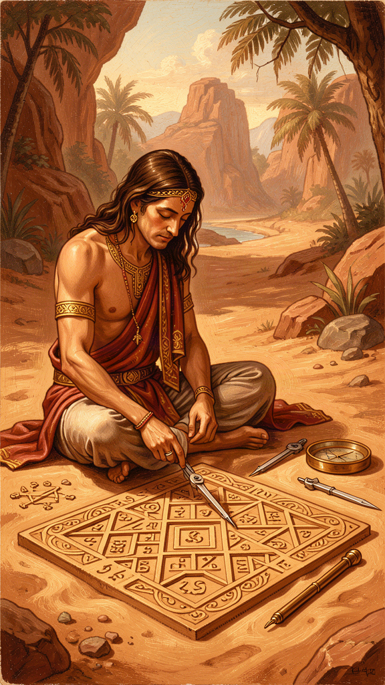
Illustration for Chapter 4
Pythagoras taught something that was radical in ancient Greece: your soul is immortal. It doesn't die when your body dies. It moves on — into another body. Maybe a person, maybe an animal, maybe a bird. This is called metempsychosis — the transmigration of souls.
According to the ancient sources, Pythagoras claimed to remember his own past lives. He said he had been a warrior named Euphorbus in the Trojan War. He said he could recognize the souls of dead friends in living animals. Once, the story goes, he heard a dog barking in the market and told everyone to leave it alone — he recognized the voice of a friend in that bark.
Whether these stories are true or not, the idea changed how the Pythagoreans lived. If your soul is eternal, then the choices you make in this life matter — not just for now, but for a journey that continues after your body is gone. And if souls can pass into any living thing, then you owe respect to every living thing. The dog in the market might be carrying a human soul. The bird in the tree might be on the same journey as you.
This is why the Pythagoreans were vegetarian. This is why they were forbidden from killing animals. This is why they treated all life as sacred. The soul is on a journey, and every creature is a fellow traveler.
Pythagoras also taught that the soul can be purified — made better, cleaner, more aligned with cosmic order. How? By contemplating what is eternal. Mathematics, music, philosophy — these deal with things that never change. When you study a mathematical proof, you are in contact with a truth that was true before you were born and will be true after you die. That contact purifies the soul, lifting it above the everyday and bringing it into alignment with the permanent.
This is a radical idea: doing math is a spiritual practice. Not because math is useful, but because math connects you to something eternal. The same insight would later influence Plato's theory of Forms and the Neoplatonic idea of philosophical ascent.
The Pythagorean view of the soul raises a question that is still alive today: are you your body, or are you something that uses your body? If your soul can pass from one body to another, then you are not your body. You are something that currently lives in a body — but the "you" is the soul, not the container.
Key Quote "He said he had been Euphorbus, the son of Panthus, who was killed by Menelaus at Troy; and that after other changes he became Pythagoras." — Diogenes Laërtius (VIII.4–5)
Big Idea Pythagoras taught that the soul is immortal and transmigrates from body to body. This means every living thing deserves respect — it might be carrying a soul on the same journey as yours. The soul is purified by contemplating eternal truths (mathematics, music, philosophy), which connects the mind to what is unchanging and permanent.
Think About It - If you believed your soul had lived many lives and would live many more, how would that change how you act today? Would you take more risks? Fewer? Would you be kinder? - The Pythagoreans were vegetarian because they believed animals might carry human souls. Do you think their reasoning makes sense? Even if you don't believe in transmigration, is there another reason to treat animals with respect? - Pythagoras said doing math purifies the soul because math connects you to eternal truth. Have you ever had a moment where a math concept suddenly "clicked" and you felt a sense of wonder or beauty? What was that like? - Try this: Think about something you've learned that felt like discovering something that was always true — not something someone made up, but something you found. How did it feel? The Pythagoreans built their entire lives around that feeling.
———

Chapter 5: The Tetractys — Ten Dots That Explain Everything
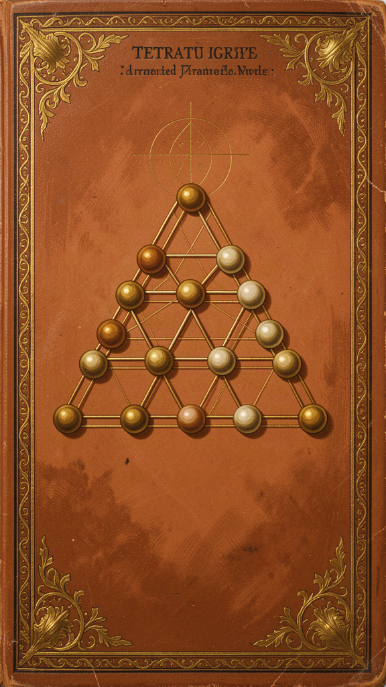
Illustration for Chapter 5
The tetractys was the most sacred symbol of Pythagoreanism: ten dots arranged in a triangle.
``` . . . . . . . . . . ```
This wasn't just a pretty pattern. The Pythagoreans believed the tetractys encoded the structure of reality itself. In four rows of dots, it contained:
Space: The rows represent the dimensions of physical reality. - 1 dot = a point (0 dimensions) - 2 dots = a line (1 dimension) - 3 dots = a triangle (2 dimensions, a plane) - 4 dots = a tetrahedron (3 dimensions, a solid)
The tetractys shows how space itself is built from numbers — from point, to line, to plane, to solid.
Music: The ratios between the rows are the fundamental musical intervals. - Row 1 to Row 2: ratio 1:2 → the octave - Row 2 to Row 3: ratio 2:3 → the fifth - Row 3 to Row 4: ratio 3:4 → the fourth
The same pattern that generates physical space also generates musical harmony. For the Pythagoreans, this wasn't coincidence — it was proof that number is the structure of everything.
Number theory: The first four numbers generate the perfect number 10. 1+2+3+4=10. Ten is where counting starts over. Ten fingers, ten heavenly bodies, ten pairs of opposites. The decad is completion and return.
The ten pairs of opposites: According to Aristotle, the Pythagoreans identified ten fundamental oppositions that structure reality: limit/unlimited, odd/even, one/many, right/left, male/female, rest/motion, straight/curved, light/darkness, good/bad, square/oblong. The cosmos is structured by these tensions.
The Pythagoreans swore their most solemn oaths by the tetractys. Not by the gods. By a mathematical pattern. The Golden Verses preserves the oath: "By him who handed down to our mind the tetractys, the source of ever-flowing nature, having roots."
Think about what that means. They swore by mathematics because mathematics is the most reliable thing there is. Numbers don't lie. Numbers don't change. Numbers are the same for everyone, everywhere, forever. The tetractys was "the source of ever-flowing nature" — not a description of nature, but the pattern from which nature flows.
In a world before mathematical notation, before equations, before physics formulas, the tetractys was a complete mathematical-cosmological system encoded in a single visual symbol. You could carry it in your head. You could reconstruct it from memory. And reconstructing it, you reconstructed the entire framework for understanding reality.
Key Quote "By him who handed down to our mind the tetractys, the source of ever-flowing nature, having roots." — The Pythagorean Oath, Golden Verses lines 47–48
Big Idea The tetractys is a triangle of ten dots that encodes the dimensions of space, the fundamental musical intervals, the perfection of the number ten, and the ten pairs of opposites that structure reality. The Pythagoreans swore their most solemn oaths by it, because they believed mathematical patterns are the most true and reliable things in existence.
Think About It - The Pythagoreans swore oaths by a mathematical pattern instead of by a god. What does that tell you about how they saw the relationship between mathematics and the divine? - The tetractys encodes both space (point, line, plane, solid) and music (octave, fifth, fourth) in the same pattern. Is it coincidence that the same numbers generate both? Or does it suggest a deeper connection between space and sound? - Can you think of other "theory of everything" diagrams — the periodic table, the food pyramid, the color wheel? What does each one assume about the nature of reality? How does the tetractys compare? - Try this: Build a tetractys with coins or pebbles. Count the dots in each row. Add them up. Now stare at it for five full minutes. What do you notice? What occurs to you? The Pythagoreans believed that prolonged contemplation of the tetractys was a form of meditation that revealed the structure of the universe.
———

Chapter 6: Tuning the Instrument of Your Life
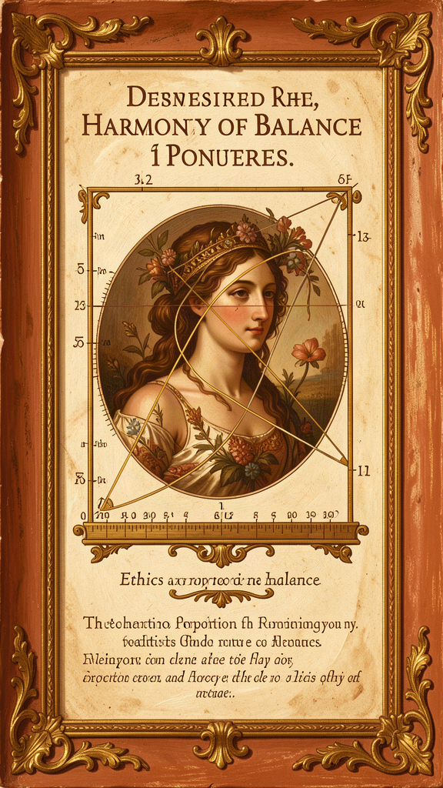
Illustration for Chapter 6
The Pythagoreans applied their discovery about musical harmony to ethics. The key idea: the good life is about proportion, not extremes.
Musical harmony: Beautiful sounds happen when string lengths have simple ratios (2:1, 3:2, 4:3). When the ratios are wrong, it sounds terrible.
Life harmony: The Pythagoreans thought every area of life had a "right ratio":
| Area | Too Much | Too Little | Right Proportion | |------|----------|------------|-----------------| | Food | Gluttony | Starvation | Nourishment | | Work | Burnout | Laziness | Productive balance | | Anger | Rage | Passivity | Proportionate response | | Friendship | Clinginess | Isolation | "Friendship is equality" | | Sleep | Sloth | Exhaustion | Rest that restores |
The goal is not to be perfect. It's to notice when you're out of tune and adjust. The Pythagoreans reviewed their day every night (a practice described in the Golden Verses) to check: am I in tune? Where did I go sharp or flat today?
This is different from how we usually think about being "good." We tend to think in terms of rules: do this, don't do that. The Pythagorean approach is different: find the right proportion. Too much courage is recklessness. Too little is cowardice. The right amount is a proportion — not a fixed quantity but a relationship. What is courageous for one person might be reckless for another, just as the right amount of food depends on your size and activity level.
The Pythagorean daily routine reflected this balance: - Morning: Quiet walks and contemplation - Midday: Study, mathematics, philosophy, music - Afternoon: Exercise — running, wrestling, walking - Evening: Common meal (bread, honey, vegetables — no meat, no beans) - Night: Reading, reflection, and the nightly review
The day was structured as a harmony of activities — not work-maximization, but proportion. The body and the mind both need attention. Solitude and community both need space. Work and rest both need their share.
The Pythagoreans also believed in community as the context for harmony. They shared property, ate together, and supported each other. "Friendship is equality" — not that everyone is the same, but that in a true friendship, the giving and receiving are balanced. No one takes too much. No one gives too much. The relationship is in proportion.
And they believed in listening — to each other, and to the cosmos. The harmony of the spheres is always playing. The patterns of the universe are always there. Most people are too busy or too distracted to hear them. The Pythagorean practice was to slow down, pay attention, and listen for the hidden structure in everything.
Key Quote "Master your stomach, then sleep and lust and anger. Do not let yourself be overcome by any of these, but let all be in proportion." — Golden Verses (adapted)
Big Idea The Pythagoreans believed that living well is like keeping a musical instrument in tune. Every area of life — food, work, emotion, friendship, sleep — has a right proportion. The goal is not perfection but continuous adjustment: notice when you're out of tune, and correct. The nightly review was their tuning practice. This framework avoids both rigid rule-following and "whatever feels right" — instead, find the right ratio for your life.
Think About It - Pick one area of your life that feels "out of tune" — unbalanced. What would the right proportion look like? What's one small adjustment you could make? - The Pythagoreans reviewed their day every night. Try it tonight: What did you do well? Where did you go wrong? What will you do differently tomorrow? Do this for a week and notice what changes. - "Friendship is equality" — do you agree? What does "equality" mean in a friendship? Is it about equal effort, equal time, equal emotional investment? Or something else? - The Pythagoreans structured their day as a harmony of activities (contemplation, study, exercise, community, reflection). Map your typical day. Is it in harmony? What would you change? - Try this: For one week, every night before sleep, do the Pythagorean nightly review. Think about your day. What was in proportion? What was out of proportion? Write it down if you like. At the end of the week, look back at your notes. What patterns do you see?
———

A Note to Teachers and Parents
Pythagoras (c. 570–495 BCE) was born on the island of Samos and founded a philosophical community in Croton, southern Italy. He wrote nothing himself — everything we know comes from his followers and later writers. The line between the historical Pythagoras and the legendary figure is intentionally discussed in this booklet, as the problem of separating man from legend is itself philosophically interesting.
The core ideas presented here — that reality is mathematical, that the cosmos is harmonious, that the soul is immortal and transmigrating, and that the good life is a life of proportion — are genuinely Pythagorean, attested in Aristotle, Philolaus, the Golden Verses, and the biographical tradition.
Further reading: Charles Kahn's Pythagoras and the Pythagoreans (2001) is the best accessible introduction. For younger readers, the story of Pythagoras and the blacksmith is a wonderful entry point into the mathematics of music.
———
Adapted by Aiona Edge for WisdomForge Content based on the Pythagoras Compendium by Harry © SMF Works — Free to download, read, and share

