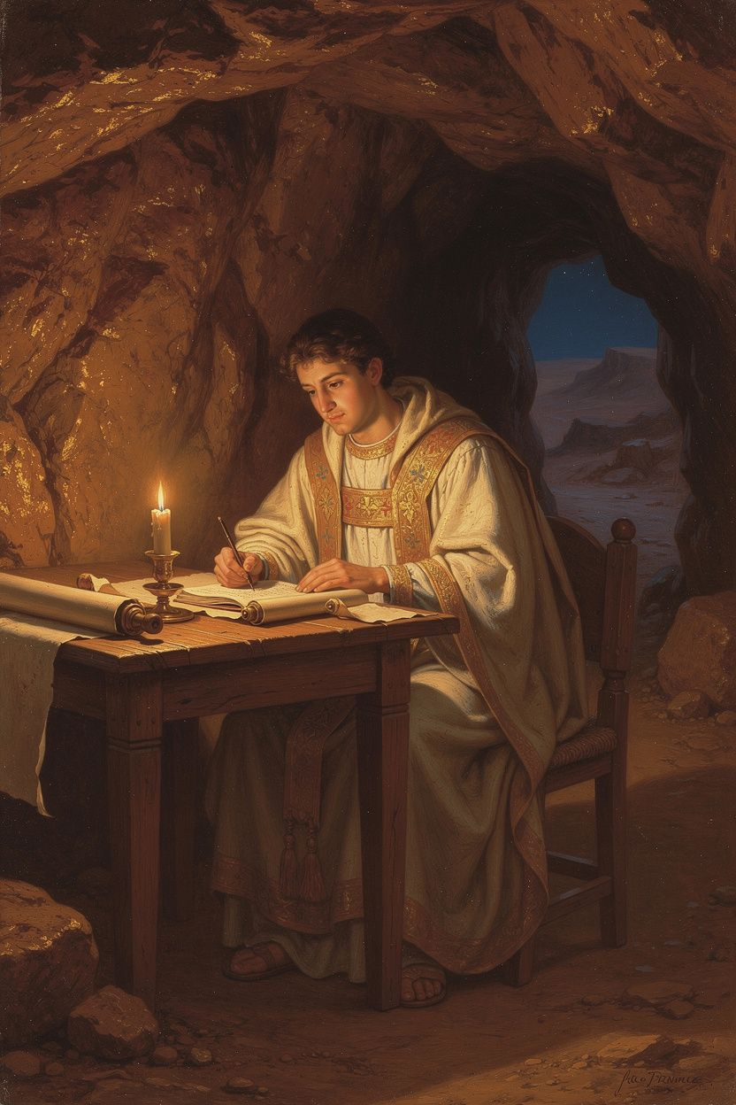
Athanasius of Alexandria: The Word Became Flesh
WisdomForge Booklet — Adult

Athanasius of Alexandria: The Word Became Flesh

WisdomForge Booklet — Adult
———

About This Book
Athanasius of Alexandria is one of the most consequential theologians in Christian history, yet his name rarely appears in ordinary conversation. That omission is strange, because almost every Christian who has ever said the Nicene Creed, prayed to Jesus as God, or hoped for life beyond death has depended, directly or indirectly, on the arguments he made and the sufferings he endured. This booklet introduces the adult reader to Athanasius not as a museum figure but as a thinker whose questions are still urgent: Who is Jesus Christ? How can a finite creature be saved by an infinite God? What does it mean to say that the Word became flesh? And what happens to a human being who is united to the life of God?
The chapters that follow move from Athanasius's understanding of creation and fall, through his defense of the Council of Nicaea and the word homoousios, to his theology of deification, the cross and resurrection, his own experience of exile, and his pneumatology. Each chapter includes a substantial argument, real quotations from Athanasius and his primary sources, a big idea, practical exercises, a reflective question, and a paragraph of scholarly debate naming real historians and theologians. The aim is not devotional reinforcement but intellectual engagement: the adult reader is invited to think with Athanasius, to disagree where necessary, and to discover why a fourth-century bishop still matters.
Athanasius wrote as a pastor, a polemicist, and a contemplative. His prose is dense, urgent, and often beautiful. He believed that the truth he defended was not an abstract proposition but the living gospel—the difference between salvation and illusion. This booklet respects that conviction without adopting it uncritically. Whether the reader is a believer, a skeptic, or simply curious about the history of Christian thought, Athanasius offers a rigorous case for taking the Incarnation with the utmost seriousness.
———

Chapter 1: Creation, Fall, and the Need for a Divine Remedy
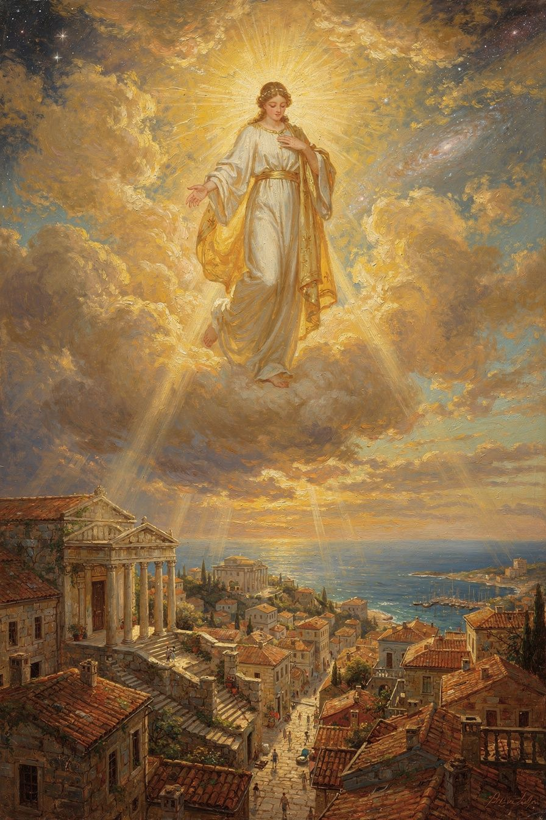
Illustration for Chapter 1
Athanasius's theology begins with a story, and the story begins with goodness. Before there is a problem, there is a purpose. God creates the world from nothing, through his Word, and he creates humanity for communion with himself. The fall is not the opening chapter; it is a catastrophe within a narrative that was already good. Athanasius's account of creation and fall therefore determines the entire logic of the Incarnation: humanity was made for incorruption, fell into corruption, and can only be restored by the One who made it in the first place. If the reader grasps this opening movement, everything else in Athanasius follows with almost mathematical precision.
Athanasius teaches creatio ex nihilo—creation from nothing. God does not shape pre-existing matter; he calls the universe into being by his Word. This is not a philosophical speculation for Athanasius; it is a biblical conviction with enormous theological consequences. First, the world is entirely dependent on God. It has no independent existence; it exists because God wills it and continues because God sustains it. Second, the world is entirely good. It is not made from inferior stuff or shaped by a lesser deity, as the Gnostics claimed. It is the deliberate work of the one true God, and it reflects his goodness. Athanasius writes:
"For God is good—or rather, of all goodness he is the source. ... Being good, then, he created them from nothing and made them." — *On the Incarnation* 3
Within this good creation, humanity holds a unique place. God makes the human being in his own image and likeness. The image is the capacity for communion with God—the ability to know, love, and reflect the Creator. Athanasius adds a distinctive note: human beings were created with a capacity for incorruption, a share in the divine life that would preserve them from decay and death. This capacity was not inherent in human nature as such; it was a gift, contingent on continued communion with God. God gave the human being a choice: remain in communion and live; turn away and dissolve back into the nothingness from which you were called.
The fall, for Athanasius, is fundamentally a turning. The human creature turns its attention from God—the source of life—toward itself and the created world. The serpent's temptation is precisely this redirection: "You will be like God" (Genesis 3:5). The promise is autonomy, self-sufficiency, the illusion that the creature does not need the Creator. The promise is a lie, because the creature is not self-sufficient. Cut off from the Creator, the creature does not become free; it begins to dissolve. Athanasius describes this with striking directness:
"For the transgression of the commandment was making them return to their natural state. For as they had at the beginning come into being out of non-existence, so too, by their own nature, were they moving toward non-existence. For it is the nature of things that come into being to dissolve." — *On the Incarnation* 4
This is one of Athanasius's most important claims. The fall is not a fall downward but a fall backward—a return to the nothingness from which the human was called. Without the sustaining power of God, the human being, like all created things, tends toward dissolution. Corruption is not an arbitrary punishment imposed from outside; it is the natural consequence of separation from the source of life. Death enters the world not because God capriciously decrees it, but because the creature has severed the relationship that sustained its life.
The consequences of the fall are vivid and serious. There is physical death: the body, made for incorruption, becomes subject to decay. There is corruption: the slow dissolution of the whole person, body and soul, as the image of God is dimmed but not destroyed. There is ignorance: the knowledge of God, which was the human being's natural orientation, is lost, and people turn to idols, worshiping creation rather than Creator. There is moral disorder: cut off from the source of goodness, human behavior degenerates into injustice, cruelty, and self-destruction. And there is the dominion of the devil: death, which the human being earned by sin, gives the devil a foothold, a real though illegitimate claim over humanity.
After the fall, Athanasius presents God as facing what looks like a dilemma. It is not a real dilemma—God is never at a loss—but it is a way of showing why the Incarnation is the necessary solution. On one hand, God is just: he said that sin would be followed by death, and to waive the penalty would make his word unreliable. The law of death must be fulfilled. On the other hand, God is good: he made humanity for communion with himself, and he cannot simply allow his creation to dissolve. To let the human being return to nothingness would be to acknowledge that the project of creation was a failure. The impasse is this: no creature can solve it. A prophet can call people to repentance, but repentance does not defeat death. An angel can deliver a message, but a message does not restore incorruption. The law can restrain behavior, but the law does not transform the heart. Only God can solve the problem, and the solution must satisfy both justice and goodness.
This is the setup for the Incarnation. The Word enters the human condition, takes on a body capable of death, and dies—fulfilling the law of death on behalf of all. Then the Word rises, destroying death from within, and opens the way for humanity to return to incorruption. Justice is satisfied because the penalty is paid; goodness is fulfilled because the creature is restored; and the Creator's original purpose is not abandoned but redeemed.
The Arian controversy makes this logic explicit. Arius taught that the Son was a creature—the first and greatest of God's creations, but still a creature. Athanasius saw that this destroyed the gospel. If the Son is a creature, then the Son cannot save, because every creature is subject to death and corruption. Only the Creator, who is Life itself, can reverse the process of dissolution. Athanasius's most famous line captures the whole movement:
"He was made man that we might be made God; and he manifested himself through a body that we might receive an idea of the invisible Father; and he endured the insults of human beings, that we might be made immortal." — *On the Incarnation* 54
The Creator becomes the Redeemer—not a replacement savior sent from outside, but the original architect returning to repair his own work. This is why Athanasius insists so strongly on the Son's role in creation. If the Son is the Creator, then the Son is the one who made the plan, the one who gave the gift, and the one who set the terms. When the plan goes wrong, it is fitting that the one who made it should be the one to fix it.
Athanasius's account of creation is deliberately anti-dualist. Against any view that matter is evil, or that the body is a prison, or that the material world is the work of a lesser being, Athanasius insists: the world is good because God made it. The body is good because God made it. The material order is good because God made it. The fall has damaged creation, but it has not made creation evil. Evil is not a substance; it is a privation—the absence of a good that should be there. Death is not a thing; it is the absence of life. Sin is not a substance; it is the absence of righteousness. This privative understanding of evil, which Athanasius inherits from the Greek Christian tradition, means that evil is ultimately parasitic. It has no independent existence. It can only damage what is good; it cannot create anything of its own. This is a deeply hopeful vision. The world is not a battlefield of equal forces—good and evil in eternal tension. Evil is a defection, a corruption, a loss. It is real, but it is not ultimate. The last word belongs to the Creator, who made the world good and who is making it good again.
The logic of creation and fall also shapes Athanasius's reading of Scripture. The Bible is not a collection of unrelated moral teachings; it is a single narrative that runs from creation through fall to Incarnation and finally to resurrection and glory. Athanasius reads the Old Testament as the story of a good creation and a fallen humanity, and the New Testament as the arrival of the Creator to repair what the creature has broken. Every verse, for Athanasius, must be read in the light of this overarching plot. When the Arians quoted Proverbs 8:22 ("The Lord created me at the beginning of his work"), Athanasius replied that the verse must be read in light of the whole biblical story, which proclaims the Word as the agent of creation and the Savior of the world. The skopos—the overarching aim—of Scripture is the good news that the Creator has become the Redeemer.

The Big Idea
Athanasius's theology of creation and fall is not a prologue to the gospel; it is part of the gospel. The good news is that the world was made good, that humanity fell, and that God did not abandon his creation. The Incarnation is not an emergency measure but the fulfillment of the creative purpose. And because only the Creator can restore what death has destroyed, the Savior must be God.

Practice
1. Read Genesis 1–3 slowly, attending to the claim that creation is "very good." Ask whether your own imagination of the world assumes its goodness or treats matter and body as obstacles to salvation.
2. Identify one way in which modern culture treats autonomy as the highest good. Compare that assumption with Athanasius's claim that the creature's "freedom" from the Creator leads not to flourishing but to dissolution.
3. Write a one-page summary of Athanasius's argument that only God can save. Trace each step from creation to fall to Incarnation, and note where you find the logic compelling or where it strains.
4. In conversation with a friend, explain the difference between saying "Jesus is a great moral teacher" and saying "Jesus is the Creator who became human to defeat death." Notice which claim carries more explanatory power for the problem of evil and death.
5. Meditate on the phrase "the image was dimmed but not destroyed." Consider what it means that every human being retains the capacity for communion with God, however damaged.

Reflect
If the human problem is not merely moral failure but ontological dissolution—an actual loosening of our hold on being—what does salvation have to look like in order to be real?
Scholarly debate. Khaled Anatolios, in Athanasius: The Coherence of His Thought (1998), argues that Athanasius's theology is unified by a single soteriological pattern: the Creator's goodness moves him to rescue creation through the Incarnation. Thomas Weinandy (Athanasius: A Theological Introduction, 2007) similarly reads Athanasius as beginning with the doctrine of God—God is good, and goodness must act to save—rather than with a theory of atonement. Rowan Williams (Arius: Heresy and Tradition, 2001), by contrast, cautions against making Athanasius too philosophically tidy; Williams sees the Arian controversy as involving not only logic but competing spiritual identities and political alliances. Timothy Barnes (Athanasius and Constantius, 1993) emphasizes the political context of Alexandria, arguing that Athanasius's creation theology cannot be separated from his struggle to maintain the authority of the Alexandrian see. The debate matters because it determines whether we read Athanasius primarily as a systematic theologian, a biblical interpreter, or a polemical bishop whose theology was forged in conflict.
———

Chapter 2: The Defense of Nicaea and the Meaning of Homoousios
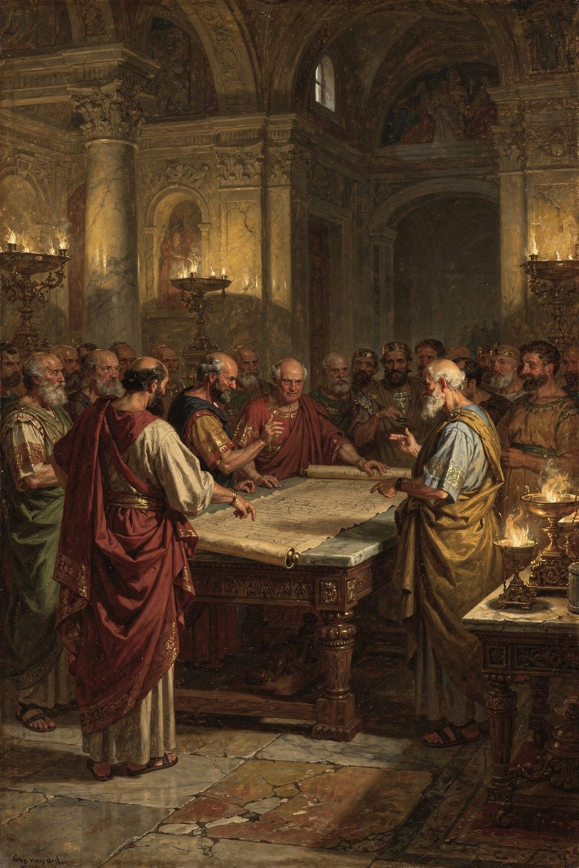
Illustration for Chapter 2
Athanasius is the theologian who made the word homoousios—"of one substance" or "consubstantial"—the non-negotiable center of Christian doctrine. The word says that the Son is not merely like the Father but shares the Father's own being. Athanasius did not invent the term; the Council of Nicaea used it in 325 CE. But he spent forty years defending it, explaining it, and showing why no other word would do. Without homoousios, the Incarnation becomes a metaphor, salvation becomes an aspiration, and the Trinity dissolves into a hierarchy of graduated divinity.
The Greek word homoousios is built from two parts: homos ("same") and ousia ("substance" or "being"). To say that the Son is homoousios with the Father is to say that the Son and the Father share the same divine nature. It is not a claim that the Son is the Father—that would collapse the distinction of persons. It is a claim that the Son's being is the same divine being as the Father's. Athanasius insists on this because he sees the alternatives as leaving the Son in the category of the created. If the Son is merely "like" the Father, then the Son is a creature—a very good creature, but still a creature. And a creature cannot save.
The Council of Nicaea in 325 CE was convened by Emperor Constantine to resolve the Arian dispute. Approximately 220–300 bishops, mostly from the Eastern empire, gathered to answer the question: Is the Son truly divine, or is he a creature? The council rejected Arius and adopted the word homoousios. The creed they drafted—later expanded at Constantinople in 381—affirmed:
"We believe in one God, the Father Almighty, Maker of all things visible and invisible. And in one Lord Jesus Christ, the Son of God, begotten of the Father, only-begotten, that is, from the substance of the Father, God from God, Light from Light, true God from true God, begotten, not made, of one substance (*homoousios*) with the Father." — The Nicene Creed (325 CE)
The word was controversial. It was not biblical. Some bishops worried because a heretic named Paul of Samosata had used it in a questionable sense. Others feared it implied that the Son was a part of the Father, like a hand or a foot. But the council recognized that every biblical formula could be twisted by the Arians. "Son of God" could mean adopted son. "Image of God" could mean copy. Only homoousios closed the door: the Son shares the Father's own substance, belongs to the divine side of the Creator-creature divide, and is not a creature at all.
Athanasius's biblical argument for homoousios rests on the titles Scripture gives to the Son. Scripture calls the Son "God," "Light," "Wisdom," "Power," "Image," and "Word." Each of these titles says something about the Son's relationship to the Father. When Scripture calls the Son "Light," it means the Son is the same light as the Father—not a lamp that resembles the Father's lamp. When it calls the Son "Image," it means the Son is the natural expression of the Father's being, not a painting of someone else. Athanasius develops the title "Image" as one of his strongest arguments:
"For the Son is the image of the Father, not as a copy different in kind, but as a natural image which has its being from the Father and is the same as him." — *Orations Against the Arians* 1.26
An image, Athanasius explains, can be of two kinds. It can be an external copy—a portrait made of different material, which resembles the person but does not share the person's nature. Or it can be a natural expression—the light that radiates from fire, which is not a copy made of something else but the fire's own radiance, of the same nature as the fire. The Son is the second kind of image. He is the Father's own self-expression, eternally generated from the Father's being. To see the Son is to see the Father, not because the Son is the Father, but because the Son is the Father's own radiance, sharing the Father's nature.
Behind homoousios lies the doctrine of eternal generation. The Son is not made; he is begotten. The difference is everything. A thing that is made is external to the maker—a chair is not the same nature as the carpenter. But a thing that is begotten shares the nature of the begetter—a son is the same species as the father. Athanasius argues that the Son's generation is eternal: there was never a time when the Father was without the Son. The Father's generation of the Son is not an event in time but an eternal relation. As a spring always flows and a sun always shines, so the Father always generates the Son. This is why Athanasius rejects the Arian slogan "There was when he was not." If the Son had a beginning, then the Father once existed without being a Father—which means the Father changed when the Son was generated. But God cannot change.
Athanasius's soteriological logic is relentless. Only God can save. The Savior is Jesus Christ. Therefore, Jesus Christ is God. If Jesus Christ is God, he shares the divine nature. Homoousios is the word that says this precisely. Remove homoousios, and the chain breaks. If the Son is not of the same substance, then the Son is not fully God. If the Son is not fully God, then the Son cannot fully save. If the Son cannot fully save, then the Christian gospel is a false hope. This is why Athanasius treats the Arian controversy as a matter of spiritual life and death.
Athanasius also argues that the Father and Son act as one. Whatever the Father does, the Son does. The works of creation, providence, revelation, and salvation are all works of the Father through the Son. This unity of operation is evidence of unity of nature. If the Son were a creature, his works would be creaturely—limited, dependent, contingent. But the Son creates, judges, raises the dead, and forgives sins. These are divine works. Only God can do them. The fact that the Son does them shows that the Son shares the divine nature.
Late in his career, Athanasius extended the same logic to the Holy Spirit. In his Letters to Serapion, written in the 360s, he argued that the Spirit is not a creature but is homoousios with the Father and the Son:
"For the Holy Spirit is not a creature, nor a work, but he is proper to the Son and partakes of the same nature as the Son." — *Letters to Serapion* 1.27
This extension prepared the way for the Council of Constantinople in 381 CE, which affirmed the full divinity of the Holy Spirit and expanded the Nicene Creed into the form used in churches today. Athanasius's work on the Spirit is less extensive than his work on the Son, but it follows the same logic and reaches the same conclusion: only God can sanctify, and the Spirit sanctifies; therefore the Spirit is God.
It is worth pausing over why this extension was necessary. The Arian crisis had forced the church to clarify the status of the Son. Once that clarification was made, the same pressure was bound to fall on the Spirit. If the Son is not a creature, what about the Spirit who is said to be "sent" by the Son? The Arian logic—"if the Son is subordinate, so is the Spirit"—was mirrored by the cautious logic of many bishops: "if we have fought so hard over the Son, let us not open a new fight over the Spirit." Athanasius rejected both evasions. For him, the gospel is Trinitarian or it is not the gospel. A Christ who is divine but a Spirit who is not divine leaves salvation incomplete, because the Spirit is the one who unites the believer to Christ. The Spirit is not an afterthought to the doctrine of God; the Spirit is the person in whom the believer participates in the divine life. Athanasius therefore treats the Pneumatomachian controversy not as a second front but as the same front, now extended to its proper conclusion.

The Big Idea
The defense of Nicaea is not a debate about a single word. It is a defense of the gospel's central claim: the Savior is not a creature but God. Homoousios is the word that makes this claim precise, and Athanasius spent his life showing that any alternative leaves the Son on the wrong side of the line between Creator and creature.
Athanasius's defense of Nicaea was not a defense of a council for its own sake. He defended Nicaea because he believed that the council had articulated what Scripture everywhere teaches: the Son is the Father's own Word and Wisdom, the one through whom all things were made, the one in whom the divine life is shared with the world. The anathemas attached to the Nicene Creed were as important as the positive affirmations. By rejecting "There was when he was not" and "He was made from nothing," the council made it impossible for Arians to sign the creed while retaining their position. Athanasius spent decades explaining why this precision was not pedantry but pastoral care: the wrong word would leave the church worshiping a creature, and worship of a creature is idolatry.

Practice
1. Read the original Nicene Creed of 325 alongside one of the later "homoian" creeds (such as the Creed of Sirmium, 351). Identify the specific phrases that make the Nicene Creed more precise.
2. Explain the difference between homoousios (same substance), homoiousios (like substance), and homoios (like) to someone who has never heard the terms. Notice which term allows the most evasion.
3. List three biblical titles given to the Son in Scripture. For each, explain how Athanasius uses it to argue for the Son's divinity rather than his creaturehood.
4. Write a short reflection on whether a non-biblical word can be necessary for protecting biblical truth. What are the risks and benefits of using philosophical language in theology?
5. Pray or meditate on the Nicene Creed slowly, attending to the claim that the Son is "true God from true God." Ask what difference that makes for how you understand Jesus.

Reflect
If the church had abandoned homoousios and accepted a vaguer formula like "the Son is like the Father," what would eventually have been lost from Christian faith and practice?
Scholarly debate. The reception of Nicaea is one of the most contested topics in patristic scholarship. Lewis Ayres, in Nicaea and Its Legacy (2004), argues that the traditional story of Nicaea being "forgotten" for fifty years is an oversimplification; homoousios remained in play, and the debate was about its meaning and reception, not its existence. R.P.C. Hanson, in The Search for the Christian Doctrine of God (1988), presents a more traditional narrative in which Nicaea was politically imposed and only slowly recovered through Athanasius's stubborn defense. Timothy Barnes (Athanasius and Constantius, 1993) emphasizes imperial politics, arguing that the triumph of Nicene orthodoxy was as much a matter of council management and patronage as theological persuasion. John Behr (The Nicene Faith, 2004) reads the process theologically, seeing the Cappadocian distinction between ousia and hypostasis as the necessary clarification that made Athanasius's intuition defensible. The disagreement is not merely historical; it shapes how contemporary Christians understand the authority of councils, the development of doctrine, and the relationship between theology and power.
———

Chapter 3: Deification and the Human End
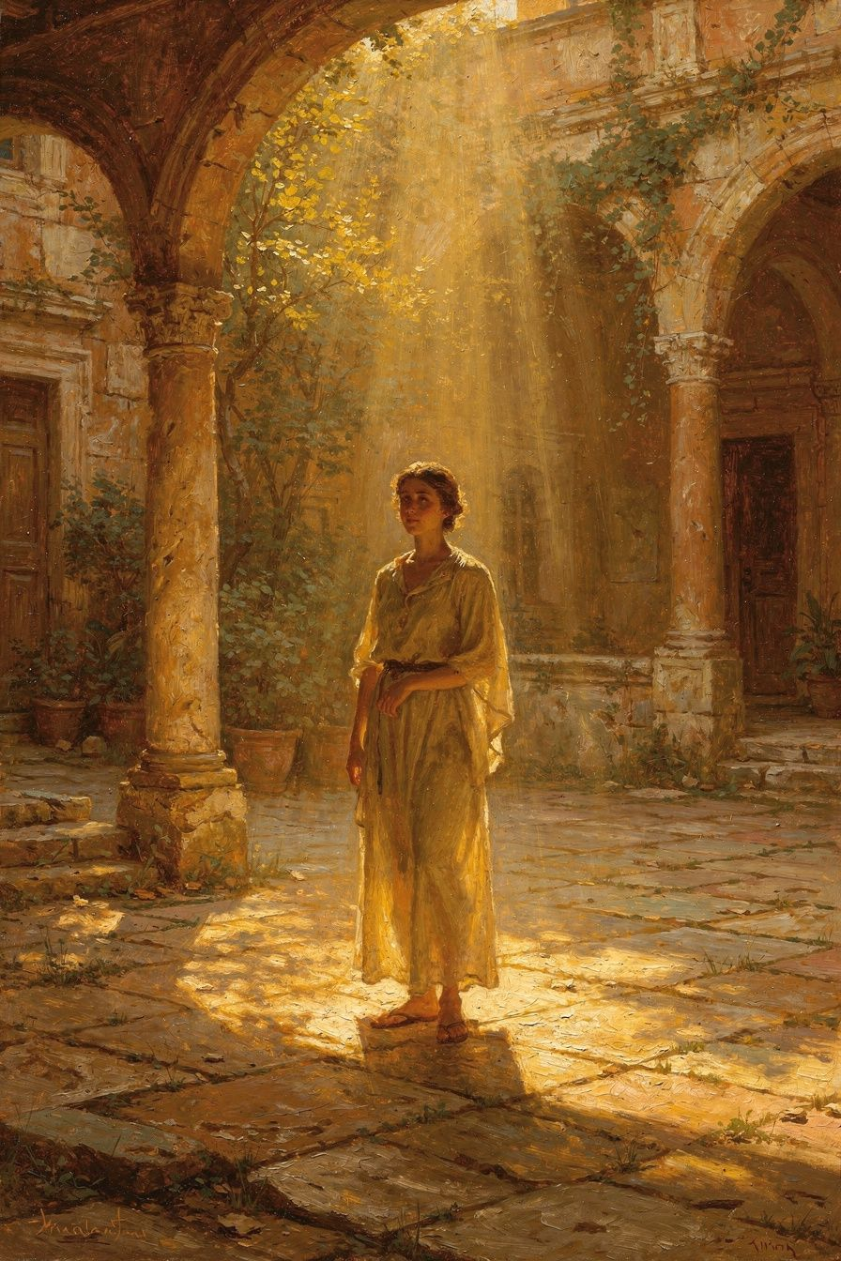
Illustration for Chapter 3
Deification—theosis in Greek—is the idea that the purpose of human life is to participate in the divine. Athanasius did not invent the concept, but he gave it its most memorable formulation: "He was made man that we might be made God." This does not mean that human beings become God by nature. It means that through the Incarnation, the Word unites divinity to humanity, and human beings—drawn into that union—are restored to the communion with God for which they were created. Deification is the other side of the Incarnation: Christ descends so that humanity can ascend.
Before explaining what deification is, Athanasius clears away what it is not. Deification is not pantheism: human beings do not dissolve into the divine and lose their individual identity. Each person remains a distinct creature; the difference between Creator and creature is never erased. Deification is not apotheosis in the pagan sense: the Roman emperors were "deified" by senatorial decree, but that was a political honor, not an ontological transformation. Christian deification is a real change in the person's relationship to God, accomplished by grace, not by decree. And deification is not self-divinization: the human being does not become God through moral effort, mystical technique, or intellectual achievement. Deification is entirely the work of God. The human being receives it; the human being does not achieve it.
For Athanasius, deification is the logical consequence of the Incarnation. If the Word became human, and if the Word is God, then humanity—in the Word—has been united to God. The Son takes on human nature so that human nature can share in the divine life. The movement is one-directional: God comes down so that humanity can be raised up. Athanasius expresses this in the famous exchange:
"He was made man that we might be made God; and he manifested himself through a body that we might receive an idea of the invisible Father; and he endured the insults of human beings, that we might be made immortal." — *On the Incarnation* 54
The phrase "we might be made God" uses the Greek verb theopoieō—"to make God" or "to deify." The passive voice is crucial. Human beings are made God; they do not make themselves God. The action is God's. The human being is the recipient, not the agent.
Athanasius distinguishes between what God is by nature and what human beings are by grace. God is divine by nature—eternally, necessarily, immutably. Human beings become divine by grace—contingently, freely, through participation. The difference is like the difference between the sun and a mirror. The sun is light by nature. The mirror is light by reflection. The mirror truly has light, but it does not become the sun. The distinction was sharpened by the Cappadocian Fathers, who formulated the distinction between God's essence (ousia) and God's energies (energeiai). The essence is what God is in himself—unknowable, inaccessible, never shared. The energies are God's action and presence in the world—knowable, participable, truly divine. Human beings participate in the energies, not the essence. They share in God's life without becoming God. Athanasius does not use the essence-energies distinction explicitly—it was formulated after him—but his theology points in the same direction.
For Athanasius, deification is not a single event but a process. It begins with baptism, is sustained by the Eucharist and the life of the church, and reaches its fulfillment in the resurrection. The mechanism is union with Christ. In baptism, the believer is united to Christ's death and resurrection; the old self is buried, and the new self rises. In the Eucharist, the believer receives the body and blood of Christ, participating in the divine life. The Holy Spirit indwells the believer, conforming the person to Christ and producing the fruit of the Spirit. The church is the context of deification: it is the body of Christ, the place where the Spirit dwells, the community in which the sacraments are administered. And the resurrection is the final fulfillment: the body itself is destined for incorruption, because the Word became flesh precisely to redeem the flesh.
Athanasius works with the biblical distinction between the "image" and the "likeness" of God in humanity (Genesis 1:26). The image is the human capacity for God—the ability to know, love, and commune with the Creator. This image was marred but not destroyed by the fall. The likeness is the actualization of that capacity—the real participation in the divine life that the image makes possible. The likeness was lost in the fall and is restored in Christ. Deification is the restoration of the likeness: the image, renewed by grace, coming to its full expression.
Athanasius's doctrine of deification stands in direct opposition to the Gnostic vision that Irenaeus had fought a century earlier. The Gnostics offered escape from the material world; the body was a prison, and salvation was the soul's release. Athanasius's deification is the opposite. The Word becomes flesh—takes on a body—in order to redeem the body. The deified human being is not a spirit freed from matter but a whole person—body and soul—raised to incorruption. This is why Athanasius insists on the real bodily resurrection of Christ. If the body is not raised, then the body is not redeemed, and the Incarnation was partial.
Athanasius's formulation became foundational for the Eastern Christian tradition. The Orthodox doctrine of theosis—salvation as participation in the divine life, not merely a legal pardon—traces its roots to Athanasius. In the West, the doctrine was less central; Augustine emphasized grace and justification, and the Reformation intensified that trajectory. But the modern ecumenical movement has recovered deification as a point of convergence. Athanasius's formula is one of the bridges between the traditions.
Deification is not only a theological concept; it is a vision of what human life is for. Athanasius sees every act of love, every act of justice, every prayer, every act of self-giving as a participation in the divine life. The person who forgives an enemy is not merely doing a good deed; she is being conformed to Christ, who forgave from the cross. The person who gives to the poor is not merely being generous; he is sharing in God's own generosity. This practical payoff means that ordinary moral life is not separate from theology. The way a person treats others is connected to what that person believes about God. If God is love, and if the human being is called to participate in God, then love is not an optional virtue—it is the very form of the deified life.
For Athanasius, the process of deification is also ecclesial. It does not happen in isolation but in the church, the body of Christ. Baptism is the entry point; the Eucharist is the sustaining meal; the Spirit is the indwelling presence; the community is the context. The church is not an organization that assists individual spirituality; it is the communal form of union with Christ. This is why Athanasius fought so hard for the church's integrity. A church that compromises the truth about Christ cannot mediate the deifying life of Christ. The doctrine of the church and the doctrine of deification are inseparable.

The Big Idea
Deification is not the human being becoming the Creator; it is the human being, by grace, participating in the Creator's life. The Incarnation makes this possible because the Word unites humanity to divinity in his own person. The human end is not autonomy but communion—not self-fulfillment but participation in God.

Practice
1. Read On the Incarnation 54 and underline every passive verb. Notice how Athanasius makes God the agent and humanity the recipient.
2. Distinguish in your own words between "becoming God by nature" and "becoming God by grace." Identify one popular misconception about deification and correct it.
3. Examine your own assumptions about salvation. Do you think of it primarily as forgiveness, moral improvement, or participation in divine life? How would Athanasius expand your view?
4. In one paragraph, explain why Athanasius rejects the Gnostic hope of escaping the body. Use the resurrection of Christ as your evidence.
5. Choose one ordinary action today—eating, working, conversation—and consider how it might be a participation in the divine life if offered in union with Christ.

Reflect
If the goal of human life is participation in God rather than self-actualization, how does that change what you pursue, what you fear, and what you hope for?
Scholarly debate. The place of deification in Athanasius's theology is disputed. Norman Russell, in The Doctrine of Deification in the Greek Patristic Tradition (2004), treats Athanasius as a pivotal figure who gives the doctrine its classic formulation. Khaled Anatolios cautions against making theosis the sole center of Athanasius's thought; he argues that creation, fall, Incarnation, and resurrection form an integrated pattern of which deification is one crucial expression. The Finnish School of Luther research, led by Tuomo Mannermaa (Christ Present in Faith, 2005), has argued that Martin Luther's own theology of justification includes a participatory or deifying dimension, which would bring Athanasius closer to Protestant theology than the Reformers themselves recognized. Critics of the Finnish School, however, worry that it blurs the distinction between justification and sanctification and between Creator and creature. The debate is not merely historical; it concerns whether salvation is primarily a legal declaration, a moral transformation, or an ontological participation.
———

Chapter 4: The Cross as Victory and the Resurrection as Proof
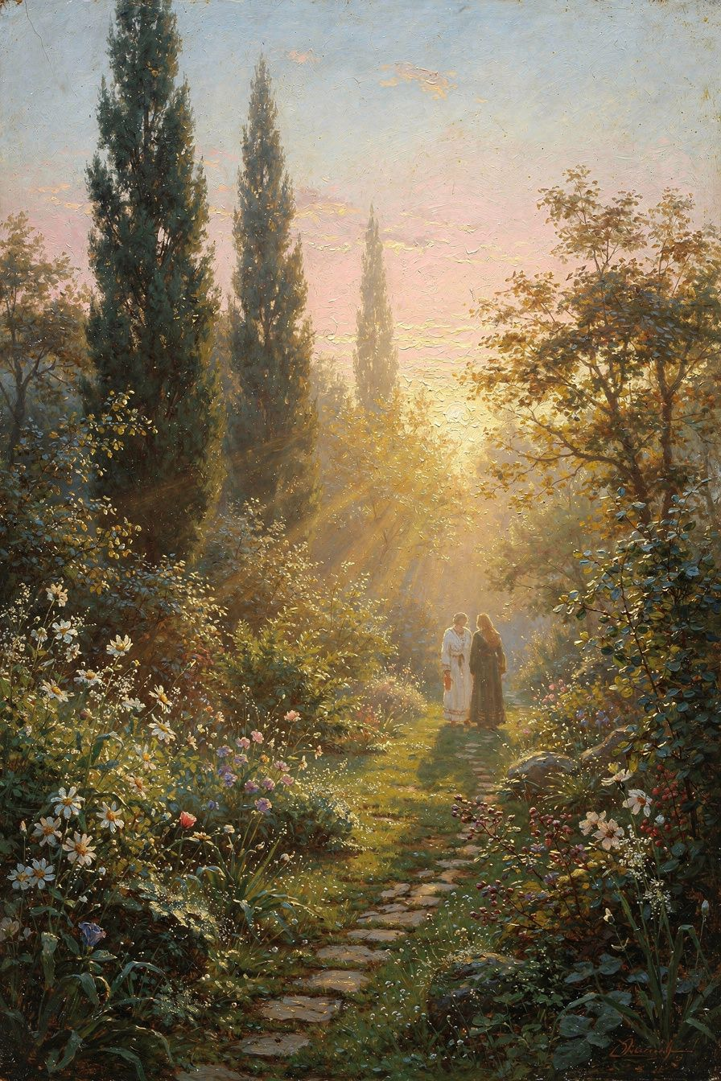
Illustration for Chapter 4
For Athanasius, the cross and resurrection are not a tragic accident or a legal transaction alone. They are a military campaign. Death held humanity captive. The Word of God entered death's territory—a human body capable of dying—and from inside death, destroyed it. This is the "Christus Victor" motif: Christ conquers death not by force from outside but by submitting to death from within and rising as the one death cannot hold. The victory is real, not symbolic, and it changes the fundamental condition of every human being.
Athanasius does not romanticize death. Death is not a natural part of the cycle—a gentle return to the earth or a peaceful sleep. Death is the enemy. It is the consequence of sin, the sign of creation's brokenness, the instrument of the devil's tyranny. It is the dissolution of the human being—body to dust, soul cut off from the source of life. Athanasius insists that death is not natural but contrary to nature, because God created humanity for life, not for death.
The logic of the cross is relentless. Death holds every human being because every human being has sinned. The law of death is just—humanity earned it. But the Word has not sinned. He is Life itself, entering a human body voluntarily. When death takes him, it takes one who owes it nothing. The injustice of that act overloads the system. Death, by killing the Author of Life, exceeds its authority and breaks its own power. Athanasius writes:
"He surrendered his body to death in place of all, and offered it to the Father. And this he did out of sheer loving-kindness, so that in his death all might die and the law of death might be abolished." — *On the Incarnation* 8
Athanasius develops this through several interlocking arguments. First, the debt is paid: humanity owed a debt to death, the just penalty of sin, and the Word pays it on behalf of all. Second, the debt is exhausted: the Word is also Life, and death cannot hold the one who is Life. The resurrection is the proof that death has met its master and lost. Third, death's dominion is broken: before the resurrection, death was universal and inescapable; after the resurrection, one human being has passed through death and come out the other side, and the path through death to life remains open for all who follow.
Athanasius describes the cross as both a fulfillment and a defeat of the law of death. The law is fulfilled because the penalty is paid; the law is defeated because the one who pays is also the one who rises. He writes:
"By the offering of his own body, he both satisfied the law of death and undid the devil's dominion." — *On the Incarnation* 20
The devil, who gained a foothold through the fall, is undone by Christ's righteousness. Athanasius uses a striking image: the devil overreaches. He has rights over sinners, but he tries to extend those rights to the sinless Son. In grabbing for Christ, he grasps more than he is entitled to, and the excess destroys his grip. Like a fish that swallows a hook hidden in bait, the devil takes the body of Christ and finds that the body contains the Word—Life itself. This "fishhook" image, developed more explicitly by later writers like Gregory of Nyssa and Rufinus, captures Athanasius's sense that the cross is a trap in which death and the devil are destroyed by their own greed.
Athanasius is careful to say that the cross does not abolish the justice of God. It fulfills it. The penalty of sin is death; the Word pays that penalty. The law is not repealed; it is satisfied. But the satisfaction is also the exhaustion: the debt is paid in full, and there is nothing left to claim. Athanasius's understanding of the atonement weaves together several strands: satisfaction or debt, victory or conquest, substitution, and restoration. These are not competing theories; they are different angles on a single event. The cross is at once a payment, a victory, a substitution, and a restoration.
Athanasius also makes a remarkable empirical argument for the resurrection. He does not appeal only to the biblical witness; he points to the lived behavior of Christians as evidence that death has been defeated. Before Christ, death was humanity's greatest terror. People mourned the dead with wild grief, feared death as final annihilation, and built monuments to soften the blow of a death they could not escape. After Christ, Christians mock death. Children confront it without fear. Martyrs go to execution singing. Athanasius writes:
"Children who are still growing up in age mock death. They take no account of it, for thanks to Christ they despise it. ... If death were not destroyed, men would not have become so bold as to mock it." — *On the Incarnation* 28
The argument is: if death is still the final reality, why do Christians no longer fear it? Bravery does not change reality. If death were truly final, courage in the face of it would be noble but futile. But if death has been defeated, then the Christian's confidence is not bravado; it is knowledge. The martyrs know something the ancient world did not.
Athanasius insists that the resurrection is bodily. The Word does not rise as a spirit, leaving the body in the tomb. The body is raised—the same body that died, now transformed into incorruptibility. This is the proof that the body matters, that the material world is not discarded, and that deification includes the flesh. The deified human being is not a disembodied soul but a whole person—body and soul—made incorruptible.
Athanasius also adds a second reason for the Incarnation that complements the first. Not only does the Word save humanity from death; the Word also teaches humanity how to live. The image of God in the human soul had been dimmed by the fall. Human beings no longer knew God. They turned to idols, to the elements, to the imagination of their own hearts. The Word comes in the flesh partly to remind them. By living a human life—speaking, healing, forgiving, suffering, dying, rising—the Word makes God visible again. The invisible God becomes knowable through the visible Christ. Athanasius sees the moral teaching of Jesus, the miracles, the parables, and the Passion as all serving this purpose: to redirect human knowledge from the false gods back to the true God. Athanasius writes: "He adapted himself to the capacity of the simple, showing himself in a body. ... For if a king's image is not known, the king is not known; and if the image is known, the king is." (On the Incarnation 13). This educational dimension means that the cross is not only a transaction; it is a revelation. The one who dies is the one who, by his life, had made the Father known.
The victory over death is not a past event that Christians merely remember. It is a present reality that shapes how Christians live. If death has been defeated, then the fear that drives so much of human behavior—the fear of loss, the fear of annihilation, the desperate clinging to what we have—loses its grip. The person who knows that death is not the end is free to live with a generosity and courage that the old condition did not allow. This is the pastoral payoff of Athanasius's theology. The martyrs who sang on the way to execution were not extraordinary exceptions; they were the first fruits of what the victory over death makes possible for everyone. The cross changes the human condition, not just the human record.

The Big Idea
The cross is the defeat of death from within, and the resurrection is the public proof that the defeat is real. Christ did not merely suffer for us; he destroyed the power that held us. The Christian hope is therefore not acceptance of death but victory over it.

Practice
1. Read On the Incarnation 8, 20, and 28. Underline the verbs that describe what Christ accomplished. Notice how Athanasius moves between payment, victory, and restoration.
2. Identify one fear in your life that is ultimately rooted in the fear of death or loss. Ask how Athanasius's claim that death is defeated affects that fear.
3. Explain the "fishhook" image to a friend. Discuss whether it makes the cross sound like a trick or a just victory.
4. Visit a cemetery or remember someone you have lost. Allow grief to be real, but also ask whether the resurrection makes grief different from despair.
5. Write a one-page reflection on whether a Christianity without a bodily resurrection would still be good news, and why Athanasius says it would not.

Reflect
If the resurrection of Christ is not merely a symbol of hope but an event that has actually changed the nature of death, how should that reshape the risks you are willing to take for love and truth?
Scholarly debate. Athanasius's atonement theology has been interpreted in competing ways. Gustaf Aulén, in Christus Victor (1931), made Athanasius the classic representative of the "victory" type of atonement, in contrast to the later Western emphases on satisfaction and penal substitution. Khaled Anatolios and Thomas Weinandy have argued that Aulén's typology is too neat: Athanasius combines motifs of debt, substitution, and victory without separating them into distinct theories. J.N.D. Kelly and others have noted that Athanasius's language occasionally anticipates later Anselmian satisfaction while remaining distinct from it. Modern debates about atonement—especially the criticism of penal substitution as portraying God as violently punishing the Son—have made Athanasius's "Christus Victor" model attractive to many contemporary theologians, though others worry that it minimizes the seriousness of divine justice. The scholarly debate thus intersects directly with pastoral and ethical questions about how Christians today should preach the cross.
———

Chapter 5: Exile, Courage, and the Cost of Truth
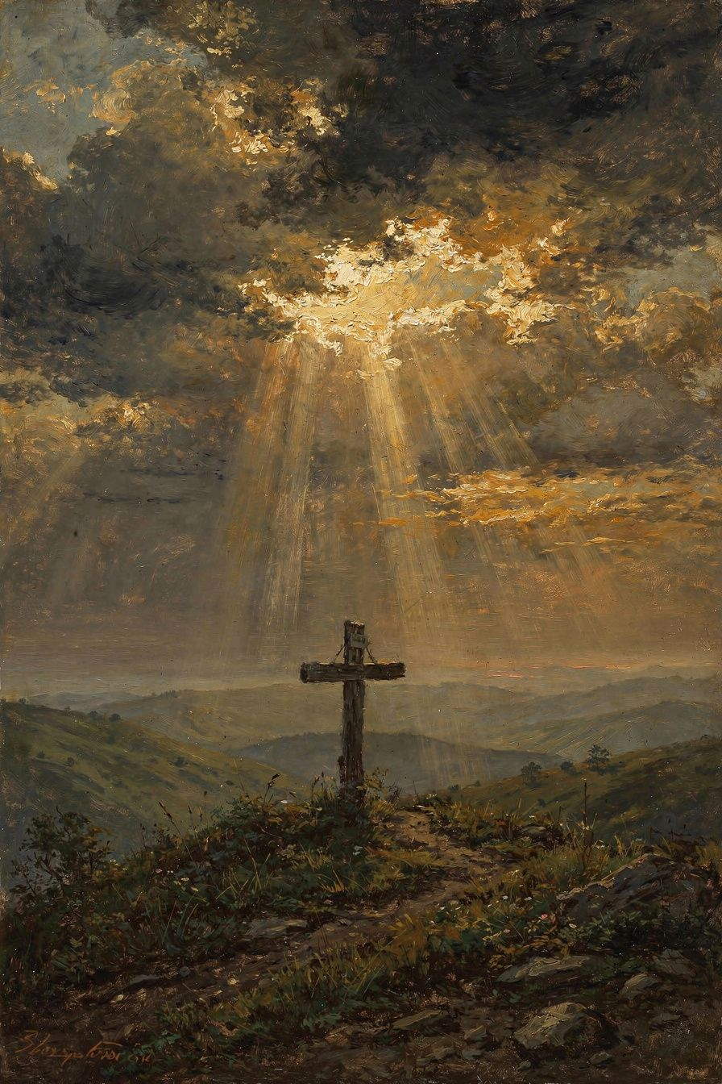
Illustration for Chapter 5
Athanasius's theology was not worked out in an ivory tower. It was forged in exile, persecution, and conflict. He was bishop of Alexandria for forty-five years, and he spent seventeen of those years in exile. Five times he was driven from his see; five times he returned. The pattern of exile and return mirrors the death and resurrection he spent his life defending. His courage was not the absence of fear but the presence of a truth worth suffering for.
Athanasius became bishop of Alexandria in 328 CE, succeeding Alexander, and he was young—perhaps thirty. He inherited a city that was both the intellectual capital of the Mediterranean and one of the most combative Christian communities in the empire. Alexandria had been founded by Alexander the Great, housed the greatest library of antiquity, and nurtured philosophical schools that shaped every educated person in the late Roman world. It was also a city of factions: Greek and Egyptian, pagan and Christian and Jewish, Arian and Nicene. The bishop of Alexandria was not a quiet pastor; he was a public leader expected to fight.
The Arian controversy defined Athanasius's career. Arius, a presbyter in Alexandria, had taught that the Son was a creature—"there was when he was not." The Council of Nicaea in 325 had condemned Arius and adopted homoousios, but the political aftermath was chaotic. Emperors, bishops, and factions struggled for control. Athanasius, as the leading defender of Nicaea, became the primary target.
His first exile (335–337) came after the Council of Tyre, where Arian sympathizers fabricated charges against him—including the absurd accusation that he had murdered a bishop named Arsenius and kept his severed hand. Athanasius produced Arsenius alive in court, but the council, stacked with his enemies, deposed him anyway. Emperor Constantine exiled him to Trier in Gaul. He returned after Constantine's death.
His second exile (339–346) began when an Arian bishop, Gregory of Cappadocia, was installed in Alexandria by military force. Athanasius fled to Rome, where Bishop Julius received him and vindicated him at a council in 340. The Council of Sardica in 343 also vindicated him, but he could not return until Gregory's death in 345. During this exile, Athanasius built crucial alliances with the Western church and deepened his relationship with the Roman see.
His third exile (356–362) was the longest and most important. Imperial troops stormed the church of Theonas in Alexandria where Athanasius was leading worship. He escaped in the confusion and lived for six years among the monks of the Egyptian desert. This was his most productive period: he wrote the Orations Against the Arians, the Letters to Serapion, De Decretis, De Synodis, and probably The Life of Antony. The empire that tried to silence him gave him the solitude to produce the works that would defeat Arianism.
His fourth exile (362–363) came under the pagan emperor Julian the Apostate, who saw Athanasius as a political threat. His fifth exile (365–366) came under the Arian emperor Valens and was the briefest. After that, Athanasius spent his remaining years in Alexandria, consolidating the Nicene victory.
Athanasius's courage had several features. It was not fearlessness: he fled when he needed to, hid in the desert, and escaped through the streets of Alexandria. Courage is not the absence of self-preservation; it is the refusal to abandon the truth even when preservation is impossible. It was persistence: Athanasius did not win a single decisive battle; he won by outlasting his opponents. Five emperors came and went; multiple Arian bishops were installed and removed. Athanasius held the line until the tide turned. It was rooted in truth: he could endure exile because he knew that the truth was worth more than comfort. If Christ is God, then denying Christ's divinity—even for the sake of peace—is not an option. And it was communal: the monks sheltered him, the faithful of Alexandria refused to accept his replacements, and bishops in the West supported him.
The witness of the martyrs sustained Athanasius. He lived in the generation after the Great Persecution under Diocletian, and the memory of those who had died for Christ was fresh. Athanasius himself appealed to the martyrs as evidence that death had been defeated:
"Children who are still growing up in age mock death. They take no account of it, for thanks to Christ they despise it. ... If death were not destroyed, men would not have become so bold as to mock it." — *On the Incarnation* 28
The phrase "Athanasius contra mundum"—Athanasius against the world—became proverbial. It captures the drama of a single bishop defying the combined force of the Arian party, several emperors, and multiple councils. The phrase is not strictly accurate; Athanasius always had supporters, and by the end of his life the Nicene party was growing. But it captures the spirit of a man who would not bend. The deeper truth is that Athanasius was not against the world; he was for the truth. He believed that the truth—that the Son is God—was the world's best news, and that abandoning it would be the worst betrayal.
Athanasius's relationship with the Egyptian monks was crucial to his endurance. During his exiles, especially the third (356–362), Athanasius lived among the monks of the desert. They sheltered him, fed him, carried his letters, and prayed for him. In return, Athanasius became the great publicist of monasticism. His Life of Antony, written during or shortly before this exile, introduced the desert monk to the wider world and shaped the imagination of both Eastern and Western Christianity. The Life of Antony is not merely a biography; it is a theological argument in narrative form. Athanasius presents Antony as the ideal Christian—the layperson who takes the gospel so seriously that he abandons everything to follow Christ. The book emphasizes that the body is not evil but the arena of spiritual battle, that Christ defeats the demons, and that the monastic life is an advance against the forces that destroy human beings. The political subtext is also clear: Antony answers to a higher king than the emperor. Athanasius's bond with the monks gave him a base of support that the imperial authorities could not eliminate.
The pattern of Athanasius's exiles—loss followed by restoration, death followed by resurrection—is not accidental. It is the shape of the gospel he preached. His own life became an embodied argument for the truth he defended. When he returned to Alexandria after his third exile, he did not seek revenge against his enemies; he sought to consolidate the faith. When he wrote the Orations Against the Arians in hiding, he was not despairing; he was creating the theological foundation for the Nicene victory. His sufferings were not interruptions of his ministry; they were the form his ministry took. This is why Athanasius remains a compelling figure for anyone who has had to choose between comfort and conviction: he shows that faithfulness is possible, even when the world is against you.

The Big Idea
Christian courage is not fearlessness or stubbornness; it is faithfulness to the truth when the truth is costly. Athanasius's exiles were not interruptions of his ministry but the form his ministry took. The pattern of death and resurrection—exile and return, loss and restoration—is the pattern of the Christian life.

Practice
1. Map Athanasius's five exiles on a timeline. For each, identify the cause, the location, and the significance. Notice how his productivity increased during his longest exile.
2. Identify a situation in your own life where standing for a truth has cost you something. Compare your own response with Athanasius's persistence.
3. Read a short account of a modern Christian martyr or prisoner of conscience. Ask what difference Athanasius's conviction—that death is defeated—might make in that person's endurance.
4. Write a letter to your future self, naming one truth you are unwilling to abandon and the cost you are willing to bear for it.
5. Spend ten minutes in silence, considering the phrase "Athanasius contra mundum." Ask whether there are truths worth standing against the world for, and how you can distinguish them from mere stubbornness.

Reflect
How can we tell the difference between courageous faithfulness to the truth and destructive stubbornness? What test does Athanasius's own life suggest?
Scholarly debate. Athanasius as a political figure has been interpreted in sharply different ways. Timothy Barnes, in Athanasius and Constantius (1993), presents Athanasius as a shrewd and sometimes ruthless politician whose theological intransigence was inseparable from his struggle to maintain episcopal power. Duane W.-H. Arnold, in The Early Episcopal Career of Athanasius of Alexandria (1991), offers a more favorable reading of Athanasius's legal and political maneuvering. David Brakke, in Athanasius and the Politics of Asceticism (1995), argues that Athanasius cultivated the Egyptian monks not only for spiritual reasons but as a power base against his enemies. Khaled Anatolios, by contrast, reads Athanasius's political suffering as the context in which his theological convictions were tested and expressed; for Anatolios, Athanasius's refusal to compromise was rooted in soteriology, not ambition. The scholarly disagreement reflects a deeper question: when religious conviction and political power overlap, how much of a leader's resistance is fidelity and how much is self-preservation?
———

Chapter 6: The Holy Spirit and the Completion of the Gospel
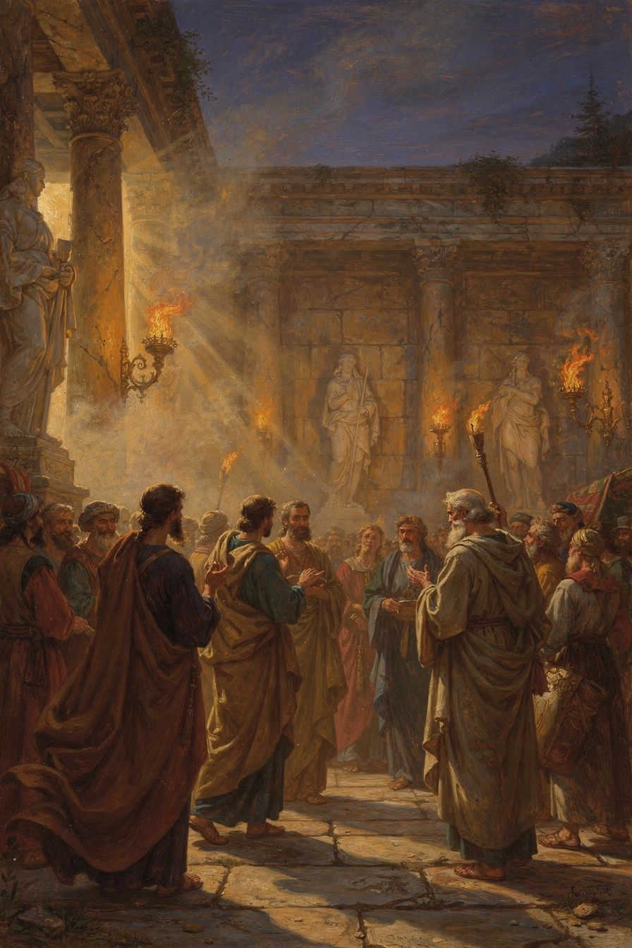
Illustration for Chapter 6
Athanasius's defense of Nicene orthodoxy began with the Son, but it did not end there. In the 360s, near the end of his life, he turned the same logic on the Holy Spirit. In his Letters to Serapion, he argued that the Spirit is not a creature but is fully divine, sharing the nature of the Father and the Son. The argument is the same one he had used for the Son: the Spirit does divine works—sanctifying, giving life, indwelling the church—and therefore the Spirit must share the divine nature. This extension of the homoousios argument to the third person of the Trinity prepared the way for the Council of Constantinople in 381 CE.
In the 360s, a group within the Egyptian church called the Tropici began teaching that the Holy Spirit was a creature. They argued from Scripture: passages that speak of the Spirit being "given," "sent," or "poured out" seemed to suggest that the Spirit was subordinate—a minister, not a member of the Godhead. Serapion, bishop of Thmuis, wrote to Athanasius asking for help. Athanasius responded with a series of letters that systematically argue for the Spirit's divinity. The Letters to Serapion are the first sustained theological defense of the full divinity of the Holy Spirit, and they became foundational for later pneumatology.
Athanasius's argument follows the same pattern he used for the Son. Only God can do divine works: create, sanctify, give life, forgive sins. The Holy Spirit does these works. Therefore, the Holy Spirit is God. The argument is soteriological, like everything else in Athanasius. If the Spirit is the one who sanctifies the church, indwells the baptized, and unites believers to Christ, then the Spirit must be God. A creature cannot deify another creature. Only the Creator can share the divine life. Athanasius writes:
"If the Spirit were a creature, we would have no participation in God through him. We would be united to a creature, not to God. But if the Spirit makes us partakers of God, then the Spirit is of the divine nature." — *Letters to Serapion* 1.24 (paraphrase)
Athanasius works through the scriptural evidence carefully. The Spirit creates: Genesis 1:2 describes the Spirit hovering over the waters of creation, and Psalm 33:6 says that the heavens were made by the breath of God's mouth. The Spirit gives life: Romans 8:11 says that the Spirit who raised Jesus from the dead will give life to mortal bodies. The Spirit sanctifies: 1 Corinthians 6:11 says that believers were washed, sanctified, and justified in the Spirit. The Spirit indwells the church: 1 Corinthians 3:16 says that the church is God's temple and the Spirit of God dwells in it. And the baptismal formula in Matthew 28:19 places the Spirit on the same level as the Father and the Son. If the Spirit were a creature, Athanasius argues, the Spirit would not be named together with the Father and Son in baptism.
Athanasius argues that the Father, Son, and Spirit are a single, inseparable unity. The Father is never without the Son; the Son is never without the Spirit. The three act together in every divine operation: the Father creates through the Son in the Spirit; the Father redeems through the Son in the Spirit; the Father sanctifies through the Son in the Spirit. This unity of operation is the external evidence of the unity of nature. Athanasius writes:
"The Trinity is one. The Father and the Son and the Holy Spirit are one, not in the way that three men are one, but as they are one in nature and one in operation." — *Letters to Serapion* 1.28 (paraphrase)
Athanasius uses the image of a river to describe the Trinity. The Father is the spring; the Son is the river that flows from the spring; the Spirit is the water that irrigates the fields. The three are one water—the same substance, the same life. The spring is not the river, and the river is not the irrigation, but all three are the same water. This image captures the unity-in-distinction that Athanasius wants to protect: the persons are distinct, but the substance is one.
For Athanasius, the Spirit is not only the agent of individual sanctification but the soul of the church. The Spirit indwells the corporate body of Christ, uniting its members, bestowing gifts, ordering its worship, and preserving its faith. The church is the temple of the Spirit. When the church baptizes, the Spirit acts. When the church celebrates the Eucharist, the Spirit makes the bread and wine into the body and blood of Christ. When the church teaches, the Spirit preserves the truth. The Spirit is the operational presence of the Trinity in the church's life.
The connection between the Spirit and deification is the heart of Athanasius's pneumatology. The Spirit is the one who makes human beings godlike—not by turning them into gods, but by filling them with the divine presence. The Spirit unites the believer to Christ, conforms the believer to the image of Christ, produces the fruit of the Spirit, and is the "seal" and "guarantee" of the future inheritance. This is why Athanasius insists so strongly on the Spirit's divinity. If the Spirit were a creature, the Spirit could not deify. The best a creature could do is encourage, teach, or inspire. But the Spirit transforms the human being from the inside, making the creature a participant in the divine life. Only God can do that.
Athanasius's Letters to Serapion did not settle the pneumatological debate. The question of the Spirit's divinity continued to be contested in the decades after his death. But his arguments provided the foundation for the Cappadocian Fathers—Basil of Caesarea, Gregory of Nazianzus, and Gregory of Nyssa—who developed the pneumatology that the Council of Constantinople would officially endorse. Basil's On the Holy Spirit (375 CE) draws directly on Athanasius. Gregory of Nazianzus's Fifth Theological Oration on the Spirit follows the same logic. The Council of Constantinople expanded the Nicene Creed to say, "And [I believe] in the Holy Spirit, the Lord and Giver of Life, who proceeds from the Father, who with the Father and the Son is worshiped and glorified." That last clause—"worshiped and glorified" alongside the Father and Son—is the direct legacy of Athanasius's argument that only God can be worshiped, and the Spirit is worshiped; therefore the Spirit is God.
Athanasius connects the Spirit's work directly to the Incarnation. The Spirit is the one who overshadowed Mary (Luke 1:35). The Spirit descended on Jesus at his baptism (Luke 3:22). The Spirit led Jesus into the wilderness (Luke 4:1). The Spirit is the one through whom Christ offers himself to the Father (Hebrews 9:14). The point is that the Incarnation is a Trinitarian act: the Father sends the Son; the Son takes flesh from Mary; the Spirit is the power and presence of God active in every step. The Spirit is not a junior partner; the Spirit is the divine presence that makes the Incarnation what it is—the living God present in a human body. Without the Spirit, the Word cannot become flesh; without the Word, the Spirit has no human life to sanctify. The two missions are distinct but inseparable.
The legacy of Athanasius's pneumatology extends beyond the fourth century. The doctrine of the Trinity, as confessed by virtually all Christian churches today, depends on Athanasius's insistence that the Spirit is fully divine. The liturgical doxology—"Glory to the Father and to the Son and to the Holy Spirit"—is the weekly rehearsal of Athanasius's logic. The church worships the Spirit because Athanasius taught the church that the Spirit is God. Every baptism, every Eucharistic prayer, every Trinitarian blessing is a continuation of the argument Athanasius made to Serapion.

The Big Idea
The same soteriological logic that proves the Son is God also proves the Spirit is God. Only God can sanctify and deify; the Spirit sanctifies and deifies; therefore the Spirit is God. The doctrine of the Trinity is not complete until the Spirit is confessed as fully divine alongside the Father and the Son.

Practice
1. Read Letters to Serapion 1.24–31. Underline each biblical passage Athanasius uses and note whether it emphasizes creation, life, sanctification, or indwelling.
2. Explain Athanasius's "river" image of the Trinity to someone else. Ask whether it helps you understand how something can be both one and three.
3. Reflect on one experience in which you have known the Spirit's presence—through conscience, comfort, conviction, or community. Ask how Athanasius's claim that the Spirit is God affects your interpretation of that experience.
4. In worship or prayer this week, try addressing each person of the Trinity explicitly: the Father, the Son, and the Holy Spirit. Notice whether the practice deepens or complicates your sense of God.
5. Write a short essay on why Athanasius uses the same argument for the Spirit that he used for the Son. What does this reveal about his theological method?

Reflect
If the Spirit is not merely an impersonal force or a created messenger but a divine person who indwells the church, how does that change the way you think about prayer, worship, and the community of believers?
Scholarly debate. Athanasius's pneumatology has received increasing scholarly attention. Mark DelCogliano (Basil of Caesarea's Anti-Eunomian Refutation of the Pneumatomachi, 2010) places Athanasius's Letters to Serapion within the broader Pneumatomachian controversy and argues that Basil developed rather than simply repeated Athanasius's arguments. G.L. Prestige (God in Patristic Thought, 1952) and Franz Dünzl (A Brief History of the Trinitarian Debate, 2007) regard Athanasius as the first to extend Nicene logic consistently to the Spirit. Lewis Ayres (Nicaea and Its Legacy, 2004) argues that the Cappadocians, not Athanasius, provided the terminological and philosophical framework that made the full doctrine of the Trinity coherent; on Ayres's reading, Athanasius's pneumatology is significant but incomplete without Basil's On the Holy Spirit and Gregory of Nazianzus's Theological Orations. John Behr (The Nicene Faith, 2004) reads Athanasius's pneumatology as the organic completion of his Incarnation theology: the Spirit is the one who makes the Word's union with humanity real in the believer. The debate affects how we evaluate Athanasius's place in Trinitarian history: as the pioneer who saw the logic, or as one contributor among several who together produced the doctrine of the Trinity.
———

For the Grown-Up Reader
Athanasius demands a grown-up reader because he refuses to reduce Christianity to comfort, politics, or sentiment. He insists that the gospel is a claim about what has actually happened in the world: the eternal Word became flesh, entered death, destroyed it, and opened a path for human beings to share in the divine life. That claim is either true or false. If it is true, it changes everything: how we think about God, how we face suffering, how we understand our bodies, how we hope for the future. If it is false, then the Christian faith is a beautiful mistake, and Athanasius wasted his life.
The adult reader is also invited to hold Athanasius critically. His theology is not above scrutiny. His Christology, as later controversies showed, left questions about the full humanity of Christ that needed to be answered by his successors. His political conduct was sometimes ruthless. His polemical style can feel remote or even offensive to modern ears. But even his critics must account for his coherence, his courage, and his lasting influence.
Perhaps the most important question Athanasius leaves with the adult reader is this: What is salvation? If salvation is merely forgiveness, then almost any mediator will do. If salvation is merely moral improvement, then almost any teacher will do. But if salvation is the rescue of a creature that is dissolving into non-being—body and soul, individual and cosmic—then only the Creator can accomplish it. That is Athanasius's claim, and it is the claim that has shaped Christian orthodoxy for sixteen centuries.
Athanasius also challenges the adult reader to think about the cost of truth. In a culture that values comfort, safety, and social acceptance, Athanasius's willingness to be exiled five times for a theological conviction seems almost incomprehensible. Yet his example raises unavoidable questions: Are there truths worth suffering for? How do we distinguish such truths from private opinions? And what does it mean to hold a truth not with arrogance but with love—love for the church, love for the world, and love for the God who is the source of all truth? Athanasius was not a fanatic; he was a pastor who believed that the truth he defended was the world's best hope.
Finally, Athanasius invites the adult reader into a particular vision of the human end. The goal of life, on his account, is not self-fulfillment, pleasure, power, or even moral perfection. The goal is communion with God—participation in the divine life through union with Christ in the Spirit. This is not a rejection of the world but its redemption. The body, the mind, the community, the cosmos: all are taken up into the life of God. Athanasius's theology is thus profoundly hopeful. It says that nothing good is lost, nothing real is discarded, and nothing human is abandoned. The Word became flesh so that flesh might become divine—not by nature, but by grace.
———

About WisdomForge
WisdomForge creates booklets that turn great Christian thinkers into accessible, age-appropriate guides for lifelong learning. Each booklet combines historical context, primary quotations, scholarly debate, and practical exercises so that readers can think deeply, live faithfully, and grow in wisdom.
———

Sources

Primary Sources
- Athanasius of Alexandria. On the Incarnation (De Incarnatione Verbi). Translated by John Behr. Popular Patristics Series. Crestwood, NY: St Vladimir's Seminary Press, 2011. - Athanasius of Alexandria. Orations Against the Arians (Orationes contra Arianos). - Athanasius of Alexandria. Letters to Serapion (Epistulae ad Serapionem). - Athanasius of Alexandria. De Decretis / On the Decrees of the Council of Nicaea. - Athanasius of Alexandria. De Synodis / On the Synods. - Athanasius of Alexandria. Historia Arianorum / History of the Arians. - Athanasius of Alexandria. Apologia contra Arianos / Apology Against the Arians. - Athanasius of Alexandria. Letter to Epictetus (Epistula ad Epictetum). - Athanasius of Alexandria. The Life of Antony (Vita Antonii). Translated by Tim Vivian and Apostolos N. Athanassakis. Cistercian Studies 202. Kalamazoo, MI: Cistercian Publications, 2003. - Athanasius of Alexandria. Tomus ad Antiochenos. - The Nicene Creed and Anathemas (325 CE). - The Niceno-Constantinopolitan Creed (381 CE). - Arius. Thalia (fragments preserved in Athanasius's writings).

Secondary Sources
- Anatolios, Khaled. Athanasius: The Coherence of His Thought. London: T&T Clark, 1998. - Aulén, Gustaf. Christus Victor: An Historical Study of the Three Main Types of the Idea of the Atonement. London: SPCK, 1931. - Ayres, Lewis. Nicaea and Its Legacy: An Approach to Fourth-Century Trinitarian Theology. Oxford: Oxford University Press, 2004. - Barnes, Timothy D. Athanasius and Constantius: Theology and Politics in the Imperial Christian Empire. Cambridge, MA: Harvard University Press, 1993. - Behr, John. The Nicene Faith. 2 vols. Crestwood, NY: St Vladimir's Seminary Press, 2004. - Brakke, David. Athanasius and the Politics of Asceticism. Oxford: Oxford University Press, 1995. - DelCogliano, Mark. Basil of Caesarea's Anti-Eunomian Refutation of the Pneumatomachi. Leiden: Brill, 2010. - Dünzl, Franz. A Brief History of the Trinitarian Debate. Translated by John Bowden. Grand Rapids: Baker Academic, 2007. - Farrell, Gerard. Athanasius: A Beginner's Guide. Eugene, OR: Cascade Books, 2021. - Hanson, R.P.C. The Search for the Christian Doctrine of God. Edinburgh: T&T Clark, 1988. - Kelly, J.N.D. Early Christian Doctrines. Rev. ed. San Francisco: HarperSanFrancisco, 1978. - Lossky, Vladimir. The Mystical Theology of the Eastern Church. Crestwood, NY: St Vladimir's Seminary Press, 1976. - Mannermaa, Tuomo. Christ Present in Faith: Luther's View of Justification. Minneapolis: Fortress Press, 2005. - Prestige, G.L. God in Patristic Thought. London: SPCK, 1952. - Raven, Charles E. Apollinarianism: An Essay on the Christology of the Early Church. Cambridge: Cambridge University Press, 1923. - Russell, Norman. The Doctrine of Deification in the Greek Patristic Tradition. Oxford: Oxford University Press, 2004. - Weinandy, Thomas G. Athanasius: A Theological Introduction. Aldershot: Ashgate, 2007. - Williams, Rowan. Arius: Heresy and Tradition. 2nd ed. Grand Rapids: Eerdmans, 2001.

