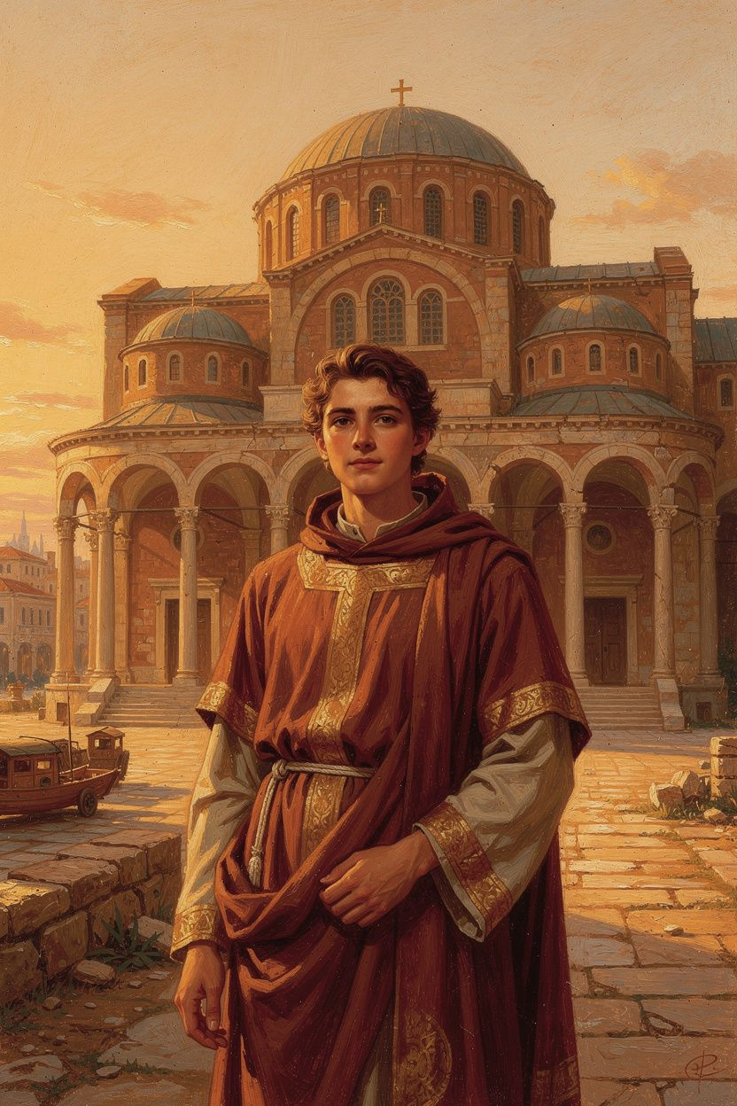
The Bishop Who Said No to Kings
WisdomForge Booklet — Ages 5–10

The Bishop Who Said No to Kings

WisdomForge Booklet — Ages 5–10
———

About This Book
A long time ago, when the Roman Empire still ruled the world, there lived a bishop named Athanasius. He was the leader of the church in Alexandria, a great city in Egypt where people studied the stars, sailed ships across the sea, and argued about big ideas in tall libraries. Alexandria had a famous lighthouse and a famous library full of scrolls. Athanasius loved God and loved the people God had made. He spent his whole life telling everyone the most important truth he knew: Jesus is not just a great teacher or a holy man. Jesus is God's own Son, and he is one with God forever.
Some powerful people did not like this. Emperors, soldiers, and rival bishops chased Athanasius out of his city five different times. He hid in deserts, slept in caves, and wrote letters by candlelight. He dressed like a monk so soldiers would not recognize him. He traveled by night and rested by day. But he never stopped teaching. This book tells his story in six short chapters. Each chapter has a story, words to remember, a big idea, something to try, and a question to ask a grown-up.
Athanasius lived from about 296 to 373 CE. That means he was alive more than 1,600 years ago. He became bishop when he was still young, and he stayed bishop for forty-five years. He wrote books, preached sermons, and traveled from Egypt to Rome. He met monks in the desert and debated bishops in councils. He once hid in a place where people mummified the dead so soldiers would not find him. Another time, he escaped from his church at night while soldiers guarded the doors. A brave friend rowed him past enemy ships on the Nile River. Through it all, he kept saying the same thing: Jesus is the Son of God, truly and fully.
This booklet is for children ages five to ten. The stories are simple, but the ideas are real. Athanasius believed that even the youngest Christian can know that Jesus is God and can begin to live in God's life. The words are big sometimes, but the love behind them is bigger. Each chapter ends with words to remember, a big idea, seven things to try, and a question for a grown-up.
As you read, you will meet some big words. Homoousios means "one with." Theosis means "becoming filled with God's life." Incarnation means "the Word became flesh." These words are like treasure chests. At first they look heavy, but when you open them, they are full of light. Athanasius would be glad that you are learning them while you are still young.
You do not have to read this whole book in one sitting. You can read one chapter at a time, perhaps at bedtime or on a quiet afternoon. After each story, try at least one activity. Then ask the grown-up question to someone older than you. The goal is not to memorize everything. The goal is to know that God loves you, came down to find you, and wants you to shine with his life.
As you color and draw and sing, remember that you are learning the same truth that Athanasius taught emperors and bishops. The truth does not change because you are small. God is just as glad for your faith as he was for Athanasius's courage.
———

Chapter 1: The King Who Came Down
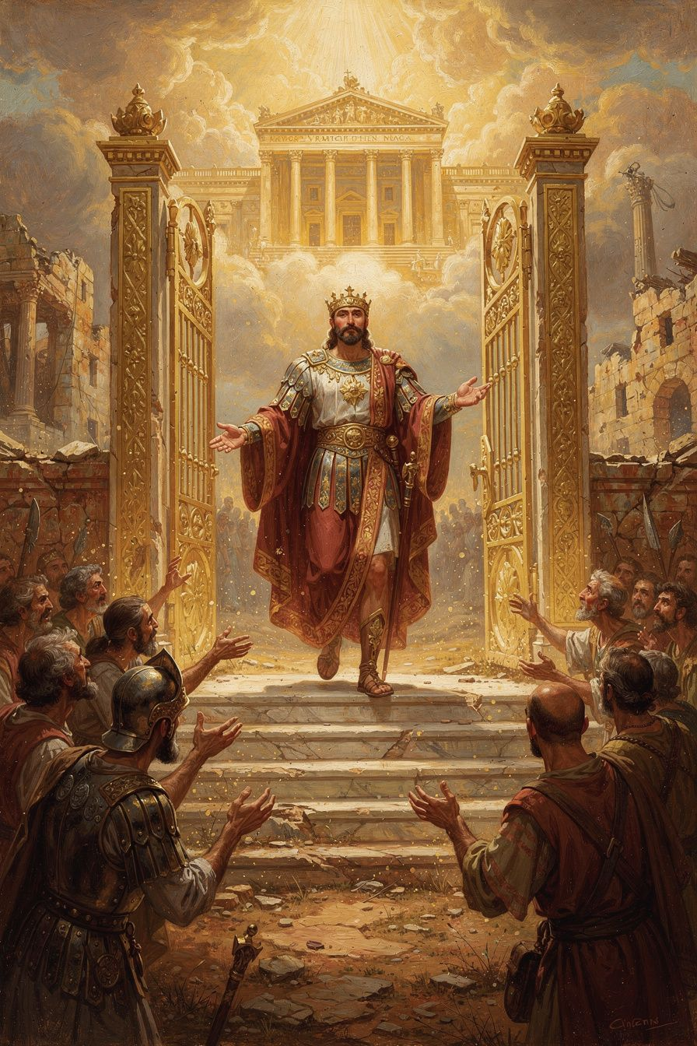
Illustration for Chapter 1
Once upon a time — before time began, really — there was a King. This King was so full of life that everything that lives came from him. He spoke, and the stars appeared. He breathed, and the oceans rolled. He formed the first people with his own hands and walked with them in a beautiful garden. The garden had tall trees, clear rivers, colorful birds, and fruit that tasted like sunshine.
The people were happy because they were with the King. They did not have to be afraid. They did not grow old or sick. They were made to live forever in the King's love. They talked with the King every day. They named the animals. They explored the garden. They were exactly where they were supposed to be.
But one day the people forgot whose garden it was. They listened to a voice that whispered, "You can be kings on your own. You do not need the One who made you." They ate fruit they were not supposed to eat. They tried to take what was not theirs. They ran away from the King who had made them.
And because they had left the source of life, a sad thing began to happen. Their bodies grew old. Their hearts grew afraid. They started to fight with one another. Death came into the world like a thief, taking grandparents and children and kings.
The King could have made new people. He could have said, "I will start over with someone else." But he loved the ones he had made. He remembered every name. He saw every tear. He knew every hiding place. So he did something nobody expected.
He became small.
The King who had made the stars became a baby in a stable. He grew up in a little town called Nazareth. He learned to walk and talk and eat bread. He played with other children. He helped his mother carry water. He became one of the people he had made, so that he could find them and bring them home.
That baby grew up to be Jesus. He taught people about the King's love. He healed sick people. He fed hungry people. He forgave people who had done wrong things. He made friends with lonely people. He welcomed children. And when the time came, he died on a cross and rose from the dead, because death could not hold the King of life.
Athanasius, the brave bishop, spent his whole life telling people this truth: the King came down because he wanted to carry us back up. He did not send a letter. He did not send an angel. He came himself. He came as a person we could touch, talk to, and love. That is why Christmas and Easter are not just holidays for Athanasius. They are the heart of the whole story.
Athanasius lived a long time ago, but the story he told is still true. God did not stay far away. He came close. He came to find us, heal us, and bring us home.
Words to Remember
"The Word of God, being by nature life, did not let what was made to perish."
Athanasius wrote that. He meant that the King, who is life itself, could not stand to let his people die.
Big Idea
God became a human being because he loves the people he made and wants to save them from death.
Try This
1. Draw a picture of the King leaving his bright palace and walking down a long road to find the people he had made. Use gold and blue for the palace, brown and green for the road. 2. Pretend you are telling the story of the King who came down to a stuffed animal or a younger friend. Use your own words. Start with "Once upon a time..." 3. Write one sentence about why it matters that God became small instead of staying far away. 4. Make a crown out of paper. On each point, write one thing the King made: stars, oceans, people, animals, flowers, love. 5. Act out the story with your family. Someone can be the King, someone can be the people, and someone can be the voice that whispers "be your own king." 6. Find a baby picture of yourself. Think about how God once became a baby too. 7. Draw two pictures side by side: one of a king on a throne far away, and one of a king kneeling beside a child. Which picture shows what Jesus did?
Ask a Grown-Up
Why do you think God wanted to become one of us instead of sending someone else?
———

Chapter 2: The Word Is God's Very Own Son
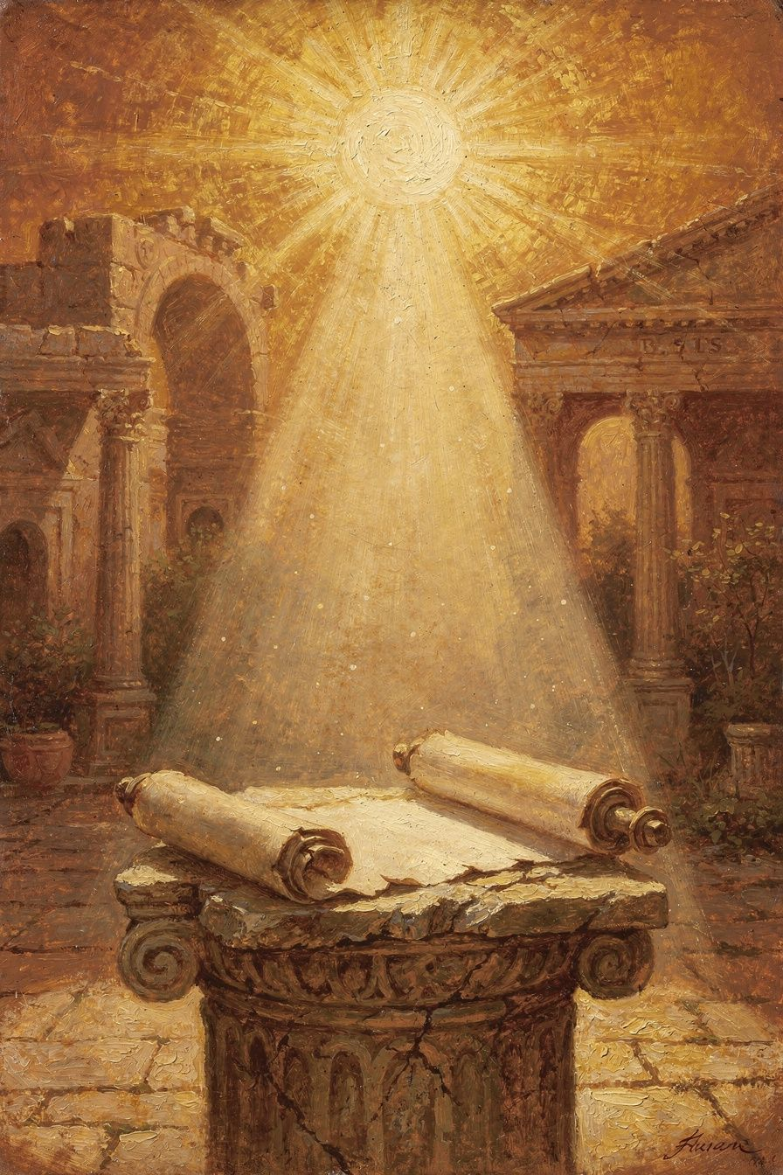
Illustration for Chapter 2
Athanasius lived in a time when some people were confused about Jesus. They said, "Jesus is wonderful, but he is not really God's Son. He is more like God's best servant. He was the first thing God made, and then God used him to make everything else."
Athanasius shook his head. He knew that could not be right.
Here is why. If Jesus were only a servant, then he would be like an angel or a prophet. Angels and prophets can tell us about God. They can do amazing things. But they cannot give us God's own life. They cannot make us part of God's family forever. They cannot defeat death.
But Jesus does give us God's life. He forgives sins. He raises the dead. He makes the blind see. He walks on water. He says, "Anyone who has seen me has seen the Father." That is not what a servant says. That is what a Son says.
Athanasius used pictures to help people understand. He said the Father is like the sun, and the Son is like the ray of light that comes from the sun. The ray is not a different sun, and the sun is not without its ray. They are one light. Jesus is like that with the Father.
He also said the Son is the Father's Word. When you speak a word, your word is not someone else. It is your own thought coming out so others can hear it. Jesus is the Father's Word, the perfect picture of what God is like.
Some emperors and bishops tried to make Athanasius stop saying this. They said the word he used was too hard to understand. The word was homoousios, which means "of the same stuff" or "one with." Athanasius said, "Hard or not, it is true. And without it, the good news is not good news anymore."
Athanasius was brave. Even when soldiers chased him, even when he had to hide in the desert, he kept teaching that Jesus is God's very own Son. He believed this was the most important truth in the world. If Jesus were only a servant, then we would still be separated from God. Because Jesus is the Son, he can bring us all the way home.
Words to Remember
"The Son is the Father's Word and Wisdom and Image."
Athanasius wrote that. He meant that Jesus is the perfect picture of what God is like.
Big Idea
Jesus is God's own Son, not a servant or a creature. He shows us exactly what God is like.
Try This
1. Draw a sun with a ray of light coming from it. Label the sun "God the Father" and the ray "Jesus, the Son." Talk about how they are different but cannot be separated. 2. Make a list of three things Jesus did that only God can do: forgiving sins, raising the dead, calming the storm. 3. Practice saying "homoousios" five times fast. Then explain what it means in simple words: "Jesus is one with God." 4. Draw three circles. In the first, write "servant." In the second, write "friend." In the third, write "Son." Draw Jesus in the third circle. 5. Write a short prayer thanking God that Jesus is his Son. 6. Find a picture of Jesus in a Bible or book. Ask yourself, "Does this Jesus look like God's Son or like a servant?" 7. Make a sign that says "Jesus is God's Son" and put it on your bedroom door or mirror.
Ask a Grown-Up
What difference does it make in your life whether Jesus is God's Son or just God's servant?
———

Chapter 3: Made to Shine Like God
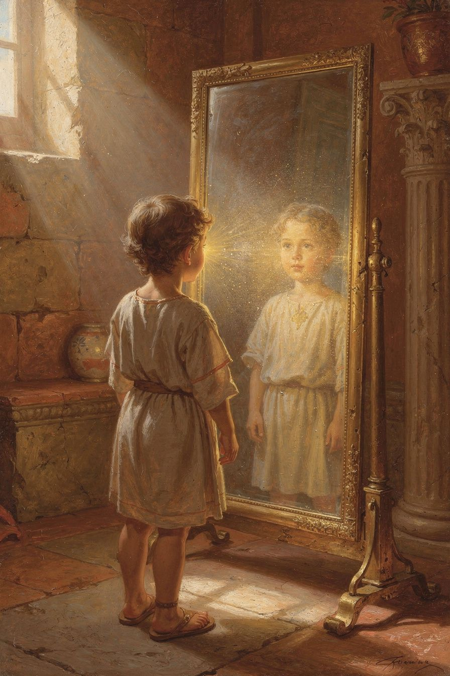
Illustration for Chapter 3
When Athanasius talked about what God wants for people, he used a beautiful picture. He said God made us to shine. We were made to reflect God's life the way a clean mirror reflects light. When God looks at us, he wants to see his own love shining back.
But sin made the mirror dirty and cracked. We could not shine anymore. We forgot whose image we bore. We started to think we were small and dark and alone. We did things that hurt ourselves and others.
Then Jesus came. Because he is God and human at the same time, he can do what no one else could do. He can make the mirror clean again. He can put his own light inside us. Athanasius said it this way: "He was made man that we might be made God." He did not mean we become gods on our own. He meant we are filled with God's life so that we can shine like him.
This happens little by little. When we pray, God's light grows. When we love someone who is hard to love, God's light grows. When we say we are sorry and try again, God's light grows. When we share our food or our time, God's light grows. When we tell the truth even when it is hard, God's light grows.
Athanasius believed that one day, when Jesus comes back, our whole bodies will shine with God's life. Even our fingers and toes will be full of light. We will not be different people. We will be the people God always meant us to be. We will shine like the moon reflects the sun, but brighter.
This is why Athanasius was not afraid to die. He knew that God's light was already inside him, and that one day it would fill him completely. He wanted every child, every grown-up, and every old person to know that God is making them shine.
Words to Remember
"He was made man that we might be made God."
Athanasius wrote that. He meant that Jesus became human so that humans could be filled with God's life.
Big Idea
God wants to fill us with his own life so that we can shine like him.
Try This
1. Draw a dirty mirror being cleaned by a bright light. Write "me" on the mirror and "God's life" on the light. 2. Think of one kind thing you can do tomorrow. Imagine it as a little spark of God's light inside you. 3. Stand in front of a real mirror and say, "God wants me to shine with his life." 4. Make a "shine chart" for one week. Every time you do something kind or brave, draw a little sun. 5. Cut out a paper sun and write five words that describe what it means to shine with God's life: kind, brave, honest, loving, hopeful. 6. Write a poem or song with the title "I Was Made to Shine." 7. Draw a picture of yourself shining like the sun, with light coming from your hands and heart.
Ask a Grown-Up
What are some ways you have seen someone "shine" with God's love?
———

Chapter 4: The Garden That Broke
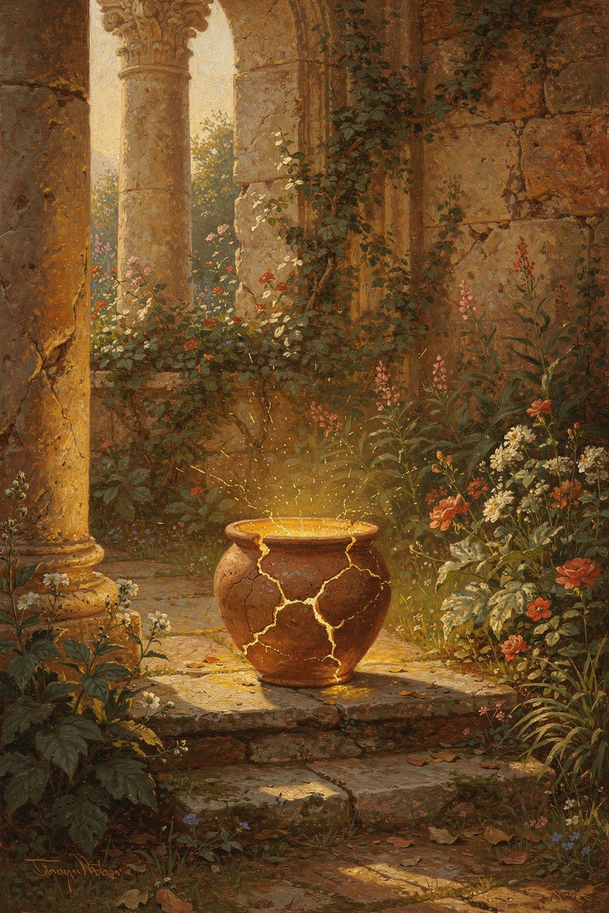
Illustration for Chapter 4
Athanasius believed the world began as a gift. God did not have to make anything. He made the world because he is generous. He made people because he wanted friends. He gave them a beautiful garden with trees, rivers, and animals. Everything was good. The sun shone. The water sparkled. The animals played. There was no sickness and no fear.
But the first people chose their own way instead of God's way. The Bible calls this sin. Athanasius explained it like this: the people turned away from the source of life, so death began to grow. It was as if a plant pulled up its own roots. Without water, it begins to wither. Without the sun, it turns brown.
The sad thing was that people could not fix themselves. They were like a broken vase trying to glue itself back together. They needed the one who had made them to heal them. That is why the King came down. He did not come to punish the broken vase. He came to make it whole again.
Athanasius wanted children to know that the world is still a gift. Our bodies are gifts. Our families are gifts. The sun, the rain, the bread on the table — all gifts. Even when things are hard, God is working to heal what is broken. The garden will bloom again.
He also wanted children to know that evil is not a superpower. Evil is not a monster with its own kingdom. Evil is what happens when good things go missing, like a shadow when light goes away. God did not make evil. Evil is the absence of the good that should be there.
So when we see brokenness in the world, we do not have to be afraid. We can ask God to heal it. We can be part of the healing, too, by loving, forgiving, and helping. Every small kindness pushes back the darkness.
Athanasius thought that when Jesus returns, the whole world will be healed. There will be no more sickness, no more sadness, and no more death. The garden will be even more beautiful than before.
Words to Remember
"God made us for incorruption, and we became corruptible."
Athanasius wrote that. He meant God made us to live forever, but sin brought death.
Big Idea
The world is a good gift from God, and God is healing what sin broke.
Try This
1. Draw a garden with something broken in it — a cracked pot, a fallen tree, or a wilting flower. Then draw Jesus in the garden, mending what is broken. 2. Make a list of three gifts God has given you: one from nature, one from people, and one from your own body. 3. Plant a seed in a cup of dirt. Water it every day. Watch it grow. Talk about how God grows new life out of small things. 4. Write "GIFT" vertically on a piece of paper. Next to each letter, write one gift from God. 5. Find something broken in your house that you can help fix: a toy, a drawer, a friendship. Ask a grown-up to help. 6. Draw a picture of light pushing back darkness. Use black crayon for the dark and bright colors for the light. 7. Make a thank-you card for God listing five gifts in your life.
Ask a Grown-Up
What does it mean to you that God is healing the world instead of throwing it away?
———

Chapter 5: The Battle Nobody Expected
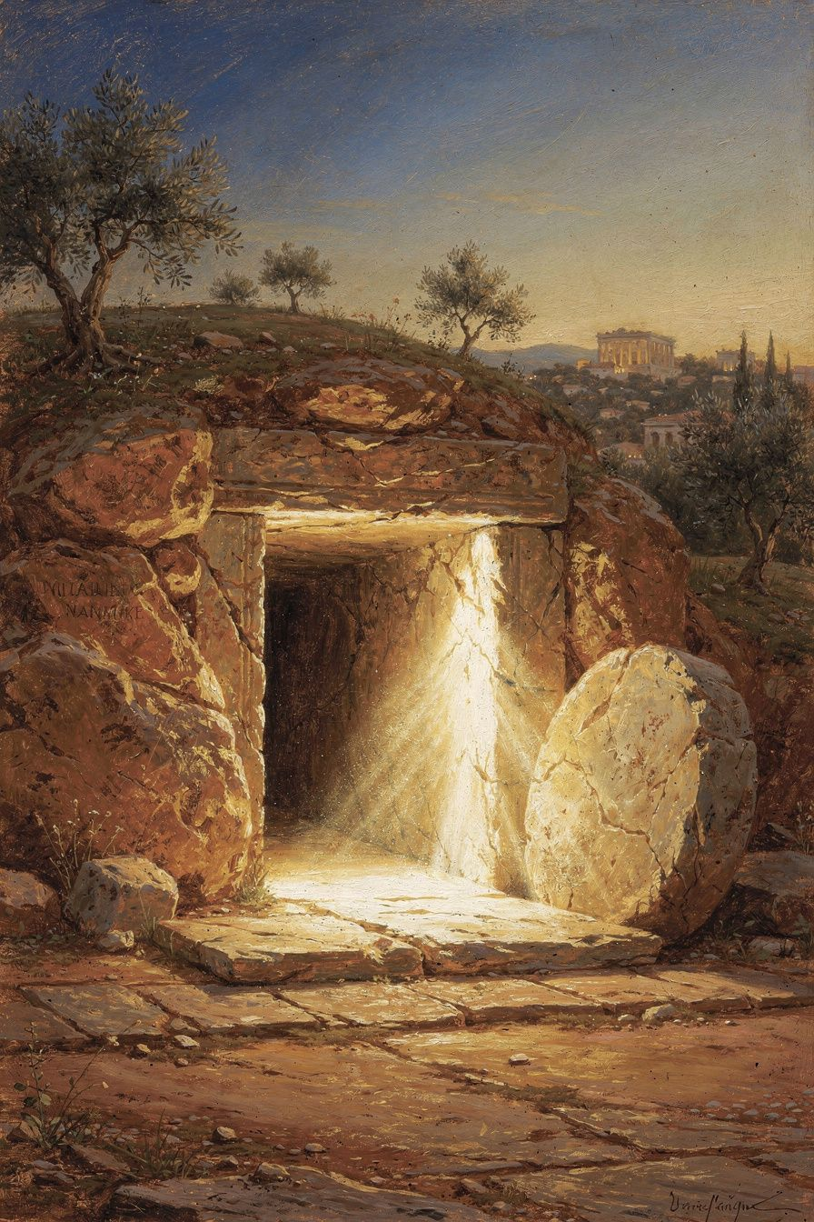
Illustration for Chapter 5
Death was the strongest enemy. It took grandparents, kings, and little children. People were afraid of it. They built tombs and wrote sad poems. They thought death always won. Even strong soldiers trembled when death came near.
But Athanasius taught that Jesus picked a fight with death — and won. It happened on a cross outside Jerusalem. Jesus, who had never sinned, was killed. His friends were heartbroken. They thought the story was over. They hid behind locked doors.
But death made a mistake. Jesus was not just a man. He was life itself wearing a human body. Death could not hold him.
On the third day, Jesus walked out of the tomb. The stone was rolled away. The grave was empty. An angel sat on the stone and told the women, "He is not here. He has risen." Jesus's friends were amazed. One of them, Thomas, even touched the scars in his hands to be sure it was really him.
Athanasius said this was like a fish trying to swallow a hook and finding the hook was too strong. The devil, who had tricked people into sin, thought he had won. But Jesus was stronger. He entered death's dark house and turned on the light.
This changed everything. People stopped being afraid. They sang songs about the empty tomb. They told the story everywhere. Athanasius himself lived without fear of death, even when emperors threatened him. He knew the enemy had already lost.
Even today, people who follow Jesus can face hard things without despair, because they know that death is not the end of the story. Easter morning proved it.
Words to Remember
"Death is the last enemy that shall be destroyed."
Athanasius taught from the Bible that death is an enemy, not a friend.
Big Idea
Jesus defeated death by rising from the tomb, so we do not have to be afraid of it anymore.
Try This
1. Draw a picture of the empty tomb with the stone rolled away. Put bright light coming from inside. 2. Write a short victory song that a child in the early church might have sung after hearing about the resurrection. 3. Ask three people in your family: "Are you afraid of death? Why or why not?" Listen to their answers. 4. Make an empty-tomb craft using a paper cup for the tomb and a stone-shaped piece of paper. Open it to show the light inside. 5. Draw a picture of Jesus as light breaking through darkness. Use yellow, white, and gold. 6. Write a letter to Jesus thanking him that death does not have the last word. 7. Make a list of three "enemies" in your life — things that scare you or feel too big. Draw Jesus standing bigger than each one.
Ask a Grown-Up
How does Jesus's resurrection change the way you face hard or scary things?
———

Chapter 6: The Helper Inside
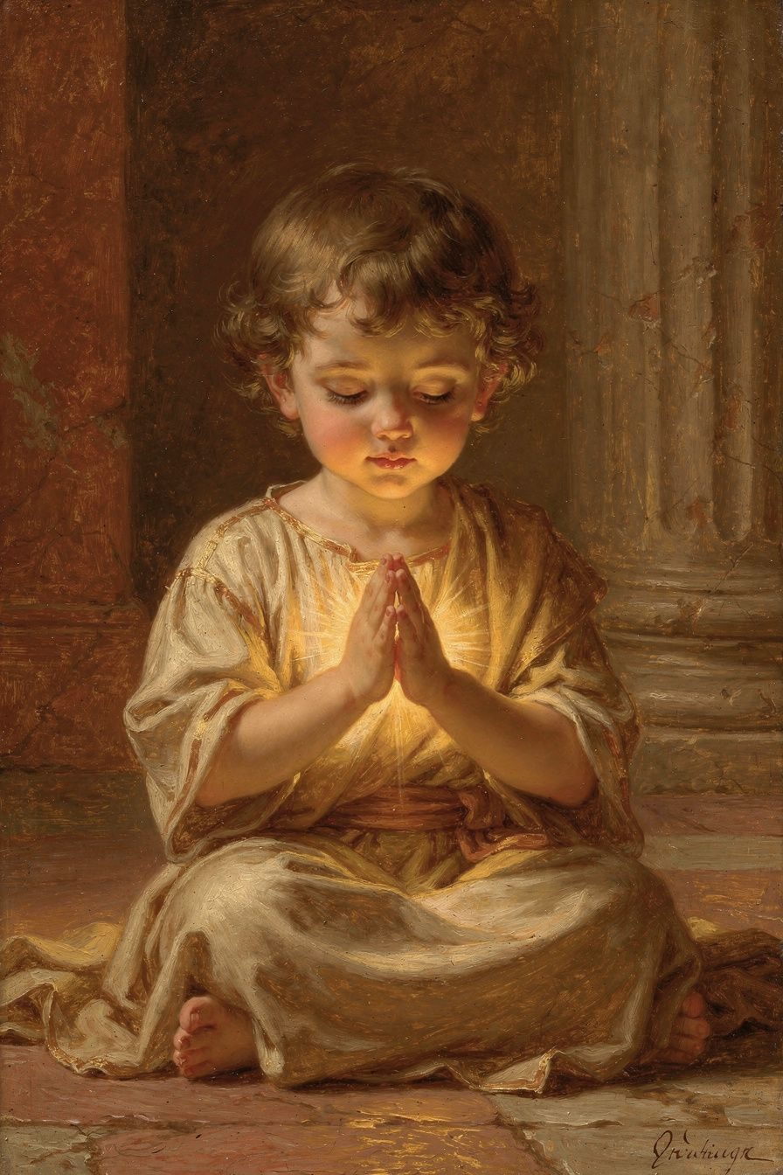
Illustration for Chapter 6
After Jesus rose from the dead, he went back to heaven. But he did not leave his people alone. He sent the Holy Spirit to live inside them. Athanasius taught that the Holy Spirit is God, too. The Spirit is the helper who makes all the other good things real.
The Spirit helps people remember what Jesus taught. The Spirit helps them love when love is hard. The Spirit joins them together as a family called the church. The Spirit gives courage when people are afraid.
Athanasius said the Spirit is like the warmth of the sun after the ray has touched you. The Father is the sun, the Son is the ray, and the Spirit is the warmth that fills everything. One sun, one light, three ways we experience it. You cannot see warmth, but you can feel it. You cannot see the Spirit, but you can feel his help.
When people are baptized, the Spirit comes to live in them. When they pray, the Spirit prays with them. When they are kind, the Spirit is at work. When they read the Bible, the Spirit helps them understand. Athanasius believed that the Spirit makes ordinary people shine with God's life.
The Spirit also gives people courage. Athanasius needed courage when emperors were angry with him. The Spirit helped him keep going. He believed the same Spirit lived in every Christian, even little ones. So even a child can be brave with the Spirit's help.
The Spirit is also the one who helps us love. When someone is mean to us, the Spirit gives us the power to be kind back. When we are sad, the Spirit comforts us. When we do not know what to pray, the Spirit prays for us. Athanasius wanted everyone to know that the Spirit is God with us, inside us, every day.
Words to Remember
"The Spirit makes us partakers of God."
Athanasius wrote that. He meant the Holy Spirit brings us into God's own life.
Big Idea
The Holy Spirit is God living inside us, helping us to love and to shine.
Try This
1. Draw a picture of a child with a warm light inside their chest. Label it "Holy Spirit." 2. Think of one hard thing you need help with today. Ask the Holy Spirit to help you in your heart. 3. Make a card for someone in your church or family. Write "God's Spirit is with you" inside. 4. Learn a simple breath prayer: breathe in "Holy Spirit," breathe out "help me love." 5. Draw a picture of a church building with many lights in the windows. Each light is a person with the Holy Spirit inside. 6. Write a short prayer asking the Holy Spirit to help you be brave like Athanasius. 7. Make a windsock or pinwheel. When it moves, remember that the Spirit is like the wind — you cannot see him, but you can see what he does.
Ask a Grown-Up
How do you know when the Holy Spirit is helping you?
———

For the Grown-Up Reader
This elementary booklet introduces Athanasius of Alexandria through six simple themes that mirror his major theological claims: the Incarnation, the Son's divine sonship, deification, creation and fall, the defeat of death, and the Holy Spirit. The language is deliberately concrete. Quotations are paraphrased from Athanasius's On the Incarnation, Orations Against the Arians, and Letters to Serapion. The goal is not to teach technical theology but to help young children see that Christianity is a story of a God who comes down to heal and raise up what he has made.
Athanasius himself believed that theological truth matters for everyone, including children. His Festal Letter 39 even lists the books of the Bible for catechumens, showing his concern for Christian formation. The activities in this booklet are designed to reinforce the central claim — Jesus is God's Son who came to rescue us — through drawing, storytelling, prayer, and action.
The chapter sequence moves from creation to Incarnation, from the Son's identity to deification, from the fall to the defeat of death, and finally to the Holy Spirit. This mirrors the structure used in the older bands so that families can read across ages together.
Athanasius's theology has sometimes been called difficult, but at its heart it is a child's truth: the King came down to find his people, the Son is one with the Father, and the Spirit helps us shine. These truths can be grown into throughout a lifetime, but they can also be believed at five years old.
If you want to go deeper, read Athanasius's On the Incarnation aloud. The first eight chapters are especially clear and are often recommended as an introduction to patristic theology. Khaled Anatolios's Athanasius: The Coherence of His Thought is the standard scholarly starting point for adults.
Reading this booklet with a child is an opportunity for the grown-up to relearn the gospel in simple language. Children often ask the questions adults are afraid to ask. Their wonder can refresh our own. Athanasius would welcome their questions, because he believed that the truth about Jesus is strong enough to bear the scrutiny of every age.
———

About WisdomForge
WisdomForge adapts one philosopher or theologian into four age-banded booklets — elementary, middle, high school, and adult — so the same ideas can grow with the reader. Each booklet has six chapters, real quotations, activities, and reflection prompts. All booklets are free.
WisdomForge is a project of SMF Works. We believe that the great ideas of philosophy and theology belong to everyone, including children. A five-year-old can begin to grasp that God came down to find us. A fifteen-year-old can learn the word homoousios. An adult can wrestle with the scholarly debates. All four readers are learning the same truth at the depth that fits them.
———
Sources: Athanasius, On the Incarnation; Orations Against the Arians; Letters to Serapion; Festal Letter 39.
Recommended for grown-ups: Khaled Anatolios, Athanasius: The Coherence of His Thought (1998); John Behr, The Nicene Faith (2004).
Adapted by: Airia Edge for WisdomForge / SMF Works.

