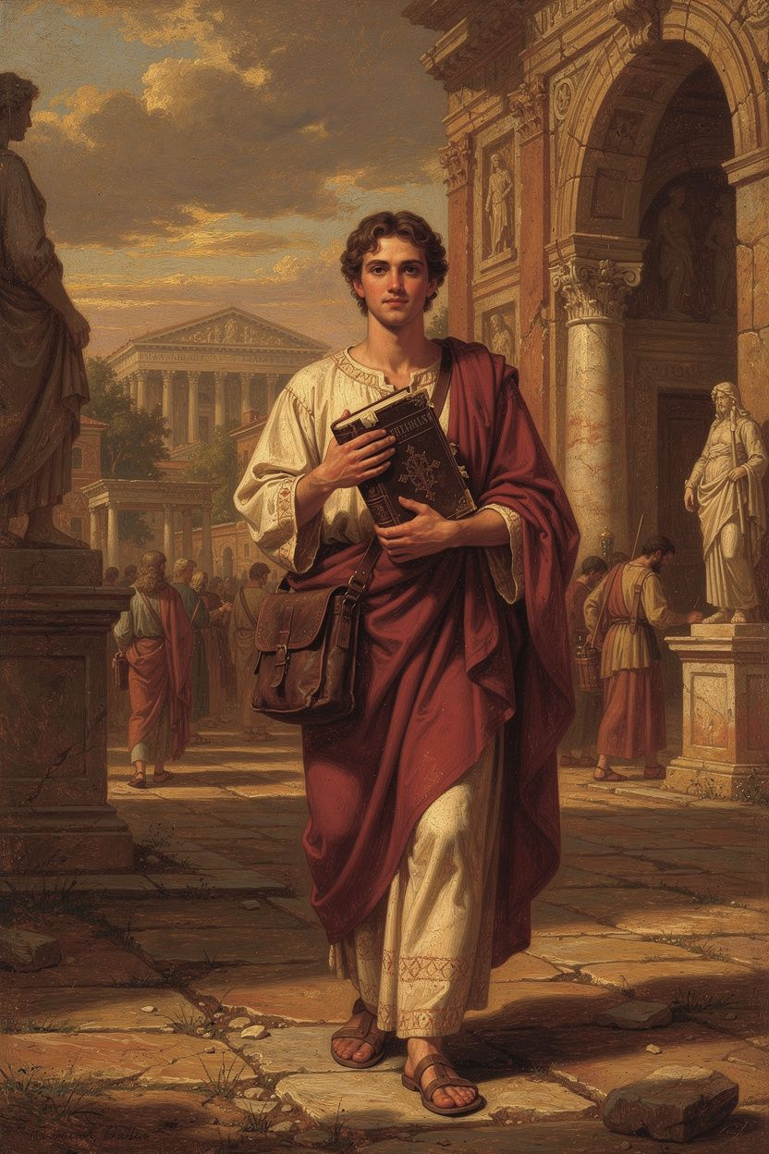
Athanasius: Theology on the Run
WisdomForge Booklet — Ages 15–18

Athanasius: Theology on the Run

WisdomForge Booklet — Ages 15–18
———

About This Book
Athanasius of Alexandria died in 373 CE after five exiles, countless intrigues, and a lifetime of arguing that the man Jesus of Nazareth is the eternal Son of God. He was not yet thirty when he helped shape the Creed of Nicaea. He spent much of his adulthood on the run, hiding in deserts, monastic cells, and the homes of allies, because emperors and church councils kept deciding that he was the problem. Yet his writings survived, and they became some of the most important documents in Christian history. This booklet is an introduction to his mind.
Why Athanasius now? For one thing, he asks the questions every sharp teenager eventually asks. Who was Jesus, really? Was he God, or just a very good person? What does the cross actually accomplish? Is salvation a legal pardon, a moral example, or something deeper? What happens to us after death? Athanasius does not answer these questions with vague sentiment. He answers with logic, Scripture, and a fierce conviction that the gospel either means something definite or it means nothing at all.
The title of this book, Theology on the Run, is meant to capture two truths. First, Athanasius literally wrote much of his theology while fleeing imperial authorities. Second, his theology itself is mobile: it moves from creation to fall, from fall to Incarnation, from Incarnation to cross and resurrection, from resurrection to the gift of the Holy Spirit, and from the Spirit to the final transformation of human beings into the likeness of God. That movement is not decorative. It is the argument.
This booklet is written for readers aged fifteen to eighteen, though anyone who wants a serious but accessible entrance into Athanasius can use it. You do not need a theology degree. You do need patience for close reasoning, because Athanasius rewards close reasoning. Each chapter opens with a substantial argument, includes real quotations from Athanasius and his sources, pauses for practice and reflection, and ends with a note about how scholars still debate the topic today.
A word about quotations. Athanasius wrote in Greek, and the English versions you will meet here come from modern translations. Where the wording in a quotation is not a literal translation of a surviving phrase, the note will say so. Where the wording is close to Athanasius's own, no apology is needed: the ideas are his.
The chapters follow a single trajectory. Chapter 1 explains the logic of the Incarnation: why Athanasius thinks only God can save. Chapter 2 turns to the Trinity and the controversial word homoousios. Chapter 3 explores the most famous line in Athanasius: "He was made man that we might be made God." Chapter 4 traces the story of creation, fall, and the restoration of incorruption. Chapter 5 focuses on the cross and the empty tomb as the victory over death. Chapter 6 asks how the Holy Spirit makes this transformation real in the life of the believer. Together they form an account of what Athanasius believed Christianity is about: the Creator enters the creation in order to bring the creation back to life.
You can use this booklet in several ways. Read it straight through as a six-chapter introduction. Dip into a single chapter before discussing a topic in class or at home. Work through the exercises with a friend, a mentor, or a study group. Treat the research prompts as invitations to read Athanasius for yourself. The goal is not to memorize a party line but to understand a way of thinking — and perhaps to discover that the ancient bishop still has something to say to the modern world.
Athanasius would have welcomed your questions. He believed that the truth about Jesus is strong enough to bear scrutiny, and he spent his life answering objections rather than silencing them. If at first his arguments feel foreign, read them again slowly. The logic is there, and it rewards patience.
———

Chapter 1: The Logic of the Incarnation
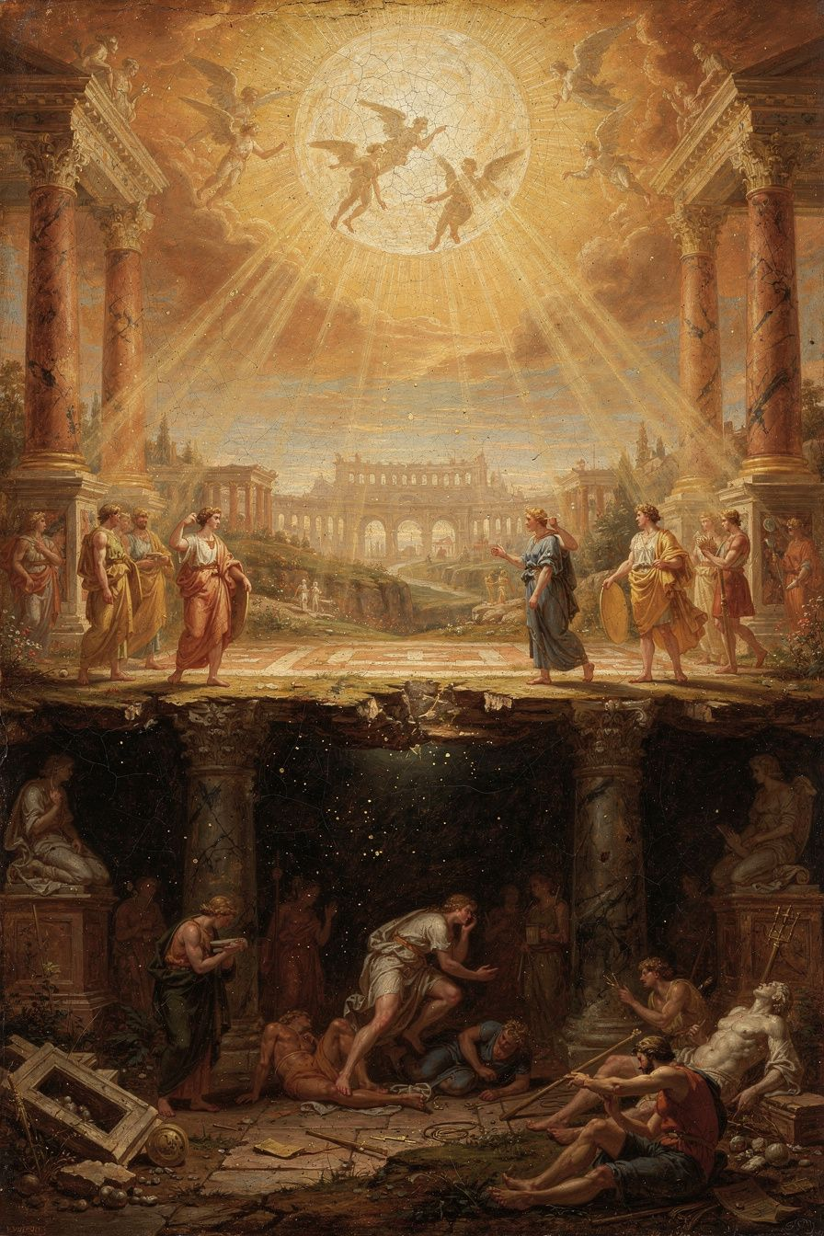
Illustration for Chapter 1
In the year 325 CE, a young deacon from Alexandria named Athanasius stood near the emperor Constantine at the Council of Nicaea and argued that the Son of God is not a creature. He is not the first thing God made. He is not a super-powered angel. He is God, of the same substance as the Father. Why did this matter so much to Athanasius? The answer is the subject of this chapter, and it begins with a question about salvation.

The Human Problem
Athanasius starts his most famous book, On the Incarnation, with creation and fall. God made human beings in his own image, which means they were made for communion with God. That communion is not optional decoration; it is the source of human life. But the first human beings turned away from God. The result was not merely guilt, though guilt is real. The result was corruption and death. Athanasius puts it bluntly: "For the transgression of the commandment was making them return to their natural state. For as they had at the beginning come into being out of non-existence, so too, by their own nature, were they moving toward non-existence." (On the Incarnation 4).
That is a heavy sentence. What does it mean? It means that created things are fragile by nature. They exist because God keeps them in existence. When they cut themselves off from God, they begin to slide back toward the nothingness from which they came. The warning in Genesis, "in the day you eat of it you shall surely die," is not an arbitrary punishment. It is the natural consequence of severing the life-source. Death, for Athanasius, is not a normal part of being human. It is an enemy that entered because of sin. The human creature is now dying from the inside out.
This is why Athanasius rejects the idea that a creature could save us. A creature cannot stop death because every creature is itself subject to death. Imagine a drowning person trying to rescue another drowning person. Both will go under. Only someone who is not drowning can save the one who is. In the same way, only the Creator — the one who is Life itself — can rescue created beings from corruption. This is the logic that drives Athanasius to the Incarnation.

The Argument Step by Step
Athanasius lays out the argument with almost mathematical clarity.
1. God created human beings for incorruption and communion with himself. 2. Human beings sinned and broke that communion. 3. The consequence was death and corruption. 4. No creature can reverse death, because every creature is finite and mortal. 5. Only the Creator, who is immortal life, can defeat death. 6. Therefore the Creator — the Word through whom all things were made — became human and entered death in order to destroy it from within.
The conclusion is dramatic. If Jesus were only a creature, however holy, he could not save us. He would be one more human being under the same sentence of death. But if Jesus is the eternal Word of God, then his death is not the death of a victim. It is the invasion of death's kingdom by Life itself. And his resurrection proves that death has been broken.

The Divine Exchange
At the climax of On the Incarnation, Athanasius states the whole argument in a single famous sentence:
"He was made man that we might be made God; and he manifested himself through a body that we might receive an idea of the invisible Father; and he endured the insults of human beings, that we might be made immortal." — *On the Incarnation* 54
This is the "divine exchange." Christ takes what belongs to us — a body, suffering, shame, death — and in return gives us what belongs to him: divine life, knowledge of God, immortality. Notice what Athanasius does not say. He does not say we become God by nature. That would erase the difference between Creator and creature. What he says is that we are made like God, filled with God's own life, restored to the communion for which we were created. The later Eastern Christian tradition will call this theosis or deification, and we will look at it closely in Chapter 3.

Why a Real Body Matters
Athanasius insists that the body of Jesus was a real human body, not an appearance or a costume. In his Letter to Epictetus, written near the end of his life, he writes:
"The Word was not changed into flesh, nor was he turned into a human being; but, as he has said, 'The Word became flesh' — not by being changed, but by taking to himself a body from the Virgin Mary." — *Letter to Epictetus* 2
This careful language matters. The Word is not transformed into something he was not. He remains fully divine while uniting himself to a fully human body. If the body were not real, the suffering would be fake, the death would be fake, and the rescue would be fake. Athanasius thinks the Arians and the various heresies of his day are trying to have Christianity without paying the price of a real Incarnation. He will not allow it.

The Cross as Victory
Athanasius understands the cross as a victory, not only as a sacrifice. Death has a kind of legal claim on humanity because humanity has sinned. The Word, who has not sinned, enters death voluntarily. Death overreaches: it takes one who has no debt to pay. In taking the innocent Life, death exhausts its own power. Athanasius writes that the Word "surrendered his body to death in place of all, and offered it to the Father. And this he did out of sheer loving-kindness, so that in his death all might die and the law of death might be abolished" (On the Incarnation 8). The law is fulfilled, and its dominion is undone, because the one who dies is also the source of life.
This is the Christus Victor theme, though Athanasius does not use that modern label. The cross is a battlefield on which the Word defeats the tyrant death. It is also a demonstration of love: God does not stand at a distance and command our rescue. He enters the danger himself.

The Resurrection as Evidence
Athanasius thinks the resurrection can be argued from the changed human attitude toward death. Before Christ, death was the great terror. After Christ, Christians face death with confidence. Athanasius points to the martyrs:
"Children who are still growing up in age mock death. They take no account of it, for thanks to Christ they despise it. ... If death were not destroyed, men would not have become so bold as to mock it." — *On the Incarnation* 28
His point is empirical as well as theological. If death were still the final winner, people would not die singing. The fact that they do means something has happened to death itself.

The Educational Purpose
There is a second reason for the Incarnation in Athanasius. Human beings had forgotten God. They worshipped idols, stars, demons, and their own imaginings. The invisible God became visible in Jesus so that human beings could learn what God is like. Athanasius compares the Incarnation to a king's image:
"He adapted himself to the capacity of the simple, showing himself in a body. ... For if a king's image is not known, the king is not known; and if the image is known, the king is." — *On the Incarnation* 13
The teaching, the miracles, the compassion, and the suffering of Jesus all reveal the Father. The Incarnation is not only rescue; it is re-education. It turns human knowledge back toward the true God.
The Big Idea. Athanasius argues that the Incarnation is necessary because only God can defeat death and restore human beings to life. The Word became flesh not by ceasing to be God but by taking a real human body. He took our death so that we might receive his life. This is the "divine exchange" at the center of the Christian gospel.
Practice
1. Read On the Incarnation 1–10 in a modern translation. Underline each step of Athanasius's argument and number them 1–6. 2. Explain Athanasius's "divine exchange" in your own words to someone who has never heard it. Use one concrete image: a rescue diver, a king's image, or a debt paid. 3. Write a one-page response to the claim: "Jesus was a great moral teacher, but not God." Use at least two arguments from this chapter. 4. List three ways Athanasius says the Incarnation changes how human beings relate to death. 5. Compare Athanasius's view of the cross with the view you have heard most often in church, music, or culture. Where do they overlap? Where do they differ?
Reflect. If Jesus were only a creature, however exalted, what happens to Athanasius's entire argument? Which step collapses first?
Scholarly debate. Modern scholars still argue about how to read Athanasius's Christology. Some, like Charles Raven in the early twentieth century, thought Athanasius's language about Christ's humanity was structurally close to Apollinarianism because he did not clearly affirm a human rational mind in Jesus. Others, like Thomas Weinandy and Khaled Anatolios, argue that Athanasius's theology as a whole implies a full human nature, even if he did not always spell it out. The development position — probably the majority view today — holds that Athanasius grew clearer about Christ's human soul in later works such as the Letter to Epictetus, but that his early focus on the body and the Word left the question underdeveloped. The debate matters because it affects how we describe what Athanasius actually believed about the man Jesus.
———

Chapter 2: Homoousios and the Identity of Christ
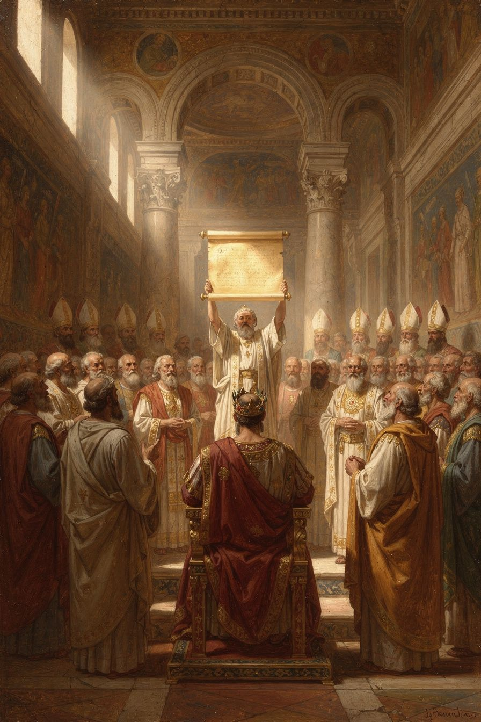
Illustration for Chapter 2
If Chapter 1 asks why the Word became flesh, Chapter 2 asks who the Word is. Athanasius's answer got him into trouble for most of his adult life. He believed, and persuaded the Council of Nicaea to confess, that the Son is homoousios with the Father: of the same substance, or the same being. That one Greek word shaped the next two centuries of Christian history.

Arius and the Question
The controversy began in Alexandria around 318 CE, when a presbyter named Arius taught that the Son of God was not eternal. Arius reportedly sang his theology in popular poems:
"There was a time when he was not." — Arius, *Thalia* (paraphrase)
The claim sounds technical, but the consequences are enormous. If there was a time when the Son did not exist, then the Son is a creature. He may be the first and greatest creature, but he is still made, not begotten. He is not God in the same sense as the Father. He is God's supreme agent, the instrument through whom the world was made, but not the Creator himself.
Athanasius saw the danger immediately. If the Son is a creature, then the one who saves us is a creature. And a creature cannot give us divine life. The whole gospel unravels. Athanasius therefore argues that the Son is not from nothing. He is not from any other substance. He is "proper to the Father's substance and the image of the Father" (Orations Against the Arians 1.21). The Father is always Father, and therefore the Son is always Son.

The Council of Nicaea
In 325 CE, Constantine called the first empire-wide council of bishops to settle the dispute. The council produced the Creed of Nicaea, which includes these decisive lines:
"We believe in one God, the Father Almighty, Maker of all things visible and invisible. And in one Lord Jesus Christ, the Son of God, begotten of the Father, only-begotten, that is, from the substance of the Father, God from God, Light from Light, true God from true God, begotten, not made, of one substance (*homoousios*) with the Father." — The Nicene Creed (325 CE)
The key word is homoousios. It means "of the same substance" or "of the same being." It says that the Son shares the very divine nature of the Father. He is not like the Father; he is not similar to the Father; he is of the same stuff, the same reality, the same Godhead as the Father. The council also attached anathemas — condemnations — for anyone who said that the Son was from nothing, or that there was a time when he was not, or that he was of a different substance from the Father.

Why the Word Was Controversial
The word homoousios had a tricky history. It had been used by some earlier theologians, but it was also associated with the philosopher Paul of Samosata, whose theology had been condemned. Some bishops feared the word was too philosophical, too bold, or too easily misunderstood. Others thought the Bible did not use such language and that the council should stick to biblical terms.
Athanasius defended the word. He argued that Nicaea was not inventing a new doctrine but gathering in one term what Scripture already taught. The point of the word was to protect the gospel. Without it, the Arians could sign any creed that did not explicitly deny the Son's full divinity, while still believing he was a creature. The word homoousios made the confession precise.

The Image of the Father
Athanasius's favorite image for the Son is the Father's image. But he is careful to say what kind of image he means. A painting of a king is an image, but it is a copy made of different materials. The Son is not that kind of image. Athanasius writes:
"For the Son is the image of the Father, not as a copy different in kind, but as a natural image which has its being from the Father and is the same as him." — *Orations Against the Arians* 1.26
The Son is the Father's own self-expression. He is not a separate thing standing alongside the Father. He is the Father's Word, the Father's radiance, the Father's offspring from his own being. That is why Athanasius can say:
"The Son is not a creature, nor a work, but he is proper to the Father's substance, and the Father's own offspring from his own being." — *De Decretis* 11
This is not a theory about a distant heavenly being. It is a claim about Jesus of Nazareth. The man who walked in Galilee, who was crucified under Pontius Pilate, and who rose on the third day, is this very Son.

The Long Struggle After Nicaea
Nicaea did not end the controversy. For decades after 325, Arian and semi-Arian parties held imperial favor, called councils, and exiled Athanasius five times. Jerome later wrote, with grim exaggeration, that "the whole world groaned and was astonished to find itself Arian" (Dialogue Against the Luciferians 19). Athanasius spent years in hiding, supported by monks in the Egyptian desert and by a network of allies across the empire.
Why did he keep fighting? Because he believed the issue was not a matter of words but of salvation. A created savior cannot save. A divine savior can. The whole structure of Christian hope depends on getting this right.

The Cappadocian Settlement
Athanasius died in 373. The final victory of the Nicene faith came a few years later, at the Council of Constantinople in 381, and it was won partly by three theologians from Cappadocia in Asia Minor: Basil of Caesarea, Gregory of Nazianzus, and Gregory of Nyssa. They solved a problem Athanasius had left unresolved.
The problem was language. Greek had one word, ousia, for both "substance" in general and the particular substance of one thing. If the Father, Son, and Holy Spirit share one ousia, does that mean they are one person? The Cappadocians clarified the vocabulary: the three share one ousia (one being, one divine nature) but exist as three hypostaseis (three persons, three individual existences). This distinction allowed the church to say both that God is one and that the Father, Son, and Spirit are three.
Gregory of Nazianzus expressed the mystery beautifully:
"No sooner do I conceive of the One than I am illumined by the splendor of the Three. No sooner do I distinguish the Three than I am carried back to the One." — Gregory of Nazianzus, *Oration* 40.41
Athanasius himself did not use the Cappadocian vocabulary. He tended to speak of the Son as "proper to the Father's substance" and to treat the Holy Spirit as sharing the same divine nature. But the Cappadocians built on his foundation. He had held the line; they completed the structure.

Why Trinitarian Language Matters
Some people today ask why Christians bother with these old debates. Athanasius would say the language matters because the gospel matters. If the Son is not truly God, then the God who saves us is not the one who entered our condition. If the Son is only a messenger, then God has not really come near. The doctrine of the Trinity is not an abstract puzzle. It is the grammar Christians use to say that God is love, that God is personal, and that God has personally entered the world in Jesus Christ.
The Big Idea. The Council of Nicaea confessed that the Son is homoousios with the Father — of the same divine substance. Athanasius defended this word because he believed that a created savior cannot save. The Son is the Father's own Word and image, not a creature, and therefore he can give us the divine life we lost in the fall.
Practice
1. Memorize the Nicene Creed. Then identify the exact phrases that rule out Arius's claim that the Son is a creature. 2. Write a short dialogue between an Arian and an Athanasian bishop at Nicaea. Each side should use at least one biblical text. 3. Explain the difference between ousia and hypostasis as Basil and the Cappadocians used them. Use a human analogy: three people sharing one human nature. 4. Read Athanasius, Orations Against the Arians 1.21 and 1.26. Summarize his argument that the Son is the Father's natural image. 5. Research the five exiles of Athanasius. Make a timeline showing where he was, who was emperor, and what theological party held power.
Research Prompt. Some modern scholars, such as Lewis Ayres and Khaled Anatolios, argue that calling Athanasius "the Nicene theologian" oversimplifies his thought. Read a short introduction by one of these scholars and summarize how they complicate the traditional picture.
Scholarly debate. Historians still argue about how central Athanasius was to the reception of Nicaea. One view, associated with R.P.C. Hanson and Lewis Ayres, holds that Nicaea was never fully forgotten; the debate was over the meaning of homoousios, not its existence. Another view emphasizes the Cappadocians as the real architects of the Nicene settlement, with Athanasius playing the role of stubborn guardian rather than systematic theologian. A third line of scholarship, represented by Timothy Barnes, stresses the political dimension: the triumph of Nicene theology was inseparable from imperial politics, the installation of friendly bishops, and the management of councils. These debates remind us that Athanasius did not win by argument alone. He won because his argument was part of a larger struggle for the future of the church.
———

Chapter 3: He Was Made Man That We Might Be Made God
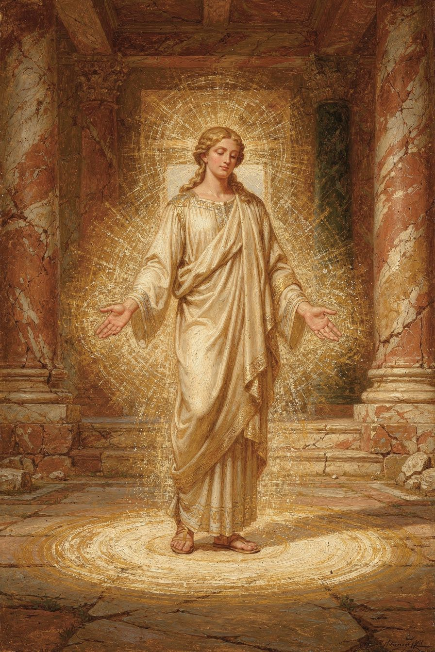
Illustration for Chapter 3
This chapter takes its title from the most famous sentence Athanasius ever wrote. It is a sentence that has startled, inspired, and misused readers for seventeen centuries. The task here is to understand what Athanasius actually meant.

What Deification Is Not
When Athanasius says "we might be made God," he does not mean that human beings cease to be creatures and become the Creator. That would be pantheism, or a kind of madness. The creature remains a creature. The finite does not swallow the infinite. Athanasius is not inviting us to become independent gods.
He also does not mean that we become divine by nature, the way the Son is divine by nature. The Son is God eternally, by generation from the Father. We are not. Our deification is by grace, by participation, by union with Christ. The difference between nature and grace is everything here.
Nor does Athanasius mean that human moral effort earns divinity. Theosis is not a reward for being very good. It is the result of God's own life flowing into those who are joined to Christ. Human beings cooperate with grace, but the life itself comes from God.

What Deification Is
For Athanasius, deification is the restoration and fulfillment of the original human vocation. Human beings were made in God's image so that they might share in God's life. Sin broke that sharing. Christ repairs it by uniting human nature to his own divine person. The result is that those who are in Christ begin to participate in the divine nature, not by becoming what God is but by receiving what God gives.
Athanasius states the logic at the beginning of On the Incarnation:
"For the Son of God became man so that we might become God through him. He, the Life of all, came in the likeness of our mortal flesh, so that he might make man alive once more through himself and free him from death." — *On the Incarnation* 7
Notice the prepositions. We become God through him. He makes us alive through himself. The life is his; we receive it by participation. The same point appears in the fuller formula:
"He was made man that we might be made God; and he manifested himself through a body that we might receive an idea of the invisible Father; and he endured the insults of human beings, that we might be made immortal." — *On the Incarnation* 54
The three clauses move together: incarnation, revelation, suffering — each producing a corresponding gift in us. The goal is not a change of nature but a change of condition. We move from corruption to incorruption, from death to life, from alienation from God to communion with God.

Participation and the Sacraments
Athanasius connects this participation to the concrete life of the church. Baptism is the doorway. In baptism, the believer is united to Christ's death and resurrection. The old life is buried; the new life rises. Athanasius also points to the Eucharist: as the bread is united to the body of the Word, so those who receive it are united to the Word. These are not magic rituals. They are the means by which the divine life is communicated to those who believe.
The key term is union. Athanasius is not primarily interested in a legal status. He is interested in a real connection between the believer and Christ. Because Christ is divine and human, he is the bridge. Those who are joined to him are joined to God.

Theosis in the Christian Tradition
Athanasius did not invent the idea of deification out of nothing. The New Testament already says that believers are "partakers of the divine nature" (2 Peter 1:4). Earlier theologians, especially Irenaeus of Lyons, had spoken of the Word becoming what we are so that we might become what he is. Irenaeus wrote:
"The Word became flesh, recapitulating in himself the long history of humanity." — Irenaeus, *Against Heresies* 3.18.1
Athanasius inherited this pattern and gave it sharper expression. Later theologians would continue it. Cyril of Alexandria, another bishop of Alexandria, defended the formula of "one incarnate nature of the Word" against Nestorius. Augustine of Hippo spoke of the restless heart that finds rest only in God. Eastern Orthodoxy would make theosis a central theme of its spirituality. The Athanasian line runs through all of them.

Deification and Modern Protestantism
Some modern Christians are nervous about the word "deification." They worry it contradicts the Protestant emphasis on justification by faith alone. But recent scholarship, especially the so-called Finnish School led by Tuomo Mannermaa, has argued that Martin Luther himself spoke of believers as united to Christ in a way that transforms them. Luther's phrase "Christ in us and we in Christ" is not far from Athanasius's "made God." The difference is largely one of vocabulary and emphasis, not of substance.
Still, there are real differences. Protestant theology usually distinguishes justification (God's declaration that the sinner is righteous) from sanctification (the Spirit's work of making the sinner holy). Athanasius does not draw that distinction in the same way. For him, salvation is one great movement from death to life, from corruption to incorruption, from estrangement to communion. Whether we call that "justification" or "deification" depends on which aspect we want to emphasize.

The Difference Between Grace and Nature
The most important distinction in this chapter is between nature and grace. By nature, only the Son is God. By grace, believers share in the Son's life. Athanasius sometimes uses the language of "flesh of the Spirit" or "made spiritual" to describe this transition. The human being does not stop being human. The human being becomes a human being filled with the Holy Spirit, conformed to the image of Christ, destined for resurrection and glory.
This is why theosis is not arrogance. It is humility on the other side of grace. The creature receives what it could never earn, and the proper response is wonder, gratitude, and worship.
The Big Idea. When Athanasius says "He was made man that we might be made God," he means that through union with Christ, human beings participate in the divine life by grace. We do not become divine by nature; we are restored to the communion with God for which we were created, and we are transformed from corruption to incorruption.
Practice
1. Write out Athanasius's sentence from On the Incarnation 54 and underline every preposition that shows how the gift comes to us "through" Christ. 2. Compare 2 Peter 1:4 ("partakers of the divine nature") with Athanasius's language. What do they share? Where do they differ? 3. Explain the difference between nature and grace in theosis to a friend who thinks "made God" means becoming a god. 4. Read a short passage from Irenaeus's Against Heresies 3.18–19. How does his "recapitulation" theme prepare the way for Athanasius? 5. Write a journal entry reflecting on one area of your life where you need to be "made alive" rather than merely forgiven.
Reflect. Is deification a helpful word today, or does it cause more confusion than clarity? If you had to translate Athanasius's sentence for a modern audience, what phrase would you use?
Scholarly debate. The meaning and centrality of theosis in Athanasius are hotly debated. Some scholars argue that the word "deification" is rare in Athanasius and that his real emphasis falls on participation in Christ rather than on becoming divine. The Finnish School of Luther research has reopened the question of whether Protestant theology can accommodate theosis, with some saying yes and others seeing it as a confusion of justification and sanctification. Meanwhile, Eastern Orthodox scholars tend to place theosis at the center of Athanasius's vision, while Western scholars sometimes treat it as one theme among many. The debate is not merely academic: it shapes how different churches speak about salvation, holiness, and the goal of the Christian life.
———

Chapter 4: Created for Incorruption
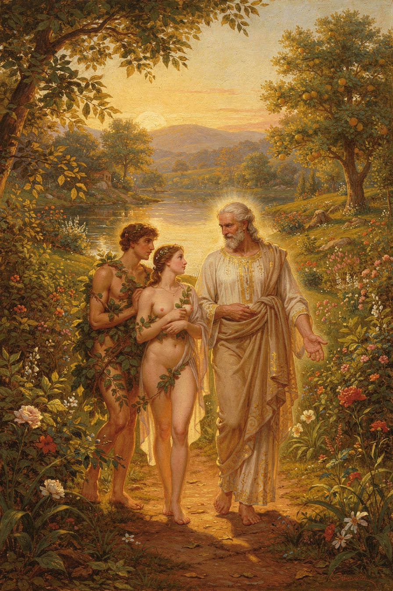
Illustration for Chapter 4
Athanasius does not begin the Christian story with the cross. He begins with creation. To understand why the Word became flesh, we have to understand what human beings were made for. This chapter tells that story: creation, fall, and the restoration of incorruption.

Creation from Nothing
Athanasius teaches that God created the world from nothing, not by shaping pre-existing matter. This matters because it means everything depends on God. Nothing exists by its own power. The universe is not a machine that God wound up and left alone. It is a gift held in existence moment by moment by the Creator's will.
God created, Athanasius says, not because he needed anything, but because he is good. "For God is good — or rather, of all goodness he is the source. ... Being good, then, he created them from nothing and made them. For he was not moved by any necessity to create them, but by his own goodness" (On the Incarnation 3). Creation is an act of generosity. It is God overflowing with life and inviting other beings to share in it.

The Crown of Creation
Human beings occupy a special place. They are made in the image of God, which means they have the capacity for knowledge of God and communion with God. They are also body-soul unities. Athanasius is not a Platonist who despises the body. He believes the body is good, created by God, and destined for resurrection. The human being is a microcosm: a creature that sums up the visible and invisible worlds, able to know God and to rule the creation.
Athanasius also says that human beings were created for incorruption. "God made humanity for incorruption, and as an image of his own eternity" (On the Incarnation 4–5). Death was not part of the original design. It entered because of sin.

The Fall and Its Consequences
The fall, for Athanasius, is not just a story about eating forbidden fruit. It is the moment when human beings turned away from the source of their life. The result was not merely guilt or shame, though those are real. The result was a slide back toward non-existence. Athanasius writes:
"For the transgression of the commandment was making them return to their natural state. For as they had at the beginning come into being out of non-existence, so too, by their own nature, were they moving toward non-existence." — *On the Incarnation* 4
This is strong language. It means that without God, the human creature is dissolving. The image of God is not erased — Athanasius insists it remains, though dimmed — but the life-giving connection is broken. The human being begins to die, body and soul, from the inside out. Death is not a punishment imposed from outside; it is the natural consequence of cutting oneself off from Life.

Death as the Enemy
Athanasius calls death an enemy. It entered through the devil's envy. The devil, seeing human beings honored with the image of God, tempted them to rebel. When they rebelled, death seized its opportunity. From that moment, death ruled over humanity. It was feared, mourned, and worshipped in some cultures. It was the great dark fact behind every human life.
But death is not natural. It is contrary to nature. The human being was made for life, for communion, for incorruption. Death is an invader. And because it is an invader, it can be driven out.

The Restoration of Incorruption
How does God respond? He does not abandon the creature. Athanasius says that God would have been within his rights to let humanity dissolve. The creature rebelled; the creature reaps the consequence. But God is merciful. And God is also wise. He solves the problem in a way that preserves both justice and mercy.
The Word becomes flesh. He takes a body that is subject to death. He enters death. And because he is Life, he destroys death from within. He restores the human nature he assumed, raising it from death and clothing it with incorruption. What happens to Christ's body is a promise of what will happen to the bodies of all who are united to him.
Athanasius puts it this way: "By the offering of his own body, he both satisfied the law of death and undid the devil's dominion" (On the Incarnation 20). The law of death is fulfilled because a sinless life is offered; the dominion of death is undone because the one who dies cannot be held by it.

The Permanence of the Incarnation
One common misunderstanding is that the Incarnation was a temporary measure. Jesus came, fixed the problem, and then returned to heaven without a body. Athanasius rejects this. The body the Word took is not discarded. It is raised, glorified, and remains his forever. The Incarnation is permanent. The Son of God is now and forever the Son of Man. That is why Athanasius can say that the risen body of Jesus is the first installment of a new creation.
This has implications for how we think about the material world. Matter is not a prison from which we must escape. The body is not a temporary container for the soul. Creation is good, and its redemption includes bodies, communities, and the whole material order. Athanasius's theology is deeply hopeful about the physical world because the Word became physical flesh and will not let it go.

The Human Vocation Restored
The goal of salvation, then, is not escape from the world. It is the restoration of the human vocation. Human beings were made to know God, to love God, to reflect God's wisdom and goodness into the creation, and to be filled with divine life. Sin interrupted that vocation. Christ restores it. The Spirit continues it. The resurrection completes it.
This means ethics is not arbitrary. The moral life is the life that fits the human being's true nature. To love God, to love neighbor, to practice justice, to care for the body, to pursue truth — these are not extraneous rules. They are the shape of life for creatures made in God's image and redeemed by Christ.

The Hope of the New Creation
Athanasius's vision does not end with individual souls going to heaven. It ends with the renewal of all things. Because the Word united himself to the material world, the material world is included in his redemption. The resurrection of Jesus is the first sign of a new creation in which death, corruption, and sin will be abolished. The bodies of believers will rise. The earth will be renewed. The whole cosmos will reflect the glory of God.
This is why Athanasius cares so much about the reality of Christ's body. If the body is an illusion or a temporary shell, then the redemption of creation is also an illusion. But if the body is real and destined for glory, then nothing in God's good creation is beyond hope. The arts, sciences, friendships, cultures, and ecosystems that human beings build and steward are not disposable distractions. They are part of the world God made and will redeem.
The Big Idea. Human beings were created from nothing, in God's image, for incorruption and communion with God. Sin broke that communion and introduced death. The Word became flesh to restore human nature from corruption to incorruption, and the redemption includes the body as well as the soul.
Practice
1. Read On the Incarnation 3–5 slowly. Draw a diagram showing the movement from creation to fall to restoration. 2. Write a paragraph explaining why death is "contrary to nature" for Athanasius, not part of the original design. 3. List three ways Athanasius's view of creation differs from the view that matter is evil or that the body is a prison. 4. Explain the difference between a "temporary Incarnation" and Athanasius's view that the Incarnation is permanent. 5. Imagine you are talking to a friend who fears death. Use at least one quotation from Athanasius in this chapter to offer hope.
Research Prompt. How do modern theologians talk about the "new creation" and the resurrection of the body? Find one contemporary theological statement on bodily resurrection and compare it with Athanasius's view.
Scholarly debate. Scholars debate how to read Athanasius's anthropology, especially his understanding of the soul and the body. Some interpreters, influenced by Platonism, find in Athanasius a sharp dualism between soul and body. Others, such as Khaled Anatolios, argue that Athanasius's emphasis falls on the body-soul unity and on the whole human being's need for redemption. The debate affects how we understand his doctrine of the Incarnation. If Christ saves only the soul, the body is secondary. If Christ saves the whole human being, then the body is central, and the resurrection of the body becomes essential to the gospel. Athanasius's insistence on the real, risen body suggests the latter reading is closer to his intention.
———

Chapter 5: Christus Victor and the Empty Tomb
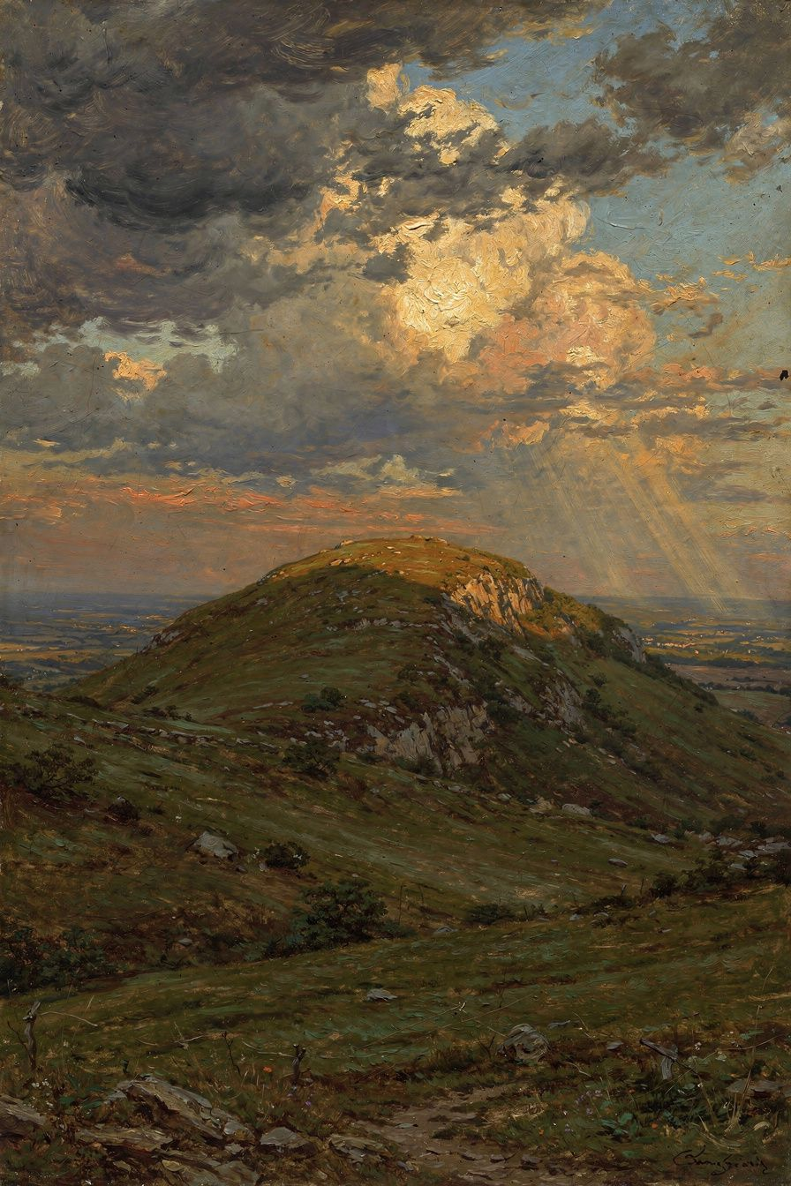
Illustration for Chapter 5
The cross is the center of the Christian story, but it is easy to misunderstand. Some see it only as a moral example: Jesus died to show us how to love. Others see it as a legal transaction: God punished Jesus in our place. Athanasius offers a different picture. He sees the cross as a victory over death, the devil, and the law of corruption. This chapter explores that vision.

The Cross as Victory
For Athanasius, the cross is first of all a battlefield. The tyrant death has held humanity captive. The Word enters death's territory, not because he owes death anything, but in order to break its power. Athanasius writes that the Word "surrendered his body to death in place of all, and offered it to the Father. And this he did out of sheer loving-kindness, so that in his death all might die and the law of death might be abolished" (On the Incarnation 8).
The image is not of a distant king paying a fine. It is of a king entering the enemy's fortress, allowing himself to be captured, and then proving that the fortress cannot hold him. Death thinks it has swallowed Life. Instead, Life swallows death. Athanasius puts it starkly: "By the offering of his own body, he both satisfied the law of death and undid the devil's dominion" (On the Incarnation 20).

Justice and Mercy Together
Athanasius does not ignore the justice of God. The law of death is just. Human beings sinned; they earned corruption. God could have let the law run its course. But God is also merciful. The Word offers his own sinless life in place of guilty lives. In doing so, he satisfies the law and simultaneously empties it of its power. The law is fulfilled, not abolished by decree. And mercy triumphs because the one who fulfills the law is also the one who rises from its grasp.
This is why Athanasius rejects cheap grace. Salvation is free to us, but it is not cheap. It cost the Word his body and his blood. The cross is a gift, but it is a gift bought at the highest price.

The Resurrection as Proof and Power
The resurrection is not an afterthought. It is the proof that the cross worked. If Jesus had remained dead, the cross would be a tragedy. His rising shows that death has been defeated, not merely endured. Athanasius argues from the changed behavior of Christians. Martyrs face death with joy. Ordinary believers no longer live in terror of the grave. Athanasius writes:
"Children who are still growing up in age mock death. They take no account of it, for thanks to Christ they despise it. ... If death were not destroyed, men would not have become so bold as to mock it." — *On the Incarnation* 28
The argument is both theological and observational. The resurrection produces a new kind of human being: one who can look death in the face and not flinch, because death has already been swallowed by Life.

Athanasius's Own Courage
Athanasius did not write about courage from an armchair. He lived it. He was exiled five times, pursued by imperial soldiers, slandered by enemies, and condemned by councils. The traditional saying about him was "Athanasius contra mundum" — Athanasius against the world. He once wrote, in spirit if not exactly these words, that he would rather suffer anything than let the truth be suppressed.
His courage was rooted in his theology. If death is defeated, then the worst thing anyone can do to you is not the last thing. Exile, poverty, ridicule, and even execution lose their final power when the tomb is empty. Athanasius faced the powers of his age not because he was naturally fearless but because he believed the resurrection had already decided the outcome.

The Connection to the Martyrs
The martyr tradition runs through Athanasius's thought. In his account, the martyrs are living evidence that death is no longer master. They go to their deaths not grimly but triumphantly, because they have already died with Christ in baptism and risen with him in faith. Athanasius connects their courage to the cross: "The martyrs show that death is no longer to be feared. ... They who speak of death as a great thing are refuted by those who despise it" (On the Incarnation 28, paraphrase).
This does not mean suffering is easy or desirable. Athanasius knew it was brutal. But it does mean suffering is not meaningless. The cross transforms the meaning of suffering because it transforms the meaning of death.

The Empty Tomb and History
Athanasius treats the resurrection as a historical event, not a myth or a symbol. The tomb was empty. The body that rose was the body that died. The disciples saw, touched, and ate with the risen Lord. This matters because the gospel is not a philosophy about timeless truths. It is a claim about something that happened in first-century Palestine. If the tomb is not empty, the argument of Athanasius collapses.
At the same time, Athanasius knows the resurrection is not a raw historical fact that proves itself. It requires faith, because faith is the eye that sees the hand of God in the event. The empty tomb is evidence; the Spirit gives the interpretation.

The Shape of Christian Hope
Christian hope, for Athanasius, is not the hope that things will get better in this life. It is the hope that death and corruption have been defeated and will finally be abolished. This hope gives patience in suffering, courage in persecution, and joy in the face of loss. It is not optimism. It is confidence rooted in the resurrection of Christ.

Living from the Empty Tomb
The empty tomb is not merely a past event to believe. It is a present power to live by. Athanasius thinks that Christians who understand the resurrection will face their daily struggles differently. Fear of death loses its grip. The need for status, pleasure, and self-protection loses its urgency. The love of God, made visible in the cross, becomes the motive for action.
This does not make Christians reckless or detached. It makes them free. They can serve others, tell the truth, forgive enemies, and endure hardship because the worst possible outcome has already been defeated. The resurrection turns every loss into a temporary interruption and every act of love into an investment in the coming kingdom. The tomb is empty, and the world has not yet absorbed what that means.
The Big Idea. Athanasius sees the cross as the victory of Life over death and the empty tomb as the proof that the victory is real. The resurrection changes the meaning of death, giving Christians courage to face suffering and persecution because the worst enemy has already been defeated.
Practice
1. Read On the Incarnation 20, 27–28. Identify at least three images Athanasius uses to describe the cross and resurrection. 2. Write a short meditation on the statement: "The cross is a battlefield, not just a payment." 3. Research one Christian martyr from any century. How does their death illustrate Athanasius's claim that death has been defeated? 4. Compare Athanasius's Christus Victor view with a penal substitution view of the atonement. What does each emphasize? What might each miss? 5. Memorize On the Incarnation 28 and use it as a prayer when facing fear or loss.
Reflect. Where in your own life do you most need the truth that death is not the last word?
Scholarly debate. The meaning of the atonement in Athanasius has been debated for centuries. The Christus Victor reading, emphasized by Gustaf Aulén in the twentieth century, sees Athanasius as a classic proponent of the view that Christ defeats the powers of evil and death. Other scholars note that Athanasius also uses juridical and sacrificial language, so his atonement theology is richer than any single label. Modern debates about penal substitution often ask whether Athanasius anticipates that view. Most scholars answer that he does not, at least not in the developed form found in later Protestant theology. The lesson is that Athanasius's cross is many-dimensional: it is victory, sacrifice, justice, and love, all at once.
———

Chapter 6: The Spirit Who Makes It Real
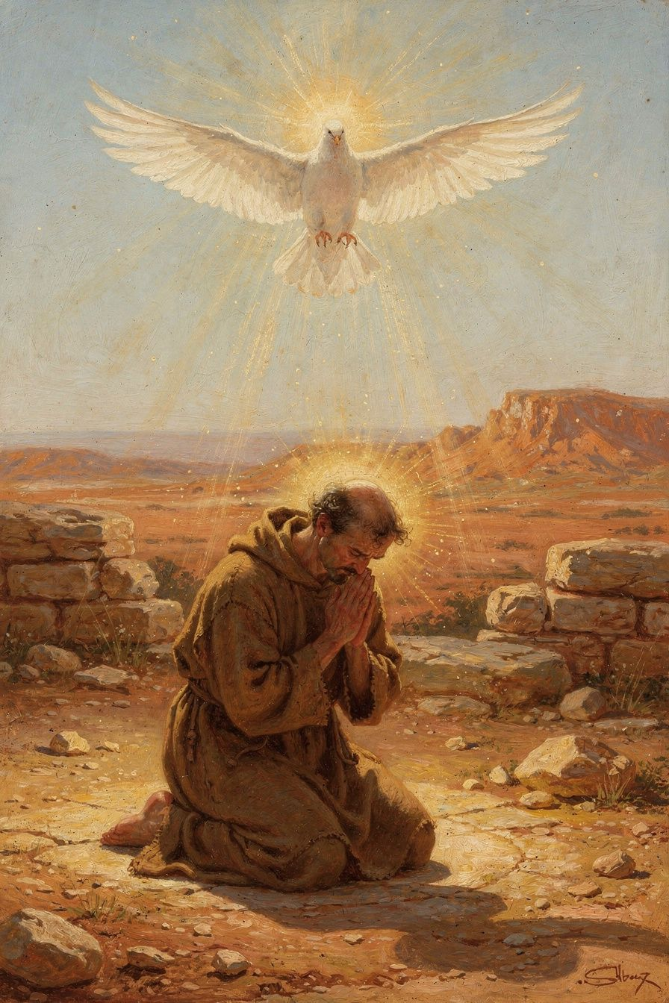
Illustration for Chapter 6
Athanasius's theology does not stop with the cross and the empty tomb. It continues with the Holy Spirit. If the Son rescues us from death, the Spirit makes that rescue real in our minds, hearts, and communities. This final chapter asks how the Spirit works according to Athanasius and why the Spirit's divinity matters as much as the Son's.

The Tropici and the New Controversy
After the Council of Nicaea, a new group of opponents arose. They were called the Tropici, and they denied the full divinity of the Holy Spirit. They said the Spirit was a creature, an angelic being, perhaps the highest of God's servants, but not God. Athanasius responded with a series of letters to a bishop named Serapion. These Letters to Serapion are the most important early treatise on the Holy Spirit.
Athanasius's argument against the Tropici is simple and devastating. If the Spirit is a creature, then our union with God is union with a creature. A creature cannot make us partakers of God. Only God can deify. Athanasius writes:
"If the Spirit were a creature, we would have no participation in God through him. We would be united to a creature, not to God. But if the Spirit makes us partakers of God, then the Spirit is of the divine nature." — *Letters to Serapion* 1.24 (paraphrase of Athanasius's argument)
The logic is the same as the argument against Arius. If the Spirit saves, the Spirit must be God. If the Spirit is a creature, our salvation is an illusion.

The Spirit's Identity
Athanasius is clear about who the Spirit is:
"For the Holy Spirit is not a creature, nor a work, but he is proper to the Son and partakes of the same nature as the Son." — *Letters to Serapion* 1.27
The Spirit belongs to the Son in the same way the Son belongs to the Father. The Spirit is not a stranger introduced into the Trinity. He is the bond of unity between the Father and the Son, and the one who unites believers to Christ. Where the Son is the Word, the Spirit is the one who makes the Word alive in us.

The Trinity at Work
Athanasius emphasizes that the works of the Trinity are undivided. The Father works through the Son in the Spirit. The Son works from the Father in the Spirit. The Spirit works from the Father through the Son. You cannot separate their action, even though you distinguish the persons. This is why Athanasius can say that the activity of the Spirit is not separate from the Son: "For the Trinity is one, and its activity is one" (Letters to Serapion 1.30, paraphrase).
This has practical consequences. When Christians pray, they pray to the Father, through the Son, in the Spirit. When they are baptized, they are baptized into the name of the Father, Son, and Holy Spirit. When they worship, they worship one God in three persons. The Trinity is not a puzzle to solve before you can be a Christian. It is the shape of the Christian life.

Scripture as a Unified Story
Athanasius also has a distinctive approach to reading the Bible. He rejects the Arian method of pulling proof-texts out of context. Instead, he looks for the skopos — the target or goal — of Scripture. The whole Bible, he believes, tells one story: the story of God's rescue of humanity through the Incarnation, death, and resurrection of the Word. Every part of Scripture must be read in light of that center.
This means the Old Testament is not a failed first attempt. It is preparation. The Law, the prophets, and the wisdom literature all point forward to Christ. The New Testament is not a replacement but the fulfillment. Athanasius's method is Christ-centered, narrative, and theological. It is the opposite of treating the Bible as a collection of disconnected rules.

Prayer and the Monastic Example
The Life of Antony, which Athanasius wrote or supervised, shows what the Spirit-filled life looks like in practice. Antony, a wealthy young Egyptian, heard the Gospel call to sell what he had and give to the poor. He went into the desert and spent decades in prayer, fasting, and combat with demonic temptation. Athanasius presents him not as a superhuman but as an ordinary man made extraordinary by faith and the Spirit.
One famous scene shows Antony's freedom from worldly power. When the emperor Constantius wrote to him, Antony reportedly replied:
"I have received a letter from my Lord, the King of heaven. What does the emperor of the earth want with me?" — *Life of Antony* 81 (paraphrase)
The line is startling. It is not political rebellion. It is a statement of ultimate allegiance. Antony respects earthly authority, but his loyalty belongs to Christ. The Spirit has reordered his loves.

The Spirit and the Church
For Athanasius, the Spirit is the one who makes the church the church. The church is not a human organization that happens to believe certain things. It is the community in which the Spirit is at work, baptizing, teaching, sanctifying, and uniting believers to Christ. The church's authority comes from the Spirit, and the church's unity is a sign of the Spirit's presence.
This is why Athanasius fought so hard for the Nicene faith. The church must speak truly about God because the church is the place where the Spirit teaches the truth about God. To deny the full divinity of the Son or the Spirit is not merely to get a doctrine wrong. It is to misidentify the God who is saving us.

The Journey to Glory
The Christian life, in Athanasius's view, is a journey from corruption to incorruption, from death to life, from estrangement to communion. The Word has opened the way by his Incarnation and resurrection. The Spirit walks with us on that way, transforming us by degrees into the image of Christ. The goal is not merely escape from hell or acceptance into heaven. The goal is theosis — participation in the life of the Trinity.
Athanasius never suggests that this journey is easy. It involves repentance, struggle, suffering, and patience. But it is also joyful, because the one who walks with us is the Lord of life, and the destination is glory.
The Big Idea. The Holy Spirit is God, not a creature, because only God can make human beings partakers of the divine life. The Spirit applies the work of Christ to believers, unites them to Christ, and transforms them into his likeness. The Christian life is therefore Trinitarian from beginning to end.
Practice
1. Read Letters to Serapion 1.24 and 1.27. Write out Athanasius's argument that the Spirit must be divine. 2. Practice praying the Trinitarian formula: "Father, Son, and Holy Spirit." Use it at the beginning and end of each day for one week. Journal what you notice. 3. Choose one Gospel story. Read it three times, each time asking: How does this story fit the central story of God's rescue through Christ? 4. Read a short section of the Life of Antony. What does Athanasius think the Spirit does in a person's daily life? 5. Explain to a friend why Athanasius believed that getting the doctrine of the Holy Spirit right is not optional.
Research Prompt. Some scholars question whether Athanasius himself wrote the Life of Antony. Read the arguments on both sides and write a one-page opinion with evidence.
Scholarly debate. The authorship of the Life of Antony remains one of the liveliest debates in Athanasius scholarship. The ancient tradition, including Gregory of Nazianzus, attributes the work to Athanasius, and defenders such as T.D. Barnes and Khaled Anatolios argue that the cumulative evidence supports the traditional view. Challengers, including G.J.M. Bartelink and Samuel Rubenson, point to stylistic and theological differences and suggest the work may have been composed by a close associate or disciple. A moderate position, held by scholars like Philip Rousseau, proposes that Athanasius provided the material and oversight while someone else polished the final text. The debate matters because it affects how much we can treat the Life of Antony as a direct window into Athanasius's own piety and priorities.
———

For the Grown-Up Reader
This booklet is written for high-school readers, but adults who want a brisk re-introduction to Athanasius can use it too. The chapters cover the heart of his theology: the logic of the Incarnation, the defense of Nicaea, theosis, creation and fall, the victory of the cross, and the work of the Holy Spirit. Each chapter also signals where modern scholars disagree.
If you want to go deeper, the best starting point is Athanasius's own On the Incarnation, available in several modern translations. The translation by John Behr in the Popular Patristics Series is particularly helpful. From there, move to the Orations Against the Arians and the Letters to Serapion. Khaled Anatolios's Athanasius: The Coherence of His Thought and Thomas Weinandy's Athanasius: A Theological Introduction are excellent secondary guides. For historical context, Timothy Barnes's Athanasius and Constantius is indispensable, though demanding.
The payoff for this reading is a sharper sense of why Christian doctrine is not a set of abstract puzzles but a grammar for speaking about salvation. Athanasius wrote in crisis, on the run, and often in anger. But his anger was the anger of a man who had seen what was at stake. He believed that if the church got Jesus wrong, it would lose the gospel itself. History suggests he was right.
One caution for adult readers: do not read Athanasius as though he were a modern systematic theologian writing in footnotes. He is a polemical churchman, a pastor, and a biblical interpreter. His arguments are often dense, but their density serves a purpose. He is trying to save what he believes is the only hope of the world. Reading him sympathetically does not require agreeing with every conclusion. It requires understanding why he thought the stakes were so high, and why he was willing to endure exile after exile rather than compromise.
High-school readers who finish this booklet are well prepared to read Athanasius in translation and to follow the scholarly debates about his legacy.
———

About WisdomForge
WisdomForge produces booklets that introduce great thinkers of the Christian tradition to readers of different ages. Each booklet combines accurate scholarship, engaging narrative, and practical exercises. The goal is not merely to inform but to form: to help readers think more clearly, live more faithfully, and love more deeply.
———

Sources
Primary Texts by Athanasius - Athanasius, On the Incarnation (De Incarnatione Verbi), esp. chapters 1–10, 13, 20, 28, 54. Trans. John Behr, Popular Patristics Series (SVS Press, 2011). - Athanasius, Orations Against the Arians (Contra Arianos), esp. 1.21, 1.26. Trans. John Behr, The Nicene Faith (SVS Press, 2004). - Athanasius, De Decretis (On the Decrees of Nicaea), esp. 11. - Athanasius, Letters to Serapion (Epistulae ad Serapionem), esp. 1.24, 1.27. - Athanasius, Letter to Epictetus (Epistula ad Epictetum), esp. 2. - Athanasius, Life of Antony (Vita Antonii), esp. 81.
Other Primary Sources - Arius, Thalia (surviving fragments, paraphrase in Athanasius and others). - Council of Nicaea, Creed and Anathemas (325 CE). - Irenaeus of Lyons, Against Heresies (Adversus Haereses), esp. 3.18.1. - Augustine of Hippo, Confessions 1.1. - Gregory of Nazianzus, Oration 40.41. - Jerome, Dialogue Against the Luciferians 19.
Secondary Scholarship - Anatolios, Khaled. Athanasius: The Coherence of His Thought. T&T Clark, 1998. - Ayres, Lewis. Nicaea and Its Legacy: An Approach to Fourth-Century Trinitarian Theology. Oxford, 2004. - Barnes, Timothy D. Athanasius and Constantius: Theology and Politics in the Constantinian Empire. Harvard, 1993. - Behr, John. The Nicene Faith. SVS Press, 2004. - Hanson, R.P.C. The Search for the Christian Doctrine of God: The Arian Controversy, 318–381. T&T Clark, 1988. - Weinandy, Thomas G. Athanasius: A Theological Introduction. Ashgate, 2007. - Young, Frances M. From Nicaea to Chalcedon. 2nd ed. Baker Academic, 2010.

