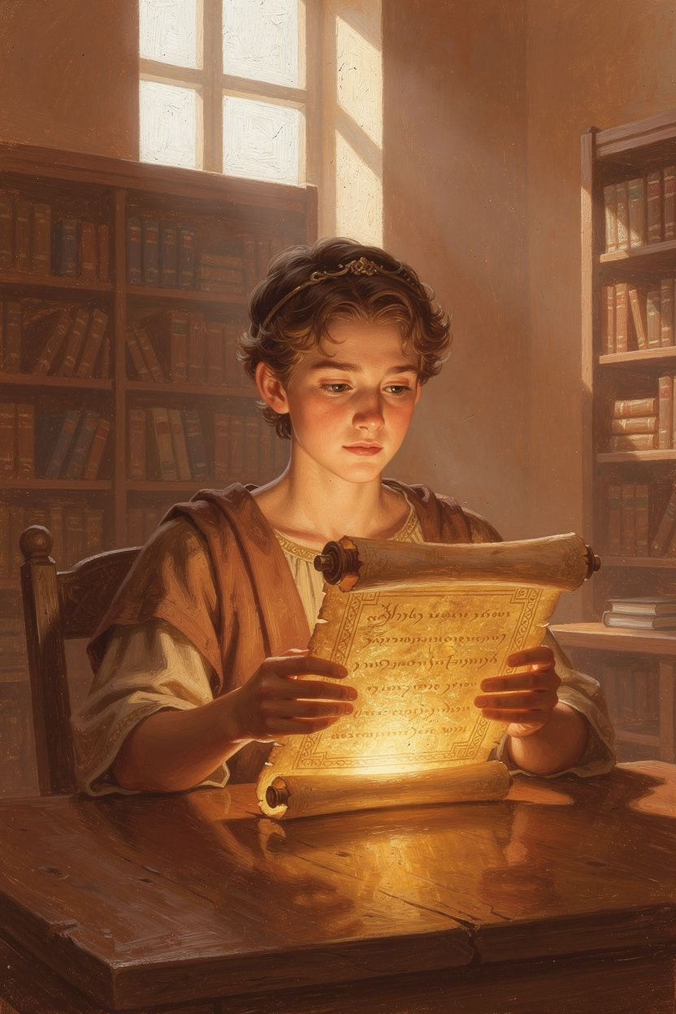
Athanasius and the Battle for the Real Jesus
WisdomForge Booklet — Ages 11–14

Athanasius and the Battle for the Real Jesus

WisdomForge Booklet — Ages 11–14
———

About This Book
Imagine that the most important truth you know is suddenly called into question. Your teachers, your government, and even some religious leaders start saying that Jesus was a created being—a very powerful angel or prophet, but not truly God. They use Bible verses to support their claim. They have money, soldiers, and political power on their side. You are one person with a library, a pen, and a conviction. What do you do?
This is the story of Athanasius of Alexandria, a fourth-century Christian bishop who spent most of his life defending the belief that Jesus Christ is truly God. He argued that if Jesus were only a creature, even the greatest creature, then he could not save us from sin and death. Athanasius did not invent the doctrine of the Trinity, but he became its fiercest defender. He was exiled five times, hunted by imperial troops, slandered with false accusations, and abandoned by many fellow bishops. Yet he refused to back down, because he believed the truth about Jesus was worth more than comfort, reputation, or even freedom.
Athanasius wrote one of the most famous sentences in Christian history: “He was made man that we might be made God.” That sentence is the heartbeat of this booklet. It means that the eternal Son of God became human so that humans, united to him, could share in the divine life. This is not about becoming gods in a comic-book sense. It is about being restored to the kind of friendship with God that humanity was made for in the first place.
This booklet invites you to follow Athanasius’s reasoning step by step. You will meet the Arian controversy, learn why the word homoousios mattered so much, explore the meaning of deification, discover why the body and the resurrection matter, and see how Athanasius’s battle still shapes Christian worship today. Each chapter includes a real quotation, discussion questions, and activities to help you think with your mind, speak with your family, and live with courage.
———

Chapter 1: The Logic of the Incarnation
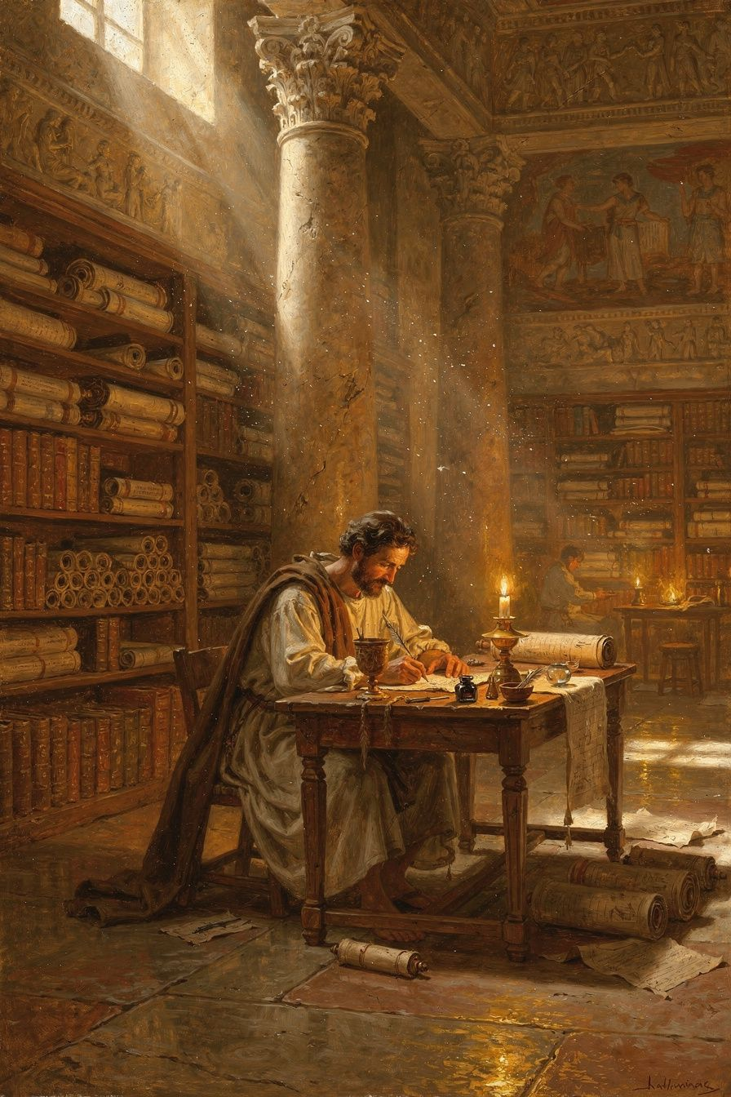
Illustration for Chapter 1
In the city of Alexandria, around the year 318 CE, a priest named Arius began teaching something that sounded reasonable to many people. He said that the Son of God was not eternal. Before the Son existed, only the Father existed. The Son was the first and greatest thing God ever created, but he was still a creature. Arius summed up his view in a short slogan: “There was when he was not.”
To a lot of educated people in the ancient world, this made sense. If God is absolutely one, then how could there also be a Son who is equally God? Would that not mean there are two gods? Arius thought he was protecting monotheism. He also had Bible verses. Proverbs 8:22 says that Wisdom was “created” at the beginning of God’s work. Colossians 1:15 calls the Son “the firstborn of all creation.” John 14:28 records Jesus saying, “The Father is greater than I.” Arius read these verses and concluded that the Son must be subordinate to the Father.
Athanasius listened to these arguments and disagreed radically. He believed the real question was not “How can we fit the Son into a philosophy of one God?” but “How can death be defeated?” Start there, he said, and everything else follows.
Athanasius believed that humanity was created for communion with God. In the beginning, God made human beings in his own image and gave them a share in his life. That share was like a gift plugged into a power source: as long as the connection remained, the human being lived in incorruption. But when the first humans turned away from God, the connection broke. Death and corruption entered the world. The problem was not just that people did bad things and needed forgiveness. The problem was that the human creature was beginning to dissolve, returning to the nothingness from which God had called it.
No creature can fix that problem. An angel can deliver a message, but a message does not restore life. A prophet can call people to repentance, but repentance does not destroy death. Only the Author of life can reverse death, because life belongs to God. Therefore, Athanasius argued, the Savior must be God. If Jesus has actually defeated death—and Christians believe he has—then Jesus must be the Creator, not a creature.
This is the logic of the Incarnation. The eternal Word, through whom all things were made, took a real human body and entered the human condition. He did this not because he needed to, but because we could not save ourselves. Athanasius wrote:
“He was made man that we might be made God; and he manifested himself through a body that we might receive an idea of the invisible Father; and he endured the insults of human beings, that we might be made immortal.” — *On the Incarnation* 54
Notice what Athanasius is saying. The Word took on human life so that human beings could take on divine life. He endured suffering and death so that human beings could be made immortal. He became visible in a body so that human beings could see the invisible Father. This exchange—Christ takes what is ours so that we can receive what is his—is the center of Athanasius’s theology.
Athanasius was careful about how he described the Incarnation. He did not say that the Word changed into a human being. He said the Word assumed a human body. The divine nature did not turn into flesh; the divine person united himself to real flesh. In a letter written late in life, Athanasius explained:
“The Word was not changed into flesh, nor was he turned into a human being; but, as he has said, ‘The Word became flesh’—not by being changed, but by taking to himself a body from the Virgin Mary.” — *Letter to Epictetus* 2
This careful language matters. If the Word turned into a human, then God stopped being God, which is impossible. If the Word only pretended to be human, then the body was not really saved. Athanasius insisted on both truths: Jesus is truly God, and Jesus is truly human.
The implications of this argument stretch beyond the fourth century. Athanasius believed that getting the identity of Jesus right is not a theological hobby; it is the difference between a faith that saves and a faith that does not. If Jesus is only a creature, then his death is the death of a creature, and creatures cannot defeat death. The resurrection becomes a trick or a metaphor rather than a real victory. Worship becomes admiration rather than adoration. Christianity collapses into one more philosophy about a wise teacher. Athanasius saw all of this at stake in the Arian controversy, and he refused to let the church settle for a smaller Jesus.
His own life proved his seriousness. He was not a comfortable scholar writing from an ivory tower. He was a bishop in a city famous for riots, a city where ideas started political movements. Alexandria was the intellectual capital of the Mediterranean, home to the greatest library and the most combative Christian community in the empire. When Arius began preaching in Alexandria, the whole empire listened. Athanasius answered him not only with books but with a lifetime of resistance: five exiles, hidden years in the desert, letters smuggled to supporters, and a refusal to accept the Arian bishops installed in his place. The phrase that later generations attached to him—"Athanasius contra mundum," Athanasius against the world—captures the drama of a single man holding a line that everyone else seemed willing to cross.
Yet Athanasius was not simply stubborn. He was convinced that the line was the gospel itself. The Jesus he defended was the Creator who had become a creature without ceasing to be Creator, the Life who had entered death in order to end it. That Jesus was worth exile, worth slander, worth loneliness. Athanasius’s logic of the Incarnation is therefore also a logic of courage: the truth about Jesus is the truth that makes every other loss bearable.

The Big Idea
The Incarnation is not an emergency measure or a philosophical puzzle. It is the rescue mission of the Creator. Because only God can defeat death, the Savior must be God. Because the Savior is Jesus, Jesus must be the eternal Word made flesh. Athanasius’s logic moves from the human problem to the divine solution.

Try This
1. Draw a simple chain of cause and effect: (a) humanity fell, (b) death entered, (c) no creature can defeat death, (d) Jesus defeated death, (e) therefore Jesus is God. Explain each step in your own words to a family member. 2. Imagine you are a friend trying to comfort someone who is afraid of death. Write three sentences based on Athanasius’s logic that might help them see why Christians hope in the resurrection. 3. Athanasius used the image of a king whose children are lost in a forest. The king could send a servant, but the servant might get lost too, so the king goes himself. Rewrite this story as a one-paragraph modern analogy using a rescue you might read about today. 4. Look up one verse Athanasius would have used to show Jesus is divine—such as John 1:1, Colossians 1:16, or Hebrews 1:8—and write a one-sentence explanation of what it says.

Talk About It
1. Why does Athanasius think the question “Who is Jesus?” is connected to the question “Can we be saved from death?” 2. What is the difference between saying the Word “became” flesh and saying the Word “assumed” flesh? Why does Athanasius care about that difference? 3. Do you think the idea that “only God can save” is convincing? Why or why not?
———
If Jesus were only a creature, what would that mean for the Christian hope of eternal life?
———

Chapter 2: Homoousios and the Identity of Christ
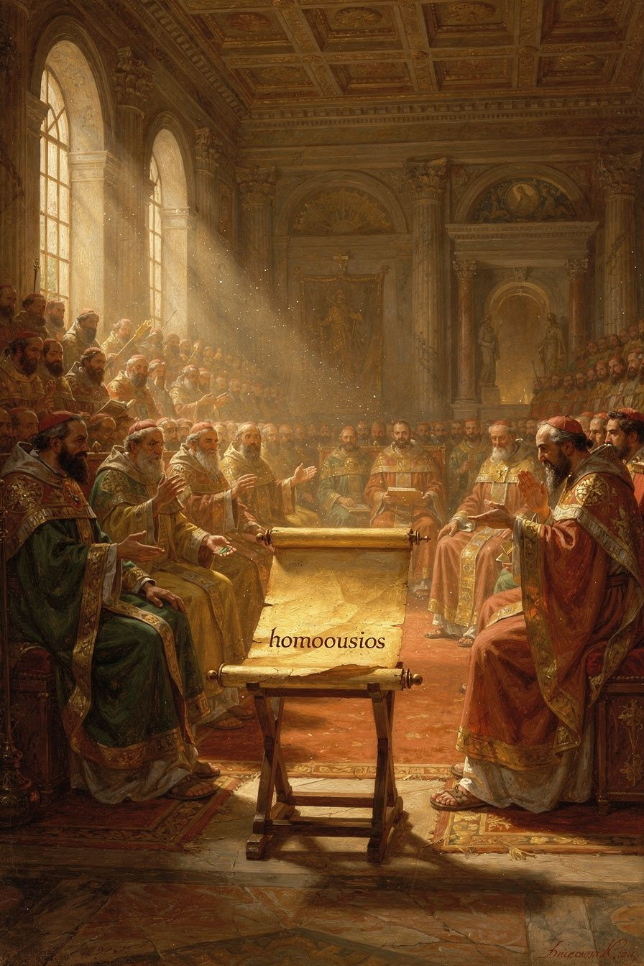
Illustration for Chapter 2
By the time Emperor Constantine called the Council of Nicaea in 325 CE, the argument over Arius’s teaching had spread across the Roman Empire. Bishops were divided. Churches were tense. Constantine, who had recently united the empire under his rule, wanted Christianity to be a source of unity, not division. So he invited bishops from across the empire to meet at Nicaea, a city in what is now Turkey, and settle the question.
The question they had to answer was simple but explosive: Is the Son of God truly divine, or is he a creature? The council rejected Arius’s view. Then it did something surprising. It chose a word that does not appear anywhere in the Bible: homoousios. This Greek word means “of one substance” or “consubstantial.” To say that the Son is homoousios with the Father is to say that the Son shares the Father’s own being, the same divine nature, not merely a similar one.
The council wrote these words into the creed: “We believe in one Lord Jesus Christ, the Son of God, begotten of the Father, only-begotten, that is, from the substance of the Father, God from God, Light from Light, true God from true God, begotten, not made, of one substance with the Father.” Then it added anathemas—condemnations—against anyone who said “there was when he was not” or “before being begotten he was not” or that the Son is “of a different substance” or “a creature.” These anathemas were as important as the creed itself. They made it impossible for an Arian to sign the document while still teaching Arianism.
Some bishops were nervous about the word. It was not biblical. It had been used before in questionable ways. But Athanasius and others argued that every biblical phrase the Arians accepted could be twisted. The Arians could say “Yes, the Son is called Wisdom,” but mean “the Son is wise like God, not God’s own Wisdom.” They could say “Yes, the Son is the Image,” but mean “the Son is a copy, not the Father’s own radiance.” Only homoousios closed the door. It placed the Son unambiguously on the divine side of the line between Creator and creature.
Athanasius was not at Nicaea as a voting bishop. He was a young deacon, probably in his twenties, attending as an assistant to Alexander of Alexandria. But he absorbed every argument. He understood that the word was not a clever invention; it was the church’s attempt to say clearly what it had always believed.
Athanasius spent the next fifty years defending homoousios. He argued that the Son is the “natural image” of the Father, not a copy made of different material. An image can be one of two kinds. A painted portrait of a king looks like the king but is made of different stuff. It is not the king. But the light that shines from fire is not a separate thing made to look like fire; it is the fire’s own radiance. The ray is not the sun, but it is sun-light. In the same way, Athanasius said, the Son is the Father’s own self-expression, eternally generated from the Father’s being.
“For the Son is the image of the Father, not as a copy different in kind, but as a natural image which has its being from the Father and is the same as him.” — *Orations Against the Arians* 1.26
Athanasius also attacked the Arian slogan “There was when he was not.” If the Son had a beginning, he argued, then the Father once existed without being a Father. But the Father is always Father. The Father’s generation of the Son is not an event in time; it is the eternal relation between them. As a spring always flows and a sun always shines, so the Father always generates the Son.
The Arians tried many compromise words. Homoiousios meant “of similar substance.” Homoios meant “like.” Anomoios meant “unlike.” Each sounded safer than homoousios, but each left a crack through which Arianism could return. Athanasius refused every compromise. He saw that the issue was not the word itself but the reality it protected. Remove homoousios, and the Son becomes a creature. If the Son is a creature, he cannot save.
The council of 325 did not end the controversy. In fact, the decades that followed were among the most turbulent in church history. Constantine, who had supported the council, later wavered under the influence of Arian bishops. His son Constantius II openly favored Arianism and used the power of the empire to pressure Nicene bishops. Athanasius was exiled five times, sometimes by Arian emperors, sometimes by pagan ones who simply wanted him out of the way. Rival bishops were installed in Alexandria by military force. Councils were convened to overturn Nicaea. For long stretches, it looked as though homoousios would be buried.
Athanasius spent those decades explaining and defending the word. In works such as De Decretis and De Synodis, he told the story of Nicaea for bishops who had not attended and who were being pressured to abandon its decision. In the Orations Against the Arians, he dismantled the Arian proof-texts one by one. He showed that verses like "The Father is greater than I" refer to Christ’s human nature, not his divine nature. He argued that "firstborn of all creation" means preeminent, not first-created. He insisted that the whole Bible must be read according to its skopos, its central aim, which is that the Son is the Savior and therefore God.
The reason Athanasius kept fighting is that he understood homoousios as a boundary, not a boundary for the sake of exclusion but a boundary for the sake of truth. A boundary says what is inside and what is outside. Inside the Nicene line: the Son is truly God. Outside the line: the Son is a creature. The boundary does not claim that everything inside is fully understood; there is still enormous mystery in the Trinity. But without the boundary, the church no longer knows whom it worships. And if the church does not know whom it worships, it no longer knows what salvation is.

The Big Idea
Homoousios is the word that says Jesus Christ shares the Father’s divine nature. Athanasius defended it not because he loved technical language but because he believed that only a fully divine Savior can rescue humanity from death. The word is the fence around the gospel, the line that keeps the church from sliding into a Christianity without a divine Savior.

Try This
1. Make a four-column chart for these Greek words: homoousios, homoiousios, homoios, and anomoios. Write what each means in plain English and explain which one Athanasius thought was the only safe choice. 2. Write a one-page letter from the perspective of a young deacon at Nicaea. Describe the debate and explain why the bishops chose a non-biblical word to protect a biblical truth. 3. Use the “fire and ray” analogy to explain the Father-Son relationship to someone five years younger than you. Check whether your explanation keeps both the unity and the distinction. 4. Find the Nicene Creed online. Underline every phrase that Athanasius would have seen as directly anti-Arian, such as “begotten, not made” and “of one Being with the Father.”

Talk About It
1. Why was it important to Athanasius that the Son is “of the same substance” rather than “of similar substance” with the Father? 2. Is it ever right for the church to use words that are not in the Bible to protect biblical truths? Can you think of modern examples? 3. Athanasius said compromise formulas left “a crack through which Arianism could enter.” What did he mean by that?
———
If Jesus were only “like” the Father, what could he give us that the Father could not give directly?
———

Chapter 3: He Was Made Man That We Might Be Made God
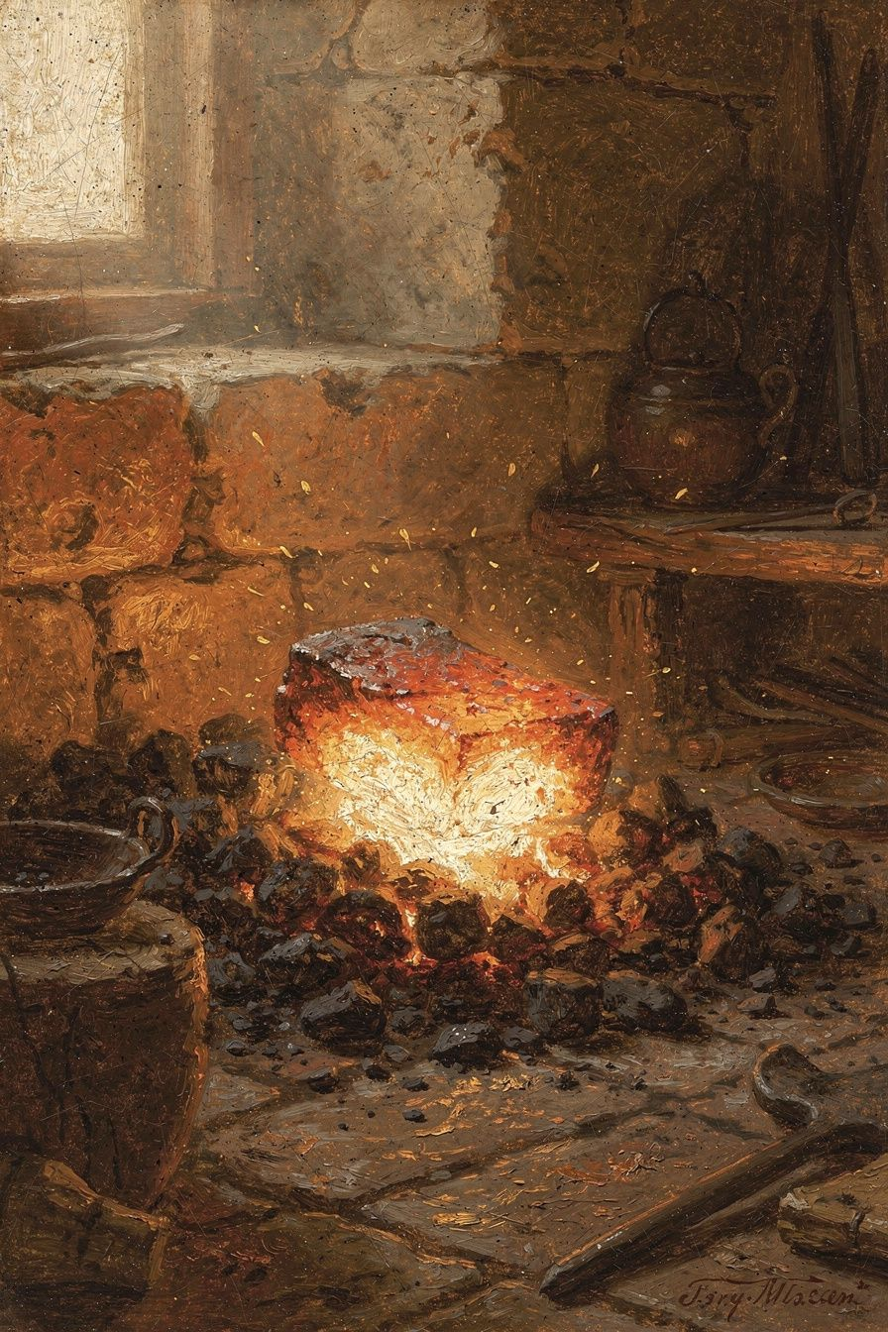
Illustration for Chapter 3
Athanasius’s most famous sentence can sound shocking at first: “He was made man that we might be made God.” If you read it quickly, you might think he is saying that human beings become divine by nature, like characters in a myth who turn into gods. But that is not what Athanasius meant. He was describing a transformation by grace, not by nature.
To understand the sentence, go back to the logic of the Incarnation. The eternal Son took human nature. If he is truly God, then in taking human nature he united humanity to God. The human nature he assumed was not absorbed or destroyed; it was lifted up. And because he assumed human nature as a whole, the rest of humanity can be drawn into the same union. The movement is entirely one-directional: God comes down so that humans can be raised up.
Athanasius used the Greek verb theopoieō, which means “to make God” or “to deify.” The passive voice is crucial. Human beings are made God; they do not make themselves God. The action is God’s. Human beings receive it. This is why Athanasius’s teaching is sometimes called theosis or deification. It means participation in the divine life, not identity with the divine essence.
How does this participation happen? Athanasius pointed to the church’s sacraments. In baptism, the believer is united to Christ’s death and resurrection: the old self is buried, and a new self rises. In the Eucharist, the believer receives the body and blood of Christ and so is nourished by the life that conquered death. Through the indwelling Holy Spirit, the believer is gradually conformed to the image of Christ. These are not magical ceremonies; they are the ordinary means by which God communicates his life to human beings. Athanasius believed that the same Word who became flesh now meets his people through water, bread, wine, and the Spirit.
Think of the difference between the sun and a mirror. The sun is light by nature. A mirror is not light by nature. But when a mirror faces the sun, it is full of light. The light is real; the mirror truly has it. But the mirror does not become the sun. In the same way, human beings who are united to Christ are filled with God’s life, but they remain human creatures. Athanasius would later develop this through the church’s sacraments: baptism, the Eucharist, and the indwelling of the Holy Spirit are the ways that divine life is communicated to human beings.
The goal of deification is the restoration of the “likeness” of God. Athanasius, following the language of Genesis, believed that human beings were made in the image and likeness of God. The image—the capacity to know and love God—was damaged but not erased by the fall. The likeness—the actual participation in God’s life—was lost and is restored in Christ. Christ does not replace the image; he cleans and repairs it, revealing what was always there.
Athanasius’s doctrine of deification also has a moral dimension. The person who is being deified is being conformed to Christ. Acts of love, forgiveness, justice, and generosity are not simply good deeds; they are the shape of the divine life appearing in a human life. The person who forgives an enemy is not merely being nice; she is being made like Christ, who forgave from the cross. The person who gives to the poor is not merely being generous; he is sharing in God’s own generosity.
Athanasius’s understanding of deification is the opposite of two common mistakes. It is not pantheism, in which the individual person dissolves into God. And it is not self-divinization, in which a human being becomes godlike through moral effort, mystical technique, or intellectual achievement. Deification is gift, not achievement. It comes from union with Christ, not from climbing a ladder.
This teaching became foundational for the Eastern Christian tradition. Over the centuries, theologians would refine Athanasius’s insight with greater precision. The Cappadocian Fathers—Basil of Caesarea, Gregory of Nazianzus, and Gregory of Nyssa—would distinguish between God’s essence, which is unknowable and unshared, and God’s energies, which are God’s presence in action and which human beings can participate in. Later theologians such as Maximus the Confessor and Gregory Palamas would develop this into the full Orthodox doctrine of theosis. But the seed of all of it is Athanasius’s famous sentence.
Athanasius’s view also stands in sharp contrast to the Gnostic alternative of his time. Some religious teachers in the ancient world believed that the material world was evil and that salvation meant the soul’s escape from the body. Athanasius rejected this completely. If the body were evil, the Word would not have taken a body. If the world were a prison, the resurrection of the body would be a mistake. Instead, Athanasius taught that the Word became flesh precisely to redeem the flesh. Deification includes the body. The final goal is not a disembodied spirit floating in heaven; it is a whole person—body and soul—made incorruptible and filled with divine life.
For middle-school readers today, the idea of deification can sound strange because modern culture often thinks of self-improvement as something you achieve by effort, willpower, or technique. Athanasius would say that this is the wrong starting point. The goal is not to make yourself into a better version of yourself. The goal is to be united to Christ and to receive his life. Moral effort matters, but it matters as the fruit of union, not as the root. The root is grace. The human being does not climb up to God; God comes down to the human being, lifts the human being up, and fills the human being with his own life.

The Big Idea
“He was made man that we might be made God” means that the Son’s humanity opens the way for our participation in God’s life. We do not become God by nature; we become godlike by grace, sharing through Christ in the life that belongs to God alone. Deification is the restoration of humanity’s original destiny, accomplished by God’s gift rather than human achievement.

Try This
1. Draw the sun-and-mirror analogy as a picture or diagram. Label “God by nature,” “human by nature,” and “human filled with divine life by grace.” 2. Write two short parables: one that correctly illustrates deification and one that accidentally turns it into self-divinization. Explain the difference. 3. Interview three people about what they think “salvation” means. Share Athanasius’s idea that salvation is participation in divine life, and ask which view they find more surprising. 4. Choose one action from the chapter—love, forgiveness, justice, or generosity—and describe how Athanasius would see it as part of being “made like God.”

Talk About It
1. What is the difference between becoming God “by nature” and becoming God “by grace”? Why does Athanasius care about that difference? 2. How does the idea of deification change the way you think about doing good things? 3. Why does Athanasius say deification requires the Incarnation? Could God not simply declare us deified from heaven?
———
What would it look like in your daily life to be “filled with God’s life” the way a mirror is filled with sunlight?
———

Chapter 4: Created for Incorruption
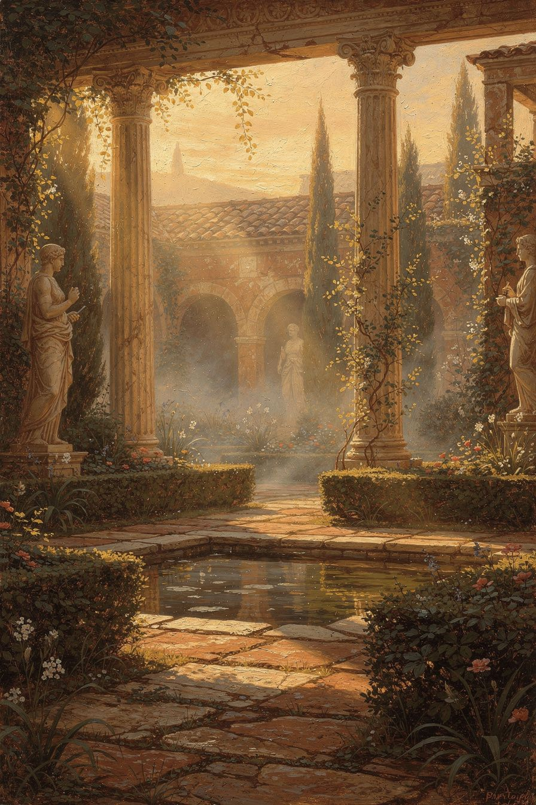
Illustration for Chapter 4
Athanasius’s theology begins with creation. Before there is a fall, there is a gift. Before there is a rescue, there is a plan. This is important because it shapes the whole tone of his work. The world is not a mistake. The body is not a prison. Matter is not evil. God made the world from nothing, through his Word, and he made it good.
Athanasius taught the doctrine of creatio ex nihilo, creation from nothing. This means God did not shape pre-existing stuff, as a carpenter shapes wood. He called the universe into being by his Word. The world exists because God willed it, and it continues to exist because God sustains it. This is not a scientific theory about the origin of the universe; it is a theological claim about why anything exists at all. Every leaf, every star, every human body is a gift, held in being by the goodness of God.
Within creation, human beings have a special place. God made humanity in his own image and likeness. Athanasius understood the image as the capacity for communion with God—the ability to know, love, and reflect the Creator. But he added something distinctive. Human beings were created with a capacity for incorruption, a share in the divine life that would preserve them from decay and death. This capacity was not built into human nature on its own; it was a gift, dependent on continued communion with God.
The fall, then, was not the activation of a built-in defect. It was the loss of a supernatural gift. When the first humans turned away from God, they did not become more independent. They began to dissolve. Athanasius described the fall as a kind of return to non-being. Created things naturally tend toward dissolution unless they are held in being by the Creator. When humanity cut itself off from the source of life, it began to die.
This is why Athanasius said that God faced a kind of dilemma after the fall. On the one hand, God is just: he had warned that sin brings death, and he cannot simply pretend the warning was never given. On the other hand, God is good: he made humanity for communion with himself, and he cannot abandon his creation without admitting that the project of creation was a failure. No creature can solve this dilemma. Only the Creator can satisfy both justice and goodness. The Incarnation is the solution: the Word enters death, pays the debt that justice demands, and rises to restore what goodness loves.
This view of creation and fall explains why Athanasius is so opposed to any kind of dualism. Some ancient religions taught that matter is evil, that the body is a prison, and that salvation means escaping the physical world. Athanasius rejected all of this. If matter were evil, then the Word would not have taken a body. If the body were a prison, then the resurrection of the body would make no sense. But Athanasius believed that the Word became flesh precisely because the flesh matters. God made the body, God loves the body, and God will redeem the body.
Athanasius also saw the fall as causing ignorance. Cut off from God, human beings forgot who God was. They began to worship the creation instead of the Creator—idols, stars, political power, their own desires. The Incarnation is God’s answer to this ignorance too. The invisible God becomes visible in Christ so that human beings can know him again. Athanasius wrote:
“He adapted himself to the capacity of the simple, showing himself in a body. ... For if a king’s image is not known, the king is not known; and if the image is known, the king is.” — *On the Incarnation* 13
This means the Incarnation is also an education. The Word comes not only to rescue us from death but to teach us how to live. The life of Jesus—his teaching, his healing, his compassion, his suffering, his rising—shows us what God is like and what human life is meant to be.
Athanasius’s high view of creation also shaped how he understood evil. For him, evil is not a thing with its own independent existence. It is a privation, an absence of the good that should be there. Death is not a created thing; it is the absence of life. Sin is not a substance; it is the absence of righteousness. This way of thinking is deeply hopeful, because it means that evil cannot create anything. It can only damage what is already good. The last word does not belong to death or sin; it belongs to the Creator who made the world good and who is making it good again.
This hope runs through everything Athanasius wrote about creation and redemption. The same Word who made the world in the beginning is the Word who comes to redeem it. The same hands that shaped humanity are the hands that are stretched out on the cross. The same voice that called the universe into being is the voice that calls Lazarus from the tomb. Creation and redemption are not two separate projects. They are one continuous work of love. The fall interrupted the work, but it did not end it. The Incarnation is the resumption of the creative project, the moment when the Creator returns to repair his own masterpiece.
Against the Gnostic and Platonic tendencies of his time, Athanasius insisted that the material world is not an obstacle to knowing God. In fact, the Incarnation proves that the material can be a vehicle of the divine. Because the Word took a body, a human face can show us the face of God. Because the Word suffered in a body, human suffering can be joined to the redemptive work of God. Because the Word rose in a body, human bodies have an eternal future. Athanasius’s theology of creation is therefore not an abstract doctrine about the origin of the world. It is the foundation for a whole way of seeing the world—as a gift, as a theater of God’s glory, and as the object of God’s redeeming love.

The Big Idea
The world was made good, and human beings were made for communion with God. The fall broke that communion and brought death, but it did not erase God’s original purpose. The Incarnation is the Creator returning to restore what he made. The body is not a prison; it is a created good that God will redeem.

Try This
1. Write a one-page “creation account” from Athanasius’s perspective. Describe a world made good, a humanity made for God, and a fall that broke the connection. End with the promise that the Creator will come to restore it. 2. Make a list of five things in the physical world that some people treat as bad or unimportant. Next to each, write why Athanasius would say it is good and worth redeeming. 3. Draw a “before and after” picture: one side showing humanity rooted in God, the other showing the same humanity uprooted and beginning to wither. Add captions in your own words. 4. Compare Athanasius’s view of the fall with the view that death is simply natural. Write a paragraph explaining which view makes more sense of the Christian hope for resurrection.

Talk About It
1. Why does Athanasius say the fall is a “return to non-being”? What does that mean? 2. How does Athanasius’s positive view of creation affect the way Christians think about the body and the physical world? 3. If the world is basically good but damaged, how should we respond to evil and suffering?
———
If God made the world good, why do you think evil and suffering seem so powerful?
———

Chapter 5: Christus Victor and the Empty Tomb
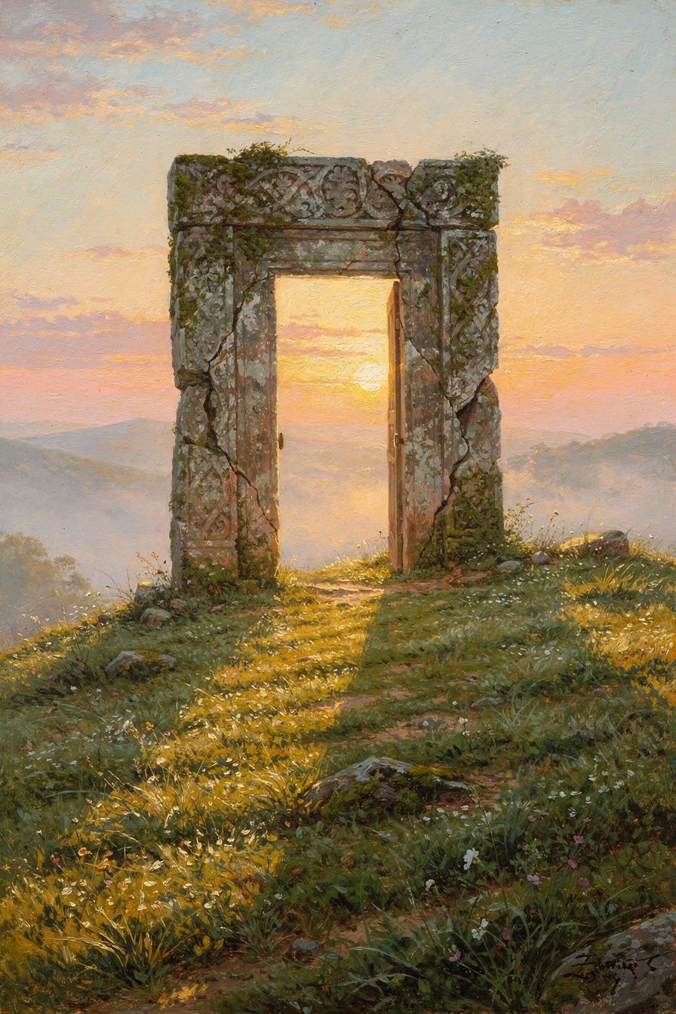
Illustration for Chapter 5
For Athanasius, the cross is not primarily a legal transaction. It is a victory. Death held humanity captive. The Word entered death’s territory and destroyed it from within. This way of understanding the cross is often called the “Christus Victor” view: Christ is the conqueror who defeats sin, death, and the devil.
Start with the problem. Death claims every human being because every human being has sinned. The law of death is just: sin earns death. But the Word, who became human, has not sinned. Death has no rightful claim on him. When death takes him anyway, it overreaches. It seizes one who owes it nothing. And because the one it seizes is also Life itself, death cannot hold him. The resurrection is the proof that death has been destroyed.
Athanasius used several images to explain this. One is the image of a debt. Humanity owed a debt of death because of sin. The Word pays that debt on behalf of all. But because the Word is also Life, the debt is not merely paid; it is exhausted. Another image is the fishhook. The devil is like a fish that swallows bait. The humanity of Christ is the bait; the divinity of Christ is the hook. The devil grabs what looks like an ordinary man and discovers too late that he has grabbed the living God.
Athanasius saw a precise injustice at the center of the cross. Death operates by a legal logic: sin earns death, and death claims the sinner. But the Word had not sinned. When death took him, it overreached. It acted unjustly by seizing one who owed it nothing. In that overreach, death exposed its own flaw. The system that seemed to execute divine justice did not know when to stop. By taking the sinless one, death swallowed Life itself and was destroyed. This is why Athanasius says the cross both fulfills the law of death and undoes the devil’s dominion at the same time.
Athanasius also made an empirical argument. He pointed to the behavior of Christians as evidence that death had been defeated. Before Christ, death was humanity’s greatest terror. After Christ, Christians faced death with confidence—even joy. Children, he said, mocked death. Martyrs went to their executions singing. Athanasius asked: if death is still the final reality, why do Christians no longer fear it? Bravery does not change reality. The only explanation is that something has happened to death itself.
“Children who are still growing up in age mock death. They take no account of it, for thanks to Christ they despise it. ... If death were not destroyed, men would not have become so bold as to mock it.” — *On the Incarnation* 28
The resurrection of Jesus is the center of this argument. Athanasius insisted that it was bodily. The same body that died rose again, transformed but continuous. This matters because it shows that the body is not discarded. The body matters. The physical world matters. The resurrection is not the escape of a soul from a corpse; it is the transformation of the whole person—body and soul—into incorruptibility.
Athanasius’s view of the cross and resurrection shaped how he faced his own suffering. During his five exiles, he lost his home, his reputation, and his safety. But he did not despair. He believed that the pattern of cross and resurrection was the pattern of every Christian life. Loss is real, but it is not final. Death is real, but it is not the last word.
The martyrs were Athanasius’s best evidence. He lived in the generation after the Great Persecution under the Roman emperor Diocletian, and the memory of Christians who had died for their faith was still fresh. Athanasius himself had been formed by confessors—people who had suffered for Christ and survived. He knew that courage in the face of death was not a stoic refusal to feel fear; it was a confidence grounded in the resurrection. The martyrs did not deny that death hurt. They denied that death was the end. Their singing, their forgiveness of executioners, their peaceful faces were the visible proof that something had changed in the human condition.
This is why Athanasius tied the resurrection so closely to the body. A merely spiritual resurrection—a soul escaping from a corpse—would not have redeemed the body that suffered. It would have left the physical world behind, implying that the body was not worth saving. But Athanasius believed that the body is worth saving because God made it. The resurrection of Jesus is the same body that died, now transformed into incorruptibility. And the Christian hope is that the same transformation awaits every believer. The body that is buried is the body that will rise. The person who dies in Christ will be raised in Christ. This is not a metaphor; it is the fulfillment of the Incarnation.
Athanasius’s theology also warns against turning the cross into a single, narrow theory. Some later theologians emphasize the cross as a payment for sin. Others emphasize it as a demonstration of God’s love. Others emphasize it as a victory over evil. Athanasius does not choose one and reject the others. He holds them together. The cross pays the debt of sin, reveals the love of God, defeats the devil, and opens the way to resurrection. Each image captures something true. Together they give a rich picture of what God accomplished in Christ.
Athanasius’s famous biography of Antony, the desert monk, fits this same pattern. Antony faced demons, hunger, loneliness, and the temptation to give up, yet he emerged strengthened because he trusted in Christ’s victory. The monk who goes to the desert to fight the devil is living out the belief that the cross has already defeated the powers that destroy human beings. The same victory that raised Jesus from the dead enables ordinary people to resist evil in their own lives. Athanasius wanted his readers to see that the cross is not only a past event; it is a present power.

The Big Idea
The cross is the decisive battle in which the Word enters death and defeats it from within. The resurrection is the proof that death has lost its power. Christians can face suffering and death with courage because the worst enemy has already been beaten, not by force from outside but by love from within.

Try This
1. Write three short skits that illustrate the cross as (a) payment of a debt, (b) a fishhook catching the devil, and (c) a victory over an enemy. Perform one for your family or class. 2. Interview an older Christian about how they think about death. Ask whether they agree with Athanasius that Christians can “mock death” because of the resurrection. 3. Draw a before-and-after picture of a tomb: one side shows the stone in place, the other shows the stone rolled away and light coming out. Add captions from Athanasius’s argument. 4. Write a letter from the perspective of Athanasius in exile, explaining how the resurrection gives him hope even while he is separated from his church.

Talk About It
1. Why does Athanasius say death “overreached” when it took Christ? What does that mean? 2. How is Athanasius’s view of the cross different from the idea that God punished Jesus in our place? 3. What evidence does Athanasius offer for the resurrection? Do you find it convincing?
———
If death has been defeated, how should that change the way you face fear and loss?
———

Chapter 6: The Holy Spirit and the Completion of the Gospel
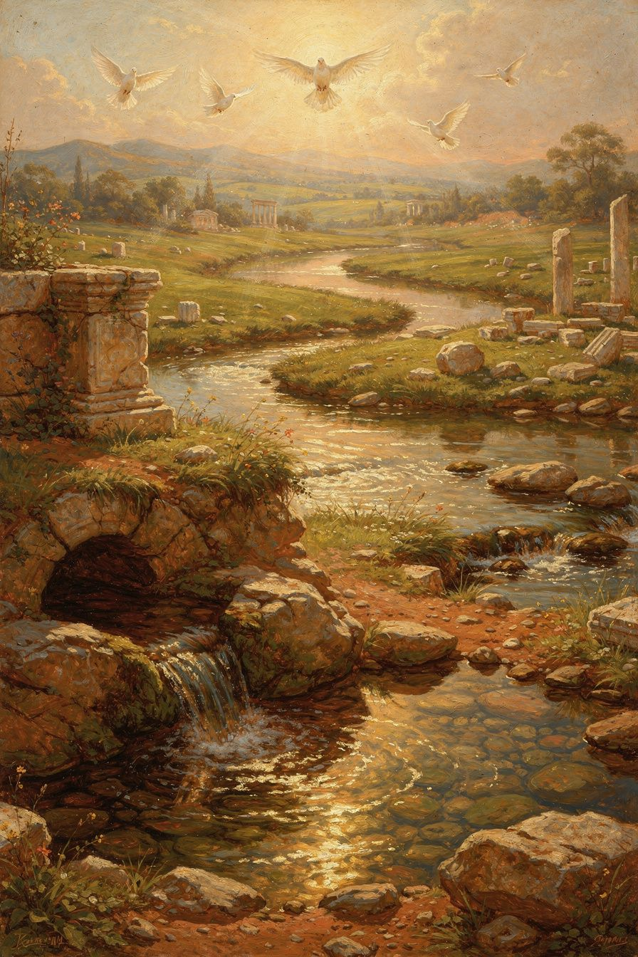
Illustration for Chapter 6
Athanasius spent most of his life defending the Son’s divinity, but he did not stop there. Near the end of his life, a new controversy arose. A group in Egypt called the Tropici began teaching that the Holy Spirit was a creature. They pointed to biblical language about the Spirit being “given,” “sent,” and “poured out.” If the Spirit is given, they argued, then the Spirit must be subordinate. If the Spirit is sent, then the Spirit must be a servant, not God.
Athanasius responded with a series of letters to Serapion, bishop of Thmuis. His argument was the same one he had used for the Son: look at what the Spirit does, and you will know what the Spirit is. Only God can sanctify. Only God can give life. Only God can indwell the church. The Spirit does all of these things. Therefore the Spirit is God.
Athanasius wrote:
“For the Holy Spirit is not a creature, nor a work, but he is proper to the Son and partakes of the same nature as the Son.” — *Letters to Serapion* 1.27
This was a bold step. Nicaea had not officially addressed the Holy Spirit. Many bishops were unsure about extending the word homoousios to the Spirit. But Athanasius saw that the same logic that proved the Son’s divinity also proved the Spirit’s divinity. If the Spirit makes human beings godlike, then the Spirit must be divine. A creature cannot deify another creature.
Athanasius also argued that the Trinity works as one. The Father creates through the Son in the Spirit. The Father redeems through the Son in the Spirit. The Father sanctifies through the Son in the Spirit. The works of God are one because the nature of God is one. This unity of operation is the external evidence of the unity of being.
He used the image of a river to explain the Trinity. The Father is the spring; the Son is the river flowing from the spring; the Spirit is the water that irrigates the fields. The three are one water—the same substance, the same life. They are distinct in their role, but they are not divided in their being. This image captures the mystery Athanasius wanted to protect: one God, three persons; unity and distinction together.
Athanasius’s teaching on the Spirit prepared the way for the Council of Constantinople in 381 CE, a few years after his death. That council expanded the Nicene Creed to include the Holy Spirit and affirmed that the Spirit is “the Lord and Giver of Life, who proceeds from the Father, who with the Father and the Son is worshiped and glorified.” The creed that many Christians still recite in worship today is the fruit of Athanasius’s arguments.
This means that Athanasius’s legacy is not just a doctrine about Jesus. It is a doctrine about God. The God Christians worship is Father, Son, and Holy Spirit—one in being, three in person. Athanasius defended that truth when it was under attack, and it remains the faith of the church today.
The completion of Athanasius’s Trinitarian vision came through others. Athanasius laid the foundation by defending the Son’s divinity and extending the same argument to the Spirit. The Cappadocian Fathers—Basil, Gregory of Nazianzus, and Gregory of Nyssa—then refined the vocabulary. They distinguished between ousia, the one divine substance, and hypostasis, the three divine persons. This distinction made it possible to say clearly that God is both one and three, without falling into the errors of tritheism (three gods) or modalism (one God wearing three masks). The Council of Constantinople in 381 adopted this refined language and completed the creed that Christians still use in worship.
Athanasius himself did not use the ousia/hypostasis distinction as sharply as the Cappadocians would. His genius was not terminological precision but theological conviction. He saw that the church could not afford a half-divine Savior or a half-divine Spirit. He held the line when the line was unpopular. The Cappadocians built the house on the foundation he had defended. Both were necessary: Athanasius’s courage and the Cappadocians’ clarity.
The practical result of Athanasius’s pneumatology is that Christian worship is Trinitarian. Every baptism, every prayer, every Eucharistic liturgy is addressed to the Father, through the Son, in the Holy Spirit. Athanasius’s argument that only God can be worshiped means that the Spirit must be God, because the church worships the Spirit. The same is true of the Son. The church does not merely admire Jesus; it worships him. If Jesus or the Spirit were creatures, the church would be guilty of idolatry. Athanasius’s defense of the Trinity is therefore also a defense of Christian prayer and worship.

The Big Idea
Athanasius extended his defense of homoousios to the Holy Spirit. Because the Spirit sanctifies, gives life, and indwells the church, the Spirit must be fully divine. The Trinity—Father, Son, and Holy Spirit—is one God in three persons, and Christian worship depends on that truth remaining intact.

Try This
1. Draw Athanasius’s river image: label the spring, the river, and the irrigating water. Write one sentence explaining how the image shows both unity and distinction. 2. Make a “what the Spirit does” chart. List at least five actions of the Spirit from the Bible or this chapter. Next to each, explain why Athanasius would say only God can do it. 3. Write a short worship prayer addressed to the Father, through the Son, in the Holy Spirit. Notice how Trinitarian prayer is shaped. 4. Compare the Nicene Creed of 325 with the expanded version from 381. Highlight the additions about the Holy Spirit and explain why they matter.

Talk About It
1. Why does Athanasius use the same kind of argument for the Holy Spirit that he used for the Son? 2. What would be lost in Christian life and worship if the Holy Spirit were only a creature? 3. How does Athanasius’s river image help you understand the Trinity? What are its limits?
———
If the Holy Spirit is truly God, how should that change the way you pray and think about your own spiritual life?
———

For the Grown-Up Reader
This booklet draws on the life and writings of Athanasius of Alexandria (c. 296–373 CE), whose works are among the most important theological texts of the early church. The primary sources used include On the Incarnation (De Incarnatione Verbi), the Orations Against the Arians, the Letters to Serapion, the Letter to Epictetus, and the Festal Letters. Quotations are taken from widely accepted English translations, especially those available in the Popular Patristics Series published by St. Vladimir’s Seminary Press, and are identified by their standard chapter or section numbers.
Athanasius did not invent the doctrine of the Trinity. The New Testament already names the Father, Son, and Holy Spirit together and ascribes divine titles and works to Christ. Pre-Nicene writers such as Ignatius of Antioch, Irenaeus of Lyons, Tertullian, and Origen developed the language that Athanasius would later defend. The Council of Nicaea in 325 adopted the word homoousios before Athanasius became bishop, and the Council of Constantinople in 381 completed the Trinitarian settlement that Athanasius had argued for.
For readers who want to go deeper, the best modern studies include Khaled Anatolios, Athanasius: The Coherence of His Thought; John Behr, The Nicene Faith; Lewis Ayres, Nicaea and Its Legacy; and Rowan Williams, Arius: Heresy and Tradition. Accessible introductions include Peter J. Leithart, Athanasius, and Gerard Farrell, Athanasius: A Beginner’s Guide. The booklet has aimed to preserve Athanasius’s arguments while adapting their language and density for readers aged eleven to fourteen. It is intended for discussion in families, classrooms, and study groups, not as a final theological treatise.
———

About WisdomForge
WisdomForge creates age-adapted booklets that bring the great philosophers and theologians of the past within reach of every learner. Each figure is presented in four bands—elementary, middle, high school, and adult—so that families, classrooms, and curious individuals can read, question, discuss, and practice together. The goal is not merely to learn about historical figures but to wrestle with their ideas and to let those ideas shape how we think, speak, and live.
———

Sources
Primary: - Athanasius, On the Incarnation (De Incarnatione Verbi), especially chapters 1–10, 13, 20, 28, 33, 54. - Athanasius, Orations Against the Arians 1.21, 1.26, 2.26, 2.59, 3.6. - Athanasius, Letters to Serapion 1.24–31. - Athanasius, Letter to Epictetus 2. - Athanasius, Festal Letter 39 (367 CE). - Athanasius, History of the Arians. - Athanasius, Life of Antony. - The Nicene Creed and Anathemas (325 CE). - The Niceno-Constantinopolitan Creed (381 CE).
Secondary: - Anatolios, Khaled. Athanasius: The Coherence of His Thought. T&T Clark, 1998. - Ayres, Lewis. Nicaea and Its Legacy: An Approach to Fourth-Century Trinitarian Theology. Oxford University Press, 2004. - Barnes, Timothy D. Athanasius and Constantius: Theology and Politics in the Imperial Christian Empire. Harvard University Press, 1993. - Behr, John. The Nicene Faith, Parts 1–2. St. Vladimir’s Seminary Press, 2004. - Farrell, Gerard. Athanasius: A Beginner’s Guide. Cascade Books, 2021. - Hanson, R.P.C. The Search for the Christian Doctrine of God. T&T Clark, 1988. - Leithart, Peter J. Athanasius. Baker Academic, 2011. - Weinandy, Thomas G. Athanasius: A Theological Introduction. Ashgate, 2007. - Williams, Rowan. Arius: Heresy and Tradition. 2nd ed. Eerdmans, 2001.

