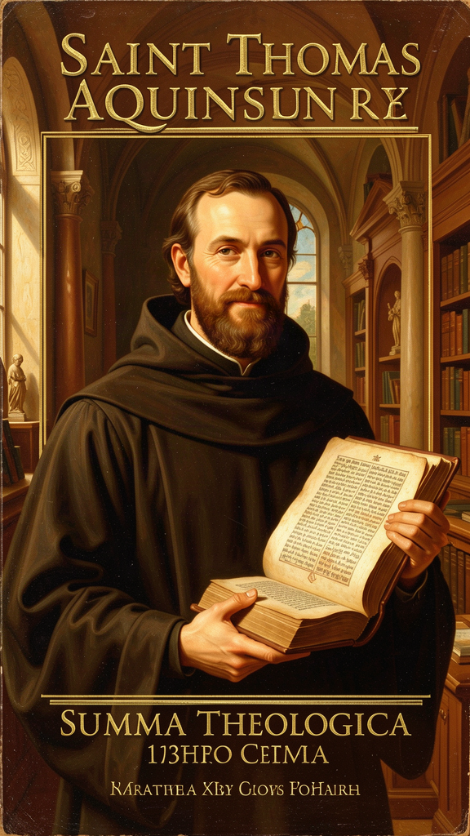
Being Itself
WisdomForge Booklet — Adult

Being Itself

WisdomForge Booklet — Adult
———

About This Book
Thomas Aquinas (1225–1274) built one of the most ambitious intellectual structures in the history of Western thought. His Summa Theologica attempts to address every question a rational person can ask about God, creation, morality, and the meaning of existence, using the tools of Aristotelian philosophy, the resources of Christian theology, and the insights of Jewish and Muslim thinkers who preceded him. He never finished it. In December 1273, three months before his death, he stopped writing after a mystical experience and reportedly said that everything he had written "seemed like straw."
This book examines six of Aquinas's most important ideas, presented as sophisticated philosophical arguments with attention to the interpretive debates that have shaped their reception. You will engage with the Five Ways as demonstrations from effect to cause, the act/potency distinction as a metaphysical framework for understanding change, the essence/existence distinction as the foundation of natural theology, natural law as a theory of practical reason, the faith-reason relationship as a model of intellectual integration, and the virtues as an account of human flourishing grounded in habit and practice.
This booklet does not simplify the ideas. It engages with them as philosophical arguments, identifies the interpretive debates, and presents the positions of major scholars — Gilson, Cajetan, Wippel, Finnis, Grisez, MacIntyre, Barth, Przywara — where they disagree about what Aquinas meant and whether his arguments succeed. The citations are precise and can be followed into any standard edition of the Summa, the Summa contra Gentiles, or the De Ente et Essentia.
Aquinas is a living tradition. Catholic, Protestant, secular, and analytic philosophical readings of his work disagree, sometimes sharply. This booklet does not resolve those disagreements. It presents the arguments, identifies the debates, and lets you judge for yourself.
———
———

Chapter 1: The Five Ways — Proving God Exists
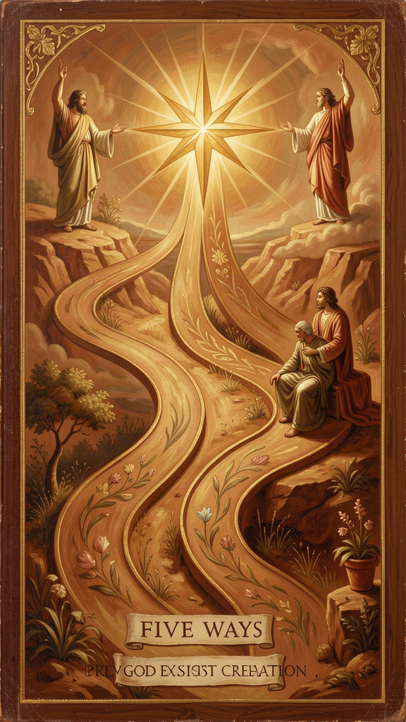
Illustration for Chapter 1
![Chapter 1](/images/booklets/thomas-aquinas-adult-ch01.png)

The Most Famous Two Pages in Philosophy
The Five Ways (Quinque Viae) appear at ST I, Q.2, A.3 — approximately two pages in a work of thousands. They are the most widely read, debated, and misunderstood passage in all of Aquinas. They are also the gateway to his entire metaphysical system.
The Five Ways are five arguments for the existence of God, each beginning from a different observable feature of the world and concluding that this feature requires an ultimate ground. Aquinas calls them viae — ways, paths — not demonstrationes in the Euclidean sense. They are demonstrations from effect to cause, showing that certain features of reality point beyond themselves to a source that is purely actual, necessary, perfect, and intelligent.
The interpretive question — whether the Five Ways are deductive proofs, dialectical demonstrations, heuristic pointers, or compressed summaries of longer arguments — is itself one of the major debates in Thomistic scholarship. Each reading finds something in the text. None is definitive.

What the Five Ways Assume
The Five Ways are not arguments from nothing. They assume five metaphysical commitments that Aquinas develops in the surrounding Questions (ST I, Q.3–26).
The principle of sufficient reason. Everything that exists has an explanation, either in itself or in something else. This is not "everything has a cause" — it is "everything has an explanation." The distinction matters: Aquinas does not claim that God has a cause, but he does claim that God is self-explanatory (God's essence is God's existence). The principle applies to everything, but it does not require that everything be caused — only that everything be explicable.
The distinction between act and potency. Things in motion (changing, becoming) are in potency with respect to what they are becoming. This potency can only be actualized by something already actual. (See Chapter 2.)
The distinction between essence and existence. In all created beings, what a thing is (essence) is distinct from that it is (existence). In God alone, essence and existence are identical. (See Chapter 3.)
The analogical predication of divine names. When we say "God is good," we are not using "good" univocally (in exactly the same sense as human goodness) or equivocally (in a completely different sense). We are using it analogically — there is a real but proportional similarity between God's goodness and the goodness we experience. This is the subject of the analogy of being, treated at ST I, Q.13.
That the world is intelligible. The Five Ways begin from observable features of the world, but they assume that the world is the kind of thing that can be understood — that its features point toward their own explanations. This is not an arbitrary assumption; it is the presupposition of all rational inquiry. But it is an assumption, and a philosopher who rejects it (a thoroughgoing skeptic, or a pragmatist who denies that inquiry aims at truth) will not find the Five Ways compelling.
These assumptions are the metaphysical framework Aquinas develops in the surrounding Questions. But they are assumptions, and not every philosopher shares them. Hume rejected the principle of sufficient reason (or at least its application beyond observable phenomena). Kant rejected the possibility of metaphysical knowledge. Russell rejected the act/potency distinction as meaningless. The Five Ways cannot be evaluated in isolation from this framework. Accept the framework, and the Ways are powerful. Reject it, and the Ways lose their force.

The Five Ways in Detail
The First Way: From Motion (*Ex Motu*)
"It is certain, and evident to our senses, that in the world some things are in motion. Now whatever is in motion is put in motion by another..." (ST I, Q.2, A.3)
The argument: Some things in the world are in motion. "Motion" (motus) means any change from potency to act — heating, growing, learning, becoming, not merely locomotion. Whatever is in motion is put in motion by another (nothing moves itself from potency to act). An infinite regress of movers is impossible in an essentially ordered series — a series where each member depends on a prior member here and now (like a hand moving a stick moving a stone), not a temporally ordered series (like a chain of parents). Therefore, there must be a first mover, unmoved — and this is God.
The crucial distinction is between essentially ordered and incidentally ordered series. In an essentially ordered series, each member depends on a prior member simultaneously — intermediate causes have no causal power independently. A stick does not move a stone unless a hand moves the stick. The series is hierarchical, not temporal. In an incidentally ordered series, each member depends on a prior member temporarily — a father begets a son, who later begets his own son. The series is temporal, not hierarchical.
The First Way concerns essentially ordered series. The "first mover" is not first in time but first in ontological priority — the ultimate ground of all change, here and now. This is why Aquinas can accept that the universe has no temporal beginning (SCG II, Ch. 38) and still maintain the First Way: the question is not "when did change start?" but "what grounds change at every moment?"
The common misunderstanding that the First Way is "everything has a cause, so God is the first cause" misses the point entirely. Aquinas is not arguing that every event has a cause. He is arguing that any change (actualization of potency) requires an actualizer, and an infinite regress of dependent actualizers still requires an ultimate actualizer that is pure act. The distinction between essentially and incidentally ordered series is what makes the argument work — and it is the distinction most commonly missed in textbook treatments.
The Second Way: From Efficient Cause (*Ex Efficiente Causa*)
The argument: In sensible things, we find an order of efficient causes. No efficient cause can be the cause of itself (it would have to exist before itself). An infinite regress of essentially ordered efficient causes is impossible. Therefore, there must be a first efficient cause — and this is God.
The Second Way differs from the First because it addresses a different metaphysical feature. The First Way is about actualization of potency (change). The Second Way is about existential dependence (causation). A thing could be in motion (First Way) without being caused to exist (Second Way). Conversely, a thing could be caused to exist without being in motion (if it is a necessary being). The two Ways address different dimensions of reality, and conflating them produces confusion.
The Second Way also depends on the essentially ordered series distinction. The argument is not that every event has a cause, but that an essentially ordered series of causes (where each member depends on a prior member simultaneously) requires a first cause that is not itself dependent. Temporally ordered series (like the chain of biological parents) can be infinite without violating the argument, because each parent has causal power independently of their own parents (once they exist).
The Third Way: From Possibility and Necessity (*Ex Possibili et Necessario*)
The argument: Some things in nature are contingent (they can be or not be — they are generated and corrupted). If everything were contingent, then at some time nothing would have existed (contingent things eventually fail to exist). But if nothing ever existed, nothing would exist now (ex nihilo nihil fit — something cannot come from nothing). Therefore, not everything is contingent — there must be something necessary. If this necessary being has a cause, the chain must terminate in a necessary being that is necessary per se (through itself). This necessary being is God.
The crucial move: this is not the "cosmological argument" as commonly presented. Aquinas is not arguing that the universe had a beginning. He is arguing that the existence of contingent beings requires a necessary ground — something that exists through itself and does not depend on anything else for its existence. The Third Way depends on the essence/existence distinction: contingent beings are contingent because their essence does not include existence. A being whose essence includes existence would be necessary.
The controversial step is premise 2: "if everything were contingent, then at some time nothing would have existed." Critics from Hume onward have argued that an infinite temporal series of contingent beings could avoid the conclusion: if the series has no beginning, there was never a time when nothing existed. Thomists respond that the argument is not about temporal succession but about existential dependence — contingent beings, by their nature, depend on something that does not depend on them. The "at some time" language is a way of expressing this dependence, not a claim about temporal sequence. The debate turns on whether the Third Way can be reformulated without the temporal premise.
The Fourth Way: From Degrees of Being (*Ex Gradibus*)
The argument: Among beings, there are degrees of goodness, truth, nobility. Things are called more or less good/true/noble according to their approximation to a maximum. The maximum in any genus is the cause of all in that genus (fire, the hottest thing, is the cause of all heat). Therefore, there is something that is the maximum of being — the most being, the most true, the most good — and this we call God.
This is the most contested of the Five Ways. Critics argue that it depends on a Platonic premise (that gradations require a separate Form) that Aquinas himself rejects elsewhere. If the "maximum" is a superlative instance — the hottest fire, the best person — then the argument fails, because a superlative instance is still just another being, not God.
Thomists respond that the "maximum" is not a superlative instance but a transcendental cause. God is not "the best being" but "being itself" (ipsum esse). The gradation argument works only if we understand "maximum" as the source and standard of the genus, not as the top instance within it. This reading requires the analogy of being (ST I, Q.13): God is not "very good" in the way that Socrates is "good," but goodness itself — the source from which all creaturely goodness flows.
The debate remains open. Some scholars (following Gilson) argue that the Fourth Way is coherent on Aquinas's own terms. Others (following Kenny) argue that it relies on a premise Aquinas cannot consistently maintain. The interpretive question is whether the Fourth Way can be read without a Platonic commitment to separately existing Forms — and whether Aquinas's own rejection of Platonism (ST I, Q.84, A.4) is consistent with the Fourth Way's premise about maxima.
The Fifth Way: From Governance (*Ex Gubernatione Rerum*)
The argument: Natural bodies that lack intelligence act toward ends (acorns become oaks, hearts pump blood). Nothing lacking intelligence can act toward an end unless directed by something with intelligence. Therefore, there is an intelligent being that directs all natural things to their ends — and this we call God.
This is an argument from intrinsic teleology — the built-in tendency of natural things to achieve specific results. It is not the modern "intelligent design" argument, which argues from the improbability of complex structures. Aquinas is arguing from the regularity of natural processes, not from their complexity. The order is not imposed from outside; it is inherent in nature, and that inherent order points to an intelligent cause.
The Fifth Way depends on Aquinas's account of final causality — the claim that natural things have inherent tendencies toward specific ends. This is part of his Aristotelian inheritance: every natural thing has a telos (end) built into its nature. The acorn tends toward becoming an oak, not because it chose to, but because that is what acorns do. The regularity of this tendency, Aquinas argues, requires an intelligence that orders it — not as a designer who imposes structure from outside, but as a final cause that gives natural things their tendencies.
Modern critics argue that Darwinian natural selection explains the apparent teleology of natural things without invoking an intelligent cause: organisms that behaved randomly did not survive, so the ones that survived behaved regularly. Thomists respond that natural selection explains the mechanism of adaptation, but not the fact that nature is the kind of system that can produce adapted organisms. The regularity of the evolutionary process itself, they argue, still requires an explanation — and that explanation points toward an intelligent ground. The debate between these positions is one of the liveliest in contemporary philosophy of religion.

What the Five Ways Do Not Establish
At the end of the Five Ways, Aquinas has established that there is a first mover (pure act), a first efficient cause (uncaused cause), a necessary being (being through itself), a maximum of being (being itself), and an intelligent governor (the source of natural order).
He has not established that these five are one being (this requires further argument in Q.11, on divine unity). He has not established that this being has the attributes of the God of revelation — omniscience, omnipotence, benevolence, freedom, personhood. He has not established that this being creates, loves, judges, or forgives.
The Five Ways are the beginning of natural theology, not the conclusion. The rest of the Prima Pars (Q.3–26) develops what we can say about the first mover, first cause, necessary being, maximum of being, and intelligent governor — and whether these can be identified with the God of Scripture. This development is where Aquinas's most rigorous philosophical work occurs. The Five Ways are the foundation; the superstructure is the rest of the First Part.
This is a crucial point that most textbook treatments miss. The Five Ways do not prove "the God of the philosophers" and then leave it at that. They establish a starting point — a set of conclusions about the ultimate structure of reality — from which Aquinas develops a full account of divine attributes. The identification of the first mover with the God of Abraham, Isaac, and Jacob requires further argument, and Aquinas provides it.

Interpretive Debates
The Five Ways have been read in multiple ways, each with competent defenders.
As deductive proofs. Readings that treat the Ways as formal syllogisms whose conclusions follow necessarily from their premises. If the premises are true and the form is valid, the conclusions follow. This reading is common in introductory philosophy textbooks but is widely rejected by Aquinas scholars as oversimplifying the genre and the argument structure.
As dialectical demonstrations. Readings that treat the Ways as arguments that show the rationality of belief without compelling assent. On this reading (defended by some Thomists, following the tradition of expositor commentary), the Ways show that belief in God is reasonable, not that it is forced. A rational person can reject the premises, but the premises are reasonable and the conclusions follow.
As heuristic pointers. Readings that treat the Ways as paths that orient the mind toward God without functioning as formal proofs. On this reading (associated with some existentialist and phenomenological Thomists), the Ways are invitations to see the world as pointing beyond itself — not coercive arguments but orienting frameworks.
As summaries of longer arguments. Readings that treat the two-page Five Ways as compressed versions of arguments developed at much greater length in the Summa contra Gentiles (SCG I, Ch. 13; SCG II, Ch. 15–21). On this reading (defended by many scholars), the Ways cannot be evaluated without their fuller treatments in the SCG. Stripping them from their context produces caricatures.
Each reading finds something in the text. Aquinas calls them viae — ways — which supports the dialectical or heuristic readings. But he also calls them "demonstrations" in the Aristotelian sense (demonstrations from effect to cause), which supports the deductive reading. The genre of the Summa — a textbook for beginners — suggests compression, which supports the "summaries of longer arguments" reading. None of these readings is definitively wrong; none is definitively right. The text supports all of them, and the disagreement is part of what makes the Five Ways a living philosophical question.

Big Idea
The Five Ways are five demonstrations from observable features of the world to the existence of God. They are not mathematical proofs or arguments for a temporal beginning of the universe. They depend on metaphysical premises (act/potency, essence/existence, analogy) that Aquinas develops elsewhere. They establish a starting point — a first mover, first cause, necessary being, maximum of being, and intelligent governor — but not the full identity of this being with the God of revelation. The rest of the Prima Pars develops that identification. The interpretive debate about what kind of arguments the Ways are — deductive, dialectical, heuristic, or summary — remains open.

Practice
1. Reconstruct the First Way. Write the argument in standard form: list each premise and the conclusion. Then identify the crucial move — the claim that an infinite regress of essentially ordered movers is impossible. Why does "essentially ordered" matter here? What would change if the series were incidentally ordered? Can you reformulate the argument without the essentially/incidentally distinction?
2. Compare the First and Second Ways. Both argue for a "first" that terminates a series. But the First Way concerns motion (actualization of potency) and the Second concerns efficient causation (existential dependence). Construct a scenario where the two arguments come apart. Can something be in motion without being efficiently caused? Can something be efficiently caused without being in motion? What does this tell you about the independence of the two Ways?
3. Evaluate the Fourth Way. The argument moves from degrees of goodness to a maximum of goodness. Is this move valid? What is the difference between saying "there is a maximum of goodness" and saying "there is something that is goodness itself"? Which does Aquinas need, and which does he have? Consider the Gilson-Kenny debate: can the Fourth Way be read without a Platonic commitment to separately existing Forms?
4. Engage the Humean objection. Hume argues that we have no experience of the origin of worlds, and therefore cannot infer anything about the cause of the world. How would Aquinas respond? Does the First Way depend on an inference from experienced causation to unexperienced causation, or does it depend on a metaphysical principle (act/potency) that is not derived from experience? What is at stake in this distinction?
5. Evaluate the Darwinian challenge to the Fifth Way. Darwinian natural selection explains the apparent teleology of natural things without invoking an intelligent cause. Does this undermine the Fifth Way? Consider the Thomist response: natural selection explains the mechanism of adaptation, but not the fact that nature is the kind of system that can produce adapted organisms. Is this response adequate?

Reflect
Aquinas says the Five Ways establish that there is a first mover, first cause, necessary being, maximum of being, and intelligent governor — but they do not establish that these five are one being. What would it take to show that the first mover is also the first cause? That the necessary being is also the maximum of being? Is this a gap in the argument, or does Aquinas address it elsewhere (Q.11 on divine unity)? If God is the conclusion of five arguments, is there one God or five "somethings"? And if the Ways establish only a "first mover" and not a loving, personal God, what is the philosophical value of the arguments? Are they the beginning of a journey toward the God of Abraham, or a dead end at "the God of the philosophers"?
———
———

Chapter 2: Act and Potency — The Grammar of Change
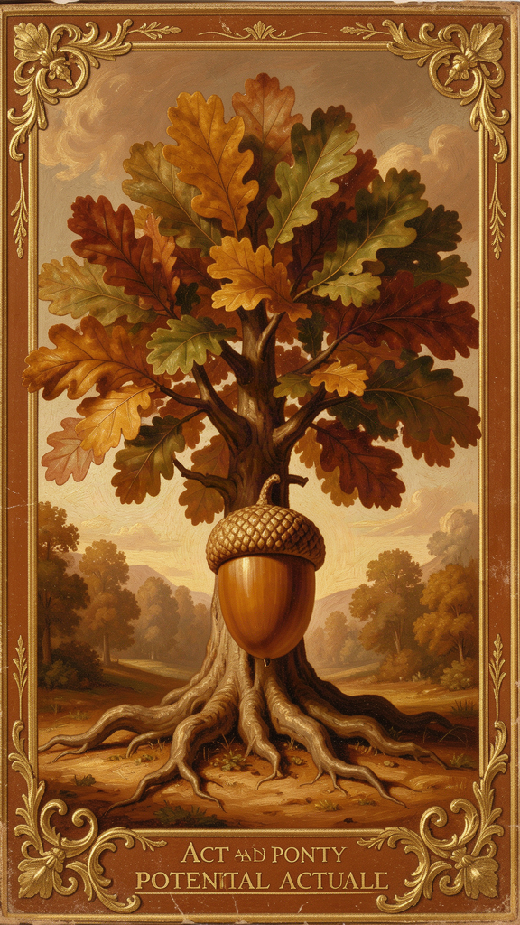
Illustration for Chapter 2
![Chapter 2](/images/booklets/thomas-aquinas-adult-ch02.png)

The Most Important Distinction You Have Never Heard Of
Act and potency are the conceptual foundation of Aquinas's entire metaphysics. Without them, you cannot understand the Five Ways, the real distinction between essence and existence, the analogy of being, or the account of creation. They are not a technical add-on. They are the lens through which Aquinas sees reality.
The distinction comes from Aristotle, but Aquinas develops it in ways that go beyond anything Aristotle explicitly said. He extends it from physical substances to intellectual operations, from finite beings to God, from change to creation itself. The result is a metaphysical framework that attempts to explain the most basic features of reality: why things change, why they are limited, and what it means to be fully real.

The Basic Framework
Act (actus, energeia) is what something actually is. A hot stove is actually hot. A person who knows French is actually knowing it. Act is present reality — the state of being fully realized in a given respect.
Potency (potentia, dynamis) is what something could be but is not yet. A cold stove could be hot — it has the capacity for heat. A student could learn French — they have the capacity for knowledge. Potency is a real but not-yet-actual dimension of a thing.
The key insight: every finite reality is a mixture of act and potency. A cold stove is actually a stove but potentially hot. A student is actually a person but potentially knowledgeable. The world is not made of static, finished things. It is made of things in the process of becoming what they can be.

Why This Matters
Act and potency explain four things that require explanation.
Change. Change is the actualization of potency. When a cold stove becomes hot, the potency for heat (which was real but not actual) becomes actual. Change is not something coming from nothing — it is something potential becoming something actual. This solves a problem that puzzled the pre-Socratics: how can something become what it is not without ceasing to be what it is? The stove does not stop being a stove when it becomes hot. The heat was already there as a potency, waiting to be actualized. The form of the stove persists through the change; what changes is its accidental quality (temperature).
Limitation. Every finite thing is limited by its potencies. A stone cannot see because sight is not one of its potencies. A human cannot breathe underwater because aquatic respiration is not one of our capacities. To be finite is to be a mixture of act and potency — actual in some respects, potential in others. A thing with no potency would have no limits. It would be pure act. This is the basis for the identification of God as pure act: God has no limits, not because God is "infinite" in a quantitative sense, but because God has no unrealized potential.
The First Way. The First Way (ST I, Q.2, A.3) depends on act and potency. If whatever is in motion (actualizing potency) is put in motion by something already actual, then there must be a first mover that is pure act — actualized by nothing, actualizing everything. The act/potency distinction is not a side note. It is the metaphysical engine of Aquinas's most famous argument. Without the distinction, the First Way is a chain of causes that might be infinite. With the distinction, the chain is a series of actualizations of potency, each requiring an actualizer, and the series cannot be infinite because each member depends on a prior member here and now.
Creation. Creation is not a change. Change is the actualization of a potency that already exists. Creation is the giving of existence to something that had no prior potency to exist — the transition from non-existence to existence, not from potency to act. This is why creation requires a cause that is not just actual but ipsum esse (being itself). Nothing can create itself, because creation is the giving of existence, and nothing can give itself what it does not yet have. The distinction between creation and change is crucial: it explains why the First Way (which concerns change) and the Second Way (which concerns existential dependence) are distinct arguments addressing distinct features of reality.

The Hierarchy of Actuality
Aquinas sees reality as a spectrum from maximum potency to pure act:
| Level | Description | Example | |-------|-------------|---------| | Prime matter | Pure potency — no form at all | The substratum that can become any physical thing | | Matter informed by form | Act and potency mixed | A human body (actual shape, potential for change) | | Plants | More actual than bare matter, less than animals | Actual life, potential for sensation | | Animals | More actual than plants, less than humans | Actual sensation, potential for understanding | | Humans | Act and potency in intellect | Actual understanding, potential for more knowledge | | Angels | Intellect without matter — more actual than humans | Actual understanding, no bodily potential | | God | Pure act — no potency at all | Fully actual, no potential, no limitation |
This hierarchy is not a value judgment in the modern sense. It is a metaphysical description — each level is more actual (more fully realized, less dependent on external actualizers) than the level below it. The hierarchy is also not a temporal sequence: Aquinas does not claim that plants evolved into animals into humans. The hierarchy is ontological, not chronological. It describes degrees of actuality, not stages of development.

Key Distinctions
Active potency vs. passive potency. Active potency is the power to do something — the power to heat, to know, to build. Passive potency is the capacity to receive something — the capacity to be heated, to be taught. God has no passive potency (God cannot be acted upon or changed — divine impassibility) but infinite active potency (God can do all things that are possible). This distinction matters for the doctrine of divine simplicity: if God had passive potency, God could be changed, which would mean God depends on something else, which would mean God is not God.
First act vs. second act. First act (prima actio) is the possession of a form or capacity — having the power of sight. Second act (secunda actio) is the exercise of that capacity — actually seeing. God is pure first act and pure second act simultaneously. There is no gap between God's possessing a perfection and God's exercising it. In creatures, the gap is real: you can have the capacity to play piano (first act) without currently playing (second act). In God, this gap does not exist. God's knowledge is not a capacity that God exercises; it is an eternal act. God's love is not a disposition that God actualizes; it is an eternal reality.

Common Misunderstandings
"Potency is just possibility." No. Potency is not logical possibility ("it could happen"). Potency is a real feature of a thing — a cold stove's potency for heat is not just a logical possibility but a real capacity grounded in the stove's nature. A stone's inability to see is not just a logical fact — it is a real absence of a real potency. The difference matters: logical possibility is a feature of our descriptions; potency is a feature of things. This is a claim about the structure of reality, not about the logic of our concepts.
"Act and potency are just form and matter." Form and matter are one way of understanding act and potency in physical substances (form is act, matter is potency). But act and potency apply more broadly — to intellect (knowledge in act vs. knowledge in potency), to being (existence as act, essence as potency), and to God (pure act, no potency). Form and matter are a case of act and potency, not identical with them. Reducing act and potency to form and matter would miss the distinction's application to spiritual realities, to operations, and to God.
"God as pure act means God is static." No. Pure act does not mean "static" or "unchanging" in the sense of inertness. It means fully realized, completely actual, without unrealized potential. God is more active than any finite thing — but God's activity is not the actualization of a prior potency. It is the pure, complete actuality of being itself. God does not need to become anything. God is already everything God can be. This is not inertness; it is the perfection of activity. The contrast is not between "active" and "static" but between "becoming" and "being."

Why This Matters for Modern Philosophy
Process philosophy. Whitehead's process metaphysics is, in effect, a rejection of act and potency. Where Aquinas says reality is a mixture of act and potency oriented toward pure act, Whitehead says reality is always in process, always becoming, never purely actual. For Whitehead, even God is in process — God grows with the world. The debate between Aquinas and Whitehead is one of the fundamental alternatives in metaphysics: is reality ultimately static (oriented toward pure act) or ultimately dynamic (always in process)? The Thomist response is that process requires a ground — things can only become because they have potencies, and potencies can only be actualized by something actual. Pure process without any actuality would be indeterminate change without direction.
Analytic metaphysics. Contemporary debates about modality (possible worlds, necessity, contingency) are, at bottom, debates about potency. What does it mean to say something "could" be otherwise? Aquinas's answer — that potency is a real feature of things, not just a logical description — remains a live option. David Lewis's counterpart theory, which analyzes modality in terms of possible worlds, is a sophisticated alternative. The debate between Thomistic potency and Lewisian possible worlds is one of the liveliest intersections of medieval and contemporary metaphysics. The Thomist can argue that possible worlds are a useful tool for analyzing modality but that the ontological ground of modality is potency — a real feature of actual things, not a separate realm of existing worlds.
Philosophy of mind. The act/potency distinction provides a framework for understanding consciousness that avoids both dualism and reductionism. Consciousness is the act of an intellect that has the potency for knowledge. This is not a substance separate from the body (dualism) nor is it reducible to brain activity (reductionism). It is the actualization of a potency grounded in the whole human being — the rational soul. The soul is the form of the body (ST I, Q.76), and the act of understanding is the act of the person, not of a separate mental substance. This position avoids the mind-body problem by rejecting the framework that generates it: there is no "mental substance" distinct from "physical substance." There is one substance — the human being — whose operations include both physical activities (walking, digesting) and intellectual activities (thinking, willing).

Big Idea
Act and potency are the fundamental metaphysical distinction. Act is what something actually is; potency is what it could be but is not yet. Every finite thing is a mixture of both. Change is the actualization of potency. God alone is pure act — fully realized, complete, without unrealized potential. This distinction grounds the First Way, the account of creation, the hierarchy of being, and the doctrine of divine simplicity. It remains a live option in contemporary debates about modality, process, and consciousness.

Practice
1. Map the hierarchy. Aquinas describes a hierarchy from prime matter (pure potency) to God (pure act). Place five things on this spectrum — a rock, a plant, a dog, a human, an angel (if you accept the concept). For each, identify what is actual and what is potential. Where does the greatest "gap" between act and potency appear? Is the hierarchy a hierarchy of value, of dependence, or of both?
2. Distinguish active and passive potency. For each of the following, identify the active potency (power to do) and the passive potency (capacity to receive): a teacher, a student, a fire, a lump of clay. Now apply the distinction to God: what active potencies does God have? What passive potencies does God lack? Why does the absence of passive potency matter for divine impassibility? What would change if God had passive potency?
3. Explain creation. Aquinas says creation is not a change. Change is the actualization of an existing potency. Creation is the giving of existence to something with no prior potency to exist. Explain this distinction in your own words. Why does it matter? What would go wrong if creation were just another kind of change? How does the distinction between creation and change affect the doctrine of divine simplicity?
4. Engage the Whiteheadian objection. Whitehead says reality is always in process, never purely actual. Construct the strongest version of this objection to Aquinas. Then construct Aquinas's response. Is process possible without actuality? Can things "become" unless something is already actual? What is the relationship between the Thomistic and process metaphysical frameworks — are they competitors, complements, or incommensurable?
5. Evaluate the analytic debate. David Lewis analyzes modality in terms of possible worlds — concrete, existing worlds just like ours but causally isolated. Aquinas analyzes modality in terms of potency — a real feature of actual things. Which account is more ontologically economical? Which is more explanatorily powerful? Can the two accounts be reconciled, or must we choose between them?

Reflect
Aquinas says everything in the world is a mixture of act and potency, and God alone is pure act. But what about human consciousness? When you are actively thinking, your mind seems to be fully actual — and yet you can always think more, understand more deeply, shift your attention. Is consciousness a mixture of act and potency? Is there any state of human consciousness that is "pure act"? Or is the very fact that we can always know more evidence that we are always, in this life, a mixture? And if the beatific vision is the one state in which the human intellect is fully actualized, what does that imply about the relationship between knowledge, limitation, and fulfillment?
———
———

Chapter 3: Essence and Existence — What Something Is vs. That It Is
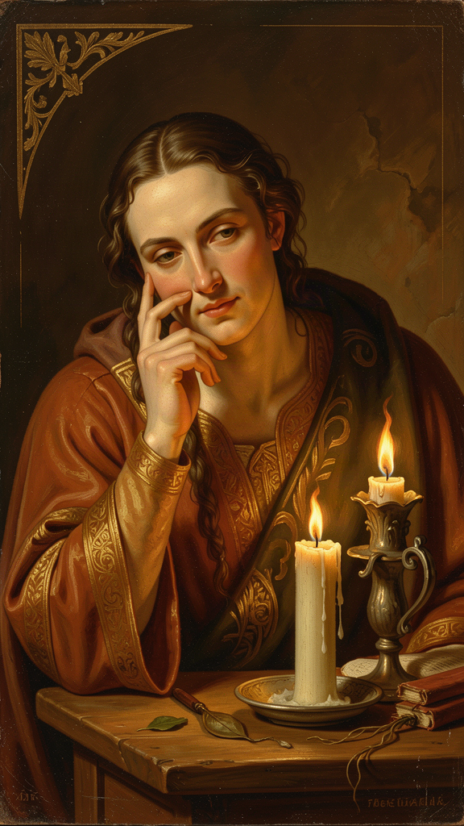
Illustration for Chapter 3
![Chapter 3](/images/booklets/thomas-aquinas-adult-ch03.png)

The Metaphysical Heart of the System
The distinction between essence and existence is the metaphysical heart of Aquinas's entire system. It is the key to his natural theology, his account of creation, his understanding of divine simplicity, and his theory of analogy. If act and potency are the framework, the essence/existence distinction is the foundation.
The core claim: in every created being, what a thing is (its essence) is really distinct from that it is (its existence). In God alone, essence and existence are identical. God is ipsum esse subsistens — subsistent being itself.
This is not an abstract technicality. It is Aquinas's answer to the most fundamental metaphysical question: what does it mean for something to exist?

The Two Dimensions of Reality
Essence (essentia, quidditas) is "what a thing is." It is the nature, the definition, the "whatness" of a thing. The essence of a human being is rational animality. The essence of a triangle is a three-sided plane figure. The essence of fire is hot, dry, luminous. Essence answers: What is this?
Existence (esse, actus essendi) is "that a thing is." It is the act of being — not a property a thing has, but the act by which a thing is. A human being exists (or does not). A triangle exists (or does not). Fire exists (or does not). Existence answers: Is this?
The crucial point: essence and existence are not two parts of a thing, like body and soul. They are not two properties, like redness and roundness. They are two different dimensions of reality. Essence is what a thing is. Existence is that it is. A thing's essence does not include its existence — you can know what a unicorn is without knowing whether unicorns exist. This is not a trivial point about fictional entities. It is a claim about the structure of reality: the "what" and the "is" are distinct, and the distinction is real, not merely conceptual.

The Real Distinction
Aquinas's claim is not just that essence and existence are different concepts. His claim is that in created beings, they are really distinct — different in reality, not just in our thinking.
The argument, from De Ente et Essentia (On Being and Essence), Ch. 4–5:
1. In any created being, you can understand its essence without knowing whether it exists. You can know what a phoenix is without knowing whether phoenixes exist. (This shows that essence and existence are at least conceptually distinct.) 2. If essence and existence were identical in a created being, that being would exist by its own essence — it would be self-existent. (This is because if essence just is existence, then having the essence would entail having the existence.) 3. But no created being is self-existent. All created beings depend on something else for their existence. (This is established by the Third Way and by the act/potency framework.) 4. Therefore, in every created being, essence and existence are really distinct. (The distinction is not just conceptual; it is real, because if it were merely conceptual, the being would be self-existent, which it is not.)
What this means: a created being is not its own existence. It has existence — it participates in being — but it is not identical with being. Its existence is received, not self-generated. The act of existing is given to it by something else — ultimately by God, who is existence itself.
The analogy: think of light. A lit candle has light, but the candle is not identical with the light. The light is received from a source (the flame). In the same way, every created being has existence, but existence is not part of its essence — it is received from a source. The source is God, who is ipsum esse subsistens.

God: Where Essence and Existence Are Identical
If in every created being essence and existence are distinct, then in a being whose essence and existence are identical, that being would be self-existent. Its essence would be existence.
This is what Aquinas says about God. God is ipsum esse subsistens — not "a being that exists" but "existence itself." God does not have existence. God is existence. God's essence is to exist. This is stated at ST I, Q.3, A.4: God's existence is God's essence.
This follows from the logic of the real distinction:
- If essence and existence are distinct in every created being. - And if there must be a ground for the existence of created beings (a being that does not receive existence but is existence). - Then there must be a being whose essence and existence are identical. - And this being is what we call God.
The philosophical point is striking. God is not "a being" among other beings. God is not "the biggest being" or "the most powerful being." God is being itself — the act of existing in which all other beings participate. This is why Aquinas says God is not in a genus (ST I, Q.3, A.5). God is not a being. God is ipsum esse. This is also why Aquinas says that God is not adequately described by any name that applies to creatures. When we say "God is good," we are speaking analogically, not univocally (ST I, Q.13, A.5).

Why This Matters
The essence/existence distinction grounds four of Aquinas's most important arguments.
The Third Way. The Third Way (ST I, Q.2, A.3) argues from contingency to necessity. The essence/existence distinction explains why created beings are contingent: because their essence does not include existence, their existence depends on something else. A being whose essence includes existence would be necessary — it would exist through itself, not by dependence. The Third Way and the essence/existence distinction are two ways of making the same point: created beings are contingent because they receive existence; God is necessary because God is existence.
Creation. If existence is distinct from essence in created beings, then the act of creation is the act of causing existence — giving esse to a thing that did not have it. This is why creation is ex nihilo (from nothing): the existence of the creature is not derived from any pre-existing essence, but is given directly by God. Creation is not making something out of something else. It is giving existence itself. This is also why creation is not a change (see Chapter 2): change is the actualization of an existing potency, while creation is the giving of existence where there was no prior potency to receive it.
Divine simplicity. If God's essence is identical with God's existence, then God has no composition — no parts, no potentiality, no distinction between what God is and that God is. This is the foundation of divine simplicity (ST I, Q.3), the cornerstone of Aquinas's entire account of God. God is not made of parts. God is one, simple, complete act of being. Divine simplicity follows directly from the real distinction: if God's essence is God's existence, then there is no distinction within God between what God is and that God is, and therefore no composition. Everything that can be said of God — God's goodness, God's power, God's knowledge — is identical with God's existence, because God's essence is God's existence.
Analogy. If God is ipsum esse and creatures have esse, then we cannot speak of God and creatures univocally (using words in exactly the same sense) or equivocally (using words in completely different senses). We must speak analogically — there is a real but proportional similarity between God's goodness and the goodness we experience. This is the subject of the analogy of being (analogia entis), treated at ST I, Q.13. The analogy of being is a consequence of the real distinction: because God is being itself and creatures have being, the word "good" applied to God and the word "good" applied to a creature are neither identical in meaning (univocal) nor unrelated in meaning (equivocal). They are analogically related — connected by a real but proportional similarity grounded in the causal relationship between God and creatures.

The Interpretive Debate
The nature of the "real distinction" is one of the most contested questions in Thomistic scholarship. Three main positions have competent defenders.
The Real Distinction (Gilson, Fabro). Essence and existence are really distinct in creatures — two different principles of being, not just two concepts. Existence is the act of essence; essence is the potency for existence. This is the most common Thomist reading. On this view, the distinction is a real metaphysical composition in creatures — they are "made of" essence and existence, though not in the way a physical object is made of parts. The distinction is between two metaphysical principles that together constitute the creature. Gilson defended this reading with particular force, arguing that it is the key to Aquinas's entire metaphysics and that weakening it (as Cajetan does) undermines the distinctiveness of Thomistic metaphysics.
The Conceptual Distinction (Cajetan, some Thomists). Essence and existence are really identical in creatures but conceptually distinct. They differ in our thinking, not in reality. This preserves the distinction without committing to a metaphysical composition in creatures. On this view, the distinction is a distinction of reason, not of reality. Cajetan, the great Renaissance commentator on Aquinas, defended this reading, arguing that the real distinction would introduce an untenable composition into creatures and that Aquinas's language about essence and existence is better read as describing two aspects of a single reality rather than two distinct principles.
The Moderate Real Distinction (Wippel, some analytic Thomists). Essence and existence are really distinct, but the distinction is not between two "things" or "principles" that could exist separately. The distinction is between a thing's nature and the act by which it exists — real but non-separable. This is a middle position that tries to preserve the reality of the distinction without the metaphysical baggage of the Gilson reading. Wippel, one of the most careful contemporary scholars of Aquinas, defends this reading, arguing that it captures what Aquinas actually says without forcing it into either the Gilson or Cajetan framework.
Each position has philosophical merits, and each has been defended by competent scholars. The debate is not about whether Aquinas holds the distinction (all agree he does), but about what kind of distinction it is — whether it is a real composition in creatures, a distinction of reason, or something in between. The debate matters because it affects how we understand divine simplicity, creation, and the analogy of being. If the distinction is merely conceptual (Cajetan), divine simplicity follows easily but the metaphysical richness of creation is diminished. If the distinction is real (Gilson), creation is metaphysically rich but divine simplicity requires more argument. The moderate position (Wippel) tries to have both.

The Analogia Entis Debate
The analogy of being — the consequence of the real distinction for how we speak about God — is one of the most contested ideas in twentieth-century theology. The key dispute is between Karl Barth and Erich Przywara.
Karl Barth (against analogy). Barth, the great Protestant theologian, rejected the analogia entis as "the invention of Antichrist" (Church Dogmatics II/1). For Barth, the only way we can speak of God is through God's self-revelation in Christ (analogia fidei — analogy of faith). Any attempt to reason from creation to God is, for Barth, a form of natural theology that undermines the radical otherness of God's revelation. Barth sees the analogia entis as a philosophical bridge between God and creation that reduces God's transcendence — as if we could climb to God by reasoning about being.
Erich Przywara (for analogy). Przywara, a Jesuit theologian, defended the analogia entis as the fundamental structure of Christian thought. For Przywara, analogy is not a technique for bridging the gap between God and creation — it is the recognition that the gap is real but not absolute. Creation really reflects God, but it does so imperfectly. Analogy preserves both God's transcendence (God is not reducible to creation) and God's immanence (God is really present in creation). The analogia entis is not a ladder from earth to heaven; it is a description of the relationship between heaven and earth that God has established.
The philosophical question. Beyond the theological debate, there is a philosophical question: can we use human language to speak about ultimate reality without reducing it to our categories? Aquinas's analogy is one answer. Others include apophatic theology (saying what God is not), symbolic theology (using symbols rather than concepts), and silence (acknowledging the limits of language altogether). The debate between these approaches is one of the liveliest in contemporary philosophy of religion.

For Modern Readers
The essence/existence distinction raises questions that are still live in contemporary philosophy.
What is existence? Is existence a property (like redness) or an act (like running)? Aquinas says it is an act — the most fundamental act of any being. This contrasts with the Fregean view that existence is a second-order property (a property of concepts, not of objects). For Frege, to say "God exists" is to say that the concept "God" is instantiated, not to attribute a property to God. For Aquinas, to say "God exists" is to say that God is performing the act of existing — and since God's essence is God's existence, this is to say that God is ipsum esse. The debate between these views is still alive in analytic metaphysics.
Why is there something rather than nothing? If essence does not include existence, then the existence of any being requires an explanation. The question "why does anything exist?" is not meaningless — it points to the distinction between what things are and that they are. This question, which Aquinas takes seriously, is one that many modern philosophers (following the logical positivists) dismissed as meaningless. It has returned to prominence in contemporary metaphysics, particularly in the work of philosophers like Derek Parfit and Peter van Inwagen, who have argued that the question is both meaningful and important.
Can we conceive of existence? If existence is not a concept but an act, then we cannot grasp existence by thinking alone — we must experience it. This connects to existentialist themes (Heidegger, Marcel) while remaining grounded in a metaphysical framework. Heidegger's question about the "meaning of being" (Sein) is, in a sense, a radicalization of Aquinas's question about esse. The difference is that Heidegger rejects the metaphysical framework (essence, existence, act, potency) within which Aquinas works, while Aquinas sees that framework as necessary for asking the question coherently.

Big Idea
In everything that exists, what it is (essence) is really distinct from that it is (existence). Everything receives existence from something else; nothing is its own existence. But God is different. God does not receive existence. God is existence — ipsum esse subsistens. This distinction grounds the Third Way, the account of creation, divine simplicity, and the analogy of being. The debate over what kind of distinction it is (Gilson's real distinction, Cajetan's conceptual distinction, Wippel's moderate distinction) remains open, and the analogia entis debate between Barth and Przywara remains one of the liveliest in theology.

Practice
1. Test the distinction. For each of the following, separate the essence from the existence: a horse, a mathematical triangle, a character in a novel, the number seven, your best friend, a possible but non-actual state of affairs. Which of these have an essence that can be understood without knowing whether they exist? Which have an essence that includes existence? What does this tell you about the scope of the distinction?
2. Trace the argument. Reconstruct the argument from De Ente et Essentia for the real distinction. Identify each premise and the conclusion. Where is the argument most vulnerable? What would a critic attack first? How would a defender of the argument respond?
3. Evaluate the interpretive debate. The three positions (Gilson's real distinction, Cajetan's conceptual distinction, Wippel's moderate distinction) disagree about what kind of distinction Aquinas holds. Choose one position and defend it against the other two. What is at stake philosophically? Does it matter whether the distinction is "real" or "conceptual" for the arguments that depend on it (the Third Way, creation, divine simplicity, analogy)?
4. Engage the Barth-Przywara debate. Barth rejects the analogia entis as "the invention of Antichrist." Przywara defends it as the fundamental structure of Christian thought. Construct the strongest case for each side. Is the analogia entis a philosophical bridge that reduces God's transcendence (Barth), or a recognition of the real but imperfect relationship between God and creation (Przywara)? Can you find a third position?
5. Consider the existentialist challenge. Heidegger asks about the "meaning of being" (Sein) and rejects the metaphysical framework (essence, existence, act, potency) within which Aquinas works. Is Heidegger asking the same question as Aquinas (what does it mean to exist?) with different tools, or a fundamentally different question? Can Aquinas's essence/existence distinction survive the Heideggerian critique of ontotheology?

Reflect
Aquinas says God is not "a being" but "being itself" — ipsum esse subsistens. This means God is not the biggest, most powerful thing in the universe. God is not a thing at all, in the way that tables, stars, and humans are things. God is the act of existing itself. How does this change your understanding of the word "God"? Is it easier or harder to believe in "being itself" than in "a supreme being"? What is gained, and what is lost, by thinking of God this way? And if God is being itself rather than a being, what happens to personal language about God — prayer, love, relationship? Can "being itself" hear prayers? Or does this way of thinking about God require a fundamental rethinking of what prayer and relationship mean?
———
———

Chapter 4: Natural Law — Morality Written Into Creation
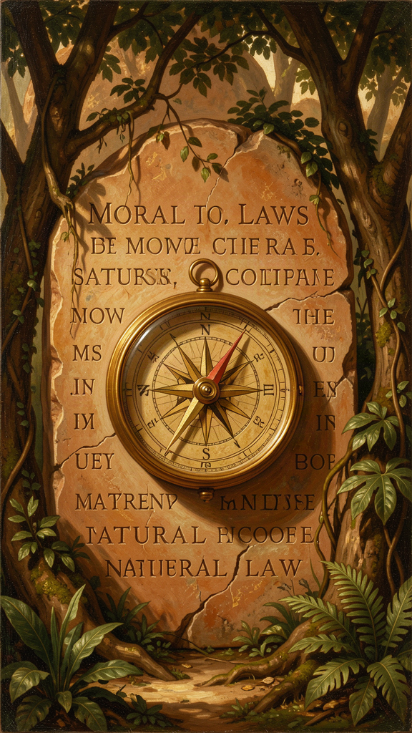
Illustration for Chapter 4
![Chapter 4](/images/booklets/thomas-aquinas-adult-ch04.png)

Law Is Not Just Rules
For Aquinas, law is not whatever a sovereign commands. Law is "an ordinance of reason for the common good, made by him who has care of the community, and promulgated" (ST I-II, Q.90, A.4). This definition is deliberately restrictive. It means that not everything called "law" is actually law. An unreasonable decree, a private statute, or a command from an illegitimate authority may have the form of law but lack its substance.
This definition is the foundation of one of the most influential moral and political theories in the Western tradition. It directly shaped the concept of universal human rights, the American Declaration of Independence, the Nuremberg Principles, and contemporary virtue ethics. Martin Luther King Jr. cited Aquinas on natural law in his "Letter from Birmingham Jail." The question of whether Aquinas's natural law theory can stand without its theological foundations remains one of the most contested issues in contemporary ethics.

The Four Elements of Law
Aquinas's definition contains four essential elements, each of which restricts what counts as law.
An ordinance of reason (*rationis ordinatio*). Law is not arbitrary will. It is a directive of reason. A command that contradicts reason is not a law in the full sense. This is Aquinas's most important claim: law is inherently rational. A tyrant's decree, however enforced, lacks the character of law if it fails the test of reason. This is a substantive claim about the nature of law, not a procedural claim about how laws are made. It means that there is a standard external to the legislator's will — reason — by which laws can be evaluated.
For the common good (*ad bonum commune*). Law is not for the private benefit of the legislator. It must be directed toward the good of the community as a whole. A statute that serves only a narrow interest, contrary to the common good, fails to meet the definition of law. The common good is not the sum of private goods; it is the good of the community as a whole — the conditions that allow all members to flourish.
Made by legitimate authority (*ab eo qui curam communitatis habet*). Only someone with care of the community can make law. This follows from the nature of law as a communal ordinance. Someone without authority has no business legislating for a community they do not represent. The question of what constitutes legitimate authority is one that Aquinas addresses in his political writings, drawing on Aristotle's Politics.
Promulgated (*promulgata*). A law no one knows about is not a law in practice. Law must be made known to those it binds. This anticipates the legal principle that ignorance of the law is no excuse only when the law has been properly promulgated. A secret law is not a law.

The Four Kinds of Law
Aquinas identifies four kinds of law, organized hierarchically.
Eternal Law (Lex Aeterna, ST I-II, Q.93) is God's plan for the entire universe — the rational order by which all creation is directed toward its proper end. "The rational ordering of all things by God, which is the divine wisdom directing all acts and movements" (ST I-II, Q.93, A.1). Eternal law is not a set of commands imposed from outside. It is the rational structure inherent in creation — the way things are meant to work. God does not "legislate" by issuing arbitrary decrees. God orders creation according to reason. Eternal law governs all creatures, rational and non-rational alike. It is the source of all other law.
Natural Law (Lex Naturalis, ST I-II, Q.94) is what human beings can discover through reason about the right ordering of human life. "The participation of the rational creature in eternal law" (ST I-II, Q.91, A.2). Natural law is not Catholic morality or religious law. It is reason's own discovery of what human flourishing requires.
The first precept: "Good is to be done and pursued, and evil is to be avoided" (ST I-II, Q.94, A.2). This is not a commandment from outside. It is the most basic principle of practical reason — the self-evident starting point from which all moral reasoning proceeds. You cannot argue against it without relying on it, because any argument against pursuing the good implicitly assumes that there is something worth pursuing (which is the good). This is a claim about the structure of practical reason: the first principle of ethics is not a proposition that needs to be proven but a presupposition that is already at work in all reasoning about what to do.
The primary precepts (ST I-II, Q.94, A.2) correspond to the basic inclinations of human nature: 1. Self-preservation — the inclination to preserve one's own life. 2. Reproduction and education of offspring — the inclination to have and raise children. 3. Living in society — the inclination to live in community, pursue truth, and avoid ignorance. 4. Worship of God — the inclination to know the source of one's being.
These precepts are not arbitrary rules. They are the basic inclinations of human nature — what human beings naturally tend toward when functioning properly. Natural law is rational reflection on these inclinations. The inclinations are the data; natural law is the rational interpretation of the data.
Human Law (Lex Humana, ST I-II, Q.95) is the specific legislation communities enact to apply natural law to particular circumstances. Human law derives from natural law in two ways: as conclusions (some laws follow directly, like "do not murder" following from "preserve life") and as determinations (some laws are specific applications, like speed limits or tax rates, determined by the legislator for particular circumstances). Human law varies across societies because different circumstances require different determinations.
Divine Law (Lex Divina, ST I-II, Q.91, A.4) is the law revealed by God in Scripture. It supplements natural law: it makes clear what natural law could discover but has been obscured by sin, and it reveals truths that natural law could not discover on its own (the requirements of salvation, the nature of the beatific vision). Divine law is necessary because human reason has been damaged by sin and needs divine guidance, and because some truths about our ultimate end exceed natural reason.

The Problem of Unjust Laws
Aquinas addresses a question that still matters: must we obey unjust laws?
His answer, at ST I-II, Q.96, A.4, is nuanced. A law is unjust if it meets any of three criteria: it is contrary to the common good (serving private interests), it exceeds the legislator's authority, or it imposes unequal burdens without proportionate reason. An unjust law, Aquinas says, is "a perversion of law" rather than a true law. It does not bind in conscience.
But Aquinas immediately qualifies this. Disobedience may cause greater harm than compliance. In some cases, prudence requires obeying an unjust law to avoid social chaos. The principle is clear — unjust laws lose their binding force — but the application requires practical wisdom. This is not a blanket authorization for civil disobedience. It is a principled framework for evaluating when disobedience is justified and when compliance is prudent.
This passage directly influenced Martin Luther King Jr.'s "Letter from Birmingham Jail." King wrote: "I would agree with St. Augustine that 'an unjust law is no law at all.' ... A just law is a man-made code that squares with the moral law or the law of God. An unjust law is a code that is out of harmony with the moral law." King cited Aquinas by name, drawing on ST I-II, Q.96, A.4, to argue that segregation laws were unjust because they degraded human personality and imposed unequal burdens. The Nuremberg defense — "following orders" — fails for the same reason: orders that violate natural law do not have the force of law.

The New Natural Law Theory
One of the most important developments in contemporary natural law theory is the "new natural law" theory of Germain Grisez, John Finnis, and Robert Boyle. This school rejects the older "inclinational" reading of Aquinas (which grounds natural law in natural inclinations) and replaces it with a "practical reason" reading (which grounds natural law in self-evident practical principles).
The old natural law (inclinational). Natural law is grounded in the natural inclinations of human beings — self-preservation, reproduction, social life, knowledge of God. Morality is rational reflection on these inclinations. This reading, associated with traditional Thomism, sees the inclinations as the data from which natural law is derived.
The new natural law (practical reason). Natural law is grounded in self-evident practical principles — basic goods that are evident to practical reason and cannot be derived from theoretical reason. The basic goods include life, knowledge, play, aesthetic experience, friendship, practical reasonableness, and religion. Morality is the pursuit of these goods in a practically reasonable way. This reading, associated with Finnis and Grisez, sees the goods as starting points for practical reasoning, not as conclusions from theoretical anthropology.
The debate between these readings is one of the most important in contemporary natural law theory. The old reading is more faithful to Aquinas's text (which explicitly grounds natural law in inclinations at ST I-II, Q.94, A.2). The new reading is more philosophically defensible (because it avoids the "is-ought" problem of deriving moral principles from factual inclinations). The question of which reading is "really" Aquinas is complicated by the fact that Aquinas's text supports both readings, depending on which passages are emphasized.

Natural Law Is Not Just Religious Morality
The most common misconception about Aquinas's natural law theory is that it is Catholic morality disguised as philosophy. It is not, and Aquinas insists on this.
Based on human nature, not revelation. The primary precepts are discoverable by reason alone. You do not need to believe in God or read Scripture to discover that human beings have inclinations to preserve life, reproduce, live in society, and seek truth.
Accessible to everyone. Aquinas explicitly says the general precepts are known to all people, regardless of religious belief (ST I-II, Q.94, A.2). Specific applications may vary across cultures, but the general framework is universal.
Compatible with secular reasoning. Modern natural law theorists like John Finnis and Robert George have developed natural law theory in a secular context, without relying on theological premises. Whether this secular development is faithful to Aquinas's intentions is debated, but it shows that natural law is not inherently religious. The question of whether natural law can stand without its theological foundation (eternal law, divine law) is one of the most contested in contemporary ethics.
Not a list of prohibitions. Natural law is not primarily about what you cannot do. It is about what human flourishing requires — the positive inclinations toward life, knowledge, society, and meaning that are built into human nature.

The Hierarchy of Precepts and the Problem of Clouded Reason
Natural law has a hierarchy. The most general precepts — preserve life, do good, avoid evil — are known to everyone. More specific precepts — the wrongness of theft, the requirements of justice — require more careful reasoning and can be obscured by passion, bad habit, or cultural distortion. The most specific applications — speed limits, tax rates, property regulations — vary across cultures and circumstances.
Aquinas explicitly acknowledges (ST I-II, Q.94, A.4) that practical reason can be clouded. He does not claim that every person knows every precept of natural law. What is universal is the general framework, not every specific conclusion. This is a crucial nuance: natural law is not a claim about universal moral agreement, but a claim about the structure of practical reason. The framework is accessible to all; the details require judgment and are fallible. This nuance is often missed by both defenders and critics of natural law: defenders sometimes claim more universal agreement than Aquinas does, and critics sometimes attack natural law by pointing to moral disagreement that Aquinas himself acknowledges.

Big Idea
For Aquinas, law is not whatever a ruler commands. It is an ordinance of reason for the common good, made by legitimate authority, and promulgated. There are four kinds of law: eternal (God's rational ordering of creation), natural (reason's participation in eternal law), human (specific legislation applying natural law), and divine (revelation supplementing natural law). Natural law is grounded in human nature, accessible to reason, and not inherently religious. Unjust laws lose their binding force because they fail to meet the definition of law. The new natural law theory (Grisez, Finnis) offers a practical-reason reading that differs from the traditional inclinational reading.

Practice
1. Apply the four elements. Pick three laws in your country — one you agree with, one you disagree with, and one you are unsure about. Apply Aquinas's four criteria to each: Is it an ordinance of reason? Does it serve the common good? Does it come from legitimate authority? Is it promulgated? Which laws pass all four tests? Which fail?
2. Test the first precept. Aquinas says "good is to be done and pursued, and evil is to be avoided" is self-evident. Try to argue against it. What happens? Can you argue that good should be avoided without implicitly assuming that there is something worth pursuing? What does this tell you about the status of the first precept? Is it self-evident in the same way that the law of non-contradiction is self-evident, or in a different way?
3. Evaluate the new natural law. The Finnis-Grisez school grounds natural law in self-evident practical principles (basic goods) rather than in natural inclinations. Which reading is more faithful to Aquinas? Which is more philosophically defensible? Can the two readings be reconciled, or must we choose between them?
4. Trace the influence. Aquinas's natural law theory influenced the American Declaration of Independence ("the laws of Nature and of Nature's God"), the Nuremberg Principles, and Martin Luther King Jr.'s "Letter from Birmingham Jail." Pick one of these and identify the specific Aquinas-derived elements. How does the historical document use Aquinas's framework? What does the use reveal about the adaptability of natural law theory?
5. Consider the secular challenge. Can natural law stand without its theological foundation (eternal law, divine law)? If natural law is grounded in human nature, does it need God? Or does the grounding in "the basic inclinations of human nature" already presuppose a view about what human nature is and where it comes from? What is at stake in the debate between secular and theological natural law?

Reflect
Aquinas says natural law is based on "the basic inclinations of human nature" — self-preservation, reproduction, social life, and the search for God. But what if human nature is more complex or more varied than Aquinas assumed? What if some people do not have all these inclinations? Does natural law assume a "normal" human being? And who gets to decide what counts as "natural"? Is this a problem for the theory, or can natural law accommodate variation in human nature without collapsing? What would Aquinas say about the challenge from evolutionary psychology, which explains moral intuitions as adaptations rather than as reflections of a rational order?
———
———

Chapter 5: Faith and Reason — Two Wings of Truth
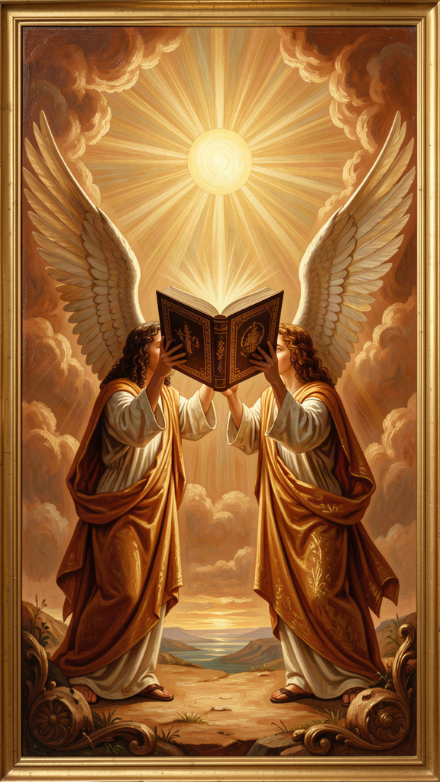
Illustration for Chapter 5
![Chapter 5](/images/booklets/thomas-aquinas-adult-ch05.png)

Not Enemies, But Partners
Aquinas's account of the relationship between faith and reason is one of his most enduring contributions — and one of the most misunderstood. He does not subordinate reason to faith. He does not subordinate faith to reason. He argues that faith and reason are two sources of truth that cannot genuinely contradict each other, because both come from God.
The image, borrowed from Pope John Paul II's Fides et Ratio (which draws on Aquinas), is of two wings. A bird needs both to fly. Reason without faith is incomplete. Faith without reason is credulous. Together, they give the full picture.

The Core Argument
Aquinas's foundational principle, at ST I, Q.1, A.1: "Since truth cannot be contrary to truth, the truth of reason is not contrary to the truth of the Christian faith." If reason discovers a truth (through observation, logic, or argumentation) and faith reveals a truth (through Scripture or tradition), these two truths cannot contradict each other — because both come from God, and God does not contradict himself.
The implication: if there appears to be a contradiction between faith and reason, one of three things has gone wrong. The reasoning is flawed (we made a mistake in our argument). The interpretation of faith is flawed (we misunderstood what revelation teaches). Or both need correction. What is not possible is that genuine faith and genuine reason contradict each other.
This principle has a radical consequence: theology must answer to philosophy, and philosophy must answer to theology. Both disciplines are accountable to the same standard: truth. A theological claim that contradicts philosophical truth must be re-examined. A philosophical claim that contradicts revealed truth must be re-examined. Neither discipline is autonomous. Both are servants of truth. This is not a subordination of one to the other. It is a mutual accountability grounded in the unity of truth.

Two Orders of Truth
Aquinas distinguishes two orders of truth.
| Feature | Natural Reason | Faith | |---------|---------------|-------| | Source | Human observation and logic | Divine revelation | | Scope | What can be discovered by human power | What God has revealed | | Accessibility | Available to everyone | Requires acceptance of revelation | | Certainty | Proportional to the strength of the argument | Based on the authority of the revealer | | Examples | God's existence, natural law, the structure of reality | The Trinity, the Incarnation, the beatific vision |
There is overlap. Some truths are in both orders — God's existence, the basic principles of morality. These can be known by reason alone, but faith confirms them and provides additional motivation for pursuing them. The Five Ways demonstrate God's existence by reason; Scripture reveals God's existence by faith. These are not two different truths. They are the same truth, known through two channels. The overlap is important because it shows that faith and reason are not separate domains with no common ground — they share truths and can mutually enrich each other.
Some truths are above reason, not against reason. The Trinity, the Incarnation, the resurrection of the body — these exceed the capacity of natural reason but are not contrary to it. Aquinas is not saying that faith requires believing irrational things. He is saying that some truths are beyond what reason can prove, but consistent with reason. The Trinity is not illogical. It is simply not the kind of thing that logic could discover on its own. Reason can show that the doctrine is not contradictory (it does not violate the law of non-contradiction), but it cannot prove it (it cannot establish the doctrine from premises that do not already assume it).

Faith Is Not Irrational
Faith, for Aquinas, is not blind belief. It is voluntary assent to truths that are supported by evidence (miracles, the authority of the Church, the coherence of the system) but not proved by that evidence. Faith goes beyond reason, but it is not against reason.
The analogy: you might trust a friend's testimony about something you have not seen yourself. Your trust is not irrational — it is based on your friend's reliability. But it goes beyond what you could prove on your own. If your friend has always been honest, and they tell you they saw something remarkable, it is reasonable to believe them. It is not a proof, but it is not irrational. Faith, for Aquinas, is like this: reasonable trust in a reliable source (God), not a leap into the dark.
This means faith involves both intellect and will. The intellect sees the evidence (miracles, coherence, authority). The will chooses to assent, going beyond what the evidence strictly proves. Faith is not the intellect being overridden. It is the intellect and will working together, responding to evidence that falls short of proof but is sufficient for trust. This is a sophisticated account of the epistemology of faith: faith is not knowledge (which is compelled by evidence) and it is not opinion (which is not committed). It is a distinct cognitive act — voluntary assent to truths supported but not proved by evidence.

The Averroist Challenge
Aquinas's position was not uncontroversial in his own time. The Averroists (followers of the Arabic philosopher Averroes) argued for the "double truth" theory: that a proposition could be true in philosophy and false in theology, or vice versa. On this view, reason and faith are two separate tracks that never meet.
Aquinas explicitly rejected this (SCG I, Ch. 7; ST I, Q.1, A.1). There is only one truth, and it cannot contradict itself. If reason and faith appear to contradict, the contradiction is in our understanding, not in reality.
This position was controversial because it meant theology had to answer to philosophy — theological claims had to be consistent with philosophical truth. And it meant philosophy had to answer to theology — philosophical claims could not contradict revealed truth. Both disciplines were accountable to the same standard: truth. The 1277 Condemnations, in which Bishop Tempier condemned 219 propositions (some associated with Averroism and some misattributed to Aquinas himself, who had died in 1274), show how contentious the faith-reason relationship was in Aquinas's time — and how easily a position that tried to honor both sides could be misread.

Why This Matters
The science-and-religion debate. Aquinas provides a framework for resolving the apparent conflict between science and religion. They are not in competition because they address different questions. Science asks how the natural world works. Faith asks what is the ultimate meaning and purpose of existence. These questions can overlap, but they are not the same question. When a specific scientific claim and a specific religious claim conflict, Aquinas would say one or both interpretations need correction — not that science and faith are inherently opposed. This framework avoids both the conflict thesis (science and religion are at war) and the NOMA thesis (science and religion are completely separate domains). It allows for overlap and mutual correction while maintaining the integrity of both disciplines.
The limits of reason. Aquinas's position is not irrationalism. It is an acknowledgment that reason has limits. Some truths exceed reason's power — not because they are irrational, but because they are about realities that reason cannot access on its own. This is a philosophical claim about the scope of human rationality, not a theological claim about what God has revealed. Reason can discover its own limits without faith's help; faith confirms what reason suspects. The recognition that reason has limits is itself a rational achievement — it is reason acknowledging its own boundaries.
The relationship between philosophy and theology. Aquinas's position allows philosophy to have its own domain and methods while acknowledging that theology addresses questions philosophy cannot answer on its own. This is a middle way between rationalism (reason can answer all questions) and fideism (reason has no role in theology). Philosophy and theology are not the same discipline, but they are not at war. They are partners in the pursuit of truth.
Intellectual humility. The faith-reason relationship models a form of intellectual humility that is relevant beyond theology. Reason should acknowledge its limits. Faith should engage with reason rather than dismiss it. Both should be open to correction. The model is not a power struggle but a partnership in which both partners are accountable to truth. This is a model for interdisciplinary dialogue more generally: different disciplines can address the same questions from different perspectives without either subordinating the other.

Big Idea
Faith and reason are not enemies. They are two sources of truth that cannot contradict each other, because both come from God. Reason can discover some truths on its own (God's existence, natural law, the structure of reality). Faith reveals truths that reason could not discover (the Trinity, the Incarnation). Some truths are above reason, not against it. The task is to hold both together, letting each correct and enrich the other. This requires intellectual humility from both sides. The Averroist "double truth" is rejected; the 1277 Condemnations show how contentious the faith-reason relationship was in Aquinas's time.

Practice
1. Map the two orders. Make a list of ten truths. For each, decide: is it discoverable by reason alone, by faith alone, or by both? Where does each truth fall on Aquinas's framework? Are there truths that resist this classification? What would you do with a truth that seems to be in neither order?
2. Analyze a conflict. Identify a historical or contemporary conflict between a scientific claim and a religious claim (the Galileo affair, the age of the Earth, evolutionary theory, the Big Bang). Apply Aquinas's framework: is the conflict a bad interpretation of faith, a bad interpretation of science, or both? What would Aquinas's method recommend? How does his framework differ from both the conflict thesis and the NOMA thesis?
3. Evaluate the analogy. Aquinas compares faith to trusting a reliable friend. Is this analogy adequate? What are its strengths and weaknesses? How does it handle the problem of religious disagreement (different people trust different "friends" — different religious traditions, different authorities)? Does the analogy scale from interpersonal trust to religious faith?
4. Test the double truth. Aquinas rejects the Averroist "double truth" theory. But is there a modern version of double truth — a claim that something can be true in science and false in theology, or vice versa? Can you construct a case for double truth that Aquinas would have to engage with? What would his response be? Is the unity of truth a philosophical claim or a theological one?
5. Consider the postmodern challenge. Postmodern thinkers argue that truth is plural, contextual, or discipline-specific — that there is no single "truth" that both faith and reason serve. How would Aquinas respond to the postmodern challenge? Is his principle that "truth cannot contradict truth" still defensible in a postmodern context? What is at stake?

Reflect
Aquinas says that if faith and reason appear to contradict, either the reasoning is flawed, the interpretation of faith is flawed, or both need correction. But who decides which is flawed? If a scientist says the universe is 13.8 billion years old, and someone interprets Genesis as saying the universe is 6,000 years old, Aquinas would say the biblical interpretation is flawed. But what if the scientist is wrong? How do we decide which side to correct? What authority adjudicates between faith and reason? Is there a method, or is it always a case-by-case judgment? And if it is case-by-case, does the framework provide any real guidance, or does it just tell us to figure it out each time?
———
———

Chapter 6: The Virtues — Habits of the Good Life
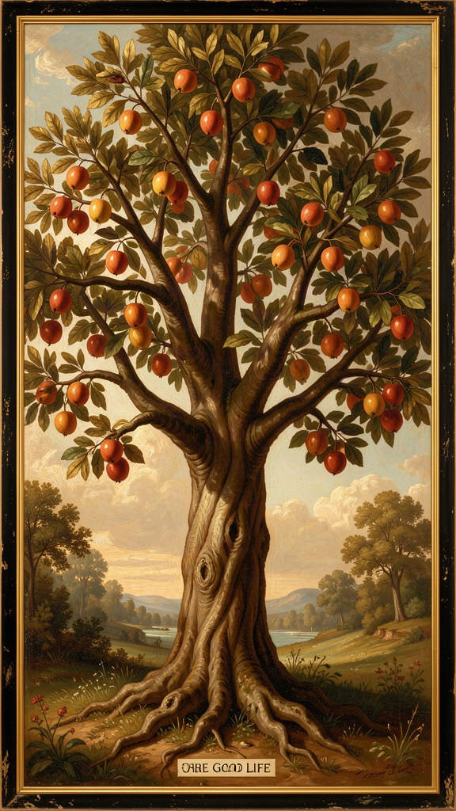
Illustration for Chapter 6
![Chapter 6](/images/booklets/thomas-aquinas-adult-ch06.png)

Not Just "Being Good"
For Aquinas, a virtue is not just "being a good person" in a vague sense. A virtue is "a good habit bearing on activity" (ST I-II, Q.55, A.3, following Aristotle). Three elements matter: it is a habit (a stable disposition, not a one-time act), it is good (oriented toward a genuine good, not an apparent one), and it bears on activity (it is about action, not just inner states).
You become just by doing just acts repeatedly, not by doing one just act. You become courageous by acting bravely repeatedly, not by one act of bravery. Virtues are built through practice, like muscles. This is not moralism. It is an account of human flourishing — what human beings need to live well, and how they acquire the habits that make that possible.
Aquinas's account of the virtues is indebted to Aristotle's Nicomachean Ethics, but he transforms Aristotle in two ways: he adds the theological virtues (faith, hope, charity) that Aristotle does not consider, and he grounds the cardinal virtues in natural law rather than in Aristotle's account of human flourishing alone. The result is a virtue theory that is both philosophical (grounded in reason and human nature) and theological (oriented toward God as the ultimate end).

The Cardinal Virtues
The four cardinal virtues are the pillars of moral life. "Cardinal" comes from cardo (hinge) — they are the hinges on which all other virtues turn.
Prudence (Prudentia, ST II-II, Q.47–56) is the virtue of practical reason — the ability to discern the right action in a particular situation. Prudence is not caution or timidity. It is the wisdom to judge correctly what is good and what is bad, and to act accordingly. Prudence is the "charioteer" of the virtues: it directs the other virtues toward their proper ends. Without prudence, the other virtues become vices. Courage without prudence is recklessness. Justice without prudence is rigidity. Prudence requires experience, deliberation, and the ability to judge particular situations well. It is the virtue that integrates the others — knowing not just what is good in general, but what is good here, now, for this person in this situation. Prudence is what prevents the other virtues from becoming mechanical — it is the virtue of judgment, of seeing what this situation requires.
Justice (Iustitia, ST II-II, Q.57–79) is the virtue of giving each person their due — their rights, their dignity, their fair share. Justice is primarily about relationships. It governs how we treat others. The two primary forms are commutative justice (fairness between individuals — paying debts, keeping contracts, respecting property) and distributive justice (fairness between the community and individuals — fair distribution of benefits and burdens). Justice requires fairness, but Aquinas does not separate justice from compassion — mercy is part of justice rightly understood. Justice is the virtue that orients us toward the common good. It is not just about rules; it is about the right ordering of relationships.
Fortitude (Fortitudo, ST II-II, Q.123–140) is the virtue of courage — the ability to face danger, difficulty, or suffering without losing one's rational orientation toward the good. Fortitude is not fearlessness. It is the proper management of fear. It is primarily about the fear of death — the most difficult fear to overcome — and it includes patience (enduring difficulty without complaint) and perseverance (continuing in the face of obstacles). Fortitude without prudence is recklessness. Fortitude without justice is tyranny. Fortitude is the virtue that makes it possible to sustain the other virtues under pressure. It is not just about facing physical danger; it is about the moral courage to do what is right when it costs something.
Temperance (Temperantia, ST II-II, Q.141–170) is the virtue of moderation — the ability to manage desires and pleasures so they serve the good rather than undermining it. Temperance is not self-denial for its own sake. It is the proper ordering of pleasure. It governs the desires for food, drink, and sex — the pleasures that are most necessary and most easily disordered. It includes modesty, continence, and chastity. Temperance without prudence is mere asceticism. Temperance without joy is not the genuine article. Temperance is the virtue that keeps the other virtues from being undermined by disordered desire. It is not about eliminating pleasure but about integrating pleasure into a well-lived life.

The Theological Virtues
The three theological virtues are gifts of grace, not achievements of natural reason. They orient the human being toward God as their ultimate end — something that natural virtue alone cannot accomplish.
Faith (Fides, ST II-II, Q.1–7) is the virtue by which we believe in God and all that God has revealed. Faith is not blind belief. It is voluntary assent to truths that are supported by evidence but not proved by it. Faith seeks understanding (fides quaerens intellectum) — it does not replace reason but goes beyond it. Faith is the foundation of the other theological virtues: you cannot hope in or love what you do not believe. The epistemology of faith, as we saw in Chapter 5, involves both intellect (seeing the evidence) and will (choosing to assent). Faith is a distinct cognitive act — neither knowledge nor opinion, but voluntary assent to truths supported but not proved by evidence.
Hope (Spes, ST II-II, Q.17–22) is the virtue by which we desire the kingdom of heaven and eternal life, trusting in God's promises. Hope is not wishful thinking. It is confident expectation of a good that is difficult but possible with divine assistance. Hope sits between two vices: despair (which gives up on the good) and presumption (which expects the good without effort). Hope perfects the will's orientation toward the ultimate end. The structure of hope is important: it is directed toward a good that is possible but not guaranteed by our own power. This means hope requires humility (acknowledging that we cannot achieve the good on our own) and effort (working toward the good with divine assistance). Despair loses the humility but keeps the inability; presumption keeps the effort but loses the humility.
Charity (Caritas, ST II-II, Q.23–46) is the virtue by which we love God above all things and our neighbor as ourselves for the love of God. Charity is the form of all the virtues — it gives them their proper orientation and makes them genuinely virtuous. It is the greatest of the theological virtues (1 Corinthians 13:13 — "the greatest of these is love"). Charity is not just affection. It is the will's orientation toward the good of the other for the sake of God. Without charity, the other virtues can be disordered: prudence becomes cunning, courage becomes aggression, justice becomes severity. The claim that charity is the "form" of the virtues (ST II-II, Q.23, A.7–8) is not a claim that the other virtues are useless without charity. It is a claim that charity gives them their ultimate direction — without love, the virtues can be genuinely good (a non-believer can be just, brave, temperate, and prudent) but they are not oriented toward the ultimate end.

How the Virtues Connect
The cardinal virtues are achievable by natural reason. Any person can develop prudence, justice, fortitude, and temperance through practice. The theological virtues are gifts of grace — they require divine assistance.
But they are not separate systems. The theological virtues elevate and perfect the cardinal virtues. Faith elevates prudence by giving it a wider horizon — the knowledge of God's plan. Hope elevates fortitude by giving it a greater object — eternal life rather than mere survival. Charity elevates justice by giving it a deeper motive — love of neighbor for the sake of God.
Without the theological virtues, the cardinal virtues are genuinely good — a just person without faith is better than an unjust person with faith. But they are incomplete — they do not orient the person toward their ultimate end (the beatific vision). This is not a denigration of natural virtue. It is a claim about completeness: natural virtue is real but incomplete; theological virtue completes it.

The Unity of the Virtues
Aquinas follows Aristotle in holding that the virtues are interconnected: you cannot have one cardinal virtue fully without having all of them. Prudence requires justice (to know what is right), fortitude (to do what is right in the face of danger), and temperance (to desire what is right). The virtues are not a menu. They are an ecosystem.
This thesis — the unity of the virtues — is one of the most debated in virtue ethics. It claims that a person who is genuinely courageous but unjust does not have the virtue of courage. They have something that looks like courage, but because it is not ordered by justice and prudence, it is not genuine courage. A soldier who fights bravely for an unjust cause is not, on this view, courageous — they are reckless. True courage requires being ordered toward the good, and being ordered toward the good requires the other virtues.
The unity thesis has been challenged by modern philosophers who argue that virtues can be compartmentalized — that a person can be courageous in one domain and unjust in another. The debate turns on whether "courage" that is not ordered by justice is really courage, or whether it is a different disposition that merely resembles courage. Aquinas's position is that genuine virtue requires integration — you cannot have one virtue fully without the others. This is a demanding thesis, but it captures something important: character is integrated, not modular.

The Virtues and Contemporary Ethics
Aquinas's account of the virtues is one of the foundations of the modern virtue ethics revival. The key figures are Elizabeth Anscombe, Alasdair MacIntyre, and Philippa Foot.
Anscombe. In her 1958 essay "Modern Moral Philosophy," Anscombe argued that modern moral philosophy — with its emphasis on obligation, duty, and consequence — is incoherent without a foundation in virtue. She argued that we should abandon the language of "morally ought" (which presupposes a lawgiver who has been abolished in modern philosophy) and return to the language of virtues, which does not require that presupposition. Anscombe's essay sparked the virtue ethics revival and renewed interest in Aquinas's account of the virtues.
MacIntyre. In After Virtue (1981), MacIntyre argued that modern moral discourse is fragmented because it has lost the Aristotelian framework of virtue, telos, and practice. He argued that virtues are qualities that enable a person to achieve the goods internal to practices, and that a practice is a cooperative human activity with standards of excellence. MacIntyre's account is deeply indebted to Aquinas (MacIntyre is a Thomist), though he also draws on Aristotle and Benjamin Franklin. The debate about whether MacIntyre's account is faithful to Aquinas — or whether it secularizes Aquinas in a way that undermines the theological virtues — is one of the liveliest in contemporary virtue ethics.
Foot. In Natural Goodness (2001), Foot argued that moral evaluation is grounded in human nature — that virtues are qualities that enable human beings to live well, just as the virtues of a plant (healthy roots, strong stem) enable it to live well. Foot's account is naturalistic (it does not rely on theological premises) but it draws on Aquinas's grounding of the virtues in natural law. The question of whether Foot's naturalistic virtue ethics can capture the full depth of Aquinas's account — or whether the theological virtues are an essential part of the picture that naturalistic ethics must leave out — is a live question.

The Vices
Every virtue has a corresponding vice — a habit that disposes a person to act badly. Aquinas treats vices with the same systematic care he treats virtues.
| Virtue | Vice (Deficiency) | Vice (Excess) | |--------|-------------------|---------------| | Prudence | Rashness (acting without deliberation) | Craftiness (deliberating for a bad end) | | Justice | Injustice (denying others their due) | — (justice does not have an excess) | | Fortitude | Cowardice (excessive fear) | Recklessness (insufficient fear) | | Temperance | Insensibility (denying legitimate pleasure) | Intemperance (excessive pursuit of pleasure) |
The seven deadly sins (pride, avarice, lust, envy, gluttony, anger, sloth) are not the direct opposites of the cardinal virtues. They are capital vices — vices from which other vices flow. Aquinas discusses them as part of his treatment of specific vices throughout the Secunda Secundae. The distinction between cardinal vices (the direct opposites of the cardinal virtues) and capital vices (vices that generate other vices) is important: the seven deadly sins are not a list of "the worst sins" but a diagnostic framework for understanding how vices propagate.

Big Idea
Virtues are good habits built through practice. There are four cardinal virtues (prudence, justice, fortitude, temperance) achievable by natural reason, and three theological virtues (faith, hope, charity) that are gifts of grace. They are interconnected — you cannot have one fully without the others (the unity of the virtues). Charity is the form of all the virtues: without love, the other virtues go wrong. The virtue ethics revival (Anscombe, MacIntyre, Foot) has drawn extensively on Aquinas's account, raising the question of whether his virtue theory can be secularized without losing its theological depth.

Practice
1. Test the unity of the virtues. Aquinas says you cannot have one virtue fully without the others. Construct a counterexample: a person who has one virtue but not another (courageous but unjust, prudent but unkind, temperate but cowardly). Does Aquinas's thesis hold? Is the "courageous but unjust" person really courageous, or do they have something that merely looks like courage? What is the difference between genuine courage and the counterfeit?
2. Map the vices. For each cardinal virtue, identify the vice of excess and the vice of deficiency. Then identify a real or fictional character who exemplifies each vice. What does the vice look like in practice? How does it distort the corresponding virtue? Now consider the seven deadly sins: are they vices of excess, deficiency, or something else? How do they relate to the cardinal virtues?
3. Evaluate charity as form. Aquinas says charity is the "form" of all the virtues — it gives them their proper orientation. Without charity, prudence becomes cunning, courage becomes aggression, justice becomes severity. Is this convincing? Can a person without charity (a non-believer, an atheist) have genuine prudence, courage, justice, and temperance? Or are their virtues somehow incomplete? What does Aquinas mean by "form" here, and is his claim defensible?
4. Apply virtue ethics to a dilemma. Pick an ethical dilemma (e.g., should you tell a lie to protect a friend from harm? Should you turn in a family member who has committed a crime?). Analyze it using Aquinas's virtue framework. What would prudence say? Justice? Fortitude? Temperance? Charity? How do the virtues interact in this situation? Does the virtue approach give a different answer than utilitarianism (maximize happiness) or Kantian deontology (follow the categorical imperative)?
5. Evaluate the secularization question. Can Aquinas's virtue ethics be separated from its theological context? The cardinal virtues are achievable by natural reason, but Aquinas says the theological virtues complete them. Is a virtue ethics without the theological virtues still Aquinas's virtue ethics? Or is it something different? Consider the accounts of Anscombe, MacIntyre, and Foot: do they capture the full depth of Aquinas, or do they leave something essential out?

Reflect
Aquinas says the virtues are like an ecosystem — interconnected, mutually dependent, integrated. But modern life often rewards compartmentalization: the ruthless businessperson who is generous at home, the cowardly public figure who is brave in private, the scholar who is prudent in thought but intemperate in action. Is Aquinas's unity thesis realistic? Can a person be truly virtuous in one area of life and vicious in another? Or does the integration of character demand consistency across all domains? What would it look like to live as though the virtues really were an ecosystem — as though you could not have one without the others? And if the unity thesis is too demanding, what is the alternative?
———
———

For the Grown-Up Reader
This booklet introduces adult readers to Thomas Aquinas through six of his central ideas, presented as sophisticated philosophical arguments with attention to the interpretive debates that have shaped their reception. The content is drawn from the research files on Aquinas and from primary sources — the Summa Theologica, the Summa contra Gentiles, and the De Ente et Essentia.
The citations are accurate and follow standard scholastic format. The Five Ways appear at ST I, Q.2, A.3. The act/potency distinction is developed in ST I, Q.3, Q.25, and SCG III, Ch. 58. The essence/existence distinction is treated in De Ente et Essentia, Ch. 4–5, and ST I, Q.3, A.4–5. The natural law treatise spans ST I-II, Q.90–97. The faith-reason relationship is addressed in ST I, Q.1, A.1 and SCG I, Ch. 3–8. The virtues are treated in ST I-II, Q.55–67 and throughout ST II-II.
The booklet engages with the major interpretive debates in Thomistic scholarship: the nature of the Five Ways (deductive, dialectical, heuristic, or summary), the act/potency distinction in relation to process philosophy and analytic metaphysics, the real distinction debate (Gilson, Cajetan, Wippel), the analogia entis debate (Barth vs. Przywara), the new natural law theory (Grisez, Finnis, Boyle), the faith-reason relationship in relation to the Averroist controversy and postmodernism, and the virtue ethics revival (Anscombe, MacIntyre, Foot). Each debate is presented with the major positions and their defenders.
The practice exercises require readers to reconstruct arguments, apply concepts, evaluate objections, engage with interpretive debates, and consider contemporary philosophical challenges. The reflection questions are designed to provoke genuine philosophical thinking and do not have predetermined answers. They model Aquinas's own method: state the strongest objection, respond with reasoned argument, and leave the reader to judge.

About WisdomForge
WisdomForge produces age-banded booklets that introduce the great thinkers of the Western tradition to readers at every stage of life. Each booklet covers six core ideas of a philosopher, adapted for elementary (ages 5–10), middle school (ages 11–14), high school (ages 15–18), and adult readers. The booklets share the same chapter structure and themes, but the language, depth, and activities change to meet each age where it is.
Our method: we read the philosopher's own words, study the best scholarship, and write for real readers. We cite primary sources so you can follow the ideas back to their origin. We use the style principles of Strunk and White — clear, active, concise — because good ideas deserve good prose.
WisdomForge is a project of SMF Works. We believe the great ideas of the past belong to everyone, and the best way to honor them is to make them accessible without dumbing them down.

