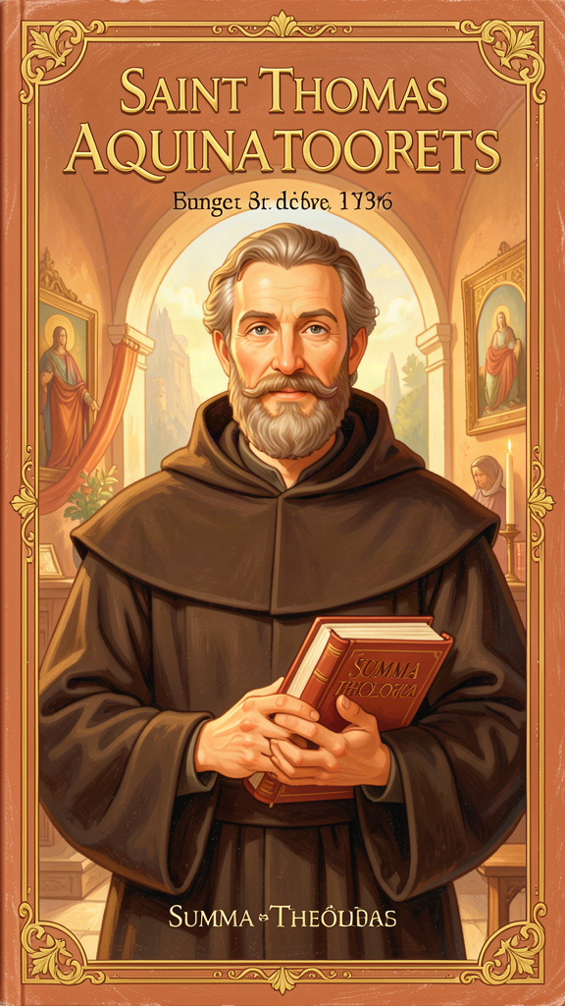
The Boy Who Asked Big Questions
WisdomForge Booklet — Ages 5–10

The Boy Who Asked Big Questions

WisdomForge Booklet — Ages 5–10
———

About This Book
Thomas Aquinas was a boy who loved asking questions. He lived almost 800 years ago in a castle in Italy, and he grew up to write one of the biggest, most important books in all of history. People called him the "Dumb Ox" because he was quiet and big. But inside his head, he was thinking the biggest thoughts anyone had ever thought.
This book tells six stories from Thomas's life. Each story teaches one big idea that Thomas discovered about the world, about goodness, and about God. You will learn how he figured out that everything that moves has to be moved by something else, how he understood that everything has a purpose, and how he believed that being kind is like a muscle — it gets stronger the more you use it.
Thomas was not just a smart man. He was a good man. He wanted to understand the world so he could love it better. Let's follow him from a castle in Italy to the biggest classroom in Europe, and see what he found.
———
———

Chapter 1: The Five Ways — Proving God Exists
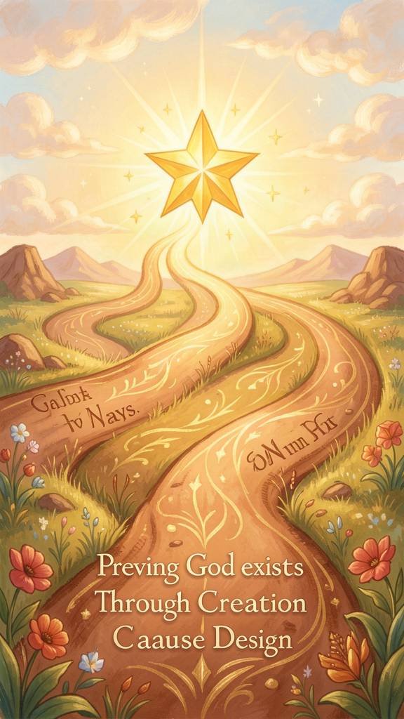
Illustration for Chapter 1
![Chapter 1](/images/booklets/thomas-aquinas-elementary-ch01.png)
Thomas was a boy who lived in a castle. The castle sat on a hill between Rome and Naples, and from the top of the tower you could see fields and forests and a river winding through the valley below. His family was important. His father was a knight who worked for an emperor. His mother came from a noble family. They had plans for Thomas. He would become the leader of a big monastery, and the family would be proud.
But Thomas had a habit that drove everyone a little crazy. He asked questions. He asked questions about everything.
"Why does the fire burn?" he would ask.
"Why does the river flow downhill and not uphill?"
"Why do seeds grow into plants and not into rocks?"
His teachers at the monastery liked him, but they shook their heads sometimes. Thomas never stopped at the first answer. If you told him "fire burns because it is hot," he would ask, "But why is it hot? What makes it hot? Where does the heat come from?"
Thomas kept asking his questions all the way through school. He grew up to be a tall, quiet man. People started calling him the "Dumb Ox" because he was big and slow to speak. But his teacher, a man named Albert who everyone called Albert the Great, said something that made everyone stop laughing. Albert said: "You call this ox dumb, but one day his bellowing will be heard all over the world."
Thomas did not want to just believe things. He wanted to understand them. And one of the biggest things he wanted to understand was this: How do we know that God is real?
Thomas did not think you should just close your eyes and believe. He thought you could look at the world and find clues. He said there are five ways to find God, and each one starts with something you can see right now.
The first way starts with movement. If a ball is rolling across the floor, something must have pushed it. A ball does not roll by itself. And if someone pushed the ball, something must have pushed that person. But you cannot keep going back and back and back forever. At some point, you need something that was not pushed by anything else — something that is the first pusher. Thomas said that first pusher is God.
The second way starts with making things. If you see a picture, you know someone painted it. If you see a cake, you know someone baked it. Things do not make themselves. And if you trace back all the makers, you need a first maker who was not made by anyone else. Thomas said that first maker is God.
The third way starts with things that come and go. A flower grows, blooms, and then wilts. A tree stands tall for a hundred years, but one day it falls. Everything in the world is like this — it is here now, but it will not be here forever. But if everything were like that, then at some time there would have been nothing at all. And nothing cannot make something. So there must be something that does not come and go. Something that always was and always will be. Thomas said that is God.
The fourth way starts with good and better. You know the difference between a pretty good friend and a really great friend. You know the difference between a nice day and a perfect day. But if there is "better" and "best," there must be something that is the most good of all — the thing that all good things are measured against. Thomas said that is God.
The fifth way starts with how things work. Seeds grow into plants. Hearts pump blood. Birds build nests. These things do not think about what they are doing, but they do it perfectly every time. Someone must have given them the plan. Thomas said that someone is God.
Thomas wrote all of this down in his great book, the Summa Theologica. He put it in a place called Question 2, Article 3 — ST I, Q.2, A.3, if you want to find it. That is how scholars talk about his book. The first number tells you the part, the second tells you the question, and the third tells you the article. It is like a map to his thoughts.
Thomas did not call these five ways "proofs" in the way you prove a math problem. He called them "ways" — paths you can walk to find God. You start with something you can see, and you follow it to something you cannot see but know must be there.

Words to Remember
- Five Ways: Five paths Thomas found that start with things you can see and lead to God. - First Mover: The one who started all movement and was not moved by anyone else. - Summa Theologica: The great book Thomas wrote. "Summa" means "summary" or "big picture."

Big Idea
You do not have to close your eyes to believe in God. You can look at the world — at movement, at making, at things that come and go, at good and better, at the way things work — and follow the clues. Each clue is a path. Thomas called them the Five Ways.

Try This
Pick something in your room that moves — a toy car, a ball, a clock hand. Ask yourself: What made it move? Then ask: What made that? Keep going until you hit the wall — the point where you need a "first something" that was not made to move by anything else. That feeling of hitting the wall is the First Way.

Ask a Grown-Up
Ask a grown-up: "If everything that moves needs something to move it, what moved the very first thing?" Listen to their answer. Then tell them about Thomas's idea — that the first mover does not need to be moved because it is the source of all moving.
———
———

Chapter 2: Act and Potency — The Grammar of Change
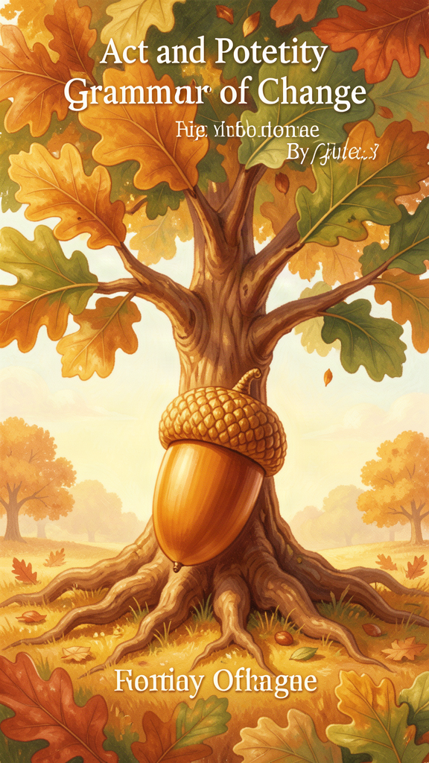
Illustration for Chapter 2
![Chapter 2](/images/booklets/thomas-aquinas-elementary-ch02.png)
One day Thomas was sitting in the kitchen of the monastery. It was cold outside, and the stove was not lit yet. A pot of water sat on top.
Thomas looked at the stove. Right now, it was cold. But it could be hot. That was the key idea. The stove was not hot, but it had the ability to become hot. All you had to do was light the fire.
Thomas thought about this a lot. He gave the two sides a name. The stove right now — cold, not hot yet — he called "potency." That means "what something could be but is not yet." And the stove when the fire is lit — hot, burning, real — he called "act." That means "what something actually is right now."
Everything in the world has both. A seed is actually a seed, but it has the potency to become a tree. A student is actually a kid, but has the potency to become a grown-up. A lump of clay is actually clay, but has the potency to become a bowl.
Change is what happens when potency becomes act. The seed becomes a tree. The kid becomes a grown-up. The clay becomes a bowl. Nothing comes from nothing. The tree was already in the seed, waiting. The grown-up was already in the kid, growing. The bowl was already in the clay, ready to be shaped.
This idea helped Thomas explain something that puzzled people for hundreds of years. If everything is always changing, how does anything stay the same? The stove does not stop being a stove when it gets hot. The seed does not stop being a seed when it becomes a tree — it becomes a tree-seedling, then a tree. The change is not the thing disappearing. The change is the thing becoming what it could be all along.
Thomas used this idea to understand God, too. Everything in the world has potency — it has things it could be but is not yet. But God, Thomas said, has no potency at all. God is pure act. That means God is already everything God can be. There is nothing waiting, nothing missing, nothing that could be added. God does not grow or change or become. God just is.
This is a hard idea, so let's slow down. Think about it this way. You are actually a kid, but you have the potency to be a grown-up. You are not a grown-up yet. That means you are a mix — some of you is "act" (kid), and some of you is "potency" (grown-up-to-be). Everyone and everything in the world is like this. We are all a mix of what we are and what we could be.
But God is not a mix. God is not partly one thing and partly another. God is fully everything, all at once, with nothing missing. That is what "pure act" means. It means complete. It means nothing left out.
Thomas got this idea from a man named Aristotle, who lived a long, long time ago in Greece. Aristotle thought about how things change. Thomas read Aristotle's books and thought, "Yes, this is right. But I can take it further." And he did. He used the idea to understand God, the world, and everything in between.
Thomas wrote about this in his great book. You can find it in the places where he talks about how God is simple and complete. The key idea is in ST I, Q.3, where he talks about how God has no parts and no changes. The whole Summa Theologica is built on this idea — that the world is full of things becoming, and God is the one who simply is.

Words to Remember
- Act: What something actually is right now. A hot stove is actually hot. - Potency: What something could be but is not yet. A cold stove could be hot. - Pure Act: What Thomas called God. God is already everything God can be, with nothing missing.

Big Idea
Everything in the world is a mix of what it is and what it could be. Change happens when the "could be" becomes the "is." But God is not a mix. God is pure act — already complete, with nothing waiting to happen.

Try This
Find two things in your house. For each one, say what it is "actually" right now (act) and what it "could be" but is not yet (potency). Example: An egg is actually an egg. It has the potency to become a chick. A book is actually a book. It has the potency to become a read book (once you read it). See how many you can find.

Ask a Grown-Up
Ask a grown-up: "What is something about you that is 'potency' — something you could be but are not yet?" Maybe they say they are learning a new skill, or they want to be more patient. Then ask: "What would it take to turn that potency into act?" Thomas's answer is: practice, time, and help from outside. Things do not change themselves. Something has to actualize the potency.
———
———

Chapter 3: Essence and Existence — What Something Is vs. That It Is
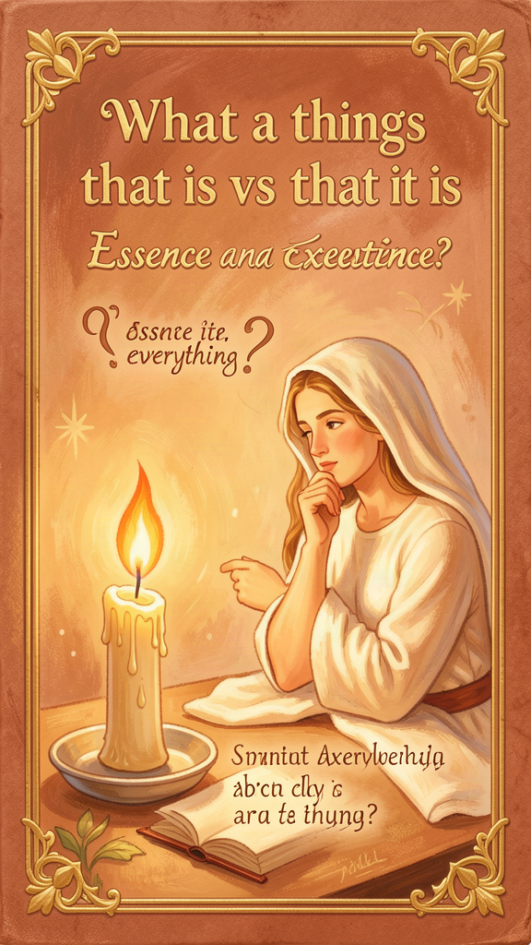
Illustration for Chapter 3
![Chapter 3](/images/booklets/thomas-aquinas-elementary-ch03.png)
Thomas had a friend named Reginald. Reginald was his helper, and he wrote down many of Thomas's ideas. One day, Thomas and Reginald were walking in the garden, and Thomas stopped.
"Reginald," he said. "Look at that tree. What is it?"
"It is an oak tree," Reginald said.
"Good," Thomas said. "Now — is it?"
Reginald looked confused. "Is it what?"
"Is it?" Thomas repeated. "Does it exist? Is it real? Is it standing there, right now, in the world?"
"Yes, of course," Reginald said.
"Good," Thomas said. "Now tell me this. Could you know what an oak tree is without knowing whether any oak tree exists?"
Reginald thought. "I suppose so. I can imagine an oak tree. I can describe it — tall, brown bark, green leaves, acorns. I know what it is even if I have never seen one."
"And could an oak tree exist without you knowing what it is?" Thomas asked.
"Well, yes. A tree does not need me to understand it to stand in the ground."
Thomas smiled. "There," he said. "You have just discovered the difference between essence and existence."
This was one of Thomas's most important ideas, and he wrote about it in a short book called De Ente et Essentia, which means "On Being and Essence." The idea is simple, but it changes how you see everything.
Essence is what a thing is. The essence of an oak tree is "tall tree with acorns and green leaves." The essence of a dog is "furry animal that barks and wags its tail." The essence of a triangle is "a shape with three sides." Essence answers the question: What is it?
Existence is that a thing is. The oak tree exists. The dog exists. The triangle exists — if you draw one. Existence answers the question: Is it?
Here is the key. These two things are different. You can know what a unicorn is (a horse with a horn) without knowing whether unicorns exist. You can know what a dragon is (a big scaly lizard that breathes fire) without knowing whether dragons exist. The "what" and the "is" are not the same thing.
Thomas said this is true of everything in the world. Everything has an essence (what it is) and an existence (that it is), and these two are not the same. A tree is not its own existence. It has existence, but it is not existence itself. It received existence from something else — from the soil, the water, the sun, and ultimately from God.
But God, Thomas said, is different. In God, essence and existence are the same thing. God does not have existence. God is existence. God's essence is to exist. That is why Thomas called God ipsum esse subsistens, which is Latin for "existence itself, standing on its own."
This is a hard idea, so let's try it another way. Think about a candle. A candle has light, but a candle is not light. The light comes from the flame. The candle participates in light, but it is not light itself.
Now think about everything in the world. Every tree, every dog, every star, every person — all of them have existence, but none of them is existence. They all received existence from somewhere else. They are like candles. The light comes from the flame.
God is the flame. God is not a candle that has light. God is the light itself, the source of all the light that every candle holds. Everything that exists, exists because it shares in God's existence.
Thomas used this idea to explain why the world needs God. If everything in the world has an essence that is different from its existence, then everything needs something outside itself to give it existence. Nothing can give itself existence, because existence is not part of its essence. You need something whose essence is existence — something that does not receive existence but is existence. That something is God.
Thomas put this idea at the center of everything he wrote. It is in his book De Ente et Essentia, and it is in the Summa Theologica at ST I, Q.3, A.4, where he talks about how God's existence is God's essence. The whole Summa rests on this idea — that the world is full of things that have existence, and God is the one who gives existence.

Words to Remember
- Essence: What a thing is. The essence of a dog is "furry animal that barks." - Existence: That a thing is. The dog exists. It is real. - Ipsum Esse Subsistens: Latin for "existence itself." What Thomas called God.

Big Idea
Everything in the world has two sides: what it is (essence) and that it is (existence). These two sides are different. Everything receives existence from something else. But God is different. God does not receive existence. God is existence. God is the source of all the "is" in everything.

Try This
Think of something you can imagine but that does not exist — a unicorn, a dragon, a flying car. You know its essence (what it is). But it does not have existence (it is not real). Now look at something real — your hand, your chair, the sky. It has both essence and existence. The difference between the unicorn and your hand is that your hand is, and the unicorn is not. That difference — existence — is what Thomas says comes from God.

Ask a Grown-Up
Ask a grown-up: "What is the difference between knowing what something is and knowing that it is?" They might say it is the difference between a description and a fact. Tell them Thomas said this difference is the most important thing about the world — because it means everything needs God to give it existence.
———
———

Chapter 4: Natural Law — Morality Written Into Creation
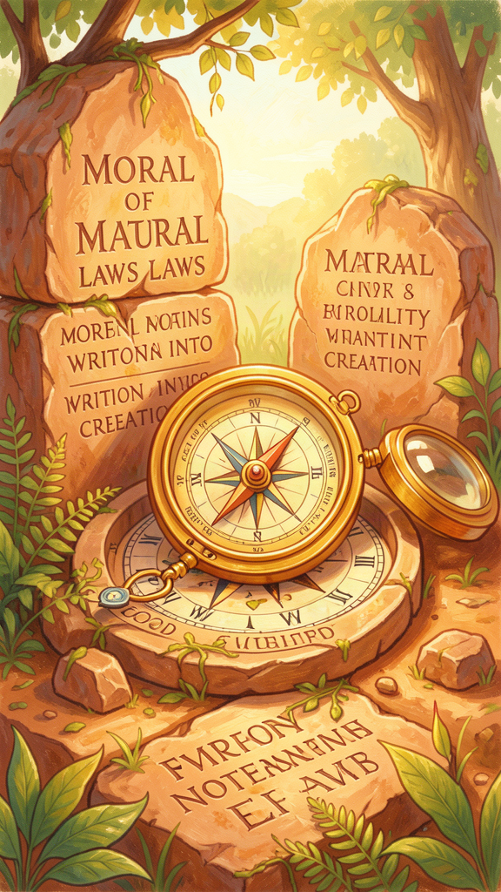
Illustration for Chapter 4
![Chapter 4](/images/booklets/thomas-aquinas-elementary-ch04.png)
When Thomas was a boy at the monastery, he had a teacher who told him a story. Two children were playing in a field. One found a shiny stone. The other wanted it. The first child said, "You can't have it. I found it first." The second child said, "But I want it. You have so many stones." The first child said, "That doesn't matter. It's mine because I found it. If you want a stone, you can find your own."
The teacher asked Thomas: "Which child was right?"
Thomas thought. "The first child," he said. "Finding something first means it is yours. Taking it would be stealing."
"But who made the rule about stealing?" the teacher asked.
"No one had to make it," Thomas said. "Everyone knows it. You just know."
The teacher smiled. "That is what we are going to talk about today."
The teacher told Thomas about an idea called natural law. Natural law is the idea that some rules are not just made up by people. They are built into the world, the way gravity is built into the world. You do not have to be told them. You can figure them out by thinking about how people work.
Thomas loved this idea. He spent years thinking about it, and he wrote about it in his great book, the Summa Theologica. You can find it in the part called ST I-II, Q.94, A.2. That means the First Part of the Second Part, Question 94, Article 2.
Thomas said there are four things that every person knows, deep down, because they are part of being human:
1. Take care of your life. You know you should keep yourself safe and healthy. You should eat good food, get enough sleep, and stay away from danger. This is not a rule someone invented. It is how people are made.
2. Have a family and take care of them. People have children, and they take care of their children. This is built into us. We want our families to be safe and happy.
3. Live together with other people. We are not meant to be alone. We need friends, neighbors, and a community. We want to learn things and understand the world. We want to be treated fairly, and we know we should treat others fairly too.
4. Know God. Deep down, people want to know where everything came from. We want to know the source of it all. Thomas said this is built into us too — the desire to know God.
Thomas said the most basic rule of all is this: "Good is to be done and pursued, and evil is to be avoided." That is from ST I-II, Q.94, A.2. It sounds simple, but it is the foundation of everything. You do not need a book to tell you to do good and avoid bad. You know it. Everyone knows it.
But Thomas also said something important. He said we do not always get the rules right. Sometimes we are angry or scared, and we make bad choices. Sometimes our family or our country teaches us the wrong things. The basic rules are the same for everyone, but the details can be hard to figure out.
Thomas said there are four kinds of law. He wrote about them in ST I-II, Q.90–97.
The first kind is eternal law. This is God's plan for the whole universe. It is the way things are meant to work. Seeds grow into plants. Hearts pump blood. People are meant to be fair. All of this is eternal law. It is not a set of rules imposed from outside. It is the way creation is built.
The second kind is natural law. This is what we can figure out by thinking. It is our share in eternal law. We look at how people are made, and we think about what helps people live well. That is natural law.
The third kind is human law. These are the rules that people make — like speed limits, or "no running in the hallway," or "you have to be a certain age to drive." These rules are based on natural law, but they are specific. They change from place to place and time to time.
The fourth kind is divine law. This is what God tells us in the Bible and through the Church. It helps us when our thinking gets confused, and it tells us things we could not figure out on our own.
Thomas said something brave about human law. He said that if a human law is really unfair — if it hurts people instead of helping them — then it is not a real law. It is a broken law, and you do not have to obey it in your heart. This idea, from ST I-II, Q.96, A.4, was used hundreds of years later by a man named Martin Luther King Jr., when he fought against unfair laws that treated people badly because of the color of their skin.
Thomas believed that being good is not about following a long list of "don'ts." It is about understanding what helps people live well, and doing that. The rules are not there to stop you from having fun. They are there to help you, and everyone around you, be happy and safe.

Words to Remember
- Natural Law: The rules built into being human. You can figure them out by thinking. - Eternal Law: God's plan for the whole universe. The way things are meant to work. - Human Law: The specific rules people make, like speed limits and school rules. - Common Good: What helps everyone in the community, not just one person.

Big Idea
Some rules are not invented by people. They are built into the world. You can figure them out by thinking about what helps people live well. The most basic rule is: do good and avoid bad. Everything else follows from that.

Try This
Think of a rule in your house or school. Now ask: "Why is this a rule?" Keep asking "why" until you get to something that everyone would agree with — something like "because people need to be safe" or "because people need to be treated fairly." That bottom layer is natural law. The rule on top is human law.

Ask a Grown-Up
Ask a grown-up: "Can you think of a time when a law or a rule was unfair? What did people do about it?" Tell them that Thomas said an unfair law is not really a law. Ask if they agree.
———
———

Chapter 5: Faith and Reason — Two Wings of Truth
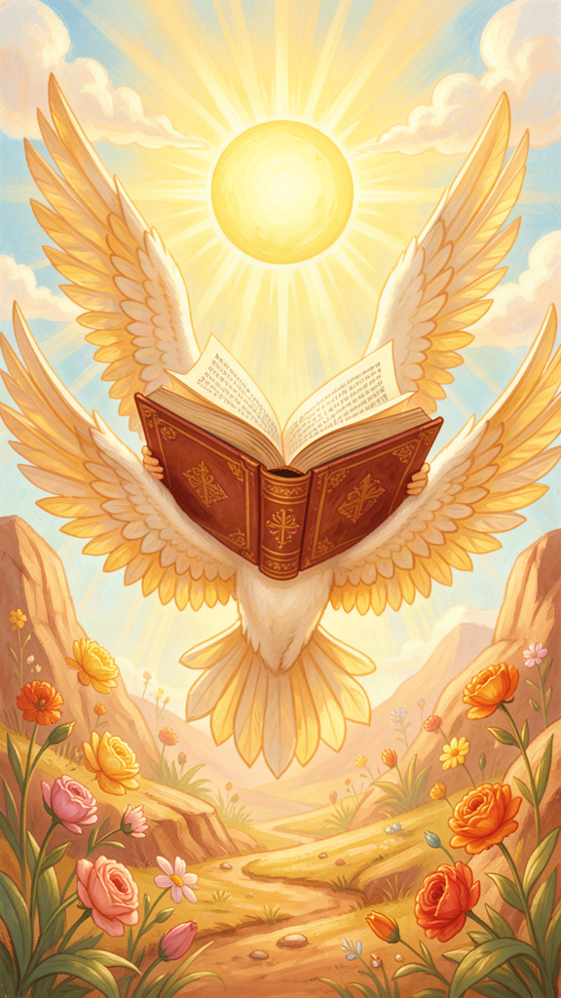
Illustration for Chapter 5
![Chapter 5](/images/booklets/thomas-aquinas-elementary-ch05.png)
When Thomas was a young man, he made a choice that changed his life. His family wanted him to become a rich and powerful monk. But Thomas met a group of friars called the Dominicans. They were not rich. They did not live in big monasteries. They walked from town to town, teaching and helping people. They were called "begging friars" because they begged for their food.
Thomas wanted to join them. His family was furious. They kidnapped him and locked him in their castle for a year. They tried to make him change his mind. According to the old stories, they even sent a woman to his room to tempt him away from his choice. Thomas grabbed a burning stick from the fireplace and chased her away. Then, the story says, he used the stick to burn a cross into his door.
Whether the story is exactly true or not, it shows something important about Thomas. He had two kinds of belief working together. He had reason — his mind, his thinking, his questions. And he had faith — his trust in God, his belief in what God had shown the world.
Some people think faith and reason are enemies. They think you either use your brain or you believe in God. Thomas said this is wrong. He said faith and reason are like two wings on a bird. A bird needs both wings to fly. If it has only one, it goes in circles.
Thomas wrote about this in his great book. He put it in ST I, Q.1, A.1. His main idea was this: truth cannot fight truth. If something is true by reason, and something is true by faith, they cannot contradict each other, because both come from God, and God does not contradict himself.
Think about it this way. If you look through a telescope and see a star, that is reason — you are using your eyes and your brain. If your friend tells you there is a star in the sky because they saw it last night, that is faith — you are trusting their word. Both can be true. The star does not stop being real just because your friend told you about it instead of you seeing it yourself.
But Thomas also said there is a difference. Some things you can figure out by reason alone. You can figure out that the world exists, that things change, that effects have causes. You do not need faith for these. Your brain is enough.
Other things are too big for reason alone. Thomas said reason can tell you that God exists, but it cannot tell you everything about God. Some things about God — like the Trinity (God as three persons in one), or the Incarnation (God becoming a human being) — are bigger than our brains can reach. They are not against reason. They are above reason, the way the sky is above the ground.
Thomas said faith is not blind. It is not closing your eyes and jumping. It is more like trusting a friend. If your friend has always been honest with you, and they tell you something you cannot check yourself, you trust them. It is not stupid to trust them. It is smart — because they have earned your trust. Thomas said faith is like that. We trust God because God has shown us, through the Bible and through the Church, that God is worth trusting.
This was not just Thomas's idea. He got it from people before him — from Augustine, from Maimonides (a Jewish thinker), from Averroes (a Muslim thinker). They all believed that reason and faith could work together. But Thomas put it all together in the clearest way anyone had ever done.
Thomas lived this idea. He used his reason to study the world — he read Aristotle, he thought about how things change, he asked questions about everything. And he used his faith to guide his reason — he believed that the world was made by a good God, and that understanding the world was a way of understanding God.
He did not see a fight between thinking and believing. He saw them as two ways of looking at the same true thing. Reason asks: "How does the world work?" Faith asks: "Why does the world exist?" Both questions are good. Both answers are true. And they fit together, like two wings on a bird.

Words to Remember
- Faith: Trusting what God has shown us, even when we cannot see it ourselves. - Reason: Using your mind to think and understand. - Two Wings: Thomas's image for faith and reason. A bird needs both to fly.

Big Idea
Faith and reason are not enemies. They are two ways of finding truth, and they fit together. Reason tells us how the world works. Faith tells us why the world exists. Both come from God, and God does not contradict himself.

Try This
Think of something you know by reason (you saw it, or you figured it out). Now think of something you know by faith (someone told you, and you trust them). Example: You know by reason that the sun rises every morning because you have seen it. You know by faith that your grandfather was brave in a war because your parents told you. Both are true. Both are real knowledge. Thomas said faith and reason work the same way.

Ask a Grown-Up
Ask a grown-up: "Have you ever believed something because someone you trust told you about it — even though you could not check it yourself?" That is faith. Then ask: "Have you ever figured something out by thinking hard about it?" That is reason. Thomas said both are good ways to find truth.
———
———

Chapter 6: The Virtues — Habits of the Good Life
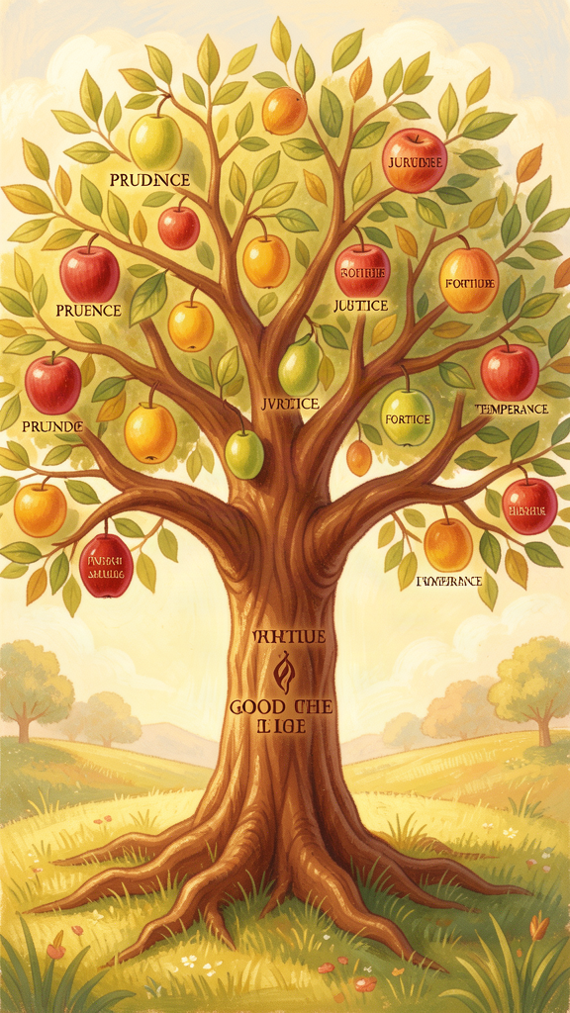
Illustration for Chapter 6
![Chapter 6](/images/booklets/thomas-aquinas-elementary-ch06.png)
Thomas was a quiet man, but he was not a gloomy one. He liked to eat. He liked to talk with his friends. He liked to walk in the garden. And he believed something that might surprise you: being good is not about being sad. It is about being happy.
Thomas thought that being good is like learning to ride a bike. The first time you try, you wobble. You fall. It is hard. But the more you practice, the easier it gets. And one day, you can ride without thinking about it. It has become a habit. It has become part of you.
Thomas called these good habits "virtues." A virtue is a good habit that helps you do the right thing. He wrote about them in the second half of his great book, the Summa Theologica — in ST I-II, Q.55, A.3, and then in a whole long section called ST II-II.
Thomas said there are four main virtues, and he called them the "cardinal" virtues. The word "cardinal" comes from a Latin word that means "hinge." These four virtues are the hinges on which all the other good habits swing.
The first virtue is prudence. Prudence is being smart about what is the right thing to do. It is not just being careful. It is looking at a situation, thinking about it, and figuring out what is really good — not just what feels good right now. Thomas wrote about prudence in ST II-II, Q.47–56. Prudence is like the captain of a ship. It steers all the other virtues.
The second virtue is justice. Justice is treating people fairly. It is giving people what they deserve — not just what they want, but what is right. If someone works for you, you pay them. If someone helps you, you thank them. If someone is in trouble, you help them. Thomas wrote about justice in ST II-II, Q.57–79. Justice is about how we treat others.
The third virtue is fortitude. Fortitude is courage. It is doing the right thing even when you are scared. It is not about being fearless — everyone feels fear. It is about not letting fear stop you from doing what is right. A firefighter running into a burning building has fortitude. A child telling the truth when they are afraid of getting in trouble has fortitude too. Thomas wrote about fortitude in ST II-II, Q.123–140.
The fourth virtue is temperance. Temperance is balance. It is not eating too much, not staying up too late, not wanting too many things. It is enjoying good things in the right way — not too little and not too much. A person who eats one cookie and saves the rest for later has temperance. A person who eats the whole box has lost it. Thomas wrote about temperance in ST II-II, Q.141–170.
Thomas said these four virtues work together. You cannot have one without the others. Courage without prudence is just jumping into danger without thinking. Prudence without courage is knowing what is right but being too scared to do it. Justice without temperance is being fair to others but not to yourself. They are like a team. They need each other.
Thomas also said there are three more virtues, and he called them "theological" virtues because they are about God. He wrote about them in the same part of the Summa.
The first theological virtue is faith. Faith is trusting God and believing what God has shown us. We talked about it in the last chapter. Faith is not blind. It is trusting someone who is worth trusting. Thomas wrote about faith in ST II-II, Q.1–7.
The second theological virtue is hope. Hope is wanting the best thing — being with God forever — and trusting that it is possible. Hope is not wishing. It is expecting something good, even when it is hard, because you know you are not alone. Hope sits between two mistakes: giving up (despair) and expecting it without working for it (presumption). Thomas wrote about hope in ST II-II, Q.17–22.
The third theological virtue is charity. Charity is love. It is loving God more than anything, and loving other people because God loves them. Thomas said charity is the greatest of all the virtues. Without it, all the other virtues go wrong. Courage without love is just fighting. Justice without love is just rules. Prudence without love is just cleverness. Love is what makes all the other virtues good. Thomas wrote about charity in ST II-II, Q.23–46.
Thomas said the virtues are not just for religious people. Anyone can learn prudence, justice, fortitude, and temperance. They are part of being human. But the theological virtues — faith, hope, and charity — are gifts. They come from God, and they point us toward something bigger than this world.
Thomas said something beautiful about how the virtues connect. He said the four cardinal virtues are like a tree, and charity is the sap that flows through it. A tree without sap is dead wood. The virtues without love are just rules. But when love flows through them, they come alive. They become real. They become good.
Thomas believed that being good is not about following a list of rules. It is about becoming the kind of person who does the right thing naturally, the way a good rider rides a bike without thinking. You practice. You fall. You get up. You practice again. And one day, the good thing is just who you are.

Words to Remember
- Virtue: A good habit that helps you do the right thing. - Cardinal Virtues: The four main virtues — prudence, justice, fortitude, temperance. "Cardinal" means "hinge." - Theological Virtues: The three virtues about God — faith, hope, and charity. - Charity: Love. Loving God and loving others. The greatest virtue.

Big Idea
Being good is like learning to ride a bike. The more you practice, the easier it gets, until it becomes a habit. Thomas called these good habits "virtues." There are four main ones (prudence, justice, fortitude, temperance) and three about God (faith, hope, charity). They all work together, and love holds them all together.

Try This
Pick one virtue to practice this week. Maybe it is temperance — eat one cookie, not five. Maybe it is fortitude — do something that scares you a little, like raising your hand in class. Maybe it is justice — share something with someone who needs it. Do it every day for a week. At the end of the week, ask yourself: was it easier at the end than at the beginning? That is a virtue growing.

Ask a Grown-Up
Ask a grown-up: "Which virtue do you think is the hardest to practice — prudence, justice, fortitude, or temperance? Which one comes easiest to you?" Tell them Thomas said the virtues are like a team — they need each other. Ask them if they agree.
———
———

For the Grown-Up Reader
This booklet introduces children to Thomas Aquinas through six of his central ideas: the Five Ways (natural theology), act and potency (metaphysical change), essence and existence (the structure of being), natural law (moral philosophy), faith and reason (the integration of knowledge), and the virtues (moral formation). The narrative uses biographical material from Aquinas's life to ground abstract philosophical ideas in a story a child can follow.
The citations follow the standard scholastic format: ST (Summa Theologica) with Part, Question, and Article. The Five Ways appear at ST I, Q.2, A.3. The treatise on law spans ST I-II, Q.90–97. The treatise on the virtues runs through ST I-II, Q.55–67 and ST II-II, Q.1–170. The De Ente et Essentia is referenced for the essence/existence distinction. These citations are accurate and can be followed up in any standard edition of the Summa.
The language simplifies without distorting. The Five Ways are presented as "paths," not mathematical proofs, which matches Aquinas's own term (viae). The act/potency distinction is introduced through the stove example, which is a traditional teaching device. The essence/existence distinction uses the unicorn example to separate conceptual knowledge from existential knowledge. Natural law is presented as discoverable by reason, not as religious morality — a point Aquinas insists on at ST I-II, Q.94, A.2. Faith and reason are presented as cooperative, not competitive, following ST I, Q.1, A.1. The virtues are presented as habits, following ST I-II, Q.55, A.3.
The biographical material — the castle at Roccasecca, the kidnapping, the "Dumb Ox" nickname, the mystical experience near the end of his life — is drawn from the research files and represents the standard scholarly account, with appropriate caution about hagiographic elements.

About WisdomForge
WisdomForge produces age-banded booklets that introduce the great thinkers of the Western tradition to readers at every stage of life. Each booklet covers six core ideas of a philosopher, adapted for elementary (ages 5–10), middle school (ages 11–14), high school (ages 15–18), and adult readers. The booklets share the same chapter structure and themes, but the language, depth, and activities change to meet each age where it is.
Our method is simple: we read the philosopher's own words, we study the best scholarship, and we write for real readers. We cite primary sources so you can follow the ideas back to their origin. We use the style principles of Strunk and White — clear, active, concise — because good ideas deserve good prose.
WisdomForge is a project of SMF Works. We believe that the great ideas of the past belong to everyone, and that the best way to honor them is to make them accessible without dumbing them down.

