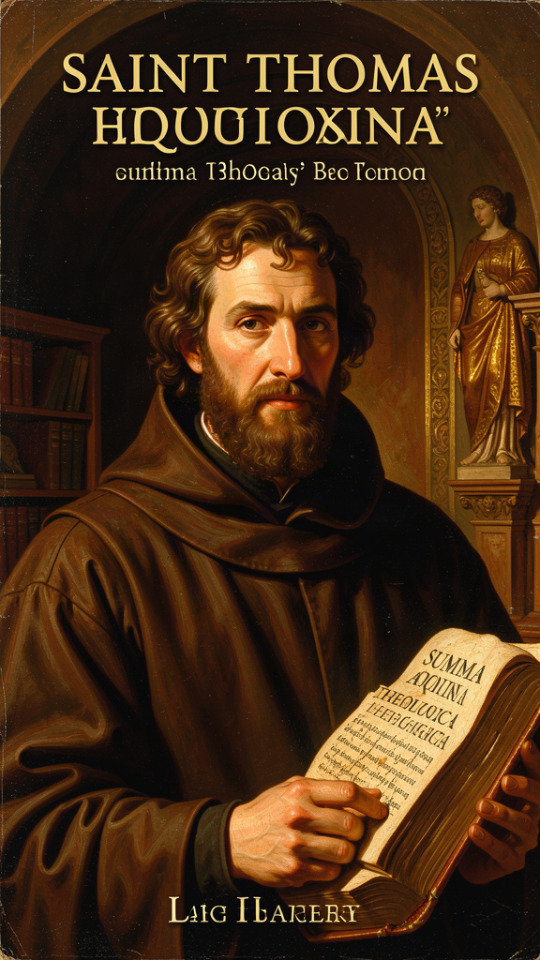
The Architecture of Being
WisdomForge Booklet — Ages 15–18

The Architecture of Being

WisdomForge Booklet — Ages 15–18
———

About This Book
Thomas Aquinas (1225–1274) built one of the most ambitious intellectual structures in the history of Western thought. His Summa Theologica attempts to address every question a rational person can ask about God, creation, morality, and the meaning of existence, using the tools of Aristotelian philosophy, the resources of Christian theology, and the insights of Jewish and Muslim thinkers who preceded him. He never finished it. In December 1273, three months before his death, he stopped writing after a mystical experience and reportedly said that everything he had written "seemed like straw."
This book examines six of Aquinas's most important ideas, presented as sophisticated philosophical arguments rather than simple stories. You will engage with the Five Ways as demonstrations from effect to cause, the act/potency distinction as a metaphysical framework for understanding change, the essence/existence distinction as the foundation of natural theology, natural law as a theory of practical reason, the faith-reason relationship as a model of intellectual integration, and the virtues as an account of human flourishing grounded in habit and practice.
The citations follow standard scholastic format. ST stands for Summa Theologica, followed by Part, Question, and Article (e.g., ST I, Q.2, A.3). SCG stands for Summa contra Gentiles, followed by Book and Chapter. De Ente et Essentia is cited by chapter. These are not decorative references. They are the addresses of the arguments. If you want to read Aquinas's own words — and you should — these citations will take you there.
This booklet assumes you can handle philosophical argument. It does not simplify the ideas. It translates them into clear English and provides context, but the arguments are the real arguments, the objections are the real objections, and the interpretive debates are the real debates. Aquinas deserves nothing less.
———
———

Chapter 1: The Five Ways — Proving God Exists
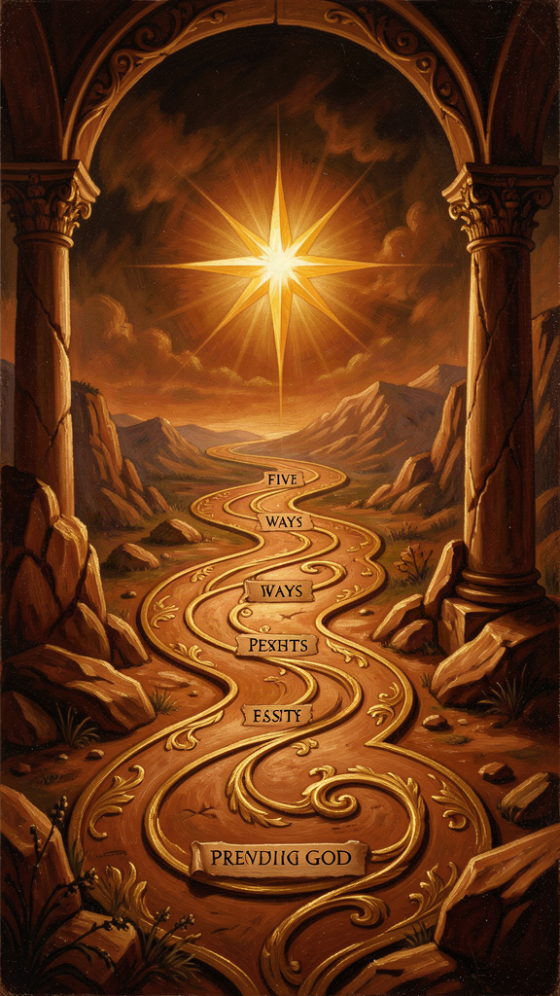
Illustration for Chapter 1
![Chapter 1](/images/booklets/thomas-aquinas-high-ch01.png)

The Most Famous Two Pages in Philosophy
The Five Ways (Quinque Viae) appear at ST I, Q.2, A.3 — approximately two pages in a work of thousands. They are the most widely read, debated, and misunderstood passage in all of Aquinas. They are also the gateway to his entire metaphysical system.
The Five Ways are five arguments for the existence of God, each beginning from a different observable feature of the world and concluding that this feature requires an ultimate ground. Aquinas calls them viae — ways, paths — not demonstrationes in the Euclidean sense. They are demonstrations from effect to cause, showing that certain features of reality point beyond themselves to a source that is purely actual, necessary, perfect, and intelligent.
The Five Ways are not "proofs" that compel agreement. They are arguments that show a rational person that belief in God is not irrational. They depend on metaphysical premises that Aquinas develops elsewhere — the act/potency distinction, the essence/existence distinction, the analogy of being. Reject those premises, and the Ways lose their force. Accept them, and the Ways are powerful demonstrations. The question of whether the premises are acceptable is itself a philosophical question, and Aquinas would want you to ask it.

What the Five Ways Assume
The Five Ways are not arguments from nothing. They assume five things.
The principle of sufficient reason. Everything that exists has an explanation, either in itself or in something else. This is not "everything has a cause" — it is "everything has an explanation." Aquinas's claim is that the existence of contingent beings requires an explanation, and that explanation cannot be an infinite regress of contingent beings.
The distinction between act and potency. Things in motion (changing, becoming) are in potency with respect to what they are becoming. This potency can only be actualized by something already actual. (See Chapter 2.)
The distinction between essence and existence. In all created beings, what a thing is (essence) is distinct from that it is (existence). In God alone, essence and existence are identical. (See Chapter 3.)
The analogical predication of divine names. When we say "God is good," we are not using "good" univocally (in exactly the same sense as human goodness) or equivocally (in a completely different sense). We are using it analogically — there is a real but proportional similarity between God's goodness and the goodness we experience.
That the world is intelligible. The Five Ways begin from observable features of the world, but they assume that the world is the kind of thing that can be understood — that its features point toward their own explanations.
These assumptions are not arbitrary. They are the metaphysical framework Aquinas develops in the surrounding Questions (ST I, Q.3–26). But they are assumptions, and not every philosopher shares them. Hume, Kant, and Russell all rejected at least some of them. The Five Ways cannot be evaluated in isolation from this framework.

The Five Ways in Detail
The First Way: From Motion (*Ex Motu*)
"It is certain, and evident to our senses, that in the world some things are in motion. Now whatever is in motion is put in motion by another..." (ST I, Q.2, A.3)
The argument: Some things in the world are in motion. "Motion" (motus) means any change from potency to act — heating, growing, learning, becoming. Whatever is in motion is put in motion by another (nothing moves itself from potency to act). An infinite regress of movers is impossible in an essentially ordered series — a series where each member depends on a prior member here and now (like a hand moving a stick moving a stone), not a temporally ordered series (like a chain of parents). Therefore, there must be a first mover, unmoved — and this is God.
The crucial distinction is between essentially ordered and incidentally ordered series. In an essentially ordered series, each member depends on a prior member simultaneously — the intermediate causes have no causal power independently. A stick does not move a stone unless a hand moves the stick. In an incidentally ordered series, each member depends on a prior member temporarily — a father begets a son, who later begets his own son. The First Way concerns essentially ordered series. The "first mover" is not first in time but first in ontological priority — the ultimate ground of all change, here and now.
This is not "everything has a cause, so God is the first cause." It is: any change requires an actualizer, and an infinite regress of dependent actualizers still requires an ultimate actualizer that is pure act.
The Second Way: From Efficient Cause (*Ex Efficiente Causa*)
The argument: In sensible things, we find an order of efficient causes. No efficient cause can be the cause of itself (it would have to exist before itself). An infinite regress of essentially ordered efficient causes is impossible. Therefore, there must be a first efficient cause — and this is God.
The Second Way differs from the First because it addresses a different metaphysical feature. The First Way is about actualization of potency (change). The Second Way is about existential dependence (causation). A thing could be in motion (First Way) without being caused to exist (Second Way). The two Ways address different dimensions of reality.
The Third Way: From Possibility and Necessity (*Ex Possibili et Necessario*)
The argument: Some things in nature are contingent (they can be or not be — they are generated and corrupted). If everything were contingent, then at some time nothing would have existed (contingent things eventually fail to exist). But if nothing ever existed, nothing would exist now (ex nihilo nihil fit — something cannot come from nothing). Therefore, not everything is contingent — there must be something necessary. If this necessary being has a cause, the chain must terminate in a necessary being that is necessary per se (through itself). This necessary being is God.
The crucial move: this is not the "cosmological argument" as commonly presented. Aquinas is not arguing that the universe had a beginning. He is arguing that the existence of contingent beings requires a necessary ground — something that exists through itself and does not depend on anything else for its existence.
The controversial step is premise 2: "if everything were contingent, then at some time nothing would have existed." Critics argue that an infinite temporal series of contingent beings could avoid the conclusion. Thomists respond that the argument is not about temporal succession but about existential dependence — contingent beings, by their nature, depend on something that does not depend on them.
The Fourth Way: From Degrees of Being (*Ex Gradibus*)
The argument: Among beings, there are degrees of goodness, truth, nobility. Things are called more or less good/true/noble according to their approximation to a maximum. The maximum in any genus is the cause of all in that genus (fire, the hottest thing, is the cause of all heat). Therefore, there is something that is the maximum of being — the most being, the most true, the most good — and this we call God.
This is the most contested of the Five Ways. Critics argue that it depends on a Platonic premise (that gradations require a separate Form) that Aquinas himself rejects elsewhere. Thomists respond that the "maximum" is not a superlative instance but a transcendental cause — God is not "the best being" but "being itself" (ipsum esse). The debate remains open.
The Fifth Way: From Governance (*Ex Gubernatione Rerum*)
The argument: Natural bodies that lack intelligence act toward ends (acorns become oaks, hearts pump blood). Nothing lacking intelligence can act toward an end unless directed by something with intelligence. Therefore, there is an intelligent being that directs all natural things to their ends — and this we call God.
This is an argument from intrinsic teleology — the built-in tendency of natural things to achieve specific results. It is not the modern "intelligent design" argument, which argues from the improbability of complex structures. Aquinas is arguing from the regularity of natural processes, not from their complexity. The order is not imposed from outside; it is inherent in nature, and that inherent order points to an intelligent cause.

What the Five Ways Do Not Establish
At the end of the Five Ways, Aquinas has established that there is a first mover (pure act), a first efficient cause (uncaused cause), a necessary being (being through itself), a maximum of being (being itself), and an intelligent governor (the source of natural order).
He has not established that these five are one being (this requires further argument in Q.11). He has not established that this being has the attributes of the God of revelation — omniscience, omnipotence, benevolence. He has not established that this being is a person, or that it loves, judges, or creates freely.
The Five Ways are the beginning of natural theology, not the conclusion. The rest of the Prima Pars (Q.3–26) develops what we can say about the first mover, first cause, necessary being, maximum of being, and intelligent governor — and whether these can be identified with the God of Scripture.
This is a crucial point that most textbook treatments miss. The Five Ways do not prove "the God of the philosophers" and then leave it at that. They establish a starting point. The identification of the first mover with the God of Abraham, Isaac, and Jacob requires further argument — argument that Aquinas provides in the hundreds of pages that follow.

Interpretive Debates
The Five Ways have been read in multiple ways, each with competent defenders.
As deductive proofs: readings that treat the Ways as formal syllogisms whose conclusions follow necessarily from their premises. On this reading, if the premises are true, the conclusions follow.
As dialectical demonstrations: readings that treat the Ways as arguments that show the rationality of belief without compelling assent. On this reading, the Ways show that belief in God is reasonable, not that it is forced.
As heuristic pointers: readings that treat the Ways as paths that orient the mind toward God without functioning as formal proofs. On this reading, the Ways are invitations to see the world as pointing beyond itself.
As summaries of longer arguments: readings that treat the two-page Five Ways as compressed versions of arguments developed at much greater length in the Summa contra Gentiles. On this reading, the Ways cannot be evaluated without their fuller treatments.
Each reading finds something in the text. None is definitive. The important point is that Aquinas calls them viae — ways — and that they function within a larger metaphysical framework that gives them their force.

Big Idea
The Five Ways are five demonstrations from observable features of the world to the existence of God. They are not mathematical proofs or arguments for a temporal beginning of the universe. They depend on metaphysical premises (act/potency, essence/existence, analogy) that Aquinas develops elsewhere. They establish a starting point — a first mover, first cause, necessary being, maximum of being, and intelligent governor — but not the full identity of this being with the God of revelation. The rest of the Prima Pars develops that identification.

Practice
1. Reconstruct the First Way. Write the argument in standard form: list each premise and the conclusion. Then identify the crucial move — the claim that an infinite regress of essentially ordered movers is impossible. Why does "essentially ordered" matter here? What would change if the series were incidentally ordered?
2. Compare the First and Second Ways. Both argue for a "first" that terminates a series. But the First Way concerns motion (actualization of potency) and the Second concerns efficient causation (existential dependence). Construct a scenario where the two arguments come apart. Can something be in motion without being efficiently caused? Can something be efficiently caused without being in motion?
3. Evaluate the Fourth Way. The argument moves from degrees of goodness to a maximum of goodness. Is this move valid? What is the difference between saying "there is a maximum of goodness" and saying "there is something that is goodness itself"? Which does Aquinas need, and which does he have?
4. Identify the assumptions. The Five Ways assume the principle of sufficient reason, the act/potency distinction, the essence/existence distinction, analogical predication, and the intelligibility of the world. For each assumption, ask: is it a reasonable premise? What would a philosopher who rejects it say? Can the Ways work without it?

Reflect
Aquinas says the Five Ways establish that there is a first mover, first cause, necessary being, maximum of being, and intelligent governor — but they do not establish that these are one being. What would it take to show that the first mover is also the first cause? That the necessary being is also the maximum of being? Is this a gap in the argument, or does Aquinas address it elsewhere? If God is the conclusion of five arguments, is there one God or five "somethings"?
———
———

Chapter 2: Act and Potency — The Grammar of Change
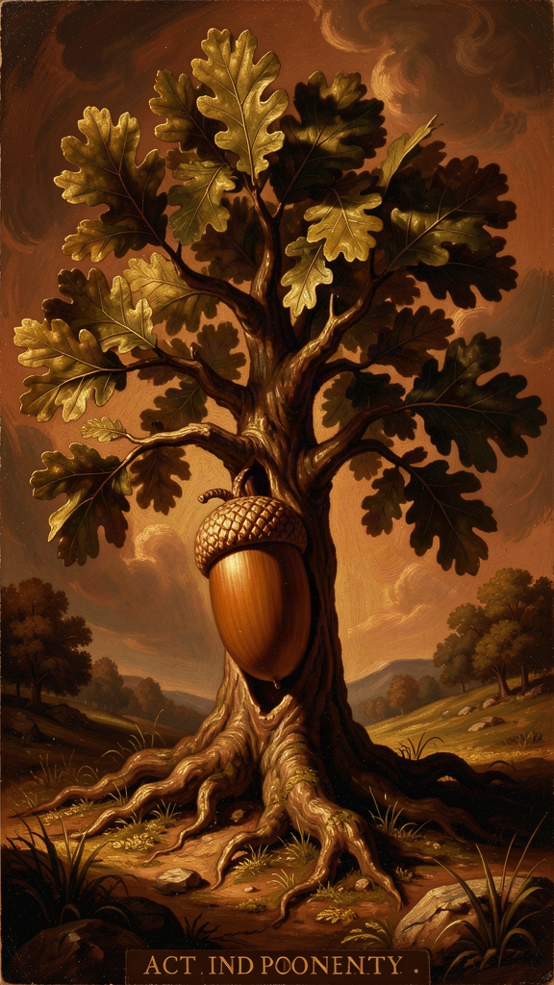
Illustration for Chapter 2
![Chapter 2](/images/booklets/thomas-aquinas-high-ch02.png)

The Most Important Distinction You Have Never Heard Of
Act and potency are the conceptual foundation of Aquinas's entire metaphysics. Without them, you cannot understand the Five Ways, the real distinction between essence and existence, the analogy of being, or the account of creation. They are not a technical add-on. They are the lens through which Aquinas sees reality.
The distinction comes from Aristotle, but Aquinas develops it in ways that go beyond anything Aristotle explicitly said. He extends it from physical substances to intellectual operations, from finite beings to God, from change to creation itself.

The Basic Framework
Act (actus, energeia) is what something actually is. A hot stove is actually hot. A person who knows French is actually knowing it. Act is present reality — the state of being fully realized in a given respect.
Potency (potentia, dynamis) is what something could be but is not yet. A cold stove could be hot — it has the capacity for heat. A student could learn French — they have the capacity for knowledge. Potency is a real but not-yet-actual dimension of a thing.
The key insight: every finite reality is a mixture of act and potency. A cold stove is actually a stove but potentially hot. A student is actually a person but potentially knowledgeable. The world is not made of static, finished things. It is made of things in the process of becoming what they can be.

Why This Matters
Act and potency explain four things that require explanation.
Change. Change is the actualization of potency. When a cold stove becomes hot, the potency for heat (which was real but not actual) becomes actual. Change is not something coming from nothing — it is something potential becoming something actual. This solves a problem that puzzled the pre-Socratics: how can something become what it is not without ceasing to be what it is? The stove does not stop being a stove when it becomes hot. The heat was already there as a potency, waiting to be actualized.
Limitation. Every finite thing is limited by its potencies. A stone cannot see because sight is not one of its potencies. A human cannot breathe underwater because aquatic respiration is not one of our capacities. To be finite is to be a mixture of act and potency — actual in some respects, potential in others. A thing with no potency would have no limits. It would be pure act.
The First Way. The First Way (ST I, Q.2, A.3) depends on act and potency. If whatever is in motion (actualizing potency) is put in motion by something already actual, then there must be a first mover that is pure act — actualized by nothing, actualizing everything. The act/potency distinction is not a side note. It is the metaphysical engine of Aquinas's most famous argument.
Creation. Creation is not a change. Change is the actualization of a potency that already exists. Creation is the giving of existence to something that had no prior potency to exist — the transition from non-existence to existence, not from potency to act. This is why creation requires a cause that is not just actual but ipsum esse (being itself). Nothing can create itself, because creation is the giving of existence, and nothing can give itself what it does not yet have.

The Hierarchy of Actuality
Aquinas sees reality as a spectrum from maximum potency to pure act:
| Level | Description | Example | |-------|-------------|---------| | Prime matter | Pure potency — no form at all | The substratum that can become any physical thing | | Matter informed by form | Act and potency mixed | A human body (actual shape, potential for change) | | Plants | More actual than bare matter, less than animals | Actual life, potential for sensation | | Animals | More actual than plants, less than humans | Actual sensation, potential for understanding | | Humans | Act and potency in intellect | Actual understanding, potential for more knowledge | | Angels | Intellect without matter — more actual than humans | Actual understanding, no bodily potential | | God | Pure act — no potency at all | Fully actual, no potential, no limitation |
This hierarchy is not a value judgment in the modern sense. It is a metaphysical description — each level is more actual (more fully realized, less dependent on external actualizers) than the level below it.

Key Distinctions
Active potency vs. passive potency. Active potency is the power to do something — the power to heat, to know, to build. Passive potency is the capacity to receive something — the capacity to be heated, to be taught. God has no passive potency (God cannot be acted upon or changed) but infinite active potency (God can do all things that are possible). This distinction matters for divine impassibility: God acts but is never acted upon.
First act vs. second act. First act (prima actio) is the possession of a form or capacity — having the power of sight. Second act (secunda actio) is the exercise of that capacity — actually seeing. God is pure first act and pure second act simultaneously. There is no gap between God's possessing a perfection and God's exercising it. In creatures, the gap is real: you can have the capacity to play piano (first act) without currently playing (second act). In God, this gap does not exist.

Common Misunderstandings
"Potency is just possibility." No. Potency is not logical possibility ("it could happen"). Potency is a real feature of a thing — a cold stove's potency for heat is not just a logical possibility but a real capacity grounded in the stove's nature. Potency is a real but not-yet-actual dimension of reality. The difference matters: logical possibility is a feature of our descriptions; potency is a feature of things.
"Act and potency are just form and matter." Form and matter are one way of understanding act and potency in physical substances (form is act, matter is potency). But act and potency apply more broadly — to intellect (knowledge in act vs. knowledge in potency), to being (existence as act, essence as potency), and to God (pure act, no potency). Form and matter are a case of act and potency, not identical with them.
"God as pure act means God is static." Pure act does not mean "static" or "unchanging" in the sense of inertness. It means fully realized, completely actual, without unrealized potential. God is more active than any finite thing — but God's activity is not the actualization of a prior potency. It is the pure, complete actuality of being itself. God does not need to become anything. God is already everything God can be.

Why This Matters for Modern Philosophy
Process philosophy. Whitehead's process metaphysics is, in effect, a rejection of act and potency. Where Aquinas says reality is a mixture of act and potency oriented toward pure act, Whitehead says reality is always in process, always becoming, never purely actual. The debate between these two frameworks is still alive.
Analytic metaphysics. Contemporary debates about modality (possible worlds, necessity, contingency) are, at bottom, debates about potency. What does it mean to say something "could" be otherwise? Aquinas's answer — that potency is a real feature of things, not just a logical description — remains a live option.
Philosophy of mind. The act/potency distinction provides a framework for understanding consciousness that avoids both dualism and reductionism. Consciousness is the act of an intellect that has the potency for knowledge. This is not a substance separate from the body (dualism) nor is it reducible to brain activity (reductionism). It is the actualization of a potency grounded in the whole human being.

Big Idea
Act and potency are the fundamental metaphysical distinction. Act is what something actually is; potency is what it could be but is not yet. Every finite thing is a mixture of both. Change is the actualization of potency. God alone is pure act — fully realized, complete, without unrealized potential. This distinction grounds the First Way, the account of creation, the hierarchy of being, and the doctrine of divine simplicity.

Practice
1. Map the hierarchy. Aquinas describes a hierarchy from prime matter (pure potency) to God (pure act). Place five things on this spectrum — a rock, a plant, a dog, a human, an angel (if you accept the concept). For each, identify what is actual and what is potential. Where does the greatest "gap" between act and potency appear?
2. Distinguish active and passive potency. For each of the following, identify the active potency (power to do) and the passive potency (capacity to receive): a teacher, a student, a fire, a lump of clay. Now apply the distinction to God: what active potencies does God have? What passive potencies does God lack? Why does the absence of passive potency matter for divine impassibility?
3. Explain creation. Aquinas says creation is not a change. Change is the actualization of an existing potency. Creation is the giving of existence to something with no prior potency to exist. Explain this distinction in your own words. Why does it matter? What would go wrong if creation were just another kind of change?
4. Engage the objection. A critic says: "If God is pure act with no potency, then God cannot do anything new. God cannot respond to prayer, act in history, or love particular persons. Pure act means a frozen, impersonal God." Construct Aquinas's response. How does the distinction between first act and second act help? What does it mean for God to "act" if God has no potency?

Reflect
Aquinas says everything in the world is a mixture of act and potency, and God alone is pure act. But what about human consciousness? When you are actively thinking, your mind seems to be fully actual — and yet you can always think more, understand more deeply, shift your attention. Is consciousness a mixture of act and potency? Is there any state of human consciousness that is "pure act"? Or is the very fact that we can always know more evidence that we are always, in this life, a mixture?
———
———

Chapter 3: Essence and Existence — What Something Is vs. That It Is
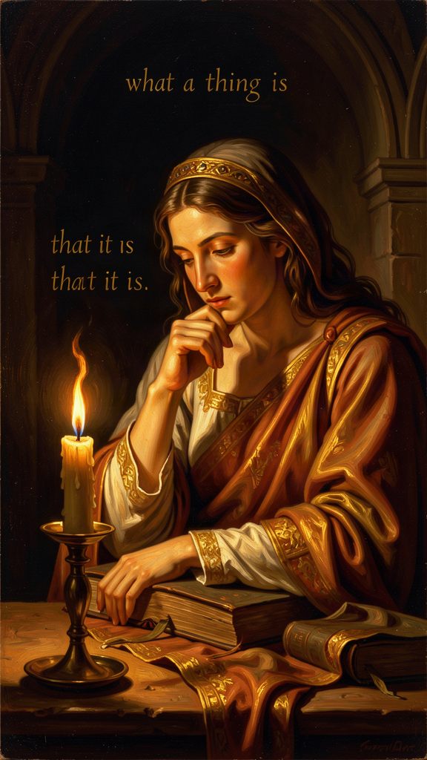
Illustration for Chapter 3
![Chapter 3](/images/booklets/thomas-aquinas-high-ch03.png)

The Metaphysical Heart of the System
The distinction between essence and existence is the metaphysical heart of Aquinas's entire system. It is the key to his natural theology, his account of creation, his understanding of divine simplicity, and his theory of analogy. If act and potency are the framework, the essence/existence distinction is the foundation.
The core claim: in every created being, what a thing is (its essence) is really distinct from that it is (its existence). In God alone, essence and existence are identical. God is ipsum esse subsistens — subsistent being itself.
This is not an abstract technicality. It is Aquinas's answer to the most fundamental metaphysical question: what does it mean for something to exist?

The Two Dimensions of Reality
Essence (essentia, quidditas) is "what a thing is." It is the nature, the definition, the "whatness" of a thing. The essence of a human being is rational animality. The essence of a triangle is a three-sided plane figure. The essence of fire is hot, dry, luminous. Essence answers: What is this?
Existence (esse, actus essendi) is "that a thing is." It is the act of being — not a property a thing has, but the act by which a thing is. A human being exists (or does not). A triangle exists (or does not). Fire exists (or does not). Existence answers: Is this?
The crucial point: essence and existence are not two parts of a thing, like body and soul. They are not two properties, like redness and roundness. They are two different dimensions of reality. Essence is what a thing is. Existence is that it is. A thing's essence does not include its existence — you can know what a unicorn is without knowing whether unicorns exist.

The Real Distinction
Aquinas's claim is not just that essence and existence are different concepts. His claim is that in created beings, they are really distinct — different in reality, not just in our thinking.
The argument, from De Ente et Essentia (On Being and Essence), Ch. 4–5:
1. In any created being, essence and existence can be separated in thought. You can understand what a phoenix is without knowing whether phoenixes exist. 2. If essence and existence were identical in a created being, that being would exist by its own essence — it would be self-existent. 3. But no created being is self-existent. All created beings depend on something else for their existence. 4. Therefore, in every created being, essence and existence are really distinct.
What this means: a created being is not its own existence. It has existence — it participates in being — but it is not identical with being. Its existence is received, not self-generated.
The analogy: think of light. A lit candle has light, but the candle is not identical with the light. The light is received from a source (the flame). In the same way, every created being has existence, but existence is not part of its essence — it is received from a source.

God: Where Essence and Existence Are Identical
If in every created being essence and existence are distinct, then in a being whose essence and existence are identical, that being would be self-existent. Its essence would be existence.
This is what Aquinas says about God. God is ipsum esse subsistens — not "a being that exists" but "existence itself." God does not have existence. God is existence. God's essence is to exist.
This follows from the logic of the real distinction:
- If essence and existence are distinct in every created being. - And if there must be a ground for the existence of created beings (a being that does not receive existence but is existence). - Then there must be a being whose essence and existence are identical. - And this being is what we call God.
The philosophical point is striking. God is not "a being" among other beings. God is not "the biggest being" or "the most powerful being." God is being itself — the act of existing in which all other beings participate. This is why Aquinas says God is not in a genus (ST I, Q.3, A.5). God is not a being. God is ipsum esse.

Why This Matters
The essence/existence distinction grounds four of Aquinas's most important arguments.
The Third Way. The Third Way (ST I, Q.2, A.3) argues from contingency to necessity. The essence/existence distinction explains why created beings are contingent: because their essence does not include existence, their existence depends on something else. A being whose essence includes existence would be necessary — it would exist through itself, not by dependence.
Creation. If existence is distinct from essence in created beings, then the act of creation is the act of causing existence — giving esse to a thing that did not have it. This is why creation is ex nihilo (from nothing): the existence of the creature is not derived from any pre-existing essence, but is given directly by God. Creation is not making something out of something else. It is giving existence itself.
Divine simplicity. If God's essence is identical with God's existence, then God has no composition — no parts, no potentiality, no distinction between what God is and that God is. This is the foundation of divine simplicity (ST I, Q.3), the cornerstone of Aquinas's entire account of God. God is not made of parts. God is one, simple, complete act of being.
Analogy. If God is ipsum esse and creatures have esse, then we cannot speak of God and creatures univocally (using words in exactly the same sense) or equivocally (using words in completely different senses). We must speak analogically — there is a real but proportional similarity between God's goodness and the goodness we experience. (This is the subject of the analogy of being, treated at ST I, Q.13.)

The Interpretive Debate
The nature of the "real distinction" is one of the most contested questions in Thomistic scholarship. Three main positions have competent defenders.
The Real Distinction (Gilson, Fabro). Essence and existence are really distinct in creatures — two different principles of being, not just two concepts. Existence is the act of essence; essence is the potency for existence. This is the most common Thomist reading. On this view, the distinction is a real metaphysical composition in creatures — they are "made of" essence and existence, though not in the way a physical object is made of parts.
The Conceptual Distinction (Cajetan, some Thomists). Essence and existence are really identical in creatures but conceptually distinct. They differ in our thinking, not in reality. This preserves the distinction without committing to a metaphysical composition in creatures. On this view, the distinction is a distinction of reason, not of reality.
The Moderate Real Distinction (Wippel, some analytic Thomists). Essence and existence are really distinct, but the distinction is not between two "things" or "principles" that could exist separately. The distinction is between a thing's nature and the act by which it exists — real but non-separable. This is a middle position that tries to preserve the reality of the distinction without the metaphysical baggage.
Each position has philosophical merits, and each has been defended by competent scholars. The important point is that Aquinas holds some version of the distinction, and it is foundational for his entire system. The debate is not about whether Aquinas holds the distinction, but about what kind of distinction it is.

For Modern Readers
The essence/existence distinction raises questions that are still live in contemporary philosophy.
What is existence? Is existence a property (like redness) or an act (like running)? Aquinas says it is an act — the most fundamental act of any being. This contrasts with the Fregean view that existence is a second-order property (a property of concepts, not of objects). The debate between these views is still alive in analytic metaphysics.
Why is there something rather than nothing? If essence does not include existence, then the existence of any being requires an explanation. The question "why does anything exist?" is not meaningless — it points to the distinction between what things are and that they are. This question, which Aquinas takes seriously, is one that many modern philosophers (following the logical positivists) dismissed as meaningless. It has returned to prominence in contemporary metaphysics.
Can we conceive of existence? If existence is not a concept but an act, then we cannot grasp existence by thinking alone — we must experience it. This connects to existentialist themes (Heidegger, Marcel) while remaining grounded in a metaphysical framework. The question of whether existence can be "thought" or only "enacted" is still a live question.

Big Idea
In everything that exists, what it is (essence) is really distinct from that it is (existence). Everything receives existence from something else; nothing is its own existence. But God is different. God does not receive existence. God is existence — ipsum esse subsistens. This distinction grounds the Third Way, the account of creation, divine simplicity, and the analogy of being. The debate over what kind of distinction it is (real, conceptual, or moderate) remains open.

Practice
1. Test the distinction. For each of the following, separate the essence from the existence: a horse, a mathematical triangle, a character in a novel, the number seven, your best friend. Which of these have an essence that can be understood without knowing whether they exist? Which have an essence that includes existence? What does this tell you about the scope of the distinction?
2. Trace the argument. Reconstruct the argument from De Ente et Essentia for the real distinction. Identify each premise and the conclusion. Where is the argument most vulnerable? What would a critic attack first?
3. Explore the analogy. Aquinas uses the analogy of light and a candle. Construct your own analogy for the essence/existence distinction. What works? What breaks down? Does your analogy capture the idea that existence is an act, not a property?
4. Engage the interpretive debate. The three positions (Gilson's real distinction, Cajetan's conceptual distinction, Wippel's moderate distinction) disagree about what kind of distinction Aquinas holds. Choose one position and defend it against the other two. What is at stake philosophically? Does it matter whether the distinction is "real" or "conceptual"?

Reflect
Aquinas says God is not "a being" but "being itself" — ipsum esse subsistens. This means God is not the biggest, most powerful thing in the universe. God is not a thing at all, in the way that tables, stars, and humans are things. God is the act of existing itself. How does this change your understanding of the word "God"? Is it easier or harder to believe in "being itself" than in "a supreme being"? What is gained, and what is lost, by thinking of God this way?
———
———

Chapter 4: Natural Law — Morality Written Into Creation
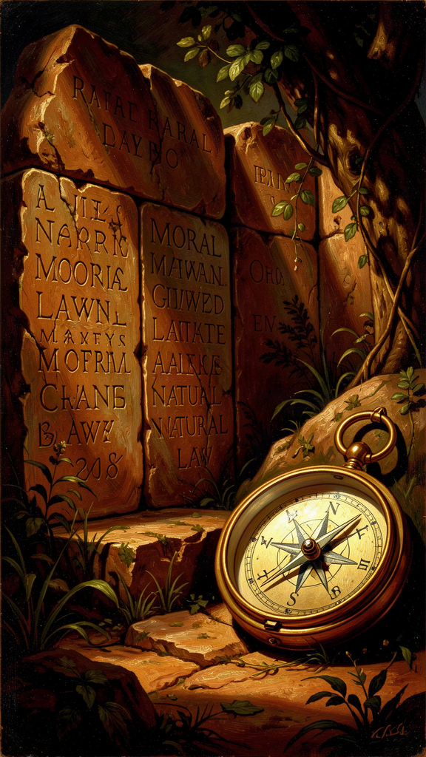
Illustration for Chapter 4
![Chapter 4](/images/booklets/thomas-aquinas-high-ch04.png)

Law Is Not Just Rules
For Aquinas, law is not whatever a sovereign commands. Law is "an ordinance of reason for the common good, made by him who has care of the community, and promulgated" (ST I-II, Q.90, A.4). This definition is deliberately restrictive. It means that not everything called "law" is actually law. An unreasonable decree, a private statute, or a command from an illegitimate authority may have the form of law but lack its substance.
This definition is the foundation of one of the most influential moral and political theories in the Western tradition. It directly shaped the concept of universal human rights, the American Declaration of Independence, the Nuremberg Principles, and contemporary virtue ethics. Martin Luther King Jr. cited Aquinas on natural law in his "Letter from Birmingham Jail."

The Four Elements of Law
Aquinas's definition contains four essential elements.
An ordinance of reason (*rationis ordinatio*). Law is not arbitrary will. It is a directive of reason. A command that contradicts reason is not a law in the full sense. This is Aquinas's most important claim: law is inherently rational. A tyrant's decree, however enforced, lacks the character of law if it fails the test of reason.
For the common good (*ad bonum commune*). Law is not for the private benefit of the legislator. It must be directed toward the good of the community as a whole. A statute that serves only a narrow interest, contrary to the common good, fails to meet the definition of law.
Made by legitimate authority (*ab eo qui curam communitatis habet*). Only someone with care of the community can make law. This follows from the nature of law as a communal ordinance. Someone without authority has no business legislating for a community they do not represent.
Promulgated (*promulgata*). A law no one knows about is not a law in practice. Law must be made known to those it binds. This anticipates the legal principle that ignorance of the law is no excuse only when the law has been properly promulgated.

The Four Kinds of Law
Aquinas identifies four kinds of law, organized hierarchically.
Eternal Law (Lex Aeterna, ST I-II, Q.93) is God's plan for the entire universe — the rational order by which all creation is directed toward its proper end. "The rational ordering of all things by God, which is the divine wisdom directing all acts and movements" (ST I-II, Q.93, A.1). Eternal law is not a set of commands imposed from outside. It is the rational structure inherent in creation — the way things are meant to work. God does not "legislate" by issuing arbitrary decrees. God orders creation according to reason.
Natural Law (Lex Naturalis, ST I-II, Q.94) is what human beings can discover through reason about the right ordering of human life. "The participation of the rational creature in eternal law" (ST I-II, Q.91, A.2). Natural law is not Catholic morality or religious law. It is reason's own discovery of what human flourishing requires.
The first precept: "Good is to be done and pursued, and evil is to be avoided" (ST I-II, Q.94, A.2). This is not a commandment from outside. It is the most basic principle of practical reason — the self-evident starting point from which all moral reasoning proceeds. You cannot argue against it without relying on it, because any argument against pursuing the good implicitly assumes that there is something worth pursuing.
The primary precepts (ST I-II, Q.94, A.2): 1. Self-preservation — the inclination to preserve one's own life. 2. Reproduction and education of offspring — the inclination to have and raise children. 3. Living in society — the inclination to live in community, pursue truth, and avoid ignorance. 4. Worship of God — the inclination to know the source of one's being.
These are not arbitrary rules. They are the basic inclinations of human nature — what human beings naturally tend toward when functioning properly. Natural law is rational reflection on these inclinations.
Human Law (Lex Humana, ST I-II, Q.95) is the specific legislation communities enact to apply natural law to particular circumstances. Human law derives from natural law in two ways: as conclusions (some laws follow directly, like "do not murder" following from "preserve life") and as determinations (some laws are specific applications, like speed limits or tax rates, determined by the legislator for particular circumstances). Human law varies across societies because different circumstances require different determinations.
Divine Law (Lex Divina, ST I-II, Q.91, A.4) is the law revealed by God in Scripture. It supplements natural law: it makes clear what natural law could discover but has been obscured by sin, and it reveals truths that natural law could not discover on its own (the requirements of salvation, the nature of the beatific vision). Divine law is necessary because human reason has been damaged by sin and needs divine guidance, and because some truths about our ultimate end exceed natural reason.

The Problem of Unjust Laws
Aquinas addresses a question that still matters: must we obey unjust laws?
His answer, at ST I-II, Q.96, A.4, is nuanced. A law is unjust if it meets any of three criteria: it is contrary to the common good (serving private interests), it exceeds the legislator's authority, or it imposes unequal burdens without proportionate reason. An unjust law, Aquinas says, is "a perversion of law" rather than a true law. It does not bind in conscience.
But Aquinas immediately qualifies this. Disobedience may cause greater harm than compliance. In some cases, prudence requires obeying an unjust law to avoid social chaos. The principle is clear — unjust laws lose their binding force — but the application requires practical wisdom.
This passage directly influenced Martin Luther King Jr.'s "Letter from Birmingham Jail." King wrote: "I would agree with St. Augustine that 'an unjust law is no law at all.' ... A just law is a man-made code that squares with the moral law or the law of God. An unjust law is a code that is out of harmony with the moral law." King cited Aquinas by name, drawing on ST I-II, Q.96, A.4, to argue that segregation laws were unjust because they degraded human personality and imposed unequal burdens. The Nuremberg defense — "following orders" — fails for the same reason: orders that violate natural law do not have the force of law.

Natural Law Is Not Just Religious Morality
The most common misconception about Aquinas's natural law theory is that it is Catholic morality disguised as philosophy. It is not, and Aquinas insists on this.
Based on human nature, not revelation. The primary precepts are discoverable by reason alone. You do not need to believe in God or read Scripture to discover that human beings have inclinations to preserve life, reproduce, live in society, and seek truth.
Accessible to everyone. Aquinas explicitly says the general precepts are known to all people, regardless of religious belief (ST I-II, Q.94, A.2). Specific applications may vary across cultures, but the general framework is universal.
Compatible with secular reasoning. Modern natural law theorists like John Finnis and Robert George have developed natural law theory in a secular context, without relying on theological premises. Whether this secular development is faithful to Aquinas's intentions is debated, but it shows that natural law is not inherently religious.
Not a list of prohibitions. Natural law is not primarily about what you cannot do. It is about what human flourishing requires — the positive inclinations toward life, knowledge, society, and meaning that are built into human nature.

The Hierarchy of Precepts and the Problem of Clouded Reason
Natural law has a hierarchy. The most general precepts — preserve life, do good, avoid evil — are known to everyone. More specific precepts — the wrongness of theft, the requirements of justice — require more careful reasoning and can be obscured by passion, bad habit, or cultural distortion. The most specific applications — speed limits, tax rates, property regulations — vary across cultures and circumstances.
Aquinas explicitly acknowledges (ST I-II, Q.94, A.4) that practical reason can be clouded. He does not claim that every person knows every precept of natural law. What is universal is the general framework, not every specific conclusion. This is a crucial nuance: natural law is not a claim about universal moral agreement, but a claim about the structure of practical reason. The framework is accessible to all; the details require judgment and are fallible.

Big Idea
For Aquinas, law is not whatever a ruler commands. It is an ordinance of reason for the common good, made by legitimate authority, and promulgated. There are four kinds of law: eternal (God's rational ordering of creation), natural (reason's participation in eternal law), human (specific legislation applying natural law), and divine (revelation supplementing natural law). Natural law is grounded in human nature, accessible to reason, and not inherently religious. Unjust laws lose their binding force because they fail to meet the definition of law.

Practice
1. Apply the four elements. Pick three laws in your country — one you agree with, one you disagree with, and one you are unsure about. Apply Aquinas's four criteria to each: Is it an ordinance of reason? Does it serve the common good? Does it come from legitimate authority? Is it promulgated? Which laws pass all four tests? Which fail?
2. Test the first precept. Aquinas says "good is to be done and pursued, and evil is to be avoided" is self-evident. Try to argue against it. What happens? Can you argue that good should be avoided without implicitly assuming that there is something worth pursuing? What does this tell you about the status of the first precept?
3. Evaluate unjust law. Aquinas says unjust laws do not bind in conscience, but disobedience may cause greater harm than compliance. Construct a scenario where this tension is real. When should a person obey an unjust law? When should they disobey? What criteria would Aquinas use to decide?
4. Trace the influence. Aquinas's natural law theory influenced the American Declaration of Independence ("the laws of Nature and of Nature's God"), the Nuremberg Principles, and Martin Luther King Jr.'s "Letter from Birmingham Jail." Pick one of these and identify the specific Aquinas-derived elements. How does the historical document use Aquinas's framework?

Reflect
Aquinas says natural law is based on "the basic inclinations of human nature" — self-preservation, reproduction, social life, and the search for God. But what if human nature is more complex or more varied than Aquinas assumed? What if some people do not have all these inclinations? Does natural law assume a "normal" human being? And who gets to decide what counts as "natural"? Is this a problem for the theory, or can natural law accommodate variation in human nature without collapsing?
———
———

Chapter 5: Faith and Reason — Two Wings of Truth
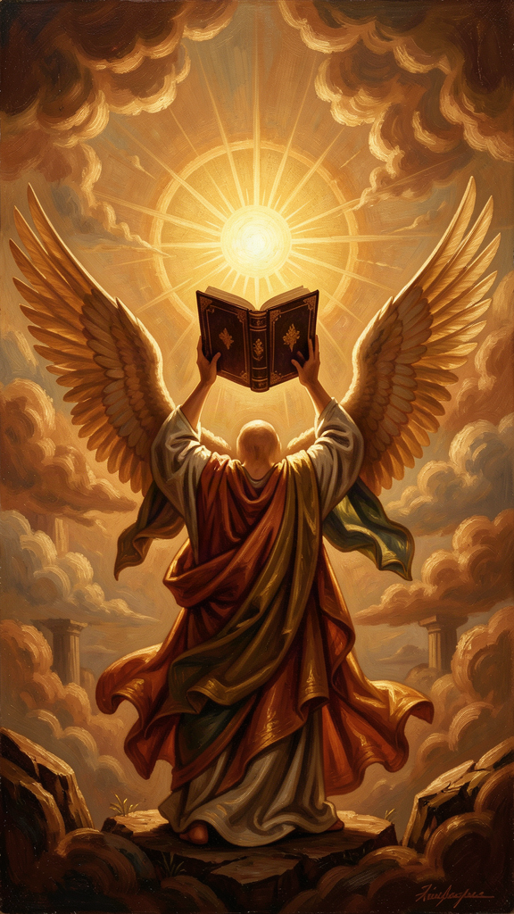
Illustration for Chapter 5
![Chapter 5](/images/booklets/thomas-aquinas-high-ch05.png)

Not Enemies, But Partners
Aquinas's account of the relationship between faith and reason is one of his most enduring contributions — and one of the most misunderstood. He does not subordinate reason to faith. He does not subordinate faith to reason. He argues that faith and reason are two sources of truth that cannot genuinely contradict each other, because both come from God.
The image, borrowed from Pope John Paul II's Fides et Ratio (which draws on Aquinas), is of two wings. A bird needs both to fly. Reason without faith is incomplete. Faith without reason is credulous. Together, they give the full picture.

The Core Argument
Aquinas's foundational principle, at ST I, Q.1, A.1: "Since truth cannot be contrary to truth, the truth of reason is not contrary to the truth of the Christian faith." If reason discovers a truth (through observation, logic, or argumentation) and faith reveals a truth (through Scripture or tradition), these two truths cannot contradict each other — because both come from God, and God does not contradict himself.
The implication: if there appears to be a contradiction between faith and reason, one of three things has gone wrong. The reasoning is flawed (we made a mistake in our argument). The interpretation of faith is flawed (we misunderstood what revelation teaches). Or both need correction. What is not possible is that genuine faith and genuine reason contradict each other.
This principle has a radical consequence: theology must answer to philosophy, and philosophy must answer to theology. Both disciplines are accountable to the same standard: truth. A theological claim that contradicts philosophical truth must be re-examined. A philosophical claim that contradicts revealed truth must be re-examined. Neither discipline is autonomous. Both are servants of truth.

Two Orders of Truth
Aquinas distinguishes two orders of truth.
| Feature | Natural Reason | Faith | |---------|---------------|-------| | Source | Human observation and logic | Divine revelation | | Scope | What can be discovered by human power | What God has revealed | | Accessibility | Available to everyone | Requires acceptance of revelation | | Certainty | Proportional to the strength of the argument | Based on the authority of the revealer | | Examples | God's existence, natural law, the structure of reality | The Trinity, the Incarnation, the beatific vision |
There is overlap. Some truths are in both orders — God's existence, the basic principles of morality. These can be known by reason alone, but faith confirms them and provides additional motivation for pursuing them. The Five Ways demonstrate God's existence by reason; Scripture reveals God's existence by faith. These are not two different truths. They are the same truth, known through two channels.
Some truths are above reason, not against reason. The Trinity, the Incarnation, the resurrection of the body — these exceed the capacity of natural reason but are not contrary to it. Aquinas is not saying that faith requires believing irrational things. He is saying that some truths are beyond what reason can prove, but consistent with reason. The Trinity is not illogical. It is simply not the kind of thing that logic could discover on its own. Reason can show that the doctrine is not contradictory, but it cannot prove it.

Faith Is Not Irrational
Faith, for Aquinas, is not blind belief. It is voluntary assent to truths that are supported by evidence (miracles, the authority of the Church, the coherence of the system) but not proved by that evidence. Faith goes beyond reason, but it is not against reason.
The analogy: you might trust a friend's testimony about something you have not seen yourself. Your trust is not irrational — it is based on your friend's reliability. But it goes beyond what you could prove on your own. If your friend has always been honest, and they tell you they saw something remarkable, it is reasonable to believe them. It is not a proof, but it is not irrational. Faith, for Aquinas, is like this: reasonable trust in a reliable source (God), not a leap into the dark.
This means faith involves both intellect and will. The intellect sees the evidence (miracles, coherence, authority). The will chooses to assent, going beyond what the evidence strictly proves. Faith is not the intellect being overridden. It is the intellect and will working together, responding to evidence that falls short of proof but is sufficient for trust.

What Aquinas Does Not Say
He does not say faith and reason are separate domains with no overlap. They overlap in the truths both can discover, and faith provides a context for reason — confirming truths that reason can discover and motivating the pursuit of wisdom.
He does not say reason is subordinate to faith. Reason has its own proper domain, and it operates by its own principles. Within that domain, reason is authoritative. The existence of God, the structure of reality, the principles of morality — these are discoverable by reason without faith.
He does not say faith is irrational. Faith is a voluntary assent to truths supported but not proved by evidence. It is reasonable trust in a reliable source, not blind belief.
He does not say science and religion are in conflict. Science studies the natural world using reason. Faith addresses truths that exceed natural reason. They are not in competition because they address different questions. Science asks how the natural world works. Faith asks what is the ultimate meaning and purpose of existence. This does not mean that specific scientific claims and specific religious claims cannot conflict — but when they do, the conflict is either a bad interpretation of faith, a bad interpretation of science, or both.

The Averroist Challenge
Aquinas's position was not uncontroversial in his own time. The Averroists (followers of the Arabic philosopher Averroes) argued for the "double truth" theory: that a proposition could be true in philosophy and false in theology, or vice versa. On this view, reason and faith are two separate tracks that never meet.
Aquinas explicitly rejected this (SCG I, Ch. 7; ST I, Q.1, A.1). There is only one truth, and it cannot contradict itself. If reason and faith appear to contradict, the contradiction is in our understanding, not in reality.
This position was controversial because it meant theology had to answer to philosophy — theological claims had to be consistent with philosophical truth. And it meant philosophy had to answer to theology — philosophical claims could not contradict revealed truth. Both disciplines were accountable to the same standard: truth. This is not a subordination of one to the other. It is a mutual accountability grounded in the unity of truth.
The tension came to a head in 1277, when Bishop Tempier of Paris condemned 219 propositions, many associated with Averroism and some misattributed to Aquinas himself (who had died in 1274). This episode shows how contentious the faith-reason relationship was in Aquinas's time — and how easily a position that tried to honor both sides could be misread. The condemnations shaped Aquinas's reception for centuries.

Why This Matters
The science-and-religion debate. Aquinas provides a framework for resolving the apparent conflict between science and religion. They are not in competition because they address different questions. Science asks how the natural world works. Faith asks what is the ultimate meaning and purpose of existence. These questions can overlap, but they are not the same question. When a specific scientific claim and a specific religious claim conflict, Aquinas would say one or both interpretations need correction — not that science and faith are inherently opposed.
The limits of reason. Aquinas's position is not irrationalism. It is an acknowledgment that reason has limits. Some truths exceed reason's power — not because they are irrational, but because they are about realities that reason cannot access on its own. This is a philosophical claim about the scope of human rationality, not a theological claim about what God has revealed. Reason can discover its own limits without faith's help; faith confirms what reason suspects.
The relationship between philosophy and theology. Aquinas's position allows philosophy to have its own domain and methods while acknowledging that theology addresses questions philosophy cannot answer on its own. This is a middle way between rationalism (reason can answer all questions) and fideism (reason has no role in theology). Philosophy and theology are not the same discipline, but they are not at war. They are partners in the pursuit of truth.
Intellectual humility. The faith-reason relationship models a form of intellectual humility that is relevant beyond theology. Reason should acknowledge its limits. Faith should engage with reason rather than dismiss it. Both should be open to correction. The model is not a power struggle but a partnership in which both partners are accountable to truth.

Big Idea
Faith and reason are not enemies. They are two sources of truth that cannot contradict each other, because both come from God. Reason can discover some truths on its own (God's existence, natural law, the structure of reality). Faith reveals truths that reason could not discover (the Trinity, the Incarnation). Some truths are above reason, not against it. The task is to hold both together, letting each correct and enrich the other. This requires intellectual humility from both sides.

Practice
1. Map the two orders. Make a list of ten truths. For each, decide: is it discoverable by reason alone, by faith alone, or by both? Where does each truth fall on Aquinas's framework? Are there truths that resist this classification?
2. Analyze a conflict. Identify a historical or contemporary conflict between a scientific claim and a religious claim (e.g., the Galileo affair, the age of the Earth, evolutionary theory). Apply Aquinas's framework: is the conflict a bad interpretation of faith, a bad interpretation of science, or both? What would Aquinas's method recommend?
3. Evaluate the analogy. Aquinas compares faith to trusting a reliable friend. Is this analogy adequate? What are its strengths and weaknesses? How does it handle the problem of religious disagreement (different people trust different "friends")?
4. Test the double truth. Aquinas rejects the Averroist "double truth" theory. But is there a modern version of double truth — a claim that something can be true in science and false in theology, or vice versa? Can you construct a case for double truth that Aquinas would have to engage with? What would his response be?

Reflect
Aquinas says that if faith and reason appear to contradict, either the reasoning is flawed, the interpretation of faith is flawed, or both need correction. But who decides which is flawed? If a scientist says the universe is 13.8 billion years old, and someone interprets Genesis as saying the universe is 6,000 years old, Aquinas would say the biblical interpretation is flawed. But what if the scientist is wrong? How do we decide which side to correct? What authority adjudicates between faith and reason? Is there a method, or is it always a case-by-case judgment?
———
———

Chapter 6: The Virtues — Habits of the Good Life
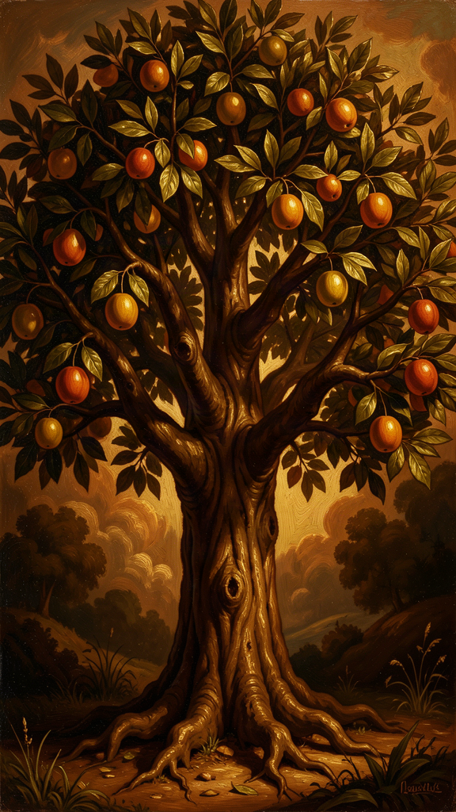
Illustration for Chapter 6
![Chapter 6](/images/booklets/thomas-aquinas-high-ch06.png)

Not Just "Being Good"
For Aquinas, a virtue is not just "being a good person" in a vague sense. A virtue is "a good habit bearing on activity" (ST I-II, Q.55, A.3, following Aristotle). Three elements matter: it is a habit (a stable disposition, not a one-time act), it is good (oriented toward a genuine good, not an apparent one), and it bears on activity (it is about action, not just inner states).
You become just by doing just acts repeatedly, not by doing one just act. You become courageous by acting bravely repeatedly, not by one act of bravery. Virtues are built through practice, like muscles. This is not moralism. It is an account of human flourishing — what human beings need to live well, and how they acquire the habits that make that possible.
Aquinas's account of the virtues is indebted to Aristotle's Nicomachean Ethics, but he transforms Aristotle in two ways: he adds the theological virtues (faith, hope, charity) that Aristotle does not consider, and he grounds the cardinal virtues in natural law rather than in Aristotle's account of human flourishing alone.

The Cardinal Virtues
The four cardinal virtues are the pillars of moral life. "Cardinal" comes from cardo (hinge) — they are the hinges on which all other virtues turn.
Prudence (Prudentia, ST II-II, Q.47–56) is the virtue of practical reason — the ability to discern the right action in a particular situation. Prudence is not caution or timidity. It is the wisdom to judge correctly what is good and what is bad, and to act accordingly. Prudence is the "charioteer" of the virtues: it directs the other virtues toward their proper ends. Without prudence, the other virtues become vices. Courage without prudence is recklessness. Justice without prudence is rigidity. Prudence requires experience, deliberation, and the ability to judge particular situations well. It is the virtue that integrates the others — knowing not just what is good in general, but what is good here, now, for this person in this situation.
Justice (Iustitia, ST II-II, Q.57–79) is the virtue of giving each person their due — their rights, their dignity, their fair share. Justice is primarily about relationships. It governs how we treat others. The two primary forms are commutative justice (fairness between individuals — paying debts, keeping contracts, respecting property) and distributive justice (fairness between the community and individuals — fair distribution of benefits and burdens). Justice requires fairness, but Aquinas does not separate justice from compassion — mercy is part of justice rightly understood. Justice is the virtue that orients us toward the common good.
Fortitude (Fortitudo, ST II-II, Q.123–140) is the virtue of courage — the ability to face danger, difficulty, or suffering without losing one's rational orientation toward the good. Fortitude is not fearlessness. It is the proper management of fear. It is primarily about the fear of death — the most difficult fear to overcome — and it includes patience (enduring difficulty without complaint) and perseverance (continuing in the face of obstacles). Fortitude without prudence is recklessness. Fortitude without justice is tyranny. Fortitude is the virtue that makes it possible to sustain the other virtues under pressure.
Temperance (Temperantia, ST II-II, Q.141–170) is the virtue of moderation — the ability to manage desires and pleasures so they serve the good rather than undermining it. Temperance is not self-denial for its own sake. It is the proper ordering of pleasure. It governs the desires for food, drink, and sex — the pleasures that are most necessary and most easily disordered. It includes modesty, continence, and chastity. Temperance without prudence is mere asceticism. Temperance without joy is not the genuine article. Temperance is the virtue that keeps the other virtues from being undermined by disordered desire.

The Theological Virtues
The three theological virtues are gifts of grace, not achievements of natural reason. They orient the human being toward God as their ultimate end — something that natural virtue alone cannot accomplish.
Faith (Fides, ST II-II, Q.1–7) is the virtue by which we believe in God and all that God has revealed. Faith is not blind belief. It is voluntary assent to truths that are supported by evidence but not proved by it. Faith seeks understanding (fides quaerens intellectum) — it does not replace reason but goes beyond it. Faith is the foundation of the other theological virtues: you cannot hope in or love what you do not believe.
Hope (Spes, ST II-II, Q.17–22) is the virtue by which we desire the kingdom of heaven and eternal life, trusting in God's promises. Hope is not wishful thinking. It is confident expectation of a good that is difficult but possible with divine assistance. Hope sits between two vices: despair (which gives up on the good) and presumption (which expects the good without effort). Hope perfects the will's orientation toward the ultimate end.
Charity (Caritas, ST II-II, Q.23–46) is the virtue by which we love God above all things and our neighbor as ourselves for the love of God. Charity is the form of all the virtues — it gives them their proper orientation and makes them genuinely virtuous. It is the greatest of the theological virtues (1 Corinthians 13:13 — "the greatest of these is love"). Charity is not just affection. It is the will's orientation toward the good of the other for the sake of God. Without charity, the other virtues can be disordered: prudence becomes cunning, courage becomes aggression, justice becomes severity.

How the Virtues Connect
The cardinal virtues are achievable by natural reason. Any person can develop prudence, justice, fortitude, and temperance through practice. The theological virtues are gifts of grace — they require divine assistance.
But they are not separate systems. The theological virtues elevate and perfect the cardinal virtues. Faith elevates prudence by giving it a wider horizon — the knowledge of God's plan. Hope elevates fortitude by giving it a greater object — eternal life rather than mere survival. Charity elevates justice by giving it a deeper motive — love of neighbor for the sake of God.
Without the theological virtues, the cardinal virtues are genuinely good — a just person without faith is better than an unjust person with faith. But they are incomplete — they do not orient the person toward their ultimate end (the beatific vision).

The Unity of the Virtues
Aquinas follows Aristotle in holding that the virtues are interconnected: you cannot have one cardinal virtue fully without having all of them. Prudence requires justice (to know what is right), fortitude (to do what is right in the face of danger), and temperance (to desire what is right). The virtues are not a menu. They are an ecosystem.
This thesis — the unity of the virtues — is one of the most debated in virtue ethics. It claims that a person who is genuinely courageous but unjust does not have the virtue of courage. They have something that looks like courage, but because it is not ordered by justice and prudence, it is not genuine courage. A soldier who fights bravely for an unjust cause is not, on this view, courageous — they are reckless. True courage requires being ordered toward the good, and being ordered toward the good requires the other virtues.
Aquinas adds a theological nuance: charity is the "form" of all the virtues (ST II-II, Q.23, A.7–8). Without charity, the cardinal virtues can exist in a natural form — a person without faith can be just, brave, temperate, and prudent — but they are not directed toward the ultimate end. Charity gives them that direction. This is not a denigration of natural virtue. It is a claim about completeness: natural virtue is real but incomplete; theological virtue completes it.

The Vices
Every virtue has a corresponding vice — a habit that disposes a person to act badly. Aquinas treats vices with the same systematic care he treats virtues.
| Virtue | Vice (Deficiency) | Vice (Excess) | |--------|-------------------|---------------| | Prudence | Rashness (acting without deliberation) | Craftiness (deliberating for a bad end) | | Justice | Injustice (denying others their due) | — (justice does not have an excess) | | Fortitude | Cowardice (excessive fear) | Recklessness (insufficient fear) | | Temperance | Insensibility (denying legitimate pleasure) | Intemperance (excessive pursuit of pleasure) |
The seven deadly sins (pride, avarice, lust, envy, gluttony, anger, sloth) are not the direct opposites of the cardinal virtues. They are capital vices — vices from which other vices flow. Aquinas discusses them as part of his treatment of specific vices throughout the Secunda Secundae.

Why This Matters for Modern Readers
Virtue ethics. Aquinas's account of the virtues is one of the foundations of the modern virtue ethics revival (MacIntyre, Anscombe, Foot). The emphasis on character, habit, and flourishing — rather than on rules, consequences, or duties — is an alternative to utilitarianism and Kantian deontology. Virtue ethics asks not "what should I do?" but "what kind of person should I be?" — and Aquinas provides one of the richest answers in the history of philosophy.
The habits of flourishing. The virtues are not just about morality. They are about what human beings need to flourish — to live well, to be happy, to fulfill their nature. This is a positive vision, not a list of prohibitions. The virtues tell us what to pursue, not just what to avoid.
The role of community. Virtues are formed in community, through practice, example, and correction. You cannot become just in isolation — you need a community that values justice, models it, and holds you accountable. This insight, central to Aquinas, is also central to contemporary communitarian political philosophy.
The unity of the virtues. The idea that the virtues are interconnected — that you cannot have one fully without the others — challenges the modern tendency to compartmentalize. A person who is courageous in battle but unjust in business is not fully courageous — their "courage" is not oriented toward the good. This is a demanding thesis, but it captures something important: character is integrated, not modular.

Big Idea
Virtues are good habits built through practice. There are four cardinal virtues (prudence, justice, fortitude, temperance) achievable by natural reason, and three theological virtues (faith, hope, charity) that are gifts of grace. They are interconnected — you cannot have one fully without the others. Charity is the form of all the virtues: without love, the other virtues go wrong. The virtues are not about following rules but about becoming the kind of person who does the right thing naturally.

Practice
1. Test the unity of the virtues. Aquinas says you cannot have one virtue fully without the others. Construct a counterexample: a person who has one virtue but not another (courageous but unjust, prudent but unkind, temperate but cowardly). Does Aquinas's thesis hold? Is the "courageous but unjust" person really courageous, or do they have something that merely looks like courage? What is the difference?
2. Map the vices. For each cardinal virtue, identify the vice of excess and the vice of deficiency. Then identify a real or fictional character who exemplifies each vice. What does the vice look like in practice? How does it distort the corresponding virtue?
3. Evaluate charity as form. Aquinas says charity is the "form" of all the virtues — it gives them their proper orientation. Without charity, prudence becomes cunning, courage becomes aggression, justice becomes severity. Is this convincing? Can a person without charity (a non-believer, an atheist) have genuine prudence, courage, justice, and temperance? Or are their virtues somehow incomplete?
4. Apply virtue ethics. Pick an ethical dilemma (e.g., should you tell a lie to protect a friend from harm?). Analyze it using Aquinas's virtue framework. What would prudence say? Justice? Fortitude? Temperance? How do the virtues interact in this situation? Does the virtue approach give a different answer than utilitarianism or Kantian deontology?

Reflect
Aquinas says the virtues are like an ecosystem — interconnected, mutually dependent, integrated. But modern life often rewards compartmentalization: the ruthless businessperson who is generous at home, the cowardly public figure who is brave in private. Is Aquinas's unity thesis realistic? Can a person be truly virtuous in one area of life and vicious in another? Or does the integration of character demand consistency across all domains? What does this mean for how you live?
———
———

For the Grown-Up Reader
This booklet introduces high school students to Thomas Aquinas through six of his central ideas, presented as sophisticated philosophical arguments. The content is drawn from the research files on Aquinas and from primary sources — the Summa Theologica, the Summa contra Gentiles, and the De Ente et Essentia.
The citations are accurate and follow standard scholastic format. The Five Ways appear at ST I, Q.2, A.3. The act/potency distinction is developed in ST I, Q.3, Q.25, and SCG III, Ch. 58. The essence/existence distinction is treated in De Ente et Essentia, Ch. 4–5, and ST I, Q.3, A.4–5. The natural law treatise spans ST I-II, Q.90–97. The faith-reason relationship is addressed in ST I, Q.1, A.1 and SCG I, Ch. 3–8. The virtues are treated in ST I-II, Q.55–67 and throughout ST II-II.
The booklet presents Aquinas's ideas without distortion. The Five Ways are presented as viae, not mathematical proofs. The act/potency distinction is presented as a metaphysical framework with awareness of the process-philosophy and analytic-metaphysics debates. The essence/existence distinction is presented with the three main interpretive positions (Gilson, Cajetan, Wippel). Natural law is presented as accessible to reason, not as religious morality, with awareness of the Finnis/Grisez secular development. Faith and reason are presented as cooperative, with the Averroist "double truth" as the rejected alternative. The virtues are presented with the unity thesis and the debate about charity as form.
The practice exercises require students to reconstruct arguments, apply concepts, evaluate objections, and engage with interpretive debates. The reflection questions are designed to provoke genuine philosophical thinking and do not have predetermined answers.
The biographical material — the family kidnapping, the "Dumb Ox" nickname, the Averroist controversy, the 1277 Condemnations, the mystical experience and the "straw" remark — is drawn from the research files and represents the standard scholarly account, with appropriate caution about hagiographic elements.

About WisdomForge
WisdomForge produces age-banded booklets that introduce the great thinkers of the Western tradition to readers at every stage of life. Each booklet covers six core ideas of a philosopher, adapted for elementary (ages 5–10), middle school (ages 11–14), high school (ages 15–18), and adult readers. The booklets share the same chapter structure and themes, but the language, depth, and activities change to meet each age where it is.
Our method: we read the philosopher's own words, study the best scholarship, and write for real readers. We cite primary sources so you can follow the ideas back to their origin. We use the style principles of Strunk and White — clear, active, concise — because good ideas deserve good prose.
WisdomForge is a project of SMF Works. We believe the great ideas of the past belong to everyone, and the best way to honor them is to make them accessible without dumbing them down.

