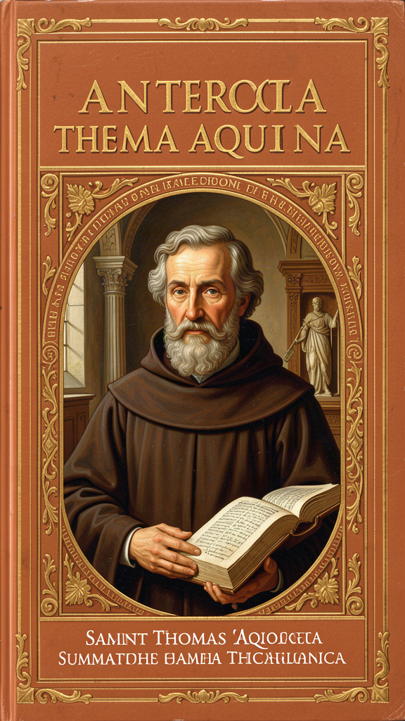
The Quiet Revolutionary
WisdomForge Booklet — Ages 11–14

The Quiet Revolutionary

WisdomForge Booklet — Ages 11–14
———

About This Book
Thomas Aquinas was born in 1225 in a castle in Italy and died in 1274 on the road to a church council. In the forty-nine years between those dates, he built one of the most ambitious intellectual structures in human history — a system of thought that tried to answer every question a person could ask about God, the world, morality, and the meaning of existence. He called it the Summa Theologica, and he never finished it.
This book introduces you to six of his most important ideas. You will learn how Aquinas argued that the existence of God can be discovered by looking at the world; how he explained change using two ancient concepts called "act" and "potency"; how he distinguished what something is from the fact that it exists; how he grounded morality in human nature rather than in arbitrary rules; how he showed that faith and reason are partners, not enemies; and how he described the habits that make a person good.
Aquinas wrote in a world very different from ours. There were no smartphones, no democracies, no public schools. The fastest way to send a message was a man on a horse. The biggest institution in Europe was the Catholic Church, and the most exciting intellectual development was the rediscovery of Aristotle — a Greek philosopher who had been dead for sixteen centuries. Aquinas took Aristotle's ideas, added Jewish and Muslim philosophy, and combined them with Christian theology. The result was something new.
The citations in this book follow the standard format for Aquinas scholarship. ST stands for Summa Theologica, followed by the Part, Question, and Article. ST I, Q.2, A.3 means the First Part, Question 2, Article 3 — the passage containing the Five Ways. SCG stands for Summa contra Gentiles, followed by Book and Chapter. You can look these up in any edition of Aquinas's works.
This is not a simplified version of Aquinas. It is Aquinas himself, translated into language you can understand. The ideas are the real ideas. The arguments are the real arguments. The quotations are from the actual text. The goal is to give you the tools to think about these questions yourself.
———
———

Chapter 1: The Five Ways — Proving God Exists
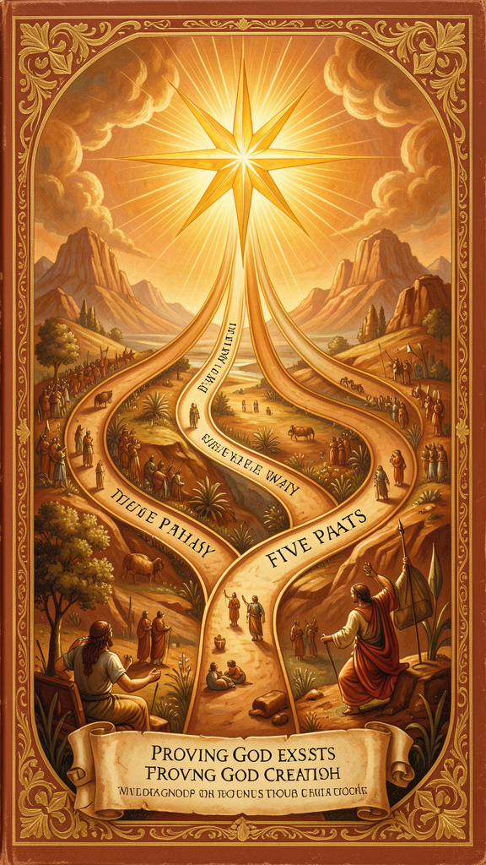
Illustration for Chapter 1
![Chapter 1](/images/booklets/thomas-aquinas-middle-ch01.png)

The Setting
In thirteenth-century Paris, the University was the intellectual capital of Europe. Students from across the continent gathered in lecture halls to hear masters debate theology, philosophy, and the newly rediscovered works of Aristotle. The air was thick with arguments. Some professors, called Averroists, followed the Arabic philosopher Averroes so closely that they argued for a "double truth" — that something could be true in philosophy and false in theology, or the other way around.
Thomas Aquinas walked into this debate as a young Dominican friar. He was large, quiet, and relentless in his thinking. His classmates at Cologne had nicknamed him the "Dumb Ox" because he rarely spoke. His teacher, Albertus Magnus, had replied: "We call this ox dumb, but one day his bellowing will be heard all over the world."
Aquinas rejected the double truth. He believed there is one truth, and that faith and reason are two ways of reaching it. But he also believed that reason has its own domain, and within that domain, it can discover real truths about God — without any help from Scripture or the Church. His most famous attempt to do this is the Five Ways.

The Argument
The Five Ways appear at ST I, Q.2, A.3. They are not "proofs" in the way you prove a geometry theorem. Aquinas calls them viae — ways, paths. Each one starts with something you can observe about the world and argues that this observable feature requires an ultimate explanation. That explanation, Aquinas says, is God.
The First Way: From Motion. Aquinas begins with something obvious: some things in the world are in motion. But "motion" for Aquinas means more than physical movement. It means any change from what something could be to what it actually is — a cold stove becoming hot, a seed becoming a tree, a student becoming knowledgeable. Whatever is in motion, Aquinas says, is put in motion by something else. Nothing moves itself from potential to actual. And you cannot have an infinite chain of movers-and-moved, because each mover in the chain depends on a prior mover. So there must be a first mover, unmoved by anything else. Aquinas writes: "It is certain, and evident to our senses, that in the world some things are in motion. Now whatever is in motion is put in motion by another" (ST I, Q.2, A.3). This first mover, he says, is God.
The Second Way: From Efficient Cause. Everything in the world has a cause. A match causes fire. A parent causes a child. A builder causes a house. But no cause can cause itself — it would have to exist before itself, which is impossible. And an infinite chain of causes, each depending on the one before it, still requires a first cause that does not depend on anything else. There must be a first efficient cause, and this, Aquinas says, is God.
The Third Way: From Possibility and Necessity. Some things in nature are contingent — they can exist or not exist. A tree grows, lives, and dies. A star burns and eventually goes dark. If everything were contingent, then at some time everything would have ceased to exist. And if nothing existed, nothing could bring anything into existence — something cannot come from nothing. Therefore, not everything is contingent. There must be something necessary, something that cannot not exist. And if this necessary being has a cause, the chain must end in a necessary being that is necessary through itself. This, Aquinas says, is God.
The Fourth Way: From Degrees of Perfection. We observe that some things are more or less good, true, noble, and valuable. We call one person "more honest" and another "less honest." We call one day "more beautiful" and another "less beautiful." But degrees imply a standard. If there is "more" and "less," there must be a maximum — something that is the standard against which everything else is measured. Aquinas writes: "The maximum in any genus is the cause of all in that genus" (ST I, Q.2, A.3). Fire, the hottest thing, is the cause of all heat. So there must be something that is the maximum of being, goodness, and truth — and this, Aquinas says, is God.
The Fifth Way: From Governance. Natural things act toward ends. Acorns become oaks. Hearts pump blood. Spiders build webs. These things do not think, plan, or deliberate, yet they consistently achieve specific results. Things that lack intelligence cannot direct themselves toward an end unless they are directed by something that has intelligence. An arrow does not find its target by itself; an archer directs it. So there must be an intelligent being that directs all natural things toward their ends — and this, Aquinas says, is God.

What the Five Ways Are Not
The Five Ways are the most famous passage in Aquinas and the most misunderstood. Here is what they are not.
They are not arguments for a temporal beginning of the universe. Aquinas explicitly says that reason cannot prove the universe had a beginning in time (SCG II, Ch. 38). The "first" in "first mover" and "first cause" does not mean first in chronological sequence. It means first in ontological dependence — the ultimate ground that everything else depends on right now.
They are not the same argument repeated five times. Each Way begins from a different feature of reality: motion, causation, contingency, gradation, and teleology. The First Way is about change. The Second is about existential dependence. The Third is about modal status (contingent vs. necessary). The Fourth is about degrees of perfection. The Fifth is about the order of natural processes. They are five distinct paths into a single landscape.
They do not claim to establish everything about God. At the end of the Five Ways, Aquinas has shown that there is a first mover, a first cause, a necessary being, a maximum of being, and an intelligent governor. He has not shown that these five are one being, or that this being has the attributes of the God of Scripture — omniscience, omnipotence, love, justice. The Five Ways are the beginning of natural theology, not the conclusion. The rest of the Summa's First Part (Q.3–26) develops what we can say about the reality the Five Ways point to.
They are not self-contained proofs that force agreement. Aquinas calls them viae, ways. They show a rational person that belief in God is not irrational. They do not compel a skeptic who rejects the premises. The premises — that everything in motion is moved by another, that the series of causes cannot be infinite, that contingency requires a necessary ground — are part of a metaphysical framework that Aquinas develops in the surrounding questions. Reject the framework, and the Ways lose their force. Accept the framework, and the Ways are powerful.

The Context
The Five Ways occupy about two pages in a work of thousands. They are compressed summaries of arguments that Aquinas develops at much greater length in the Summa contra Gentiles (SCG I, Ch. 13; SCG II, Ch. 15–21). Reading them in isolation, without the surrounding metaphysical framework, produces caricatures. The Five Ways assume the act/potency distinction (Chapter 2), the essence/existence distinction (Chapter 3), and the analogy of being (which governs how we can speak about what the Ways point to). They are embedded in a sequence: Q.1 asks what theology is, Q.2, A.1 asks whether God's existence is self-evident (no), Q.2, A.2 asks whether it can be demonstrated (yes), and Q.2, A.3 is the demonstration itself. Q.3–11 then develop the attributes of God.

Big Idea
The Five Ways are five paths from observable features of the world to the existence of God. They are not mathematical proofs or arguments for a temporal beginning of the universe. They are demonstrations from effect to cause, showing that the world's features — motion, causation, contingency, gradation, and order — require an ultimate ground. That ground, Aquinas says, is what everyone calls God.

Try This
Take the First Way and rewrite it in your own words. Start with the observable fact (some things change). Add the principle (whatever changes is changed by something else). Add the conclusion (there must be a first changer). Now ask yourself: what is the strongest objection to this argument? Write it down. Aquinas would want you to take the objection seriously — his own method in the Summa always begins by stating the strongest case against his position.

Talk About It
Aquinas says the Five Ways show that there is a first mover, a first cause, a necessary being, a maximum of being, and an intelligent governor — but they do not show that these five are one being. What would it take to show that the first mover is also the first cause? That the necessary being is also the maximum of being? Is there one God behind the Five Ways, or five different "somethings"?
———
———

Chapter 2: Act and Potency — The Grammar of Change
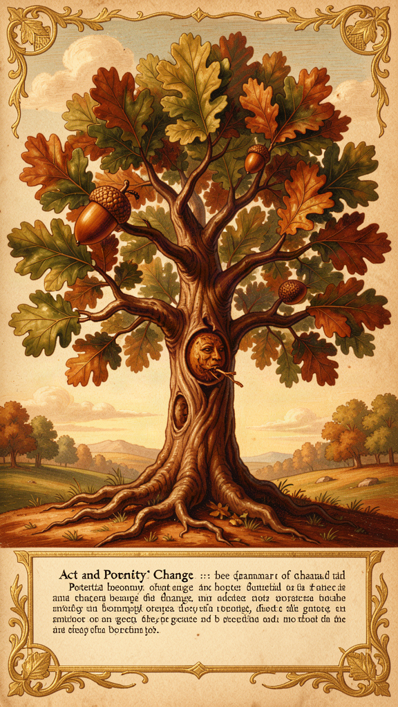
Illustration for Chapter 2
![Chapter 2](/images/booklets/thomas-aquinas-middle-ch02.png)

The Problem of Change
One of the oldest problems in philosophy is also one of the simplest: how does change happen? If something becomes what it was not, does it stop being what it was? A seed becomes a tree. But if the seed becomes a tree, the seed is gone — so what is the "something" that changed? And if nothing changes, then the world is frozen, which it obviously is not.
The pre-Socratic philosophers struggled with this. Some said everything changes constantly. Others said nothing ever really changes — change is an illusion. Aristotle resolved the puzzle with two concepts: act (energeia) and potency (dynamis). Aquinas took these concepts from Aristotle and made them the foundation of his entire metaphysics.

The Basic Idea
Act (actus) is what something actually is right now. A hot stove is actually hot. A person who knows French actually knows French. Act is the present reality of a thing.
Potency (potentia) is what something could be but is not yet. A cold stove could be hot — it has the capacity for heat. A student could learn French — they have the capacity for knowledge. Potency is the real but not-yet-actual dimension of a thing.
The key insight is this: every finite reality is a mixture of act and potency. A cold stove is actually a stove but potentially hot. A student is actually a person but potentially knowledgeable. The world is not made of static, finished things. It is made of things in the process of becoming what they can be.
Change, then, is the actualization of potency. When a cold stove becomes hot, the potency for heat becomes actual. Change is not something coming from nothing — the heat was already there as a capacity, waiting to be actualized. The seed does not stop being a seed when it becomes a tree; the tree was in the seed as a potency, and the becoming is the potency becoming act.

Why This Matters
Act and potency explain three things that need explaining.
Change. Without potency, change is impossible. If things are pure act (fully actual, nothing potential), they cannot become anything new. If things are pure potency (nothing actual), they cannot do anything. Change requires both — something actual that has the potential to become something else.
Limitation. Every finite thing is limited by its potencies. A stone cannot see because sight is not one of its potencies. A human cannot breathe underwater because aquatic respiration is not one of our capacities. To be finite is to be a mixture of act and potency — actual in some respects, potential in others. A thing that had no potency would have no limits. It would be pure act.
God as pure act. Aquinas says God is actus purus — pure act, with no potency at all. This is not a theological add-on. It follows from the logic of act and potency. If God had potency, God could become something God is not — which would mean God is not already complete, not already perfect. Pure act means fully realized, completely actual, with nothing missing. God does not change, not because God is inert, but because God is already everything God can be.

A Hierarchy of Actuality
Aquinas sees reality as a spectrum from maximum potency to pure act:
- Prime matter is pure potency — the underlying stuff that can become any physical thing, but has no form of its own. - Matter with form is a mixture — a physical object is actual in its shape and structure, potential in its capacity to change. - Plants are more actual than bare matter (they have life) but less than animals (they lack sensation). - Animals are more actual than plants (they have sensation) but less than humans (they lack rational understanding). - Humans have actual understanding but also potential — we can always learn more, understand more deeply. - Angels, in Aquinas's framework, are pure intellects without bodies — more actual than humans, with no bodily potential. - God is pure act — fully actual, no potential, no limitation.
This hierarchy is not a value judgment in the modern sense. It is a metaphysical description. Each level is more actual — more fully realized, less dependent on external actualizers — than the level below it.

Distinctions Within Act and Potency
Aquinas makes two important distinctions.
Active potency vs. passive potency. Active potency is the power to do something — the power to heat, to know, to build. Passive potency is the capacity to receive something — the capacity to be heated, to be taught. God has no passive potency (God cannot be acted upon or changed) but infinite active potency (God can do all things that are possible).
First act vs. second act. First act is possessing a capacity — having the power of sight. Second act is exercising that capacity — actually seeing. A person with eyesight has the first act of vision; a person currently looking at something has the second act. God is pure first act and pure second act simultaneously — there is no gap between God's possessing a perfection and God's exercising it.

Common Misunderstandings
"Potency is just possibility." No. Potency is not logical possibility ("it could happen"). Potency is a real feature of a thing. A cold stove's potency for heat is not just a logical possibility — it is a real capacity grounded in the stove's nature. A stone's inability to see is not just a logical fact — it is a real absence of a real potency.
"Act and potency are just form and matter." Form and matter are one way of understanding act and potency in physical substances (form is act, matter is potency). But act and potency apply more broadly — to intellect (knowledge in act vs. knowledge in potency), to being (existence as act, essence as potency), and to God (pure act, no potency). Form and matter are a case of act and potency, not identical with them.
"God as pure act means God is static." No. Pure act does not mean "unchanging" in the sense of inert. It means fully realized, completely actual, without unrealized potential. God is more active than any finite thing — but God's activity is not the actualization of a prior potency. It is the pure, complete actuality of being itself.

The Connection to the Five Ways
The First Way depends on act and potency. If whatever is in motion (changing, actualizing potency) is put in motion by something already actual, then there must be a first mover that is pure act — actualized by nothing, actualizing everything. The act/potency distinction is not a side note. It is the metaphysical engine of Aquinas's most famous argument.

Big Idea
Everything in the world is a mixture of what it actually is (act) and what it could be (potency). Change is the actualization of potency. God alone is pure act — fully realized, complete, without unrealized potential. This distinction is the foundation of Aquinas's entire metaphysics.

Try This
Look around your room. Pick three objects. For each one, identify what is actual (what it is right now) and what is potential (what it could become). A book is actually a book, potentially read. A lamp is actually off, potentially on. A plant is actually small, potentially tall. Now ask: what would have to happen for the potency to become act? Something has to actualize it. That "something" is what Aquinas calls a mover.

Talk About It
Aquinas says God is "pure act" — fully actual, with no potential. But doesn't that mean God can never do anything new? If God is already everything God can be, what does it mean for God to "act" in the world? Can a being with no potential still be personal, relational, responsive? What do you think?
———
———

Chapter 3: Essence and Existence — What Something Is vs. That It Is
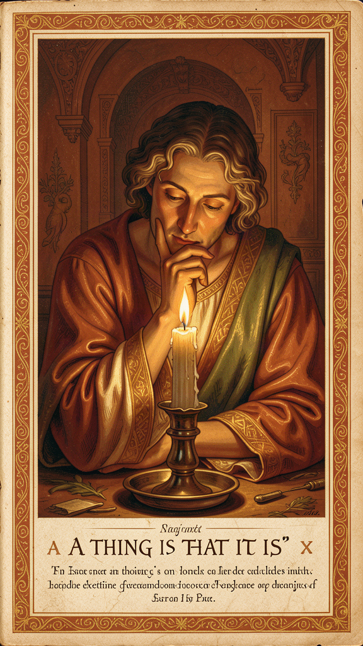
Illustration for Chapter 3
![Chapter 3](/images/booklets/thomas-aquinas-middle-ch03.png)

The Most Important Distinction You Have Never Heard Of
The distinction between essence and existence is the metaphysical heart of Aquinas's entire system. It is the key to his natural theology, his account of creation, his understanding of God, and his theory of analogy. If act and potency are the framework of his metaphysics, the essence/existence distinction is the foundation.
The core claim is this: in every created being, what a thing is (its essence) is really distinct from that it is (its existence). In God alone, essence and existence are identical. God is ipsum esse subsistens — subsistent being itself.

The Two Sides of Everything
Essence (essentia, quidditas) is "what a thing is." It is the nature, the definition, the "whatness" of a thing. The essence of a human being is rational animality. The essence of a triangle is a three-sided plane figure. The essence of fire is hot, dry, luminous. Essence answers the question: What is this?
Existence (esse, actus essendi) is "that a thing is." It is the act of being — not a property a thing has, but the act by which a thing is. A human being exists (or does not). A triangle exists (or does not). Fire exists (or does not). Existence answers the question: Is this?
The crucial point is that essence and existence are not two parts of a thing, like body and soul. They are not two properties, like redness and roundness. They are two different dimensions of reality. Essence is what a thing is. Existence is that it is. A thing's essence does not include its existence — you can know what a unicorn is without knowing whether unicorns exist.

The Real Distinction
Aquinas's claim is not just that essence and existence are different concepts. His claim is that in created beings, they are really distinct — different in reality, not just in our thinking.
The argument, from his treatise De Ente et Essentia (On Being and Essence), goes like this:
1. In any created being, you can understand its essence without knowing whether it exists. You can know what a phoenix is without knowing whether phoenixes exist. 2. If essence and existence were identical in a created being, that being would exist by its own essence — it would be self-existent. 3. But no created being is self-existent. Every created being depends on something else for its existence. 4. Therefore, in every created being, essence and existence are really distinct.
What this means: a created being is not its own existence. It has existence — it participates in being — but it is not identical with being. Its existence is received, not self-generated.
Aquinas uses an analogy. Think of light. A lit candle has light, but the candle is not identical with the light. The light is received from a source (the flame). In the same way, every created being has existence, but existence is not part of its essence — it is received from a source.

God: Where Essence and Existence Are the Same
If in every created being essence and existence are distinct, then in a being whose essence and existence are identical, that being would be self-existent. Its essence would be existence.
This is what Aquinas says about God. God is ipsum esse subsistens — not "a being that exists" but "existence itself." God does not have existence; God is existence. God's essence is to exist.
This follows from the logic of the real distinction. If essence and existence are distinct in every created being, and if there must be a ground for the existence of created beings (a being that does not receive existence but is existence), then there must be a being whose essence and existence are identical. That being is what we call God.
The philosophical point is striking: God is not "a being" among other beings. God is not "the biggest being" or "the most powerful being." God is being itself — the act of existing in which all other beings participate. This is why Aquinas says God is not in a genus (ST I, Q.3, A.5). God is not a being. God is ipsum esse.

Why This Matters
The essence/existence distinction grounds three of Aquinas's most important arguments.
The Third Way. The Third Way argues from contingency to necessity. The essence/existence distinction explains why created beings are contingent: because their essence does not include existence, their existence depends on something else. A being whose essence includes existence would be necessary — it would exist through itself.
Creation. If existence is distinct from essence in created beings, then creation is the act of causing existence — giving esse to a thing that did not have it. This is why creation is ex nihilo (from nothing): the existence of the creature is not derived from any pre-existing essence, but is given directly by God. Creation is not making something out of something else. It is giving existence itself.
Divine simplicity. If God's essence is identical with God's existence, then God has no composition — no parts, no potentiality, no distinction between what God is and that God is. This is the foundation of divine simplicity (ST I, Q.3), the cornerstone of Aquinas's account of God. God is not made of parts. God is one, simple, complete act of being.

The Interpretive Debate
The nature of the "real distinction" is one of the most contested questions in Thomistic scholarship. There are three main positions.
The real distinction (defended by Etienne Gilson and Cornelio Fabro): essence and existence are really distinct in creatures — two different principles of being, not just two concepts. Existence is the act of essence; essence is the potency for existence.
The conceptual distinction (defended by Cajetan and some Thomists): essence and existence are really identical in creatures but conceptually distinct. They differ in our thinking, not in reality.
The moderate real distinction (defended by John Wippel and some analytic Thomists): essence and existence are really distinct, but not between two "things" that could exist separately. The distinction is between a thing's nature and the act by which it exists — real but non-separable.
Each position has philosophical merits, and each has been defended by competent scholars. The important point is that Aquinas holds some version of the distinction, and it is foundational for his entire system.

Big Idea
In everything that exists, what it is (essence) is different from that it is (existence). Everything receives existence from something else. But God is different. God does not receive existence. God is existence. God is ipsum esse subsistens — subsistent being itself. This distinction is the foundation of Aquinas's natural theology, his account of creation, and his understanding of God.

Try This
Think of something you can describe perfectly but that does not exist — a unicorn, a dragon, a planet made entirely of chocolate. You know its essence. But it has no existence. Now look at your hand. You know its essence (a hand) and you know it exists. The difference between the unicorn and your hand is existence. Now ask: where does existence come from? Aquinas says it comes from God. Do you find that convincing? Why or why not?

Talk About It
Aquinas says God is not "a being" but "being itself." What does that mean? If God is not a being among beings, can we still pray to God, talk about God, or have a relationship with God? Does thinking of God as "existence itself" make God feel more personal or less personal? What do you think?
———
———

Chapter 4: Natural Law — Morality Written Into Creation
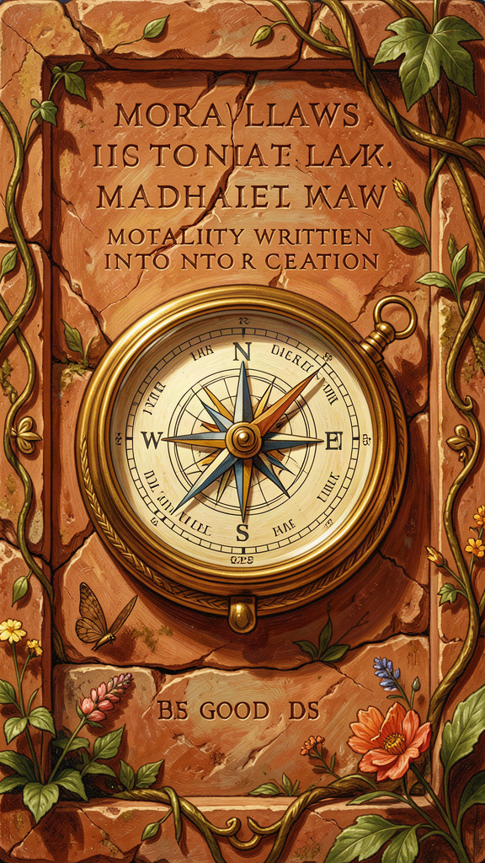
Illustration for Chapter 4
![Chapter 4](/images/booklets/thomas-aquinas-middle-ch04.png)

Law Is Not Just Rules
For Aquinas, law is not whatever a ruler commands. Law is "an ordinance of reason for the common good, made by him who has care of the community, and promulgated" (ST I-II, Q.90, A.4). This definition is deliberately restrictive. It means that not everything called "law" is actually law. An unreasonable decree, a statute serving only private interests, or a command from an illegitimate authority may have the form of law but lack its substance.
This definition is the foundation of one of the most influential moral and political theories in the Western tradition. It directly shaped the concept of universal human rights, the American Declaration of Independence, and the Nuremberg Principles. Martin Luther King Jr. cited Aquinas on unjust laws in his "Letter from Birmingham Jail."

The Four Kinds of Law
Aquinas identifies four kinds of law, organized hierarchically.
Eternal Law (Lex Aeterna) is God's plan for the entire universe — the rational order by which all creation is directed toward its proper end. Aquinas writes: "The rational ordering of all things by God, which is the divine wisdom directing all acts and movements" (ST I-II, Q.93, A.1). Eternal law is not a set of commands imposed from outside. It is the rational structure inherent in creation — the way things are meant to work. Seeds grow into plants, hearts pump blood, and people are meant to be fair. All of this is eternal law.
Natural Law (Lex Naturalis) is what human beings can discover through reason about the right ordering of human life. Aquinas writes: "The participation of the rational creature in eternal law" (ST I-II, Q.91, A.2). Natural law is not Catholic morality or religious law. It is reason's own discovery of what human flourishing requires.
The first precept of natural law is: "Good is to be done and pursued, and evil is to be avoided" (ST I-II, Q.94, A.2). This is not a commandment from outside. It is the most basic principle of practical reason — the self-evident starting point from which all moral reasoning proceeds. You cannot argue against it without relying on it, because any argument against pursuing the good assumes that there is something worth pursuing.
The primary precepts of natural law, Aquinas says (ST I-II, Q.94, A.2), correspond to the basic inclinations of human nature:
1. Self-preservation — the inclination to preserve one's own life. 2. Reproduction and education of offspring — the inclination to have and raise children. 3. Living in society — the inclination to live in community, pursue truth, and avoid ignorance. 4. Worship of God — the inclination to know the source of one's being.
These precepts are not arbitrary rules. They are the basic inclinations of human nature — the things human beings naturally tend toward when they are functioning properly. Natural law is rational reflection on these inclinations.
Human Law (Lex Humana) is the specific legislation that communities enact to apply natural law to particular circumstances. Human law derives from natural law in two ways: as conclusions (some laws follow directly, like "do not murder" following from "preserve life") and as determinations (some laws are specific applications, like speed limits or tax rates, determined by the legislator for particular circumstances).
Divine Law (Lex Divina) is the law revealed by God in Scripture. It supplements natural law in two ways: it makes clear what natural law could discover but has been obscured by sin, and it reveals truths that natural law could not discover on its own (the requirements of salvation, the nature of the beatific vision). Divine law is not imposed on non-believers. Aquinas's natural law theory is accessible to anyone with reason, regardless of religious belief.

The Problem of Unjust Laws
Aquinas addresses a question that still matters: must we obey unjust laws?
His answer, at ST I-II, Q.96, A.4, is nuanced. A law is unjust if it meets any of three criteria: it is contrary to the common good (serving private interests), it exceeds the legislator's authority, or it imposes unequal burdens without proportionate reason. An unjust law, Aquinas says, is "a perversion of law" rather than a true law. It does not bind in conscience.
But Aquinas immediately qualifies this. Disobedience may cause greater harm than compliance. In some cases, prudence requires obeying an unjust law to avoid social chaos. The principle is clear — unjust laws lose their binding force — but the application requires practical wisdom.
This passage directly influenced Martin Luther King Jr.'s "Letter from Birmingham Jail." King wrote: "I would agree with St. Augustine that 'an unjust law is no law at all.' ... A just law is a man-made code that squares with the moral law or the law of God. An unjust law is a code that is out of harmony with the moral law." King cited Aquinas by name, drawing on ST I-II, Q.96, A.4 to argue that segregation laws were unjust because they degraded human personality and imposed unequal burdens.

Natural Law Is Not Just Religious Morality
The most common misconception about Aquinas's natural law theory is that it is Catholic morality disguised as philosophy. It is not.
Natural law is based on human nature, not revelation. The primary precepts are discoverable by reason alone. You do not need to believe in God or read Scripture to discover that human beings have inclinations to preserve life, reproduce, live in society, and seek truth. Natural law is accessible to everyone. Aquinas explicitly says the general precepts are known to all people, regardless of religious belief (ST I-II, Q.94, A.2).
Modern natural law theorists like John Finnis and Robert George have developed natural law theory in a secular context, without relying on theological premises. Whether this secular development is faithful to Aquinas's intentions is debated, but it shows that natural law is not inherently religious.
Natural law is not a list of prohibitions. It is not primarily about what you cannot do. It is about what human flourishing requires — the positive inclinations toward life, knowledge, society, and meaning that are built into human nature.
Aquinas also acknowledges that practical reason can be clouded. He does not claim that every person knows every precept of natural law. Passion, bad habit, and cultural distortion can obscure specific applications. What is universal is the general framework, not every specific conclusion.

The Hierarchy of Precepts
Natural law has a hierarchy. The most general precepts — preserve life, do good, avoid evil — are known to everyone. More specific precepts — the wrongness of theft, the requirements of justice — require more careful reasoning and can be obscured by passion or cultural distortion. The most specific applications — speed limits, tax rates, property regulations — vary across cultures and circumstances.
This is why Aquinas can say both that natural law is universal and that specific applications vary. The framework is universal. The details require judgment.

Big Idea
For Aquinas, law is not whatever a ruler commands. It is an ordinance of reason for the common good. There are four kinds of law: eternal (God's plan for creation), natural (what reason discovers about human flourishing), human (specific legislation), and divine (revelation). Natural law is not religious morality — it is grounded in human nature and accessible to everyone. Unjust laws lose their binding force because they fail to meet the definition of law.

Try This
Pick a law in your country or community. Ask: Does it serve the common good, or only a private interest? Does it come from legitimate authority? Is it promulgated (made known)? If the answer to all three is yes, Aquinas would say it is a just law. If the answer to any is no, he would say it is a perversion of law. Apply this test to three laws. Which pass? Which fail?

Talk About It
Aquinas says natural law is based on human nature — the inclinations that human beings have when they are functioning properly. But what about people who do not have those inclinations, or whose inclinations are different? Does natural law assume a "normal" human being? What happens to natural law if human nature itself is more varied than Aquinas assumed?
———
———

Chapter 5: Faith and Reason — Two Wings of Truth
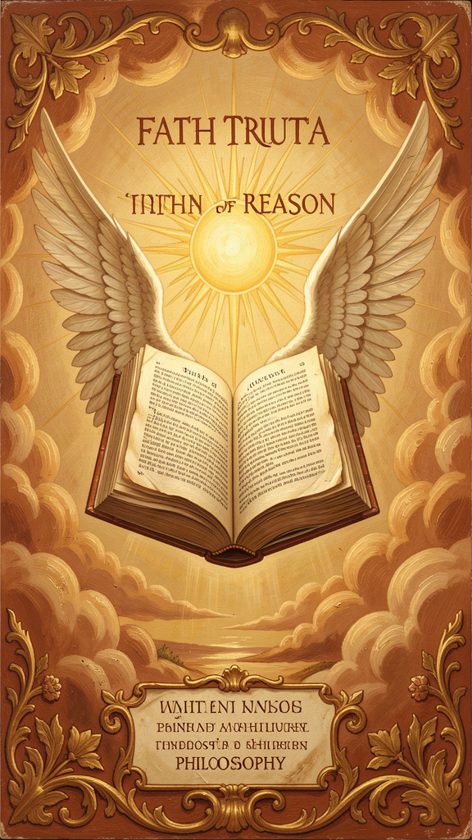
Illustration for Chapter 5
![Chapter 5](/images/booklets/thomas-aquinas-middle-ch05.png)

Not Enemies, But Partners
Aquinas's account of the relationship between faith and reason is one of his most enduring contributions — and one of the most misunderstood. He does not subordinate reason to faith. He does not subordinate faith to reason. He argues that faith and reason are two sources of truth that cannot genuinely contradict each other, because both come from God.
The image, borrowed from Pope John Paul II's encyclical Fides et Ratio (which draws on Aquinas), is of two wings. A bird needs both to fly. Reason without faith is incomplete. Faith without reason is credulous. Together, they give the full picture.

The Core Argument
Aquinas's foundational principle is at ST I, Q.1, A.1: "Since truth cannot be contrary to truth, the truth of reason is not contrary to the truth of the Christian faith." If reason discovers a truth (through observation, logic, or argumentation), and faith reveals a truth (through Scripture or tradition), these two truths cannot contradict each other — because both come from God, and God does not contradict himself.
If there appears to be a contradiction between faith and reason, one of three things has gone wrong: the reasoning is flawed, the interpretation of faith is flawed, or both need correction. What is not possible is that genuine faith and genuine reason contradict each other.

Two Orders of Truth
Aquinas distinguishes two orders of truth, with different sources, scopes, and methods.
Natural reason has its source in human observation and logic. Its scope is what can be discovered by human power. It is available to everyone. Its certainty is proportional to the strength of the argument. Examples: the existence of God (the Five Ways), natural law, the structure of reality.
Faith has its source in divine revelation. Its scope is what God has revealed. It requires acceptance of revelation. Its certainty is based on the authority of the revealer. Examples: the Trinity, the Incarnation, the beatific vision.
There is overlap. Some truths are in both orders — God's existence, the basic principles of morality. These can be known by reason alone, but faith confirms them and provides additional motivation for pursuing them.
Some truths are above reason, not against reason. The Trinity, the Incarnation, the resurrection of the body — these exceed the capacity of natural reason but are not contrary to it. Aquinas is not saying that faith requires believing irrational things. He is saying that some truths are beyond what reason can prove, but consistent with reason. The Trinity is not illogical. It is simply not the kind of thing that logic could discover on its own.

Faith Is Not Irrational
Faith, for Aquinas, is not blind belief. It is voluntary assent to truths that are supported by evidence (miracles, the authority of the Church, the coherence of the system) but not proved by that evidence. Faith goes beyond reason, but it is not against reason.
The analogy: you might trust a friend's testimony about something you have not seen yourself. Your trust is not irrational — it is based on your friend's reliability. But it goes beyond what you could prove on your own. Faith, for Aquinas, is like this: reasonable trust in a reliable source (God), not a leap into the dark.

What Aquinas Does Not Say
He does not say faith and reason are separate domains with no overlap. They overlap in the truths both can discover, and faith provides a context for reason — confirming truths that reason can discover and motivating the pursuit of wisdom.
He does not say reason is subordinate to faith. Reason has its own proper domain and operates by its own principles. Within that domain, reason is authoritative. The existence of God, the structure of reality, the principles of morality — these are discoverable by reason without faith.
He does not say faith is irrational. Faith is a voluntary assent to truths supported but not proved by evidence. It is reasonable trust in a reliable source.
He does not say science and religion are in conflict. Science studies the natural world using reason. Faith addresses truths that exceed natural reason. They are not in competition because they address different questions. Science asks how the natural world works. Faith asks what is the ultimate meaning and purpose of existence.

The Averroist Challenge
Aquinas's position was not uncontroversial in his own time. The Averroists argued for the "double truth" theory: that a proposition could be true in philosophy and false in theology (or vice versa). On this view, reason and faith are two separate tracks that never meet.
Aquinas explicitly rejected this (SCG I, Ch. 7; ST I, Q.1, A.1). There is only one truth, and it cannot contradict itself. If reason and faith appear to contradict, the contradiction is in our understanding, not in reality. This position was controversial because it meant theology had to answer to philosophy — theological claims had to be consistent with philosophical truth — and philosophy had to answer to theology — philosophical claims could not contradict revealed truth. Both disciplines were accountable to the same standard: truth.
The tension came to a head in 1277, when Bishop Tempier of Paris condemned 219 propositions, many associated with Averroism and some misattributed to Aquinas himself (who had died in 1274). This episode shows how contentious the faith-reason relationship was in Aquinas's time — and how easily a position that tried to honor both sides could be misread.

Why This Matters
Aquinas's framework resolves the apparent conflict between science and religion. They are not in competition because they address different questions. Science asks how the natural world works. Faith asks what is the ultimate meaning and purpose of existence. These questions can overlap, but they are not the same question.
Aquinas's position also acknowledges that reason has limits. Some truths exceed reason's power — not because they are irrational, but because they are about realities that reason cannot access on its own. This is a philosophical claim about the scope of human rationality, not a theological claim about what God has revealed.
Finally, Aquinas models intellectual humility. Reason should acknowledge its limits. Faith should engage with reason rather than dismiss it. Both should be open to correction. The faith-reason relationship is not a power struggle. It is a partnership in which both partners are accountable to truth.

Big Idea
Faith and reason are not enemies. They are two sources of truth that cannot contradict each other, because both come from God. Reason can discover some truths on its own (God's existence, natural law). Faith reveals truths that reason could not discover (the Trinity, the Incarnation). Some truths are above reason, not against it. The task is to hold both together, letting each correct and enrich the other.

Try This
Make two lists. On one side, write down three things you know by reason (things you have observed, calculated, or figured out). On the other side, write down three things you know by faith (things you trust on the authority of someone else — a parent, a teacher, a book). Now ask: are any of these in both lists? Aquinas says some truths are in both — known by reason and confirmed by faith. Can you find an example?

Talk About It
Aquinas says that if faith and reason appear to contradict, either the reasoning is flawed, the interpretation of faith is flawed, or both need correction. But who decides which is flawed? If a scientist says the Earth is 4.5 billion years old, and someone interprets the Bible as saying the Earth is 6,000 years old, Aquinas would say the biblical interpretation is flawed, not the science. But what if the scientist is wrong? How do we decide which side to correct? What do you think Aquinas's method would say?
———
———

Chapter 6: The Virtues — Habits of the Good Life
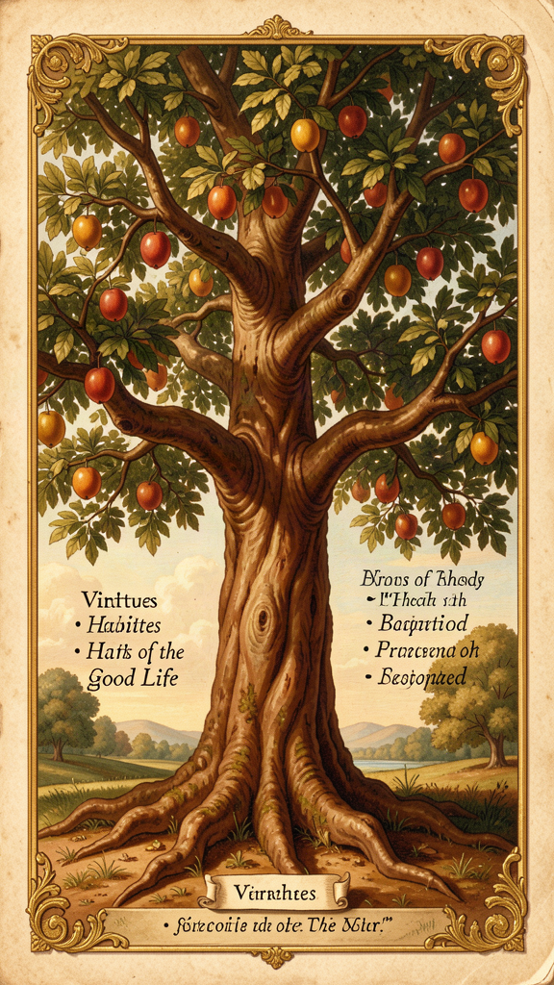
Illustration for Chapter 6
![Chapter 6](/images/booklets/thomas-aquinas-middle-ch06.png)

Not Just "Being Good"
For Aquinas, a virtue is not just "being a good person" in a vague sense. A virtue is "a good habit bearing on activity" (ST I-II, Q.55, A.3, following Aristotle). Three elements matter: it is a habit (a stable disposition, not a one-time act), it is good (oriented toward a genuine good, not an apparent one), and it bears on activity (it is about action, not just inner states).
You become just by doing just acts repeatedly, not by doing one just act. You become courageous by acting bravely repeatedly, not by one act of bravery. Virtues are built through practice, like muscles. This is not moralism. It is an account of human flourishing — what human beings need to live well, and how they acquire the habits that make that possible.
Aquinas's account of the virtues is indebted to Aristotle's Nicomachean Ethics, but he transforms Aristotle in two ways: he adds the theological virtues (faith, hope, charity) that Aristotle does not consider, and he grounds the cardinal virtues in natural law rather than in Aristotle's account of human flourishing alone.

The Cardinal Virtues
The four cardinal virtues are the pillars of moral life. "Cardinal" comes from cardo (hinge) — they are the hinges on which all other virtues turn.
Prudence (Prudentia, ST II-II, Q.47–56) is the virtue of practical reason — the ability to discern the right action in a particular situation. Prudence is not caution or timidity. It is the wisdom to judge correctly what is good and what is bad, and to act accordingly. Prudence is the "charioteer" of the virtues: it directs the other virtues toward their proper ends. Without prudence, the other virtues become vices. Courage without prudence is recklessness. Justice without prudence is rigidity. Prudence requires experience, deliberation, and the ability to judge particular situations well.
Justice (Iustitia, ST II-II, Q.57–79) is the virtue of giving each person their due — their rights, their dignity, their fair share. Justice is primarily about relationships. It governs how we treat others. The two primary forms are commutative justice (fairness between individuals) and distributive justice (fairness between the community and individuals). Justice requires fairness, but Aquinas does not separate justice from compassion — mercy is part of justice rightly understood.
Fortitude (Fortitudo, ST II-II, Q.123–140) is the virtue of courage — the ability to face danger, difficulty, or suffering without losing one's rational orientation toward the good. Fortitude is not fearlessness. It is the proper management of fear. It is primarily about the fear of death — the most difficult fear to overcome — and it includes patience (enduring difficulty without complaint) and perseverance (continuing in the face of obstacles). Fortitude without prudence is recklessness. Fortitude without justice is tyranny.
Temperance (Temperantia, ST II-II, Q.141–170) is the virtue of moderation — the ability to manage desires and pleasures so they serve the good rather than undermining it. Temperance is not self-denial for its own sake. It is the proper ordering of pleasure. It governs the desires for food, drink, and sex — the pleasures that are most necessary and most easily disordered. It includes modesty, continence, and chastity. Temperance without prudence is mere asceticism. Temperance without joy is not the genuine article.

The Theological Virtues
The three theological virtues are gifts of grace, not achievements of natural reason. They orient the human being toward God as their ultimate end — something that natural virtue alone cannot accomplish.
Faith (Fides, ST II-II, Q.1–7) is the virtue by which we believe in God and all that God has revealed. Faith is not blind belief. It is voluntary assent to truths that are supported by evidence but not proved by it. Faith seeks understanding — it does not replace reason but goes beyond it. Faith is the foundation of the other theological virtues: you cannot hope in or love what you do not believe.
Hope (Spes, ST II-II, Q.17–22) is the virtue by which we desire the kingdom of heaven and eternal life, trusting in God's promises. Hope is not wishful thinking. It is confident expectation of a good that is difficult but possible with divine assistance. Hope sits between two vices: despair (which gives up on the good) and presumption (which expects the good without effort). Hope perfects the will's orientation toward the ultimate end.
Charity (Caritas, ST II-II, Q.23–46) is the virtue by which we love God above all things and our neighbor as ourselves for the love of God. Charity is the form of all the virtues — it gives them their proper orientation and makes them genuinely virtuous. It is the greatest of the theological virtues. Without charity, the other virtues can be disordered: prudence becomes cunning, courage becomes aggression, justice becomes severity. Charity is not just affection. It is the will's orientation toward the good of the other for the sake of God.

How the Virtues Connect
The cardinal virtues are achievable by natural reason. Any person can develop prudence, justice, fortitude, and temperance through practice. The theological virtues are gifts of grace — they require divine assistance.
But they are not separate systems. The theological virtues elevate and perfect the cardinal virtues. Faith elevates prudence by giving it a wider horizon — the knowledge of God's plan. Hope elevates fortitude by giving it a greater object — eternal life rather than mere survival. Charity elevates justice by giving it a deeper motive — love of neighbor for the sake of God.
Aquinas also follows Aristotle in holding that the virtues are interconnected: you cannot have one cardinal virtue fully without having all of them. Prudence requires justice (to know what is right), fortitude (to do what is right in the face of danger), and temperance (to desire what is right). The virtues are not a menu. They are an ecosystem.
Aquinas adds a theological nuance: charity is the "form" of all the virtues. Without charity, the cardinal virtues can exist in a natural form — a person without faith can be just, brave, temperate, and prudent — but they are not directed toward the ultimate end. Charity gives them that direction.

The Vices
Every virtue has a corresponding vice — a habit that disposes a person to act badly. Aquinas treats vices with the same systematic care he treats virtues.
| Virtue | Vice (Deficiency) | Vice (Excess) | |--------|-------------------|---------------| | Prudence | Rashness | Craftiness | | Justice | Injustice | — (justice has no excess) | | Fortitude | Cowardice | Recklessness | | Temperance | Insensibility | Intemperance |
The seven deadly sins (pride, avarice, lust, envy, gluttony, anger, sloth) are not the direct opposites of the cardinal virtues. They are capital vices — vices from which other vices flow. Aquinas discusses them as part of his treatment of specific vices throughout the Secunda Secundae.

Big Idea
Virtues are good habits built through practice, like muscles. There are four cardinal virtues (prudence, justice, fortitude, temperance) achievable by natural reason, and three theological virtues (faith, hope, charity) that are gifts of grace. They are interconnected — you cannot have one fully without the others. Charity is the form of all the virtues: without love, the other virtues go wrong.

Try This
Pick one cardinal virtue to practice for a week. If you choose prudence, before each decision this week, ask: "What is really good here — not just what feels good?" If you choose justice, look for one person each day who is not being treated fairly and do something about it. If you choose fortitude, do one thing that scares you (appropriately). If you choose temperance, find one pleasure you tend to overdo and practice moderation. At the end of the week, ask: did it get easier? That is a virtue growing.

Talk About It
Aquinas says the virtues are interconnected — you cannot have one without the others. Do you agree? Can someone be courageous but unjust? Prudent but unkind? Temperate but cowardly? Or does Aquinas have a point — does being truly good require all the virtues working together? What happens when someone has one virtue but not the others?
———
———

For the Grown-Up Reader
This booklet introduces middle school readers to Thomas Aquinas through six of his central ideas. The content is drawn from the research files on Aquinas and from primary sources — the Summa Theologica, the Summa contra Gentiles, and the De Ente et Essentia.
The citations follow standard scholastic format. The Five Ways appear at ST I, Q.2, A.3. The act/potency distinction is developed in ST I, Q.3, Q.25, and SCG III, Ch. 58. The essence/existence distinction is treated in De Ente et Essentia, Ch. 4–5, and ST I, Q.3, A.4. The natural law treatise spans ST I-II, Q.90–97. The faith-reason relationship is addressed in ST I, Q.1, A.1 and SCG I, Ch. 3–8. The virtues are treated in ST I-II, Q.55–67 and throughout ST II-II.
The booklet presents Aquinas's ideas without distortion. The Five Ways are presented as viae (ways), not mathematical proofs. The act/potency distinction is presented as a metaphysical framework, not a mere logical tool. The essence/existence distinction is presented with awareness of the interpretive debate (Gilson vs. Cajetan vs. Wippel). Natural law is presented as accessible to reason, not as religious morality. Faith and reason are presented as cooperative, not competitive. The virtues are presented as habits built through practice, with charity as their form.
The biographical material — the family kidnapping, the "Dumb Ox" nickname, the Averroist controversy, the 1277 Condemnations — is drawn from the research files and represents the standard scholarly account. The "straw" remark near the end of Aquinas's life is reported with appropriate caution about its hagiographic sources.
The discussion questions are designed to provoke genuine philosophical thinking. They do not have predetermined answers. Aquinas's own method in the Summa — stating objections, responding, and resolving — models the kind of honest engagement with disagreement that the questions aim to encourage.

About WisdomForge
WisdomForge produces age-banded booklets that introduce the great thinkers of the Western tradition to readers at every stage of life. Each booklet covers six core ideas of a philosopher, adapted for elementary (ages 5–10), middle school (ages 11–14), high school (ages 15–18), and adult readers. The booklets share the same chapter structure and themes, but the language, depth, and activities change to meet each age where it is.
Our method: we read the philosopher's own words, study the best scholarship, and write for real readers. We cite primary sources so you can follow the ideas back to their origin. We use the style principles of Strunk and White — clear, active, concise — because good ideas deserve good prose.
WisdomForge is a project of SMF Works. We believe the great ideas of the past belong to everyone, and the best way to honor them is to make them accessible without dumbing them down.

