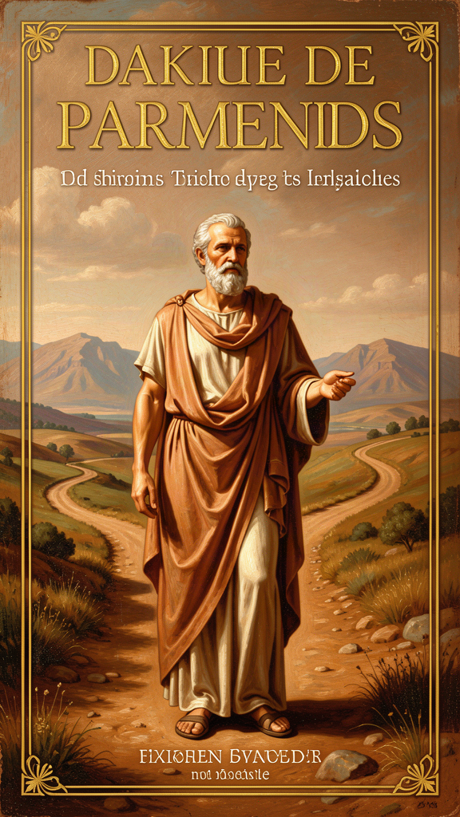
Parmenides: What Is, Is
WisdomForge Booklet — Adult

Parmenides: What Is, Is

WisdomForge Booklet — Adult
———

About This Book
This booklet reads Parmenides of Elea as the founder of Western metaphysics and the first philosopher to demonstrate that reason, not sensory experience, is the arbiter of what is real. Drawing on the surviving fragments of "On Nature" (DK B1–B19) and the secondary literature from Plato to the present, it traces six threads through Parmenides' work: the two-roads argument, the signs of being, the Way of Opinion, the primacy of reason, the courage of logic, and the legacy that runs from Zeno through Plato, Aristotle, Descartes, and into modern analytic philosophy.
Each chapter combines scholarly precision with practical application. It assumes you are an adult with limited time and a real life — that you are not trying to become a Presocratic specialist but to understand why a 2,500-year-old argument still matters and how it can sharpen your thinking. The goal is not admiration but use.
———

Chapter 1: The Two Roads — The Argument That Started Everything
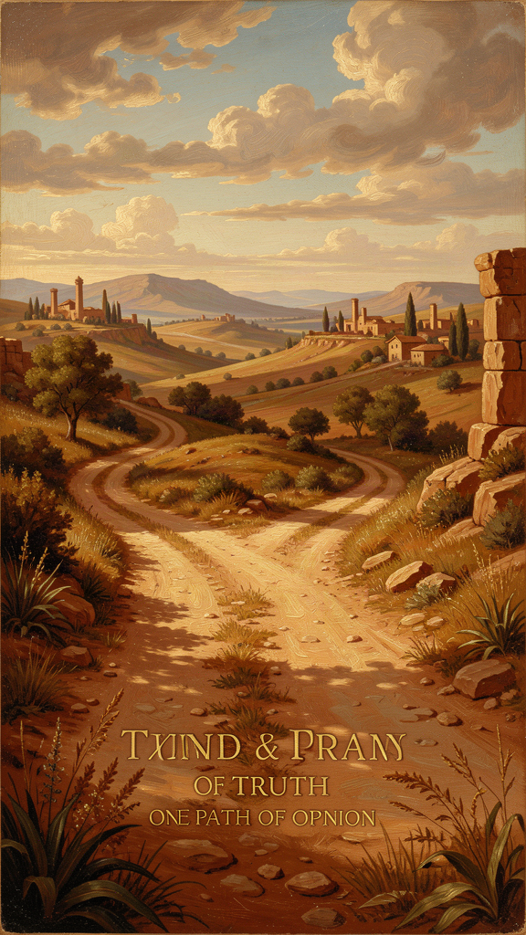
Illustration for Chapter 1
It begins with a fork. Not in a road you walk, but in the road of thought itself. The goddess in Parmenides' poem draws the map:
Come now, I will tell you — and you, once you have heard the tale, carry it away — the only two ways of inquiry that can be thought of: the one, that [it] is and that [it] is not not to be, is the path of conviction, for it follows true reality; the other, that [it] is not and that [it] must not be — this, I tell you, is a path wholly without report: for you could not apprehend what is not, for it cannot be done, nor could you indicate it. (DK B2.3–8)
Two roads. One says "it is." One says "it is not." The second is not merely false. It is impassable. You cannot think what-is-not. You cannot speak what-is-not. There is no object for the thought, no referent for the word. The road doesn't go anywhere because there is no "there" there.
This is the moment Western philosophy begins. Not as wisdom literature, not as cosmological speculation, but as argument. Parmenides is the first thinker to structure his case as a deductive chain: pose a dichotomy, demonstrate that one option is impossible, commit to the other, and derive consequences. The method is so clean it still feels modern. And the conclusion — that the only coherent starting point for thought is "it is" — is the foundation on which every subsequent Western metaphysics is built, whether it accepts Parmenides or responds to him.
The argument's force lies in its simplicity. Try to think pure nothing. Not "an empty room." Not "blank space." Not "darkness." Pure, absolute nothing — no space, no time, no content, no possibility. The attempt fails at every turn. The moment you try to conceive nothing, your mind produces something: an image of darkness (darkness is something), a concept of emptiness (emptiness is a concept — something), a spatial metaphor for void (space is something). The attempt to think non-being generates being. Non-being, as a starting point for thought, is cognitively inert.
This is not a psychological observation about the limits of human imagination. It is a structural claim about the nature of cognition. Thought requires an object. Non-being provides none. Therefore, non-being cannot be thought. Therefore, "it is not" is not a road you can walk. The only road is "it is."
From this single move, Parmenides derives everything. The chain runs:
1. You can only think about what is. (Non-being is unthinkable.) 2. Therefore, "it is" is the only starting point for any thought, any speech, any inquiry. 3. If something is, it cannot have come from nothing (nothing cannot produce anything). 4. If something is, it cannot become nothing (you cannot go where there is no "there"). 5. Therefore, what is has no beginning and no end. 6. Therefore, what is does not change (change requires transition from what-is to what-is-not, which is impossible). 7. Therefore, what is is whole (no gaps — gaps would require non-being), continuous (no divisions — divisions require non-being between parts), single (all of one kind — being), unmoving (no empty space to move into), and complete (nothing is missing — what would be missing is non-being, which is impossible).
The world your senses show you — the world of change, plurality, birth, death, motion — is, on this argument, not the real world. It is the world of appearance. The real world is what reason discovers when it follows the logic of "it is" to its conclusions.
This is the Parmenidean revolution. Before him, philosophers described the world they observed. Thales said everything is water. Anaximander said everything is the boundless. Heraclitus said everything is flux. They were doing natural philosophy — offering accounts of the observable world. Parmenides does something different. He doesn't describe what he sees. He derives what must be the case from a logical starting point, and he finds that the derivation contradicts the observations. His response is not to adjust the derivation but to distrust the observations. The senses show you appearance. Reason shows you reality. This is the birth of the appearance/reality distinction that runs through all of Western philosophy.
The practical stakes are higher than they look. You spend a significant portion of your mental life on the "it is not" road. You worry about outcomes that haven't occurred. You rehearse conversations that don't exist. You fear states that are not real. You build arguments on premises you haven't verified. All of this is thinking about non-being — about what is not. It feels productive because the mind can generate vivid representations of non-being. But the representations are not the thing. They are appearances of what isn't, not encounters with what is. And building on them is building on fog.
The "it is" road starts from what is actually the case. Not what might be. Not what could be. Not what you fear. What is. That's the only foundation that holds. You can build on it because it's real. You can't build on "what if" because "what if" is a thought about non-being, and non-being has no foundation to offer.
This is not a call to stop planning or considering risks. It's a call to build your thinking on what you know, not on what you imagine. The fears and "what ifs" are weather. They pass through. They are not the ground. Build on the ground.
———
The Big Idea
Parmenides' two-roads argument is the first deductive argument in Western philosophy, and it identifies a structural feature of thought itself: you can only think about what is. "It is not" is not a road you can walk, because there's nothing there to walk on. Every act of thinking, speaking, or inquiring implicitly affirms being. You cannot start from non-being. You can only start from being.
This means that every worry about "what if," every fear of what hasn't happened, every argument built on unverified premises, is a walk down the "it is not" road. It feels real because the mind can simulate it. But the simulation is not the reality. The reality is what is — the facts, the resources, the knowns. That's the only foundation that holds.
———
Practice
1. The Foundation Audit Pick a decision or worry that has been occupying you. Write it down. Now write the thoughts underneath it — the fears, the "what ifs," the assumptions. For each, ask: "Is this about what is, or about what is not?" Mark each accordingly. You may find that most of your anxiety is built on non-being — on states that don't exist, outcomes that haven't occurred, interpretations you haven't verified. Now rewrite the situation starting only from what is. That's your foundation. Build from there.
2. The Non-Being Experiment Set a timer for two minutes. Try to think absolute nothing — no space, no time, no darkness, no emptiness. When a thought, image, or feeling appears, note it. You will discover what Parmenides discovered: the mind cannot hold nothing. Every attempt fills the space with something. This is not a limitation. It is the structural condition of thought. "It is not" is not a place your mind can stand.
3. The Starting Point Check Before making a decision this week, pause and ask: "What do I actually know is true right now?" Not what might happen. Not what could be. What is. Write down one thing that is undeniably real in this moment. Start there. Parmenides would say that's the only honest place to begin.
———

Chapter 2: The Signs of Being — What Reason Demands
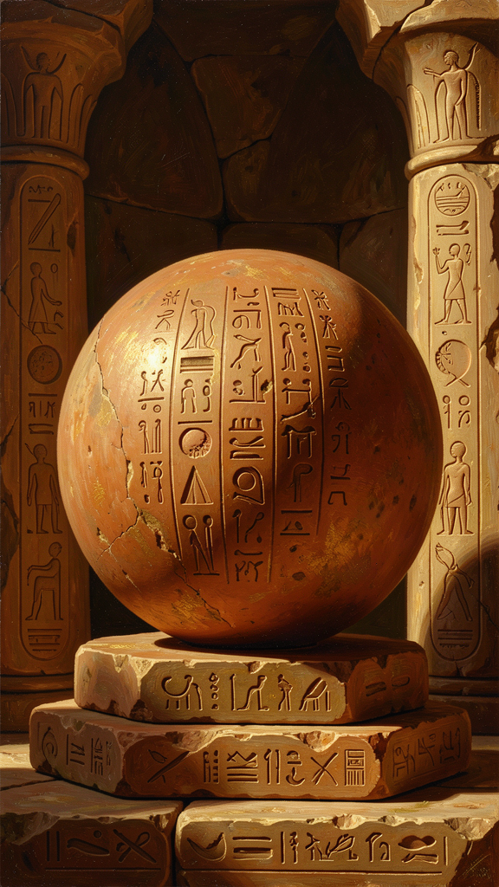
Illustration for Chapter 2
If "it is" is the only road, what follows about what is? Parmenides does not describe the world he sees. He derives, through logic alone, the attributes that anything which is must possess. These are the sēmata — the signs, or markers — of true being:
As yet a single tale of a way remains, that it is; and along this path markers are there very many: that What Is is ungenerated and deathless, whole and uniform, and still and perfect. (DK B8.1–4)
Six signs. Each is a deduction from the impossibility of non-being:
Ungenerated. What is cannot have come into being. If it came from what-is, it already was — that's continuity, not generation. If it came from what-is-not, the source is impossible. Therefore, what is was never born. The argument includes a temporal component: if being were going to come into existence, when would it do so? There is no privileged moment. No trigger. Nothing can cause something to come from nothing. Therefore, being is eternal — it has no beginning.
Imperishable. What is cannot cease to be. Ceasing would mean becoming what-is-not, which is impossible. Therefore, what is will never die. "Thus generation is extinguished and destruction unheard of" (DK B8.21).
Whole. If what is had gaps or divisions, what would fill the gaps? What-is-not? Impossible. Therefore, what is is continuous. "What Is draws to What Is" (DK B8.25) — there is no repulsion, no separation, no gap. Being presses against being with nothing in between.
Single (uniform). What is is all of one kind — being. There is no mixture of being and non-being. The word mounogenes (single, of one kind) is significant: it may mean "only one thing exists" (strict monism) or "of a single kind" (predicative monism, which allows plurality within being so long as each entity has a determinate nature). The text supports both readings, and the debate between them remains live in scholarship.
Unmoving. Motion requires a place to move into. But all places are already full of being. There is no empty space (empty space would be what-is-not, which is impossible). Therefore, what is has nowhere to move. It is already everywhere it could be. The image of "great bonds" (megala desma) is not a prison but Necessity (Anankē) holding being in place — expressing its internal completeness, not constraining it from outside.
Complete. If what is lacked something, what would it lack? Only what-is-not. But what-is-not is impossible. Therefore, what is lacks nothing. It is teleon — complete, perfect, finished. The sphere simile captures this:
But since there is a furthest limit, it is perfected from every side, like the bulk of a well-rounded globe, from the middle equal every way. For that it be neither any greater nor any smaller in this place or in that is necessary. (DK B8.42–44)
Not that being is shaped like a ball. The sphere is an analogy for completeness: a perfect sphere has no direction in which it could be more or less than it is. No part sticks out. No part is missing. It is teleon from every side.
None of these signs describe anything you can observe. Everything you see was generated, is perishable, has parts, moves, and is incomplete. Your senses show you a world that contradicts every sign. So either Parmenides is wrong, or your senses are not showing you reality. Parmenides chooses the second option. The senses show you appearance. Reason shows you reality. And reality — the deep structure of what is — has the six signs, whether or not you can see them.
This is the birth of the appearance/reality distinction that runs through all of Western philosophy. Plato's Forms: eternal, unchanging, perfect — the six signs. Kant's noumena: the thing-in-itself, beyond the reach of sensory experience. The scientist's model vs. the data: the model captures the underlying structure; the data are noisy appearances. All of them inherit Parmenides' basic move: what is really real is not what appears to the senses but what reason discovers beneath the surface.
The signs are also a test. When you encounter a claim about what is real — a political ideology, a scientific theory, a personal narrative — check it against the signs. Does it describe something generated and perishable? Then it's an appearance, not a foundation. Does it point to something ungenerated and imperishable? Then it might be pointing at the deep structure. The test is not whether the claim feels true. The test is whether it has the logical properties of being.
———
The Big Idea
The six signs of being are not empirical observations. They are logical deductions from the impossibility of non-being. If "it is" is the only starting point, then what is must be ungenerated, imperishable, whole, single, unmoving, and complete. None of these describe anything you can see. They describe what you can only think.
This means the most real things are not the visible things. The most real things are logical structures, ideas, principles — things that were never born, that won't die, that don't change. Justice, truth, number, logical necessity. You can't see any of them. You can only think them. And Parmenides says that's not a weakness. That's where the real lives.
———
Practice
1. The Sign Audit Pick something you consider "real" — a relationship, a career, a value, a belief about yourself. Check it against the six signs. Was it "generated"? Will it "perish"? Is it "whole"? Is it "single"? Does it "move"? Is it "complete"? You won't find anything in the visible world that matches all six. That's the point: the realest things are not the visible things. The things that match the signs are the things you can only think — principles, truths, logical structures. They were never born. They won't die.
2. The Sphere Visualization Picture a perfect sphere. No preferred direction. No side more important than another. Nothing sticking out. Nothing missing. Complete from every angle. This is Parmenides' image of true being. When your life feels fragmented, incomplete, or asymmetrical, hold this image. The fragmentation is in the appearance. The completeness is in the structure underneath. The appearance is noisy. The structure is quiet. Learn to hear the quiet.
3. The Deduction Chain Write out the deductive chain from "non-being is unthinkable" to "being is complete." Follow each step. Where does a step feel weak? Where does it feel forced? Mark those points. They are the places where the argument is most alive — where you can push back, refine, or extend. Parmenides' argument is not a doctrine to accept. It is a challenge to engage.
———

Chapter 3: The Way of Opinion — Understanding Error

Illustration for Chapter 3
The goddess does not stop at truth. She insists that Parmenides learn error as well:
You must learn all things: both the unshaken heart of well-rounded truth, and the opinions of mortals, in which there is no genuine trustworthiness. Yet nonetheless these things too shall you learn — how the things that seem had to be as they pass through all things in every way. (DK B1.28b–32)
Learn the opinions. Even though they are unreliable. Even though there is "no genuine trustworthiness" in them. Why? Because understanding error is part of understanding truth. You cannot recognize the counterfeit without studying it. You cannot navigate the world of appearance without understanding how appearance works.
The Way of Opinion is the road most people walk. It is the road of sensory experience, inherited belief, and unexamined assumption. The goddess describes those who walk it as "two-headed" (dikranoi) — trying to hold being and non-being simultaneously, treating "it is" and "it is not" as interchangeable:
For helplessness in their breasts directs wandering understanding. They are borne along deaf and blind at once, dazed, undiscerning crowds, who have supposed that to be and not to be are the same and not the same; but the path of all these turns back on itself. (DK B6.5–9)
The mortal error is not moral. It is logical. Mortals treat "it is not" as if it could function as a predicate. They say "this came to be" (it was not, and now it is) and "this perished" (it was, and now it is not), as though non-being were a real state that things could pass through. But non-being is not a state. It is not anything. The path "turns back on itself" because it leads nowhere.
The Way of Opinion includes the sensory world — the world of change, plurality, and the two forms, Light and Night, whose mixture produces the appearances we experience. This cosmology is not presented as truth. It is the best account available within the world of opinion — a "deceptive" ordering of appearances that is internally consistent but does not reach the truth.
The scholarly debate about the Way of Opinion is ongoing. Is it a genuine contribution to cosmology? A demonstration of how error works? A warning? The most compelling reading is that it is all three. The goddess teaches the Way of Opinion not because it is true but because it is the world you live in. You eat, work, love, and die in the world of appearance. You cannot function without it. The question is whether you understand what it is — a world of seeming, not of being — or whether you mistake it for reality.
The philosophical skill is not to escape the Way of Opinion. It is to recognize it for what it is, navigate it with awareness, and return to the Way of Truth when you need to know what is real. You live on the surface. But you know the depth is there. And you know how to tell the difference.
This maps onto a distinction you use every day, whether you know it or not. There is the way things seem — the rumor that feels true, the assumption you've never checked, the story you tell yourself about why someone acted the way they did. And there is the way things are — the evidence you can verify, the logic you can follow, the facts you can confirm. The first is the Way of Opinion. The second is the Way of Truth. The error is not living in the first. The error is forgetting that it's the first.
———
The Big Idea
The Way of Opinion is the world of appearance — the world your senses show you, the world of inherited beliefs and unexamined assumptions. It is not evil. It is where you live. The goddess insists you learn it because you cannot navigate a world you don't understand. But you must not mistake it for the Way of Truth.
The skill is knowing which road you're on. When you're acting on appearance, know it. When you need to know what's real, switch to reason. The goddess doesn't say "abandon opinion." She says "learn it, and don't trust it as truth." That's the discipline. Live on the surface with awareness. Reach for the depth when it matters.
———
Practice
1. The Opinion Inventory Pick a domain of your life — work, relationships, self-image, politics. List five beliefs you hold in that domain. For each, ask: "Did I verify this, or did I inherit it?" If you inherited it — from family, culture, social media, an old assumption — it's on the Way of Opinion. That doesn't make it wrong. It makes it unverified. What would it take to verify it?
2. The Two-Headed Check Parmenides calls mortals "two-headed" because they treat "it is" and "it is not" as interchangeable. Notice when you do this. You say "this career is over" (it is not — you're in it right now) and then act as though the statement were a fact. You say "I'm a failure" (it is not — you're a person who has experienced failures) and then treat the label as a description of reality. The two-headed error is confusing a temporary state with a permanent truth. Catch yourself. Ask: "Am I treating what is not as though it were?"
3. The Cosmology of Your World The goddess gives a cosmology of the Way of Opinion — Light and Night, two forms whose mixture produces appearances. What are the "two forms" in your world? What basic categories do you sort things into — success/failure, worthy/unworthy, secure/threatened? These are your Light and Night. They structure your appearances. But they are not the truth. They are the lens. What would it look like to hold the lens more loosely? To recognize that the categories are interpretive frameworks, not features of reality?
———

Chapter 4: Reason Over Sensation — The Birth of Rationalism
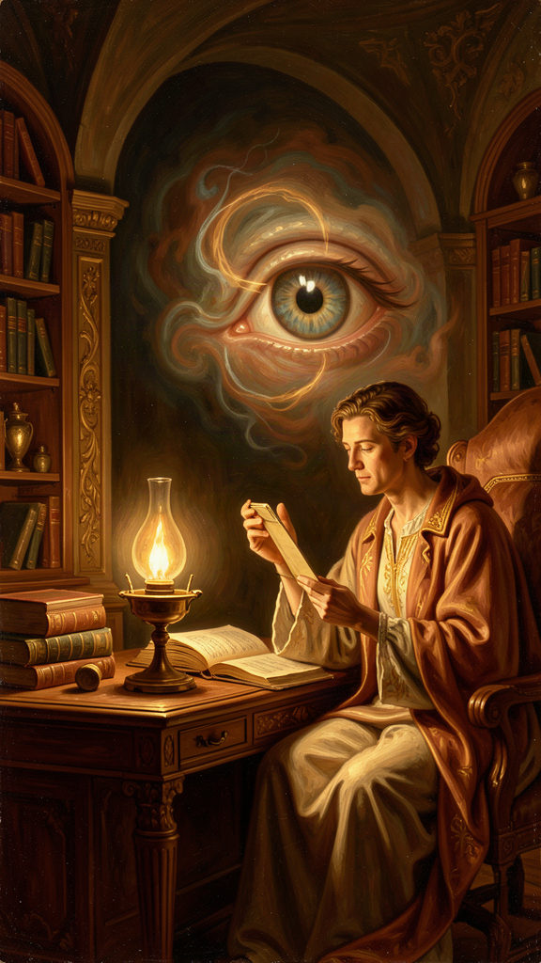
Illustration for Chapter 4
The goddess issues the most important command in the poem:
For this may never be made manageable, that things that are not are. But you from this way of inquiry restrain your understanding, and do not let habit born of much experience force you along this way, to employ aimless sight and echoing hearing and tongue. But judge by reason the much-contested proof I have delivered. (DK B7)
"Do not let habit born of much experience force you." "Aimless sight." "Echoing hearing." "Judge by reason." This is the first explicit statement in Western philosophy that reason (logos) is the ultimate arbiter of truth, and that sensory experience is unreliable as a guide to what is real.
This is the birth of rationalism — the philosophical position that certain truths can be known through reason alone, independently of what the senses report. It will run through Plato, Descartes, Leibniz, Spinoza, and into the foundations of modern logic, mathematics, and science. All of them inherit Parmenides' basic claim: the senses show you appearance; reason discovers reality.
The argument is not that the senses are useless. They are how you navigate the surface. But the surface is not the depth. The depth is what reason finds when it asks: "What must be true, given that 'it is' is the only starting point?"
Consider what happens when you trust the senses without reason. Your eyes tell you the earth is flat. Your experience tells you heavy objects fall faster than light ones (they don't). Your gut tells you a sequence of random events has a pattern (it doesn't — that's the gambler's fallacy, and it costs people real money). Your feelings tell you a colleague's short email means they're angry (it might mean they're busy). In every case, the senses mislead. In every case, reason — measurement, calculation, logical analysis, evidence — corrects the error.
Parmenides is making a stronger claim than "the senses sometimes mislead." He is saying the senses systematically mislead about the nature of reality, because they show you a world of change, plurality, and motion — and those are logically incoherent if "it is" is the only starting point. The senses show you the Way of Opinion. Reason shows you the Way of Truth.
The practical implication: when what you feel contradicts what you can prove, trust the proof. When your experience says "this is hopeless" and your reasoning says "here are three options you haven't tried," trust the reasoning. When your gut says "everyone is against me" and the evidence says "one person was critical and the rest seem supportive," trust the evidence. The feelings are the surface. The reasoning is the depth.
This is not cold logic against warm humanity. It is the recognition that your most important decisions — about what to believe, how to act, who to trust — should be based on what is true, not on what feels true. Feelings have their place. They are data. But they are not the final word. Reason is.
And there is a direct modern application: cognitive behavioral therapy, the most evidence-supported form of psychotherapy, is essentially Parmenidean. CBT asks you to examine your automatic thoughts (the deliverances of "habit born of much experience"), check them against evidence ("judge by reason"), and replace distorted thoughts with accurate ones. The therapist is the goddess. The automatic thoughts are the "aimless sight and echoing hearing." The examination is the "judge by reason." The method works because Parmenides was right: when you subject appearance to the discipline of reason, you get closer to reality. And getting closer to reality — seeing what is instead of what seems — is the foundation of both mental health and clear thinking.
———
The Big Idea
Parmenides' rationalism is not a rejection of experience. It is a ranking of sources of knowledge. Experience gives you appearances. Reason gives you reality. When the two conflict about what is fundamentally true, reason wins. This is the philosophical foundation of the scientific method: science does not trust raw experience. It subjects experience to the discipline of reason — controlled observation, measurement, logical inference, reproducibility. The scientist who designs an experiment to control for bias is doing Parmenides.
The same discipline applies to your inner life. Your automatic thoughts — the swift, often unconscious interpretations that drive your emotional reactions — are the "aimless sight and echoing hearing." They feel authoritative because they're fast and familiar. But they are appearances, not reality. The discipline of examining them, checking them against evidence, and replacing the distorted ones with accurate ones is the Parmenidean discipline. It is also, not coincidentally, the discipline that cognitive science has shown produces the most reliable improvement in anxiety, depression, and distorted thinking.
———
Practice
1. The Sense-Reason Conflict Log For one week, log moments where your feelings told you one thing and your reasoning told you another. Write both down. Which did you trust? What happened? Over time, you'll notice that feelings are loud and immediate; reason is quieter but more reliable. The skill is learning to hear the quieter voice — to not let the volume of the feeling drown out the accuracy of the reasoning.
2. The Cognitive Restructuring Pick a negative belief you hold about yourself ("I'm not competent enough," "I don't deserve this," "I'll always be alone"). Write it down. Apply Parmenides' test: is this "it is" or "it seems"? What's the evidence for the belief? What's the evidence against it? If the evidence is weaker than the feeling, the belief is on the Way of Opinion. Rewrite it based on what the evidence actually supports. This is CBT. It's also Parmenides, 2,500 years early.
3. The Proof Over Feeling Drill Find a claim that feels true but that you can check. "I'll never finish this project." Check it: Have you finished projects before? Do you have the skills? Is there a path? The feeling says "never." The evidence says "you've done hard things before and you have resources." Trust the evidence. Practice this until it becomes a reflex. The reflex is the Parmenidean inheritance.
———

Chapter 5: The Courage of Logic — Following the Argument
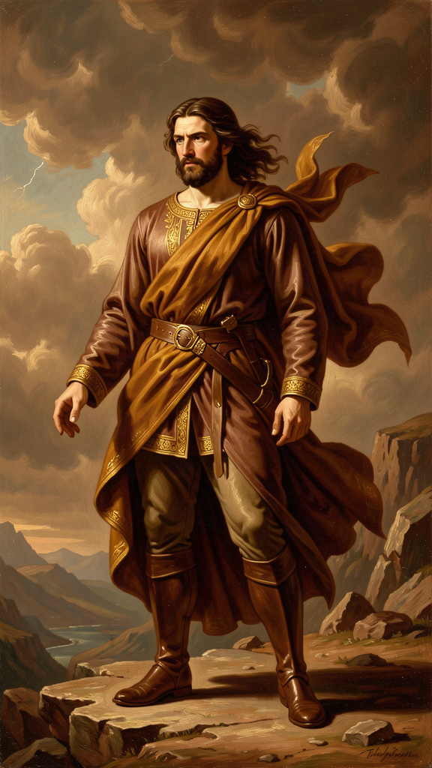
Illustration for Chapter 5
Parmenides' argument leads to a conclusion that contradicts every experience you've ever had. The world changes. Things move. Things are born and die. And Parmenides says: none of that is ultimately real. What is real is ungenerated, imperishable, whole, single, unmoving, complete.
To take this seriously requires a specific kind of courage. The courage to follow an argument wherever it leads, even when the destination seems absurd. The courage to trust logic over the testimony of your own eyes. The courage to say: "My experience is wrong, and here is the proof."
This is intellectual courage, and it is rare. Most thinking is not courageous. Most thinking starts from what feels comfortable and works backward to justify it. Most people encounter an argument that challenges their worldview and find a way to dismiss it — "that's just philosophy," "that's unrealistic," "that doesn't apply to real life." The dismissal is easier than the engagement. The comfort is easier than the truth.
Parmenides offers no comfort. His argument says: everything you see is, in the deepest sense, not what it seems. Your entire experience of the world is the Way of Opinion. The truth is something you can only reach by abandoning the authority of your senses and committing to the authority of reason. That is a terrifying commitment. It means trusting something invisible (logic) over something tangible (experience). It means being willing to arrive at conclusions that make you feel like you've lost your grip on reality.
But every major advance in human knowledge has required exactly this courage. Copernicus trusted the math over the appearance — the earth looks stationary, but the math says it moves. Einstein trusted the equations over the intuition — time feels absolute, but the equations say it's relative. Darwin trusted the evidence over the consensus — the world looks designed, but the evidence says it evolved. In every case, the thinker had to follow the argument past the point where experience agreed, into territory that felt wrong but was logically demanded.
Parmenides is the first person to model this. He follows the logic of "it is" to conclusions that contradict all experience, and he does not flinch. He does not say "well, that can't be right, let me adjust the argument." He says: "The argument is sound. The experience is misleading. Trust the argument."
This is not dogmatism. It is the opposite. Dogmatism is clinging to what you already believe. Parmenides is abandoning what everyone believes and following the logic. The courage is in the abandonment. The trust is in the logic.
The practical version: you will encounter arguments that challenge what you believe. About politics, about relationships, about yourself, about the world. The easy path is to dismiss them. The Parmenidean path is to engage them — to follow the logic wherever it leads, even if it leads somewhere uncomfortable. You don't have to accept every argument. But you have to be willing to follow it. That willingness is the virtue Parmenides introduces to the West.
And here is the deeper point: the willingness to follow an argument past comfort is not just a philosophical virtue. It is a practical one. The arguments you resist most strongly are often the ones you most need to engage. Resistance is a signal. It tells you that an argument is touching something you're invested in — a belief, an identity, a narrative. That's exactly where honest thinking is most valuable and most difficult. The Parmenidean discipline is to notice the resistance, acknowledge it, and follow the argument anyway. Not to abandon your beliefs at the first challenge. But to refuse to protect them from challenge. To let them be tested. And to accept the results of the test, even when they're uncomfortable.
———
The Big Idea
Intellectual courage is the willingness to follow an argument past the point of comfort. It is the willingness to say "my experience might be wrong" and to take seriously the possibility that logic reveals something your senses can't. This is not about being contrarian or rejecting common sense. It's about engagement. When you encounter an argument that challenges your beliefs, the Parmenidean response is not "that's wrong" but "let me follow it." Where does the logic lead? Is it sound? If it is, what does that mean for what I thought I knew?
Most of the time, the argument will have a flaw, and you'll find it. But sometimes it won't. And in those moments, the courage to accept the conclusion — even when it's uncomfortable — is what separates honest thinking from defensive thinking. Parmenides' conclusion — that the changing world is not ultimately real — has been uncomfortable for 2,500 years. It has also been productive. Every philosopher who engaged it seriously produced something valuable: Plato's Forms, Aristotle's categories, Descartes' method, Kant's antinomies. The discomfort was the point. It forced thinking forward.
———
Practice
1. The Uncomfortable Argument Find an argument that challenges something you believe — from a book, an article, a colleague, a podcast. Instead of dismissing it, follow it. Write out the logic step by step. Where does it lead? Is each step sound? If you find a flaw, identify it precisely. If you don't, sit with the conclusion. You don't have to accept it, but you have to take it seriously. That's the Parmenidean move.
2. The Experience Challenge Identify one thing your experience tells you that you have never questioned. Maybe "people don't change," or "hard work always pays off," or "I'm not the kind of person who could do that." Find the strongest argument against it. Follow the argument. Does it hold up? The point is not to abandon your belief. The point is to demonstrate that you can engage with a challenge without flinching.
3. The Resistance Signal Notice the next time you feel resistance to an argument — the flash of "that's wrong" or "that's ridiculous" before you've actually engaged the logic. That resistance is data. It tells you something is at stake. Instead of acting on the resistance, sit with it. Ask: "What belief is this argument threatening? Why do I care? What would it cost me to take the argument seriously?" Then follow the argument. The resistance doesn't make the argument wrong. It makes it worth examining.
———

Chapter 6: The Legacy — Parmenides' Children

Illustration for Chapter 6
Parmenides wrote one poem. The poem is fragmentary — we have about 150 lines, preserved mostly by Simplicius in the 6th century CE, over a thousand years after Parmenides lived. And from those fragments, the entire history of Western metaphysics unfolds.
Zeno of Elea (c. 490–430 BCE) was Parmenides' student and his most ingenious defender. Zeno's paradoxes — Achilles and the tortoise, the arrow, the stadium, the dichotomy — were designed to show that the denial of Parmenidean monism leads to contradictions. If you assume plurality and motion are real, Zeno argued, you get absurdities: Achilles can never pass the tortoise (there's always half the distance remaining), an arrow in flight is always at rest (at any instant it occupies a fixed position), and half the time equals double the time (the stadium). The paradoxes are reductio ad absurdum arguments: assume the opposite of Parmenides, derive a contradiction, conclude that Parmenides was right. Zeno's method — proving a point by showing that its denial is incoherent — became a permanent tool of philosophical and mathematical reasoning. His paradoxes are still discussed in the foundations of calculus and the philosophy of motion, 2,500 years later.
Plato (c. 428–348 BCE) was the next great inheritor. Plato's Theory of Forms is a direct response to Parmenides. The Forms are eternal, unchanging, perfect — they have the six signs. The sensible world is changing, imperfect, multiple — it's the Way of Opinion. Plato's two-world metaphysics (Forms vs. particulars) is Parmenides' two roads (Truth vs. Opinion) given an ontological framework. Plato even wrote a dialogue named Parmenides, in which an elderly Parmenides cross-examines a young Socrates on the Theory of Forms. The dialogue is one of the most difficult texts in the Platonic corpus, and it shows Plato taking Parmenides seriously enough to let him dismantle Plato's own theory. That's intellectual honesty: letting the critic win, at least temporarily, because the argument matters more than the position.
Aristotle (384–322 BCE) could not escape Parmenides either. Aristotle's entire system of logic — the law of non-contradiction, the syllogism, the categories — is built on Parmenidean foundations. The law of non-contradiction (something cannot be both X and not-X at the same time and in the same respect) is a formalization of Parmenides' distinction between "it is" and "it is not." Aristotle's response to Parmenides is not rejection but refinement: he argues that "being" has multiple senses (substance, quantity, quality, relation), and that change is possible because a thing can be X in one respect and not-X in another respect. This preserves Parmenides' insight (you can't get something from nothing) while making room for the change that experience demands. Aristotle's metaphysics is a negotiated settlement with Parmenides — and it set the framework for Western philosophy for the next 2,000 years.
René Descartes (1596–1650) rediscovered the Parmenidean foundation in the 17th century. His Meditations on First Philosophy strip away every belief that can be doubted — sensory experience, memory, the existence of the external world, even mathematics (what if an evil demon is deceiving me?) — until one thing remains: Cogito, ergo sum. "I think, therefore I am." The moment of thinking proves that something is. Descartes' method of systematic doubt, arriving at an indubitable foundation, is Parmenides' argument in modern form: you can't doubt that thinking is happening, because doubting is thinking, and thinking is something, and something is. Modern philosophy begins here, and it begins on Parmenides' road.
Modern logic and analytic philosophy continue the tradition. Gottlob Frege's distinction between sense and reference, Bertrand Russell's theory of descriptions, W.V.O. Quine's criterion of ontological commitment ("to be is to be the value of a bound variable") — all grapple with the Parmenidean question: what does it mean to say that something is, and what are the logical conditions for meaningful assertion? When a logician says a statement must have a referent to be meaningful, that's Parmenides. When a philosopher of language says "nothing" is not a name but a quantifier, that's a response to Parmenides. When a cognitive scientist says that the mind constructs models of reality and that these models can be checked against logical constraints, that's Parmenides in a new vocabulary.
The thread from Parmenides to the present is not a straight line. It bends, branches, and sometimes doubles back. But it never breaks. Every serious thinker in the Western tradition has had to confront the question Parmenides posed: what is, and how do we know? The answers differ. The question endures. And the method — rigorous argument, logical deduction, the willingness to follow reason past the point of comfort — is the method Parmenides invented.
You are now part of this thread. Every time you ask "but is that really true?" — every time you check a belief against evidence, follow an argument to its conclusion, or refuse to accept an answer that doesn't hold up — you are walking Parmenides' road. The road is 2,500 years old. It is still open. And it still leads somewhere worth going.
The poem that started it all is mostly lost. We have fragments. Fragments are enough. From a few lines preserved by a Neoplatonist commentator in the 6th century, the entire edifice of Western metaphysics grew. That's the lesson: it doesn't take much. One argument, made clearly, followed honestly, and engaged seriously by those who come after. That's how ideas live. That's how they outlast empires.
Parmenides gave us one argument. It has been enough for 2,500 years. The question is what you'll do with it.
———
The Big Idea
Parmenides wrote one poem. Zeno defended it. Plato transformed it. Aristotle refined it. Descartes rediscovered it. Modern logic formalized it. And now you've read it. The thread is unbroken because the question is permanent: what is real, and how do we know?
You don't have to answer it. You have to ask it — honestly, rigorously, and without flinching from where the logic leads. That's the Parmenidean inheritance. It's not a set of conclusions. It's a method. A commitment. A road. The road is still open. It's been open for 2,500 years. It will be open for as long as anyone is willing to think.
———
Practice
1. The Thread Forward Pick one idea from this booklet that changed how you think. Trace it forward: where does it show up in your work, your relationships, your decisions? Write down three concrete ways the idea will affect how you approach something this week. The thread is only alive if you use it. Parmenides gave us a method. The method only works if you practice it.
2. The Question You Carry Parmenides' question — "what is real?" — doesn't have a final answer. That's the point. The question keeps thinking alive. Write down your version of the question. Not the answer — the question. Carry it. Ask it about your beliefs, your fears, your ambitions, your certainties. The question is the Parmenidean inheritance. The answers are yours to find. The discipline of asking — honestly, repeatedly, without settling for comfortable answers — is the practice.
3. The Argument You Make Parmenides was one person with one argument. It outlasted empires. What's your argument? What's something you think that most people around you don't? Write it down. Defend it with logic. Follow it to its conclusion. Be willing to be wrong — but engage the argument honestly before you conclude that you are. You don't have to be right. You have to be willing to think — clearly, rigorously, and without flinching. That's the road. It's still open. It's waiting for you.
———
WisdomForge — Parmenides — Adult Adapted by Aiona Edge SMF Works — WisdomForge Project

