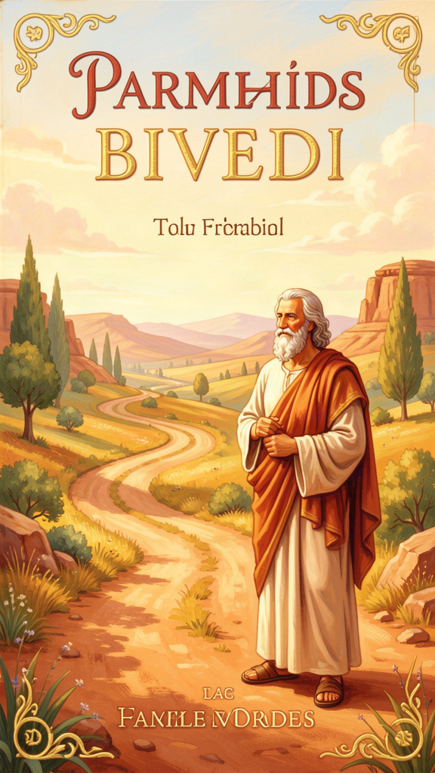
Parmenides: The Boy Who Rode to the Truth
WisdomForge Booklet — Ages 5–10

Parmenides: The Boy Who Rode to the Truth

WisdomForge Booklet — Ages 5–10
———

About This Book
This booklet tells the story of Parmenides, a man who lived over 2,500 years ago in a town by the sea. He rode in a chariot in his imagination to meet a goddess who told him the biggest secret in the world: what is real is real, and what is not real is not even worth talking about.
Each chapter has a story, a big idea, and something to try. Read it alone or with a parent or teacher. The questions aren't tests — they're starting points for conversations.
———

Chapter 1: The Chariot Ride
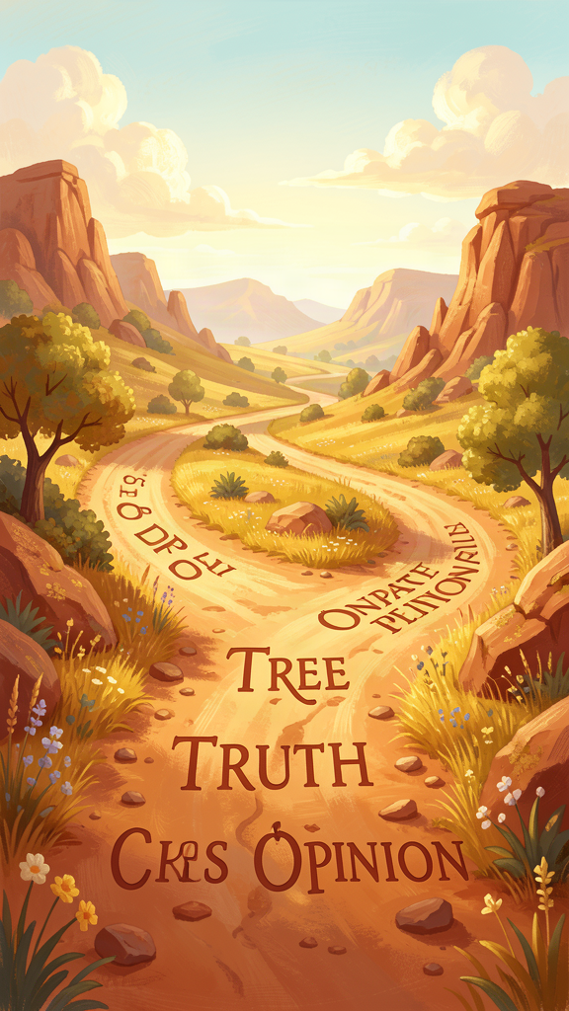
Illustration for Chapter 1
Long ago, in a sunny town called Elea, near the sea in the south of Italy, there lived a boy named Parmenides. Elea was a Greek town, but it was far from Athens, far from the big cities where most famous thinkers lived. It was a quiet place where fishermen mended their nets and olive trees grew in silver-green rows up the hillsides.
Parmenides was a quiet boy, too. He liked to sit by the water and think. While other children raced through the marketplace and shouted at the games, Parmenides watched the waves and wondered. His mother sometimes found him sitting on the rocks at sunset, staring at the horizon as though he could see something no one else could see.
"What are you looking at?" she asked once.
"I'm trying to see what's really there," he said.
His mother smiled. "The sea is there. The sky is there. What else would there be?"
But Parmenides wasn't sure that what you see is the same as what is real. The water looked blue, but when he cupped it in his hands, it was clear. The sun looked small enough to hold, but his teacher said it was bigger than the whole earth. His eyes told him one thing and his mind told him another. Which one should he trust?
One night, Parmenides had a dream. Or maybe it was more than a dream. In it, he was carried in a chariot pulled by wise horses — horses that knew where they were going before he did. He wasn't driving. He was being taken.
The horses galloped down a road that glowed like moonlight on water. Fire bloomed from the chariot's wheels. The air hummed with music, like a pipe playing a note you could feel in your chest but couldn't quite hear.
Then he came to a gate. It was enormous, taller than any building in Elea, made of stone and bronze. It stood at the place where night and day meet — the hinge of the whole world. A tall woman stood at the gate, holding a ring of keys.
"Who are you?" Parmenides asked.
"I am Justice," she said. "I guard the gate between what people think they know and what is really true."
The horses' companions — shining women called the Daughters of the Sun — spoke gently to Justice, and she opened the gate. The doors swung wide, and beyond them was a bright, open space. Parmenides rode through.
On the other side, a goddess was waiting. She took his hand and smiled. "Welcome," she said. "You have come a long way. Now I will teach you the truth."
Parmenides woke up with his heart pounding. The dream felt more real than his bed, more real than the morning light coming through the window. He picked up a piece of charcoal and began to write. He wrote in the old poetic style, the way the storytellers wrote about heroes and gods. But what he wrote was not a story about gods. It was a story about truth.
He called it "On Nature." And it changed everything.
Words to Remember What is, is. And what is not, is not. — Parmenides
Big Idea Sometimes the most important journeys happen inside your mind. Parmenides didn't sail across the sea or climb a mountain to find truth. He sat still, thought hard, and followed his reasoning wherever it led. Thinking carefully is its own kind of adventure.
Try This - Close your eyes and take a journey. Sit quietly for one minute. Imagine you are riding in a chariot toward a gate. When you pass through the gate, what do you see? Draw or describe what you found on the other side. - Trust and check. Look at a straw in a glass of water. It looks bent, doesn't it? Now take it out. It's straight! Your eyes told you it was bent, but your mind knows it's straight. This is what Parmenides meant: sometimes you have to think, not just look. - Ask a Grown-Up: "Have you ever seen something that turned out not to be what it looked like?"
———

Chapter 2: What Is, Is
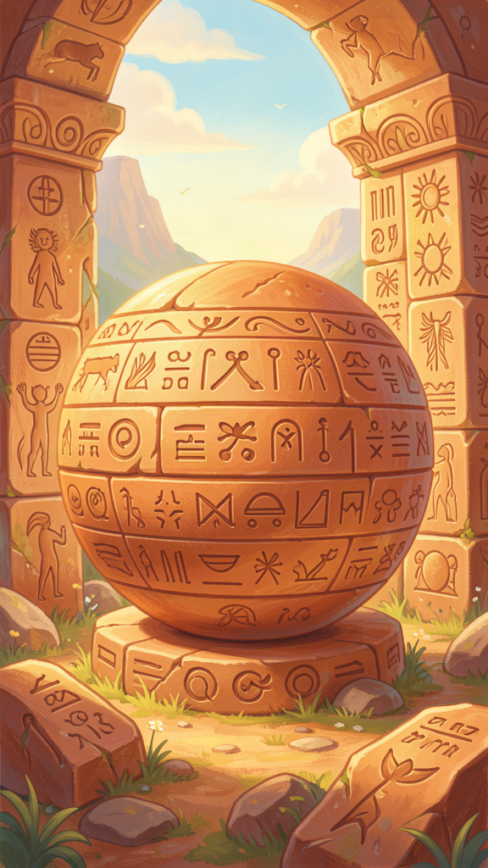
Illustration for Chapter 2
After Parmenides rode through the gate, the goddess sat him down and said something very simple. So simple that it sounds like nothing at all. But it was the biggest idea anyone had ever had.
"Here is the first thing you must learn," she said. "There are only two roads you can walk. The first road says: 'It is.' The second road says: 'It is not.'"
"Those don't sound very different," Parmenides said.
"Oh, but they are," said the goddess. "The first road is real. You can walk on it. The second road doesn't exist. You can't walk on a road that isn't there."
Parmenides frowned. "But I can say the words 'it is not.' I can say 'there is no dragon in this room.' Isn't that talking about what is not?"
The goddess nodded. "You can say the words. But try to think about nothing. Not an empty room. Not a blank page. Nothing. No space, no time, no anything."
Parmenides tried. He squeezed his eyes shut and tried to think about nothing.
He couldn't do it.
Every time he tried to think about nothing, he was thinking about something. Even "empty" is something. Even "dark" is something. The moment you try to think about nothing, it becomes something you are thinking about.
"That's the secret," the goddess said. "You cannot think about what is not. You can only think about what is. So if you want to find the truth, you have to start with 'it is.' That's the only road that goes anywhere."
This was a strange and powerful idea. Most people, the goddess said, are confused. They walk down both roads at the same time. They say things like "this used to not exist, and now it does" — as though something can come from nothing. But nothing comes from nothing. If something is here now, it must have always been here in some way. And if it's here, it can't just disappear into nothing.
"Think about it like this," the goddess said. "Can you make a picture out of nothing? Can you build a tower out of nothing? Can you go to a place that doesn't exist?"
"No," said Parmenides.
"Right. Nothing is not a thing you can use. It's not a place you can go. It's not even something you can think about. So why would you ever start with 'it is not'? Start with 'it is.' That's where everything real begins."
Parmenides wrote this down. It was the first rule: what is, is. What is not, is not even worth talking about.
Words to Remember You cannot know what is not, nor can you talk about it. — Parmenides
Big Idea You can't build anything out of nothing. You can't think about nothing. You can't go to a place that doesn't exist. The only place to start anything — thinking, building, dreaming — is with what is. When you feel stuck or scared, ask yourself: "What is actually true here?" Start from what is real, not from what you are afraid might be.
Try This - The Nothing Game. Try to think about nothing for ten seconds. Set a timer. How long does it take before a thought, a picture, or a feeling shows up? That's Parmenides' point: you can't think about nothing. Even trying proves that something is there. - What Is, Is. Next time you feel worried, write down two lists. List 1: "What I am afraid might happen." List 2: "What is actually true right now." Which list feels steadier? Which one can you do something with? - Ask a Grown-Up: "Have you ever worried about something that turned out not to be real? How did you figure out it wasn't real?"
———

Chapter 3: The Signs of What Is Real
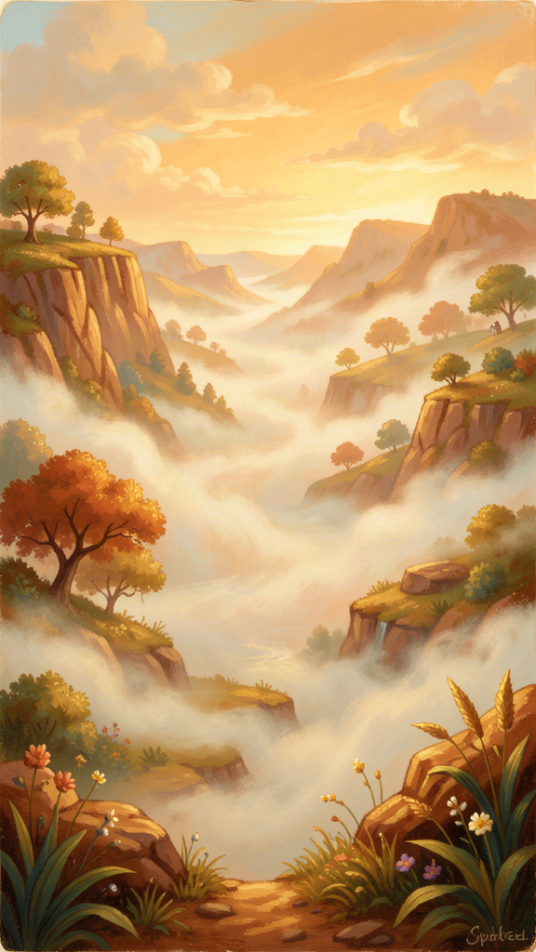
Illustration for Chapter 3
The goddess said, "Now that you know that 'it is' is the only road, let me show you what you can find along that road. If something is truly real, it has certain signs — like clues that tell you it's the real thing."
She held up her hand and counted on her fingers.
"One: it was never born, and it will never die."
Parmenides blinked. "But everything is born and dies. Flowers bloom and wilt. People are born and grow old."
"Those are things you see," the goddess said. "But think about it. If something is truly real — if it is — where did it come from? From something that already is? Then it was already there. From nothing? But nothing can't make anything. So what is truly real was never made. And if it can't be made, it can't be unmade. It just is."
"Two: it is whole. It has no missing pieces."
"If it had a hole or a gap, what would be in the gap? Nothing? But nothing isn't real. So there can't be any gaps. What is real is complete, like a full circle."
"Three: it does not move."
"Where would it go? Every place is already full of what is. There's no empty space to move into. It stays, because it is already everywhere it needs to be."
"Four: it is perfect, like a ball."
"Not that it is shaped like a ball. But like a ball, it is the same all the way around. No side is bigger or smaller. Nothing sticks out. Nothing is missing. It is finished and complete."
Parmenides sat with this. It sounded strange. The world he could see was full of change — things growing, moving, breaking, being born, dying. But the goddess was saying that what you see is not what is real. What is real doesn't change. It can't change, because changing would mean becoming something it wasn't, and that would mean what it was before wasn't real.
"Think of it like a puzzle," the goddess said. "The picture on the box is whole and complete. When you dump the pieces out, they look broken and scattered. But the real picture — the one on the box — was never broken. The pieces just make it hard to see."
Parmenides looked at the world differently after that. The world he saw was like the scattered puzzle pieces. Somewhere underneath, there was a whole, complete picture. You just couldn't see it with your eyes. You had to think your way to it.
Words to Remember What is real is whole, complete, and unchanging — like a perfect circle. — Parmenides
Big Idea What is truly real doesn't break, doesn't fade, and doesn't need to become anything else. It is already complete. When things in your life feel broken or unfinished, remember that the brokenness might be in how things look, not in how they truly are. The truth underneath is whole.
Try This - Draw a perfect circle. Use a cup or a compass to draw the roundest circle you can. Now look at it. It has no beginning and no end. No side is bigger than another. Nothing is missing. That's what Parmenides said true being is like: complete, whole, perfect. - The Puzzle Picture. Find a puzzle and dump out the pieces. Look at the scattered pieces — they look like a mess. Now look at the picture on the box. That picture is whole and complete, even though the pieces are scattered. Parmenides said the world is like the scattered pieces, and truth is like the picture on the box. - Ask a Grown-Up: "What is something in your life that felt broken but turned out to be part of something whole?"
———

Chapter 4: The Road of Make-Believe
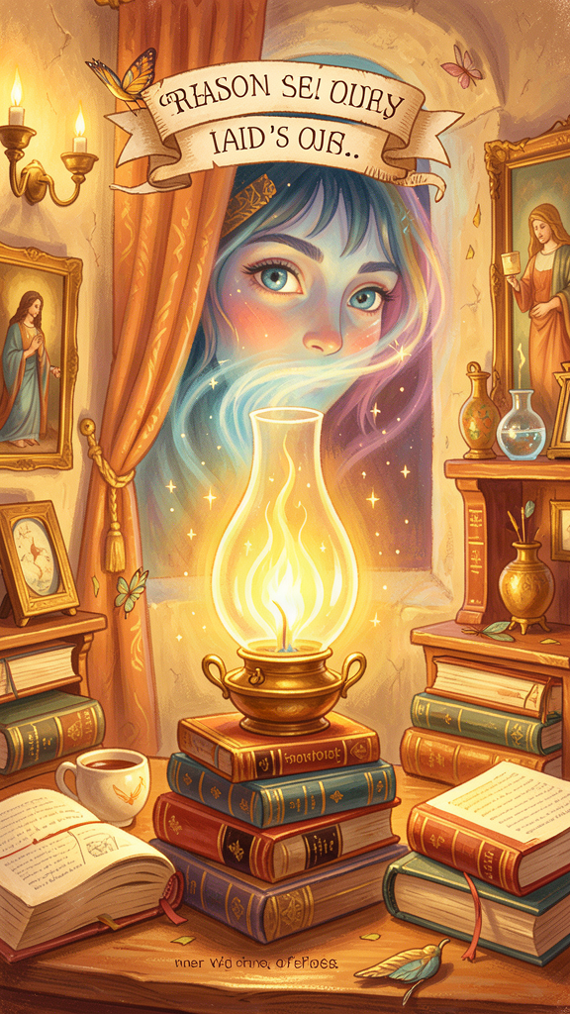
Illustration for Chapter 4
The goddess had one more thing to teach Parmenides. After she showed him the road of truth, she showed him another road — the road that most people walk every day.
"This is the road of opinions," she said. "It's the road of make-believe."
"What's wrong with make-believe?" Parmenides asked. "Isn't imagination good?"
"Imagination is wonderful," the goddess said. "But make-believe is different. Make-believe is when you forget that you're pretending. When you start thinking that the way things look is the way things are."
She explained: Most people walk around thinking that the world they see — the changing, moving, growing, dying world — is all there is. They believe their eyes. They trust their ears. They think that if something looks blue, it is blue. If something feels hot, it is hot. If something seems gone, it is gone.
"But your eyes can fool you," she said. "Remember the bent straw in the water? Your eyes can show you a world that doesn't match what is real. The road of opinions is like walking through a fog. You see shapes and shadows, and you think they are the real thing. But they are just shapes in the fog."
"Then why do people walk on that road?" Parmenides asked.
"Because it's the easy road," the goddess said. "It's the road your body wants to walk. Your eyes want to see. Your ears want to hear. Your feelings want to react. It takes effort to step off that road and think instead of just look."
But the goddess didn't say the road of opinions was useless. She said it was worth understanding — not to live on, but to recognize.
"You need to know what the fog looks like," she said, "so you don't mistake it for the real thing. You need to know how people get confused, so you don't get confused the same way. The road of opinions isn't evil. It's just not the road of truth. Walk it enough to recognize it. Then come back to what is."
Parmenides thought about this. He thought about all the times he had been sure of something because he saw it or felt it — and then found out he was wrong. The time he was sure his friend was angry because she had a frown on her face, but she was just thinking hard about a math problem. The time he was sure it was going to rain because the sky looked dark, but the wind changed and the sun came out.
Seeing isn't the same as knowing. Feeling isn't the same as understanding. The road of opinions is the road of "it seems like." The road of truth is the road of "it is."
Words to Remember The things that seem to be are not the same as the things that are. — Parmenides
Big Idea Your eyes and ears can fool you. Things that look one way often turn out to be another way. That doesn't mean you should never trust what you see — it means you should always check. Ask: "Does this seem true, or is it true?" There's a big difference.
Try This - Seems vs. Is. Think of a time you were sure about something and then found out you were wrong. Maybe you thought someone was mad at you, but they were just tired. Maybe you thought you failed a test, but you actually did fine. Write down: "It seemed like _____. But it was actually _____." This is the difference between the road of opinions and the road of truth. - The Fog Walk. Next time it's foggy (or imagine fog), look at how trees and buildings look different in the fog. They seem blurry, scary, different. But they haven't changed. The fog changed how they look, not what they are. That's what opinions do to the truth. - Ask a Grown-Up: "Have you ever been completely sure about something and then found out you were wrong? What happened?"
———

Chapter 5: Trust Your Thinking, Not Just Your Eyes
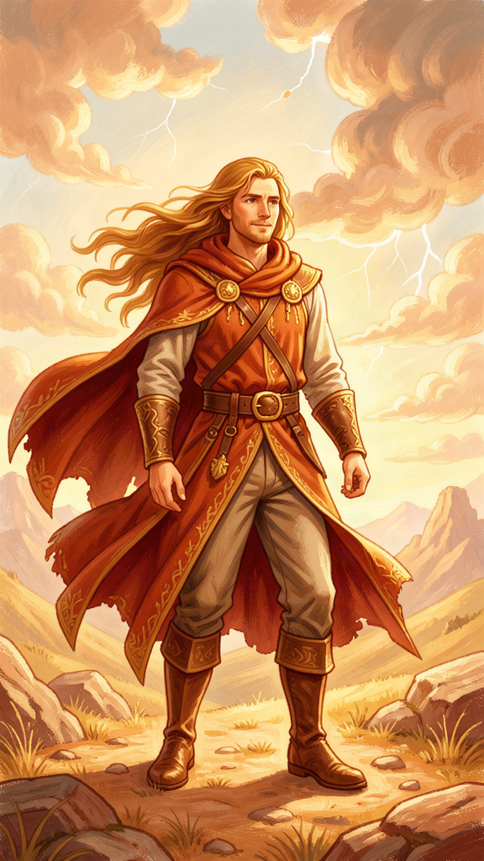
Illustration for Chapter 5
One day, Parmenides was sitting with his students by the sea. A boy named Zeno was there — Zeno was clever and asked the best questions.
"Teacher," Zeno said, "if what you say is true — that what is real doesn't change, doesn't move — then how do you explain this?" He picked up a pebble and threw it into the water. The pebble sank. Ripples spread across the surface. "That pebble moved. The water changed. I saw it with my own eyes."
Parmenides nodded. "You saw it. But what did you actually see?"
"I saw the pebble go from my hand to the water."
"And where is the pebble now?"
"At the bottom of the sea."
"So the pebble still is," Parmenides said. "It changed where it is, but it didn't stop being. It didn't turn into nothing. It's still a pebble. What you saw was the pebble doing something. You didn't see the pebble stop existing."
Zeno thought about this. "But it moved. You said what is real doesn't move."
"Think about it differently," Parmenides said. "When you walk from one side of the room to the other, did you change? You're still Zeno. You're still the same person. You moved, but you didn't appear and disappear. You were you the whole time. The movement is something that happened. The you that it happened to was there the whole time."
"So you're saying that the changes we see are like... ripples on top of something that stays the same?"
"Exactly," Parmenides said. "The ripples move, but the water is still water. The pebble sinks, but the pebble is still a pebble. Underneath all the moving and changing, there is something that just is. And that something is what is real."
He leaned forward. "Here is the hardest part, Zeno. You have to learn to trust your thinking more than your eyes. Your eyes will always show you change. Your ears will always hear movement. Your skin will always feel difference. But your mind can see something your eyes can't: that underneath all the change, something stays. And that something — that is — is the truth."
Zeno picked up another pebble and held it in his palm. He looked at it for a long time. Then he smiled. "I think I understand," he said. "The pebble changes where it is. But the pebble doesn't change what it is."
"That's the beginning of wisdom," Parmenides said.
This was Parmenides' great gift to the world: the idea that thinking is more powerful than looking. That reason can see things that eyes can't. That the truth is not always what you see — sometimes it's what you figure out when you sit still and think.
Words to Remember Do not let habit force you to trust your eyes and ears. Judge by reason. — Parmenides
Big Idea Your eyes are amazing, but they can only show you the surface of things. Your mind can go deeper. When you think carefully, you can understand things you can't see — like fairness, like love, like truth. These are real even though you can't point at them. Trust your thinking. It can see further than your eyes.
Try This - The Invisible Things. Make a list of things that are real but that you can't see. Start with: love, fairness, tomorrow, ideas, numbers. Can you see any of these? No. Are they real? Yes. This is what Parmenides meant: the most real things are often the things you can't see with your eyes. - Think Before You Look. Next time someone tells you something surprising ("There's a monster under the bed!"), don't just look. Think first. Ask: "Does that make sense? Have monsters ever been under the bed before? What would a monster eat under there?" Thinking before looking is the Parmenides way. - Ask a Grown-Up: "What is something you know is real even though you can't see it?"
———

Chapter 6: The Children of the Truth
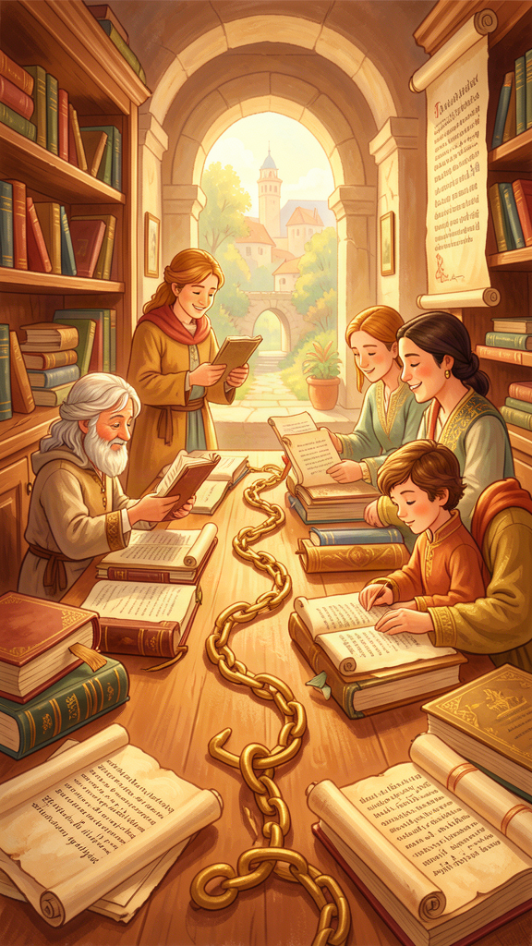
Illustration for Chapter 6
Parmenides grew old in Elea. He wrote his poem, "On Nature," and people came from far away to hear him talk. He taught Zeno, who became famous for his puzzles — the ones that proved that moving is impossible (even though we all move every day!). Zeno's puzzles made people think hard, and thinking hard was exactly what Parmenides wanted.
Word of Parmenides' poem traveled across the sea to Athens. There, a young man named Socrates heard about it. And later, Socrates' student Plato wrote a whole book about Parmenides. In it, Plato imagined Parmenides visiting Athens as an old man, with white hair and a noble face, sitting down to talk with young Socrates about what is real.
Plato took Parmenides' idea — that what is truly real doesn't change — and built his whole philosophy on it. Plato said there are two worlds: the world we see, which is always changing, and the world of Forms, which never changes. The world of Forms is the real world. The world we see is like a shadow of it.
Sound familiar? It should. Plato got that idea from Parmenides.
Hundreds of years later, more thinkers picked up Parmenides' thread. René Descartes, in the 1600s, sat by a fire and thought: "What can I be absolutely sure of?" He doubted everything his eyes told him, everything his ears heard, everything his feelings suggested. And in the end, he found one thing he couldn't doubt: "I think, therefore I am." Thinking proves that something is. That's Parmenides' idea, wearing new clothes.
Even today, scientists and philosophers use Parmenides' rule without knowing it. When a scientist says "you can't get something from nothing," that's Parmenides. When a logician says "a statement has to be about something to be meaningful," that's Parmenides. When you check whether a fear is real or just something you imagined, that's Parmenides.
Parmenides lived 2,500 years ago, in a small town by the sea. He wrote one poem. And that poem is still alive, still making people think, still asking the same question: What is real? What truly is?
The road to truth is still open. The gate is still there. And the question is still waiting for you: Will you trust what you see, or will you think?
Words to Remember What is, is. The rest is fog. — after Parmenides
Big Idea One person, sitting by the sea, thinking hard, changed the world. Parmenides didn't have a laboratory or a computer. He had his mind. And his mind was enough. You have a mind, too. Every time you ask "but is it really true?" you are walking the same road Parmenides walked. You are one of the children of the truth.
Try This - The Parmenides Question. Pick something you believe. Maybe "my friend is mad at me" or "I'm bad at math." Now ask: "Is this really true, or does it just seem true?" If you're not sure, how could you find out? This is the question that started Western philosophy. - Draw the Road. On a piece of paper, draw two roads. Label one "Seems True" and the other "Is True." Along the "Seems True" road, draw things that can fool you (fog, shadows, bent straws in water). Along the "Is True" road, draw things that don't change (a circle, a star, the idea of fairness). Which road would you rather walk? - Ask a Grown-Up: "What is one thing you used to believe was true that turned out not to be? How did you find out?"
———
WisdomForge — Parmenides — Ages 5–10 Adapted by Aiona Edge SMF Works — WisdomForge Project

