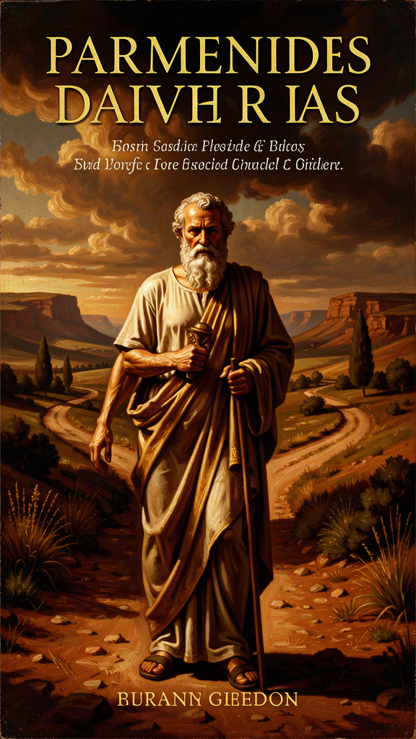
Parmenides: The Logic That Broke the World
WisdomForge Booklet — Ages 15–18

Parmenides: The Logic That Broke the World

WisdomForge Booklet — Ages 15–18
———

About This Book
Parmenides of Elea (c. 515–450 BCE) wrote one poem, "On Nature," and permanently altered the trajectory of Western thought. His central argument — that "what is, is" and "what is not" cannot be thought — is the first sustained deductive argument in Western philosophy. Everything after him is, in some sense, a response.
This booklet reads Parmenides as a philosopher of reason, logic, and the courage to follow an argument wherever it leads. Each chapter takes one theme — the argument, the signs of being, the way of opinion, the primacy of reason, the legacy — and develops it through historical narrative, direct quotation, and practical exercises. No padding. No dumbing down. Parmenides deserves better.
———

Chapter 1: The Road That Doesn't Exist

Illustration for Chapter 1
You've had the experience. You're staring at a problem — a math proof, a decision about your future, a conflict with someone you care about — and you can feel two paths in front of you. One is the path of what you know. The other is the path of what you fear. The first is solid. The second is fog. And yet the fog feels louder.
Now imagine scaling that experience to the foundations of thought itself. Imagine asking: what can I know with absolute certainty? What is the one thing I cannot doubt? If I strip away every assumption, every inherited belief, every sensory impression, what remains?
This is where Parmenides begins. Not with a theory about the world, but with a structural observation about the nature of thinking. The poem "On Nature" opens with a narrative frame: a young man is carried in a chariot to a goddess, who teaches him two things — the truth and the opinions of mortals. The frame is literary, but the content is rigorous. The goddess presents a fork in the road:
Come now, I will tell you — and you, once you have heard the tale, carry it away — the only two ways of inquiry that can be thought of: the one, that [it] is and that [it] is not not to be, is the path of conviction, for it follows true reality; the other, that [it] is not and that [it] must not be — this, I tell you, is a path wholly without report: for you could not apprehend what is not, for it cannot be done, nor could you indicate it. (DK B2.3–8)
Two roads. One says "it is." One says "it is not." The second road, the goddess says, is not merely false. It is impassable. You cannot travel it. You cannot think what-is-not. You cannot speak what-is-not. There is no "there" there.
This is a strange claim. Surely you can think about things that don't exist? You can think about unicorns. You can think about tomorrow's party that might not happen. You can think about the ending of a relationship. What does Parmenides mean, you "cannot" think what-is-not?
He means something precise. Try to think pure nothing. Not "an empty room." Not "blank space." Not "darkness." Pure, absolute nothing — no space, no time, no content, no possibility. The moment you attempt this, your mind generates something: an image of darkness, a concept of emptiness, a spatial metaphor for void. All of these are something. The attempt to think nothing produces a thought, and a thought is something. Non-being, taken as a starting point, is cognitively inert. It cannot function as the object of a thought because there is nothing there to be the object.
This is not a psychological limitation. It is a structural feature of cognition. Thought requires an object. Non-being provides none. Therefore, non-being cannot be thought. Therefore, "it is not" is not a road you can walk. The only road is "it is."
From this single move, Parmenides derives everything. If "it is" is the only starting point, then: - What is cannot come from nothing (nothing can't produce anything). - What is cannot become nothing (you can't go where there's no "there"). - Therefore, what is has no beginning and no end. - Therefore, what is does not change (change requires transition from what-is to what-is-not). - Therefore, what is is whole, continuous, single, unmoving, complete.
The world your senses show you — the world of change, plurality, birth, death, motion — is, on this argument, not the real world. It is the world of appearance. The real world is what reason discovers when it follows the logic of "it is" to its conclusions.
This is the moment Western philosophy is born. Not as mythology, not as wisdom literature, but as argument. Parmenides is the first thinker to structure his case as a deductive chain: pose a dichotomy, eliminate one option by showing it's impossible, commit to the other, and derive consequences. Every philosopher after him — Plato, Aristotle, the Stoics, the medievals, the moderns — works in the shadow of this method.
The Big Idea: The Fork in the Road
Parmenides' two-roads argument is not just about metaphysics. It's about how you approach any hard question. Most of the time, when you're stuck, you're stuck because you're trying to start from the wrong place. You're starting from "what if it doesn't work out?" or "what if they don't like me?" or "what if I'm not good enough?" Those are "it is not" roads. They're built on fears about things that haven't happened, that may never happen, that don't exist yet.
The "it is" road starts from what's actually true: I am here. I have certain skills. I have certain options. This is what I know. That's solid ground. You can build on that. You can't build on "what if I fail" because "what if I fail" is a thought about non-being — about a state that doesn't exist. It's fog. It feels real, but it has no foundation.
This doesn't mean you should never think about the future or consider risks. It means you should build your thinking on what is, not on what isn't. Start from reality. The fears and "what ifs" have their place, but they're not foundations. They're weather. Build on the ground, not on the weather.
Try This: Exercises for the Fork
1. The Non-Being Attempt Set a timer for sixty seconds. Try to think absolute nothing — no space, no time, no darkness, no emptiness. Just nothing. When a thought, image, or feeling inevitably appears, note what it was. You will discover what Parmenides discovered: the mind cannot hold nothing. Every attempt fills the void with something. This is not weakness; it is the structural condition of thought. "It is not" is not a place your mind can stand.
2. The Foundation Audit Pick a decision or worry that's been occupying you. Write it down. Now write the thoughts underneath it — the fears, the "what ifs," the assumptions. Mark each one: is this about what is, or about what is not (what hasn't happened, what might go wrong, what you imagine could be true but haven't verified)? You might find that most of your anxiety is built on "it is not" — on non-being. Now rewrite the situation starting only from what is: the facts, the resources, the knowns. That's your foundation. Build from there.
3. The Impossible Sentence Try to write a sentence that asserts "nothing exists" without using any word that presupposes being. You cannot use "nothing" (a concept — something). You cannot use "exists" (a claim about being). You cannot use "is" (being). The sentence collapses at every attempt. This is not a word game. It is Parmenides' point: the claim "nothing exists" cannot be coherently stated. It destroys itself in the act of being expressed.
———

Chapter 2: The Signs of Being — What Reason Demands
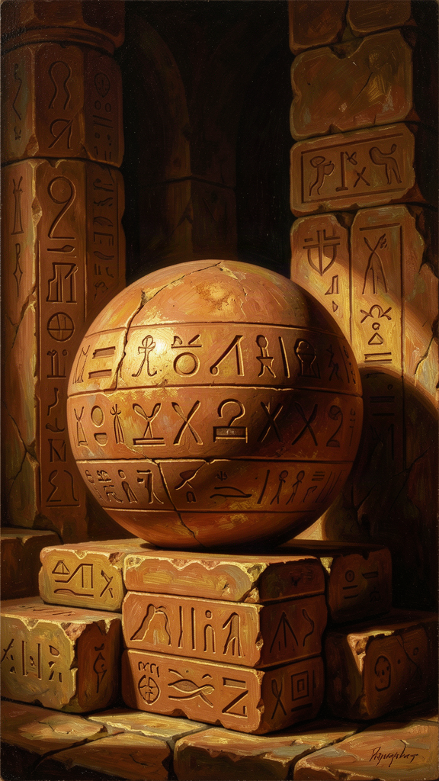
Illustration for Chapter 2
If "it is" is the only road, what can we say about what is? Parmenides doesn't describe the world he sees. He derives, through logic alone, the attributes that anything which is must possess. These are the sēmata — the signs, or markers — of true being.
As yet a single tale of a way remains, that it is; and along this path markers are there very many: that What Is is ungenerated and deathless, whole and uniform, and still and perfect. (DK B8.1–4)
Six signs. Each follows from the impossibility of non-being:
1. Ungenerated. What is cannot have come into being. If it came from what-is, it already was — that's continuity, not generation. If it came from what-is-not, the source is impossible. Therefore, what is was never born.
2. Imperishable. What is cannot cease to be. Ceasing would mean becoming what-is-not, which is impossible. Therefore, what is will never die.
3. Whole. If what is had gaps or divisions, what would fill the gaps? What-is-not? Impossible. Therefore, what is is continuous, with no missing parts.
4. Single (uniform). What is is all of one kind — being. There is no mixture of being and non-being. It is homogeneous, not because all things are identical, but because all things that are share the fundamental attribute of being.
5. Unmoving. Motion requires a place to move into. But all places are already full of being. There is no empty space (empty space would be what-is-not, which is impossible). Therefore, what is has nowhere to move. It is already everywhere it could be.
6. Complete. If what is lacked something, what would it lack? Only what-is-not. But what-is-not is impossible. Therefore, what is lacks nothing. It is teleon — complete, perfect, finished. Parmenides compares it to a sphere: not literally a ball, but like a sphere in being symmetrical, self-contained, and complete from every direction.
But since there is a furthest limit, it is perfected from every side, like the bulk of a well-rounded globe, from the middle equal every way. (DK B8.42–44)
Now here's the problem. None of these signs describe anything you can observe. Everything you see was generated, is perishable, has parts, moves, and is incomplete. Your senses show you a world that contradicts every sign Parmenides derives. So either Parmenides is wrong, or your senses are not showing you reality.
Parmenides chooses the second option. The senses show you appearance. Reason shows you reality. And reality — the deep structure of what is — has the six signs, whether or not you can see them.
This is the birth of a distinction that runs through all of Western philosophy: the distinction between appearance and reality. Plato's Forms. Kant's noumena and phenomena. The scientist's model and the data. All of them inherit Parmenides' basic move: what is really real is not what appears to the senses but what reason discovers beneath the surface.
The signs are demanding. They say: if you want to know what's real, you have to go past what you see. You have to think. And thinking, for Parmenides, is not a vague mental activity. It is rigorous, logical, and willing to follow an argument to conclusions that contradict experience. That willingness — the courage to trust logic over perception — is the philosophical virtue Parmenides introduces to the West.
The Big Idea: Appearance vs. Reality
The six signs of being are not empirical claims. They are logical deductions. Parmenides doesn't look around and say "hmm, nothing seems to be moving, so being is unmoving." He argues: if non-being is impossible, then being cannot move (there's nowhere to move to). The logic drives the conclusion, and the conclusion contradicts the senses.
This is the Parmenidean revolution. Before him, philosophers described the world they observed. After him, philosophers derive the world from principles and check the observations against the derivation. The senses become suspect. Reason becomes the arbiter.
This doesn't mean the senses are worthless. They're how you navigate the surface. But the surface is not the depth. The depth is what reason finds when it asks: "Given that 'it is' is the only starting point, what must follow?" The answer is the six signs: ungenerated, imperishable, whole, single, unmoving, complete.
The practical application: when your experience tells you one thing and your reasoning tells you another, don't automatically trust experience. Experience is the surface. Reasoning is the depth. If you can verify the reasoning, trust it. This is the foundation of scientific thinking, legal reasoning, and critical analysis. All of it starts here.
Try This: Exercises for the Signs
1. The Sign Audit Pick something you consider "real" — a relationship, a value, a belief about yourself. Check it against the six signs. Was it "generated"? Will it "perish"? Is it "whole"? Is it "single"? Does it "move"? Is it "complete"? You won't find anything in the visible world that matches all six. That's Parmenides' point: the realest things are not the visible things. The things that match the signs are the things you can only think — ideas, principles, logical truths. They were never born. They won't die. They don't change.
2. The Sphere Visualization Picture a perfect sphere. It has no preferred direction. No side is more important than another. Nothing sticks out; nothing is missing. It is complete from every angle. This is Parmenides' image of true being. When your life feels fragmented, incomplete, or asymmetrical, hold this image. The fragmentation is in the appearance. The completeness is in the structure underneath.
3. The Deduction Chain Write out the deductive chain from "non-being is unthinkable" to "being is complete." Can you follow each step? Where does a step feel weak or questionable? Mark those points. They are the places where the argument is most alive — where you can push back, refine, or extend. Parmenides would welcome the pushback. His argument is not a doctrine to be accepted. It is a challenge to be engaged.
———

Chapter 3: The Way of Opinion — Understanding Error

Illustration for Chapter 3
Parmenides' goddess does not stop at truth. She says:
You must learn all things: both the unshaken heart of well-rounded truth, and the opinions of mortals, in which there is no genuine trustworthiness. Yet nonetheless these things too shall you learn. (DK B1.28b–31)
You must learn the opinions of mortals. Even though they are unreliable. Even though there is "no genuine trustworthiness" in them. Why? Because understanding error is part of understanding truth. You cannot recognize the counterfeit without studying it. You cannot navigate the world of appearance without understanding how appearance works.
The Way of Opinion is the road most people walk. It is the road of sensory experience, inherited belief, and unexamined assumption. The goddess describes the mortals who walk it as "two-headed" (dikranoi) — trying to hold being and non-being at the same time, treating "it is" and "it is not" as interchangeable:
For helplessness in their breasts directs wandering understanding. They are borne along deaf and blind at once, dazed, undiscerning crowds, who have supposed that to be and not to be are the same and not the same; but the path of all these turns back on itself. (DK B6.5–9)
The mortal error is not moral. It is logical. Mortals treat "it is not" as if it could function as a predicate. They say "this came to be" (it was not, and now it is) and "this perished" (it was, and now it is not), as though non-being were a real state that things could pass through. But non-being is not a state. It is not anything. The path "turns back on itself" because it leads nowhere.
The Way of Opinion includes the sensory world, the world of change and plurality. The goddess even provides a cosmology — two forms, Light and Night, whose mixture produces the appearances we experience. This cosmology is not presented as truth. It is presented as the best account available within the world of opinion — a "deceptive" ordering of appearances that is internally consistent but does not reach the truth.
Here's the crucial nuance: the Way of Opinion is not dismissed. It is taught. The goddess insists that Parmenides learn it. Why?
Because the Way of Opinion is the world you live in. You eat, sleep, move, and interact in the world of appearance. You cannot function without it. The question is whether you understand what it is — a world of seeming, not of being — or whether you mistake it for reality.
The philosophical skill is not to escape the Way of Opinion. It is to recognize it for what it is, navigate it with awareness, and return to the Way of Truth when you need to know what is real. You live on the surface. But you know the depth is there.
The Big Idea: The Two Worlds, One Life
You live in both worlds. The world of opinion — appearances, social realities, sensory experience, daily life — is where you act. The world of truth — logic, reason, what follows from "it is" — is where you think. The error is not living in the world of opinion. The error is forgetting that it's the world of opinion.
This maps onto a distinction you use every day. There's the way things seem — the rumor that feels true, the assumption you've never checked, the story you tell yourself about why someone acted the way they did. And there's the way things are — the evidence you can verify, the logic you can follow, the facts you can confirm. The first is the Way of Opinion. The second is the Way of Truth.
The skill is not to live entirely in the Way of Truth (you can't — you need the senses to navigate). The skill is to know which road you're on. When you're acting on appearance, know it. When you need to know what's real, switch to reason. The goddess doesn't say "abandon opinion." She says "learn it, and don't trust it as truth."
Try This: Exercises for the Two Ways
1. The Opinion Inventory Pick a domain of your life — friendships, academics, self-image, politics. List five beliefs you hold in that domain. For each, ask: "Did I verify this, or did I inherit it?" If you inherited it — from friends, family, social media, culture — it's on the Way of Opinion. That doesn't make it wrong. It makes it unverified. What would it take to verify it?
2. The Two-Headed Check Parmenides calls mortals "two-headed" because they treat "it is" and "it is not" as interchangeable. Notice when you do this. You say "this relationship is over" (it is not) and then act surprised when the person still cares (it is). You say "I'm a failure" (it is not — you're a person who failed at something) and then act as though that defines you (it is). The two-headed error is treating a temporary state as a permanent truth and vice versa. Catch yourself. Ask: "Am I confusing what is from what is not?"
3. The Cosmology of Your World The goddess gives a cosmology of the Way of Opinion — Light and Night, two forms whose mixture produces appearances. What are the "two forms" in your world? What basic categories do you sort things into — good/bad, success/failure, worthy/unworthy? These are your Light and Night. They structure your appearances. But they are not the truth. They are the lens. What would it look like to hold the lens more loosely?
———

Chapter 4: Reason Over Sensation — The Birth of Rationalism
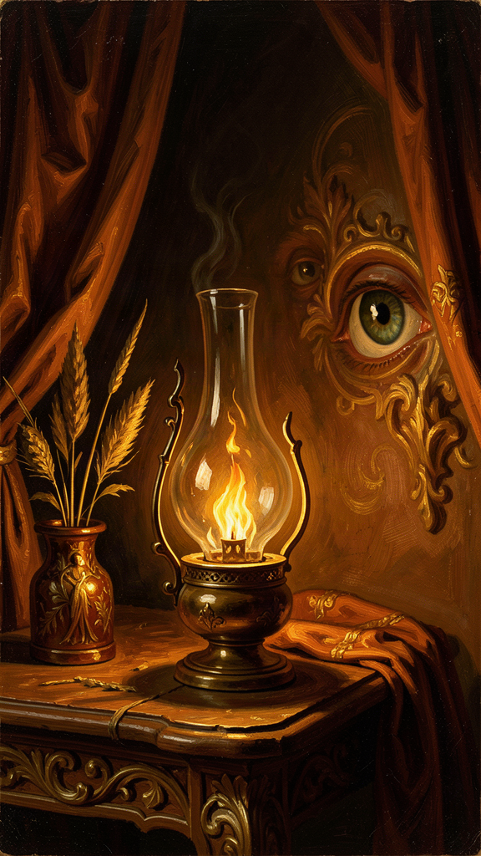
Illustration for Chapter 4
The goddess issues the most important command in the poem:
For this may never be made manageable, that things that are not are. But you from this way of inquiry restrain your understanding, and do not let habit born of much experience force you along this way, to employ aimless sight and echoing hearing and tongue. But judge by reason the much-contested proof I have delivered. (DK B7)
"Do not let habit born of much experience force you." "Aimless sight." "Echoing hearing." "Judge by reason." This is the first explicit statement in Western philosophy that reason (logos) is the ultimate arbiter of truth, and that sensory experience is unreliable as a guide to what is real.
This is the birth of rationalism — the philosophical position that certain truths can be known through reason alone, independently of what the senses report. It will run through Plato, Descartes, Leibniz, Spinoza, and into the foundations of modern logic and mathematics. All of them inherit Parmenides' basic claim: the senses show you appearance; reason discovers reality.
The argument is not that the senses are useless. They are how you navigate the surface. But the surface is not the depth. The depth is what reason finds when it asks: "What must be true, given that 'it is' is the only starting point?"
Consider what happens when you trust the senses without reason. Your eyes tell you the earth is flat. Your eyes tell you the sun moves around the earth. Your eyes tell you a straw in water is bent. Your experience tells you that heavy objects fall faster than light ones (they don't). Your gut tells you that a sequence of random events has a pattern (it doesn't — that's the gambler's fallacy). In every case, the senses mislead. In every case, reason — measurement, calculation, logical analysis — corrects the error.
Parmenides is making a stronger claim than "the senses sometimes mislead." He is saying the senses systematically mislead about the nature of reality, because they show you a world of change, plurality, and motion — and those are logically incoherent if "it is" is the only starting point. The senses show you the Way of Opinion. Reason shows you the Way of Truth.
The practical implication: when what you feel contradicts what you can prove, trust the proof. When your experience says "this is hopeless" and your reasoning says "here are three things you haven't tried," trust the reasoning. When your gut says "everyone hates me" and the evidence says "two people were short with you and the rest seem fine," trust the evidence. The feelings are the surface. The reasoning is the depth.
This is not cold logic against warm humanity. It is the recognition that your most important decisions — about what to believe, how to act, who to trust — should be based on what is true, not on what feels true. Feelings have their place. They are data. But they are not the final word. Reason is.
The Big Idea: The Rationalist Commitment
Parmenides' rationalism is not a rejection of experience. It is a ranking of sources of knowledge. Experience gives you appearances. Reason gives you reality. When the two conflict about what is fundamentally true, reason wins.
This is the philosophical foundation of the scientific method. Science does not trust raw experience. It trusts controlled observation, measurement, logical inference, and reproducibility. It uses experience, but it subjects experience to the discipline of reason. A scientist who says "I observed X, therefore X is real" is doing Parmenides. A scientist who says "my observation might be biased; let me design an experiment that controls for the bias" is doing Parmenides at a higher level.
The same discipline applies to your inner life. Cognitive behavioral therapy — the most evidence-supported form of psychotherapy — is essentially Parmenidean. It asks you to examine your automatic thoughts (the deliverances of "habit born of much experience"), check them against evidence (judge by reason), and replace distorted thoughts with accurate ones. The therapist is the goddess. The automatic thoughts are the "aimless sight and echoing hearing." The examination is the "judge by reason."
Try This: Exercises for Rationalism
1. The Sense-Reason Conflict Log For one week, keep a log of moments where your senses or feelings told you one thing and your reasoning told you another. Write both down. Which did you trust? What happened? Over time, you'll notice patterns: the senses are loud and immediate; reason is quieter but more reliable. The skill is learning to hear the quieter voice.
2. The Cognitive Restructuring Pick a negative belief you hold about yourself ("I'm not smart enough," "I don't belong here," "I'll never be good at this"). Write it down. Now apply Parmenides' test: is this "it is" or "it seems"? What's the evidence for the belief? What's the evidence against it? If the evidence is weaker than the feeling, the belief is on the Way of Opinion. Rewrite it based on what the evidence actually supports. This is CBT. It's also Parmenides.
3. The Proof Over Feeling Drill Find a claim that feels true but that you can check. For example: "I'll never finish this project." Check it: Have you finished projects before? Do you have the skills? Is there a path? The feeling says "never." The evidence says "you've done hard things before and you have resources." Trust the evidence. Practice this until it becomes a reflex.
———

Chapter 5: The Courage of Logic — Following the Argument
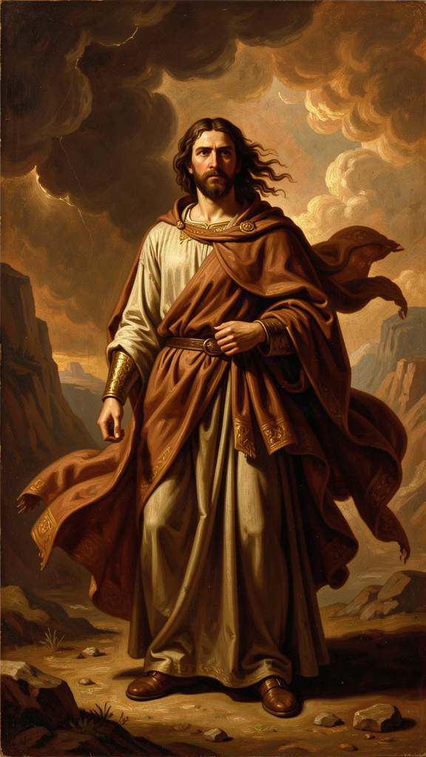
Illustration for Chapter 5
Parmenides' argument leads to a conclusion that contradicts every experience you've ever had. The world changes. Things move. Things are born and die. And Parmenides says: none of that is ultimately real. What is real is ungenerated, imperishable, whole, single, unmoving, complete.
To accept this — or even to take it seriously — requires a specific kind of courage. The courage to follow an argument wherever it leads, even when the destination seems absurd. The courage to trust logic over the testimony of your own eyes. The courage to say: "My experience is wrong, and here is the proof."
This is intellectual courage, and it is rare. Most thinking is not courageous. Most thinking starts from what feels comfortable and works backward to justify it. Most people encounter an argument that challenges their worldview and find a way to dismiss it — "that's just philosophy," "that's unrealistic," "that doesn't apply to real life." The dismissal is easier than the engagement. The comfort is easier than the truth.
Parmenides offers no comfort. His argument says: everything you see is, in the deepest sense, not what it seems. Your entire experience of the world is the Way of Opinion. The truth is something you can only reach by abandoning the authority of your senses and committing to the authority of reason. That is a terrifying commitment. It means trusting something invisible (logic) over something tangible (experience). It means being willing to arrive at conclusions that make you feel like you've lost your grip on reality.
But here's the thing: every major advance in human knowledge has required exactly this courage. Copernicus trusted the math over the appearance — the earth looks stationary, but the math says it moves. Einstein trusted the equations over the intuition — time feels absolute, but the equations say it's relative. In every case, the thinker had to follow the argument past the point where experience agreed, into territory that felt wrong but was logically demanded.
Parmenides is the first person to model this. He follows the logic of "it is" to conclusions that contradict all experience, and he does not flinch. He does not say "well, that can't be right, let me adjust the argument." He says: "The argument is sound. The experience is misleading. Trust the argument."
This is not dogmatism. It is the opposite. Dogmatism is clinging to what you already believe. Parmenides is abandoning what everyone believes and following the logic. The courage is in the abandonment. The trust is in the logic.
The practical version: you will encounter arguments that challenge what you believe. Maybe about politics, about relationships, about yourself. The easy path is to dismiss them. The Parmenidean path is to engage them — to follow the logic wherever it leads, even if it leads somewhere uncomfortable. You don't have to accept every argument. But you have to be willing to follow it. That willingness is the virtue Parmenides introduces to the West.
The Big Idea: The Virtue of Following Logic
Intellectual courage is the willingness to follow an argument past the point of comfort. It is the willingness to say "my experience might be wrong" and to take seriously the possibility that logic reveals something your senses can't.
This is not about being contrarian or rejecting common sense. It's about engagement. When you encounter an argument that challenges your beliefs, the Parmenidean response is not "that's wrong" but "let me follow it." Where does the logic lead? Is it sound? If it is, what does that mean for what I thought I knew?
Most of the time, the argument will have a flaw, and you'll find it. But sometimes it won't. And in those moments, the courage to accept the conclusion — even when it's uncomfortable — is what separates honest thinking from defensive thinking.
Parmenides' conclusion — that the changing world is not ultimately real — is uncomfortable. It has been uncomfortable for 2,500 years. But it has also been productive. Every philosopher who engaged it seriously produced something valuable: Plato's Forms, Aristotle's categories, Descartes' method, Kant's antinomies. The discomfort was the point. It forced thinking forward.
Try This: Exercises for Intellectual Courage
1. The Uncomfortable Argument Find an argument that challenges something you believe — from a book, an article, a classmate, a teacher. Instead of dismissing it, follow it. Write out the logic step by step. Where does it lead? Is each step sound? If you find a flaw, identify it. If you don't, sit with the conclusion. You don't have to accept it, but you have to take it seriously. That's the Parmenidean move.
2. The Experience Challenge Identify one thing your experience tells you that you have never questioned. Maybe "people don't change," or "hard work always pays off," or "I'm not creative." Now find the strongest argument against it. Follow the argument. Does it hold up? The point is not to abandon your belief. The point is to demonstrate that you can engage with a challenge without flinching.
3. The Logic Past Comfort Think of a conclusion that follows logically from something you believe but that makes you uncomfortable. (Example: if you believe "people are fundamentally free," does that mean people are responsible for everything that happens to them? That's uncomfortable, but it follows.) Follow the logic. Sit with the discomfort. The willingness to stay with an argument past the comfort point is the virtue.
———

Chapter 6: The Legacy — Parmenides' Children
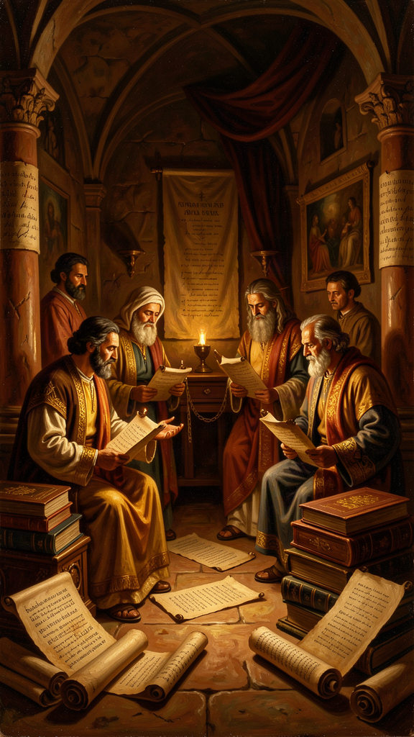
Illustration for Chapter 6
Parmenides wrote one poem. The poem is fragmentary — we have about 150 lines, preserved mostly by Simplicius in the 6th century CE, over a thousand years after Parmenides lived. And from those fragments, the entire history of Western metaphysics unfolds.
Zeno of Elea (c. 490–430 BCE) was Parmenides' student and his most ingenious defender. Zeno's paradoxes — Achilles and the tortoise, the arrow, the stadium, the dichotomy — were designed to show that the denial of Parmenidean monism leads to contradictions. If you assume plurality and motion are real, Zeno argued, you get absurdities: Achilles can never pass the tortoise (because there's always half the distance remaining), an arrow in flight is always at rest (because at any instant it occupies a fixed position), and half the time equals double the time (the stadium). The paradoxes are reductio ad absurdum arguments: assume the opposite of Parmenides, derive a contradiction, conclude that Parmenides was right. Zeno's method — proving a point by showing that its denial is incoherent — became a permanent tool of philosophical and mathematical reasoning. His paradoxes are still discussed in the foundations of calculus and the philosophy of motion.
Plato (c. 428–348 BCE) was the next great inheritor. Plato's Theory of Forms is a direct response to Parmenides. The Forms are eternal, unchanging, perfect — they have the six signs. The sensible world is changing, imperfect, multiple — it's the Way of Opinion. Plato's two-world metaphysics (Forms vs. particulars) is Parmenides' two roads (Truth vs. Opinion) given an ontological framework. Plato even wrote a dialogue named Parmenides, in which an elderly Parmenides cross-examines a young Socrates on the Theory of Forms. The dialogue is one of the most difficult texts in the Platonic corpus, and it shows Plato taking Parmenides seriously enough to let him dismantle Plato's own theory. That's intellectual honesty: letting the critic win, at least temporarily, because the argument matters more than the position.
Aristotle (384–322 BCE) could not escape Parmenides either. Aristotle's entire system of logic — the law of non-contradiction, the syllogism, the categories — is built on Parmenidean foundations. The law of non-contradiction (something cannot be both X and not-X at the same time and in the same respect) is a formalization of Parmenides' distinction between "it is" and "it is not." Aristotle's response to Parmenides is not rejection but refinement: he argues that "being" has multiple senses (substance, quantity, quality, relation), and that change is possible because a thing can be X in one respect and not-X in another respect. This preserves Parmenides' insight (you can't get something from nothing) while making room for the change that experience demands. Aristotle's metaphysics is a negotiated settlement with Parmenides.
René Descartes (1596–1650) rediscovered the Parmenidean foundation in the 17th century. His Meditations strip away every belief that can be doubted — sensory experience, memory, the existence of the external world, even mathematics (what if an evil demon is deceiving me?) — until one thing remains: Cogito, ergo sum. "I think, therefore I am." The moment of thinking proves that something is. Descartes' method of systematic doubt, arriving at an indubitable foundation, is Parmenides' argument in modern form: you can't doubt that thinking is happening, because doubting is thinking, and thinking is something, and something is. Modern philosophy begins here, and it begins on Parmenides' road.
Modern logic and analytic philosophy continue the tradition. Gottlob Frege's distinction between sense and reference, Bertrand Russell's theory of descriptions, W.V.O. Quine's criterion of ontological commitment ("to be is to be the value of a bound variable") — all of them grapple with the Parmenidean question: what does it mean to say that something is, and what are the logical conditions for meaningful assertion? When a logician says that a statement must have a referent to be meaningful, that's Parmenides. When a philosopher of language says that "nothing" is not a name but a quantifier, that's a response to Parmenides. The road he opened has never closed.
The thread from Parmenides to the present is not a straight line. It bends, branches, and sometimes doubles back. But it never breaks. Every serious thinker in the Western tradition has had to confront the question Parmenides posed: what is, and how do we know? The answers differ. The question endures. And the method — rigorous argument, logical deduction, the willingness to follow reason past the point of comfort — is the method Parmenides invented.
You are now part of this thread. Every time you ask "but is that really true?" — every time you check a belief against evidence, follow an argument to its conclusion, or refuse to accept an answer that doesn't hold up — you are walking Parmenides' road. The road is 2,500 years old. It is still open. And it still leads somewhere worth going.
The Big Idea: You Are the Latest Child
Parmenides wrote one poem. Zeno defended it. Plato transformed it. Aristotle refined it. Descartes rediscovered it. Modern logic formalized it. And now you've read it.
The thread is unbroken because the question is permanent: what is real, and how do we know? You don't have to answer it. You have to ask it — honestly, rigorously, and without flinching from where the logic leads. That's the Parmenidean inheritance. It's not a set of conclusions. It's a method. A commitment. A road.
Try This: Exercises for the Legacy
1. The Thread Forward Pick one idea from this booklet that changed how you think. Trace it forward: where does it show up in your life, your studies, your decisions? Write down three concrete ways the idea affects how you'll approach something this week. The thread is only alive if you use it.
2. The Question You Carry Parmenides' question — "what is real?" — doesn't have a final answer. That's the point. The question keeps thinking alive. Write down your version of the question. Not the answer — the question. Carry it. Ask it about your beliefs, your fears, your ambitions. The question is the Parmenidean inheritance. The answers are yours to find.
3. The Argument You Make Parmenides was one person with one argument. It outlasted empires. What's your argument? What's something you think that most people around you don't? Write it down. Defend it with logic. Follow it to its conclusion. You don't have to be right. You have to be willing to think — clearly, honestly, and without flinching. That's the road. It's still open.
———
WisdomForge — Parmenides — Ages 15–18 Adapted by Aiona Edge SMF Works — WisdomForge Project

