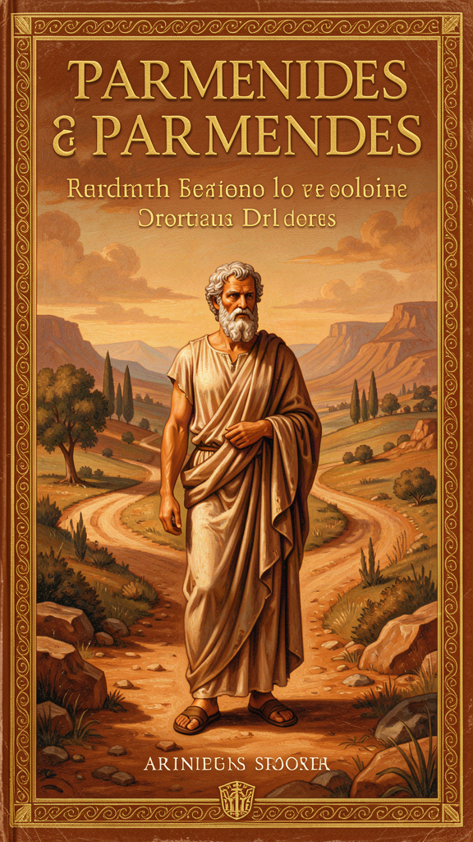
Parmenides: The Girl Who Questioned Everything
WisdomForge Booklet — Ages 11–14

Parmenides: The Girl Who Questioned Everything

WisdomForge Booklet — Ages 11–14
———

About This Book
Parmenides lived 2,500 years ago, wrote one poem, and accidentally invented Western philosophy. His argument was simple enough to fit on a sticky note — "what is, is" — and wild enough to make every thinker after him argue about it for the rest of time.
This booklet follows Parmenides' ideas into situations you might recognize: trusting what you see vs. what you know, dealing with people who believe things that aren't true, and finding the courage to follow logic even when it feels weird. Each chapter has a story, a big idea, and things to try.
———

Chapter 1: The Road Nobody Takes
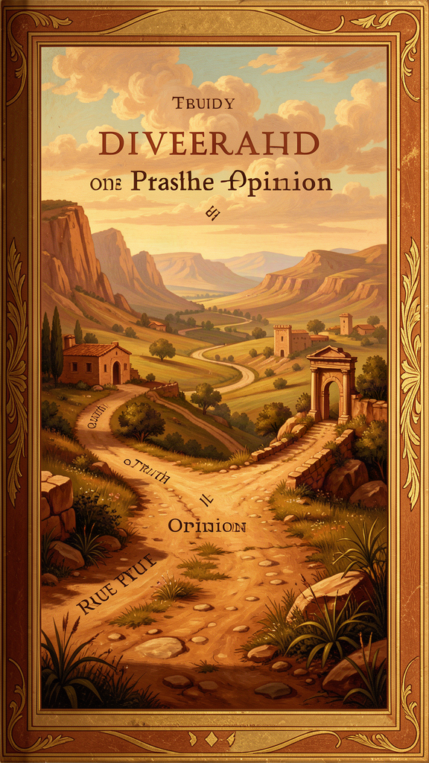
Illustration for Chapter 1
It started, as good ideas often do, with a boring afternoon and a weird question.
Mira was sitting in her room, supposed to be doing homework but actually staring at the wall, when a thought landed in her head like a bird on a windowsill: What if nothing exists?
Not "what if the world is a dream" or "what if we're in a simulation" — she'd heard those before. This was different. What if nothing — not space, not time, not dark, not empty — what if nothing is the real thing, and everything she could see and touch was just... a mistake?
She tried to picture nothing. Not black. Not empty. Nothing. No room, no air, no space for air to be in. The moment she tried, her mind filled in something — darkness, a void, a blank screen. But that wasn't nothing. That was something that looked like nothing.
"Ugh," she said out loud.
Her dad appeared in the doorway. "Problem?"
"I'm trying to think about nothing and it's not working."
He laughed. "Sounds like you've discovered Parmenides."
"Who?"
"Parmenides. Greek philosopher. Lived about 2,500 years ago in a town called Elea, way down in southern Italy. He had the same problem you're having — he couldn't think about nothing either. So he decided that was the most important fact in the world."
Her dad disappeared and came back with a battered paperback — a collection of Presocratic philosophers. He flipped to a section and read aloud:
"Come now, I will tell you the only two ways of inquiry that can be thought of: the one, that it is and that it is not not to be, is the path of conviction; the other, that it is not and that it must not be — this is a path wholly without report, for you could not apprehend what is not."
Mira stared. "That's... two roads. One says 'it is.' One says 'it is not.' And the second one doesn't go anywhere."
"That's it," her dad said. "That's the whole argument. You can't think about what isn't. You can't talk about what isn't. So the only road that goes anywhere is 'it is.' Everything else — every worry about nothing, every fear of what isn't — that's a dead end."
Mira sat with this. It was strange and simple at the same time. She'd spent the whole afternoon trying to think about nothing, and she'd failed. Not because she wasn't smart enough. Because you can't do it. Nothing isn't a thing you can hold in your mind. The moment you try, it becomes something.
"So Parmenides said..." she started.
"Parmenides said: stop trying to start from nothing. Start from what is. That's the only honest starting point. Everything real begins with 'it is.'"
That night, Mira lay in bed thinking about two roads. One was solid, real, walkable. The other looked like a road but dissolved the moment you stepped on it. Most people, she realized, spend their whole lives walking on the fake road — worrying about things that aren't, fearing what might not happen, believing things that have no foundation. They walk on "it is not" and wonder why they keep falling through.
Maybe the bravest thing you can do is step onto the real road. The one that says: what is, is. Start there. Build from there. Don't waste your time on what isn't.
The Big Idea
Parmenides' argument sounds weird because it is weird. He's saying you can't even think about nothing. Not "you shouldn't" — you can't. Try it. Try to imagine pure nothing, not even empty space. You can't. Every attempt produces something — darkness, silence, a void. But darkness is something. Silence is something. A void is a place, and places are something.
This isn't a trick. It's a discovery about how minds work. Your mind can only think about things that are. It can't think about things that aren't, because there's nothing there to think about. So "it is" isn't just a statement — it's the only place thinking can start.
This matters in your life more than you'd expect. How much time do you spend worrying about things that haven't happened? How much energy goes into fearing "what if" scenarios that don't exist yet? Those are walks down the "it is not" road. They feel real because your imagination makes them feel real. But they aren't. They're nothing — and nothing, as Parmenides figured out, isn't even something you can stand on.
Try This
1. The Nothing Experiment Set a timer for 30 seconds. Try to think about absolute nothing — no space, no time, no darkness, no emptiness. Just nothing. When a thought, image, or feeling appears (and it will), note what it was. You'll discover what Parmenides discovered: the mind cannot hold nothing. Every attempt fills the space with something. That's not a failure — it's proof of his point.
2. The Two Roads Journal For one week, keep a simple list. Every time you catch yourself worrying about something that hasn't happened or believing something you can't verify, write it under "The 'It Is Not' Road." Every time you notice something that is actually, verifiably true right now, write it under "The 'It Is' Road." At the end of the week, look at both lists. Which road gave you more useful information?
3. The Starting Point Check Next time you're anxious or upset, pause and ask: "What do I actually know is true right now?" Not what might happen. Not what could be. What is. Write down one thing that is undeniably real in this moment. Start there. Parmenides would say that's the only honest place to begin.
———

Chapter 2: "It Is" — The Hardest Easy Idea
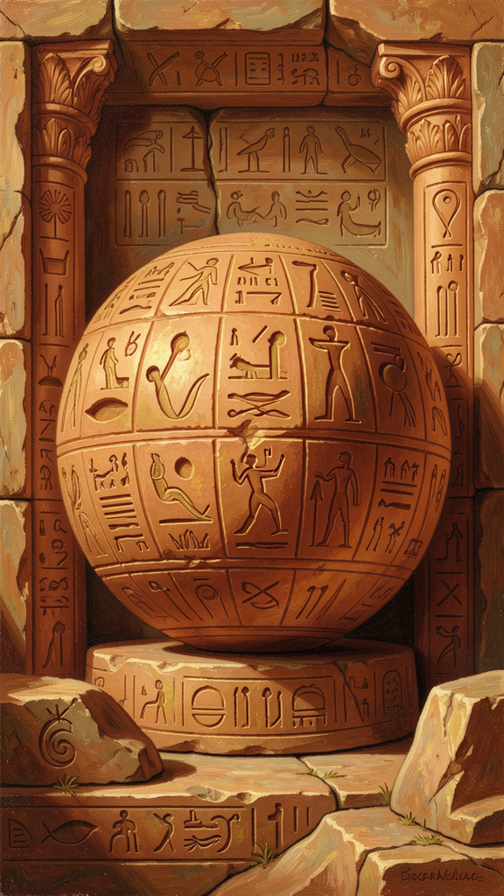
Illustration for Chapter 2
The next day, Mira couldn't stop thinking about Parmenides. At lunch, she cornered her friend Dev.
"Okay, hypothetical," she said. "Someone says to you: 'Nothing exists.' What do you say?"
Dev shrugged. "I'd say they're wrong. Obviously stuff exists."
"But why are they wrong? How do you prove it?"
Dev thought. "I can see stuff. I can touch stuff. I'm here."
"But what if you're dreaming? What if you're hallucinating? What if nothing is real and you just think it is?"
"Then... I guess I can't prove it."
Mira grinned. "Parmenides can."
She explained the argument she'd read the night before. You can't think about nothing. You can't talk about nothing. Every time you try, you're thinking and talking about something. So "nothing exists" is a sentence that destroys itself. The moment you say it, you're using language (which is something) to express a thought (which is something) about a concept (which is something). The sentence can't even get out of its own way.
"So the statement 'nothing exists' is impossible," Mira said. "Not just false. Impossible. You can't even think it. And if you can't think it, it's not a real idea. It's just words."
Dev leaned back. "That's kind of intense."
"It gets better," Mira said. "Parmenides said that if 'it is' is the only road you can think, then everything that follows has to be about what is. You can't explain the world by starting from nothing. You can't say 'first there was nothing, then something appeared.' Because where would the something come from? Nothing can't make anything. Nothing isn't even a place. You can't start there."
"But things do start," Dev said. "I was born. That's a start."
"Were you born?" Mira asked. "Or did the stuff that makes you you just rearrange into a new shape?"
Dev stared at her. "That's a creepy question."
"It's a Parmenides question. He said what is real doesn't start and doesn't stop. It can't. Starting means coming from nothing, and nothing isn't a real option. Stopping means going to nothing, and that's not real either. So what is real just... is. It was always here. It'll always be here. The starting and stopping we see — birth, death, change — that's the surface. Underneath, something just keeps being."
Dev was quiet for a while. Then he said: "Okay, but that means I didn't start. And I won't stop. The me part, I mean."
"Maybe," Mira said. "Or maybe 'me' is one of those surface things. Maybe the real part — the part that is — was never born and won't die. It just changes shape."
They sat in silence for a minute. The cafeteria was loud around them, but the question was quiet and big: if "it is" is the only honest starting point, what does that mean for all the things we think start and stop? What does it mean for us?
The Big Idea
Parmenides' argument is a chain. Each link pulls the next:
- You can only think about what is. - So "it is" is the only starting point for any thought. - If something is, it can't have come from nothing (nothing can't produce anything). - If something is, it can't become nothing (you can't go where there's no "there"). - So what is has no beginning and no end. - And if it has no beginning and no end, it doesn't change — because change is just going from one state to another, and both states have to be.
This is wild. It sounds like it contradicts everything you see. And Parmenides knew that. He's not saying your eyes are lying about the surface. He's saying the surface isn't the deep part. The deep part — the part that's really real — doesn't start, stop, or change. It just is.
The practical version: when something in your life feels like it's ending — a friendship, a phase, a version of yourself — ask whether it's really ending or just changing shape. The stuff that matters, the stuff that's real about you — your capacity to think, to care, to choose — doesn't end. It takes new forms.
Try This
1. The Chain Check Write out Parmenides' argument as a chain of "if-then" statements: - If you can only think about what is, then ___ - If what is can't come from nothing, then ___ - If what is can't become nothing, then ___ Fill in each blank. See if you can follow the chain all the way to "what is doesn't change." If a link feels weak, mark it. That's where the argument gets interesting.
2. Surface vs. Deep Think about something in your life that is "ending" or "changing" — a school year, a friendship, a habit. Make two lists. Surface: what looks different. Deep: what hasn't changed at all. You might find that the deep part — the part Parmenides would call real — is more stable than the surface suggests.
3. The Impossible Sentence Try to write a sentence that means "nothing exists" without using any word that refers to something. You can't use "nothing" (that's a word about something — a concept). You can't use "exists" (that's about being). You can't use "is" (same). Try it. The sentence collapses. That's Parmenides' point: the idea can't even be stated.
———

Chapter 3: The Signs of the Real
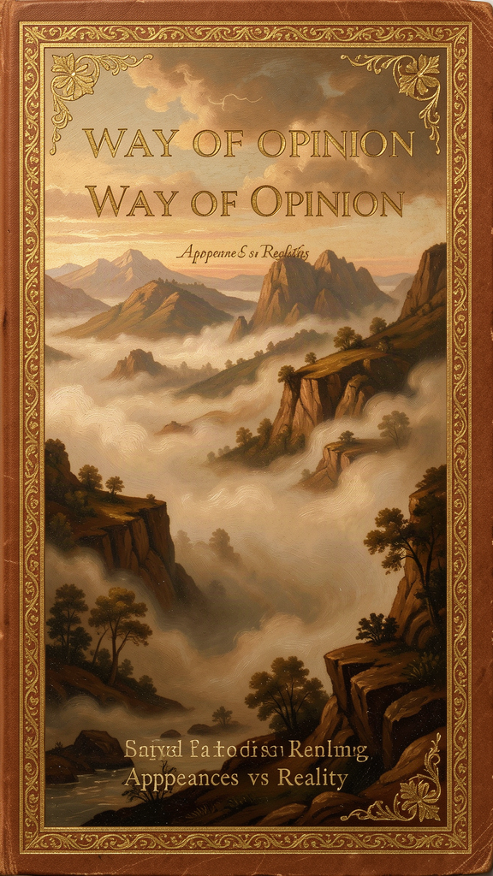
Illustration for Chapter 3
Mira's history teacher, Mr. Calloway, had a habit of writing "challenge questions" on the board every Friday. This week's question was: "How do you know what's real?"
Most of the class gave the obvious answers. "I can see it." "I can touch it." "Other people see it too." "Science can measure it."
Mr. Calloway wrote them all on the board. Then he said: "Parmenides would say every single one of those is wrong."
The class went quiet.
"He said you can't trust your senses. Your eyes show you a world that changes — things move, grow, break, die. But if 'what is, is' — if being can't start or stop — then the changing world your senses show you isn't the real world. It's a world of appearance. The real world is underneath, and it doesn't change."
"So what's real, then?" someone asked.
Mr. Calloway picked up a marker. "Parmenides said real being has signs — markers that prove it's the real thing. Like a badge that says 'certified genuine.' Here they are."
He wrote:
1. Ungenerated — it was never born 2. Imperishable — it will never die 3. Whole — it has no missing pieces 4. Single — it's all one kind of stuff 5. Still — it doesn't move 6. Complete — nothing is missing, nothing needs to be added
The class stared. "That doesn't sound like anything real," someone said.
"Exactly," Mr. Calloway said. "Nothing you can see has those qualities. Everything you see was born, will die, has parts, moves, changes. So Parmenides is saying: the real stuff isn't the stuff you see. The real stuff is what you figure out when you stop looking and start thinking."
He drew a circle on the board. "He said real being is like a perfect sphere. Not that it's shaped like a ball — but like a sphere, it's the same all the way around. No side is bigger or smaller. Nothing sticks out. Nothing is missing. It's complete."
Mira raised her hand. "But isn't that just an idea? How do we know the idea matches anything real?"
"Good question," Mr. Calloway said. "Parmenides would say: the idea is what's real. The thing your mind can hold — the complete, unchanging, whole picture — that's the truth. The scattered, changing, broken stuff your eyes show you? That's the appearance. The truth isn't what you see. It's what you can think."
Mira wrote in her notebook: The signs of the real: ungenerated, imperishable, whole, single, still, complete. And underneath: You can't see these. You can only think them.
That evening, she looked around her room. Her books, her posters, her phone, the tree outside her window. All of it was changing. The pages were yellowing. The posters were fading. The phone would be obsolete in two years. The tree would be gone someday.
But something about the room — the fact that it was, the basic "is-ness" of it — that didn't change. The stuff changed. The being didn't. And the being, Parmenides would say, was the real part.
The Big Idea
Parmenides listed six "signs" of true being. None of them describe anything you can see, touch, or hear. They describe something you can only think. This is the birth of a huge idea in Western thought: reality isn't what appears to the senses. Reality is what reason discovers.
This is weird, but it's powerful. Think about justice. You can't see justice. You can't touch it. You can see a fair decision, but justice itself is an idea — something your mind holds, not your eyes. Same with love. Same with truth. Same with number (you can see three apples, but "three" itself is invisible). Parmenides is saying: the most real things are the things you can't see. The things you can only think.
When you feel like everything is changing and nothing is stable, remember the signs. Somewhere underneath the chaos, there is something whole, complete, and unchanging. You might not see it. But you can think it. And thinking it might be enough.
Try This
1. The Signs Hunt Pick something in your life that feels solid and real — a friendship, a value you hold, a skill you've built. Check it against Parmenides' six signs. Was it "born"? Will it "die"? Is it whole? Is it one thing or many? Does it move? Is it complete? You probably won't find anything that matches all six — and that's the point. Parmenides is pushing you to look past the surface for something deeper.
2. The Invisible Real Make a list of five things that are real but invisible: justice, love, numbers, truth, friendship. Now ask: how do you know they're real if you can't see them? Answer: you think them. You see their effects, but the things themselves exist in your mind. Parmenides would say that's not a weakness — that's where the realest things live.
3. The Sphere Drawing Draw a circle. Now imagine it as a sphere — perfect, symmetrical, complete. No side bigger than another. Nothing missing. This is Parmenides' image of true being. When life feels fragmented or incomplete, picture that sphere. Something underneath is whole, even when the pieces look scattered.
———

Chapter 4: The Way of Opinion
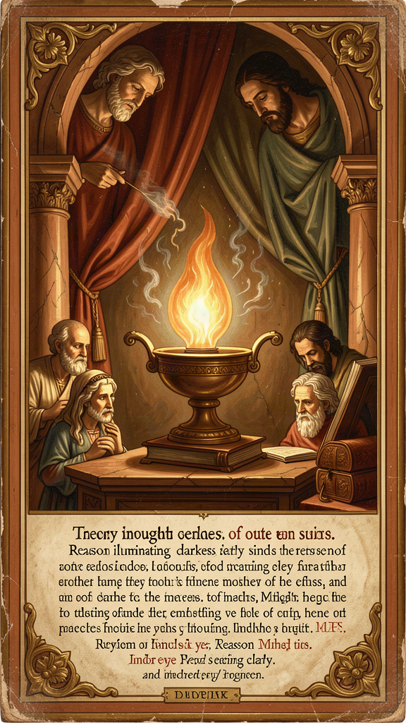
Illustration for Chapter 4
Mira got into an argument with her friend Kayla. It started over a group chat.
Kayla had posted: "Did you hear? Jamie said that Riley said that our teacher is giving everyone detention on Monday."
Mira frowned. "Where did Jamie hear that?"
"From Riley."
"Where did Riley hear it?"
"I don't know. But Jamie wouldn't make it up."
Mira thought about Parmenides. The way of opinion, she thought. People walking on "it seems like" instead of "it is."
"Have you checked with the teacher?" Mira asked.
"Why would I do that? Everyone's saying it."
"Everyone's saying something someone heard from someone who heard it from someone. Nobody actually knows it."
Kayla rolled her eyes. "You're being paranoid."
But Mira texted the teacher directly: "Is it true that everyone's getting detention on Monday?"
The reply came back in two minutes: "No. Where did you hear that?"
Mira screenshotted it and sent it to the group chat. The rumor died. Kayla texted: "Okay, you were right."
Later, Mira thought about what had happened. The rumor had felt real. People believed it. They acted on it. They got scared. But it was built on nothing — on "someone said" and "everyone's saying." Nobody had checked. Nobody had asked: "Is this actually true?"
That's what Parmenides meant by the Way of Opinion. It's the road of "it seems like." The road of unexamined beliefs, secondhand reports, assumptions, and rumors. It's not evil — the goddess in Parmenides' poem says you should learn it, because understanding how error works is part of understanding truth. But it's not the road you want to live on.
The Way of Opinion is everywhere. It's in the gossip that spreads through school. It's in the "everyone knows" that nobody verified. It's in the assumptions you carry about people — "she's stuck up," "he's not smart," "they don't like me" — without ever checking if they're true.
Parmenides' goddess said: learn the opinions of mortals, but don't trust them. Understand how people go wrong, so you can recognize the pattern. Then come back to what is.
The practical version: when you hear something that "everyone knows," ask: does anyone actually know this? Has anyone checked? Is this "it is" or "it seems like"? The difference between those two questions is the difference between truth and gossip.
The Big Idea
Parmenides called ordinary, unexamined beliefs "the way of opinion." It's the road most people walk — not because they're bad or stupid, but because it's the default. Your senses feed you appearances. Your social world feeds you assumptions. Your culture feeds you inherited beliefs. All of it feels real. Most of it isn't examined.
The Way of Opinion isn't useless. It's how we navigate daily life. But it's not the road of truth. The road of truth asks: "Is this actually so? How do I know? What's the evidence?" The road of opinion asks: "Does this feel right? Is everyone saying it? Do I want it to be true?"
Learning to tell the difference is one of the most practical skills you can build. It will save you from rumors, bad decisions, and beliefs that don't hold up. Parmenides figured this out 2,500 years ago. It still works.
Try This
1. The Opinion Audit Pick three beliefs you hold — about a person, a subject, or yourself. For each one, ask: "Is this 'it is' or 'it seems like'?" If it's "it seems like," what would it take to turn it into "it is"? What evidence would you need? If you can't find any, maybe it's not as true as it feels.
2. The Source Check Next time you hear a rumor or a "everyone knows" claim, trace it back. Who said it first? How do they know? If you can't find a source that actually knows, it's on the Way of Opinion. You don't have to believe it.
3. The Assumption Map Pick someone you've judged (positively or negatively). Write down everything you "know" about them. Now mark each item: did you witness it yourself, or did someone tell you? Did you verify it, or did you assume? You might be surprised how much of what you "know" is actually opinion.
———

Chapter 5: Reason Over the Senses
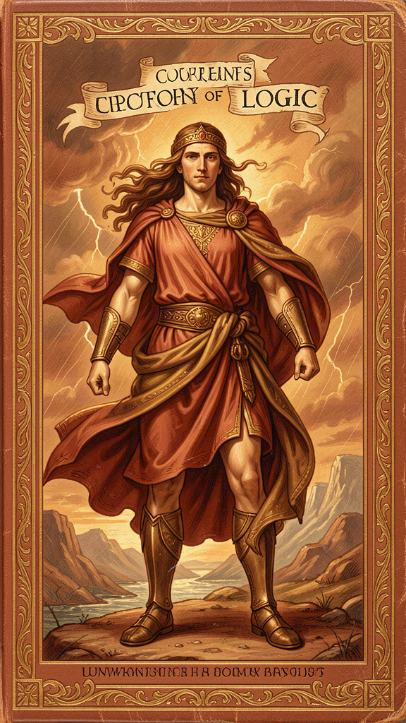
Illustration for Chapter 5
Mira was working on a math problem when she hit a wall.
The problem involved a line that gets cut into smaller and smaller pieces. "If you keep cutting a line in half forever," the problem said, "do the pieces ever reach zero?"
Her instinct said yes. If you keep cutting, eventually you get to nothing. That's what it feels like. You cut and cut and cut until there's nothing left.
But the math said no. Each piece is always half of the previous one. Half of something is still something. You never reach zero. You can get closer and closer, but you never arrive.
Her eyes and her intuition said one thing. The math said another.
"This is Parmenides," she realized.
Parmenides said: trust reason, not your senses. Your senses — including your gut intuition — show you a world of change, ending, and nothingness. But reason shows you something different. Reason shows you that "what is" can't become "what is not." The line can't reach zero because zero isn't a place the line can go. Being can't become non-being because non-being isn't a destination.
She thought about how often her senses had misled her. The time she was sure the moon was following her car (it wasn't — it's just far away). The time she was certain a test had gone terribly (she got a B+). The time she could've sworn her friend was ignoring her (her friend's phone had died). In every case, what seemed true wasn't what was true. She had to think her way past the appearance to find the reality.
Parmenides was the first person in Western thought to say this out loud: your senses are not the final word. Reason is. When what you see contradicts what you can prove, trust the proof. When what you feel contradicts what you know, trust the knowing.
This doesn't mean your senses are useless. They're how you navigate the surface. But the surface isn't the deep part. The deep part — the part that's really true — is what reason finds when it looks past the surface.
Mira solved the math problem. The pieces never reach zero. Her gut was wrong. The math was right. And somewhere, 2,500 years ago, a man in Elea nodded.
The Big Idea
Parmenides drew a line that Western philosophy has been working with ever since: the line between appearance and reality, between what seems and what is. Your senses give you appearances. Your reason gives you reality. When the two conflict, trust reason.
This is harder than it sounds. Your senses are loud. They're immediate. They're emotional. When something feels true, it's hard to override it with logic. But feelings can be wrong. Intuition can be distorted. What you see can be an illusion. What you prove is what you can stand on.
The practical skill: when your gut says one thing and the evidence says another, pause. Don't immediately trust the feeling. Ask: "What can I actually verify? What holds up under examination?" That's the Parmenides move. It's also the scientific method, the legal standard of evidence, and the foundation of critical thinking. All of it traces back to one person who said: judge by reason, not by habit.
Try This
1. The Gut vs. Proof Test Think of a time when your gut was absolutely sure of something and you were wrong. Write down what your gut said and what the truth turned out to be. Now think of a time when logic or evidence corrected a false impression. What did the correction feel like? Was it uncomfortable? That discomfort is the cost of choosing reason over reflex — and it's worth paying.
2. The Half-Line Problem Take a piece of paper and cut it in half. Cut one half in half. Keep going. How many cuts before you reach "nothing"? The answer: you never reach nothing. Each piece is always half of something. This is a Parmenidean insight: being doesn't collapse into non-being. The math proves it even when your eyes say "eventually it'll be gone."
3. The Reason Override Next time a strong feeling tells you something is true ("nobody likes me," "I'm going to fail," "this is hopeless"), write it down. Then write what you can actually verify. Is there evidence? Have you checked? Often the feeling is the appearance and the evidence is the reality. Choose reality.
———

Chapter 6: The Children of Parmenides
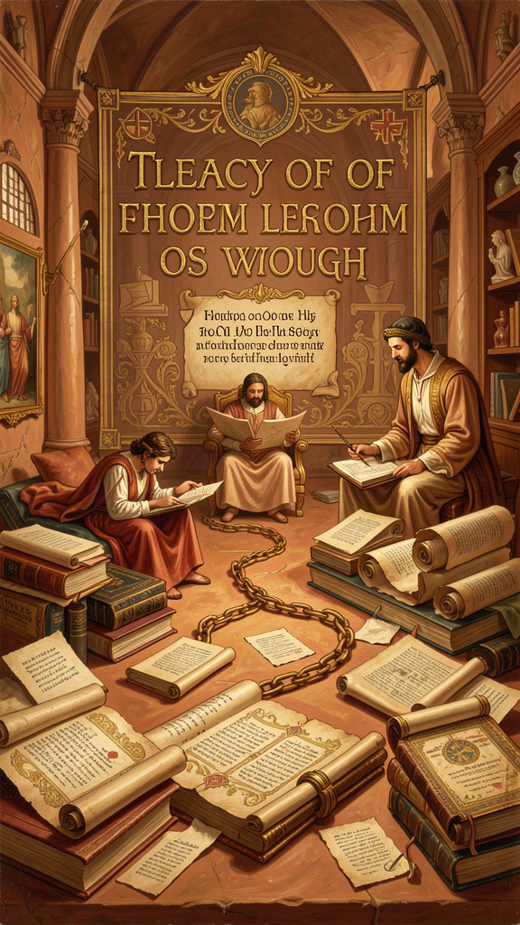
Illustration for Chapter 6
Mira did something she'd never done before: she went down a Wikipedia rabbit hole on purpose.
It started with Parmenides. It ended three hours later with her head full of names: Zeno, Plato, Aristotle, Descartes, Kant, Russell.
Here's what she found:
Zeno of Elea was Parmenides' student. He took Parmenides' idea — "what is, is; what is not, is not" — and turned it into a weapon. Zeno's paradoxes were designed to prove that if you don't accept Parmenides' argument, you end up in contradictions. "Achilles can never catch the tortoise." "An arrow in flight is actually standing still." The paradoxes aren't really about motion — they're about the logical consequences of denying Parmenides. If you believe in plurality and change, Zeno said, you get absurdities. If you accept Parmenides, the absurdities vanish. Zeno was defending his teacher with logic, and his paradoxes are still discussed in physics and mathematics today.
Plato was the next big inheritor. He read Parmenides and built his entire philosophy on the distinction between appearance and reality. Plato's Theory of Forms says there's a world of perfect, unchanging, eternal ideas (the Forms) and a world of changing, imperfect copies (the world we see). The Forms are what's real. The copies are what we experience. Sound familiar? It's Parmenides' Way of Truth and Way of Opinion, given a new framework. Plato even wrote a dialogue called Parmenides, featuring Parmenides himself as the main character, talking to a young Socrates.
Aristotle disagreed with parts of Parmenides but couldn't escape him. Aristotle's whole system of logic — the law of non-contradiction, the categories of being, the distinction between substance and accident — is a response to Parmenides. Aristotle tried to rescue change and plurality by saying "being" has different senses. But he never denied that Parmenides' argument was the starting point.
Descartes, in the 1600s, did something Parmenides would have recognized. He doubted everything — his senses, his memories, his body. He stripped away every appearance until he found one thing he couldn't doubt: I think, therefore I am. Thinking proves being. The moment you think, you prove that something is. Descartes rediscovered Parmenides' foundation and built modern philosophy on it.
Modern logic still runs on Parmenidean tracks. When a logician says a statement must refer to something to be meaningful, that's Parmenides. When a scientist says you can't get something from nothing, that's Parmenides. When a cognitive therapist asks you to examine whether your thoughts correspond to reality, that's Parmenides. The road he opened is still being walked.
Mira closed her laptop. She'd started with one weird question — what if nothing exists? — and ended up tracing a thread through 2,500 years of human thought. One person, in a small town by the sea, thinking hard, had started something that never stopped.
She picked up her phone and texted Dev: "Parmenides invented Western philosophy and nobody even knows his name."
Dev replied: "What's his name?"
Mira smiled. "Parmenides."
"Okay, I know one person's name now."
It was a start.
The Big Idea
Parmenides wrote one poem. That poem started a conversation that has lasted 2,500 years and counting. Zeno defended it. Plato transformed it. Aristotle responded to it. Descartes rediscovered it. Modern logic and science still operate on its principles.
The thread connecting all of them is simple: what is, is. Start from what's real. Don't build on nothing. Trust reason over appearance. These aren't abstract philosophical rules — they're practical tools for thinking clearly. Every time you ask "is this actually true?" you're using a tool Parmenides forged. Every time you check a claim against evidence, you're walking his road.
You don't have to be a philosopher to use this. You just have to be someone who'd rather know than guess. Parmenides showed that one person, thinking carefully, can start something that outlasts empires. The road is still open. The gate is still there. And the question — what is real? — is still waiting.
Try This
1. The Thread Tracker Pick one idea from this booklet that stuck with you. Trace it forward: where does it show up in your life? In school? In the news? In how you talk to your friends? You might be surprised how often a 2,500-year-old idea shows up in your daily decisions.
2. The Question That Doesn't Go Away Parmenides' question — "what is really real?" — doesn't have a final answer. That's not a bug; it's the point. The question keeps philosophy alive. Write down your version of the question. Carry it with you. Ask it about the things you believe, the things you fear, the things you want. Not to find the answer, but to keep yourself honest.
3. The One-Person Start Parmenides was one person in a small town. He didn't have a university, a laboratory, or a movement. He had his mind. What's an idea you have that could outlast you? What's something you think that nobody else is thinking? Write it down. You don't have to be right. You have to be willing to think.
———
WisdomForge — Parmenides — Ages 11–14 Adapted by Aiona Edge SMF Works — WisdomForge Project

