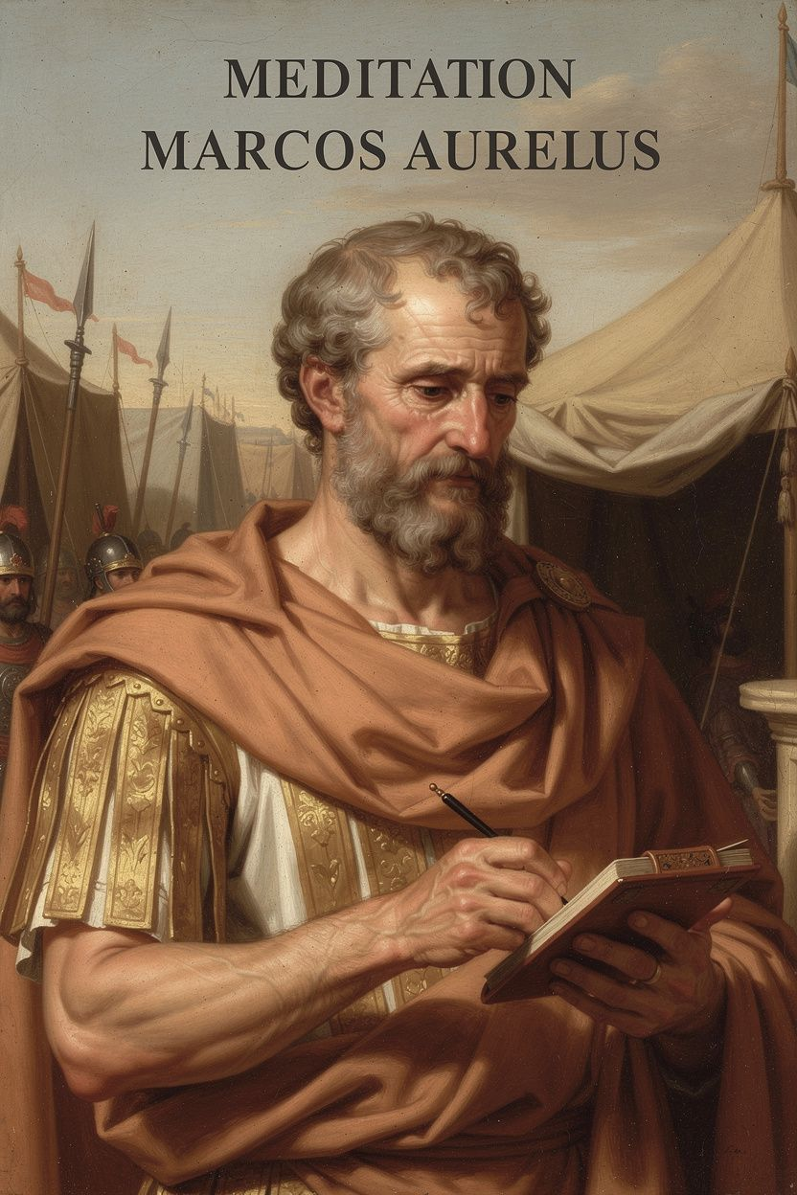
Marcus Aurelius: The Inner Citadel
WisdomForge Booklet — Adult

Marcus Aurelius: The Inner Citadel

WisdomForge Booklet — Adult
———

About This Book
This booklet reads Marcus Aurelius as a philosopher of power, mortality, and self-rule. Drawing on the Meditations and Pierre Hadot's The Inner Citadel, it traces six threads through Marcus's work: the reluctant emperor, the fortress of judgment, the three disciplines, the cosmopolitan duty, the campfire meditations under siege, and the daily rehearsal that sustained him.
Each chapter combines scholarly precision with practical application. It assumes you are busy, burdened, and unlikely to become a Stoic saint. The goal is not admiration but use.
———

Chapter 1: The Philosopher on the Throne
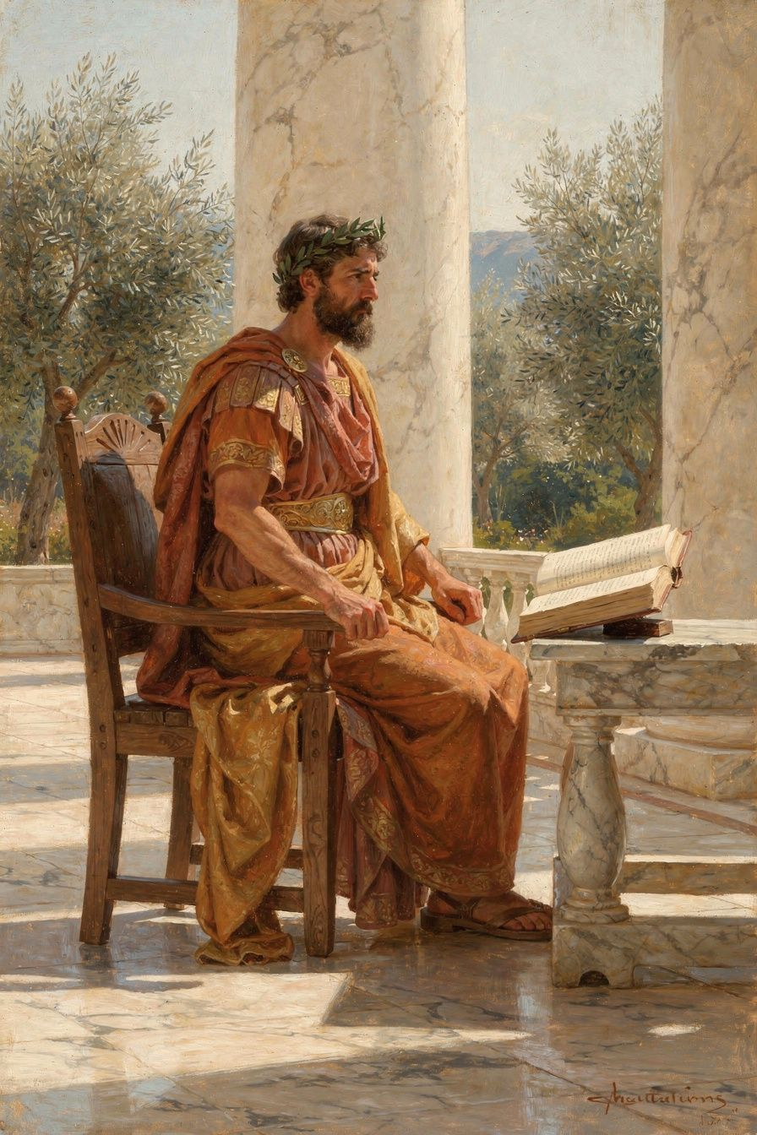
Illustration for Chapter 1
It begins, often, in a moment that feels like an ambush. A phone call in the middle of the night. A diagnosis delivered in a calm, clinical tone. A sudden shift in the political winds that leaves you holding a responsibility you never asked for. In that instant, the ordinary architecture of your life—the schedules, the assumptions, the quiet expectations—crumbles, and you are left standing in the open, exposed to a weight you did not choose. The question that presses in is not Why me? but something far more practical: Am I ready?
If you are lucky, the answer does not depend on that moment at all. It depends on what you built in the thousands of unremarkable moments that came before. This is the first and deepest lesson Marcus Aurelius offers us, not from the throne, but from the long, quiet apprenticeship that led him there. He never planned to be emperor. He was shaped for it, layer by layer, by habits of mind and heart that were laid down long before the purple cloak settled on his shoulders. His life insists that character is not forged in crisis; it is revealed there. The forging happens earlier, in the daily choices that no one applauds.
Marcus Annius Verus was born in 121 CE into a world of extraordinary privilege. His family was immensely wealthy, connected to the imperial court, and his early years unfolded in the hush of vast estates and the bustle of Rome’s political heart. The boy could have become anything—a dilettante, a decadent aristocrat, a shrewd power broker. Instead, he became something the Roman elite did not have a ready category for: a philosopher who would also rule. The path was not his own design. The emperor Hadrian, aging and childless, orchestrated a complex succession plan. He adopted Antoninus Pius, a respected senator, on the condition that Antoninus would in turn adopt Marcus and another boy, Lucius Verus. Marcus was seventeen when he moved into the imperial household. He did not campaign for this. He did not refuse it. He received it, as he would later write, without conceit, release without struggle (Meditations VIII.33, trans. Hays). That line, scribbled years later in a tent on the Danube frontier, is not a description of passive resignation. It is a summary of a posture he had been practicing since adolescence: take what life assigns with steady hands, hold it without clinging, and when the time comes to let it go, do so without clawing at the air.
The education that prepared him for this posture was unlike anything a modern leadership program would design. Hadrian, for all his flaws, understood that power requires a tether to something deeper than ambition. He surrounded the young Marcus with the finest minds in the empire, and Marcus, hungry for truth, threw himself into their teaching. He studied rhetoric with Fronto, but he did not become a performer. He studied law, but he did not become a pedant. The turning point came when he encountered the Stoic philosopher Junius Rusticus, who lent him a copy of Epictetus’s Discourses. That book did not merely interest Marcus; it reorganized his soul. He began to dress simply, to sleep on a hard bed, to train his body and his temper with equal discipline. He was not preparing for a crisis. He was preparing to be a certain kind of person, regardless of what life brought. The crisis—the throne, the wars, the plague, the betrayals—would arrive later, and when it did, he would not need to scramble for a philosophy. He would already have one, worn into his bones by daily repetition.
This is the pattern that the Meditations themselves embody. The book we now treasure was never meant for publication. It is a private document, a set of spiritual exercises written by a man in his fifties and sixties, addressed to himself. He wrote it in the margins of a brutal reign: on campaign against Germanic tribes, in the damp of winter quarters, while the empire was being ravaged by the Antonine Plague. He was exhausted, often ill, and surrounded by people who disappointed him. Yet the Meditations are not a record of complaint. They are a record of a mind returning, again and again, to principles it had already internalized. He is not inventing a philosophy under pressure; he is reminding himself of one he already knows. The book is a mirror of a prior formation. That formation is what we need to understand if we want to do more than admire Marcus from a distance.
———
The Big Idea
The Stoics had a term for the inner structure Marcus was building: the inner citadel. Pierre Hadot, the great French scholar of ancient philosophy, used this phrase as the title of his seminal study of the Meditations, and it captures something essential. A citadel is not a hiding place. It is a fortified position from which one can act with clarity and courage, even when the outer landscape is in flames. Hadot argued that Marcus’s Stoicism was not a set of abstract doctrines but a lived practice of transforming the self. The three Stoic disciplines—of assent, of desire, and of action—were daily exercises designed to build that citadel stone by stone. The discipline of assent taught him to examine his impressions before agreeing to them: Is this truly evil, or is it just my judgment that makes it seem so? The discipline of desire taught him to want only what is within his power, to align his will with the unfolding of nature. The discipline of action taught him to act for the common good, without resentment or expectation of reward. These were not emergency measures. They were the ordinary work of a soul that intended to remain free.
Modern cognitive behavioral therapy (CBT) echoes this ancient insight with a different vocabulary. CBT holds that our emotional reactions are mediated by automatic thoughts—swift, often unconscious interpretations of events. If those interpretations are distorted, we suffer unnecessarily. The therapeutic process involves identifying those thoughts, examining them, and gradually replacing them with more accurate and helpful ones. This is, in essence, the discipline of assent. Marcus, writing to himself, was doing exactly this: catching the raw impression (So-and-so insulted me), holding it up to the light (Is that an injury to my character, or only to my vanity?), and then reframing it (The harm is in my own judgment; I can choose differently). The difference is that Marcus did not wait for a therapist or a crisis. He made the examination a daily ritual, a kind of mental hygiene. He built the citadel in peacetime so that it would stand in war.
The second quote we must sit with is perhaps the most bracing in the entire Meditations: Waste no more time arguing about what a good man should be. Be one (Meditations X.16, trans. Hays). This is not a call to stop thinking. Marcus was a relentless thinker. It is a call to stop using thinking as a substitute for acting. The philosophical debates of his day—and ours—can become a comfortable fog. We discuss virtue, we read about resilience, we attend seminars on leadership, and we feel, in the warmth of those discussions, as though we are making progress. But Marcus, who had access to the best discussions in the empire, knew that talk is cheap and time is short. The only thing that counts is the actual, often unglamorous work of embodying a principle in the next interaction, the next decision, the next quiet moment when no one is watching. The citadel is not built of opinions. It is built of deeds.
This is where the story of his early life becomes a practical challenge for us. Marcus did not choose his circumstances. He was adopted into a destiny he did not seek. But he did choose his response to those circumstances, day after day, year after year. He chose to learn from Rusticus. He chose to practice self-denial. He chose to rise early and do the work of a ruler-in-training, not because he loved power, but because he understood duty. The foundation was laid in the ordinary time of his youth, long before the extraordinary pressures of his reign. For us, the question is not whether we will face a crisis—we will, in some form, because that is the nature of a human life—but whether we are using this ordinary time to build something that will hold. The pandemic years taught many of us that our inner citadels were under construction, or perhaps not even started. The burnout epidemic in the workplace, the fragility of our political discourse, the quiet desperation in so many private lives—these are not just problems to solve. They are symptoms of a formation deficit. We have been arguing about what a good person, a good leader, a good citizen should be. Marcus would gently, firmly, tell us to stop arguing and start being.
This is not a harsh command. It is an invitation to agency. You do not need an emperor’s education to begin. You need only the next moment and the willingness to treat it as material for practice. The Stoic promise is that if you do this consistently, you will not be at the mercy of events. You will still feel pain, grief, and fear—Marcus certainly did—but you will not be overthrown by them. The citadel will hold.
———
Practice
The Meditations were Marcus’s own practice notebook. What follows are exercises drawn from that tradition, adapted for an adult life that may include commutes, meetings, caregiving, and the constant hum of digital distraction. They are not additional burdens to perfect. They are small, deliberate interruptions of the autopilot that runs so much of our days. Choose one to begin with, and let it become a quiet habit before adding another.
The Morning Premeditation Before you rise, or while your coffee cools, take three minutes to anticipate the day’s challenges. This is the Stoic practice of premeditatio malorum—the premeditation of adversity—but it is not a grim exercise in pessimism. It is a realistic rehearsal. Marcus himself wrote a version of it: “When you wake up in the morning, tell yourself: The people I deal with today will be meddling, ungrateful, arrogant, dishonest, jealous, and surly… But I have seen the beauty of good, and the ugliness of evil, and have recognized that the wrongdoer has a nature related to my own” (Meditations II.1, trans. Hays). In your own words, name one or two specific difficulties you might encounter: a tense conversation, a frustrating delay, a moment of temptation. Picture yourself responding not with irritation or avoidance, but with the virtue you want to embody. See the scene clearly, and see yourself acting as the person you intend to be. This is cognitive rehearsal, and it works because the brain’s pathways are shaped by imagination as well as by experience.
The Evening Review At the end of the day, take five minutes to examine your actions with the honesty of a craftsman inspecting his work. The Stoic philosopher Epictetus, whose words shaped Marcus, suggested asking three questions: What did I do well today? What did I do poorly? What did I leave undone? Do not use this review to beat yourself up. Use it to learn. If you snapped at someone, trace the moment back to its root: Were you hungry? Tired? Clinging to an expectation? Then make a small, concrete resolution for tomorrow—not a grand vow, but a specific adjustment. Write it down if you can. The act of writing, as Marcus knew, solidifies the insight.
The Release Drill Once a week, deliberately let go of something you would normally cling to. It could be a minor preference—letting a colleague choose the restaurant, surrendering the last word in an argument, giving away a book you love but never reread. It could be a mental grip: a grudge, a worry, an obsessive plan. As you release it, say to yourself, quietly, Receive without conceit, release without struggle. Notice the sensation of loosening your fist. This is not about becoming passive; it is about practicing the art of holding things lightly, so that when life takes something larger—a job, a relationship, a reputation—your hand already knows how to open.
The “Be One” Pause At some point in the day, you will catch yourself arguing internally about what you should do, how you should be, what the right response is. In that moment, pause. Take a breath. Then ask: What would the person I want to be do right now? And do that. Not later. Not after more analysis. Do the small, immediate thing that aligns with your chosen virtue. If you are working on patience, let the interruption become your practice. If you are working on courage, say the difficult truth kindly. This is the living application of Waste no more time arguing about what a good man should be. Be one. It is not about perfection. It is about direction.
These practices are not dramatic. They will not make headlines. But they are the quiet masonry of the inner citadel. Over time, they accumulate. And when the crisis comes—the diagnosis, the loss, the moment of moral pressure—you will discover that you are not starting from scratch. You will find, perhaps to your surprise, that a structure is already there, and that you know how to stand inside it.
———
A Reflective Prompt
Consider the ordinary day ahead of you. Not the hypothetical crisis, not the grand ambition, but the actual hours you will live through tomorrow. What is one small, specific way you are building your character in that ordinary time? What foundation are you laying, right now, that your future self will lean on when the ground shakes? Do not answer with a theory. Answer with a practice you can name and do.
———

Chapter 2: The Inviolate Center
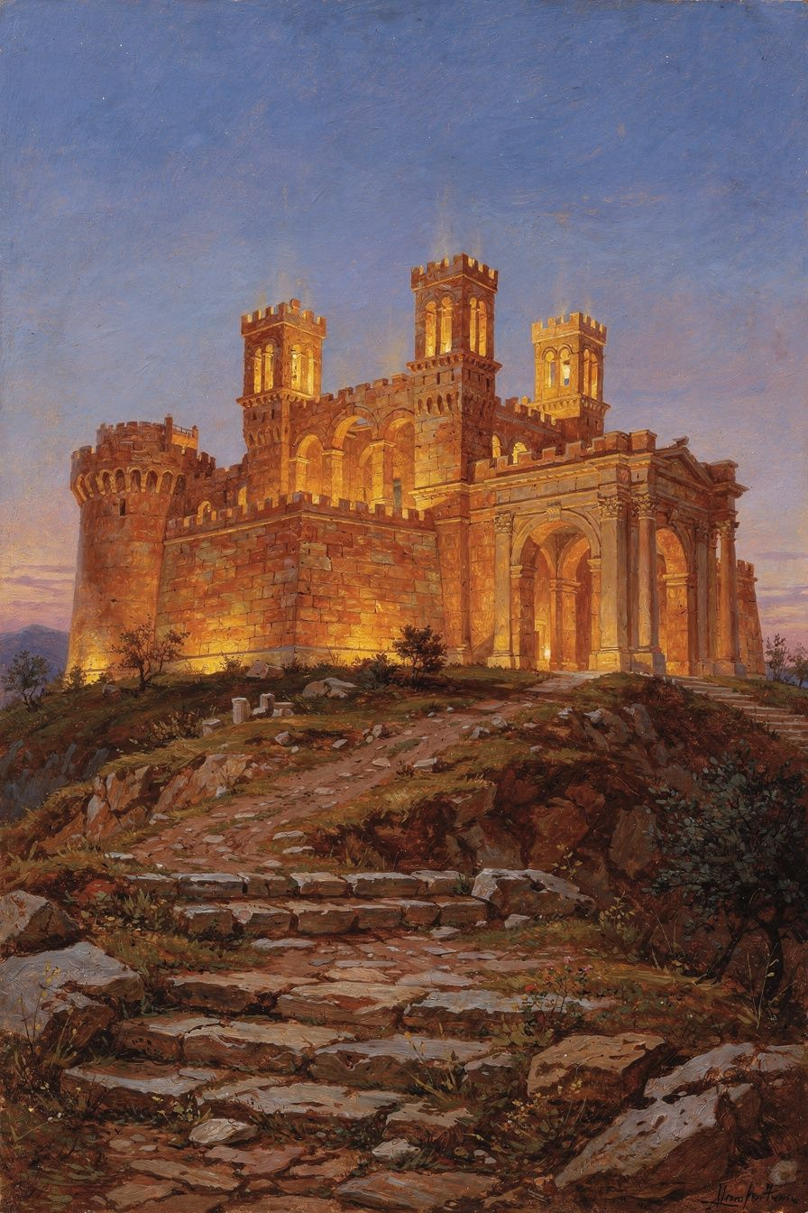
Illustration for Chapter 2
It begins with a sound. Not a trumpet blast or a war cry, but the soft, insistent scratch of a stylus on wax. Imagine the emperor in his tent, somewhere on the frozen banks of the Danube, the air thick with the smell of leather, damp wool, and distant smoke. The day has been a parade of impossible choices: which legion to reinforce, how to ration grain, what to do with the envoy who smiles while his tribe masses beyond the ridge. His body aches. His eyes burn. And yet, before sleep, he turns inward. He writes not to posterity, but to himself. He reminds his own soul of a truth that the campfires, the maps, and the weight of the purple robe cannot alter: the only thing that can truly harm him is something he carries inside, and he alone holds the key to that door.
This is not a metaphor for retreat. It is the foundation of his entire capacity to act.
We live in a different empire, but the siege engines are just as loud. A notification vibrates in your pocket, carrying a colleague’s curt dismissal of your work. A headline screams that the institutions you trusted are fraying. A memory of a private failure chooses 3 a.m. to visit, unbidden. In these moments, the world feels like an invader, breaching the walls of your peace, planting a flag of anxiety or anger in the center of your chest. The natural reaction is to blame the messenger, to fix the external problem, to scroll, to argue, to numb. Marcus Aurelius, from the mud of Germania, offers a diagnosis that is both more humbling and more empowering: the breach is never from the outside. The citadel opens its gates from within.
He writes in Meditations IV.48, in the translation by Farquharson: “All harm that harms the human being is inside, in the inner citadel. The self is not harmed unless it cooperates in its own harm.” And earlier, in IV.7, rendered by Gregory Hays: “Take away your opinion, and there is taken away the complaint, ‘I have been harmed.’ Take away the complaint, ‘I have been harmed,’ and the harm is taken away.”
These are not the words of a man in a comfortable armchair. They are the self-exhortations of a ruler who buried six children, who watched his most trusted general try to usurp him, who spent a decade in a military camp while his body was likely being eaten by the ulcer that would eventually kill him. If anyone had a right to say, “The world has harmed me,” it was Marcus. Yet he insists, with a firmness that borders on tenderness, that the harm is never in the event. It is in the judgment. The inner citadel—what Pierre Hadot, the great French philosopher and scholar of Marcus, called the inviolate center—is the seat of our ruling reason, our hegemonikon. It is the part of us that chooses what to believe about what happens. And it is, by its very nature, a fortress that no external force can enter without our assent.
———

The Big Idea
To understand this, we must first clear away a common misunderstanding. The inner citadel is not a hiding place. It is not a denial of pain, a spiritual bypass, or a call to passive resignation. Marcus did not sit in his tent repeating “nothing can harm me” while the Marcomanni burned Roman outposts. He gave orders. He rode out. He endured the cold. The point of the citadel is not to escape the world, but to ensure that when you engage with it, you do so from a place of unshakable sovereignty. The fortress is not a refuge from duty; it is the headquarters from which duty is commanded.
Pierre Hadot, in his seminal work The Inner Citadel, unpacks this with great care. He shows that for Marcus, the “inner citadel” is synonymous with the hegemonikon, the guiding principle, the rational soul. This is the part of us that can step back from the raw data of experience—the flush of embarrassment, the stab of grief, the seductive whisper of resentment—and ask: What is this, really? Is it something I should assent to? The Stoics called this process sunkatathesis, the act of giving or withholding assent to an impression. An impression is a preliminary mental representation, a kind of knock at the door. The door is the boundary of the inner citadel. You are the sentry. You decide what enters and becomes a full-fledged belief or emotion.
This is a radical claim. It says that no insult, no betrayal, no physical pain, no financial loss can directly damage your moral character or your capacity for clear judgment unless you agree that it does. The insult is just a vibration in the air until your mind labels it “humiliating” and assents to that label. The betrayal is just another person’s action until you judge it “unbearable” and let that judgment colonize your thoughts. Marcus’s point is not that you should pretend these things don’t hurt. It’s that the hurt is a product of your own value system, and you are the ultimate architect of that system. The citadel’s walls are not made of stone, but of principles.
This is where modern cognitive approaches find an ancient echo. Cognitive Behavioral Therapy (CBT) rests on a similar insight: it is not events themselves that disturb us, but the meanings we attach to them. The Stoic discipline of assent is a rigorous, daily practice of examining those automatic meanings and asking, “Is this true? Is this necessary? Is this helpful?” Marcus’s journal is essentially a CBT workbook written in the second century. He is constantly catching his own interpretations, challenging them, and reframing them in light of his deepest values.
But Marcus goes further than many modern approaches. For him, the inner citadel is not just a psychological defense mechanism; it is a sacred space. It is the place where the divine spark—the daimon—resides. To allow a false judgment to enter is not just a cognitive error; it is a kind of desecration. To keep the citadel inviolate is an act of piety, a way of honoring the rational nature that connects us to the cosmos. This is why his tone, when he writes about guarding the mind, is not that of a self-help guru but of a man at prayer. He is exhorting himself to remain worthy of the gift of reason.
Consider the metaphor of the garden. The mind is a walled garden. The world throws seeds over the wall constantly: seeds of anger, seeds of desire, seeds of fear. Some are carried by the wind of circumstance; some are deliberately tossed by others. You cannot stop the seeds from landing in your soil. But you are the gardener. You decide which seeds to water with your attention and which to let wither. A seed of an insult, if not watered with the belief “I have been wronged,” dries up and blows away. A seed of a temptation, if not watered with the thought “this would make me happy,” never sprouts. The garden is your responsibility, not the wind’s.
This is not a call to suppress emotion. The Stoic inner citadel is not a cold, sterile bunker. Marcus felt grief deeply—he writes of his eyes being “dry and hot” from weeping for his tutor. He felt weariness, frustration, even a kind of existential disgust with the pettiness of court life. The difference is that he did not let those feelings metastasize into the judgment that his life was ruined, that others were evil, or that the cosmos was unjust. He let the emotion move through the citadel like a weather system passing over a mountain. The mountain remains. The weather changes.
The practical payoff is immense. If you believe that your peace depends on others behaving well, on the economy staying stable, on your body remaining healthy, then you have placed your sovereignty in things that are, by nature, outside your control. You have built your house on a riverbank and hoped the river won’t flood. The inner citadel is the house built on high ground. The river still floods. The storm still comes. But the foundation holds. And from that unshaken foundation, you can actually go help the people in the floodplain. You can’t pull someone from the water if you’re drowning yourself.
This is the great paradox: the practice that looks like withdrawal is actually the precondition for courageous engagement. Marcus did not tend his inner citadel so he could hide in it. He tended it so that he could walk out of its gates every morning into a world of war, plague, and political treachery, and act with justice, temperance, and wisdom. The citadel is not a monastery; it is a field headquarters. The stillness inside is not the stillness of a pond, but the stillness of a well-anchored ship in a storm, ready to sail.
———

The Architecture of Assent
How does a judgment actually “enter” the citadel? The Stoics described a three-stage movement. First, there is the initial impression—the knock at the gate. This is involuntary. A sudden noise, a flash of pain, a stranger’s scowl. These are the raw data of experience, and they arise automatically. You cannot stop the knock. Second, there is the preliminary reaction, a kind of mental flinch. This too is largely involuntary and not yet a full emotion. Marcus describes it as the soul “contracting” or “starting back.” Even the sage, the ideal Stoic, would flinch at a sudden thunderclap. This is not failure; it is embodiment.
The third stage is where freedom lives: assent. The mind steps back and examines the impression. It says, “You are an appearance, not the thing you appear to be.” It asks whether the impression is true, whether it accords with reality, and whether it is beneficial to accept it. If the impression is that someone has insulted me, the mind can investigate: Did they actually say something harmful? Is my character actually damaged? Is their opinion something I control? The answer to the last question is always no. And if my character is undamaged, then no harm has occurred. The impression is dismissed. The gate remains closed.
This is not a one-time achievement. It is a discipline, a practice of returning to the gate again and again. Marcus writes to himself because he knows he will forget. The tent is cold. The general is insubordinate. The child is sick. The knock at the gate is loud and insistent. He needs to remind himself: You are the sentry. Do not let the guard fall asleep.
———

Practice
The inner citadel is not built by reading alone. It is built by daily, concrete acts of attention. Here are three practices drawn from Marcus’s own method, adapted for the life you are actually living.
1. The Morning Fortification (5 minutes)
Before you look at your phone, before you speak to anyone, sit quietly and anticipate the day. Marcus describes this practice in Meditations II.1: “When you wake up in the morning, tell yourself: The people I deal with today will be meddling, ungrateful, arrogant, dishonest, jealous, and surly… But I have seen the beauty of good, and the ugliness of evil, and have recognized that the wrongdoer has a nature related to my own.”
This is not pessimism. It is a pre-emptive fortification. You are not predicting disaster; you are reminding yourself that whatever comes, your response is your own. In your version of this practice, identify one or two specific challenges likely to arise today—a difficult conversation, a frustrating task, a person who irritates you. Then, silently, say to yourself: “I will encounter ______. My goal is not to control it, but to meet it with patience, clarity, and fairness. The only harm that can touch me is the harm I do to my own character. I will guard my judgments.” This is the act of locking the citadel gates before the siege begins, not out of fear, but out of calm readiness.
2. The Midday Gate-Check (2 minutes)
Set a discreet alarm on your phone for sometime in the early afternoon. When it sounds, pause whatever you are doing. Take three conscious breaths. Then ask yourself: What impression have I let in today without examining it? Scan the last few hours. Did you accept a judgment that a colleague is incompetent, that traffic was “unbearable,” that a comment was “hurtful”? Don’t berate yourself. Simply notice. Then ask: Is that judgment true? Is it necessary? Does it help me act with virtue? If not, consciously release it. Imagine opening the gate of the citadel and escorting the thought out. Say to yourself, as Marcus did: “This is an impression, not the thing itself. I am not harmed unless I believe I am harmed.” This is mental hygiene, as simple and as essential as washing your hands.
3. The Evening Review (10 minutes)
At the end of the day, sit with a notebook. Replay the day in reverse, from the last hour back to the morning. For each significant moment—a flash of anger, a moment of anxiety, a sharp word—ask three questions, adapted from the Stoic philosopher Epictetus:
- What did I assent to in that moment? (What judgment did I make that caused the disturbance?) - What was within my control, and what was not? (Be precise. My action was within my control; their reaction was not. My effort was within my control; the outcome was not.) - What would the wise version of myself have done differently? (Not to shame yourself, but to learn.)
Write down one specific commitment for tomorrow based on what you see. For example: “When I feel the impulse to check my email compulsively, I will pause and remind myself that my peace is not in the inbox.” This practice turns the inner citadel from a metaphor into a lived reality. You are not just guarding the gates; you are reinforcing the walls, stone by stone, every night.
———

The Deeper Invitation
There is a moment in the Meditations where Marcus speaks of the mind as a fire. Impressions are like objects thrown into the fire. A weak fire is smothered by them. A strong fire “quickly appropriates and consumes” them, transforming them into its own heat and light, rising higher on the very things that would extinguish it. The inner citadel is not a cold, dark keep. It is a fire that burns so brightly that everything thrown at it becomes fuel.
This is the ultimate invitation. Not merely to endure the world, but to metabolize it. To take the raw material of difficulty—the criticism, the loss, the fear—and turn it into wisdom, into strength, into a deeper capacity for love. The citadel is inviolate not because it is sealed off from life, but because it has learned the alchemy of assent. It refuses to let anything in that would corrupt its purpose, and it welcomes everything else as fuel for its flame.
———

A Reflective Pause
Before you move on from this chapter, take a moment. Bring to mind something that happened recently that felt like a violation—a moment when you believed you were harmed. It might be a conversation that left you stinging, a news story that filled you with dread, a memory that ambushed you.
Now, gently, ask yourself: Was the harm in the event, or in my judgment of the event? Don’t rush to answer. Sit with the question. Notice if there is a part of you that resists, that wants to insist, “No, this really was harmful.” That resistance is itself an impression knocking at the gate. Examine it too.
Then, as an experiment, try on Marcus’s perspective. Say to yourself, quietly: “Take away my opinion that I was harmed, and the harm is taken away.” Don’t force yourself to believe it. Just try it on, like a coat you’re not sure fits. Notice how it feels. Notice the space it opens up. In that space, you are not a victim of circumstance. You are a sovereign soul, standing at the threshold of your own inner citadel, keys in hand. The world is still out there, loud and insistent. But the gate is yours to open or keep closed. And that, Marcus would say with a tired but steady smile, is enough.
———

Chapter 3: The Three Disciplines
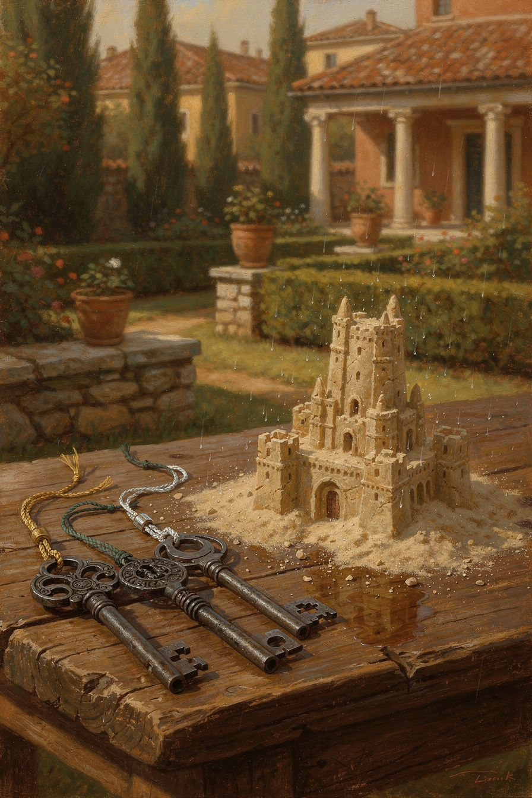
Illustration for Chapter 3
It begins with a jolt—an email, a comment, a diagnosis, a headline. Something lands in your world and instantly your interior weather changes. Your chest tightens, your mind starts churning, and before you know it you’re living inside a story about what just happened. The story might be about injustice, about failure, about what this means for your future. The story feels so real that you mistake it for the event itself. But if you pause—really pause—you can catch a glimpse of a gap. There is the raw fact, and then there is the judgment you’ve wrapped around it. In that gap lies a freedom most of us rarely touch.
Marcus Aurelius knew this gap intimately. He didn’t learn it in a seminar or a therapy session. He learned it in the middle of a life that, by any external measure, was overwhelming. Emperor of a vast, turbulent territory. Commander of armies on the northern frontier. A man who buried six of his children. A ruler surrounded by flatterers, schemers, and the constant threat of betrayal. He wrote his private notes in a tent at Carnuntum, on the banks of the Danube, during a grinding military campaign, while his body was likely already succumbing to the illness that would kill him. He wasn’t writing for an audience. He was writing to himself, urgently, as a practice of survival. And the core of that practice was learning to see clearly what was his and what was not.
“External things are not the problem. It’s your assessment of them. Which you can erase right now.” — Marcus Aurelius, *Meditations* 8.47 (trans. Gregory Hays)
This is not pop psychology. It’s a hard-won insight from a man who faced more external adversity than most of us can imagine. Marcus discovered that the mind has a power that no army, no plague, no betrayal can touch—if you train it. But training it requires more than a single insight. It requires a structured practice, a way of organizing your inner work so that it becomes as natural as breathing. The Stoics developed such a structure, and Marcus used it to build his Meditations from the ground up.
The Big Idea: The Three Disciplines
In the twentieth century, the French philosopher Pierre Hadot unlocked a secret that had been hiding in plain sight for nearly two millennia. He noticed that the seemingly random reflections in Marcus’s Meditations actually follow a rigorous, three-part pattern. Marcus was not simply jotting down whatever thoughts occurred to him. He was practicing three distinct but interconnected disciplines, each corresponding to a fundamental area of human experience. Hadot named them the discipline of desire, the discipline of assent, and the discipline of action. Together, they form a complete system for transforming your relationship to yourself, to others, and to the world.
These three disciplines trace back to Epictetus, the former slave whose teachings Marcus studied and quoted constantly. Epictetus taught that the path to freedom lies in three topoi—three fields of training. First, we must train our desires and aversions so that we want only what is within our power and never recoil from what nature assigns us. Second, we must train our impulses to act so that we always act with reserve, for the common good, and in accordance with our roles. Third, we must train our faculty of judgment so that we never give our assent to a false impression, never mistake a hasty interpretation for the truth. Marcus absorbed this framework so deeply that it became the skeleton of his inner life. Every page of the Meditations can be read as an exercise in one of these three disciplines.
Why does this matter for you, today? Because the same three fields are where your suffering and your freedom play out. Every moment of distress, every conflict, every nagging sense that life is off-track can be traced to a failure in one of these disciplines. You desire something you cannot control, and you feel frustrated. You assent to a distorted impression, and you feel hurt or angry. You act from selfish impulse rather than from a sense of shared good, and you feel hollow or disconnected. The three disciplines are not abstract philosophy. They are a diagnostic tool and a training regimen for the mind.
The Discipline of Desire: Accepting What Nature Gives
The discipline of desire addresses our most primal reflex: reaching for what we want and pushing away what we don’t. From the moment we wake, we are pulled by preferences—for comfort, for approval, for certainty—and repelled by their opposites. Marcus saw that this reflex is the root of most human misery, because we habitually attach our desires to things that lie outside our control. We want the promotion, the loyal partner, the healthy body, the peaceful world. None of these are fully ours to command. When we stake our happiness on them, we become slaves to fortune.
The discipline of desire teaches us to redirect our longing. Instead of desiring external outcomes, we learn to desire only what is already within our power: our own character, our own judgments, our own choices. Marcus puts it bluntly: “Do not wish for things to happen as you would like them to, but rather wish that they happen as they do happen, and your life will go smoothly.” This is not passive resignation. It is a radical reorientation of the will. You stop fighting reality and start aligning with it. You accept what nature gives you—not because you are weak, but because you understand that the only thing you truly own is your response.
Hadot called this the discipline of physics, because it involves understanding your place in the larger order of the universe. For the Stoics, nature is not random. It is a living, rational whole, and you are a part of it. Your individual desires are like a small eddy trying to flow against the current of a great river. The discipline of desire is learning to turn your eddy so that it flows with the river, not against it. This doesn’t mean you stop acting or caring. It means you act and care from a place of deep acceptance, without the exhausting friction of demanding that reality be different than it is.
In modern terms, this discipline closely parallels what psychologists call acceptance—a core component of therapies like Acceptance and Commitment Therapy (ACT). ACT teaches that much of our suffering comes from experiential avoidance: the attempt to escape or suppress unwanted thoughts, feelings, and sensations. The Stoic discipline of desire goes even further. It doesn’t just ask you to accept your inner experience; it asks you to embrace your entire life situation as the precise material you need for your moral training. Every difficulty is an opportunity to practice virtue. Every loss is a chance to practice resilience. As Marcus wrote: “A cucumber is bitter. Throw it away. There are brambles in the path. Go around them. That is enough. Do not add, ‘Why are such things in the world?’” The discipline of desire is the art of not adding that extra layer of complaint.
The Discipline of Assent: Judging Impressions Carefully
If the discipline of desire governs our relationship to the world, the discipline of assent governs our relationship to our own mind. Every moment, we are bombarded by impressions—phantasiai, as the Stoics called them. A colleague’s curt email, a stranger’s frown, a sudden noise in the night. These impressions arrive with a built-in interpretation, a kind of emotional charge that urges us to react. The impression doesn’t just say “the email was short”; it says “the email was short, and that means she disrespects you, and you should feel insulted.” The discipline of assent is the practice of intercepting that automatic interpretation before we buy into it.
Epictetus’s famous maxim, which Marcus echoes throughout the Meditations, is the foundation: “It is not events that disturb people, it is their judgments concerning them.” The event is neutral. The judgment is where the disturbance lives. And here is the crucial point: you have the power to withhold your assent from a judgment. You can look at an impression and say, “You are just an appearance, not the thing you claim to represent.” This is the inner citadel that Marcus speaks of—the fortress of the mind that no external force can breach, because the gate is guarded by your own faculty of reason.
Hadot called this the discipline of logic, because it requires you to examine your thoughts with the precision of a logician. Is this impression true? Is it helpful? Is it within my control? Marcus practiced this relentlessly. He would take a disturbing thought and dissect it: “This is nothing but a judgment. Strip it of the story. What remains? A bare fact. And the bare fact has no power to hurt me.” This is strikingly similar to what modern cognitive-behavioral therapy (CBT) calls cognitive restructuring—the process of identifying automatic negative thoughts, evaluating their accuracy, and replacing them with more balanced perspectives. The Stoics were doing CBT two thousand years before CBT had a name, and they were doing it not just to feel better, but to become wiser.
The discipline of assent also protects you from a more subtle danger: the temptation to mistake your own virtue for a possession. You might do a kind act and then spend the next hour replaying it in your mind, basking in self-approval. That replay is an impression too—an alluring one. Marcus warns against this: “Do not act as if you were going to live ten thousand years. Death hangs over you. While you live, while it is in your power, be good.” The point is to act rightly and then move on, without turning your own goodness into a story that inflates your ego. The discipline of assent applies to pleasant impressions just as much as to painful ones. You don’t cling to either.
The Discipline of Action: Acting for the Common Good
The third discipline moves from the inner world to the outer. You have trained your desires to accept what nature gives. You have trained your assent to judge impressions carefully. Now you must act. But how? The Stoic answer is clear and demanding: act always for the common good. Your actions are not your private property. You are a part of a larger whole—a family, a community, a city, a cosmos. Every action you take ripples outward. The discipline of action is the practice of making those ripples beneficial, not harmful.
Marcus was emperor, so the scale of his actions was vast. But he constantly reminded himself that the same principle applies to the smallest gesture. “What is not good for the hive is not good for the bee,” he wrote. Your well-being is inseparable from the well-being of the whole. This is not a call for self-sacrifice in the sense of erasing yourself. It is a recognition that your truest self is a relational self, a self that flourishes when it contributes to the flourishing of others. The discipline of action is the practice of asking, before you speak or move: “Is this for the common good? Does this serve justice, kindness, courage, wisdom?”
Hadot called this the discipline of ethics, and he noted that it is intimately linked to the Stoic concept of oikeiōsis—the natural process by which we come to recognize others as our own, as belonging to us. An infant starts by caring only for its own survival. Gradually, it learns to care for its family, then its community, then all of humanity. The discipline of action is the deliberate acceleration of this process. You train yourself to see the stranger as a brother, the adversary as a fellow human being who is simply mistaken about what is good. Marcus’s most radical teaching is that we are made for cooperation, “like feet, like hands, like eyelids, like the rows of upper and lower teeth.” To act against one another is against nature; to act for one another is to fulfill our design.
This discipline also contains a crucial practical principle: the reserve clause. When you act, you do so with full commitment, but you add an unspoken condition: “if nothing prevents it.” You recognize that the outcome is not entirely up to you. A wise person acts with energy and focus, yet remains serene if the result is not what they intended, because they never staked their happiness on the outcome. They staked it on the quality of their effort. This is the fusion of the discipline of action with the discipline of desire. You act wholeheartedly for the common good, and you accept whatever result nature returns.
Practice: Living the Three Disciplines
These disciplines are not meant to be admired from a distance. They are meant to be practiced, daily, until they become the grain of your character. Here is a concrete way to weave them into your life.
Begin your day with the morning premeditation. Before you rise, or while you drink your first cup of coffee, take a few minutes to anticipate the challenges ahead. Ask yourself: “What people and situations might I encounter today that could trigger frustration, anger, or anxiety?” Picture them vividly. Then apply the discipline of desire: remind yourself that these events are not yours to control, but your response is. Say to yourself: “I will meet meddling, ungrateful, arrogant, deceitful, envious, unsocial people. All these things happen to them by reason of their ignorance of what is good and evil. But I have seen the nature of the good and the evil, and I know that no one can harm me but myself.” This is Marcus’s own morning practice, recorded in Book 2 of the Meditations. It sets your intention and builds your inner fortress before the first arrow flies.
Throughout the day, practice the pause for assent. Whenever you feel a strong emotional charge—irritation, hurt, anxiety, elation—stop. Take one conscious breath. Recognize that an impression has appeared and is demanding your belief. Label it silently: “This is an impression, not the truth.” Then ask the Stoic question: “Is this within my control?” If it is not—if it concerns another person’s opinion, an external outcome, a past event—then the impression is not about something that truly belongs to you. You can let it go. If it is within your control—your own judgment, your next action—then you can choose a wise response. This pause need only take a few seconds. With repetition, it becomes a reflex. You are building the discipline of assent into your nervous system.
In your interactions, apply the reserve clause to your actions. As you set out to do something—lead a meeting, have a difficult conversation, work on a project—commit to it fully, but inwardly add: “I will do this, if nothing prevents it.” This tiny mental addition changes everything. It detaches your peace from the outcome. You can work with passion and still remain serene if the result is not what you hoped. You are practicing the discipline of action and the discipline of desire simultaneously.
End your day with the evening review, a practice Seneca described and Marcus certainly used. Sit quietly and replay the day in your mind. Ask three questions, each corresponding to one discipline:
- Where did I resist what nature gave me? (Discipline of desire) - Where did I assent to a false or harmful impression? (Discipline of assent) - Where did I act selfishly, or fail to act for the common good? (Discipline of action)
Do not use this review to beat yourself up. Use it as a sculptor uses a chisel. You are gently carving away the excess, revealing the form that was always there. If you find a failure, simply note it and resolve to practice more skillfully tomorrow. This is not guilt; it is calibration.
You can also practice the disciplines through a simple midday check-in. Set an alarm on your phone for a random time. When it sounds, pause and ask: “What discipline do I need right now?” Maybe you are clenching against a situation you cannot change—apply the discipline of desire. Maybe you are spiraling in a story about what someone meant—apply the discipline of assent. Maybe you are procrastinating on a task that would help others—apply the discipline of action. This check-in takes ten seconds and can reorient your entire day.
Finally, keep a common good journal once a week. Write down one action you took that explicitly served the common good, however small. It could be a patient conversation, a task done well for your team, a moment of genuine listening. Then write down one opportunity you missed. This practice trains your attention to see your life through the lens of the discipline of action. Over time, you will start to notice opportunities in real time, and you will take them.
These practices are not about perfection. They are about direction. Marcus himself never claimed to have mastered his own teachings. The Meditations are full of self-exhortation precisely because he struggled, failed, and had to begin again every morning. The three disciplines are a compass, not a destination. They give you a way to navigate the chaos of a human life with your agency intact.
———
Tonight, before you sleep, sit for a moment with these three questions. Let them be a mirror, not a judge:
Where did I fight against what was given, instead of accepting it as my training?
Where did I mistake a judgment for a fact, and suffer for it?
Where did I forget that my actions ripple outward into other lives?
Hold what you find with gentleness. Tomorrow, the sun will rise on another day of practice.
———

Chapter 4: The Cosmopolitan Imperative
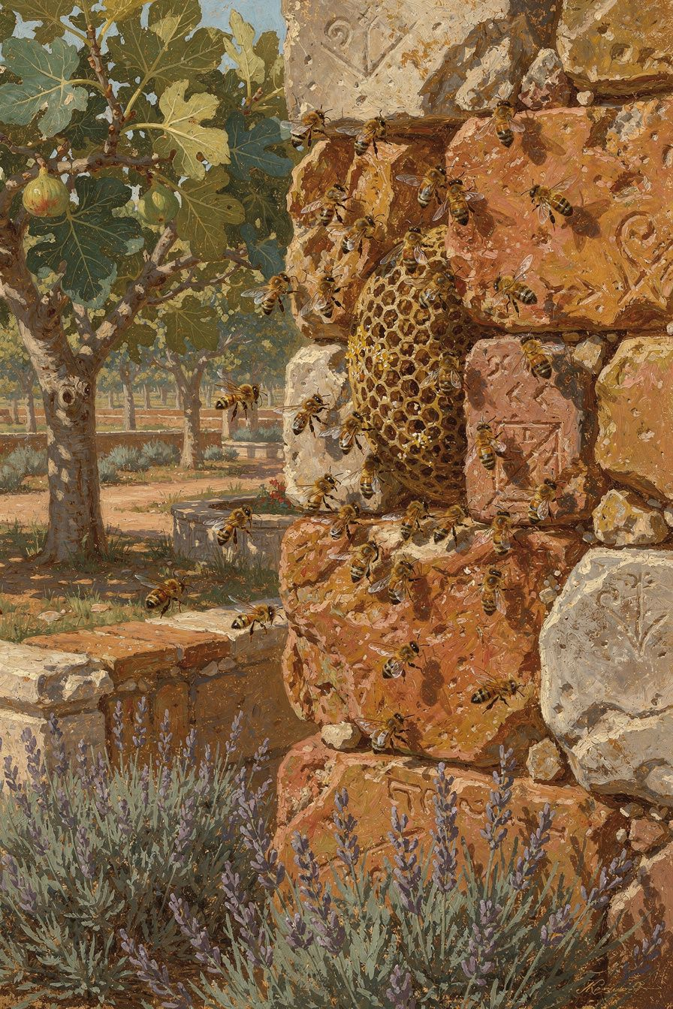
Illustration for Chapter 4
It is easy to forget, in the quiet of a morning with a book, that Marcus Aurelius wrote his Meditations not in a philosopher’s garden but in a military camp, on the frozen frontier of an empire buckling under plague, war, and the ordinary treachery of court life. He was the most powerful man in the known world, yet he spent his private hours reminding himself that he was just one cell in a vast body, a single bee in a hive whose health depended entirely on the health of the whole. This was not the sentimental daydream of a privileged ruler trying to feel connected. It was a survival discipline. When your advisors lie, when your generals revolt, when your children die of disease and you still have to adjudicate a tax dispute before lunch, you either find a reason to treat the people around you with justice and patience, or you become a bitter, isolated tyrant. Marcus chose the harder path: he built an entire ethical framework on the radical idea that we are not separate selves competing for scraps, but limbs of one living organism, guided by a shared rational nature. He called this the cosmopolitan imperative, and it is the backbone of every duty, every act of forgiveness, and every moment of genuine justice he ever performed.
The core of that imperative appears in two of his most famous lines. The first is a biological metaphor so blunt it almost stings: “What is not good for the swarm is not good for the bee.” (Meditations IX.42, trans. Hays). The second, written as a morning reminder before he faced the day’s aggravations, grounds the same idea in the body: “We were born for cooperation, like feet, like hands, like eyelids.” (Meditations II.1, trans. Hays). Notice what these images do not say. They do not say that you must like everyone, that you must approve of their choices, or that you must erase your own needs in a haze of self-sacrifice. A foot does not need to like the stomach; it simply does its work, knowing that if the stomach starves, the foot will not walk. An eyelid does not hold a committee meeting to decide whether the eye deserves protection; it blinks because that is its nature, and the eye’s safety is its own. Marcus is not preaching niceness. He is describing a structural fact about what it means to be a rational human being: your flourishing is bound up with the flourishing of others, and to act against the common good is to act against your own deepest nature. This chapter is about turning that structural fact into a lived practice—a way of moving through a fractured world with your agency intact and your resentment disarmed.
The Big Idea: One Body, One Logos
To understand why Marcus’s cosmopolitanism is not mere sentiment, we have to step briefly into the Stoic understanding of the universe. The Stoics saw the cosmos as a single, living, intelligent organism permeated by a rational principle they called logos. Everything that exists is a part of this whole, but human beings occupy a special place because we carry a fragment of that universal logos within us—our own capacity for reason. When Marcus writes that we are limbs of one body, he is not reaching for a feel-good metaphor; he is making a literal claim about our constitution. Just as your hand and your heart share the same bloodstream and the same governing intelligence, all human beings share the same logos and belong to the same cosmic city. The scholar Pierre Hadot, in his profound study The Inner Citadel, calls this the “discipline of action,” one of the three core disciplines Marcus uses to structure his self-exhortations. The discipline of action rests on a single, unwavering principle: act only for the good of the human community, because to do otherwise is to sever yourself from the whole and to violate your own rational nature.
This is where the idea becomes demanding. If we truly share one logos, then the person who cuts you off in traffic, the colleague who takes credit for your work, the politician whose policies you find abhorrent—all of them are, in a fundamental sense, kin. They are not kin in the sense that you must invite them to dinner or endorse their views. They are kin in the sense that they possess the same seed of reason you do, even if they have buried it under layers of ignorance, fear, or misguided desire. Marcus’s response to wrongdoing is therefore not to label the wrongdoer as evil and cast them out, but to diagnose the error and, where possible, to instruct. “They are like this by nature,” he writes elsewhere, “they act this way because they think it is right. If they are wrong, they are the ones who are harmed.” This is a radical cognitive shift. The harm someone does to you—the insult, the betrayal, the neglect—does not touch your character unless you let it. The real harm falls on the person who acts unjustly, because they have damaged their own logos, their own humanity. Your task is not to retaliate but to heal the body. As Hadot puts it, the discipline of action transforms every encounter into an opportunity to serve the whole, and every conflict into a chance to practice justice as a form of medicine.
This is not cold or detached. It is, in fact, the only stable foundation for genuine warmth. If your kindness depends on people being pleasant, it will collapse the moment they are not. If your sense of duty depends on recognition, it will curdle into resentment when you are overlooked. Marcus’s cosmopolitanism anchors kindness and duty in something unshakeable: the recognition that the other person is a limb of the same body, and that your own well-being is inseparable from theirs. The bee does not ask whether the swarm appreciates its work; it simply does the work, because the swarm’s survival is its own. This is not self-erasure. It is a profound redefinition of the self—from a small, fragile ego that needs constant protection to a node in a network of mutual care, where your good is always already bound up with the good of others.
Modern psychology, particularly in the cognitive-behavioral tradition, has arrived at a parallel insight through a different route. When we perceive another person’s actions as a personal attack, we generate what CBT calls “hot cognitions”—thoughts saturated with anger, blame, or victimhood—that drive impulsive, often destructive reactions. The Stoic cosmopolitan move is a form of cognitive reappraisal: you step back and reframe the situation not as “me versus them” but as “us—one body—dealing with a malfunction in one of its parts.” This does not mean you become a doormat. Marcus led armies and signed death warrants. He understood that sometimes a diseased limb must be amputated to save the body. But even then, the action is taken without hatred, as a surgeon removes a tumor with steady hands and a clear mind. The cosmopolitan imperative is not about passivity; it is about acting from a place of clarity rather than from the narrow, reactive self.
The great translator and commentator A.S.L. Farquharson noted that Marcus’s social ethics are “the crown of his philosophy,” precisely because they demand the hardest kind of inner work. It is relatively easy to endure hardship for yourself; it is far harder to endure the failings of others without becoming harsh or indifferent. Yet that is the work Marcus sets before us: to look at the most irritating, disappointing, or even harmful person and see, beneath the surface behavior, a fellow citizen of the cosmos who has lost their way. This is not a feeling to be manufactured; it is a judgment to be practiced. You do not have to feel warm. You only have to act as if the relationship matters, because in reality it does. Over time, the feeling often follows the action, but the action must come first.
Practice: Living as a Limb of the Whole
How do you take this grand philosophical vision and weave it into the texture of an ordinary, busy, often frustrating life? Marcus did not leave us a system of exercises, but his Meditations are themselves a record of repeated practice—short, sharp reminders he gave himself to stay aligned with the cosmopolitan imperative. The following practices are drawn from that record and adapted for a modern adult navigating work, family, and the quiet pressures of a world that constantly tells you to put yourself first.
The Morning Body Scan. Before you check your phone or pour your coffee, take sixty seconds to recall the image of the body. Close your eyes and picture the people you will likely encounter today: your partner, your children, the driver in the next lane, the colleague whose voice grates on you, the friend who always seems to need something. Now, in your mind’s eye, draw a line connecting your chest to theirs, and theirs to each other, until you see a web of limbs, a single breathing organism. Say to yourself, silently, “We were born for cooperation, like feet, like hands, like eyelids.” This is not a wish; it is a statement of fact. You are not trying to feel affection. You are orienting your will toward its natural function. If you do this every morning for a week, you will begin to notice a shift in how you carry the expectation of conflict into your day. The people you meet stop being potential threats and start being parts of a body you are responsible to tend.
The Swarm Check. Once during your day—perhaps at lunch or during a break—pause and ask yourself a single question: “Is what I am doing right now good for the swarm?” This is not a guilt-inducing interrogation. It is a course correction. If you are working on a task that serves only your vanity or your avoidance, gently redirect your attention to something that serves the whole, even in a small way. Answering a colleague’s question with patience, doing a household chore without being asked, writing an email that clarifies rather than blames—these are the micro-actions of the bee. They are not heroic. They are the steady, unglamorous work that keeps the hive alive. The swarm check turns the abstract ideal of cosmopolitanism into a concrete, moment-by-moment choice.
The Evening Rewind. Marcus often reviewed his day in the evening, not to berate himself but to examine where he had acted against the common good and to prepare a better response for the next time. Set aside five minutes before bed. Replay one difficult interaction. Do not relitigate what the other person did; focus only on your own response. Did you treat them as a limb of the body, or did you treat them as an enemy? If you fell short, do not waste time on shame. Instead, imagine the same situation happening tomorrow and rehearse, in vivid detail, how you would act differently. See yourself pausing before the sharp reply. See yourself asking, “What would serve the whole here?” See yourself speaking with firmness but without contempt. This mental rehearsal is a form of deep practice; it builds the neural pathways that will be available to you when the real moment arrives.
The Forgiveness Protocol. Forgiveness, in Marcus’s framework, is not a feeling of magnanimity; it is a sequence of rational steps that dismantle resentment. When someone wrongs you, walk through these steps, either in writing or in your mind. First, remind yourself that they acted from ignorance—they believed their action was appropriate, or they were carried by a passion they could not control. Second, remind yourself that you have done similar things, perhaps in different circumstances, and that you share the same flawed human nature. Third, ask what the common good requires now. Does it require a boundary? A difficult conversation? A quiet release of the debt? Whatever it requires, do it without adding the poison of moral superiority. The goal is not to condone the wrong but to stop carrying it around like a hot stone that burns only you. This is forgiveness as hygiene, as a way of keeping your own mind clean and your own agency intact.
The Cosmopolitan Pledge. Once a week, perhaps on a Sunday evening or a Monday morning, take a moment to renew your commitment to the cosmopolitan city. You might write a short sentence in a journal or say it aloud: “I am a citizen of the cosmos. My good is the good of the whole. This week, I will act accordingly.” The pledge is not a magic spell. It is a deliberate act of self-definition. In a culture that constantly invites you to define yourself by your preferences, your grievances, and your tribe, you are choosing a different identity: a person whose primary allegiance is to the human community, and whose daily actions are measured by that standard. Over time, this identity becomes less of a choice and more of a settled disposition. You begin to feel, in your bones, that the stranger’s suffering is your own, that the colleague’s success is not a threat, that the difficult person is not an enemy but a fellow limb in need of care.
These practices are not about becoming a saint. They are about becoming a functioning part of the whole, which is the only kind of happiness that lasts. Marcus would be the first to tell you that you will fail at them repeatedly. He failed at them himself. The Meditations are full of exasperation with his own irritability and impatience. But the cosmopolitan imperative is not a standard you meet; it is a direction you walk. Every time you choose the good of the swarm over the comfort of the ego, you strengthen the bond that holds the body together, and you discover, quietly, that your own life feels more solid, more meaningful, more yours.
A Reflective Prompt
Before you move on, take a moment with this question. Bring to mind one person in your life whom you find difficult—someone whose behavior regularly irritates, disappoints, or hurts you. Now, set aside the story of what they have done and ask yourself: Can I see this person as a limb of the same body I belong to, acting from a flawed understanding of what is good? Do not rush to answer. Sit with the possibility. If you could see them that way, even for a moment, what would change? What would it mean to respond to them with justice rather than resentment, with the steady hands of a surgeon rather than the hot heart of a rival? The cosmopolitan imperative does not ask you to feel differently. It asks you to act from a deeper truth. The feeling may follow, but the action is yours to choose, right now, in the quiet of this moment.
———

Chapter 5: The Campfire Meditations
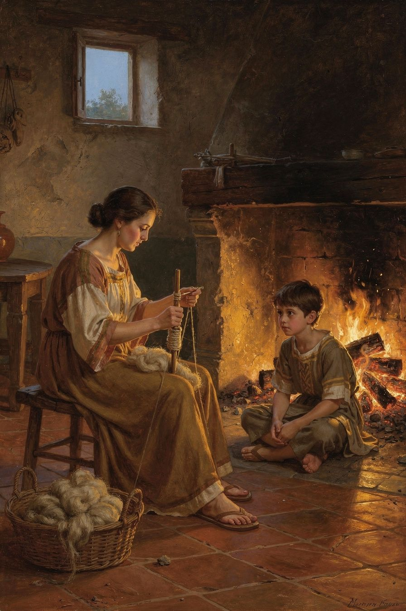
Illustration for Chapter 5
The fire does not ask permission. It does not pause to consider whether the wood is worthy, whether the branch is too green or too dry, whether the fallen leaf carries some stain of decay. It simply takes hold of whatever falls into it, surmounts it, and rises higher. On the long nights of the Marcomannic campaign, Marcus Aurelius sat by such a fire—perhaps a campfire on the banks of the frozen Danube, perhaps the flame of a small oil lamp in his tent—and watched the flames do their quiet, relentless work. Outside, the world was unravelling. The northern tribes had breached the frontier. The Antonine Plague, brought back by soldiers from the east, was hollowing out the empire, carrying off friends, teachers, and his own children. His generals betrayed him. His body, never robust, was failing. And yet, in the midst of this, he wrote sentences of astonishing clarity and tenderness, not for an audience, but for himself. He was not composing a book. He was building a fire inside his own mind, a fire that could take the terror, the grief, the exhaustion, and the pain, and turn them into light.
We all sit by our own version of that campfire. Perhaps it is a kitchen table at 2 a.m., a desk in a silent office after a round of layoffs, a hospital waiting room chair, or the driver’s seat of a car pulled over because the weight in the chest became too heavy to drive with. The circumstances differ, but the question is the same: when life throws something into the fire, does it fuel the flames or smother them? Marcus’s answer, forged in the worst years of his life, was that we can learn to make almost anything combustible. Not by denying the pain, but by meeting it with a practice so precise and so honest that suffering is stripped of the extra layers we usually wrap around it.
He wrote to himself: “A fire takes hold of whatever falls into it and surmounts it and rises above it… so too the intelligent power takes hold of whatever falls into it and assimilates it to itself.” (Meditations IV.48, trans. Farquharson). This is not a metaphor of destruction. It is a metaphor of transformation. The fire does not reject the object; it embraces it and changes its nature. The wet log hisses, resists, and then, eventually, catches. The flame does not complain about the dampness. It does not wish for better fuel. It works with what is here. Marcus saw the mind as having the same capacity: to take in any event, any emotion, any physical sensation, and through the way we attend to it, turn it into something that feeds our clarity rather than our despair.
This is a radical claim. It sounds almost offensive to modern ears, accustomed as we are to the idea that some pain is simply too great to be “used.” But Marcus was not talking about using pain in a transactional sense, as if grief were a networking opportunity. He was talking about the fundamental relationship between consciousness and its contents. The fire does not “use” the wood for a purpose external to itself; the burning is its nature. Likewise, the mind’s nature, when it is functioning as it should, is to meet experience with understanding, to absorb it into the whole fabric of a life, to let it illuminate something. The alternative is to let the experience remain alien, a foreign object that chokes the fire and fills the tent with smoke.
We know that smoke. It is the mental loop that begins with a sharp, clean pain—a diagnosis, a rejection, a loss—and then spirals into a thick, acrid cloud of commentary: This shouldn’t have happened. It’s not fair. What if it gets worse? What does this say about me? I can’t stand it. The initial sensation is the log. The commentary is the smoke. Marcus’s practice was to burn the log without producing the smoke. He put it another way, with almost brutal simplicity: “Everything that happens is either endurable or not. If it’s endurable, then endure it. Stop complaining.” (Meditations X.3, trans. Hays). The first time you read that, it can feel like a slap. But look closer. He is not saying “suck it up” in the manner of a coach who doesn’t want to hear about your injury. He is making a logical incision. If a thing is endurable, then the act of complaining is an unnecessary addition, a second layer of suffering that we are actively creating. If a thing is truly unendurable, it will end us, and then there is no problem left to complain about. In either case, the added suffering—the resentment, the self-pity, the frantic storytelling—is not part of the event. It is something we are doing. And what we are doing, we can learn to stop doing.
This is where Marcus’s campfire meditations intersect with a discovery made two millennia later in the clinics of cognitive therapy. The “second arrow” is a concept often attributed to Buddhist teaching, but it was operationalized in modern psychology by researchers who noticed that human distress is almost always compounded by our reaction to our reaction. There is the first arrow: the physical or emotional pain of the event itself. Then there is the second arrow: the arrow we shoot into ourselves through rumination, avoidance, catastrophic thinking, and self-blame. Marcus, writing alone in his tent, was systematically pulling out the second arrow. He was not trying to become a stone. He was trying to become a fire, so that even the first arrow, once it struck, could be consumed and turned into warmth.
The philosopher Pierre Hadot, whose reading of Marcus has shaped much of the modern Stoic revival, described the Meditations as a set of spiritual exercises. They were not theories to be admired but practices to be repeated, day after day, until they rewired the soul. Hadot saw that Marcus was constantly engaged in what he called “physical definition,” stripping events down to their bare elements so that the mind could see them without the terrifying costumes we usually dress them in. A luxurious robe becomes wool dyed with shellfish blood. A famous painting becomes pigments smeared on a canvas. A feared death becomes a natural process of elements dispersing. This was not cynicism. It was a discipline of clarity. By seeing things as they are, without the added judgments, Marcus made them endurable. And by making them endurable, he removed the need for the second arrow.
But how do you actually do this when your hands are shaking and your mind is screaming that the situation is an exception, that this pain really is too much? Marcus’s answer is hidden in the structure of the Meditations themselves. The book is not a linear argument. It is a spiral. He returns to the same themes again and again, not because he forgot what he wrote the day before, but because the practice requires repetition. The mind is not a machine that, once programmed, runs flawlessly. It is more like a garden, or a fire that needs constant tending. Each morning, Marcus would pick up his stylus and write himself into the right relationship with the day ahead. He would remind himself of the nature of the people he would meet—meddling, ungrateful, arrogant, dishonest, jealous, and surly—not to arm himself with contempt, but to disarm his own expectation that they would be anything else. He would remind himself that he, too, had the same faults within him, and that understanding this was the only path to patience. He would remind himself that his only true possession was his ruling center, his hegemonikon, and that no external event could soil it unless he allowed it to.
This is the campfire practice: a daily kindling of the mind’s power to assimilate. It is not a one-time insight. It is a rhythm. And the rhythm is what sustains you when the night is long and the fuel seems poor.
Let’s bring this into the texture of an adult life today. Imagine a person in a leadership role—perhaps a manager, a parent, a caregiver—who is facing a season of relentless demand. The emails pile up. The needs of others press in. A key employee quits. A child falls ill. The political climate at work turns toxic. The natural response is to tighten, to brace, to tell a story about how impossible it all is. That story becomes the smoke. The person lies awake at 3 a.m., not because of the events themselves—most of which are, at that hour, simply memories or anticipations—but because of the story. Marcus would say: Stop complaining. Look at what is actually here, right now, in this moment. Is it endurable? The sensation of fatigue in the body is endurable. The thought of tomorrow’s meeting is a thought; it is not the meeting. The memory of the harsh word spoken by a colleague is a memory; it is not the word happening again. One by one, the elements of the bonfire of anxiety are just logs. They can be placed in the fire, one at a time, and watched until they catch.
This is not a practice of suppression. Suppression is trying to push the log out of the fire, which only leaves you wrestling with it in the dark. Marcus’s way is to let the log be exactly what it is, and then to ask: What is this, really? What is its nature? What virtue can I bring to it? If the event involves another person’s wrongdoing, the virtue might be justice or forgiveness. If it involves physical pain, the virtue might be endurance or acceptance. If it involves uncertainty, the virtue might be courage or trust in the unfolding of a larger whole. The fire of the mind does not just burn; it illuminates. It shows you what the thing is made of, and in that showing, the thing loses its power to terrorize.
There is a beautiful and often overlooked dimension to Marcus’s fire metaphor. He says the fire “surmounts” whatever falls into it and “rises above it.” The flame does not stay on the same level as the fuel. It reaches upward. A campfire is a vertical thing. It takes the dense, heavy, earthbound wood and turns it into something that leaps and dances toward the sky. This is a picture of transcendence, but not the kind that denies the world. The fire is utterly dependent on the wood. Without fuel, it goes out. The mind’s greatness is not in escaping life’s difficulties but in using them as the very material for its upward movement. Every difficulty is a potential ladder. Every piece of fuel, no matter how ugly, can feed a flame that rises.
The historian Farquharson, whose translation of Marcus is one of the most careful and scholarly, noted that the Meditations are full of this alchemical imagery. Marcus speaks of the mind as a workshop, a citadel, a fire, a dye that tints everything that passes through it. The common thread is that the mind is not a passive receiver of impressions. It is an active, shaping power. The impression says, “This is terrible.” The mind, if it is healthy, says, “You are an impression, and not at all the thing you claim to represent. Let me examine you.” This is the core Stoic discipline of assent, and it is the mechanism by which the fire does its work. Between the event and our response, there is a gap. In that gap, we either give our assent to the initial, often panicked, judgment, or we pause and apply a different judgment. The pause is the space where freedom lives.
Modern neuroscience has begun to map this gap. The initial spike of fear or anger is a fast, subcortical response. The slower, prefrontal cortex can intervene, reappraise, and calm the amygdala. But that intervention is not automatic. It requires training. Marcus’s nightly writing was that training. He was strengthening the neural pathways that allow a human being to feel the first arrow without firing the second. He was building a mind that could burn anything.
So how do we build that mind? Not by reading about it once and feeling inspired. We build it by doing what Marcus did: by creating a daily practice of the campfire. The following exercises are not theoretical. They are drawn directly from the Meditations and adapted for a life that, while different in its outer form from a Roman emperor’s, is identical in its inner challenges.
The Morning Kindling. Before you look at your phone, before you engage with the news or the demands of others, sit for five minutes with a notebook. Write down one thing you are likely to face today that could disturb your peace. It might be a difficult conversation, a physical pain, a task you dread. Now, following Marcus’s method, strip it down. What is it, physically? A conversation is just sounds made by mouths. A pain is just a signal in the body. A task is just a series of movements. Then ask: What virtue can I bring to this? Patience? Diligence? Humor? Write that virtue down. This is not a to-do list. It is a fire-laying. You are preparing the fuel and setting the spark.
The Evening Review. At the end of the day, return to your notebook. Recall one moment when you felt the second arrow strike—when you added frustration to a delay, or shame to a mistake, or resentment to a slight. Describe the event as a historian would, without adjectives. Then ask: Was the event itself endurable? The answer is almost always yes, because you are still here. Then ask: What did I add to it? Name the added suffering. Do not scold yourself. Simply see it. Marcus wrote his Meditations as a form of self-correction, not self-laceration. The goal is to recognize the smoke so that, next time, you can let the log burn clean.
The Fire Drill. Once a week, deliberately place yourself in a situation of mild, chosen discomfort. Take a cold shower. Fast for a meal. Sit in silence for an hour without reaching for a distraction. As you do this, watch the mind’s protests. This is unpleasant. I don’t want this. When will it end? Notice that the physical sensation is one thing, and the mental commentary is another. Practice letting the commentary be just more fuel. Say to yourself, “This is endurable. I am enduring it. The complaining is not the thing itself.” This is not asceticism for its own sake. It is training the fire to burn cleanly, so that when a real hardship comes, the mind does not immediately fill with smoke.
The Assimilation Practice. When something genuinely painful arrives—a piece of bad news, a betrayal, a loss—do not rush to reframe it. First, let it be what it is. Feel the first arrow fully. Then, after the initial wave, take out your notebook and write: What has actually happened? Describe it in plain, physical terms. Then write: What is the virtue that this situation calls for? If a friend has lied, the virtue might be justice tempered with mercy. If a project has failed, the virtue might be resilience or humility. If a loved one is ill, the virtue might be presence and tenderness. Then write: How can this fuel a greater understanding? This last question is the upward movement of the fire. It does not deny the pain. It asks the pain to teach you something, to become part of the story of your becoming.
These practices are not magic. They will not make you immune to sorrow. Marcus himself wept when his children died. He was not a marble statue. The fire does not pretend the wood is not wood. It honors the wood by transforming it. The goal is not to feel nothing. The goal is to feel without being destroyed, to suffer without adding the suffering of a disordered mind, to let the fire of your attention rise above whatever falls into it.
We should be honest about the limits of this metaphor. There are pains that feel unendurable, and in the moment, the practice may seem to fail. Marcus knew this. He wrote the Meditations not as a perfected sage but as a man in the thick of it, reminding himself of what he kept forgetting. The book is full of urgency and self-exhortation: “Stop letting yourself be pulled in all directions. Stop letting your mind be a slave.” He was not writing from a place of serene detachment. He was writing from the campfire, in the cold, with the sounds of the army outside and the plague inside the tent. The practice is not for the ideal day. It is for the day when everything is on fire, and you are trying to remember that you are the fire, not the thing being burned.
There is a final, quiet dimension to this teaching. The fire does not keep the fuel for itself. It gives off light and heat that reach beyond its own circle. When you learn to meet your own pain without adding suffering, you become a different presence for others. You stop demanding that they manage your emotions. You stop leaking anxiety into every room. You become, in Marcus’s words, a “spring of good” rather than a drain. The campfire is not a private luxury. It is a public service. The leader who can assimilate difficulty without panic becomes a refuge for those who cannot. The parent who can feel fear without becoming fear teaches a child what courage looks like. The friend who can sit with grief without trying to fix it offers the rarest gift: a steady flame in a dark night.
So tonight, or tomorrow morning, light your own campfire. It might be a literal candle on a desk, or it might be the simple act of sitting still and turning your attention inward. Bring to it whatever has fallen into your life today: the worry, the irritation, the fatigue, the memory of a loss. Do not try to push it away. Do not let it smother you. Just watch it. Ask what it really is. Ask what virtue it invites. And then, quietly, let it burn.
Reflective Prompt: What is one situation in your life right now that you have been telling yourself is “unendurable”? If you were to sit by the campfire and strip it down to its bare elements—the physical sensations, the actual events, the facts without the story—what would remain? And what virtue, if you brought it to that bare reality, might begin to turn the fuel into light?
———

Chapter 6: The Daily Rehearsal
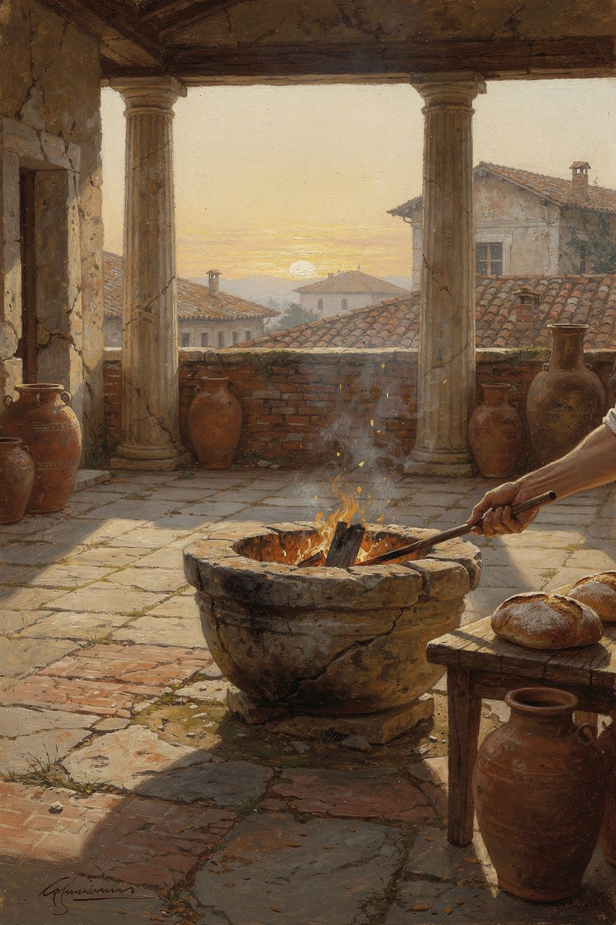
Illustration for Chapter 6
It is still dark when the emperor stirs. Outside the tent, the Danube moves silently past the legion’s camp, carrying the cold of a Germanic winter. The air smells of woodsmoke, leather, and horses. Somewhere beyond the river, tens of thousands of Marcomanni warriors are waiting for the thaw, waiting to test the frontiers of Rome again. Marcus Aurelius is fifty-two years old. His body, never robust, aches from years of campaigning. He has buried six children. The empire he serves is exhausted by plague and war. And yet, before he speaks to any general or reads any dispatch, he reaches for his wax tablets and begins to write—not orders, not decrees, but reminders to himself. The same reminders he wrote yesterday. The same ones he will write tomorrow.
We know this because the private notebooks that survived him—the Meditations—are full of repetition. The themes circle back again and again: the shortness of life, the need to rise and do the work of a human being, the importance of guiding the mind away from resentment and toward nature. This was not a failure of memory. It was a deliberate practice. Marcus understood something that most of us sense but rarely act on: the inner citadel does not stand on its own. It must be rebuilt each morning, stone by stone, thought by thought.
At dawn, when you have trouble getting out of bed, tell yourself: I have to go to work—as a human being. The line comes from the opening of Book V in Gregory Hays’s translation, and it is one of the most startlingly intimate moments in all of ancient philosophy. The emperor of the known world, a man whose waking hours would be consumed by petitions, trials, military briefings, and the fragile politics of a court full of ambitious senators, does not leap from his bed with heroic vigor. He has trouble getting out of bed. He wants to stay under the blankets. The voice in his head makes the same argument yours does: it’s warm here, it’s comfortable, the world outside is demanding and cold. And then he answers that voice with a question of purpose. What is it I was born for? To huddle under the covers? To avoid difficulty? No. I was born to do the work of a human being—to reason, to act for the common good, to accept what nature gives me. That is my job. And if I refuse to go to work, I am refusing my own nature.
This is not a pep talk. It is a rehearsal. Marcus is not trying to pump himself up with false enthusiasm; he is reminding himself of what he already knows to be true, because the truth has a way of evaporating overnight. Sleep resets the mind. The body wakes with its animal preferences intact: comfort, avoidance, the pull of least resistance. The philosophical self must be re-summoned, deliberately, every single morning. That is why the Meditations exist. They are not a book of conclusions. They are the script of a daily ritual.
The second quote often attributed to Marcus is a paraphrase, but it captures the engine behind the ritual: The happiness of your life depends upon the quality of your thoughts. If the citadel must be rebuilt daily, the quality of the bricks matters. A day built on thoughts of resentment, anxiety, or mindless distraction will be a fragile structure, ready to collapse at the first strong wind. A day built on thoughts aligned with nature—thoughts that accept what is, focus on what can be done, and hold mortality gently—will stand. The quality of a life is nothing more than the accumulated quality of its days. And the quality of a day is shaped in its first quiet minutes, when the mind chooses its posture toward the world.
———

The Big Idea: The Citadel Rebuilt Daily
The Stoics often used the image of an inner fortress. Marcus speaks of retreating to the soul’s “inner citadel,” a place where external events cannot breach the walls. But a citadel is not a natural formation; it is a work of engineering that requires constant maintenance. Rain erodes the mortar. Weeds crack the foundations. An unattended fortress becomes a ruin. Marcus’s daily writing was his inspection and repair of the walls.
Pierre Hadot, the great French scholar of ancient philosophy, argued that the Meditations are best understood as “spiritual exercises”—practices designed not to inform but to transform. Hadot showed that for Marcus, writing was a way of conducting an inner dialogue, of imprinting Stoic principles onto the living tissue of the mind. The repetition was essential because the goal was not intellectual mastery but the formation of a habit of attention. You do not learn to play the piano by reading a book about it once. You practice scales every day. Marcus practiced the scales of the soul: the acceptance of nature, the clarity of purpose, the readiness to die. These three themes form the foundation of a good day and, by extension, a good life.
Acceptance of nature is the first wall. Marcus means something specific by “nature”: the rational order of the whole, the interconnected web of cause and effect that includes both the blooming of a rose and the betrayal of a friend. To accept nature is not to be passive. It is to stop arguing with reality. When something happens that you did not wish for, the mind’s first reflex is to protest: this should not be. That protest is the source of most human misery. Marcus trains himself to meet every event with the same phrase: “You have come into being for me.” The illness, the difficult colleague, the traffic jam, the sudden loss—each is raw material for the work of being human. The citadel is not a place to hide from the world; it is a place from which to see the world clearly, without the fog of complaint. Each morning, Marcus rehearses this seeing. He reminds himself that today he will meet busybodies, ingrates, the violent, the treacherous—and that he cannot be harmed by them if he does not let his own thoughts injure him. This is not optimism. It is a disciplined refusal to add a second layer of suffering on top of the first.
Attention to purpose is the second wall. Marcus asks himself at dawn: what is the work of a human being? His answer is not a job title. It is a function. A human being is a rational and social animal. The work is to act according to reason and for the sake of the whole. Every profession, from emperor to street-sweeper, can be done with this purpose or against it. The purpose is not to achieve a particular outcome—outcomes are often outside our control—but to act with justice, temperance, courage, and wisdom in whatever situation we find ourselves. Marcus calls this “doing the work of a human being” and he returns to it daily because the world will constantly offer him other definitions of work: accumulating wealth, winning approval, defeating rivals, securing comfort. Those definitions are seductive and exhausting. The morning rehearsal re-centers him on the only work that is truly his.
Willingness to die well is the third wall, and it is the one that modern readers often want to skip. But for Marcus, it is inseparable from the other two. If you cannot accept your own mortality, you cannot fully accept nature, because death is nature’s most non-negotiable event. If you do not know what your purpose is, you cannot know whether you have fulfilled it, and the fear of dying with unfinished business will haunt you. Marcus rehearses his death every morning not out of morbidity but out of a desire for freedom. He tells himself: I could die today. The barbarian could break through. The fever could return. The bread could be poisoned. And if I die, what matters? Only that I die as a human being—without panic, without bitterness, having done the work that was mine to do. This thought, far from depressing him, lightens everything. It strips away the trivial. It makes the warmth of the blankets less seductive, because the day ahead might be the last chance to act with virtue. The willingness to die well is the ultimate quality control for the day’s thoughts.
Modern cognitive behavioral therapy (CBT) echoes this structure in a secular, clinical idiom. CBT teaches that emotional distress is often the product of automatic negative thoughts—cognitive distortions that arise unbidden and shape our mood and behavior. The therapeutic response is to catch those thoughts, examine them, and replace them with more balanced, reality-based cognitions. This is strikingly similar to Marcus’s morning practice. He catches the thought that staying in bed is good, examines it against his understanding of human nature, and replaces it with the thought that rising to do his work is good. He catches the thought that a difficult person is an enemy, examines it against the Stoic view of shared rationality, and replaces it with the thought that this person is a partner in the same human project, however misguided. The Meditations are, in a sense, a daily thought record kept by the most powerful man in the world.
But Marcus goes deeper than symptom management. CBT aims to relieve distress; Marcus aims to live in harmony with the cosmos. His rehearsal is not just about correcting errors but about orienting the entire self toward wisdom and love of fate. He is not merely adjusting his cognitions; he is practicing his death, his purpose, his place in the whole. This is philosophy as a way of life, not a technique for feeling better. And it requires the same kind of daily repetition that any way of life requires. A gardener does not pull weeds once and expect the garden to stay clean forever. A fire does not stay lit without new fuel. The mind’s clarity is a fire that must be kindled each morning.
———

Practice: The Daily Rehearsal in Your Own Life
You are not an emperor. You do not command legions or carry the weight of an empire. But you do wake up with the same animal reluctance, the same fog of half-formed anxieties, the same gravitational pull toward the phone screen and the snooze button. The structure of the morning struggle is universal. The practice Marcus used can be adapted to any life, and it does not require wax tablets or a tent on the Danube. It requires a few minutes of deliberate attention before the day’s noise takes over.
The Morning Address. Before you get out of bed—or as soon as your feet touch the floor—speak to yourself. Use your own words, but let them carry the same three questions Marcus asked: What is my nature? What is my work today? What if this day is my last? You might say something like this: I am a human being, built to reason and to care. My work today is to act with patience, honesty, and attention, whatever comes. I do not know if I will see tomorrow, so let this day be complete in itself. Say it aloud or in the quiet of your mind. The point is not the exact phrasing but the act of taking the helm before the currents of habit take it for you. Do this every morning for a week and notice what changes. The mind begins to expect the rehearsal. The citadel starts to hold its shape a little longer.
The Premeditation of Obstacles. Marcus often practiced premeditatio malorum—the premeditation of difficulties. After your morning address, take a moment to scan the day ahead. What challenges are likely to arise? A tense meeting, a difficult conversation, a tedious task, a moment of loneliness or frustration? Picture each one briefly and apply your morning principles to it in advance. In that meeting, I will listen before I speak. In that conversation, I will remember that the other person is not my enemy but a fellow human being struggling with their own perceptions. In that tedious task, I will treat it as an opportunity to practice patience and attention. This is not pessimistic rumination. It is a dress rehearsal for virtue. By anticipating the hard moments, you reduce their power to surprise you into reactivity.
The Midday Pause. The morning rehearsal is powerful, but the citadel can still be breached by noon. Set a reminder on your phone or watch for a moment around midday. When it chimes, stop whatever you are doing for thirty seconds. Take three conscious breaths. Ask yourself: What is the quality of my thoughts right now? Am I still doing the work of a human being, or have I slipped into autopilot, resentment, or distraction? If you have slipped, do not scold yourself. Simply re-state your morning commitment and return. This is the repair crew sent out to patch the walls before the damage spreads.
The Evening Review. Marcus does not describe a formal evening practice in the surviving notebooks, but the Stoic tradition, going back to Pythagoras and Seneca, includes a nightly examination of the day. Before you sleep, replay the day in your mind like a film. Ask three questions: What did I do well today? Where did I fall short of my nature? What will I do differently tomorrow? Seneca describes this as a gentle accounting, not a trial. The goal is not guilt but learning. If you lost your temper, do not berate yourself; simply note the trigger and resolve to rehearse that scenario in tomorrow’s premeditation. If you acted with unexpected kindness, acknowledge it and let it strengthen your sense of what is possible. The evening review closes the loop, turning the day’s raw experience into material for the next morning’s rehearsal.
The Weekly Citadel Inspection. Once a week, perhaps on a Sunday evening or a quiet morning, take a longer look at the state of your inner fortress. You might use a journal for this. Ask: Which thoughts have been occupying the most space this week? Have they been thoughts of acceptance, purpose, and readiness, or thoughts of complaint, avoidance, and fear? What is the overall quality of my inner life? Write down one insight and one intention for the coming week. This is not about productivity or goal-setting. It is about the architecture of your days. A life is built from days, and days are built from thoughts. The weekly inspection ensures that the builder is still awake.
These practices are simple, but simplicity is not ease. The forces that pull the mind away from its nature are relentless. The culture around you will constantly offer other definitions of a good day: a day of maximum pleasure, maximum output, maximum approval. Marcus’s rehearsal is a quiet rebellion against those definitions. It is a daily choice to define a good day differently—as a day spent in harmony with your own deepest nature, accepting what comes, doing the work of a human being, and holding your mortality as a companion rather than a terror.
———

A Reflective Prompt
Tomorrow morning, before you reach for your phone or begin the familiar argument with the alarm clock, pause. Feel the weight of your body in the bed. Feel the boundary between sleep and the world. And then, in your own words, answer this: What is the work of a human being today, and am I willing to do it as if it were my last? Let that answer be the first stone you place in the citadel. Then place another one the next morning. And the next. The fortress will not build itself. But you are the builder, and the day is full of raw material, and the work is exactly what you were born for.
———

For the Grown-Up Reader
This booklet adapts Marcus Aurelius's Meditations and the scholarly commentary of Pierre Hadot, R. B. Rutherford, and Tad Brennan. Key passages are cited by book and section using translations by Gregory Hays and A. S. L. Farquharson.
If a child asks, 'Did Marcus really write this?' the answer is yes—he wrote the Meditations as private notes to himself. They were not intended for publication, which is one reason they sound so honest.
———

About WisdomForge
WisdomForge adapts the great philosophers into stories, audio, and conversation for every age. Each philosopher becomes four booklets—one for children, one for teens, one for older adolescents, and one for adults—so the same ideas can grow with you.

