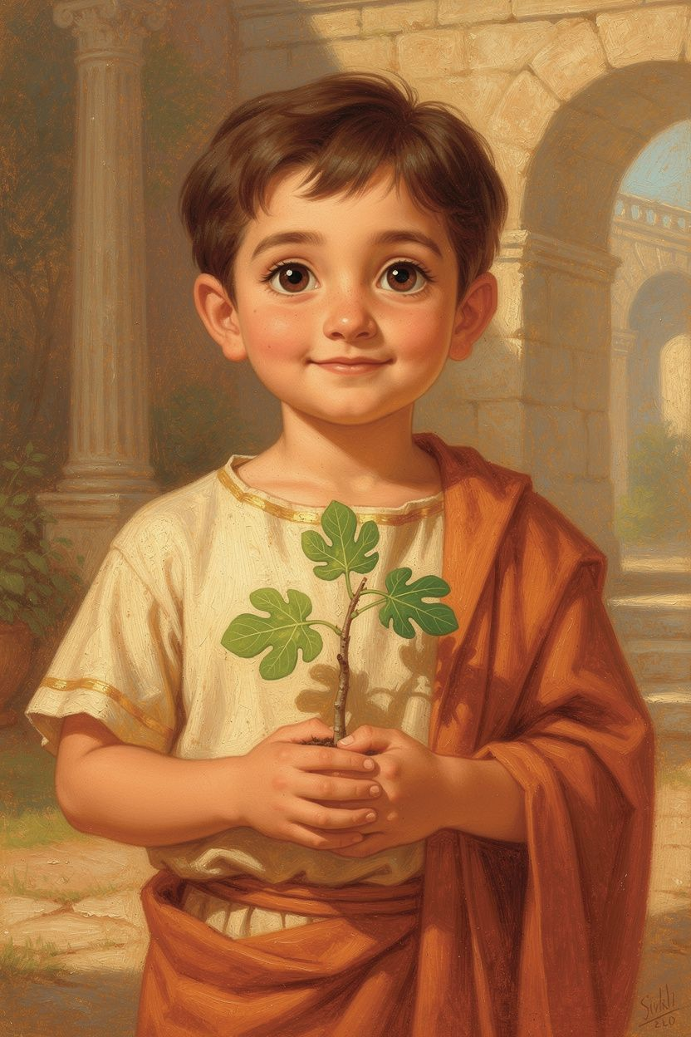
Marcus: The Boy with a Castle Inside
WisdomForge Booklet — Ages 5–10

Marcus: The Boy with a Castle Inside

WisdomForge Booklet — Ages 5–10
———

About This Book
This booklet tells the story of Marcus Aurelius, a Roman boy who grew up to become emperor—and who kept a private notebook of reminders to help him stay kind, brave, and calm. The lessons he wrote down almost 2,000 years ago still help kids today.
You will meet a boy who plants trees, guards an inner castle, learns three keys for hard days, watches bees, tends a fire, and practices rising with purpose. The stories are gentle. The ideas are strong. They are meant to be lived, not only heard.
Each chapter has a story, words to remember, a big idea, things to try, and a question for a grown-up. Read it alone or with a parent or teacher. The questions aren't tests—they're starting points for conversations that can last longer than the booklet itself.
———

Chapter 1: The Boy Who Became Emperor
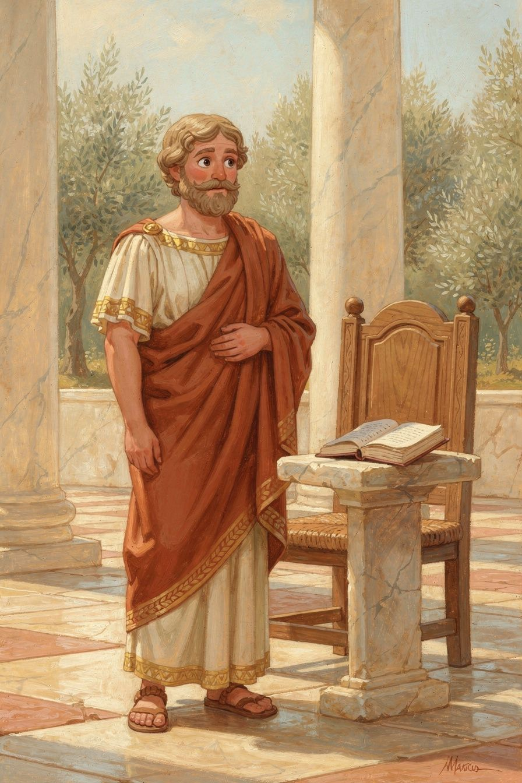
Illustration for Chapter 1
Long before he wore the purple robes of an emperor, Marcus was just a boy with serious eyes and a quiet voice. He lived in a sunny villa on a hill outside Rome, where bees hummed in the lavender and olive trees cast silver-green shadows on the ground.
He was not the loudest boy in the courtyard. He was the one who noticed when a bird’s nest had fallen, when a younger child needed a hand, when a promise needed keeping. Grown-ups sometimes said he was “old for his years.” What they meant was that he practiced caring on ordinary days, when no one was awarding prizes.
One morning, when Marcus was about eight years old, his grandfather gave him a small, spindly fig tree to plant. “This tree is your responsibility now,” his grandfather said. “Not mine. Not the gardener’s. Yours.”
Marcus dug the hole himself, his hands clumsy with the heavy trowel. He set the little tree in the earth, patted the soil around its roots, and watered it carefully. Every day after his lessons, he visited his fig tree. He checked its leaves for curling. He pulled away weeds that crept too close. He watched for ants and gently brushed them off. He did not do this because someone was watching. He did it because the tree was his, and he had given it his word.
One hot summer week, the family traveled to the seaside. Marcus worried about his tree the whole time. When they returned, he ran straight to the garden. The fig tree stood strong, its leaves a deeper green, a tiny new branch reaching sideways like a hand opening. Marcus exhaled. He had prepared the soil so well, and the tree had drawn on that deep care while he was away.
That evening, his grandfather sat beside him. “You see, Marcus? You did the work before the heat came. That is the secret. A good man does not wait for the storm to decide who he will be. He builds his roots in the quiet days.”
Marcus nodded. He did not fully understand yet, but the words settled into him like seeds into soil.
Years passed. Marcus studied with the finest teachers in Rome, learning history, philosophy, and how to govern. He was adopted into the imperial family, not because he asked for it, but because others saw his steady character. When the throne came to him, he did not grab it with excitement. He received it the way a tree receives the weight of snow—with deep roots already grown.
Words to Remember Waste no more time arguing about what a good man should be. Be one. — Marcus Aurelius
Big Idea You don’t have to wait until you’re grown up to build your character. Every time you keep a small promise, help without being asked, or do the right thing when no one is looking, you are growing strong roots inside yourself. Those roots will hold you steady when hard days come.
Try This - Plant a promise. Think of one small, kind thing you can do every day this week—like watering a plant, feeding a pet, or saying something encouraging to a friend. Do it faithfully, even when you don’t feel like it. Notice how it feels to be someone others can count on. - Draw your roots. On a piece of paper, draw a tree with deep roots underground. On each root, write or draw one good habit you are growing now (sharing, telling the truth, practicing patience). Hang it somewhere you can see it. - Breathe like a steady tree. Sit tall and imagine you are a strong tree. Breathe in slowly, feeling your roots sink deep into the earth. Breathe out, feeling your branches reach calmly toward the sky. Repeat three times whenever you feel wobbly inside.
Ask a Grown-Up “What is one small, quiet habit you built when you were young that still helps you today?”
———

Chapter 2: The Castle in Your Heart

Illustration for Chapter 2
Marcus stood at the edge of the garden, his fists clenched. His friend Lucius had just laughed at him for tripping during their race. “Slow as a snail!” Lucius had shouted, and the other boys had giggled.
It is a hard feeling, the heat that rises when someone makes you small. Your face warms. Your feet want to run or fight. Marcus knew that feeling. What he was learning—slowly, like learning to write—was that a feeling can visit without becoming the boss of the whole day.
Marcus felt a hot, tight knot in his chest. He wanted to shout back, or run home and hide. Instead, he sat under the old olive tree and closed his eyes, the way his grandfather had taught him.
“Imagine,” Grandfather had said, “that inside you is a great castle. Its walls are strong and tall, made of golden stone. The sun always shines on its towers. In the center of this castle is a calm, wise king—that’s the real you. The king decides who enters.”
Marcus breathed slowly. In his mind, he saw the castle. He saw the heavy wooden gate and the drawbridge over a quiet moat. Outside the walls, the words of Lucius were like a gust of wind, rattling the gate. Slow as a snail. The wind pushed and whistled, but it was just air. It had no sword, no battering ram. It could only get inside if the king lowered the bridge and opened the door.
Marcus, the king, stood at the gate. He watched the wind swirl. He felt the sting, but he also saw the truth: he had tripped, but that didn’t make him a snail. A snail was a snail. He was Marcus. The wind was just a noise. He chose not to open the gate. The hot knot in his chest began to cool. The castle remained peaceful, full of light.
He opened his eyes. Lucius was still laughing, but Marcus didn’t feel the same sting. He stood up, dusted off his tunic, and walked back to the race. “I’ll try again,” he said calmly. “Everyone trips sometimes.” Lucius looked surprised, then shrugged. The game went on.
Later, Marcus wrote a note to himself, a secret to remember: “The things outside my mind cannot harm it unless I let them. My castle is my own.”
———
Words to Remember “Take away your opinion, and there is taken away the complaint, ‘I have been harmed.’” —Marcus Aurelius
———
Big Idea You have a castle inside you—your mind and heart. Things people say or do are like weather outside the walls. They can only truly hurt you if you believe they can and let them storm inside. You are the keeper of the gate. This isn’t about hiding; it’s about standing strong so you can keep being kind and brave, no matter what happens around you.
———
Try This 1. Draw Your Inner Castle. On a piece of paper, draw a castle with strong walls, a gate, and a peaceful garden inside. Outside, draw things that sometimes bother you—like harsh words, mistakes, or worries—as clouds, wind, or noisy birds. Now draw yourself as the gatekeeper, deciding what comes in. 2. Practice the Pause. Next time someone says something that stings, take three slow breaths before you react. Imagine your castle gate staying closed. Then ask yourself: Is this true? Do I need to let it in? You can still speak up for yourself, but from a calm place inside. 3. Be a Castle Builder for Others. When a friend or sibling is upset, remind them quietly: “You have a castle too. You don’t have to let that hurt inside.” Help them find their own gatekeeper.
———
Ask a Grown-Up “Can you tell me about a time you felt hurt by something someone said, but you chose not to let it ruin your day? How did you keep your inner castle strong?”
———

Chapter 3: Three Magic Keys
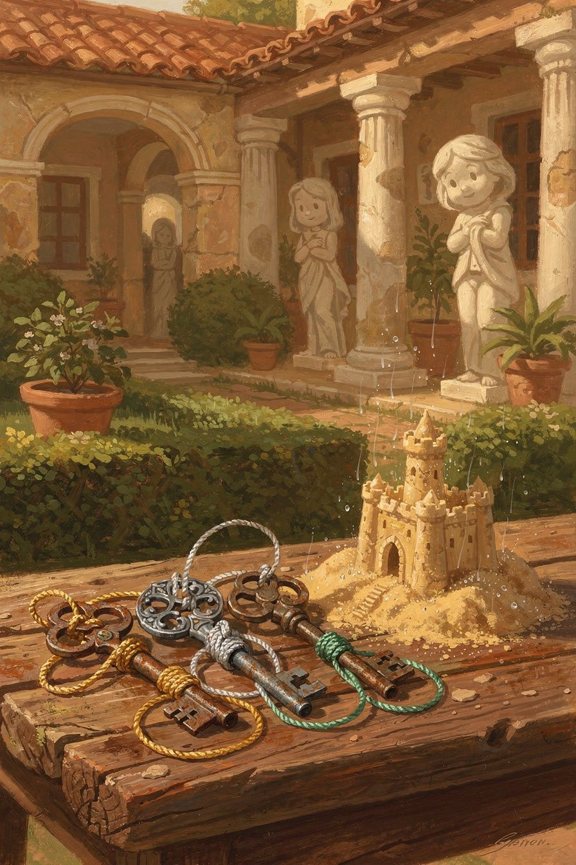
Illustration for Chapter 3
One morning, young Marcus ran into the garden with a wooden bucket and a plan. He would build the greatest sandcastle the world had ever seen—tall towers, a moat, and a flag made from a twig and a leaf. He worked with all his heart, patting the damp sand into shape, humming a little tune the gardener had taught him.
He loved making things. Making things is a kind of hope: you believe the next tower will stand, the next flag will catch the breeze. That is why it hurts so much when rain arrives. It is not only sand that melts. It is the picture in your mind of what you wanted the afternoon to be.
Then the sky rumbled. A sudden rainstorm swept over the hill, fat drops falling faster and faster. Marcus tried to shield his castle with his body, but the rain laughed at his efforts. Towers melted, the moat vanished, and the leaf-flag washed away. Marcus stood dripping, his hands clenched, hot tears mixing with the cool rain.
The old gardener found him there, soaked and furious. “It’s not fair!” Marcus cried. “The storm ruined everything!”
The gardener knelt beside him and opened a worn leather pouch. Inside, three small iron keys glinted, each tied with a different colored string: gold, silver, and green.
“These are magic keys,” the gardener said gently. “They don’t open doors. They open something much more important. Your grandfather used them, and his grandfather before him. Would you like to learn their names?”
Marcus sniffled and nodded.
The gardener held up the key with the gold string. “This is the Key of Thankful Heart. It reminds us to accept what nature gives—even rain. The storm didn’t come to hurt you. It came to water the garden. Without it, the roses would droop and the olive trees would thirst. When we stop fighting what already is, we find our first strength.”
He handed Marcus the key with the silver string. “This is the Key of Clear Eyes. It teaches us to look at our thoughts before we believe them. You thought, ‘The storm ruined my fun, so the whole day is ruined.’ But is that true? The storm brought you cool air, a chance to splash in puddles, and a story to tell. The hurt wasn’t in the rain—it was in the judgment your mind made. You have power over that judgment.”
Finally, the gardener lifted the key with the green string. “And this is the Key of Willing Hands. It turns our strength outward. When you feel upset, ask yourself: What good can I do right now? Maybe you can help me carry water to the young beans, or hold the basket while I gather snails from the lettuce. Acting for the good of the whole garden heals a stormy heart faster than any anger.”
Marcus turned the three keys over in his palm. They felt warm, as if they had been waiting for him. He looked at the ruined sandcastle and, for the first time, smiled. “The beans need water,” he said. “Can I help?”
The gardener laughed. “You already have the keys in your hand.”
Words to Remember “You have power over your mind—not outside events. Realize this, and you will find strength.” — Marcus Aurelius
Big Idea You can’t control the rain, but you can choose how you meet it. When something feels hard, use three inner keys: accept what nature brings, check your thoughts before you believe them, and do a small kindness for someone nearby. That’s where your real power lives.
Try This Draw your own three magic keys on a piece of paper and color their strings gold, silver, and green. Next time you feel a stormy emotion, take three slow breaths and imagine holding the Key of Clear Eyes—ask yourself, “Is my thought about this completely true?” Then look for one tiny way to use your Willing Hands, like tidying a shared space or saying something encouraging to a friend. Notice how your feelings shift when you act for the good of the whole.
Ask a Grown-Up “Can you tell me about a time when something outside your control went wrong, and you used your inner power to stay calm and help others?”
———

Chapter 4: The Whole World Is Family
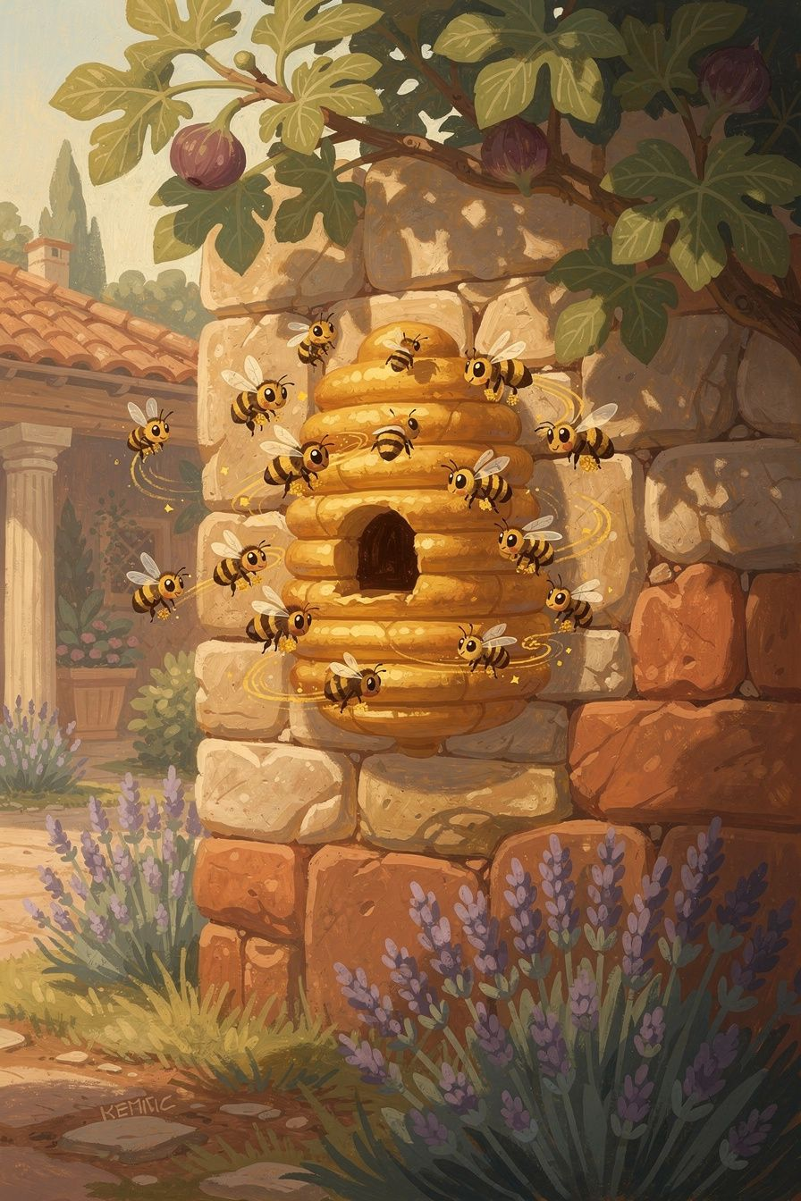
Illustration for Chapter 4
When Marcus was a little boy, he loved to visit his grandfather’s villa on the Caelian Hill. The garden there was a world of its own—fig trees, lavender, and a crumbling stone wall where the bees had built their city. Marcus would sit for hours, watching them come and go, each one carrying a tiny golden grain of pollen.
He learned the names of flowers the way other children learned the names of toys. He learned that a garden is not one plant winning. It is many living things sharing sun and water. That lesson would follow him all the way to the throne, when he had to care for a city of people he would never meet.
One afternoon, he noticed a bee that seemed to be fighting with the others. It pushed and shoved at the entrance to the hive, trying to keep a smaller bee from coming in. The little bee finally squeezed past, but the angry bee stayed outside, buzzing furiously. Later, Marcus found that same bee lying still on the ground.
His grandfather, who had been pruning the roses, knelt beside him. “What happened to it?” Marcus asked.
“It forgot the first rule of the hive,” his grandfather said. “A bee can only be well when the hive is well. If it works against the hive, it works against itself. What is not good for the swarm is not good for the bee.”
Marcus looked at the quiet bee and then at the hive, where thousands of sisters were still dancing their quiet, busy dance. He never forgot that afternoon.
———
Words to Remember “What is not good for the swarm is not good for the bee.” — Marcus Aurelius
———
Big Idea Marcus saw that all people are connected like the parts of one body. Your hands don’t fight your feet; your eyelids don’t refuse to blink for your eyes. We are made to help each other. When you do something good for the people around you, you are doing something good for yourself, too. When you hurt someone else, you hurt the whole body—and that includes you. This isn’t just a nice feeling; it’s how the world really works. We are one big family, and we take care of each other because that’s what keeps us all strong.
———
Try This 1. Draw the Hive of You – On a piece of paper, draw a beehive with lots of little cells. In each cell, write or draw a way you help your family, your classroom, or your neighborhood (like sharing, listening, or picking up litter). See how your small actions fill the whole hive with sweetness. 2. Body Team Game – With a friend or grown-up, pretend you are different parts of one body. One person is the feet (walking carefully), one is the hands (picking up toys), one is the eyes (looking out for obstacles). Try a simple task together, like carrying a book across the room. Notice how you need each part to succeed. 3. Breathe Together – Sit back-to-back with someone you trust. Close your eyes and breathe slowly. Feel your backs rise and fall together. Imagine that the same air is filling both of you, like one big pair of lungs. When you’re ready, open your eyes and share one word that describes how it felt.
———
Ask a Grown-Up “Can you tell me about a time when someone helped you, and it made you feel stronger—not just happier, but actually stronger?”
———

Chapter 5: Even When Things Hurt
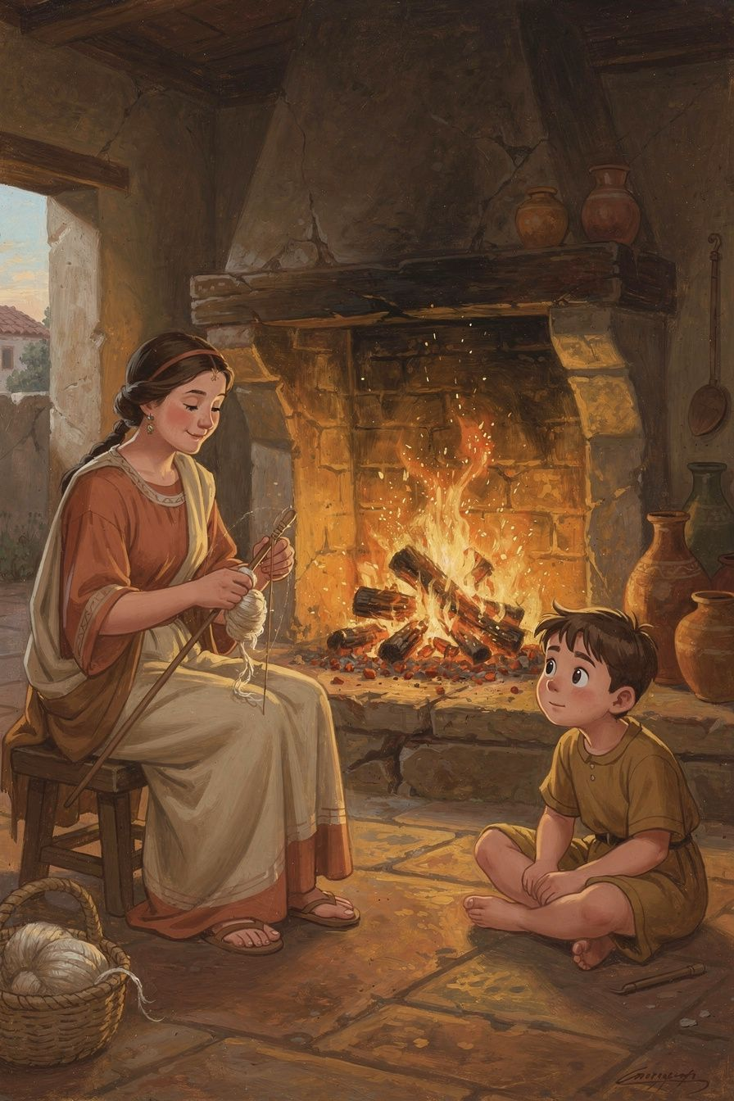
Illustration for Chapter 5
One warm afternoon in the countryside villa, eight-year-old Marcus sat on the stone floor, watching the hearth fire dance. His mother, Domitia Lucilla, was nearby, spinning wool. Marcus had been running through the garden earlier, and now his foot throbbed where he’d stubbed it on a root. He was about to whine and complain, but the fire held his gaze.
Hurt is honest. It says, Something happened. Whining is optional. Whining is the extra story we pile on top: Why me? It’s not fair! The whole day is ruined! Marcus’s mother wanted him to feel the hurt without turning it into a second, heavier bag to carry.
His mother noticed his frown. “Does your foot hurt, little philosopher?”
Marcus nodded, biting his lip. “It’s not fair. I was just playing.”
Domitia Lucilla knelt beside him and pointed to the flames. “Look at the fire, Marcus. It doesn’t care what falls into it—a dry twig, a wet leaf, even a dirty old rag. It takes each thing and turns it into light and warmth. It never complains that the twig is too small or the rag is too dirty. It just burns brighter.”
Marcus watched a log crumble into glowing embers. “But my foot isn’t a log,” he said.
“No,” his mother smiled, “but your mind is like that fire. When something painful happens, you can let it be just a hurt foot. Or you can throw in anger and complaints—It’s not fair! Why me?—and then you have a hurt foot and a heart full of smoke. The fire doesn’t add anything. It simply takes what comes and rises above it.”
Marcus thought about that. He wiggled his sore toes and decided not to add any extra smoke. The throbbing was still there, but somehow it felt smaller.
Years later, when Marcus was a grown man leading soldiers through cold, muddy lands, he remembered that lesson. He faced sickness, lost dear friends, and saw many hard things. But he kept a little fire burning inside. He wrote down a secret for himself, one that now belongs to all of us.
Words to Remember: “A fire takes hold of whatever falls into it and rises higher. So too the intelligent power takes hold of whatever happens and makes it its own.” — Marcus Aurelius
Big Idea Pain is like a log thrown into your inner fire. You can’t always stop hard things from happening, but you can choose not to add extra logs of anger, fear, or complaining. When you meet hurt calmly, you turn it into strength and light, just like a fire does.
Try This - Next time something small hurts—like a stubbed toe or a disappointment—pause and notice the feeling. Say to yourself, “This is just a log. I don’t have to throw in more logs.” See if the hurt passes more quickly. - Draw a bright fire with logs that have words like “sadness” or “frustration” written on them. Above the fire, draw the light and warmth those feelings can become when you don’t fight them. - Practice a breathing exercise: breathe in slowly and imagine the hurt as a log landing in your inner fire. Breathe out and picture it turning into glowing, peaceful light.
Ask a Grown-Up “Can you tell me about a time when something hurt, but you didn’t let it make you angry or sad for too long? How did you do that?”
———

Chapter 6: Morning Fire
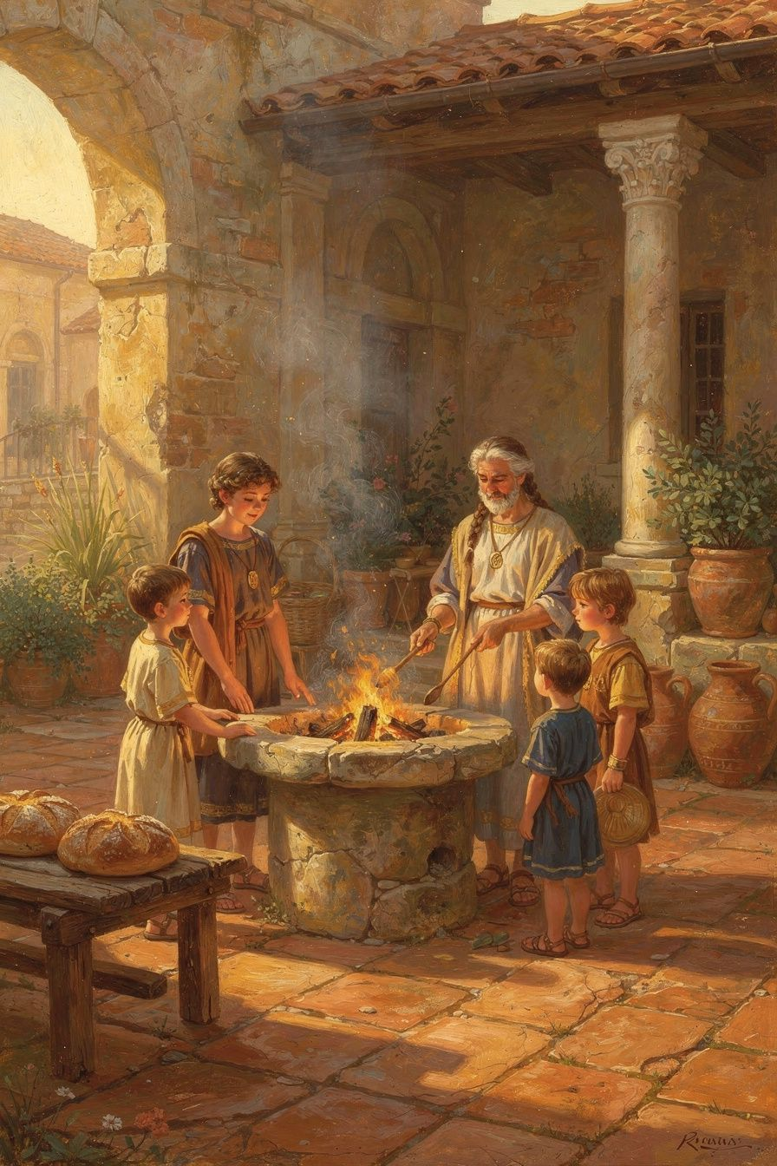
Illustration for Chapter 6
The morning air was cold, and young Marcus pulled his blanket tighter. Outside, the sky was still dark blue. He did not want to leave his warm bed. But he heard his mother moving quietly in the next room, stirring the embers in the hearth. Soon the smell of baking bread drifted in, and he knew the house fire had been brought back to life.
Every house that stays warm has a morning worker—someone who does not wait for perfect feelings before starting the day. Courage is often not a roar. It is bare feet on a cool floor, and the decision to begin again.
One winter morning, his mother let him help. She showed him the ashes from last night’s fire. “Look,” she said, “the flame is gone, but a tiny spark is still hiding under the grey. If we blow gently and add a dry twig, the fire wakes up. We have to do this every morning, or the house stays cold.”
Marcus watched the spark catch, grow into a flame, and then a cheerful blaze. He thought about how each day needed its own fire. The good warmth from yesterday was already ash. If he wanted light and heat today, he had to tend the spark again.
Years later, when he was a grown man with many duties, he still remembered that lesson. Some mornings he felt heavy and slow. His mind whispered, Stay under the covers. It’s too hard. But he would sit up and say to himself what he later wrote down:
“At dawn, when you have trouble getting out of bed, tell yourself: I have to go to work—as a human being.”
He didn’t mean just chores. He meant the work of being kind, paying attention, and doing what the day asked with a steady heart. That was his inner fire. It had to be rebuilt each morning, like the hearth.
———
Words to Remember “At dawn, when you have trouble getting out of bed, tell yourself: I rise to do the work of a human being.”
———
Big Idea Every morning is a fresh start. The strength and goodness you had yesterday are like a fire that needs new fuel. You can choose to blow on the spark inside you—your thoughts, your purpose—and build a warm, bright day. A good life is made of many mornings like this.
———
Try This 1. Draw your morning fire. On a piece of paper, draw a small spark. Around it, draw the “twigs” that help you start the day—maybe a stretch, a kind word, a deep breath, or thinking of something you’re excited about. Color the flame as it grows. 2. Practice a dawn breath. Tomorrow morning, before you jump out of bed, take three slow breaths. With each breath, whisper: I rise to do my human work. Notice how it feels to start the day on purpose. 3. Act out building a fire. With your hands, pretend to gather sticks. Name each stick: courage, curiosity, kindness. Stack them carefully. Then blow gently on your “fire” and feel your body wake up, ready to share warmth.
———
Ask a Grown-Up “What helps you get up in the morning and do your best?”
———

For the Grown-Up Reader
This booklet adapts Marcus Aurelius's Meditations and the scholarly commentary of Pierre Hadot (The Inner Citadel), R. B. Rutherford, and Tad Brennan. Key passages draw on translations by Gregory Hays and A. S. L. Farquharson. The three “keys” in Chapter 3 are a child-facing image of the classic Stoic disciplines (desire, assent, and action) as Hadot presents them.
If a child asks, “Did Marcus really write this?” the answer is yes—he wrote the Meditations as private notes to himself. They were not intended for publication, which is one reason they sound so honest. The fig tree, bees, and hearth stories are narrative frames for real themes in the Meditations; the quotations are real.
Use the “Ask a Grown-Up” questions as doorways, not quizzes. The goal is shared practice: noticing what we control, what we add to pain with our stories, and how we show up for the people around us.
———

About WisdomForge
WisdomForge adapts the great philosophers into stories, audio, and conversation for every age. Each philosopher becomes four booklets—one for children, one for teens, one for older adolescents, and one for adults—so the same ideas can grow with you.

