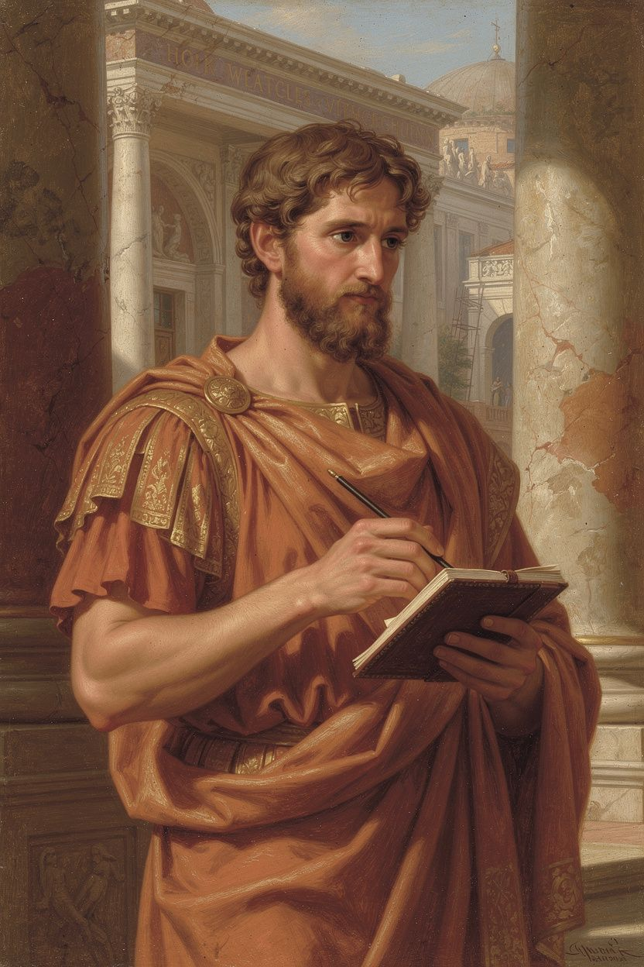
Marcus: Notes from the Frontier
WisdomForge Booklet — Ages 15–18

Marcus: Notes from the Frontier

WisdomForge Booklet — Ages 15–18
———

About This Book
Marcus Aurelius wrote the Meditations in military camps on the Danube frontier while fighting barbarian invasions and managing a plague that killed millions. He was an emperor, but his notebook is private, self-questioning, and strikingly modern.
This booklet reads Marcus as a philosopher of agency and duty. Each chapter takes one theme—identity, the inner citadel, the three disciplines, cosmopolitanism, adversity, daily practice—and develops it through historical narrative, direct quotation, and practical exercises.
———

Chapter 1: The Reluctant Emperor
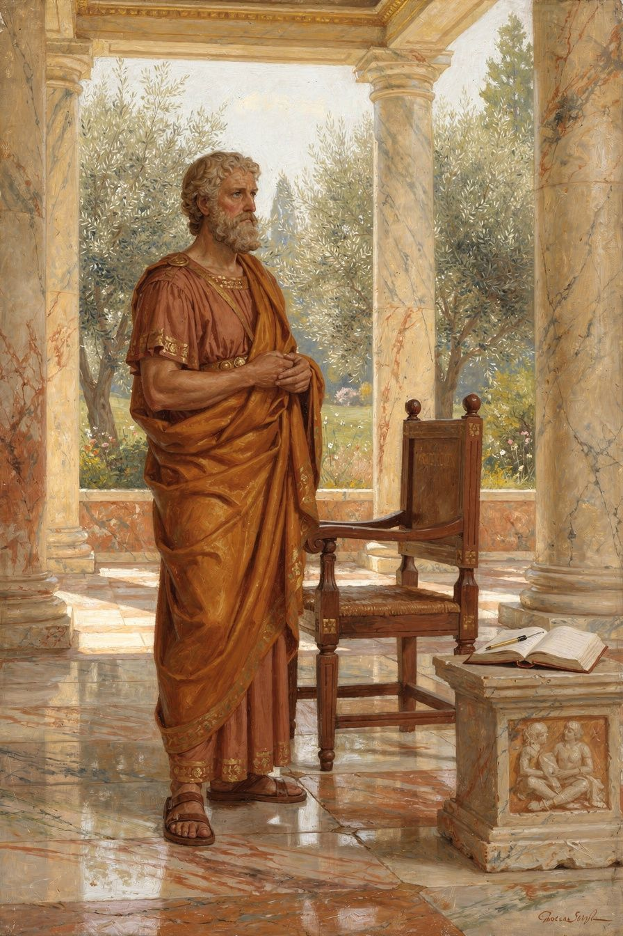
Illustration for Chapter 1
You know the feeling. Your phone buzzes with another notification—a grade posted, a message from a parent, a friend’s curated success story. The world seems to be handing you a script: achieve this, attend that, become someone impressive. The pressure hums in the background like a motor you can’t switch off. You didn’t ask for the role, but here you are, expected to perform it flawlessly.
Now imagine that pressure scaled to an empire. Imagine that your adoptive father is the most powerful man in the world, and he is quietly, methodically preparing you to replace him. Not because you campaigned for it. Not because you crave the throne. But because a chain of events—a dying emperor, a political adoption, a sense of duty—placed you next in line. This was the life of Marcus Aurelius, and he never stopped reminding himself that the throne was not a prize but a responsibility. He became emperor reluctantly, and that reluctance shaped everything he wrote.
Marcus Annius Verus was born in 121 CE into a wealthy Roman family with deep connections to the imperial court. His grandfather had been consul three times. His aunt was married to the future emperor Antoninus Pius. From his earliest years, Marcus was surrounded by privilege, but also by a culture of serious education. The emperor Hadrian took a peculiar interest in the boy, nicknaming him Verissimus—“most truthful”—and personally overseeing his upbringing. When Hadrian’s first adopted heir died unexpectedly, he arranged a chain of adoptions: Antoninus Pius would succeed him, and Antoninus would in turn adopt Marcus (then seventeen) and another young man, Lucius Verus. It was a long-term engineering project for the empire’s stability, and Marcus was its central component.
He did not resist. He did not celebrate. He simply moved into the imperial palace and began training for a job he never applied for. His education intensified under the finest tutors in rhetoric, law, and philosophy. He slept on a hard floor until his mother begged him to use a simple cot. He wore the rough cloak of a Stoic student while his peers chased pleasures. He was building something inside himself, a kind of inner architecture that could bear any weight. Years later, when he finally became emperor at age forty, he would write in his private journal: “Receive without conceit, release without struggle.” The throne came to him; he accepted it without puffing up. He knew it would one day leave him; he resolved to let it go without clinging. That quiet steadiness was not a natural gift. It was a skill he had practiced long before the crisis arrived.
Marcus’s journal—the book we now call Meditations—was never meant for publication. It was a personal drill ground, a place where he exhorted himself to live up to his own standards. One entry captures the urgency of that self-training: “Waste no more time arguing about what a good man should be. Be one.” He wasn’t writing a philosophical treatise for an audience. He was talking to himself at the end of a long day, perhaps after judging a legal case, receiving bad news from the frontier, or dealing with a difficult senator. The tone is earnest, almost impatient. Stop debating the theory. Do the work. Become the thing you admire.
This is the core of Marcus’s early life: character is not forged in the emergency room. It is built in the ordinary days before the accident. The firefighter’s courage is not invented when the alarm sounds; it is laid down in thousands of smaller choices—showing up for drills, maintaining equipment, studying fire behavior. Marcus understood that his own “alarm” would sound one day, and when it did, he would need to act from deep habit, not from panic. So he trained his mind the way an athlete trains muscle memory.
His teachers were some of the sharpest minds in Rome. Junius Rusticus introduced him to the works of Epictetus, the former slave whose Stoic lectures became Marcus’s moral compass. Marcus later thanked Rusticus for lending him his personal copy of Epictetus’s discourses, a gesture that changed the young man’s inner life. From Apollonius he learned independence and how to balance reason with intuition. From Sextus of Chaeronea, a grandson of Plutarch, he absorbed kindness and the art of living according to nature. These mentors did not just fill his head with facts; they modeled a way of being. Marcus watched them handle frustration, criticism, and fatigue. He noted how they treated servants and strangers. He was, in effect, apprenticing to master craftsmen of character.
The Stoic term for this inner citadel is prohairesis—roughly, our faculty of choice, the part of us that decides what to value and how to respond. Marcus learned that while he could not control who his father was, whether wars would erupt, or how others would judge him, he could control his prohairesis. He could choose to see the throne as a burden to carry well rather than a trophy to defend. He could choose to interpret a senator’s insult as a test of patience rather than a wound to his pride. This was not passive resignation. It was an active, daily reorientation of his will.
Modern life offers its own thrones. You may not inherit an empire, but you inherit expectations: a family legacy, a academic track, a social identity. The pressure to become “someone” can feel like a script written by others. Marcus’s story suggests a different path. You can accept the role without letting it define your worth. You can prepare for the demands of that role by building habits of mind now—when the stakes are lower, when the crisis is still hypothetical. The exam you’ll face next year, the leadership position you might hold, the grief that will inevitably come: these are future alarms. The time to train is today.
The Big Idea: The Inner Fortress Before the Storm
Stoicism teaches that external events are indifferent—not because they don’t matter, but because they don’t determine your character. Health, wealth, reputation, even the imperial throne: these are materials for virtue, not sources of it. Marcus called them things not in our control and insisted that our true good lies only in our reasoned choices. The Greek word eudaimonia—often translated as happiness or flourishing—meant for the Stoics a life of excellent activity, a garden grown from your own decisions rather than a weather-dependent crop.
Marcus’s early life illustrates a crucial principle: character is built before crisis arrives. He didn’t wait until he was emperor to ask how a good ruler should behave. He spent decades practicing justice, self-discipline, and courage in smaller settings—as a student, a son, a legal advocate. When the empire was hit by plague, war, and political treachery, he already had a well-worn path to follow. The inner fortress was standing; he just needed to step inside.
This idea translates directly to your world. You are currently in a “pre-crisis” phase of life. The habits you form now—how you handle disappointment, how you speak to yourself after a mistake, how you manage your attention—are laying the foundation for the person you will be when things get genuinely hard. If you train yourself to pause and ask “What is in my control here?” when you’re stressed about a group project, you’ll have that reflex when you face a job loss or a family conflict. If you practice releasing the need for others’ approval over small things, you’ll be less shattered by rejection later. The fortress is built brick by brick, and the bricks are your daily choices.
Try This: Exercises for the Pre-Crisis Phase
1. Journaling: The Evening Double-Entry For one week, keep a simple journal with two columns. In the left column, write one situation from your day that frustrated or worried you. In the right column, answer two questions: What part of this was truly in my control? and What part was not? Then write one sentence about how you could have used your controllable choices better. This mirrors Marcus’s own practice of reviewing his day and correcting his judgments. Don’t aim for perfect answers; aim for honest observation.
2. Translation Comparison: The Good Man Quote Find two different translations of Meditations X.16. For example, Gregory Hays renders it: “Waste no more time arguing about what a good man should be. Be one.” An older translation by George Long says: “Waste no more time arguing what a good man is, but be one.” Read both aloud. Then write a short paragraph (4-5 sentences) about which version hits you harder and why. Does the word “arguing” feel different from “discussing”? Does “should be” add a layer of obligation that “is” lacks? This exercise sharpens your ear for nuance and shows how translation is itself an act of interpretation.
3. Debate Prompt: Ambition vs. Duty With a friend or in a journal, take up this question: Is it better to pursue a role because you want it, or to accept it because you feel you should? Argue both sides. For the “ambition” side, consider how passion and drive can fuel excellence. For the “duty” side, consider Marcus’s example—he didn’t want the throne but served with extraordinary dedication. After exploring both, write a personal reflection: In your own life, where do you lean? What might you learn from the other perspective?
4. Self-Assessment: Your Pre-Crisis Training Ground Identify one future role or challenge you anticipate (e.g., college applications, a leadership position, caring for a family member). List three small, concrete habits you could build now that would prepare your character for that moment. For instance, if you expect to lead a team, you might practice: (a) asking for feedback weekly, (b) pausing before responding to criticism, (c) keeping a log of decisions and their outcomes. Rate yourself honestly on each habit today, and pick one to strengthen this month.
5. The “Receive Without Conceit” Practice The next time you receive a compliment, a good grade, or any form of recognition, try Marcus’s instruction: receive it without conceit. Notice the impulse to let it inflate your ego or to dismiss it awkwardly. Instead, mentally say to yourself: “This is a preferred indifferent. It doesn’t change my worth. I will use it as material for humility and continued effort.” Then, the next time you lose something—a game, a social opportunity, a possession—practice releasing it without struggle. Tell yourself: “This was never truly mine. My character remains my own.” Write a brief note about each experience.
———
A Question to Carry With You
Marcus Aurelius spent years preparing for a role he never sought, and that preparation made him one of history’s most respected leaders. But what if he had refused the adoption? What if he had chosen a quiet life of philosophy instead of the throne? Would that have been a failure of duty, or a legitimate exercise of his prohairesis? In your own life, how do you distinguish between a responsibility you genuinely ought to accept and an expectation that others have unfairly placed on you? Where is the line between duty and self-betrayal?
———

Chapter 2: The Inner Citadel

Illustration for Chapter 2
Lena stared at the screen, her heart hammering. The comment sat there like a thrown stone: This is garbage. You have no talent. She had posted her digital painting—a moody landscape she’d spent three weeks perfecting—to an art forum, hoping for feedback. Instead, she got a gut-punch. Her first instinct was to delete everything. The second was to fire back. The third, quieter one, was to cry. But as she sat frozen, a line from a philosophy club meeting drifted up through the noise: Take away your opinion, and there is taken away the complaint, “I have been harmed.” She’d rolled her eyes at it then. Now she tried to breathe and actually use it.
The pixels on the screen hadn’t changed. The comment was just a string of letters. The burning feeling in her chest? That was coming from a story she was telling herself: This stranger’s words define my worth. I’ve been attacked. I should be ashamed. What if she refused to tell that story? She didn’t have to agree with the insult. She didn’t have to turn an anonymous opinion into a wound. The sting was still there, but she realized she was holding the knife, not the commenter. She left the post up—not to prove she was tough, but because she decided her inner world wasn’t public property.
Marcus Aurelius would have recognized that moment. He wrote the words Lena remembered—Take away the complaint “I have been harmed,” and the harm is taken away—not in a quiet study, but in a military camp on the frozen frontier of the Roman Empire. He was aging, ill, and commanding legions against Germanic tribes while coping with betrayal from a trusted general. The man who wrote about the untouchable mind was surrounded by very tangible threats: swords, sickness, mutiny. Yet he insisted that the only real fortress was invisible. He called it the inner citadel, and he spent his private journals fortifying it, not to escape the world, but to remain steady enough to serve it.
———

The Big Idea
The philosopher Pierre Hadot, one of Marcus’s most insightful modern interpreters, gave us the phrase “the inner citadel” to describe the Stoic understanding of the mind. For Marcus, this wasn’t a poetic metaphor—it was a precise psychological map. The mind has a ruling part, what the Stoics in Greek called the hēgemonikon (hay-geh-mon-ee-KON). Think of it as the command center of the self: the place where judgments are made, values are assigned, and assent is given. Everything outside that center—wealth, reputation, health, even physical pain—is classified by Stoicism as an “indifferent.” Not because it doesn’t matter, but because it cannot, by itself, make you a good or bad person. Only what happens inside the citadel can do that.
Here’s how the process works. An impression (phantasia) knocks at the gates: a sharp word from a friend, a disappointing grade, a sudden wave of anxiety. The hēgemonikon receives the impression and immediately proposes a judgment: “This is terrible. This is an injury. I’ve been wronged.” Then comes the critical moment: assent (synkatathesis). Do you agree with that initial judgment? Do you let it in and give it a bed? If you do, the emotion hardens into distress, anger, or despair. If you pause and examine the impression, you can withhold assent. You can say, “You are just a sound, just a number, just a sensation. You are not, by yourself, harm.” The citadel remains secure.
Marcus’s version of this is blunt and liberating: All harm that harms the human being is inside, in the inner citadel. The reason is not harmed unless it cooperates in its own harm. Notice the repetition: harm appears four times in that short passage. He’s drilling the point home. The only real damage is self-inflicted, through false judgment. An insult can’t corrode your character unless you decide it has. A failure can’t make you less virtuous unless you assent to the idea that your worth depends on success. This isn’t about denying pain—Marcus felt grief, frustration, and exhaustion deeply. It’s about refusing to let pain become a permanent tenant in your mind. The citadel isn’t a place to hide; it’s a base of operations. Because your core is secure, you can act in the world with courage and compassion, without fear of being shattered by outcomes.
For a modern teenager, the citadel is under siege daily. Exam results knock at the gate dressed as prophecies of your entire future. Social media metrics whisper that your value is a number of likes. A friend’s silence arrives costumed as rejection. The Stoic move isn’t to pretend these things don’t hurt. It’s to meet them at the gate and ask: What are you, really? A grade is information about one performance on one day. A like count is other people’s split-second impulse. A friend’s silence might be their own struggle, not a verdict on you. The harm you feel is not in the event itself—it’s in the judgment you add to it. And that judgment is yours to revise.
This is not a call to passive acceptance of everything. Marcus was an emperor who spent much of his reign dealing with wars, plagues, and political crises. He didn’t sit in his tent repeating “nothing can harm me” while ignoring his responsibilities. He used the inner citadel as a foundation for action. Because he believed his character couldn’t be damaged by external events, he was free to act justly and work tirelessly without being paralyzed by fear of failure or criticism. The citadel is not an escape hatch; it’s the engine room of resilience.
———

Try This
1. The Opinion Audit Take a recent moment when you felt harmed—a harsh comment, a disappointing result, a social snub. On paper, split the experience into two columns. In the first, write only the objective facts: what was said, what number appeared on the screen, what action did or didn’t happen. In the second, write the story you told yourself about what those facts meant. Then ask: Is that story the only possible interpretation? What would happen if you suspended that judgment for an hour? For a day? Notice how the feeling shifts when you separate the raw event from the meaning you assigned it. This is the gatekeeper’s log.
2. Translation Showdown Read the same Marcus passage in two different translations. For example, Meditations IV.7 in Gregory Hays’s modern rendering: Take away your opinion, and you take away the complaint, “I have been harmed.” Take away the complaint, and the harm is taken away. Then read the same thought in Farquharson’s more classical version: Efface the judgement, and the feeling “I am hurt” is effaced. Efface the feeling, and the hurt itself is effaced. How does the word choice change the texture? Does “efface” feel more active than “take away”? Does “complaint” sound weaker than “feeling”? Which version gives you more agency? Write a short reflection on why Marcus might have chosen the metaphor of a citadel—a fortress under your command—rather than, say, a garden or a locked room.
3. Fortress Sketch Grab a notebook and draw or describe your inner citadel. What does it look like? Is it stone or something more fluid? What are the walls made of—attention, reason, self-awareness? Who or what is the gatekeeper? What impressions are currently at the gate, asking to be let in? This isn’t about artistic skill; it’s about making the metaphor tangible. When you can visualize your inner fortress, you’re more likely to remember that you control the gate.
4. Debate Prep: Resilience or Privilege? Someone says: “The idea that no one can harm you without your consent is a privileged fantasy. It ignores real trauma, systemic injustice, and genuine suffering.” Prepare the strongest version of that argument. Then, from a Stoic perspective, write a response that acknowledges the reality of pain and injustice while defending the inner citadel as a tool of psychological agency—not a denial of harm, but a refusal to let harm define your character. Where do you honestly stand after writing both sides?
5. Assent Check-In For one full day, set three reminders on your phone (morning, midday, evening). When the alert sounds, pause for thirty seconds and ask: What impression am I entertaining right now? Am I assenting to a judgment that something is terrible, unfair, or damaging? Can I see the situation as neutral information instead? Jot down a word or two. At the end of the day, review your notes. Did you catch yourself mid-assent? What did it feel like to pause before opening the gate?
———
Critical-Thinking Question: If your inner citadel is truly inviolable, does that mean you should never feel anger at injustice—whether it’s a personal insult or a larger social wrong? Where is the boundary between protecting your own mind and becoming indifferent to the suffering of others? Can the citadel be both a sanctuary and a base for fighting what’s wrong outside its walls?
———

Chapter 3: Desire, Assent, Action
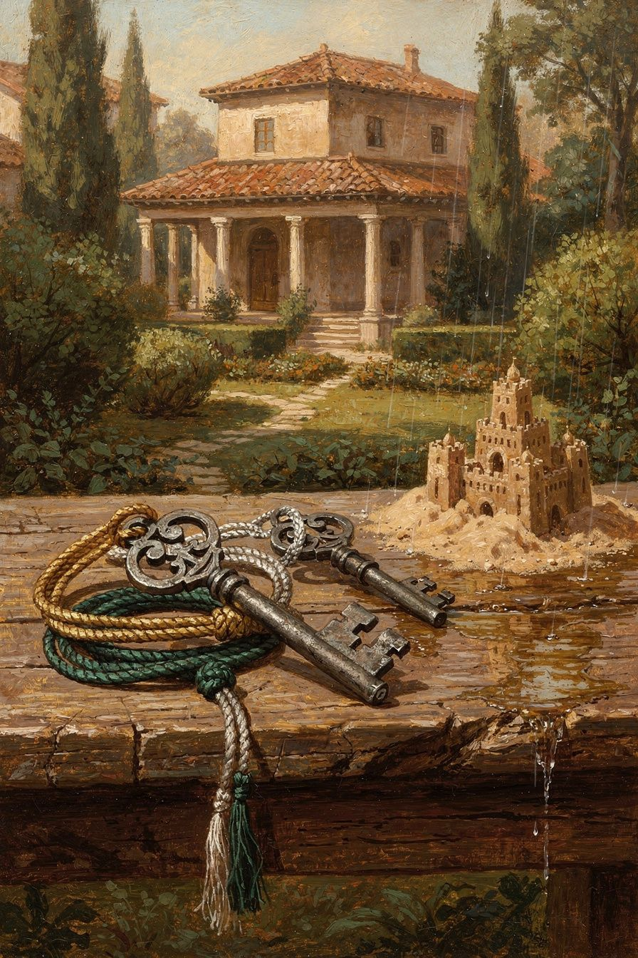
Illustration for Chapter 3
You’re sitting in your room, phone in hand, thumb hovering over a photo. It’s a picture of three friends laughing at a café you weren’t invited to. A hot wave rises in your chest—they left me out on purpose. The thought arrives so fast it feels like fact. Then another notification: your mock exam results. The grade is decent, but not the top mark you’d silently hoped for. Your stomach drops. I’m falling behind. I’ll never get into the right program. Later, in a group project chat, someone suggests an idea you think is lazy. You type a sharp reply, then delete it, then type it again. Your finger hovers over send.
In a few ordinary minutes, three invisible engines have fired up inside you: wanting something to be different, believing a story about what happened, and deciding how to act. The Stoics believed that almost everything in our inner lives—every flare of anxiety, every rush of anger, every quiet sense of purpose—can be traced back to these three movements. They called them desire, assent, and action. And they insisted that learning to work with them, rather than being dragged by them, is the closest thing to freedom a human being can find.
Marcus Aurelius never imagined a smartphone. He wrote his private notebooks in a tent on the Danube frontier, surrounded by soldiers, illness, and the dull grind of imperial administration. Yet the advice he whispered to himself reads like a field guide for the exact pressures you face. “You have power over your mind—not outside events. Realize this, and you will find strength.” That line, paraphrased from his Meditations, is not a slogan. It’s a map of the three disciplines that structure his entire philosophy. If you can learn to see desire, assent, and action as separate doors, you can choose which ones to open and which ones to quietly close.
———

The Big Idea
The French philosopher Pierre Hadot spent decades studying Marcus’s notebooks and noticed something remarkable: the Meditations aren’t a random collection of thoughts. They follow a hidden architecture built around three spiritual exercises. Hadot called them the three disciplines: the discipline of desire, the discipline of assent, and the discipline of action. Together they form a complete training programme for the mind.
To understand them, you need to grasp a simple Stoic boundary line. Some things are up to us—our judgments, our impulses, our intentions. Everything else—reputation, health, other people’s choices, the weather, exam questions, whether you get invited to the café—is not up to us. The three disciplines are different ways of honouring that boundary.
The discipline of desire teaches us to want only what is within our power, and to accept everything else as nature hands it to us. The Greek word hormê means impulse or inclination—that first spark of reaching toward something or pushing it away. Marcus trains himself not to grasp at things that can be snatched away by chance. He pictures desire as a fire: if you feed it only the fuel of your own choices, it warms you; if you throw in externals, it becomes a wildfire that consumes your peace. When you scroll through social media and feel a pang of longing for a different body, a different social circle, a different number of likes, you’re standing in that wildfire. The discipline of desire doesn’t mean you stop wanting anything. It means you redirect your wanting toward what you can actually tend: your own character, your own effort, your own kindness.
The discipline of assent is the gatekeeper. Before an impression becomes an emotion, it passes through a checkpoint: do I agree that this is true? The Stoic term sunkatathesis means “assent”—the moment you say yes to a thought. Epictetus, the philosopher who shaped Marcus more than any other, put it bluntly: “It is not events that disturb people, it is their judgments concerning them.” Marcus repeats this idea in a dozen different keys. The café photo stings not because three people sat at a table, but because you silently assented to the story they excluded me because I don’t matter. The exam grade feels like a verdict on your future only because you assented to the thought this number defines my worth. Assent is fast, often automatic, but it can be slowed down. The discipline of assent is the practice of pausing between impression and reaction, holding the thought up to the light, and asking: Is this true? Is this helpful? Is this up to me?
The discipline of action turns outward. Once you’ve stopped wrestling with things you can’t control and stopped believing every anxious story your mind tells you, what do you actually do? The Stoic answer is clear: act for the common good. Marcus calls it being a citizen of the cosmos, working like a hand or a foot that serves the whole body. The Greek term kathêkon means “appropriate action”—the thing that befits a rational, social being in this moment. It’s not about grand gestures. It’s about the small, concrete choices that weave us into the lives around us: explaining a concept patiently to a struggling classmate, picking up litter in the park, choosing a career that solves real problems, or simply not snapping at your sibling when you’re tired. The discipline of action reminds you that your character is built through deeds, not intentions.
These three disciplines are not separate compartments. They loop and feed each other. When you desire the right things (discipline of desire), you’re less likely to assent to distorted thoughts (discipline of assent), and you’re freer to act with integrity (discipline of action). Marcus’s notebooks are full of this rhythm: he checks his desires, questions his judgments, and recommits to useful action—over and over, like a musician practising scales.
———

Try This
Here are five ways to practise the three disciplines in your own life. Treat them as experiments, not chores. The goal isn’t perfection; it’s learning to notice the machinery of your mind.
1. The Desire Audit At the end of the day, take five minutes to write down three things you strongly wanted. They could be big (“I wanted to get an A on that paper”) or small (“I wanted more likes on my post”). For each one, ask: Was this desire for something within my control, or something outside it? If it was outside, how did that wanting affect your mood and your choices? Now rewrite each desire as if you were aiming only at what you can control. For example, “I wanted to get an A” becomes “I wanted to study with full focus and prepare the best paper I could.” Notice how the second version feels—does it leave you more or less anxious? This is not about lowering your standards. It’s about aiming your energy at the part of the target you can actually hit.
2. The Assent Stopwatch Pick a half-day and carry a small notebook or use a notes app. Every time you feel a spike of irritation, anxiety, or sadness, pause and write down the raw impression that flashed through your mind just before the feeling. Maybe it was “He’s ignoring me on purpose” or “I’m going to fail.” Don’t judge the thought yet—just catch it. Later, go through your list and for each impression ask: Is this definitely true? What’s another possible explanation? Does believing this help me act wisely? You’re not trying to force yourself to be positive. You’re practising the pause between impression and assent. Over time, that pause grows wider, and you gain room to choose.
3. Translation Comparison: The Power of Words Marcus wrote in Greek, but his thoughts have been translated into English in wildly different ways. Find two translations of the same passage—for example, Meditations 5.1, where Marcus talks about getting out of bed in the morning. One classic translation by George Long (1862) reads: “In the morning when thou risest unwillingly, let this thought be present—I am rising to the work of a human being.” A modern translation by Gregory Hays (2002) renders it: “At dawn, when you have trouble getting out of bed, tell yourself: ‘I have to go to work—as a human being.’” Compare the two. Which speaks to you more? What does each version assume about the reader? How does the shift from “thou risest unwillingly” to “when you have trouble getting out of bed” change the emotional tone? This exercise sharpens your ear for how language shapes assent—and reminds you that even Marcus’s words are filtered through someone else’s judgment.
4. The Common Good Challenge For one week, set a daily intention: Today I will do one small thing that serves the people around me, without needing recognition. It could be as simple as letting someone merge in traffic, explaining a tricky concept to a classmate, or doing a household chore that usually falls to someone else. At the end of each day, write down what you did and how it felt. Did you notice a difference between acting for praise and acting because it was the right thing? Did any of these actions feel forced, and if so, what judgment was behind that resistance? The discipline of action is not about being a martyr; it’s about discovering that your wellbeing is tied to the wellbeing of the whole.
5. Debate Prompt: Is It Ever Okay to Desire Externals? Gather a friend or two (or argue with yourself in a journal) and take on this question: Is it ever healthy to want something outside your control—like a relationship, a grade, or a dream job? One side can argue the strict Stoic line: desiring externals always sets you up for disappointment, because you’re attaching your happiness to something that can be taken away. The other side can argue that human beings need goals and hopes to move forward; without wanting a relationship, you’d never take the risk of being vulnerable. Push each other to be specific. Can you want something passionately while holding it lightly? What would Marcus say to an athlete who desires a gold medal? This debate isn’t about winning—it’s about seeing the nuances in the discipline of desire and discovering where you genuinely stand.
———

A Critical-Thinking Question to Carry Forward
Imagine you could master only one of the three disciplines—desire, assent, or action—and the other two would remain as messy and automatic as they are now. Which one would you choose to perfect, and why? Think about your own patterns: do you get caught most often in wanting the wrong things, believing distorted thoughts, or failing to act on your good intentions? If you strengthened just that one discipline, how might it quietly reshape the other two? There’s no single right answer. But the way you answer reveals something important about where your freedom is already waiting for you.
———

Chapter 4: Citizens of the Cosmos

Illustration for Chapter 4
You are sitting in the library, but you are not really there. Your eyes skim the same paragraph for the fourth time while your mind replays the conversation from lunch. Someone you considered a friend just announced they got the internship you wanted—the one you’d stayed up late perfecting your application for, the one that was supposed to be your proof that you were moving ahead. They smiled when they said it, and you smiled back, but inside something clenched. A small, cold voice whispered: They took what was mine. Now they’re ahead. You’re behind. The afternoon light suddenly feels thin and isolating. Everyone around you seems to be winning a race you didn’t fully realise you had entered.
That feeling—the sudden narrowing of the world into a contest of “me versus them”—is ancient. It would have been familiar to a Roman emperor who spent his mornings not in a library but in a military tent on the Danube frontier, surrounded by thousands of soldiers from a dozen tribes, trying to hold together an empire that constantly threatened to fracture into selfish pieces. Marcus Aurelius knew that cold voice intimately. He wrote his Meditations partly to talk himself out of its grip. And his antidote was not a fluffy reminder to “be nice.” It was a rigorous, almost anatomical claim about what a human being actually is.
He put it bluntly: “We were born for cooperation, like feet, like hands, like eyelids.” That line comes from the very beginning of Book II of the Meditations, where Marcus is shaking off sleep and preparing his mind for the day. He isn’t suggesting cooperation as a pleasant optional extra. He is saying that refusing to work with others is as absurd as a foot deciding it would rather walk alone. A foot that severs itself from the body is no longer a foot; it is just a piece of dead tissue. In the same way, a human being who cuts themselves off from the common good is cutting themselves off from their own nature. The logic is stark: you cannot flourish in isolation because you were not built for isolation.
This is the core of what we might call Marcus’s citizenship of the cosmos. He inherited the idea from the Stoic tradition, which held that the universe is not a random collision of atoms but a unified, living whole governed by a rational principle the Greeks called logos. You can think of logos as the organising intelligence that runs through everything—the way a single root system connects an entire grove of trees, or the way your own mind coordinates your heartbeat, your breath, and your thoughts without you having to micromanage each one. For Marcus, logos is not a distant god issuing commands; it is the very fabric of reality, and your own capacity to reason is a spark of that same fire. To act against reason—against justice, against kindness—is to act against the grain of the universe. It is to declare war on your own wiring.
That might sound grand, but Marcus brings it down to the level of a bee and its swarm. In Book IX he writes: “What is not good for the swarm is not good for the bee.” Notice the precision. He does not say, “The bee should sometimes sacrifice for the swarm.” He says that the bee’s good and the swarm’s good are not two separate things that need to be balanced. They are the same thing, seen from different angles. A bee that hoarded all the pollen for itself would not be a “successful” bee; it would be a malfunctioning bee, because the very definition of a bee includes its role in the hive. Your own flourishing, Marcus insists, works the same way. The actions that genuinely make you thrive—developing patience, acting with integrity, building trust—are precisely the actions that strengthen the human community around you. The actions that seem to benefit you at the expense of others—ruthless competition, deceit, resentment—are like a bee gorging on nectar it will never turn into honey. They feel like winning in the moment, but they starve the part of you that needs connection to stay alive.
This is not sentimentality. Marcus was a realist who buried five of his children and spent years at war. He did not believe that people are always pleasant or that communities are always harmonious. He knew that other “limbs” of the body often act like they belong to a different species. Yet his response to betrayal, incompetence, and even cruelty was shaped by this same bodily metaphor. When someone wrongs you, he advised, pause and remember that they are still a limb of the same body. A hand does not bite the foot for stumbling; it helps it regain balance. To lash out in anger is to act like a cell that attacks its neighbour, forgetting that both belong to the same organism. Forgiveness, in this framework, is not a favour you grant to the other person. It is a recognition of shared nature—a refusal to amputate yourself.
———
The Big Idea
The Stoics had a word for this radical belonging: sympatheia, or “shared feeling.” It describes the way everything in the cosmos is woven together so that a tug on one thread vibrates through the whole web. Marcus used the image of a great city. He called himself a citizen of the cosmopolis—the “world-city”—not as a poetic metaphor but as a political fact. If all rational beings share the same logos, then they are fellow citizens, regardless of the walls we build between nations, classrooms, or social cliques. Your true allegiance is not to your ego’s small kingdom but to that larger commonwealth.
This idea transforms how we think about duty. In a modern world that constantly asks, “What do you want? What is your passion? What makes you stand out?” Marcus offers a different starting question: “What does the whole need right now, and what part of that can I serve?” This is not about erasing yourself. It is about locating yourself accurately. A hand is not less valuable because it serves the body; its whole value consists in that service. When you help a struggling classmate understand a concept, you are not losing time you could have spent polishing your own brilliance. You are exercising your rational nature, which is built to connect and clarify. When you choose not to spread a rumour, even one that might temporarily boost your social standing, you are keeping the body’s circulatory system clean. These are not sacrifices; they are expressions of what you already are.
The same logic applies to justice. If we are limbs of one body, then inequality and exclusion are not just “unfortunate” or “unfair” in some abstract sense. They are like a body that diverts all blood flow to one arm while letting the other wither. Marcus would not have used modern terms like “systemic injustice,” but his framework gives you a powerful lens for examining the structures around you. Does a particular school policy actually serve the whole student body, or only a high-performing fraction? Does a friendship group function like a healthy organ, circulating support, or like a tumour, feeding on exclusion? The swarm and the body are not sentimental images; they are diagnostic tools.
And yet Marcus never lets this turn into self-righteousness. He constantly turns the gaze inward. Before you condemn another limb for failing, check your own coordination. Are you acting like a foot that refuses to walk, an eyelid that won’t blink? The citizenship of the cosmos begins with the small, unglamorous work of aligning your own reason with the good of the whole—right here, in the lunchroom, in the group chat, in the family argument.
———
Try This
These exercises are designed to move you from abstract agreement to lived understanding. Choose the ones that challenge you most.
1. Journaling: The Swarm Audit Take a recent situation where you felt isolated, competitive, or resentful—like the internship example, a group project where you did most of the work, or a social event where you felt excluded. Write a brief, honest account of what you felt and why. Then, rewrite the same event from the perspective of the swarm. Ask yourself: What was the whole system trying to do? What did it need? How did my actions and feelings either contribute to or pull against that larger need? Don’t force a happy ending. Just notice where the “me versus them” story starts to crack, and what you see through those cracks.
2. Translation Comparison: The Bee and the Hive Marcus wrote in Greek, and translators make choices that shape how we hear him. Compare Gregory Hays’s rendering of IX.42 — “What is not good for the swarm is not good for the bee” — with an older translation by George Long: “What is not good for the hive is not good for the bee.” Also look at Robin Hard’s version: “What is not beneficial to the swarm is not beneficial to the bee.” Write a short reflection (150–200 words) on the differences. Does “swarm” feel more alive and buzzing than “hive”? Does “beneficial” sound cooler and more transactional than “good”? Which word choices make the idea feel like a law of nature, and which make it feel like a moral suggestion? How does the translation affect your willingness to apply the idea to your own life?
3. Debate Prompt: The Self-Made Myth Prepare a two-minute argument for each side of this question: Is it ever justified to prioritise individual success over the well-being of the group you belong to? For the “yes” side, use concrete examples—perhaps an athlete who must focus on their own training, or an artist who needs solitude. For the “no” side, use Marcus’s body and swarm metaphors to argue that apparent individual success that harms the group is ultimately self-destructive. After you have built both cases, write a synthesis paragraph: under what conditions might a focus on individual development actually serve the swarm, and how can you tell the difference between healthy differentiation and selfish detachment?
4. Self-Assessment: Map Your Limbs Draw a simple diagram of your social body. Place yourself at the centre, then draw branches for your immediate circles: family, close friends, classmates, teammates, online communities, and any wider groups you belong to (cultural, religious, neighbourhood). For each branch, list two or three ways your actions affect that group—both positively and negatively. Be brutally honest. Do you bring calm or chaos to family dinners? Do you amplify drama in the group chat or steer it toward resolution? Then, pick one branch where your impact is more negative than you’d like. Write one small, concrete change you can make this week to act more like a healthy limb in that part of the body.
5. Forgiveness as Anatomy Think of someone who has wronged you—a friend who broke a promise, a sibling who humiliated you, a classmate who took credit for your idea. Hold the memory gently. Now, write a short letter to that person (you will not send it) that begins with this sentence: “We are limbs of the same body, and when you acted as you did, the body suffered a spasm.” Describe the “spasm” from the perspective of the whole, not just your injury. What might have been happening in that other limb—fear, pressure, ignorance—that caused it to jerk against you? End the letter by prescribing a “medicine” for the body: not necessarily reconciliation, but a way you can stop the injury from spreading through your own continued resentment. This is not about excusing harm; it is about refusing to let harm define your next move.
———
A Question to Carry
If we are all limbs of one body, does that mean we must tolerate harmful behaviour? How would Marcus distinguish between the forgiveness that heals the whole and the passivity that enables injustice? Where does the duty to the swarm require you to set a firm boundary, and how might you set it in a way that still honours the shared logos?
———

Chapter 5: Plague, War, and Grief
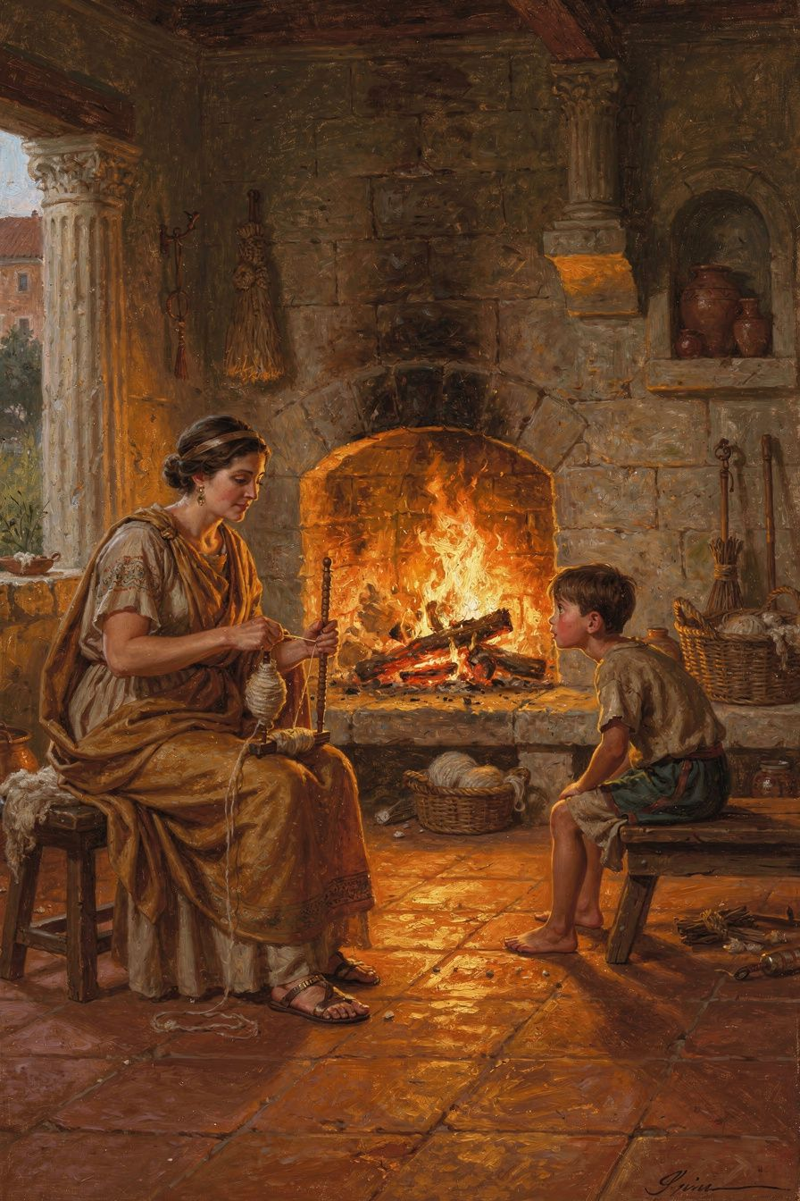
Illustration for Chapter 5
The air in the winter camp on the Danube tasted of woodsmoke, horse sweat, and something else—something sweet and rotten that clung to the back of the throat. Marcus Aurelius sat in his command tent, the leather walls barely holding back the wind, and wrote not to the Senate, not to his generals, but to himself. Outside, the Marcomannic tribes had burned another frontier settlement. Inside the camp, the Antonine Plague moved through the barracks like a slow, invisible fire, taking soldiers who had survived arrows and swords and leaving them blue-faced and gasping. That morning, a messenger had arrived from Rome: his youngest son, Annius Verus, was dead. The boy had been six years old. Marcus had already buried five children. He put the letter down, picked up his stylus, and wrote: “A fire takes hold of whatever falls into it and surmounts it and rises above it… so too the intelligent power takes hold of whatever falls into it and assimilates it to itself.”
You might never command a legion in a frozen forest while an empire cracks around you. But you know the shape of that tent. It’s the shape of your bedroom at 2 a.m. when a friendship has imploded and your phone is a grenade of notifications you can’t bear to read. It’s the shape of the exam hall when you turn over the paper and your mind goes white. It’s the shape of the hospital waiting room, the funeral home foyer, the moment you realise that something you thought was permanent is actually made of glass. Marcus’s world was larger in scale, but the texture of human pain—loss, fear, exhaustion, betrayal—has not changed in two thousand years. What he learned in that tent, and what he wrote down only for himself, was a way to meet pain without turning it into something worse.
The Meditations were never meant to be a book. They were a private dialogue, a set of emergency drills for a mind under siege. Marcus was fighting two wars simultaneously: the visible war against the Marcomanni and the invisible war against his own despair. The Antonine Plague, probably smallpox, killed somewhere between five and ten million people across the empire. It killed his co-emperor Lucius Verus. It killed his children. It killed the soldiers he relied on to hold the northern frontier. And then, in 175 CE, while Marcus was still on campaign, his most trusted general Avidius Cassius declared him dead and proclaimed himself emperor. The betrayal came from a man Marcus had raised and honoured. For a few months, the empire teetered on the edge of civil war while the plague still raged. Marcus responded by pardoning the conspirators before Cassius was even assassinated by his own men. He wrote: “Everything that happens is either endurable or not. If it’s endurable, then endure it. Stop complaining.”
That line can sound brutal if you read it quickly. It can sound like a command to shut up and take it, like the kind of toxic stoicism that tells people to bury their feelings under a stiff upper lip. But Marcus wasn’t writing a public speech. He was talking to himself, in a private notebook, while his world burned. He wasn’t telling anyone else to stop complaining. He was telling the part of his own mind that wanted to whine, to collapse, to rage against the unfairness of it all, that this was not helping. The pain was already there. The plague was already there. The dead child was already gone. Adding a layer of furious protest, self-pity, or catastrophic storytelling would not change any of it. It would only add suffering to pain. That distinction—between pain and suffering—is the quiet engine of this chapter.
The Big Idea: Pain is Inevitable, Suffering is Optional
The Stoics had a precise vocabulary for what we might call the “raw data” of experience. They used the term phantasiai for impressions—the initial mental picture that appears when something happens. A sharp word from a friend, a low grade, a physical injury: these first strike the mind as an impression, a kind of mental flash. That impression often carries a little jolt of discomfort, what the Stoics called the propatheia, the pre-emotion. Even the sage, they admitted, might flinch at a sudden loud noise or feel a brief sting of tears at bad news. That’s not failure. That’s being human.
The trouble begins with the next step: assent. The mind looks at the impression and either agrees with it or challenges it. If you assent to the thought “This is a catastrophe, I’m ruined, this shouldn’t be happening,” you have just built a second story on top of the first. The raw pain—the sting, the ache, the hollow feeling—is now wrapped in a narrative of disaster. That narrative is what the Stoics called a passion, a disturbing emotion that takes over because you’ve given it permission. Pain is the fire that falls into your life. Suffering is the flammable material you choose to pile around it.
Marcus’s fire metaphor is not about destruction. It’s about transformation. A flame doesn’t reject what falls into it. It consumes it and turns it into more flame, more light, more heat. The “intelligent power” he speaks of is our capacity for reason, our ability to look at a situation and ask: What is this, really? What is it made of? What can I do with it right now? When grief falls into you, you can let it sit there as a cold, heavy lump, or you can let your attention work on it like a fire—breaking it down, using its energy, turning it into something that fuels understanding, compassion, or resolve. This isn’t about pretending pain doesn’t hurt. It’s about refusing to let the hurt burn down the whole house.
Marcus tested this idea in conditions that would break most people. He lost eight children, most of them before they reached adulthood. He spent over a decade of his reign away from Rome, sleeping in military camps, managing a pandemic and a war simultaneously. He faced a betrayal that could have ended his rule. And through all of it, he wrote not laments but reminders to himself: You have survived worse. This is not unbearable. The obstacle is the way. He wasn’t a marble statue. He was a man who had learned, through brutal repetition, that the story you tell yourself about pain determines how much you suffer.
This is not pop psychology. It’s cognitive discipline with existential stakes. Marcus was drawing on a Stoic tradition that saw the mind as a citadel—the one place in the universe where you hold absolute sovereignty, because no one can force you to assent to a thought you know is false. You can’t control the plague. You can’t control the betrayal. You can’t bring back the dead. But you can control the judgments you make about those events, and those judgments are what turn pain into anguish or loss into despair. The discipline is simple to describe and ferociously difficult to practice: separate the facts from the story.
Let’s bring this into your world. You fail an important exam. The facts: a number on a page, a closed door to one particular course or university, a conversation you’ll need to have with your parents. The story your mind might instantly generate: “I’m a failure. My future is over. Everyone will think I’m stupid. I’ve let everyone down.” That story is not in the exam result. It’s in the assent you give to those thoughts. The Stoic move is not to deny the disappointment—that’s real, that’s the sting—but to refuse to sign the contract that turns disappointment into a permanent identity. You can feel the ache and still say: “This is a setback, not a verdict. I am still the person who can study, improve, try again. The door that closed is one door, not all doors.”
The same applies to grief, though grief is the hardest test. When someone you love dies, the impression is loss—a tearing absence that nothing will fill. The Stoics did not ask you to not feel that. They asked you to be careful about what you add to it. “They shouldn’t have died so young.” “I can’t live without them.” “The world is cruel and meaningless.” These are stories. They may feel true, but they are not the raw fact of loss. The raw fact is that someone is gone and you loved them. That fact is endurable, because it is happening and you are still here, still breathing, still capable of remembering them with love rather than torturing yourself with protest. Marcus buried child after child and kept going—not because he was cold, but because he believed that his task was to honour their memory by living with virtue, not by collapsing into bitterness.
Try This: Exercises for the Fire
1. The Two-Column Inventory. Take a recent moment of emotional pain—an argument, a rejection, a wave of anxiety. Open your journal and draw a line down the middle of a page. On the left, write only the bare facts of what happened, as if you were a security camera: “She said X. I said Y. The email arrived at 3 p.m. My heart rate increased.” On the right, write the story your mind added: “She hates me. I always mess this up. This proves I’m not good enough.” Now look at the left column alone. Ask yourself: Is any of this, by itself, unbearable? Notice how much of the weight lives in the right column. This isn’t about dismissing your feelings; it’s about seeing clearly what is fact and what is interpretation. The fire of your attention can burn through the story and leave the facts manageable.
2. Translation Lab: The Fire Passage. Read Marcus’s words in two different translations. Farquharson renders it: “A fire takes hold of whatever falls into it and surmounts it and rises above it… so too the intelligent power takes hold of whatever falls into it and assimilates it to itself.” Gregory Hays translates the same passage: “A blazing fire makes flame and brightness out of everything thrown into it.” Compare them. What does “assimilates it to itself” suggest that “makes flame and brightness” might miss? What does Hays’s version capture that Farquharson’s more philosophical language might obscure? Which translation gives you a stronger sense of agency? Write your own version of the metaphor, using an image that resonates with you—a river that carries debris downstream, a garden that composts waste into soil, a forge that heats metal until it can be reshaped. What does your chosen image reveal about how you want to handle hardship?
3. The Endurance Debate. Marcus says: “Everything that happens is either endurable or not. If it’s endurable, then endure it. Stop complaining.” But is this always true? Pair up with someone or write a dialectical response. Argue the case against Marcus: What about chronic pain that never stops? What about torture? What about the death of a child—can anyone really “endure” that without breaking? Now switch sides and defend Marcus’s position. Remember, he’s not saying you won’t feel pain; he’s saying that if something is truly unendurable, it will kill you, and if it hasn’t killed you, you are enduring it. Is that a helpful reframe or a cold tautology? Where do you draw the line between healthy endurance and toxic denial? This debate is not about winning; it’s about testing the edges of a philosophy against the hardest realities.
4. The Suffering Thermometer. Next time you feel overwhelmed, pause and assign a number from 1 to 10 to your total distress. Then ask: How much of this number comes from the raw sensation or emotion itself? (The knot in your stomach, the racing heart, the sadness.) How much comes from the story I’m telling about it? (“This is going to ruin my life,” “I can’t handle this,” “It’s so unfair.”) Give each part a separate score. You might find that the raw sensation is a 4 and the story is a 7. Now experiment: for sixty seconds, drop the story and just sit with the raw sensation. Breathe into it. Does the total number change? This is not about making the pain disappear; it’s about discovering that the story is a volume knob you didn’t know you were holding.
5. The Assimilation Practice. Choose a current difficulty—a conflict, a disappointment, a fear. In your journal, describe it as “fuel.” What could this experience, if you stopped fighting it and instead used it, teach you? What quality could it build in you? Patience? Clarity? Compassion for others who struggle? The fire in Marcus’s metaphor doesn’t judge what falls into it; it uses everything. Write a short paragraph beginning: “If I let this experience become fuel for my growth, it might…” This is not about toxic positivity or pretending the hard thing is good. It’s about refusing to let the hard thing be wasted.
———
A Final Question to Carry With You:
Marcus Aurelius wrote the Meditations while grieving, while sick, while surrounded by death and treachery. He never pretended that pain was pleasant or that loss was easy. But he insisted that the mind could remain “a fortress, a refuge, a citadel” no matter what storm raged outside. Do you think there are experiences that can breach even that inner citadel—moments when the fire is so intense that it burns the fortress down? If so, what does Stoicism offer someone in the ashes? Is the goal to never fall, or to learn how to rise?
———

Chapter 6: The Discipline of Mornings

Illustration for Chapter 6
You know the feeling. The alarm drags you out of a dream and your hand fumbles for the phone before your eyes are even open. Notifications stack up like unread verdicts: a friend’s cryptic post, a grade you’re afraid to check, a reminder about the presentation you’re not ready for. The weight of the day presses on your chest before your feet touch the floor. Maybe there’s grief tangled in there too—someone you miss, a future that suddenly looks different. The temptation to pull the covers back over your head is almost physical. Why get up? Why face any of it?
Almost two thousand years ago, a Roman emperor woke up with the same question. Marcus Aurelius wasn’t lounging in a palace; he was often in a military tent on the frozen Danube frontier, body aching, responsibilities crushing, news of betrayal or plague arriving with the morning bread. He had every excuse to stay in bed. Instead, he gave himself a talking-to that still crackles with energy:
“At dawn, when you have trouble getting out of bed, tell yourself: I have to go to work—as a human being. What do I have to complain of, if I’m going to do what I was born for—the things I was brought into the world to do? Or is *this* what I was created for? To huddle under the blankets and stay warm?”
That’s from the opening of Meditations Book V, translated by Gregory Hays. Marcus wasn’t writing a motivational poster. He was writing to himself, in a private notebook, trying to shake off the same inertia that visits every human animal at dawn. He knew that the mind’s fortress doesn’t stand on its own overnight. It must be rebuilt, stone by stone, while the world is still quiet.
———

The Big Idea: The Citadel Rebuilt Daily
Marcus kept returning to the same handful of reminders each morning: accept the nature of the world, pay attention to your purpose, and be willing to die well. These weren’t gloomy obsessions. They were the scaffolding of a good day, and a good day is the only unit of a good life we ever actually hold.
Think of your inner life as a citadel—a stronghold where your choices, values, and peace of mind are protected. The Stoics called this ruling center the hegemonikon (hay-geh-mon-ee-KON), the “commanding faculty” that decides what events mean and how you’ll respond. It’s not a physical place in the brain; it’s the part of you that can step back from a surge of anxiety and say, “This is just a sensation. I don’t have to let it steer me.” Every morning, that citadel is weathered. Sleep, dreams, and the first rush of waking emotions have loosened the stones. Social media, if you reach for it, acts like a battering ram before you’ve even posted a guard. Marcus understood that the hegemonikon needs a deliberate morning repair—a ritual of re-centering—or the day will be hijacked by whatever shouts loudest.
His three morning pillars were simple but radical:
1. Acceptance of nature. Marcus reminded himself that the world will be messy. People will be rude, plans will collapse, bodies will ache. This isn’t a personal insult; it’s the weather of being alive. The Stoics sometimes used the phrase amor fati—love of fate—not as passive resignation but as an active embrace of reality. When you stop fighting what already is, you free up enormous energy to work with it. A rainy morning isn’t a ruined day; it’s a day that requires a jacket and a different kind of light.
2. Attention to purpose. “I have to go to work—as a human being.” For Marcus, that meant acting with justice, kindness, and self-control, whether he was negotiating with barbarian chieftains or dealing with a difficult relative. Your purpose might look like being a student who learns for understanding, not just grades; a friend who shows up; a creator who makes something honest. The key is to name it before the world names you. If you don’t decide what the day is for, it will be filled with other people’s agendas.
3. Willingness to die well. This sounds intense, but Marcus brought it up constantly because it’s the ultimate perspective-giver. He wasn’t courting death; he was using the awareness of mortality to sharpen his choices. If you might not get another sunrise, how much time will you spend scrolling? How long will you hold a grudge? The thought isn’t meant to paralyze you—it’s meant to wake you up. A day lived as if it could be your last is a day where pettiness shrinks and what actually matters stands out in bold.
These three pillars are not separate tasks. They braid together: accepting that life is short (amor fati and mortality) clarifies what’s worth doing (purpose), and that clarity gives the hegemonikon a steady flame to guard. Marcus’s morning self-talk was the act of lighting that flame.
———

Why This Matters Now
Your mornings are probably louder than Marcus’s were. The phone doesn’t just deliver news; it delivers a curated highlight reel of everyone else’s achievements, designed to make you feel behind. School or work pressures don’t just ask for effort; they ask for a performance of effortless success. Ambition can curdle into anxiety before breakfast. Grief can make the whole day feel pointless. In that environment, the citadel isn’t just weathered—it’s under siege.
But the Stoic insight holds: the happiness of your life depends upon the quality of your thoughts. That’s a paraphrase of Marcus’s core conviction, and it’s not about forcing yourself to think happy thoughts. It’s about recognizing that between the event and your reaction, there is a space where your hegemonikon operates. The morning is when you reclaim that space. If you let the first ten minutes of consciousness be dictated by notifications, you’ve handed the keys of the citadel to an algorithm. If you pause and, like Marcus, tell yourself why you’re getting up, you take the keys back.
This isn’t about becoming a cheerful robot. Marcus’s tone in his morning entries is often stern, even exasperated with himself. He’s not pretending the cold floor feels good. He’s saying: “Yes, it’s hard. Do it anyway, because you’re a human being with a job to do.” That’s agency, not toxic positivity. It’s the difference between a castle that waits to be attacked and a castle that posts its own guards at dawn.
———

Try This
These exercises are designed to help you build your own morning discipline—not by copying Marcus exactly, but by translating his practice into your life. Approach them with curiosity, not pressure. You’re the architect of your citadel.
1. Write Your Own Dawn Exhortation Take a notebook (paper works better than a screen for this) and write a short paragraph addressed to yourself, in the second person, the way Marcus did. Start with the moment of waking: what’s the first resistance you feel? Name it honestly. Then remind yourself what you’re getting up for—not a to-do list, but a purpose. For example: “You’re getting up because you’re a learner, and today you’ll understand something you didn’t yesterday.” Or: “You’re getting up because someone you care about might need you to listen.” End with a line that puts the day in perspective, maybe using the idea of mortality gently: “This day is a whole life in miniature. Don’t waste it on things that won’t matter in a week.” Keep it short enough to read in one minute. Tomorrow morning, read it before you check your phone.
2. Compare Translations, Find Your Voice Marcus’s words have been rendered differently by translators, and the nuances matter. Read these three versions of the same passage from Meditations V.1 and notice how each one feels:
- Gregory Hays: “I have to go to work—as a human being.” - George Long (classic 19th-century translation): “I am rising to do the work of a human being.” - Martin Hammond (modern): “I must go to my work as a human being.”
Ask yourself: Which version gives you a sense of duty? Which one feels like a choice? Which one sounds like a burden? Now write your own version of that line, using words that resonate with your actual mornings. It could be: “I’m getting up to build something that matters to me.” Or: “I’m rising because I refuse to let fear call the shots.” There’s no right answer—only your answer.
3. Debate with Yourself: Stern or Gentle? Marcus’s morning self-talk is often blunt, almost military. But modern psychology also shows the power of self-compassion. Set a timer for 10 minutes and argue both sides in your journal. First, make the case for a stern inner voice: “If I’m too soft on myself, I’ll make excuses. Discipline requires a firm hand.” Then switch and argue for gentleness: “If I bully myself, I’ll burn out. Kindness builds long-term motivation.” Finally, look for a synthesis. What would a morning practice look like that is both honest about the difficulty and encouraging about your ability to meet it? Write one sentence that captures that balance.
4. Audit Your Morning Citadel For the next three days, keep a simple log. As soon as you wake up, jot down the first three thoughts or impulses that appear. Do you reach for your phone? Do you mentally replay a worry? Do you feel a physical reluctance? Don’t judge—just record. At the end of the three days, look at the pattern. Which of these thoughts strengthen your inner fortress, and which ones weaken it? Now design a five-minute morning ritual that you can do before you engage with the outside world. It might include reading your dawn exhortation, taking three slow breaths while naming one thing you’re grateful for, and setting one intention for the day. Test it for a week and notice what shifts.
5. The Last Day Lens This exercise uses Marcus’s willingness to die well as a tool for clarity, not fear. Find a quiet moment and write a short answer to this question: If I knew that today was my last day, how would I spend it? Be specific. Who would you talk to? What would you do with your body? What would you not do? Now look at your actual plans for today or tomorrow. What overlaps? What’s completely absent? You don’t have to overhaul your life overnight, but notice the gap. Is there one small thing you could bring from your “last day” into your ordinary day—a conversation, a walk, a moment of full presence? That’s the beginning of living as if each day counts.
———
A Question to Carry With You
If you knew with certainty that this day was your last, would you spend it differently? And if you wouldn’t change a single thing, what does that tell you about the life you’re already building?
———

For the Grown-Up Reader
This booklet adapts Marcus Aurelius's Meditations and the scholarly commentary of Pierre Hadot, R. B. Rutherford, and Tad Brennan. Key passages are cited by book and section using translations by Gregory Hays and A. S. L. Farquharson.
If a child asks, 'Did Marcus really write this?' the answer is yes—he wrote the Meditations as private notes to himself. They were not intended for publication, which is one reason they sound so honest.
———

About WisdomForge
WisdomForge adapts the great philosophers into stories, audio, and conversation for every age. Each philosopher becomes four booklets—one for children, one for teens, one for older adolescents, and one for adults—so the same ideas can grow with you.

