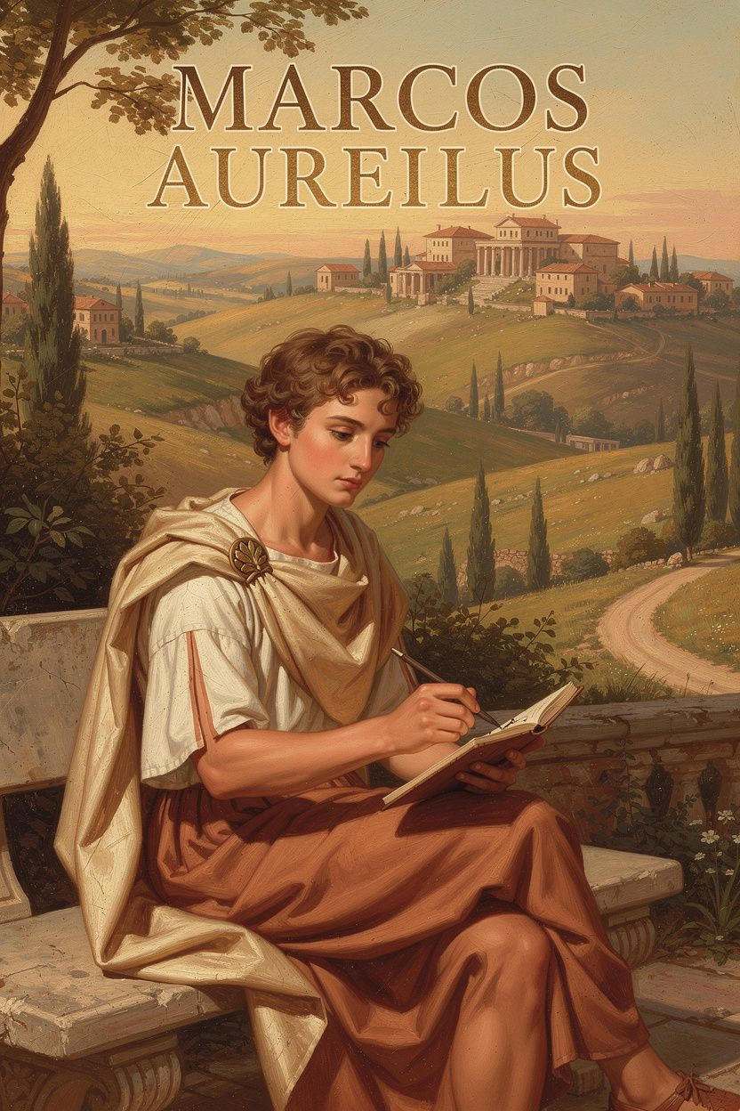
Marcus: The Emperor's Private Notebook
WisdomForge Booklet — Ages 11–14

Marcus: The Emperor's Private Notebook

WisdomForge Booklet — Ages 11–14
———

About This Book
Marcus Aurelius was one of the most powerful people in the ancient world. He was also one of the most honest. While leading Rome through war, plague, and personal loss, he wrote notes to himself about staying calm, doing his duty, and keeping his mind free.
This booklet follows those private notes into real-life situations you might recognize: school pressure, family stress, feeling left out, and wondering what you're supposed to do with your life. Each chapter combines a story, a big idea, and things to try.
———

Chapter 1: The Boy Who Didn't Want a Crown
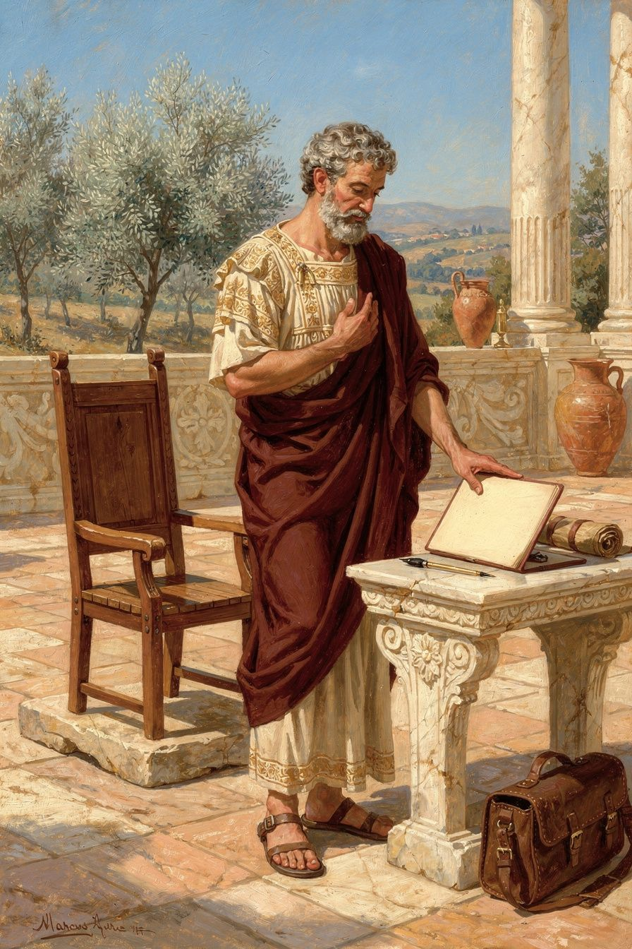
Illustration for Chapter 1
It started, as these things often do, with a phone call Leo wasn’t expecting. He was in the kitchen, halfway through a peanut butter sandwich, when his drama teacher’s name flashed on the screen. Leo wasn’t a star actor. He helped build sets, painted backdrops, and occasionally stood in the background as “Townsperson Number Three.” But the spring musical was in trouble. The lead had moved away suddenly, and the director needed someone who could learn lines fast, stay calm under pressure, and not let the whole production collapse. She had picked Leo.
Leo’s stomach dropped. He hadn’t asked for this. He didn’t want a crown—or in this case, a ridiculous velvet cape and a solo. He wanted to stay in the shadows, where it was safe. That evening, he sat on the porch with his dad, explaining the disaster. His dad listened, then disappeared into the house and came back with a small, worn paperback. “You might like this guy,” he said. “He never wanted a crown either.”
The book was a collection of writings by a Roman emperor named Marcus Aurelius. Leo expected boring history, but instead he found a diary—private thoughts a man wrote to himself, never meant for anyone else. And the man who wrote it had once been a boy a lot like Leo: a boy who didn’t seek power, but who spent his youth building the kind of character that could hold it without breaking.
Marcus was born into a wealthy Roman family, but his life wasn’t soft. His father died when Marcus was only three. He was raised by his grandfather and his mother, who both taught him that privilege wasn’t a ticket to laziness—it was a call to discipline. From the time he could walk, Marcus was trained in philosophy, not as a school subject, but as a daily practice. He learned to examine his thoughts, to control his temper, to do hard things without complaining. He didn’t do this because he dreamed of being emperor. He did it because the adults around him believed that character is built long before crisis arrives, and Marcus took that seriously.
When Marcus was still a teenager, the emperor Hadrian noticed him. Hadrian was old, sick, and scrambling to secure the future of Rome. He saw something in Marcus—a quiet steadiness, a mind that didn’t chase applause. Hadrian arranged for Marcus to be adopted by Antoninus Pius, the next in line for the throne. Suddenly, the boy who never wanted a crown was standing directly in the path of one. But here’s the key: Marcus didn’t change. He didn’t start scheming for power or panicking about the weight of it. He just kept doing what he had always done—training his mind, practicing patience, and asking himself what a good person would do. He wrote to himself, “Waste no more time arguing about what a good man should be. Be one.” That wasn’t a slogan for a future emperor. It was a reminder for a young man who knew that titles don’t make you ready; your daily habits do.
When Marcus finally became emperor at age forty, the crown wasn’t a reward for ambition. It was a duty that landed on him because Antoninus had died, and Rome needed someone steady. The crises came immediately: wars, plagues, floods, betrayals. But Marcus didn’t crumble. The foundation had already been poured. The roots were already deep. He governed not as a man hungry for glory, but as one who had spent decades practicing how to serve.
The Big Idea
Think of your character like the foundation of a house. You don’t dig the footings while the earthquake is shaking the ground. You dig them on ordinary, sunny days, when nothing seems urgent. Or imagine a tree: a sapling that grows in calm weather but never pushes its roots deep will topple in the first real storm. The tree that stands firm in a hurricane is the one that spent years anchoring itself, inch by inch, when the wind was just a breeze.
Marcus’s life shows us that preparation isn’t about predicting the future; it’s about building a self that can handle whatever future arrives. He didn’t know he would be emperor. He didn’t train for a specific crisis. He trained to be patient, honest, and clear-minded—qualities that work in any storm. When the crown came, he was ready not because he had practiced ruling, but because he had practiced being a decent human being.
Another way to see it: your mind is like a muscle. If you only exercise it when something heavy lands on you, it will tear. But if you do small, daily reps of self-control and courage—like choosing to listen before reacting, or doing a chore without being asked—you build strength that’s there when the real weight arrives. Marcus called this “receive without conceit, release without struggle.” He meant that we should accept responsibilities without puffing ourselves up, and let them go without clinging. That kind of flexibility comes from years of quiet practice, not from a last-minute scramble.
Try This
1. Your Daily Training Ground Pick one small challenge each day that builds your inner foundation. It could be holding your tongue when you want to snap at a sibling, or finishing a homework assignment before you pick up your phone. These aren’t heroic acts. They’re the equivalent of doing one push-up for your character. Notice how it feels to do something hard without anyone watching.
2. The Unwanted Crown Journal Grab a notebook and write about a responsibility you didn’t ask for—maybe you’re the oldest kid who has to set an example, or you got elected to a team role you never wanted. Ask yourself: What qualities would help me carry this well? Then write down one small way you can practice that quality today. The goal isn’t to fix everything; it’s to start building the muscle.
3. Role-Play the Emperor (or the Lead) With a friend or just in your head, imagine you’re suddenly in charge of something big—a group project, a family crisis, a community event. What would you do first? How would you treat the people around you? Now flip the script: what would you do if you had not prepared at all? This helps you see that readiness isn’t magic; it’s a set of choices you can make right now.
4. Quote to Keep Take Marcus’s words and make them yours: “Waste no more time arguing about what a good man should be. Be one.” Write it on a sticky note. Put it on your mirror or inside your locker. When you catch yourself overthinking or doubting, read it aloud. Let it pull you back to action.
———
Here’s a question to carry with you this week: If life handed you a crown you never asked for tomorrow, what inner strength would you want to have already built—and what’s one small way you can start building it today?
———

Chapter 2: The Fortress Nobody Can Storm

Illustration for Chapter 2
The hallway felt like a battlefield. Alex stood with his back against the cold locker, the laughter of three classmates still ringing in his ears. One of them had pointed at his new haircut and said something sharp—something that made everyone else snicker. Alex’s face burned. His stomach twisted. For the rest of the day, the words replayed in his mind like a song he couldn’t turn off. I’ve been harmed, he thought. They hurt me.
At dinner, he pushed his food around the plate. His dad noticed. “Rough day?”
Alex shrugged. “People are jerks.”
His dad nodded slowly. “You know, a long time ago, a Roman emperor dealt with jerks every single day. Backstabbing senators, gossiping courtiers, soldiers who grumbled about his orders. And he wrote down a secret that kept him steady.” He pulled a worn paperback from the shelf. “Marcus Aurelius said: Take away your opinion, and there is taken away the complaint, ‘I have been harmed.’”
Alex frowned. “So I’m just supposed to pretend it didn’t happen?”
“Not pretend,” his dad said. “More like… build a fortress nobody can storm.”
———
The Big Idea
Marcus Aurelius didn’t have a castle made of stone. He had one made of thought. The philosopher Pierre Hadot called it the inner citadel—a stronghold inside you that no insult, no failure, no unfair situation can break into unless you open the gate.
Imagine a real fortress on a hill. Arrows fly at it. Battering rams pound the walls. But if the walls are solid and the gate stays shut, the people inside remain safe. The attack happens outside. The harm only gets in if someone inside panics and throws the gate open.
Your mind works the same way. An event happens—someone teases you, you miss a shot in a game, you get a bad grade. That event is like an arrow. It flies toward your inner citadel. But the arrow itself can’t harm your deepest self. What harms you is the judgment you attach to it: “This is terrible. I’m a loser. They ruined my day.” That judgment is you opening the gate.
Marcus put it bluntly: All harm that harms the human being is inside, in the inner citadel. The reason is not harmed unless it cooperates in its own harm. The “reason” he’s talking about is your ability to think clearly and choose your response. It’s the commander inside the fortress. If the commander stays calm and refuses to label the arrow as a disaster, the fortress stands.
Think of a campfire. Someone throws a wet log on it. The fire hisses and smokes, but it doesn’t stop being fire. It adapts. It keeps burning. Your inner citadel is like that fire. The log is just a log—it’s your reaction that turns it into a crisis or just a temporary sizzle.
Or picture a river. People throw rocks into it. The river doesn’t scream, “How dare you!” It flows around the rocks and keeps moving. The rocks are there, but the river isn’t harmed by them. It remains a river.
This isn’t about becoming emotionless. Marcus felt frustration, sadness, and weariness—he wrote about them honestly. But he practiced catching the moment between the event and the judgment. In that tiny gap, he found freedom. He realized that no one could force him to think “I’ve been wronged” unless he agreed to think it. The inner citadel gave him a place to stand, breathe, and choose.
For Marcus, this wasn’t an escape from the world. It was the foundation of his duty. Because when you’re not busy feeling hurt or offended, you have energy to do what’s right. You can help a struggling teammate instead of sulking about your own mistake. You can be kind to someone who was rude, not because they deserve it, but because you decided kindness is who you are. The fortress makes you resilient, but it also makes you useful.
———
Try This
1. The Gatekeeper Journal For one week, keep a small notebook. Each time you feel upset, write down: - What happened (just the facts, like “Ella said my presentation was boring”). - What judgment I added (“She thinks I’m stupid,” “I’ll never be good at speaking”). - What happens if I drop that judgment? (Write a new version: “Ella gave blunt feedback. I can use it to improve, or I can decide her opinion doesn’t define me.”) Notice how the feeling shifts when you separate the event from the story you told yourself.
2. Role-Play the Fortress With a friend or family member, act out a scene where someone says something cutting. First, react as if the gate is wide open—let the words flood in and cause chaos. Then replay the same scene. This time, pause before responding. Imagine a sturdy gate inside you. Say to yourself, “That’s an arrow. I don’t have to let it in.” Choose a calm, clear response. Talk afterward: What was different the second time? Where did you feel the power?
3. Daily Check-In: Weather Outside, Climate Inside Each morning, put your hand on your chest and ask: “What’s the weather in my inner citadel today?” Maybe it’s sunny and calm. Maybe there’s a storm of worry. Just notice—don’t judge the weather. Remind yourself that the citadel’s walls are strong regardless. During the day, when something hard happens, come back to that morning check-in. You’ll find that the external event is like a rain shower that passes, while your inner climate can remain steady.
4. The “No Harm” Discussion Gather a small group (friends, class, family) and read Marcus’s quote aloud: Take away your opinion, and there is taken away the complaint, ‘I have been harmed.’ Ask everyone: Does this mean we should never feel sad? What’s the difference between feeling pain and being harmed? Can you think of a time when changing your opinion about something actually made you feel better, even though the situation didn’t change? Let the conversation wander—there are no wrong answers, only honest exploration.
———
What opinion could you drop right now, in this moment, that would make your inner citadel feel quieter and stronger?
———

Chapter 3: The Three Doors
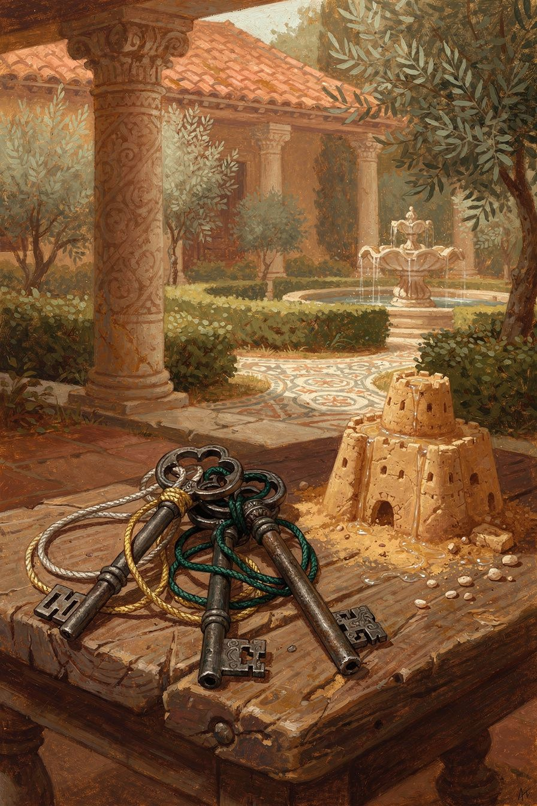
Illustration for Chapter 3
The morning sun streamed through the classroom windows, but Alex barely noticed. He stared at the cast list pinned to the drama club bulletin board, his heart sinking. Understudy. Not the lead. Not even a supporting role. Just a name at the bottom, a shadow in case someone else got sick. His friends high-fived around him, already buzzing about rehearsals, while he felt like the floor had dropped away. The walk home was a blur of hot cheeks and a tight throat. He replayed the audition in his head, picking apart every line he’d delivered, every note he’d sung. I messed up. I’m not good enough. This is humiliating. By the time he reached his room, the disappointment had curdled into a heavy, sour lump in his chest. It wasn’t just sadness—it was a story he was telling himself, a story that felt absolutely true.
Two thousand years ago, a Roman emperor faced storms far larger than a middle-school play. Marcus Aurelius spent most of his reign not in marble palaces, but in muddy military camps on the empire’s northern frontier, surrounded by war, disease, and scheming advisors. He knew that life would constantly throw things at him—betrayals, losses, physical pain, the foolishness of others—that he could not control. Yet he also discovered a quiet, unshakeable power that no one could take from him. He wrote it down for himself, a private reminder scratched onto parchment in a tent at night: “You have power over your mind—not outside events. Realize this, and you will find strength.”
That single sentence is like a key. It opens three doors, and behind each door is a practice that can transform the way you move through the world. The philosopher Pierre Hadot called them the three disciplines: the discipline of desire, the discipline of assent, and the discipline of action. Together, they form a complete toolkit for navigating anything—from a disappointing cast list to the chaos of an empire.
———

The Big Idea: Three Doors, One Key
Imagine your mind is a small, sturdy castle on a hill. Outside the walls, the weather does whatever it wants. Storms roll in, winds howl, sometimes the sun blazes too hot, sometimes the rain turns the ground to mud. You cannot stop the weather. But inside the castle, you have three doors, and you are the gatekeeper. You decide what comes in, what stays out, and what you do with what’s already inside. Marcus Aurelius practiced guarding these three doors every single day.
Door One: Desire (Accept What Nature Gives)
The first door deals with what we want and don’t want. Most of us spend our days chasing after things we desire and running away from things we fear. We want the lead role, the high score, the approval of friends. We don’t want the embarrassment, the rejection, the rainy day that ruins our plans. But here’s the hard truth: the weather outside the castle doesn’t care about our preferences. The universe will give you sunshine and storms in equal measure, and you don’t get to choose the menu.
The discipline of desire teaches us to flip the script. Instead of demanding that life serve us our favorite meal, we learn to want whatever is actually on the plate. This isn’t about giving up or becoming a doormat. It’s about recognizing that the only thing we truly control is our own character, our own choices. Everything else—our reputation, our health, the actions of others, the outcome of an audition—is ultimately outside our command. When we stop fighting reality and start accepting it as the raw material for our growth, a strange thing happens: the disappointment loses its sting. The weather still storms, but we are no longer standing outside without a coat, shaking our fist at the sky. We are inside the castle, warm and dry, watching the rain and thinking, This is what is happening. Now, what virtue can I practice here?
Door Two: Assent (Judge Your Impressions Carefully)
Before any event can upset us, it has to pass through a second door: our judgment. A thing happens—a comment from a friend, a grade on a test, a sudden change of plans. That’s the raw data, what the Stoics called an impression. Immediately, our mind slaps a label on it: This is terrible! This is unfair! I’m a failure. The discipline of assent is the art of pausing before we stick that label on. It’s the gatekeeper inspecting the package before letting it into the castle.
Marcus Aurelius learned this from the Stoic teacher Epictetus, who said, “It is not events that disturb people, it is their judgments about them.” Alex didn’t get upset because of the cast list itself—a piece of paper with names on it. He got upset because of the judgment he attached to it: Being an understudy means I’m not talented. This is a disaster. But what if he paused and asked, Is that really true? The raw event is simply that he was assigned a particular role. The rest is a story his mind is telling him. The discipline of assent means catching that story in the moment, holding it up to the light, and deciding whether to believe it. Often, we’ll find the story is exaggerated, or that we’re missing another perspective entirely—maybe the understudy gets to learn from the lead, or maybe this frees up time for something else he loves. The event itself is neutral; our judgment gives it its power.
Door Three: Action (Act for the Common Good)
Once we’ve accepted what’s outside our control and carefully examined our judgments, we’re ready for the third door: action. But not just any action. Marcus believed that we are made for each other, like hands or feet working together, like bees in a hive. Our actions, therefore, should aim at the good of the whole, not just our own comfort. This doesn’t mean you have to be a hero every day. It means that whatever role you’re given—emperor, student, understudy, friend—you can play it with justice, kindness, and integrity.
For Alex, the discipline of action might mean showing up to rehearsal and supporting the lead actor with generosity instead of resentment. It might mean learning every line anyway, so he’s truly ready if needed. It might mean helping the stage crew or encouraging a nervous castmate. The role itself is less important than how he performs it. Marcus wrote to himself, “Do what is necessary, and do it as a rational being would do it—with kindness, with freedom, with justice.” The action door isn’t about grand gestures; it’s about bringing your best self to whatever is right in front of you, right now.
———

Try This
These practices help you walk through the three doors in your own life. You can do them in a journal, in a notes app, or just in your head during a quiet moment.
1. The Weather Report (Discipline of Desire) Tonight, write down one thing that happened today that you didn’t want to happen. It could be a bad grade, an argument, a cancelled plan. Next to it, write: This was outside my control. Then, write one thing that is in your control right now—your effort, your attitude, your next choice. Finally, reframe the event as a training opportunity: What virtue can I practice because this happened? (Patience? Courage? Flexibility?) This turns the storm into a gym.
2. The Pause Button (Discipline of Assent) The next time you feel a strong emotion—anger, embarrassment, anxiety—hit an imaginary pause button. Take three slow breaths. In your mind, separate the raw event from your judgment. Say to yourself: “The event is just ____. My judgment is telling me ____.” Then ask: “Is this judgment 100% true? Is there another way to see it?” Write down at least one alternative interpretation, even if you don’t fully believe it yet. This builds the muscle of pausing before you label.
3. Role-Play the Sage (Discipline of Action) Pick a situation coming up this week that you’re nervous about or that might be frustrating. Before you go into it, take two minutes to imagine you are the wisest, kindest version of yourself—like Marcus Aurelius stepping into your shoes. Ask: What would the best version of me do here? How would they treat others? What small, helpful action can I take, regardless of the outcome? Then, during the situation, try to act from that image. Afterwards, reflect: Did I act for the common good, or just for my own comfort? No guilt—just honest noticing.
4. The Evening Gate-Check (All Three Doors) Before bed, replay one moment from your day. Walk it through the three doors: - Desire: Did I fight against something I couldn’t control, or did I accept it and look for my next right step? - Assent: Did I pause and question my first judgment, or did I let a false story run wild? - Action: Did I act in a way that helped others, or only myself? Don’t judge yourself harshly. This is a gentle review, like a coach watching game tape to help you improve. Write one sentence about what you’d like to remember for tomorrow.
———
A Question to Carry With You: What story am I telling myself right now about this situation—and is there a truer, more helpful story I could choose instead?
———

Chapter 4: One City, Many Neighbors
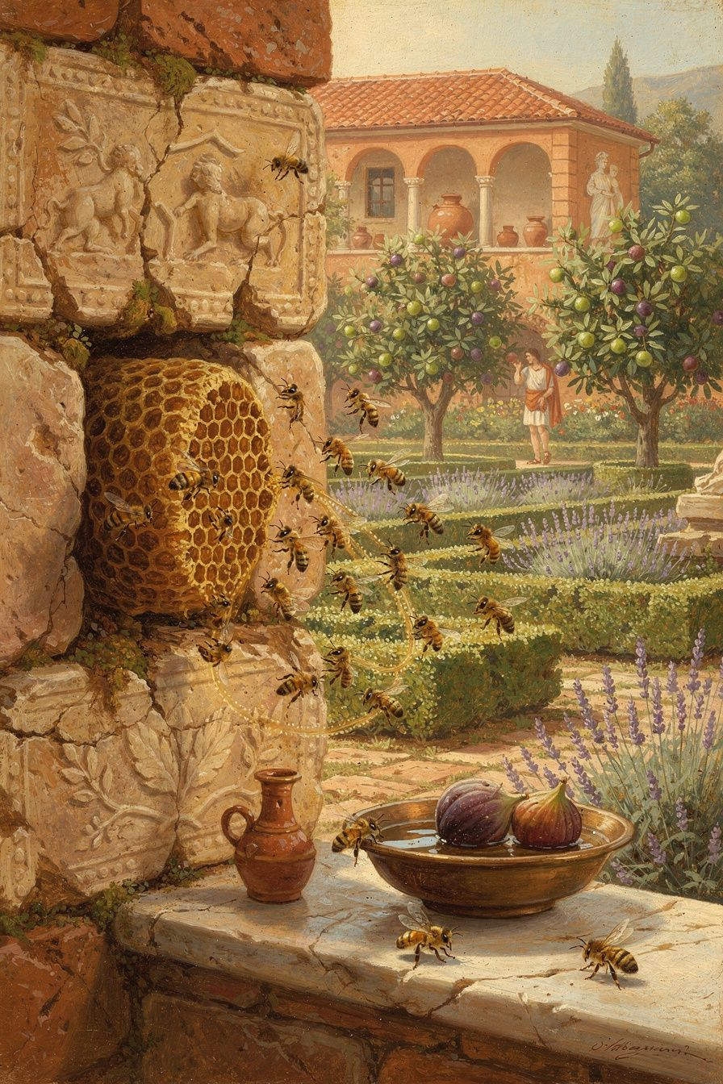
Illustration for Chapter 4
It started with a group project in Mr. Chen’s history class. Alex was paired with Jordan, and at first it seemed like a lucky break—Jordan was funny, easygoing, and always had a story to tell. But when the work began, the luck evaporated. Alex spent two evenings researching ancient Roman aqueducts while Jordan forgot the notes, showed up empty-handed, and shrugged it off with a grin. By the third meeting, Alex was simmering. Why should I do all the work? This is so unfair. I’m going to tell Mr. Chen that Jordan isn’t pulling any weight.
That night, Alex’s frustration spilled over at dinner. After listening patiently, Alex’s older sister slid a book across the table—a worn copy of Meditations by Marcus Aurelius. “You might find this interesting,” she said. “He was a Roman emperor who had to deal with way worse partners than Jordan.” Alex flipped through the pages skeptically until a line stopped them cold.
“We were born for cooperation, like feet, like hands, like eyelids.”
Alex imagined feet refusing to walk because the hands weren’t doing their share. Or eyelids deciding not to blink because the eyes looked tired. It sounded ridiculous. But wasn’t that exactly what was happening with the project? Alex had been treating Jordan like an opponent instead of a teammate. The next day, instead of complaining, Alex sat down with Jordan and asked, “Hey, I noticed you’ve been having a hard time getting your part done. Is something going on? How can we tackle this together?” Jordan admitted feeling overwhelmed by other classes and not knowing where to start. They re-divided the tasks, with Alex offering to gather the research if Jordan would build the slides. The project came together, and so did something more important: a sense that they were on the same side.
Alex realized later that the class wasn’t a collection of separate competitors. It was more like a living body, where each person’s effort—or struggle—rippled through everyone else. When one part slacked, the whole body felt the strain. When one part got support, the whole body moved better.
———

The Big Idea
Marcus Aurelius didn’t just write that line for students with group projects. He wrote it as an emperor facing wars, plagues, and political betrayals. Yet he still believed that humanity is one interconnected organism, guided by a shared rational principle he called the logos. To him, this wasn’t a sentimental wish that everyone would just be nice. It was a practical truth about how the world works—and how we should therefore act.
Think of a beehive. Every bee has its own job, but no bee survives if the hive collapses. Marcus put it bluntly: “What is not good for the swarm is not good for the bee.” If you poison the hive, you poison yourself. If you strengthen the hive, you eat honey. The same logic applies to a soccer team: a striker who never passes might score once, but the team loses again and again. A body is the ultimate example. Your foot doesn’t envy your hand, and your hand doesn’t refuse to brush your teeth because it’s “not my mouth.” When one part is injured, the whole body rallies to protect and heal it—not out of pity, but because the body knows that ignoring the injury will make everything sick.
This is the foundation of duty, justice, and forgiveness in Marcus’s philosophy. Duty means acting for the good of the whole, not just your own comfort. Justice means recognizing that every person has a role, and harming someone else’s ability to fulfill their role damages the entire community—including you. Forgiveness becomes natural when you see others as limbs of the same body. If you accidentally hit your thumb with a hammer, you don’t stay angry at your thumb. You don’t plot revenge against your own hand. You understand it’s part of you, and you focus on healing. When someone messes up, Marcus would say, they’ve acted against the common good—but they’ve also hurt themselves, because they’ve damaged their own connection to the body. Your job is not to condemn them forever, but to help restore that connection, if possible, while protecting the body from further harm.
This doesn’t mean being a doormat. A body needs boundaries—skin keeps out infection, and a broken bone needs to be set firmly. Sometimes you must stop someone from causing more damage. But you do it with the mindset of a doctor, not an executioner. You act to heal the whole, not to punish out of spite.
For a middle schooler, this might mean: when a friend says something hurtful, you don’t immediately cut them off or spread rumors. You pause and ask, “What’s really going on here? Is this person struggling with something that made them lash out?” You still protect your own feelings, but you approach the conflict as a problem to solve together, not a war to win. When a group project feels lopsided, you don’t just resent the slackers; you figure out how to redistribute the load so everyone can contribute in a way that works. When you see someone being left out, you remember that a body with a neglected part becomes weaker—so you find a way to include them.
Marcus’s insight is that we are literally made for cooperation. Our bodies, our minds, our survival—all depend on it. The bee who works against the swarm works against itself. The hand that refuses to help the foot will stumble too. This isn’t a fluffy ideal; it’s a call to see the world clearly and then do your part with quiet determination.
———

Try This
1. Journal: The Body Check. Think of a recent conflict—maybe with a sibling, a teammate, or a classmate. Write down what happened and how you felt. Now imagine that both of you are parts of the same living body. What would that body need to be healthy again? Write a second version of the story where you respond as if the other person were a hand that needed help, not an enemy.
2. Role-Play: Two Parts, One Movement. With a friend or family member, act out a common disagreement (like arguing over who gets the last slice of pizza, or who should clean up a mess). Play it the usual way first. Then replay the scene imagining you are two parts of one body—say, a left hand and a right hand—trying to accomplish a task together. How does the conversation change? What do you notice about your tone and your willingness to listen?
3. Daily Check-In: The Cooperation Reminder. For one full day, whenever you feel irritation bubbling up toward someone, silently repeat Marcus’s words: “We were born for cooperation, like feet, like hands, like eyelids.” Don’t force yourself to feel differently; just let the phrase sit in your mind. At the end of the day, jot down one moment where the reminder shifted your reaction, even a little.
4. Creative Vision: The School Body. Grab some paper and colored pencils. Draw your school as a single living creature. What parts would it have? (Think beyond students—include teachers, custodians, cafeteria workers, counselors, even the building itself.) Label each part and write next to it what that part needs from the others to stay healthy. For example, the “stomach” might be the cafeteria, needing a steady supply of respect and clean tables. The “ears” might be the counselors, needing people to actually talk to them. Hang your drawing somewhere you’ll see it and add to it over the week.
———
If your whole school were one living body, what part would you be—and what does that part need from the others to stay healthy?
———

Chapter 5: The Emperor in the Sick Tent
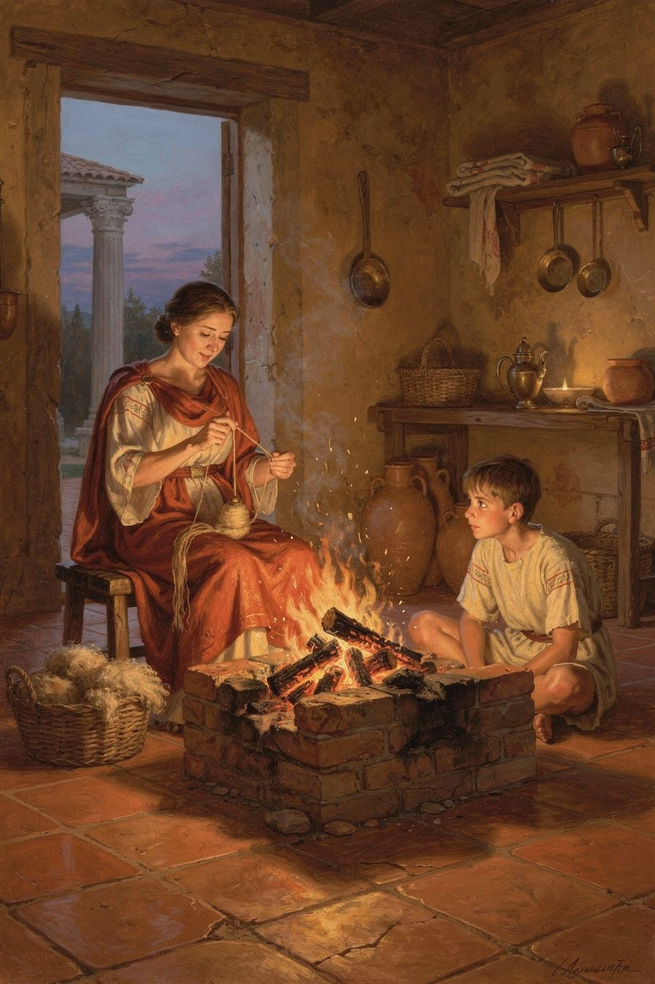
Illustration for Chapter 5
The wind off the Danube did not care who was emperor. It slipped under the leather tent flaps and bit at exposed ankles all the same. Inside, Marcus Aurelius pulled his wool cloak tighter. His fingers were stiff. His chest hurt—not from battle, but from the sickness moving through the camp. Soldiers called it the Antonine Plague. Marcus called it one more thing to endure.
He was far from Rome, middle-aged, and the Marcomannic War had dragged on for years. Letters arrived stained by mud and worse news. Friends had died. Children had died. A trusted general had betrayed him, raising a rebellion in the East. And now the fever. Any reasonable person would have thrown the inkpot across the tent and howled at the sky.
Instead, Marcus reached for his journal. By the guttering light of an oil lamp, he began to write—not for publishers, not for historians, but for himself.
He thought about fire. He wrote: "A fire takes hold of whatever falls into it and surmounts it and rises above it... so too the intelligent power takes hold of whatever falls into it and assimilates it to itself."
Imagine that. A lump of wet wood sees a spark and thinks, Not fair! Why me? It hisses, smokes, and complains. But fire? Fire swallows the wood and rises higher. It does not ask the wood for permission. It does not argue. It transforms whatever enters it.
Marcus wanted his mind to work like that. Pain, betrayal, grief, and fever fell into his life. He could not stop them from falling. But he could refuse to let them turn him into soggy, smoking ash. He could burn through them and rise.
That is easy to admire from a distance. It is much harder when the trouble is a failed test, a sick parent, a cut from a friend, or a body that refuses to cooperate. Most of us are not emperors, but we all have our own sick tents. Maybe yours is a bedroom with the flu, a lunch table where nobody saved you a seat, or the bench after a game you lost because your ankle gave out. The question is not whether hard things will find you. They will. The question is what you add on top of them.
Marcus had a razor-sharp way of cutting through that extra layer. He reminded himself: "Everything that happens is either endurable or not. If it's endurable, then endure it. Stop complaining."
That sounds harsh until you see what he is really doing. He is separating the pain from the suffering. Think of it like this.
Pain is the first arrow. It strikes when the fever spikes, when someone spreads a rumor, when the coach benches you. That arrow is real. It hurts. You cannot pretend it away.
Suffering is the second arrow. It is the story you tell yourself afterward: This ruins everything. I can't handle it. Life is always awful to me. That arrow you fire at yourself. And Marcus decided, quietly but firmly, to set down the bow.
Picture a river. A boulder crashes into the water. The river does not write a complaint to the mountain. It does not hold a grudge. It splits around the rock, keeps its course, and over time wears the boulder smooth. The river meets the obstacle without adding a tantrum. That does not mean the river feels nothing. It means the river does not waste its current on self-pity.
Or picture a garden. Drought comes. A gardener can scream at the sky, which changes nothing. Or she can note the dry soil, fetch water, and check which plants are strong enough to survive. One response adds misery. The other adds usefulness. Marcus practiced being that gardener. He still felt the drought. He simply refused to salt his own earth.
The Big Idea is this: you cannot always control what falls into your life, but you can control whether you turn it into fuel or into poison. Meeting pain without adding suffering is not about becoming a robot. It is about protecting your energy so you can actually deal with the problem. Complaining is expensive. It costs focus, sleep, and dignity. Endurance—quiet, stubborn, fire-like endurance—costs far less and leaves you stronger on the other side.
Marcus was not perfect at this. His private journal proves he had to remind himself constantly. That is why the Meditations exist. They are not the lectures of a man who has it all figured out. They are the self-talk of someone building the habit, one cold night in a tent, one sentence at a time.
If you want to build that same habit, here are a few ways to start.
Try This
The Fire Check-In. The next time something frustrating happens—a dead phone, a harsh comment, a missed bus—pause for ten seconds. Ask yourself: Am I wet wood right now, smoking and hissing? Then picture your mind as fire. Whatever just fell into it, imagine the flames taking hold and rising higher. You do not have to like what happened. You only have to refuse to let it choke you.
Two-Layer Weather Report. In a notebook, draw a quick line down the center. On the left, write only the facts of what went wrong today. Example: I got a C on the quiz. My friend ignored my text. On the right, write the story your brain immediately told you. Example: I'm terrible at math. Nobody likes me. Now look at both columns. The left column is the weather. The right column is the forecast you invented. Cross out the right column. Keep the facts. Lose the fiction.
Sick-Tent Role-Play. Find a classmate, sibling, or mirror. First, play the Complainer. Let the bad news hit you and react with maximum drama: slumped shoulders, sighing, Why does this always happen? Then reset and play Marcus. Stand taller. State the problem in one flat sentence. Add one small action you can take, even if that action is just breathe and wait. Notice how different your body feels. The situation did not change. Your response did.
The Twenty-Four-Hour Complaint Fast. Pick one day this week. Carry a scrap of paper or use your phone notes. Every time you catch yourself starting to complain, make a tally mark. Do not judge yourself. Just notice. At day's end, count the marks. Then ask: How many of those problems were still there, whether I complained or not? Usually all of them. The difference is how tired you feel.
Marcus Aurelius died in that rough frontier country, still campaigning, still writing. He never made it back to the marble palaces of Rome as an old man. Yet his notes survived because they were honest. He showed us that the highest power is not the power to make trouble disappear. It is the power to meet trouble without making it worse.
So here is the question he left for you, written by lamplight in a tent where no one was watching:
When the next hard thing falls into your life, will you let it become the reason you fall apart—or will you let it become the fuel that helps you rise?
———

Chapter 6: Start With the Sun
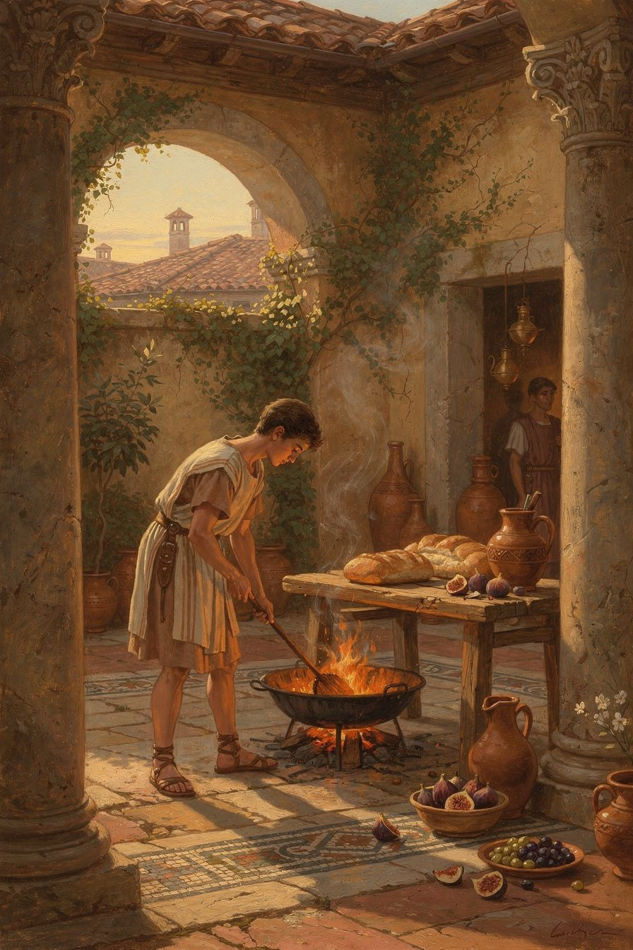
Illustration for Chapter 6
The lamps had burned low. Outside the leather tent-flap, the Danube wind carried the iron scent of coming winter, and somewhere beyond the dark ridge, enemy scouts moved through the fog like wolves testing a fence. Inside, Marcus pulled the rough wool blanket higher under his chin. His back ached from decades on horseback. His fingers, stiff from gripping a stylus, wanted nothing more than to remain curled against his chest. In a few hours, quarrelsome senators would arrive with petitions. Despatch riders needed orders. A fever was spreading through the cavalry horses, and his physician warned that the old imperial lungs sounded wetter than before. Every bone in his fifty-nine-year-old body suggested, quite reasonably, that he stay horizontal.
But he sat up.
He reached for the wax tablet he kept beside his camp cot. By the last guttering flame, he scratched a note to himself—not to a servant, not to the Senate, but to the only person who could actually change his mind. He wrote what would become one of the most famous sentences in his Meditations: At dawn, when you have trouble getting out of bed, tell yourself: I have to go to work—as a human being. He read it back. Then he swung his legs onto the frozen dirt floor, pulled on his boots, and began rebuilding his day.
You probably sleep in a room with drywall rather than canvas, and your morning enemies are algebra quizzes and crowded hallways rather than Germanic tribes. But the physics of the moment are identical. The blanket is too warm. The air is too cold. The day ahead feels heavier than your body. Maybe you argued with a friend last night. Maybe the cafeteria serves mystery meat on Tuesdays. Maybe you simply do not see why another Monday should demand your participation. Marcus understood that mood perfectly. He wrote about it constantly because he lived it constantly. What made him different was not superhuman discipline. It was a decision he made while still half-asleep: the citadel must be rebuilt daily.
The Big Idea
Imagine your mind is a wooden citadel on a hill. Overnight, the boards loosen. Rain seeps into the grain. Squirrels chew the gates, and the wind shifts the stones just enough to make the walls wobble. By sunrise, the fortress is not ruined—it is simply unready. If you walk out without inspecting the damage, every passing criticism, every petty annoyance, every unexpected quiz becomes a battering ram. Marcus returned to the same reminders each morning because he knew that courage, kindness, and clear thinking are not tattoos. They are architecture. You cannot build once and forget. You must walk the ramparts, hammer in hand, every single dawn.
This is why he accepted the cold floor, the aching shoulders, and the complaining envoys waiting in the frost. He called it acceptance of nature. A river does not negotiate with the boulders in its path; it flows around them, over them, through them, and keeps moving toward the sea. A fox does not file a complaint about winter; it grows a thicker coat or digs a deeper den. Nature is simply what happens. The quiz is real. The rain is real. Your sister's bad mood is real. Fighting these facts is like punching a cloud—you exhaust yourself and change nothing. Acceptance is not weakness or surrender. It is choosing to start from where you actually are, with the materials the day has actually given you, rather than wasting the morning mourning a fantasy world where everything goes your way.
From that solid ground, Marcus turned to attention to purpose. Going to work—as a human being meant something specific to him. It meant speaking truthfully when lies were easier. It meant listening to the boring petition instead of daydreaming about lunch. It meant doing the thing only he could do, with whatever strength he had that day, because the empire needed a steady hand and not a sulking child. The Stoics believed every creature has a job written into its bones: bees pollinate, oaks shade, wolves hunt in formation, and humans reason and cooperate. Your homework is not a punishment. It is the work of becoming someone who can finish hard things. Your apology to a friend is not a chore. It is the work of trust. Your practice at the instrument, the sport, the sketchbook—these are not obstacles between you and freedom. They are the bricks that turn you into a person who can carry weight without collapsing.
Finally, there is the part that sounds dark until you hold it up to the light: willingness to die well. Marcus did not wake up planning to die. He woke up planning to live so completely that, if the day turned out to be his last, he would not need to rewrite the script. Think of a campfire on a cold night. You do not know which log will be the final one, so you tend every flame as if it matters. A good day is built from the same material as a good life: honest effort, patience with people who annoy you, and the refusal to let your thoughts rot in resentment or panic. Marcus put it plainly: The happiness of your life depends upon the quality of your thoughts. If you let your morning mind stew in "this is unfair" and "I can't" and "why me," you are planting thorns in your own garden and then wondering why you bleed when you walk through it. If you plant "I can do my work" and "I will meet what comes" and "this belongs to the nature of things," you grow something you can actually harvest when the weather turns.
Try This
Morning Masonry. Keep a small notebook beside your bed. Before your feet touch the floor, write one sentence about what you are building today. Not what you have to survive, but what you actively choose to construct: patience with your little brother, a finished essay, honesty with a teammate, calm during the exam. Read it aloud, even if your voice cracks. That sentence is your first brick, laid while the world is still quiet.
The Marcus Alarm. When your alarm sounds tomorrow, do not reach immediately for the phone. Say Marcus's words out loud, even if you mumble into your pillow: "I have to go to work—as a human being." Adapt the language if you need to. Try "I have to go to work—as a student," or "as a friend," or "as myself." Notice how different it feels from "Ugh, five more minutes." One phrase treats you like a tool; the other treats you like a builder.
Lunchtime Inspection. Set a quiet alert on your watch or phone for the middle of the day. Step away from the noise for sixty seconds and ask three questions. First, am I fighting reality right now, or am I working with it? Second, am I doing the thing that actually needs my attention, or am I hiding in distraction? Third, if today ended after this afternoon, would I be proud of how I handled the morning? You do not need perfect answers. You need the habit of looking, because a citadel that is never inspected will fall the moment someone sneezes.
The Elder Interview. Find someone older—a parent, coach, neighbor, or grandparent—and ask them what they tell themselves on hard mornings. Do they use a prayer? A joke? A memory of their own parents? Write down what they say. You will discover that almost every adult you respect has some private ritual for rebuilding their own citadel at dawn. Compare your rituals. You may find that the work of beginning again is older than Rome itself.
If you had to rebuild your courage, your kindness, and your focus from scratch every single morning—knowing that no one else could pick up the hammer for you—what is the first brick you would place tomorrow?
———

For the Grown-Up Reader
This booklet adapts Marcus Aurelius's Meditations and the scholarly commentary of Pierre Hadot, R. B. Rutherford, and Tad Brennan. Key passages are cited by book and section using translations by Gregory Hays and A. S. L. Farquharson.
If a child asks, 'Did Marcus really write this?' the answer is yes—he wrote the Meditations as private notes to himself. They were not intended for publication, which is one reason they sound so honest.
———

About WisdomForge
WisdomForge adapts the great philosophers into stories, audio, and conversation for every age. Each philosopher becomes four booklets—one for children, one for teens, one for older adolescents, and one for adults—so the same ideas can grow with you.

