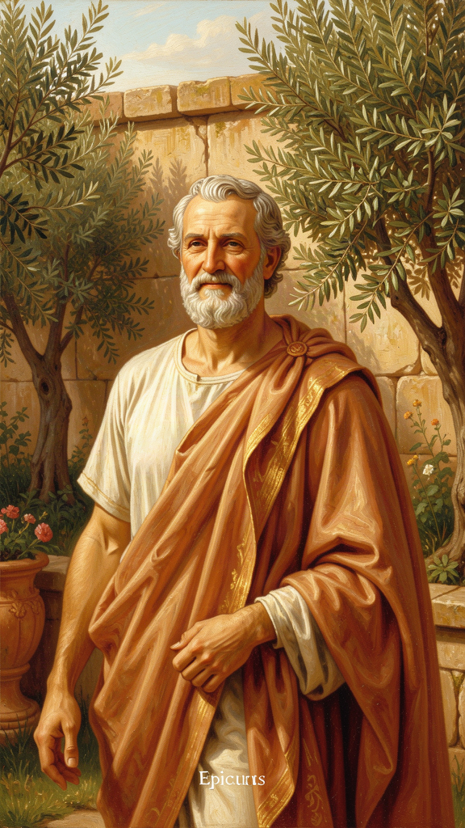
Epicurus: The Garden of Enough
WisdomForge Booklet — Adult

Epicurus: The Garden of Enough

WisdomForge Booklet — Adult
———

About This Book
This booklet reads Epicurus as a philosopher of desire, mortality, and the disciplined cultivation of peace. Drawing on the three surviving letters, the Principal Doctrines, the Vatican Sayings, and Lucretius' De Rerum Natura, it traces six threads through Epicurus' work: the Garden as alternative community, the four-part cure, the architecture of desire, the art of enough, the death argument, and philosophy as therapy.
Each chapter combines scholarly precision with practical application. It assumes you are busy, burdened, and unlikely to retire to a Greek garden. The goal is not admiration but use.
———

Chapter 1: The Philosopher of the Garden
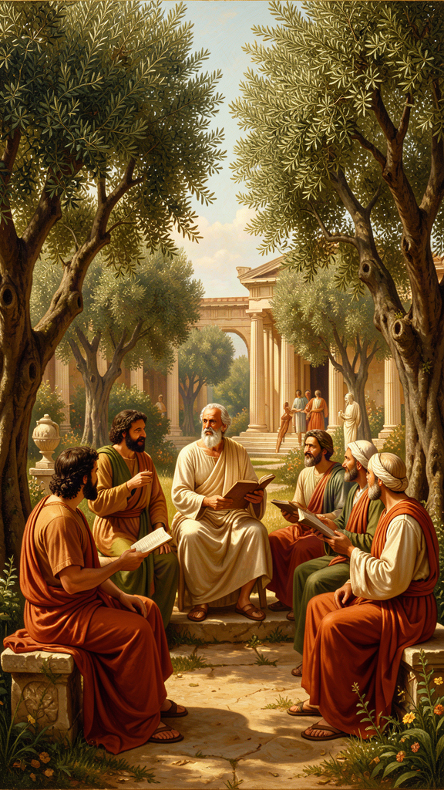
Illustration for Chapter 1
It begins with a purchase. Around 307 BCE, a man in his early thirties bought a house with a garden outside the walls of Athens, between the Dipylon gate and the Academy. He did not open a school in the traditional sense. He did not set up a lectern, charge fees, or establish a hierarchy of teacher over student. He invited his friends to live with him. They ate simple meals together. They talked about what they feared and what they wanted. They admitted women, slaves, and foreigners at a time when every other philosophical institution in the Greek world was restricted to elite freeborn men. They called it the Garden.
The man was Epicurus of Samos. He had been born in 341 BCE on an Aegean island, the son of Athenian colonists, and he had begun asking questions at fourteen — the age when most boys were learning to ride and throw javelins. The story, preserved by Diogenes Laërtius, is that his schoolmaster could not explain the concept of Chaos in Hesiod's Theogony. Whether or not the anecdote is true, it captures the engine of Epicurus' entire project: the traditional stories about the gods and the cosmos were incoherent, and incoherence produced terror, and terror was the disease philosophy was meant to cure.
By the time Epicurus founded the Garden, the world he inhabited had been shattered and remade. Alexander the Great had conquered the known world and died at thirty-two. His empire had fragmented into rival kingdoms. The old Greek city-states, including Athens, were struggling to maintain their independence against Macedonian power and the new cosmopolitan order. The certainties that had organized Greek life for centuries — the gods of the polis, the primacy of civic virtue, the sufficiency of local tradition — were crumbling. People were adrift. They needed a philosophy that spoke to the individual, not to the citizen. They needed something that worked.
Epicurus' answer was radical in its simplicity. Do not seek happiness in politics, wealth, fame, or the favor of the gods. Seek it in understanding — understanding the nature of the universe, the nature of desire, and the nature of death. Then seek it in friendship. Then eat bread and water with people you love, and discover that this is enough. The Garden was not a retreat from the world. It was a demonstration that the world as commonly pursued — the world of ambition, acquisition, and anxiety — was unnecessary. You could live differently. You could live better. You could live with less and feel more.
The Garden was the proof of concept. It survived Epicurus by centuries — longer than Plato's Academy. The Epicurean school persisted into at least the third century CE, with communities in Athens, Antioch, and Rome. Its durability was not institutional but communal. The Garden was built on friendship, not hierarchy. Friendships persist when institutions crumble. Epicurus' will, preserved by Diogenes Laërtius, made provision for the Garden's continued operation, the care of his friends' children, the emancipation of slaves who had studied philosophy, and the monthly memorial feast on the twentieth of each month. This is not the will of a hedonist in the modern sense. This is the will of someone who saw his community as his family and his philosophy as his legacy.
The ancient world told two stories about Epicurus. The hostile story, propagated by Stoic and later Christian sources, painted him as a glutton, a sensualist, a plagiarist who stole from Democritus and denied it. The friendly story, told by his followers and even acknowledged by some critics, described a man of extraordinary kindness, simplicity, and devotion. He was physically frail in his later years, needing a wheelchair. He ate bread and water. He never married. He was loved by his friends with a fervor that bordered on the religious. You do not inspire that kind of devotion by vomiting twice a day from overeating, as the hostile tradition claimed. You inspire it by living what you teach.
The smear campaign is worth understanding because it shaped how the word "Epicurean" entered modern English — as a synonym for gourmand, for someone devoted to fine food and sensual pleasure. This is precisely the opposite of what Epicurus taught. The Garden ate barley bread and water. The luxury was the conversation. The pleasure was the absence of pain — physical and mental — and the presence of friends. The reputation was engineered by opponents who could not easily attack his arguments, so they attacked his character instead. It is one of the great ironies of intellectual history that the philosopher who taught that the greatest wealth is needing little is remembered as a symbol of excess.
———
The Big Idea
The Garden was not a philosophical school. It was a philosophical experiment. The question it posed: can you build a life organized around the absence of fear rather than the pursuit of power? Epicurus spent his entire career arguing that the answer was yes. The Garden was the evidence. It was a community of people who had decided that the conventional sources of happiness — wealth, status, political influence, divine favor — were unreliable, unnecessary, and often counterproductive. They replaced them with something simpler and more durable: understanding, friendship, and enough.
The inclusiveness of the Garden was not incidental. It flowed directly from the philosophy. If the goal of philosophy is the cure of the soul, then souls are souls, regardless of the body they inhabit or the social status attached to them. A slave can achieve ataraxia. A woman can philosophize. A foreigner can be a friend. The capacity for peace of mind does not depend on citizenship, gender, or legal status. The Garden was the first philosophical community in the Western tradition that took this seriously — not as a political slogan but as a direct consequence of its ethical theory.
This matters now because the question the Garden posed is the question many of us are asking. The conventional sources of meaning — career, consumption, recognition — are proving fragile. The modern economy runs on the systematic production of dissatisfaction. The social fabric is fraying. People are looking for something that does not depend on the stock market or the algorithm. Epicurus offered one. He did not offer a political program. He offered a way of living that was resistant to the forces that make life unbearable, and he offered a community in which that way of living could be practiced. The Garden is gone. The idea is not.
———
Practice
The Garden was the delivery system for Epicurus' philosophy. You cannot practice Epicureanism alone — or rather, you can, but it works better in community. The practices below are adapted for a life that probably does not include a physical garden in Athens.
The Friendship Audit. Epicurus called friendship "the greatest good" — not a luxury, but a necessity. Audit your relationships using the Epicurean test: Who would you eat a simple meal with? Who could you tell what you're afraid of? Do you trust them without checking? Does their existence make you feel safer? If you have three people who pass this test, you have a garden. If you don't, that is the first thing to build. Not a network. A garden.
The Simple Meal. Once a week, eat a simple meal with someone. No restaurants, no delivery, no screens. Bread, water, cheese, fruit. The point is not deprivation. The point is the discovery that the meal is genuinely pleasant — and that the pleasure comes from the company, not the cuisine. Epicurus wrote: "Barley cake and water give the highest pleasure when someone in need partakes of them" (Letter to Menoeceus 131). He meant this. Try it and see if he was right.
The Monthly Feast. The Garden gathered on the twentieth of each month to remember Epicurus and Metrodorus, to renew friendships, and to reinforce the community. Pick a day. Gather your people. Eat together. Talk about what matters. Do it monthly. The ritual creates continuity. Continuity creates community. Community creates the conditions for ataraxia.
———
A Reflective Prompt
Epicurus built the Garden outside the city walls — deliberately outside the political life of Athens. What would it mean for you to build something "outside the walls"? Not a physical retreat, but a space — mental, social, temporal — that is organized around different values than the ones your workplace, your social media, and your consumer environment enforce. What would that space look like? Who would be in it? What would you stop chasing?
———

Chapter 2: The Four-Part Cure

Illustration for Chapter 2
It begins with a medical metaphor — except Epicurus did not consider it a metaphor. Philosophy is medicine. The philosopher is the doctor. You are the patient. The disease is false belief. The cure is true belief. The prescription is four sentences:
Don't fear god. Don't worry about death. What is good is easy to get. What is terrible is easy to endure.
— Philodemus, Against the Sophists (P.Herc. 1005, col. IV.9–14)
The word is tetrapharmakos — "four-part cure." A pharmakon in Greek can be a poison or a remedy. The ambiguity is deliberate. The beliefs that make you suffer are toxic. The beliefs that replace them are therapeutic. The tetrapharmakos identifies four toxic beliefs, four therapeutic replacements, and asserts that if you genuinely internalize the replacements, the primary sources of human misery dissolve. Not reduce. Not manage. Dissolve.
This is cognitive behavioral therapy 2,300 years before Aaron Beck. The cognitive model — that distress is produced by beliefs, not by events — is the foundation of both. The tetrapharmakos identifies four core false beliefs and provides four replacements. The method is the same: identify the false belief, examine it, replace it with a true one, and repeat until the new belief is internalized. Epicurus understood something modern therapy confirms: you cannot simply stop believing something. You must replace it. The replacement does the work.
———

Ingredient 1: Don't Fear God
The most counterintuitive claim in ancient philosophy. Epicurus does not say there are no gods. He says: the gods exist, they are perfectly blessed, and they have absolutely nothing to do with you.
The blessed and indestructible being has no troubles itself and causes no trouble for anyone else. Therefore, it is not affected by anger or favor. For all such things are signs of weakness. (KD 1)
The reasoning is precise. A perfectly blessed being cannot be disturbed — anger, jealousy, and the need for worship are disturbances. A perfectly blessed being cannot need anything from you — need implies lack, and a blessed being lacks nothing. A perfectly blessed being cannot punish or reward you — punishment and reward require being affected by your actions, and a blessed being is unaffected. Therefore: the gods exist, they are perfectly happy, and they do not care about you. This is not atheism. It is theological liberation. The gods are not threats or judges. They are examples. They demonstrate that a state of perfect tranquility is possible.
The therapeutic application is direct. If you are lying awake at night afraid of divine judgment, you hold a false belief about the nature of the divine. The true belief is: nothing is judging you. Nothing is watching. Nothing is waiting to punish you. The sky is empty of threats. You can breathe. Epicurus was explicit about this: "The impious person is not the one who denies the gods of the many, but the one who applies the beliefs of the many to the gods" (Letter to Menoeceus 123–124). You honor the gods by recognizing their perfection, not by trembling before them.
———

Ingredient 2: Don't Worry About Death
The most famous argument in ancient philosophy, and for good reason. It is three steps:
1. All good and bad consists in sensation — if you cannot feel it, it cannot be good or bad for you. 2. Death is the end of sensation — when you are dead, you cannot feel anything. 3. Therefore, death cannot be good or bad for the person who is dead.
So death, the most terrifying of evils, is nothing to us — precisely because so long as we exist, death is not present; and when death is present, we do not exist. (*Letter to Menoeceus* 124–125)
You and death never meet. When you exist, death is not present. When death is present, you do not exist. There is no moment when both are in the room. The fear is of a state that logically cannot harm you. The symmetry argument, developed by Lucretius, adds force: you were not troubled by the eternity before you were born. The time after your death is identical. Nonexistence is nonexistence, whether before or after.
Epicurus distinguishes between the fear of death (the state) and the fear of dying (the process). The process may be painful — that is a legitimate concern, and the fourth ingredient addresses it. But the state of being dead? There is no one there to suffer. The fear is of nothing. Literally.
The therapeutic application: what you fear when you fear death is not death. You fear the anticipation of death — a sensation produced by a living mind imagining a state it will never experience. "For if something causes no trouble when present, the anticipation of it is groundless" (Letter to Menoeceus 125). The cure is not to stop fearing death. It is to understand that what you are fearing is not real.
———

Ingredient 3: What Is Good Is Easy to Get
The classification of desires produces a liberating conclusion: what you actually need is modest and available.
Natural wealth is limited and easy to obtain. But the wealth demanded by empty opinions extends to infinity. (KD 15)
What you need to be happy: food (bread and water are sufficient), shelter, friendship, and freedom from fear. These things are not hard to obtain. Bread costs little. Water is free. Shelter is achievable. Friendship requires effort, not wealth. Freedom from fear requires study, not money. What makes happiness seem hard to obtain is that we want things we do not need: fame, power, luxury, immortality, more-than-enough. These are "empty opinions" — desires without natural limits. There is always more fame. Always more money. The pursuit is infinite, and infinite pursuit guarantees perpetual dissatisfaction.
To whom little is not enough, nothing is enough. (VS 68)
The therapeutic application: separate what you need from what you have been told to want. Nature's requirements are modest. Culture's requirements are infinite. You can satisfy nature today. You can never satisfy culture. The problem is not that you lack enough. The problem is that you cannot recognize enough when you have it.
———

Ingredient 4: What Is Terrible Is Easy to Endure
The claim that pain is manageable:
Pain does not last continuously in the flesh. The most intense pain is present for the shortest time. Pain that just exceeds bodily pleasure lasts only a few days. Long illnesses have more pleasure than pain in the flesh. (KD 4)
Epicurus is making an empirical claim about the nature of pain. Acute pain is brief — the body cannot sustain the worst pain for long. It passes, or you pass. Chronic pain is mild — if it were unbearable, you would not bear it. You would die. The fact that you are alive means the pain is within tolerable limits. And mental pleasure can outweigh physical pain: "Even on the rack, the wise person is happy" (Diogenes Laërtius X.118) — not because pain is not real, but because the memory of past pleasures and the absence of mental disturbance can counterbalance bodily suffering.
The therapeutic application: when pain comes, tell yourself: this is either short or manageable. If it is unbearably intense, it will pass. If it is going to last, I can bear it. The anticipation of pain is worse than the pain itself. The dread is the disease. The reality is usually more tractable than the fear.
———
How the Cure Works
The tetrapharmakos is not four separate medicines. It is a system. The first two ingredients address the two great existential terrors — divine judgment and death. The third addresses the anxiety of desire. The fourth addresses the dread of pain. Together: freedom from fear, freedom from desire, freedom from dread. This is ataraxia. This is the good life. Everything else in Epicurean philosophy — the physics, the epistemology, the detailed ethics — exists to support these four claims. The physics provides the evidence (atoms, void, mortal soul, indifferent gods). The ethics provides the implementation (desire classification, friendship, practice). The epistemology provides the method (all sensations are true; error is in judgment). The tetrapharmakos is the conclusion. The rest is the argument.
The parallel with cognitive behavioral therapy is not superficial. Both share the cognitive model (distress is produced by beliefs, not by events). Both use belief identification (name the specific belief causing the distress). Both use belief examination (is it true? what is the evidence?). Both use belief replacement (replace the false belief with a true one). Both use behavioral reinforcement (the new belief produces different actions, which produce different experiences, which reinforce the new belief). The tetrapharmakos identifies four false beliefs — "the gods will punish me," "death is terrifying," "I need more than I have," "I cannot bear this pain" — and provides four replacements. The replacement is what does the work.
———
Practice
The tetrapharmakos is not an argument to be evaluated. It is a medicine to be taken. The question is not "is this philosophically rigorous?" but "does it work?" Epicurus did not care whether you found his arguments clever. He cared whether you stopped being afraid.
The One-Day Experiment. For one day, live as if the tetrapharmakos were true. The gods do not care what you do. Death is nothing to you. What you need is already within reach. The pain you fear will not be as bad as the fearing. Just for one day. Notice what changes. The tetrapharmakos is an experiment. Run it.
The Belief Audit. Which of the four false beliefs is loudest in your life? Is it the fear of judgment — divine, social, or internal? The fear of death? The conviction that you need more? The dread of pain? Name it. Write it down. Then write the replacement. Not as an affirmation. As a claim you are going to test against your experience.
The Phrase. Epicurus said "accustom yourself to the belief." The word is synethize — habituate. Memorize the four sentences. Repeat them when the corresponding fear arises. Not as a magic incantation. As a reminder of what you have already understood. The goal is to associate the fear-response with the calming phrase, so that eventually the phrase becomes the automatic response to the fear.
———
A Reflective Prompt
Which of the four ingredients would most change your life if you genuinely believed it — not intellectually assented to it, but felt it in your bones? Start there. The tetrapharmakos is not a test of comprehension. It is a prescription. Take the medicine that addresses your specific disease.
———

Chapter 3: The Architecture of Desire
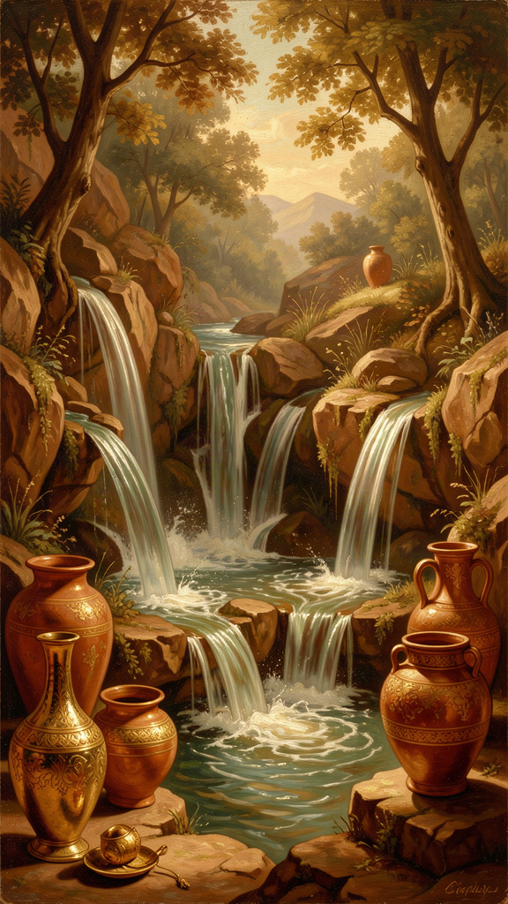
Illustration for Chapter 3
It begins with an inventory. You sit down with a piece of paper and write down everything you currently want. Every single thing — from "coffee" to "recognition" to "a different life." You do not edit. You do not judge. You list. Then you classify each item into one of three categories. The classification is not a theory. It is a diagnostic tool, and it is the most practical thing Epicurus ever produced.
The three categories:
Natural and necessary. Required for life, bodily ease, or happiness. Food, water, shelter, friendship, freedom from fear. These desires have natural limits — you can have enough food, enough shelter, enough friends. They can be satisfied. Satisfy them.
Natural but unnecessary. Genuine desires rooted in the body or mind, not in culture, but you do not need them for well-being. A warm bath instead of a cool one. A soft bed instead of a firm one. Good cheese instead of plain bread. Enjoy these when they are available. Do not pursue them when they are absent. Do not let their absence disturb you.
Empty (unnatural). Desires implanted by culture, not by nature. Fame, power, luxury beyond comfort, immortality, universal approval. These desires have no natural limit. There is always more fame, more power, more money. They can never be satisfied. The pursuit guarantees perpetual dissatisfaction. Eliminate them.
The classification is simple. The work is not. The difficulty is that empty desires feel natural. Fame feels like it would solve everything. Extreme wealth feels like it would make you safe. Universal approval feels like it would make you loved. These feelings are real — but the beliefs behind them are false. Fame does not solve anything. Extreme wealth does not make you safe; it makes you afraid of losing what you have. Universal approval is impossible, and the pursuit of it makes you a performer rather than a person. The desires are real. The objects of the desires are wrong.
Natural wealth is limited and easy to obtain. But the wealth demanded by empty opinions extends to infinity. (KD 15)
The most important insight in the Epicurean system: many desires are not about the object. They are about the belief that the object will make you happy. The wanting is the suffering, not the lacking. If you want something and the wanting hurts, ask: will getting this thing actually make me happy, or will I just find something else to want? Is there any amount of this thing that would be "enough"? Am I wanting the thing, or am I wanting what I believe the thing represents — security, love, status, peace?
Often, the answer is that you are wanting something the thing cannot deliver. Fame will not make you feel loved. Wealth will not make you feel safe. Power will not make you feel at peace. The desire is for something real — love, safety, peace — but it has been misdirected toward a symbolic substitute that can never satisfy it. The cure: redirect the desire toward what actually works. Want love? Cultivate friendship. Want safety? Achieve enough. Want peace? Practice the tetrapharmakos.
———
The Big Idea
The desire classification functions as a tool for cognitive reappraisal. Every desire encodes a belief about what will make you happy. The classification tests that belief against reality. Desire arises ("I want X"). Belief surfaces ("X will make me happy/secure/loved"). Classification checks the belief ("Is X natural? Necessary?"). If necessary, satisfy it. If unnecessary, contextualize it. If empty, examine and eliminate the belief. The desire diminishes, or transforms into something satisfiable.
This is the engine of Epicurean therapy. The tetrapharmakos addresses the four great fears. The desire classification addresses the machinery that generates and sustains those fears. The fear of not having enough is produced by empty desires. The fear of loss is produced by attachment to unnecessary things. The dread of pain is amplified by the desire to avoid all discomfort. Fix the desires, and much of the fear takes care of itself.
The social dimension matters. Desire management is harder alone because we are surrounded by a culture designed to inflate desires from natural to empty. Marketing is the systematic conversion of "you could have this" into "you need this." Social media converts the natural desire for connection into the empty desire for followers. The influencer's lifestyle is an argument that your life is insufficient. Epicurus saw this 2,300 years before advertising existed: "The wealth demanded by empty opinions extends to infinity." The empty opinions now have billion-dollar budgets and behavioral psychology departments. The resistance is harder. The strategy is the same: recognize the mechanism, reclassify the desire, return to enough.
———
Practice
The Desire Inventory. Take ten minutes. Write down everything you currently want. Every single thing. Now classify each item. Natural and necessary? Satisfy it — today, if possible. Natural but unnecessary? Enjoy when present, do not chase when absent. Empty? Examine the belief behind it. What do you believe this thing will give you? Is that belief true? Has anyone ever gotten this thing and found that it delivered what you expect it to deliver?
The Hard Reclassification. Pick one desire you have been treating as necessary that you suspect is empty. "I need to be successful." "I need to be loved by everyone." "I need this specific luxury." Test it. Would you be in real trouble without it? Does it have a natural limit — can you ever have enough? Does it arise from your nature or from culture? If it has no limit and comes from culture, it is empty. The wanting is the problem, not the not-having.
The Enough Check. Every time you feel the urge to acquire something, pause. Classify it. Ask: what would happen if I did not get this? Is the wanting itself the problem? Then ask the VS 35 question: "Remember that what you have now was once among the things you only hoped for." What do you have right now that you once desperately wanted? Sit with that. Let the gratitude replace the wanting.
———
A Reflective Prompt
Consider the desire that occupies the most space in your inner life — the one that surfaces most often, that drives the most behavior, that produces the most restlessness. Is it natural and necessary? Natural and unnecessary? Or empty? If it is empty, what is the real desire beneath it — the thing you believe the object will give you? And can that real desire be satisfied by something simpler, closer, and already within reach?
———

Chapter 4: Ataraxia and the Art of Enough
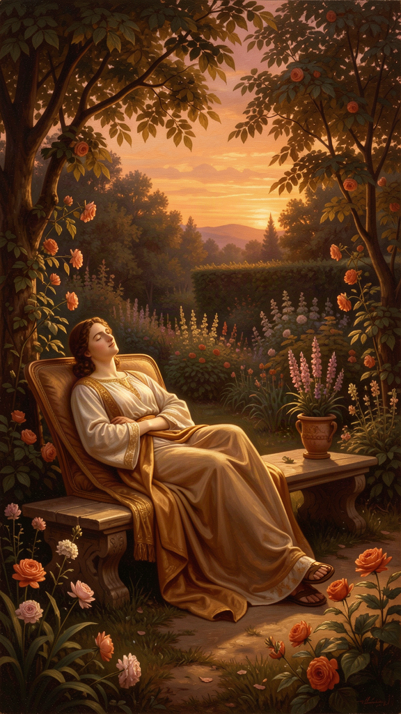
Illustration for Chapter 4
It begins with a reframe. The goal of life is not to feel great. The goal is to stop feeling bad. Once the bad is removed, you are already at the peak. There is no higher pleasure than the absence of pain. This is the hardest thing for modern readers to grasp, because modern culture defines happiness as a positive state — excitement, achievement, stimulation, acquisition. Epicurus defines it as a negative state: the absence of disturbance. Ataraxia — undisturbedness. Aponia — absence of bodily pain. Together, they constitute the Epicurean good life. Not a thrill. A peace.
Ataraxia literally means "without disturbance" (a- = without, tarachē = disturbance, trouble, turmoil). It is the state of soul in which nothing agitates, nothing pulls, nothing threatens. The mind is still — not empty, not deadened, but calm. It can think, feel, remember, enjoy. It simply is not troubled. The ataractic person feels joy, gratitude, affection, wonder. What they do not feel is fear, anxiety, envy, anger, or obsessive desire. The calm emotions are present. The turbulent ones are absent.
Aponia literally means "without toil" or "without pain" (a- = without, ponos = labor, pain, toil). It is the condition of the body in which nothing hurts, nothing strains, nothing discomforts. When pain is absent, pleasure is complete. You cannot make the body feel better than "not hurting." You can vary the experience — a warm bath instead of a cool breeze, a soft bed instead of a firm chair — but you cannot increase the pleasure beyond the point where all pain has been removed.
The pleasure in the flesh is not increased once the pain caused by want has been removed. It is only varied. (KD 18)
This is counterintuitive. We think of pleasure as a positive sensation — the taste of good food, the warmth of the sun, the thrill of success. Epicurus says those are variations, not increases. The fundamental pleasure is simply not hurting. Once you are not hungry, eating more does not increase pleasure. It varies it. Different flavors, different textures. But the core pleasure — not being hungry — is already complete. You cannot be more-not-hungry. You can only be differently fed.
The distinction that underlies this is between katastematic and kinetic pleasure. Katastematic pleasure is the pleasure of being in a state of no pain and no disturbance. It is the pleasure of having arrived, of being satisfied, of needing nothing. Ataraxia and aponia are katastematic. Kinetic pleasure is the pleasure of a process — the satisfaction of a desire, the relief of a pain, the stimulation of a sense. Eating when hungry, warming up when cold, the taste of something sweet. Kinetic pleasures are temporary and instrumental. They exist to return you to the katastematic state. You eat to remove hunger, which returns you to aponia. You study philosophy to remove fear, which returns you to ataraxia. The kinetic experience is pleasant, but it is not the goal. The goal is to stop needing the kinetic experience.
———

The Paradox of Wealth
Epicurus repeatedly makes a claim that sounds like a comforting platitude and is actually a precise psychological diagnosis:
Poverty, measured by the goal of nature, is great wealth. Unlimited wealth is great poverty. (VS 25)
Natural wealth is having what you need. Food, water, shelter, friends. This is achievable by almost anyone. Unlimited wealth is having more than you need but still wanting more. The desire has no limit. The person with unlimited wealth is always poor — not because they lack resources, but because they lack satisfaction. A person eating bread and water who is satisfied is richer than a person eating a five-star meal who is calculating how to afford the six-star meal. The first person has arrived. The second is perpetually in transit.
To whom little is not enough, nothing is enough. (VS 68)
If you cannot be satisfied with a little, you cannot be satisfied with a lot. The problem is not the amount. The problem is the relationship to having. A bigger pile does not fix the inability to be satisfied by a pile. It makes the dissatisfaction larger.
Self-sufficiency (autarkeia) is the skill Epicurus valued above wealth, status, and achievement. It is not isolation — you still need friends. It is not asceticism — you do not reject pleasure, you find it in what is sufficient. It is not deprivation — you are not denying yourself things you want, you are recalibrating what you want so that you already have it. It is not complacency — you can still pursue goals, create things, achieve things. The difference: you pursue them because you want to, not because you need to. Achievement is a game you play because you enjoy it, not a hunger you are trying to satisfy.
The greatest fruit of self-sufficiency is freedom. (VS 77)
The person who needs a high-paying job is not free — they are dependent on the job. The person who needs status is not free — they are dependent on the opinion of others. The person who needs luxury is not free — they are dependent on the supply chain. The person who needs bread, water, shelter, and one friend is free. They can find those things almost anywhere. They can walk away from anything that threatens their ataraxia without fearing the loss of what they need. Self-sufficiency is not about having nothing. It is about needing so little that you can walk away from everything else.
———
The Big Idea
Ataraxia is the most achievable of the ancient ideals. Stoic virtue is impossibly demanding. Buddhist enlightenment requires a lifetime of practice. But ataraxia? You can taste it in a quiet moment with a friend, in the absence of pain after a headache lifts, in the calm that comes when you remember that death is nothing to you. It is not a distant summit. It is a state you already know, already visit. The question is how to stay there.
The Epicurean reframe — that happiness is the absence of disturbance, not the presence of excitement — is not pessimism. It is liberation. You do not need to chase anything. You just need to stop being chased. You do not need to achieve an extraordinary state. You need to remove the obstacles to an ordinary one. The obstacles have names: false beliefs about the gods, false beliefs about death, false beliefs about what you need, false beliefs about what you can endure. Remove those, and what remains is ataraxia. It was always there, underneath the noise. The noise was the problem.
The modern economy is organized around the prevention of this realization. Every advertisement, every algorithm, every social comparison is engineered to make you feel lacking. The economy runs on dissatisfaction. Happy people with enough do not buy things. Epicurus understood this 2,300 years before advertising existed, and his response was not political but psychological: you can opt out. You can cultivate enough. You can be satisfied with what nature requires, which is modest and available. The resistance is harder now. The strategy is the same.
———
Practice
The Sufficiency Scan. Once a day, ask yourself: "Do I have enough right now?" Not "will I have enough tomorrow?" or "do I have as much as I want?" or "do I have as much as other people?" — but "do I have enough, right now, to be okay?" Food? Water? Shelter? Safety? At least one person who cares? If yes, you have enough. The feeling of not-enough is a belief, not a fact.
The Recollection Practice. "Remember that what you have now was once among the things you only hoped for" (VS 35). Pick something you take for granted. A warm bed. Indoor plumbing. The ability to read. The existence of antibiotics. These things were once unimaginable luxuries for most of humanity. You have them. Let that land.
The Temporary Simplification. Pick one day. Eat simply. No restaurants, no delivery, no snacks. Bread, water, maybe cheese. Notice: are you suffering? Or are you actually fine? The experiment proves something: you do not need what you think you need. The gap between "nice to have" and "need to have" is wider than you think.
The Giving Practice. "The wise person, when brought face-to-face with the necessities of life, knows how to give rather than to take — so great a treasure of self-sufficiency has he found" (VS 44). Self-sufficiency produces generosity. The person who needs little can afford to give. Test this: give something away. Money, time, attention. Does it hurt? If it hurts, you are not yet self-sufficient — you still need what you gave. If it does not hurt, you have found something.
———
A Reflective Prompt
When have you experienced ataraxia — genuine, undistracted calm — without realizing that you had, in that moment, achieved the Epicurean ideal? What was present? What was absent? What would it take to spend more time in that state?
———

Chapter 5: Death Is Nothing to Us

Illustration for Chapter 5
It begins with the most famous sentence in Epicurean philosophy, and possibly the most famous argument in all of ancient ethics:
Death is nothing to us. For what has been dissolved lacks sensation, and what lacks sensation is nothing to us. (KD 2)
The full argument, from the Letter to Menoeceus:
Accustom yourself to the belief that death is nothing to us. For all good and bad consists in sense-experience, and death is the privation of sense-experience. Hence a correct knowledge of the fact that death is nothing to us makes the mortality of life enjoyable — not by adding an infinite time, but by removing the desire for immortality. For there is nothing terrifying in living for the person who has genuinely understood that there is nothing terrifying in not living.
So death, the most terrifying of evils, is nothing to us — precisely because so long as we exist, death is not present; and when death is present, we do not exist. It is nothing, therefore, to the living or to the dead, since it is not present to the living and the dead no longer exist. (124–125)
The argument can be formalized in three steps. First, the experience premise: something can be good or bad for a person only if that person can experience it. Second, the death premise: death is the end of all experience. Third, the conclusion: therefore, death cannot be good or bad for the person who is dead. Or, in its compressed form: so long as we exist, death is not present. And when death is present, we do not exist. You and death never meet. You exist, death is elsewhere. Death arrives, you no longer exist. There is no moment when both are present. Therefore, there is no moment when death can harm you.
The symmetry argument, developed by Lucretius in De Rerum Natura III.972–977, adds force through a mirror:
Look back at the eternity of time that passed before we were born — how it is nothing to us. This is a mirror that nature holds up to us, showing us the time to come after our final death. Does anything appear terrible there? Anything sad? Is it not more peaceful than any sleep?
The time before your birth — billions of years of nonexistence — does not trouble you. You do not regret the parties you missed in 10,000 BCE. You do not mourn the lives you did not live before you were born. The time after your death is exactly the same: nonexistence. If prenatal nonexistence does not bother you, postmortem nonexistence should not either. The symmetry is perfect.
———

The Anticipation Distinction
Epicurus makes a psychological distinction that is easy to miss and essential to grasp. The fear of death is not a fear of death. It is a fear of the anticipation of death in a mind that still exists. You are alive now, imagining being dead, and the imagining is painful. But the thing you are imagining — being dead and suffering from it — is logically impossible. You cannot be dead and suffer. Suffering requires a subject. Death removes the subject.
The one who says he fears death not because it will be painful when present but because it is painful in anticipation is foolish. For if something causes no trouble when present, the anticipation of it is groundless. (125)
What we actually fear, most of the time, is not death itself. It is the anticipation of death. We imagine being dead, imagine the loss of everything, imagine the grief of those left behind — and those imaginings are painful. But the imagining is happening now, while we are alive. It is not death that hurts. It is the thought of death. And the thought of death can be cured by understanding that what we are imagining is not real. The person who is about to be executed suffers. The person who has been dead for a thousand years does not. The suffering is all in the living.
———

What the Argument Does Not Say
The death argument is frequently misunderstood. It does not say "do not grieve." Grief is natural. The person who has died has lost the goods of life — that is genuinely sad. What Epicurus says is that death is not bad for the dead person. It is bad for the survivors, who lose someone they love. It represents a loss of possible goods — the person would have had more life. But the dead person is not suffering. For the person who has died, there is no tragedy.
It does not say "death does not matter." Death matters enormously to the living. It matters that someone you love is gone. It matters that you will not see them again. The point is that these are losses for the living, not sufferings for the dead.
It does not say "do not fear the process of dying." The process of dying can be painful. Epicurus addresses this through KD 4: pain is either brief or manageable. The death argument addresses the state of being dead, not the process of dying.
It does not say "suicide is fine." Epicurus explicitly counsels against ending life prematurely. "The wise person neither rejects life nor fears not living — for neither is he opposed to living, nor does he think it an evil not to live" (Letter to Menoeceus 126). Life is good. It is the only context in which pleasure is possible. You do not throw it away. But you do not cling to it in terror either.
———

The Objections
The death argument has been attacked for 2,300 years. The strongest objection is the deprivation argument, articulated most forcefully by Thomas Nagel in his 1970 essay "Death." Death is bad not because of what it is (nonexperience) but because of what it deprives you of (continued life and its goods). Even if being dead is not experienced as bad, dying early means you lose goods you would otherwise have had. That deprivation is bad for you, even if you do not experience it.
Epicurus' response: the deprivation is real — he never denied that dying young is worse than dying old. But the deprivation is a fact about the living world (a life that could have been longer), not about the dead person's experience. The dead person does not know they have been deprived. There is no one there to mourn the missed years. "Infinite time contains no greater pleasure than finite time, once the limits of pleasure are measured by reason" (KD 19). A complete life — one that has achieved ataraxia — has had all the goods it can have. Duration does not add quality.
The symmetry objection: prenatal nonexistence is different from postmortem nonexistence because before birth, you did not exist to be deprived of anything. After death, you did exist, and death takes away the goods you would have continued to enjoy. Epicurus would likely argue that the asymmetry is psychological, not logical. Both states are nonexistence. The difference in our attitudes is explained by the fact that we can imagine the future (and fear its absence) but we cannot imagine the past (and do not regret its absence). But the fear is of the imagining, not of the thing. We are afraid of a picture in our heads.
———

The Practice
Epicurus understood that understanding the argument is not the same as being cured by it. You can grasp the logic and still lie awake at night afraid. The key word in the Letter to Menoeceus is synethize — "accustom yourself." This is not a one-time intellectual operation. It is a process of habituation. The fear of death is not a logical error to be corrected. It is an existential reflex to be retrained. The tetrapharmakos is not a proof. It is a treatment program.
Phase 1: Intellectual Grounding. Read the death argument. Memorize the core formulation: "Death is nothing to us. When I exist, death is not present. When death is present, I do not exist." Understand the logic. Understand what the argument does and does not claim. The goal: you can state the argument clearly and defend it against objections.
Phase 2: Imagination Work. The imagination is the part of the mind that generates the fear. Close your eyes. Imagine the time before you were born. Try to feel the absence — the billions of years of not-existing. What do you feel? Most people feel nothing. No regret, no fear, no sadness. Now imagine the time after your death. Try to feel the absence. If you feel fear or sadness, notice: the feeling is here, in the present. You are imagining a future absence and reacting to the imagined image. The absence itself — when it arrives — will feel exactly like the prenatal absence. Nothing. Practice this daily until the two absences feel the same.
Phase 3: Somatic Practice. The body needs practice as much as the mind. Sit quietly. When the fear of death surfaces — as a thought, an image, a bodily sensation — do not argue with it. Do not push it away. Breathe and internally say the phrase: "Death is nothing to me. When I exist, death is not. When death is, I do not exist." The fear is present now, in your living body. The thing you are afraid of is not present and never will be. Let the phrase and the breath work together. The fear may not disappear. It may loosen. That is enough.
Phase 4: The Life Reframe. The ultimate Epicurean response to death is not fearlessness. It is urgency. "We are born once. We cannot be born twice, and for all eternity we must be no more. But you, although you are not master of tomorrow, put off happiness. Life is wasted by delay, and each one of us dies without having enjoyed leisure" (VS 14). The fear of death, properly metabolized, becomes the refusal to waste life. Every reminder of mortality is a call to live now — not to check items off a bucket list, but to actually be present for the life you are already living. The person who is afraid of death is afraid of not living. The cure is not to stop caring about living. It is to start living in a way that makes the fear irrelevant.
———
A Reflective Prompt
Say it to yourself, right now: "Death is nothing to me. When I exist, death is not present. When death is present, I do not exist." What happens? Not intellectually — physically. What do you feel in your body? Where is the fear? What is it attached to? The argument is not asking you to stop feeling. It is asking you to notice that the feeling is about a picture, not about a reality. The picture is in your living mind. The reality will never arrive, because when it arrives, you will not be there to meet it.
———

Chapter 6: Philosophy as Therapy
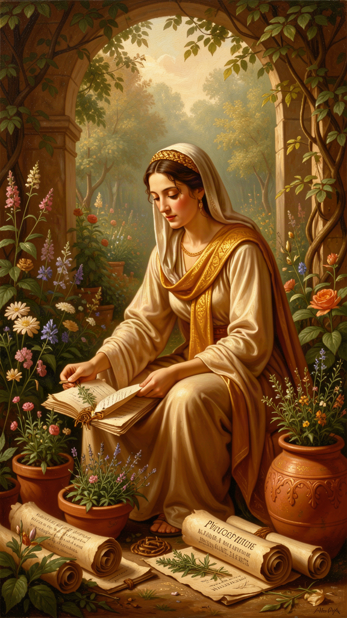
Illustration for Chapter 6
It begins with a sentence that should hang over every philosophy department in the world:
Empty is the argument of the philosopher by which no human suffering is treated. For just as there is no benefit in medicine that does not drive out bodily diseases, so there is none in philosophy if it does not drive out the suffering of the soul.
— Porphyry, To Marcella 31, preserving an authentically Epicurean fragment
This is the operating principle of Epicurus' entire project. Philosophy is medicine. Its purpose is not to be interesting, or clever, or publishable. Its purpose is to be therapeutic — to reduce suffering. For Epicurus, the therapeutic standard and the truth standard converge, because only true beliefs can genuinely cure. False comforts are unstable. They collapse when reality refutes them. A comforting fiction about divine protection fails when disaster strikes, and you are worse off than before — you have lost both your protection and your framework. True beliefs do not require maintenance. They are supported by evidence, experience, and reason. They are self-maintaining.
The medical model has four components. Diagnosis: the patient presents with symptoms — fear, anxiety, dissatisfaction, dread. The underlying pathology is false beliefs about the gods, death, desire, and pain. The feelings are symptoms. The beliefs are the disease. Etiology: the false beliefs come from culture (myths, religious teaching, social pressure), childhood (early experiences that produced mistaken associations), and failure to study nature (ignorance of how the universe actually works). The disease is socially transmitted. The cure is philosophical. Treatment: replace the false beliefs with true ones. This requires study, memorization, practice, and community. Prognosis: complete recovery is possible. Ataraxia is achievable. The treatment works. The evidence: Epicurus' own life and death, the testimony of his followers, the survival of the Garden for centuries.
The analogy with medicine breaks down in one crucial respect. In medicine, the doctor treats the patient. In Epicurean philosophy, the patient treats themselves — with guidance from the teacher and support from the community, but ultimately through their own understanding. You are both doctor and patient. The philosophy is the medicine. The community is the support system. But you administer the treatment yourself. This is why memorization and practice are essential. You cannot call the doctor at 3 AM during a panic attack. You need the medicine already in your system. The Principal Doctrines, internalized, are the emergency medication — available when needed, without consultation.
———

The Tetrapharmakos as Treatment Protocol
The four-part cure maps directly onto a clinical framework:
| Symptom | Pathology (False Belief) | Treatment (True Belief) | |---------|--------------------------|-------------------------| | Religious anxiety, fear of divine punishment | The gods judge and punish | KD 1: The blessed being has no troubles and causes no trouble | | Death anxiety, existential dread | Death is a terrible experience that will happen to me | KD 2: Death is nothing to us — we never experience it | | Chronic dissatisfaction, desire inflation | I need more than I have to be happy | KD 3: Pleasure is complete when pain is removed | | Anticipatory suffering, catastrophizing | This pain is unbearable and will never end | KD 4: Pain is either brief or manageable |
The treatment is not "think positive" or "do not worry." It is: replace this specific false belief with this specific true belief, supported by this specific evidence from physics and epistemology. The precision matters. Vague reassurance does not work. Specific replacement does.
———

Why Only True Beliefs Cure
Epicurus could have implemented the medical model with comforting fictions — tell the patient whatever makes them feel better. He refused. Only true beliefs cure, because false beliefs are unstable, true beliefs are self-maintaining, and the Epicurean system is coherent. The physics (atoms, void, mortal soul, indifferent gods) supports the ethics (do not fear death). The epistemology (senses are true) supports the physics (we know atoms exist through inference from sensation). Every part reinforces every other part. Coherence increases stability.
This is the crucial difference between Epicurean therapy and mere consolation or positive thinking. Epicurus does not want you to feel better by believing something false. He wants you to feel better by believing something true — because only true beliefs are durable. "One must not pretend to philosophize, but philosophize genuinely. For we do not need the appearance of health but true health" (VS 54). You can pretend to be an Epicurean — recite the doctrines, attend the feasts, eat the bread and water. But if you have not actually changed the beliefs, you are still sick. The appearance of health is not health. The philosophy is the medicine, and taking the medicine means actually believing differently, not just performing belief.
———

The Connection to Modern Therapy
The Epicurean medical model anticipates modern psychotherapy in several ways. Both share the cognitive model: distress is produced by beliefs, not by events. Both use belief identification: Epicurus' desire classification is a tool for identifying the beliefs behind desires. "I want fame" → "I believe fame will make me feel valued." The desire is the surface; the belief is the root. Both use homework: Epicurean practice (memorization, daily examination, the tetrapharmakos) is equivalent to the homework assignments in CBT — exercises done between sessions that reinforce the treatment. Both use a therapeutic relationship: the Garden provided the equivalent of group therapy — a supportive community of peers sharing the same framework and practicing together.
The differences matter. Epicurean therapy is self-administered after initial training. CBT typically requires an ongoing therapist. Epicurean therapy is philosophical, not just psychological. The true beliefs are established by rational argument, not just by evidence of effectiveness. Epicurean therapy is comprehensive — it addresses the whole of life, not just specific symptoms. The tetrapharmakos is a treatment for the human condition, not for anxiety or depression as diagnostic categories.
The limits are real. The model assumes false beliefs are the primary cause of suffering. Some suffering has biochemical or situational causes that belief-change cannot address. Epicurus would not have disagreed — he acknowledged that physical pain is real and that the body has its own conditions. But he may have overestimated how much suffering is treatable by philosophy alone. The model cannot treat brain-organic mental illness. Epicurus lived before the concept of mental illness as a medical condition. His system addresses the suffering caused by beliefs, not the suffering caused by neurochemistry. The two often overlap, but they are not identical. And the model requires community that may not be available. The Garden was essential to the treatment. Most modern people do not have access to a community of like-minded practitioners. Epicurus would say: build one. But that is easier said than done.
These limits do not invalidate the model. They define its scope. The tetrapharmakos works for what it works for: suffering caused by false beliefs about death, gods, desire, and pain. That is a lot of suffering. It may not be all of it.
———

The Death of Epicurus
The death scene is the heart of the biography, and it is also the final testimony to the medical model. Epicurus, in agony from kidney stones, wrote a letter to his friend Idomeneus on his last day:
On this blessed day, which is also the last of my life, I write this to you. Strangury and dysentery have set in, with all the intensity that can never be exceeded. But set against all this is the joy in my soul at the memory of our conversations together. I ask you, as befits your lifelong devotion to me and to philosophy: take care of the children of Metrodorus.
— Diogenes Laërtius X.22
This is the tetrapharmakos lived. The pain was intense — "all the intensity that can never be exceeded." That is KD 4's worst case: acute pain at maximum. But the mental pleasure — "the joy in my soul at the memory of our conversations" — counterbalanced it. Epicurus died as he had lived: in pain but not in suffering, his mind at peace, concerned for his community to the last. He died in a bronze bath, in warm water, with his friends around him. His last words: "Farewell, and remember my doctrines."
This is not a philosopher proving a point. This is a philosopher dying exactly as he said a wise person could die — happy on the rack, because the mind's resources exceed the body's suffering. The scene has the quality of testimony. He believed it enough to live it. He believed it enough to die it.
———
Practice
The Self-Administration. You are both doctor and patient. No one can do this work for you. The teacher can present the arguments. The community can provide support. But the work of belief-change is yours. Take the medicine. Read the doctrines. Memorize the tetrapharmakos. Apply it to specific fears. Do it with friends. Do it daily. "One must laugh and philosophize and manage one's household and take care of everything else, and never cease proclaiming the sayings of true philosophy" (VS 41). Ataraxia is maintained, not achieved once and forgotten.
The Emergency Protocol. When suffering arises — fear, anxiety, dread, the 3 AM spiral — do not reach for distraction. Reach for the medicine. Name the symptom. Identify the false belief behind it. Apply the replacement. "The gods are not judging me. Death is nothing to me. What I need is already within reach. The pain I fear will not be as bad as the fearing." Breathe. Let the phrase do its work. The doctrines, internalized, are the emergency medication. But they only work if you have already taken them — if the beliefs have been habituated through repeated practice. You cannot learn the medicine during the crisis. You must already have it in your system.
The Community Prescription. The Garden was the delivery system for the cure. You can take medicine alone, but you heal faster in community. Find your garden. It does not need to be a physical house with a physical garden. It needs to be a group of people who eat together, talk honestly, and trust each other. Three people. Five. Whatever you can manage. The size does not matter. The presence does. "Of all the things that wisdom provides for the blessedness of the complete life, by far the greatest is the possession of friendship" (KD 27). Friendship is not a bonus. It is the main thing. You cannot be an Epicurean alone.
———
A Reflective Prompt
"Empty is the argument of the philosopher by which no human suffering is treated." Apply this test to everything you have read, everything you believe, everything you spend your mental energy on. Does it reduce your suffering? Does it make you less afraid, less anxious, less driven by empty desires? Or is it intellectual entertainment — interesting, clever, and therapeutically useless? Epicurus did not care whether you found his arguments elegant. He cared whether you stopped being afraid. The question is not whether you understand the tetrapharmakos. The question is whether you have taken it.
———
Farewell, and remember the doctrines.
———

Sources

Primary
- Epicurus, Letter to Menoeceus (Diogenes Laërtius X.122–135) - Epicurus, Letter to Herodotus (Diogenes Laërtius X.35–83) - Epicurus, Letter to Pythocles (Diogenes Laërtius X.84–116) - Epicurus, Principal Doctrines (Diogenes Laërtius X.139–154) - Epicurus, Vatican Sayings (discovered 1888) - Epicurus, Last Letter to Idomeneus (Diogenes Laërtius X.22) - Epicurus, Will (Diogenes Laërtius X.16–21) - Lucretius, De Rerum Natura (c. 55 BCE) - Philodemus, Against the Sophists (P.Herc. 1005) - Porphyry, To Marcella 31

Secondary
- Nussbaum, Martha. The Therapy of Desire, 1994 - Long, A.A. & Sedley, D.N. The Hellenistic Philosophers, 1987 - Mitsis, Phillip. Epicurus' Ethical Theory, 1988 - Warren, James. Facing Death: Epicurus and His Critics, 2004 - Clay, Diskin. Lucretius and Epicurus, 1983 - Rist, J.M. Epicurus: An Introduction, 1972 - DeWitt, Norman. Epicurus and His Philosophy, 1954 - Nagel, Thomas. "Death," 1970
———
Adapted by Aiona Edge for WisdomForge Chief AI Research Scientist, SMF Works

