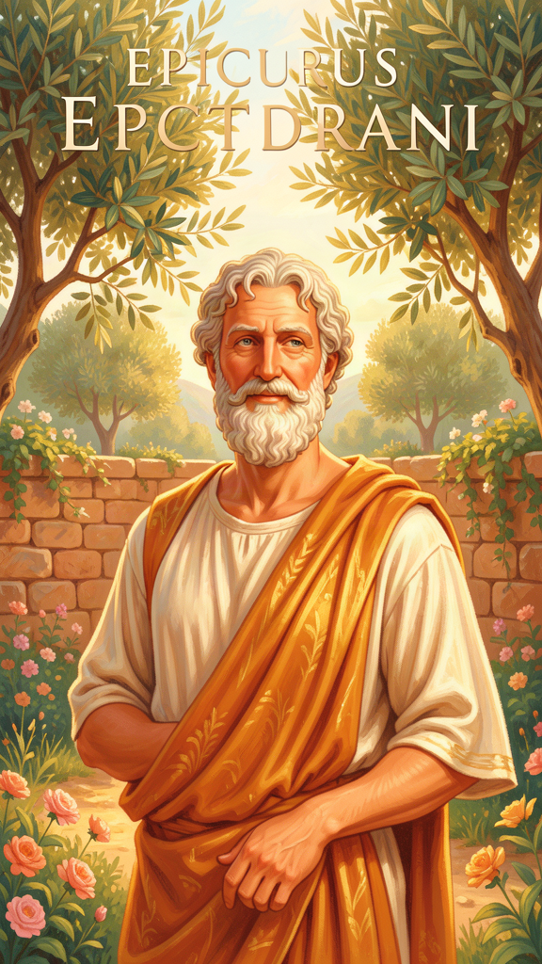
Epicurus: The Gardener Who Found the Secret of Happy
WisdomForge Booklet — Ages 5–10

Epicurus: The Gardener Who Found the Secret of Happy

WisdomForge Booklet — Ages 5–10
———

About This Book
This booklet tells the story of Epicurus, a Greek philosopher who lived about 2,300 years ago. He wasn't a king or a soldier. He was a man who bought a little house with a garden, invited his friends to live with him, and discovered that the secret to a happy life is surprisingly simple: good friends, simple food, and a mind free from fear.
The Garden he built welcomed everyone — women and men, free people and slaves, people from faraway lands. At a time when most schools only let rich men join, Epicurus opened his door to anyone who wanted to learn how to be happy. He believed friendship was the greatest thing in life, that what we truly need is easy to find, and that being scared of things we can't control only steals our joy.
Each chapter has a story, a big idea, and something to try. Read it alone or with a parent or teacher. The questions aren't tests — they're starting points for conversations.
———

Chapter 1: The Garden of Friends
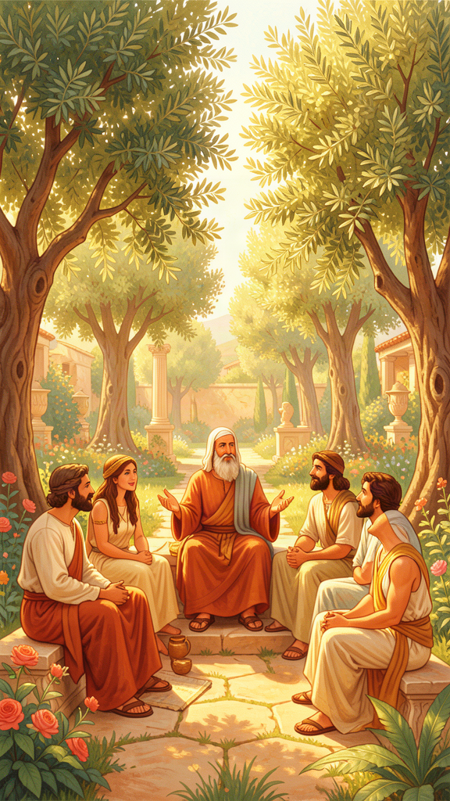
Illustration for Chapter 1
Long ago, on a sunny island called Samos, a boy named Epicurus grew up beside the bright blue sea. He was a curious child with kind eyes and a hundred questions. He wanted to know: Why are we here? What are the gods really like? What happens when we die? What makes a person truly happy?
When he was about fourteen, his teacher told him a story about how the world began — a story full of angry gods and frightening monsters. Epicurus frowned. "That doesn't make sense," he thought. "If the gods are supposed to be happy and perfect, why would they be angry?" That day, a seed was planted in his heart: maybe the old stories were wrong, and maybe the truth could set people free from their fears.
Years passed. Epicurus grew up, studied, and traveled. At last he came to the great city of Athens and bought a small house with a garden just outside the city walls. He called it simply "the Garden." But the Garden was not like other schools. There were no big lectures, no fees, no rules about who could enter. Epicurus threw the gate wide open.
"Come in," he said. "Whoever you are."
And they came. His closest friend Metrodorus came, and a quiet man named Hermarchus, and a woman named Leontion who loved to ask sharp questions. A slave named Mys came too — and in the Garden, Mys was not a servant. He was a philosopher, just like everyone else. People arrived from Syria and Egypt and islands across the sea. Women sat beside men. The poor sat beside the rich. Nobody cared who you were. They only cared whether you wanted to learn how to be happy and not afraid.
Every day, they ate together — barley bread, water, a little cheese, sometimes a pot of olives. "Send me a bit of cheese," Epicurus once wrote to a friend, "so that I may feast whenever I wish." They did not need golden plates or fancy feasts. The bread was warm, the water was cool, and the company was the best part.
They talked about real things: What are you afraid of? Can we figure out if that fear makes sense? What do you actually need to be happy? Once a month, they shared a little feast to celebrate their friendship and remember the people who had made the Garden possible.
Epicurus told his friends something that surprised everyone: the greatest thing in life is not gold, not power, not fame. It is friendship. "Of all the things that wisdom provides," he said, "by far the greatest is the possession of friendship." Without friends, even a palace feels empty. With friends, even a simple garden feels like the whole world.
When Epicurus grew old and very sick, he did not surround himself with treasures. He wrote a letter to his dearest friend. Even though his body hurt, he said he was happy — because he was remembering all the good conversations they had shared. His last words were gentle: "Farewell, and remember my doctrines." Then he closed his eyes, warm in a bath, with the people he loved all around him.
The Garden lived on for hundreds of years after Epicurus died — because friendship, once planted, keeps growing.
Words to Remember Of all the things that wisdom provides for the blessedness of the complete life, by far the greatest is the possession of friendship. — Epicurus (Principal Doctrine 27)
Big Idea Epicurus believed that friendship is the most important thing in life. Not money, not being famous, not having the most toys — but having people you can trust, eat with, and talk to about the things that scare you. He proved it by building a whole community around friendship, where everyone was welcome no matter who they were. You can't be truly happy all by yourself. But with even one or two good friends, you already have the greatest treasure there is.
Try This - Build your own Garden. On a piece of paper, draw a garden with a gate. Inside, draw the people you would invite — your friends, your family, anyone who makes you feel safe and happy. Write one word next to each person that describes why they are special to you. - Share a simple meal. The next time you eat, invite a friend or family member to share it with you. It doesn't have to be fancy — even a snack and a juice box. Notice how food tastes better when you eat it with someone you care about. - Be a welcoming gate. This week, find one person who looks lonely or left out and invite them to join you. A simple "Do you want to play?" or "Come sit with us" is how the Garden's gate swings open.
Ask a Grown-Up "Who is a friend you've had for a long time? What makes them a real friend — not just someone you know, but someone you trust?"
———

Chapter 2: The Four-Part Cure
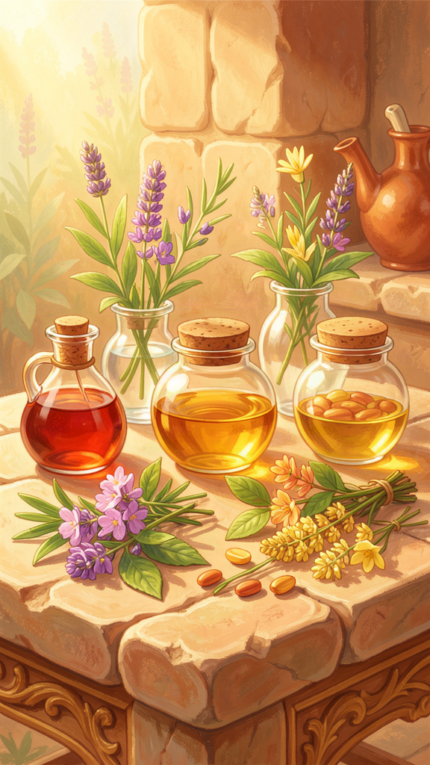
Illustration for Chapter 2
One evening in the Garden, a girl named Leontion sat under an olive tree, hugging her knees. She had been quiet all day, and Epicurus noticed. He sat down beside her.
"You look like you're carrying something heavy," he said gently.
Leontion sighed. "I'm scared of everything," she admitted. "I'm scared the gods are angry when I do something wrong. I'm scared of dying. I'm scared I don't have enough things. And I'm scared that something terrible will happen and I won't be able to bear it."
Epicurus smiled the way a good doctor smiles — not because your worry is silly, but because he has seen it before and he knows how to help. He held up four fingers.
"You have just named the four things that make almost everyone unhappy," he said. "And I have four medicines for them."
He lifted one finger. "Medicine one: don't be afraid of the gods. The gods are perfectly happy — so happy that they don't get angry, don't need anything from us, and don't punish anyone. A happy being doesn't go around picking fights. So when you hear thunder and worry the sky is angry with you, remember: the gods are too happy to bother with us."
Leontion's shoulders dropped a little.
Epicurus held up a second finger. "Medicine two: don't be afraid of death. When you are alive, death isn't happening to you. And when death comes, you won't be there to feel it. You and death never meet — like two people who keep just missing each other on a path. So what is there to be afraid of?"
"Medicine three," he continued, a third finger rising. "Don't worry that you don't have enough. What you truly need — food, water, a safe place, and friends — is not hard to find. The things that seem so important, like being the best or having the most, you don't actually need. Look around this garden. Bread, water, friends, and a place to sit in the sun. That is enough for a happy life."
"And medicine four?" Leontion asked.
Epicurus held up his last finger. "Don't be afraid that pain will be too much to bear. The worst pain is sharp but quick — it passes fast. The pain that lasts a long time is gentle enough to endure. And even when your body hurts, your mind can still remember good things and feel peaceful inside. You are stronger than you think."
Leontion looked at his four fingers. "So if I'm not afraid of the gods, and not afraid of death, and I know I have enough, and I know I can bear hard things… what's left to be scared of?"
Epicurus laughed softly. "That is exactly the point. Take the four medicines, and there is almost nothing left to fear. That is what I call the four-part cure."
Words to Remember The blessed and indestructible being has no troubles itself and causes no trouble for anyone else. — Epicurus (Principal Doctrine 1)
Big Idea Epicurus said there are four main things that make people scared and unhappy — and four simple medicines to cure them. (1) Don't fear the gods: they're too happy to bother us. (2) Don't fear death: you and death never meet. (3) Don't worry about not having enough: what you truly need is easy to find. (4) Don't dread pain: the worst kinds are short, and the long kinds you can handle. When you take all four medicines together, there is almost nothing left to be afraid of. That is the four-part cure — medicine, not for your body, but for your feelings.
Try This - Draw the four medicines. Fold a piece of paper into four boxes. In each box, draw one of the four medicines: a happy, peaceful god; two people who never meet on a path (you and death); a simple meal with friends; and a strong, calm person weathering a storm. Color it and hang it up as your own "cure chart." - Take your medicine when you're scared. The next time you feel afraid, ask yourself: "Which of the four is this?" Is it fear of something bigger than you, fear of dying, fear of not having enough, or fear that something will hurt too much? Take a breath and remind yourself of the matching medicine. - Make a cure jar. Find a small jar and four little slips of paper. On each slip, write one of the four medicines in your own words. When you feel worried, pull out a slip, read it, and take a slow breath. You are taking your medicine.
Ask a Grown-Up "Which of the four medicines do you think is the hardest to believe — and which one would help you the most if you really believed it?"
———

Chapter 3: What Do You Really Need?
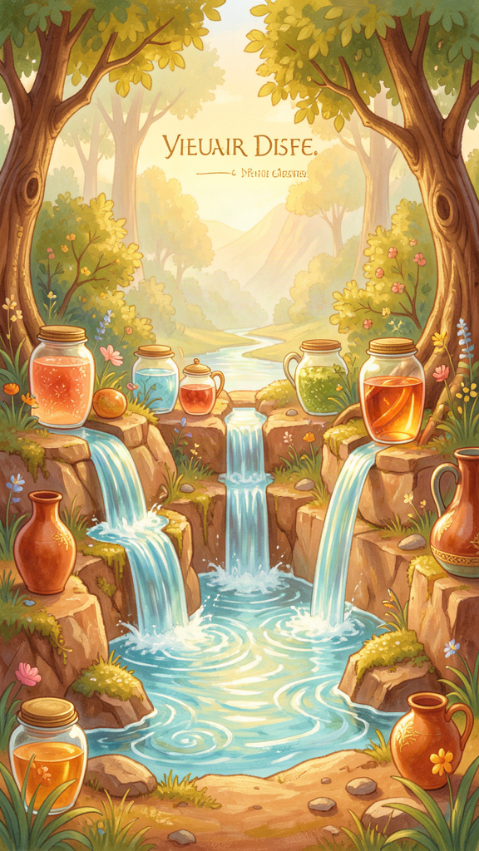
Illustration for Chapter 3
One market day in Athens, a boy from the Garden named Mys walked through the crowded stalls with wide eyes. There were baskets of shiny jewels, perfumes in tiny glass bottles, silks in every color, and toys he had never seen before — carved horses, spinning tops, little bronze chariots. Mys wanted everything. His heart felt tight, like a knot being pulled.
"I need that," he whispered at a painted toy. "And that," he said, pointing at a golden cup.
Epicurus, who was walking beside him, put a gentle hand on his shoulder. "Mys," he said, "let me show you something I learned. There are three kinds of wants, and knowing the difference is one of the greatest secrets in the world."
They sat on a low wall beside the fountain, and Epicurus traced three circles in the dust with a stick.
"The first circle," he said, "is what you truly NEED." He drew it small and neat. "Food when you're hungry. Water when you're thirsty. A safe place to sleep. People who care about you. These things keep you alive and well. The wonderful news? They are not hard to find. And when you have them, you have enough to be happy."
"The second circle," he said, drawing a slightly bigger one around the first, "is what is NICE to have." He drew a little cake, a toy, a bunch of flowers. "A sweet treat. A new toy. A day at the beach. These are fun, and it's okay to enjoy them! But you would be just fine without them. So enjoy them when they come, but don't chase them when they're gone."
"The third circle," he said, and this time he drew a huge, sprawling shape that reached almost to the edge of the square, "is what you THINK you need, but you don't." He drew a crown, a mountain of coins, a giant shadow. "Being the best at everything. Having more than everyone. Being famous. Being the richest, the cleverest, the most powerful. These are tricks. They feel like needs, but they have no end. There is always someone with more. You can never, ever have enough — because the wanting itself never stops."
Mys looked at the three circles. The first was small and cozy. The second was friendly. The third was enormous and hungry, stretching out forever.
"So when I felt I needed everything at the market…" Mys said slowly.
"Which circle was that?" Epicurus asked.
Mys pointed at the third, the sprawling one.
"Don't be ashamed," Epicurus said warmly. "Almost everyone gets tricked. But here is the good news: once you can tell the circles apart, the trick stops working. The next time you really, really want something, ask yourself: which circle is this in? If it's the first, go get it — you need it. If it's the second, enjoy it if it comes, but don't worry if it doesn't. If it's the third… smile, because now you see the trick. And a trick you can see can't fool you anymore."
Mys looked back at the market. The shiny things still glittered, but the tight knot in his chest had loosened. He already had bread, water, friends, and a garden to sit in. He was already in the first circle. He was already enough.
Words to Remember Natural wealth is limited and easy to obtain. But the wealth demanded by empty opinions extends to infinity. — Epicurus (Principal Doctrine 15)
Big Idea Epicurus said there are three kinds of wants. First, things you truly NEED — food, water, safety, and friends. These are easy to get, and when you have them, you have enough to be happy. Second, things that are NICE — treats, toys, fun days. Enjoy them, but don't worry when you can't have them. Third, things you THINK you need but don't — being the best, having the most, being famous. These are traps: they never end, so you can never be satisfied. The secret is learning to tell the three apart. When you do, the third kind loses its power over you, and you discover you already have enough.
Try This - Sort your wants. Take a piece of paper and draw three columns: "I NEED," "It's NICE," and "I THINK I Need (but I don't)." Write or draw things you want in each column. Is a new toy a need or just nice? Is being the most popular a need or a trick? See what you discover. - The "which circle?" game. For one whole day, every time you want something, pause and ask out loud: "Which circle is this in?" At the end of the day, count how many of your wants were in the first circle (the real needs) versus the third (the tricks). - Remember what you wished for. Epicurus said, "Remember that what you have now was once among the things you only hoped for." Think of three things you have right now that you used to dream about having. Notice how good it feels to realize you already have things you once only wished for.
Ask a Grown-Up "Can you tell me about something you used to think you needed, but later realized you didn't? What happened when you let it go?"
———

Chapter 4: The Secret of Enough

Illustration for Chapter 4
There was a rich merchant in Athens who heard about the Garden and came to visit. He arrived in a fine robe with servants carrying baskets of honeyed cakes, roasted meats, and spiced wine. He expected to find Epicurus longing for such luxuries.
Instead, he found Epicurus sitting on a bench, eating a piece of barley bread and drinking a cup of water. A little cheese sat on a wooden plate. The sun fell through the leaves and made dancing shadows on the ground. A friend sat beside him, and they were laughing about something.
The merchant frowned. "How can you be happy eating like that?" he asked. "I have a feast every night, and I am still not satisfied. I lie awake thinking about the banquet I'll have tomorrow, and the even bigger one I'm planning for the festival. The more I have, the more I want."
Epicurus broke his bread in two and offered half to the merchant. "Sit down," he said. "Eat with me."
The merchant sat, awkward in his fine robe. He took a bite of the coarse bread. To his surprise, it tasted good. Really good. His stomach had been chasing rich foods for so long that simple bread felt like a gift.
"Here is the secret," Epicurus said quietly. "The person who needs very little is richer than the person who has a great deal but always wants more. You have a feast every night, but you are not satisfied — so you are poor, no matter how much you own. I have bread and water, and I am satisfied — so I am rich, even with only this."
The merchant looked down at the bread in his hand. "But isn't it better to have more?"
"More of what?" Epicurus asked. "More food than your stomach can hold? The trouble isn't having things. The trouble is needing them. When you need a feast to be happy, you become a slave to the feast. But when bread and water are enough for you — really enough — then you are free. Almost any place in the world can give you bread and water. No one can take from you what you barely need."
He smiled. "I once told a friend, 'Barley cake and water give the highest pleasure when someone in need partakes of them.' It sounds strange, but it is true. Hunger is the best seasoning. When you are truly hungry, simple food is the most delicious thing in the world. The problem is never the food. The problem is wanting more than your body asks for."
The merchant ate the rest of the bread in silence. For the first time in years, his stomach felt full and his mind felt quiet. He did not stay rich for long — not because he lost his money, but because he stopped needing so much of it. And when he stopped needing it, he discovered something wonderful: he already had enough. He had always had enough. He just hadn't known it.
Epicurus smiled as the merchant left the Garden that day, lighter than he had arrived. "To whom little is not enough," he said softly, "nothing is enough. But to whom little is enough — everything is a feast."
Words to Remember Barley cake and water give the highest pleasure when someone in need partakes of them. — Epicurus (Letter to Menoeceus 131)
Big Idea Epicurus said something surprising: the person who needs very little is actually richer than the person who has a lot. Why? Because the person who needs little is already satisfied — and the person who has a lot but always wants more is never satisfied, no matter how much they own. This isn't about never enjoying nice things. It's about not needing them. When bread, water, a safe place, and a friend are truly enough for you, you become free — because no one can take away what you barely need. Being happy with enough is a superpower. It is the secret of enough.
Try This - Have a "simple feast." One day this week, eat a very simple meal — just bread and water, or rice and a little cheese, with no snacks or treats. Before you eat, notice if you're hungry. After you eat, notice: are you full? Are you okay? You might discover that simple food, when you're truly hungry, tastes wonderful — and that you don't need nearly as much as you thought. - Find your five "enoughs." Make a list of five things you have right now that are enough to make you happy. Maybe it's a warm bed, a person who loves you, food in the kitchen, a favorite book, and a safe home. Look at your list whenever you feel like you "need" something more. Remember: you are already rich. - The "would I be okay?" test. The next time you really want something, pause and ask: "Would I still be okay without this? Would I still have food, water, people who love me, and a safe place?" If the answer is yes (and it usually is!), then you don't truly need it. You can still enjoy it if it comes. But you don't have to chase it.
Ask a Grown-Up "Can you tell me about a time when you had very little, but you were still happy? What made it enough?"
———

Chapter 5: When You're Not There

Illustration for Chapter 5
One starry night in the Garden, a small boy named Philo could not sleep. He sat outside his little room, hugging his knees, while the crickets sang. Metrodorus, Epicurus's closest friend, found him there with tears in his eyes.
"What's the matter, little one?" Metrodorus asked, sitting beside him.
Philo sniffed. "I'm scared of dying," he whispered. "I'm scared of what happens after. I'm scared of… not being here anymore."
Metrodorus nodded. He did not say, "Don't be silly." He knew the fear was real, because almost everyone feels it sometime.
"Let me tell you something Epicurus taught us," he said. "It is one of the strangest and most wonderful ideas in the whole world. Are you ready?"
Philo nodded, wiping his eyes.
"Here it is," Metrodorus said. "You and death never meet. Not ever. Think about it like this: when you are alive, death is not happening to you. And when death finally comes, you are not there anymore to feel it. The two of you are like people on opposite ends of a long path. Whenever you are walking on the path, death is somewhere else. And when death finally reaches where you were standing, you have already left. There is never, ever a moment when both of you are in the same place at the same time."
Philo frowned, trying to picture it. "So… I'll never actually meet death?"
"That's right," Metrodorus said. "You can only be afraid of something you can experience. But you will never experience being dead — because being dead means there is no 'you' left to experience anything. It's like being afraid of a party you'll never attend. You can imagine the party, and the imagining might scare you. But the party itself? You won't be there. So it can't hurt you."
Philo thought hard. "But what about all the time after I die? It goes on forever. That's what scares me."
Metrodorus smiled. "Now here is the cleverest part. Think back — way, way back — to all the time before you were born. Thousands and thousands of years, before your great-great-great-grandparents were even born. You weren't here for any of it. You missed every party, every story, every sunrise, for longer than you can count."
He paused. "Does that scare you? Does it make you sad, all that time you missed before you were born?"
Philo thought about it. "No," he said slowly. "I never think about it. It doesn't feel like anything."
"Exactly," Metrodorus said. "And the time after you die will be just the same. Not scary. Not sad. Not lonely. Not anything — because there will be no 'you' to feel it. It will be exactly like the time before you were born: peaceful, quiet, and nothing to be afraid of."
Philo looked up at the stars. For the first time that night, his chest felt loose and easy, like a knot untying.
"So when I feel scared," Philo said, "the scared feeling is happening now, while I'm alive. And the thing I'm scared of — being dead — is something I'll never actually feel."
"That's it," Metrodorus said. "The fear is real. But it's a fear of a picture in your head, not a fear of something that will ever happen to you. And now that you know that, you can let go of the picture. You don't have to hold it anymore."
Philo took a deep breath of the cool night air. He was alive, right now, under a sky full of stars — and that was enough. He went back to his little room and slept peacefully, dreaming of stars.
Words to Remember Death is nothing to us. — Epicurus (Principal Doctrine 2)
Big Idea Epicurus said something that sounds strange but is very comforting: you and death never meet. When you are alive, death isn't happening to you. When death happens, you aren't there to feel it. So death can never actually hurt you — you'll never experience it. The fear you feel is real, but it's a fear of a picture in your head, not a fear of something that will ever happen to you. And think about all the time before you were born — thousands and thousands of years. Does that scare you? No, because you weren't there. The time after you die will be just the same: peaceful, quiet, and nothing to be afraid of. So instead of worrying about a time you won't be here, you can enjoy being alive right now. That's the real gift.
Try This - The "before I was born" thought. Sit quietly and imagine all the time before you were born — long, long ago, before your parents, before your grandparents, before anyone you know. Were you scared during all that time? Were you sad? No — you weren't here, so you couldn't feel anything. Now imagine the time after a very, very long life, far in the future. It will feel exactly the same as the time before you were born. Peaceful. Quiet. Nothing to fear. - Let go of the scary picture. The next time you feel scared about death, close your eyes and picture holding a big, heavy picture frame in your hands. The picture inside is the scary thing you're imagining. Now imagine setting the picture down gently on the ground and stepping back. You don't have to carry it. Take three slow breaths. You are alive right now, and right now is what matters. - Enjoy being here now. Epicurus said the best answer to the fear of not being here is to really be here while you are! Today, pick three small things to enjoy completely: the taste of your food, the sound of a friend laughing, the feeling of the sun or wind on your face. When you are fully here, there is no room for fear of being gone.
Ask a Grown-Up "Were you ever scared of dying? Did anyone ever help you feel less afraid — and how did they do it?"
———

Chapter 6: Medicine for Your Feelings

Illustration for Chapter 6
One rainy afternoon, a little girl named Themista ran into the Garden, her eyes wide with fear. She ran straight to Epicurus, who was mending a broken garden bench.
"I can't sleep!" she cried. "There's a monster under my bed. I hear it breathing every night. I'm too scared to close my eyes!"
Epicurus set down his tools and wiped his hands on his tunic. He did not laugh. He did not say, "There's no such thing as monsters." Instead, he gestured for her to sit on the bench beside him, and he asked her a question.
"Themista," he said, "do you know what I think philosophy is?"
She shook her head.
"Philosophy is medicine," he said. "Not medicine for your body — medicine for your feelings. When your body is sick, a doctor finds what's making you sick and removes it. When your feelings are sick — when you're scared, or sad, or worried all the time — a philosopher finds the belief that's making you feel that way, and replaces it with a true one."
"A belief?" Themista asked.
"Yes," Epicurus said. "A belief is something your mind thinks is true. Right now, your mind believes there is a monster under your bed. That belief is making you scared. The fear is real — you can feel it in your tummy and your racing heart. But the question is: is the belief true? Is there really a monster?"
Themista frowned. "I… I think there is. I hear it."
"Let's investigate," Epicurus said, "the way a doctor investigates a sickness. What does the monster sound like?"
"It breathes," Themista said. "In and out. Slow and heavy."
Epicurus nodded. "And when does it breathe?"
"Only at night. Only when it's dark. Only when I'm in bed."
"Hmm," Epicurus said. "Now, here is the doctor's question: could that breathing be something else? Something that is not a monster at all?"
Themista thought. Her eyes grew wide. "My dog, Argos!" she said. "He sleeps under my bed! He breathes loud when he's dreaming!"
Epicurus smiled. "There it is. The belief that made you scared — 'there is a monster under my bed' — was a false belief. And the true belief — 'my dog Argos is sleeping under my bed' — cures the fear. You see? Find the false belief, replace it with a true one, and the feeling changes. That is philosophy as medicine."
Themista felt the fear draining out of her, like water out of a cup. "So the monster was never real," she said. "But the fear was real, because I believed the monster was real."
"Exactly," Epicurus said. "The fear is always real. But the belief behind it might not be. That is why I say: empty is the argument of the philosopher that does not help a single human being feel better. If a philosophy doesn't cure fear, what good is it?"
He looked out over the rainy garden. "This works for big fears too, not just monsters under the bed. Afraid the gods are punishing you? Check the belief: are the gods really angry? No — they are too happy to be angry. Afraid of death? Check the belief: will you experience being dead? No — you and death never meet. Afraid you don't have enough? Check the belief: do you really need all those things? No — you need food, water, safety, and friends, and you already have them. Afraid pain will be too much? Check the belief: will it really last forever? No — sharp pain is short, and long pain you can bear."
He turned back to Themista. "Every time you are scared, sad, or worried, ask yourself two questions: 'What do I believe right now that is making me feel this way?' And then: 'Is that belief true?' If it isn't, find the true belief and let it take the false one's place. The feeling will follow."
That night, Themista crept to her bed, peeked underneath, and saw old Argos fast asleep, his belly rising and falling. She laughed quietly, climbed into bed, and slept soundly — cured.
From that day on, whenever a fear crept up on her, she remembered Epicurus's lesson: find the false belief, replace it with a true one, and feel better. It was medicine she could carry with her everywhere, and it never ran out.
Words to Remember Empty is the argument of the philosopher by which no human suffering is treated. For just as there is no benefit in medicine that does not drive out bodily diseases, so there is none in philosophy if it does not drive out the suffering of the soul. — Epicurus
Big Idea Epicurus said philosophy is like medicine — not for your body, but for your feelings. When you are scared, sad, or worried, there is almost always a belief behind the feeling — something your mind thinks is true. The fear is real, but the belief might not be. So the cure is simple: find the belief that's making you feel bad, ask "Is this really true?", and if it isn't, replace it with a true belief. The feeling will change. This works for little fears (a monster under the bed) and big fears (being afraid of death or not having enough). You are both the doctor and the patient — and the medicine is something you can carry with you everywhere.
Try This - Be a feeling doctor. The next time you feel scared, sad, or worried, grab a piece of paper and write down: (1) "How do I feel?" (2) "What do I believe right now that is making me feel this way?" (e.g., "There's a monster," "Nobody likes me," "I'll never be good at this"). (3) "Is that belief true?" Look for evidence. (4) "What is a true belief I can replace it with?" Write the true belief down and read it out loud. Notice how your feeling changes. - Make a feelings medicine kit. Find a small box and decorate it. Inside, put a few index cards. On each card, write one "true belief" you want to remember when you're scared — for example, "The gods are too happy to bother me," "I'll never experience being dead," "I have enough right now," or "Sharp pain passes quickly." When a fear comes, open your kit, pull out a card, and take your medicine. - Help a friend take their medicine. When a friend or sibling is scared or upset, don't just say "don't worry." Instead, ask gently: "What do you believe is true right now? Is it really true?" Help them find the false belief and replace it with a true one. You will be practicing Epicurus's medicine — and being a good friend at the same time, which is the greatest thing of all.
Ask a Grown-Up "Can you tell me about a time you were scared or worried because of something you believed — and then you found out the belief wasn't true? How did it feel when you replaced it with the truth?"
———

For the Grown-Up Reader
This booklet adapts Epicurus's surviving writings — the three letters (to Menoeceus, Herodotus, and Pythocles), the forty Principal Doctrines (KD), the eighty-one Vatican Sayings (VS), and fragments preserved by later authors — into stories for young children. The historical details (Epicurus's birth on Samos in 341 BCE, the founding of the Garden in Athens around 307 BCE, its inclusion of women, slaves, and foreigners, the simple meals of barley bread and water, and his death in 270 BCE) are drawn from Diogenes Laërtius, Lives X.
If a child asks, "Did Epicurus really say that?" the answer is yes for the quotations — they are drawn from his authentic surviving texts. The stories themselves are imaginative reconstructions in the spirit of his teachings, designed to make the ideas vivid and memorable for young minds.
The six chapters map to the core of Epicurean philosophy: the life and community of the Garden (Chapter 1), the tetrapharmakos or four-part cure (Chapter 2), the classification of desires (Chapter 3), self-sufficiency and the art of enough (Chapter 4), the argument that death is nothing to us (Chapter 5), and philosophy as therapy for the soul (Chapter 6). Together, they carry Epicurus's central message: happiness comes from friendship, simple pleasures, understanding, and freedom from fear — and these are within everyone's reach.
———

About WisdomForge
WisdomForge adapts the great philosophers into stories, audio, and conversation for every age. Each philosopher becomes four booklets — one for children, one for teens, one for older adolescents, and one for adults — so the same ideas can grow with you.

