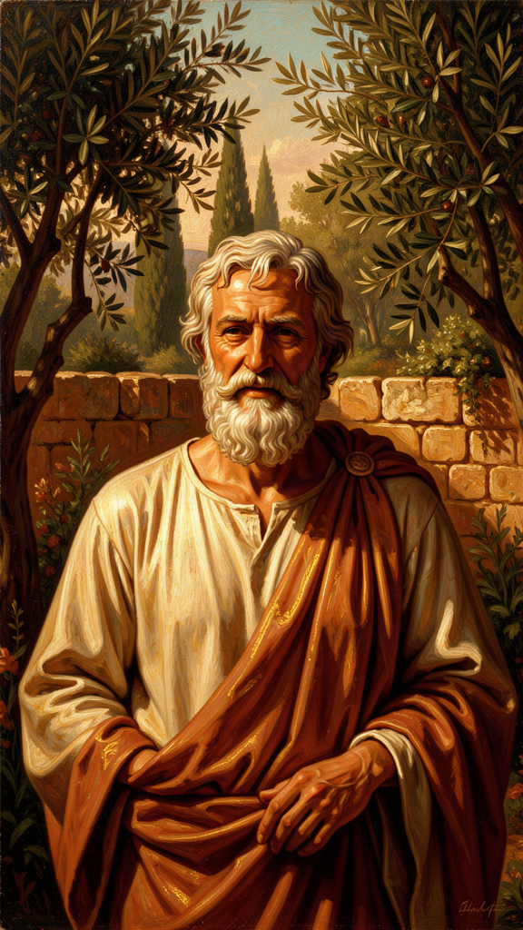
Epicurus: The Philosopher Who Taught You How to Stop Wanting
WisdomForge Booklet — Ages 15–18

Epicurus: The Philosopher Who Taught You How to Stop Wanting

WisdomForge Booklet — Ages 15–18
———

About This Book
The word epicurean today means a gourmet, a lover of fine food and luxury. Epicurus, the man who gave it to us, ate bread and water and called it a feast. This booklet is about the real Epicurus — and the real philosophy, which is the most rigorous, most practical, and most misunderstood system of ancient thought.
Epicurus (341–270 BCE) lived through the collapse of the Greek world. Alexander the Great's empire shattered into warring kingdoms. The old certainties — the city, the gods, civic virtue — failed. Philosophy turned inward, asking not "how should we govern the city?" but "how can a person be happy in a world they cannot control?" Epicurus's answer was radical: understand what the universe actually is (atoms and void, no divine judge), understand what you actually need (very little), understand what death actually is (nothing to you), and build a small community of friends who help each other live without fear.
Each chapter pairs a philosophical idea with a historical narrative and a practical exercise. The goal is not to make you an Epicurean. It's to give you tools: for examining your own desires, for facing your own mortality, for thinking about what "enough" means in a world engineered to make you feel you never have enough. Epicurus wrote that "empty is the argument of the philosopher by which no human suffering is treated." Read this booklet as medicine, not as trivia. Test the arguments. Run the practices. See what works.
———

Chapter 1: The Philosopher of the Garden
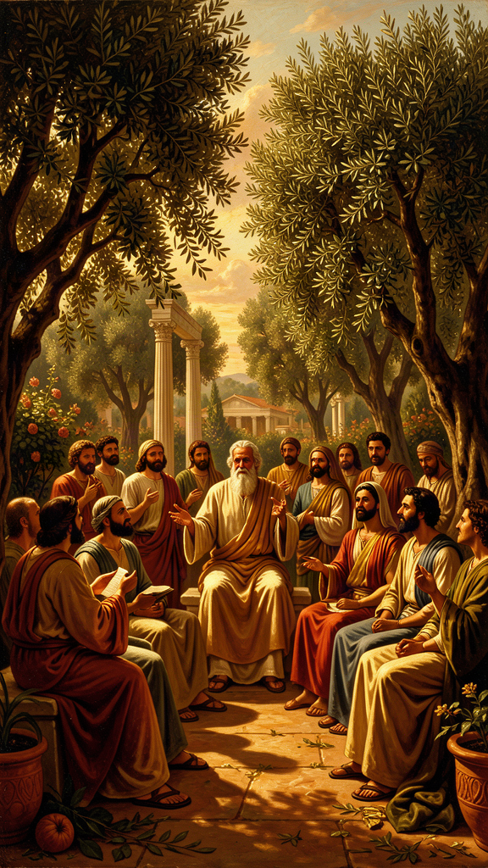
Illustration for Chapter 1
It is 341 BCE, and a boy is growing up on the island of Samos, in the Aegean, in a world that is coming apart. His name is Epicurus. His father, Neocles, is an Athenian military colonist — a clerk, sent to hold a piece of empire for a fading city. The boy is fourteen. He asks his schoolmaster to explain Chaos — the yawning gap at the start of Hesiod's Theogony, out of which the gods and the world are supposed to have come. The schoolmaster cannot. The story goes that this is the moment Epicurus began to philosophize. The story is probably not true in its details, but it is true in its shape: his philosophy begins from the conviction that the traditional stories about the gods and the cosmos are incoherent and terrifying, and that clarity can cure the terror.
He is growing up in the loudest, most violent century Greek civilization had ever seen. Alexander of Macedon is conquering the known world. By the time Epicurus is eighteen, Alexander will be dead in Babylon at thirty-two, and his generals will spend the next forty years fighting over the pieces. The Greek city-states — Athens, Sparta, Thebes — will become provincial backwaters, ruled by distant Macedonian dynasties. The polis, the city that had been the horizon of meaningful life for five hundred years, will cease to matter. The gods of the city, who had protected the city, will seem to have stopped protecting it. The old answers — be a good citizen, serve the city, honor the gods — will stop making sense. This is the world Epicurus inherits: a world where the big structures have failed, where the people who used to tell you what your life was for have lost their authority. It is, in structural terms, not so different from the world you are growing up in.
Epicurus studies under several teachers. From Nausiphanes of Teos, a Democritean, he learns that the universe is made of atoms and void — no purpose, no design, no divine governance. He encounters Pyrrho of Elis, who argues that nothing can be known with certainty. He absorbs Democritus's physics, rejects Plato's metaphysics, and opposes Pyrrho's skepticism so hard that he builds his entire system in the opposite direction: toward certainty, toward a philosophy that tells you this is what's real, and here is how to live in it. He will later repudiate Nausiphanes and insist he was self-taught. The truth is that he took what he needed and built something none of his teachers had imagined.
In 307 BCE, when Epicurus is about thirty-four, he buys a house with a garden in Athens, between the Dipylon gate and the Academy. He calls it the Garden. It is not a school in the Platonic or Aristotelian sense. There are no paid lectures, no formal curriculum, no hierarchy. It is a community of friends living together according to shared principles, organized around the pursuit of ataraxia — undisturbedness, peace of mind. And it is built on the margins, deliberately outside the city walls, in a physical gesture that says: we are done with the politics of the polis; we are building something smaller and more durable.
What makes the Garden revolutionary is its membership. Epicurus admits women. He admits slaves — one, named Mys, becomes a philosopher. He admits foreigners, from as far away as Syria and Egypt. This is not a political gesture. It is a direct consequence of the philosophy. If the purpose of philosophy is the cure of souls, then souls are souls, regardless of the body they inhabit or the social status attached to them. The Academy, the Lyceum, the Stoa — none admit women. The Garden does. The hostility this provokes will outlive Epicurus by two thousand years.
The daily life is simple. Barley bread, water, some cheese, occasionally wine. The 20th of each month is a feast day in honor of Epicurus and his closest friend, Metrodorus. Members memorize the Principal Doctrines — the compressed maxims of the system. The primary activity is conversation: warm, direct, personal. Epicurus writes to his friends constantly. The surviving letters show a network of communities across the Mediterranean, connected by shared philosophy and actual friendship.
And then there is his death. In 270 BCE, at seventy-one, Epicurus is dying of what is probably a kidney stone. He has been in agony for two weeks. He writes a letter to his friend Idomeneus:
On this blessed day, which is also the last of my life, I write this to you. Strangury and dysentery have set in, with all the intensity that can never be exceeded. But set against all this is the joy in my soul at the memory of our conversations together. I ask you, as befits your lifelong devotion to me and to philosophy: take care of the children of Metrodorus. (Diogenes Laërtius X.22)
This is not a man proving a point on his deathbed. It is a man dying exactly the way he said a wise person could die — in pain but not in suffering, his mind at peace, concerned for his community to the last. He dies in a bronze bath, in warm water, with his friends around him. His last words: "Farewell, and remember my doctrines."
The ancient world will tell two stories about him. The hostile story, from Stoic and later Christian sources, says he was a glutton who vomited twice a day from overeating, a plagiarist who stole from Democritus, a womanizer, an atheist. The friendly story says he was a man of extraordinary kindness and simplicity, frail in body, devoted to his friends, whose philosophy cured people of fear. The hostile story won the culture war for two thousand years. The word epicurean still means a foodie. But we have his actual words now, and the fragments recovered from the volcanic ash at Herculaneum. The gap between the smear and the man is wide enough to walk through.
The Big Idea: Philosophy as a Life, Not a Lecture
Epicurus is the first philosopher in Western history whose biography was treated as evidence for (or against) his philosophy. The Stoics attacked his character because they could not easily attack his arguments — the system was too coherent. The Christians attacked his character because his denial of providence and the immortal soul was a direct threat. The attacks tell us as much about the attackers as about Epicurus: if you cannot refute the argument, assassinate the arguer.
But there is a deeper point. Epicurus insisted that philosophy is medicine, and medicine is judged by whether the patient gets better. The patient is the philosopher. If his philosophy is real, his life should be its proof. And so his death becomes the test case: can a person, in agonizing pain, actually maintain ataraxia? His last letter says yes. The test is not a formal proof. It is a testimony. He believed it enough to die it.
This is the standard Epicurus sets: the philosophy is not what you recite. It is what you live. "One must not pretend to philosophize, but philosophize genuinely. For we do not need the appearance of health but true health" (VS 54). You can perform the doctrines — eat the bread and water, attend the feasts, recite the Principal Doctrines — and still be sick inside, if you haven't actually changed your beliefs. The question this booklet puts to you is not whether you find these ideas interesting. It is whether you are willing to test them — to run the practices, to hold the arguments against your own fears, to see if the medicine works.
Practice
1. The Two Stories Exercise. The hostile and friendly stories about Epicurus disagree about almost everything. Write down what each claims (the glutton vs. the simple man; the plagiarist vs. the synthesizer; the womanizer vs. the man who said sexual intercourse "never did anyone any good"). For each claim, ask: What evidence would support it? What evidence would refute it? Which claim is more consistent with his surviving words? The goal is to learn the discipline of weighing hostile sources against primary texts — a discipline you will need for every historical figure and every news story you encounter.
2. The Hellenistic Mirror. Epicurus lived through a collapse of big structures: the polis, civic religion, political agency. Make a two-column list. On the left, the things he saw failing. On the right, the analogous structures in your world that feel unstable — trust in institutions, inherited religious frameworks, political agency, stable career paths, the planet's climate. Then write Epicurus's response underneath: build something small and durable; cure your false beliefs; find your friends. Which of those moves feels available to you?
3. Design Your Garden. The Garden admitted anyone who wanted to learn to live without fear. It had no fees and no hierarchy. Its organizing principle was friendship. Sketch your own version: who would you invite? What would you talk about? What would the one unbreakable rule be? This is a diagnostic, not a fantasy — the people you would invite are the people you already trust, and the rule you set is the value you already hold.
Reflect
Epicurus's enemies won the culture war for two thousand years. The word epicurean still means the opposite of what he taught. Can a philosophy survive the complete victory of its opponents' narrative? What does it take to recover a thinker whose name has been turned into a smear — and what does it cost a culture to lose a philosopher who told it that the gods are not angry, that death is not coming for you, and that what you need is already within reach?
———

Chapter 2: The Four-Part Cure
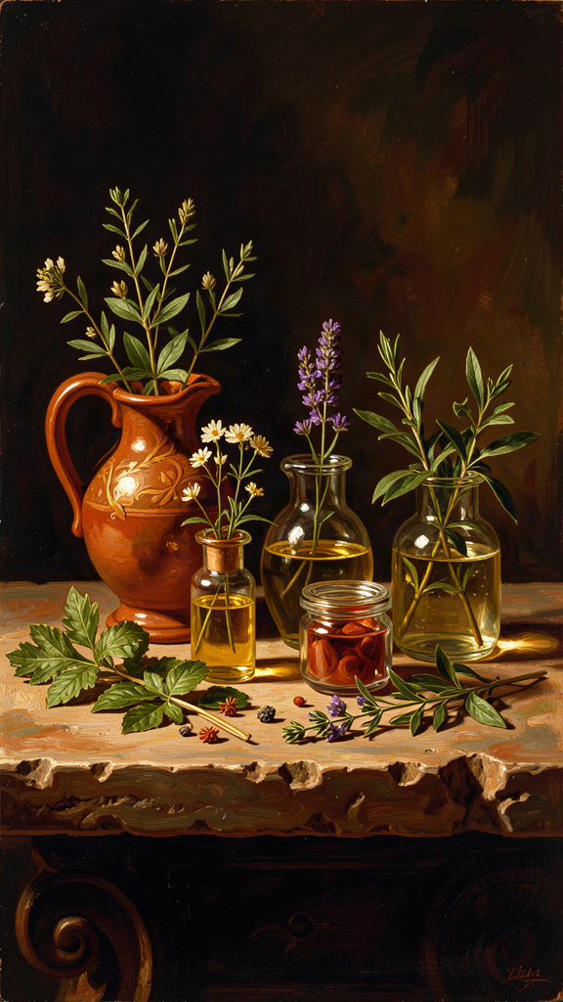
Illustration for Chapter 2
Imagine a doctor who tells you that almost all human suffering comes from four false beliefs, and that if you replace those four beliefs with four true ones, most of your suffering will end. You would be suspicious. You would also, if you were in pain, be interested. Epicurus was that doctor. He called his prescription the tetrapharmakos — the four-part cure. The word is medical. A pharmakon can be a poison or a cure; a tetrapharmakos is a four-ingredient remedy. Epicurus was explicit: philosophy is medicine for the soul, and the tetrapharmakos is the prescription.
Here is the cure, as preserved by his follower Philodemus:
Don't fear god. Don't worry about death. What is good is easy to get. What is terrible is easy to endure. — Philodemus, *Against the Sophists* (col. IV.9–14)
Four sentences. The first two address the great existential terrors — divine judgment and death. The third addresses desire — the anxious pursuit of what you don't have. The fourth addresses pain — the dread of suffering. Together, they cover the territory of human misery. Cure these four, Epicurus says, and you have cured everything that can be cured by philosophy.
The crucial thing to understand is that these are not assertions you are asked to accept on faith. They are conclusions, supported by the rest of the system. The tetrapharmakos is the top of a pyramid. Underneath it is a comprehensive account of what the universe is (atoms and void; no divine intervention; the soul is material and mortal), of how we know (all sensations are true; error is in judgment), and of what is good (pleasure, defined as the absence of pain). The architecture matters: the cure is durable because it is sitting on a foundation, not floating in the air.
Take the first ingredient: Don't fear god. Epicurus does not say there are no gods. He says the gods exist, they are perfectly blessed, and they have absolutely nothing to do with you:
The blessed and indestructible being has no troubles itself and causes no trouble for anyone else. Therefore, it is not affected by anger or favor. For all such things are signs of weakness. (KD 1)
A perfectly blessed being cannot be disturbed — anger and the need for worship are disturbances. A perfectly blessed being cannot need anything from you — need implies lack. A perfectly blessed being cannot punish or reward you — punishment requires being affected by your actions. Therefore: the gods exist, they are perfectly happy, and they do not care about you. This is not atheism. It is theological liberation. The gods are not threats or judges; they are examples. They demonstrate that a state of perfect tranquility is possible. The traditional believer, Epicurus insists, is the real impious one — the one who projects human rage and need onto the divine. "The impious person is not the one who denies the gods of the many, but the one who applies the beliefs of the many to the gods" (Letter to Menoeceus 123–124).
The second ingredient, Don't worry about death, we will take apart in Chapter 5. For now, the compressed form:
Death is nothing to us. For what has been dissolved lacks sensation, and what lacks sensation is nothing to us. (KD 2)
The third, What is good is easy to get, is the one most directly relevant to your life:
Natural wealth is limited and easy to obtain. But the wealth demanded by empty opinions extends to infinity. (KD 15)
What you actually need — food, water, shelter, friendship, freedom from fear — is modest and available. What makes happiness seem hard to obtain is that you want things you do not need: fame, power, luxury, more-than-enough. These are "empty opinions" — desires without natural limits. They cannot be satisfied because they have no endpoint. There is always more fame. "To whom little is not enough, nothing is enough" (VS 68).
The fourth, What is terrible is easy to endure, makes an empirical claim about the anatomy of pain (KD 4): acute pain is brief (the body cannot sustain the worst intensity; it passes, or you pass), chronic pain is mild (if it were unbearable, you would die; the fact that you are alive means it is within tolerable limits), and mental pleasure can outweigh physical pain. The anticipation of pain is almost always worse than the pain itself.
The Big Idea: The Architecture of a Cure
The tetrapharmakos is not four separate pills. It is a system. Don't fear god + don't fear death = freedom from the two great existential terrors. What is good is easy to get = freedom from the anxiety of infinite desire. What is terrible is easy to endure = freedom from the dread of pain. Together: freedom from fear, freedom from desire, freedom from dread. This is ataraxia. This is the good life, on Epicurus's terms.
The philosophical architecture is worth holding in your head because it explains why the cure is supposed to be durable rather than a comforting fiction:
- Physics is the evidence. The universe is atoms and void. The gods are not intervening. The soul is material and mortal. This supports "don't fear god" and "don't fear death." - Epistemology is the method. All sensations are true; error is in judgment. You can trust your senses and reason from them. This supports the whole cognitive model. - Ethics is the implementation. Pleasure is the good, defined as the absence of pain. Desire must be classified. Friendship is necessary. This supports "what is good is easy to get."
Everything serves the cure. Epicurus did not write his 37-book On Nature for the joy of physics. He wrote it so you would stop being afraid.
Now the part that separates Epicurus from a motivational poster. He understood — 2,300 years before cognitive behavioral therapy — that you cannot simply stop believing something. You must replace it. The tetrapharmakos does not say stop believing in divine punishment. It says the gods are perfectly blessed and therefore indifferent — believe THAT instead. The replacement is what does the work. And the replacement has to be true, because false comforts are unstable. If you comfort yourself with a fiction — the gods will protect me — the fiction collapses the moment disaster strikes, and you are worse off than before. True beliefs do not require maintenance. They are supported by evidence and reason. They hold. This is the crucial difference between Epicurean therapy and mere "positive thinking." Epicurus does not want you to feel better by believing something false. He wants you to feel better by believing something true — because only true beliefs are durable.
Practice
1. The Tetrapharmakos Inventory. Down the left side of a page, write the four ingredients. Down the right side, for each, write the false belief it replaces and the true belief it offers. Then, for each, write one specific situation in your life where the false belief is currently active. Example for ingredient three: False belief: I need to get into a top-tier college to be happy. True belief: what I actually need is available at almost any institution. Specific situation: the anxiety I feel every time I check a rankings list. You are diagnosing yourself the way Epicurus's doctor would diagnose you.
2. The Replacement Test. Pick one false belief from your inventory. Write down what you think the true replacement is. For one week, every time the false belief surfaces, say the replacement to yourself internally, and notice what happens to the feeling. Keep a one-line note each time. At the end of the week, read your notes. Did the replacement do anything? Did the feeling shift? This is not about instant cure. It is about learning whether the mechanism — belief → feeling — is real for you.
3. The Architecture Check. Pick one ingredient and trace its support structure. For "don't fear death": what is the physics (mortal soul, no afterlife)? What is the epistemology (we know this through observation and inference)? What is the ethics (if death is not bad, I can stop arranging my life around avoiding the thought of it)? Write the trace in three sentences. Then ask: If I rejected the physics, would the ethics still hold? This is the real test of whether the architecture is doing work or whether the cure is floating.
Research Prompt
Epicurus's tetrapharmakos identifies four false beliefs and four true replacements. The first two of the Buddha's Four Noble Truths identify suffering and its cause (craving). Compare the two therapeutic systems: what do they share? Where do they diverge? Pay attention to the role of desire — Epicurus classifies desire and eliminates only the "empty" kind, while the Buddha targets craving (tanha) more broadly. Which approach is more psychologically precise? Which is more livable?
———

Chapter 3: The Architecture of Desire

Illustration for Chapter 3
Here is a thing you have probably noticed: the wanting never stops. You wanted the phone; you got the phone; within a month, the phone was just a phone, and you wanted the next thing. You wanted the grade; you got the grade; the relief lasted a weekend. You wanted to be noticed; you were noticed; and then you wanted to be noticed more, by more people, in a different way. The wanting is not a malfunction. It is the design. And it is making you miserable in a way that is very hard to see from inside the wanting, because the wanting tells you that the problem is that you don't have the thing yet.
Epicurus saw this 2,300 years before advertising existed, and he built a tool for it. The tool is the three-fold classification of desire — not a theory but a diagnostic instrument. You use it to examine what you want, determine whether pursuing it will produce more pleasure or more pain, and decide accordingly. Most human misery, on his diagnosis, comes from wanting the wrong things — from desiring what is unnatural or unnecessary as if it were necessary, and from failing to recognize that what you actually need is already available.
Here is the classification, from the Letter to Menoeceus (127–128):
Of desires, some are natural, and some are empty. Of natural desires, some are necessary, and some are merely natural. Of necessary desires, some are necessary for happiness, some for the body's freedom from disturbance, and some for life itself.
Three categories.
Natural and necessary. These cannot be refused without harm. They divide into three: for life itself (food, water, shelter — without them you die); for the body's freedom from disturbance (relief from pain, basic comfort, sleep); for happiness (philosophy, friendship). Epicurus's claim is that these are the only things you genuinely need. Note the striking inclusion: philosophy and friendship are in the "necessary" category, as essential to well-being as food and water. "Of all the things that wisdom provides for the blessedness of the complete life, by far the greatest is the possession of friendship" (KD 27). The strategy: satisfy them. They have natural limits and can be fulfilled. You can eat enough. You can have enough friends. You can actually arrive.
Natural but unnecessary. Desires that arise from nature but are not required for well-being: fancy food, sexual desire, aesthetic pleasures, variety. These are not bad. Epicurus does not condemn them. His advice: enjoy them when present, do not pursue them when absent, do not let their absence disturb you. "Barley cake and water give the highest pleasure when someone in need partakes of them" (Letter to Menoeceus 131). The point is not that fancy food is evil. The point is that bread and water are sufficient — and the fancy food comes with troubles (cost, dependency, disappointment). Strategy: enjoy if available; do not pursue; do not depend.
Empty (unnatural and unnecessary). Desires that do not arise from nature but from culture, opinion, and imagination: fame, power, extreme wealth, honor, immortality, the admiration of strangers. These have no natural limit. There is no amount of fame that satisfies the desire for fame. The pursuit is infinite, and infinite pursuit guarantees perpetual dissatisfaction. Strategy: eliminate entirely. They cannot be satisfied and they always disturb.
This is the tool. Now the hard part: the reclassifications that hurt.
Consider the desire to be successful. The natural-and-necessary core: you need enough resources to survive and be comfortable. That is real and satisfiable. The empty shell: you need status, recognition, wealth beyond what satisfies natural needs. That shell has no limit. There is always someone more successful. If you let the shell run the show, you will never arrive, because the shell's definition of "arrived" is a moving target that moves faster than you can chase.
Or the desire to be loved. The natural-and-necessary core: you need friendship — a few genuine friends, people you eat with and trust. That is real and has a limit. The empty shell: you need universal approval, fame, the admiration of strangers. That shell has no limit. There is always another stranger who does not know you.
Or the desire to be remembered after you die. Epicurus explicitly diagnosed this as empty. You will not be there to enjoy being remembered. The desire is for a state you can never experience. It is a desire for a kind of immortality, and it cannot be satisfied from within a mortal life.
The most important insight in the whole classification: many desires are not about the object. They are about the belief that the object will make you happy. The wanting is the suffering, not the lacking. If you want something and the wanting hurts, ask: Will getting this actually make me happy, or will I just find something else to want? Is there any amount of this thing that would be "enough"? Am I wanting the thing, or am I wanting what I believe the thing represents — security, love, status, peace? Often, the answer is that you are wanting something real (love, safety, peace) but you have misdirected the desire toward a symbolic substitute that can never deliver it. Fame will not make you feel loved. Wealth will not make you feel safe. Power will not make you feel at peace. The cure: redirect the desire toward what actually works. Want love? Cultivate friendship. Want safety? Achieve enough. Want peace? Practice the tetrapharmakos.
And then there is the social dimension, which has only gotten worse. You live inside a system designed to inflate desires from natural to empty. You need food → you are told you need this specific expensive food → you are told your worth depends on eating at the right places. You need connection → you are told you need followers. Marketing is the systematic conversion of "you could have this" into "you need this." Social media converts the natural desire for connection into the empty desire for the admiration of strangers. Every advertisement is an argument that you lack something. The desire inflation is engineered, and it has billion-dollar budgets and behavioral psychology departments behind it. Epicurus's framework lets you reverse it — not by retreating from the world, but by learning to see the mechanism and reclassify the desire on contact.
The Big Idea: Desire as Belief
The philosophical move that matters most: Epicurus treats desire not as a given — not as something you are born with and must either satisfy or suppress — but as a belief to be examined. Every desire encodes a claim: "This thing will make me happy." The classification tests that claim against reality. Is the desire natural? Is it necessary? If not necessary, will pursuing it cause more trouble than satisfaction? The therapeutic sequence: desire arises → belief surfaces → classification checks the belief → if necessary, satisfy; if unnecessary, contextualize; if empty, examine and eliminate the belief → the desire diminishes or transforms into something satisfiable. You are not at the mercy of your wants. Your wants are at the mercy of your beliefs, and your beliefs are under your control — with the right tools.
Notice how this differs from the Stoic move. The Stoics eliminate desire toward externals entirely: want only virtue, treat everything else as indifferent. Epicurus preserves the natural desires — including pleasure — and only eliminates the empty ones. The result is a life that is simple but not austere, calm but not joyless. You still eat. You still enjoy. You just stop running on the treadmill of infinite wanting, because you have seen that the treadmill is the problem, not the speed.
Practice
1. The Desire Inventory. Take ten minutes. Write down everything you currently want — from "coffee" to "recognition" to "a completely different life." Do not edit. Now classify each item. For each, ask: Would I die or suffer lasting harm without it? (necessary) Does it arise from my body or from culture? (natural vs. empty) Does it have a natural limit — can I ever have enough? (the empty ones never do) After classifying, pick one "empty" desire and write a paragraph about what it would actually mean to stop wanting it — not to suppress it, but to stop believing it will make you happy.
2. The Wanting vs. the Lacking. Next time you are caught in a strong want for something you suspect is empty, pause and separate the feeling into two parts: the discomfort of not having the thing, and the discomfort of the wanting itself. Rate each from 1 to 10. You may find that the wanting is an 8 and the lacking is a 3. The insight: the wanting is the suffering, not the not-having. If the wanting is the problem, getting the thing won't fix it — you'll just transfer the wanting to the next thing. The fix is to work on the wanting, which means working on the belief underneath it.
3. The Marketing Audit. For three days, keep a log of every advertisement, sponsored post, influencer image, and "lifestyle" depiction you encounter. For each, write one sentence: What lack is this telling me I have? After three days, read your log and ask: How many of the lacks are natural and necessary, and how many are manufactured? This is the social dimension of Epicurus's diagnosis, made visible in your own feed.
4. The Friendship Reclassification. Epicurus puts friendship in the "necessary" category — as essential as food. List the people in your life who are genuine friends by his standard: people you would eat a simple meal with, people you can tell what you are afraid of, people whose existence makes you feel safer. How many? If the number is small or zero, Epicurus would say you are not mildly lonely — you are malnourished. Fix it the way you would fix hunger. This is the hardest reclassification for modern readers, because our culture treats friendship as optional and romantic partnership as essential. Epicurus reverses it. Sit with that reversal for a moment.
Reflect
Epicurus says the empty desires — fame, power, extreme wealth — "cannot be satisfied and they always disturb." But is there a version of ambition that is not empty? Can you want to be excellent at something — a sport, an art, a science — without that wanting becoming the infinite treadmill Epicurus describes? Where is the line between a natural desire for mastery and an empty desire for recognition? If you drew that line in your own life, what would fall on each side?
———

Chapter 4: Ataraxia and the Art of Enough
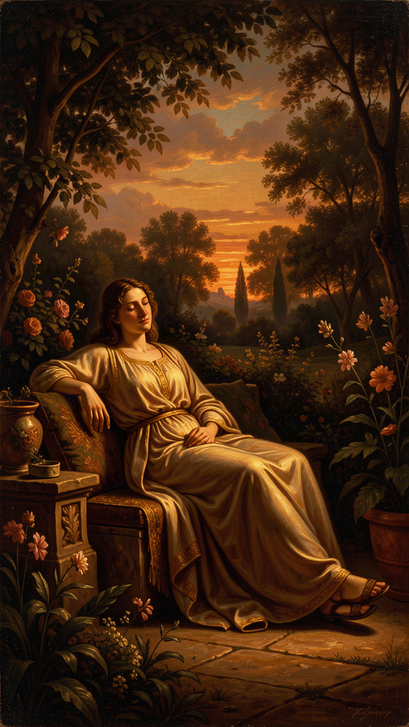
Illustration for Chapter 4
There is a paradox at the heart of Epicurean ethics. The person with little, Epicurus says, is richer than the person with much — because the person with little has enough, and the person with much never does.
Poverty, measured by the goal of nature, is great wealth. Unlimited wealth is great poverty. (VS 25)
This is not a platitude. It is a precise psychological claim. Natural wealth is having what you need: food, water, shelter, friends. This is achievable by almost anyone. Unlimited wealth is having more than you need and still wanting more. The person with unlimited wealth is always poor — not because they lack resources, but because they lack satisfaction. A person eating bread and water who is satisfied is richer than a person eating a five-star meal who is calculating how to afford the six-star meal. The first has arrived. The second is perpetually in transit. "To whom little is not enough, nothing is enough" (VS 68). If you cannot be satisfied with a little, you cannot be satisfied with a lot. The problem is not the amount. The problem is the relationship to having. A bigger pile does not fix the inability to be satisfied by a pile. It just makes the dissatisfaction larger.
The Greek word for the virtue Epicurus is pointing at is autarkeia — self-sufficiency. It is the skill he valued above wealth, status, and achievement. And it is a skill, not a personality trait. It can be learned. It must be practiced. Let's be precise about what it is and what it is not.
It is not isolation. You still need friends. Self-sufficiency means needing few material goods, not needing no people. It is not asceticism. You do not reject pleasure. You find it in what is sufficient. "I revel in the pleasure of the body, feeding on bread and water" (Fragment 181). The bread and water are genuinely pleasurable — not because you have trained yourself to enjoy suffering, but because hunger makes simple food taste good. It is not deprivation. You are not denying yourself things you want. You are recalibrating what you want so that you already have it. It is not complacency. You can still pursue goals and achieve things. The difference: you pursue them because you want to, not because you need to. Achievement becomes a game you play because you enjoy it, not a hunger you are trying to satisfy.
What it is: the condition of needing so little that almost any circumstances can provide it. Freedom from the fear of loss, because you do not depend on what might be lost. "The greatest fruit of self-sufficiency is freedom" (VS 77). The person who needs a high-paying job is not free — they are dependent on the job. The person who needs status is not free — they are dependent on the opinion of others. The person who needs bread, water, shelter, and one friend is free. They can find those things almost anywhere. They can walk away from anything that threatens their ataraxia without fearing the loss of what they need.
Now the harder philosophical claim, the one that separates Epicurus from most modern intuitions about happiness. Ataraxia is not a positive thrill. It is the absence of disturbance. The goal is not to feel good. The goal is to stop feeling bad. Once the bad is removed, you are already at the peak. There is no higher pleasure than the absence of pain.
This is the katastematic/kinetic distinction, the technical heart of Epicurean pleasure theory. Katastematic pleasure (from katastema, "state") is the pleasure of being in a state of no pain and no disturbance — the pleasure of having arrived, of needing nothing. Ataraxia (the soul at peace) and aponia (the body at peace) are katastematic. Kinetic pleasure (from kinesis, "motion") is the pleasure of a process — the satisfaction of a desire, the relief of a pain, the stimulation of a sense. Eating when hungry, warming up when cold. The relationship: kinetic pleasures are temporary and instrumental. They exist to return you to the katastematic state. You eat to remove hunger, which returns you to aponia. You study philosophy to remove fear, which returns you to ataraxia. The kinetic experience is pleasant, but it is not the goal. The goal is to stop needing the kinetic experience.
The pleasure in the flesh is not increased once the pain caused by want has been removed. It is only varied. (KD 18)
Once hunger is gone, eating more does not increase pleasure — it varies it. But the fundamental pleasure — not being hungry — is already complete. You cannot be more-not-hungry. You can only be differently-fed. This is why Epicurus says "Infinite time contains no greater pleasure than finite time, once the limits of pleasure are measured by reason" (KD 19). A complete life — one that has achieved ataraxia — has had all the goods it can have. Duration does not add quality. More time does not mean more happiness, once the peak (the absence of disturbance) has been reached.
This is counterintuitive, and you should press on it. We think of pleasure as a positive sensation — the taste of good food, the thrill of achievement, the rush of excitement. Epicurus says those are variations, not increases. The fundamental pleasure is simply not hurting. Once you are not hurting, you are at the maximum. Everything else is decoration. This is not pessimism. It is liberation. You do not need to chase anything extraordinary. You just need to get to "nothing hurts, nothing's wrong" — and you are there.
It is worth placing ataraxia next to its rivals, because the comparison clarifies what Epicurus was doing. The Stoics aimed at apatheia — freedom from passion. But the Stoics eliminate all passions, including joy and affection. Epicurus eliminates only the turbulent ones. Calm joy, friendship, and gratitude are not disturbances — they are features of ataraxia. Democritus, Epicurus's predecessor in atomism, aimed at euthymia — cheerful contentment, a positive state. Epicurus aimed at the removal of negative states. Democritus's ideal is warmer; Epicurus's is more defensive. Which is better depends on temperament — and on which you find you can actually achieve.
The Big Idea: Enough Is a Skill
The art of enough is the positive side of desire management. Not just eliminating empty desires but cultivating genuine satisfaction with what is sufficient. This is a skill, built by practice. The sufficiency scan: once a day, ask — not "will I have enough tomorrow?" or "do I have as much as other people?" — but "Do I have enough right now to be okay?" Food? Water? Shelter? Safety? At least one person who cares? If yes, you have enough. The feeling of not-enough is a belief, not a fact. The recollection practice: "Remember that what you have now was once among the things you only hoped for" (VS 35). Pick something you take for granted. These things were once unimaginable luxuries for most of humanity. You have them. Let that land. The temporary simplification: pick one day, eat simply, no restaurants, no delivery. Notice: are you suffering, or are you actually fine? The gap between "nice to have" and "need to have" is wider than you think.
Enough is not settling. It is liberation. The person who needs bread, water, shelter, and one friend is free in a way the person who needs a high-status life can never be. Self-sufficiency is not about having nothing. It is about needing so little that you can walk away from everything else.
Practice
1. The Sufficiency Scan. For one week, at the same time each day, pause and ask: "Do I have enough right now to be okay?" Write a one-line answer. At the end of the week, read your seven lines. How often was the answer yes? When the answer was no, what was the actual lack — and was it a natural-and-necessary lack, or an empty one?
2. The Recollection List. Write down five things you have right now that you once desperately wanted. For each, write one sentence about how much you wanted it and how you got it. Then sit with the list. Let the gratitude replace, briefly, the wanting. This works by reminding you that your current life contains the fulfillment of past desires — which means your future self will likely look back at your current life the same way.
3. The Temporary Simplification. Pick one day this month. Eat the simplest food you can — bread, water, simple vegetables. No screens during meals. No entertainment you have to pay for. At the end of the day, write one paragraph: Did I suffer? Or was I actually fine? What did I learn about the gap between what I think I need and what I actually need?
4. The Comparison Detox. Epicurus understood that if you only compare yourself to those who have more, you will always feel poor. For three days, deliberately broaden your reference class. Read about the lives of people in different circumstances — different countries, different centuries, different economic conditions. At the end, write: How does my sense of "enough" change when I compare against the full range of human experience instead of the curated highlight reel of my immediate peers?
Reflect
Epicurus says the person who needs little is freer than the person who needs much, because the person who needs little can walk away from anything that threatens their peace. But in a world where basic survival — housing, healthcare, education — is genuinely expensive and often precarious, is "self-sufficiency" a realistic ideal, or a philosophy for people who already have a safety net? Where does Epicurus's art of enough still hold, and where does it need to be updated for an economy in which "enough" is harder to secure than it was in a Greek garden?
———

Chapter 5: Death Is Nothing to Us

Illustration for Chapter 5
This is the most famous argument in Epicurean philosophy, and it may be the most famous argument in all of ancient ethics. It is also the one most likely to make you roll your eyes the first time you hear it. Death is nothing to us. Right. Tell that to every human who has ever grieved or trembled. But Epicurus was not making a slogan. He was making an argument, and the argument has been attacked, defended, and refined for 2,300 years. It remains philosophically alive. And at the practical level — the level Epicurus actually cared about — it works.
Here is the argument in its definitive form, from the Letter to Menoeceus (124–125):
Accustom yourself to the belief that death is nothing to us. For all good and bad consists in sense-experience, and death is the privation of sense-experience... So death, the most terrifying of evils, is nothing to us — precisely because so long as we exist, death is not present; and when death is present, we do not exist.
Formalized, the argument has three steps:
1. The Experience Premise: Something can be good or bad for a person only if that person can experience it. 2. The Death Premise: Death is the end of all experience. 3. The Conclusion: Therefore, death cannot be good or bad for the person who is dead.
Or, compressed: So long as we exist, death is not present. And when death is present, we do not exist. You and death never meet. You exist → death is elsewhere. Death arrives → you no longer exist. There is no moment when both are present. Therefore, there is no moment when death can harm you. The thing you fear — being dead and suffering from it — is logically impossible. There is no one there to suffer.
The Roman poet Lucretius, Epicurus's greatest follower, added a second argument by symmetry. Look back, he says, at the eternity of time that passed before you were born — the billions of years of nonexistence. Does it trouble you? Do you regret the parties you missed in 10,000 BCE? No. That nonexistence is nothing to you. Now look forward, at the eternity after your death. It is exactly the same thing: nonexistence. If prenatal nonexistence does not bother you, postmortem nonexistence should not either. The symmetry is perfect. Your different attitude toward them — indifference to the past, fear of the future — is not a fact about the eternities. It is a fact about your imagination, which can picture the future and fear its absence but cannot picture the past and regret its absence. The fear is of a picture in your head, not of the thing itself.
Epicurus also draws a crucial distinction: the fear of death (the state) is not the same as the fear of dying (the process). The process can be painful — that is a legitimate concern, and the fourth ingredient of the tetrapharmakos addresses it. But the state of being dead? There is no one there to suffer. "For if something causes no trouble when present, the anticipation of it is groundless" (Letter to Menoeceus 125). The fear of death is not a fear of death. It is a fear of the anticipation of death, in a mind that still exists. You are alive now, imagining being dead, and the imagining is painful. But the thing you are imagining — being dead and suffering from it — is a logical impossibility.
Now the objections, because this argument has been attacked for two millennia and the attacks are worth taking seriously.
The Deprivation Objection (the strongest counterargument). Most associated with the contemporary philosopher Thomas Nagel. Death, the objection goes, is bad not because of what it is (nonexperience) but because of what it deprives you of — continued life and its goods. Even if being dead is not experienced as bad, dying early means you lose goods you would otherwise have had: more conversations, more love, more sunsets. That deprivation is bad for you, even if you do not experience it. If posthumous harm is possible, the experience premise is false.
Epicurean response. The deprivation is real — Epicurus never denied that dying young is worse than dying old. But the deprivation is a fact about the living world (a life that could have been longer), not about the dead person's experience. The dead person does not exist to be deprived. Deprivation requires a subject. There is no subject. Furthermore: "Infinite time contains no greater pleasure than finite time, once the limits of pleasure are measured by reason" (KD 19). A complete life — one that has achieved ataraxia — has had all the goods it can have. More time would not add quality, because the peak of pleasure (the absence of disturbance) has already been reached. You are not missing a higher state by dying; there is no higher state to miss.
The Symmetry Objection. Prenatal nonexistence is different from postmortem nonexistence, because before birth you did not exist to be deprived of anything, while after death you did exist, and death takes away the goods you would have continued to enjoy. The asymmetry is real.
Epicurean response. The asymmetry is psychological, not logical. Both states are nonexistence. The difference in our attitudes is explained by the fact that we can imagine the future (and fear its absence) but cannot remember the past (and do not regret its absence). But the fear is of the imagining, not of the thing. Remove the picture — by understanding the argument — and the fear loosens.
The Emotional Reality Objection. Even if the argument is logically sound, the fear of death is not a logical conclusion — it is an emotional response, an existential reflex. You cannot reason someone out of a feeling they did not reason themselves into.
Epicurean response. This is the objection Epicurus took most seriously. His response is not "you are being irrational, stop it." His response is therapeutic. "Accustom yourself to the belief that death is nothing to us" (Letter to Menoeceus 124). The key word is accustom (συνέθιζε). This is not a one-time intellectual operation. It is a process of habituation — training the mind, over time, to hold the belief not just consciously but deeply. The argument must be internalized, not just understood. It must become part of how you see the world, not just part of what you know. This takes practice. It is philosophy as daily medicine, not as one-time proof.
It is essential to be clear about what the argument does not claim. It does not say do not grieve. Grief is natural. The person who has died has lost the goods of life — that is genuinely sad. What Epicurus says is that death is not bad for the dead person. It is bad for the survivors (they lose someone they love). But the dead person is not suffering. It does not say death does not matter. It matters enormously — to the living. The point is that these are losses for the living, not sufferings for the dead. It does not say you should not fear the process of dying. The process can be painful; KD 4 addresses that. And it does not say suicide is fine. Epicurus explicitly counsels against ending life prematurely: "The wise person neither rejects life nor fears not living" (Letter to Menoeceus 126). Life is good — it is the only context in which pleasure is possible. You do not throw it away. But you do not cling to it in terror either.
The Big Idea: The Argument as Practice
Here is the thing to understand about the death argument: it works, but not as an argument. It works as a practice. You have to accustom yourself to the belief. You have to say it to yourself, sit with it, let it settle into your bones. The fear of death is not a logical error. It is an existential reflex — the organism's resistance to its own dissolution. The argument does not eliminate the reflex. It gives you something to do with it.
When the fear surfaces — at 3 a.m., or in a hospital waiting room, or in the sudden vertigo of realizing you will not always exist — you have a response. Death is nothing to us. When I am, death is not. When death is, I am not. You say it. You breathe. The fear does not disappear, but it loosens. Eventually, it loosens enough to live. And the ultimate Epicurean move is to convert the fear of death into urgency for life. "We are born once. We cannot be born twice. Life is wasted by delay, and each one of us dies without having enjoyed leisure" (VS 14). The fear of death, properly metabolized, becomes the refusal to waste life. Every reminder of mortality is a call to live now — not to check items off a bucket list, but to actually be present for the life you are already living. The person who is afraid of death is afraid of not living. The cure is not to stop caring about living. It is to start living in a way that makes the fear irrelevant.
Practice
1. The Symmetry Visualization. Close your eyes. Imagine the time before you were born — the billions of years of not-existing. Try to feel the absence. What do you feel? Most people feel nothing — no regret, no fear. It is just blank. Now imagine the time after your death. Try to feel the absence. If you feel fear or sadness, notice: the feeling is here, in the present. You are imagining a future absence and reacting to the imagined image. The absence itself — when it arrives — will feel exactly like the prenatal absence. Nothing. Practice this until the two absences feel the same.
2. The Gratitude Reframe. When the fear of death arises, pivot to gratitude for past goods. Vatican Saying 55: "One must heal misfortunes by the grateful recollection of what has been lost." List five specific goods you have already experienced — conversations, meals, moments of beauty, acts of love. Say to yourself: "I had these. They happened. They are real. Death cannot take them away — because they are already past, already complete, already mine." The gratitude is a counterbalance to the deprivation fear. Every good you have already experienced is a good you had, not a good you will miss.
3. The Breath and the Phrase. Sit quietly. When the fear of death surfaces — as a thought, an image, a bodily sensation — do not argue with it. Breathe, and internally say: "Death is nothing to me. When I exist, death is not. When death is, I do not exist." Notice: the fear is present now, in your living body. The thing you are afraid of is not present and never will be. The phrase is a reminder that the fear is about something that cannot happen to you. Let the phrase and the breath work together. Practice this whenever the fear arises, or once a day even when it does not.
4. The Nagel vs. Lucretius Debate. Read Thomas Nagel's essay "Death" (1970), which makes the deprivation objection, alongside Lucretius's symmetry argument (De Rerum Natura III.972–977). Write a two-page paper that (a) states both arguments as fairly as you can, (b) identifies the single strongest point on each side, and (c) says which you find more convincing and why. The goal is not to "win" but to discover where you actually stand — and to learn that an ancient argument and a modern objection can still be in productive conversation.
Reflect
Epicurus says that a complete life — one that has achieved ataraxia — has had all the goods it can have, and that more time would not add quality. Is that true? Is there no good that more life could add, once you have reached the absence of disturbance? Or is Epicurus flattening something real — the value of new experiences, new relationships, new projects — in order to make his argument work? If you genuinely believed that duration does not add quality to a complete life, what would change about how you spend your next year?
———

Chapter 6: Philosophy as Therapy
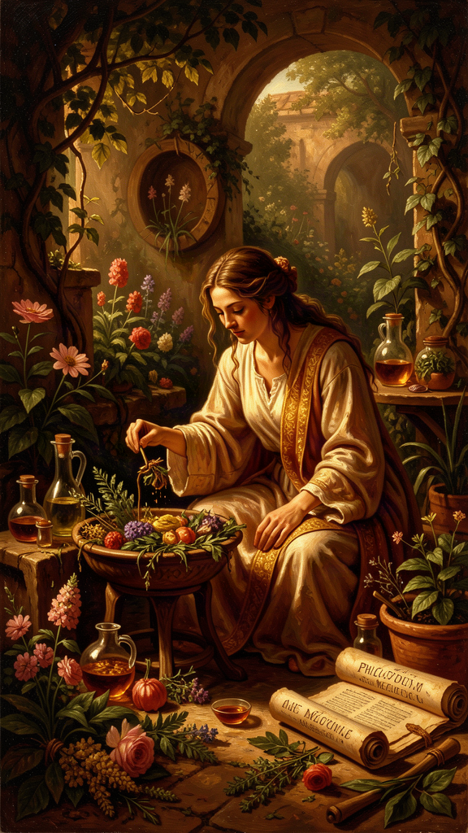
Illustration for Chapter 6
Epicurus wrote a sentence that ought to hang over the door of every philosophy department and every therapist's office:
Empty is the argument of the philosopher by which no human suffering is treated. For just as there is no benefit in medicine that does not drive out bodily diseases, so there is none in philosophy if it does not drive out the suffering of the soul. — Porphyry, *To Marcella* 31
This is the operating principle of his entire project. Philosophy is medicine. Its purpose is not to be clever, not to win arguments, not to display intellect. Its purpose is to cure suffering. And the cure works by a specific mechanism: false beliefs cause suffering; true beliefs cure it. Replace the false beliefs with true ones, and the suffering goes. This is the medical model, and Epicurus meant it literally.
The model has four components, mapping exactly onto the structure of a medical encounter. Diagnosis: the patient presents with symptoms — fear, anxiety, dissatisfaction, dread. The underlying pathology: false beliefs about the gods, death, desire, and pain. The feelings are the symptoms; the beliefs are the disease. Etiology: where do the false beliefs come from? Culture (myths, religious teaching, social pressure), childhood (early experiences that produced mistaken associations), and ignorance of nature. The disease is socially transmitted. You did not choose your false beliefs; you inherited them. But you can choose to replace them. Treatment: replace the false beliefs with true ones. This requires study, memorization, practice, and community. The tetrapharmakos is the prescription. The Garden is the clinic. You are both doctor and patient. Prognosis: complete recovery is possible. Ataraxia is achievable. The treatment works. The evidence: Epicurus's own life and death, the testimony of his followers, the survival of the Garden for centuries.
Now the question that makes this model serious rather than comforting: why does it have to be true beliefs? Why not just tell the patient whatever makes them feel better? Epicurus rejected the comforting-fiction approach, and his reasons are precise. First, false beliefs are unstable. A comforting fiction collapses when reality refutes it. If you believe the gods will protect you, and disaster strikes, the belief fails — and you are worse off than before, because you have lost both your protection and your framework. Second, true beliefs do not require maintenance. You do not have to constantly reinforce a truth against counterevidence. The truth is supported by evidence and reason. It is self-maintaining. Third, true beliefs produce coherent outcomes. The Epicurean system is consistent. The physics supports the ethics. The epistemology supports the physics. Every part reinforces every other part. Coherence increases stability. This is the crucial difference between Epicurean therapy and mere consolation. Epicurus does not want you to feel better by believing something false. He wants you to feel better by believing something true — because only true beliefs are durable.
The parallel with modern cognitive behavioral therapy is not superficial. CBT, developed by Aaron Beck and Albert Ellis in the mid-20th century, shares a fundamental premise: psychological distress is produced by beliefs, not by events. The path to relief is not to change the events (which you often cannot) but to change the beliefs (which you can). This is the tetrapharmakos restated in clinical language. Epicurus identified specific false beliefs (the gods punish, death is terrifying, I need more, this pain is unbearable) and provided true replacements. CBT identifies "automatic thoughts" and "cognitive distortions" and provides tools for correction. The structure is identical: diagnose the false belief, examine the evidence, replace with truth, practice until internalized. Epicurus was doing CBT 2,300 years before CBT existed.
The therapeutic sequences line up almost exactly. CBT: "What am I feeling? What belief is producing this feeling? What is the evidence? What is a more accurate thought? Do I feel better?" Epicurean practice: "What am I afraid of? What false belief am I holding? Is this belief consistent with the nature of things? The tetrapharmakos replacements. Am I less disturbed?" The homework model is the same: daily practice, repetition, skill-building, assessment of outcomes. Even the therapeutic relationship maps: the Garden was effectively group therapy — a supportive community of peers sharing the same framework and practicing together.
But there are differences, and they matter. Epicurean therapy is self-administered after initial training; CBT typically requires an ongoing therapist. Epicurean therapy is philosophical, not just psychological — the true beliefs are established by rational argument, not just by evidence of effectiveness. Epicurean therapy is comprehensive — it addresses the whole of life, not just specific symptoms. And Epicureanism comes with a metaphysical framework — physics, epistemology, ethics — that supports the belief-change at every level. CBT can be effective without that framework. But the framework makes the change more durable. You are not just challenging automatic thoughts; you are inhabiting a coherent worldview in which those thoughts are known to be false at every level.
The model has limits, and Epicurus would be the first to want them stated honestly. It assumes false beliefs are the primary cause of suffering, but some suffering has biochemical or situational causes that belief-change cannot address. It requires philosophical aptitude — not everyone can or wants to study physics and epistemology. It cannot treat brain-organic mental illness; Epicurus lived before the concept of mental illness as a medical condition, and his system addresses the suffering caused by beliefs, not the suffering caused by neurochemistry. It requires community that may not be available; the Garden was essential to the treatment, and most modern people do not have access to a community of like-minded practitioners. These limits do not invalidate the model. They define its scope. The tetrapharmakos works for what it works for: suffering caused by false beliefs about death, gods, desire, and pain. That is a lot of suffering. It may not be all of it.
The most radical implication: you are responsible for your own cure. No one can do it for you. The teacher can present the arguments. The community can provide support. But the work of belief-change is yours. "One must not pretend to philosophize, but philosophize genuinely. For we do not need the appearance of health but true health" (VS 54). You can pretend to be an Epicurean — recite the doctrines, attend the feasts, eat the bread and water. But if you have not actually changed the beliefs, you are still sick. The appearance of health is not health. This is demanding. It is also liberating. If your suffering is caused by your beliefs, and your beliefs are under your control (with the right tools), then your suffering is under your control. This is not victim-blaming — Epicurus never said suffering is your fault. False beliefs are socially transmitted; you did not choose them. But you can choose to replace them. The responsibility is not for the cause. The responsibility is for the cure.
And then there is the death scene — the final testimony. Epicurus, in agony from kidney stones, writing to Idomeneus that the memory of their conversations outweighs the pain. This is not a philosopher proving a point. It is a philosopher dying exactly as he said a wise person could die — happy on the rack, because the mind's resources exceed the body's suffering. The scene has the quality of testimony. He believed it enough to live it. He believed it enough to die it. "On this blessed day, which is also the last of my life... the joy in my soul at the memory of our conversations together" (Diogenes Laërtius X.22). The medicine either works or it does not. Epicurus's last letter says it works. The rest is up to you.
The Big Idea: The Test Is Whether You Get Better
The medical model changes the standard by which philosophy is judged. Philosophy is not judged by whether it is clever, or whether it wins debates, or whether it is interesting. It is judged by whether it reduces suffering. "Empty is the argument of the philosopher by which no human suffering is treated." If it does not help you, it is not philosophy — it is intellectual entertainment. Epicurus did not care whether you found his arguments clever. He cared whether you stopped being afraid.
This is a demanding standard, and it applies to everything in this booklet. The tetrapharmakos is medicine. Take it and see. If it does not work, try a different medicine. But do not mistake reading about medicine for taking it. "One must not pretend to philosophize, but philosophize genuinely." The philosophy is the medicine, and taking the medicine means actually believing differently — not just performing belief, not just reciting doctrines, but changing the actual structure of your judgments about gods, death, desire, and pain.
And here is the thing that makes the model honest rather than utopian: Epicurus knew the cure would not be instant, and he knew it would not be total. The fear of death is an existential reflex, not a logical error. The body knows it will end and recoils. That is biology, not philosophy. What philosophy can do is give you something to do with the reflex — a response, a practice, a phrase, a community — so that the fear, when it surfaces, is smaller and shorter, and so that it does not interfere with your ability to live. Success is not the complete absence of fear. Success is: the fear still arises, but it is smaller; you can recall the argument when it arises; it does not interfere with your ability to enjoy life; you use mortality as a motivator (live now) rather than a paralyzer (what is the point). That is achievable. It requires practice — daily, weekly, ongoing. But it is achievable. And the alternative — a lifetime of unexamined death terror — is not acceptable to a philosopher of the Garden.
Practice
1. The Medical Intake. Treat yourself as the patient. Write a one-page "intake" that lists: your symptoms (what are you afraid of? what do you want that you do not have? what pain are you dreading?), your suspected pathology (what false beliefs might be producing these symptoms?), and your proposed treatment (which tetrapharmakos ingredient addresses which belief?). Be honest. The diagnosis is only useful if it is accurate.
2. The Consolation vs. Cure Test. Pick a belief that comforts you. It might be religious, it might be secular ("everything happens for a reason," "it will all work out"), it might be personal. Ask: Is this belief true? What is the evidence? What would happen to this belief if disaster struck — would it hold, or would it collapse? Epicurus's claim is that only true beliefs are durable comforts. Test yours. If you find a comforting belief that would not survive a real crisis, you have found a comforting fiction, not a cure.
3. The CBT Parallel. Find a brief introduction to cognitive behavioral therapy (Aaron Beck's Cognitive Therapy and the Emotional Disorders is the classic; there are many good summaries online). Make a side-by-side list: CBT's steps next to Epicurean steps. Write a paragraph about where the parallels are strongest and where the differences are sharpest. This exercise shows you that Epicurus's method is clinically validated, and it shows you where Epicurus adds something CBT alone does not — the comprehensive worldview.
4. The Deathbed Letter. Write a letter to your closest friend as if it were your last day. What would you say? What memories would you invoke as the counterbalance to pain? What would you ask of them — not for yourself, but for the people you care about? You will not send this letter. You are writing it to discover what actually matters to you when the trivial is stripped away. What you put in this letter is your tetrapharmakos, your Garden, your philosophy — in the form of a life you have already lived.
Reflect
Epicurus says that "empty is the argument of the philosopher by which no human suffering is treated." This makes philosophy accountable to its therapeutic effects. But is that the right standard? Should philosophy be judged by whether it reduces suffering, or by whether it is true, regardless of whether it makes anyone feel better? Epicurus's answer is that the two standards converge — only true beliefs durably cure. But is he right? Can you think of a true belief that increases suffering (the reality of climate change, the finality of death, the existence of cruelty)? And can you think of a false belief that durably reduces it? Where does Epicurus's convergence break down, and what does that breakdown reveal about the limits of philosophy as therapy?
———

For the Grown-Up Reader
This booklet adapts Epicurus's surviving writings — the three letters (Menoeceus, Herodotus, Pythocles), the 40 Principal Doctrines, the 81 Vatican Sayings, and fragments from On Nature — together with Lucretius's De Rerum Natura and the scholarly commentary of Martha Nussbaum (The Therapy of Desire), Phillip Mitsis (Epicurus' Ethical Theory), James Warren (Facing Death), and A. A. Long and D. N. Sedley (The Hellenistic Philosophers). Key passages are cited by source (KD = Principal Doctrine, VS = Vatican Saying) and by section number where applicable.
If a teenager asks, "Did Epicurus really say this?" the answer is yes for every quotation in this booklet. We have his actual words, preserved by Diogenes Laërtius and recovered from the Herculaneum papyri, and the gap between the historical Epicurus and the popular caricature ("epicurean" = gourmet) is one of the great successes of intellectual slander. The man ate bread and water and called it a feast.
A note on the medical model: Epicurus conceived of philosophy as therapy 2,300 years before CBT formalized the cognitive model. The convergence is genuine. But the limits are real too. Epicurus's system addresses suffering caused by false beliefs; it does not address suffering caused by neurochemistry, trauma, or systemic injustice, and pretending it does would be a disservice to both Epicurus and to anyone dealing with those realities. The tetrapharmakos is medicine for a specific set of ailments. It is not a replacement for medical care, therapy, or social change. It is a philosophical tool, and like all tools, it has a scope.
———

About WisdomForge
WisdomForge adapts the great philosophers into stories, audio, and conversation for every age. Each philosopher becomes four booklets — one for children, one for younger teens, one for older adolescents, and one for adults — so the same ideas can grow with you. The Epicurus series covers his life and Garden, the tetrapharmakos, the architecture of desire, ataraxia and the art of enough, the death argument, and philosophy as therapy — the same system, told at four levels of depth.

