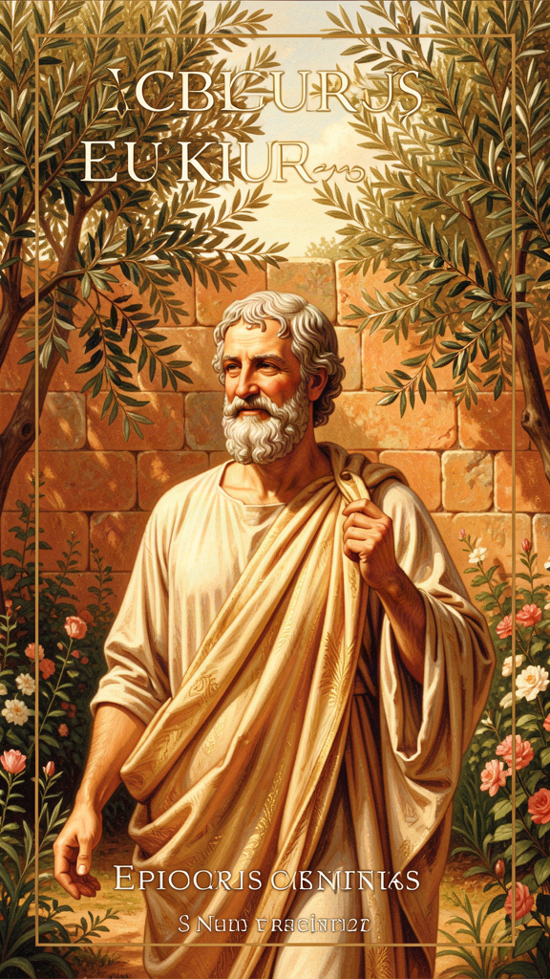
Epicurus: The Garden Where Fear Couldn't Grow
WisdomForge Booklet — Ages 11–14

Epicurus: The Garden Where Fear Couldn't Grow

WisdomForge Booklet — Ages 11–14
———

About This Book
Most people hear the word "Epicurean" and think of fancy food, expensive wine, and chasing pleasure. They've got it exactly backwards.
Epicurus was a Greek philosopher who lived over 2,300 years ago, and his big idea was almost the opposite of what people think. He said that the secret to happiness isn't getting more — it's needing less. He said that the things we're most afraid of (death, the gods, not having enough) can't actually hurt us the way we think they can. And he proved it by building something radical: a community where women, slaves, and foreigners were welcomed as equals, where the meals were bread and water, and where the whole point was to help each other stop being afraid.
This booklet follows Epicurus into situations you might recognize — the pressure to fit in, the fear of dying, the feeling that you don't have enough, the worry that something is wrong with you. Each chapter combines a story, a big idea, and things to try. You don't have to agree with everything Epicurus said. But you might be surprised how much of it still works.
———

Chapter 1: The Garden That Changed Everything
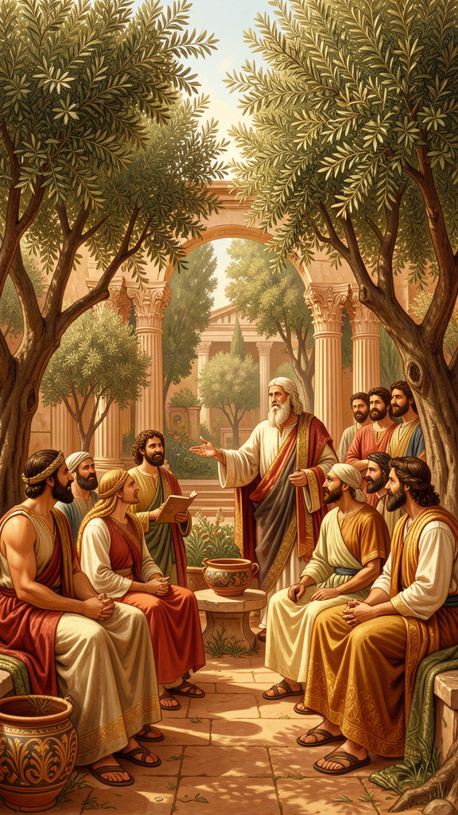
Illustration for Chapter 1
Theo had a plan for seventh grade, and the plan was not working.
The plan had been simple: get the right shoes, post the right things, hang out with the right people, and become the kind of person everyone wanted to be around. By October, he had the shoes (expensive, begged-for, scuffed within a week). He had the posts (carefully filtered, never quite enough likes). He had the people — or sort of. A shifting group whose approval he could feel slipping whenever he said the wrong thing or wore the wrong shirt. And he had a growing, sour feeling in his stomach that he couldn't name. It felt like hunger, but food didn't fix it. It felt like being tired, but sleep didn't fix it. It felt, he realized one night staring at the ceiling, like being scared all the time — scared of losing something he'd never really had.
His grandmother found him like that, lights off, phone face-down on the bed. She didn't ask what was wrong right away. She sat on the edge of the mattress and said, "When I was your age, I was miserable for almost the same reason. And a very old philosopher helped me figure out why." She held up her phone, where she'd been reading something. "His name was Epicurus. He started a garden."
———
Theo expected a story about plants. Instead he got a story about a revolution.
Epicurus was born in 341 BCE on the island of Samos, off the coast of what's now Turkey. His parents were Athenian colonists — not rich, not powerful. The world he was born into was falling apart. Alexander the Great had conquered everything in sight and then died suddenly at thirty-two. His empire shattered into rival kingdoms. The old Greek city-states, Athens included, were scrambling to keep their independence. The certainties that had organized life for centuries — the gods protect our city, virtue means being a good citizen, the universe has a purpose — were cracking. People were scared and adrift, looking for new ways to live.
Epicurus started asking questions at fourteen. The story goes that his teacher couldn't explain a passage about Chaos in an old Greek poem about the gods, and the boy decided the explanation wasn't good enough. Whether or not that's exactly true, it captures something real about him: he thought the traditional stories about the gods and the cosmos were confusing, and that confusion produced fear, and fear was the thing philosophy was supposed to cure.
He studied under several teachers, learned about atoms and the nature of the universe from a philosopher named Nausiphanes (then later insisted he'd taught himself, which his critics found suspicious), and eventually arrived at his own system. Around 307 BCE, when he was about thirty-four, he did something that would have seemed strange to every other philosopher in Athens: he bought a house with a garden just outside the city walls and invited his friends to live with him.
They called it the Garden.
Here's what made the Garden radical. Every other philosophical school in Athens — Plato's Academy, Aristotle's Lyceum, the Stoics' colonnade — was for elite freeborn Greek men. No women. No slaves. No foreigners. Philosophy was an exclusive club.
Epicurus opened the doors to everyone. Women studied there. A woman named Leontion became a philosopher whose writing was quoted for centuries. Slaves studied there — one named Mys became a philosopher, and Epicurus's will arranged for slaves who'd studied philosophy to be freed. People came from as far away as Syria and Egypt. The Garden didn't care who you were. It cared whether you wanted to learn how to stop being afraid.
And the way you learned wasn't by sitting through lectures. There were no fees, no grades, no hierarchy of teacher-above-student. The Garden was a community of friends. They ate simple meals together — barley bread, water, a little cheese, occasionally wine. Epicurus once wrote to a friend, "Send me a pot of cheese, so that I may feast whenever I wish." They memorized short sayings — the core teachings — so those sayings would be available in their heads at 3 AM when fear showed up. They talked. Not small talk — real conversation about what they were afraid of and what they wanted. And every month on the twentieth, they had a feast to remember Epicurus and his closest friend Metrodorus, renewing the bonds that held them together.
The Garden wasn't a school. It was a way of life. And it worked. It survived Epicurus by centuries — longer than Plato's Academy. Communities sprang up in other cities, connected by letters and friendship. The reason it lasted wasn't institutional structure. It was friendship. Friendships persist when institutions crumble.
———
Epicurus died in 270 BCE at age seventy-one, after two weeks of agony from what was probably kidney stones. On his last day, in terrible pain, he wrote a letter to a friend named Idomeneus. He said that the pain was as intense as pain could ever be — but that against all of it was "the joy in my soul at the memory of our conversations together." Then he asked his friend to take care of Metrodorus's children. He got into a warm bath, surrounded by his friends, and died. His last words, according to one account: "Farewell, and remember my doctrines."
That death scene is the Garden's final proof. He wasn't just teaching these ideas. He was living them — and dying them. The pain was real. The peace was real too. The philosophy was the medicine that let both things be true at once.
The Big Idea
Epicurus's life teaches something that the world outside the Garden didn't believe and still mostly doesn't: you can build a life organized around the absence of fear rather than the pursuit of power. You don't have to compete for status, chase approval, or stockpile stuff to be okay. You can choose different materials entirely — understanding, friendship, simplicity — and build something sturdier.
Think about it like this. Most people build their happiness out of things that can be taken away: popularity, money, looks, winning. It's like building a house on a frozen lake. When the weather changes — and it always does — the whole thing cracks. The Garden was built on different ground. Bread, water, shelter, friends, and a mind free of false fear. Those things are hard to lose. The house stands.
Theo's plan for seventh grade was a house on a frozen lake. The shoes could get scuffed. The posts could flop. The shifting group could shift away. None of it was built to last, so none of the safety it gave him was real. The Garden suggests a different question: not How do I get everyone to like me? but What do I actually need to be okay? The answer, Epicurus said, is less than you think — and more available than you fear.
Try This
1. Design Your Own Garden. Grab a piece of paper. Imagine you're founding a community whose whole purpose is to help people stop being afraid. Who would you invite? (It doesn't have to be people you know — think about what kinds of people.) What would you eat together? What would you talk about? What would be the most important rule? There's no wrong answer — this is your Garden. Notice what you put at the center. If you put status or popularity at the center, ask yourself why. If you put friendship or honesty there, you're already thinking like an Epicurean.
2. The Simple Meal Experiment. One day this week, eat the simplest meal you can — plain bread and water, or rice and water, or whatever the bare version of a meal is in your house. No screens, no phone. Just you and the food. Notice: are you suffering? Or are you actually fine? The point isn't that fancy food is bad. The point is to discover that the gap between need and want is wider than you thought. Epicurus said, "Barley cake and water give the highest pleasure when someone in need partakes of them." See if you can feel what he meant.
3. The Real Conversation. This week, have one conversation with someone you trust that goes below the surface. Ask them something real: "What's been scaring you lately?" or "What do you feel like you don't have enough of?" Then just listen. Don't fix it. Don't change the subject. The Garden was built on this kind of talk. Notice how it feels to have one conversation that isn't about shoes or posts or who-said-what.
4. Quote to Keep. Epicurus said: "Of all the things that wisdom provides, by far the greatest is the possession of friendship." Write it down. Put it somewhere you'll see it. When you catch yourself chasing something flimsy — likes, status, the approval of people who don't really know you — read it. Let it remind you where the real wealth is.
———
Talk About It
- Why do you think ancient critics attacked Epicurus so viciously? Was it just philosophical disagreement, or was something else going on? - The Garden welcomed women, slaves, and foreigners when no other school did. Why do you think Epicurus did this — and why did it scandalize people? - If you could build a "Garden" today, what would be the one rule that mattered most?
———
Here's a question to carry with you this week: If you were building a life that couldn't be shaken by losing your shoes, your followers, or your spot in the group — what would you build it out of instead?
———

Chapter 2: The Four-Part Cure

Illustration for Chapter 2
Maya couldn't sleep. Again.
It was the third night in a row. The thoughts came in no particular order: What if I fail the math test and have to repeat the whole grade? What if Grandma's cough is something serious? What if there's no point to any of it and we just disappear when we die and nothing matters? Each thought fed the next. By 1 AM her heart was pounding and the ceiling felt very close and very far away at the same time.
She tried what her mom always said — "just think about something nice" — but the scary thoughts were louder than the nice thoughts. She tried counting backwards from 100. She got to 87 and then: What if there's a god and he's angry at me for something? Back to the ceiling.
The next morning, bleary and frustrated, she complained to her older brother, who was home from college. He listened, nodded, and said, "There's this Greek guy who had a thing for exactly this. He called it the four-part cure. Want to hear it?" Maya shrugged. He pulled out his phone. "Epicurus. He lived around 300 BCE. He said almost all human misery comes from four false beliefs, and if you replace them with four true ones, the misery can't stick. Like medicine. He literally called it a pharmakon — a remedy."
———
Epicurus called it the tetrapharmakos — the four-part cure. It's the distilled essence of his entire philosophy, compressed into four sentences:
*Don't fear god.* *Don't worry about death.* *What is good is easy to get.* *What is terrible is easy to endure.*
That's it. The whole system, in four lines. Everything else Epicurus wrote — the physics, the long arguments, the letters, the three hundred scrolls (almost all lost) — exists to support these four claims. They're not just slogans. Each one replaces a specific false belief that, Epicurus said, is making you sick.
Think of it like a doctor's prescription. You go in with a symptom — let's say, can't sleep because you're scared of everything. The doctor doesn't just say "calm down." She diagnoses the underlying disease: you're carrying around four false beliefs that are poisoning your mind. Then she prescribes four true beliefs to replace them. You take the medicine — meaning, you actually believe the new things, not just memorize them — and the symptom fades.
Here are the four medicines.
Medicine 1: Don't fear god.
This is the most surprising one. Epicurus didn't say "there are no gods." He said something stranger: the gods exist, they're perfectly happy, and they have absolutely nothing to do with you.
His reasoning: a perfectly happy being can't be disturbed. Anger, jealousy, the need to be worshipped — those are all disturbances. A perfectly happy being doesn't have them. A perfectly happy being doesn't need anything from you (need means lack, and a happy being lacks nothing). A perfectly happy being doesn't punish or reward (that would require being affected by what you do, and a happy being isn't affected).
So: the gods aren't threats or judges. They're not watching you, waiting for you to mess up. The sky is empty of threats. You can breathe.
This was radical in ancient Athens, where people genuinely feared that the gods would punish them for irreverence. Epicurus said the real irreverence is pretending the gods are petty and angry like humans. You honor the gods by recognizing their perfection, not by trembling before them.
Medicine 2: Don't worry about death.
This one we'll dig into deeply in Chapter 5, but here's the short version. Everything good or bad in life involves feeling something — happiness feels good, pain feels bad. Death is the end of all feeling. So when you're alive, death isn't happening to you. When death happens, you're not there to feel it. You and death never meet. What you're actually afraid of when you think about death is the thought of death — a picture in your head, happening now, while you're alive. The thing itself can't hurt you because you won't be there for it.
Medicine 3: What is good is easy to get.
What do you actually need to be okay? Food. Water. Shelter. Friends. Freedom from fear (which philosophy provides). That's it. Those things are not hard to get. Bread costs little. Water is free. Shelter is achievable. Friendship takes effort but not money.
What makes happiness seem hard to get is that we want things we don't need: fame, power, luxury, everyone's approval, more-than-enough. These desires have no natural limit. There's always more fame. Always more money. Always another stranger whose approval you don't have yet. You can never arrive. The pursuit is endless, and endless pursuit guarantees you'll always feel like you're failing.
But the stuff you actually need? You can satisfy that today.
Medicine 4: What is terrible is easy to endure.
When pain comes — physical or emotional — it's never as bad as the dread of it. The worst pain is brief: the body can't sustain that level of intensity for long. Pain that lasts is, by its nature, endurable (if it were unbearable, you wouldn't bear it — you'd die, and the fact that you're alive means it's within tolerable limits). And even when your body hurts, your mind — your memories of good times, your understanding of what's happening — can stay at peace. Epicurus said a wise person could be happy even on the rack. That's extreme, but the point stands: the anticipation of pain is usually worse than the pain itself.
The Big Idea
The tetrapharmakos is cognitive behavioral therapy — invented 2,300 years early. The insight at the center of modern therapy is that distress isn't caused by events; it's caused by the beliefs we hold about events. Change the belief, and the distress changes. Epicurus understood this before anyone had a name for it.
Here's the move, in general: when you're suffering, don't just flail around trying to feel better. Ask: What do I believe right now that's making me suffer? Then ask: Is that belief actually true? If it's false, replace it with a true belief. The suffering doesn't vanish instantly, but it loosens. Over time, with practice, it loosens a lot.
The tetrapharmakos identifies four core false beliefs and gives you four true replacements:
- False: "The gods (or fate, or the universe) are judging and punishing me." → True: Nothing is judging you. The sky is empty of threats. - False: "Death is a terrible thing that will happen to me." → True: Death is the end of experience. You'll never experience it. - False: "I need more than I have to be happy." → True: What you need is simple and available. - False: "This pain is unbearable and will never end." → True: Pain is either brief or manageable. The dread is the worst part.
Notice what the cure doesn't say. It doesn't say "just think positive." It doesn't say "pretend everything's fine." It says: figure out the specific false belief, replace it with a specific true belief, supported by evidence. Vague reassurance doesn't work. Specific replacement does.
There's a catch, and it's important. You can't just decide to believe something. Try it: decide right now to believe the sky is green. Can't do it. Belief changes through understanding and practice, not willpower. Epicurus knew this. That's why he said "accustom yourself to the belief" — not "decide to believe." You study the argument. You sit with it. You apply it, over and over, until it becomes part of how you see the world. It's medicine you take daily, not a pill you swallow once.
Try This
1. The Belief Detective. The next time you're upset — anxious, angry, down — grab a notebook. Write down what you're feeling. Then ask: What am I believing right now that's producing this feeling? Not "what happened" — what you believe about what happened. Examples: "If I fail this test, my life is over." "Everyone thinks I'm weird." "I can't handle this." Write the belief down. Then ask: Is this actually true? What's the evidence? Often you'll find the belief is bigger and flimsier than it felt. Write a truer, more specific version: "I might do badly on this test, and that would be disappointing, but my life won't be over." Notice how the feeling shifts.
2. The Four-Medicine Check. When you're spiraling (can't sleep, mind racing, everything feels terrible), run through the four medicines like a checklist. Am I afraid something is judging or punishing me? (Medicine 1 — nothing is.) Am I afraid of death or disappearance? (Medicine 2 — you won't be there for it.) Am I convinced I need something I don't have? (Medicine 3 — what I need is simple.) Am I telling myself a pain is unbearable and forever? (Medicine 4 — it's brief or manageable.) Identifying which false belief is running the show is half the cure.
3. The Medicine Card. Make a small card — index card, note in your phone, whatever works. Write the four lines on it: Don't fear god. Don't worry about death. What is good is easy to get. What is terrible is easy to endure. Keep it where you can find it at 1 AM. When the thoughts start racing, read it. Not as a magic spell — as a reminder of what's actually true. It works better the more you use it, because the beliefs get stronger with repetition.
4. The "What Am I Really Afraid Of?" Drill. Fear is often fuzzy. It feels big but you can't quite name it. When fear shows up, sit with it for one minute and ask, out loud or in your head: "What exactly am I afraid of?" Keep asking until you get specific. "I'm afraid something bad will happen" → "I'm afraid I'll fail" → "I'm afraid failing means I'm worthless." Once the fear is specific, you can test it. Is it true that failing means you're worthless? No. The specific belief is usually the weak point. That's where the medicine goes.
———
Talk About It
- Which of the four medicines is hardest for you to believe? Which false belief is the hardest to let go of? - Do you think it's fair to call philosophy "medicine"? Should ideas be judged by whether they reduce suffering, or by whether they're true regardless of how they make you feel — and are those different things? - The tetrapharmakos says you can't just decide to believe something new. Have you ever tried to change a belief by willpower alone? What happened? What actually worked?
———
A question to carry with you: Right now, in this moment, which of the four false beliefs is running your life — and what would change if you replaced it with the true one?
———

Chapter 3: Three Kinds of Want

Illustration for Chapter 3
Jaden wanted a lot of things. He wanted the new console. He wanted more followers. He wanted to be the funniest person in the group chat. He wanted his parents to stop treating him like a little kid. He wanted to be better at basketball than Marcus, who was two inches taller and didn't seem to practice at all. He wanted everyone to stop talking about the school dance that he wasn't going to because nobody had asked him and also he didn't want to go and also he kind of did.
The wanting was exhausting. It felt like a low hum in the background of everything — never silent, never satisfied. When he got one thing (the console, for his birthday), the hum didn't stop; it just moved to the next item. His dad noticed him slumped on the couch one Saturday, scrolling, and said, "You don't look like a kid who just got a PlayStation."
Jaden shrugged. "It's fine."
"It's fine" was doing a lot of work. His dad sat down. "Can I tell you something weird a philosopher figured out? He said most people are unhappy not because they don't have enough, but because they want the wrong things — and they don't even know the difference between what they need and what they've been told to want."
———
Epicurus had a tool for exactly this problem. He sorted every desire into three categories. Once you know the categories, you can examine anything you want and figure out whether chasing it will make you happier or just more tired.
Category 1: Natural and Necessary.
These are things you genuinely need — for life, for your body to not hurt, or for peace of mind. Food when you're hungry. Water when you're thirsty. Shelter. Sleep. And, crucially, friendship — Epicurus considered friendship a necessity, not a luxury.
The rule for Category 1: satisfy these. They have natural limits. You can only drink so much water. You can only eat so much food before you're full. They're achievable. And neglecting them causes real suffering. If you don't eat, you suffer. If you have no friends, you suffer. These wants are not the problem.
Category 2: Natural but Unnecessary.
These are real desires — they come from your body or your nature — but you don't need them to be okay. A treat instead of a plain meal. A comfortable bed instead of a basic one. A nice day out instead of an ordinary one.
The rule for Category 2: enjoy them when they're around; don't chase them when they're not. It's fine to eat a cookie. It's not fine to be miserable because there are no cookies. The absence of a Category 2 desire shouldn't disturb your peace. If you can eat barley bread and water and be fine — and you can — then the cookie is a bonus, not a requirement.
Category 3: Empty (cultural).
These are the dangerous ones. They don't come from nature. They come from culture — from advertising, social pressure, the stories we're told about what a successful life looks like. Fame. Power. Universal approval. Being the best. Having the most. Being remembered after you die.
The rule for Category 3: eliminate them. They have no natural limit. You can never have enough fame (there's always someone more famous). You can never have enough approval (there's always another stranger whose opinion you don't have). You can never have enough money if "enough" is defined by comparison to others. Category 3 desires are infinite, and infinite desires guarantee perpetual dissatisfaction. You will always be running and never arriving.
Here's the sneaky part: Category 3 desires feel natural. It feels like you genuinely need to be popular. It feels like you genuinely need that console. It feels like being remembered after you die would solve something. The feelings are real. But the beliefs behind them are false. Fame doesn't solve the thing you think it'll solve (ask a famous person — many of them are miserable). More followers won't make you feel loved; only real friends do that. Being remembered after you die won't help you, because you won't be there to enjoy it.
The Big Idea
Epicurus's desire classification is a diagnostic tool. You use it to examine what you want and figure out whether pursuing it will produce more pleasure or more pain. The insight that makes it powerful: sometimes the wanting is the problem, not the not-having.
Think about Jaden. The console didn't fix the hum because the hum wasn't about the console. It was about wanting itself — the habit of reaching for the next thing instead of arriving at this one. Getting the thing he wanted just taught him to want the next thing. That's how Category 3 works. The desire has no floor and no ceiling. You can't fill it.
Or consider a desire that feels important: "I need everyone to like me." Test it with the classification. Do you need everyone to like you to be okay? No — you need a few genuine friends (Category 1). The admiration of a million strangers is Category 3: no limit, no satisfaction, no end. The belief "I need everyone to like me" is what's making you miserable, and the cure isn't getting everyone to like you (impossible). The cure is dropping the belief.
Here's a test Epicurus gives us, in disguise. For any desire, ask:
1. Would I be in real trouble without it? If yes — Category 1. Satisfy it. 2. Is it nice, but I'd be fine without it? If yes — Category 2. Enjoy if available, don't chase. 3. Does it have no limit? Can I ever have enough? If no — Category 3. Drop it.
The hardest reclassifications are the ones where culture has convinced you something is necessary when it's actually empty. "I need to be successful." Well — you need enough resources to be comfortable (Category 1). But status, recognition, wealth beyond what satisfies natural needs? That's Category 3. "I need to be loved by everyone." You need friendship (Category 1). Universal approval is Category 3. The difference matters. A few genuine friends has a limit (you can have enough friends). The admiration of strangers has no limit. The first is satisfying. The second is a treadmill.
And here's the deepest move: sometimes you don't want the thing. You want what you believe the thing represents. You want fame because you think it'll make you feel valued. You want wealth because you think it'll make you feel safe. You want power because you think it'll make you feel at peace. But fame doesn't make you feel valued (only real connection does). Wealth doesn't make you feel safe (you just worry about losing it). Power doesn't make you feel at peace. The desire is for something real — love, safety, peace — but it's been aimed at a target that can't deliver. The cure isn't to stop wanting love, safety, and peace. It's to aim those wants at what actually works: friendship, enough, and philosophy.
Try This
1. The Desire Inventory. Take ten minutes. Write down everything you currently want. Everything. From "a snack" to "to be famous" to "a different life." Don't edit. Don't judge. Just list. Now go back and classify each item: Category 1 (need), Category 2 (nice), or Category 3 (empty/no limit). Be honest. The things that feel most urgent are often Category 3 in disguise. When you're done, look at your Category 3 list. These are the wants that are guaranteed to make you tired without making you satisfied. What would happen if you stopped wanting them?
2. The "Does It Have a Limit?" Test. This week, each time you catch yourself wanting something, ask: Can I ever have enough of this? If the answer is no — there's always more, there's always someone who has more, there's always another level — it's Category 3. You don't have to stop wanting it instantly (you can't). Just notice. Naming the treadmill is the first step off it.
3. The Misaimed Desire Check. Pick one strong desire you have. Ask yourself: What do I believe this thing will give me? (Love? Safety? Respect? Peace? Fun?) Then ask: Will it actually give me that — or am I aiming a real need at something that can't deliver it? If fame won't make you feel loved but friendship will, the cure isn't to stop wanting love. It's to redirect the want toward friendship.
4. The "I Already Have This" Practice. Epicurus's follower left us this line: "Remember that what you have now was once among the things you only hoped for." Pick three things you have right now that you used to desperately want. Maybe a phone, a freedom, a friend, a skill. Sit with the fact that you have them. Let the gratitude push back against the wanting. The hum gets quieter when you notice how much has already arrived.
———
Talk About It
- What's one thing you want that you suspect is Category 3 (no limit, can never have enough)? What would happen if you stopped wanting it? - Epicurus said sometimes the wanting is the problem, not the not-having. Can you think of a time when getting what you wanted didn't actually fix the feeling? - Ads and social media are designed to make Category 2 things feel like Category 1. Can you name a "need" you've been sold that might actually be optional?
———
A question to carry with you: What's one thing you want that you suspect has no limit — that you could never get enough of — and what would happen if you stopped chasing it?
———

Chapter 4: The Art of Enough
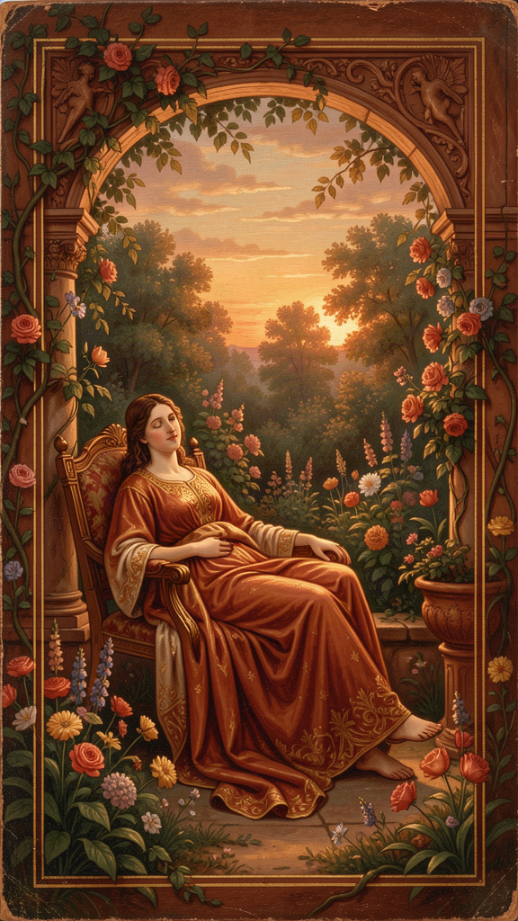
Illustration for Chapter 4
The group chat was on fire. Someone had posted a photo of their new sneakers — limited edition, resold for more than a month's rent. Then someone else posted their pair. Then the question went around: what are you guys rocking? Lila watched the messages stack up. She was wearing last year's model. They were fine. They were shoes. But "fine" and "shoes" were not the words that would sound good in the chat, so she said nothing, and the nothing felt loud.
That night she asked her mom, half-joking, "Are we poor?"
Her mom looked at her for a long second. "No. We have enough."
"Enough" sounded like the most boring word in the English language. Lila wanted to say so. But her mom had that look — the one that meant a real conversation was available if she wanted it. "There's this idea I want to show you," her mom said. "A philosopher said something about 'enough' that sounds weird at first and then kind of haunts you."
———
The philosopher was Epicurus, and the idea is called autarkeia — self-sufficiency. It's the skill he valued above wealth, status, and achievement. And it comes with a paradox that flips the normal way of thinking about wealth completely upside down.
Epicurus said: the person who needs very little is richer than the person who has a lot. Not as a comforting platitude. As a precise claim about how satisfaction works.
Here's the logic. There are two kinds of "wealth." Natural wealth is having what you need — food, water, shelter, friends. It's achievable by almost anyone. It has a limit: once you have enough, you have enough. Empty wealth is having more than you need but still wanting more. It has no limit. The desire never arrives.
So: a person eating bread and water who is satisfied is richer than a person eating a fancy meal who is already calculating how to afford a fancier one. The first person has arrived. The second is perpetually in transit. The first person's wealth is real (they have what they need and they know it). The second person's wealth is an illusion (they have a lot but they feel poor, because the wanting hasn't stopped).
Epicurus put it in a single, devastating line:
*Poverty, measured by the goal of nature, is great wealth. Unlimited wealth is great poverty.*
And:
*To whom little is not enough, nothing is enough.*
Read that second one again. To whom little is not enough, nothing is enough. If you can't be satisfied with a little, you can't be satisfied with a lot. The problem isn't the amount. The problem is the capacity for satisfaction. A bigger pile doesn't fix the inability to be satisfied by a pile. It just makes the dissatisfaction bigger.
This is why winning the lottery doesn't make people lastingly happier (studies have shown this). It's why people who achieve their big goal often feel empty a week later. It's why Lila's sneakers, even if she got the limited edition, wouldn't have fixed the feeling in the chat. The feeling wasn't about shoes. It was about the belief that she needed something she didn't have to be okay. And that belief doesn't get fixed by getting the thing. It gets fixed by changing the belief.
———
Now, self-sufficiency doesn't mean what it sometimes sounds like. It's not isolation — Epicurus said friendship is a necessity, and you can't be a good Epicurean alone. It's not asceticism — you're not supposed to reject pleasure; you're supposed to find pleasure in what's sufficient. (Bread and water, when you're hungry, are genuinely delicious. Hunger is the best seasoning.) It's not deprivation — you're not denying yourself things; you're recalibrating what you want so that you already have it. And it's not complacency — you can still pursue goals and create things. The difference: you pursue them because you want to, not because you need to. Achievement becomes a game you play for fun, not a hunger you're trying to fill.
Self-sufficiency is: the condition of needing so little that almost any circumstances can provide it. Freedom from the fear of loss (because you don't depend on what might be lost). The foundation that makes peace of mind possible.
Here's the part that connects to your life. The modern world — the ads, the feeds, the group chats — is an engine designed to make you feel like you don't have enough. That's not an accident. Happy people who feel they have enough don't buy as much, post as much, or scroll as much. The economy runs on dissatisfaction. Epicurus saw this 2,300 years before advertising existed:
*Natural wealth is limited and easy to obtain. But the wealth demanded by empty opinions extends to infinity.*
The "empty opinions" now have billion-dollar budgets. The resistance is harder than it was in ancient Athens. But the strategy is the same: recognize the mechanism, reclassify the desire, return to enough.
The Big Idea
Self-sufficiency flips "enough" from a settling-for-less word into a liberation word. The person who needs a high-paying job to be happy isn't free — they're dependent on the job. The person who needs status isn't free — they're dependent on the opinions of others. The person who needs luxury isn't free — they're dependent on the supply chain that delivers it.
The person who needs bread, water, shelter, and one friend? That person is free. They can find those things almost anywhere. They can walk away from anything that threatens their peace without fearing the loss of what they need.
This is the real meaning of "enough." Not "I give up" but "I have arrived." Not "I'm settling" but "I'm no longer running." Enough is the place where the hum stops. And the secret Epicurus discovered is that enough is closer than you think — because what you actually need is simpler and more available than what you've been told to want.
Think about Lila again. The chat made her feel poor. But she had food, shelter, people who cared about her, last year's shoes that still worked. By Epicurus's measure, she was already rich. The feeling of poverty wasn't a fact about her life. It was a belief — the belief that she needed the limited-edition shoes to be okay. Drop the belief, and the poverty evaporates. The shoes were never the point. The belief was.
Try This
1. The Sufficiency Scan. Once a day — maybe before you get out of bed — ask yourself: Do I have enough right now? Not "will I have enough tomorrow?" Not "do I have as much as other people?" Just: do I have enough, right now, to be okay? Food? Water? Shelter? Safety? At least one person who cares? If yes — you have enough. The feeling of not-enough is a belief, not a fact. Practice catching it.
2. The Worst-Case Simulation. Ask: If I lost everything — all my stuff, my status, my followers — what would I still need to be okay? The answer, on Epicurus's terms: food, water, shelter, one friend. That's it. Those four things are achievable from almost any starting point. Knowing that you can survive the worst case makes the worst case less terrifying — and makes all the stuff you're afraid of losing feel less essential.
3. The Temporary Simplification. Pick one day. Eat simply — no restaurants, no delivery, no snacks, just basic food. Skip the luxuries. Notice: are you suffering, or are you actually fine? The experiment proves something you might not believe until you feel it: you don't need what you think you need. The gap between "nice to have" and "need to have" is wider than you think.
4. The "I Once Wanted This" Recall. Pick something you have right now that you used to desperately want. A phone. A freedom. A friend. A skill. Remember how much you wanted it. Now you have it, and you probably take it for granted. Sit with that for thirty seconds. Let it land. The things you're chasing today will be the things you take for granted tomorrow — unless you learn to notice what you already have.
5. The Giving Test. Epicurus said self-sufficiency produces generosity, because the person who needs little can afford to give. Test it: give something away this week — time, a small amount of money, attention to someone who needs it. Notice: does it hurt? If it hurts, you're not yet self-sufficient — you still need what you gave. If it doesn't hurt, you've found something. You've found enough.
———
Talk About It
- "To whom little is not enough, nothing is enough." Do you agree? Can you think of someone who has a lot but never seems satisfied? Can you think of someone who has little but seems content? - Is "enough" settling, or is it freedom? What's the difference between being satisfied with what you have and giving up on improving your life? - The modern world is an engine designed to make you feel like you don't have enough. Where do you feel that pressure most — ads, social media, friends, school? How could you push back?
———
A question to carry with you: What's one thing you think you "need" that might actually be optional — and what would happen if you stopped needing it?
———

Chapter 5: Death Is Nothing to Us
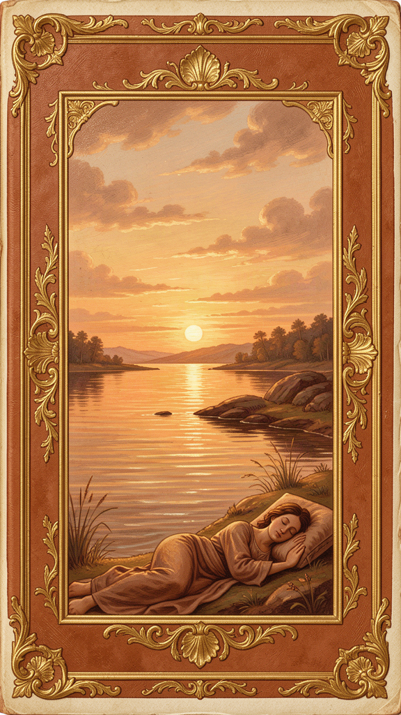
Illustration for Chapter 5
It came out of nowhere, the way it always did. Sam was fine — doing homework, normal Tuesday — and then a thought arrived: One day I won't exist. One day everything I am will just... stop. The thought was simple. It was also the most terrifying thing Sam had ever thought. His chest went tight. The room felt wrong. He stood up and sat down and stood up again. He wanted to call someone but didn't know what he'd say. I'm afraid of something that happens to everyone and that I can't stop and that nobody can explain. The fear lasted maybe ten minutes. Then it faded, and he felt shaky and stupid for the rest of the night.
He didn't tell anyone. Who admits they're scared of dying at thirteen? But it came back. Not every night, but enough. And each time, the same tight chest, the same wrong-feeling room, the same sense that he'd glimpsed something he wasn't supposed to look at.
Months later, in a class on ancient Greece, the teacher mentioned a philosopher who said death was "nothing to us." Sam's head snapped up. The teacher read the quote:
*Death is nothing to us. For what has been dissolved lacks sensation, and what lacks sensation is nothing to us.*
Sam didn't understand it yet. But he wrote it down.
———
This is the most famous argument in Epicurean philosophy, and maybe the most famous argument in all of ancient ethics. It's worth slowing down for, because it's not a trick and it's not a denial. It's a careful piece of reasoning that, once you really get it, changes how death feels.
Here's the argument in three steps.
Step 1: Everything good or bad in life involves feeling something.
Happiness feels good. Pain feels bad. A great meal is good because you taste it. A betrayal is bad because you feel it. Everything that matters to you, matters because you can experience it. If you couldn't feel anything — no sensation, no thought, no emotion — then nothing could be good or bad for you, because there'd be no "you" there for it to be good or bad for.
Step 2: Death is the end of all feeling.
When you're dead, you can't experience anything. Not pain, not sadness, not loss, not regret, not fear. Nothing. There's no "you" there to feel.
Step 3: Therefore, death can't be good or bad for you.
If something can only be good or bad for you if you can experience it, and death means you can't experience anything, then death can't be good or bad for you. It's not good (you're not there to enjoy anything). It's not bad (you're not there to suffer anything). It just... isn't anything, for you.
Epicurus put it in one sharp line: So long as we exist, death is not present. And when death is present, we do not exist. You and death never meet. You exist → death is somewhere else. Death arrives → you no longer exist. There is no moment when both are in the room. So there's no moment when death can harm you.
———
There's a second argument that adds force. It's called the symmetry argument, and the Roman poet Lucretius (an Epicurean) wrote it beautifully. Look back at all the time before you were born. Billions of years. You didn't exist. Does it bother you? Do you regret the parties you missed in 10,000 BCE? Do you mourn the life you didn't live before you were conceived? No. It's just... blank. Not scary. Not sad. Just nothing.
Now look forward at the time after your death. Billions more years of nonexistence. It's exactly the same as the time before your birth — nonexistence. If the first nonexistence doesn't trouble you, the second shouldn't either. They're identical. The symmetry is perfect.
If you're thinking but the second one feels different! — you're right, it does. And Epicurus has an explanation for why. You can imagine the future. You can picture being dead, picture the loss, picture the people you'd leave behind. That imagining happens now, while you're alive, and it's painful. But you can't imagine the past nonexistence the same way — you have no picture of it, so it doesn't bother you. The difference isn't in the two states (they're both just nonexistence). The difference is in your imagination of them. The fear is of a picture in your head, not of the thing itself. And pictures in your head can be examined and loosened.
———
Now, what the argument does not say — because this gets misunderstood a lot:
It doesn't say "don't be sad when people die." Grief is natural and real. When someone you love dies, you are still alive, and you feel the loss. That's real suffering, and Epicurus never denied it. What he said is that the dead person isn't suffering. They're not in pain, not lonely, not scared. They're not anywhere. Understanding that can actually help with grief — the person you love isn't suffering. You are. And your suffering is the thing that deserves attention and care.
It doesn't say "death doesn't matter." It matters enormously to the living. It matters that someone you love is gone. It matters that you won't see them again. These are real losses. The point is that these are losses for the living, not sufferings for the dead.
It doesn't say "don't fear the process of dying." The process of dying can be painful — that's a real concern. But that's covered by Medicine 4 of the tetrapharmakos (pain is brief or manageable). The death argument is specifically about the state of being dead, not the process of getting there.
It doesn't say "life doesn't matter, so why bother." This is almost the opposite of what Epicurus believed. He thought life was the only context in which pleasure and joy and friendship are possible. You don't throw it away. But you don't cling to it in terror either. The ideal response to mortality isn't fear or despair — it's urgency. You're alive now. This is when happiness is possible. Don't waste it being afraid of the thing that can't hurt you.
———
There's one more piece, and it's the most important one for actually using this. Epicurus knew that understanding the argument isn't the same as being cured by it. You can grasp every step — death ends sensation, you won't be there, the symmetry holds — and still lie awake at night with a tight chest. The fear of death isn't a logical error you can correct with logic. It's deeper than that. It's bodily. It's ancient. Animals fear death without concepts.
That's why Epicurus said: "Accustom yourself to the belief." Not "understand the argument once." Accustom yourself. The word means habituation — training the mind, over time, to hold the belief not just in your head but in your bones. This is a practice, not a proof. It's medicine you take daily.
How? When the fear shows up (a thought, an image, a tight chest), don't argue with it. Don't push it away. Breathe, and say to yourself — quietly, inside — the core line: "Death is nothing to me. When I exist, death is not present. When death is present, I do not exist." Let the phrase and the breath work together. The fear may not disappear. But it loosens. And over time, with repetition, it loosens more. The phrase becomes the automatic response to the fear. That's the practice.
And then the final move: turn the fear into fuel. Epicurus's follower wrote, "We are born once. We cannot be born twice... Life is wasted by delay." The fear of death, properly handled, becomes the refusal to waste life. Every reminder that you'll die is a call to be here now — not to build a bucket list, but to actually taste your food, listen to your friend, feel the air. The fear of death is, at bottom, the fear of not being alive. The response is to be more alive.
The Big Idea
The death argument doesn't tell you death isn't a big deal. It tells you that the state of being dead can't harm you, because there's no "you" there to be harmed. What can harm you — what's keeping Sam up at night — is the anticipation of death: a picture in your head, happening now, while you're alive. The picture is real and it hurts. But the thing the picture is of is not something you'll ever experience. You and death never coexist.
This doesn't make the fear vanish. The fear is too old and too deep for that. But it gives you something to do with the fear when it comes. You don't flail. You don't pretend. You say the line. You breathe. You remember that the thing you're afraid of is a picture, not a reality. And then, because you're alive and that's the only time joy is possible, you turn back to your life and live it.
Epicurus proved this wasn't just theory. He died in agony from kidney stones and wrote, on his last day, that the joy in his soul at the memory of conversations with friends outweighed the pain. The pain was real. The peace was real too. The argument wasn't something he'd figured out. It was something he'd accustomed himself to — all the way to the end.
Try This
1. Memorize the Line. Write down: "Death is nothing to me. When I exist, death is not present. When death is present, I do not exist." Put it where you can find it at night. When the fear comes, don't fight it. Breathe. Say the line — out loud or in your head. Let it sit alongside the fear. The goal isn't to banish the fear. It's to give the fear a true thing to bump into. Over time, the true thing wins ground.
2. The Symmetry Visualization. Close your eyes. Imagine the time before you were born — all the billions of years you didn't exist. Try to feel something about it. Most people feel nothing — no regret, no fear, no sadness. Just blank. Now imagine the time after your death. If you feel fear or sadness, notice: the feeling is here, now, in your living body. You're reacting to a picture of future nonexistence. The nonexistence itself will feel exactly like the prenatal blank — nothing. Practice this until the two blanks start to feel the same.
3. The Gratitude Reframe. When death anxiety hits, don't argue with it. Pivot. List five specific good things you've already experienced — conversations, meals, moments of beauty, times someone was kind to you. Say to yourself: I had these. They happened. They're real. Death can't take them away, because they're already past, already complete, already mine. The fear of missing out on the future shrinks when you anchor in what you've already had.
4. The "Be Alive Right Now" Prompt. When the fear of death shows up, use it as a signal: What would make me feel more alive right now? Then do it. Not something huge — something present. Taste your food. Listen to the sounds around you. Text a friend. Feel your feet on the floor. The fear of death is the fear of not being alive. The cure is to be more alive, right now, in the only moment you'll ever have.
———
Talk About It
- Does Epicurus's argument actually make death less scary for you? Or does it feel like it's missing something — like there's something about death that's still frightening even if you won't experience it? - The argument says the dead aren't suffering, but the living who lost them are. How does this change the way you think about grief — for a person, a pet, or anyone you've lost? - Epicurus said the fear of death, handled well, becomes urgency to live. What's one thing you'd stop postponing if you took that seriously?
———
A question to carry with you: When the fear of death comes — and it will — what would it look like to meet it not with panic, but with the line, the breath, and a decision to be more alive in this moment?
———

Chapter 6: Philosophy as Medicine

Illustration for Chapter 6
By the end of the semester, Theo, Maya, Jaden, Lila, and Sam had each, in their own way, been changed by a dead Greek guy. Theo had stopped chasing the shifting group and started eating lunch with two people he actually liked. Maya had a card on her nightstand and hadn't had a 1 AM spiral in three weeks. Jaden had done the desire inventory and been horrified to find how much of his list was Category 3 — and then felt lighter than he had in months. Lila had answered the group chat with "last year's model and proud" and survived. Sam still got the tight chest sometimes, but now he had a line to say and a breath to take, and the fear didn't run the night anymore.
None of them had their lives figured out. They were thirteen. But something had shifted. They'd been given a tool — several tools — and the tools worked. Not perfectly, not permanently, but enough to make a difference. And the difference came from somewhere specific: a man in a garden 2,300 years ago who believed that philosophy was medicine, and that the medicine was for everyone.
———
Here's the idea that ties everything together. Epicurus didn't think of philosophy as a subject you study to seem smart. He thought of it as medicine for the soul. He said it directly:
*Empty is the argument of the philosopher by which no human suffering is treated. For just as there is no benefit in medicine that does not drive out bodily diseases, so there is none in philosophy if it does not drive out the suffering of the soul.*
Read that carefully. A philosophical argument that doesn't reduce suffering is empty. Useless. Not worth your time. If it doesn't help you hurt less, fear less, or live better — what's the point? This was a radical claim in ancient Athens, where philosophy was often about showing off how clever you were. Epicurus said: if it doesn't heal, it's not philosophy. It's entertainment.
He meant the medical model literally. The philosopher is the doctor. You are the patient. The disease is false beliefs. The cure is true beliefs. The prescription is the tetrapharmakos. The clinic is the Garden. Here's how the treatment works:
1. Diagnosis. You come in with symptoms: fear, anxiety, dissatisfaction, dread, the tight chest, the hum of wanting, the 1 AM spiral. The doctor doesn't just treat the symptoms. She looks for the underlying disease. What belief is producing this suffering? Is it "the gods are punishing me"? "Death will be terrible"? "I need more than I have"? "This pain is unbearable"? The belief is the disease. The feeling is the symptom.
2. Treatment. Replace the false belief with a true one. Not vaguely — specifically. The tetrapharmakos is the prescription: four false beliefs, four true replacements, each supported by evidence. "The gods punish me" → "Nothing is judging you; the sky is empty of threats." "Death is terrifying" → "You and death never coexist." "I need more" → "What you need is simple and available." "This pain is unbearable" → "Pain is brief or manageable." The precision matters. Vague reassurance doesn't work. Specific replacement does.
3. Practice. Take the medicine daily. Memorize the doctrines so they're in your head when you need them (you can't call the doctor at 3 AM). Apply them to specific fears and desires. And — this is the part most people miss — do it with friends. The Garden wasn't a solo project. It was group therapy before group therapy existed. You heal faster in community. You reinforce each other's true beliefs. You catch each other when the false beliefs creep back.
4. Prognosis. Recovery is possible. Peace of mind — what Epicurus called ataraxia — is achievable. The treatment works. The evidence is Epicurus's own life and death, the testimony of his followers, the survival of the Garden for centuries. This isn't wishful thinking. It's a prognosis, based on observed outcomes.
———
Here's something that might surprise you: Epicurus's medical model is almost identical to modern cognitive behavioral therapy (CBT), the most widely used and evidence-backed form of psychotherapy today. CBT works like this: distress is produced by beliefs, not by events. Identify the specific belief causing the distress. Examine it: is it true? What's the evidence? Replace the false belief with a true one. Practice the new belief until it sticks. The new belief produces different actions, which produce different experiences, which reinforce the new belief.
Epicurus described this exact process 2,300 years before CBT had a name. The tetrapharmakos is a CBT worksheet in four lines. The desire classification is a CBT tool for examining the beliefs behind your wants. The daily memorization and practice is the CBT "homework" that makes the new beliefs stick. The Garden is the group-therapy format that supports the whole thing.
There are differences, of course. CBT usually involves a therapist who guides you through the process. Epicurean therapy is mostly self-administered after you've learned the framework — you are both doctor and patient. CBT treats specific problems (anxiety, depression, phobias). Epicurus treats the whole human condition — he thinks the same four false beliefs cause most human misery, and curing them is the project of a lifetime. And Epicurus's therapy is philosophical — the true beliefs are established by reasoning about the nature of the universe, not just by noticing that they work.
But the core insight is the same, and it's the thing that makes both of them work: your suffering is not caused by the world. It's caused by what you believe about the world. And beliefs can be examined and changed.
This is the most empowering and the most demanding part of Epicurus's philosophy. Empowering because it means your suffering is, to a large extent, under your control — not because you chose the false beliefs (you didn't; they're handed to you by culture, by childhood, by the world) but because you can choose to replace them. Demanding because no one can do it for you. The teacher can present the arguments. The community can support you. But the work of actually changing what you believe — that's yours. Epicurus said: "One must not pretend to philosophize, but philosophize genuinely. For we do not need the appearance of health but true health." You can recite the doctrines and eat the bread and water and attend the feasts. But if you haven't actually changed the beliefs, you're still sick. The appearance of health is not health.
———
This is also where we have to be honest about the limits of the model. Epicurus lived 2,300 years ago. He didn't know about brain chemistry, about depression and anxiety as medical conditions, about trauma. His system addresses the suffering caused by false beliefs — and that's a lot of suffering, maybe most of it. But not all suffering is caused by beliefs. Some of it is biochemical. Some of it is situational. Some of it needs more than philosophy. If you're struggling in a way that doesn't respond to the tools in this booklet, that's not a failure of philosophy. It's a sign that the medicine you need might be different — and there's no shame in that. Epicurus would have been the first to say: use what works. The test is whether the suffering is treated.
The Big Idea
Epicurus's medical model says: philosophy is not a spectator sport. It's a treatment. And the test of whether it's working is whether you hurt less. Not whether you can argue cleverly. Not whether you've read all the scrolls. Whether you're less afraid. Whether you want more wisely. Whether you can eat bread and water with a friend and feel rich. Whether you can think about death without the tight chest taking over. Whether the hum has quieted.
This is the thread that runs through the whole booklet. The Garden (Chapter 1) is the clinic — the community where healing happens. The tetrapharmakos (Chapter 2) is the prescription — four false beliefs, four true replacements. The desire classification (Chapter 3) is a diagnostic tool — which beliefs are driving your wanting? The art of enough (Chapter 4) is the positive side of the cure — not just dropping false beliefs but building genuine satisfaction. The death argument (Chapter 5) is the deepest treatment — replacing the oldest, biggest false belief of all. And this chapter is the frame that holds them together: all of it is medicine. All of it is for you. Not for a grade. Not for appearing smart. For hurting less and living more.
Epicurus didn't care whether you found his arguments clever. He cared whether you stopped being afraid. The tetrapharmakos is medicine. Take it and see. If it works, keep taking it. If it doesn't, try different medicine. But don't mistake reading about medicine for taking it. The appearance of health is not health. The philosophy only counts if it changes how you live.
Try This
1. The Symptom Log. For one week, keep a small log. Each time you notice yourself suffering — anxious, down, afraid, the hum of wanting, the tight chest — write down: (a) what you're feeling, (b) what happened just before, and (c) what you're believing that's producing the feeling. This is the diagnostic step. You can't treat a belief you haven't identified. At the end of the week, look for patterns. Are the same false beliefs showing up again and again? Those are your diseases. Now you know where to aim the medicine.
2. The Daily Dose. Pick one piece of the tetrapharmakos that you most need. Maybe it's "what is good is easy to get" (if your suffering is about wanting). Maybe it's "death is nothing to us" (if your suffering is existential dread). Maybe it's "what is terrible is easy to endure" (if your suffering is anticipatory fear of pain). For one week, take that medicine daily: read it in the morning, recall it during the day, apply it when the relevant fear shows up. Notice if the symptom shifts over the week. This is how you test whether a treatment works — by running the experiment.
3. The Community Prescription. Epicurus was clear: you heal faster with friends. This week, share one thing from this booklet with someone you trust. It could be the tetrapharmakos. It could be the desire classification. It could be the death argument. Tell them what you found interesting or useful, and ask what they think. The conversation itself is the Garden — two people examining what they believe and helping each other replace what's false. You don't need a physical garden. You need a real conversation.
4. The "Does It Work?" Test. Epicurus's standard is ruthless and honest: does this reduce your suffering? At the end of your experiment with these tools, ask yourself: Am I less afraid? Do I want more wisely? Can I think about death without panic? Is the hum quieter? If yes — keep going. The medicine is working. If no — that's information, not failure. Maybe you need a different tool, a different approach, or additional help. The goal isn't to prove Epicurus right. The goal is to hurt less and live more. Use whatever gets you there.
5. Quote to Keep. Write down Epicurus's test and keep it where you'll see it: "Empty is the argument of the philosopher by which no human suffering is treated." Let it be your standard for everything you encounter — this booklet, other books, other philosophies, other people's advice. Does it help you hurt less, fear less, live better? If yes, it's medicine. Take it. If no, it's noise. Move on.
———
Talk About It
- Do you think philosophy (or any set of ideas) should be judged by whether it reduces suffering — or by whether it's true, regardless of how it makes anyone feel? Are those two standards ever in conflict? - Epicurus said you have to actually believe the new ideas, not just recite them. How do you know when you actually believe something versus when you're just performing it? - The booklet says the tools might not fix everything, and that's okay. Where's the line between "this philosophy isn't working yet, keep practicing" and "I need a different kind of help"? How would you tell?
———
A final question to carry with you: If philosophy is medicine, and the test is whether it reduces your suffering — then what's one piece of medicine from this booklet that you're going to actually take, starting today?
———

For the Grown-Up Reader
This booklet adapts Epicurus's surviving works — the three letters (Menoeceus, Herodotus, Pythocles), the Principal Doctrines, the Vatican Sayings, and fragments preserved by Diogenes Laërtius and others — alongside the Roman poet Lucretius's De Rerum Natura, which preserves Epicurean physics and the death argument in detail.
The tetrapharmakos is reconstructed from Philodemus (Against the Sophists, col. IV) and the first four Principal Doctrines. The death argument follows the Letter to Menoeceus (124–127) and Lucretius DRN III.830–1094. The desire classification follows the Letter to Menoeceus (127–132). The friendship doctrine is KD 27 and the Vatican Sayings on friendship. The medical model is preserved by Porphyry (To Marcella 31) and is the operating principle of the entire system.
If a young person asks, "Did Epicurus really say this?" — yes. The quotes in this booklet are real, drawn from the surviving texts. The stories (Theo, Maya, Jaden, Lila, Sam) are invented scenarios designed to make the ideas concrete for middle-school readers; the philosophy is not invented.
A note on sensitivity: the death chapter, in particular, can surface real fear in young readers. The goal is not to dismiss that fear but to give it something true to meet. If a child is struggling with death anxiety in a way that doesn't respond to these tools, that's not a failure of philosophy — it's a sign that additional support may help, and there's no shame in seeking it.
———

About WisdomForge
WisdomForge adapts the great philosophers into stories, audio, and conversation for every age. Each philosopher becomes four booklets — one for children, one for teens, one for older adolescents, and one for adults — so the same ideas can grow with you.

