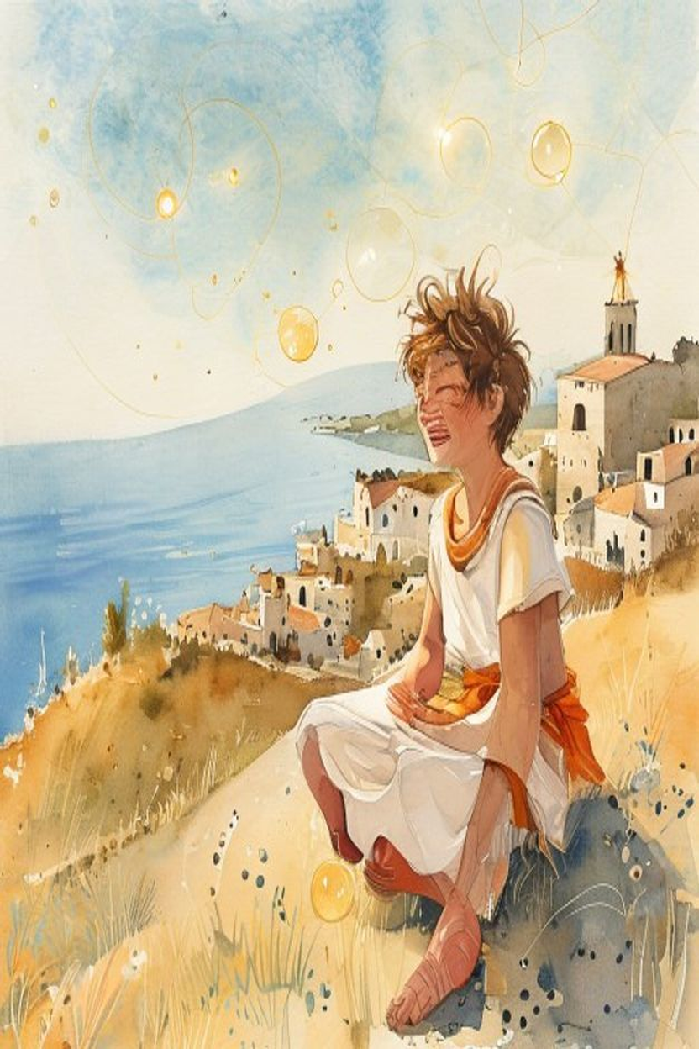
Democritus: The Laughing Philosopher
WisdomForge Booklet — Ages 5–10

———

About This Book
This booklet tells the story of Democritus, a philosopher who lived in ancient Greece almost 2,500 years ago. He was called "the Laughing Philosopher" because he found a way to be cheerful about everything, even when things went wrong. He also had an amazing idea: that everything in the whole universe is made of tiny, invisible building blocks called atoms.
Each chapter has a story, a big idea, and something to try. Read it alone or with a parent or teacher. The questions aren't tests—they're starting points for conversations.
———

Chapter 1: The Boy from the Silly Town
Long ago, in a town called Abdera, far in the north of Greece, a boy named Democritus was born. Abdera was famous, but not for anything good. People in other cities told jokes about Abdera. They said the people there were foolish. If someone did something silly, people would say, "What an Abderite!" It was like being known as the town where everyone was a little bit ridiculous.
But Democritus was different. He grew up surrounded by people who made silly choices, who worried about silly things, who got upset over things that didn't matter. And instead of becoming silly himself, he learned something valuable: he learned to laugh. Not a mean laugh. A gentle, understanding laugh. The kind of laugh you get when you see someone running to catch a hat that's blowing away in the wind. You know the feeling? It's funny, but you also want to help.
Democritus's family had money. His father was wealthy enough to host a king once, when the great Persian king Xerxes passed through Abdera with his army. The king left behind some wise men called Chaldeans, and young Democritus learned about the stars and the sky from them. He was curious about everything.
When Democritus grew up, he made a big decision. He had inherited money from his father, and instead of buying a big house or fancy clothes, he spent it all on traveling. He went to Egypt to learn geometry from the priests. He went to Persia to study the stars. Some people even say he traveled as far as India and met wise men who lived in the forests. He spent every coin he had on learning.
When he came home, he had no money left. His neighbors thought he was foolish, just like everyone from Abdera. They even tried to take him to court for wasting his inheritance! But Democritus read aloud from a book he had written, and the people were so amazed by his wisdom that they not only let him go—they gave him a reward.
He lived to be very, very old. Some people say he lived to be over 100 years old. And he laughed until the very end.
Words to Remember The person who wants little has enough. The person who wants much is always poor. — Democritus
Big Idea Democritus came from a place where people were known for being foolish, and he turned it into wisdom. He learned to laugh at foolishness instead of being bothered by it. He spent all his money on learning, and it made him the richest person in the world—not in gold, but in understanding. You don't have to come from a famous place or a perfect family to become wise. You just have to be curious and willing to laugh.
Try This - The Giggle Test. Think of something that annoyed you recently. Now imagine telling a friend about it in the funniest possible way. Exaggerate it. Make it sound ridiculous. Does it feel different when you tell it as a funny story? That's the Democritus laugh, beginning. - Spend Your Coins. Imagine you have a bag of gold coins. You can spend them on anything. Write down or draw what you would spend them on. Now look at your list. How many are about learning, helping, or experiencing something new? How many are just stuff? Democritus spent his coins on learning. What would you choose? - The Town Story. Ask a grown-up to tell you about the town or city where they grew up. Was it famous for anything? How did people there act? Compare it to where you live now.
Ask a Grown-Up "Have you ever been somewhere that people made fun of, and you found something good about it anyway?"
———

Chapter 2: Everything Is Made of Tiny Blocks
One afternoon, Democritus sat by the sea, watching the waves. The water looked smooth and solid, like one big thing. But he had an idea. What if it wasn't one thing at all? What if it was made of thousands and thousands of tiny pieces, too small to see?
He picked up a handful of sand. It looked like one solid thing in his palm. But when he let it trickle through his fingers, he could see each tiny grain. Each grain was a separate, tiny piece. And yet, together, they made a whole beach.
Democritus thought about this for a long time. He imagined cutting something in half, then cutting it in half again, and again, and again. Could you keep cutting forever? He decided no. At some point, you would reach a piece so small that you couldn't cut it anymore. He called this piece an atom, which means "uncuttable."
He said that everything in the whole universe is made of atoms. Mountains, oceans, trees, the sun, the moon, your own body, your thoughts, your feelings—all atoms. Atoms come in different shapes. Some are round and smooth, like tiny balls. Some are hooked, like burrs that stick to your clothes. Some are sharp, like little needles. When they fit together in different ways, they make different things.
And here's the most amazing part: atoms never disappear. When a puddle dries up, the water atoms haven't vanished. They've just spread out into the air, too small to see. When a tree grows, it's gathering atoms from the soil and the air and weaving them into leaves and branches. Nothing is ever truly created. Nothing is ever truly destroyed. Everything is just rearranged, like a LEGO castle you take apart to build a spaceship. Same blocks, different shape.
There was one more thing. Democritus said there was also empty space—the void. If there were no empty space, the atoms would be packed so tight that nothing could move. Nothing could change. The world would be frozen solid. But because there is space between the atoms, they can move and bump and tangle and arrange. The empty space makes everything possible.
Words to Remember By convention, sweet; by convention, bitter; by convention, color. But in reality: atoms and void. — Democritus
Big Idea Everything you can see, touch, taste, smell, or hear is made of tiny, invisible building blocks called atoms, moving through empty space. Atoms never go away—they just rearrange. This means nothing is ever really lost. It just changes form. You are made of atoms that have been part of stars, oceans, and dinosaurs. You are the universe rearranging itself.
Try This - The LEGO Universe. Build something with blocks. Take a good look at it. Now take it apart and build something completely different. Same blocks, different thing. That's Democritus's universe: same atoms, endless combinations. The blocks didn't disappear. They just rearranged. - The Sand Test. Next time you're near sand (or salt, or sugar), look at it closely. It looks like one thing. But if you look very carefully, or with a magnifying glass, you can see each tiny grain. Now imagine something even smaller. And smaller than that. That's an atom. - Draw the Universe. On a piece of paper, draw dots and circles everywhere—atoms! Leave spaces between them—the void! Now draw something inside all those atoms: a tree, a mountain, a person. Everything is atoms and space. Everything.
Ask a Grown-Up "If everything is made of atoms, and atoms never disappear, where do you think the atoms in your body have been before they were part of you?"
———

Chapter 3: The Colors That Aren't There
Democritus had a friend who was a painter. One day, the painter showed him a beautiful painting of a red rose. "Look at this red," the painter said. "It's the most beautiful red I've ever mixed."
Democritus looked at it carefully. Then he said something that surprised his friend. "The red isn't really in the rose."
The painter was confused. "Of course it is! I can see it right there!"
"Tell me," Democritus said. "If you close your eyes, is the rose still red?"
"Well... yes. The rose is still there."
"But no one is seeing the red. So where is the red? Is it in the rose, or is it in the seeing?"
Democritus had an idea about how we see things. He said that every object is constantly shedding tiny, invisible "skins"—thin films that fly through the air like ghosts. When these skins enter your eyes, you see the object. But here's the twist: the skins don't carry color. The flower's atoms have a certain shape, and when those shaped atoms meet your eye, your eye creates the experience of redness. The red isn't in the flower. The red is what happens when the flower and your eye meet.
Think of it like a piano. A piano doesn't contain music. The keys are just wood and wire. The music happens when you press the keys. Perception is like that. You "play" the world, and the experience—color, sound, taste, smell—happens in the playing.
This means you're not just a receiver of the world. You're a co-creator. The world gives you the shapes. You supply the colors, the sounds, the flavors. The sunset isn't less beautiful because the red isn't "in" it. It's more beautiful, because the sunset is a collaboration between the sun and you.
Words to Remember Sweet and bitter, warm and cold, color—these are by convention. In reality, there are only atoms and void. — Democritus
Big Idea The colors, sounds, and tastes you experience aren't really "in" the objects around you. They happen when your body meets the world. The world provides the shapes; you provide the qualities. This doesn't make a sunset less beautiful—it makes it a collaboration between you and the universe. You are a co-creator of the world you experience.
Try This - The Eye Test. Look at something colorful—a red apple, a blue sky, a green leaf. Now imagine the color isn't in the object at all. It's what happens when light from the object enters your eyes and your brain turns it into color. You are painting the world, right now, with your eyes! - The Piano Game. Press a key on a piano (or tap a table). The sound isn't "in" the key. The sound happens when the key moves the air and the air reaches your ear. You and the piano make the sound together. - The Blindfold Test.Close your eyes. What colors do you see? Nothing? That's because without your eyes meeting the world, there are no colors. The colors are in the meeting. Open your eyes. The colors come back. You and the world, working together.
Ask a Grown-Up "If the colors we see aren't really 'in' things, do you think other animals see the same colors we do? What about a dog or a bee?"
———

Chapter 4: The World That Was Always Going to Happen
Democritus had an idea that sounds strange, even for a philosopher. He said that everything happens by necessity. What does that mean?
Imagine a line of dominoes. You push the first one, and it knocks over the second, which knocks over the third, and on and on. Once you push the first domino, the rest was always going to happen. Each domino had to fall because the one before it pushed it. There was no "maybe." No "let's see." It was necessary.
Democritus said the whole universe works like that. Atoms move and bump into each other, and each bump was always going to happen because of the bump before it. Every cloud in the sky, every wave on the sea, every thought in your head—they were all going to happen, determined by atoms that were moving before you were even born.
But wait. Democritus also said you should choose to be cheerful. You should choose to want less. You should choose to be kind. How can you "choose" anything if everything was always going to happen?
Here's one way to think about it. When you decide to share your snack with a friend, that decision came from you—your personality, your kindness, the things you've learned. It was always going to happen, because you're the kind of person who does that. But it's still YOUR choice. You made it. It came from inside you, even if "inside you" is atoms.
Think of a river. The water follows the path of the riverbed. The path was carved by the land. But the water is still flowing. It's still moving. It's still the river. Your choices are like the water. They follow the path of who you are, but they're still your choices.
Democritus didn't solve this puzzle completely. Nobody has. But he lived with it. He believed the universe was determined, and he still chose to be cheerful, to learn, to laugh. Maybe that's the most Democritean thing of all: seeing that you're part of a vast, determined cosmos and responding with a smile.
Words to Remember Everything happens by necessity. The universe is a dance of atoms, and the dance was always going to be this way. — Democritus (as remembered by Diogenes Laërtius)
Big Idea Everything that happens was going to happen, because of what came before. But your choices are still real, because they come from who you are. You are like a river, following the path carved by your character. The path was always there, but the water is still flowing, still moving, still yours.
Try This - The Domino Chain. Set up a line of dominoes (or blocks). Push the first one. Watch them all fall. Now think: once you pushed the first one, was there ever any doubt the rest would fall? That's "necessity." But YOU pushed the first one. Your choice started it. - The River Drawing. Draw a river winding through hills. The river follows the path the land carved. But the water is still moving, still flowing. Label the river "Your Choices" and the land "Who You Are." Your choices follow who you are, but they're still your choices. - The "Was It Always Going to Happen?" Game. Think of a good choice you made recently. Maybe you helped someone or were honest about something. Now imagine all the things that led to that choice—your kindness, your parents' teaching, your experiences. The choice came from all of those. But it was still you who made it. Does knowing it was "always going to happen" make it feel less good? Or does it make the whole universe feel like a team that helped you be kind?
Ask a Grown-Up "Have you ever looked back at something that happened and thought, 'That was always going to happen, given everything that led up to it'? Did that make you feel better or worse?"
———

Chapter 5: The Cheerful Soul
Democritus had a favorite word: euthymia. It means "cheerfulness," but not the jumping-up-and-down kind. Not the birthday-party kind. Not the got-a-new-toy kind.
Imagine a pond on a windy day. The water is choppy, splashing, restless. Waves crash against the shore. That's what most people's minds are like—always wanting something, always worried about something, always wishing things were different.
Now imagine the same pond on a calm morning. The water is still. You can see the reflection of the sky in it. A leaf falls and makes one small, perfect ring. That's euthymia. The water is still peaceful, content, at rest. Not dead. Not boring. Just... settled.
Democritus said this is the best thing in life. Not pleasure. Not excitement. Not getting everything you want. Just a calm, cheerful soul that isn't disturbed by what happens.
And he said you get there by doing something surprising: wanting less.
Here's how it works. Imagine you want a hundred toys. You have ten. You feel poor. You feel like you're missing ninety toys. Every time you see a toy you don't have, you feel a little pang of wanting.
Now imagine you want five toys. You have ten. You feel rich! You have more than you wanted! You look at your toys and feel happy.
Same toys. Different wanting. The wanting is the key.
Democritus also said: don't only compare yourself to people who have more. If you only look up, you'll always feel like you don't have enough. Look around. Look at the full range of people. Some have more. Some have less. When you see how much you have compared to many others, you feel grateful, not jealous.
And he said: your inner self matters more than your outer self. A strong body with a troubled mind isn't worth much. A weak body with a cheerful soul is still doing well. Fix the soul, and the body's problems become smaller.
Words to Remember Cheerfulness arises through moderation of enjoyment and measuredness in life. — Democritus
Big Idea The best thing in life is euthymia—a calm, cheerful soul. You get there not by getting more, but by wanting less. When your wanting is small, what you have feels like plenty. When your wanting is big, what you have feels like nothing. The secret to wealth isn't getting more. It's wanting less.
Try This - The Calm Pond. Close your eyes and imagine a pond. Is it choppy or calm right now? What's making it choppy? (Wanting something? Worried about something?) Now imagine the wind stopping. The water getting still. That's euthymia. Try to hold that image for ten seconds. - The Wanting List. Write down three things you want that you don't have. Now cross out the ones that are just "I saw someone else have it." How many are left? Those are your real wants. Are they as big as you thought? - The Gratitude Look. Look around the room you're in right now. Count five things you have that you're glad to have. Now think: some people don't have these things. How does that change how you feel about them? - The Soul Check. Put your hand on your chest. Ask yourself: "Is my soul calm right now, or is it choppy?" There's no wrong answer. Just notice. Then take three slow breaths and imagine the water getting still.
Ask a Grown-Up "What's the difference between being happy because things are going well and being cheerful inside even when things aren't? Have you ever felt the second kind?"
———

Chapter 6: The Secret of Enough
There was a man who lived near Democritus who had everything. A big house. Fine clothes. The best food. Servants to do everything for him. And he was miserable. He always wanted more. A bigger house. Finer clothes. Better food. He was like a person at a banquet who can't enjoy the food because he's already thinking about the next course.
Democritus watched this man and shook his head. Not with anger. With a gentle, understanding laugh. He had seen this pattern many times. The more you have, the more you want. And the more you want, the less you enjoy what you have.
Democritus himself lived simply. He ate simple food—bread, olives, a little cheese. He slept on a simple bed. He wore plain clothes. And he was cheerful. Not because he didn't know about luxuries—he had traveled to the great cities of the world. He chose simplicity because it made him free.
Here's his secret, in one sentence: if you desire little, a little will seem like a lot.
Think about it like a math problem. How rich you feel is: what you have ÷ what you want. If you have ten things and want a hundred, you feel at 10%. If you have ten things and want ten, you feel at 100%. Same stuff. Different wanting. Different feeling.
The man with the big house kept wanting more, so no matter how much he got, he felt poor. Democritus wanted little, so no matter how little he had, he felt rich.
This doesn't mean you should never try to improve things. Democritus wasn't lazy. He traveled the world. He wrote books. He learned from everyone he met. But he didn't do those things to get more stuff. He did them because learning and growing are their own rewards. He grew on the inside, not on the outside.
And here's the most important part: Democritus said that when you have enough, you should help others who don't. He wrote: "When those who have the means help those who have not, and assist them and benefit them, herein at last is pity and the end of isolation, and comradeship, and mutual defense, and concord among the citizens." In other words: share. When you have enough and someone else doesn't, helping them makes the whole community stronger. It makes friends. It makes peace. It makes the world better for everyone, including you.
The cheerful soul isn't selfish. It's generous. Because when you know you have enough, you're free to give.
Words to Remember If you do not desire much, a little will seem much to you. For desire that is small makes poverty equally powerful with wealth. — Democritus
Big Idea The secret to feeling rich isn't getting more. It's wanting less. When you want little, everything you have feels like plenty. And when you have enough, the best thing you can do is share. Helping others makes the whole community stronger—and makes your own cheerfulness grow.
Try This - The "Enough" List. Write down everything you have right now that you can genuinely say is enough. Food? Enough. A home? Enough. People who love you? Enough. Toys? Enough. Look at your list. How rich are you already? - The Simple Meal. Next time you eat a simple meal—bread, fruit, a sandwich—really taste it. Democritus said that simple things are the sweetest cures for hunger. Was the bread good? Was the fruit sweet? You don't need a feast to enjoy food. - The Sharing Project. Find one thing you have that you don't need—extra crayons, a book you've already read, a toy you've outgrown. Give it to someone who would enjoy it. Notice how it feels. Does giving make you feel poorer or richer? - The Wanting Experiment. Pick one thing you usually want more of (snacks, screen time, attention). For one whole day, try being happy with exactly what you have. No asking for more. At the end of the day, ask yourself: was it as hard as you thought? Did you feel different?
Ask a Grown-Up "Is there something you used to think you needed, but then you realized you didn't? What changed your mind?"
———

For the Grown-Up Reader
This booklet adapts the philosophy of Democritus of Abdera (c. 460–370 BCE), drawing on the Diels-Kranz fragments (DK B numbers), Diogenes Laërtius (Lives IX.34–49), and the scholarly commentary of C.C.W. Taylor (The Atomists, 1999) and Sylvia Berryman ("Democritus" in the Stanford Encyclopedia of Philosophy).
Democritus wrote nothing that survives intact. What we have are fragments quoted by later authors and testimonia from ancient writers. The biographical details—his travels, his trial, his longevity—are largely legendary but consistent in their broad outline.
If a child asks, "Did Democritus really figure out atoms without a microscope?" the answer is yes. He reasoned to the existence of atoms purely through logic and observation—a hypothesis confirmed in modified form more than 2,000 years later.
———

About WisdomForge
WisdomForge adapts the great philosophers into stories, audio, and conversation for every age. Each philosopher becomes four booklets—one for children, one for teens, one for older adolescents, and one for adults—so the same ideas can grow with you.

