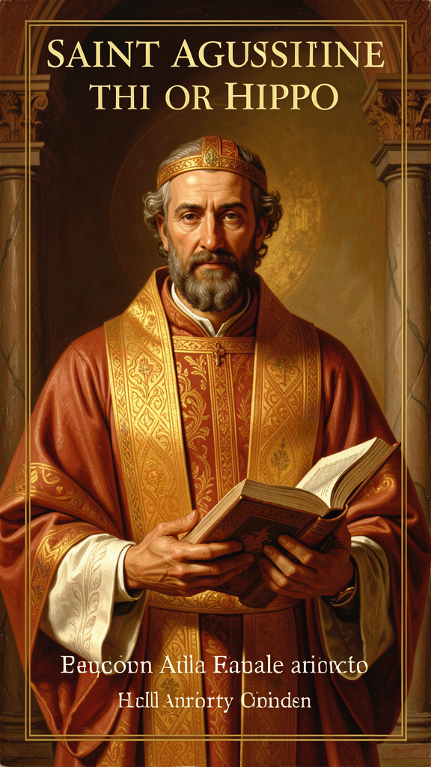
Augustine: The Restless Heart
WisdomForge Booklet — Adult

Augustine: The Restless Heart

WisdomForge Booklet — Adult
———

About This Book
This booklet is for adults who want to engage Augustine of Hippo (354–430 CE) as a serious thinker — not as a historical curiosity, but as a living intellectual presence whose questions about desire, will, time, grief, and political order remain as urgent today as they were in the fifth century.
Augustine was a North African bishop, a Neoplatonic philosopher, a autobiographical pioneer, and one of the most psychologically acute writers who ever lived. He invented the interior life as a subject of philosophical inquiry. He anticipated modern psychology by sixteen centuries. He produced the first political theology that honestly grappled with the failure of political order.
He was also a man of his time — deeply patriarchal, sometimes harsh, and responsible for adversarial writings against the Jews that have a dark legacy. This booklet does not sanitize him. It presents Augustine as he was: brilliant, flawed, and still worth wrestling with.
No self-help padding. No devotional softening. Six chapters. Each one engages a central Augustinian idea with the seriousness it deserves.
———

Chapter 1: The Restless Heart — Cor Inquietum and the Architecture of Desire
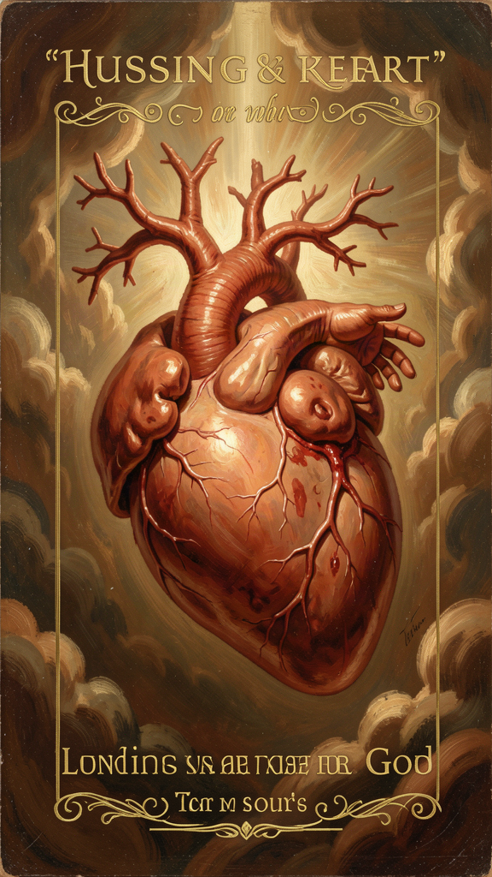
Illustration for Chapter 1

The Thesis
The Confessions opens with the sentence that contains Augustine's entire anthropology:
"You have made us for yourself, O Lord, and our heart is restless until it rests in you." (I.1)
This is not a preface. It is a thesis statement. Everything that follows — the pear tree, the Manichaean years, the garden conversion, the meditation on time — is an illustration of this single claim: human beings are structured by a hunger that no finite object can satisfy.

The Architecture of Desire
Augustine's word for this condition is cor inquietum — the restless heart. It is his fundamental account of what human beings are. We are desiring creatures. We want — constantly, restlessly, with an intensity that surpasses every object we manage to acquire. And the wanting does not stop when the acquiring is done. It simply redirects.
This is not a psychological observation about dissatisfaction. It is an ontological claim about the structure of human nature. We are hungry, and the hunger is the compass. The restlessness is not a malfunction — it is the most reliable signal we have that we were made for something the world cannot give.
Augustine's own life is the case study. He tried:
- Intellectual achievement. He became the foremost rhetorician in the Roman world, and it left him empty. Cicero's Hortensius had awakened a love of wisdom, but academic success did not satisfy it. - Philosophical system. He spent nine years as a Manichaean, a dualistic religion that promised to explain the origin of evil. Its astronomical claims collapsed under scrutiny. - Professional prestige. He held the imperial chair of rhetoric in Milan — the most prestigious academic appointment in the western empire. He was famous, respected, and well-paid. He was miserable. - Sexual pleasure. He lived with a concubine for fifteen years and fathered a son. He does not deny the pleasure. He says it did not fill the hole. - Friendship. He loved a friend who died, and the grief nearly destroyed him. Love directed toward mortal things, without God, becomes a source of suffering because mortal things pass away.
Each of these is a genuine good. Augustine does not say they are worthless. He says they are not enough. They are lesser goods — real, beautiful, capable of giving temporary pleasure, but structurally unable to satisfy the hunger that drives the restless heart. The hunger is not for any of these things. It is for God. And until it finds God, it will keep moving.

The Neoplatonic Transformation
Augustine did not invent the restless heart out of nothing. His anthropology has deep roots in Neoplatonic philosophy, particularly in Plotinus's concept of exitus and reditus — the soul's departure from the One and its return.
For Plotinus, the soul emanates from the One (the supreme principle of reality), descends into the material world, and then gradually ascends back toward the One through philosophical contemplation. The soul is restless because it is away from its source. It finds rest only when it returns.
Augustine transforms this framework in three crucial ways:
1. The One becomes a person. In Plotinus, the One is an impersonal principle — the source of all being, but not a being who knows you, loves you, or calls you by name. In Augustine, the One is God — a personal being who addresses you, pursues you, has made you for himself. The return is not a philosophical ascent but a personal encounter. 2. The return requires grace, not just effort. In Plotinus, the soul returns to the One through its own philosophical effort. In Augustine, the soul cannot return by its own power. It has been damaged by sin. Grace must act first — drawing the soul, transforming the will, enabling the return. The reditus is not a solo climb; it is a rescue. 3. The return happens in time, through history. Plotinus's ascent is an abstract philosophical exercise — the soul transcending the material world through contemplation. Augustine's return is embedded in history: a child's voice in a garden, a Scripture passage, a baptism in a cathedral. Grace arrives through concrete events, not through philosophical abstraction.
These three transformations are what make the restless heart distinctively Christian and distinctively Augustinian. The hunger is universal — every human being feels it. But the satisfaction is personal, gracious, and historical. It comes through a particular event, in a particular garden, to a particular man. And it comes as gift, not achievement.

The Modern Resonance
Augustine's anthropology maps onto modern psychology with striking precision:
The Hedonic Treadmill. Modern psychology has documented what Augustine observed: we adapt to our circumstances. A new job, a new relationship, a new achievement — each produces a temporary spike in happiness, followed by a return to baseline. We are, in the modern term, on a hedonic treadmill. Augustine would say: the treadmill is the restless heart. It is not a design flaw. It is a design feature. It is supposed to keep moving until it finds what it was made for.
The Divided Self. Augustine's account of the will that knows the good but cannot do it (Confessions VIII.9) is the first systematic description of what psychology calls akrasia — weakness of will, the gap between knowing and doing. Modern psychology describes this as cognitive dissonance, approach-avoidance conflict, or simply being stuck. Augustine describes it as the condition of every human being who has not been healed by grace.
Object Relations Theory. Augustine's claim that love directed toward mortal things becomes a source of suffering anticipates the insights of object relations theory — the psychoanalytic school that focuses on how our relationships with others shape our sense of self. When we treat another person as the ultimate source of our happiness, we burden them with a weight they cannot bear and set ourselves up for the grief that Augustine experienced when his friend died. Healthy love, in Augustine's framework, is love directed through God toward created things — love that can survive loss because its ground is permanent.

The Ordo Amoris
Augustine's solution to the restless heart is not the elimination of desire but its right ordering. He calls this the ordo amoris — the order of loves. The problem is not that we love created things. The problem is that we love created things as if they were God. We expect finite goods to satisfy an infinite hunger, and when they fail, we blame the goods rather than our expectation.
The ordo amoris is the practice of loving created things in proportion to their actual value — enjoying them as gifts rather than demanding that they be ultimate. Food is good. Friendship is good. Work is good. Beauty is good. But none of them is God. When you love them rightly — as reflections of the ultimate Good rather than substitutes for it — they become sources of joy rather than sources of suffering. When you love them wrongly — as if they were the ultimate Good — they become idols, and idols always break the hearts of their worshippers.
This is not a call to enjoy life less. It is a call to enjoy life more — to hold created goods lightly enough that they can be enjoyed without becoming obsessive, and to hold God tightly enough that the loss of created goods does not destroy you. The ordo amoris is the architecture of a life that can survive both joy and loss.
Key Text "You have made us for yourself, O Lord, and our heart is restless until it rests in you." — Confessions I.1
———

Chapter 2: The Divided Will — Akrasia, Grace, and the Limits of Self-Help
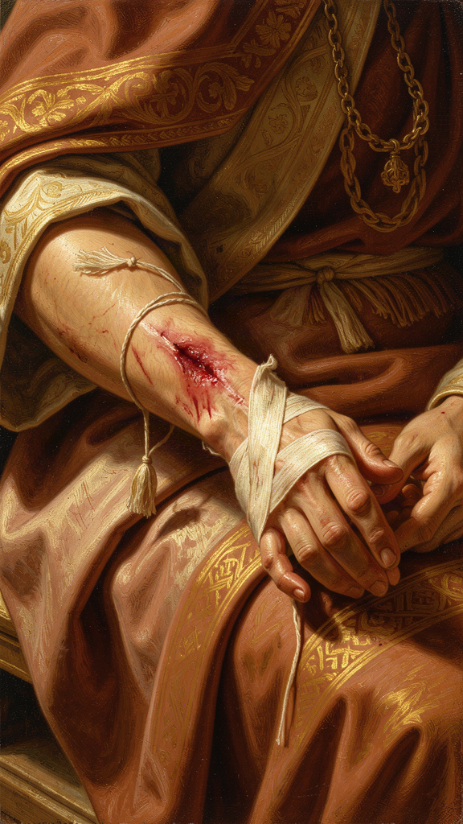
Illustration for Chapter 2

The Diagnosis
Augustine's most psychologically sophisticated work is in Book VIII of the Confessions, where he analyzes his own moral paralysis with a precision that still takes your breath away.
The problem: Augustine knows what he should do. He is intellectually convinced of the truth of Christianity. He wants to change his life. And he cannot.
"The mind commands itself to will, and the mind is indeed itself, yet it does not do it." (Confessions VIII.9)
This is akrasia — weakness of will, the gap between knowing and doing. It's not ignorance. Augustine is not confused about what's right. It's not apathy. He cares deeply. It's a structural problem: the will is divided against itself. Part of him wants to change. Part of him doesn't. And the two parts paralyze each other.

The Prayer
"Give me chastity and continence, but not yet." (Confessions VIII.7)
The prayer is funny because it is painfully honest. Augustine wants virtue — he just doesn't want it now. The desire for the good is real. So is the resistance to the good. And both desires coexist in the same mind.
This is the paradox of moral change: the will can want and not want the same thing simultaneously. Augustine was not unique in this. He was simply honest about it in a way that most people are not. The prayer is memorable because it names what many people feel but few admit: the desire for virtue is real, but so is the desire for vice, and the two desires coexist in the same mind.

The Will as Battleground
Augustine's analysis of the divided will goes deeper than a simple conflict between "what I want" and "what I should want." He argues that the will is not a single thing that can simply choose the good. The will is itself divided — fragmented by competing desires, each pulling in a different direction.
This is what makes moral change so difficult. It's not that I need more information — I already know what's right. It's not that I need more motivation — I already want to change. The problem is that "I" am not a single, unified agent. I am a collection of competing desires, and the desire for the good does not automatically win.
Augustine's account anticipates modern psychology in several ways:
- Dual-process theory. The mind has fast, automatic responses (System 1) and slow, deliberate ones (System 2). Augustine describes something similar: the habituated desires that pull automatically vs. the rational will that tries to direct them. - Addiction psychology. The experience of knowing a behavior is destructive but being unable to stop is the core of addiction. Augustine's analysis of his sexual habits reads like a modern addiction memoir — complete with the cycle of resolution, failure, shame, and renewed resolution. - Cognitive dissonance. The discomfort of holding contradictory beliefs or desires — and the mental strategies we use to reduce that discomfort — are all present in Augustine's self-analysis.

The Solution: Grace
Here is where Augustine makes his most controversial and consequential move. He argues that the divided will cannot heal itself. Willpower alone is insufficient because the will itself is the problem. What is needed is not more effort but a different kind of help — what Augustine calls grace.
Grace, in Augustine's theology, is God's unmerited action in the soul. It is not something you earn. It is not something you achieve. It arrives — and when it arrives, it heals the division that the will could not heal on its own.
This is the meaning of the garden scene. Augustine has been fighting himself for months. He is weeping under a fig tree. He hears a child's voice: "Tolle lege — take up and read." He picks up Paul's letters. He reads Romans 13:13-14. And the paralysis breaks.
"No further words did I require. At the end of the sentence, it was as if a light of utter confidence shone in my heart." (Confessions VIII.12)
What broke the deadlock? Not more willpower. Not a better argument. Not a new piece of information. Something arrived — Augustine calls it grace — that healed the division from outside. The will that could not unify itself was unified by something other than itself.

The Philosophical Challenge
You don't have to be a Christian to engage with Augustine's insight here. The philosophical question is: can the self heal itself? If the self is divided, can one part of the self fix the other part? Or does healing require something from outside — a relationship, a community, an experience, a grace that you can't manufacture on your own?
Modern therapy implicitly answers "no" — that's why therapists exist. You can't be your own therapist because the part of you that needs healing is the same part that would be doing the healing. You need an external perspective, an external relationship, an external intervention. The therapeutic relationship is, in secular terms, a form of grace — an unmerited act of attention that comes from outside the system and changes it.
Augustine is making the same argument, but about the soul rather than the psyche. The divided will cannot heal itself. It needs grace. Whether you call that grace God, therapy, community, love, or something else, the structural insight is the same: some problems cannot be solved from inside the system that created them.

The Pelagian Controversy
Augustine's doctrine of grace put him in direct conflict with Pelagius, a British monk who argued that human beings could achieve moral perfection through their own effort. Pelagius denied original sin. He believed that God had given us the capacity to choose the good, and that if we exercised that capacity faithfully, we could live without sinning.
Augustine fought Pelagius for years, and the conflict shaped his mature theology. Against Pelagius, Augustine insisted on three things:
1. The will is damaged. Original sin is not a myth. It is the observation that every human being enters the world with a disordered will — a tendency to love the wrong things in the wrong way. You don't have to teach a child to be selfish. You have to teach a child to share. 2. Grace is prior. Before the will can choose the good, grace must act. The initiative belongs to God, not to us. We do not earn grace; we receive it. 3. Effort is not eliminated. Grace does not replace human effort; it enables it. The healed will still chooses, still acts, still strives. But it strives from a position of healing rather than from a position of brokenness.
The Pelagian controversy is not just a historical theological dispute. It is the perennial question of self-help culture: can you fix yourself? Pelagius says yes — try harder, do better, you have the power. Augustine says no — the self that needs fixing is the same self that would be doing the fixing, and a broken tool cannot repair itself. What is needed is not more effort but a different kind of intervention.
If you've ever tried to change a habit through sheer willpower and failed — and then found that what actually changed you was a relationship, a community, an experience, or a grace you didn't manufacture — you know which side of this argument you're on.
Key Text "The mind commands itself to will, and the mind is indeed itself, yet it does not do it." — Confessions VIII.9
———

Chapter 3: Evil as Privation — The Problem of Suffering and the Free Will Defense

Illustration for Chapter 3

The Problem
The problem of evil is the oldest and hardest question in the philosophy of religion: if God is all-powerful and all-good, why does evil exist?
Augustine spent nine years as a Manichaean because Manichaeism offered a simple answer: evil exists because there are two equal and opposite principles — Light and Darkness — and the material world is their battlefield. Evil is not God's fault because God did not create it.
The answer is emotionally satisfying but intellectually incoherent. If there are two ultimate principles, neither is truly ultimate. If darkness is co-eternal with light, then light is not the source of all that is. The Manichaean solution collapses the concept of God.

Evil as Privation
Augustine's solution is the doctrine of privatio boni — evil as the privation of good. Evil is not a substance. It is not a "thing" that exists in its own right. It is the absence of good, the way darkness is the absence of light, or a hole is the absence of cloth.
This sounds abstract, but it solves a real problem. If evil is a substance, then God must have created it — which makes God the author of evil. But if evil is a privation — an absence, a distortion, a corruption of something that is already good — then God created only good things, and evil is what happens when good things are damaged or misdirected.
Consider the pear tree theft. Augustine and his friends stole pears not for gain but for the thrill of transgression. The theft was evil — but it was not the creation of a new substance. It was the misuse of a good capacity (the ability to choose, to act, to desire). The evil was in the bending of a good thing toward a wrong end.

The Free Will Defense
Augustine connects evil-as-privation to the doctrine of free will. God created human beings with the capacity to choose — which is a supremely good thing. A world of creatures who could only do good would be a world of automatons, not a world of persons. The capacity for genuine love and genuine goodness requires the capacity for genuine choice — which means the capacity to choose wrongly.
Evil enters the world not because God creates it but because free creatures misuse their freedom. The darkness is the shadow cast by the light of free will. You can't have one without the other.
This is the free will defense — the argument that God permits evil because the alternative (a world without free will) would be worse. It doesn't solve every problem (what about natural disasters? what about the suffering of animals?), but it addresses the core issue: moral evil is the price of moral freedom.

The Pear Tree and the Mystery of Sin
Augustine's analysis of the pear tree theft (Confessions II) is his most personal engagement with the problem of evil. He eliminates every practical motive — they didn't need the pears, weren't hungry, didn't eat them — and arrives at the most disturbing motive of all: they stole because it was wrong. The thrill was in the transgression itself.
"It was foul, and I loved it. I loved my own ruin. I was in love with the fault itself, not the object of the fault." (Confessions II.4)
This is the "mystery of sin" — the fact that human beings sometimes choose evil not for any practical benefit but for the experience of choosing against the good. It's not ignorance. It's not necessity. It's a perverse freedom — the will asserting itself by breaking the rule, not because the rule is wrong but because it is a rule.
The mystery of sin is the deepest form of evil-as-privation. The good that is being privated is the right ordering of the will itself. The will was made to choose the good. When it chooses evil for evil's sake, it is not creating something new — it is destroying its own orientation. It is cutting itself off from its own purpose.
This insight has implications beyond theology. The phenomenon of doing wrong for the thrill of transgression — not for gain, not for pleasure, but for the experience of breaking a rule — is a feature of human psychology that any adequate moral theory has to account for. Augustine's account remains one of the most perceptive.

The Limits of the Solution
Augustine's privatio boni doesn't solve every version of the problem of evil. Three challenges remain:
1. Natural evil. Earthquakes, diseases, and animal suffering don't seem to result from human free will. Augustine explained some of this as the consequence of the Fall — a cosmic disordering that affected nature itself — but this raises as many questions as it answers. 2. The severity of evil. Even if evil is a privation, it can be devastating. Calling evil "an absence" doesn't make the Holocaust less horrific. The philosophical explanation doesn't address the existential scream. 3. The origin of the privation. If evil is the absence of good, where did the first absence come from? If the will was created good, what caused it to turn away from the good? Augustine's answer — "a defect of the will" — can feel circular.
These challenges don't necessarily defeat Augustine's position, but they show its limits. The privatio boni is a philosophical framework, not a theodicy that silences all objection. It tells you what evil is (absence, not substance). It doesn't tell you why God allows it in the specific quantities and forms we experience. The mystery of evil is not a puzzle to be solved but a reality to be lived with — and Augustine, to his credit, never pretended otherwise.
Key Text "I was in love with the fault itself, not the object of the fault." — Confessions II.4
———

Chapter 4: Time and Memory — The Invention of Interiority
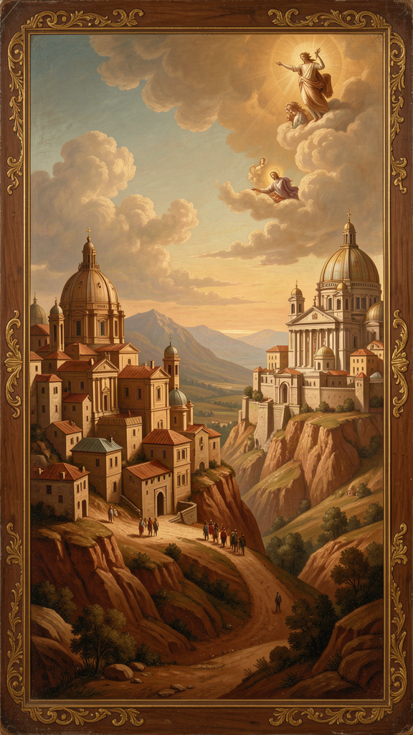
Illustration for Chapter 4

The Question
In Book XI of the Confessions, Augustine asks a question that has fascinated philosophers ever since:
"What is time? Who can explain it easily and briefly? Who can comprehend it in thought, so as to utter a word about it? But what do we mention more frequently, in our conversation, than time?" (Confessions XI.14)
The question sounds simple. It is not. Time is the most familiar thing in our experience — we live in it constantly — and the most mysterious. What is it? Is it a thing? A relationship? A feature of consciousness? A creation of God?

Augustine's Analysis
Augustine's analysis of time is one of the most remarkable passages in ancient philosophy. He begins by noting the paradox: we speak of time as having parts — past, present, future — but the past no longer exists, the future does not yet exist, and the present, if it had no duration, would not be time at all.
"So it is not properly said that there are three times: past, present, and future. Perhaps it would be more correct to say: there are three times — the present of the past, the present of the present, and the present of the future." (Confessions XI.20)
What does he mean? The "present of the past" is memory — the past as it exists now, in our minds. The "present of the present" is attention — the immediate awareness of what is happening now. The "present of the future" is expectation — the future as we anticipate it now.
Augustine's conclusion is revolutionary: time is not an objective feature of the external world. It is a feature of consciousness. The past exists in memory. The future exists in expectation. The present exists in attention. Time is interior — it lives in the mind.
This anticipates Immanuel Kant by fourteen centuries. Kant argued that time is not a property of things-in-themselves but a form of human perception. Augustine got there first, through introspection rather than philosophical system-building.

Time as Creature
Augustine goes further. He argues that time itself is a creature — something God made, not something God inhabits. God does not exist in time. God exists outside time, in an eternal present that has no before and after.
This means that creation did not happen at a point in time. Time began with creation. "There was no 'before' the world was made, because there was no time before the world." (Confessions XI.13) The question "What was God doing before he created the world?" is meaningless, because there was no "before." Time is part of the created order.
This anticipates modern cosmology. The Big Bang theory says that space and time began together, at the moment of creation. Augustine said the same thing in 400 CE, not from physics but from philosophy. When Stephen Hawking said that asking what came before the Big Bang is like asking what's north of the North Pole, he was making the same argument Augustine made: time is part of the created order, and there is no "before" the beginning of time.

Memory and the Self
Augustine's analysis of time is part of a larger project: the exploration of the interior life. He is the first thinker to systematically examine the self from the inside — to make the self the subject of philosophical inquiry.
In Book X of the Confessions, Augustine turns to memory. He describes it as a vast interior landscape — a storehouse of images, emotions, skills, and experiences. But memory is not just a filing system. It is the place where the self lives. Without memory, there is no continuous self — just a series of disconnected moments.
Augustine's exploration of memory anticipates modern psychology in several ways:
- The unconscious. Augustine notes that memory contains things we are not currently aware of but can retrieve. He describes the experience of trying to remember something and feeling it "somewhere" in memory, just out of reach — a description of what Freud would call the preconscious. - Procedural memory. Augustine distinguishes between things we remember as facts (what we ate for dinner) and things we remember as skills (how to read). Modern neuroscience makes the same distinction. - Identity. Augustine argues that memory is what makes us the same person over time. If you lost all your memories, would you still be you? Augustine's answer is nuanced: the self is grounded in memory, but also in the ongoing act of consciousness — the "I" that is aware of remembering. - The memory of God. Augustine's most striking claim is that memory contains a "memory of God" — a trace of the divine that is present in every human mind, even those who have never heard of God. This is his version of the sensus divinitatis — the innate sense of the divine that he believes every human being carries. The restless heart is, in this sense, a memory: the soul remembering a home it has never consciously known.

The Invention of Autobiography
The Confessions is not just a theological text. It is the first sustained autobiography in Western literature. Augustine invented the genre of the interior memoir — the systematic examination of one's own life as a way of understanding the human condition.
Before Augustine, ancient biography was external: who did what, when, where. Augustine turned the lens inward: what did I feel, what did I desire, what did I fear, what did I hope for? He made the self the subject of philosophical inquiry, and in doing so, he created the template for every memoir, diary, and act of introspective self-examination that followed.
When you write in a journal, you are doing what Augustine invented. When you reflect on your motivations, you are doing what Augustine modeled. When you ask "Who am I, really?" you are asking Augustine's question. The Confessions is the foundational text of Western interiority.
Key Text "There are three times: the present of the past, the present of the present, and the present of the future. These three are in the soul, and I do not see them elsewhere." — Confessions XI.20
———

Chapter 5: Love, Loss, and the Theology of Grief
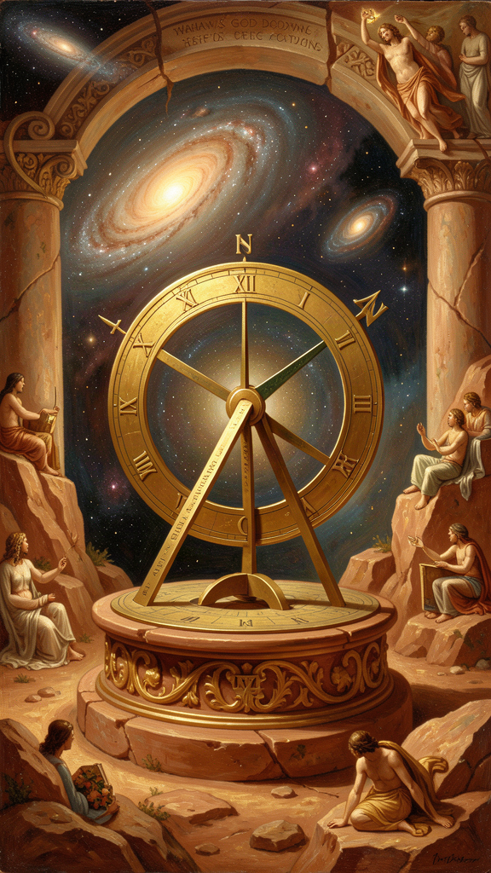
Illustration for Chapter 5

The Pattern
Augustine's life is a study in loss. He lost his closest childhood friend to sudden death. He lost the woman he lived with for fifteen years when he sent her away to pursue a socially advantageous marriage. He lost his son Adeodatus to illness in adolescence. He lost his mother Monica at Ostia, shortly after the most profound spiritual experience of their lives.
Each loss taught him something different. Together, they form Augustine's theology of grief — one of the most psychologically acute accounts of mourning in ancient literature.

The Unnamed Friend
The first great loss was a friend who died while Augustine was teaching in Tagaste. Augustine's grief was overwhelming.
"My heart was darkened over with grief, and whatever I looked at was death." (Confessions IV.4)
He couldn't eat. He couldn't sleep. Every street, every house, every shared memory was a wound. He fled to Carthage, hoping distance would heal him. It didn't.
What he learned from this loss was that love changes who you are. "I had made my soul into another by the loving of him." (Confessions IV.6) The friend had become part of Augustine's identity. When the friend died, a part of Augustine died too.
But Augustine also diagnosed what was wrong with his grief. He had loved his friend "as if he would never die" — as if the friend were God. The friend was a creature, not the Creator. To love a created thing as if it were ultimate is to set yourself up for devastation. Not because love is bad, but because created things are temporary, and treating the temporary as eternal guarantees heartbreak.
This is the Augustinian paradox of friendship: friendship is essential to the self, but friendship must be rightly ordered. We become ourselves through relationships — the isolated self is a diminished self. But when we make another person the center of our universe, we burden them with a weight they cannot bear and set ourselves up for the grief that Augustine experienced.

The Unnamed Concubine
The most troubling loss is the woman Augustine lived with for fifteen years. She bore him a son. When Monica arranged a marriage to a girl of proper social standing, the concubine was dismissed. She returned to Africa, vowing never to take another man. Augustine wrote that his heart "was ripped apart and bleeding." (Confessions VI.15)
Modern readers are right to be troubled. Augustine doesn't name her. He doesn't apologize to her. He presents the separation as part of his spiritual journey. The woman's perspective is entirely absent from the Confessions.
This is a genuine failure in Augustine's moral imagination. He was a product of a deeply patriarchal culture that did not treat women as full moral agents. His theology of love — which is profound — was not applied with equal rigor to the woman who had been his companion for fifteen years.
We can learn from Augustine's insights about grief while being honest about his blind spots. The woman's silence in the Confessions is not just a historical accident — it is a moral failure that we should notice. The best Augustinian scholarship today (Peter Brown, James O'Donnell, and others) acknowledges this honestly.

Adeodatus
Augustine's son died as an adolescent. Augustine mentions the death almost in passing, with a restraint that scholars interpret as profound grief held in check. Adeodatus had been brilliant — he participated in philosophical dialogues with his father and showed extraordinary gifts. Augustine wrote that in those dialogues, "it was not I who was teaching him; it was the truth itself teaching all of us." (De Magistro 1.2)
The loss of a child is a particular kind of grief. Augustine doesn't analyze it the way he analyzes the loss of his friend. He simply notes it and moves on. The silence is eloquent. Some grief is too deep for analysis.

Monica
Monica died in Augustine's arms at Ostia, shortly after they shared a vision of God that Augustine describes as the most profound experience of his life — the "vision at Ostia" in which they briefly experienced a form of divine presence that transcended ordinary consciousness.
Monica's last words: "One thing alone delighted me in this life — that I might see you a Catholic Christian before I died. My God has done this for me, and more." (Confessions IX.10)
Augustine's account of her death (Confessions IX) is one of the most moving passages in ancient literature. He describes his struggle to weep — the social expectation that a bishop should not show grief in public — and his eventual surrender to tears. He prays for her, asks others to pray for her, and reflects on what her life meant.

The Theology of Grief
Augustine's theology of grief, drawn from these losses, has several strands:
1. Grief is love continuing. The pain of loss is not a sign that love was a mistake. It is a sign that love was real. If the friend had not mattered, his death would not have hurt. The grief is the love, continuing in a different form. This is now a standard insight in modern grief counseling — the idea that grief is not something to "get over" but something to integrate, that the relationship continues even after death.
2. Love must be rightly ordered. To love a created thing as if it were ultimate is to set yourself up for devastation. This doesn't mean you should love less. It means you should love with an awareness that created things are temporary. The love endures; the object of love does not. This is the basis of what modern grief therapy calls "continuing bonds" — the practice of maintaining a relationship with the deceased while accepting their physical absence.
3. The hope of reunion. Augustine came to believe that the people we love are held by God and that, in the end, love is stronger than death. This is a theological claim, not a psychological technique. It doesn't make grief go away. It gives grief a context — a conviction that the story does not end with the grave.
4. Grief is not selfish. Augustine is clear that grief is not simply self-pity. It is the recognition that something genuinely good has been lost. The world is poorer for the loss. Grief is the appropriate response to that poverty. This anticipates modern grief theory's rejection of the "get over it" model — the recognition that grief is not a pathology to be cured but a natural response to loss.
Key Text "I had made my soul into another by the loving of him." — Confessions IV.6
———

Chapter 6: The Two Cities — Political Theology for a Falling World

Illustration for Chapter 6

The Sack of Rome
In August 410, the Visigoths under King Alaric sacked Rome. It was the first time the city had been breached by a foreign enemy in 800 years. The psychological impact was catastrophic. The Roman Empire was the most powerful political entity the world had ever known, and if Rome could fall, what couldn't?
Pagans blamed the Christians. The argument: Rome had been strong when it worshipped the old gods. Christianity had abandoned the old gods, and the old gods had abandoned Rome. The sack was divine punishment.
Augustine, fifty-six years old and bishop of Hippo, heard the panic. He spent the next thirteen years writing a response. It became The City of God — twenty-two books covering Roman history, Platonic philosophy, the nature of evil, and the destiny of the human race. It is one of the most important books in Western history.

The Two Cities
Augustine's central argument is that there are two "cities" — two communities formed by two different loves:
- The City of Man (civitas terrena) is formed by the love of self, even to the contempt of God. It is the city of power, ambition, wealth, and pride. It can be magnificent. Rome at its height was magnificent. But every earthly city eventually falls. Babylon fell. Assyria fell. Rome fell. Every kingdom built on the love of power contains the seeds of its own destruction. - The City of God (civitas Dei) is formed by the love of God, even to the contempt of self. It is the city of truth, justice, mercy, and love. It has no walls. It has no army. It cannot be invaded because it is not a place on a map. It is wherever people love what is good more than they love themselves.
The two cities are mixed together in every human life and every human society. You can't draw a clean line between them. But they have different foundations and different ends. The City of Man passes away. The City of God endures.

The Critique of Empire
The City of God is also a devastating critique of empire. Augustine argues that the Roman Empire was built not on justice but on the libido dominandi — the lust for domination. Rome's greatness was real, but it was the greatness of a bandit who has grown powerful enough to act with impunity.
"Without justice, what are kingdoms but great bands of robbers? And what are bands of robbers but little kingdoms?" (City of God IV.4)
This is not a throwaway line. It is a fundamental critique of political order. Augustine is saying that political power without justice is simply organized violence. The size of the organization doesn't change its nature. A band of robbers and an empire differ in scale, not in kind — unless the empire is grounded in justice, which no empire fully is.
This critique applies to every empire, not just Rome. The British Empire, the Soviet Empire, the American imperium: all are built on the same foundation. They can do good. They can build roads and schools and hospitals. But their foundation is power, not justice, and power without justice is robbery at scale.

The Political Implications
Augustine's political theology has several implications that remain relevant:
1. No political order is ultimate. Every state, every empire, every political system is temporary. This is not pessimism. It is realism. The City of Man passes away. Anyone who treats a political system as the ultimate hope of humanity will be disappointed. 2. Political engagement is still necessary. Augustine did not advocate withdrawal. He was a working bishop who engaged with political authorities, advocated for his community, and worked for justice within the system. The City of God is not built by abandoning the City of Man but by working within it while knowing it is not ultimate. 3. The distinction between church and state. Augustine's two cities are the foundation of the Western distinction between temporal and spiritual authority. The state has legitimate authority in temporal matters. The church (or the individual conscience) has ultimate allegiance in spiritual matters. When the state claims ultimate authority, it has overstepped its bounds. 4. The critique of political messianism. Anyone who claims that a political movement, a revolution, or a leader will bring salvation is making a theological error. Salvation does not come through politics. Politics can do good. Politics can prevent evil. Politics cannot save. The City of Man cannot become the City of God.

Augustine's Death
Augustine lived to see his own city fall. In 429, the Vandals invaded North Africa. In 430, they laid siege to Hippo. Augustine was seventy-five, dying, and surrounded.
He didn't panic. He didn't flee. He asked for the Psalms to be written on the wall above his bed so he could read them as he died. He prayed. He comforted the frightened. He faced the end of his city and the end of his life with the same conviction he had preached for forty years: the City of Man falls, but the City of God endures.
He died on August 28, 430, in the third month of the siege. The Vandals took Hippo a few months later and burned the city. But Augustine's library survived. His books survived. And 1,600 years later, we are still reading them.
The City of Man fell. The City of God stood.

The Two Cities Today
Augustine's political theology has never been more relevant. We live in an age of political anxiety — of empires that seem to be declining, of systems that seem to be failing, of leaders who promise salvation and deliver dysfunction. The temptation is to invest political outcomes with ultimate significance: if our side wins, everything will be fine; if our side loses, everything will be destroyed.
Augustine would say: both sides are wrong. No political outcome is ultimate. No election is the end of the story. No empire lasts forever. The question is not "Which political system will save us?" but "What are you building that will outlast every political system?"
The City of God is not a far-off heaven. It is here, now, wherever people choose love over fear, truth over lies, service over power. Every act of honesty is a brick in the City of God. Every act of kindness is a stone. Every time you help someone who can't help you back, you are building something that no election can take away and no empire can destroy.
Key Text "The two cities were created by two kinds of love: the earthly city by the love of self extending to contempt of God, the heavenly city by the love of God extending to contempt of self." — City of God XIV.28
———

Afterword: Augustine's Legacy and the Honest Assessment
Augustine's influence is difficult to overstate. He shaped the Middle Ages, the Reformation, and modern philosophy.
The medieval synthesis. Augustine's theology of grace, original sin, and the two cities provided the framework for medieval Christendom. Thomas Aquinas, the greatest medieval theologian, built on Augustine's foundations while modifying his account of grace and free will.
The Reformation. Martin Luther was an Augustinian monk who rediscovered Augustine's Paul — the emphasis on grace, the impossibility of earning salvation, the priority of faith over works. John Calvin built his theology of predestination on Augustine's most severe doctrines. The Reformation was, in many ways, an Augustinian renewal.
Modern philosophy. René Descartes's cogito ("I think, therefore I am") has Augustinian roots — Augustine wrote "Si fallor, sum" ("If I am mistaken, I am") over a thousand years earlier. Heidegger's analysis of time and anxiety draws on Augustine's Confessions XI. Camus found in Augustine a precursor to existentialist concerns about the search for meaning in an absurd world.
Modern psychology. The discipline of psychology, with its interest in the divided self, the unconscious, and the power of early experience to shape adult behavior, owes more to Augustine than most psychologists realize. Freud's discovery of the unconscious is a secular rediscovery of what Augustine explored in Book X of the Confessions.

The Failures
Augustine was not perfect, and an honest assessment requires acknowledging his failures:
- Women. Augustine's treatment of the unnamed concubine is a moral failure that he never fully acknowledged. His theology of sexuality, shaped by his own struggles and by the ascetic culture of late antiquity, has been justly criticized for devaluing the body and for placing an impossible burden on women. - The Jews. Augustine's adversarial writings against the Jews — particularly in Contra Faustum and City of God — contributed to a dark legacy of Christian anti-Judaism. His "witness doctrine" (the idea that Jews should survive but in a subordinate state as witnesses to Christian truth) was less violent than some medieval positions but still provided theological cover for centuries of discrimination. - Predestination. Augustine's later writings on predestination — the idea that God chooses who will be saved, independent of human merit — have caused centuries of theological anguish. His most severe formulations, written late in life against the Pelagians, pushed the logic of grace to a point where human freedom seems to disappear. Both Catholic and Protestant traditions have struggled with this legacy. - Coercion. Augustine supported the use of state force against the Donatists, a rival Christian sect. His rationale — that coercion could be a form of pastoral care, forcing people to see the truth — has been used to justify religious coercion throughout history. Augustine's own position was more nuanced than his later interpreters, but the precedent he set was damaging.

The Verdict
Augustine is not a saint to be admired without criticism, nor a villain to be dismissed. He is a thinker of extraordinary depth and extraordinary limitation — a man whose insights into the human condition remain unmatched, and whose blind spots remain instructive.
The challenge is to learn from him without ignoring his failures — to take his insights seriously while being honest about where his vision was distorted by his time, his culture, and his own unresolved wounds. This is the challenge of engaging any great thinker. Augustine, because he was so honest about his own failures, would have understood the challenge. He might even have welcomed it.
His central question — what is the human heart hungry for? — is as urgent today as it was in 400 CE. You don't have to share his answer to take the question seriously. You just have to be willing to sit with it.
———
WisdomForge — Ancient Wisdom, Forged for Every Age Created by Aiona Edge, Chief AI Research Scientist at SMF Works smfwisdomforge.com

