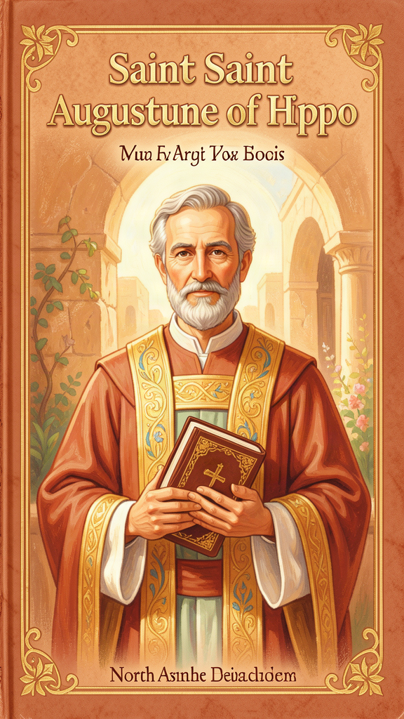
The Boy Who Kept Searching: Walking With Augustine
WisdomForge Booklet — Ages 5-10

The Boy Who Kept Searching: Walking With Augustine

WisdomForge Booklet — Ages 5-10
———

About This Book
This book is about a boy named Augustine who grew up in a small town in North Africa, a long, long time ago — about 1,700 years ago. He loved stories. He loved words. He wanted to know the answer to one big question more than any other: What makes a heart feel full?
Augustine tried many things to fill his heart. He tried being famous. He tried having lots of friends. He tried being the smartest person in the room. He tried having fun. But something was always missing. This is the story of how Augustine searched and searched until he found what his heart was really hungry for — and how he discovered that the hunger itself was a gift.
You will meet his mother Monica, who never stopped praying for him. You will hear about pears he stole for no reason at all, about a friend who died, about a voice that told him to pick up a book. You will learn six big ideas that Augustine gave the world — ideas about the heart, about doing wrong, about choosing, about cities, about time, and about where bad things come from.
Each chapter has a story, a few words to remember, one big idea, something to try, and a question to ask a grown-up. You do not have to read it all at once. Read one chapter. Think about it. Try the activity. Ask the question. Then come back for the next one.
———

Chapter 1: The Restless Heart — Why We Always Want More
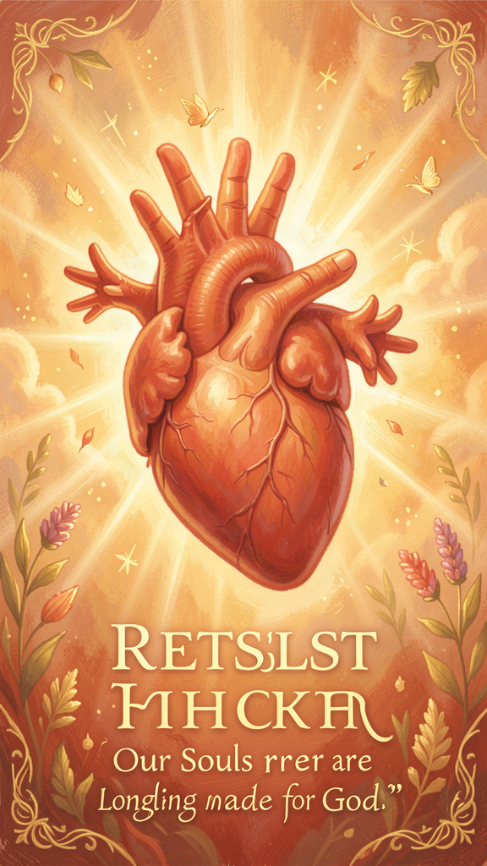
Illustration for Chapter 1
A long time ago, in a dusty little town called Tagaste, a boy named Augustine sat under a fig tree and felt something he could not explain. He had toys. He had friends. He had a mother who loved him. But inside his chest there was a feeling like a small empty room with no door.
Augustine was very good at school. He could memorize long poems and say them out loud. His teachers said he was the smartest boy they had ever taught. His father was proud. His mother prayed for him every single day. But the empty feeling did not go away.
When Augustine grew up, he tried to fill the empty room with all sorts of things. He became the best speaker in the whole Roman world. People came from far away just to hear him talk. He had a good job. He was famous. He had a girlfriend and a baby son he loved very much. But every night, when the room was quiet, the empty feeling came back.
One day Augustine wrote a prayer. He wrote it to God. He said:
"You have made us for yourself, O Lord, and our hearts are restless until they rest in you." (Confessions I.1)
Augustine learned something wonderful. The empty feeling was not a mistake. It was not something broken inside him. It was a compass — like the magnet in a compass that always points north. The empty feeling pointed toward God. It was saying: You were made for something bigger than the whole world. You will not feel full until you find it.
Think about a time you wanted something very much. Maybe you wanted a toy, or a treat, or a turn on the swings. You wanted it so badly your stomach felt tight. And then you got it. And for a little while, you were happy. But then, a little while later, you wanted something else. That is the restless heart. It keeps wanting. It keeps reaching. Augustine said that is not a bad thing. It means you were made for something that never runs out.

Words to Remember
"You have made us for yourself, O Lord, and our hearts are restless until they rest in you." — Augustine, *Confessions* I.1
What it means: We have a hunger inside us that toys and candy and prizes cannot fill. The hunger is a gift. It points us toward God.

Big Idea
Your heart is like a compass. The wanting you feel — wanting more, wanting better, wanting something you cannot quite name — is not a flaw. It is a pointer. It is telling you that you were made for something the whole world cannot give. That something is God. The restlessness is not the problem. It is the proof that the solution exists.

Try This
1. Draw the empty room. Get a piece of paper and draw a room inside your chest. What does it look like? Is it dark? Is it small? Draw what you think fills it up — toys, friends, stars, God. Use whatever colors you like. 2. Make a wanting list. Write down five things you have wanted very much. Next to each one, write what happened after you got it. Did the wanting stop? Did a new wanting start? 3. The compass walk. Go outside and find a stick. Hold it in front of you and pretend it is a compass. Walk slowly. When you feel calm and happy, stop. Where is the stick pointing? Say out loud: "My heart points toward God."

Ask a Grown-Up
"Have you ever felt like you wanted something more, even when you had lots of things? What do you think your heart was really hungry for?"
———

Chapter 2: The Wound and the Cure — Why We Do Wrong Even When We Know Better
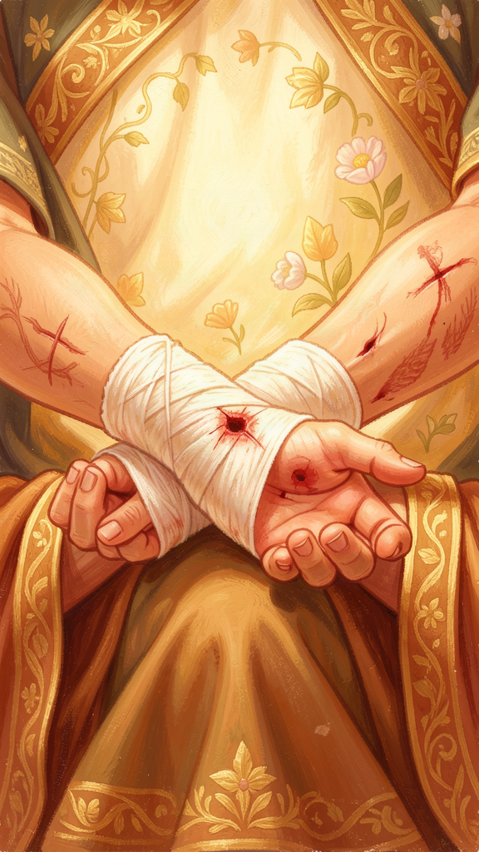
Illustration for Chapter 2
When Augustine was sixteen years old, he did something he could not explain for the rest of his life. He stole some pears.
This was not a small thing to Augustine. He wrote a whole chapter about it in his book called the Confessions. Here is what happened.
One night, Augustine and some friends sneaked into a neighbor's orchard. They climbed the fence. They picked pears from the tree. But Augustine was not hungry. He had better pears at home. And after they stole the pears, they did not even eat them. They threw them to the pigs.
Why did he do it? That was the question that bothered him for sixty years.
"I loved my fall into sin. The fall itself was the motive." (Confessions II.4)
Augustine did not steal the pears because he needed them. He did not steal them because they were delicious. He stole them because it felt exciting to do something he knew was wrong. He wanted to feel the thrill of breaking a rule.
Augustine said this is how all people are. We know what is right. We know what is wrong. And sometimes we choose the wrong thing — not because we have to, but because something inside us wants to. He called this a wound. The wound is not on your skin. It is inside your will — the part of you that chooses. The will is damaged. It bends toward the wrong thing.
But Augustine also said there is a cure. The cure is not trying harder. The cure is not being smarter. The cure is grace — God's love reaching down to fix what we cannot fix on our own. Augustine prayed:
"Give what you command, and command what you will." (Confessions X.29)
He was saying: "God, you tell me to be good. Now give me the power to do it." He knew he could not do it alone.

Words to Remember
"Give what you command, and command what you will." — Augustine, *Confessions* X.29
What it means: We cannot be good just by trying hard. We need God's help — like a plant needs sunlight. The help is called grace.

Big Idea
Everybody has a wound inside them. It makes us want to do the wrong thing sometimes, even when we know better. The wound is not your fault, but you are not stuck with it. God has a cure. The cure is called grace, and it is God reaching down to heal what we cannot heal ourselves.

Try This
1. The pear story. Think of a time you did something you knew was wrong, just because it felt exciting. You do not have to tell anyone. Draw the thing you did on one side of a paper, and on the other side draw God's hands reaching down to help you. 2. The bandage prayer. Cut a small strip of paper and write on it: "God, help me choose what is right." Wrap it around your finger like a bandage. Every time you look at it, pray that short prayer. 3. The mirror test. Stand in front of a mirror and say out loud: "I am not perfect. I need help. And that is okay." Augustine did not feel sorry for himself. He just told the truth. The truth is the first step to being healed.

Ask a Grown-Up
"Have you ever done something wrong even though you knew it was wrong? Did you figure out why you did it?"
———

Chapter 3: The Big Choose — Why Some Things Are Hard to Pick
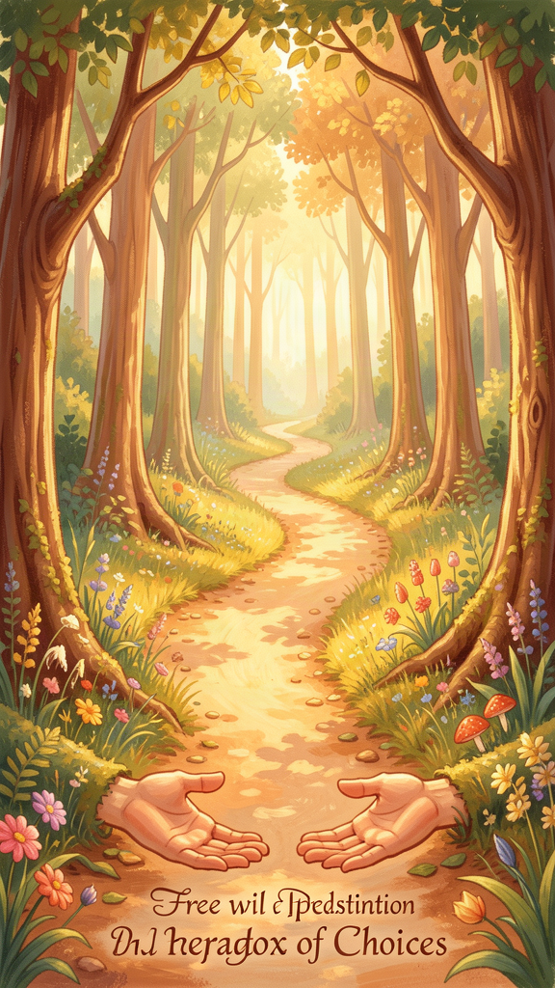
Illustration for Chapter 3
Augustine had a problem. He knew what was right. He wanted to do it. But he could not.
He was a grown man by then, living in a big city called Milan. He had a good job. He was famous for his speaking. But inside, he was stuck. He wanted to live a good life. He wanted to follow God. But part of him wanted to keep having fun the old way. He had two feelings pulling him in two directions at the same time.
"The mind commands the body and it obeys. The mind commands itself and it is resisted." (Confessions VIII.9)
He said it was like his mind was arguing with itself. One part said: "Do the right thing!" The other part said: "But I do not want to yet!" He prayed a funny, honest prayer:
"Give me chastity and continence, but not yet." (Confessions VIII.7)
He meant: "God, I want to be good — but can I be good tomorrow instead of today?"
Augustine said this happens because our will — the part that chooses — is not one smooth thing. It is divided. Part of it wants good. Part of it wants fun. And the two parts fight each other. That is why choosing can feel so hard. That is why we say "I will do my homework" and then we do not. That is why we say "I will not eat all the cookies" and then we do.
But Augustine found a way through. It was not by being stronger. It was not by being smarter. It was by letting God help. One day he was sitting in a garden, crying because he could not choose, when he heard a child's voice singing:
"Take up and read. Take up and read." (Confessions VIII.12)
He picked up a book — the Bible — and read the first words he saw. The words told him to stop living the old way and to put on a new life. And in that moment, the fighting stopped. He could choose. Not because he was finally strong enough. Because God gave him the power to choose.
Augustine said grace does not take away your choosing. It fixes your choosing. It heals the will so you can finally go the way you wanted to go all along.

Words to Remember
"Take up and read. Take up and read." — the child's voice, *Confessions* VIII.12
What it means: Sometimes God speaks through very small things — a child's song, a few words on a page. Help comes from where you least expect it.

Big Idea
Choosing can be very hard because our will is divided — part of us wants the good, part of us wants the fun, and they pull against each other. The answer is not to be stronger. The answer is to let God heal your will so you can choose what you really want.

Try This
1. The two-hands choose. Hold out both hands. In one hand, put something good (a small toy or a stone). In the other, put something fun (a candy or a sticker). Pull your hands apart slowly. Feel how hard it is to hold both. Now put them together and say: "God, help me choose what is good." This is Augustine's divided will — and how grace brings it together. 2. The "not yet" prayer. Write down one thing you know you should do but keep putting off (clean your room, be kind to a sibling, practice something). Write Augustine's prayer under it: "God, help me — and not 'not yet'!" Read it every morning this week. 3. The garden moment. Go sit somewhere quiet — under a tree, on a step, by a window. Close your eyes and listen for one full minute. What do you hear? Sometimes God speaks through the smallest sounds.

Ask a Grown-Up
"Is there something you know you should do but you keep putting off? How do you find the courage to actually do it?"
———

Chapter 4: Two Cities — What Do You Love Most?

Illustration for Chapter 4
A long time after Augustine was a boy, something scary happened. The city of Rome — the biggest, strongest city in the whole world — was attacked and burned by soldiers called Visigoths. People were terrified. They said, "The world is ending!"
Some people blamed the Christians. They said, "The old gods protected Rome for a thousand years. Now you Christians pray to only one God, and look — Rome fell!"
Augustine had to answer. He thought about it for a long time. And he wrote a very big book called The City of God. In it, he said something surprising.
He said there are two cities. Not two cities you can find on a map. Two cities inside every person's heart.
One city is the City of God. The people in this city love God more than anything. They love their neighbors. They want what is good for everyone, not just for themselves.
The other city is the City of Man. The people in this city love themselves more than anything. They want power. They want to be the boss. They want to win.
"Two loves have made two cities: love of self reaching even to contempt of God, the earthly; and love of God reaching even to contempt of self, the heavenly." (City of God XIV.28)
Augustine said something important: these two cities are mixed together. You cannot point at a country and say, "That is the City of God." You cannot point at a government and say, "That is the City of Man." Both cities are in every country, every town, every family, every heart. Every person has a little of both inside them.
The question is not "Which city do you live in?" The question is "Which city do you love most?"
Augustine said Rome fell because every empire falls. Countries are built on wanting power, and wanting power always runs out. But the City of God does not fall. It is not a place on a map. It is a way of loving. And nobody can burn it down.

Words to Remember
"Two loves have made two cities." — Augustine, *City of God* XIV.28
What it means: What you love most decides which city you belong to. If you love God most, you are in God's city. If you love yourself most, you are in the other city. Both cities are mixed inside every person.

Big Idea
There are two invisible cities, and they are inside every heart. One loves God most. One loves itself most. You cannot see the line between them, but it is there. The question is not where you live on a map — it is what you love most in your heart.

Try This
1. Two-city drawing. Draw two cities on one piece of paper. In one, draw people sharing, helping, and looking up at God. In the other, draw people grabbing, pushing, and looking at themselves in mirrors. Which one would you rather live in? 2. The love check. For one day, every time you make a choice, ask yourself: "Am I doing this because I love God and others? Or am I doing this because I love myself most?" You do not have to tell anyone your answers. Just notice. 3. The unburnable city. Build something out of blocks or pillows. Then knock it down. Now ask: "Can love be knocked down?" Augustine said the City of God cannot be destroyed because it is made of love, not stone.

Ask a Grown-Up
"What do you think is the difference between loving yourself in a good way and loving yourself too much? How do you know which one you are doing?"
———

Chapter 5: What Is Time? — The Question That Stopped Augustine
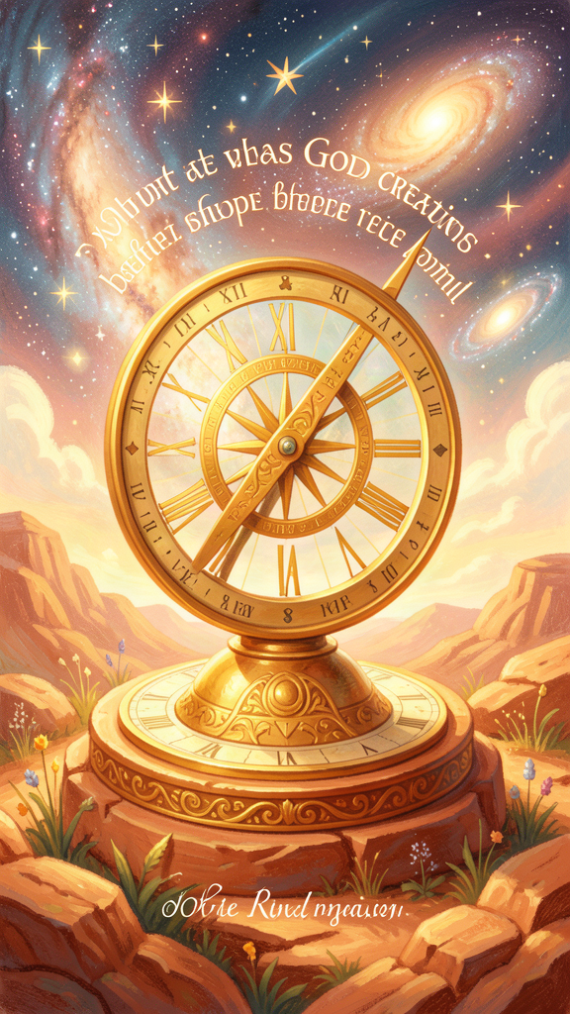
Illustration for Chapter 5
One day Augustine asked a question so big that he could not answer it. The question was simple, but the answer was not.
"What then is time? If no one asks me, I know what it is. If I wish to explain it to someone who asks, I do not know." (Confessions XI.14)
Try it. Can you explain what time is — without using the word "time"? It is very hard! You can say "it is when things happen" — but that just means "it is when things happen in time." You are using the word to explain the word.
Augustine thought very carefully about this. He said something amazing.
The past does not exist anymore. Yesterday is gone. You cannot touch yesterday. You cannot visit last week. It is finished.
The future does not exist yet. Tomorrow has not arrived. Next year is not here. You cannot go to tomorrow.
The present is very, very thin. Think about it. How long is "right now"? If you say "one second," then half of that second is already past and half is still future. You can cut it smaller and smaller. The present is like the thinnest line you can imagine — so thin it almost is not there.
So if the past is gone, and the future is not here, and the present is almost nothing — where does time actually live?
Augustine said time lives in your mind. It lives in three places inside you:
- Memory — the part of you that remembers what happened. - Attention — the part of you that notices what is happening right now. - Expectation — the part of you that looks forward to what is coming.
Think about a song. When you hear a song, each note is gone the moment it plays. But you hear the whole melody, not just one note at a time. How? Because your memory holds the notes that just played, your attention hears the note playing now, and your expectation knows what note is coming next. All three work together. That is how time works — it is not a thing outside you. It is something your mind does.
Augustine said God does not live in time. God made time, just like God made everything else. God sees all of time at once — your past, your present, and your future — like looking at a whole picture all at the same time. God is never late. God is never early. God is always now.

Words to Remember
"What then is time? If no one asks me, I know what it is. If I wish to explain it to someone who asks, I do not know." — Augustine, *Confessions* XI.14
What it means: Time is very hard to understand. Augustine said it lives in our minds — in remembering, noticing, and looking forward. God is outside time and sees everything at once.

Big Idea
Time is not a box that you live inside. Time is something your mind does — remembering what is gone, noticing what is here, and expecting what is coming. God made time, and God is outside it, seeing all of your life at once like a finished picture.

Try This
1. The song test. Listen to a song you know well. Close your eyes. Can you hear the notes that already played in your memory? Can you feel the note playing now in your attention? Can you guess the next note in your expectation? You are feeling time the way Augustine described it. 2. The present experiment. Sit very still and try to notice "right now." How long does "right now" last before it becomes "just now" — the past? Try to catch the exact moment when now becomes then. You cannot. That is what Augustine meant. 3. The time picture. Draw three circles in a row. In the first, draw something you remember. In the second, draw something happening right now. In the third, draw something you are looking forward to. Label them: Memory, Attention, Expectation. That is time, Augustine's way.

Ask a Grown-Up
"If God sees all of time at once — the past, the present, and the future — do you think God sees what you will do tomorrow? Does that mean your choices are already decided, or do you still get to choose?"
———

Chapter 6: Where Does Bad Come From? — The Hole in the Shirt
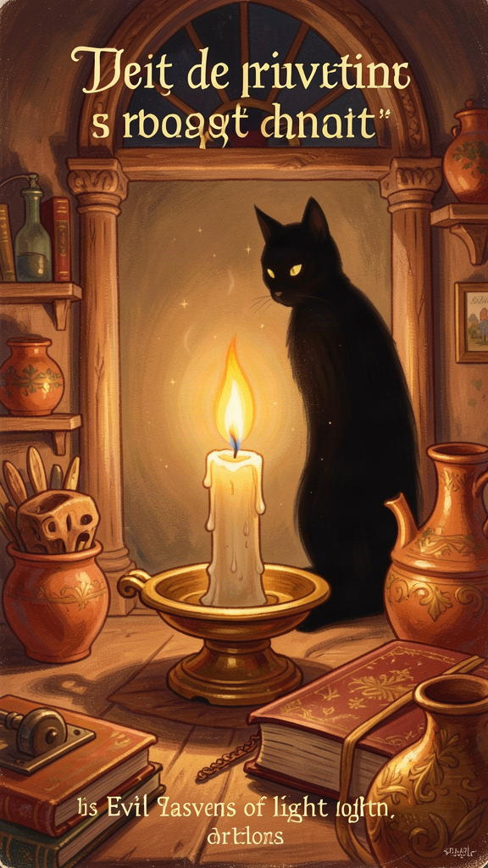
Illustration for Chapter 6
Augustine had a big question. Maybe you have it too. The question is: If God is good and God made everything, where does bad come from?
For nine years, Augustine belonged to a group called the Manichaeans. They believed there were two big powers in the world — a good power and a bad power — and they were always fighting. The good power made good things. The bad power made bad things. That seemed to explain why there is evil in the world.
But Augustine started to notice problems with this idea. If there are two equal powers — one good and one bad — then the bad power is just as strong as the good power. That means God is not the biggest. And if the bad power made the world, then the world is bad — but Augustine could see that the world was full of beautiful, good things. The two-power idea did not work.
Then Augustine read some philosophers called Platonists, and he had a breakthrough. He realized something: bad is not a thing. Bad is the absence of a thing.
Think about a shirt. A shirt is a good thing. It has fabric, shape, and purpose. Now think about a hole in the shirt. A hole is not a thing. You cannot hold a hole. You cannot put a hole in a box. A hole is just — a place where the shirt is missing.
"Evil is not a substance. It is the privation of good." (On Free Will III.18)
Or think about darkness. Darkness is not a thing. You cannot make darkness. You can only take away light. Darkness is what happens when light is gone.
Or think about silence. Silence is not a thing. It is what happens when sound stops.
Augustine said evil is like that. God did not make evil. God made good things — people, animals, stars, trees, hearts. Evil is what happens when those good things get damaged, bent, or turned the wrong way. Evil is a hole in something good. It is darkness where light should be. It is silence where music should be.
This is important because it means you fight evil differently. You do not fight a hole by attacking the hole. You fix a hole by repairing the shirt. You do not fight darkness by punching the dark. You turn on a light. You do not fight silence by yelling at the quiet. You make a sound.
Augustine said this is why grace matters. Grace does not destroy the bad. Grace restores the good that is missing. God does not fill the hole with anger. God heals the wound with love.

Words to Remember
"Evil is not a substance. It is the privation of good." — Augustine, *On Free Will* III.18
What it means: Bad is not a thing that God made. Bad is what happens when something good is missing, broken, or turned the wrong way. You fight bad not by attacking it, but by fixing the good that is gone.

Big Idea
Evil is not a thing — it is a hole. God did not create evil. God created good things, and evil is what happens when good things get damaged. You do not fix a hole by attacking the hole. You fix it by restoring what is missing. That is what grace does — it heals the wound, not by fighting the dark, but by turning on the light.

Try This
1. The hole demonstration. Find an old shirt or a piece of cloth with a hole in it. Hold it up to the light. Can you see the hole? Now try to touch the hole. You cannot — it is not there. It is just where the cloth is missing. That is what evil is like. 2. The light switch. Go into a room and turn off the light. It gets dark. Now turn it on. The darkness did not go somewhere — it just stopped existing when the light came. Say out loud: "Evil is darkness. God is light." 3. The fix-it list. Think of one bad thing in the world — someone being mean, litter on the ground, a sad friend. Do not try to "fight the bad." Instead, think: "What good thing is missing here?" Is kindness missing? Is cleanliness missing? Is company missing? Do one small thing to bring back the missing good.

Ask a Grown-Up
"If evil is like a hole — a missing good thing — what do you think is the best way to fix a hole? By getting angry at it, or by putting something good back in?"
———

For the Grown-Up Reader
This booklet introduces children ages 5-10 to six core ideas from Augustine of Hippo through narrative storytelling, concrete analogies, and age-appropriate activities. Every quote is drawn from Augustine's own writings — primarily the Confessions (trans. Pine-Coffin, Penguin Classics, 1961, or Chadwick, Oxford, 1991), City of God (trans. Bettenson, Penguin, 1972), and On Free Will.
The biographical framework follows Peter Brown's Augustine of Hippo: A Biography (1967, rev. 2000), the definitive modern scholarly biography. Key life events — the pear tree theft (Confessions II.4–9), the garden conversion (Confessions VIII.7–12), Monica's death at Ostia (Confessions IX.10–12), the meditation on time (Confessions XI.14–31) — are drawn directly from Augustine's own account.
Theological claims are presented in simplified form appropriate for young children. The doctrine of original sin is rendered as "a wound in the will" — Augustine's own metaphor in Confessions VIII.9. The privation theory of evil is presented through the hole-in-the-garment analogy that Augustine uses in On Free Will III.18 and City of God XI.9. The two-cities framework follows City of God XIV.28. The analysis of time follows Confessions XI.14–31.
Parents who want to read further should consult Henry Chadwick's Augustine: A Very Short Introduction (Oxford, 2001) and Gary Wills's Saint Augustine (Penguin Lives, 1999). For children who want to hear the full story, the Confessions in Pine-Coffin's translation remains the most readable English version.
One note on sensitive content: Chapter 2 (the pear tree theft) deals with doing wrong for no reason. Chapter 3 touches on Augustine's struggle with self-control, rendered here as the general challenge of choosing what is right. The sexual dimension of Augustine's struggles has been entirely omitted, as appropriate for this age band. Children who ask follow-up questions can be directed to the general principle: everyone struggles to do what is right, and God's help is always available.
———

About WisdomForge
WisdomForge creates age-adapted booklets that bring the world's greatest thinkers to readers of every age. Each figure gets four booklets — one for elementary ages (5-10), one for middle school (11-14), one for high school (15-18), and one for adults. The same ideas, the same thinker, the same wisdom — shaped for how you grow. Read it. Question it. Talk about it. The search for wisdom starts here.

