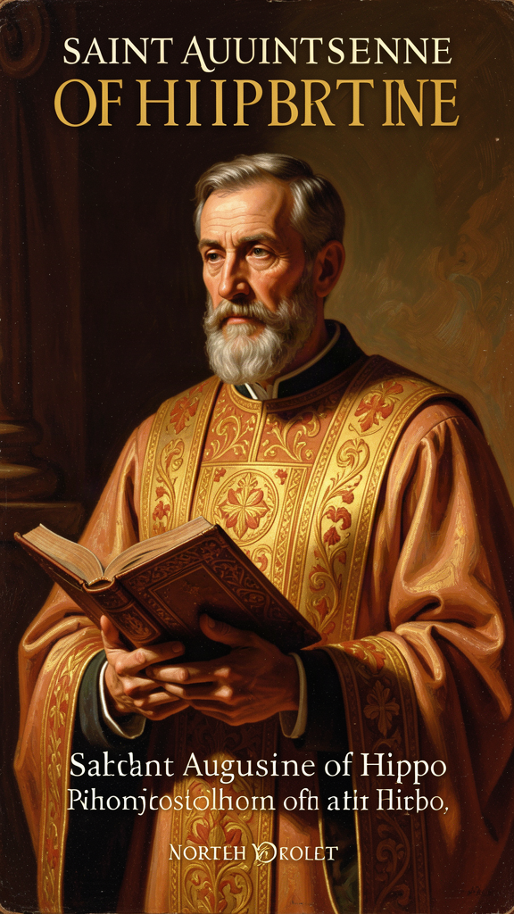
The Opened Heart: Augustine and the Architecture of the Self
WisdomForge Booklet — Ages 15-18

The Opened Heart: Augustine and the Architecture of the Self

WisdomForge Booklet — Ages 15-18
———

About This Book
Augustine of Hippo (354–430 CE) lived one of the most thoroughly documented lives in antiquity — a spiritual and intellectual journey spanning the collapse of the Roman world. Born in a modest North African town in what is now eastern Algeria, he became the most celebrated rhetorician in the Roman Empire, then renounced everything for a life of prayer, study, and ecclesiastical leadership. He wrote the Confessions, the first genuine interior narrative in Western literature, and the City of God, the most comprehensive Christian theology of history ever attempted.
This booklet engages six of Augustine's most important ideas as living arguments rather than museum pieces. Each chapter takes one concept — the restless heart, original sin and grace, free will and predestination, the two cities, time and creation, and evil as privation — and develops it through narrative, philosophical analysis, scholarly debate, and practical exercises.
Augustine is harder than the Greek philosophers you may have studied before. The Stoics taught that reason could master the passions. Augustine taught that reason alone cannot — only grace can. The Stoics built inner fortresses. Augustine tore his open and let God in. He is the first great psychologist of the interior life, and his analysis of the divided will, the restless heart, and the structure of time remains philosophically serious sixteen centuries later. He is also a theologian — his ideas are inseparable from his faith. This booklet presents him as he was: a bishop, a mystic, a memoirist, and a system-builder working at the collision point of Greek philosophy and biblical revelation.
———

Chapter 1: The Restless Heart — Our Souls Are Made for God
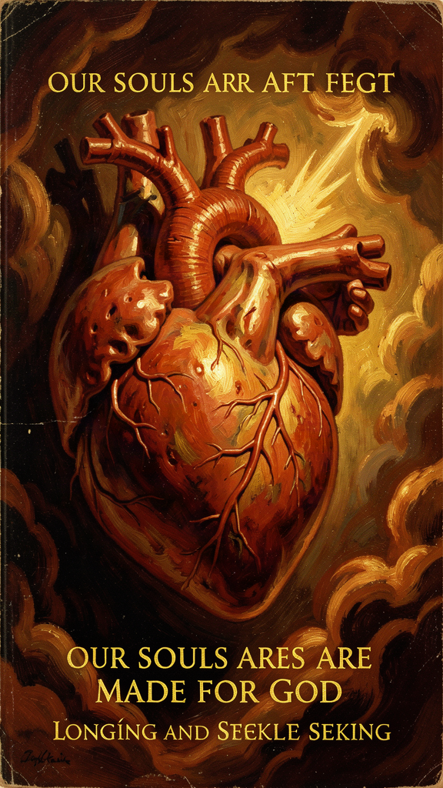
Illustration for Chapter 1

The Opening Sentence
The Confessions begins with one of the most quoted sentences in Western literature:
"You have made us for yourself, O Lord, and our hearts are restless until they rest in you." (*Confessions* I.1)
This is not a preface. It is a thesis statement. Everything that follows — the pear tree, the Manichaean years, the garden conversion, the meditation on time — is an illustration of this single claim. We are restless because we were made for something we have not yet found. The restlessness is not the problem. It is the proof that the solution exists.
Augustine does not say that human beings are unhappy. He does not say that they are unfulfilled. He says they are restless — inquietum, from in- (not) + quietus (at rest, settled, still). Restlessness is motion without arrival. Desire without satisfaction. The experience of having a hunger that no amount of eating fills, a thirst that no amount of drinking quenches, a longing that no achievement satisfies.

The Trajectory of a Restless Life
Augustine's own life is the case study. He tried:
Intellectual achievement. He became the foremost rhetorician in the Roman world, the equivalent of a celebrity intellectual. He held the chair of rhetoric in Milan, the imperial capital. The Hortensius of Cicero had awakened a love of wisdom at nineteen, but academic success did not satisfy it.
Sexual pleasure. He lived with a woman he loved for fifteen years and fathered a son, Adeodatus. He does not deny the pleasure. He says it did not fill the hole. When Monica arranged a socially advantageous marriage to a girl of proper standing, Augustine "dismissed" his concubine. "My heart, which clung to her, was torn and wounded until it bled" (Confessions VI.15). The marriage never happened. He lost the woman he loved and gained nothing in return.
Philosophical system. He spent nine years as a Manichaean "hearer," drawn by the religion's promise to explain the problem of evil through a cosmic dualism of Light and Darkness. The system could not answer his questions. The famous Manichaean bishop Faustus, whom Augustine had longed to meet as a font of wisdom, turned out to be "fluent in speech but ignorant of the liberal arts" (Confessions V.7).
Professional prestige. He was famous, respected, and well-paid. He was miserable.
Friendship. He loved a friend who died, and the grief nearly destroyed him. "My heart was darkened over with grief, and whatever I looked at was death" (Confessions IV.4). Love directed toward mortal things, without God, becomes a source of suffering because mortal things pass away.
Each of these is a genuine good. Augustine does not say they are worthless. He says they are not enough. They are lesser goods — real, beautiful, capable of giving temporary pleasure, but structurally unable to satisfy the hunger that drives the restless heart. The hunger is not for any of these things. It is for God. And until it finds God, it will keep moving.

What the Restlessness Is — and Is Not
It is important to say what the restless heart is not, because Augustine has been widely misread.
This is not a denial of earthly happiness. Augustine does not say earthly goods are worthless. He says they are not ultimate. Food is good. Friendship is good. Work is good. The problem is not that these things are bad; the problem is that they are not God. When we treat them as God — when we expect them to satisfy the hunger that only God can fill — they break our hearts, not because they are evil but because they are insufficient.
It is not a call to withdraw from the world. Augustine spent thirty-five years as a working bishop, preaching daily, managing church finances, adjudicating disputes, caring for refugees, writing letters, arguing with heretics, and serving a congregation through plague, war, and siege. The restless heart does not demand retreat. It demands right ordering.
It is not a psychological diagnosis. Augustine is not describing a clinical condition. He is making a theological claim about what human beings are. The restlessness is not a symptom to be treated; it is a signal to be read. It tells you something about your nature — that you were made for communion with God, and that communion is the only thing that will satisfy the hunger you feel.

The Neoplatonic Background
Augustine did not invent the restless heart out of nothing. His anthropology has deep roots in Neoplatonic philosophy, particularly in Plotinus's concept of exitus and reditus — the soul's departure from the One and its return. For Plotinus, the soul emanates from the One (the supreme principle of reality), descends into the material world, and then gradually ascends back through philosophical contemplation. The soul is restless because it is away from its source.
Augustine transforms this framework in three crucial ways:
1. The One becomes a person. In Plotinus, the One is impersonal — the source of all being, but not a being who knows you, loves you, or calls you by name. In Augustine, the One is God — a personal being who addresses you, pursues you, has made you for himself. The return is not a philosophical ascent but a personal encounter.
2. The return requires grace, not just effort. In Plotinus, the soul returns to the One through its own philosophical effort. In Augustine, the soul cannot return by its own power. It has been damaged by sin. Grace must act first — drawing the soul, transforming the will, enabling the return. The reditus is not a solo climb. It is a rescue.
3. The return happens in time, through history. Plotinus's ascent is abstract — the soul transcending the material world through contemplation. Augustine's return is embedded in history: a child's voice in a garden, a Scripture passage, a baptism in a cathedral. Grace arrives through concrete events, not through philosophical abstraction.

The Restless Heart and Modern Psychology
Augustine's restless heart anticipates several key insights of modern psychology:
The divided self. Augustine's account of the will that knows the good but cannot do it (Confessions VIII.9) is the first systematic description of what psychology calls akrasia — weakness of will, the gap between knowing and doing. He explains this not as mere ignorance but as a structural feature of fallen human nature.
Object relations theory. Augustine's claim that love directed toward mortal things becomes a source of suffering anticipates the insight that when we treat another person as the ultimate source of our happiness, we burden them with a weight they cannot bear and set ourselves up for the grief Augustine experienced when his friend died.
The hedonic treadmill. Modern psychology has documented what Augustine observed: we adapt to our circumstances. A new job, a new relationship, a new achievement — each produces a temporary spike in happiness, followed by a return to baseline. We are on a hedonic treadmill. Augustine would say: the treadmill is the restless heart. It is not a design flaw. It is a design feature. It is supposed to keep moving until it finds what it was made for.
The scholarly debate: Is *cor inquietum* theological or psychological? One of the most interesting scholarly questions about the restless heart is whether it is a theological claim (you are made for God) or a psychological one (you are wired for dissatisfaction). Some scholars, like Michael Hanby in Augustine and Modernity (2003), argue that the two cannot be separated — Augustine's psychology is theological through and through, and reading it as "mere psychology" misses the point. Others, like James O'Donnell, suggest that the restless heart can be appreciated as a psychological insight even by those who do not share Augustine's theology. The question matters because it determines whether the cor inquietum is accessible to everyone or only to believers. Augustine himself would probably say: the restlessness is universal, but the rest is theological. Everyone feels the hunger. Not everyone recognizes what it is for.

The Big Idea
The restlessness you feel — the sense that something is always missing, that what you have is never quite enough — is not a flaw in you. It is a compass. You were made for something the world cannot give, and the wanting is the proof. Every time you get what you thought you wanted and still want more, that is the restless heart telling you that you were made for something bigger. Augustine tried fame, pleasure, philosophy, success, and friendship. All were real goods. None was enough. The hunger points beyond all of them.

Practice
1. The wanting map. List five things you have wanted badly in the last year — a grade, a relationship, a skill, a possession, an experience. For each, write what happened when you got it (or did not). Did the wanting stop? Did a new wanting replace it? Look for the pattern Augustine saw: satisfaction followed by renewed desire. Write one paragraph analyzing the pattern. What does it tell you about what you are actually hungry for? 2. The hedonic treadmill audit. Pick one achievement or acquisition from the last six months that you wanted badly. Rate your happiness 1–10 at the moment you got it. Rate it now. Has it faded? Augustine says this is not a bug but a feature — the treadmill is the restless heart doing its job. Write one paragraph about whether this changes how you think about pursuing your next goal. 3. The lesser-goods test. Augustine says earthly goods are not bad — they are just not enough. Think of one good thing in your life that you enjoy (a friendship, a skill, a possession). Ask: "Is this a gift I am grateful for, or have I made it the thing I live for?" The difference between gratitude and idolatry is whether the good thing is a window or a wall. Write about what you find. 4. The compass check. For one week, every time you feel the "I want more" feeling, write down what triggered it. At the end of the week, review the list. What is your restless heart actually pointing toward? Is it pointing at a specific thing (status, approval, pleasure) or at the deeper hunger that no specific thing can fill?

Reflect
Augustine says the restlessness does not stop when you find God. It changes direction. Before conversion, it searches for satisfaction in created things. After conversion, it searches for deeper communion with the Creator. The restlessness is the same. The address is different. If the hunger is permanent, the question is not whether you will hunger. The question is what you hunger for. What is your restless heart pointing toward right now — and have you been looking in the right places?
———

Chapter 2: Original Sin and Grace — The Wound and the Cure
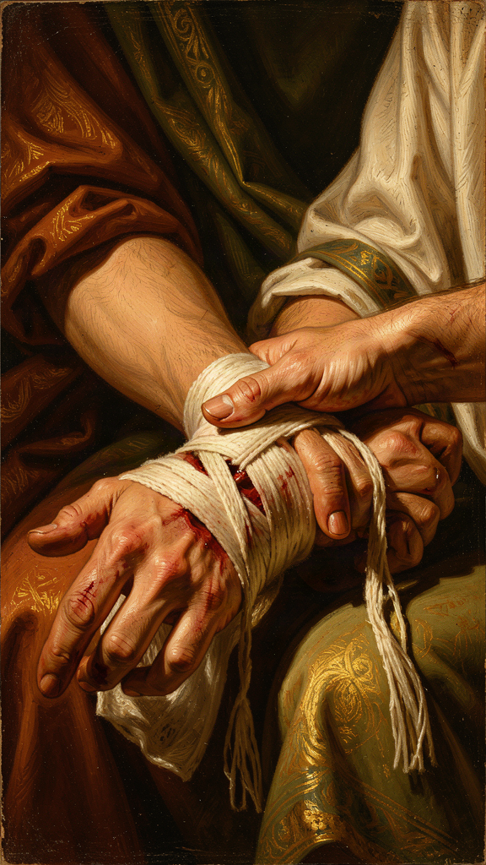
Illustration for Chapter 2

The Problem: Why We Do Wrong
Augustine's doctrine of original sin begins with an observation, not a theory. The observation is universal: human beings do wrong even when they know what is right, even when they have no external reason to do wrong, even when doing wrong gives them no pleasure. The pear tree theft is the paradigm case — Augustine stole pears he did not want, from a tree he did not need, for the sheer pleasure of transgression.
"I loved my fall into sin. The fall itself was the motive. I loved the self-destruction, the fact that I was doing something that was forbidden." (*Confessions* II.4)
The Stoics had an answer: we err because of false judgments. If we truly knew what was good, we would choose it. Vice is ignorance. The remedy is more knowledge — more philosophy, more discipline, more clarity about what is in our power and what is not.
Augustine tried this answer. He lived it. He was one of the most intelligent and best-educated men in the Roman world, and he found himself doing what he knew was wrong anyway. Knowledge was not enough. The problem was deeper than false judgment. It was a problem of the will — a will that knew the good but could not consistently choose it.
"The mind commands the body and it obeys. The mind commands itself and it is resisted." (*Confessions* VIII.9)
This is not ignorance. It is something more disturbing: a divided self that knows what it wants and cannot want it fully. The will is not merely weak. It is disordered. It loves the wrong things, or it loves the right things in the wrong way, or it loves the right things and the wrong things simultaneously and cannot choose between them.

Original Sin: The Inherited Wound
Augustine's doctrine of original sin has three components:
The Fall. The first human beings were created good, with free will intact. They chose to turn away from God toward themselves — a free choice to prefer self to God.
The Consequence. The will, previously free to choose good or evil, is now inclined toward evil. The intellect is clouded by pride. The emotions are disordered — we love created things more than the Creator. Humans still choose, but their choosing is weighted toward wrong by a condition they did not create and cannot cure.
The Inheritance. This damage is inherited. Every human being is born with a will that is damaged — not destroyed, but damaged — and this damage is not the result of any individual's choice but of the human condition itself.

What Original Sin Is Not
Original sin does not mean that human beings are as bad as they could possibly be. Augustine explicitly affirms that fallen human nature retains genuine goods — reason, conscience, the capacity for love, the ability to form just societies, the desire for truth. Original sin means that every dimension of human nature has been damaged, not destroyed. The image of God in human beings is not erased. It is disfigured. Like a mirror that has been cracked: it still reflects, but the reflection is distorted.
Original sin also does not mean that people cannot do good things. Unbelievers can be courageous, just, temperate, and prudent. But these virtues, Augustine says, are "splendid vices" — genuine goods pursued for the wrong reasons, or genuine goods that do not lead to their proper end. The courage of a soldier who fights for glory is real courage. But it is directed toward self-glorification rather than toward God, and therefore it falls short of its proper object.

Grace: The Cure That Precedes the Patient
If original sin is the diagnosis, grace is the cure. And for Augustine, the cure comes before the patient is ready for it.
Grace is God's unmerited favor — the initiative by which God acts on the human will to enable it to choose the good. This is not supplementary assistance. It is not a helping hand extended to someone who is already reaching up. It is the hand that reaches down into the pit and pulls the person out before they know they need rescuing.
Prevenient grace — grace that comes first. Before the human will can choose God, God must act upon it to make that choice possible. The fallen will is free enough to be guilty — it can still choose, and its choices are really its own — but it is not free enough to save itself.
Irresistible grace — grace that accomplishes its purpose. When God moves to save, his grace is effective. This does not mean God forces the will against its desire. It means God transforms the will so that it desires what it previously could not desire. The will is not coerced. It is healed. It chooses freely, but it chooses freely because grace has made it possible to choose freely.
Persevering grace — grace that sustains the will to the end. Those whom God calls, he also keeps. Salvation is not a one-time event but an ongoing process, and the grace that begins it is the same grace that completes it.

The Pelagian Controversy
Augustine's theology of grace was forged in opposition to Pelagius, a British monk who arrived in Rome around 380 CE and was disturbed by the moral laxity he found there. Pelagius's core teachings:
Human nature is uncorrupted. Adam's sin affected Adam, not his descendants. We are born into the same moral condition as Adam before the fall: free, capable, and responsible. There is no "original sin" that corrupts human nature at birth.
Free will is sufficient for righteousness. Human beings have the natural capacity to choose good and avoid evil. Grace is helpful — it provides instruction, example, and forgiveness — but it is not strictly necessary for moral action. A person could, in principle, live without sin.
Christ's example is as important as his atonement. Christ saves us not primarily by dying for our sins but by showing us how to live. His perfect life is a model we can emulate.
Augustine's response was comprehensive and relentless. If humans can save themselves by their own effort, then Christ died for nothing. If the will is not damaged by original sin, then the whole structure of Christian theology — fall, incarnation, atonement, redemption — collapses. The controversy was resolved (in the West) by the Council of Carthage in 418 CE, which condemned Pelagianism and affirmed Augustine's positions. But the debate did not end there. It continued through the medieval period, flared again in the Reformation, and persists today.

The Scholarly Debate: Did Augustine Go Too Far?
The most intellectually sophisticated opponent of Augustine's later position was Julian of Eclanum, bishop of Eclanum in Italy. Julian was not a Pelagian in the narrow sense — he accepted the condemnation of Pelagianism — but he rejected Augustine's more extreme formulations, particularly the idea that human nature was totally corrupted and that sexual desire was a consequence of the fall. Julian's arguments were sharp and sometimes personal: he accused Augustine of being a crypto-Manichaean for his negative view of the body and sexuality.
The charge of Manichaeism is the most enduring critique of Augustine's doctrine of original sin. Augustine spent nine years as a Manichaean, and his later emphasis on the corruption of human nature and the necessity of grace has been read by some scholars as a residue of his Manichaean past — a tendency to see the world in terms of darkness and light, corruption and rescue, that goes beyond what the biblical text clearly teaches. Elaine Pagels, in Adam, Eve, and the Serpent (1988), argues that Augustine's doctrine of original sin, with its emphasis on inherited corruption and the transmission of sin through sexual procreation, reflects his personal struggles projected onto theology rather than a faithful reading of Paul.
Defenders of Augustine, including Peter Brown and John Rist, argue that the doctrine is not Manichaean at all. Manichaeism taught that matter was evil and the body was a prison. Augustine explicitly rejected both claims. The body is good. Creation is good. The problem is not with the body but with the will — the orientation of the whole self away from God and toward self. The doctrine of original sin is not a denial of the body's goodness but an honest acknowledgment that the will is damaged, and damaged things need a healer.

The Big Idea
We all have a wound in the part of us that chooses — the will. The wound makes us want the wrong thing even when we know better. We did not cause the wound and we cannot cure it by trying harder. The cure comes from outside us — grace, God's love reaching down to heal what we cannot heal ourselves. This is not a denial of human goodness. It is an honest acknowledgment that our goodness is damaged, and damaged things need a healer. The question is whether you trust the diagnosis, and whether you are willing to receive the cure.

Practice
1. The akrasia experiment. Augustine says the gap between knowing and doing is not about information but about will. Test this: pick one thing you know you should do — study, exercise, be patient, put your phone away. You already know it is good. You already know how to do it. The problem is not knowledge. What is it? Write one paragraph naming the real obstacle. Is it habit? Fear? Competing desire? Akrasia? 2. The "give what you command" prayer. Augustine's prayer — "Give what you command, and command what you will" (Confessions X.29) — admits that willpower is not enough. Try it for one week, directed at one specific struggle. Each morning, say the prayer. Each evening, write one sentence: did the admission of need change anything? Not magically — honestly. 3. The splendid-vice hunt. Augustine says people can do good things for the wrong reasons, and these are "splendid vices." Identify one example from your own life or from public life: a good action done for a self-serving motive. What makes the motive "wrong" if the action is good? Write one paragraph analyzing the distinction between good action and good motive. 4. The wound diagnosis. Augustine says the will is wounded — not destroyed, but damaged. Write a self-assessment: where is your will most damaged? What is the thing you keep doing despite knowing better? Do not punish yourself — diagnose yourself, the way Augustine diagnosed himself in the pear tree chapter. Name the pattern. Name the wound. Name what kind of help you need.

Reflect
Augustine says the will is damaged and cannot cure itself. This is either deeply comforting (the pressure is off — you cannot fix yourself by willpower alone) or deeply disturbing (you are not in control — the problem is deeper than you thought). Which is it for you? And if the cure comes from outside, what does it look like when it arrives? Is it a sudden moment, like the garden conversion, or a slow healing? Have you experienced either?
———

Chapter 3: Free Will and Predestination — The Paradox of Choice

Illustration for Chapter 3

The Early Position: Free Will Can Choose the Good
In On Free Will (388–395 CE), written in the years immediately following his conversion, Augustine takes a position markedly more optimistic about human freedom than his later theology allows. The argument proceeds like this:
If God is good and all-powerful, why is there evil? The Manichaean answer — that evil is a substance created by a rival power — has been rejected. The Neoplatonic answer — that evil is a privation of good — has been accepted. But this raises a new question: if evil is not a substance but a corruption of good things, who is responsible for the corruption?
Augustine's answer: free will. God created human beings with free will because freedom is necessary for genuine love and moral action. A creature that cannot choose cannot love. But a creature that can choose can choose badly. The cause of moral evil is not God but the free will of creatures who turn away from the supreme good toward lesser goods. "We do nothing by fate. Whatever we do well is from God; whatever we do ill is from ourselves" (On Free Will III.20).
This is the early Augustine: confident that free will is the solution to the problem of evil, optimistic that human beings can choose the good if they try, eager to show that God's justice is compatible with human freedom. It sits comfortably alongside the Stoic emphasis on what is "in our power."

The Late Position: Grace Is Necessary for Every Good Choice
By the 390s, Augustine's experience as a bishop had confronted him with a reality that his early optimism could not account for: the sheer difficulty of moral transformation. People knew what was right and could not do it. They wanted to change and could not sustain the change. They came to confession, repented, resolved to do better — and fell back into the same patterns, over and over. The will was free, yes — but free to do what?
The Pelagian controversy crystallized this shift. Pelagius taught that humans could, by the exercise of natural free will, choose to live without sin. Grace was helpful — it illuminated the mind and forgave past sins — but it was not necessary for the present choice to do good. Augustine's response, developed over more than a decade of polemical writing, was that Pelagianism was not merely an error but a denial of the gospel itself. If humans can choose good without grace, Christ died for nothing.
The key texts of the late Augustine: On Nature and Grace (415 CE), On Grace and Free Will (426/427 CE), On Rebuke and Grace (426 CE), and On the Predestination of the Saints (428–429 CE). These works push the logic of grace to its limits: if grace is absolutely necessary for salvation, and if God chooses whom to save, then salvation is predestined. Not all who are called are chosen.

The Logic of Grace
Augustine's argument proceeds in steps:
1. All human beings are born with original sin. The will is damaged. It is free enough to be guilty but not free enough to save itself. 2. Grace is necessary for every good choice, including the first movement toward God. This is prevenient grace — grace that comes before. 3. Grace is given by God, not earned by human merit. No one deserves grace. If grace were earned, it would be wages, not grace. 4. Therefore, God chooses whom to save. This is the doctrine of election. 5. The question of those not chosen remains open. Augustine never explicitly affirms double predestination. He says God passes over some, leaving them in their sin, but he does not say God positively wills their damnation. The distinction is subtle and has been debated for centuries.

How Free Will and Predestination Coexist
The obvious objection: if God has already chosen who will be saved, how can human beings be genuinely free?
Augustine's answer: grace does not override the will. It transforms it. The will that receives grace does not lose its freedom. It gains the freedom it previously lacked — the freedom to choose God. Before grace, the will is free to choose among created goods but not free to choose the Creator. After grace, the will is free to choose both. Grace does not eliminate choice. It expands it.
This has been read in two ways for sixteen centuries:
The Augustinian/Reformed reading: Grace is necessary and effective. The human will cannot choose God without it. Those who receive grace are genuinely free, but their freedom is the result of grace, not the cause of it. God's choice precedes human choice. This is the reading Luther and Calvin developed into the Protestant doctrine of salvation by grace alone.
The Catholic/Thomist reading: Grace is necessary but not irresistible. God offers grace to all, and human beings can accept or reject it. The will cooperates with grace — not as an equal partner, but as a participant that grace has enabled. This is the reading the Council of Trent (1546) affirmed in response to the Reformation.
Both readings claim Augustine. Both have textual support. The tension is not a flaw in the argument. It is a genuine dilemma that arises whenever you affirm both divine sovereignty and human freedom. Augustine affirms both, and the result is not a neat resolution but a mystery he holds in tension until the end of his life.

The Development Question
One of the most debated questions in Augustinian scholarship is whether Augustine changed his mind on free will. Did the early Augustine (who emphasized free will) and the late Augustine (who emphasized grace) hold the same position, or did he undergo a genuine reversal?
The "development" thesis (Peter Brown, James O'Donnell): Augustine genuinely developed from a more optimistic anthropology to a more pessimistic one. The Pelagian controversy forced him to articulate positions that were latent but not explicit in his early work. The "old" Augustine is significantly different from the "young" Augustine.
The "continuity" thesis (John Rist, Gerald Bonner): Augustine's fundamental position never changed. The early works affirm freedom within the context of grace; the later works affirm grace within the context of freedom. The apparent change is a shift in emphasis driven by polemical context, not a reversal of substance.
The "trajectory" thesis (Carol Harrison): Augustine did not change his mind so much as follow his premises to their logical conclusion. The early commitment to grace as necessary implied the later conclusion that grace is sufficient and irresistible. The trajectory was always present. It simply took decades to unfold.
The scholarly stakes are real. If Augustine changed his mind, which Augustine is authoritative — the young or the old? Protestants tend to prefer the old (anti-Pelagian); Catholics tend to affirm both while qualifying the old. The question affects whether the grace/free will tension is still open or was settled by Augustine's later writings.

Why This Matters Beyond Theology
The free will/predestination debate is not merely a theological puzzle. It touches on questions every thoughtful person faces:
How free are we, really? Neuroscience, behavioral genetics, and social psychology all suggest that our choices are influenced by factors outside our conscious control — genes, upbringing, environment, unconscious biases. If these factors significantly shape our decisions, how free are we? Augustine's answer — free enough to be responsible, but not free enough to save ourselves — resonates with modern findings even if the theological framework is different.
Is transformation possible? Augustine says yes, but not by willpower alone. Real change requires something outside ourselves — whether you call it grace, therapy, community, or love. The claim that the will is too damaged to fix itself is not uniquely Christian. It is shared by every honest account of addiction, compulsion, and self-destructive behavior.
What about justice? If God chooses some and not others, is that fair? Augustine's answer — that none of us deserve grace, so the question is not "why are some not saved?" but "why are any saved at all?" — is logically coherent but emotionally unsatisfying. It remains one of the hardest claims in Christian theology.

The Big Idea
Human beings are genuinely free, but our freedom is damaged. We can choose among the things the world offers. We cannot choose God without God's prior help. Grace does not override our will — it heals it, expanding our freedom to include the one choice we could not make on our own. The hardest part of this idea is what it implies about those who do not receive grace. Augustine never fully resolved that tension, and it has generated sixteen centuries of debate. The question is not whether the tension can be resolved — it probably cannot. The question is whether you can hold both truths at once without collapsing either one.

Practice
1. The divided-will diary. For one week, notice moments when your will is divided — when part of you wants one thing and part of you wants another. Write each down. At the end of the week, analyze: what do your divisions have in common? What does the pattern tell you about the state of your will? Is it akrasia, competing desires, or something else? 2. The early-vs-late Augustine test. Read On Free Will III (the early, optimistic position) and On Grace and Free Will (the late, grace-centered position). Write one paragraph on each: which is more convincing to you? Did Augustine change his mind, or did he develop? Use the scholarly debate (Brown vs. Rist vs. Harrison) to frame your answer. 3. The fairness inquiry. Augustine says none of us deserve grace, so the question is not "why are some not saved?" but "why are any saved at all?" Does this answer satisfy you logically? Does it satisfy you emotionally? Write one paragraph on the gap between the two. Where does that gap come from? 4. The neuroscience connection. Augustine says we are free enough to be responsible but not free enough to save ourselves. Modern neuroscience suggests our choices are shaped by factors outside conscious control. Write one paragraph comparing Augustine's framework to the modern picture. Where do they agree? Where do they diverge? Does neuroscience support or undermine Augustine's position?

Reflect
Augustine says grace heals the will rather than overriding it. This means the moment of transformation feels like your choice — but a choice you could not have made before. Have you ever experienced a moment like that? A moment when you finally did something you had been unable to do, and it felt simultaneously like your decision and like something given to you? What was that moment? What broke the paralysis?
———

Chapter 4: The Two Cities — The City of Man and the City of God
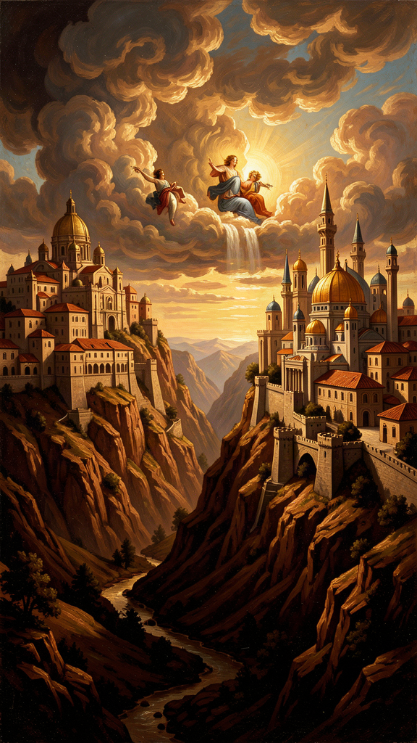
Illustration for Chapter 4

The Catastrophe
On August 24, 410 CE, Visigothic warriors under King Alaric breached the walls of Rome and spent three days looting the city. Rome had not been sacked by a foreign army for nearly eight centuries. It was the "eternal city," the heart of civilization, the guarantee of order. Its fall sent shockwaves through the entire Roman world.
Pagans blamed the Christians. The old gods had protected Rome for a thousand years. Christianity had abandoned those gods. The new God had not protected the city. Therefore Christianity was responsible for the catastrophe.
Augustine's response was the City of God — twenty-two books written between 413 and 426, spanning theology, philosophy, political theory, and cultural criticism. It is one of the longest single-author works to survive from antiquity, and one of the most influential books ever written.

The Two Cities
The central concept is the distinction between two cities that coexist in human history:
"Two loves, then, have made two cities: love of self reaching even to contempt of God, the earthly; and love of God reaching even to contempt of self, the heavenly." (*City of God* XIV.28)
The City of God (civitas Dei) is the community of those who love God above all else. Their primary citizenship is heavenly. Their peace is not the absence of conflict but tranquillitas ordinis — the tranquility of order, the right relationship of all things to each other and to God.
The City of Man (civitas terrena) is the community of those who love themselves above all else. This does not mean its members are uniformly wicked. Pagans can display genuine virtues — courage, justice, temperance, prudence. But these virtues are compromised by their motive. The Roman who displays courage in battle may be driven by libido dominandi — the lust for domination and glory — rather than by love of justice. These are "splendid vices" — beautiful in appearance, hollow at the core.

What the Two Cities Are Not
The two cities are not two nations. You cannot point to them on a map. They coexist in every country, every city, every neighborhood.
They are not two churches. The City of God is not the Christian church, and the City of Man is not the non-Christian world. The visible church contains members of both cities. People outside the visible church may, by God's grace, belong to the City of God.
They are not two political systems. The City of God is not a theocracy, and the City of Man is not a secular state. Both cities coexist within every political system.
They are not two kinds of people. Every human being contains elements of both cities. The distinction is one of orientation — of what we love most, not of what we are.

The Two Loves
The distinction between the two cities is fundamentally a distinction of love. This is crucial: the difference between the cities is not a difference of behavior but of desire. Two people can perform the same action — give money to the poor, serve their country, raise their children — and one can be acting from love of God and the other from love of self.
Augustine uses the Latin words caritas and cupiditas:
Caritas is love directed toward God and, through God, toward created things. It seeks the good of the other for the other's own sake. It is disinterested in the best sense.
Cupiditas is love directed toward created things as though they were ultimate. It seeks the good of the other for one's own sake. It is possessive, grasping, and ultimately unsatisfying, because created things cannot bear the weight of being loved as ultimate.
Every human being experiences both kinds of love. The question is which one dominates.

Libido Dominandi: The Lust for Domination
Augustine's most devastating critique of the City of Man centers on libido dominandi — the lust for domination. This is not merely the desire for political power. It is the desire to control, to possess, to make other people serve your will. It is the impulse that drives empires, corporations, abusers, and anyone who treats other human beings as means rather than ends.
Rome, Augustine argues, was built on libido dominandi. The Republic was not a community of free citizens governing themselves. It was a community of free citizens governing others — slaves, subject peoples, conquered nations. The Empire was the Republic scaled up. The virtues of Rome — courage, justice, temperance, prudence — were real virtues, but they served domination.
"Remove justice, and what are kingdoms but gangs of criminals on a large scale?" (*City of God* IV.4)
This critique is not limited to Rome. Augustine is describing a permanent feature of human political life. Every empire, every nation, every institution that pursues power for its own sake is an expression of the City of Man. The specific form changes — Rome, Babylon, the British Empire — but the underlying orientation is the same: love of self reaching even to contempt of God.

The Peace of the Two Cities
Both cities have peace, but they are not the same peace.
The peace of the City of Man is pax terrena — earthly peace. It is the peace that comes when conflict is suppressed, when order is maintained, when people can go about their business without fear of violence. This is a genuine good. Augustine does not despise it. He says earthly peace is better than war, just laws are better than unjust ones, good government is better than bad government.
But earthly peace is penultimate. It is fragile, temporary, and always mixed with injustice. The peace of Rome was maintained by slavery, conquest, and the suppression of dissent.
The peace of the City of God is pax aeterna — eternal peace. It is the tranquility of order fully realized — every relationship rightly ordered, every love directed toward its proper end. This peace is not yet fully present on earth. It is present in foretaste, in moments of genuine communion, in the love between friends. But it will not be fully realized until the end of history.

The Scholarly Debate: Blueprint or Critique?
Augustine's political theology has been interpreted in diametrically opposed ways:
The Christendom reading (dominant from the Middle Ages through the nineteenth century): The City of God provided theological justification for Christian empire. The church is the visible expression of the City of God on earth. Augustine's endorsement of coercion against the Donatists is a model for Christian governance.
The anti-political reading (Reinhold Niebuhr, R.A. Markus, twentieth century): The two cities are intermixed and cannot be identified with any earthly institution. No earthly polity is the City of God. The libido dominandi corrupts all earthly power, including Christian power. Augustine is the ancestor of modern liberalism, realism, and the separation of church and state.
The "secular" Augustine (Markus, Saeculum, 1970): Augustine invented the concept of a "secular" space — politics, culture, society — that is neither sacred nor sinful but simply human. This reading has been influential but contested. Critics argue Augustine never uses saeculum in the modern sense and that his political theology is deeply theological, not neutral.
Christian realism (Niebuhr and successors): Augustine is neither utopian nor anti-political but realistic. Politics is necessary because of human sinfulness. Politics is limited because of human sinfulness. The best politics acknowledges its limitations and seeks relative justice rather than absolute righteousness.
The truth is that Augustine's political theology contains elements that support multiple readings. He endorsed state coercion against the Donatists (Christendom). He insisted no earthly institution is the City of God (anti-political). He developed a realistic analysis of power (realist). He affirmed the relative value of earthly peace while denying its ultimacy (secular). He is the father of both Christian realism and Christian utopianism because he contained both possibilities.

The Big Idea
There are two invisible cities, and they are inside every heart. One loves God most. One loves itself most. They are not nations or governments or churches — they are orientations of love that coexist in every community and every person. The question is not where you live on a map but what you love most. Empires built on the lust for domination always fall, because domination runs out. The City of God endures because it is built on love, not power. The hardest part is that both cities are in you — and the line between them is invisible.

Practice
1. The love audit. Augustine says the two cities are distinguished by what they love most. For one week, track what drives your choices. Are you acting from caritas (love of God and others) or cupiditas (love of self)? You do not have to be harsh — just honest. Write one example per day. At the end of the week, analyze the pattern. 2. The splendid-vice analysis. Identify a "splendid vice" in public life — a good action done for a self-serving motive. Write one paragraph analyzing what makes the motive wrong if the action is good. Is the distinction between good action and good motive sustainable? Can the same action be virtuous in one person and vicious in another? 3. The dual-citizen tension. Augustine says Christians are dual citizens — of the City of God by faith and of the City of Man by birth. Write about one situation where these two citizenships create tension in your life. How do you navigate it? When do you prioritize one over the other? What would "engagement without idolatry" look like in your case? 4. The political theology test. Read City of God IV.4 ("Remove justice, and what are kingdoms but gangs of criminals?") and XIX.13 (on the peace of the two cities). Write one paragraph on whether Augustine's framework is a blueprint for Christian political order or a critique of all political order. Use the scholarly debate (Christendom vs. anti-political vs. realist vs. secular) to frame your answer. Which reading is most convincing to you, and why?

Reflect
Augustine says no earthly political order is the City of God. This means no government, no party, no movement can claim ultimate authority. But it also means you cannot withdraw — you are a dual citizen, and you owe something to both cities. The question is how to engage in politics without idolatry — working for justice without expecting any system to bring about the kingdom of God. What does that look like in your life? What would it mean to care about politics "in the right way, with the right expectations"?
———

Chapter 5: Time and Creation — What Was God Doing Before Creation?
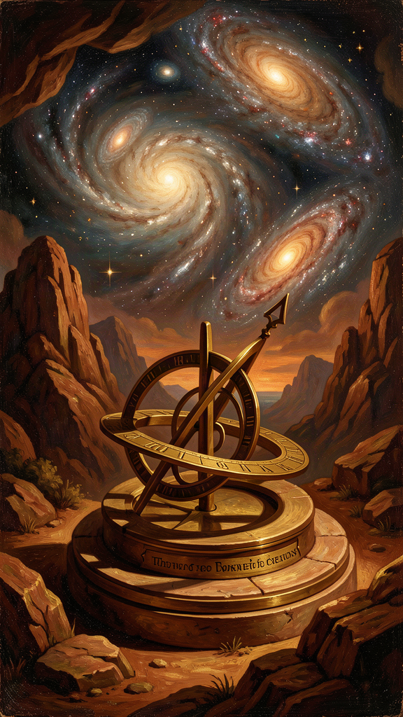
Illustration for Chapter 5

The Question
In Book 11 of the Confessions, Augustine does something unexpected. He has finished telling his life story (Books 1–9), examined his present state (Book 10), and now he turns to the nature of time itself. The question seems to come from nowhere. He is praying — addressing God, as always — and the prayer turns into an investigation:
"What then is time? If no one asks me, I know what it is. If I wish to explain it to someone who asks, I do not know." (*Confessions* XI.14)
This is not a rhetorical flourish. It is a precise description of a genuine philosophical puzzle. Time is the most familiar thing in the world — we live in it, measure it, organize our lives around it — and yet the moment we try to say what it is, it vanishes. Every philosopher who has tackled it — Aristotle, Newton, Kant, Bergson, Heidegger, McTaggart — has found the same thing: time resists explanation.

The Argument
Augustine's analysis proceeds in stages, each more unsettling than the last.
The past does not exist. Yesterday is gone. The past has passed away. When we speak of "the past," we are referring to something that was but is no longer. But if the past does not exist, how can we remember it? Augustine's answer: we remember images of the past that exist in the present. Memory produces images of things that no longer exist and holds them in the present mind.
The future does not exist. Tomorrow has not arrived. The future is not yet. But if the future does not exist, how can we anticipate it? Augustine's answer: we anticipate signs of the future that exist in the present. Expectation produces images of things that do not yet exist and holds them in the present mind.
The present is vanishingly thin. If the past does not exist and the future does not exist, only the present exists. But how long does the present last? A year includes months past and future. A month? A day? A second? However thin you slice it, the present can always be divided into a part that has just passed and a part that has not yet arrived. The present is a knife-edge — a durationless instant between two nothings.
And yet we experience duration. We hear a melody, and we hear it as a continuous whole, not as a series of isolated instants. How is this possible if only the present exists?

Time as Consciousness
Augustine's answer is one of the most original claims in the history of philosophy. Time is not an external container within which events occur. It is something the mind does — through three faculties:
- Memory (memoria): the mind's retention of what has passed. - Attention (attentio): the mind's focus on what is happening now. - Expectation (expectatio): the mind's anticipation of what is to come.
All three are present activities. Memory is not the past — it is a present act of remembering. Expectation is not the future — it is a present act of anticipating. Attention is not the present passing by — it is a present act of attending. Time, for Augustine, is the mind's way of stretching itself across what no longer exists, what does exist, and what does not yet exist.
This is a stunning claim. Time is not "out there" in the world, like space or matter. It is "in here" — in the mind's activity of remembering, attending, and expecting. Without a mind to remember and anticipate, there is no experience of time. There may be events that succeed one another in the physical world, but the duration that we experience as time is a product of consciousness.

The Philosophical Significance
Augustine's analysis of time is one of the most original contributions in the history of philosophy. It anticipates several major developments:
Phenomenology. Edmund Husserl's analysis of internal time-consciousness — the distinction between retention (memory of what has just passed), primal impression (the present moment), and protention (anticipation of what is about to come) — is essentially Augustine's distinction, developed with greater philosophical precision. Husserl was reading Augustine.
Relativity. Einstein's theory demonstrates that time is relative to the observer's frame of reference. Augustine's insight that time depends on the perspective of the observer is structurally similar, though he is not making a claim about physics.
The problem of becoming. Whether time is real or illusory — whether the passage from past to present to future is a feature of the world or of our experience — remains one of the deepest unsolved problems in philosophy. Augustine's answer (time is a creature, dependent on consciousness) is one of the most enduring attempts to resolve it.

The Scholarly Debate: Is Augustine's Time Subjective?
One of the key scholarly debates about Augustine's theory of time is whether it makes time purely subjective — a product of the mind with no objective reality. If time is "in here" rather than "out there," does that mean time is not real?
The debate turns on what Augustine means by "time." He distinguishes between two things: the physical succession of events in the world (which exists independently of any observer) and the experience of duration (which requires a mind). The first is objective. The second is not. Time, in Augustine's sense, is the second — the experience of duration, the sense that a melody has length, that a sentence has beginning, middle, and end. This experience requires consciousness. Without a mind to remember and anticipate, there is no duration — only a succession of isolated instants that nobody experiences as connected.
Some scholars argue that this makes Augustine a precursor to phenomenology — the philosophical tradition that studies the structures of experience. Others argue that it makes time unreal in a way Augustine did not intend. The question matters because it determines whether Augustine's theory is a viable account of what time is or only an account of how time feels.

God Outside Time
If time is a creature — something God made along with the universe — then God exists outside time, in an eternal present that has no before or after. This has several consequences:
- God does not "foresee" our actions in the sense of looking ahead at a future that already exists. God sees all moments simultaneously, in an eternal present. Our future is not predetermined because God sees it. It is simply seen from a perspective that transcends time. - God does not "remember" the past or "anticipate" the future. For God, all moments are equally present. - This has implications for the doctrine of predestination: if God sees all moments simultaneously, then God's "foreknowledge" of who will be saved is not knowledge of a future that already exists. It is knowledge of a present that includes what we experience as future.
The famous joke question — "What was God doing before creation?" — gets a famous Augustinian answer. The question is malformed. There was no "before" creation, because time itself is part of creation. You cannot ask what happened before time, because "before" is a word that only makes sense inside time. It is like asking what is north of the North Pole. The question sounds reasonable but has no answer, because it assumes a framework that does not apply.

Time and the Restless Heart
The meditation on time is not a digression from the Confessions. It is the logical culmination of the book's central theme. If the restless heart is made for God, and if God exists outside time, then the restlessness we experience in time is structural. We are stretched between a past that no longer exists and a future that does not yet exist, and the present is a knife-edge we cannot hold. We are always losing what we have and reaching for what we do not yet have. This is the structure of restlessness: the self stretched across time, unable to rest in any single moment, because every moment vanishes as it arrives.
Augustine's answer is not to escape time but to orient it. Memory can remember God. Attention can attend to God. Expectation can anticipate God. When these three faculties are directed toward the God who exists outside time, time itself becomes a form of worship.

The Big Idea
Time is not a container you live inside. It is something your mind does — remembering what is gone, attending to what is here, expecting what is coming. The past does not exist. The future does not exist. The present is a knife-edge between two nothings. And yet we experience duration because the mind stretches itself across all three. God is outside time, seeing all moments at once. The restlessness we feel in time is structural — we are always losing and reaching — but when we orient memory, attention, and expectation toward God, time itself becomes a form of worship.

Practice
1. The present hunt. Sit still and try to catch "right now." How long does it last before it becomes "just now" — the past? Try to find the exact edge between now and then. You cannot. Write one paragraph about what this tells you about time. Is the present a point, a line, or an illusion? 2. The melody experiment. Listen to a song you know well. Notice how your mind holds the notes that have passed (memory/retention), attends to the note playing now (attention/primal impression), and anticipates the notes coming next (expectation/protention). All three are happening at once. Write one paragraph on what this reveals about the structure of temporal experience. Is Augustine's model accurate? 3. The time-orientation check. Augustine says we can orient memory, attention, and expectation toward God or away from God. Which of the three dominates your life right now? Are you living in the past (memory), the present (attention), or the future (expectation)? What would it mean to orient all three toward God? Write one paragraph on each faculty: what would it look like to direct it well? 4. The "before creation" test. Try to imagine what existed before the universe. If you imagine empty space, you are imagining space — which is part of the universe. If you imagine waiting, you are imagining time — which is also part of the universe. Augustine's point: you cannot get outside creation using the tools creation gave you. Write about what this means for the limits of human imagination. Can we think about what is beyond time, or can we only think about the boundary?

Reflect
Augustine says time lives in your mind — in memory, attention, and expectation. If he is right, then the way you spend time is the way you spend your consciousness. Which of the three faculties is running your life right now? Are you trapped in the past (reliving old wounds, replaying old conversations)? Absorbed in the present (distracted, unable to focus beyond the next notification)? Anxious about the future (planning, worrying, projecting)? What would it mean to aim all three at God — to let memory become gratitude, attention become prayer, and expectation become hope?
———

Chapter 6: Evil as Privation — Darkness Is the Absence of Light
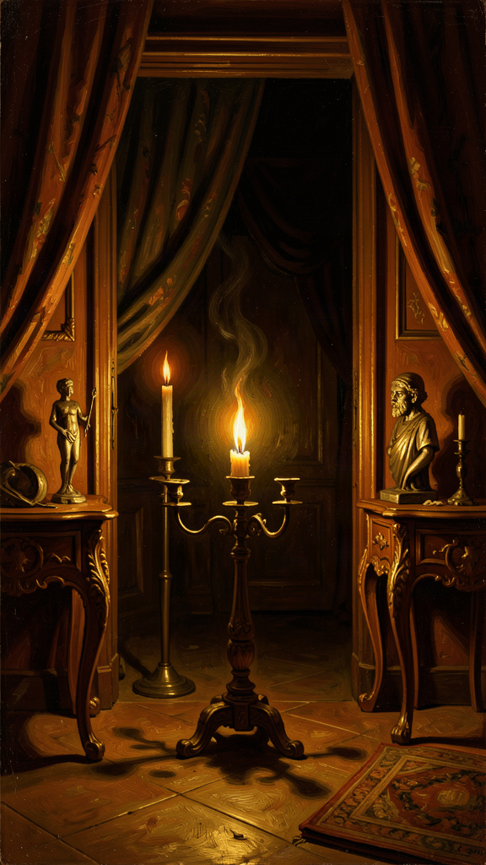
Illustration for Chapter 6

The Problem of Evil
The problem of evil is the oldest and most stubborn objection to the existence of a good and all-powerful God. It can be stated simply: if God is good, he wants to eliminate evil; if God is all-powerful, he can eliminate evil; but evil exists; therefore, either God is not good or God is not all-powerful.
This is the challenge that drove Augustine into Manichaeism. The Manichaean solution was elegant: there are two equal and opposite principles — Light (good) and Darkness (evil) — and the material world is the battlefield where they clash. Evil is not God's fault because God did not create it. Evil is an independent, coeternal force.
The problem with this solution is that it makes evil eternal and powerful. God is neither sovereign over all creation nor capable of defeating evil entirely. It also makes the physical world inherently corrupt, leaving no room for the claim that God created the world and called it good.
Augustine spent nine years as a Manichaean. When he finally left, it was because the system could not answer his questions. The decisive intellectual shift came when he encountered Neoplatonic philosophy and grasped the concept of privation.

Evil Is Not a Substance
The Neoplatonic insight was this: evil is not a substance. It is not a thing. It is the absence of good — the lack of good where good should be.
The analogy is a hole in a garment. A garment is a good thing — it has substance, form, function. A hole in the garment is not a thing. It has no being of its own. It is a deficiency, a corruption, a lack. The hole does not exist in the same way the garment exists. You cannot hold a hole. You cannot put a hole in a box. A hole is just — nothing, where something should be.
Similarly, darkness is not a substance. It is the absence of light. Silence is not a substance. It is the absence of sound. Blindness is not a substance. It is the absence of sight. Disease is not a substance. It is the absence of health. In each case, what we call "evil" is not a positive force that exists alongside good. It is the diminishment of good — a good thing that is not as good as it should be.
This resolves the problem of evil in one move: God did not create evil, because evil is not a thing that can be created. God created good things — substances, beings, forms, capacities — and evil is what happens when those good things are corrupted, misused, or directed away from their proper end. Evil is parasitic on good. It cannot exist on its own. A hole cannot exist without a garment. Darkness cannot exist without light to define it. Evil cannot exist without good to corrupt.

The Pear Tree Revisited
The doctrine of evil as privation is not merely a philosophical abstraction. It is the interpretive key to the pear tree theft.
"I loved my fall into sin. The fall itself was the motive. I loved the self-destruction, the fact that I was doing something that was forbidden." (*Confessions* II.4)
Augustine did not steal the pears because he was hungry. He did not steal them because they were valuable. He stole them for the sheer pleasure of transgression. This is evil as privation: the will turned away from its proper end (the good) and toward something that is not an end at all — the mere experience of choosing wrong.
But even here, evil is not pure negation. Augustine did not choose evil as evil. He chose a lesser good (the pleasure of transgression) over a greater good (obedience to the moral law). The act was evil because it was a choice to prefer a lesser good to a greater one — a distortion of the will's proper ordering, not a choice of a substance called "evil."
This is a crucial point. No one ever chooses evil as evil. We always choose what appears to us as good — even if it is a lesser good, a distorted good, or a good pursued in the wrong way. The pear tree theft is not an exception to this rule. It is the extreme case that reveals it. Augustine chose the "good" of transgression — the thrill of breaking the rules — over the good of obedience. The evil was not in the pears or in the theft itself. It was in the will's preference for a lesser good over the greater good.

Natural Evil
The doctrine of evil as privation handles moral evil (the will choosing wrong) straightforwardly. But what about natural evil — earthquakes, diseases, tsunamis, cancer? These are not the result of human choice. How can they be privations of good?
Augustine's answer: natural evil is the consequence of living in a fallen creation. The fall introduced corruption into the created order, with cascading effects. Earthquakes, diseases, and natural disasters are not evil in themselves. They are features of a physical world operating according to its own laws, which include decay, mutation, and catastrophe. These become "evil" only in relation to human beings who suffer from them.
This answer is not fully satisfying — and Augustine knew it. He does not claim to have solved the problem of natural evil. He claims to have shown that evil is not a substance that God created. Natural evil remains a mystery — a feature of a fallen creation that is not yet fully redeemed. The City of God argues that even natural disasters serve a purpose within God's providential plan, but Augustine is careful not to claim that he can see the purpose in every case.

The Scholarly Debate: Is Privation Coherent?
The privation theory of evil has been debated for sixteen centuries. The key objections:
The positive existence objection. Some scholars argue that the experience of suffering requires evil to have positive existence, not just absence. A torture victim's pain is not "just a hole." A genocide is not "just a privation." The privation theory, these critics say, does not take suffering seriously enough. It explains evil away rather than confronting it.
Augustine's defenders respond that the doctrine does not minimize suffering. A hole in a garment is a real hole — it causes real damage. Darkness is real to the person who cannot see. Disease is real to the person who is sick. The doctrine of privation does not say evil is unreal. It says evil is parasitic — it depends on good for its existence. This is not a dismissal. It is a reframing.
The natural evil objection. The privation theory handles moral evil well but struggles with natural evil. Are earthquakes and cancer really "privations"? Or are they features of a physical world that includes death and decay as part of its natural operation? If God designed a world with plate tectonics and cell mutation, then the suffering these cause is not a privation but a feature. Augustine's answer — that the fall corrupted the created order — presupposes a theological framework that not everyone shares.
The "evil as evil" objection. Augustine says no one chooses evil as evil. But the pear tree theft seems to be a counterexample: Augustine says he loved "the self-destruction, the fact that I was doing something that was forbidden." Is that not choosing evil as evil? Augustine's response is that even here, he chose a lesser good (the thrill of transgression, the feeling of freedom) over a greater good (obedience). The evil was in the disordering, not in the object chosen. But the case is genuinely difficult, and scholars continue to debate whether the privation theory can handle it.

Why This Matters
The doctrine of evil as privation has practical implications that go beyond theodicy:
1. It changes the question. Instead of asking "Why does God allow evil?" we ask "Why do good things get corrupted, and what can be done about it?" The first question leads to despair. The second leads to investigation, healing, and restoration.
2. It takes suffering seriously. A hole in a garment is a real hole. Darkness is real to the person who cannot see. Disease is real to the person who is sick. The doctrine does not minimize suffering. It reframes it.
3. It preserves God's goodness. God did not create evil. God created good things that are capable of being corrupted. The corruption is not God's doing.
4. It directs attention toward restoration. If evil is the absence of good, then the remedy is not the destruction of evil (you cannot destroy an absence) but the restoration of good. You do not fill a hole by attacking the hole. You fill it by restoring the garment. You do not cure blindness by attacking darkness. You cure it by restoring sight. This is why Augustine's theology of grace is fundamentally restorative — grace does not destroy the will. It heals it.

The Big Idea
Evil is not a thing. It is a hole — the absence of good where good should be. God did not create evil, because evil is not a thing that can be created. God created good things, and evil is what happens when those good things are corrupted, diminished, or turned away from their proper end. You do not fight evil by attacking it (you cannot attack a hole). You fight it by restoring the good that is missing. This is why grace heals rather than destroys — it fills the hole with what belongs there. The hardest question is whether this theory takes terrible things seriously enough. Augustine says it does — because a hole in a garment is real, and the person who feels it knows how real it is.

Practice
1. The privation test. Think of one "bad" thing in your life — a habit, a relationship problem, a character flaw. Instead of seeing it as a thing that exists, try to see it as the absence of something good. What good is missing? Is patience missing? Is honesty missing? Is love missing? Write one paragraph reframing the bad as a hole, and identifying what belongs in the hole. 2. The "no one chooses evil as evil" check. Augustine says nobody chooses evil knowing it is evil. We always choose what looks good to us. Think of a bad choice you have made. What did it look like to you at the time? What good were you actually going for? Does understanding the motive change how you think about the choice? Write one paragraph on the gap between what you chose and what you thought you were choosing. 3. The restore-not-destroy exercise. Think of a problem in your community — bullying, litter, loneliness, injustice. Instead of asking "How do we stop the bad?" ask "What good is missing?" Is kindness missing? Is respect missing? Is connection missing? Is justice missing? Write one paragraph on what you would restore, not what you would destroy. Does this change how you think about the problem? 4. The coherence challenge. The privation theory has been criticized for not taking terrible things seriously enough. Write one paragraph arguing either for or against this objection. Is genocide "just a hole"? Is torture "just an absence"? Or does the privation theory have resources for taking radical evil seriously? Use the scholarly debate (the positive existence objection, the natural evil objection) to frame your answer.

Reflect
Augustine says you fight evil not by attacking it but by restoring the good that is missing. You do not fill a hole by attacking the hole. You fill it by restoring the garment. If that is true, then the way you approach every problem in your life changes. Instead of asking "How do I destroy the bad?" you ask "What good is missing, and how do I bring it back?" What is one hole in your life that needs filling — and what good would you ask God to put back in?
———

For the Grown-Up Reader
This booklet engages readers ages 15-18 with six core ideas from Augustine of Hippo through narrative, philosophical analysis, scholarly debate, and practical exercises. Every quote is from Augustine's own writings — the Confessions (trans. Pine-Coffin or Chadwick), City of God (trans. Bettenson), On Free Will, On Grace and Free Will, and On the Predestination of the Saints (trans. Teske, New City Press).
The biographical framework follows Peter Brown's Augustine of Hippo: A Biography (1967, rev. 2000). The developmental question follows the scholarly debate between Brown (development), Rist (continuity), and Harrison (trajectory). The political theology debate follows Markus (Saeculum, 1970), Niebuhr, and Gregory. The privation theory follows On Free Will III and City of God XI.9, with the Neoplatonic background from Confessions VII.5–7. The analysis of time follows Confessions XI.14–31.
The scholarly debate paragraphs engage real disagreements in Augustinian scholarship: the theological-vs-psychological reading of cor inquietum (Hanby vs. O'Donnell), the Manichaean-influence critique of original sin (Pagels vs. Brown/Rist), the development question on free will (Brown vs. Rist vs. Harrison), the Christendom-vs-anti-political reading of the City of God (traditional vs. Niebuhr/Markus), the subjectivity debate on time (phenomenological vs. metaphysical readings), and the coherence objection to the privation theory (positive existence vs. parasitic evil). These debates are presented as open questions.
Readers who want to go deeper should consult Chadwick's Augustine: A Very Short Introduction (Oxford, 2001), Wills's Saint Augustine (Penguin Lives, 1999), and the Cambridge Companion to Augustine (ed. Stump and Kretzmann, 2001). The Confessions in Chadwick's Oxford translation is the recommended primary text. Peter Brown's biography is essential for historical context.
Note on sensitive content: Chapters 2 and 3 engage with Augustine's struggle with sexual self-control, presented through his framing of the divided will and the prayer "Give me chastity, but not yet." The sexual dimension is acknowledged honestly but not sensationalized. The predestination discussion raises the question of divine fairness, presented as a genuine theological difficulty. The political theology chapter engages with Augustine's endorsement of coercion against the Donatists as a genuine moral problem in his legacy. Readers should be prepared to wrestle with these tensions rather than expecting them to be smoothed over.
———

About WisdomForge
WisdomForge creates age-adapted booklets that bring the world's greatest thinkers to readers of every age. Each figure gets four booklets — one for elementary ages (5-10), one for middle school (11-14), one for high school (15-18), and one for adults. The same ideas, the same thinker, the same wisdom — shaped for how you grow. Read it. Question it. Talk about it. The search for wisdom starts here.

