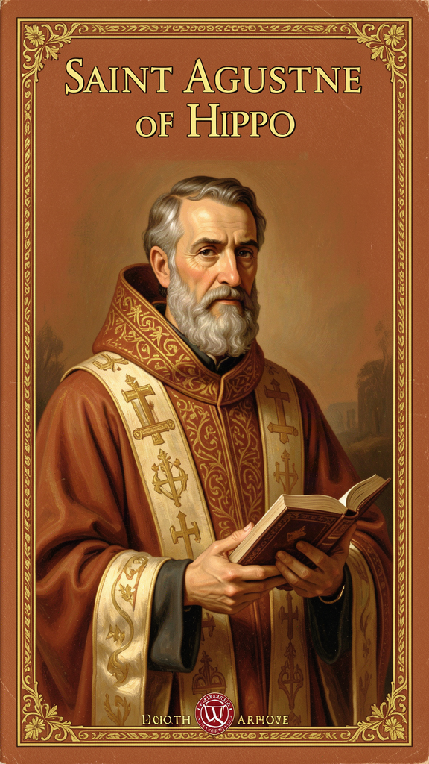
The Restless Bishop: Augustine's Search for Truth
WisdomForge Booklet — Ages 11-14

The Restless Bishop: Augustine's Search for Truth

WisdomForge Booklet — Ages 11-14
———

About This Book
Augustine of Hippo was born in 354 CE in a small North African town called Tagaste, in what is now eastern Algeria. He was not a saint when he was young. He was a brilliant, restless, complicated person who spent thirty-three years searching for the truth before he found it — or rather, before it found him.
This book tells the story of that search through six of Augustine's biggest ideas. You will follow him from a dusty provincial schoolroom to the greatest city in the Roman world. You will meet his mother Monica, who prayed for him every day for seventeen years. You will read about the pears he stole for no reason, the friend whose death nearly destroyed him, the nine years he spent in a religion he later rejected, and the moment in a garden when a child's voice changed everything.
Augustine was not a philosopher in the way the ancient Greeks were. He was a bishop, a preacher, a memoirist, and a theologian. His ideas do not sit in neat boxes — they mix together, because his life and his thinking were the same thing. He wrote the first real autobiography in Western history, the Confessions, as an extended prayer addressed directly to God. He wrote the City of God, one of the longest single-author works to survive from antiquity, while the Roman Empire was collapsing around him.
The six chapters cover: the restless heart (why we always want more), original sin and grace (why we do wrong even when we know better), free will and predestination (the hardest question Augustine ever wrestled with), the two cities (what you love most decides who you are), time and creation (what time actually is), and evil as privation (why bad is not a thing).
Each chapter has a story, a big idea, something to try, questions to talk about, and a question to carry with you. You do not need to read them all at once. Read one. Think about it. Come back for the next.
———

Chapter 1: The Restless Heart — Why Nothing Was Ever Enough
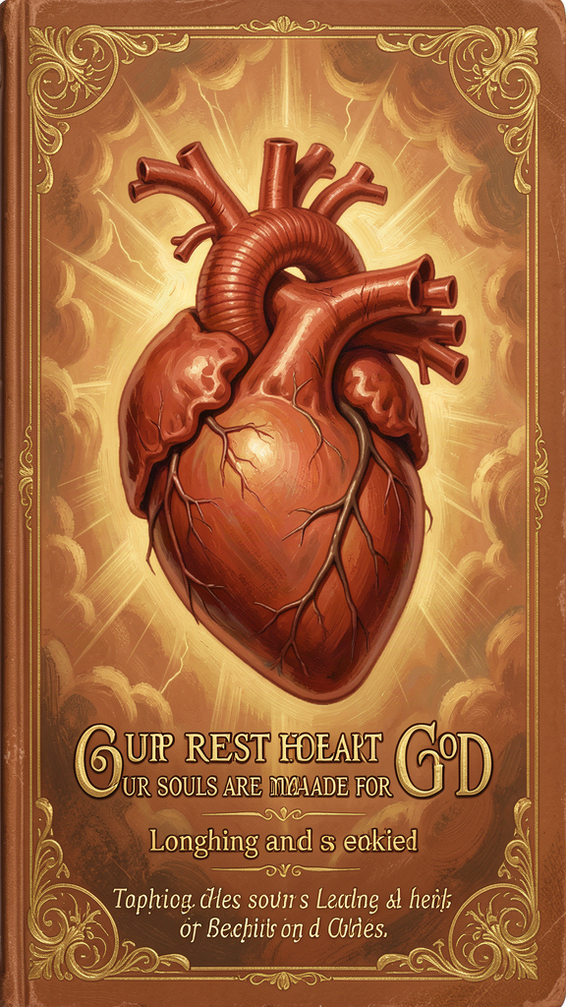
Illustration for Chapter 1
Augustine was the smartest kid in his town. Everyone said so. His father, Patricius, scraped together every penny he could find to send the boy to the best schools, because he could see that Augustine had a gift for words that would take him far. His mother, Monica, prayed for him every single day — partly because she wanted him to succeed, but mostly because she wanted him to find God.
Augustine did not want God. He wanted wisdom. He wanted fame. He wanted pleasure. He wanted, above all, to understand the world — and he wanted the world to know his name.
When he was nineteen, he read a book called Hortensius, by the Roman philosopher Cicero. The book is lost now — nobody has read it for over a thousand years — but Augustine says it "changed my affections and turned my prayers toward you, Lord" (Confessions III.4). Cicero argued that the pursuit of wisdom — sapientia — was the highest calling a human being could have. The book lit a fire in Augustine that never went out. He wanted truth the way a starving person wants bread.
But Cicero's book also sent him in the wrong direction. Because it was not a Christian book, it pointed him away from the Bible — which, when Augustine tried to read it, seemed crude and simple compared to Cicero's polished Latin — and toward a religion called Manichaeism, which claimed to explain the problem of evil through an elaborate system of two warring cosmic powers, Light and Darkness. Augustine spent nine years as a Manichaean "hearer" before he realized the system could not answer his questions.
He tried other things too. He became the most celebrated public speaker in the Roman Empire — the equivalent, in his world, of a celebrity. He held the chair of rhetoric in Milan, the imperial capital. He lived with a woman he loved for fifteen years and had a son named Adeodatus, "Given by God." He had friends, students, reputation, money.
And none of it was enough.
That is the key to understanding Augustine. He did not fail at the things he tried. He succeeded at them, spectacularly, and found them empty. The fame was real. The pleasure was real. The intellectual achievement was real. But there was a hole inside him that none of it could fill. He writes about it with an honesty that still feels modern:
"You have made us for yourself, O Lord, and our hearts are restless until they rest in you." (*Confessions* I.1)
This is not a complaint. It is a diagnosis. Augustine is saying that the restlessness itself is not a malfunction — it is a compass. The hunger is not a design flaw. It is a signal. We were made for something the world cannot give, and the constant wanting is the proof. Every time you get what you thought you wanted and still want more, that is the restless heart telling you that you were made for something bigger.
The Neoplatonic philosophers Augustine later read — Plotinus and Porphyry — had a similar idea. They taught that the soul emanates from a supreme principle (the One) and is restless until it returns. Augustine transformed this idea in three ways: the One became a personal God who knows you by name; the return required grace, not just philosophical effort; and the return happened through history — through real events like a child's voice in a garden, not through abstract contemplation.
Augustine's restless heart is not a theory. It is his life. He tried everything, succeeded at most of it, and kept moving. The movement was the point. The restlessness was not something to be cured. It was something to be followed — all the way to its source.

Big Idea
The restlessness you feel — the sense that something is always missing, that what you have is never quite enough — is not a flaw in you. It is a compass. You were made for something the world cannot give, and the wanting is the proof. Augustine tried fame, pleasure, philosophy, success, and friendship. All were real goods. None was enough. The hunger points beyond all of them.

Try This
1. The wanting map. Make a list of five things you have wanted badly in the last year — a game, a grade, a friendship, a skill, an experience. For each, write what happened when you got it (or did not). Did the wanting stop? Did a new wanting replace it? Look for the pattern Augustine saw. 2. The compass check. For one week, every time you feel the "I want more" feeling, write down what triggered it. Was it seeing something? Feeling bored? Comparing yourself to someone? At the end of the week, look at your list. What is your restless heart actually pointing toward? 3. The lesser-goods test. Augustine said earthly goods are not bad — they are just not enough. Think of one good thing in your life that you enjoy. Ask: "Is this a gift I am grateful for, or have I made it the thing I live for?" The difference matters.

Talk About It
1. Augustine tried fame, pleasure, philosophy, and success, and none of it filled the hole. Do you think this is true for everyone, or was Augustine just unusually hard to satisfy? Are there people who seem genuinely content with ordinary things? 2. "Our hearts are restless until they rest in you." If you are not a Christian, what do you think Augustine's restlessness is pointing toward? Can the same idea work with a different destination — truth, justice, meaning, connection? 3. Augustine read Cicero's Hortensius at nineteen and it changed his life. Have you ever read a book, heard a song, or seen something that lit a fire in you the way Cicero's book lit one in Augustine? What was it?
———
What is your restless heart pointing toward right now — and have you been looking in the right places?
———

Chapter 2: Original Sin and Grace — The Wound and the Cure
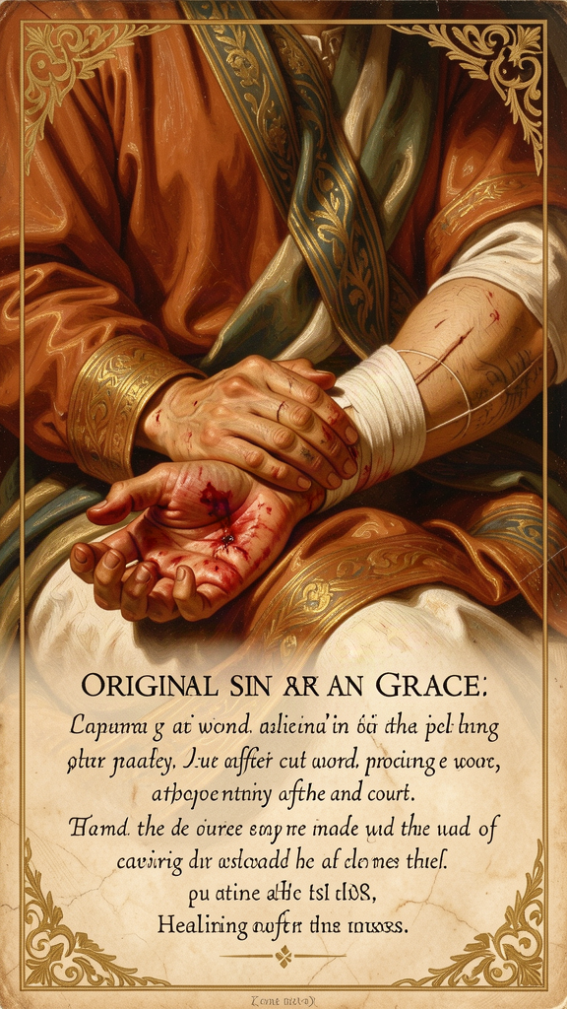
Illustration for Chapter 2
When Augustine was sixteen, he did something that haunted him for the rest of his life. He stole some pears.
That does not sound like much. But Augustine could not stop thinking about it, and he wrote an entire chapter about it in the Confessions. Here is what bothered him: he did not steal the pears because he was hungry. He had better pears at home. He did not steal them to sell. He and his friends threw most of them to the pigs.
"I loved my fall into sin. The fall itself was the motive. I loved the self-destruction, the fact that I was doing something that was forbidden." (*Confessions* II.4)
He stole them for the thrill of breaking a rule. And that, Augustine realized, is the deepest mystery of being human. We do wrong — not because we have to, not because we are forced, not because we do not know better — but because part of us wants to. The will is not just weak. It is bent. It leans toward the wrong thing even when the wrong thing gives us nothing.
Augustine called this original sin. He did not invent the idea — the Apostle Paul had written about it centuries earlier — but Augustine was the one who built it into a complete theory of human nature. His argument has three parts:
The Fall. The first human beings were created good, with free will intact. They chose to turn away from God toward themselves. That was the first sin.
The Consequence. The consequence of that choice was a damage that extends to every part of human nature. The will, which was previously free to choose good or evil, is now inclined toward evil. The mind is clouded by pride. The emotions are disordered — we love created things more than the Creator. We still choose, but our choosing is weighted toward wrong.
The Inheritance. This damage is inherited. Every human being is born with a will that is bent — not destroyed, but damaged. You did not choose to be this way. Nobody did. But here we all are.
This sounds grim, but Augustine was very careful about one thing: original sin does not mean human beings are as bad as they could possibly be. The image of God in human beings is not erased. It is cracked — like a mirror that still reflects, but the reflection is distorted. People who do not believe in God can still be brave, fair, honest, and kind. Augustine called these "splendid vices" — genuine goods pursued for the wrong reasons, or goods that do not lead to their proper end.
The cure for original sin is grace. Grace is God's unmerited favor — the initiative by which God acts on the human will to enable it to choose the good. This is not a helping hand extended to someone who is already reaching up. It is the hand that reaches down into the pit and pulls the person out before they know they need rescuing.
Augustine's famous prayer captures the whole idea:
"Give what you command, and command what you will." (*Confessions* X.29)
He is saying: "God, you tell me to be good. Now give me the power to do it." He knew that willpower alone was not enough. He had tried it. He had been one of the most intelligent and disciplined people in the Roman world, and he could not stop doing what he knew was wrong. The problem was not in his brain. It was in his will. And the will needed healing, not just information.
This idea got Augustine into the biggest fight of his life. A British monk named Pelagius taught that human beings could be good through their own effort — that grace was helpful but not necessary, that the will was not really damaged, and that a person could, in principle, live without sin. Augustine responded that this was not a minor disagreement but a denial of the gospel itself. If humans can save themselves by effort, Christ died for nothing. The debate raged for twenty years and was settled (in the West) by the Council of Carthage in 418 CE, which condemned Pelagianism and affirmed Augustine's position.
The debate did not end there. It continued through the medieval period, flared again in the Reformation, and persists today in every argument about how free we really are. The fundamental question — How much can we fix ourselves, and how much do we need help from outside? — is as alive now as it was in 415 CE.

Big Idea
We all have a wound in the part of us that chooses — the will. The wound makes us want the wrong thing even when we know better. We did not cause the wound and we cannot cure it by trying harder. The cure comes from outside us — grace, God's love reaching down to heal what we cannot heal ourselves. This is not a denial of human goodness. It is an honest acknowledgment that our goodness is damaged, and damaged things need a healer.

Try This
1. The gap exercise. Think of one thing you know you should do but keep not doing — study, exercise, be patient with a sibling, put your phone away. Write it down. Now write: "I know I should do this. I have not done it. Why?" Augustine says the gap between knowing and doing is not about information. It is about the will. What does your gap tell you about your will? 2. The "splendid vices" hunt. Augustine said people can do good things for the wrong reasons. Can you think of one example from your own life or from someone you know? A good action done for selfish reasons? What makes the reason "wrong" if the action itself is good? 3. The grace experiment. Augustine's prayer — "Give what you command, and command what you will" — is a way of admitting you cannot do it alone. Try praying it (or saying it) every morning for one week about one specific thing you are struggling with. Notice whether admitting you need help changes anything. 4. The pear-tree journal. Augustine spent pages analyzing why he stole pears. Write one page analyzing something you did wrong recently — not to punish yourself, but to understand the motive. What did you actually want? Was it the thing itself, or the thrill of breaking a rule, or the approval of the group?

Talk About It
1. Augustine said the will is damaged — not destroyed, but bent. Do you think that is true? Is there evidence in your own experience that people know what is right but cannot consistently do it? 2. Pelagius said people can be good through their own effort. Augustine said they cannot — they need grace. Who do you think is closer to right? Is there a middle position? 3. "I loved my fall into sin. The fall itself was the motive." Augustine is saying he chose wrong because he wanted to break a rule, not because he wanted the pears. Have you ever done something wrong purely for the thrill of it? What does that tell you about human nature?
———
If the will is wounded and cannot cure itself, where does the healing come from — and what does it look like when it arrives?
———

Chapter 3: Free Will and Predestination — The Paradox of Choice
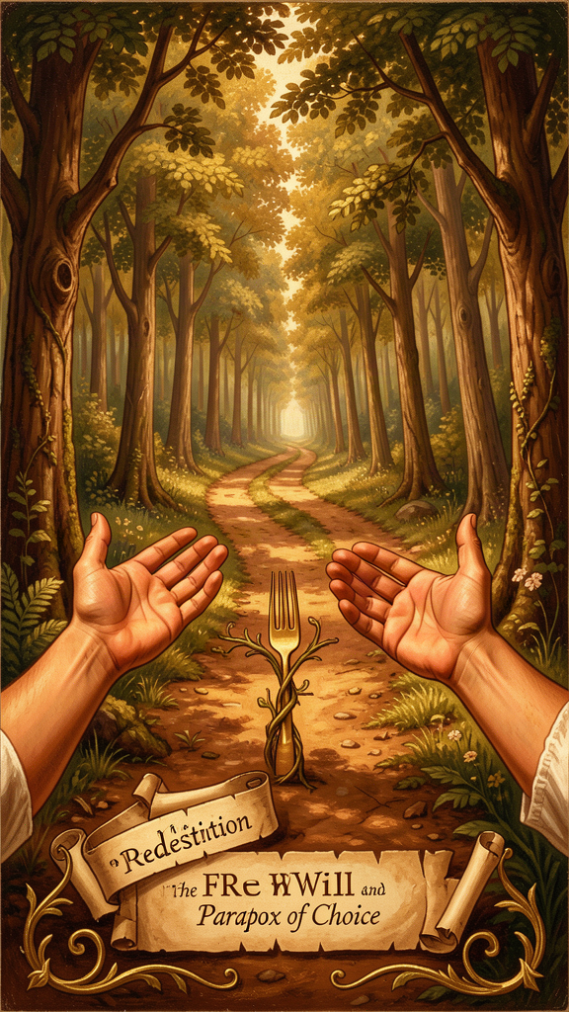
Illustration for Chapter 3
By the time Augustine was thirty-two, he was intellectually convinced that Christianity was true. He had read the Platonists. He had listened to Bishop Ambrose preach in Milan. He understood the arguments. He believed.
But he could not commit.
He was stuck. He knew what he should do — give up his career, his sexual relationships, his ambition, and live for God. He wanted to do it. But part of him did not want to. And the two parts fought each other in his own mind.
"The mind commands the body, and the body obeys at once. The mind commands itself, and is resisted." (*Confessions* VIII.9)
This is one of the most important passages in the history of psychology. Augustine is describing what philosophers call akrasia — weakness of will, the gap between knowing and doing. He is not saying he lacked information. He had plenty of information. He is saying he lacked the power to act on what he knew. The will was divided — not into two separate wills, but into one will torn apart by competing desires.
The resolution came in a garden in Milan. Augustine had withdrawn with his friend Alypius to wrestle with his conscience. He was weeping under a tree when he heard a child's voice:
"Take up and read. Take up and read." (*Confessions* VIII.12)
He picked up a copy of Paul's letters that lay nearby. He opened it at random and read: "Put on the Lord Jesus Christ, and make no provision for the flesh, to gratify its desires" (Romans 13:14). The paralysis broke. "No further words did I require. At the end of the sentence, it was as if a light of utter confidence shone in my heart" (Confessions VIII.12).
The key to this story is not Augustine's decision. It is the fact that the decision was not entirely his own. He had been trying to choose for years and could not. Something outside him intervened — a child's voice, a random page, a sentence that happened to be exactly what he needed. Augustine called this grace. And the more he thought about it, the more he realized that grace was not just a one-time gift. It was the foundation of every good choice he would ever make.
This led Augustine to the hardest question he ever wrestled with: If grace is necessary for every good choice, and God decides who receives grace, then what about the people who do not receive it?
Augustine's early work, On Free Will (388–395 CE), had been optimistic. He argued that free will was the solution to the problem of evil: God gave human beings freedom because freedom is necessary for love, and a creature that cannot choose cannot love. Evil is the misuse of a good gift. This position sat comfortably alongside the Stoic emphasis on what is "in our power."
But decades of pastoral experience changed his mind. As a bishop, he watched people know what was right and fail to do it, over and over. He watched them repent and fall back into the same patterns. He watched his own will fail him in the garden. Free will was real, yes — but free to do what? Free to choose among created goods, yes. Free to choose God without God's prior action? Increasingly, Augustine thought not.
The Pelagian controversy forced the question into the open. Pelagius taught that humans could choose good without grace. Augustine responded that grace was absolutely necessary — not helpful, not supplementary, but essential. The logic went like this:
1. All human beings are born with a damaged will (original sin). 2. Grace is necessary for every good choice, including the first movement toward God. 3. Grace is given by God, not earned by human merit. 4. Therefore, God chooses whom to save. This is the doctrine of election. 5. The question of those not chosen remains open. Augustine never explicitly affirmed double predestination (God choosing some for damnation), but the logic of his position makes it difficult to avoid.
The tension is this: grace does not override the will. It heals it. The will that receives grace does not lose its freedom. It gains the freedom it previously lacked — the freedom to choose God. Before grace, the will is free to choose among created goods but not free to choose the Creator. After grace, it is free to choose both.
This is a subtle argument, and it has been read in two different ways for sixteen centuries. The Augustinian and Reformed (Protestant) reading says grace is necessary and effective. God's choice precedes human choice. The Catholic reading says grace is necessary but not irresistible — God offers it, and human beings can accept or reject it. Both readings claim Augustine. Both have textual support. The tension is not a flaw in his argument. It is a genuine dilemma that arises whenever you affirm both divine sovereignty and human freedom.
Peter Brown, Augustine's greatest modern biographer, argues that the development is real but not a contradiction. Augustine always believed in free will. What changed was his estimate of how much freedom the damaged will retains. The early Augustine thought free will was sufficient to choose good. The late Augustine, confronted by the Pelagian controversy and his own experience, concluded that the will is too damaged to reach toward God on its own. It is still free. It just cannot get there from here.

Big Idea
Human beings are genuinely free, but our freedom is damaged. We can choose among the things the world offers. We cannot choose God without God's prior help. Grace does not override our will — it heals it, expanding our freedom to include the one choice we could not make on our own. The hardest part of this idea is what it implies about the people who do not receive grace. Augustine never fully resolved that tension, and it has generated sixteen centuries of debate.

Try This
1. The divided-will diary. For three days, notice moments when your will is divided — when part of you wants to do one thing and part of you wants another. Write each one down. At the end of three days, look at the pattern. What do your divisions have in common? What does it feel like when the will is torn? 2. The akrasia experiment. Augustine said the gap between knowing and doing is not about information but about will. Test this: pick one thing you know you should do. You already know it is good. You already know how to do it. The problem is not knowledge. What is it? Write one paragraph naming the real obstacle. 3. The "give what you command" prayer. Augustine's prayer admits that willpower is not enough. Try it for one week, directed at one specific struggle. Each morning, say: "God, give me the power to do what you command." Notice whether the admission of need changes anything — not magically, but honestly. 4. The garden reenactment. Read Confessions VIII.8–12 (the garden conversion scene) in any translation. Write down the three things that broke Augustine's paralysis: the child's voice, the opened book, the specific sentence. Notice that all three came from outside him. Grace arrived through the simplest possible channels.

Talk About It
1. If God has already chosen who will be saved, how can human beings be genuinely free? Augustine says grace heals the will rather than overriding it. Does that answer satisfy you, or does it just move the problem? 2. Augustine changed his mind about free will over the course of his life. The young Augustine was optimistic; the old Augustine was more pessimistic. Is changing your mind a sign of growth or inconsistency? Which Augustine do you find more convincing? 3. The garden conversion — a child's voice saying "take up and read" — broke years of paralysis. Do you think moments of breakthrough are always prepared by long struggle, or can they really come out of nowhere? Has anything like that ever happened to you?
———
If your will is free but damaged, what is the one thing you cannot choose on your own — and what would it take to finally choose it?
———

Chapter 4: The Two Cities — What You Love Most Decides Who You Are
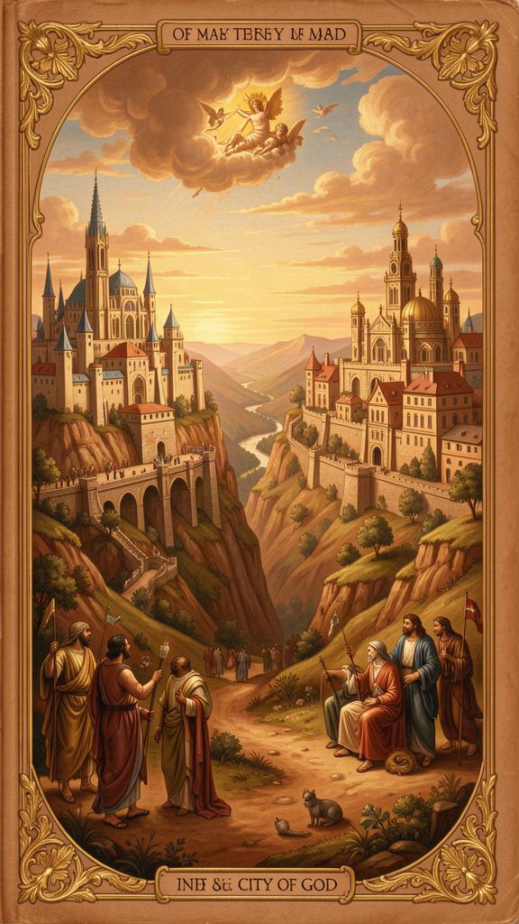
Illustration for Chapter 4
In the year 410 CE, something unthinkable happened. An army of Visigoths under King Alaric breached the walls of Rome and spent three days looting the city. Rome had not been sacked by a foreign army for nearly eight centuries. It was the "eternal city," the heart of civilization, the center of the world. Its fall sent shockwaves through the entire Roman Empire.
Pagans blamed the Christians. The old gods had protected Rome for a thousand years, they argued. Christianity had abandoned those gods. The new God had not protected the city. Therefore Christianity was to blame.
Augustine had to answer. He thought about it for years. Between 413 and 426, he wrote the City of God — twenty-two books of theology, philosophy, political theory, and cultural criticism. It is one of the longest single-author works to survive from antiquity, and one of the most influential books ever written.
The central idea is simple and profound. There are two cities — not two cities on a map, but two communities defined by what they love most:
"Two loves, then, have made two cities: love of self reaching even to contempt of God, the earthly; and love of God reaching even to contempt of self, the heavenly." (*City of God* XIV.28)
The City of God (civitas Dei) is the community of those who love God above all else. Their primary citizenship is not in any country but in the kingdom of heaven. Their peace is not the absence of conflict but tranquillitas ordinis — the tranquility of order, the right relationship of all things to each other and to God.
The City of Man (civitas terrena) is the community of those who love themselves above all else. This does not mean they are uniformly wicked. Augustine explicitly says that pagans can display genuine virtues — courage, justice, temperance, prudence. But these virtues are compromised by their motive. The Roman who fights bravely in battle may be driven by libido dominandi — the lust for domination and glory — rather than by love of justice. These are "splendid vices" — beautiful in appearance, hollow at the core.
The most important thing Augustine says about the two cities is that they are intermingled. You cannot point to a country and say "That is the City of God." You cannot point to a government and say "That is the City of Man." Both cities coexist in every nation, every town, every church, every human heart. The visible church contains members of both cities. People outside the church may, by God's grace, belong to the City of God. The distinction is invisible. Only God can draw the line.
Augustine's most devastating critique of the City of Man centers on libido dominandi — the lust for domination. Rome, he argues, was built on this lust. The Roman Republic was not a community of free citizens governing themselves. It was a community of free citizens governing others — slaves, subject peoples, conquered nations. The Empire was the Republic scaled up: more territory, more subjects, more domination. The virtues of Rome were real, but they served domination. The Roman who fought bravely fought for glory. The Roman who governed justly governed for praise. The good was real. The motive was self.
This critique is not limited to Rome. Augustine is describing a permanent feature of human political life. Every empire, every nation, every institution that pursues power for its own sake is an expression of the City of Man. The specific form changes — Rome, Babylon, the British Empire — but the underlying orientation is the same.
But Augustine does not despise earthly peace. He says explicitly that earthly peace is better than war, that just laws are better than unjust ones, that good government is better than bad government. The peace of the City of Man — pax terrena — is a genuine good. It is just not ultimate. It is fragile, temporary, and always mixed with injustice.
The peace of the City of God — pax aeterna — is eternal. It is not yet fully present on earth. It is present in foretaste — in moments of genuine communion, in the life of the church, in the love between friends. But it will not be fully realized until the end of history.
Augustine's framework has shaped Western political thought for 1,600 years. If no state is the City of God, then no state can claim ultimate authority. This is one of the deep roots of limited government and the separation of church and state. If human beings are created for God, their dignity transcends political order. If every institution contains elements of both cities, no institution can be trusted absolutely.

Big Idea
There are two invisible cities, and they are inside every heart. One loves God most. One loves itself most. They are not nations or governments or churches — they are orientations of love. Both coexist in every community and every person. The question is not where you live on a map but what you love most in your heart. Empires built on the lust for domination always fall. The City of God endures because it is built on love, not power.

Try This
1. The love audit. Augustine says the two cities are distinguished by what they love most. For one week, pay attention to what drives your choices. Are you acting from love of God and others (caritas), or from love of yourself (cupiditas)? You do not have to be harsh — just honest. Write down one example per day. 2. The splendid-vice search. Can you identify a "splendid vice" in the world around you — a good action done for a self-serving motive? A brave act done for glory? A generous act done for recognition? What makes the motive wrong if the action is good? 3. The empire test. Augustine said empires built on the lust for domination always fall. Can you think of an empire or institution in history (or today) that fits Augustine's description? What happened to it? Does the pattern Augustine identified still hold? 4. The dual-citizen journal. Augustine says Christians are dual citizens — of the City of God by faith and of the City of Man by birth. They owe allegiance to both, but ultimate allegiance to God. Write about one situation in your life where these two citizenships create tension. How do you navigate it?

Talk About It
1. "Remove justice, and what are kingdoms but gangs of criminals on a large scale?" (City of God IV.4). What do you think Augustine means? Is any government without justice just a powerful gang? What would "justice" have to look like for a government to be legitimate? 2. Augustine says the two cities are mixed together in every person. Can you see both cities in yourself? Which one is dominant right now? 3. If no earthly political order is the City of God, should people of faith even participate in politics? Or does the two-cities framework demand engagement without idolatry — working for justice without expecting any system to be perfect?
———
What does your life love most — and which city is that love building?
———

Chapter 5: Time and Creation — What Was God Doing Before Creation?
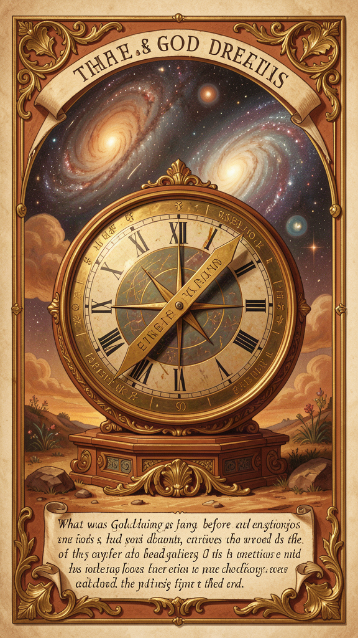
Illustration for Chapter 5
In Book 11 of the Confessions, Augustine does something unexpected. He stops telling his life story. He has finished the narrative (Books 1–9), examined his present condition (Book 10), and now he turns to a question that seems to come from nowhere:
"What then is time? If no one asks me, I know what it is. If I wish to explain it to someone who asks, I do not know." (*Confessions* XI.14)
This is not a rhetorical flourish. It is a precise description of a genuine puzzle. Time is the most familiar thing in the world — we live in it, measure it, organize our lives around it — and yet the moment we try to say what it is, it vanishes. Every philosopher who has tackled the question — Aristotle, Newton, Kant, Bergson, Heidegger — has found the same thing: time resists explanation.
Augustine's analysis proceeds in stages, and each stage is more unsettling than the last.
The past does not exist. Yesterday is gone. You cannot touch yesterday. You cannot visit last week. The past has passed away. When we speak of "the past," we are not referring to something that currently exists. We are referring to something that was but is no longer. But if the past does not exist, how can we remember it?
Augustine's answer: we do not remember the past itself. We remember images of the past that exist in the present. Memory is not a window onto something that still exists somewhere. It is a faculty that produces images of things that no longer exist and holds them in the present mind.
The future does not exist. Tomorrow has not arrived. Next year is not here. The future is not yet. When we speak of "the future," we are not referring to something that currently exists. We are referring to something that will be but is not yet. But if the future does not exist, how can we anticipate it?
Augustine's answer: we do not anticipate the future itself. We anticipate signs of the future that exist in the present. Expectation is not a window onto something that already exists ahead of us. It is a faculty that produces images of things that do not yet exist and holds them in the present mind.
The present is vanishingly thin. If the past does not exist and the future does not exist, then only the present exists. But how long does the present last? A year? No — a year includes months that are past and months that are future. A month? A day? An hour? A second? However thin you slice it, the present can always be divided into a part that has just passed and a part that has not yet arrived. The present, strictly speaking, is a knife-edge — a durationless instant between two nothings.
And yet we experience duration. We hear a melody, and we hear it as a continuous whole, not as a series of isolated instants. How is this possible if only the present exists?
Time is a function of consciousness. Augustine's answer is one of the most original claims in the history of philosophy. Time is not an external container within which events occur. It is something the mind does — through three faculties:
- Memory (memoria): the mind's retention of what has passed. - Attention (attentio): the mind's focus on what is happening now. - Expectation (expectatio): the mind's anticipation of what is to come.
All three are present activities. Memory is not the past — it is a present act of remembering. Expectation is not the future — it is a present act of anticipating. Attention is not the present passing by — it is a present act of attending. Time, for Augustine, is the mind's way of stretching itself across what no longer exists, what does exist, and what does not yet exist.
This analysis anticipates Edmund Husserl's phenomenology of internal time-consciousness by roughly fifteen centuries. Husserl's distinction between retention (memory of what has just passed), primal impression (the present moment), and protention (anticipation of what is about to come) is essentially Augustine's distinction between memory, attention, and expectation, developed with greater philosophical precision.
God is outside time. If time is a creature — something God made along with the universe — then God exists outside time, in an eternal present that has no before or after. God does not "foresee" our actions in the sense of looking ahead at a future that already exists. God sees all moments simultaneously, in an eternal present. Our future is not predetermined because God sees it. It is simply seen from a perspective that transcends time.
This also means God does not "remember" the past or "anticipate" the future. For God, all moments are equally present. The incarnation, the crucifixion, the resurrection — these are not past events that God recalls. They are eternally present to God's awareness.
This connects to the restless heart. If the heart is made for God, and God exists outside time, then the restlessness we experience in time is structural. We are stretched between a past that no longer exists and a future that does not yet exist, and the present is a knife-edge we cannot hold. We are always losing what we have and reaching for what we do not yet have. This is the shape of restlessness: the self stretched across time, unable to rest in any single moment, because every moment vanishes as it arrives.
Augustine's answer is not to escape time but to orient it. Memory can remember God. Attention can attend to God. Expectation can anticipate God. When these three faculties are directed toward the God who exists outside time, time itself becomes a form of worship.
The famous joke question — "What was God doing before creation?" — gets a famous Augustinian answer. Augustine says the question is malformed. There was no "before" creation, because time itself is part of creation. You cannot ask what happened before time, because "before" is a word that only makes sense inside time. It is like asking what is north of the North Pole. The question sounds reasonable but has no answer, because it assumes a framework that does not apply.

Big Idea
Time is not a container you live inside. It is something your mind does — remembering what is gone, attending to what is here, expecting what is coming. The past does not exist. The future does not exist. The present is vanishingly thin. And yet we experience duration because the mind stretches itself across all three. God is outside time, seeing all moments at once. The restlessness we feel in time is structural — we are always losing and reaching — but when we orient memory, attention, and expectation toward God, time becomes a form of worship.

Try This
1. The present hunt. Sit still and try to catch "right now." How long does it last before it becomes "just now" — the past? Try to find the exact edge between now and then. You cannot. Write one paragraph about what that tells you about time. 2. The melody experiment. Listen to a song you know well. Notice how your mind holds the notes that have passed (memory), attends to the note playing now (attention), and anticipates the notes coming next (expectation). All three are happening at once. That is Augustine's theory of time, happening inside your head right now. 3. The time orientation check. Augustine says we can orient memory, attention, and expectation toward God or away from him. Which of the three dominates your life right now — are you living in the past (memory), the present (attention), or the future (expectation)? What would it mean to orient all three toward God? 4. The "before creation" test. Try to imagine what existed before the universe. If you find yourself imagining empty space, you are imagining space — which is part of the universe. If you imagine waiting, you are imagining time — which is also part of the universe. Augustine's point: you cannot get outside creation using the tools creation gave you. Write about what that feels like.

Talk About It
1. If the past does not exist and the future does not exist, does only the present exist? And if the present has no duration — if it is a knife-edge between two nothings — then does anything exist at all? What is Augustine's way out of this? 2. Augustine says time is a function of consciousness. Does that mean time is subjective? If there were no conscious beings, would time still exist? How does this compare to what physics says about time? 3. "What was God doing before creation?" is a malformed question, Augustine says, because time did not exist before creation. Does that answer satisfy you? Can you think of a better question to ask about what came "before" the universe?
———
If time lives in your mind — in memory, attention, and expectation — which of the three is running your life right now, and what would it mean to aim all three at God?
———

Chapter 6: Evil as Privation — Darkness Is the Absence of Light
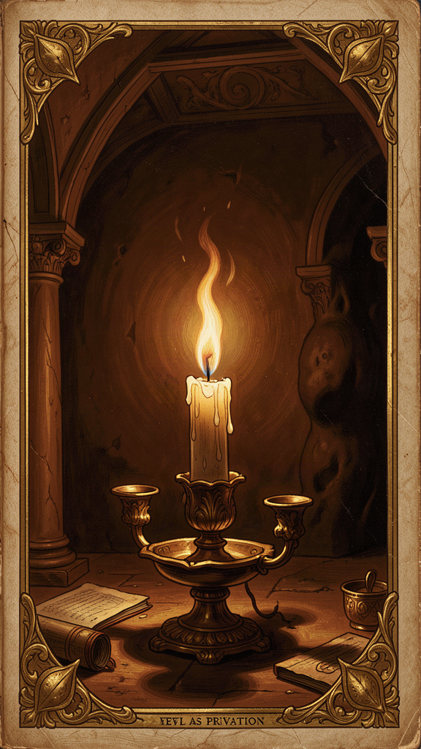
Illustration for Chapter 6
For nine years, Augustine was a Manichaean. The Manichaeans taught that the universe was a battlefield where two equal and opposite powers — Light (good) and Darkness (evil) — fought for control. The material world was the battlefield. The human body was a prison of darkness. Salvation meant liberating the particles of light trapped in matter through ascetic practice and secret knowledge.
This solved the problem of evil in one stroke. God is not responsible for evil because God did not create it. Evil is an independent, coeternal force. But the solution had a cost: it made evil eternal and powerful, which meant God was neither sovereign over all creation nor capable of defeating evil entirely. It also made the physical world inherently corrupt, which left no room for the claim that God created the world and called it good.
Augustine drifted away from Manichaeism over several years. The decisive intellectual shift came when he encountered Neoplatonic philosophy — probably through Latin translations of Plotinus by the Roman senator Marius Victorinus — and grasped the concept of privation.
The Neoplatonic insight was this: evil is not a substance. It is not a thing. It is the absence of good — the lack of good where good should be.
The analogy Augustine uses is a hole in a garment. A garment is a good thing — it has substance, form, function. A hole in the garment is not a thing. It has no being of its own. It is a deficiency, a corruption, a lack. The hole does not exist in the same way the garment exists. You cannot hold a hole. You cannot put a hole in a box. A hole is just — nothing, where something should be.
Similarly, darkness is not a substance. It is the absence of light. Silence is not a substance. It is the absence of sound. Blindness is not a substance. It is the absence of sight. Disease is not a substance. It is the absence of health. In each case, what we call "evil" is not a positive force that exists alongside good. It is the diminishment of good — a good thing that is not as good as it should be.
This resolves the problem of evil in one move: God did not create evil, because evil is not a thing that can be created. God created good things — substances, beings, forms, capacities — and evil is what happens when those good things are corrupted, misused, or directed away from their proper end. Evil is parasitic on good. It cannot exist on its own. A hole cannot exist without a garment. Darkness cannot exist without light to define it. Evil cannot exist without good to corrupt.
The pear tree theft is the personal illustration. Augustine did not steal the pears because he was hungry. He did not steal them because they were valuable. He stole them for the sheer pleasure of transgression. But even here, evil is not pure negation. Augustine did not choose evil as evil. He chose a lesser good (the thrill of transgression) over a greater good (obedience to the moral law). The act was evil because it was a choice to prefer a lesser good to a greater one — a distortion of the will's proper ordering, not a choice of a substance called "evil."
No one ever chooses evil as evil. We always choose what appears to us as good — even if it is a lesser good, a distorted good, or a good pursued in the wrong way. The pear tree theft reveals the rule: Augustine chose the "good" of transgression — the thrill of breaking the rules — over the good of obedience. The evil was not in the pears or in the theft itself. It was in the will's preference for a lesser good over the greater good.
The doctrine of evil as privation has practical consequences that go beyond theodicy:
It changes the question. Instead of asking "Why does God allow evil?" we ask "Why do good things get corrupted, and what can be done about it?" The first question leads to despair. The second leads to investigation, healing, and restoration.
It takes suffering seriously. A hole in a garment is a real hole. Darkness is real to the person who cannot see. Disease is real to the person who is sick. The doctrine of privation does not minimize suffering. It reframes it.
It preserves God's goodness. God did not create evil. God created good things that are capable of being corrupted. The corruption is not God's doing.
It directs attention toward restoration. If evil is the absence of good, then the remedy for evil is not the destruction of evil (you cannot destroy an absence) but the restoration of good. You do not fill a hole by attacking the hole. You fill it by restoring the garment. You do not cure blindness by attacking darkness. You cure it by restoring sight. This is why Augustine's theology of grace is fundamentally restorative. Grace does not destroy the will. It heals it.

Big Idea
Evil is not a thing. It is a hole — the absence of good where good should be. God did not create evil, because evil is not a thing that can be created. God created good things, and evil is what happens when those good things are corrupted, diminished, or turned away from their proper end. You do not fight evil by attacking it (you cannot attack a hole). You fight it by restoring the good that is missing. This is why grace heals rather than destroys — it fills the hole with what belongs there.

Try This
1. The hole demonstration. Find a piece of cloth or paper with a hole in it. Hold it up. Can you see the hole? Now try to touch the hole — not the edges, the hole itself. You cannot. The hole is not there. It is the absence of something. That is what evil is like, Augustine says. Write one paragraph about what this changes about how you think about bad things. 2. The light switch. Turn off the light in a room. Now turn it on. The darkness did not "go somewhere." It simply ceased to exist when the light arrived. Augustine says evil is like darkness — it has no substance, no independent existence. It is what happens when good is absent. Try to think of one "bad" thing in your life as an absence rather than a presence. What good is missing? 3. The restore-not-destroy test. Think of a problem in your community — bullying, litter, loneliness. Instead of asking "How do we stop the bad?" ask "What good is missing?" Is kindness missing? Is respect missing? Is connection missing? Write down what you would restore, not what you would destroy. 4. The "no one chooses evil as evil" check. Augustine says nobody chooses evil knowing it is evil. We always choose what looks good to us. Think of a bad choice you have made. What did it look like to you at the time? What good were you actually going for? Does understanding the motive change how you think about the choice?

Talk About It
1. If evil is just the absence of good, does that mean everything that exists is good? What about genocide, torture, abuse? Are those just "holes"? Does the privation theory take terrible things seriously enough? 2. "No one sins in order to be miserable. All sin under the appearance of good." Is this true? Do people ever choose evil knowing it is evil, or do they always see some good in what they are choosing? 3. If you fight evil by restoring the good that is missing (not by attacking the evil), how does that change the way you approach problems in your own life? Does it work for everything, or are there some problems where you really do need to "fight" rather than "restore"?
———
If evil is a hole — a missing good — what is the one hole in your life that needs filling, and what good would you ask God to put back in?
———

For the Grown-Up Reader
This booklet introduces readers ages 11-14 to six core ideas from Augustine of Hippo through narrative, historical context, and age-appropriate engagement. Every quote is drawn from Augustine's own writings — the Confessions (trans. Pine-Coffin, Penguin Classics, 1961, or Chadwick, Oxford, 1991), City of God (trans. Bettenson, Penguin, 1972), and On Free Will. All translations cited are standard scholarly editions.
The biographical framework follows Peter Brown's Augustine of Hippo: A Biography (1967, rev. 2000), the definitive modern scholarly biography. Key life events — the pear tree theft (Confessions II.4–9), the nine years as a Manichaean (Confessions III.6), the garden conversion (Confessions VIII.7–12), Monica's death at Ostia (Confessions IX.10–12), the meditation on time (Confessions XI.14–31) — are drawn directly from Augustine's own account.
Theological claims are presented at a level appropriate for middle-school readers while maintaining scholarly accuracy. The doctrine of original sin follows the framework developed in On Nature and Grace and On Grace and Free Will. The free will/predestination discussion follows the developmental analysis in Peter Brown (biographical) and James O'Donnell's Augustine: A New Biography (Harper, 2005). The two-cities framework follows City of God XIV.28 and XIX.13. The analysis of time follows Confessions XI.14–31, with the Husserl connection drawn from standard phenomenology scholarship. The privation theory of evil follows On Free Will III.18 and City of God XI.9, with the Neoplatonic background drawn from Confessions VII.5–7.
The Pelagian controversy is presented at a level that captures the stakes without overwhelming young readers. For the full historical context, see the research files at `/home/mikesai1/Documents/WisdomForge/wisdomforge/content/augustine/3.5-the-pelagian-controversy.md`. The developmental question — did Augustine change his mind on free will? — follows the scholarly debate between Peter Brown (development thesis), John Rist (continuity thesis), and Carol Harrison (trajectory thesis), summarized in the research file `7.1-the-young-augustine-vs-the-old.md`.
Parents who want to read further with their children should consult Henry Chadwick's Augustine: A Very Short Introduction (Oxford, 2001) and Gary Wills's Saint Augustine (Penguin Lives, 1999). The Confessions in Pine-Coffin's Penguin translation is the most readable English version for this age group. The BBC Radio 4 In Our Time episodes on Augustine provide accessible audio companions.
One note on sensitive content: Chapter 3 touches on Augustine's struggle with self-control, rendered here as the general challenge of choosing what is right when part of you does not want to. The sexual dimension of Augustine's conversion is acknowledged (the prayer "Give me chastity, but not yet") without explicit detail. The predestination discussion raises the question of those who do not receive grace, presented as an open question rather than a resolved one. Parents should be prepared for follow-up questions about divine fairness and human freedom.
———

About WisdomForge
WisdomForge creates age-adapted booklets that bring the world's greatest thinkers to readers of every age. Each figure gets four booklets — one for elementary ages (5-10), one for middle school (11-14), one for high school (15-18), and one for adults. The same ideas, the same thinker, the same wisdom — shaped for how you grow. Read it. Question it. Talk about it. The search for wisdom starts here.

