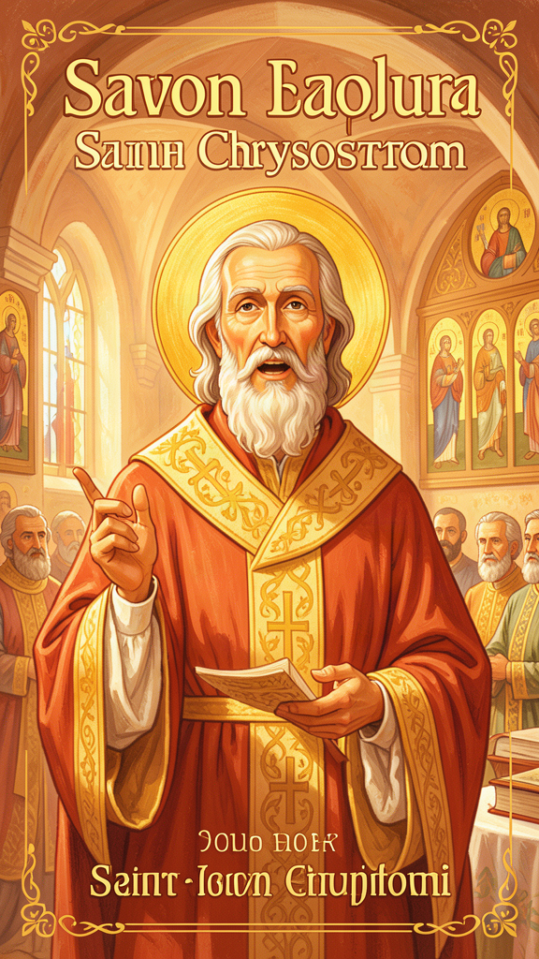
The Golden Mouth
WisdomForge Booklet — Ages 5–10

The Golden Mouth

WisdomForge Booklet — Ages 5–10
———

About This Book
A long time ago, about 1,600 years ago, there lived a man whose name meant "Golden Mouth." His real name was John, but people called him Chrysostom (say it like crih-SOSS-tum), which means "golden mouth" in the Greek language they spoke. They gave him that name because he was the best preacher anyone had ever heard. When John spoke, people listened. When John preached, people changed how they lived.
John lived in a world very different from ours. There were no cars, no electricity, no computers. The Roman Empire was still powerful, and its biggest cities were full of grand buildings, busy markets, and splendid palaces. But outside the churches and palaces, poor people sat at the gates. Some had no homes. Some had no food. Some were sick with no one to care for them.
John noticed those people. He noticed them when other people walked past. And he used his golden mouth to speak for them.
John was a bishop, which means he was a leader of the church. He preached every week, sometimes every day. He told the rich people in his church that the extra food in their cupboards did not really belong to them. It belonged to the hungry. He told them that the extra coats hanging in their wardrobes belonged to the people who were cold. He said that when they ignored a poor person, they were ignoring Jesus himself.
Not everyone liked hearing that. The powerful people in the city got angry. A queen got so angry that she sent John away from his home. He was marched across the countryside in the cold and the rain, far from the people he loved. He never came back. He died far from home, still trusting God, still preaching in his letters what he had preached from his pulpit.
In this book, you will read six stories about John Chrysostom. Each one teaches a big idea about sharing, courage, saying sorry, making good choices, listening to God's word, and hanging on when things get hard. You will meet the poor people he loved. You will hear about the queen he stood up to. You will learn about the prodigal son and how God always welcomes us back. You will discover that the same mouth that could preach beautiful words could also get a person into very big trouble — and that some kinds of trouble are worth it.
John's golden mouth is silent now. But his words are still here, written down and saved for 1,600 years. They are waiting for you.
———

Chapter 1: The Bread That Belongs to the Hungry
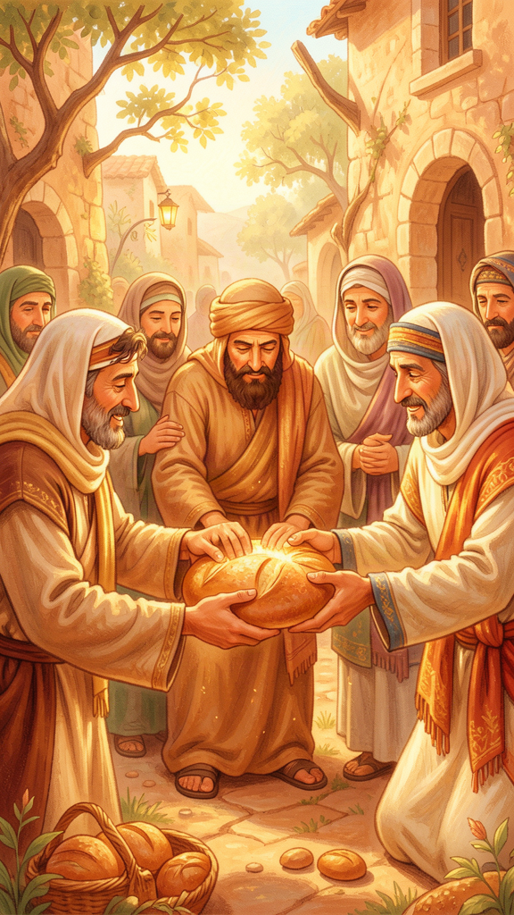
Illustration for Chapter 1
![Chapter 1](/images/booklets/chrysostom-elementary-ch01.png)
John lived in two big, busy cities. First he lived in Antioch (say it like AN-tee-ok). Then he moved to Constantinople (say it like con-stan-ti-NO-pul). Both cities were full of rich people and poor people, living almost side by side.
In Antioch, the rich people lived in houses with beautiful gardens. They had silver dishes on their tables. They had servants to cook their food and bring their wine. They had extra cloaks hanging in their wardrobes — more clothes than anyone could wear.
Outside the gates of those houses, poor people sat. Some were hungry. Some were sick. Some had no family to help them. Some were shivering in the cold.
John was a priest in Antioch, and then a bishop in Constantinople. Every time he walked to church, he passed the poor people at the gates. Every time he walked home, he saw the rich people inside their walls. He saw both, and he could not pretend that he did not.
One Sunday, John stood up to preach. The church was full. Rich people sat in the front, wearing their fine clothes. Poor people stood near the back or outside the doors. John looked at them all and said something that made everyone sit up straight.
He said: "The bread which you hold back belongs to the hungry. The coat which you guard in your wardrobe belongs to the naked."
He was not saying this was a nice idea. He was saying this was how things really are. The extra bread in the rich person's cupboard did not belong to the rich person. It belonged to the person who had no bread. The extra coat in the closet belonged to the person who was cold.
Imagine you have five sandwiches for lunch and the child next to you has none. John would say that three of your sandwiches do not belong to you. They belong to the hungry child. You are keeping something that is not yours.
"Not to share our wealth with the poor is theft from the poor and deprivation of their daily bread." — Homilies on the Acts of the Apostles, Homily 11
That is a strong thing to say. John said it because he believed that God made the earth for everyone. God gives us what we need, but God does not give one person five sandwiches and another person none. When some people have too much and others have too little, something has gone wrong. And the people who have too much are the ones who need to fix it.
John also said something even more amazing. He said that every poor person you meet is like meeting Jesus. When you give bread to a hungry person, you are giving bread to Jesus. When you turn away from a poor person, you are turning away from Jesus.
"If you wish to honor the body of Christ, do not scorn him when he is naked. Do not honor him here in church with silken vestments while outside you leave him suffering from cold and nakedness." — Homilies on the Gospel of Matthew, Homily 50
John did not just preach this. He lived it. When he became bishop of Constantinople, he found that the bishop's house had fancy furniture, expensive dishes, and a big staff of servants. John sold the fancy things. He sent the extra servants away. He took the money and gave it to hospitals and to the poor. He said a bishop's house should look like a place where poor people are welcome, not a place where poor people feel ashamed to knock.
Some people loved what John did. They had been waiting for someone to say what they always felt was true: that sharing is not just being nice. It is doing what is right. The poor are not beggars asking for a favor. They are people who are owed what is already theirs.
Other people were furious. They liked their silver dishes. They liked their extra cloaks. They did not want a preacher telling them that their extra things belonged to someone else.
But John kept preaching. He could not stop. He had a golden mouth, and he used it for the people who had no voice.

Words to Remember
"The bread which you hold back belongs to the hungry; the coat which you guard in your wardrobe belongs to the naked." — Homilies on Matthew, Homily 78

Big Idea
Sharing with people who are hungry or cold is not just being generous. It is giving back what already belongs to them. When you help a poor person, you are helping Jesus.

Try This
Look in your kitchen. Count how many extra things you have — extra cans of food, extra loaves of bread, extra boxes of cereal. Now imagine a child who has nothing to eat today. Pick one thing from your extra things and ask a grown-up to help you give it to someone who needs it. It could go to a food bank, a church, a neighbor, or a shelter. Notice how it feels to share something that was extra for you but important for them.

Ask a Grown-Up
Ask a grown-up: "Have you ever given something to someone who needed it more than you? What did it feel like?" Listen to their story. Then ask: "Do you think John was right that the extra things we have might really belong to someone else?"
———

Chapter 2: The Bishop Who Told the Queen She Was Wrong
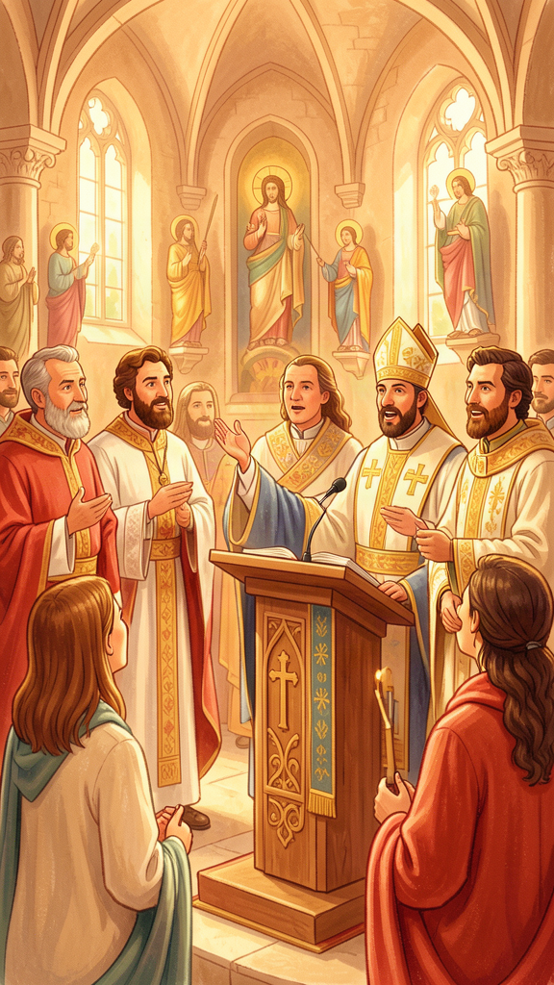
Illustration for Chapter 2
![Chapter 2](/images/booklets/chrysostom-elementary-ch02.png)
John had a job that was very important and very hard. He was a bishop. A bishop is a leader of the church. Bishops preach, teach, pray, baptize, and care for the people in their church.
But John believed that being a bishop was more than giving nice speeches. He believed a bishop had to tell the truth, even when the truth was unwelcome. He said a priest is like a doctor. Sometimes a doctor gives you medicine that tastes bad because it will make you better. Sometimes a preacher has to say something that makes people uncomfortable because it is what they need to hear.
"The priest must often appear harsh to those who are sick, not because he is harsh by nature, but because the disease demands it. A surgeon does not handle the wound gently when the flesh is rotten; he cuts, he cauterizes, he causes pain — but only so that health may follow." — On the Priesthood, Book III
This sounds serious, but think about it this way. If you go to a doctor and the doctor sees that you are sick, would you want the doctor to say, "You are fine, go eat candy and play"? No. You would want the doctor to tell you the truth, even if the medicine tasted bad. John said a preacher is like that doctor. The preacher must tell people what they need to hear, not just what they want to hear.
The hardest part of John's job was that sometimes the person doing wrong was the most powerful person in the whole empire. Her name was Eudoxia (say it like yoo-DOK-see-uh), and she was the empress. She lived in a palace. She had guards and soldiers and servants. She could order anyone arrested. She could order anyone exiled.
One day, Eudoxia took a vineyard from a widow. A vineyard is a field where grapes grow. The widow needed that vineyard to feed her family. The empress took it for herself.
John heard about this. He could have stayed quiet. He could have said, "The empress is too powerful. I cannot fight her. Someone else should help the widow." That would have been the safe thing to do.
But John believed that a bishop who stays quiet when a poor person is robbed has failed at his job. So he preached a sermon. In the sermon, he told a story from the Bible about a wicked queen named Jezebel who took a vineyard from a man named Naboth. Everyone in the church knew that story. Everyone knew what John meant.
He said:
"Again Jezebel is furious; again she rages; again she seeks to have the prophets driven out and the vineyard taken."
The empress heard about it. She was furious. She felt like John had called her a wicked queen in front of the whole city. She sent her soldiers. They dragged John out of his church and sent him away from Constantinople.
An earthquake hit the city that night. People were terrified. They thought God was angry that John had been sent away. The empress got scared and called him back. But the peace did not last. Soon John spoke out again, and soon he was sent away again — this time for good.
He was marched across the country in the cold. He was sent to a faraway place called Cucusus (say it like KOO-koo-sus). It was cold and lonely. He was sick. But even from far away, he kept writing letters to his friends, telling them to be brave and to keep caring for the poor.
John's story teaches us something important. Sometimes telling the truth is dangerous. Sometimes the person doing wrong is very powerful. But if you stay quiet when someone is being hurt, you are not being peaceful. You are being afraid. John was afraid too, but he spoke anyway, because the widow needed someone to speak for her.
Was John brave, or was he foolish? Maybe he was both. He was right to defend the widow. But comparing the empress to Jezebel was so bold that it made it impossible for them to ever make peace. Sometimes courage and wisdom do not go together. John had more courage than wisdom that day. But the widow knew that someone had spoken for her, and that mattered.

Words to Remember
"Again Jezebel is furious; again she rages; again she seeks to have the prophets driven out and the vineyard taken." — Sermon in Constantinople, 403 CE

Big Idea
A leader who tells the truth — even to someone powerful — is like a doctor who gives you bad-tasting medicine because it will help you. Sometimes telling the truth is dangerous, but staying silent when someone is being hurt is not peace. It is fear.

Try This
Think of a time when you saw someone being treated unfairly — maybe a younger child being picked on, or a friend being left out, or someone being teased. Did you speak up? If you did, how did it feel? If you did not, what held you back? Talk about this with a grown-up. There is no wrong answer. This is just practice in thinking about when and how to be brave.

Ask a Grown-Up
Ask a grown-up: "Have you ever had to tell someone in charge — a boss, a teacher, a parent — that something they were doing was wrong? What happened?" Listen to their story. Then ask: "How did you know it was the right time to speak?"
———

Chapter 3: The Father Who Runs to Meet You
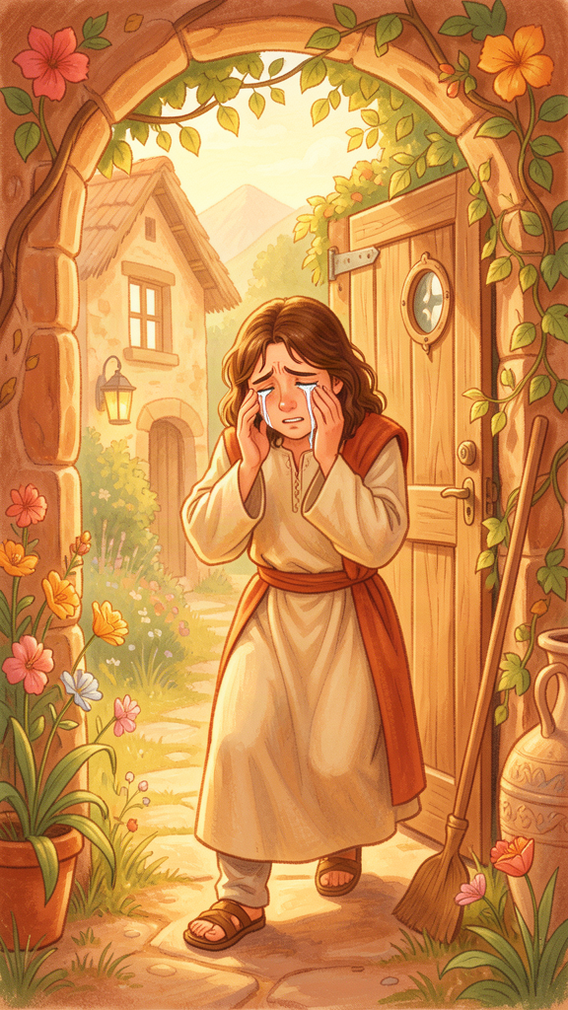
Illustration for Chapter 3
![Chapter 3](/images/booklets/chrysostom-elementary-ch03.png)
John preached about many things, but one of his favorite things to talk about was saying sorry. He believed that saying sorry and meaning it is one of the most important things a person can do. He also believed that God is always waiting to welcome us back when we turn around.
John told the story of the prodigal son. You might know this story. It is one Jesus told.
There was a man who had two sons. The younger son said, "Father, give me my share of the money now." So the father divided his money and gave the younger son his part. The younger son took the money and went far away from home. He spent it all on parties and foolish things. Soon he had nothing left. A famine came, and he was so hungry that he took a job feeding pigs. He was so hungry that even the pig food looked good to him.
Then he thought: "My father's servants have plenty to eat, and here I am starving. I will go back to my father and say, 'Father, I have done wrong. I am not worthy to be called your son. Let me be one of your hired workers.'"
So he started walking home. He was probably scared. He probably felt ashamed. He probably wondered if his father would be angry or would turn him away.
But while the son was still a long way off, his father saw him. The father ran. He ran! In those days, important older men did not run. It was beneath their dignity. But this father did not care about dignity. He cared about his son. He ran to meet him, threw his arms around him, and kissed him.
The son started his speech: "Father, I have done wrong. I am not worthy to be called your son."
But the father did not even let him finish. He called to his servants: "Bring the best robe! Put a ring on his finger! Put sandals on his feet! Let us have a feast! My son was dead and is alive again. He was lost and is found."
John loved this story. He preached on it many times. He said the father in the story is God, and the son who ran away is any of us who have done wrong. John's message was this: God does not wait for you to be perfect. God runs to meet you while you are still on the road, still messy, still ashamed.
But John also said something that people sometimes forget. He said that saying sorry is not just about feeling bad. It is about changing. If you say "I'm sorry" but then go do the same thing again, your sorry was just words. Real sorry changes your hands, your feet, your mouth, and your choices.
"Repentance is a change of mind from the worse to the better. It is not enough to weep; we must also correct."
John used the Greek word for repentance, which is metanoia. It means turning around. Imagine you are walking in the wrong direction. You realize you are going the wrong way. Repentance is the moment you stop, turn around, and start walking the right way. It is not just feeling bad about going the wrong way. It is actually turning your feet.
John said that God is patient with us. God does not punish us the moment we do something wrong. God waits. God gives us time to turn around.
"God does not punish immediately, not because he does not see, but because he waits for repentance. He extends the time so that we may change."
This is good news, but it is also a warning. God's patience is not permission to keep doing wrong. It is an invitation to stop and turn around — today, not tomorrow.
John said that one of the best ways to show you have really turned around is to share with the poor. If you were greedy, give. If you were selfish, share. If you held onto too much, let go. The proof that your sorry is real is in what you do next.

Words to Remember
"God does not punish immediately, not because he does not see, but because he waits for repentance. He extends the time so that we may change." — Homilies on the Gospel of Matthew

Big Idea
Saying sorry is not just feeling bad. It is turning around and walking a different way. God is always waiting to welcome us back, like the father who ran to meet his son. But real sorry shows itself in what we do next, not just in what we say.

Try This
Think of something you did this week that you wish you had done differently. Maybe you were unkind, or you did not share, or you told a lie, or you hurt someone's feelings. Now think: what would it look like to turn around? What could you do differently next time? Do not just say "sorry" in your head. Pick one action — something you can actually do — and try it this week.

Ask a Grown-Up
Ask a grown-up: "What is the difference between saying sorry and actually changing? Have you ever said sorry but kept doing the same thing?" Listen to what they say. Then ask: "What helped you actually change when you needed to?"
———

Chapter 4: Different Ways to Serve God
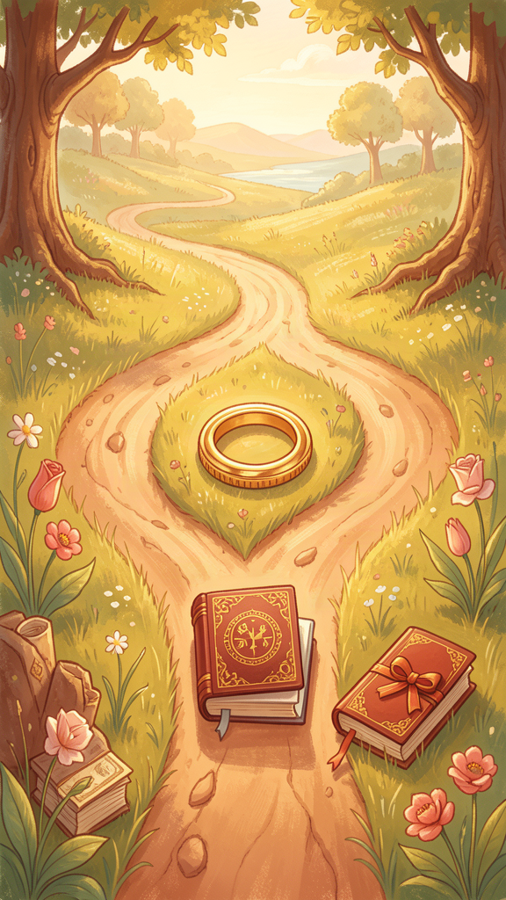
Illustration for Chapter 4
![Chapter 4](/images/booklets/chrysostom-elementary-ch04.png)
John believed that God calls people to different ways of living. Some people marry and have families. Some people choose to live without marrying so they can give all their time to God and to helping others. John said both ways are good, but they are different.
Think of a garden. Some flowers grow best in one kind of soil. Some grow best in another. A wise gardener does not force every flower into the same pot. A wise gardener knows that different plants need different care. God, John said, is like that gardener. God gives different people different callings.
John thought the life of someone who does not marry — someone who gives their whole life to prayer and to serving the church — was the most free way to live. He called this "virginity," which means a life devoted completely to God.
"Marriage is honorable and the bed undefiled; but virginity is the most excellent of all, because it is free from the cares that divide the heart."
He said that married people have many good things to care about: their husbands or wives, their children, their homes. These are good things, but they take a lot of time and attention. A person who does not marry can give all their attention to God and to the poor.
But John also said that marriage is good and honorable. He did not think married people were second-best Christians. He said that marriage is a school where people learn to love, to share, to be patient, and to put others first. A family is like a small church. The way you treat your husband, wife, or children is part of how you serve God.
John had strong words for people who used having a family as an excuse for not helping the poor. He said:
"Do not say, 'I have a wife and children, therefore I cannot give alms.' It is for their sake that you should give. You are teaching them to be Christians."
In other words, if you have a family, that is all the more reason to be generous. Your children are watching. If you teach them to share, they learn to share. If you teach them to care about the poor, they learn to care about the poor. The best way to raise good children is to be good yourself.
John also said something that might surprise you. He said that having too much money can be dangerous, just like wanting too much of anything can be dangerous. He said that the problem is not having things. The problem is when things have you. When you care more about your toys, your clothes, or your money than about people, something has gone wrong.
The way to fix this, John said, is to give. Every time you share, you loosen the grip that things have on your heart. Every time you give to someone who needs it more, you remind yourself that people matter more than stuff.
So John taught three paths:
1. The married life — loving your family, raising children in the faith, sharing what you have, and making your home a small church.
2. The unmarried life — giving all your time to God, to prayer, and to serving the poor, without the cares of a household.
3. The generous life — which everyone, married or unmarried, is called to live. Everyone is called to share. Everyone is called to care. Everyone is called to hold things loosely.

Words to Remember
"Marriage is honorable and the bed undefiled; but virginity is the most excellent of all, because it is free from the cares that divide the heart." — On Virginity

Big Idea
God calls different people to different ways of living. Some marry and have families. Some give their whole lives to God without marrying. Both are good. But everyone — no matter which path — is called to be generous and to put people before things.

Try This
Think about the grown-ups in your life. Some are married with children. Some are not. Some give their time to helping others in special ways. Ask yourself: "What do I admire about each of these people? What kind of person do I want to become?" You do not have to decide now. Just notice that there are many good ways to live, and the best thing is to find the way that lets you love God and love other people well.

Ask a Grown-Up
Ask a grown-up: "Why do you think some people choose not to marry so they can serve God? What do you think would be hard about that? What do you think would be freeing?" Listen to their answer. There is no wrong answer. This is a big question that even grown-ups think about.
———

Chapter 5: The Book That Feeds Your Soul
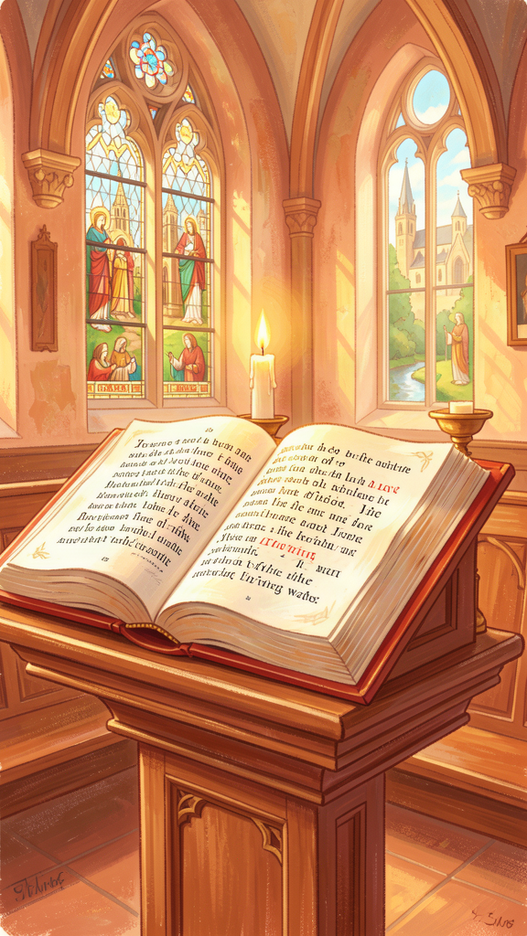
Illustration for Chapter 5
![Chapter 5](/images/booklets/chrysostom-elementary-ch05.png)
John believed that the Bible is like food for your soul. Just as your body needs bread and fruit and vegetables to grow strong, your soul needs God's word to grow strong. If you never hear God's word, your soul gets hungry and weak, just like your body gets weak when you skip too many meals.
In John's church, the most important part of the service was not what the building looked like. It was not the fancy clothes. It was the reading of the Bible and the preaching. The people would gather together. Someone would read from the Scriptures — from the Psalms, the prophets, the Gospels, or the letters of Paul. Then John would stand up and explain what the words meant and how they applied to the people's lives.
John said something beautiful about what happens when the Bible is read:
"When the Scriptures are read, the angels stand by in reverence; for they see the Master speaking to his servants."
Imagine that. When the Bible is read out loud, John said, the angels lean in to listen, because they see God speaking to us. The Bible is not just an old book with old words. It is God speaking, right now, to the people who are listening.
John also said that the Bible is not just for special people — not just for monks, priests, or bishops. It is for everyone.
"Do not think that the reading of the Scriptures is only for monks. They are for you, the merchant, the soldier, the wife, the child — for all who would be saved."
John believed that every person needs to hear God's word: people who sell things in the market, people who work in the army, mothers and fathers, and children too. No one is too busy or too ordinary for the Bible.
But John had a warning. He said that reading the Bible is not enough if it does not change how you live. He said the Bible is like medicine. Medicine only helps if you take it. A bottle of medicine on the shelf does not make you better. You have to open it and swallow what is inside.
John's way of preaching showed this. He did not just explain what a Bible passage meant. He always asked: "So what does this mean for us, right now, today?" If he read about the early church sharing everything, he told his people to share. If he read about Jesus healing the sick, he told his people to care for the sick. If he read about forgiving, he told his people to forgive.
He said the church is like a hospital, not a museum. A museum is a place where you look at beautiful old things and admire them. A hospital is a place where people who are hurting come to get better. John said the church should be a hospital. The medicine is God's word. And every person who comes in is someone who needs healing — which means all of us.
John also believed that the Bible belongs to the whole church, not just to one person reading alone. The Bible is meant to be read together, discussed together, and lived together. When you hear a Bible story, you are hearing the same story that your parents, grandparents, and people all the way back to John's time heard. You are part of a big family that has been listening to God's word for thousands of years.

Words to Remember
"Do not think that the reading of the Scriptures is only for monks. They are for you, the merchant, the soldier, the wife, the child — for all who would be saved." — Homilies on the Acts of the Apostles

Big Idea
The Bible is like food for your soul. It is God speaking to you, and it is for everyone — not just for special people. But reading it is not enough. The Bible is meant to change how we live, like medicine that only helps if you take it.

Try This
Ask a grown-up to read one short story from the Bible with you — maybe the story of the prodigal son, or the story of the good Samaritan, or the story of Jesus feeding the five thousand. After you read it, ask yourself: "What does this story tell me about how I should live?" Talk about your answer with your grown-up. You do not need a perfect answer. Just practice asking the question.

Ask a Grown-Up
Ask a grown-up: "Is there a Bible story that has helped you in your life? Which one, and why?" Listen to their story. Then ask: "Do you think the Bible is more like a museum or more like a hospital? Why?"
———

Chapter 6: The Long Journey Home
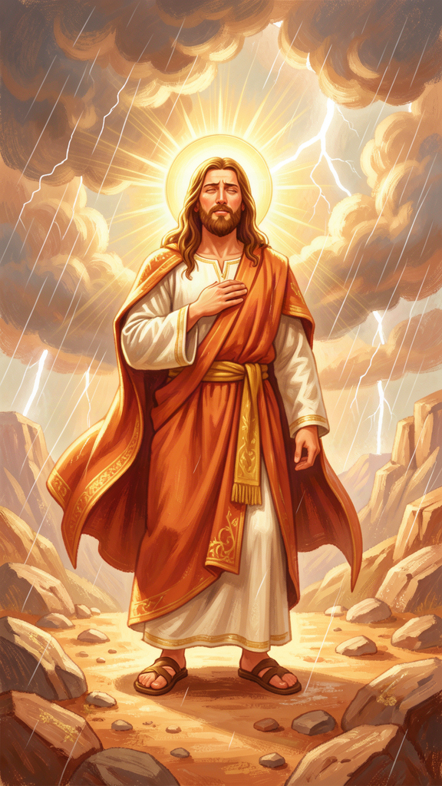
Illustration for Chapter 6
![Chapter 6](/images/booklets/chrysostom-elementary-ch06.png)
The last story about John Chrysostom is a hard one, but it is also a brave one. After the empress sent him away, John had to travel a very long way to a cold, lonely place. He was sick. He was tired. He missed his church and his friends.
But John did not give up. He kept writing letters. He kept praying. He kept believing that God was with him, even when everything had gone wrong.
John believed something very important: that hard things are not useless. He said that suffering is like a school. You do not go to school because it is fun. You go to school because it teaches you things. In the same way, John said, hard times can teach us things that easy times cannot.
"Suffering is a school. The soul that has been trained by affliction becomes more vigilant, more humble, more compassionate."
Think about a time when something was very hard for you. Maybe you were sick, or you lost someone you loved, or you failed at something that mattered to you. In the moment, it was just painful. But afterward, maybe you noticed something. Maybe you were more patient with other people who were hurting. Maybe you were kinder. Maybe you understood what other people were going through in a way you could not before.
That is what John meant. Hard times can make our hearts softer, not harder — if we let them. They can make us more understanding, more humble, and more compassionate.
John wrote letters to his friend Olympias (say it like oh-LIM-pee-us) while he was in exile. Olympias was a rich woman who used her money to help the poor and to support the church. She was one of John's closest friends. When John was sent away, Olympias was sad and worried. John wrote to comfort her.
He told her that even though his enemies had sent him away, God was still in charge. He said that God can bring good out of bad things, even when we cannot see how.
"If the Lord has ordered these things, we must receive them with thanksgiving. For even this storm will work for us a weight of glory, if only we endure with patience and give thanks in everything."
John did not say his enemies were right. He did not say that being sent away was fair. He said that God could use even unfair and painful things for a good purpose. He said the storm would pass, and if he held on with patience and gratitude, something good could come from it.
John also said something that might sound strange at first. He said that being patient does not mean doing nothing. He said you can trust God and still try to change what is wrong. You can pray and still work. You can accept that something is hard and still look for a way through it.
John did not just accept exile quietly. He wrote letters. He appealed to friends. He kept leading his church from far away. He did everything he could. But he also trusted that even if he could not fix everything, God was still at work.
After two years in exile, John was ordered to travel even farther away, to a place called Pityus on the Black Sea. The journey was brutal. He was marched through cold and rain. He was already weak from illness. He died on the way, near a town called Comana, before he reached his new destination.
His last words, the stories tell us, were a prayer:
"Glory be to God for all things."
Even at the end — sick, far from home, treated unfairly — John thanked God. He did not say, "Why did this happen to me?" He said, "Glory be to God for all things." All things. The good and the bad. The preaching and the exile. The golden mouth and the cold road. All of it.
That is what endurance looks like. It is not pretending things are easy. It is not giving up. It is holding on to God and to what is right, even when everything around you says to let go.
John's body was brought back to Constantinople thirty years later. The people wept. The emperor himself asked forgiveness for what his parents had done. The man who had been sent away was welcomed home as a saint.
His golden mouth was silent. But his words — written down, copied, saved, passed from hand to hand for 1,600 years — are still speaking. They are speaking to you right now.

Words to Remember
"If the Lord has ordered these things, we must receive them with thanksgiving. For even this storm will work for us a weight of glory, if only we endure with patience and give thanks in everything." — Letter to Olympias, from exile

Big Idea
Hard times are not useless. They can teach us patience, make us more compassionate, and help us trust God more deeply. Endurance does not mean giving up or pretending things are fine. It means holding on to what is right and trusting that God is at work, even in the storm.

Try This
Think about something hard that you have been through — or something hard you are going through right now. Ask yourself: "Did this hard thing teach me anything? Did it make me notice other people's pain more? Did it make me stronger in any way?" If the answer is yes, you are beginning to understand what John meant. If the answer is no yet, that is okay too. Some lessons take a long time to see. Talk about this with a grown-up.

Ask a Grown-Up
Ask a grown-up: "What is something hard you went through that taught you something important? What did you learn?" Listen to their story. Then ask: "How did you keep going when you wanted to give up?"
———

For the Grown-Up Reader
This booklet introduces children to John Chrysostom through six core themes drawn from his homilies, treatises, and letters. The story-form retellings are faithful to the content and spirit of Chrysostom's preaching while simplifying the vocabulary and historical context for young readers.
The quotes are real, drawn from widely available English translations of Chrysostom's works (primarily the Nicene and Post-Nicene Fathers series). Where the research files note that a passage is a paraphrase of a recurring theme rather than a verbatim quotation, that has been indicated in the source citation. No words have been invented and placed in Chrysostom's mouth.
A few notes on approach:
- The poor at the center. The sandwich illustration in Chapter 1 translates Chrysostom's claim that surplus belongs to the hungry into a child's frame of reference. The core theological move — that sharing is justice, not generosity — is preserved without the economic complexity that belongs to older readers. - The priesthood and prophetic speech. Chapter 2 uses the doctor analogy from On the Priesthood Book III to make the idea of truth-telling concrete. The Jezebel episode is told as a story of courage, but the booklet also notes that John's boldness may have been imprudent — the beginning of an honest reckoning that the later booklets develop further. - Repentance and mercy. Chapter 3 retells the prodigal son parable (Luke 15:11–32) and connects it to Chrysostom's teaching that repentance is metanoia — a turning, not just a feeling. The emphasis on almsgiving as evidence of real repentance is drawn from Chrysostom's homilies on Matthew and Acts. - Wealth, virginity, and marriage. Chapter 4 simplifies Chrysostom's threefold scheme into language a child can understand. The garden metaphor is not Chrysostom's own (it comes from the research guide's age-5–10 suggestion), but it accurately conveys his view that different callings suit different people. - Scripture and the church. Chapter 5 uses the food and medicine metaphors that Chrysostom himself employs. The "hospital, not a museum" line is attributed in the research files as likely apocryphal but capturing his spirit; the booklet presents it honestly as a summary of his teaching rather than a verbatim quote. - Suffering and endurance. Chapter 6 tells the story of John's exile and death. The last words "Glory be to God for all things" are attributed in the ancient sources and capture the spirit of his letters from exile. The suffering-as-school theme is drawn from the Treatise on the Providence of God.
When reading with a child, let the stories breathe. Chrysostom's world is distant, but his questions — about sharing, courage, honesty, choices, listening, and hanging on — are immediate. The "Ask a Grown-Up" prompts are designed to extend the conversation beyond the page and to connect John's ancient wisdom to the child's own life.
———

About WisdomForge
WisdomForge creates age-adapted booklets that bring the great thinkers of human history to readers of every age. Each booklet takes a single figure — a philosopher, theologian, scientist, or sage — and presents their most important ideas in a form suited to the reader's stage of life.
Every WisdomForge figure gets four booklets: one for elementary ages (5–10), one for middle school (11–14), one for high school (15–18), and one for adult readers. The same core ideas appear in all four, but the depth, vocabulary, and style change. A child meets Chrysostom as a story character. A teenager meets him as a preacher with arguments to wrestle with. An adult meets him as a figure whose words still challenge the church and the world today.
WisdomForge uses only real quotes, cited by source. We do not invent words and put them in a thinker's mouth. When Chrysostom speaks, the words come from his homilies, treatises, or letters, and the source is named.
Our booklets are written in the spirit of the thinkers themselves: clear, honest, and unwilling to settle for easy answers. We believe that the best ideas do not decay. They wait, like seeds, for the right reader to pick them up.

