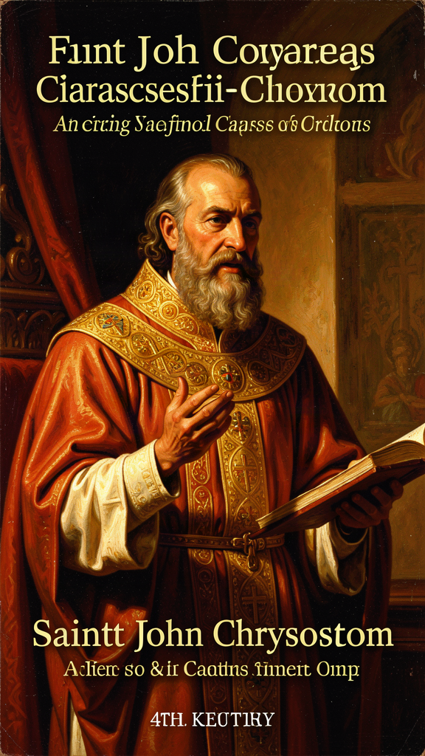
The Golden Mouth and the Cost of Conviction
WisdomForge Booklet — Ages 15–18

The Golden Mouth and the Cost of Conviction

WisdomForge Booklet — Ages 15–18
———

About This Book
John Chrysostom (c. 347–407 CE) was the most celebrated preacher of early Christianity and the most prolific Greek theologian of the fourth century. His nickname, Chrysostom, means "Golden Mouth." It was given after his death, but it fits. No other early Christian writer so relentlessly turns theological reflection into moral summons. He survived as roughly seven hundred sermons, numerous treatises, more than two hundred letters, and a liturgy still sung in Eastern Orthodox churches every Sunday. Everything he wrote is held together by one voice: direct, urgent, concrete, and convinced that the Gospel must change how people actually live.
Chrysostom preached in two of the richest cities of the late Roman Empire: Antioch, a commercial center on the Orontes River, and Constantinople, the imperial capital built by Constantine. Both cities had wealthy families in villas with silver dishes and idle slaves, and poor people at the church gates, hungry and sick. Chrysostom could see the contrast every time he walked to church. He did not look away. He pointed at what was visible from the pulpit — the silver dishes, the extra cloaks, the locked storehouses, the fattened bodies. He preached in concrete images, not abstractions. This made his economic ethics impossible to spiritualize away.
His central conviction was this: God has put the poor at the center of the Christian life, and those who ignore them ignore Christ. The bread the rich hold back belongs to the hungry. The coat in the wardrobe belongs to the naked. Failing to share is not a failure of generosity. It is theft. When you pass a beggar without helping, you are passing by Christ himself.
He also believed that a preacher's job is to tell the truth, even when the truth is unwelcome — especially to the powerful. He compared a priest to a surgeon who sometimes must cut to heal. Chrysostom practiced what he preached. He told an empress she was wrong. It cost him his home, his church, and his life.
But there is a complication that this booklet takes seriously throughout. Chrysostom was not a saint in a stained-glass window. He was a man of the fourth century who shared many of its prejudices. His homilies against the Jews are violent in their language and have been used to justify persecution across history. His assumptions about gender, authority, and household order reflect his culture, not timeless principles. His political judgment was not always sound, and his own rhetoric contributed to his downfall. A responsible reading holds together his moral brilliance and his human failures. This booklet does both.
The six chapters that follow trace the arc of Chrysostom's most important ideas: the poor at the center of the Gospel, the priesthood and the cost of prophetic speech, repentance as a lifelong practice, the three paths of wealth and vocation, Scripture as the church's living food, and suffering as a school of endurance. Each chapter is a narrative essay. The quotes are real, drawn from his homilies, treatises, and letters, with the source named. The arguments are Chrysostom's own, reconstructed faithfully from the texts. The questions at the end are for you.
———

Chapter 1: The Bread That Belongs to the Hungry
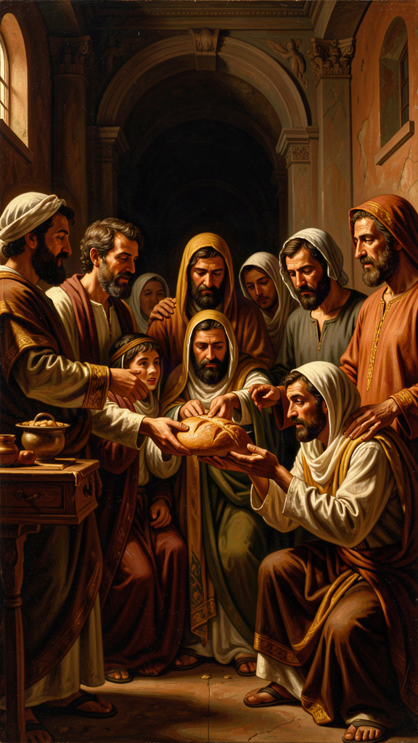
Illustration for Chapter 1
![Chapter 1](/images/booklets/chrysostom-high-ch01.png)

The Economic World of the Pulpit
Chrysostom preached in cities of sharp inequality. Antioch was a cosmopolitan center where goods from the East met the markets of the Mediterranean. Constantinople was a city of palaces, processions, and power. In both places, the wealthy lived in villas while the poor sat at the gates. Chrysostom could see both worlds from the pulpit, and he refused to let his congregation pretend that the gap between them was normal.
His sermons name the details of this world with forensic precision: silver dishes, extra cloaks, idle slaves, fattened bodies, locked storehouses. He did not speak in abstractions. He pointed to what his congregation could see with their own eyes. This concrete style made his economic ethics impossible to spiritualize away. When he said that the coat in your wardrobe belongs to the naked, he was talking about a real coat in a real wardrobe that his congregation could picture — because some of them were wearing one.

Charity as Justice
The most striking feature of Chrysostom's teaching on wealth is his refusal to treat care for the poor as optional charity. He calls it justice.
The standard view of charity says: "I have something, and I am being kind by giving some of it to you." Charity is extra. It is a generous add-on to a life that is otherwise mine. Chrysostom dismantles this framing. He says the rich are in possession of the goods of the poor. The bread they hold back belongs to the hungry. The coat in the wardrobe belongs to the naked. Failure to share is not a failure of generosity. It is theft and deprivation.
"The rich are in possession of the goods of the poor, even if they have acquired them honestly or inherited them lawfully. The bread which you hold back belongs to the hungry; the coat which you guard in your wardrobe belongs to the naked." — Homilies on Matthew, Homily 78
This claim rests on a particular view of property. In Chrysostom's reading of Scripture, God gives the earth for the common good. Private ownership exists for management and order, but it does not give anyone the right to hoard necessities while others starve. Surplus carries a moral duty. Holding it without sharing is, in his language, theft and deprivation.
This is stronger than saying "be generous." It says the existing distribution of goods is already a moral problem when some have too little and others have too much. The poor do not need the rich to be kind. They need what is, by divine intention, theirs.
"Not to share our wealth with the poor is theft from the poor and deprivation of their daily bread." — Homilies on the Acts of the Apostles, Homily 11

The Poor as Images of Christ
Chrysostom gives a theological reason for this claim that goes beyond economics. In Matthew 25, Jesus says that what is done to the hungry, the stranger, the naked, the sick, and the prisoner is done to him. Chrysostom presses this identification harder than almost any other early Christian writer.
When a Christian refuses a beggar, Chrysostom argues, they are refusing Christ. When they feed a poor person, they are feeding Christ. Every encounter with a poor person becomes a sacramental moment. The poor person is not a distraction from spiritual life. The poor person is a place where Christ becomes visible.
"If you wish to honor the body of Christ, do not scorn him when he is naked. Do not honor him here in church with silken vestments while outside you leave him suffering from cold and nakedness." — Homilies on the Gospel of Matthew, Homily 50
Chrysostom sometimes says that the poor are more honorable than the rich because the rich need the poor in order to be saved. The poor give the rich an opportunity to practice justice, to loosen the grip of possessions, and to encounter Christ. Without the poor, the rich would have no path to salvation. This is not instrumentalization — using the poor as tools for the rich. Chrysostom also insists that the poor are full human beings, made in God's image, with their own virtues and spiritual greatness. The widow who gives two small coins is, for him, greater than the wealthy donor.

Almsgiving as Medicine
Chrysostom treats almsgiving as a medicine for sin. The rich have many temptations: pride, luxury, hardness of heart, indifference. Giving to the poor is the cure. It loosens the grip of possessions, reminds the giver that life is short, and creates solidarity with those whom God loves.
He sometimes suggests that almsgiving can balance or heal past wrongs — not by earning forgiveness but by turning the heart in the direction God desires. This is not a transactional theology. It is a therapeutic one. The medicine works by changing the patient, not by paying the doctor.

What Chrysostom Does Not Say
It is important to be fair to Chrysostom. His most famous sentences sound like a total rejection of riches, but read in context he allows that wealth can be used well. The problem is not having goods. The problem is withholding them. A rich person who shares, who treats possessions as a trust, who does not define himself by luxury, is not condemned merely for being rich. Chrysostom needed wealthy patrons himself — Olympias, one of his closest friends, was wealthy. He did not reject her wealth. He urged her to use it for the poor and the church.
The problem is not possession but excess. Chrysostom asks what you do with what you do not need. The surplus is the place where greed or generosity is revealed. A person who has enough and gives generously is not his target. A person who hoards luxury while others starve is.
He also does not offer a political program. He does not outline a system of taxation, property law, or economic redistribution. He preaches to individuals and congregations. His aim is to change hearts and habits, not to draft legislation. Modern readers disagree about whether his teaching supports welfare states, private charity, or something more radical. That debate matters, but it should not be confused with what Chrysostom himself said. He gave principles, not policies.

The Poor as Hermeneutical Center
What makes Chrysostom's economic ethics more than a set of moral exhortations is that the poor are not one topic among many in his preaching. They are the hermeneutical center — the lens through which he reads almost every book of the Bible. He reads the prophets as critics of wealth and defenders of the oppressed. He reads the Psalms as the prayer of the afflicted. He reads the Gospels as the story of God becoming poor. He reads Acts as the model of a community where no one lacks necessities.
When he preaches on a parable, he asks what it says about the rich and the poor. When he preaches on a miracle, he notices who is healed and fed. The poor are not a special interest. They are the organizing principle of his entire reading of Scripture.

Big Idea
Chrysostom treats care for the poor not as generosity but as justice. The extra things you hold belong to those who lack necessities. When you meet a poor person, you meet Christ. The poor are not one topic in his theology. They are the lens through which he reads the entire Gospel. Sharing is not an optional act of kindness. It is giving back what already belongs to the hungry.

Practice
1. Calculate your surplus. Make a list of everything you own that goes beyond what you genuinely need — extra clothes, extra devices, extra food, extra subscriptions. For each item, ask: "Could this belong to someone who needs it more?" You do not have to give everything away. The exercise is to notice the gap between need and excess, and to feel the moral weight of that gap. Chrysostom's question is not "How much can I keep?" but "How much can I use for others?"
2. Change the framing. The next time you give something — money, time, food, attention — notice the language you use internally. Do you think "I am being generous"? Chrysostom would say: "I am returning what was never exclusively mine." Try reframing one act of giving as justice rather than charity. Notice how the emotional tone shifts. Charity can make the giver feel noble. Justice reminds the giver that the goods were never theirs alone.
3. Read the poor into Scripture. Take a passage from the Gospels — the parable of the rich fool (Luke 12:16–21), the story of the rich young ruler (Mark 10:17–22), or the parable of the sheep and the goats (Matthew 25:31–46). Read it through Chrysostom's lens: what does this passage say about wealth, poverty, and obligation? Does reading it this way change what you thought the passage meant?

Reflect
Chrysostom says that the bread you hold back belongs to the hungry. Does this mean private property is wrong, or only that hoarding is wrong? Where is the line between owning things and keeping what belongs to someone else? If you take his claim seriously, what would have to change in your life? And if you resist his claim — what exactly are you defending, and why?
———

Chapter 2: The Surgeon and the Empress
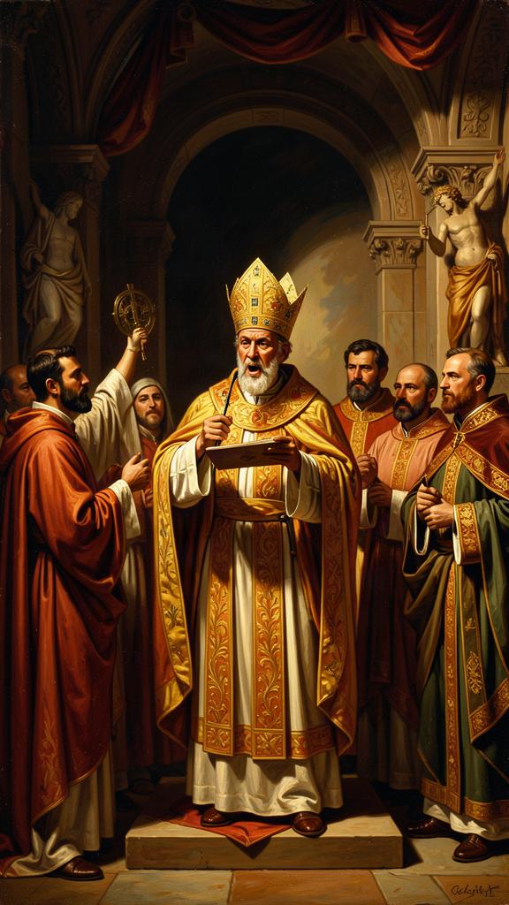
Illustration for Chapter 2
![Chapter 2](/images/booklets/chrysostom-high-ch02.png)

The Priest as Physician
Chrysostom's understanding of ministry is not managerial or ceremonial. It is prophetic and therapeutic. The priest is a physician of souls whose primary duty is truth-telling, even when the patient does not want to hear it.
His favorite image for the priest is the surgeon. A sick person wants comfort, but comfort is not always healing. Sometimes the wound must be cut, the rotten flesh removed, the pain endured, so that health can follow. The priest, in the same way, must sometimes say hard things in order to do good things.
"The priest must often appear harsh to those who are sick, not because he is harsh by nature, but because the disease demands it. A surgeon does not handle the wound gently when the flesh is rotten; he cuts, he cauterizes, he causes pain — but only so that health may follow." — On the Priesthood, Book III
This analogy is powerful but also risky. It can be used to justify verbal violence, manipulation, or bullying — the pastor who is cruel and calls it "tough love." Chrysostom himself was capable of rhetorical excess. The task for readers is to distinguish genuine pastoral courage from self-righteous aggression. The difference lies in whether the speaker is serving the hearer's good or the speaker's own power.
Chrysostom places enormous weight on preaching. In On the Priesthood, Book II, he argues that the priest's teaching shapes the conscience of the congregation more than any other force. The priest does not merely explain texts. He forms souls. A single sermon can turn a person toward repentance or confirm them in complacency. This high view of preaching is one reason Chrysostom became the model for Orthodox, Catholic, and Protestant preachers. His influence on homiletics — the art of preaching — extends far beyond his own communion.

The Danger of the Office
Chrysostom insists that the priesthood is not only glorious but dangerous. The honor of the office can corrupt. A priest can begin to love being admired more than serving God. He can soften his message to keep his position. He can use his authority to dominate rather than to heal.
"The dignity of the priesthood is great, but its burden is greater. He who climbs a high place must fear a great fall." — On the Priesthood, Book VI
In On the Priesthood, Chrysostom confesses that he once resisted ordination partly through humility and partly through a subtle evasion. He did not want the burden. The book defends the greatness of the office while warning that it is not for the ambitious or the weak.

Speaking to the Powerful
The priestly office, for Chrysostom, includes the duty to speak unwelcome truth to those in power. This is not an extra role. It is part of what it means to stand for God before the people and for the people before God. When a preacher flatters the rich or avoids conflict with rulers, he has already failed.
Chrysostom's own conflict with Empress Eudoxia is the most famous example. In 403 CE, after Eudoxia seized a widow's vineyard, Chrysostom compared her to Jezebel, the Phoenician queen of the Old Testament who seized Naboth's vineyard and had him killed. The sermon provoked her fury and helped bring about his exile.
"Again Jezebel is furious; again she rages; again she seeks to have the prophets driven out and the vineyard taken." — Sermon in Constantinople, 403 CE
The comparison was explosive. It named the empress as a murderous idolater and her action as theft. It also invoked a biblical pattern in which prophets confront wicked rulers. Eudoxia was furious, and her anger became the engine of Chrysostom's downfall.

The Synod of the Oak
The historical reality is more complicated than a simple story of holy courage versus wicked power. A council was convened at a villa called the Oak, near Chalcedon, in 403 CE. It was orchestrated by Theophilus, bishop of Alexandria, who had his own grievances against Chrysostom. The charges included treason against the empress, misconduct as bishop, returning from exile illegally, and receiving condemned clergy. Many of the charges were exaggerated or fabricated. The council was essentially a political trial.
Chrysostom was condemned and exiled. As he was being led away, an earthquake struck Constantinople. The terrified populace interpreted it as divine judgment, and Eudoxia herself recalled him. But the reconciliation was shallow. Within months, conflict resumed — Chrysostom criticized a statue of Eudoxia that had been erected near the church, complaining that the noise of celebrations disturbed the liturgy. Whether this was a deliberate insult or a pastoral complaint, it was read as another attack. In 404 CE he was exiled again, this time for good.

Courage and Its Costs
Not every bold word is prophetic. Chrysostom was sometimes reckless, and his language could be cruel. Modern readers must ask: was his confrontation with Eudoxia a model of courage or a failure of prudence? The answer may be both.
He was right to defend the widow and wrong, perhaps, to use a comparison so inflammatory that it made reconciliation impossible. Prophetic speech requires more than courage. It requires accuracy, love for the opponent, timing, and a willingness to accept consequences without demanding martyrdom. Chrysostom meets some of these standards and falls short of others.
A useful test: does the speech increase compassion for the victim or contempt for the opponent? Prophetic speech does both when necessary, but it never loses compassion. Self-righteous speech delights in contempt. Chrysostom's Jezebel comparison may have crossed this line. He was serving the widow, but his language may also have been serving his own outrage.
The conflict also reveals an institutional failure. The church had become too entangled with imperial power to protect a truth-teller. When a bishop attacks an empress, the system that connects them has already broken. Modern institutions — churches, businesses, governments, schools — should ask whether they would protect or sacrifice someone who speaks unwelcome truth. The presence of truth-tellers is a sign of institutional health. Their absence is a warning.

When Silence Is Not Betrayal
Chrysostom believed that silence before injustice was betrayal. But there are times when silence is not betrayal: when speaking would harm the very people you want to protect, when you do not yet know enough to speak accurately, when private correction is more likely to succeed than public accusation, or when your own motives are too mixed to be trusted.
The goal is not to speak every truth at maximum volume. The goal is to make truth effective in the world. Sometimes that requires public confrontation. Sometimes it requires a private meeting, a carefully worded letter, or patient preparation. Chrysostom's example is inspiring precisely because it is complicated. He shows both the power and the danger of speaking truth to power.

Big Idea
A leader who speaks for God must tell the truth, even to the powerful. But prophetic speech requires more than courage. It requires accuracy, timing, compassion, and a willingness to accept consequences. Chrysostom's confrontation with Eudoxia shows both the necessity and the danger of truth-telling. He was right to defend the widow. He may have been wrong about how he did it. Both judgments can be held together — and must be.

Practice
1. Test your own truth-telling. Think of a situation where you know something is wrong — at school, at home, in your community, or in the wider world. Ask yourself: (1) Do I know the facts accurately? (2) Am I serving the victim or my own ego? (3) Is this the right time and place to speak? (4) Can I say what needs to be said without destroying the possibility of reconciliation? (5) Am I willing to accept the cost? If you cannot answer all five honestly, you may not be ready to speak yet. That does not mean you should stay silent forever. It means you should prepare.
2. Distinguish prophetic from self-righteous speech. Listen to a public argument — a political debate, a social media controversy, a sermon, or an editorial. Ask: does this speech increase compassion for the victim, or does it increase contempt for the opponent? Prophetic speech does both when necessary but never loses compassion. Self-righteous speech delights in contempt. Practice hearing the difference.
3. Examine an institution. Think about a community you belong to — a school, a church, a team, a workplace. Does it protect truth-tellers or sacrifice them? What happens to someone who names a problem that others would rather ignore? The answer tells you something about the health of the institution.

Reflect
Chrysostom compared the empress to Jezebel. The comparison was accurate in content — both involved a powerful person seizing a vineyard — but inflammatory in tone. Was it prophetic courage or rhetorical malpractice? Can a speech be morally right in its content and morally wrong in its delivery? If so, what does that mean for how we speak truth to power today? When is the most courageous thing not to speak at the top of your voice, but to find a more effective way to make the truth land?
———

Chapter 3: Turning Around
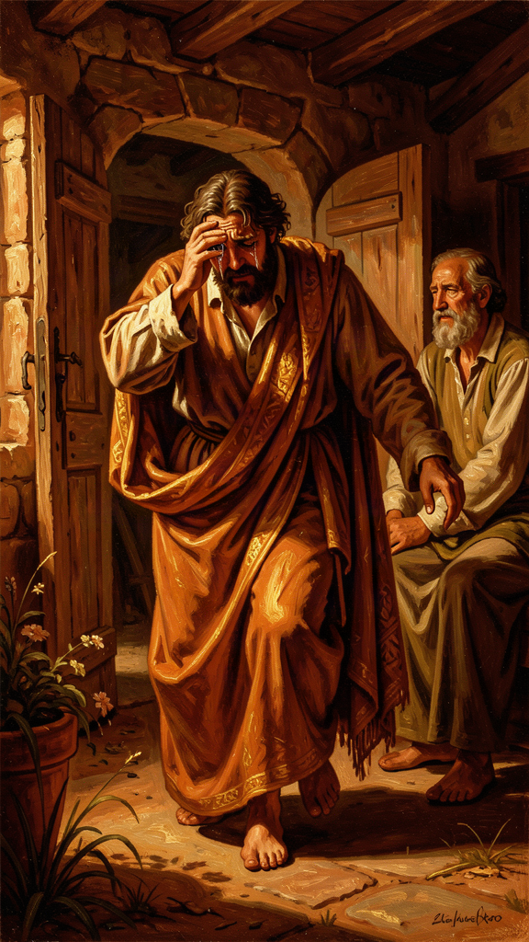
Illustration for Chapter 3
![Chapter 3](/images/booklets/chrysostom-high-ch03.png)

Compunction, Not Paralysis
For Chrysostom, repentance is not a single crisis moment. It is the ongoing shape of the Christian life. God is patient and merciful, always offering time to turn around. Human beings are called to respond with compunction — a sorrow for sin that produces change rather than despair. Chrysostom's preaching on repentance is severe about sin and expansive about grace. He refuses both complacency and hopelessness.
Chrysostom uses the word compunction to describe the proper response to sin. Compunction is not guilt that crushes a person. It is grief that moves a person. It sees the wrong, feels its weight, and then turns toward God with a request for mercy and a commitment to change.
This distinction matters because guilt can become self-indulgent. A person may wallow in feelings of unworthiness without actually changing behavior. Chrysostom wants sorrow to be practical. If repentance does not change how a person acts, it is incomplete. Tears are not enough. The fruit of repentance is the correction of the life that follows it.

Repentance as Return
The Greek word for repentance, metanoia, literally means a change of mind or a turning around. Chrysostom emphasizes this movement. Sin is a direction — away from God and neighbor. Repentance is the decision to walk back. It is not enough to feel bad. The hands, the feet, the wallet, the tongue must all be redirected.
"Repentance is a change of mind from the worse to the better. It is not enough to weep; we must also correct."
This is why Chrysostom connects repentance so closely with almsgiving, prayer, fasting, and care for the poor. These practices are not penances that buy forgiveness. They are the visible evidence that a person has actually turned around. If you say you have repented but your wallet, your tongue, and your habits have not changed, your repentance was just words.

Divine Patience
One of Chrysostom's most repeated themes is that God does not punish immediately because God wants repentance.
"God does not punish immediately, not because he does not see, but because he waits for repentance. He extends the time so that we may change. If he were swift to punish, where would be the room for repentance?" — Homilies on the Gospel of Matthew
This patience is good news, but it is also a warning. The delay of judgment is not permission to keep sinning. It is an invitation to stop. Chrysostom warns that the time given for repentance will one day run out. The question for the hearer is whether the present moment will be used or wasted. If God waits, that makes sin more serious, not less — because it means God's patience has a purpose, and to squander it is to despise the very mercy that gives us time.

Mercy Beyond Deserving
Chrysostom's God is not a distant accountant. He is a father who runs to meet the returning sinner, like the father in the parable of the prodigal son (Luke 15:11–32). The preaching on mercy is rooted in Scripture — the Psalms, the prophets, the parable — and it is aimed at people who are tempted to despair.
Chrysostom insists that no sin is too great for God's mercy if the sinner truly turns. This does not mean that sin is trivial. It means that mercy is greater. The proper response to great mercy is great repentance, not casual presumption.
"Do not despair because you have fallen often. The physician does not reject the sick man because he has relapsed. He heals him again and again." — To the Fallen Theodore

Mercy and the Poor
Chrysostom connects divine mercy with human mercy. God forgives; therefore human beings must forgive. God gives; therefore human beings must give. The person who receives mercy but refuses mercy to others has not understood what mercy is. This is why almsgiving appears so often in his teaching on repentance. It is the external sign of an internal transformation.
The person who has been forgiven but will not forgive, the person who has received but will not give, has not actually repented. They have only felt bad. Real repentance changes the direction of the entire life — including the economic direction. A greedy person who repents becomes generous. A selfish person who repents becomes other-directed. The proof is in the practice.

The Practical Habits of Repentance
Chrysostom recommends concrete practices that keep repentance alive:
- Confession. Acknowledging sin to God and, when appropriate, to the church. Sin that is never named cannot be addressed. - Tears. Chrysostom values tears as a sign of a softened heart, though he warns against theatrical sorrow — crying for show rather than for change. - Fasting. Reducing bodily appetite as a way of training the soul. If you cannot control your hunger for food, how will you control your hunger for power, status, or revenge? - Almsgiving. Using possessions for others as a sign that greed is being overcome. The wallet is the most honest indicator of where the heart is. - Forgiveness of others. Refusing to hold grudges because God has forgiven the sinner. The person who will not forgive has not understood the mercy they themselves received. - Frequent return. Repentance is not once-for-all. The Christian returns again and again. Chrysostom's image of the physician who heals the relapsed patient makes this clear: repentance is a pattern, not a single event.

The Limits of the Discussion
Chrysostom is not a systematic theologian of justification or grace in the later Western sense. He does not work out the precise relationship between human effort and divine initiative — the debates that would later divide Western Christianity between Augustine and Pelagius, between Luther and Erasmus, between Calvinists and Arminians. He preaches. His aim is to move the will, not to settle every theological question. Readers must be careful not to force his language into later doctrinal categories that he did not use. His emphasis on practical change and human action does not make him a Pelagian. His emphasis on divine mercy does not make him an Augustinian. He is a preacher who refuses to let theology become an excuse for inaction.

Big Idea
Repentance is not a one-time event but a lifelong practice. It is not feeling bad — it is turning around and walking a different direction. God is patient, always offering time to change, but that patience is an invitation, not a guarantee. Real repentance shows itself in action: in sharing, forgiving, fasting, and returning to God again and again. The proof that your sorrow is real is in what you do next, not in what you feel.

Practice
1. Name one pattern honestly. Think of one recurring pattern in your life that you know is wrong — a habit of lying, a tendency to be cruel, a refusal to share, a grudge you will not release. Call it by its right name. Do not make excuses. Then ask: what would turning around look like for this specific pattern? Not the feeling of being sorry — the action. What is one concrete thing you could do differently this week?
2. Test your repentance against your wallet. Chrysostom says the most honest indicator of repentance is almsgiving. If you say you have repented but your giving has not changed, your repentance is incomplete. Look at how you spend your money and your time. Does the way you spend show that you have turned toward God and neighbor, or that you are still turned inward? The answer may be uncomfortable. That discomfort is the beginning of real change.
3. Practice frequent return. Choose one practice of repentance — confession, forgiveness, fasting, or almsgiving — and commit to it for one week. Not as a one-time resolution, but as a daily practice. At the end of the week, ask: did this practice change anything? If you failed, that is expected. Chrysostom's physician heals the relapsed patient again and again. The point is not perfection. The point is return.

Reflect
Chrysostom says that God's patience is an invitation, not a guarantee. If God waits for repentance, does that make sin less serious or more serious? If the time for repentance will one day run out, how should that change how you live right now? And what about the connection between repentance and almsgiving — is Chrysostom being manipulative by tying your spiritual life to your wallet, or is he being honest about the one place where your real values are visible?
———

Chapter 4: Three Paths, One Question

Illustration for Chapter 4
![Chapter 4](/images/booklets/chrysostom-high-ch04.png)

The Question Beneath the Question
Chrysostom has a complex view of wealth, marriage, and celibacy. He praises virginity — the unmarried life devoted to God — as the highest calling because it allows undivided devotion. But he also defends marriage as honorable, necessary for most people, and a school of virtue. His real target is not pleasure or family life as such. It is desire that has become greedy, self-centered, and idolatrous. Whether the issue is money or sex, the question is the same: does this thing serve God, or has it taken God's place?

Virginity as the Unmarried Life Devoted to God
In On Virginity, Chrysostom argues that the unmarried life devoted to God is the most free and focused form of Christian existence. Marriage brings cares, duties, and divided attention. The virgin can give herself entirely to prayer, almsgiving, and the service of the church.
"Marriage is honorable and the bed undefiled; but virginity is the most excellent of all, because it is free from the cares that divide the heart." — On Virginity
This view was common in early Christianity, especially after the rise of monasticism. It does not mean that married people are second-class Christians. It means that celibacy, freely chosen, offers a special kind of spiritual availability.
Chrysostom insists that virginity is more than avoiding sex. It is a whole way of life — purity of mind, detachment from luxury, freedom from ambition, and devotion to God. A person can be physically celibate and spiritually greedy. True virginity shows itself in humility and love. The high calling does not guarantee holiness. It only creates the conditions for it. Chrysostom warns that the unmarried life has its own temptations: pride, judgment toward married people, love of reputation, and spiritual laziness.

Marriage as a Good and Demanding Calling
Chrysostom does not reject marriage. He defends its goodness. In several homilies he insists that marriage is instituted by God, that husbands and wives have mutual duties, and that the family is a place of spiritual formation. He rejects the view — held by some radical ascetics — that marriage is evil or impure.
His preaching on marriage is practical. Husbands are to love their wives sacrificially. Wives are to honor their husbands. Parents are to raise children in the faith. The household is a small church, and its daily life is the field of Christian virtue.
"The husband is the head of the wife, not as a tyrant but as one who lays down his life for her." — Homilies on the Epistle to the Ephesians
He is also a man of his age. Some of his assumptions about gender, authority, and household order reflect fourth-century social conventions rather than timeless principles. Modern readers must distinguish what is central to his theology — the sacrificial love, mutual duty, and spiritual formation of the household — from what belongs to his culture — the hierarchical assumptions about male headship and female submission. The distinction is not always easy to draw, but it is necessary.

Wealth and the Household
Marriage and wealth intersect in Chrysostom's thinking. A household requires money, and a family can become obsessed with acquiring, displaying, and protecting it. Chrysostom warns against using marriage as an excuse for greed.
"Do not say, 'I have a wife and children, therefore I cannot give alms.' It is for their sake that you should give. You are teaching them to be Christians." — Homilies on the Acts of the Apostles
This is characteristic. Chrysostom refuses to let family responsibilities become an excuse for hoarding. If anything, having a family makes generosity more important, because children learn by watching what their parents do. If you teach your children to hoard, they learn to hoard. If you teach them to share, they learn to share. The household is not an exemption from the duty to the poor. It is a context for teaching that duty.

Wealth as a Test of Detachment
Chrysostom's teaching on wealth is best understood as an attack on greed rather than on possessions themselves. Money is dangerous because it attaches the heart to this world. The rich are tempted to trust in what they own, to despise the poor, and to forget that life is short.
Giving breaks the grip of wealth and turns the heart outward. A person who holds possessions loosely and uses them for others has, in Chrysostom's view, overcome the danger of riches.
"Who is rich? He who does not desire more. And who is poor? He who has not enough even for necessary things." — Homilies on the Acts of the Apostles, Homily 11
This definition of wealth is internal, not external. The rich person is not the one who has the most but the one who wants the most. The poor person is the one who lacks necessities, not the one who lacks luxuries. Chrysostom's economic critique is ultimately a critique of desire. The problem is not that you have things. The problem is that things have you.

The Connection Between Sexual and Economic Desire
Chrysostom sometimes connects the appetites for pleasure and wealth. Both can become insatiable. Both promise happiness and deliver anxiety. Both are disciplined by ascetic practices — fasting, generosity, prayer, and self-examination. The Christian life, in his view, is a training of desire so that the soul can love God without distraction.
This connection may seem strange to modern readers who separate sexual ethics from economic ethics. But Chrysostom sees them as two forms of the same problem: desire that has lost its ordering principle. The person who cannot control sexual appetite and the person who cannot control economic appetite share the same disease. The cure is the same: practices that train desire toward God and away from self.

Three Paths
Chrysostom's scheme offers three paths:
1. The married life — loving your family, raising children in the faith, sharing what you have, and making your home a place of Christian virtue.
2. The unmarried life — giving all your time to God, to prayer, and to serving the poor, without the cares of a household.
3. The generous life — which everyone, married or unmarried, is called to live. Everyone is called to share. Everyone is called to care. Everyone is called to hold things loosely.
The third path is not optional. It applies to everyone. The first two are different vocations, but both must be lived generously. The question beneath all the questions about wealth, sex, and vocation is always the same: does this thing serve God, or has it taken God's place?

Big Idea
God calls different people to different ways of living. Some marry and raise families. Some give their whole lives to God without marrying. Both are good. But the question beneath all choices is the same: does this thing — money, pleasure, ambition, family — serve God, or has it taken God's place? The training of desire is the real work of the Christian life, and it applies to everyone, married or unmarried.

Practice
1. Examine your desires. Make a list of three things you want most — not things you need, but things you actively desire. For each, ask: does this desire serve God and others, or does it serve only me? Has it become insatiable — meaning that having it does not satisfy but only makes you want more? Chrysostom's question is not "Do you have this thing?" but "Does this thing have you?"
2. Distinguish theology from culture. Read one of Chrysostom's passages on marriage or household order. Ask: what is the central theological claim — the part that expresses the Gospel? What is the cultural assumption — the part that reflects fourth-century Roman society? This distinction is not always easy, but it is necessary. If you cannot tell the difference, you risk either rejecting his wisdom because of his culture or accepting his culture because of his wisdom.
3. Test the connection between appetites. Chrysostom says sexual desire and economic desire are two forms of the same problem: desire that has lost its ordering principle. Do you see this connection in your own life or in the culture around you? The person who cannot control spending and the person who cannot control sexual appetite — are they dealing with the same issue in different forms? What would a practice of training desire look like for you?

Reflect
Chrysostom ranks celibacy above marriage without demeaning marriage. Is that possible? Can one calling be higher without making the other lesser? Or does ranking always create a hierarchy that demeans? What about his assumptions about gender and household order — which of these are cultural and which are theological? And the hardest question: where in your life has desire taken God's place, and what would a practice of detachment look like?
———

Chapter 5: The Book That Speaks
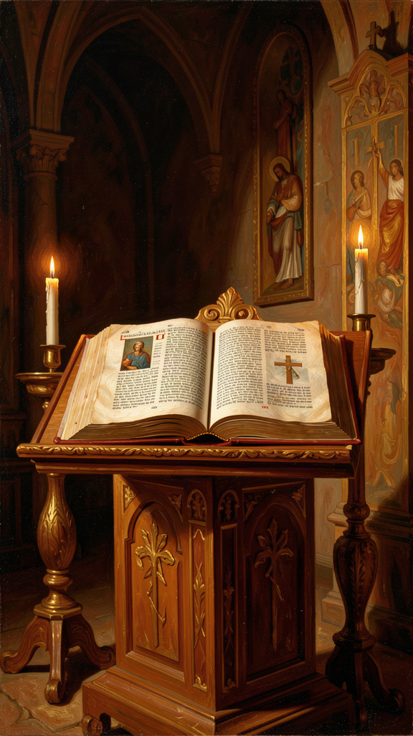
Illustration for Chapter 5
![Chapter 5](/images/booklets/chrysostom-high-ch05.png)

Scripture as the Church's Food
Chrysostom believed that the church is formed primarily by the public reading and explanation of Scripture. The Bible is not a private book for isolated reading. It is the shared food of the community, read in worship, preached from the pulpit, meditated on at home, and applied to daily life. For Chrysostom, Scripture is alive, practical, and communal. The preacher's task is not to display learning but to transform lives.
In Chrysostom's church, the Eucharistic liturgy included a substantial reading and exposition of Scripture. The people gathered to hear the Law, the Prophets, the Psalms, the Gospels, and the Letters of Paul read aloud and then explained. This was not a lecture. It was the central act of Christian formation.
"When the Scriptures are read, the angels stand by in reverence; for they see the Master speaking to his servants." — Homilies on the Gospel of Matthew
He also insisted that the Bible is not just for monks and clergy. It is for everyone — the merchant, the soldier, the wife, the child.
"Do not think that the reading of the Scriptures is only for monks. They are for you, the merchant, the soldier, the wife, the child — for all who would be saved." — Homilies on the Acts of the Apostles

Preaching as Formation
Chrysostom's homilies are not neutral biblical scholarship. They are pastoral exhortations. He moves from text to life with almost no gap. A passage about the early church becomes a summons to share possessions. A miracle of healing becomes a call to care for the sick. A parable about mercy becomes an examination of conscience.
This method assumes that Scripture is always speaking to the present congregation. The text has a fixed meaning, but its application is new each time it is preached. The preacher's job is to make the ancient word address the present need. Chrysostom wants his hearers to leave the church different from how they entered it.

The Plain Sense and the Moral Sense
Chrysostom is best known for his commitment to the plain, literal sense of Scripture. He resists excessive allegory, especially when it becomes a way of avoiding the text's practical demands. A passage that commands care for the poor should not be spiritualized into a vague message about detachment from the world. The literal meaning is the foundation, and the moral demand is the point.
At the same time, he does not read the Bible as a flat historical document. The Old Testament is preparation for Christ. The Psalms are the prayers of the church. The Gospels are the living voice of the Savior. Chrysostom allows for typology — seeing patterns and figures that point forward — but he insists that the literal meaning is the foundation. He is an Antiochene exegete, and the Antiochene school was known for its resistance to the wilder forms of Alexandrian allegory.

Christ at the Center
Chrysostom reads the whole Bible as centered on Christ. The Law points to him, the prophets announce him, the Psalms pray in his voice, the Gospels reveal him, and the epistles explain his significance for the church. This christological reading was standard in the early church, but Chrysostom applies it with unusual practical force. He does not merely say that the Old Testament points to Christ. He says that reading the Old Testament without seeing Christ is like reading a letter addressed to you and missing the signature.

Scripture Is Not Private
Chrysostom does not imagine Christians reading Scripture alone as detached individuals. The Bible belongs to the church. It is read in assembly, interpreted by authorized teachers, and applied to the common life. Private reading is good, but it must be shaped by the church's tradition.
The preacher stands between the text and the congregation. He must understand the text accurately, feel its urgency, and communicate it plainly. Chrysostom dislikes preachers who show off their education or who soften the text to please the crowd. The goal is not applause but transformation.

Scripture and the Liturgy
The Divine Liturgy of St. John Chrysostom is saturated with Scripture. Readings, psalms, prayers, and the Eucharistic narrative all draw on biblical language. The liturgy is, in effect, a living commentary on the Bible. Worship and Bible study are not separate activities. They are the same reality experienced differently. Historians debate exactly how much of the Liturgy Chrysostom himself composed, but there is no doubt that his preaching and pastoral leadership shaped the worship of Constantinople and beyond.

A Critical Note
No part of Scripture is purely theoretical for Chrysostom. Even the most difficult or obscure passages are pressed into service for moral instruction. This is sometimes a strength and sometimes a weakness. The strength is that Scripture becomes immediately relevant. The weakness is that he can flatten complex texts into single moral lessons. A narrative about war in Joshua becomes a lesson about fighting sin. A legal code in Leviticus becomes a spiritual allegory. A love poem in the Song of Songs becomes an allegory of Christ and the church. Reading Chrysostom on Scripture is inspiring, but it also requires the reader to notice when the preacher's urgency has outrun the text's actual meaning.
The question for the modern reader is: is he faithful to the original meaning, or does he use the text to make his own point? Sometimes both. His moral applications are often brilliant and genuinely arise from the text. Sometimes they overshoot the text and impose a sermon on a passage that does not naturally yield one. The discernment is yours.

Big Idea
The Bible is not a private book for isolated study. It is the shared food of the whole church, read and explained in worship, and applied to how we actually live. The preacher's job is not to show off learning but to change lives. Scripture is always speaking to us right now — but that means we must listen carefully, not just for what we want to hear, and notice when the preacher's urgency has outrun the text's actual meaning.

Practice
1. Read a homily. Find one of Chrysostom's homilies (many are freely available through the Christian Classics Ethereal Library or New Advent). Read a section and identify how he moves from text to application. Ask: Is he faithful to the original meaning, or does he use the text to make his own point? Where does the moral application genuinely arise from the text? Where does it overshoot?
2. Read Scripture communally. Chrysostom says the Bible belongs to the church, not to individuals. Find someone — a friend, a family member, a teacher, a pastor — and read a passage of Scripture together. Discuss what it means and what it asks of you. Notice how reading with another person changes what you notice. Private reading is good, but it is not the whole picture.
3. Test the medicine metaphor. Chrysostom says Scripture is like medicine — it only helps if you actually take it. Read a passage and ask: what would "taking" this passage look like? Not just understanding it. Not just agreeing with it. Actually doing what it says. If you cannot answer that question, you have read the passage as information, not as medicine.

Reflect
Chrysostom insists on the plain sense of Scripture but also reads everything through Christ. Are these compatible? Can you read the literal meaning of an Old Testament passage and also see it as pointing to Christ, or does the christological reading eventually override the literal one? And what about his tendency to flatten complex texts into moral lessons — is this a feature of his preaching or a bug? What is gained and what is lost when every passage becomes immediately practical?
———

Chapter 6: The Storm and the Glory
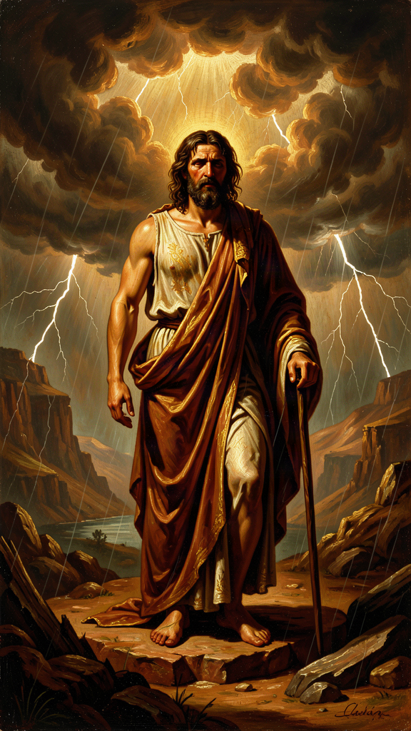
Illustration for Chapter 6
![Chapter 6](/images/booklets/chrysostom-high-ch06.png)

Divine Providence
For Chrysostom, suffering is never meaningless. God governs the world with wise providence, and even painful events can become a school of patience, trust, and purification. Chrysostom preached this confidence from the pulpit and tested it in his own exile. His final letters show a man exhausted by injustice but still convinced that God is at work. His theology of endurance is not stoical detachment. It is active trust in a provident God.
His Treatise on the Providence of God argues that nothing happens outside God's wise care. The world may appear chaotic — empires rise and fall, the innocent suffer, plans collapse — but behind the chaos is a governing hand. Providence does not mean that every event is good. It means that God can bring good out of evil for those who trust him.
This conviction is rooted in Scripture, especially the Psalms and the book of Job. Chrysostom believes that the believer can rest in God's care even when evidence is against it. Faith is not the denial of suffering. It is the refusal to let suffering have the last word.

Providence and Human Freedom
Chrysostom does not try to solve the philosophical puzzle of how divine providence and human freedom relate. He is a preacher, not a systematic theologian. He affirms both: God governs, and human beings are responsible for their choices. The tension is left unresolved because his aim is practical. He wants his hearers to trust God and to act rightly, not to solve metaphysics. This refusal to resolve the tension is not intellectual laziness. It is a pastoral decision: a theodicy that explains away suffering can become an excuse for doing nothing about it.

Providence in Exile
The most moving application of this doctrine comes in Chrysostom's letters from exile. He interprets his suffering as permitted by God for the purification of his own soul and the good of the church. He does not say that his enemies are right. He says that God is using even their injustice for a higher purpose.
"If the Lord has ordered these things, we must receive them with thanksgiving. For even this storm will work for us a weight of glory, if only we endure with patience and give thanks in everything." — Letter to Olympias, from exile
This is a dangerous idea if misused. It can encourage passive acceptance of evil or silence the victims of oppression. "Everything happens for a reason" can become a way of telling suffering people to stop complaining. Chrysostom himself did not accept injustice passively — he fought Eudoxia to the end, he wrote letters, he appealed, he resisted. His trust in providence coexisted with his resistance to wrongdoing. The two are not contradictory. They are two sides of the same conviction: God is at work, and so am I.

Suffering as a School
Chrysostom teaches that suffering trains the soul in patience. When life is easy, people forget God. When life is hard, they learn to depend on him. The goal is not suffering for its own sake but the virtues that suffering can produce: humility, compassion, endurance, and hope.
"Suffering is a school. The soul that has been trained by affliction becomes more vigilant, more humble, more compassionate."
One of the fruits of suffering, in Chrysostom's view, is compassion. A person who has endured hardship is better able to comfort others. Chrysostom's own suffering gave him a tender tone in his letters from exile. He could speak to Olympias and others from inside the same experience of loss.
But Chrysostom does not romanticize suffering. Hardship can embitter as well as purify. What transforms suffering is how it is received: with patience, prayer, love for enemies, and trust in God. Without these, suffering simply wounds. The school of suffering is not automatic. It requires a student who is willing to learn.

The Danger of Despair
Chrysostom warns against despair. Suffering can either drive a person toward God or away from him. The difference is whether the sufferer interprets hardship as punishment without mercy or as discipline within love. Chrysostom insists on the second interpretation, even when the evidence is ambiguous.
His letters from exile show him clinging to providence while still grieving his losses. He does not pretend to be serene. He is tired, lonely, and sometimes uncertain. The icon of the calm hierarch does not capture this humanity. The letters reveal a man who is honest about his pain and still trusting. That is more impressive than serenity.

Endurance and Resistance
Chrysostom's endurance is not the same as resignation. He does not tell victims to accept injustice without protest. His own life shows the opposite: he spoke, wrote, appealed, and resisted. Endurance, for him, is the refusal to let suffering destroy faith, hope, or love. It is compatible with active struggle against evil.
His most remarkable practice was praying for his persecutors. This is not weakness. It is the refusal to let cruelty define your own soul. Returning hatred makes you a mirror of the injustice you suffer. Praying for enemies is a way of keeping your own heart from becoming a copy of what was done to you.
Chrysostom did not die a martyr in the technical sense — his death was not a formal execution for faith. But his death was a kind of martyrdom of witness. He suffered because he refused to be silent. His exile and death became a testimony to the cost of prophetic speech. Later Christians venerated him as one who laid down his life for the truth.

The Final Journey
After two years in Cucusus, a remote and unhealthy place in Armenia, Chrysostom was ordered to Pityus, an even more distant destination on the Black Sea coast. The journey was brutal. He was marched through harsh weather, sometimes denied adequate food and rest. He was already weakened by illness, cold, and inadequate food. He died on September 14, 407 CE, near Comana in Pontus, before reaching Pityus. The hardships of exile clearly contributed to his death. His last words reportedly included:
"Glory be to God for all things."
Whether or not these were his exact words, they capture the spirit of his letters from exile. He died trusting the providence he had preached. His body was returned to Constantinople in 438 CE, and he was soon venerated as a saint. The people wept. The emperor himself asked pardon for what his parents had done. The man who had been sent away was welcomed home as one of the greatest saints of the church.

What Not to Say to the Suffering
Chrysostom's example warns against easy answers to suffering. "Everything happens for a reason" reduces providence to a slogan. "God won't give you more than you can handle" misquotes Scripture and dismisses real pain. "Just have more faith" treats faith as a lever that removes suffering. "Your suffering will make you stronger" promises a guaranteed outcome that Chrysostom himself would not promise. The promise is God's presence, not a guaranteed result. Better than any of these: be present, listen, pray, and help practically.

Big Idea
Suffering is never meaningless for Chrysostom, but it is not automatically good either. God can bring good out of evil, but that does not mean we should accept evil passively. Endurance is not resignation. It is the refusal to let suffering destroy faith, hope, or love, combined with active resistance to what is wrong. Chrysostom trusted God's providence even as he fought injustice — and his last words were gratitude, not despair.

Practice
1. Read a letter from exile. Find one of Chrysostom's letters to Olympias from exile (available through the Christian Classics Ethereal Library or New Advent). Read it and ask: How does he combine honest grief with trust in God? Where does he sound tired? Where does he sound hopeful? Does his trust in providence comfort you, or does it feel like it lets his enemies off the hook?
2. Distinguish endurance from resignation. Think about a situation of suffering or injustice — your own or someone else's. Ask: What would endurance look like here? What would resignation look like? Chrysostom says endurance includes both trusting God and resisting evil. Can you identify both elements in the situation you are thinking about?
3. Examine your language about suffering. Listen to the things people say to those who are suffering — and to the things you say. Do you use easy answers like "everything happens for a reason"? Chrysostom's example suggests that presence, listening, and practical help are better than slogans. The next time someone you know is suffering, try saying nothing at first. Just be present.

Reflect
Chrysostom says suffering is a school. But does this work only for the person who is willing to learn? Can suffering destroy a person who is not prepared for it? And the hardest question: can his interpretation of suffering as divine discipline be reconciled with the reality of systemic injustice? When suffering is caused not by providence but by human cruelty, is it still a school — or is it just evil that must be stopped? How do you hold both: the conviction that God is at work and the conviction that some suffering should not exist?
———

For the Grown-Up Reader
This booklet introduces high-school readers to John Chrysostom through six core themes drawn from his homilies, treatises, and letters. The narrative essays are faithful to the content and spirit of Chrysostom's preaching while adding the historical context, theological nuance, and critical engagement appropriate for this age group.
The quotes are real, drawn from widely available English translations of Chrysostom's works (primarily the Nicene and Post-Nicene Fathers series). Where the research files indicate that a passage is a paraphrase of a recurring theme rather than a verbatim quotation, that has been indicated in the source citation. No words have been invented and placed in Chrysostom's mouth.
A few notes on approach:
- The poor at the center. Chapter 1 presents the full force of Chrysostom's economic ethics — charity as justice, the poor as images of Christ, almsgiving as medicine — while also noting what he does not say (he does not condemn all wealth, he does not offer a political program) and why the poor function as his hermeneutical center. The practice exercises ask students to calculate their own surplus and to reframe giving as justice rather than charity. - The priesthood and prophetic speech. Chapter 2 presents the surgeon analogy, the Eudoxia conflict, and the Synod of the Oak. It engages honestly with the question of whether Chrysostom's confrontation was courageous or imprudent — or both. The "when silence is not betrayal" section introduces the nuance that prophetic speech requires wisdom, not just bravery. - Repentance and mercy. Chapter 3 presents metanoia as turning, compunction as productive grief, divine patience as invitation rather than permission, and the connection between repentance and almsgiving. The note about Chrysostom not being a systematic theologian of grace prevents readers from forcing his language into later Western categories. - Wealth, virginity, and marriage. Chapter 4 presents the three paths and the underlying question about desire. The cultural note about gender and household order is developed more fully than in the middle-school booklet. The connection between sexual and economic desire is introduced as a distinctive feature of Chrysostom's thought. - Scripture and the church. Chapter 5 presents Chrysostom's plain-sense hermeneutics, christological reading, and communal understanding of Scripture. The critical note about his tendency to flatten complex texts into moral lessons is developed with specific examples and asks students to discern where the preacher's urgency outruns the text. - Suffering and endurance. Chapter 6 presents the Treatise on the Providence of God, the letters from exile, and the careful distinction between endurance and resignation. The "what not to say to the suffering" section applies Chrysostom's insights critically to common platitudes. The question of whether providence can be reconciled with systemic injustice is raised but not resolved.
Chrysostom's moral failures — particularly his anti-Jewish rhetoric — are acknowledged in the introduction and alluded to in the chapters, but the full engagement with this material is reserved for the adult booklet, where the scholarly literature on this question can be presented properly. The high-school booklet holds together admiration and honest criticism without overwhelming the reader with the full complexity of the scholarly debates.
When reading with a high-school student, let the Reflect questions do their work. Chrysostom's gift was pressing uncomfortable questions, not providing comfortable answers. The closing questions in each chapter are designed to resist closure and to extend the conversation beyond the page.
———

About WisdomForge
WisdomForge creates age-adapted booklets that bring the great thinkers of human history to readers of every age. Each booklet takes a single figure — a philosopher, theologian, scientist, or sage — and presents their most important ideas in a form suited to the reader's stage of life.
Every WisdomForge figure gets four booklets: one for elementary ages (5–10), one for middle school (11–14), one for high school (15–18), and one for adult readers. The same core ideas appear in all four, but the depth, vocabulary, and style change. A child meets Chrysostom as a story character. A teenager meets him as a preacher with arguments to wrestle with. An adult meets him as a figure whose words still challenge the church and the world today.
WisdomForge uses only real quotes, cited by source. We do not invent words and put them in a thinker's mouth. When Chrysostom speaks, the words come from his homilies, treatises, or letters, and the source is named.
Our booklets are written in the spirit of the thinkers themselves: clear, honest, and unwilling to settle for easy answers. We believe that the best ideas do not decay. They wait, like seeds, for the right reader to pick them up.

