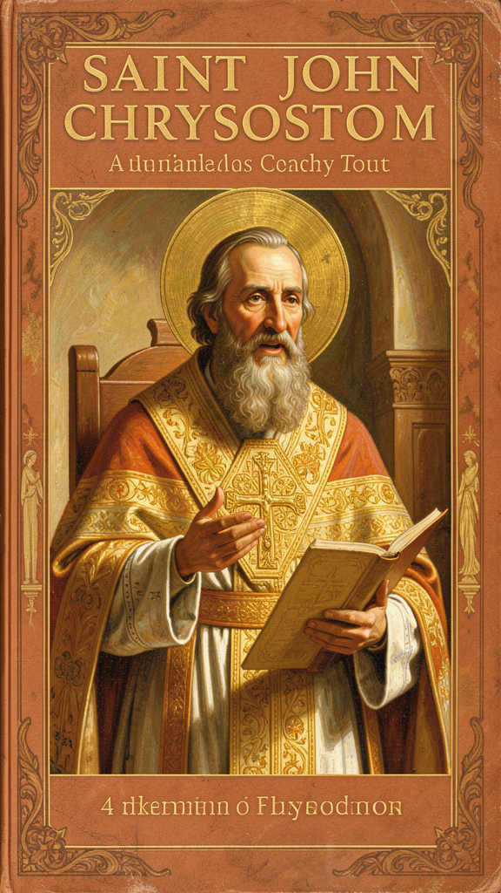
Golden Mouth
WisdomForge Booklet — Ages 11–14

Golden Mouth

WisdomForge Booklet — Ages 11–14
———

About This Book
About 1,600 years ago, in two of the greatest cities of the Roman Empire, a man stood up to preach and changed the world. His name was John. People called him Chrysostom, which means "Golden Mouth" in Greek. They gave him that name because no one in the early church could preach like he could. His words were vivid, direct, and impossible to ignore. He could comfort the suffering. He could also make the comfortable very uncomfortable.
John Chrysostom lived from about 347 to 407 CE. He was born in Antioch, a major city in what is now Turkey. He studied rhetoric with the greatest teacher of his age, a pagan named Libanius. He trained as a lawyer. Then he walked away from a public career and spent years as a hermit in the mountains, fasting and praying until his health broke. He came back to the city, became a priest, and preached sermons that made him famous across the empire. In 397 CE, against his will, he was made bishop of Constantinople, the imperial capital. He reformed the church, fought corruption, defended a widow against an empress, and was sent into exile, where he died.
That is the outline of his life. The ideas are what matter.
Chrysostom had one conviction that organized everything else: God has put the poor at the center of the Christian life. He did not mean that the poor are objects of pity. He meant they are creditors, teachers, images of Christ, and a test of faith. He said the extra bread in your cupboard belongs to the hungry. He said failing to share is theft. He said that when you pass a beggar without helping, you are passing by Christ himself.
He also believed that a preacher's job is to tell the truth, even when the truth is unwelcome — especially to the powerful. He compared a priest to a surgeon. A surgeon sometimes has to cut to heal. A preacher sometimes has to say hard things to help. Chrysostom practiced what he preached. He told an empress she was wrong. It cost him his home, his church, and his life.
This booklet tells six chapters of Chrysostom's story and thought. You will read about his teaching on the poor, his understanding of the priesthood, his preaching on repentance, his views on wealth and the different paths of Christian life, his approach to Scripture, and his final years of exile and endurance. Each chapter includes the real words of Chrysostom, drawn from his homilies, treatises, and letters, with the source named.
Chrysostom was not perfect. He could be harsh. His political judgment was not always wise. His language about Jews and about women sometimes reflected the prejudices of his age. A responsible reading holds together his moral brilliance and his human failures. This booklet does both.
The questions at the end of each chapter are for you. Chrysostom's words are 1,600 years old. His questions are not.
———

Chapter 1: The Bread That Belongs to the Hungry
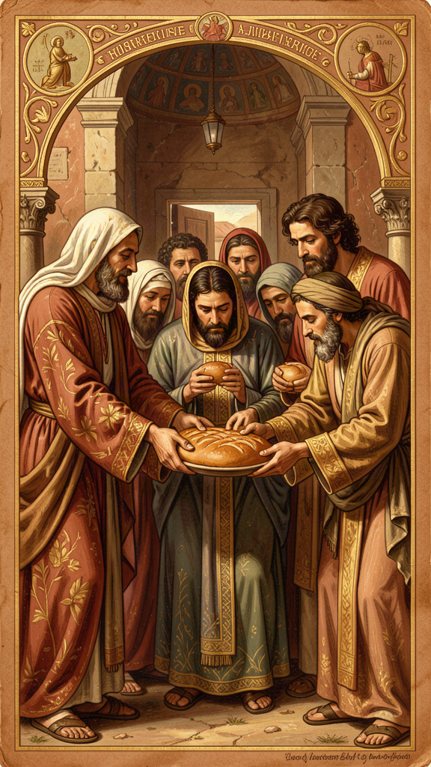
Illustration for Chapter 1
![Chapter 1](/images/booklets/chrysostom-middle-ch01.png)
Chrysostom preached in two of the richest cities of the late Roman Empire. Antioch sat on the Orontes River, a commercial center where goods from the East met the markets of the Mediterranean. Constantinople, the new capital built by Emperor Constantine, was a city of palaces, processions, and sharp inequality. In both cities, wealthy families lived in villas with silver dishes and idle slaves, while poor people sat at the church gates, hungry and sick.
Chrysostom could see this contrast every time he walked to church. He did not look away. He pointed at what was visible from the pulpit. He named the silver dishes, the extra cloaks, the locked storehouses, the fattened bodies. He preached in concrete images, not abstractions. This made his economic ethics impossible to spiritualize away.

Charity as Justice
The most striking feature of Chrysostom's teaching on wealth is his refusal to treat care for the poor as optional charity. He calls it justice.
The standard view of charity says: "I have something, and I am being kind by giving some of it to you." Charity is extra. It is a generous add-on to a life that is otherwise mine.
Chrysostom rejects this framing entirely. He says the rich are in possession of the goods of the poor. The bread they hold back belongs to the hungry. The coat in the wardrobe belongs to the naked. Failure to share is not a failure of generosity. It is theft.
"The rich are in possession of the goods of the poor, even if they have acquired them honestly or inherited them lawfully. The bread which you hold back belongs to the hungry; the coat which you guard in your wardrobe belongs to the naked." — Homilies on Matthew, Homily 78
This claim rests on a particular view of property. In Chrysostom's reading of Scripture, God gives the earth for the common good. Private ownership exists for management and order, but it does not give anyone the right to hoard necessities while others starve. Surplus carries a moral duty. Holding it without sharing is, in his language, deprivation.
This is stronger than saying "be generous." It says the existing distribution of goods is already a moral problem when some have too little and others have too much. The poor do not need the rich to be kind. They need what is, by divine intention, theirs.

The Poor as Images of Christ
Chrysostom gives a theological reason for this claim. In Matthew 25, Jesus says that what is done to the hungry, the stranger, the naked, the sick, and the prisoner is done to him. Chrysostom presses this identification hard.
When a Christian refuses a beggar, Chrysostom argues, they are refusing Christ. When they feed a poor person, they are feeding Christ. Every encounter with a poor person becomes a sacramental moment. The poor person is not a distraction from spiritual life. The poor person is a place where Christ becomes visible.
"If you wish to honor the body of Christ, do not scorn him when he is naked. Do not honor him here in church with silken vestments while outside you leave him suffering from cold and nakedness." — Homilies on the Gospel of Matthew, Homily 50
Chrysostom sometimes says that the poor are more honorable than the rich because the rich need the poor in order to be saved. The poor give the rich an opportunity to practice justice, to loosen the grip of possessions, and to encounter Christ. Without the poor, the rich would have no path to salvation.

Almsgiving as Medicine
Chrysostom treats almsgiving as a medicine for sin. The rich have many temptations: pride, luxury, hardness of heart, indifference. Giving to the poor is the cure. It loosens the grip of possessions, reminds the giver that life is short, and creates solidarity with those whom God loves.
This idea has ancient roots in Jewish and Christian tradition, but Chrysostom states it with unusual force. He sometimes suggests that almsgiving can balance or heal past wrongs — not by earning forgiveness but by turning the heart in the direction God desires.

What Chrysostom Does Not Say
It is important to be fair. Chrysostom's most famous sentences sound like a total rejection of riches, but read in context he allows that wealth can be used well. The problem is not having goods. The problem is withholding them. A rich person who shares, who treats possessions as a trust, who does not define himself by luxury, is not condemned merely for being rich.
Chrysostom also insists that the poor are full human beings, made in God's image, with their own virtues and spiritual greatness. The widow who gives two small coins is, for him, greater than the wealthy donor. He does not use the poor as mere instruments for the rich. He sees them as persons with their own dignity and their own holiness.
He does not offer a political program. He does not outline a system of taxation, property law, or economic redistribution. He preaches to individuals and congregations. His aim is to change hearts and habits, not to draft legislation. Modern readers therefore disagree about whether his teaching supports welfare states, private charity, or something more radical. That debate belongs to older readers. What matters here is the core claim: surplus belongs to those in need, and ignoring the poor is ignoring Christ.

Big Idea
Chrysostom treats care for the poor not as generosity but as justice. The extra things you hold belong to those who lack necessities. When you meet a poor person, you meet Christ. Sharing is not an optional act of kindness. It is giving back what already belongs to the hungry.

Try This
Make a list of five things you own that are more than you need — extra clothes, extra food, extra devices, extra anything. For each one, ask: "Could this belong to someone who needs it more than I do?" You do not have to give everything away. The exercise is to notice the difference between what you need and what you have, and to feel the moral weight of that gap.

Talk About It
Discuss with a friend, classmate, or family member: What is the difference between charity and justice? Charity says "I am kind to give." Justice says "This belongs to you already." Which way of thinking is harder? Which is more honest? Have you ever thought about sharing as giving back rather than giving away?
———

Chapter 2: The Surgeon and the Empress
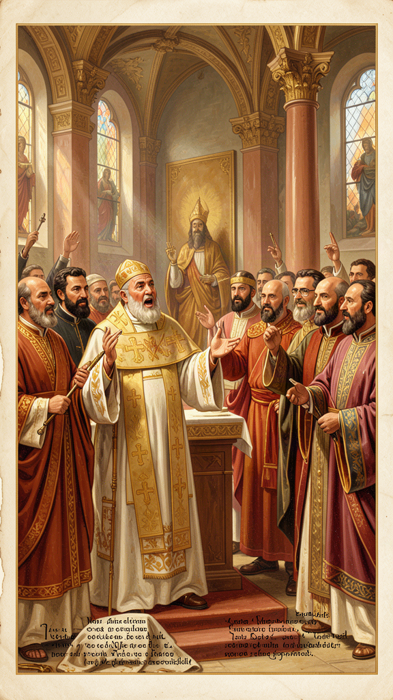
Illustration for Chapter 2
![Chapter 2](/images/booklets/chrysostom-middle-ch02.png)
Chrysostom had a high and demanding view of the priesthood. He wrote a book about it called On the Priesthood, which remains one of the most important Christian texts on pastoral ministry. In it he argues that the priesthood is the most necessary, dangerous, and honorable office in the church. The priest stands between God and the people, interpreting Scripture, forming conscience, and — when necessary — rebuking the powerful.

The Priest as Physician
Chrysostom's favorite image for the priest is the physician or surgeon. A sick person wants comfort, but comfort is not always healing. Sometimes the wound must be cut, the rotten flesh removed, the pain endured, so that health can follow.
"The priest must often appear harsh to those who are sick, not because he is harsh by nature, but because the disease demands it. A surgeon does not handle the wound gently when the flesh is rotten; he cuts, he cauterizes, he causes pain — but only so that health may follow." — On the Priesthood, Book III
This analogy is powerful but also risky. It can be used to justify verbal violence, manipulation, or bullying. Chrysostom himself was capable of rhetorical excess. The task for readers is to distinguish genuine pastoral courage from self-righteous aggression. The difference lies in whether the speaker is serving the hearer's good or the speaker's own power.
Chrysostom places enormous weight on preaching. The priest's teaching shapes the conscience of the congregation more than any other force. The priest does not merely explain texts. He forms souls. A single sermon can turn a person toward repentance or confirm them in complacency. This is why Chrysostom became the model for Orthodox, Catholic, and Protestant preachers. His influence on homiletics — the art of preaching — extends far beyond his own communion.

Speaking to the Powerful
The priestly office, for Chrysostom, includes the duty to speak unwelcome truth to those in power. This is not an extra role. It is part of what it means to stand for God before the people and for the people before God. When a preacher flatters the rich or avoids conflict with rulers, he has already failed.
Chrysostom's own conflict with Empress Eudoxia is the most famous example. In 403 CE, after Eudoxia seized a widow's vineyard, Chrysostom compared her to Jezebel, the Phoenician queen of the Old Testament who seized Naboth's vineyard and had him killed. The sermon provoked her fury and helped bring about his exile. He did not back down. For Chrysostom, the cost of silence was higher than the cost of confrontation.
"Again Jezebel is furious; again she rages; again she seeks to have the prophets driven out and the vineyard taken." — Sermon in Constantinople, 403 CE
The comparison was explosive. It named the empress as a murderous idolater and her action as theft. It also invoked a biblical pattern in which prophets confront wicked rulers. Eudoxia was furious, and her anger became the engine of Chrysostom's downfall.

Courage and Its Costs
Not every bold word is prophetic. Chrysostom was sometimes reckless, and his language could be cruel. Was his confrontation with Eudoxia a model of courage or a failure of prudence? The answer may be both. He was right to defend the widow and wrong, perhaps, to use a comparison so inflammatory that it made reconciliation impossible.
Prophetic speech requires more than courage. It requires accuracy, love for the opponent, timing, and a willingness to accept consequences without demanding martyrdom. Chrysostom meets some of these standards and falls short of others. He was right about the widow. He may have been wrong about the method. Both judgments can be held together.
The historical reality is more complicated than a simple story of holy courage versus wicked power. Chrysostom made enemies at court and among fellow bishops. His own uncompromising style contributed to the disaster. A council was convened at a villa called the Oak, near Chalcedon, in 403 CE. The charges included treason against the empress, misconduct as bishop, and receiving condemned clergy. Many of the charges were exaggerated or fabricated. The council was essentially a political trial.
Chrysostom was condemned and exiled. As he was being led away, an earthquake struck Constantinople. The terrified populace interpreted it as divine judgment, and Eudoxia herself recalled him. But the reconciliation was shallow. Within months, conflict resumed. In 404 CE he was exiled again, this time for good.
"The dignity of the priesthood is great, but its burden is greater. He who climbs a high place must fear a great fall." — On the Priesthood, Book VI

Big Idea
A leader who speaks for God must tell the truth, even to the powerful. But prophetic speech requires more than courage. It requires accuracy, timing, and a willingness to accept consequences. Chrysostom's confrontation with Eudoxia shows both the power and the danger of speaking truth to power. He was right to defend the widow. He may have been unwise in how he did it.

Try This
Think about a situation in your life where someone in authority — a teacher, a coach, a parent, a group leader — was doing something wrong. Did anyone speak up? What happened? Now imagine you were in that situation. What would make you speak? What would make you stay silent? Write down your answers. There is no right answer here — this is practice in thinking about when and how truth-telling is worth its cost.

Talk About It
Discuss with a friend or family member: Is there a difference between being brave and being reckless? Can someone be right about what they say and still wrong about how they say it? Where is the line between prophetic courage and self-righteousness? What would help you tell the difference?
———

Chapter 3: Turning Around
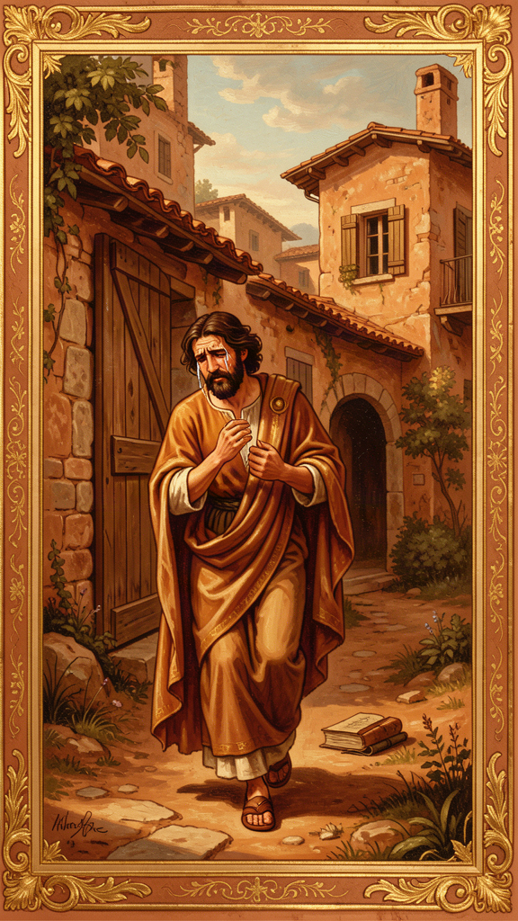
Illustration for Chapter 3
![Chapter 3](/images/booklets/chrysostom-middle-ch03.png)
For Chrysostom, repentance is not a single crisis moment. It is the ongoing shape of the Christian life. God is patient and merciful, always offering time to turn around. Human beings are called to respond with compunction — a sorrow for sin that produces change rather than despair. Chrysostom's preaching on repentance is severe about sin and expansive about grace. He refuses both complacency and hopelessness.

Compunction, Not Paralysis
Chrysostom uses the word compunction to describe the proper response to sin. Compunction is not guilt that crushes a person. It is grief that moves a person. It sees the wrong, feels its weight, and then turns toward God with a request for mercy and a commitment to change.
This distinction matters because guilt can become self-indulgent. A person may wallow in feelings of unworthiness without actually changing behavior. Chrysostom wants sorrow to be practical. If repentance does not change how a person acts, it is incomplete.

Repentance as Return
The Greek word for repentance, metanoia, literally means a change of mind or a turning around. Chrysostom emphasizes this movement. Sin is a direction — away from God and neighbor. Repentance is the decision to walk back. It is not enough to feel bad. The hands, the feet, the wallet, the tongue must all be redirected.
This is why Chrysostom connects repentance so closely with almsgiving, prayer, fasting, and care for the poor. These practices are not penances that buy forgiveness. They are the visible evidence that a person has actually turned around.
"Repentance is a change of mind from the worse to the better. It is not enough to weep; we must also correct."

Divine Patience
One of Chrysostom's most repeated themes is that God does not punish immediately because God wants repentance.
"God does not punish immediately, not because he does not see, but because he waits for repentance. He extends the time so that we may change. If he were swift to punish, where would be the room for repentance?" — Homilies on the Gospel of Matthew
This patience is good news, but it is also a warning. The delay of judgment is not permission to keep sinning. It is an invitation to stop. Chrysostom warns that the time given for repentance will one day run out. The question for the hearer is whether the present moment will be used or wasted.

Mercy Beyond Deserving
Chrysostom's God is not a distant accountant. He is a father who runs to meet the returning sinner, like the father in the parable of the prodigal son. The preaching on mercy is rooted in Scripture — the Psalms, the prophets, the parable — and it is aimed at people who are tempted to despair.
Chrysostom insists that no sin is too great for God's mercy if the sinner truly turns. This does not mean that sin is trivial. It means that mercy is greater. The proper response to great mercy is great repentance, not casual presumption.
"Do not despair because you have fallen often. The physician does not reject the sick man because he has relapsed. He heals him again and again." — To the Fallen Theodore

Mercy and the Poor
Chrysostom connects divine mercy with human mercy. God forgives; therefore human beings must forgive. God gives; therefore human beings must give. The person who receives mercy but refuses mercy to others has not understood what mercy is. This is why almsgiving appears so often in his teaching on repentance. It is the external sign of an internal transformation.
Chrysostom recommends concrete practices that keep repentance alive: confession, tears (as a sign of a softened heart), fasting (to reduce bodily appetite as a way of training the soul), almsgiving (to use possessions for others as a sign that greed is being overcome), forgiveness of others, and frequent return. Repentance is not once-for-all. The Christian returns again and again.

The Limits of the Discussion
Chrysostom is not a systematic theologian of justification or grace in the later Western sense. He does not work out the precise relationship between human effort and divine initiative. He preaches. His aim is to move the will, not to settle every theological question. Readers must be careful not to force his language into later doctrinal categories that he did not use.

Big Idea
Repentance is not a one-time event but a lifelong practice. It is not feeling bad — it is turning around and walking a different direction. God is patient, always offering time to change, but that patience is an invitation, not a guarantee. Real repentance shows itself in action: in sharing, forgiving, fasting, and returning to God again and again.

Try This
Think of one thing in your life that you keep doing even though you know it is wrong — maybe being unkind to someone, lying, being selfish, or holding a grudge. You have probably said "sorry" more than once. Now ask the harder question: what would actually turning around look like? Not the words — the action. What is one concrete thing you could do differently this week that would show your "sorry" is real?

Talk About It
Discuss with a friend or family member: What is the difference between feeling guilty and actually changing? Have you ever said sorry but kept doing the same thing? What would it look like to make your sorry real — to turn your feet, not just your feelings? Why is it easier to feel bad than to change?
———

Chapter 4: Three Paths, One Question
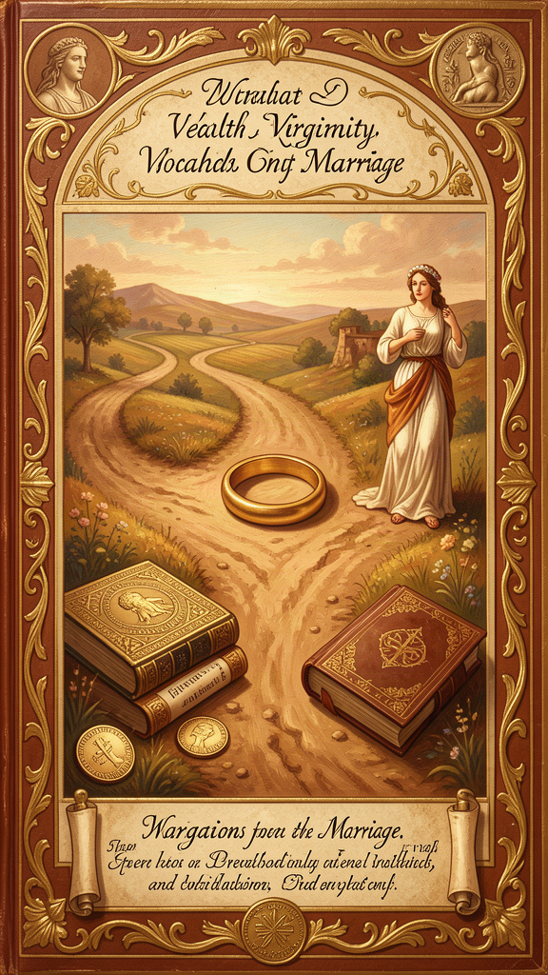
Illustration for Chapter 4
![Chapter 4](/images/booklets/chrysostom-middle-ch04.png)
Chrysostom has a complex view of wealth, marriage, and celibacy. He praises virginity — the unmarried life devoted to God — as the highest calling because it allows undivided devotion to God. But he also defends marriage as honorable, necessary for most people, and a school of virtue. His real target is not pleasure or family life as such. It is desire that has become greedy, self-centered, and idolatrous. Whether the issue is money or sex, the question is the same: does this thing serve God, or has it taken God's place?

Virginity as the Unmarried Life
In On Virginity, Chrysostom argues that the unmarried life devoted to God is the most free and focused form of Christian existence. Marriage brings cares, duties, and divided attention. The virgin can give herself entirely to prayer, almsgiving, and the service of the church.
"Marriage is honorable and the bed undefiled; but virginity is the most excellent of all, because it is free from the cares that divide the heart." — On Virginity
This view was common in early Christianity, especially after the rise of monasticism. It does not mean that married people are second-class Christians. It means that celibacy, freely chosen, offers a special kind of spiritual availability.
Chrysostom insists that virginity is more than avoiding sex. It is a whole way of life: purity of mind, detachment from luxury, freedom from ambition, and devotion to God. A person can be physically celibate and spiritually greedy. True virginity shows itself in humility and love.
He also warns that the unmarried life has its own temptations: pride, judgment toward married people, love of reputation, and spiritual laziness. The high calling does not guarantee holiness. It only creates the conditions for it.

Marriage as a Good and Demanding Calling
Chrysostom does not reject marriage. He defends its goodness. In several homilies he insists that marriage is instituted by God, that husbands and wives have mutual duties, and that the family is a place of spiritual formation. He rejects the view — held by some radical ascetics — that marriage is evil or impure.
His preaching on marriage is practical. Husbands are to love their wives sacrificially. Wives are to honor their husbands. Parents are to raise children in the faith. The household is a small church, and its daily life is the field of Christian virtue.
He is also a man of his age. Some of his assumptions about gender, authority, and household order reflect fourth-century social conventions rather than timeless principles. Modern readers must distinguish what is central to his theology from what belongs to his culture.
"The husband is the head of the wife, not as a tyrant but as one who lays down his life for her." — Homilies on the Epistle to the Ephesians

Wealth and the Household
Marriage and wealth intersect in Chrysostom's thinking. A household requires money, and a family can become obsessed with acquiring, displaying, and protecting it. Chrysostom warns against using marriage as an excuse for greed.
"Do not say, 'I have a wife and children, therefore I cannot give alms.' It is for their sake that you should give. You are teaching them to be Christians." — Homilies on the Acts of the Apostles
This is characteristic of Chrysostom. He refuses to let family responsibilities become an excuse for hoarding. If anything, having a family makes generosity more important, because children learn by watching what their parents do.

Wealth as a Test of Detachment
Chrysostom's teaching on wealth is best understood as an attack on greed rather than on possessions themselves. Money is dangerous because it attaches the heart to this world. The rich are tempted to trust in what they own, to despise the poor, and to forget that life is short.
This is why almsgiving is so important. Giving breaks the grip of wealth and turns the heart outward. A person who holds possessions loosely and uses them for others has, in Chrysostom's view, overcome the danger of riches.
Chrysostom sometimes connects the appetites for pleasure and wealth. Both can become insatiable. Both promise happiness and deliver anxiety. Both are disciplined by ascetic practices: fasting, generosity, prayer, and self-examination. The Christian life, in his view, is a training of desire so that the soul can love God without distraction.

Three Paths
Chrysostom's scheme offers three paths:
1. The married life — loving your family, raising children in the faith, sharing what you have, and making your home a place of Christian virtue.
2. The unmarried life — giving all your time to God, to prayer, and to serving the poor, without the cares of a household.
3. The generous life — which everyone, married or unmarried, is called to live. Everyone is called to share. Everyone is called to care. Everyone is called to hold things loosely.
The third path is not optional. It applies to everyone. The first two are different vocations, but both must be lived generously.

Big Idea
God calls different people to different ways of living. Some marry and raise families. Some give their whole lives to God without marrying. Both are good. But everyone — married or unmarried — is called to hold things loosely, to share generously, and to make sure that nothing takes God's place in their heart.

Try This
Think about what you want your life to look like when you are older. Not the specific job — the kind of person you want to be. Write down three qualities you want to have (like generous, honest, brave). Now ask: does the way I live right now point toward those qualities? The path you choose matters less than the kind of person you become on it.

Talk About It
Discuss with a friend or family member: Chrysostom says the problem is not having things but letting things have you. What does it look like when something takes God's place in a person's life? Can you think of an example — maybe from your own life, from someone you know, or from the news? What would it look like to hold that thing more loosely?
———

Chapter 5: The Book That Speaks
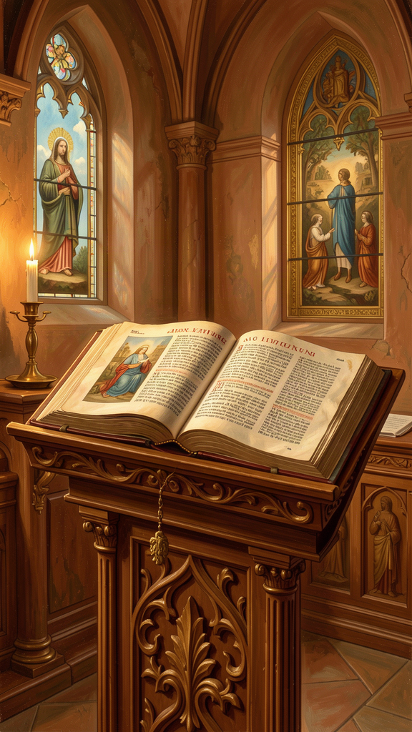
Illustration for Chapter 5
![Chapter 5](/images/booklets/chrysostom-middle-ch05.png)
Chrysostom believed that the church is formed primarily by the public reading and explanation of Scripture. The Bible is not a private book for isolated reading. It is the shared food of the community, read in worship, preached from the pulpit, meditated on at home, and applied to daily life. For Chrysostom, Scripture is alive, practical, and communal. The preacher's task is not to display learning but to transform lives.

Scripture as the Church's Food
In Chrysostom's church, the Eucharistic liturgy included a substantial reading and exposition of Scripture. The people gathered to hear the Law, the Prophets, the Psalms, the Gospels, and the Letters of Paul read aloud and then explained. This was not a lecture. It was the central act of Christian formation.
Chrysostom compares Scripture to food, medicine, light, and a weapon. Just as the body needs bread, the soul needs the word of God. Without regular exposure to Scripture, Christians become spiritually malnourished.
"When the Scriptures are read, the angels stand by in reverence; for they see the Master speaking to his servants." — Homilies on the Gospel of Matthew
He also insisted that the Bible is not just for monks and clergy. It is for everyone.
"Do not think that the reading of the Scriptures is only for monks. They are for you, the merchant, the soldier, the wife, the child — for all who would be saved." — Homilies on the Acts of the Apostles

Preaching as Formation
Chrysostom's homilies are not neutral biblical scholarship. They are pastoral exhortations. He moves from text to life with almost no gap. A passage about the early church becomes a summons to share possessions. A miracle of healing becomes a call to care for the sick. A parable about mercy becomes an examination of conscience.
This method assumes that Scripture is always speaking to the present congregation. The text has a fixed meaning, but its application is new each time it is preached. The preacher's job is to make the ancient word address the present need.

The Plain Sense and the Moral Sense
Chrysostom is best known for his commitment to the plain, literal sense of Scripture. He resists excessive allegory, especially when it becomes a way of avoiding the text's practical demands. A passage that commands care for the poor should not be spiritualized into a vague message about detachment from the world.
At the same time, he does not read the Bible as a flat historical document. The Old Testament is preparation for Christ. The Psalms are the prayers of the church. The Gospels are the living voice of the Savior. Chrysostom allows for typology — seeing patterns and figures that point forward — but he insists that the literal meaning is the foundation.

Christ at the Center
Chrysostom reads the whole Bible as centered on Christ. The Law points to him, the prophets announce him, the Psalms pray in his voice, the Gospels reveal him, and the epistles explain his significance for the church. This christological reading was standard in the early church, but Chrysostom applies it with unusual practical force.

Scripture Is Not Private
Chrysostom does not imagine Christians reading Scripture alone as detached individuals. The Bible belongs to the church. It is read in assembly, interpreted by authorized teachers, and applied to the common life. Private reading is good, but it must be shaped by the church's tradition.
The preacher stands between the text and the congregation. He must understand the text accurately, feel its urgency, and communicate it plainly. Chrysostom dislikes preachers who show off their education or who soften the text to please the crowd. The goal is not applause but transformation.

Scripture and the Liturgy
The Divine Liturgy of St. John Chrysostom is saturated with Scripture. Readings, psalms, prayers, and the Eucharistic narrative all draw on biblical language. The liturgy is, in effect, a living commentary on the Bible. Worship and Bible study are not separate activities. They are the same reality experienced differently.

A Critical Note
No part of Scripture is purely theoretical for Chrysostom. Even the most difficult or obscure passages are pressed into service for moral instruction. This is sometimes a strength and sometimes a weakness. The strength is that Scripture becomes immediately relevant. The weakness is that he can flatten complex texts into single moral lessons. Reading Chrysostom on Scripture is inspiring, but it also requires the reader to notice when the preacher's urgency has outrun the text's actual meaning.

Big Idea
The Bible is not a private book for isolated study. It is the shared food of the whole church, read and explained in worship, and applied to how we actually live. The preacher's job is not to show off learning but to change lives. Scripture is always speaking to us right now — but that means we must listen carefully, not just for what we want to hear.

Try This
Find a short passage from the Bible — maybe a parable, a psalm, or a saying of Jesus. Read it slowly. Then ask yourself three questions: (1) What is this passage actually saying? (2) What does it mean for how I live? (3) Is there a difference between what it says and what I want it to say? Write down your answers. The third question is the hardest and the most important.

Talk About It
Discuss with a friend or family member: Chrysostom says the Bible is like medicine — it only helps if you actually take it. What does it mean to "take" the Bible, not just read it? Have you ever read something in the Bible that challenged you — that made you uncomfortable? What did you do with that discomfort?
———

Chapter 6: The Storm and the Glory
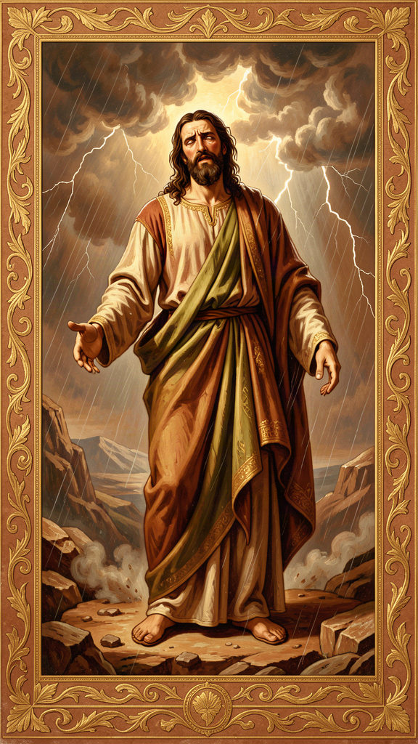
Illustration for Chapter 6
![Chapter 6](/images/booklets/chrysostom-middle-ch06.png)
For Chrysostom, suffering is never meaningless. God governs the world with wise providence, and even painful events can become a school of patience, trust, and purification. Chrysostom preached this confidence from the pulpit and tested it in his own exile. His final letters show a man exhausted by injustice but still convinced that God is at work. His theology of endurance is not stoical detachment. It is active trust in a provident God.

Divine Providence
Chrysostom's Treatise on the Providence of God argues that nothing happens outside God's wise care. The world may appear chaotic — empires rise and fall, the innocent suffer, plans collapse — but behind the chaos is a governing hand. Providence does not mean that every event is good. It means that God can bring good out of evil for those who trust him.
This conviction is rooted in Scripture, especially the Psalms and the book of Job. Chrysostom believes that the believer can rest in God's care even when evidence is against it. Faith is not the denial of suffering. It is the refusal to let suffering have the last word.
Chrysostom does not try to solve the philosophical puzzle of how divine providence and human freedom relate. He is a preacher, not a systematic theologian. He affirms both: God governs, and human beings are responsible for their choices. The tension is left unresolved because his aim is practical. He wants his hearers to trust God and to act rightly, not to solve metaphysics.

Suffering as a School
Chrysostom teaches that suffering trains the soul in patience. When life is easy, people forget God. When life is hard, they learn to depend on him. The goal is not suffering for its own sake but the virtues that suffering can produce: humility, compassion, endurance, and hope.
"Suffering is a school. The soul that has been trained by affliction becomes more vigilant, more humble, more compassionate."
One of the fruits of suffering, in Chrysostom's view, is compassion. A person who has endured hardship is better able to comfort others. Chrysostom's own suffering gave him a tender tone in his letters from exile. He could speak to Olympias and others from inside the same experience of loss.

Providence in Exile
The most moving application of this doctrine comes in Chrysostom's letters from exile. He interprets his suffering as permitted by God for the purification of his own soul and the good of the church. He does not say that his enemies are right. He says that God is using even their injustice for a higher purpose.
"If the Lord has ordered these things, we must receive them with thanksgiving. For even this storm will work for us a weight of glory, if only we endure with patience and give thanks in everything." — Letter to Olympias, from exile
This is a dangerous idea if misused. It can encourage passive acceptance of evil or silence the victims of oppression. Chrysostom himself did not accept injustice passively — he fought Eudoxia to the end. His trust in providence coexisted with his resistance to wrongdoing. Endurance, for him, is the refusal to let suffering destroy faith, hope, or love. It is compatible with active struggle against evil.

The Final Journey
After two years in Cucusus, a remote and unhealthy place in Armenia, Chrysostom was ordered to Pityus, an even more distant destination on the Black Sea coast. The journey was brutal. He was marched through harsh weather, sometimes denied adequate food and rest. He was already weakened by illness, cold, and inadequate food.
He died on September 14, 407 CE, near Comana in Pontus, before reaching Pityus. The hardships of exile clearly contributed to his death. His last words reportedly included:
"Glory be to God for all things."
Whether or not these were his exact words, they capture the spirit of his letters from exile. He died trusting the providence he had preached. His body was later returned to Constantinople in 438 CE, and he was soon venerated as a saint. The people wept. The emperor himself asked pardon for what his parents had done. The man who had been sent away was welcomed home as one of the greatest saints of the church.

Endurance Is Not Passivity
Chrysostom's endurance is not the same as resignation. He does not tell victims to accept injustice without protest. His own life shows the opposite: he spoke, wrote, appealed, and resisted. Endurance, for him, is the refusal to let suffering destroy faith, hope, or love. It is compatible with active struggle against evil.
He did not die a martyr in the technical sense — his death was not a formal execution for faith. But his death was a kind of martyrdom of witness. He suffered because he refused to be silent. His exile and death became a testimony to the cost of prophetic speech. Later Christians venerated him as one who laid down his life for the truth.

Big Idea
Suffering is never meaningless for Chrysostom. God can bring good out of even the worst events, but that does not mean we should accept evil passively. Endurance is not giving up. It is holding on to faith, hope, and love while also resisting what is wrong. Chrysostom trusted God's providence even as he fought injustice — and his last words were gratitude, not despair.

Try This
Think about a hard time in your life — or a hard time you are going through now. Ask yourself three questions: (1) Did this hard time teach me anything? (2) Did it make me more understanding of other people's pain? (3) Is there anything I can do — not just endure — to make this situation better? Write down your answers. The third question is the one Chrysostom would push you on: trusting God and acting are not opposites.

Talk About It
Discuss with a friend or family member: Chrysostom says suffering is a school. Do you agree? Can you think of a time when something hard taught you something that easy times could not? Now the harder question: does saying that suffering teaches us sometimes let us off the hook for fighting injustice? How do you hold both ideas — that suffering can be meaningful and that some suffering should be stopped?
———

For the Grown-Up Reader
This booklet introduces middle-school readers to John Chrysostom through six core themes drawn from his homilies, treatises, and letters. The narrative retellings are faithful to the content and spirit of Chrysostom's preaching while adding historical context appropriate for this age group.
The quotes are real, drawn from widely available English translations of Chrysostom's works (primarily the Nicene and Post-Nicene Fathers series, with some paraphrases of recurring themes as noted in the source citations). Where the research files indicate that a passage is a paraphrase of a recurring theme rather than a verbatim quotation, that has been indicated. No words have been invented and placed in Chrysostom's mouth.
A few notes on approach:
- The poor at the center. Chapter 1 presents Chrysostom's economic ethics through the distinction between charity and justice. The key theological move — that surplus belongs to the hungry and that the poor are images of Christ — is presented without the complex scholarly debates about how his teaching applies to modern economic systems. Those debates appear in the adult booklet. - The priesthood and prophetic speech. Chapter 2 uses the surgeon analogy from On the Priesthood Book III and tells the Eudoxia conflict honestly, including the observation that Chrysostom's boldness may have been imprudent. The Synod of the Oak is mentioned to show that the conflict was not simply holy courage versus wicked power. - Repentance and mercy. Chapter 3 presents metanoia as turning rather than feeling, connects repentance to almsgiving, and introduces the concept of compunction. The note about Chrysostom not being a systematic theologian of grace is included to prevent readers from forcing his language into later doctrinal categories. - Wealth, virginity, and marriage. Chapter 4 presents the three paths fairly. The cultural note about Chrysostom's assumptions about gender and household order is included so readers can begin to distinguish theology from culture. - Scripture and the church. Chapter 5 presents Chrysostom's plain-sense hermeneutics, his christological reading, and his communal understanding of Scripture. The critical note about his tendency to flatten complex texts into moral lessons is included as the beginning of honest engagement. - Suffering and endurance. Chapter 6 tells the story of exile and death, presents the Treatise on the Providence of God, and carefully distinguishes endurance from passivity. The danger of misusing providence to silence victims is noted.
Chrysostom's moral failures — particularly his anti-Jewish rhetoric — are mentioned in the introduction but not developed in the chapters, as the research files flag these as most appropriate for high-school and adult readers. The middle-school booklet focuses on the ideas that are most accessible and most urgently relevant to this age group: sharing, courage, honesty, choices, attention, and endurance.
When reading with a young person, let the "Talk About It" questions linger. Chrysostom's gift was not providing comfortable answers but pressing uncomfortable questions. The closing questions in each chapter are designed to extend the conversation beyond the page.
———

About WisdomForge
WisdomForge creates age-adapted booklets that bring the great thinkers of human history to readers of every age. Each booklet takes a single figure — a philosopher, theologian, scientist, or sage — and presents their most important ideas in a form suited to the reader's stage of life.
Every WisdomForge figure gets four booklets: one for elementary ages (5–10), one for middle school (11–14), one for high school (15–18), and one for adult readers. The same core ideas appear in all four, but the depth, vocabulary, and style change. A child meets Chrysostom as a story character. A teenager meets him as a preacher with arguments to wrestle with. An adult meets him as a figure whose words still challenge the church and the world today.
WisdomForge uses only real quotes, cited by source. We do not invent words and put them in a thinker's mouth. When Chrysostom speaks, the words come from his homilies, treatises, or letters, and the source is named.
Our booklets are written in the spirit of the thinkers themselves: clear, honest, and unwilling to settle for easy answers. We believe that the best ideas do not decay. They wait, like seeds, for the right reader to pick them up.

